Sts. Peter & Paul
Evangelical Lutheran Church
Lutheran Church-Missouri Synod
Founded-1917
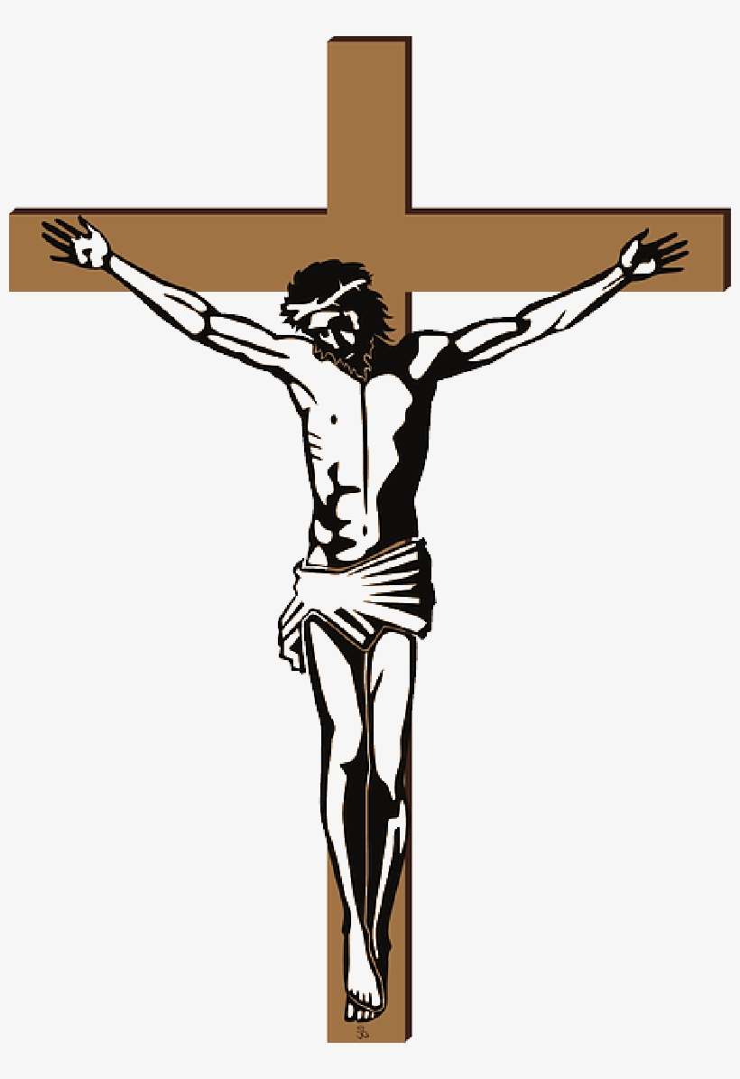

699 Stambaugh Avenue
Sharon, Pennsylvania 16146

2024 Lenten Midweek Vespers Service:
“Spiritual Contemplation of Christ’s Suffering”

“I was glad when they said to me,
Let us go to the house of the LORD!”
Psalm 122:1
Sts. Peter & Paul Evangelical Lutheran Church, LC-MS
LENTEN MIDWEEK VESPERS SERVICE

OPENING HYMN:
February 21: LSB #562 “All Mankind Fell in Adam’s Fall”
February 28: LSB #439:1-8 “O Dearest Jesus, What Law Hast Thou Broken”
March 6: LSB #440 “Jesus, I Will Ponder Now”
March 13: LSB #430 “My Song Is Love Unknown”
March 20: LSB #756 “Why Should Cross and Tral Grieve Me”

Stand
LENT VERSICLES
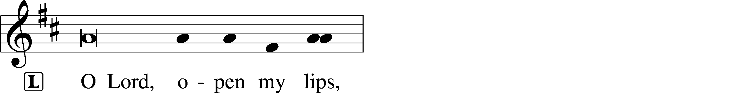
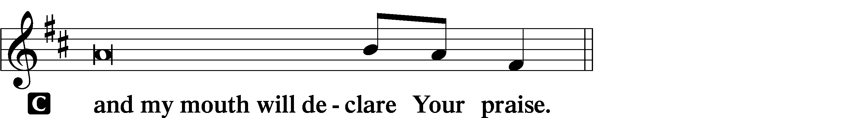

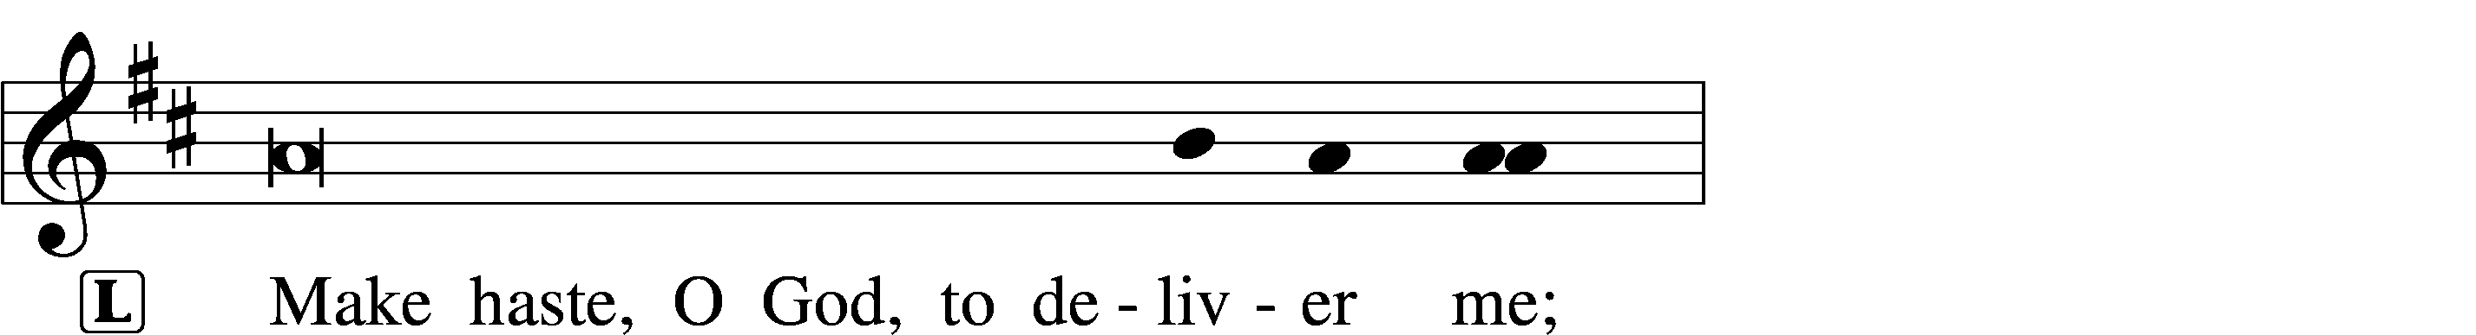
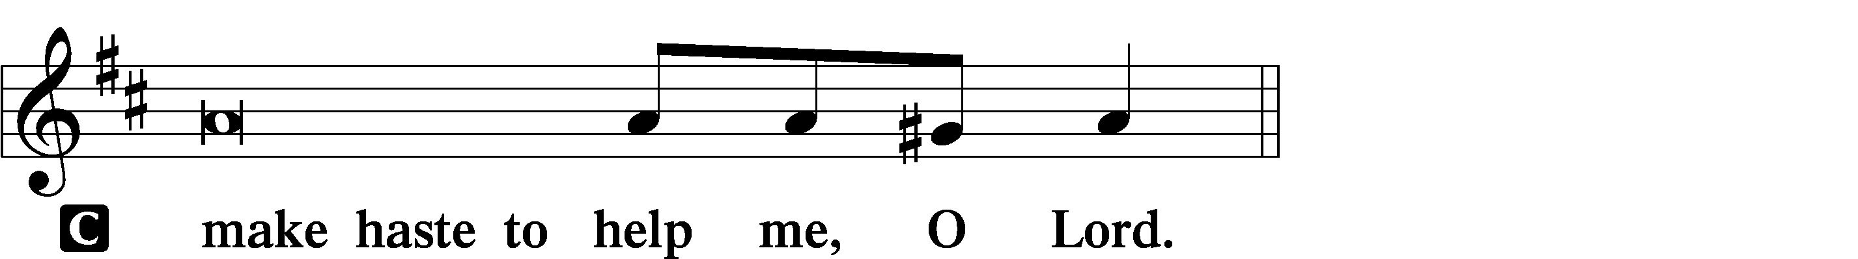

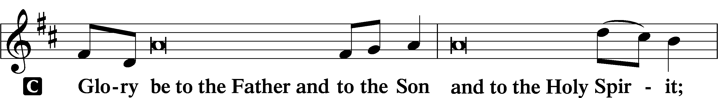
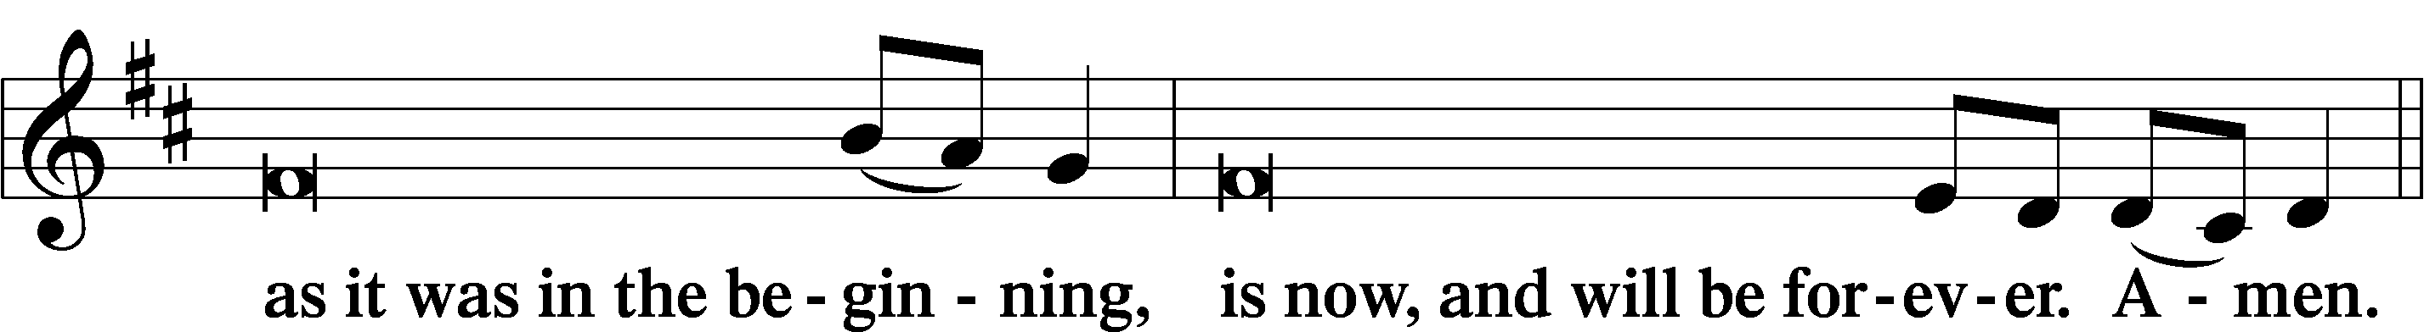
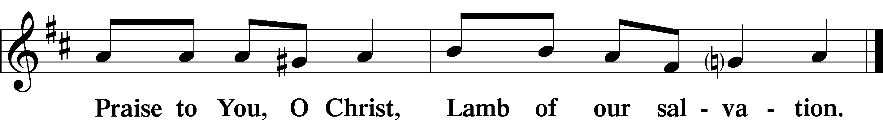
Psalmody

PSALMS:
February 21: Psalm 16 March 13: Psalm 85
February 28: Psalm 103 March 20: Psalm 119:65-72
March 6: Psalm 22
Sit

HYMN OF THE DAY:
February 21: LSB #438 “A Lamb Goes Uncomplaining Forth”
February 28: LSB #568 “If Your Beloved Son, O God”
March 6: LSB #438 “A Lamb Goes Uncomplaining Forth”
March 13: LSB #571 “God Loved the World So That He Gave”
March 20: LSB #685 “Let Us Ever Walk with Jesus”
Readings

PROPHECY:
February 21: Isaiah 50:5-10 March 13: Hosea 14:1-9
February 28: Isaiah 52:13—53:12 March 20: Job 1:6-22
March 6: Zechariah 13:1-9

Reading Response:
P O Lord, have mercy on us.
C Thanks be to God.

EPISTLE:
February 21: Romans 5:1-21 March 13: 1 John 4:7-21
February 28: Galatians 3:10-14 March 20: 1 Peter 4:12-19
March 6: Acts 4:23-31

Reading Response:
P O Lord, have mercy on us.
C Thanks be to God.
GOSPEL:
February 21: John 6:35-40 March 13: John 15:1-17
February 28: John 3:13-21 March 20: John 15:18—16:4
March 6: Mark 14:26-50

Reading Response:
P O Lord, have mercy on us.
C Thanks be to God.

RESPONSORY (LENT) LSB 231
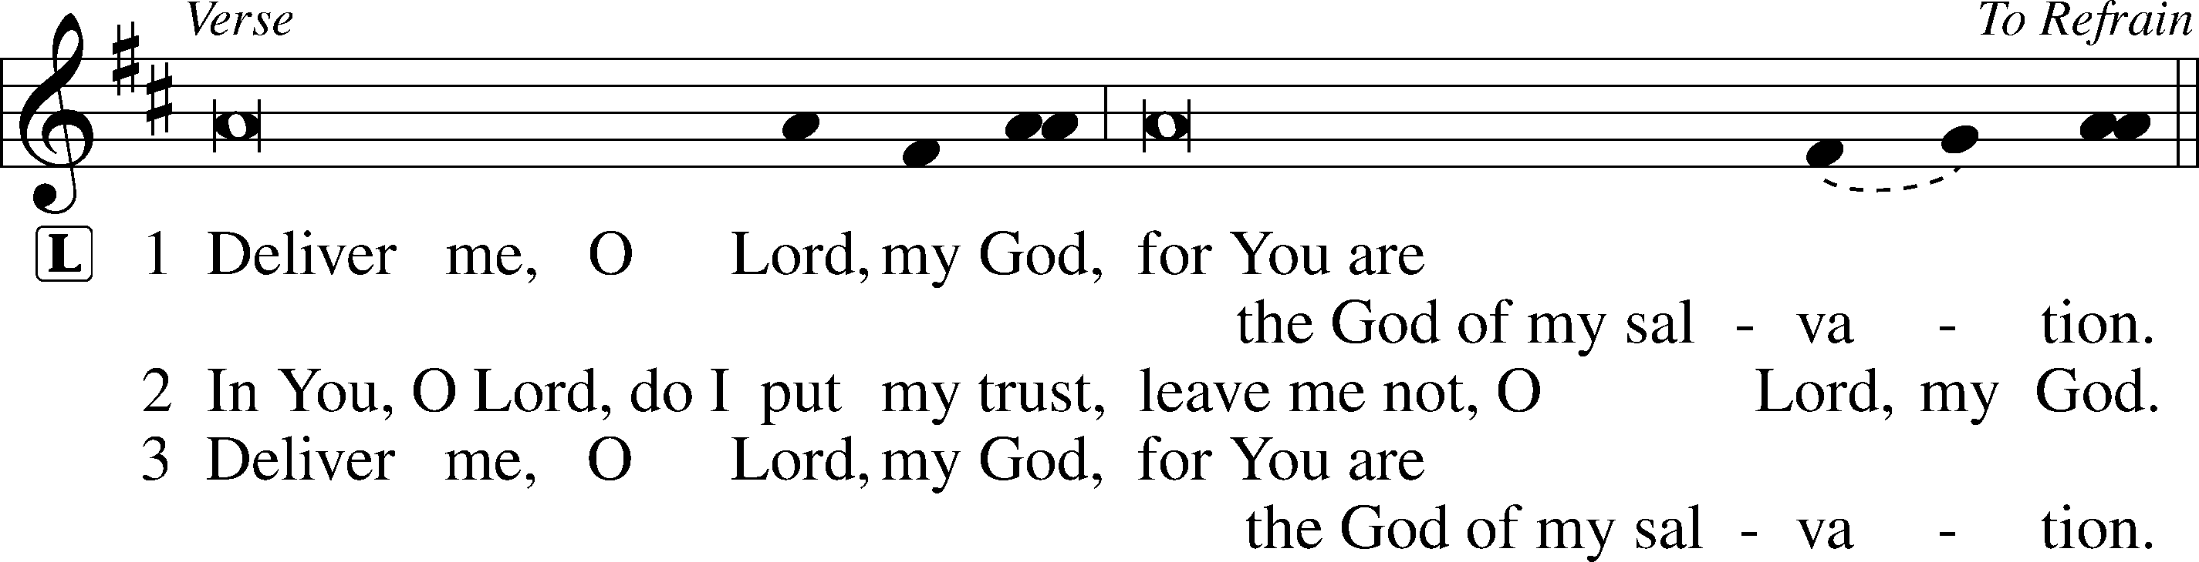
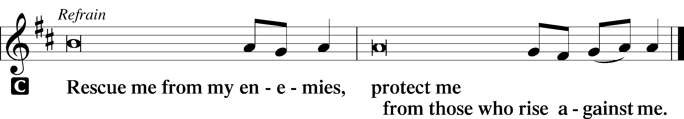

SERMON
Canticle
Stand

ANTIPHON (COMMON) 231
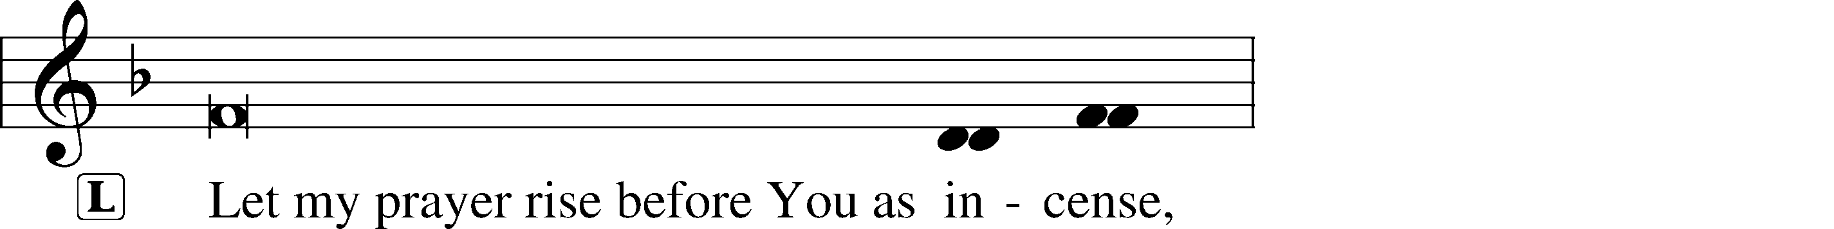
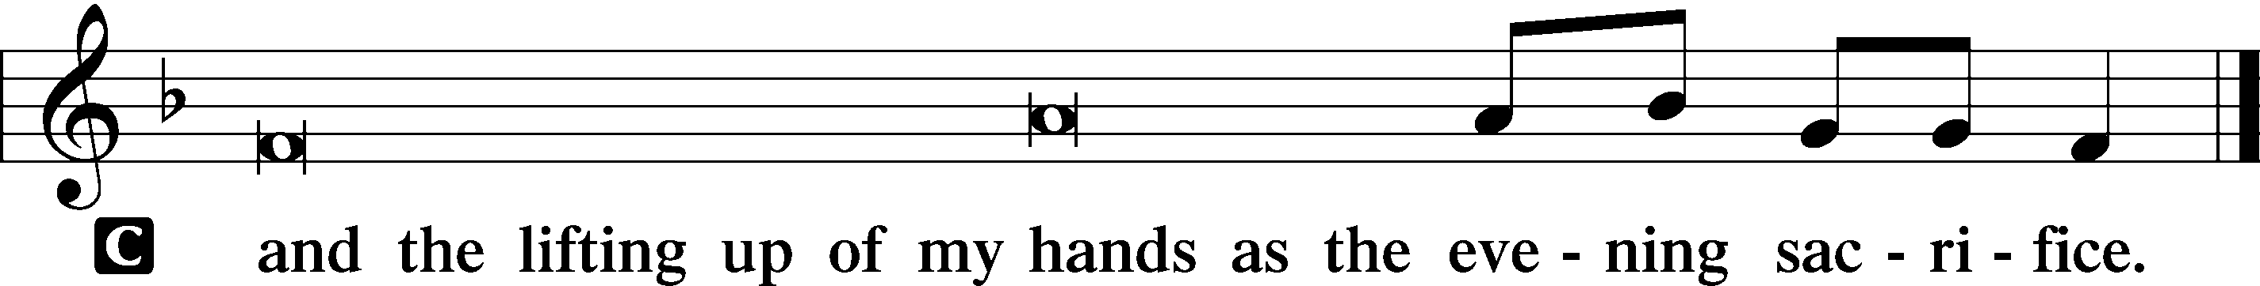

MAGNIFICAT 231
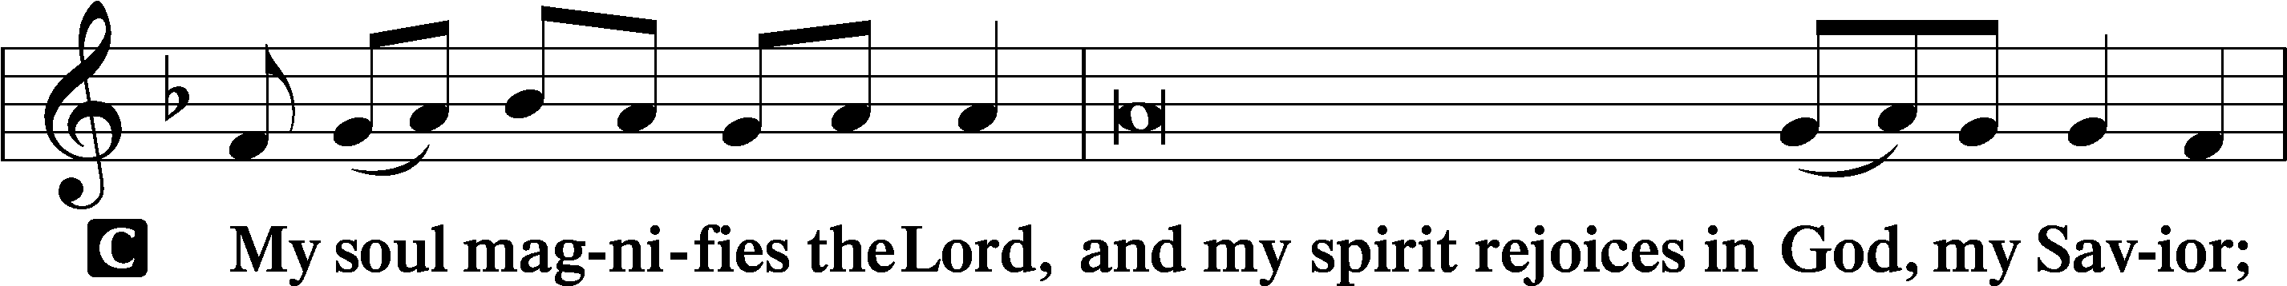
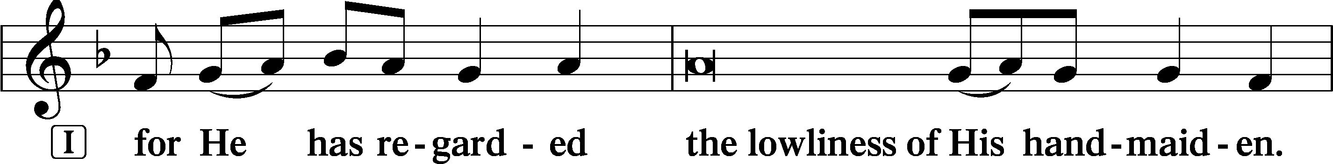
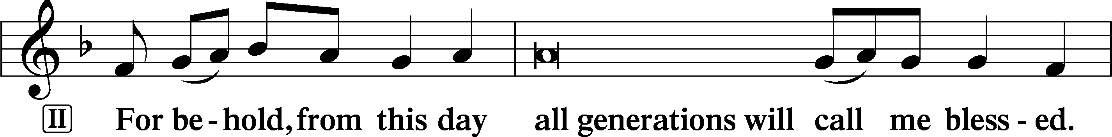
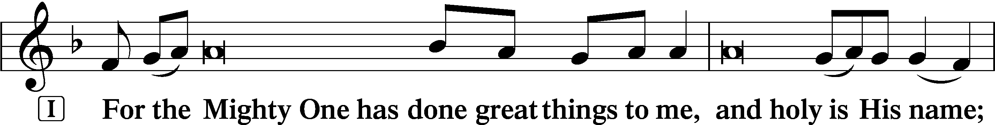
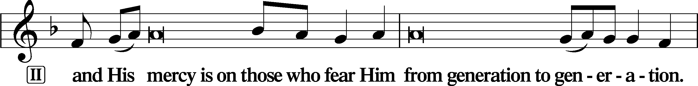
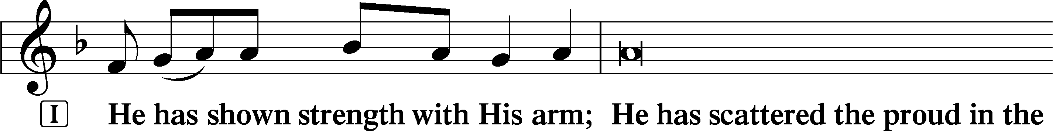
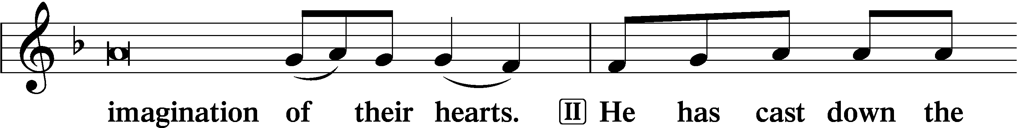
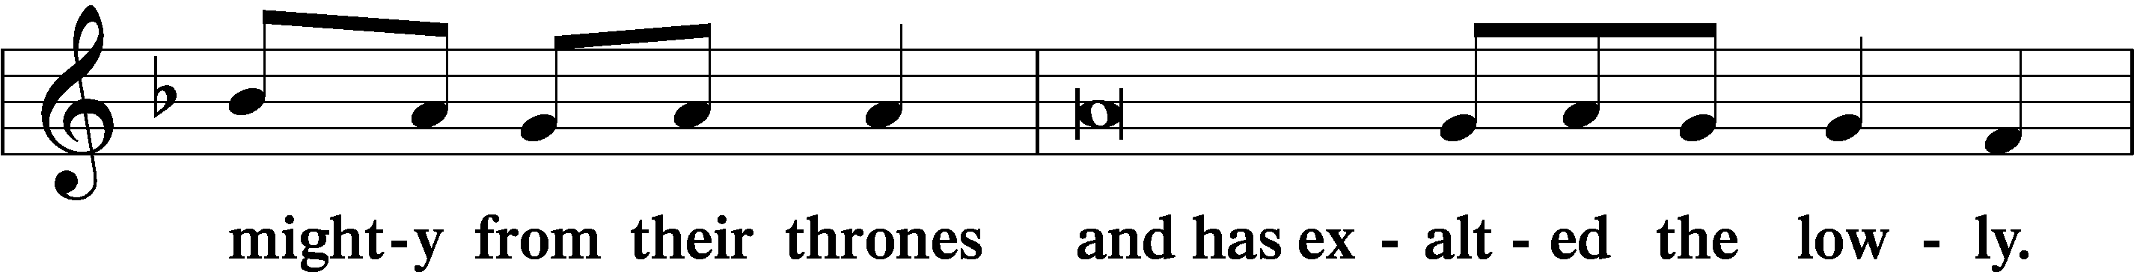
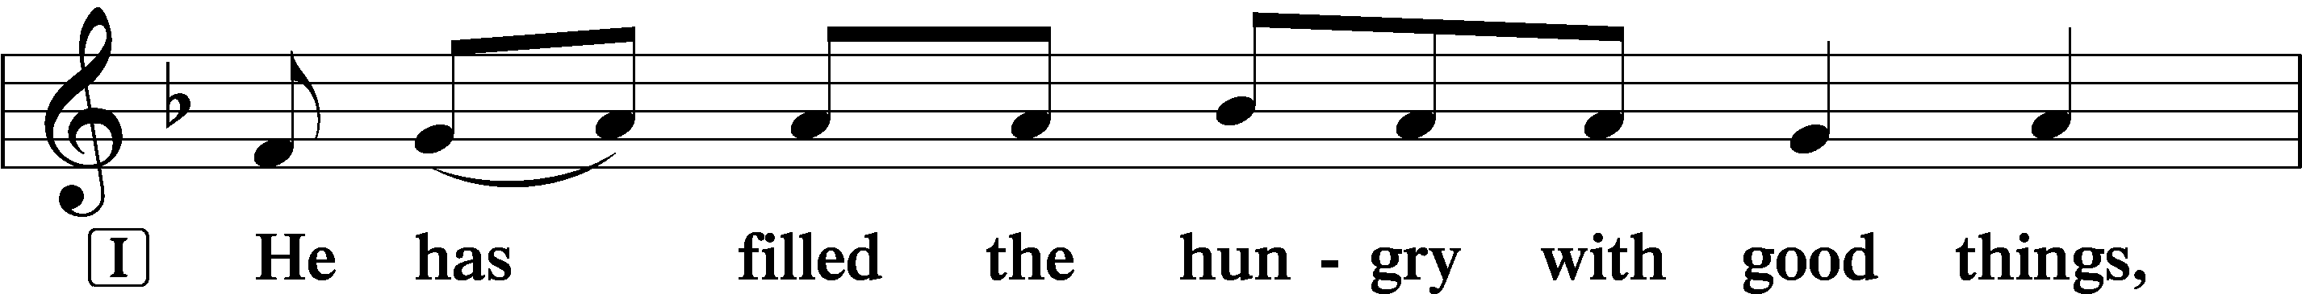
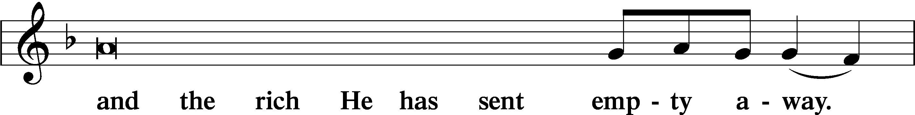
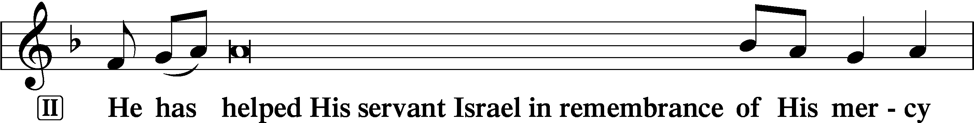
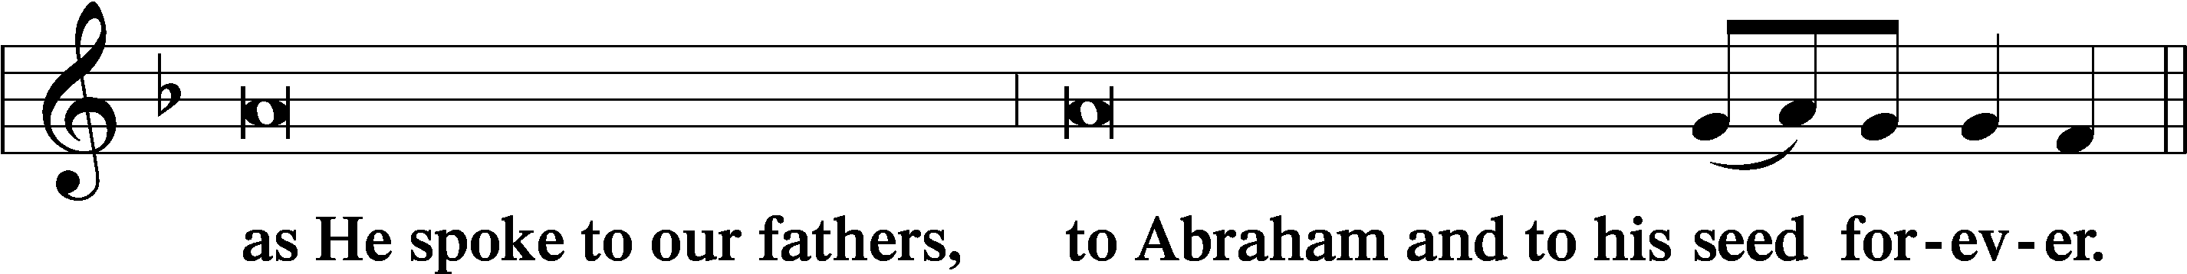
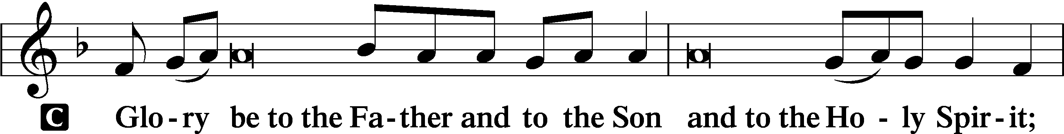
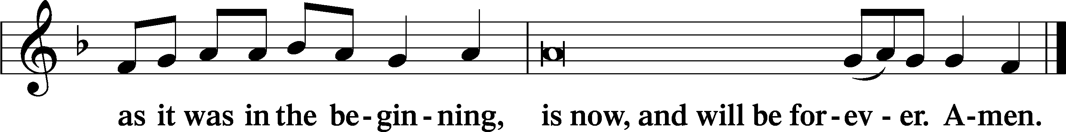

Prayer

KYRIE LSB 233
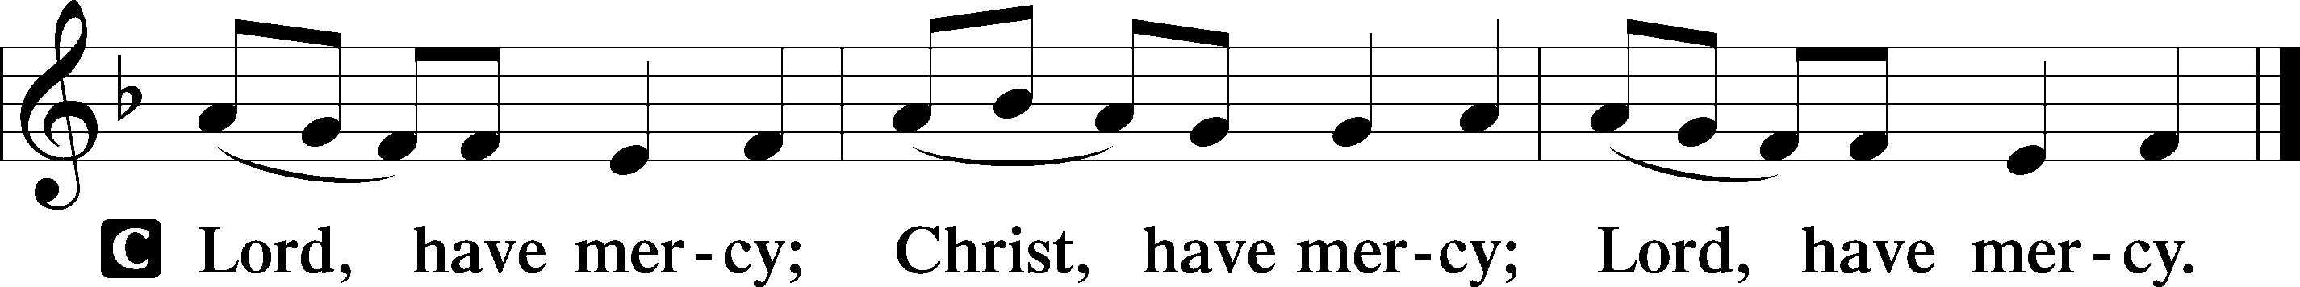

THE LORD’S PRAYER: LSB #957 “Our Father Who Art in Heaven” LSB 957
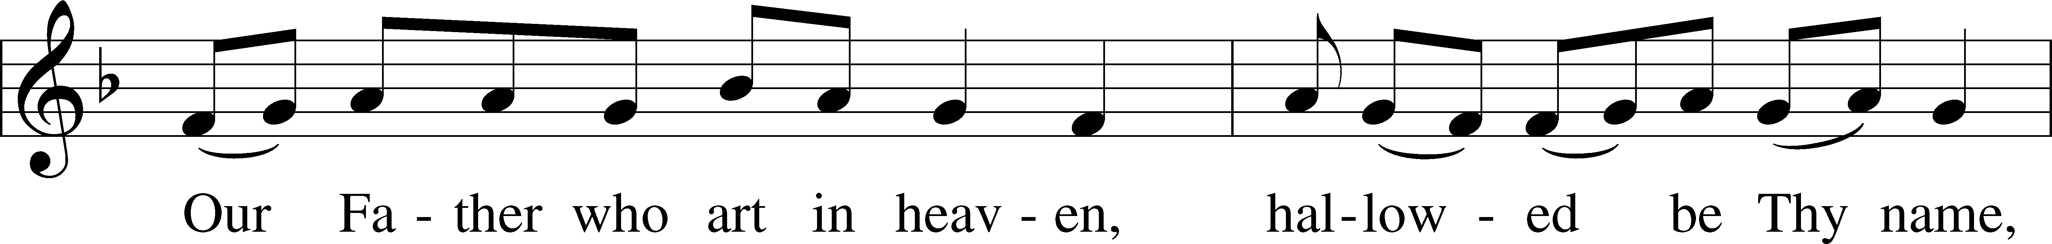
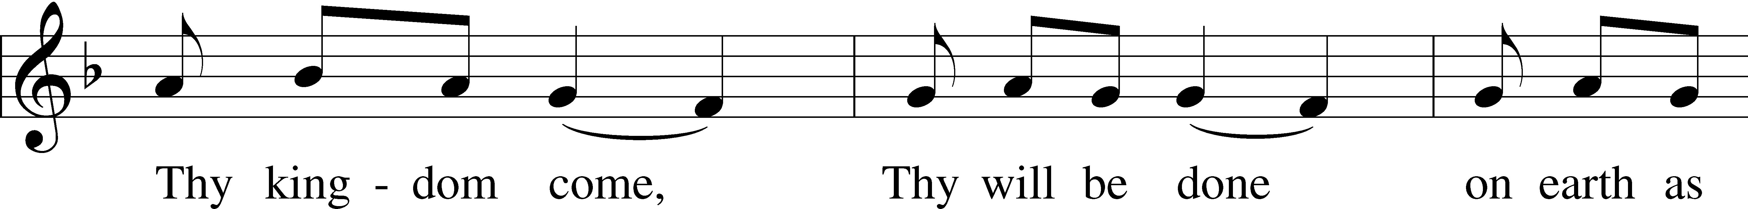
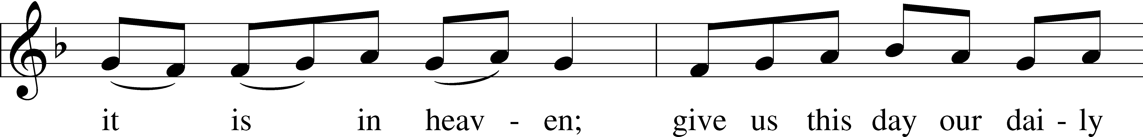
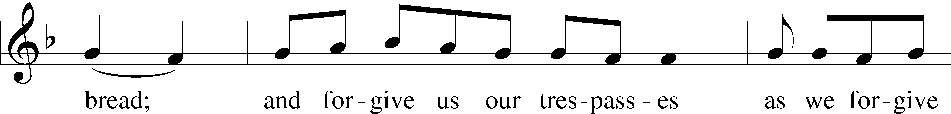
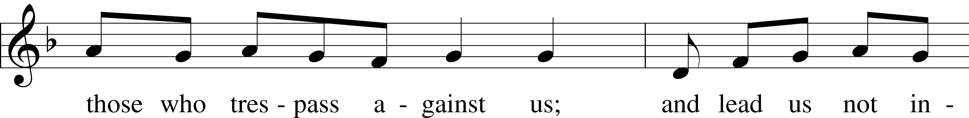
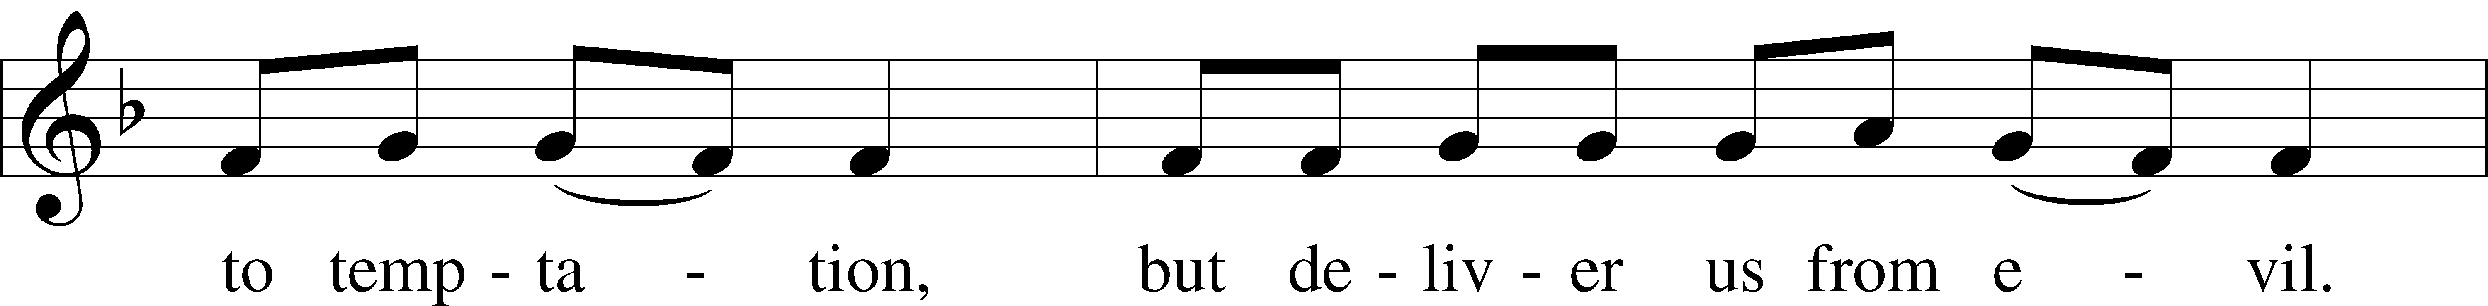
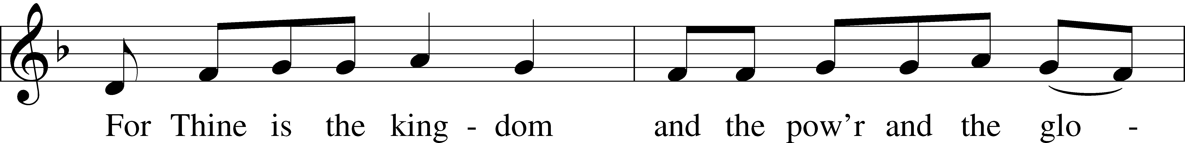
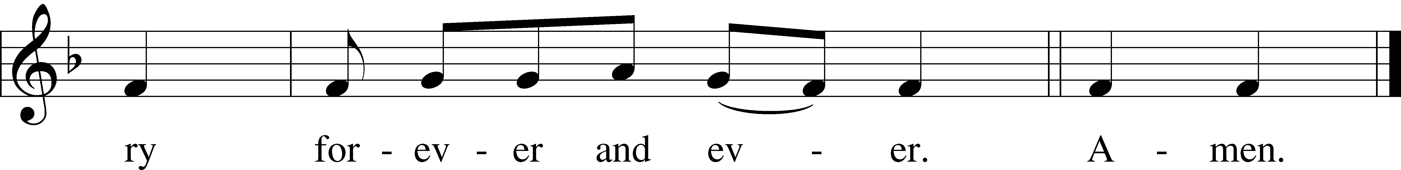
Text: Traditional
Tune: Plainsong, mode VII
Text and tune: Public domain

COLLECTS LSB 233
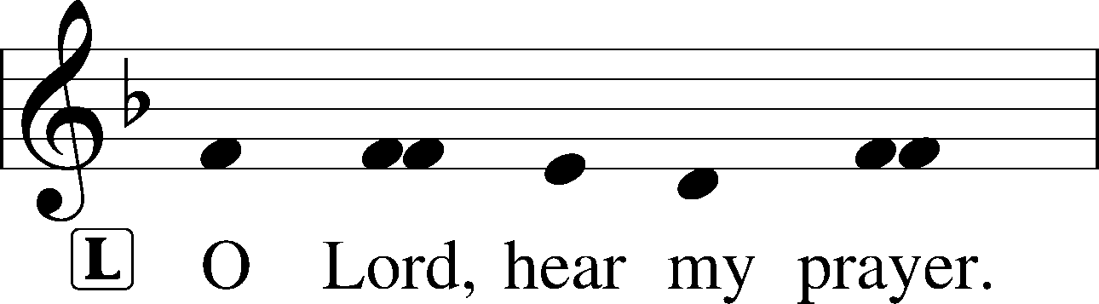
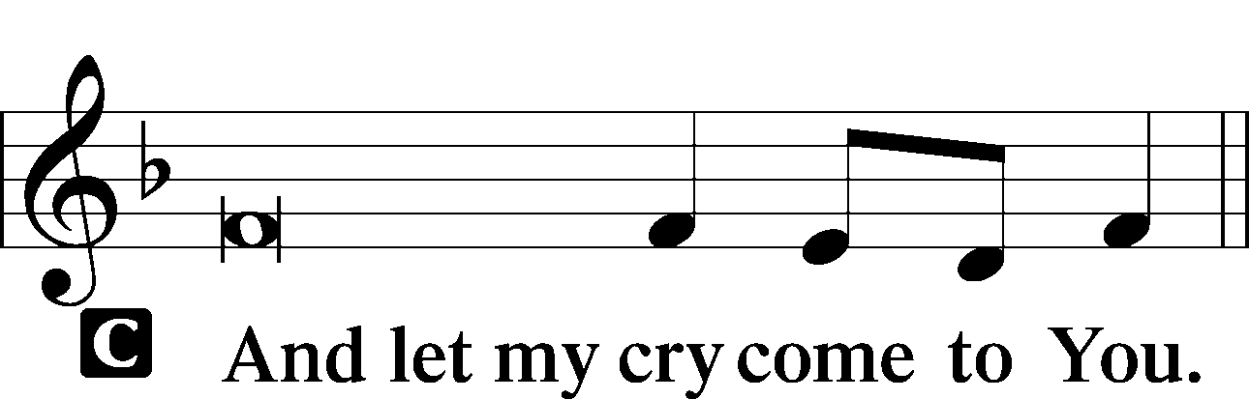

COLLECT OF THE DAY
P … through Jesus Christ, Your Son, our Lord, who lives and reigns with You and the Holy Spirit, one God, now and forever.
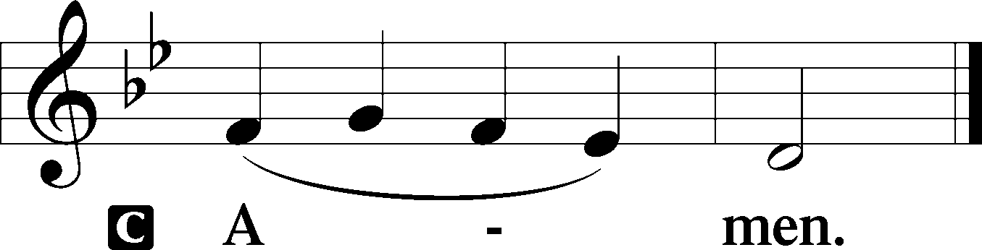

COLLECT FOR PEACE
P O God, from whom come all holy desires, all good counsels, and all just works, give to us, Your servants, that peace which the world cannot give, that our hearts may be set to obey Your commandments and also that we, being defended from the fear of our enemies, may live in peace and quietness; through Jesus Christ, Your Son, our Lord, who lives and reigns with You and the Holy Spirit, one God, now and forever.
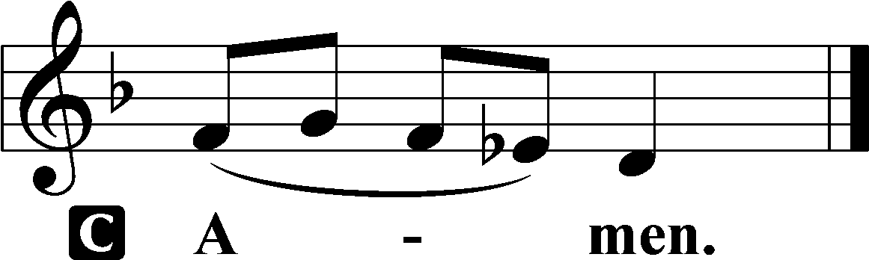

Stand

BENEDICAMUS LSB 234
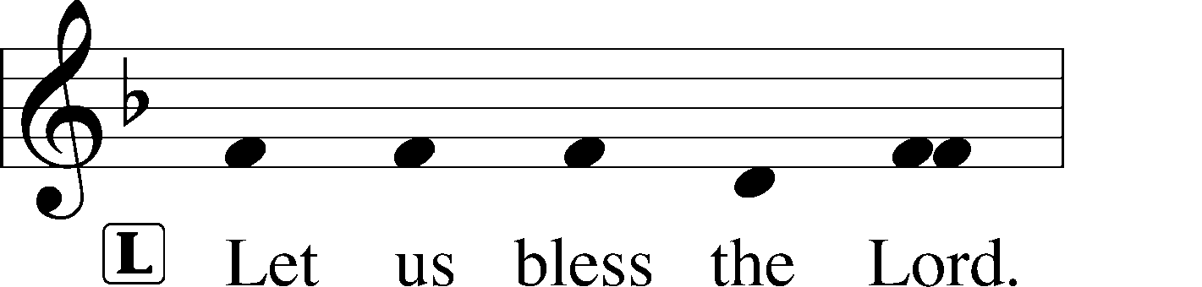
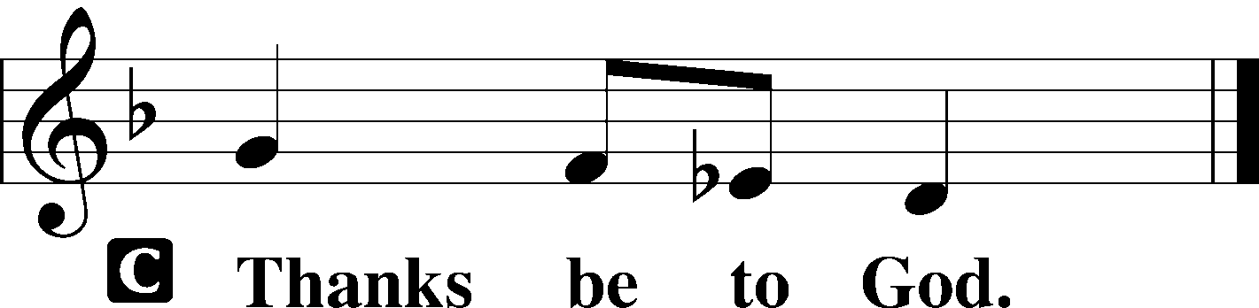

BENEDICTION LSB 234
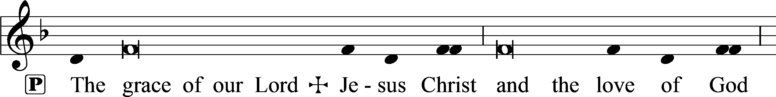
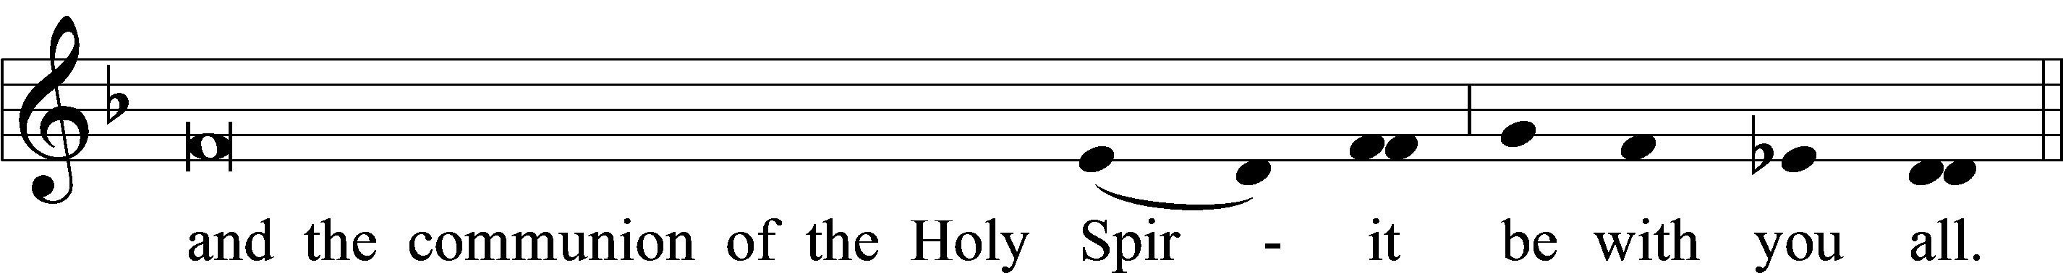

CLOSING HYMN:
February 21: LSB #556 “Dear Christians, One and All, Rejoice”
February 28: LSB #439: 9-15 “O Dearest Jesus, What Law Hast Thou Broken”
March 6: LSB #555 “Salvation unto Us Is Come”
March 13: LSB #746 “Through Jesus’ Blood and Merit”
March 20: LSB #724 “If God Himself Be for Me”

Acknowledgments
Unless otherwise indicated, Scripture quotations are from the ESV® Bible (The Holy Bible, English Standard Version®), copyright © 2001 by Crossway, a publishing ministry of Good News Publishers. Used by permission. All rights reserved.
Created by Lutheran Service Builder © 2023 Concordia Publishing House.

