Sts. Peter & Paul
Evangelical Lutheran Church
Lutheran Church-Missouri Synod
Founded-1917

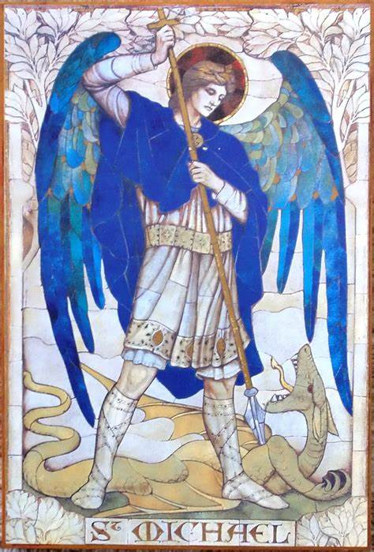

September 29, 2023

699 Stambaugh Ave.
Sharon, Pennsylvania 16146

“I was glad when they said to me,
Let us go to the house of the LORD!”
Psalm 122:1
Sts. Peter & Paul Evangelical Lutheran Church, LC-MS
THE FESTIVAL OF
SAINT MICHAEL AND ALL ANGELS
September 29, 2023
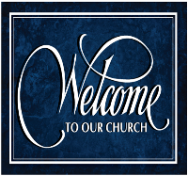
A special welcome to our guests this day! If you would like more information about The Lutheran Church - Missouri Synod, or this congregation, please speak with Pastor Deal or an Elder after the service.
Members & Guests: Don’t be embarrassed if your children make noise during the worship service, all children do. We encourage families to worship together but, if you feel the need, there are pews in the rear of the Church which are reserved for young families on both sides of the sanctuary. There is also a quiet room available to you, located next to the sanctuary (formerly the Pastor’s office), where you would be able to follow along with the service.

Today’s service includes the Sacrament of Holy Communion. If during this past year, you have not worshipped with us and been communed, we respectfully ask that you do not partake of this sacrament this day before first speaking with Pastor Deal.
If visiting from a sister congregation of the LC-MS and are in good standing, please inform Pastor Deal of your desire to commune prior to the service.
If wishing to receive a blessing during communion, please approach with your arms crossed.

CONTACT INFORMATION
Pastor Deal: pastordeal@saintspeterandpaul.net or 724-347-3620 (opt. 2)
Church Office: church@saintspeterandpaul.net or 724-347-3620 (opt. 3)
Secretary’s Office: The office will be open Mon. & Thurs (8:30 am-4:30 pm).

Silent prayer before worship: Heavenly Father, cause my faith to grow by the power of Your Word so that I can come to You without fear, and trust in Your Son Jesus Christ for my salvation. In His name. Amen.
Confession and Absolution

Opening Hymn: LSB #421 “Jesus, Grant That Balm and Healing”

Stand

The sign of the cross may be made by all in remembrance of their Baptism.

Invocation
P In the name of the Father and of the T Son and of the Holy Spirit.
C Amen.

Exhortation Hebrews 10:22; Psalm 124:8; Psalm 32:5
P Beloved in the Lord! Let us draw near with a true heart and confess our sins unto God our Father, beseeching Him in the name of our Lord Jesus Christ to grant us forgiveness.

P Our help is in the name of the Lord,
C who made heaven and earth.
P I said, I will confess my transgressions unto the Lord,
C and You forgave the iniquity of my sin.

Silence for reflection on God’s Word and for self-examination.

Confession of Sins
P O almighty God, merciful Father,
C I, a poor, miserable sinner, confess unto You all my sins and iniquities with which I have ever offended You and justly deserved Your temporal and eternal punishment. But I am heartily sorry for them and sincerely repent of them, and I pray You of Your boundless mercy and for the sake of the holy, innocent, bitter sufferings and death of Your beloved Son, Jesus Christ, to be gracious and merciful to me, a poor, sinful being.

Absolution [John 20:19–23]
P Upon this your confession, I, by virtue of my office, as a called and ordained servant of the Word, announce the grace of God unto all of you, and in the stead and by the command of my Lord Jesus Christ I forgive you all your sins in the name of the Father and of the T Son and of the Holy Spirit.
C Amen.

Service of the Word

Introit Psalm 103:20–22; antiphon: v. 1
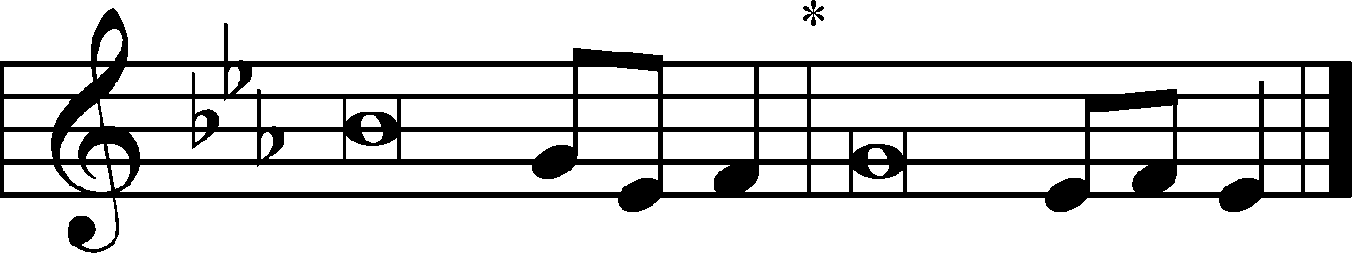
Bless the Lord, | O my soul,*
and all that is within me, bless his | holy name!
Bless the Lord, O you his | angels,*
you mighty ones who do his word, obeying the voice | of his word!
Bless the Lord, | all his hosts,*
his ministers, who | do his will!
Bless the Lord, all his works, in all places of his do- | minion.*
Bless the Lord, | O my soul!
Bless the Lord, | O my soul,*
and all that is within me, bless his | holy name!

Gloria Patri
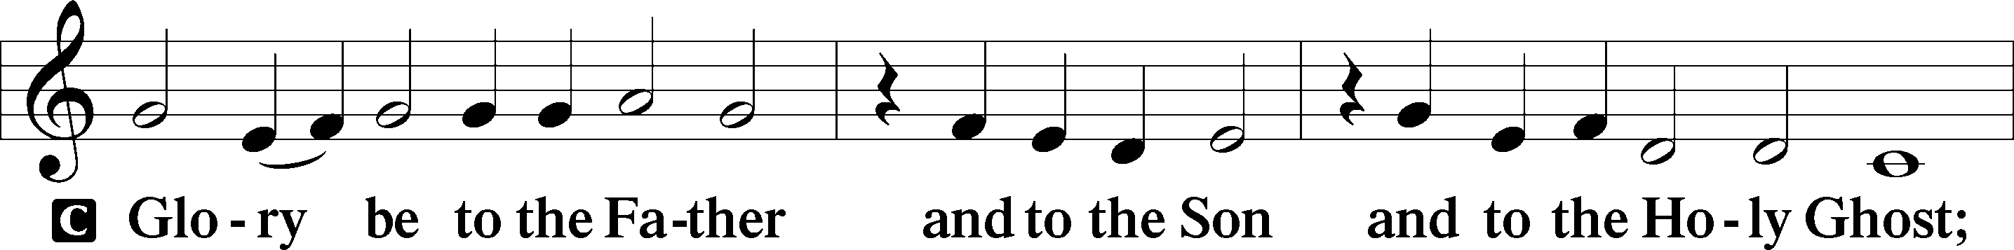
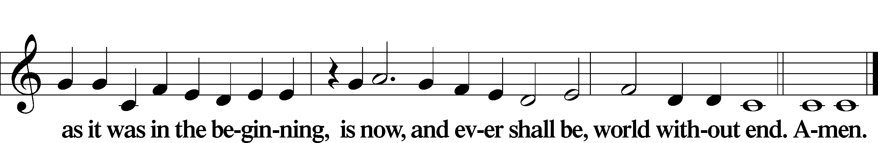

Kyrie Mark 10:47
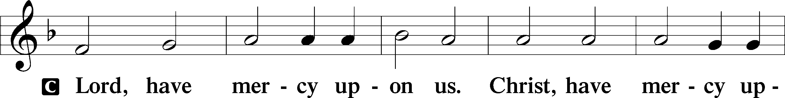
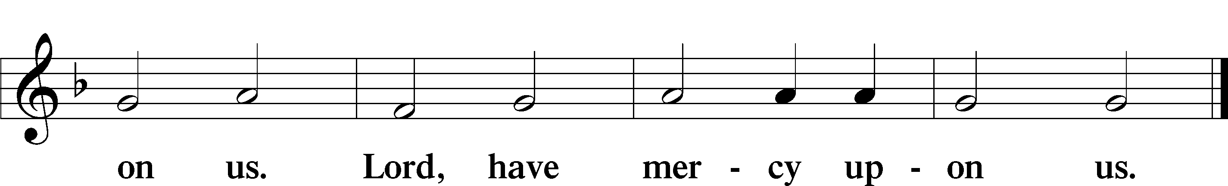

Gloria in Excelsis Luke 2:14; John 1:29
P Glory be to God on high:
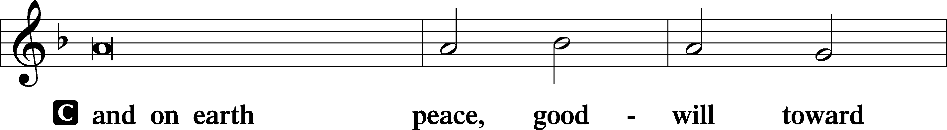
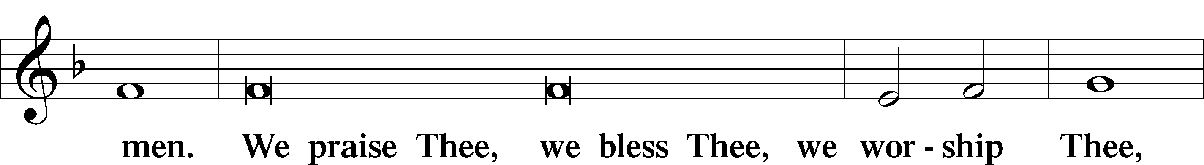
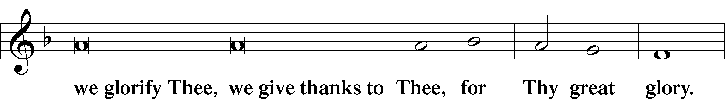
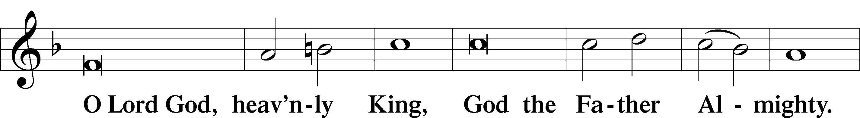
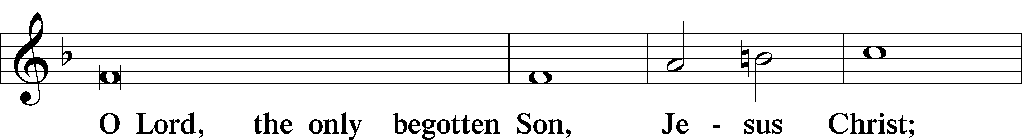
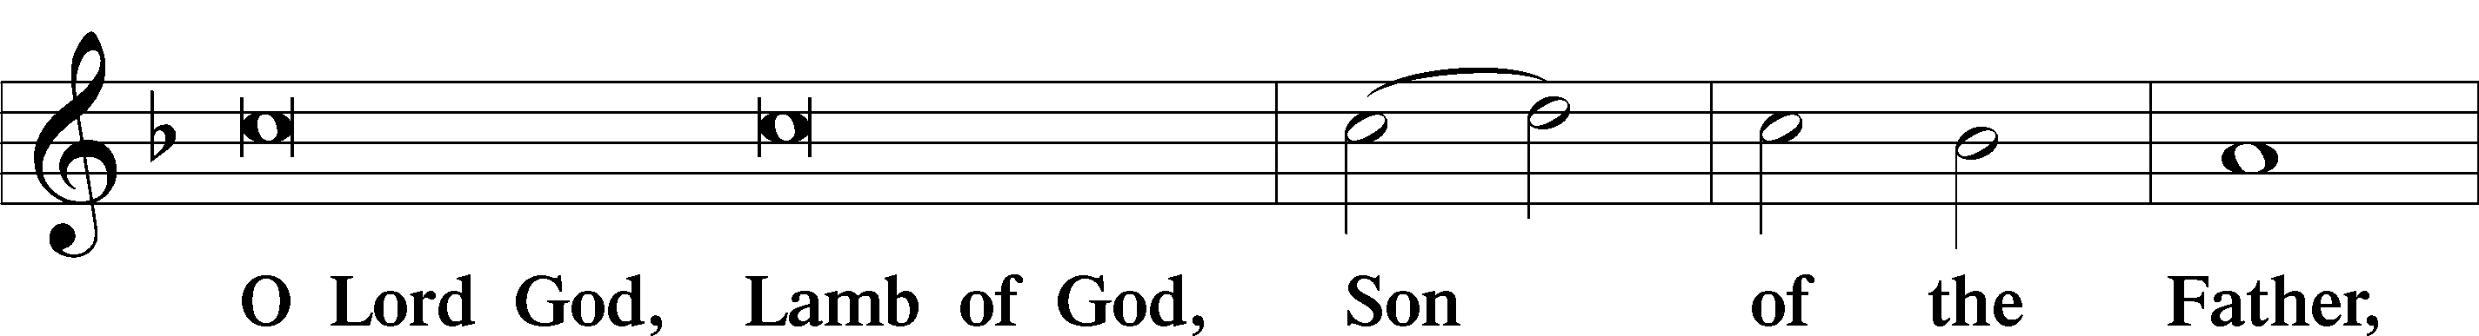
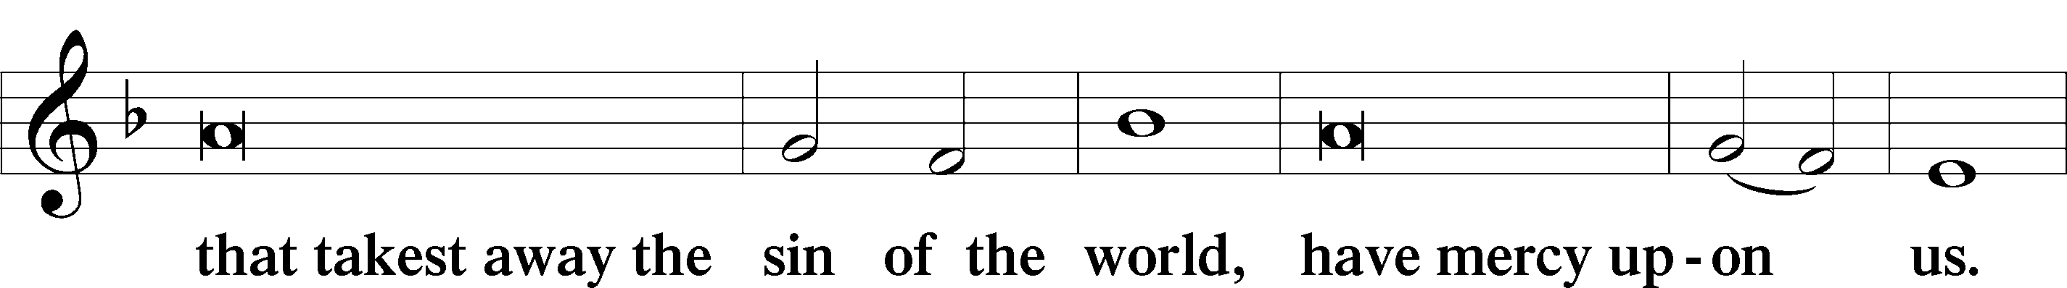
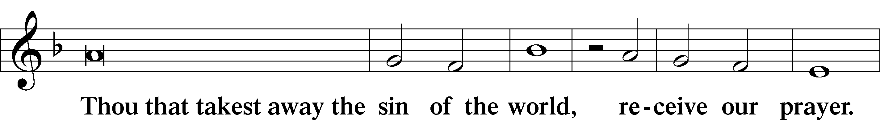
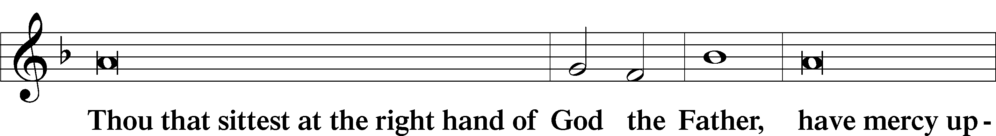
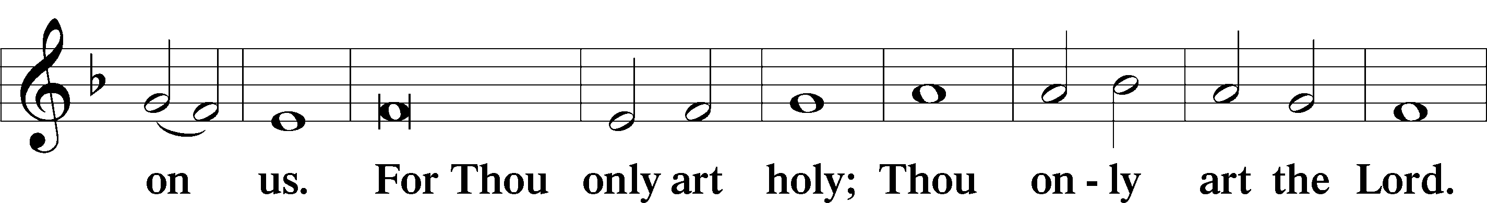
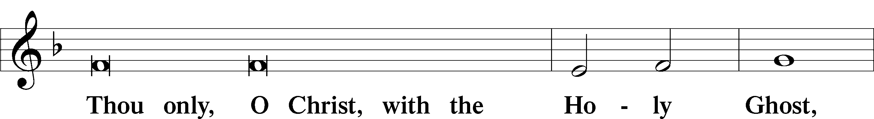
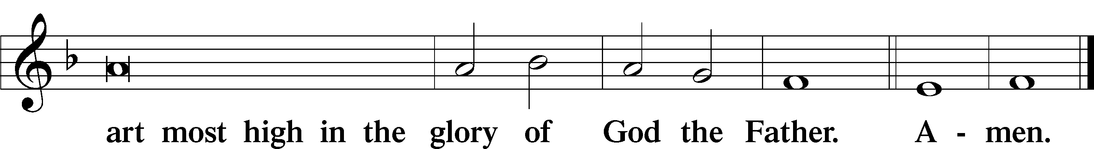

Salutation and Collect of the Day: St. Michael and All Angels
P The Lord be with you.
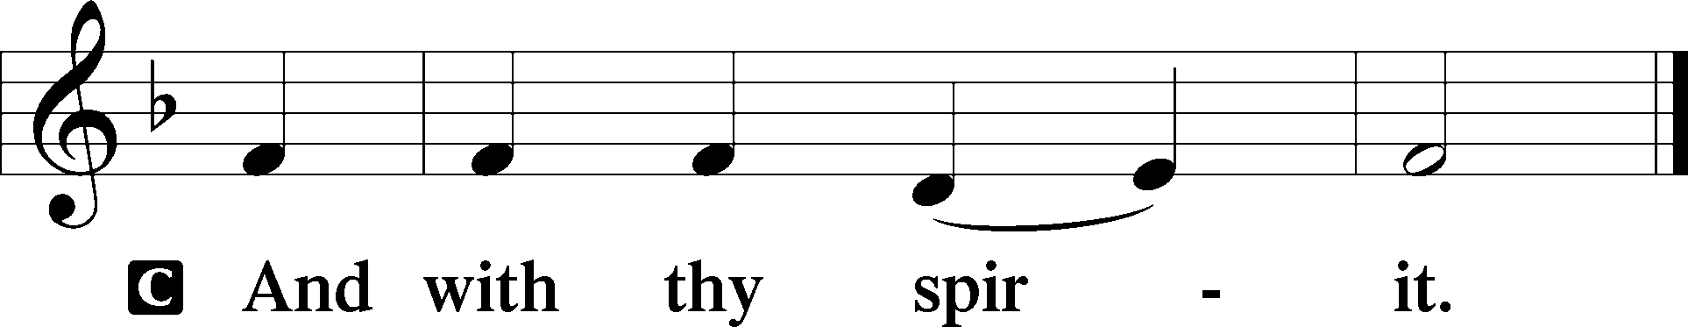

P Let us pray.
Everlasting God, You have ordained and constituted the service of angels and men in a wonderful order. Mercifully grant that, as Your holy angels always serve and worship You in heaven, so by Your appointment they may also help and defend us here on earth; through Your Son, Jesus Christ, our Lord, who lives and reigns with You and the Holy Spirit, one God, now and forever.
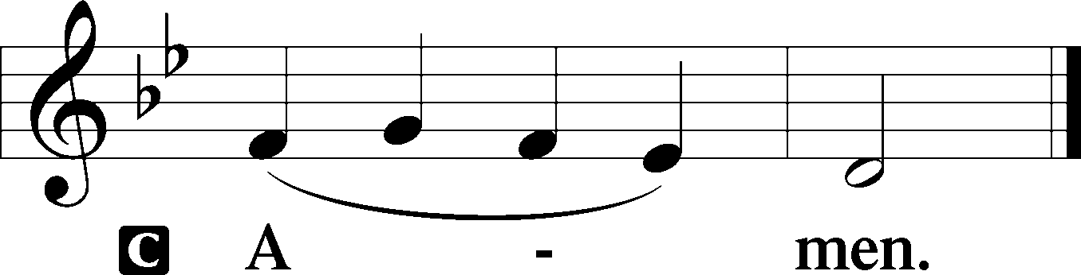
Sit

Prophecy: Daniel 12:1–3 (NKJV)
In those days: “Michael shall stand up, the great prince who stands watch over the sons of your people; and there shall be a time of trouble, such as never was since there was a nation, even to that time. And at that time your people shall be delivered, every one who is found written in the book. And many of those who sleep in the dust of the earth shall awake, some to everlasting life, some to shame and everlasting contempt. Those who are wise shall shine like the brightness of the firmament, and those who turn many to righteousness like the stars forever and ever.”

P This is the Word of the Lord.
C Thanks be to God.

Gradual Psalm 91:11; 103:1
He will command his angels con- | cerning you*
to guard you in | all your ways.
Bless the Lord, | O my soul,*
and all that is within me, bless his | holy name!

Epistle: Revelation 12:7–12a (NKJV)
In those days: War broke out in heaven: Michael and his angels fought with the dragon; and the dragon and his angels fought, but they did not prevail, nor was a place found for them in heaven any longer. So the great dragon was cast out, that serpent of old, called the Devil and Satan, who deceives the whole world; he was cast to the earth, and his angels were cast out with him. Then I heard a loud voice saying in heaven, “Now salvation, and strength, and the kingdom of our God, and the power of His Christ have come, for the accuser of our brethren, who accused them before our God day and night, has been cast down. And they overcame him by the blood of the Lamb and by the word of their testimony, and they did not love their lives to the death. Therefore rejoice, O heavens, and you who dwell in them!”

P This is the Word of the Lord.
C Thanks be to God.

Stand
Verse Revelation 12:11
Alleluia. They have conquered him by the blood of the Lamb and by the word of their testimony, for they loved not their lives even unto death. Alleluia.

Alleluia
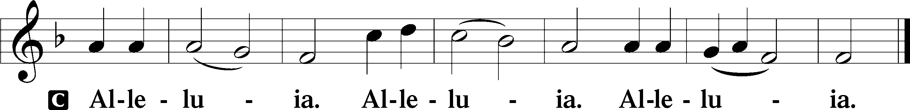

Holy Gospel: Matthew 18:1-11 (NKJV)
P The Holy Gospel according to St. Matthew, the eighteenth chapter.
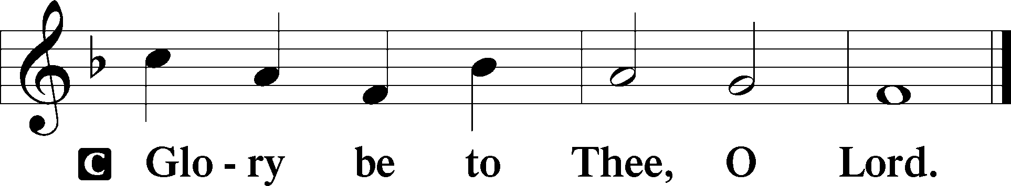

At that time the disciples came to Jesus, saying, “Who then is greatest in the kingdom of heaven?” Then Jesus called a little child to Him, set him in the midst of them, and said, “Assuredly, I say to you, unless you are converted and become as little children, you will by no means enter the kingdom of heaven. Therefore whoever humbles himself as this little child is the greatest in the kingdom of heaven. Whoever receives one little child like this in My name receives Me. But whoever causes one of these little ones who believe in Me to sin, it would be better for him if a millstone were hung around his neck, and he were drowned in the depth of the sea. Woe to the world because of offenses! For offenses must come, but woe to that man by whom the offense comes! If your hand or foot causes you to sin, cut it off and cast it from you. It is better for you to enter into life lame or maimed, rather than having two hands or two feet, to be cast into the everlasting fire. And if your eye causes you to sin, pluck it out and cast it from you. It is better for you to enter into life with one eye, rather than having two eyes, to be cast into hell fire. Take heed that you do not despise one of these little ones, for I say to you that in heaven their angels always see the face of My Father who is in heaven. For the Son of Man has come to save that which was lost.”

P This is the Gospel of the Lord.
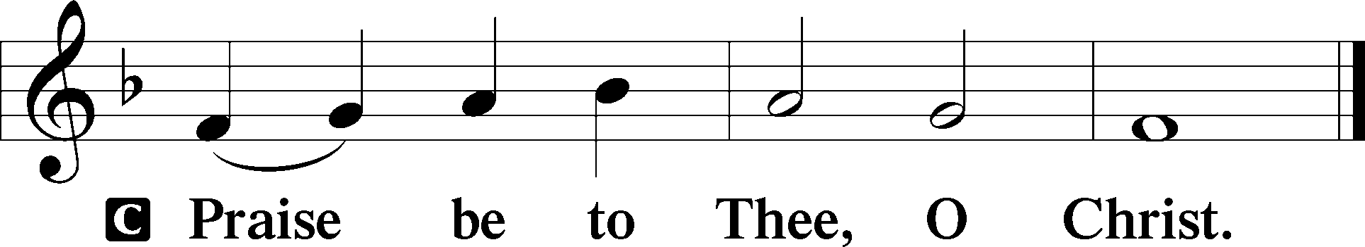

Nicene Creed
C I believe in one God,
the Father Almighty,
maker of heaven and earth
and of all things visible and invisible.

And in one Lord Jesus Christ,
the only-begotten Son of God,
begotten of His Father before all worlds,
God of God, Light of Light,
very God of very God,
begotten, not made,
being of one substance with the Father,
by whom all things were made;
who for us men and for our salvation came down from heaven
and was incarnate by the Holy Spirit of the virgin Mary
and was made man;
and was crucified also for us under Pontius Pilate.
He suffered and was buried.
And the third day He rose again according to the Scriptures
and ascended into heaven
and sits at the right hand of the Father.
And He will come again with glory to judge both the living and the dead,
whose kingdom will have no end.
And I believe in the Holy Spirit,
the Lord and giver of life,
who proceeds from the Father and the Son,
who with the Father and the Son together is worshiped and glorified,
who spoke by the prophets.
And I believe in one holy Christian and apostolic Church,
I acknowledge one Baptism for the remission of sins,
and I look for the resurrection of the dead
and the life T of the world to come. Amen.
Sit

Hymn of the Day: LSB #522 “Lord God, to Thee We Give All Praise”

Sermon

Stand

Offertory Psalm 51:10–12
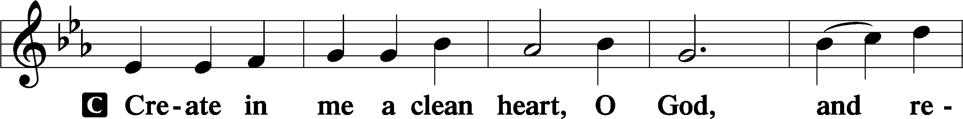
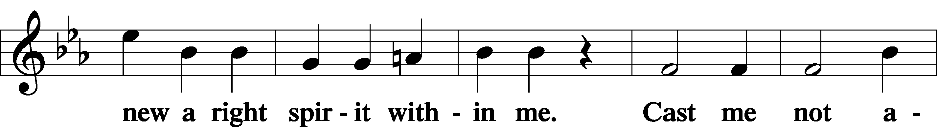
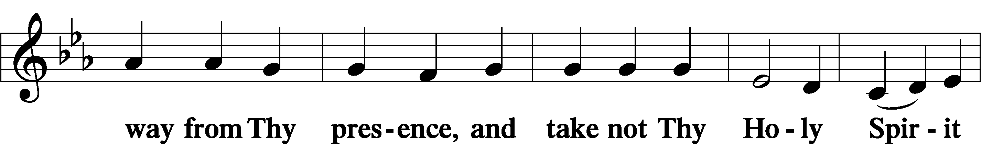
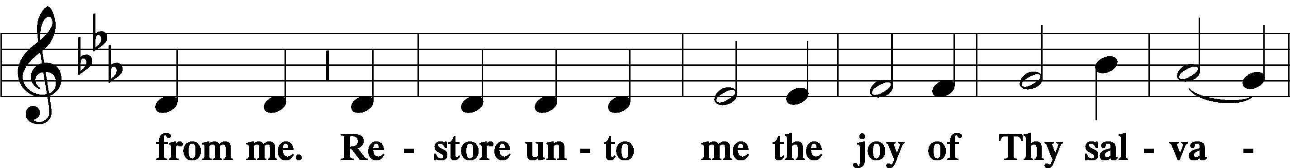
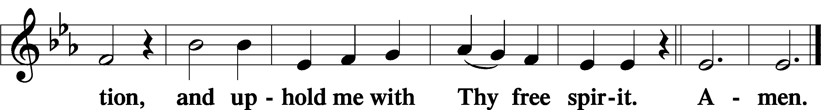

Prayer of the Church

Sit

Preparatory Hymn: LSB #725 “Children of the Heavenly Father”

Stand
Service of the Sacrament

Preface 2 Timothy 4:22; Colossians 3:1 Psalm 136
P The Lord be with you.
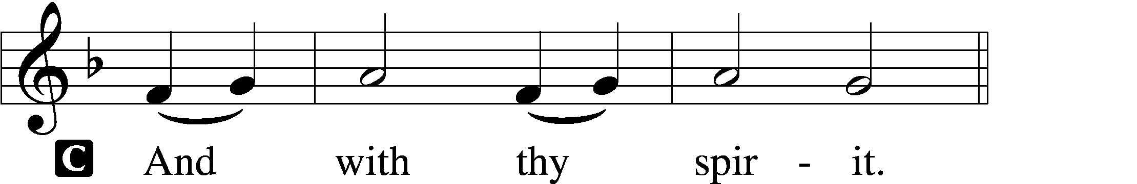

P Lift up your hearts.
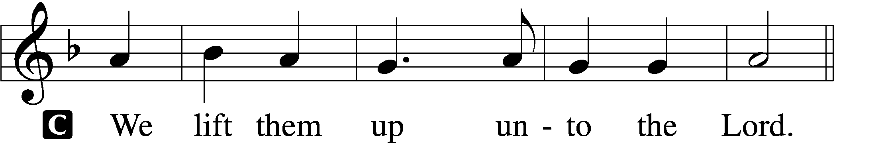

P Let us give thanks unto the Lord, our God.
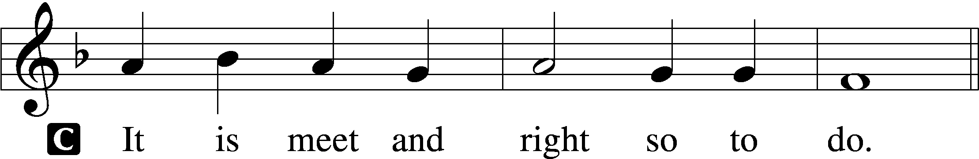

Proper Preface (Abbreviated) LSB 194
P It is truly meet, right, and salutary . . . evermore praising You and saying:

Sanctus Isaiah 6:3; Matthew 21:9
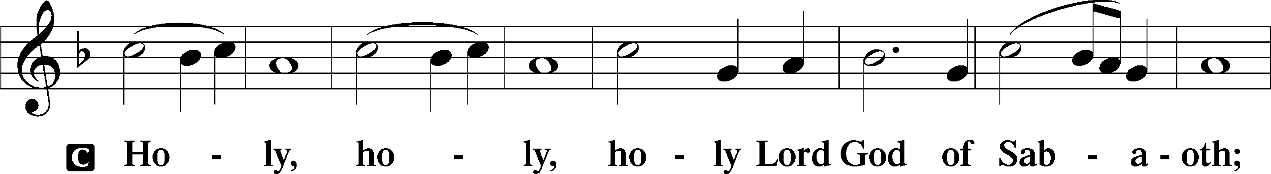
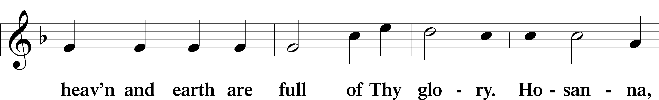
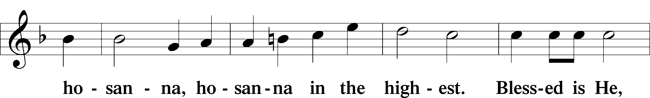
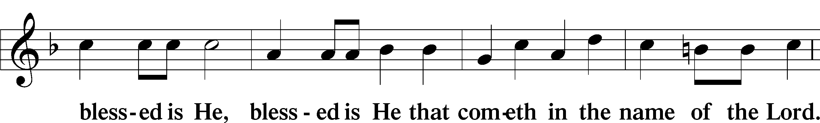
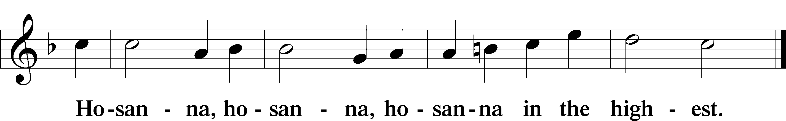

Lord’s Prayer Matthew 6:9–13
C Our Father who art in heaven,
hallowed be Thy name,
Thy kingdom come,
Thy will be done on earth as it is in heaven;
give us this day our daily bread;
and forgive us our trespasses as we forgive those who trespass against us;
and lead us not into temptation,
but deliver us from evil.
For Thine is the kingdom and the power and the glory forever and ever. Amen.

The Words of Our Lord Matthew 26:26–28; Mark 14:22–24; Luke 22:19–20; 1 Corinthians 11:23–25
P Our Lord Jesus Christ, on the night when He was betrayed, took bread, and when He had given thanks, He broke it and gave it to the disciples and said: “Take, eat; this is My T body, which is given for you. This do in remembrance of Me.”

In the same way also He took the cup after supper, and when He had given thanks, He gave it to them, saying: “Drink of it, all of you; this cup is the new testament in My T blood, which is shed for you for the forgiveness of sins. This do, as often as you drink it, in remembrance of Me.”
Pax Domini John 20:19
P The peace of the Lord be with you always.
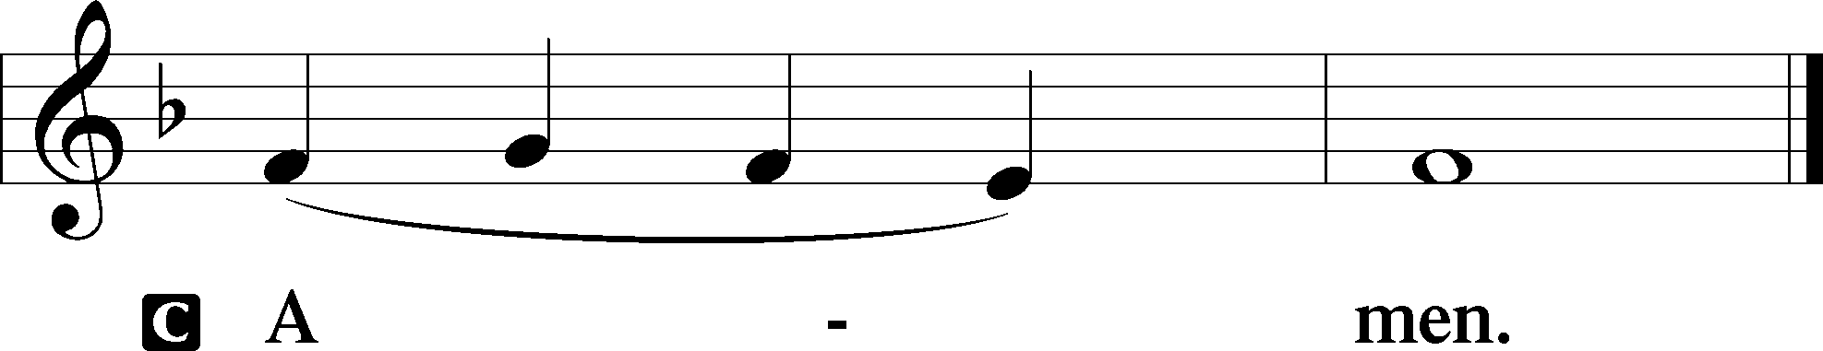

Agnus Dei John 1:29
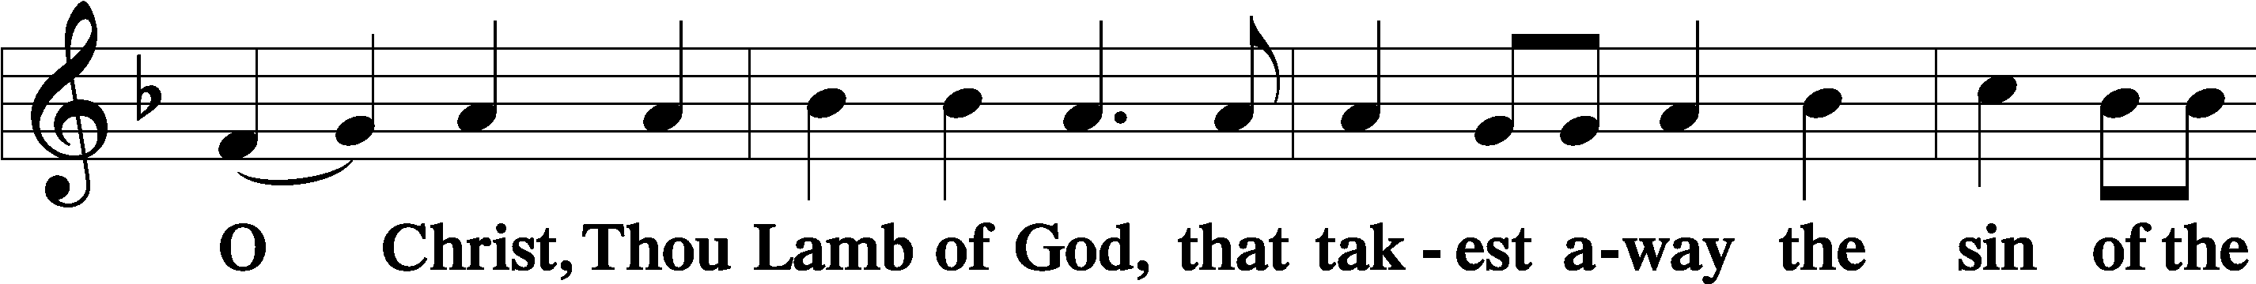
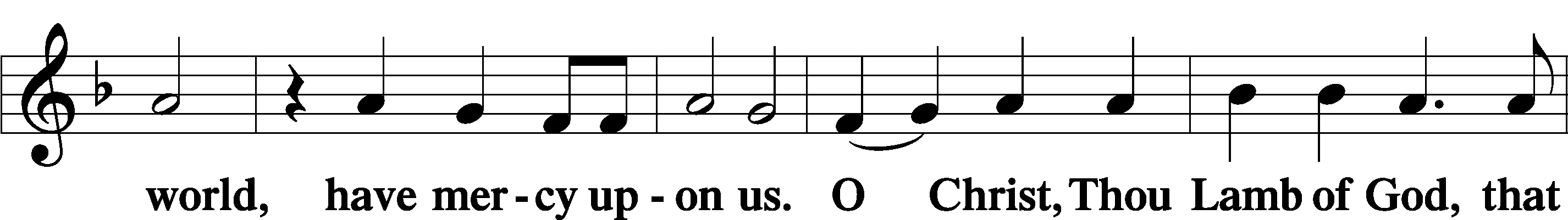
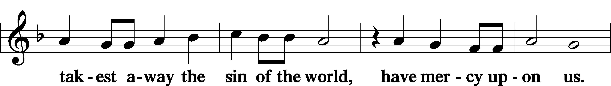
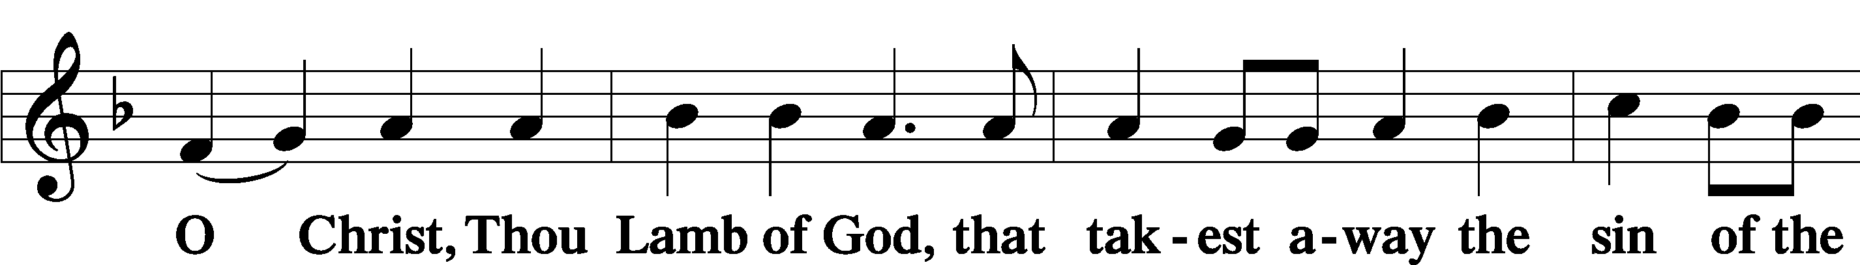
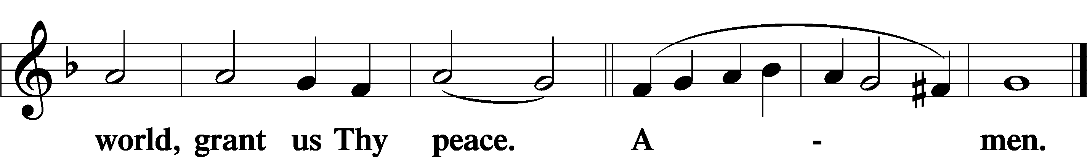
Sit

Distribution
The pastor and those who assist him receive the body and blood of Christ first and then distribute them to those who come to receive, saying:
Take, eat; this is the true body of our Lord and Savior Jesus Christ, given into death for your sins.
Amen.

Take, drink; this is the true blood of our Lord and Savior Jesus Christ, shed for the forgiveness of your sins.
Amen.

In dismissing the communicants, the following is said:
The Dismissal
P The body and blood of our Lord Jesus Christ strengthen and preserve you in body and soul to life everlasting. Depart T in peace.
C Amen.

Distribution Hymn: LSB #508 “The Day Is Surely Drawing Near”

Stand

Nunc Dimittis Luke 2:29–32
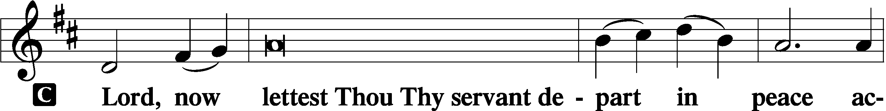
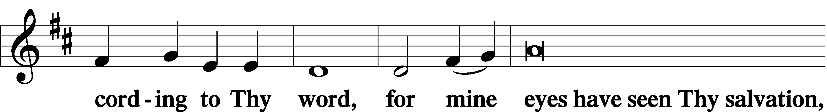
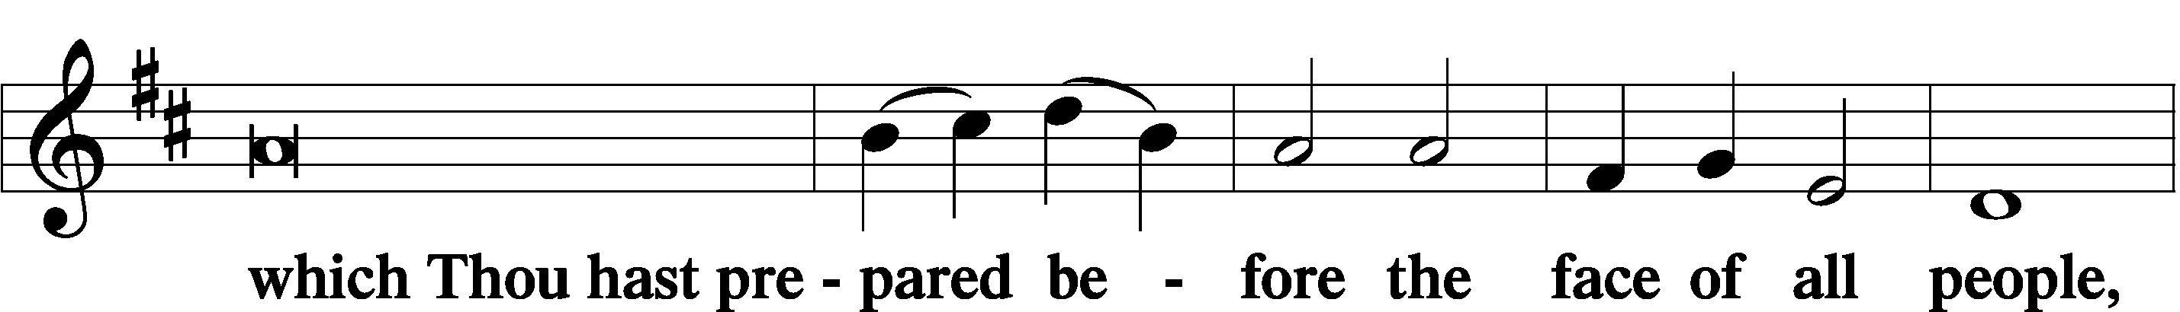
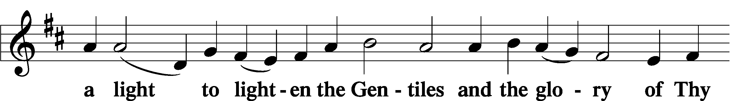
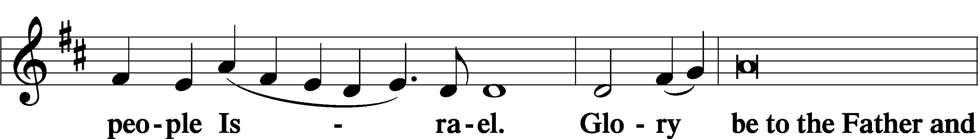
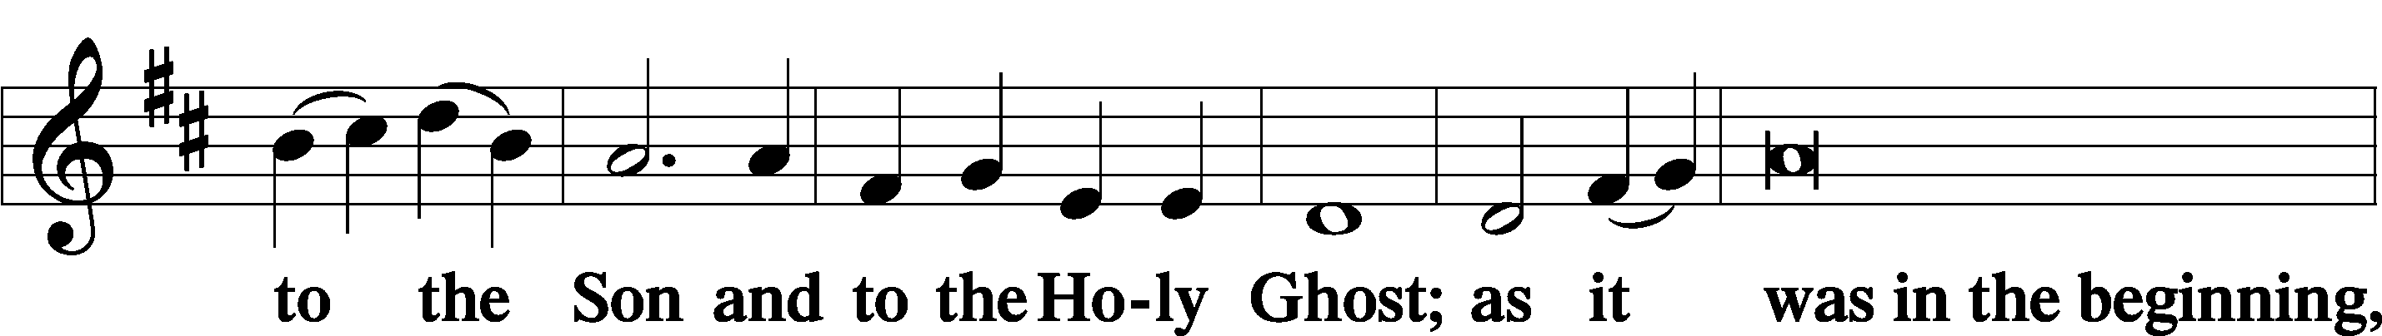
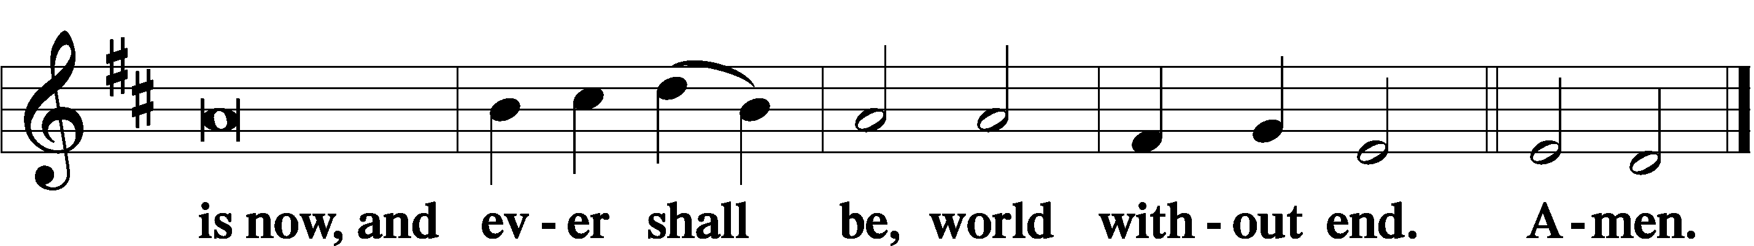

Thanksgiving Psalm 107:1
P O give thanks unto the Lord, for He is good,
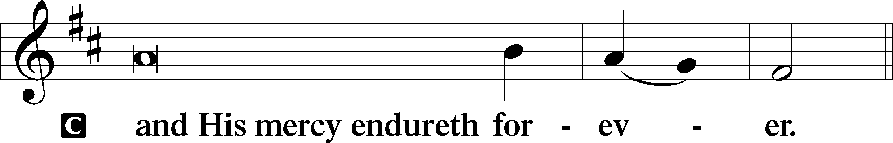

Post-Communion Collect
P Let us pray.
We give thanks to You, almighty God, that You have refreshed us through this salutary gift, and we implore You that of Your mercy You would strengthen us through the same in faith toward You and in fervent love toward one another; through Jesus Christ, Your Son, our Lord, who lives and reigns with You and the Holy Spirit, one God, now and forever.
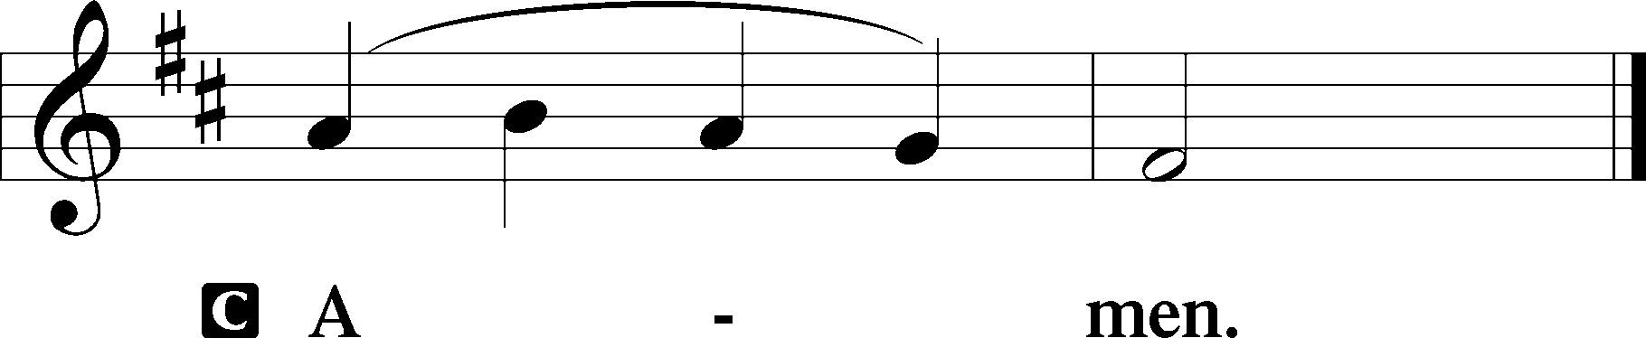

Salutation 2 Timothy 4:22
P The Lord be with you.
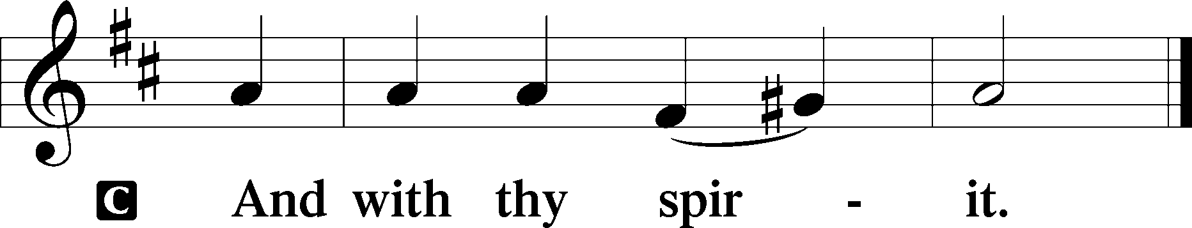

Benedicamus Psalm 103:1
P Bless we the Lord.
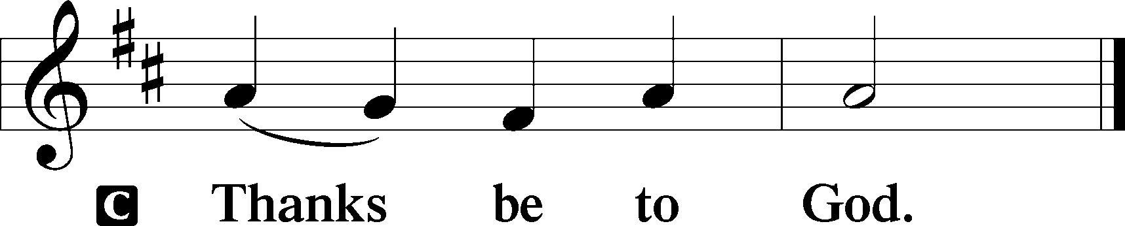

Benediction Numbers 6:24–26
P The Lord bless you and keep you.
The Lord make His face shine upon you and be gracious unto you.
The Lord lift up His countenance upon you and T give you peace.
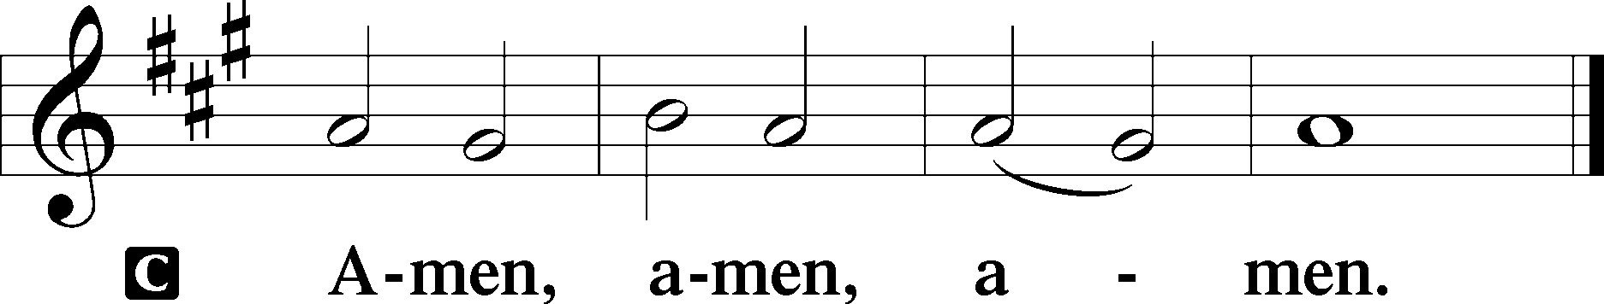

Closing Hymn: LSB #521 “Christ, the Lord of Hosts, Unshaken”

Silent prayer after worship: Dear Jesus, You demonstrated Your great love for all humankind by dying on the cross. Lead me to daily live in Your love by trusting in You and by sharing Your love with others. Amen.
fffffffffffffffffffffffffffffffffff
Acknowledgments
Unless otherwise indicated, Scripture quotations are from the ESV® Bible (The Holy Bible, English Standard Version®), copyright © 2001 by Crossway, a publishing ministry of Good News Publishers. Used by permission. All rights reserved.
Created by Lutheran Service Builder © 2023 Concordia Publishing House.

