Sts. Peter & Paul
Evangelical Lutheran Church
Lutheran Church-Missouri Synod
Founded-1917

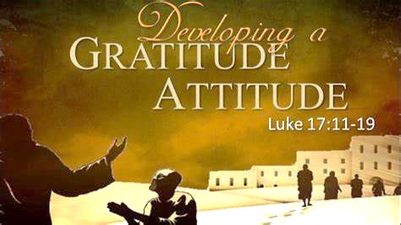

September 10, 2023

699 Stambaugh Ave.
Sharon, Pennsylvania 16146

“I was glad when they said to me,
Let us go to the house of the LORD!”
Psalm 122:1
Sts. Peter & Paul Evangelical Lutheran Church, LC-MS
THE FOURTEENTH SUNDAY AFTER TRINITY
September 10, 2023
A special welcome to our guests this day! If you would like more information about The Lutheran Church - Missouri Synod, or this congregation, please speak with Pastor Deal or an Elder after the service.
Members & Guests: Don’t be embarrassed if your children make noise during the worship service, all children do. We encourage families to worship together but, if you feel the need, there are pews in the rear of the Church which are reserved for young families on both sides of the sanctuary. There is also a quiet room available to you, located next to the sanctuary (formerly the Pastor’s office), where you would be able to follow along with the service.

Today’s service includes the Sacrament of Holy Communion. If during this past year, you have not worshipped with us and been communed, we respectfully ask that you do not partake of this sacrament this day before first speaking with Pastor Deal.
If visiting from a sister congregation of the LC-MS and are in good standing, please inform Pastor Deal of your desire to commune prior to the service.
If wishing to receive a blessing during communion, please approach with your arms crossed.

CONTACT INFORMATION
Pastor Deal: pastordeal@saintspeterandpaul.net or 724-347-3620 (opt. 2)
Church Office: church@saintspeterandpaul.net or 724-347-3620 (opt. 3)
Secretary’s Office: The office will be open Monday & Thursday, 8:30 am-4:30 pm.

Silent prayer before worship Lord Jesus, give me courage to resist temptations even when they come through people whom I love. Help me, O Lord, to keep You in front of me as I follow You faithfully, and Satan behind me as I flee from him. Amen.
Confession and Absolution

Opening Hymn: LSB #873 “Christ, Whose Glory Fills the Skies”

Stand

The sign of the cross may be made by all in remembrance of their Baptism.

Invocation
P In the name of the Father and of the T Son and of the Holy Spirit.
C Amen.

Exhortation Hebrews 10:22; Psalm 124:8; Psalm 32:5
P Beloved in the Lord! Let us draw near with a true heart and confess our sins unto God our Father, beseeching Him in the name of our Lord Jesus Christ to grant us forgiveness.

P Our help is in the name of the Lord,
C who made heaven and earth.
P I said, I will confess my transgressions unto the Lord,
C and You forgave the iniquity of my sin.

Silence for reflection on God’s Word and for self-examination.

Confession of Sins
P O almighty God, merciful Father,
C I, a poor, miserable sinner, confess unto You all my sins and iniquities with which I have ever offended You and justly deserved Your temporal and eternal punishment. But I am heartily sorry for them and sincerely repent of them, and I pray You of Your boundless mercy and for the sake of the holy, innocent, bitter sufferings and death of Your beloved Son, Jesus Christ, to be gracious and merciful to me, a poor, sinful being.

Absolution [John 20:19–23]
P Upon this your confession, I, by virtue of my office, as a called and ordained servant of the Word, announce the grace of God unto all of you, and in the stead and by the command of my Lord Jesus Christ I forgive you all your sins in the name of the Father and of the T Son and of the Holy Spirit.
C Amen.

Service of the Word

Introit Psalm 84:1–2a, 4, 10b, 11b; antiphon: vv. 9–10a
Behold our shield, | O God;*
look on the face of your a- | nointed!
For a day | in your courts*
is better than a thousand | elsewhere.
How lovely is your dwelling place, O | Lord of hosts!*
My soul longs, yes, faints for the courts | of the Lord.
Blessèd are those who dwell | in your house,*
ever sing- | ing your praise!
I would rather be a doorkeeper in the house | of my God*
than dwell in the tents of | wickedness.
The Lord bestows favor and | honor.*
No good thing does he withhold from those who walk up- | rightly.
Behold our shield, | O God;*
look on the face of your a- | nointed!
For a day | in your courts*
is better than a thousand | elsewhere.

Gloria Patri
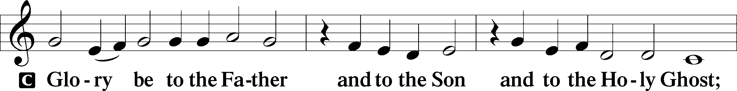
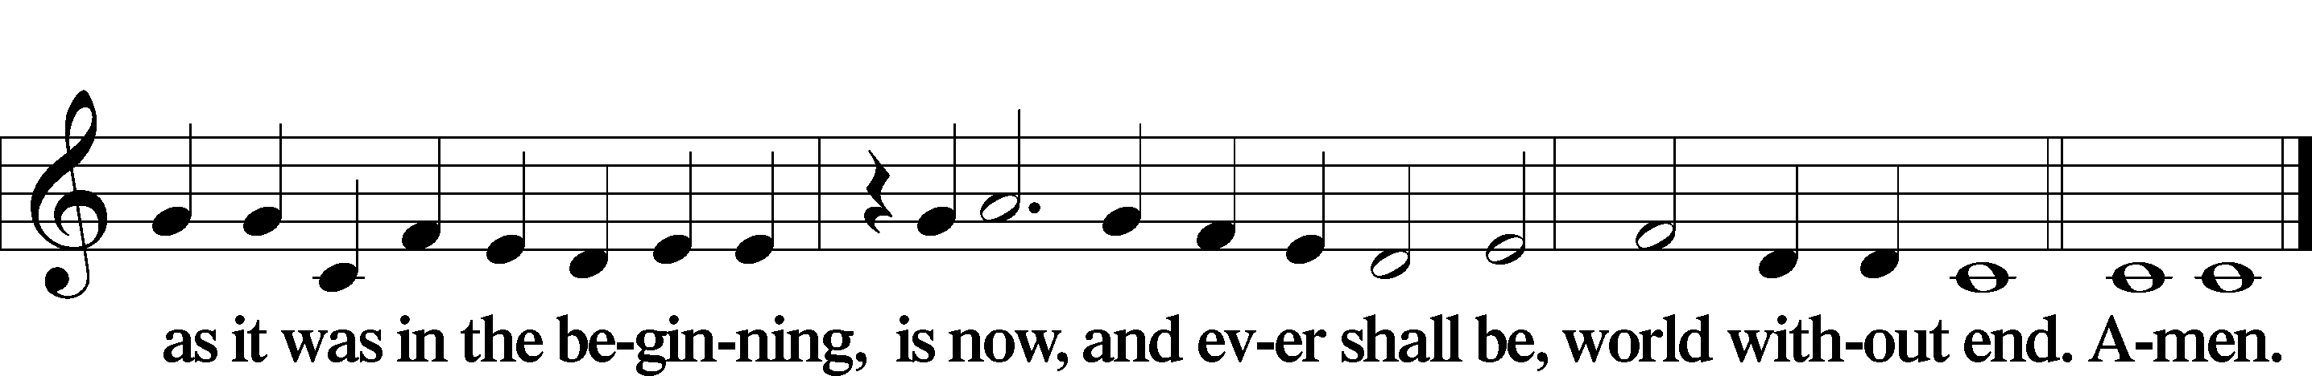

Kyrie Mark 10:47
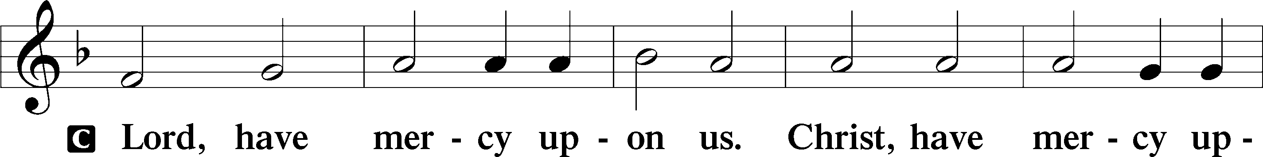
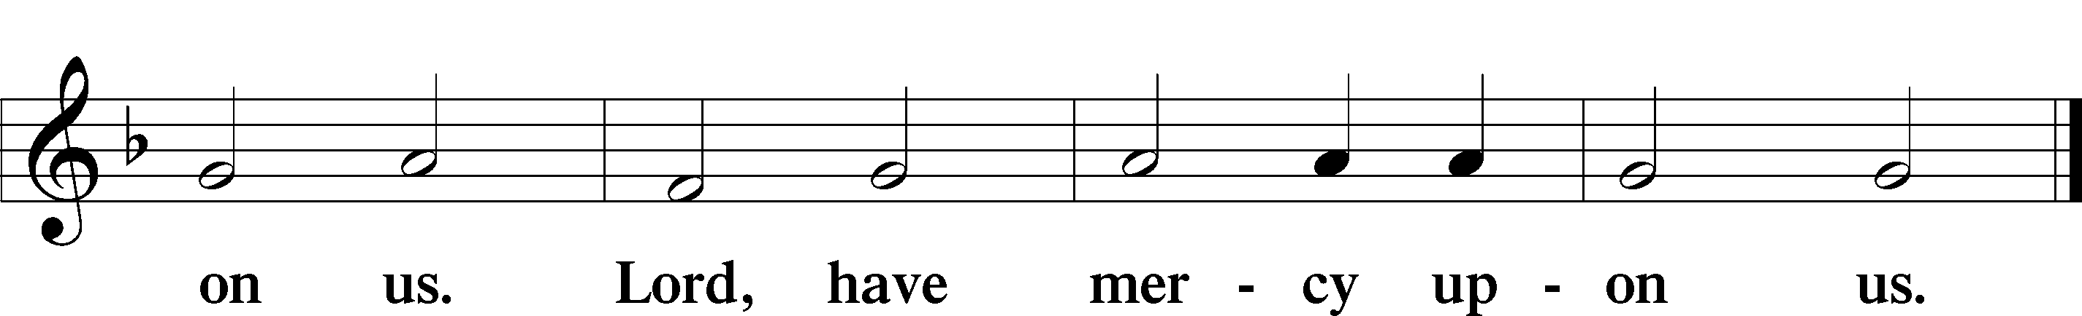

Gloria in Excelsis Luke 2:14; John 1:29
P Glory be to God on high:
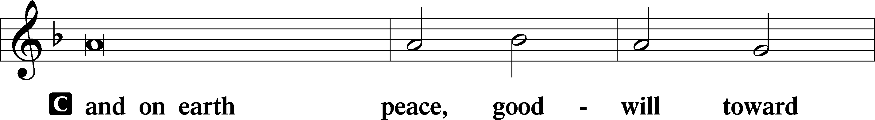
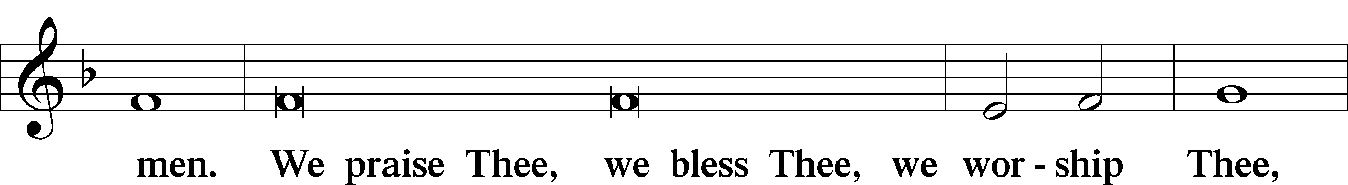
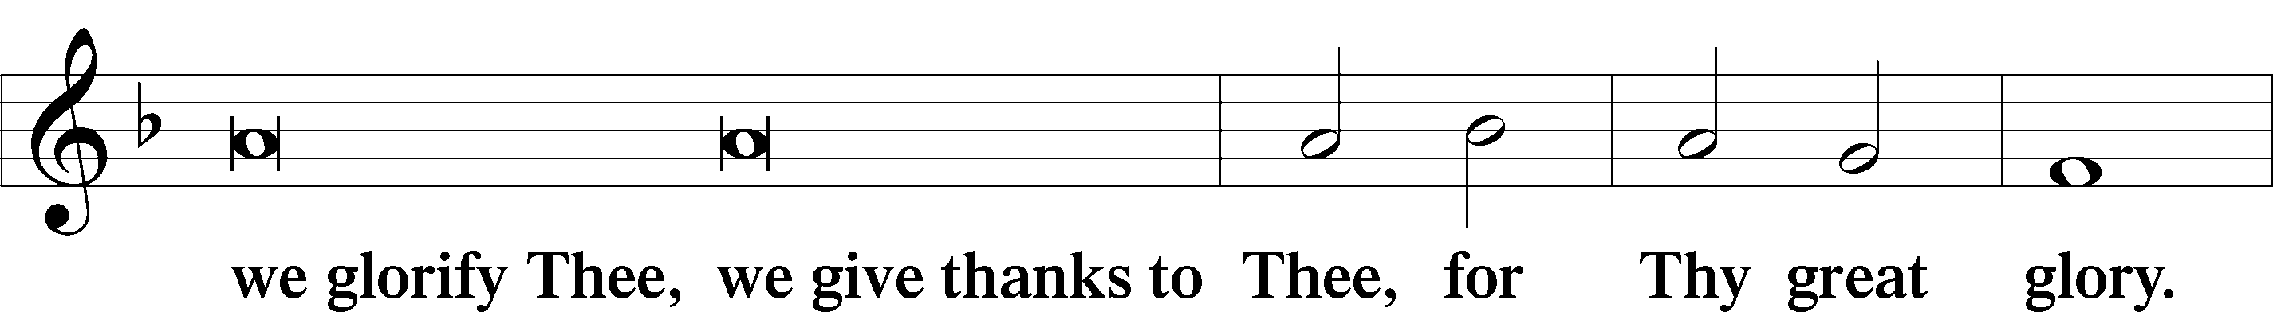
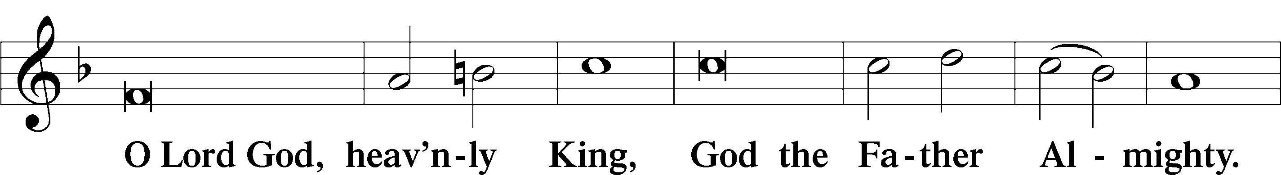
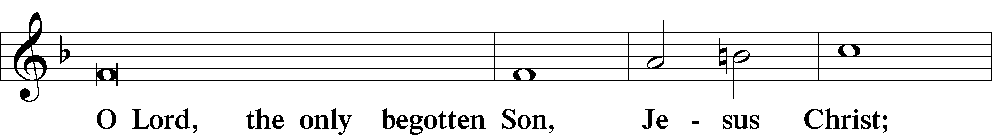
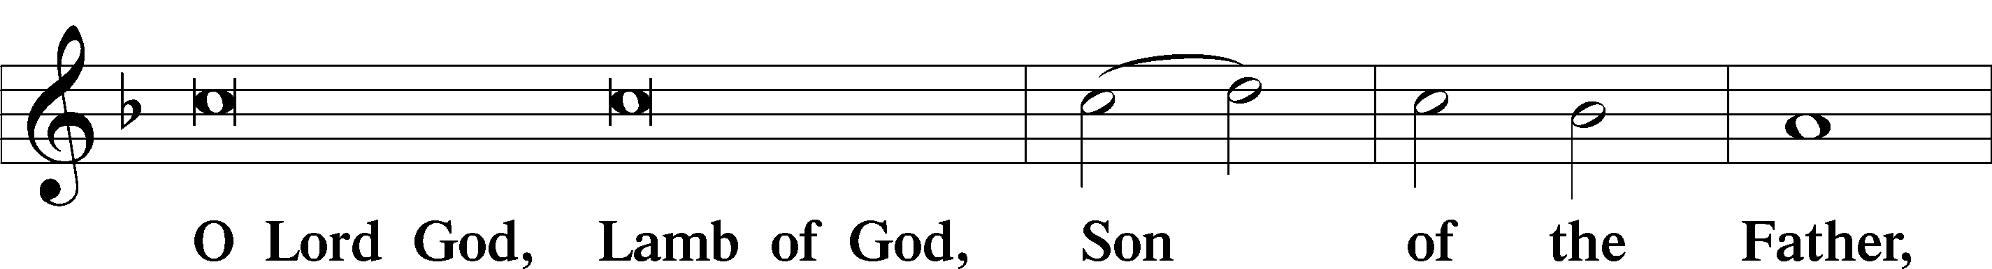
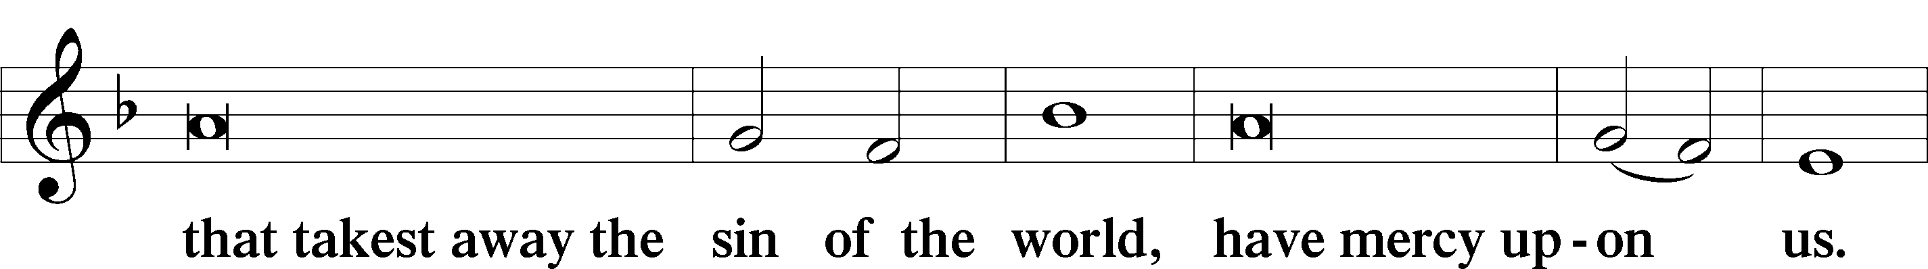
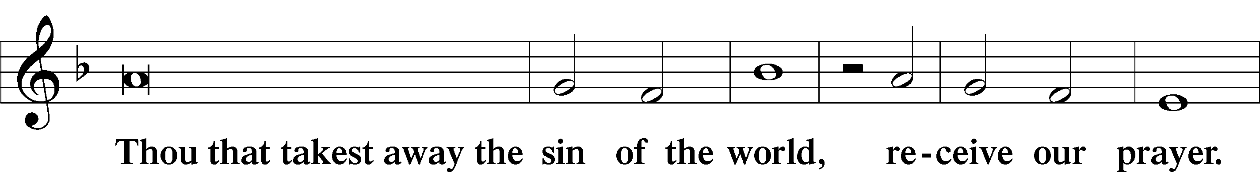
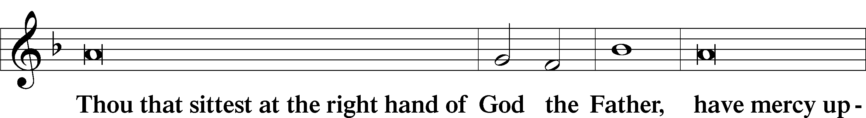
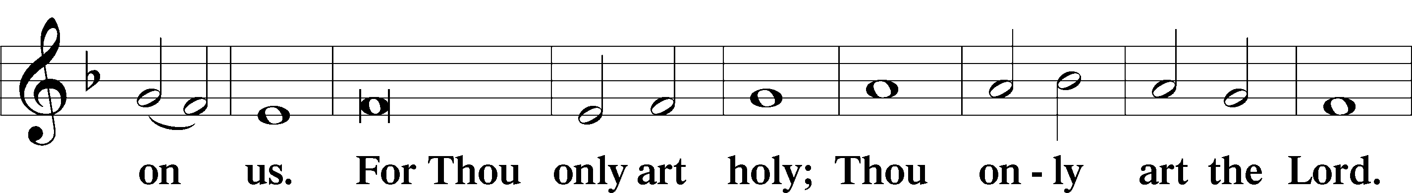
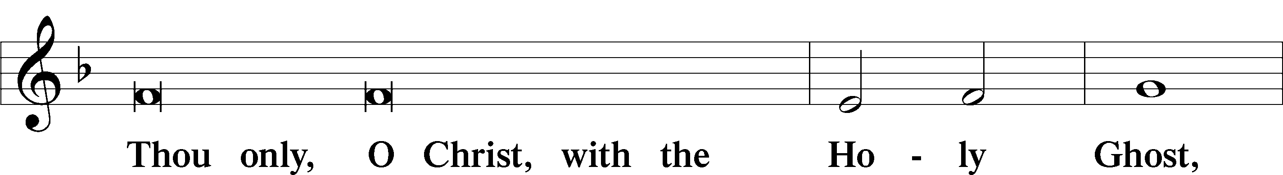
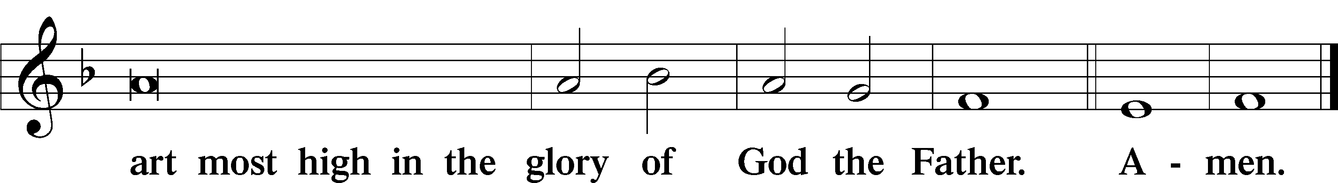

Salutation and Collect of the Day: Trinity 14
P The Lord be with you.
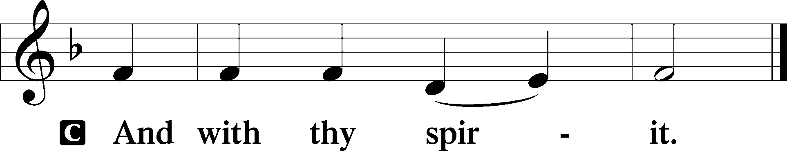

P Let us pray.
O Lord, keep Your Church with Your perpetual mercy; and because of our frailty we cannot but fall, keep us ever by Your help from all things hurtful and lead us to all things profitable to our salvation; through Jesus Christ, Your Son, our Lord, who lives and reigns with You and the Holy Spirit, one God, now and forever.
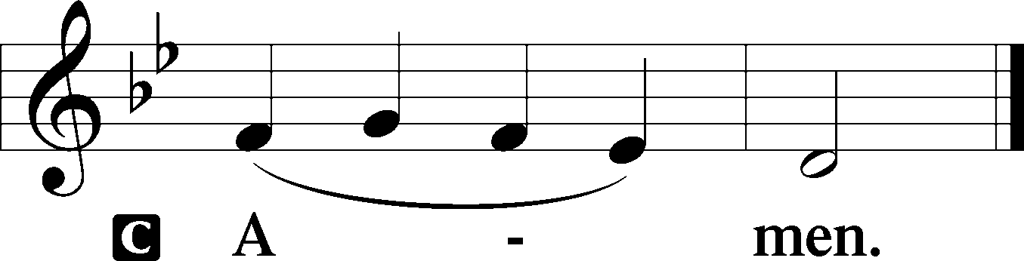
Sit

Prophecy: Proverbs 4:10–23 (NKJV)
Hear, my son, and receive my sayings, and the years of your life will be many. I have taught you in the way of wisdom; I have led you in right paths. When you walk, your steps will not be hindered, and when you run, you will not stumble. Take firm hold of instruction, do not let go; keep her, for she is your life. Do not enter the path of the wicked, and do not walk in the way of evil. Avoid it, do not travel on it; turn away from it and pass on. For they do not sleep unless they have done evil; and their sleep is taken away unless they make someone fall. For they eat the bread of wickedness, and drink the wine of violence. But the path of the just is like the shining sun, that shines ever brighter unto the perfect day. The way of the wicked is like darkness; they do not know what makes them stumble. My son, give attention to my words; incline your ear to my sayings. Do not let them depart from your eyes; keep them in the midst of your heart; for they are life to those who find them, and health to all their flesh. Keep your heart with all diligence, for out of it spring the issues of life.

P This is the Word of the Lord.
C Thanks be to God.

Gradual Psalm 92:1–2
It is good to give thanks | to the Lord,*
to sing praises to your name, | O Most High;
to declare your steadfast love in the | morning,*
and your faithful- | ness by night.

Epistle: Galatians 5:16–24 (NKJV)
Brethren: Walk in the Spirit, and you shall not fulfill the lust of the flesh. For the flesh lusts against the Spirit, and the Spirit against the flesh; and these are contrary to one another, so that you do not do the things that you wish. But if you are led by the Spirit, you are not under the law. Now the works of the flesh are evident, which are: adultery, fornication, uncleanness, lewdness, idolatry, sorcery, hatred, contentions, jealousies, outbursts of wrath, selfish ambitions, dissensions, heresies, envy, murders, drunkenness, revelries, and the like; of which I tell you beforehand, just as I also told you in time past, that those who practice such things will not inherit the kingdom of God. But the fruit of the Spirit is love, joy, peace, longsuffering, kindness, goodness, faithfulness, gentleness, self-control. Against such there is no law. And those who are Christ’s have crucified the flesh with its passions and desires.

P This is the Word of the Lord.
C Thanks be to God.

Stand

Verse Psalm 65:1
Alleluia. Praise is due to you, O God, in Zion, and to you shall vows be performed. Alleluia.

Alleluia
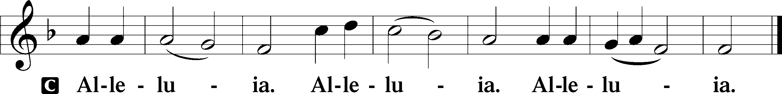

Holy Gospel: Luke 17:11–19 (NKJV)
P The Holy Gospel according to St. Luke, the seventeenth chapter.
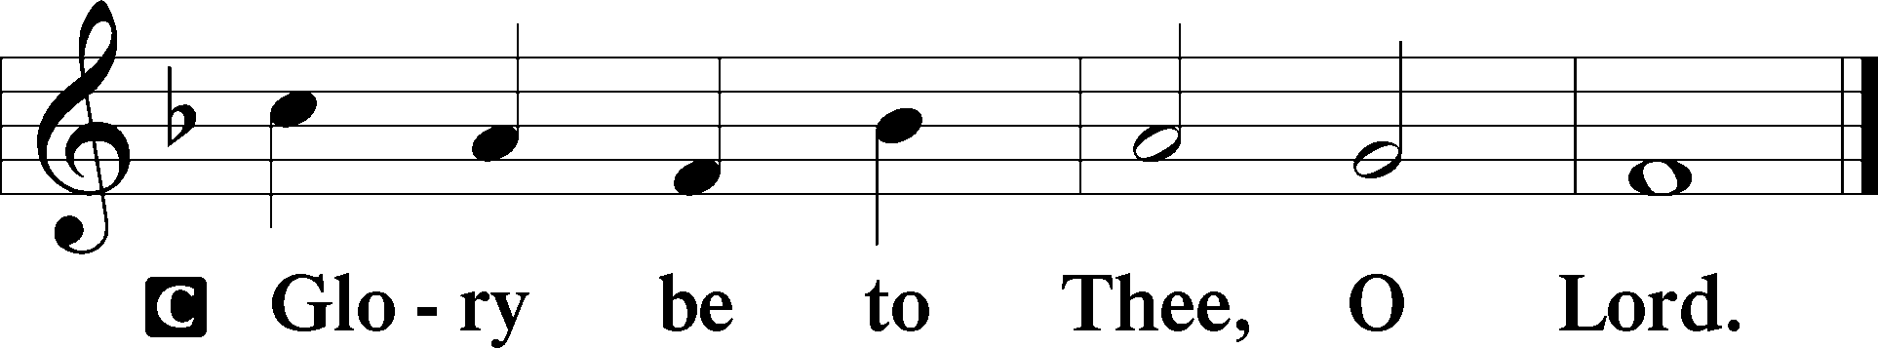

At that time: As Jesus went to Jerusalem He passed through the midst of Samaria and Galilee. Then as He entered a certain village, there met Him ten men who were lepers, who stood afar off. And they lifted up their voices and said, “Jesus, Master, have mercy on us!” So when He saw them, He said to them, “Go, show yourselves to the priests.” And so it was that as they went, they were cleansed. And one of them, when he saw that he was healed, returned, and with a loud voice glorified God, and fell down on his face at His feet, giving Him thanks. And he was a Samaritan. So Jesus answered and said, “Were there not ten cleansed? But where are the nine? Were there not any found who returned to give glory to God except this foreigner?” And He said to him, “Arise, go your way. Your faith has saved you.”

P This is the Gospel of the Lord.
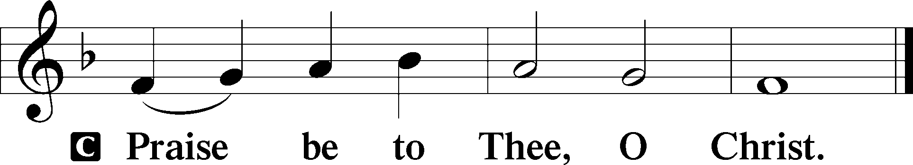

Nicene Creed
C I believe in one God,
the Father Almighty,
maker of heaven and earth
and of all things visible and invisible.

And in one Lord Jesus Christ,
the only-begotten Son of God,
begotten of His Father before all worlds,
God of God, Light of Light,
very God of very God,
begotten, not made,
being of one substance with the Father,
by whom all things were made;
who for us men and for our salvation came down from heaven
and was incarnate by the Holy Spirit of the virgin Mary
and was made man;
and was crucified also for us under Pontius Pilate.
He suffered and was buried.
And the third day He rose again according to the Scriptures
and ascended into heaven
and sits at the right hand of the Father.
And He will come again with glory to judge both the living and the dead,
whose kingdom will have no end.

And I believe in the Holy Spirit,
the Lord and giver of life,
who proceeds from the Father and the Son,
who with the Father and the Son together is worshiped and glorified,
who spoke by the prophets.
And I believe in one holy Christian and apostolic Church,
I acknowledge one Baptism for the remission of sins,
and I look for the resurrection of the dead
and the life T of the world to come. Amen.
Sit

Hymn of the Day: LSB #713 “From God Can Nothing Move Me”

Sermon

Stand

Offertory Psalm 51:10–12
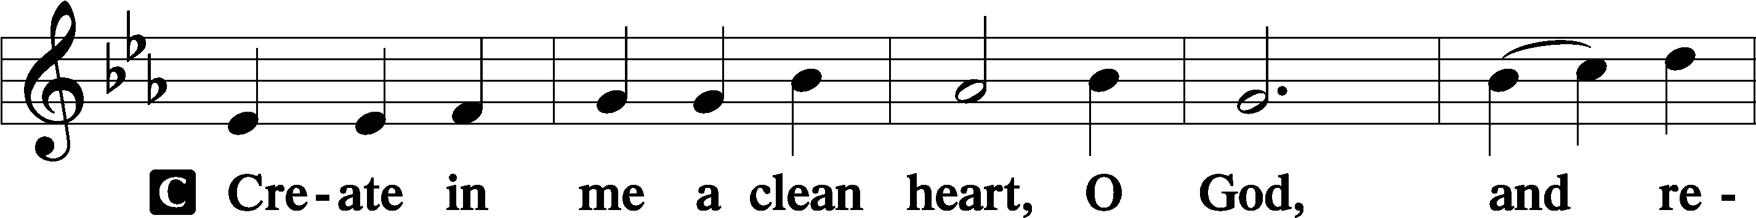
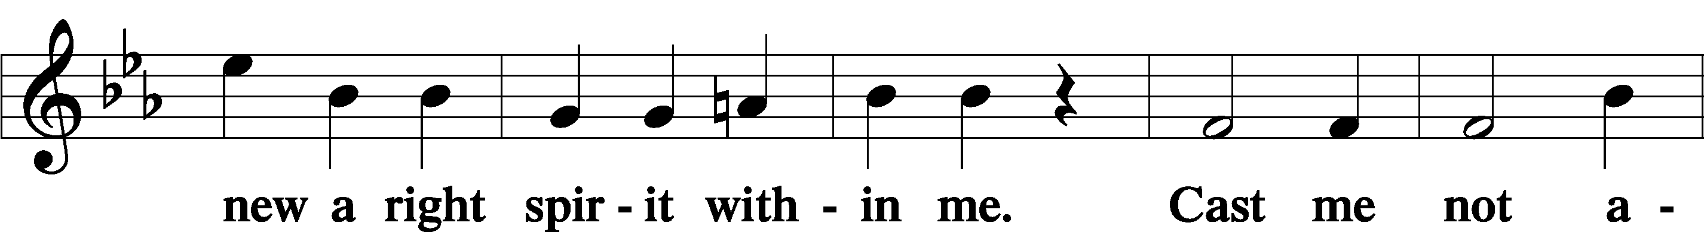
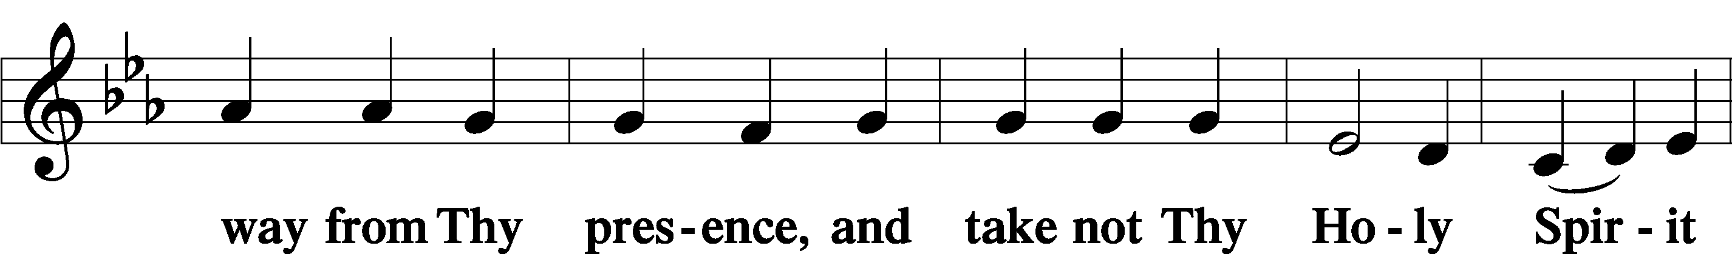
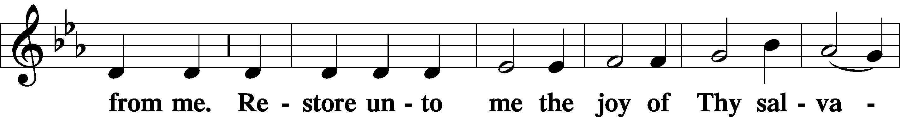
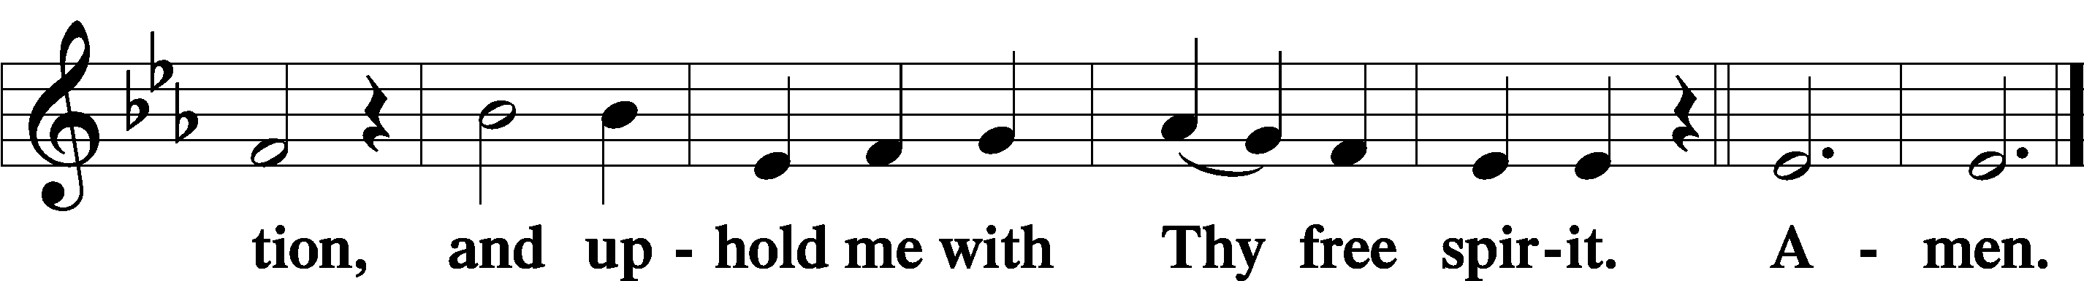

Prayer of the Church

Sit

Preparatory Hymn: LSB #737 “Rejoice, My Heart, Be Glad and Sing”

Stand

Service of the Sacrament

Preface 2 Timothy 4:22; Colossians 3:1 Psalm 136
P The Lord be with you.
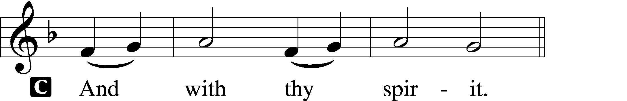

P Lift up your hearts.
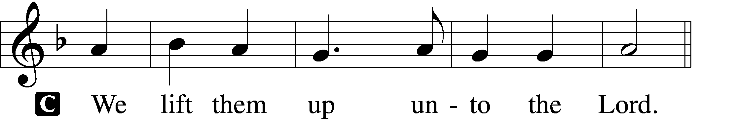

P Let us give thanks unto the Lord, our God.
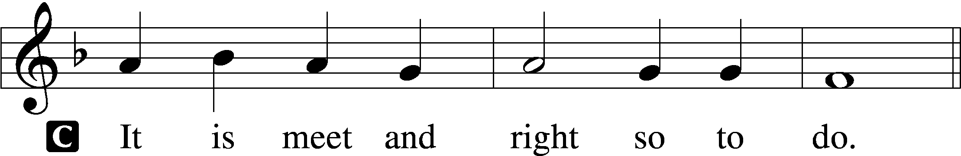

Proper Preface (Abbreviated) LSB 194
P It is truly meet, right, and salutary . . . evermore praising You and saying:

Sanctus Isaiah 6:3; Matthew 21:9
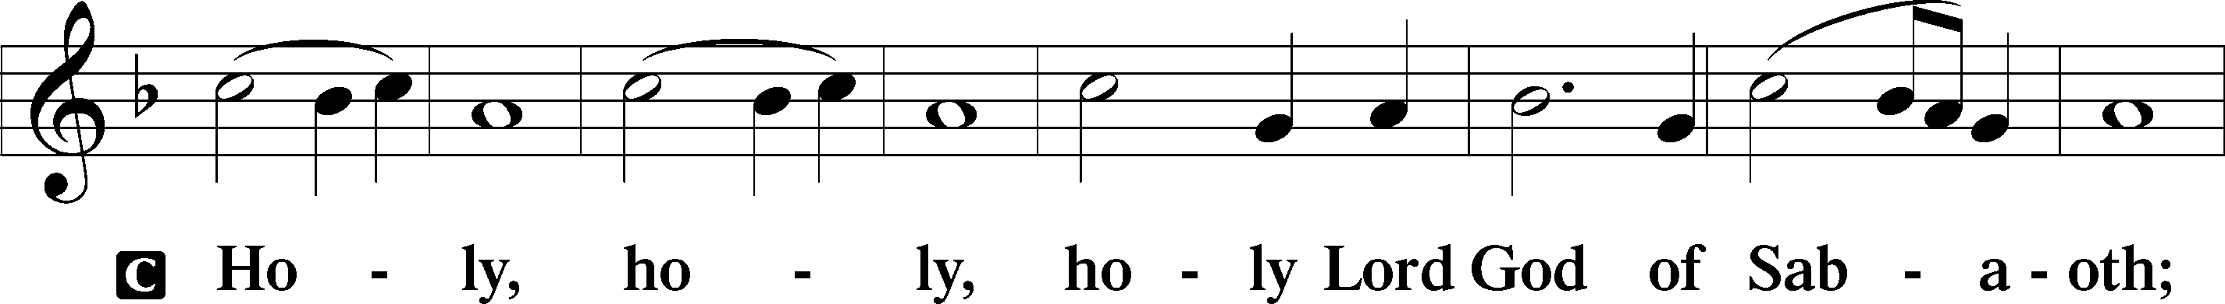
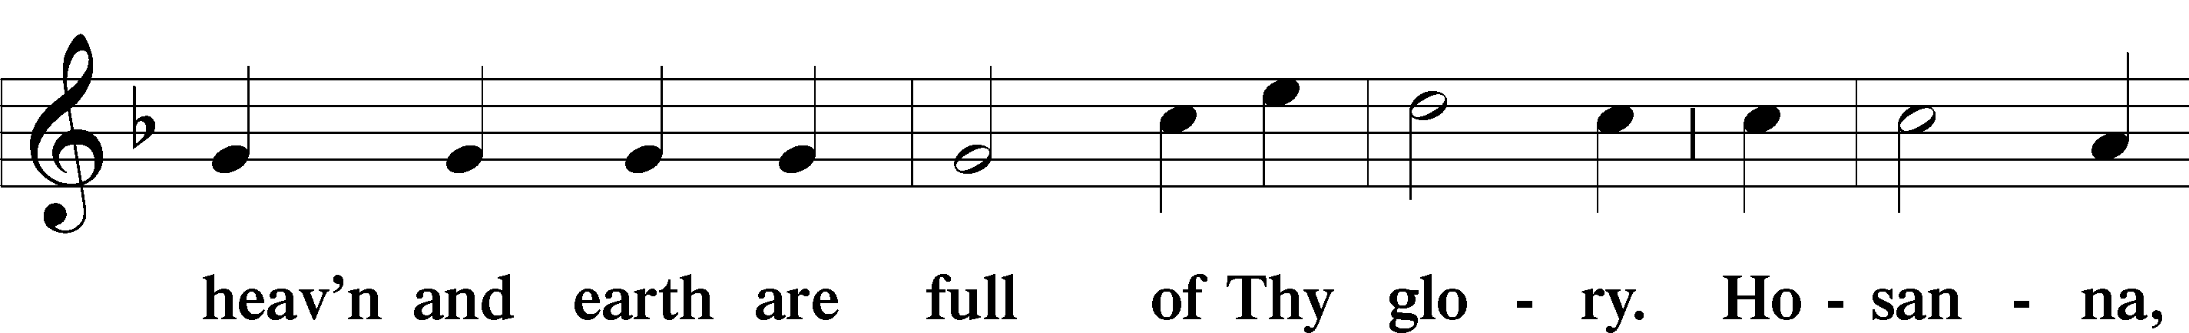
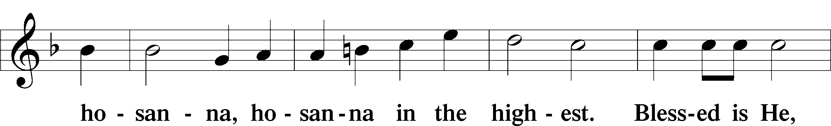
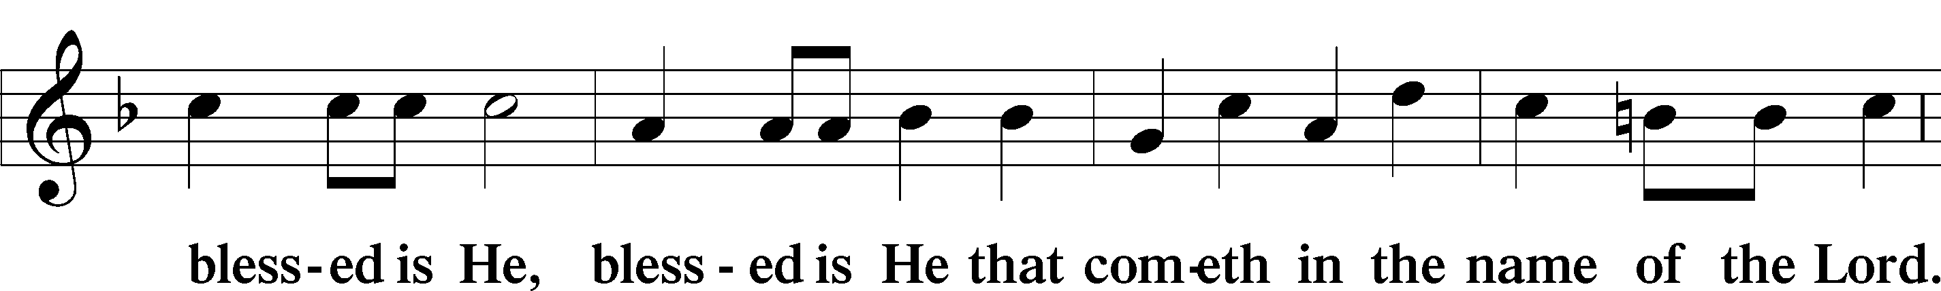
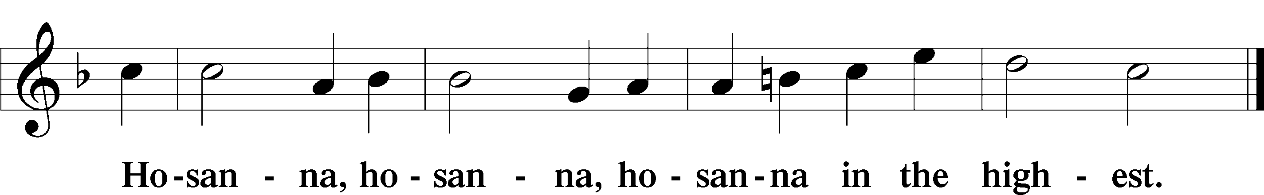

Lord’s Prayer Matthew 6:9–13
C Our Father who art in heaven,
hallowed be Thy name,
Thy kingdom come,
Thy will be done on earth as it is in heaven;
give us this day our daily bread;
and forgive us our trespasses as we forgive those who trespass against us;
and lead us not into temptation,
but deliver us from evil.
For Thine is the kingdom and the power and the glory forever and ever. Amen.
The Words of Our Lord Matthew 26:26–28; Mark 14:22–24; Luke 22:19–20; 1 Corinthians 11:23–25
P Our Lord Jesus Christ, on the night when He was betrayed, took bread, and when He had given thanks, He broke it and gave it to the disciples and said: “Take, eat; this is My T body, which is given for you. This do in remembrance of Me.”

In the same way also He took the cup after supper, and when He had given thanks, He gave it to them, saying: “Drink of it, all of you; this cup is the new testament in My T blood, which is shed for you for the forgiveness of sins. This do, as often as you drink it, in remembrance of Me.”

Pax Domini John 20:19
P The peace of the Lord be with you always.
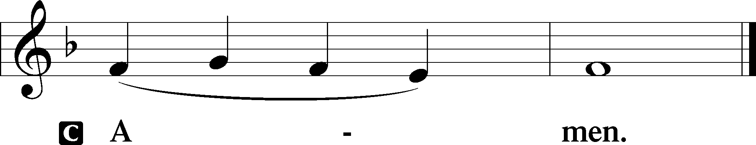

Agnus Dei John 1:29
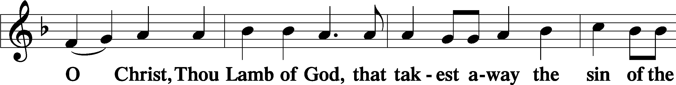
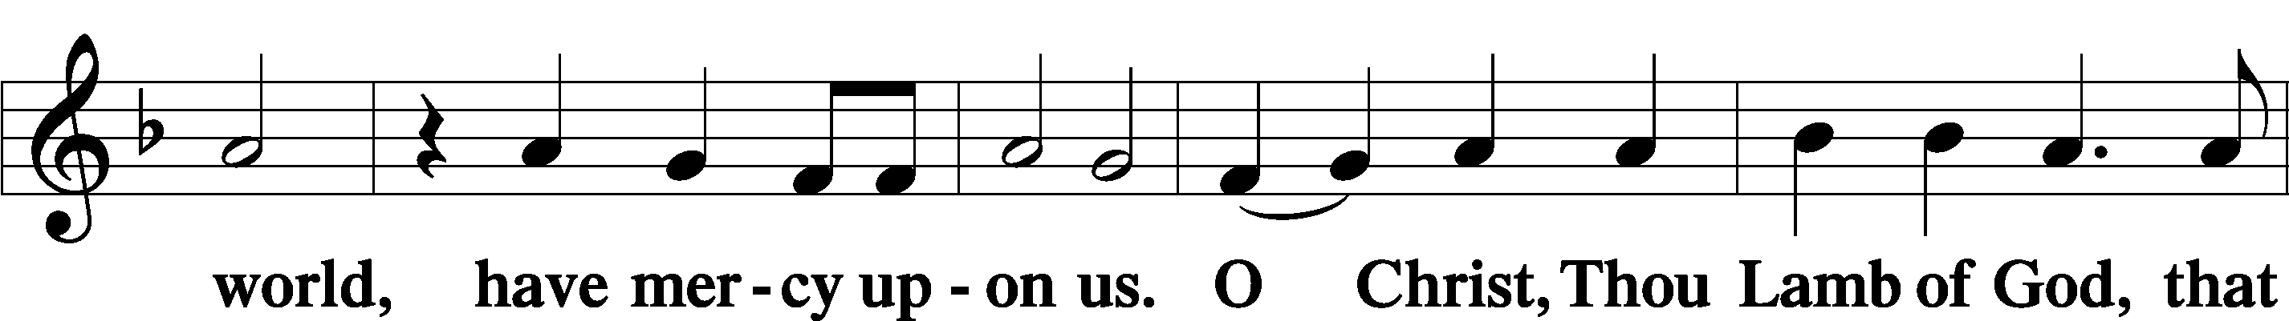
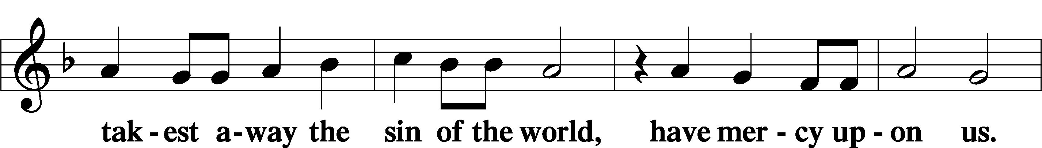
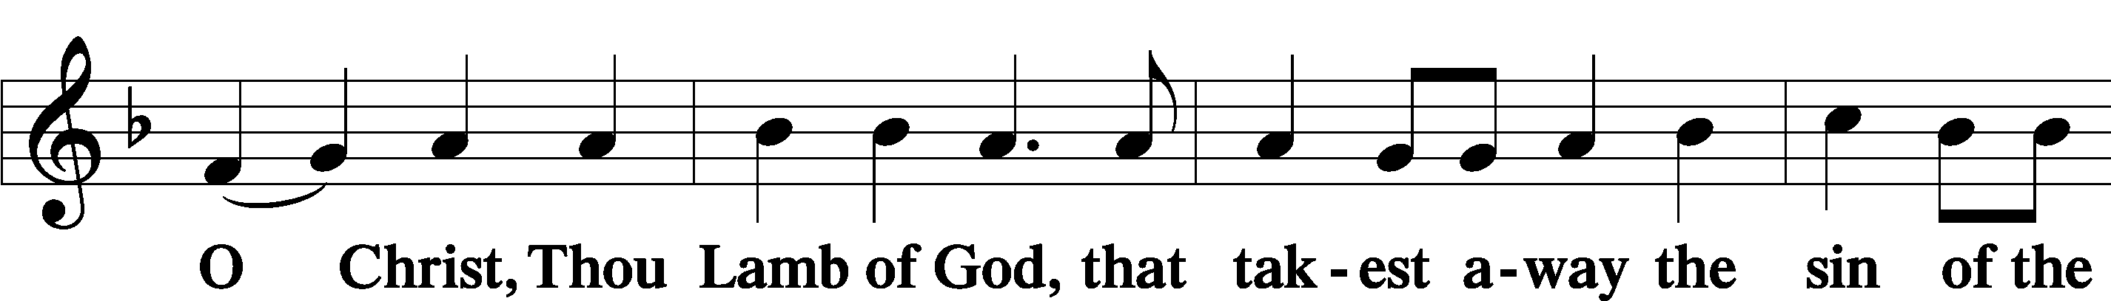
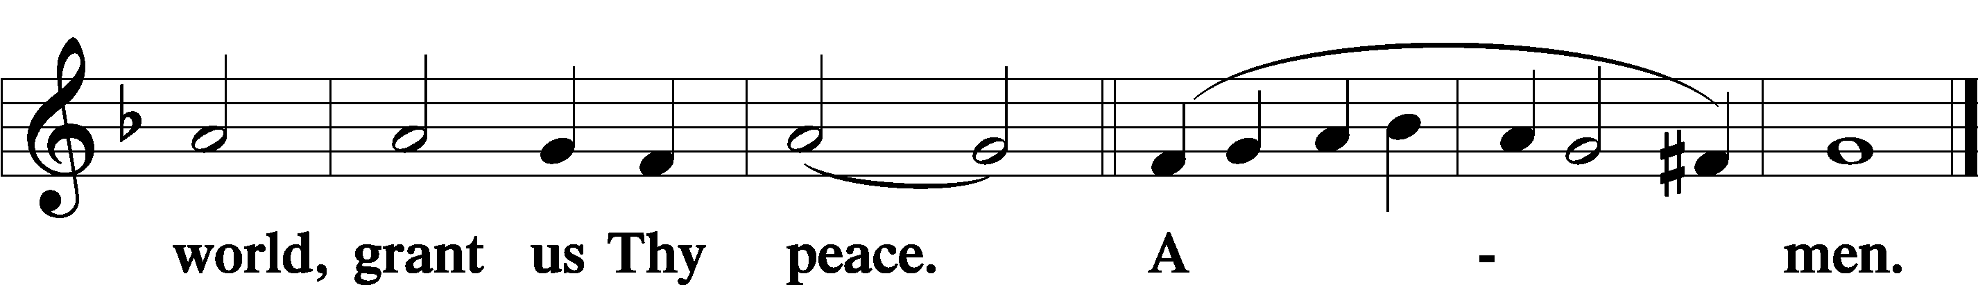
Sit
Distribution
The pastor and those who assist him receive the body and blood of Christ first and then distribute them to those who come to receive, saying:
Take, eat; this is the true body of our Lord and Savior Jesus Christ, given into death for your sins.
Amen.

Take, drink; this is the true blood of our Lord and Savior Jesus Christ, shed for the forgiveness of your sins.
Amen.

In dismissing the communicants, the following is said:
The Dismissal
P The body and blood of our Lord Jesus Christ strengthen and preserve you in body and soul to life everlasting. Depart T in peace.
C Amen.

Distribution Hymn: LSB #602 “The Gifts Christ Freely Gives”

Distribution Hymn: LSB #849 “Praise the One Who Breaks the Darkness”

Distribution Hymn: LSB #696 “O God, My Faithful God”

Stand

Nunc Dimittis Luke 2:29–32
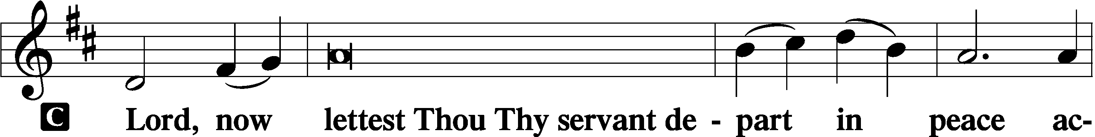
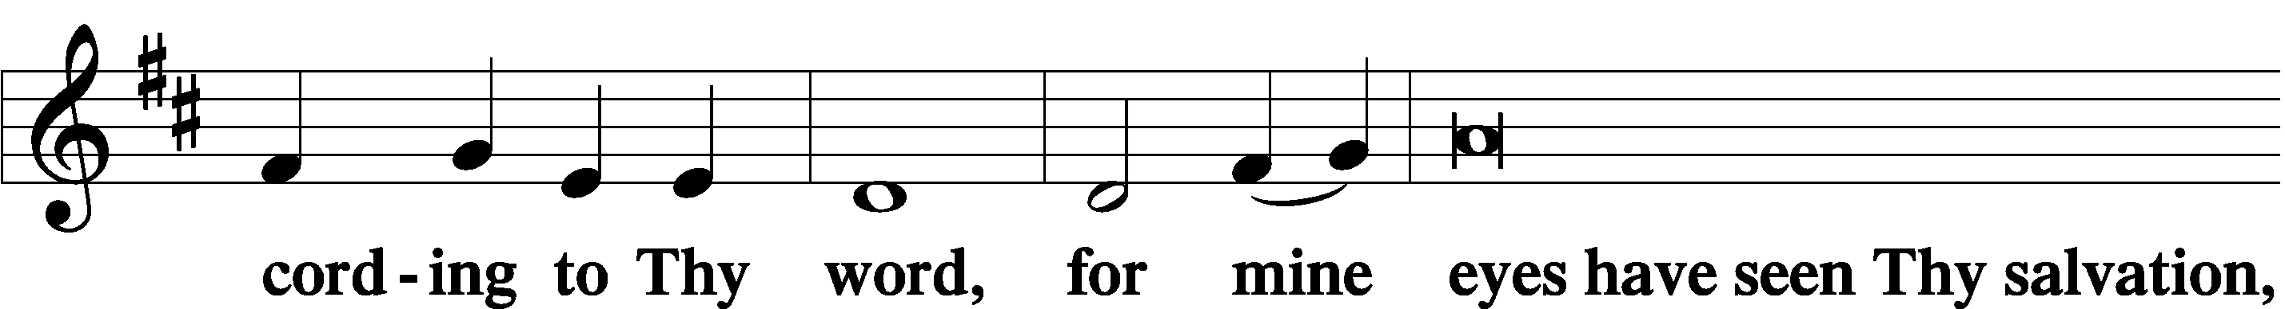
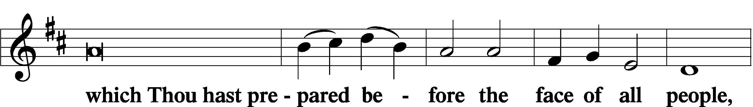
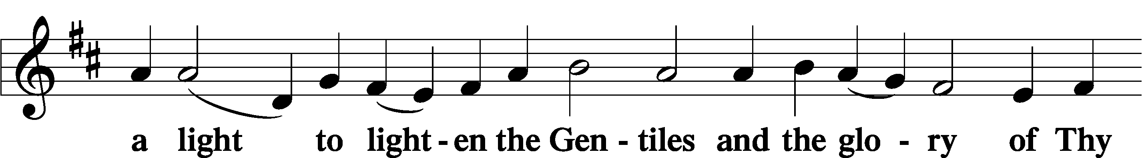
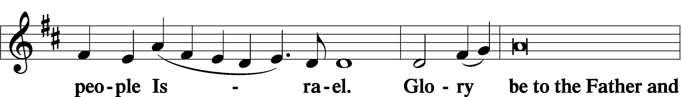
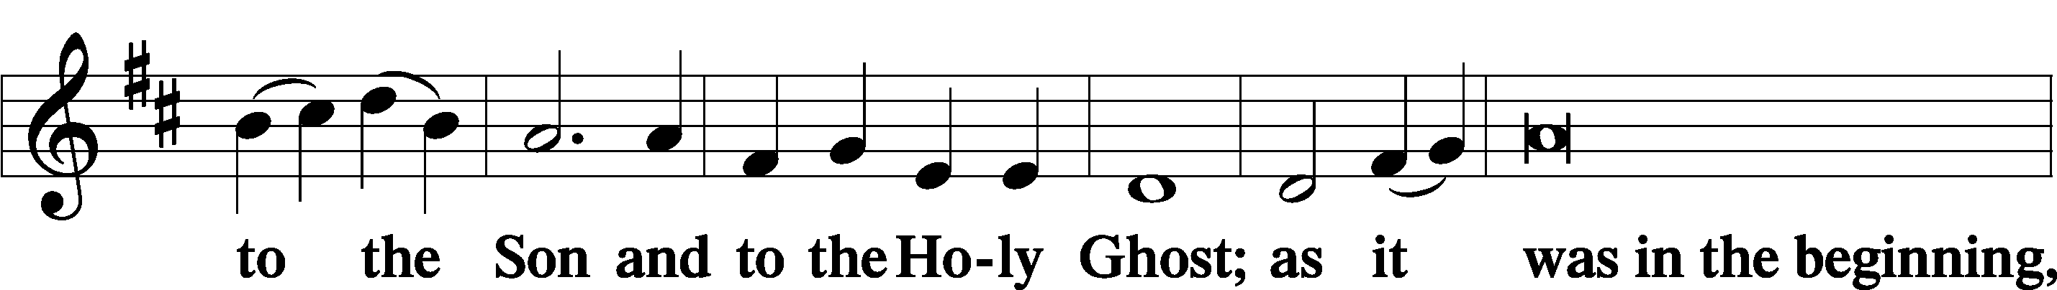
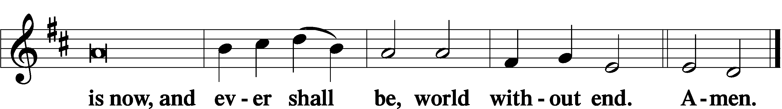

Thanksgiving Psalm 107:1
P O give thanks unto the Lord, for He is good,
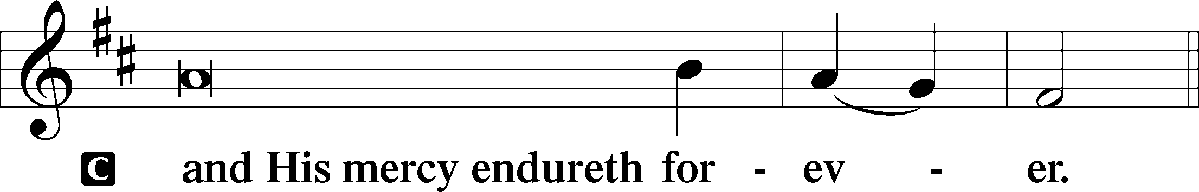

Post-Communion Collect
P Let us pray.
We give thanks to You, almighty God, that You have refreshed us through this salutary gift, and we implore You that of Your mercy You would strengthen us through the same in faith toward You and in fervent love toward one another; through Jesus Christ, Your Son, our Lord, who lives and reigns with You and the Holy Spirit, one God, now and forever.
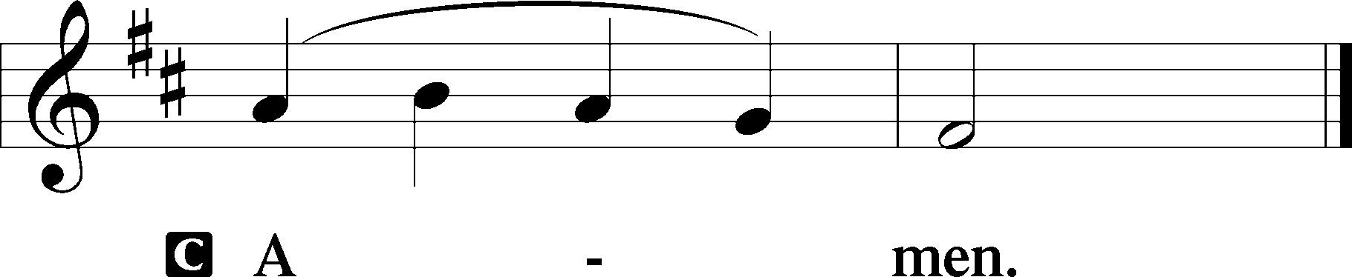

Salutation 2 Timothy 4:22
P The Lord be with you.
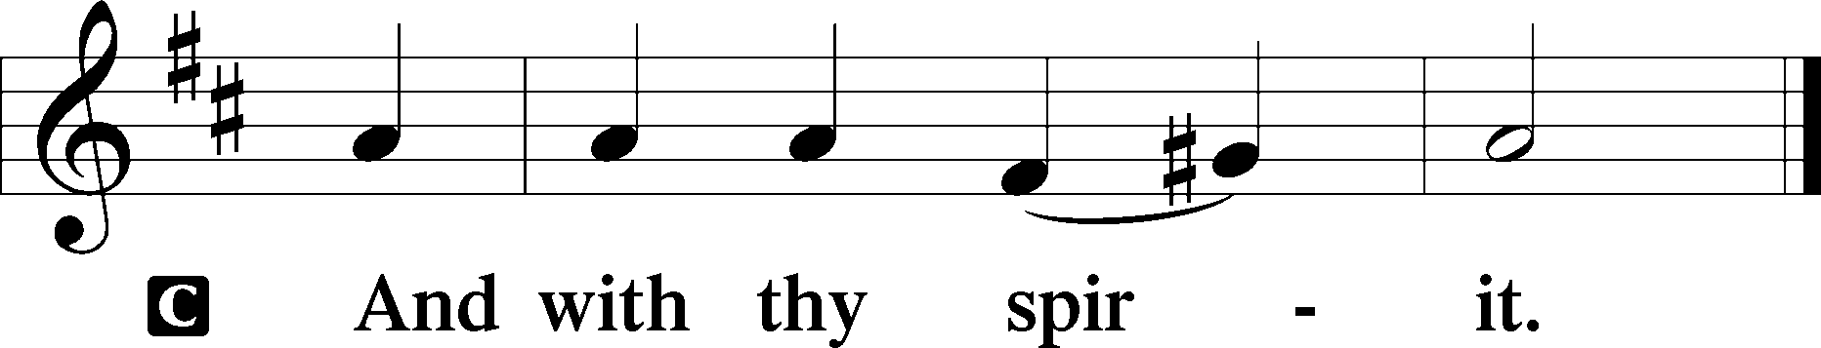

Benedicamus Psalm 103:1
P Bless we the Lord.
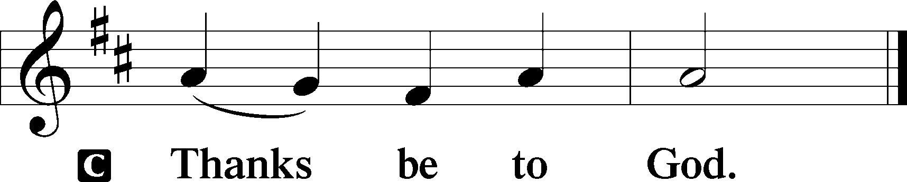

Benediction Numbers 6:24–26
P The Lord bless you and keep you.
The Lord make His face shine upon you and be gracious unto you.
The Lord lift up His countenance upon you and T give you peace.
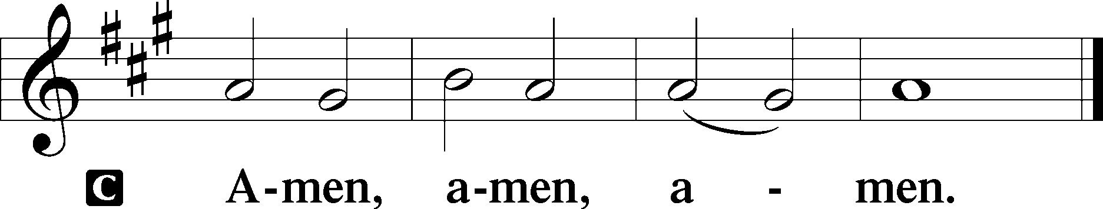

Closing Hymn: LSB #790 “Praise to the Lord, the Almighty”

Silent prayer after worship: Heavenly Father, grant that I may be in Your Word and in prayer daily, so that through Your Word I may be certain of my salvation and may also share that hope with others. In Jesus’ name. Amen.
fffffffffffffffffffffffffffffffffff
Acknowledgments
Unless otherwise indicated, Scripture quotations are from the ESV® Bible (The Holy Bible, English Standard Version®), copyright © 2001 by Crossway, a publishing ministry of Good News Publishers. Used by permission. All rights reserved.
Created by Lutheran Service Builder © 2023 Concordia Publishing House.
fffffffffffffffffffffffffffffffffff

SCHEDULE THROUGH SEPTEMBER 17, 2023:

:

Today, following Worship, Fellowship Hall: Coffee Fellowship
7 pm, Fellowship Hall: AA Meeting
Tuesday, 7-9 pm, Fellowship Hall: Penn-Ohio Singers
Wednesday, 7:30 pm, Fellowship Hall: NA Meeting
Thursday, 9 am, Downstairs: Food Pantry
Saturday, 1 pm, Fellowship Hall: Altar Guild Meeting
4 pm, Fellowship Hall: Men’s Bible Study
Next Sunday, 8 am, Fellowship Hall: Bible Study
9 am, Sanctuary: Divine Service
Following, Library: Monthly Audit
7 pm, Fellowship Hall: AA Meeting
fffffffffffffffffffffffffffffffffff
Attendance: Sunday, September 3, 2023: 41
fffffffffffffffffffffffffffffffffff
Our Stewardship of Treasures for the Lord:
In order to do the Lord’s work, we need $2,553.63 each week to meet our 2023 budget for general purposes and $76.92 for the SELC.
Online Figures for August 31, 2023
General Fund: $80.00
Figures for Sunday, September 3, 2023
General Fund: $1,780.00 Behind for the week*: -$693.63
SELC: $140.00 Ahead for the week: +$63.08
Capital Campaign: $775.00 *Includes above figure.

For online giving, check out https://www.saintspeterandpaul.net/online-giving.
fffffffffffffffffffffffffffffffffff
THANK YOU FOR SERVING IN SEPTEMBER: Elder: Jonathan Baisch; Ushers: Mark Kleindienst, Jerry Krivosh, & Gordon Marquette; Altarware: (prior) Diane Riefstahl; (after) Arlene Sutton (09.10), Kati Laird (09.03, 09.17, and 09/24), and Hank Holcroft (all).
fffffffffffffffffffffffffffffffffff
Bible Memory Verses ~ Week of September 10th:
For Adults: Humble yourselves, therefore, under the mighty hand of God so that at the proper time he may exalt you, 1 Peter 5:6
For Children: Bless the Lord, O my soul, and forget not all his benefits. Psalm 103:2
fffffffffffffffffffffffffffffffffff
Sunday Morning Bible Study has resumed. We are continuing our study of the minor prophets. All are welcome to join!
fffffffffffffffffffffffffffffffffff
Reminders!
- This morning is “Stock the Food Pantry” Sunday. Your financial contributions will be greatly appreciated. Donations may be placed in a pew envelope and put in the offering plate.
- The next Altar Guild meeting will be held Saturday, September 16th beginning at 1 pm. All women are welcome to join! September’s hostess will be Marie Flaugher.
- Men’s Bible Study will resume this Saturday at 4 pm in the Fellowship Hall. All men are welcome!
- Auditors will meet next Sunday in the library following worship for a monthly audit of deposits.
- Items for the October calendar and newsletter are due to the secretary by noon, September 18th.
- There will be a special Divine Service held Friday, September 29th at 7 pm celebrating the Feast of Saint Michael and All Angels.
fffffffffffffffffffffffffffffffffff
Join us following worship this morning for Coffee Fellowship! September’s sponsors are Ruth Meszaros and Joani Rice.

We are still seeking sponsors for October and November. If interested, please sign the sheet in the narthex.
fffffffffffffffffffffffffffffffffff

Remember the following in Prayer…
~The Hurting and Healing: Amy, Steve Antolovich, Ellen Baron^{CA}, Amy Blomenberg, Lois Bortner^{CA}, Sara Brubaker, Dee Bullock, Bev & Joe Chlpka, Susan Davies, Loretta Deal, Tim Dudash, Judith & Eddy Furey, Griffin, Peter Haenftling, Austin Hamilton, Pastor Charles Henrickson, Joan, Keith Jozwiakowski, Darla Krajci, Barbara Kreske, Pastor Ed Kucera, Jess Lavoie, Elizabeth Loughan, Paul Lucas^{CA}, Sandy Marshall, Gene Moore, Frank Niemeyer^{CA}, Juanita Rentschler, Richard Reuning^{CA}, Nancy Robertson^{CA}, Landon Sargent, Kriss Svidro^{CA}, Joel & Peggy Wasson, Angela Weser^{CA}, and Ruth Wolf.
~The Homebound: Anna Mae Daris, Millie Elavsky, Rudy & Jean Tomko, Betty Wolf, and Ed & Millie Zachar.
~Celebrating this Week: Birthdays: Alyxis Riffle (09.10) & Dolores Fee (09.14).
~Serving in the Military: Alex (Sasha) Carr, Curtis Sinewe, and Joshua Solyan.
~Community & World Needs: Those suffering due to the conflict between Ukraine and Russia; those suffering from loss and dislocation because weather disasters; those suffering from addiction and their families; Local, State, and National Government Leaders; safety for all Police Officers, Firefighters, & First Responders; the unemployed; our Third Quarter Local Mission: Luther Classical College.
*CA represents cancer.
fffffffffffffffffffffffffffffffffff
If you would like someone’s name added to or deleted from the prayer list, please put a written note in the secretary’s mail slot. Thank you!
fffffffffffffffffffffffffffffffffff

Here to Serve
Pastor………………………………………………...……………Rev. Jacob Deal
E-mail …………………………….……pastordeal@saintspeterandpaul.net
Phone Number……………………..…………………724-347-3620 (Option 2)
Church Office………………………..…………………724-347-3620 (Option 3)
Website …………………………………………www.saintspeterandpaul.net
Secretary…………………………………………………………Diane Riefstahl
E-mail ………………………………………church@saintspeterandpaul.net
Website …………………………………………www.saintspeterandpaul.net
Food Pantry (email): ……………foodpantry@saintspeterandpaul.net
Congregation President………………………………….…Jonathan Baisch
Church Elder …………………………………………...……. Jonathan Baisch
Organist………………………………………………..….…Rebecca Marquette
Choir Director…………………………………………………….…Chris Nelson
AA Contact: Steve………………………………………………...…724-813-2358
NA Contact: Larry……………………………………..…………..724-977-8733
fffffffffffffffffffffffffffffffffff
If needing to get into the church building during the week, please phone first to make certain someone is here to let you in.

