Sts. Peter & Paul
Evangelical Lutheran Church
Lutheran Church-Missouri Synod
Founded-1917

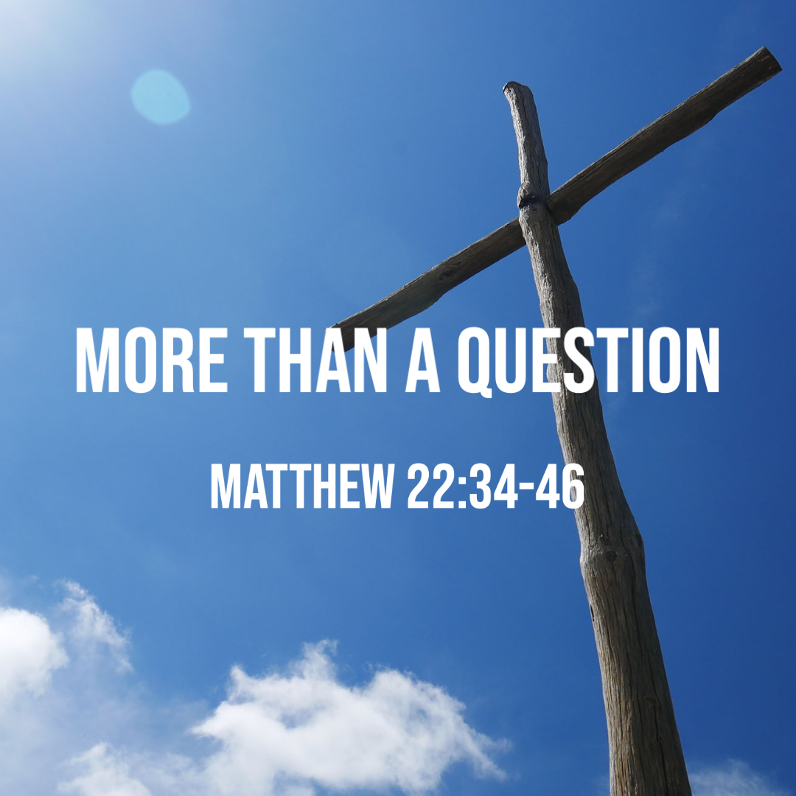

October 8, 2023

699 Stambaugh Ave.
Sharon, Pennsylvania 16146

“I was glad when they said to me,
Let us go to the house of the LORD!”
Psalm 122:1
Sts. Peter & Paul Evangelical Lutheran Church, LC-MS
THE EIGHTEENTH SUNDAY AFTER TRINITY
October 8, 2023
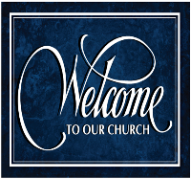
A special welcome to our guests this day! If you would like more information about The Lutheran Church - Missouri Synod, or this congregation, please speak with Pastor Deal or an Elder after the service.
Members & Guests: Don’t be embarrassed if your children make noise during the worship service, all children do. We encourage families to worship together but, if you feel the need, there are pews in the rear of the Church which are reserved for young families on both sides of the sanctuary. There is also a quiet room available to you, located next to the sanctuary (formerly the Pastor’s office), where you would be able to follow along with the service.

Today’s service includes the Sacrament of Holy Communion. If during this past year, you have not worshipped with us and been communed, we respectfully ask that you do not partake of this sacrament this day before first speaking with Pastor Deal.
If visiting from a sister congregation of the LC-MS and are in good standing, please inform Pastor Deal of your desire to commune prior to the service.
If wishing to receive a blessing during communion, please approach with your arms crossed.

CONTACT INFORMATION
Pastor Deal: pastordeal@saintspeterandpaul.net or 724-347-3620 (opt. 2)
Church Office: church@saintspeterandpaul.net or 724-347-3620 (opt. 3)
Secretary’s Office: The office will be open Mon. & Thurs (8:30 am-4:30 pm).

Silent prayer before worship: Heavenly Father, cause Your Holy Spirit to work through Your word so that my faith and my love for You may grow, and I may be certain of my salvation through Jesus Christ. Amen.


Confession and Absolution

Opening Hymn: LSB #919 “Abide, O Dearest Jesus”

Stand

The sign of the cross may be made by all in remembrance of their Baptism.

Invocation
P In the name of the Father and of the T Son and of the Holy Spirit.
C Amen.

Exhortation Hebrews 10:22; Psalm 124:8; Psalm 32:5
P Beloved in the Lord! Let us draw near with a true heart and confess our sins unto God our Father, beseeching Him in the name of our Lord Jesus Christ to grant us forgiveness.

P Our help is in the name of the Lord,
C who made heaven and earth.
P I said, I will confess my transgressions unto the Lord,
C and You forgave the iniquity of my sin.

Silence for reflection on God’s Word and for self-examination.

Confession of Sins
P O almighty God, merciful Father,
C I, a poor, miserable sinner, confess unto You all my sins and iniquities with which I have ever offended You and justly deserved Your temporal and eternal punishment. But I am heartily sorry for them and sincerely repent of them, and I pray You of Your boundless mercy and for the sake of the holy, innocent, bitter sufferings and death of Your beloved Son, Jesus Christ, to be gracious and merciful to me, a poor, sinful being.

Absolution [John 20:19–23]
P Upon this your confession, I, by virtue of my office, as a called and ordained servant of the Word, announce the grace of God unto all of you, and in the stead and by the command of my Lord Jesus Christ I forgive you all your sins in the name of the Father and of the T Son and of the Holy Spirit.
C Amen.

Service of the Word

Introit Psalm 122:1, 6, 8–9; antiphon: Liturgical Text
Give peace, O Lord, to those who | wait for you,*
and let your prophets be proven | faithful.
Hear the prayer of your | servants,*
according to the blessing of Aaron upon your | people.
I was glad when they | said to me,*
“Let us go to the house | of the Lord!”
Pray for the peace of Je- | rusalem!*
May they be secure who | love you!
For my brothers and com- | panions’ sake*
I will say, “Peace be with- | in you!”
For the sake of the house of the | Lord our God,*
I will | seek your good.
Give peace, O Lord, to those who | wait for you,*
and let your prophets be proven | faithful.
Hear the prayer of your | servants,*
according to the blessing of Aaron upon your | people.

Gloria Patri
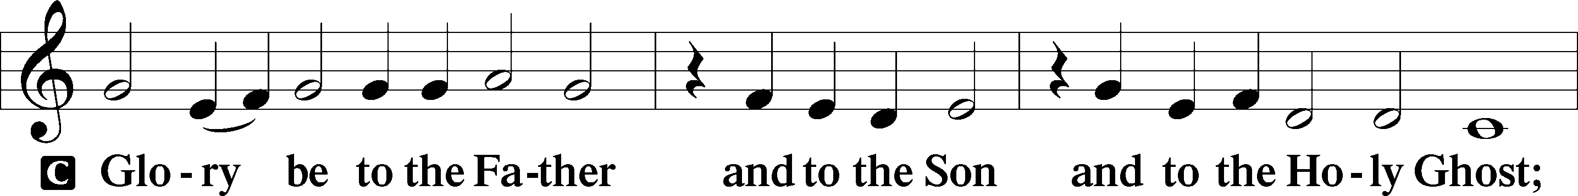
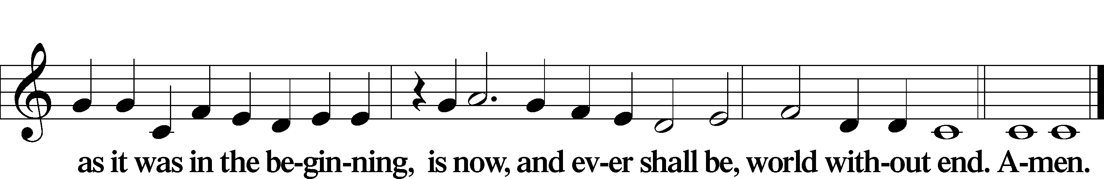

Kyrie Mark 10:47
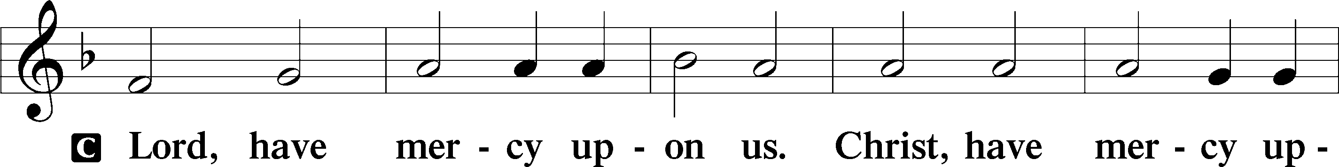
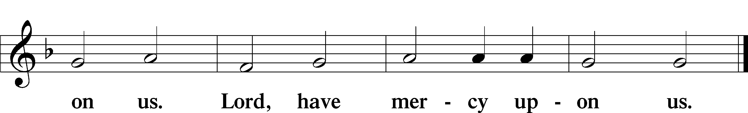

Gloria in Excelsis Luke 2:14; John 1:29
P Glory be to God on high:
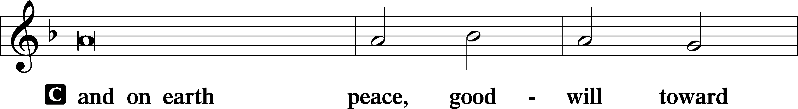
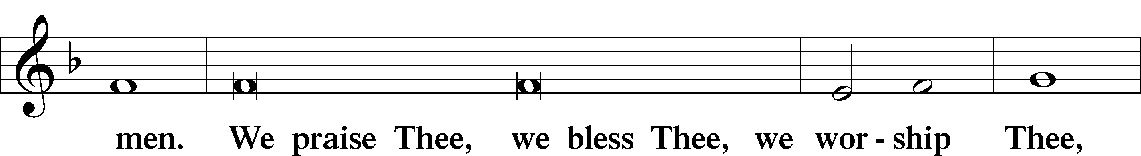
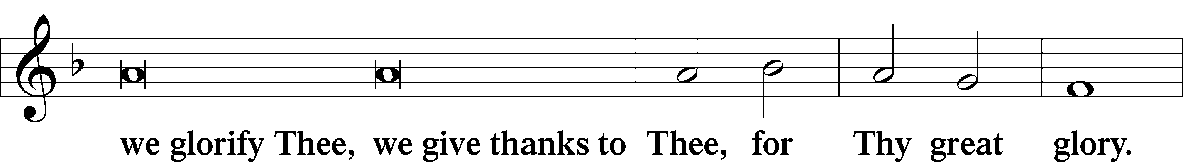
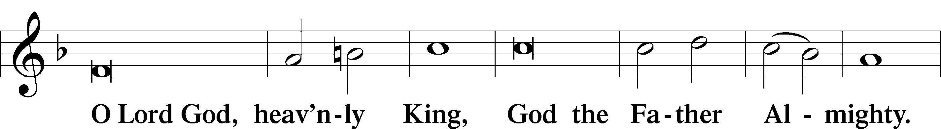
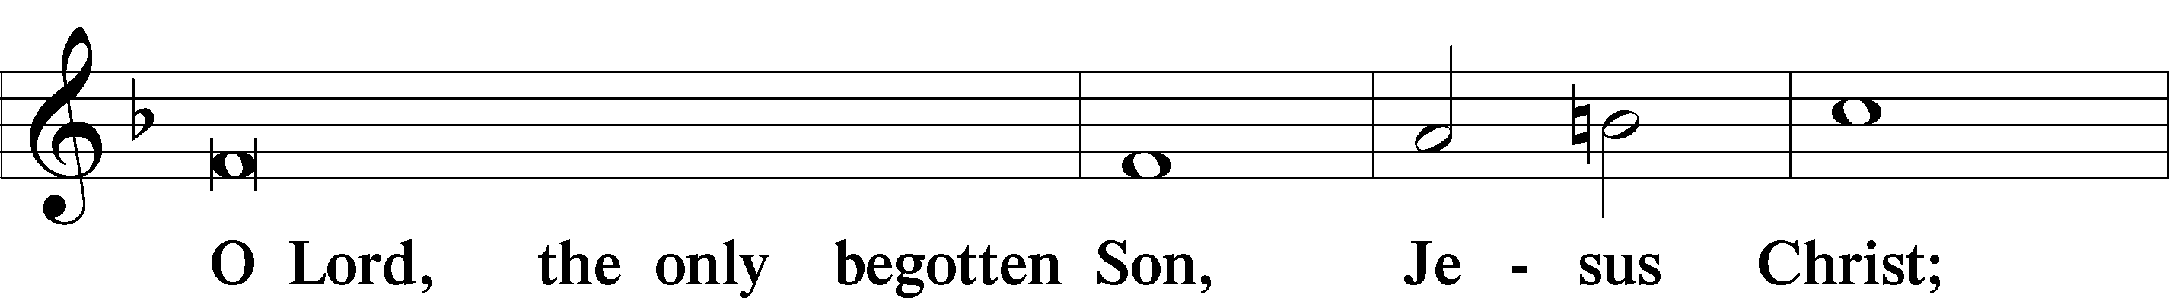
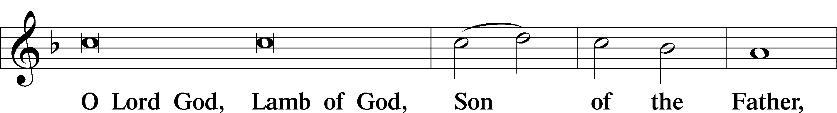
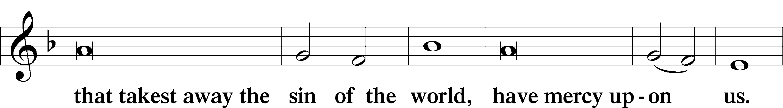
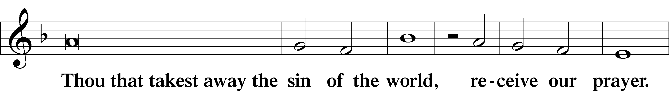
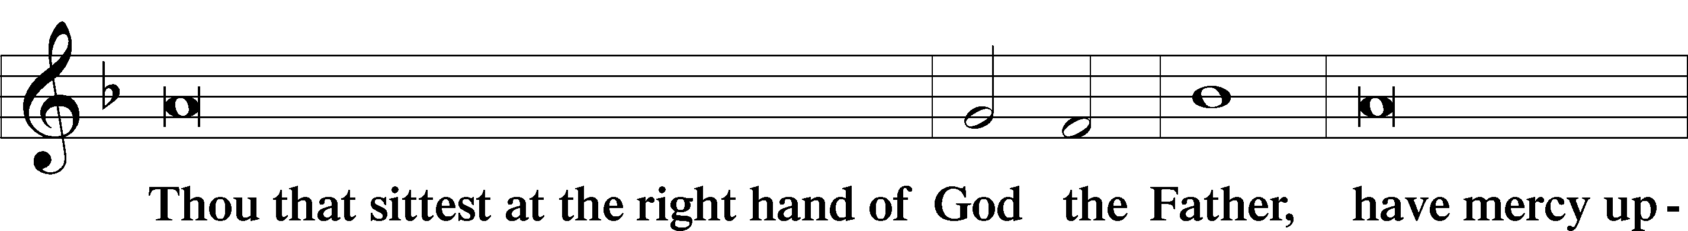
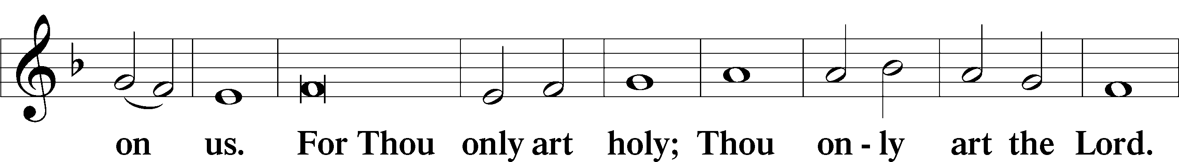
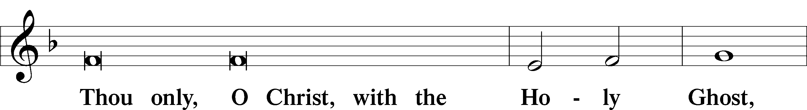
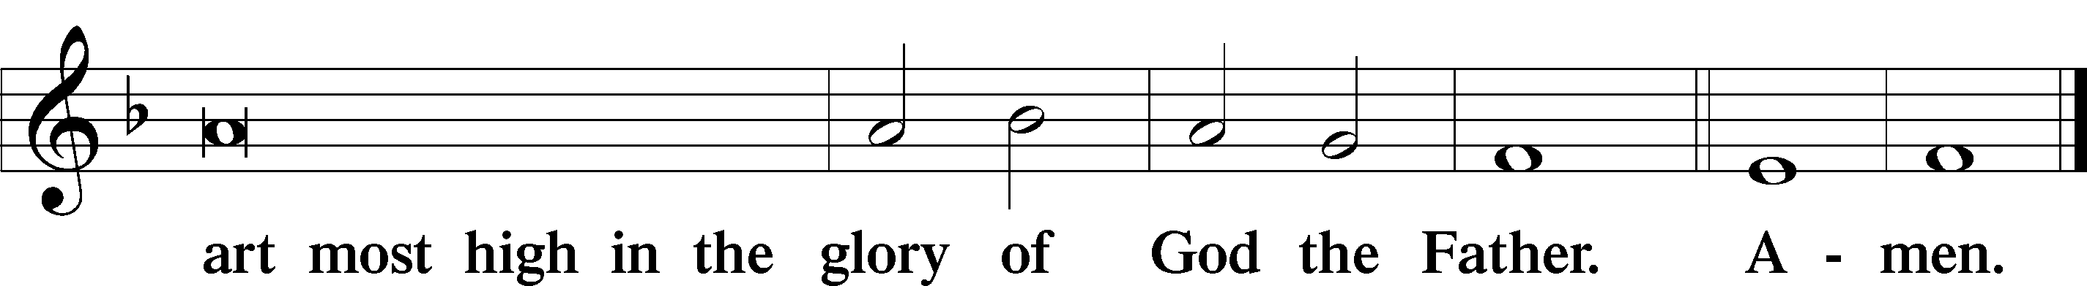

Salutation and Collect of the Day: Trinity 18
P The Lord be with you.
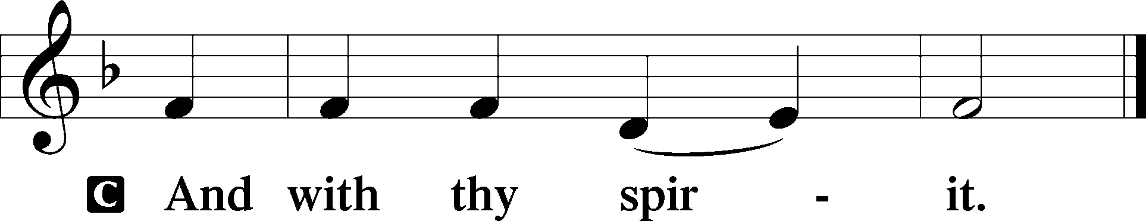

P Let us pray.
O God, because without You we are not able to please You, mercifully grant that Your Holy Spirit may in all things direct and rule our hearts; through Jesus Christ, Your Son, our Lord, who lives and reigns with You and the Holy Spirit, one God, now and forever.
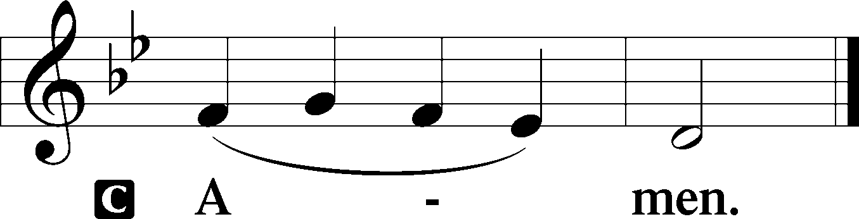

Sit

Prophecy: Deuteronomy 10:12–21 (NKJV)
In those days Moses spoke to the children of Israel, saying: “What does the Lord your God require of you, but to fear the Lord your God, to walk in all His ways and to love Him, to serve the Lord your God with all your heart and with all your soul, and to keep the commandments of the Lord and His statutes which I command you today for your good? Indeed heaven and the highest heavens belong to the Lord your God, also the earth with all that is in it. The Lord delighted only in your fathers, to love them; and He chose their descendants after them, you above all peoples, as it is this day. Therefore circumcise the foreskin of your heart, and be stiff-necked no longer. For the Lord your God is God of gods and Lord of lords, the great God, mighty and awesome, who shows no partiality nor takes a bribe. He administers justice for the fatherless and the widow, and loves the stranger, giving him food and clothing. Therefore love the stranger, for you were strangers in the land of Egypt. You shall fear the Lord your God; you shall serve Him, and to Him you shall hold fast, and take oaths in His name. He is your praise, and He is your God, who has done for you these great and awesome things which your eyes have seen.”

P This is the Word of the Lord.
C Thanks be to God.

Gradual Psalm 122:1, 7
I was glad when they | said to me,*
“Let us go to the house | of the Lord!”
Peace be with- | in your walls*
and security within your | towers!
Epistle: 1 Corinthians 1:4-8 (NKJV)
Brethren: I thank my God always concerning you for the grace of God which was given to you by Christ Jesus, that you were enriched in everything by Him in all utterance and all knowledge, even as the testimony of Christ was confirmed in you, so that you come short in no gift, eagerly waiting for the revelation of our Lord Jesus Christ, who will also confirm you to the end, that you may be blameless in the day of our Lord Jesus Christ.

P This is the Word of the Lord.
C Thanks be to God.

Stand

Verse Psalm 117:1
Alleluia. Praise the Lord, all nations! Extol him, all peoples! Alleluia.

Alleluia
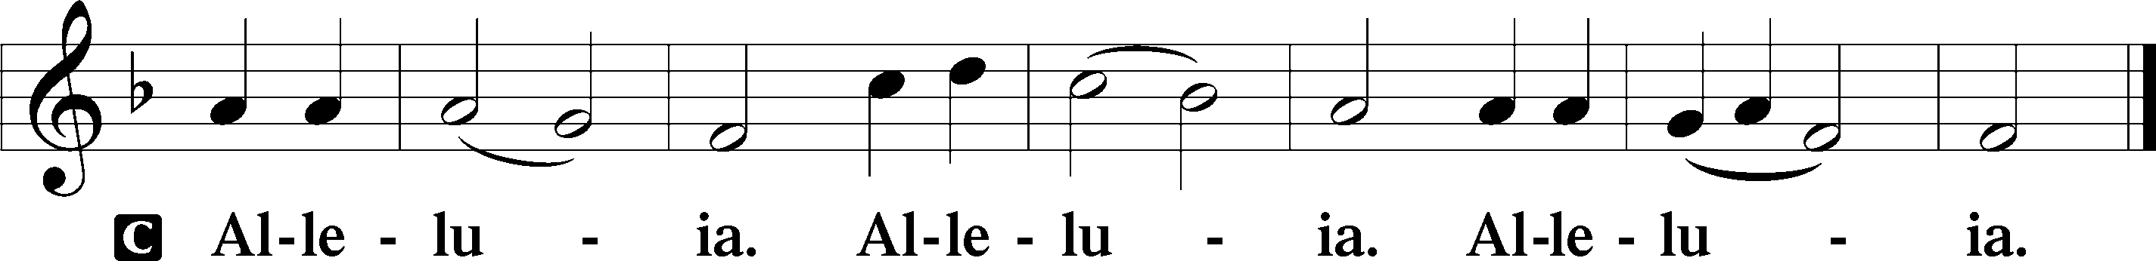

Holy Gospel: Matthew 22:34–46 (NKJV)
P The Holy Gospel according to St. Matthew, the twenty-second chapter.
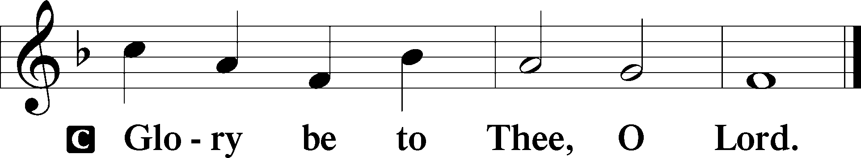

At that time: The Pharisees gathered together and came to Jesus. Then one of them, a lawyer, asked Him a question, testing Him, and saying, “Teacher, which is the great commandment in the law?” Jesus said to him, “‘You shall love the Lord your God with all your heart, with all your soul, and with all your mind.’ This is the first and great commandment. And the second is like it: ‘You shall love your neighbor as yourself.’ On these two commandments hang all the Law and the Prophets.” While the Pharisees were gathered together, Jesus asked them, saying, “What do you think about the Christ? Whose Son is He?” They said to Him, “The Son of David.” He said to them, “How then does David in the Spirit call Him ‘Lord,’ saying: ‘The Lord said to my Lord, “Sit at My right hand, till I make Your enemies Your footstool” ’? If David then calls Him ‘Lord,’ how is He his Son?” And no one was able to answer Him a word, nor from that day on did anyone dare question Him anymore.

P This is the Gospel of the Lord.
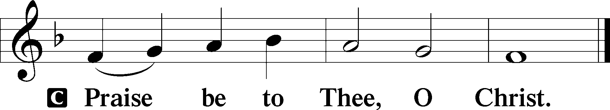

Nicene Creed
C I believe in one God,
the Father Almighty,
maker of heaven and earth
and of all things visible and invisible.

And in one Lord Jesus Christ,
the only-begotten Son of God,
begotten of His Father before all worlds,
God of God, Light of Light,
very God of very God,
begotten, not made,
being of one substance with the Father,
by whom all things were made;
who for us men and for our salvation came down from heaven
and was incarnate by the Holy Spirit of the virgin Mary
and was made man;
and was crucified also for us under Pontius Pilate.
He suffered and was buried.
And the third day He rose again according to the Scriptures
and ascended into heaven
and sits at the right hand of the Father.
And He will come again with glory to judge both the living and the dead,
whose kingdom will have no end.

And I believe in the Holy Spirit,
the Lord and giver of life,
who proceeds from the Father and the Son,
who with the Father and the Son together is worshiped and glorified,
who spoke by the prophets.
And I believe in one holy Christian and apostolic Church,
I acknowledge one Baptism for the remission of sins,
and I look for the resurrection of the dead
and the life T of the world to come. Amen.

Sit

Hymn of the Day: LSB #402 “The Only Son from Heaven”

Sermon

Stand

Offertory Psalm 51:10–12
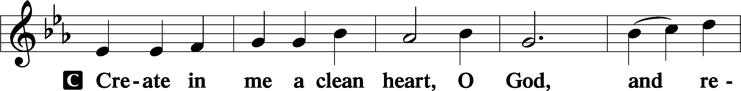
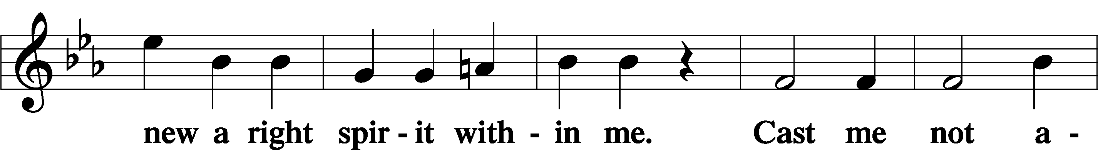
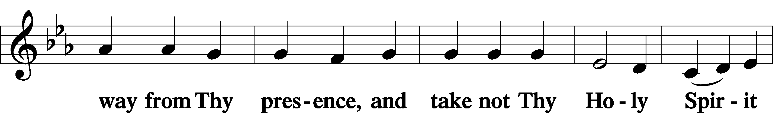
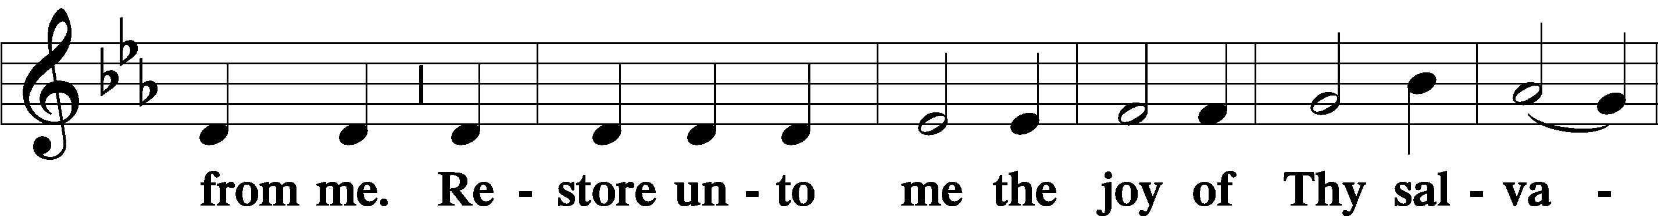
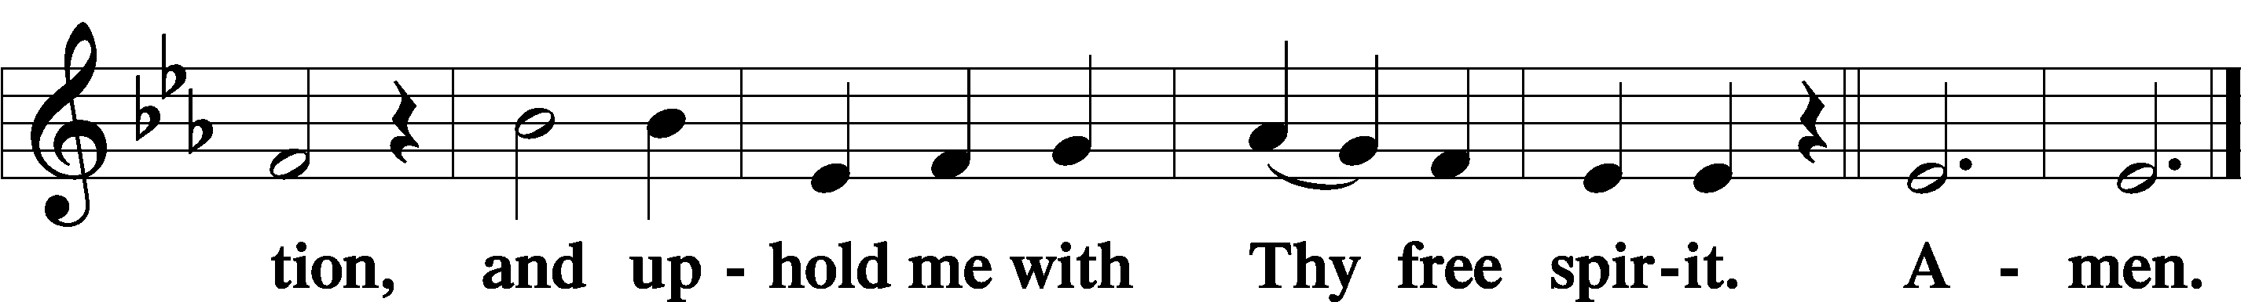

Prayer of the Church

Sit

Preparatory Hymn: LSB #745 “In God, My Faithful God”

Stand

Service of the Sacrament

Preface 2 Timothy 4:22; Colossians 3:1 Psalm 136
P The Lord be with you.
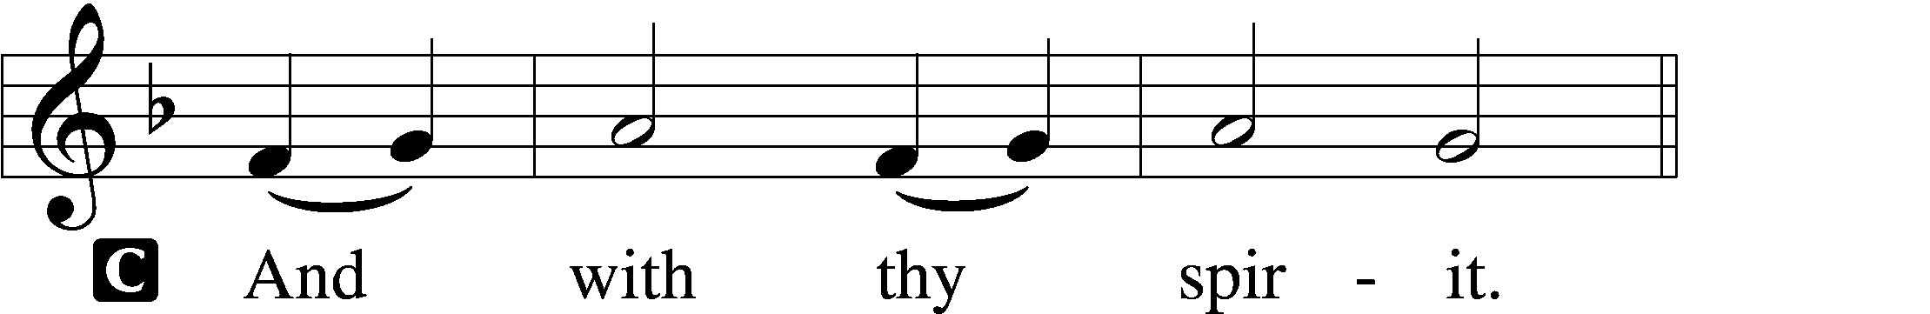

P Lift up your hearts.
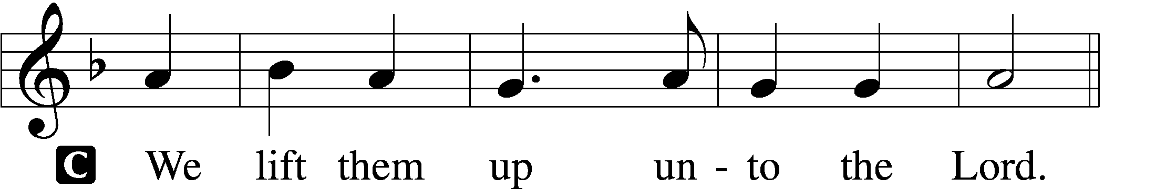

P Let us give thanks unto the Lord, our God.
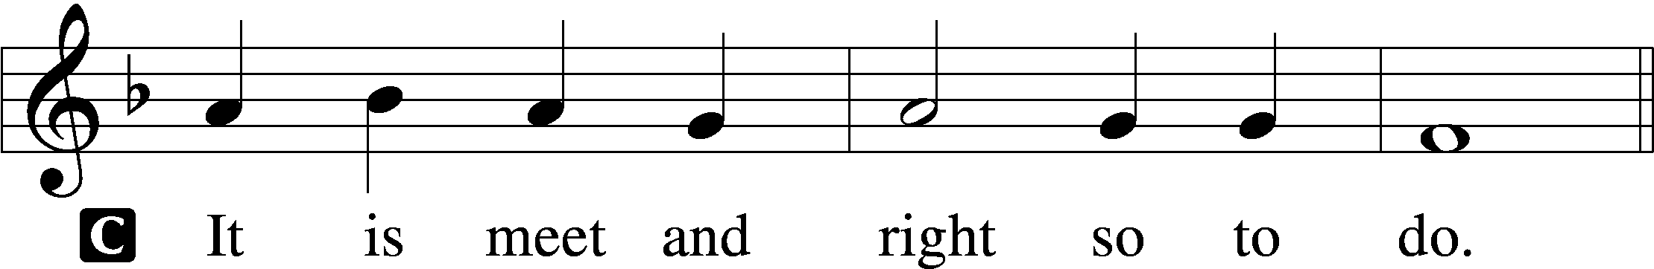

Proper Preface (Abbreviated) LSB 194
P It is truly meet, right, and salutary . . . evermore praising You and saying:

Sanctus Isaiah 6:3; Matthew 21:9
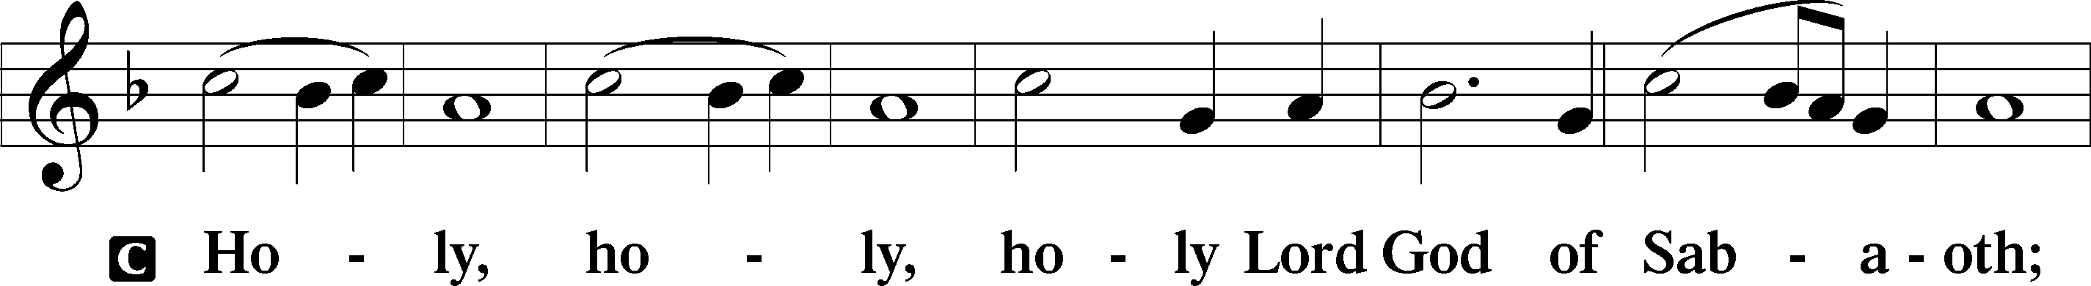
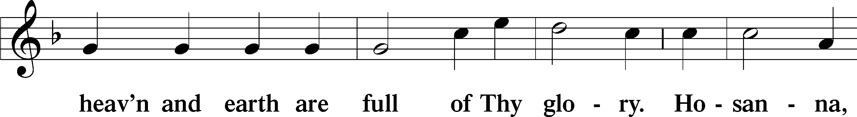
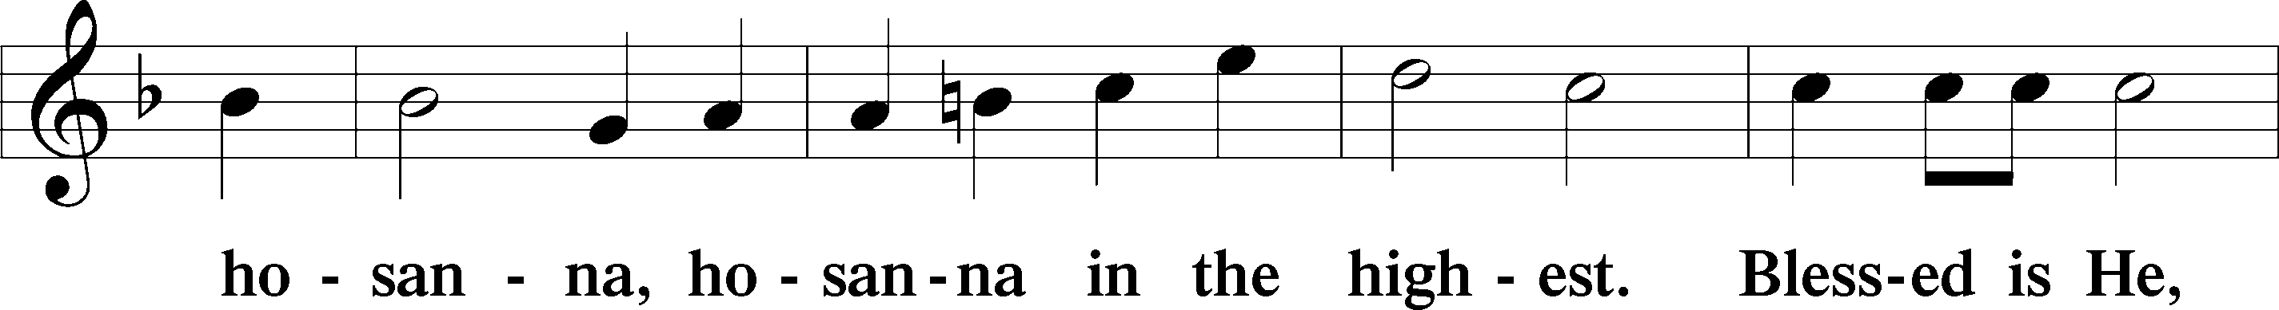
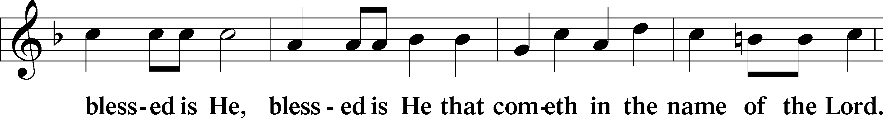
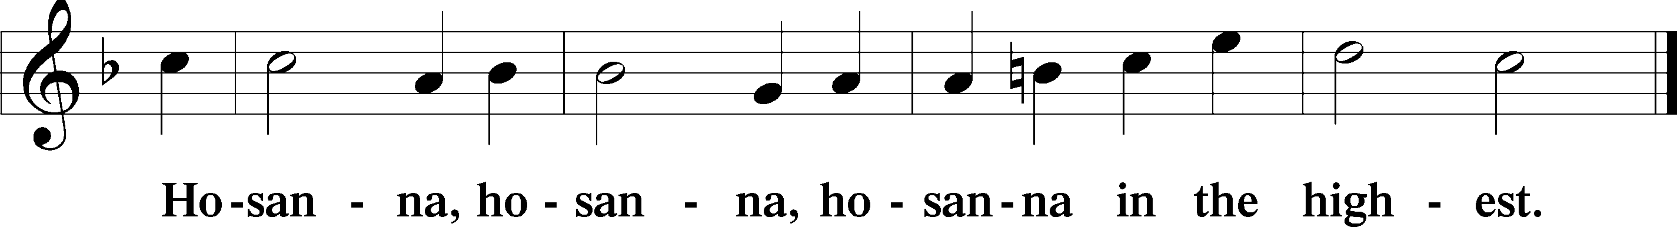

Lord’s Prayer (Congregation will pray silently as it is chanted.) Matthew 6:9–13
P Our Father who art in heaven,
hallowed be Thy name,
Thy kingdom come,
Thy will be done on earth as it is in heaven;
give us this day our daily bread;
and forgive us our trespasses as we forgive those who trespass against us;
and lead us not into temptation,
but deliver us from evil.
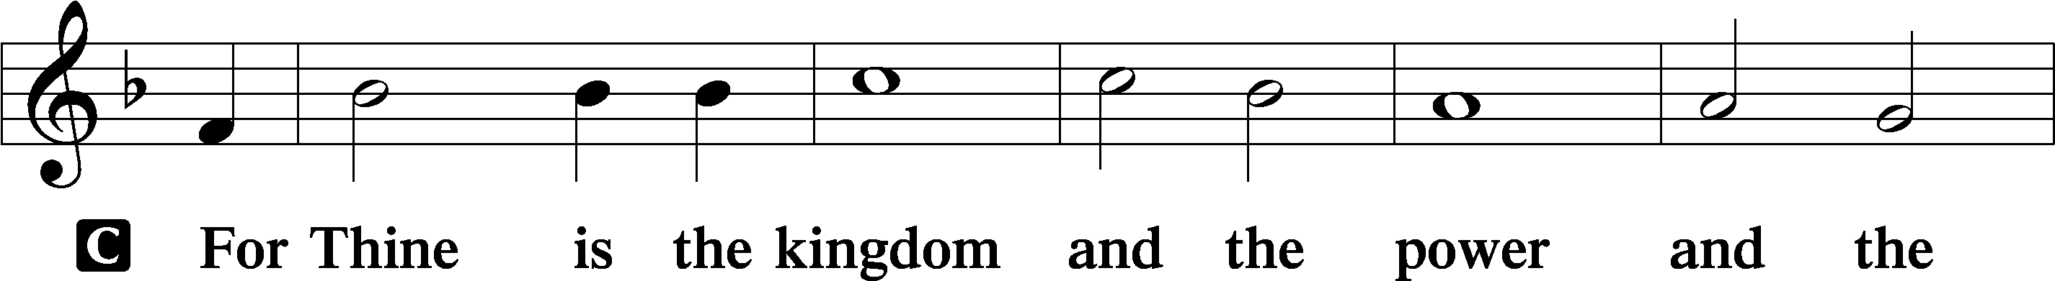
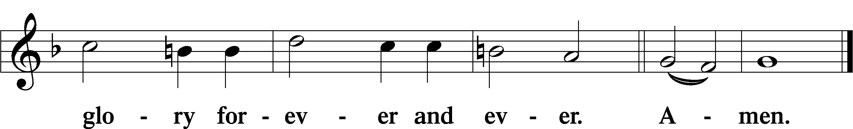
The Words of Our Lord Matthew 26:26–28; Mark 14:22–24; Luke 22:19–20; 1 Corinthians 11:23–25
P Our Lord Jesus Christ, on the night when He was betrayed, took bread, and when He had given thanks, He broke it and gave it to the disciples and said: “Take, eat; this is My T body, which is given for you. This do in remembrance of Me.”

In the same way also He took the cup after supper, and when He had given thanks, He gave it to them, saying: “Drink of it, all of you; this cup is the new testament in My T blood, which is shed for you for the forgiveness of sins. This do, as often as you drink it, in remembrance of Me.”

Pax Domini John 20:19
P The peace of the Lord be with you always.
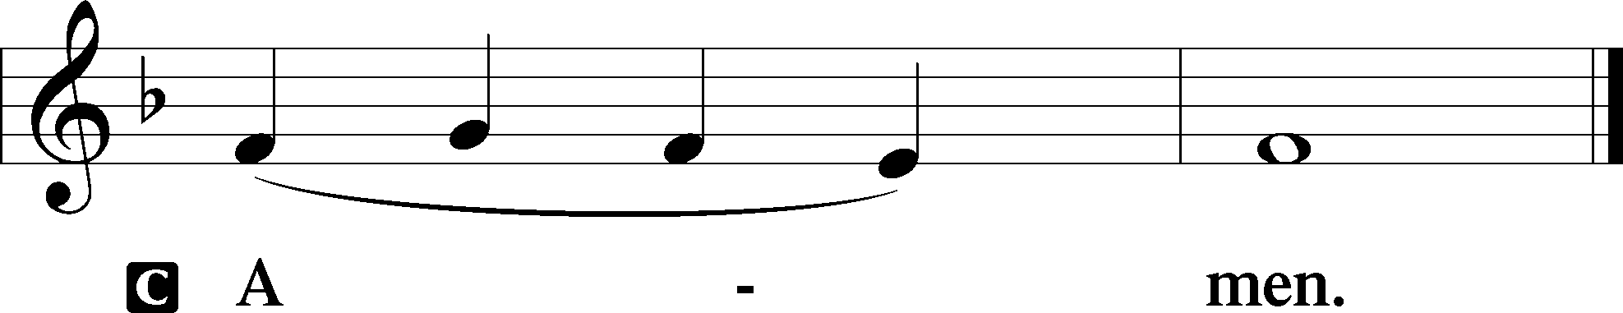

Agnus Dei John 1:29
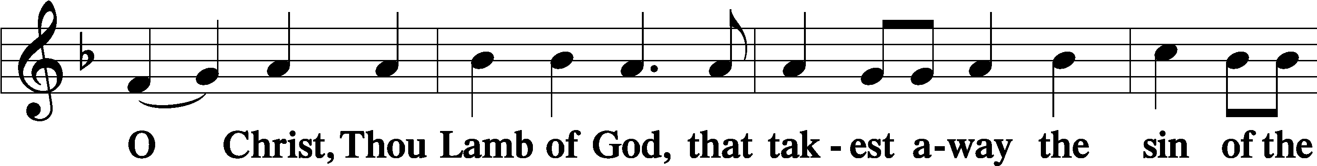
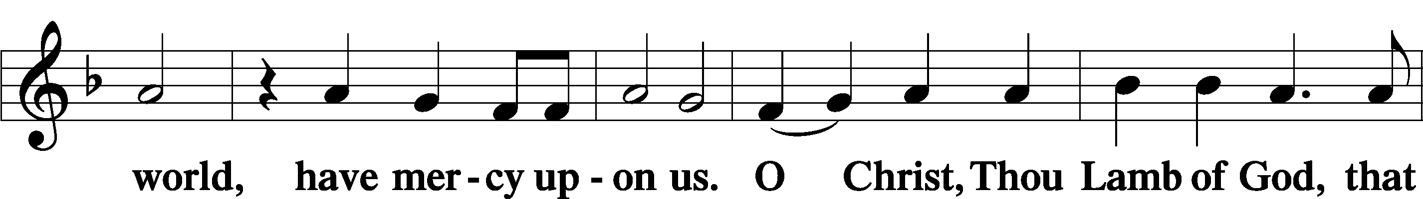
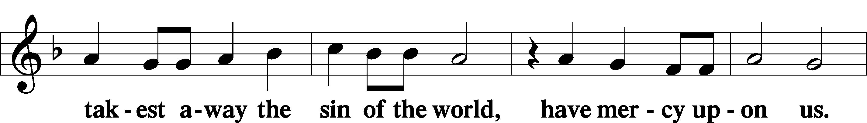
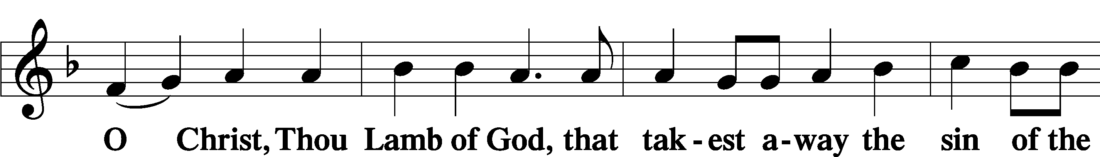
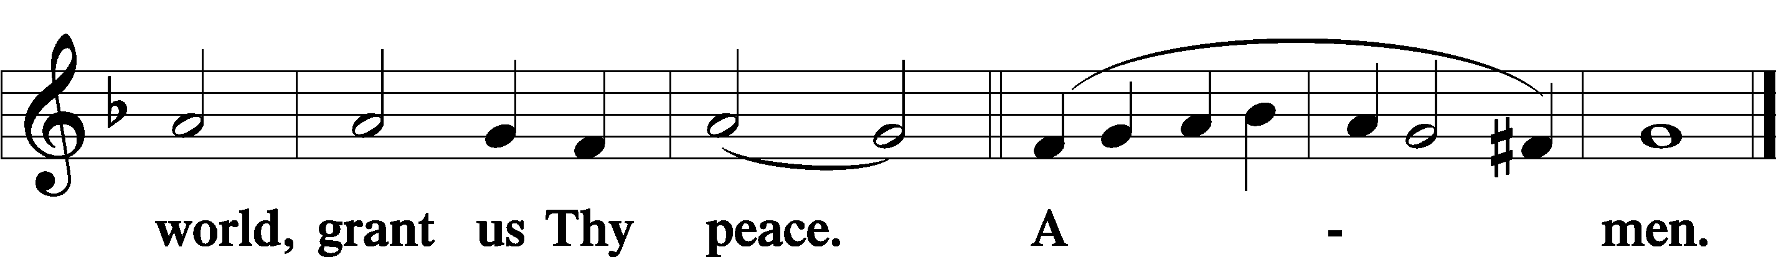
Sit
Distribution
The pastor and those who assist him receive the body and blood of Christ first and then distribute them to those who come to receive, saying:
Take, eat; this is the true body of our Lord and Savior Jesus Christ, given into death for your sins.
Amen.

Take, drink; this is the true blood of our Lord and Savior Jesus Christ, shed for the forgiveness of your sins.
Amen.

In dismissing the communicants, the following is said:
The Dismissal
P The body and blood of our Lord Jesus Christ strengthen and preserve you in body and soul to life everlasting. Depart T in peace.
C Amen.

Distribution Hymn: LSB #398 “Hail to the Lord’s Anointed”

Distribution Hymn: LSB #632 “O Jesus, Blessed Lord, to Thee”

Distribution Hymn: LSB#656 “A Mighty Fortress Is Our God” (Please, stand.)

Nunc Dimittis Luke 2:29–32
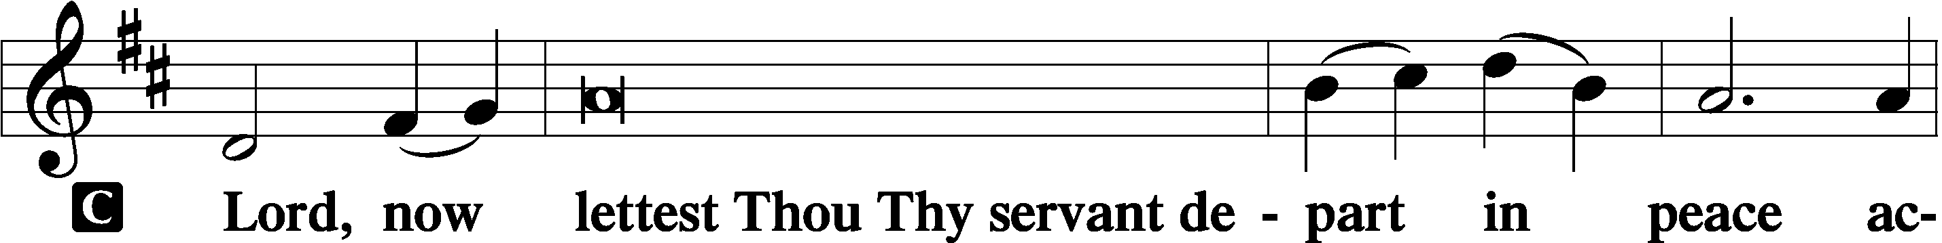
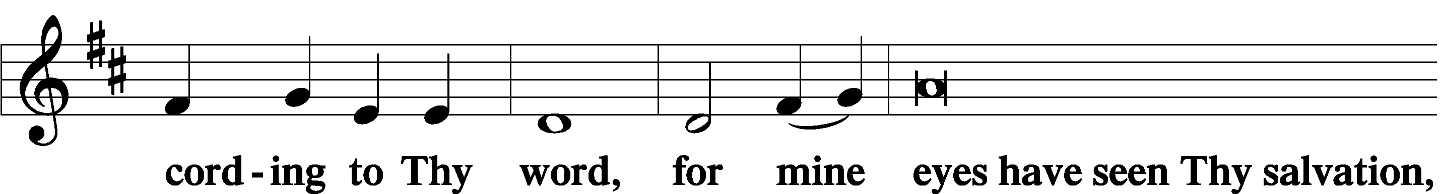
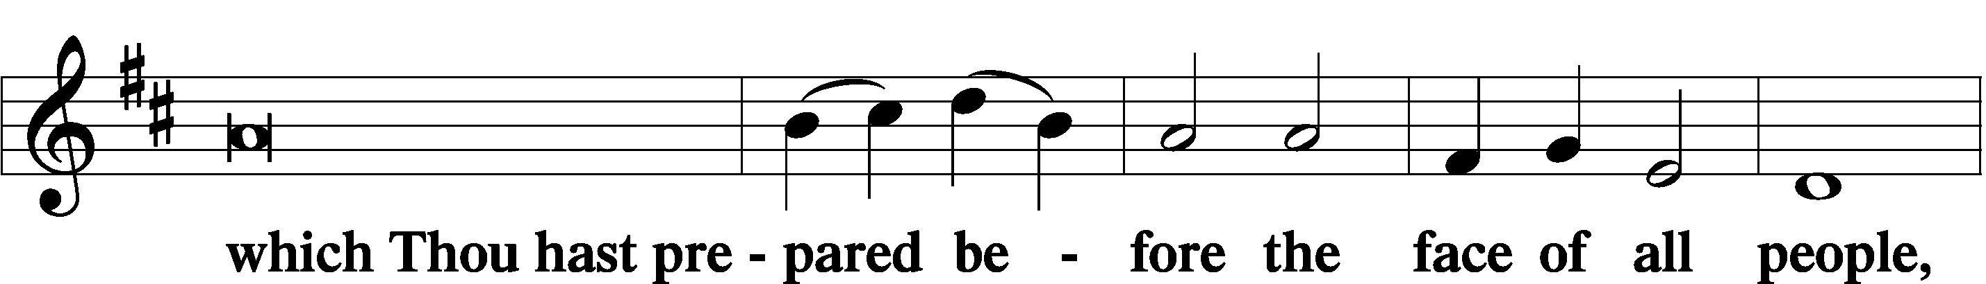
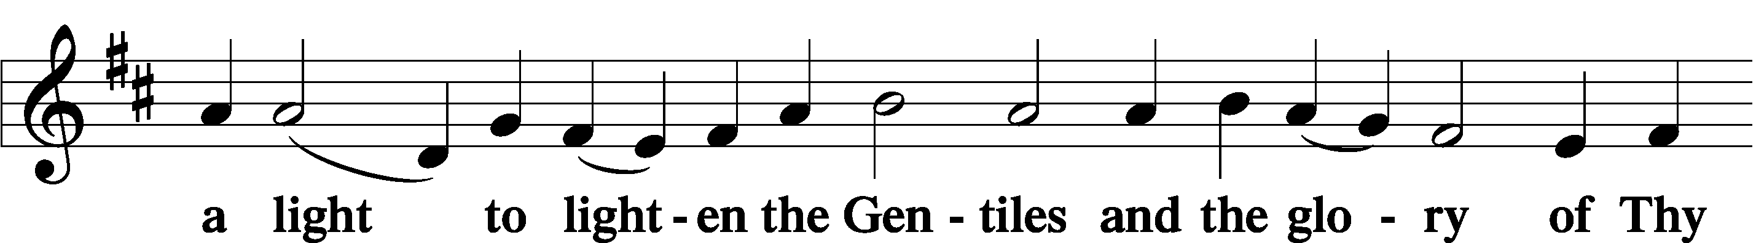
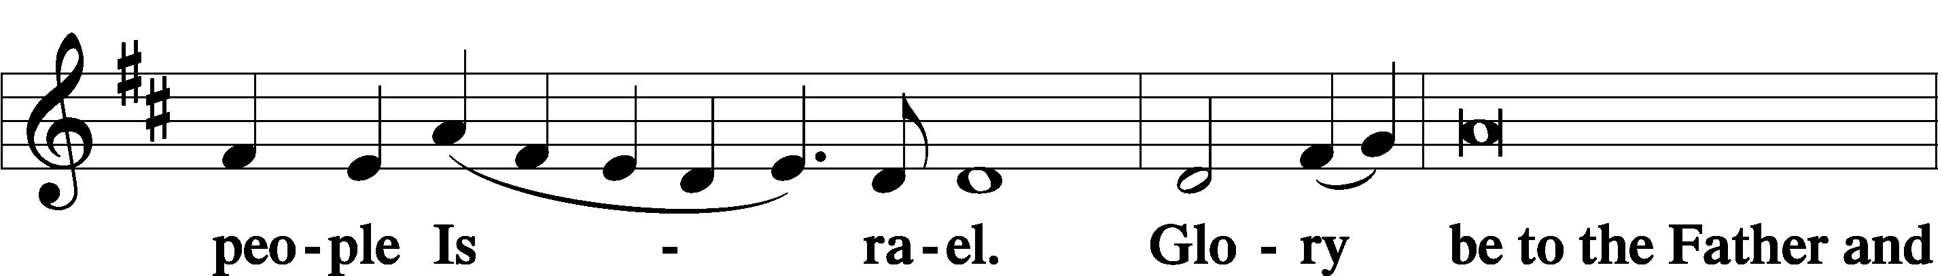
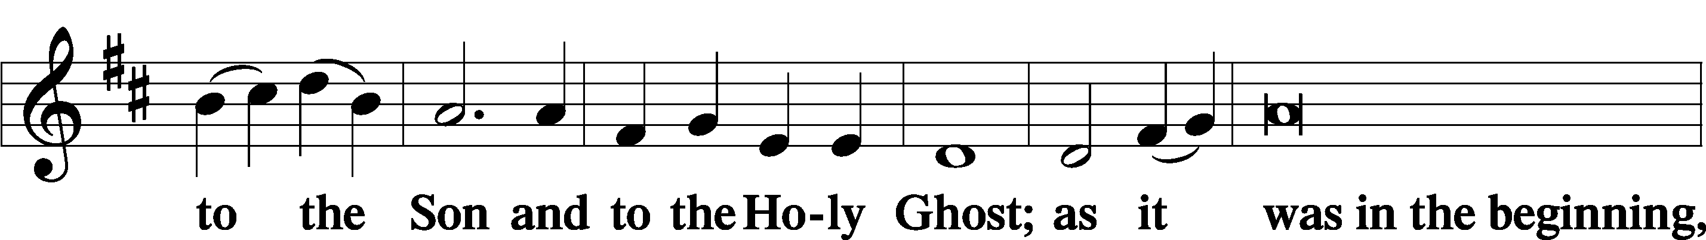
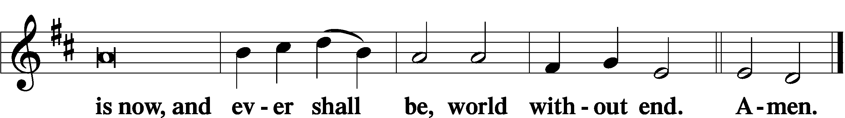

Thanksgiving Psalm 107:1
P O give thanks unto the Lord, for He is good,
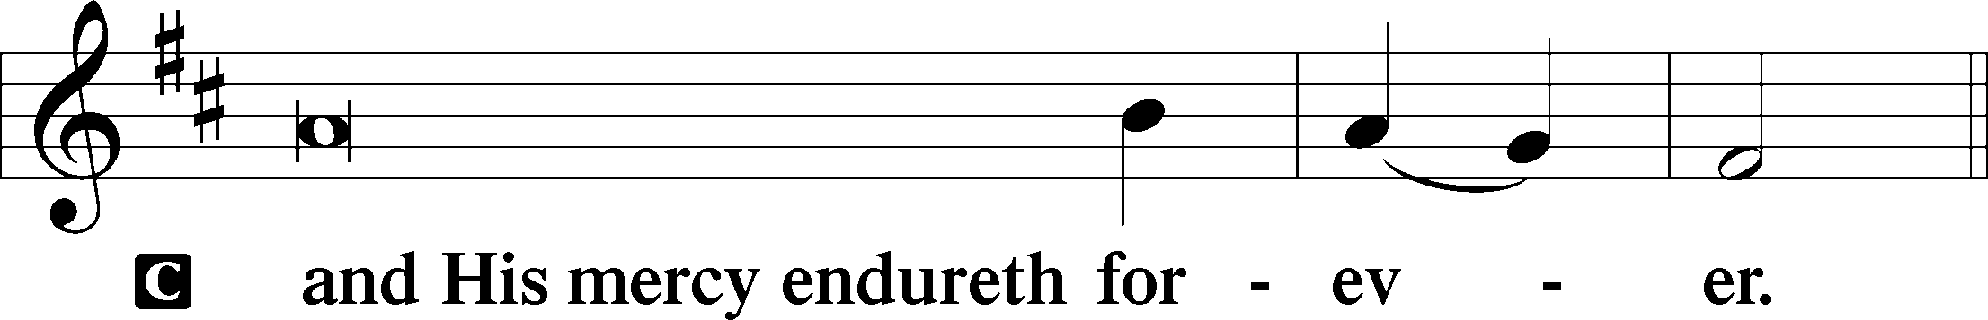

Post-Communion Collect
P Let us pray.
We give thanks to You, almighty God, that You have refreshed us through this salutary gift, and we implore You that of Your mercy You would strengthen us through the same in faith toward You and in fervent love toward one another; through Jesus Christ, Your Son, our Lord, who lives and reigns with You and the Holy Spirit, one God, now and forever.
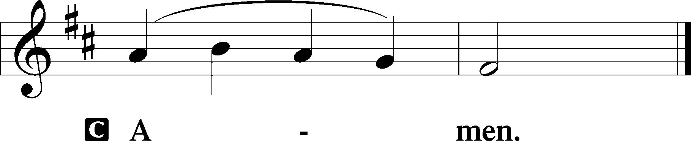

Salutation 2 Timothy 4:22
P The Lord be with you.
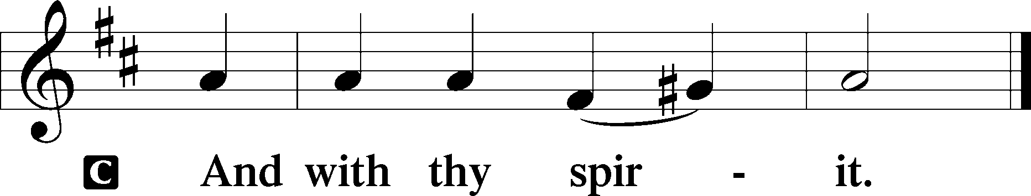

Benedicamus Psalm 103:1
P Bless we the Lord.
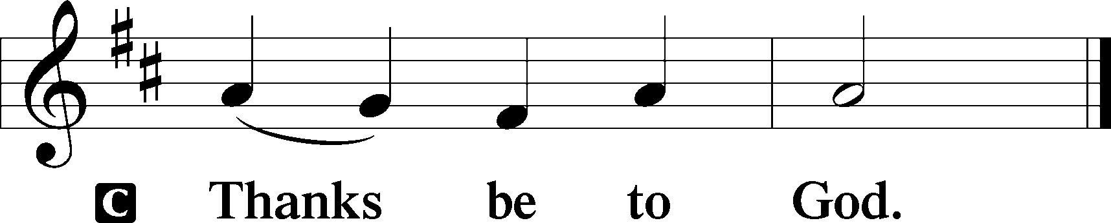

Benediction Numbers 6:24–26
P The Lord bless you and keep you.
The Lord make His face shine upon you and be gracious unto you.
The Lord lift up His countenance upon you and T give you peace.
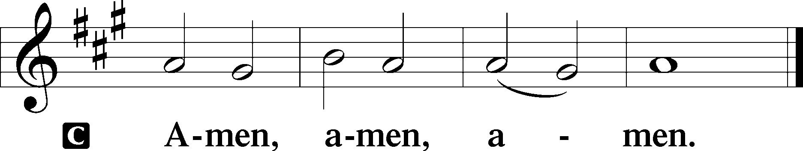

Closing Hymn: LSB #554 “O Jesus, King Most Wonderful”
fffffffffffffffffffffffffffffffffff
Silent prayer after worship: Dear Jesus, as I leave Your house, go with me and guide me through the week. Lead me to trust in You for all things, and to follow You faithfully until You receive me to Yourself in heaven. Amen.
fffffffffffffffffffffffffffffffffff
Acknowledgments
Unless otherwise indicated, Scripture quotations are from the ESV® Bible (The Holy Bible, English Standard Version®), copyright © 2001 by Crossway, a publishing ministry of Good News Publishers. Used by permission. All rights reserved.
Created by Lutheran Service Builder © 2023 Concordia Publishing House.
fffffffffffffffffffffffffffffffffff
fffffffffffffffffffffffffffffffffff
In Loving Memory of Husband, Bob Rice Joani Rice.
In Loving Memory of Vi Sakony: Ruth Meszaros (Food Pantry).
fffffffffffffffffffffffffffffffffff
Attendance: Friday, September 29, 2023: 15
Sunday, October 1, 2023: 42
fffffffffffffffffffffffffffffffffff

SCHEDULE THROUGH OCTOBER 8, 2023:

:

Today, following Worship, Fellowship Hall: Coffee Fellowship
7 pm, Fellowship Hall: AA Meeting
Monday, 6 pm, Library: Interior Committee Meeting
Tuesday, 7-9 pm, Fellowship Hall: Penn-Ohio Singers
Wednesday, 7:30 pm, Fellowship Hall: NA Meeting
Thursday, 9 am, Downstairs: Food Pantry
Next Sunday, 8 am, Fellowship Hall: Bible Study
9 am, Sanctuary: Divine Service
7 pm, Fellowship Hall: AA Meeting
fffffffffffffffffffffffffffffffffff
Our Stewardship of Treasures for the Lord:
In order to do the Lord’s work, we need $2,553.63 each week to meet our 2023 budget for general purposes and $76.92 for the SELC.

Online Figures for September 28, 2023
General Fund: $80.00
Figures for Sunday, October 1, 2023
General Fund: $1,998.00 Behind for the week: -$475.63
SELC: $170.00 Behind for the week: +$93.08
Food Pantry: $10.00
Quarterly Missions: $50.00
Capital Campaign: $235.00

For online giving, check out https://www.saintspeterandpaul.net/online-giving.
fffffffffffffffffffffffffffffffffff
THANK YOU FOR SERVING IN OCTOBER: Elder: Jonathan Baisch; Ushers: Matt Berent, Mark Gabriel, Michael Laird, & Jerome Thomas; Altarware ~ Sundays: (prior) Diane Riefstahl; (after) Oct. 29th~Elizabeth Haenftling; other~Cheryl Fedele & Clara Krivosh; Special Divine Services: Oct. 18th ~ Diane Riefstahl; Oct. 23rd & 31st ~ Elizabeth Haenftling.
fffffffffffffffffffffffffffffffffff
Bible Memory Verses ~ Week of October 8th:
For Adults: For if you live according to the flesh you will die, but if by the Spirit you put to death the deeds of the body, you will live. Romans 8:13

For Children: This commandment we have from him: whoever loves God must also love his brother. 1 John 4:21
fffffffffffffffffffffffffffffffffff
Remember the following in Prayer…
~The Hurting and Healing: Amy, Steve Antolovich, Ellen Baron^{CA}, Amy Blomenberg, Lois Bortner^{CA}, Sara Brubaker, Dee Bullock, Bev & Joe Chlpka, Susan Davies, Loretta Deal, Tim Dudash, Judith & Eddy Furey, Griffin, Peter Haenftling, Austin Hamilton, Pastor Charles Henrickson, Joan, Keith Jozwiakowski, Darla Krajci, Barbara Kreske, Jess Lavoie, Elizabeth Loughan, Paul Lucas^{CA}, Sandy Marshall, Frank Niemeyer^{CA}, Juanita Rentschler, Richard Reuning^{CA}, Nancy Robertson^{CA}, Kriss Svidro^{CA}, Joel & Peggy Wasson, Angela Weser^{CA}, and Ruth Wolf.
~The Homebound: Anna Mae Daris, Millie Elavsky, Rudy & Jean Tomko, Betty Wolf, and Ed & Millie Zachar.
~Celebrating this Week: Birthdays: Kelsey Zurawsky (10.10), Nancy Robertson (10.13), & Rebecca Marquette (10.14). Anniversary: Paul & Gretchen Andolina (10.10).
~Serving in the Military: Alex (Sasha) Carr, Duncan Vaupel, Curtis Sinewe, and Joshua Solyan.
~Community & World Needs: Those suffering due to the conflict between Ukraine and Russia; those suffering from loss and dislocation because weather disasters; those suffering from addiction and their families; Local, State, and National Government Leaders; safety for all Police Officers, Firefighters, & First Responders; the unemployed; our Fourth Quarter Local Mission: Willow Women’s Center.
*CA represents cancer.
fffffffffffffffffffffffffffffffffff
The October issue of “The Rock and the Sword” newsletter is available on tables in the narthex and by the parking lot entrance. Please also remember to pick up your copy of “Portals of Prayer” for October, November, and December. Note: If you had previously picked up a large print version which had been damaged by rain, there are now new, undamaged copies available.
PASTOR & FAMILY APPRECIATION DINNER - SATURDAY, OCT. 28th, 5 PM
Come and join us for some good food and fellowship with a special dinner in appreciation of Pastor Deal and family. There will also be a birthday cake in celebration of Loretta's 5th birthday! Mark your calendars now! You don't want to miss this time with your church family.
The organizing team will be contacting everyone to make sure all are advised and to ask what you can do to help - pray for the event, set up, prepare a salad or side dish, clean up. Main entrée and dessert will be provided! If you have any questions, you can call Bess Kleindienst at 973-768-8874.
If planning to attend, please sign either the sheet located in the narthex or by the parking lot entrance so plans can be made. We look forward to sharing in this time together and pray God's blessings on us all!
fffffffffffffffffffffffffffffffffff
Please join us following worship this morning for Coffee Fellowship! This month’s fellowship will be sponsored by past freewill offerings.
We are still seeking a sponsor for November’s fellowship. If interested, please sign the sheet posted in the narthex. Speak with Diane if you have any questions.
Also, on the coffee hutch downstairs are some ceramic coffee mugs free for the taking! Many of these bear pictures of our church and would make a nice keepsake.
fffffffffffffffffffffffffffffffffff
Up-Coming Meetings:
- Tomorrow, Monday, October 9 at 6 pm ~ Interior Committee
- Tuesday, October 16 at 6 pm ~ Constitution & Bylaws Committee
fffffffffffffffffffffffffffffffffff
This morning is “Stock the Food Pantry” Sunday. Your financial contributions will be greatly appreciated.
fffffffffffffffffffffffffffffffffff

Here to Serve
Pastor………………………………………………...……………Rev. Jacob Deal
E-mail …………………………….……pastordeal@saintspeterandpaul.net
Phone Number……………………..…………………724-347-3620 (Option 2)
Church Office………………………..…………………724-347-3620 (Option 3)
Website …………………………………………www.saintspeterandpaul.net
Secretary…………………………………………………………Diane Riefstahl
E-mail ………………………………………church@saintspeterandpaul.net
Website …………………………………………www.saintspeterandpaul.net
Food Pantry (email): ……………foodpantry@saintspeterandpaul.net
Congregation President………………………………….…Jonathan Baisch
Church Elder …………………………………………...……. Jonathan Baisch
Organist………………………………………………..….…Rebecca Marquette
Choir Director…………………………………………………….…Chris Nelson
AA Contact: Steve………………………………………………...…724-813-2358
NA Contact: Larry……………………………………..…………..724-977-8733
fffffffffffffffffffffffffffffffffff
If needing to get into the church building during the week, please phone first to make certain someone is here to let you in.

