Sts. Peter & Paul
Evangelical Lutheran Church
Lutheran Church-Missouri Synod
Founded-1917

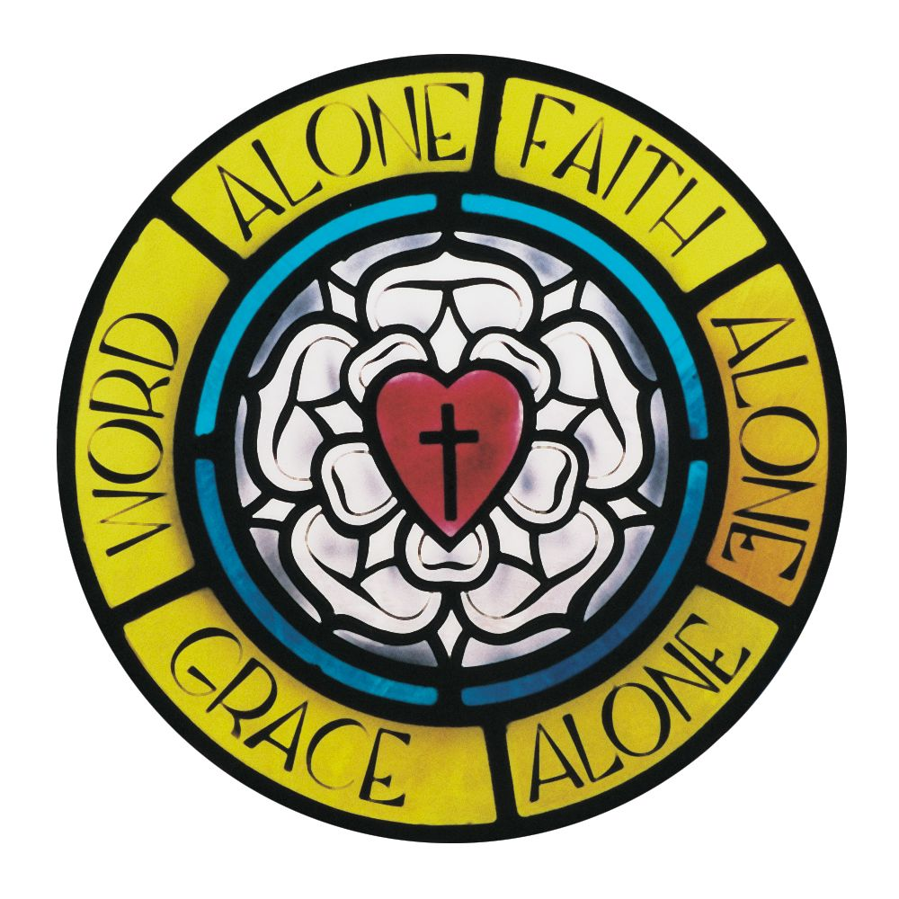

October 31, 2023

699 Stambaugh Ave.
Sharon, Pennsylvania 16146

“I was glad when they said to me,
Let us go to the house of the LORD!”
Psalm 122:1
Sts. Peter & Paul Evangelical Lutheran Church, LC-MS
REFORMATION DAY
October 31, 2023
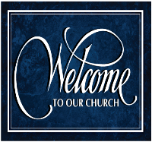
A special welcome to our guests this day! If you would like more information about The Lutheran Church - Missouri Synod, or this congregation, please speak with Pastor Deal or an Elder after the service.
Members & Guests: Don’t be embarrassed if your children make noise during the worship service, all children do. We encourage families to worship together but, if you feel the need, there are pews in the rear of the Church which are reserved for young families on both sides of the sanctuary. There is also a quiet room available to you, located next to the sanctuary (formerly the Pastor’s office), where you would be able to follow along with the service.

Today’s service includes the Sacrament of Holy Communion. If during this past year, you have not worshipped with us and been communed, we respectfully ask that you do not partake of this sacrament this day before first speaking with Pastor Deal.
If visiting from a sister congregation of the LC-MS and are in good standing, please inform Pastor Deal of your desire to commune prior to the service.
If wishing to receive a blessing during communion, please approach with your arms crossed.

CONTACT INFORMATION
Pastor Deal: pastordeal@saintspeterandpaul.net or 724-347-3620 (opt. 2)
Church Office: church@saintspeterandpaul.net or 724-347-3620 (opt. 3)
Secretary’s Office: The office will be open Mon. (8:30 am–5 pm) & Thurs. (8:30 am-10 am; 11 am-5 pm).

Silent prayer before worship: Almighty God, by the power of Your Holy Word You brought new life to Your church over 500 years ago. Continue to bring new life to my soul through the Gospel of Jesus Christ. In Jesus’ name. Amen.
Confession and Absolution

Stand

Opening Hymn: LSB #656 “A Mighty Fortress Is Our God”

The sign of the cross may be made by all in remembrance of their Baptism.

Invocation
P In the name of the Father and of the T Son and of the Holy Spirit.
C Amen.

Exhortation Hebrews 10:22; Psalm 124:8; Psalm 32:5
P Beloved in the Lord! Let us draw near with a true heart and confess our sins unto God our Father, beseeching Him in the name of our Lord Jesus Christ to grant us forgiveness.

P Our help is in the name of the Lord,
C who made heaven and earth.
P I said, I will confess my transgressions unto the Lord,
C and You forgave the iniquity of my sin.

Silence for reflection on God’s Word and for self-examination.

Confession of Sins
P O almighty God, merciful Father,
C I, a poor, miserable sinner, confess unto You all my sins and iniquities with which I have ever offended You and justly deserved Your temporal and eternal punishment. But I am heartily sorry for them and sincerely repent of them, and I pray You of Your boundless mercy and for the sake of the holy, innocent, bitter sufferings and death of Your beloved Son, Jesus Christ, to be gracious and merciful to me, a poor, sinful being.

Absolution [John 20:19–23]
P Upon this your confession, I, by virtue of my office, as a called and ordained servant of the Word, announce the grace of God unto all of you, and in the stead and by the command of my Lord Jesus Christ I forgive you all your sins in the name of the Father and of the T Son and of the Holy Spirit.
C Amen.
Service of the Word

Introit Psalm 34:1–2, 11, 22; antiphon: Psalm 119:46
I will speak of your testimonies before kings, | [O Lord,]*
and shall not be | put to shame.
I will bless the Lord at | all times;*
his praise shall continually be | in my mouth.
My soul makes its boast | in the Lord;*
let the humble hear | and be glad.
Come, O children, lis- | ten to me;*
I will teach you the fear | of the Lord.
The Lord redeems the life of his | servants;*
none of those who take refuge in him will | be condemned.
I will speak of your testimonies before kings, | [O Lord,]*
and shall not be | put to shame.

Gloria Patri
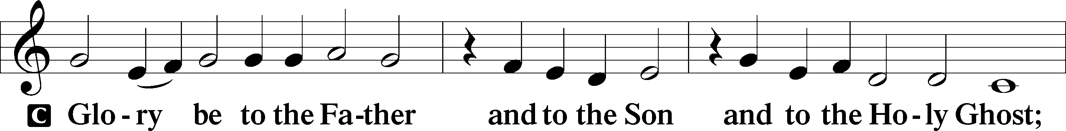
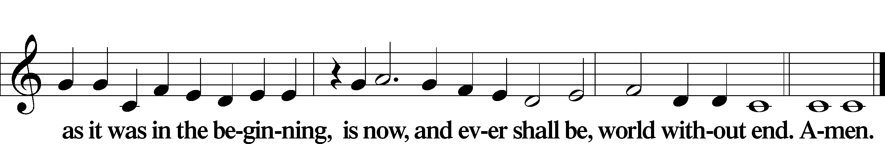
Kyrie Mark 10:47
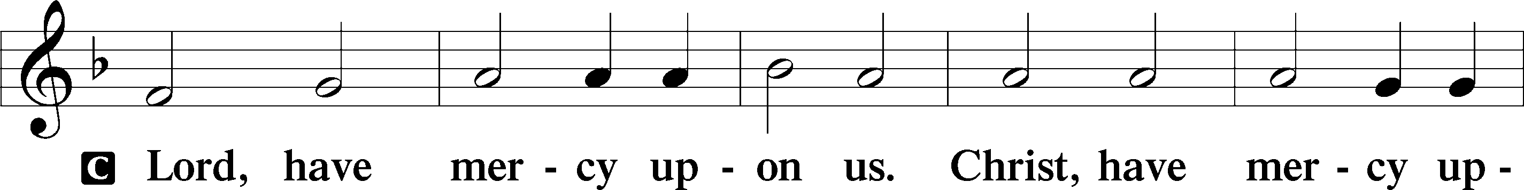
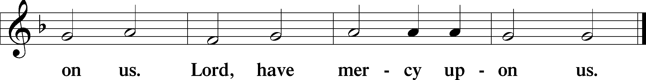

Gloria in Excelsis Luke 2:14; John 1:29
P Glory be to God on high:
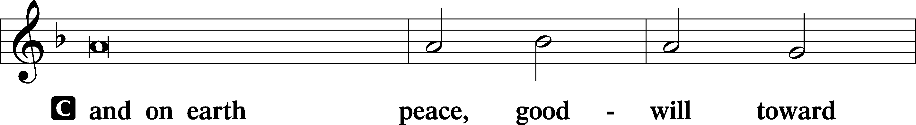
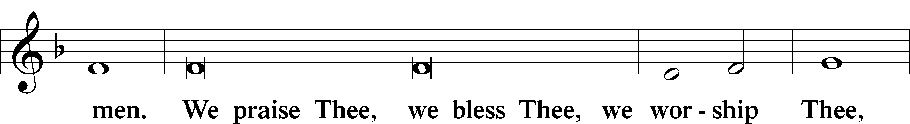
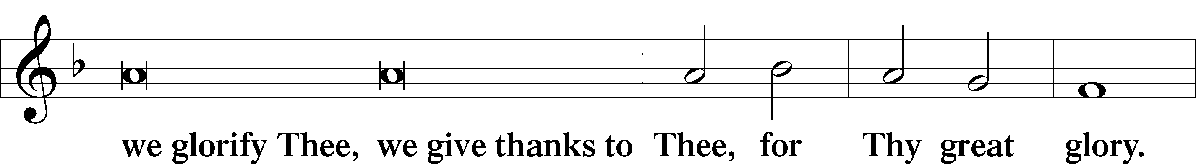
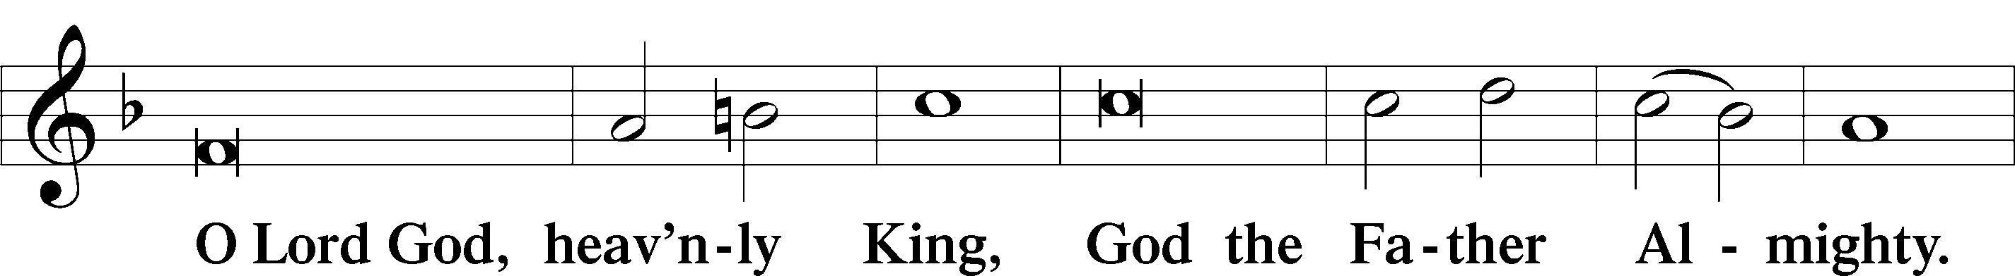
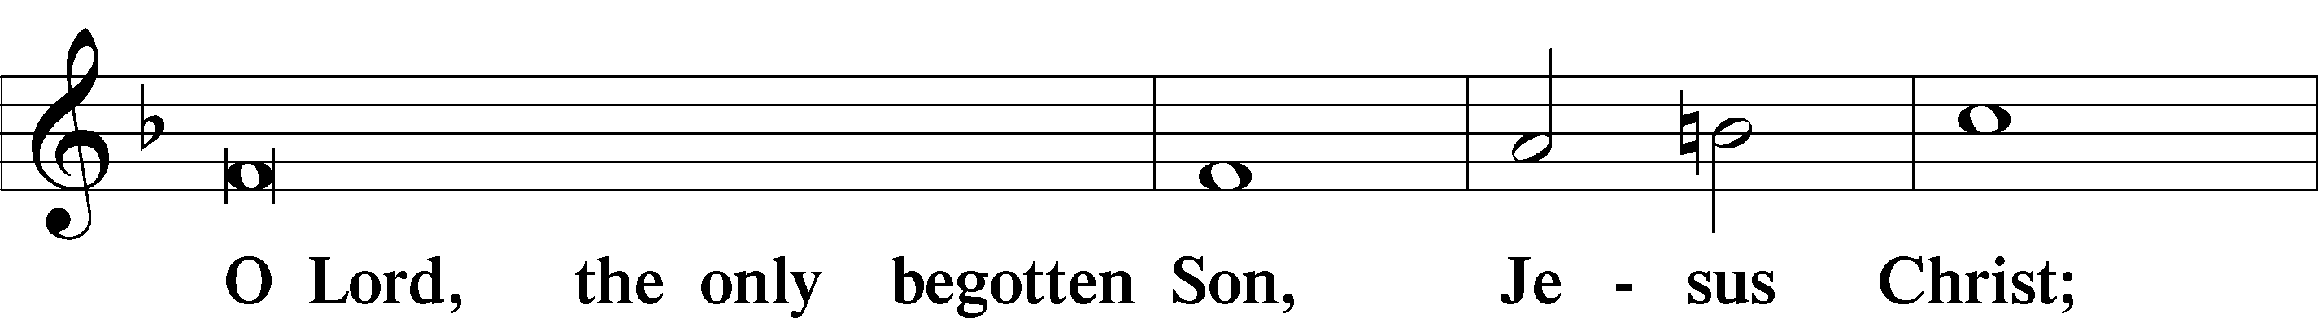
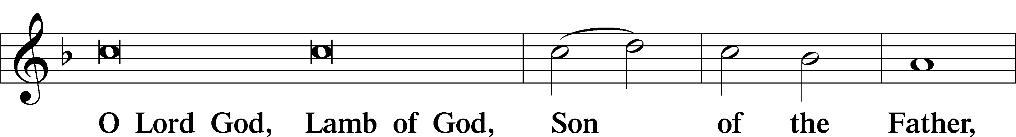
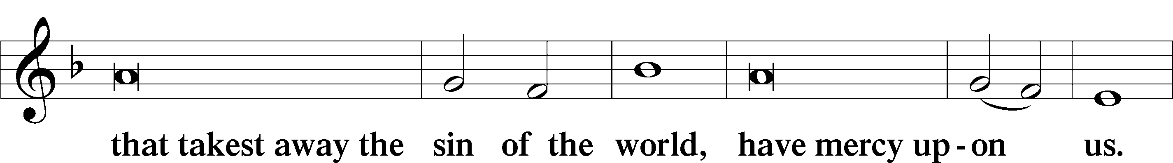
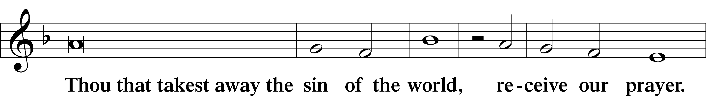
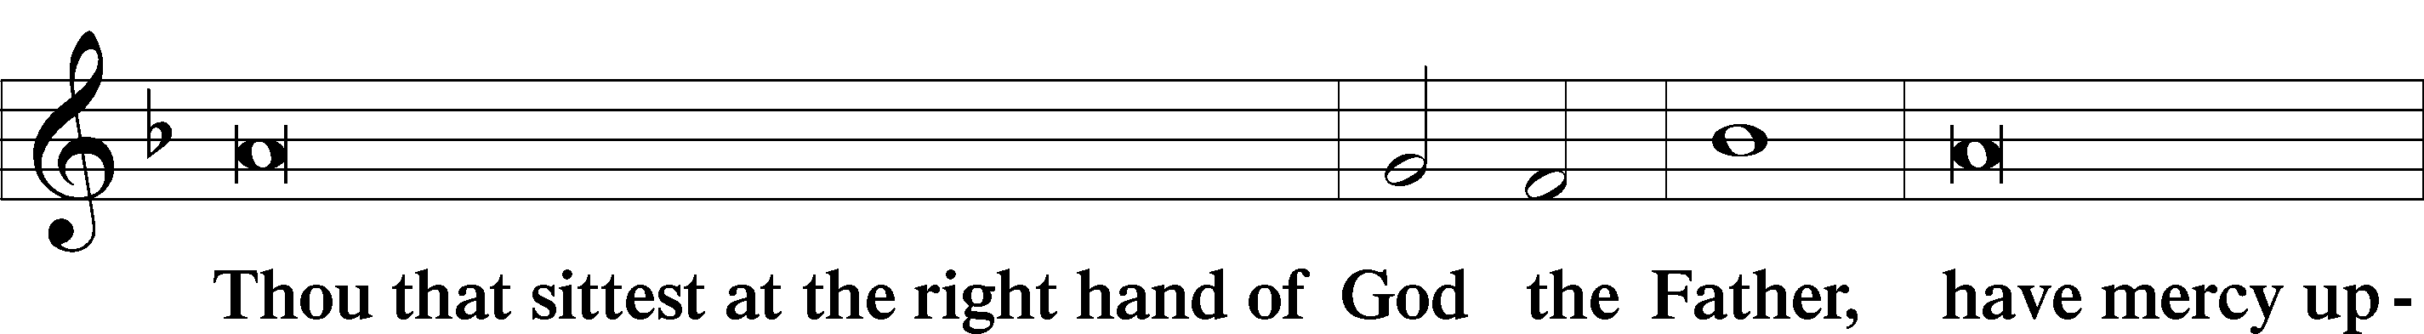
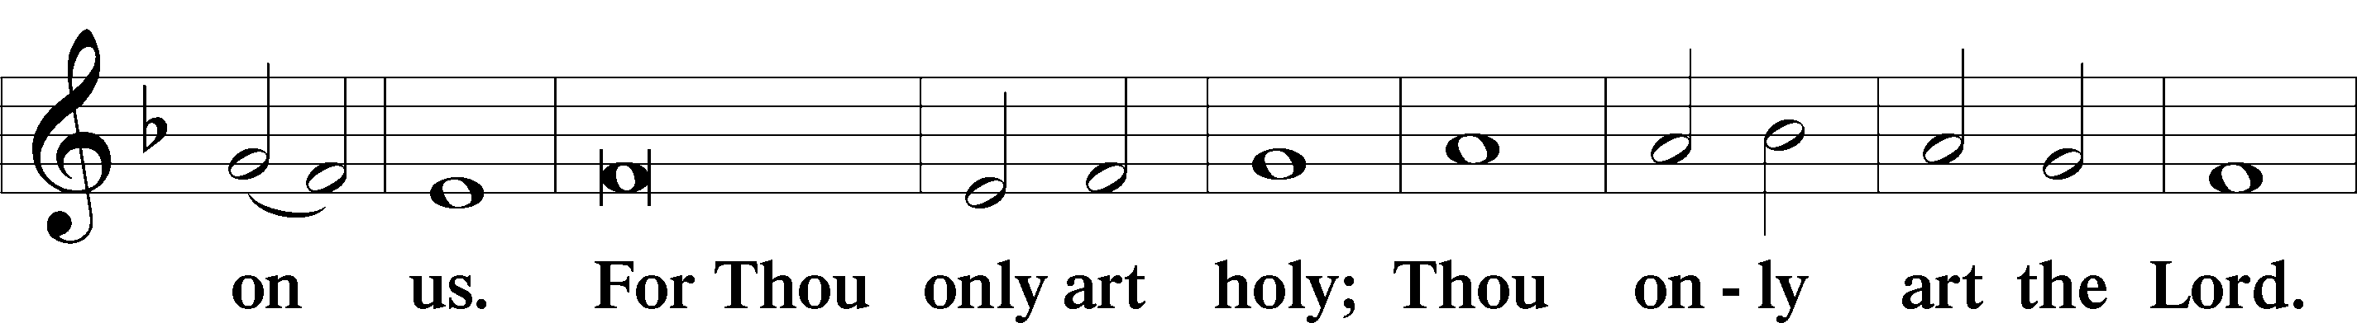
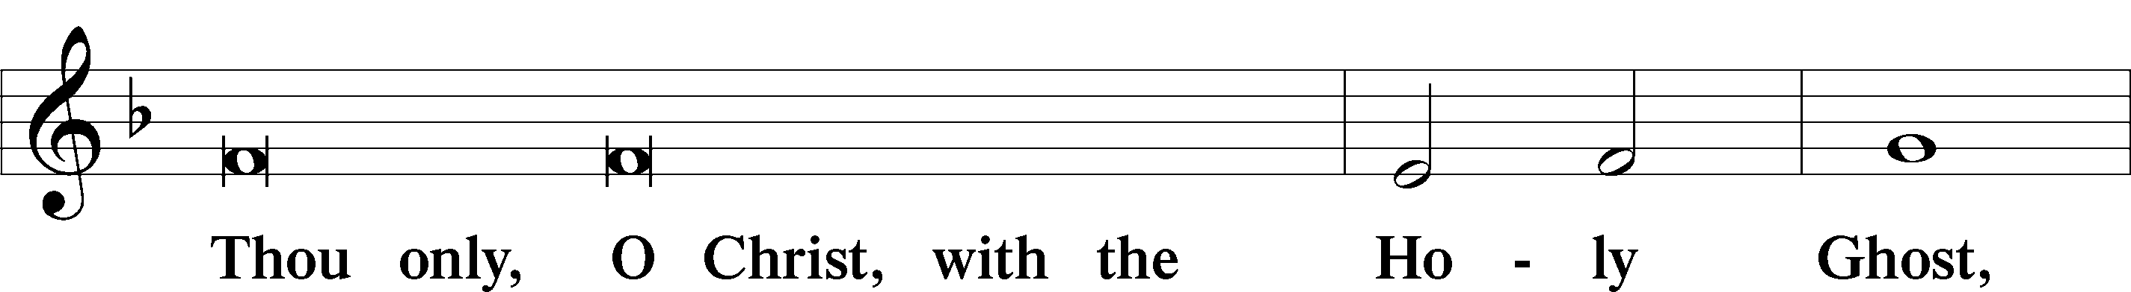
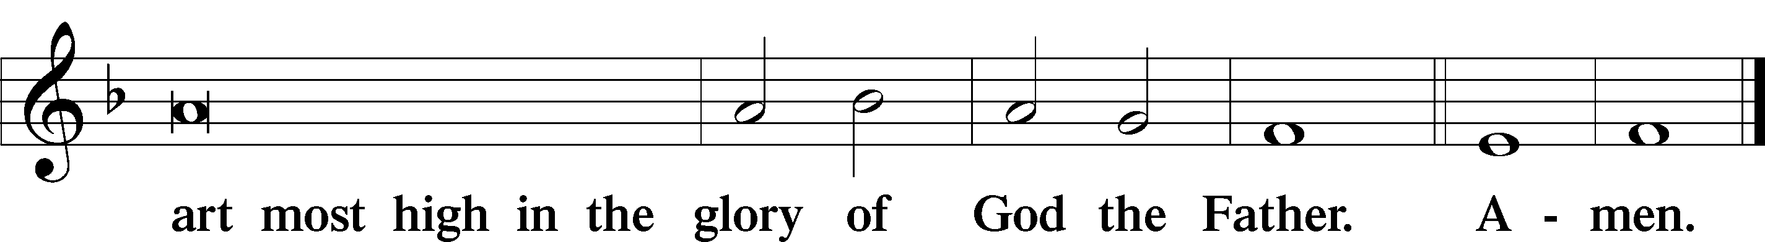

Salutation and Collect of the Day: Reformation Day
P The Lord be with you.
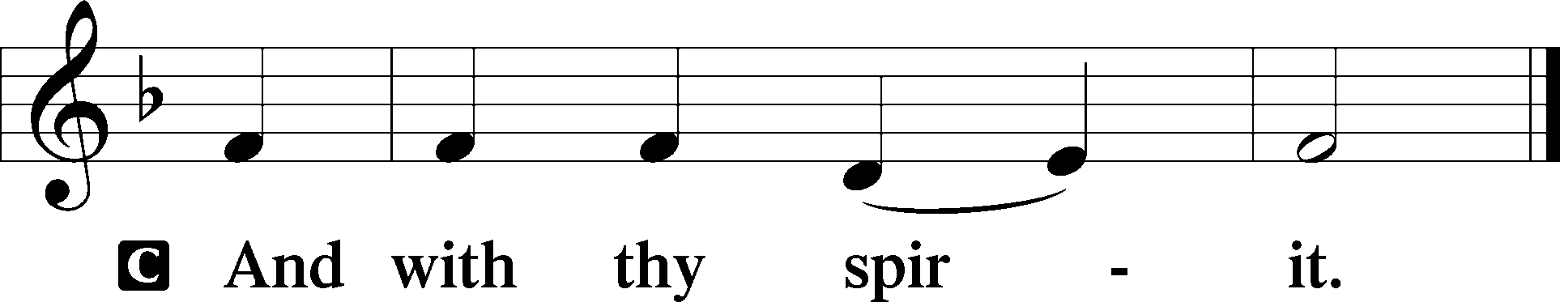

P Let us pray.
Almighty and gracious Lord, pour out Your Holy Spirit on Your faithful people. Keep us steadfast in Your grace and truth, protect and deliver us in times of temptation, defend us against all enemies, and grant to Your Church Your saving peace; through Jesus Christ, Your Son, our Lord, who lives and reigns with You and the Holy Spirit, one God, now and forever.
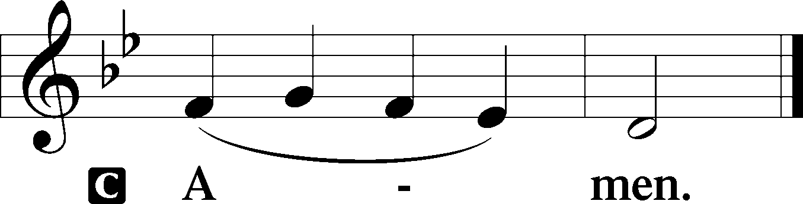
Sit

First Reading: Revelation 14:6–7 (NKJV)
In those days: I, John, saw another angel flying in the midst of heaven, having the everlasting gospel to preach to those who dwell on the earth—to every nation, tribe, tongue, and people—saying with a loud voice, “Fear God and give glory to Him, for the hour of His judgment has come; and worship Him who made heaven and earth, the sea and springs of water.”

P This is the Word of the Lord.
C Thanks be to God.

Gradual Psalm 48:1a, 12–14a
Great is the Lord and greatly | to be praised*
in the city | of our God!
Walk about Zion, go around her, number her | towers,*
consider well her ramparts, go through her | citadels,
that you may tell the next gener- | ation*
that this is God, our God forever and | ever.

Epistle: Romans 3:19–28 (NKJV)
Brethren: We know that whatever the law says, it says to those who are under the law, that every mouth may be stopped, and all the world may become guilty before God. Therefore by the deeds of the law no flesh will be justified in His sight, for by the law is the knowledge of sin. But now the righteousness of God apart from the law is revealed, being witnessed by the Law and the Prophets, even the righteousness of God, through faith in Jesus Christ, to all and on all who believe. For there is no difference; for all have sinned and fall short of the glory of God, being justified freely by His grace through the redemption that is in Christ Jesus, whom God set forth as a propitiation by His blood, through faith, to demonstrate His righteousness, because in His forbearance God had passed over the sins that were previously committed, to demonstrate at the present time His righteousness, that He might be just and the justifier of the one who has faith in Jesus. Where is boasting then? It is excluded. By what law? Of works? No, but by the law of faith. Therefore we conclude that a man is justified by faith apart from the deeds of the law.

P This is the Word of the Lord.
C Thanks be to God.

Stand

Verse Luke 12:32
Alleluia. Fear not, little flock, for it is your Father’s good pleasure to give you the kingdom. Alleluia.

Alleluia
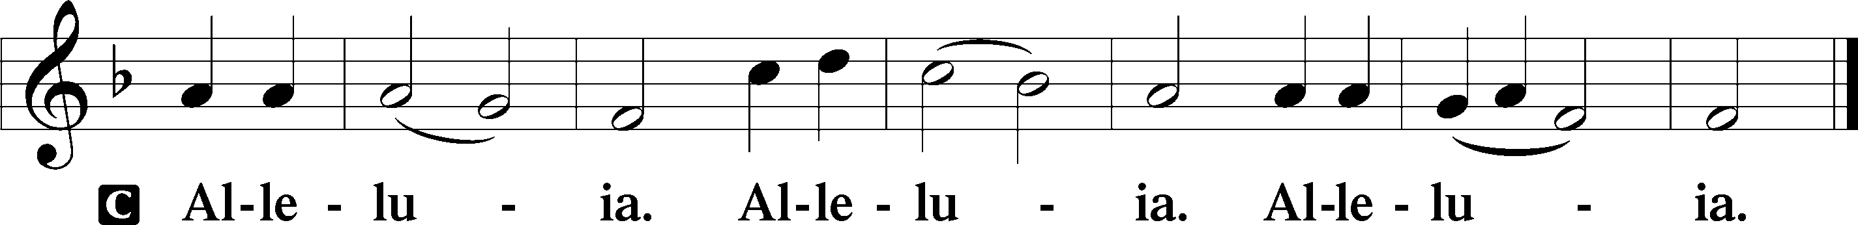

Holy Gospel: Matthew 11:12-15 (NKJV)
P The Holy Gospel according to St. Matthew, the eleventh chapter.
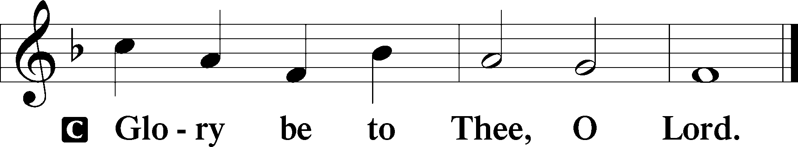

At that time Jesus said to His disciples and the multitude of the Jews: “From the days of John the Baptist until now the kingdom of heaven suffers violence, and the violent take it by force. For all the prophets and the law prophesied until John. And if you are willing to receive it, he is Elijah who is to come. He who has ears to hear, let him hear!”

P This is the Gospel of the Lord.
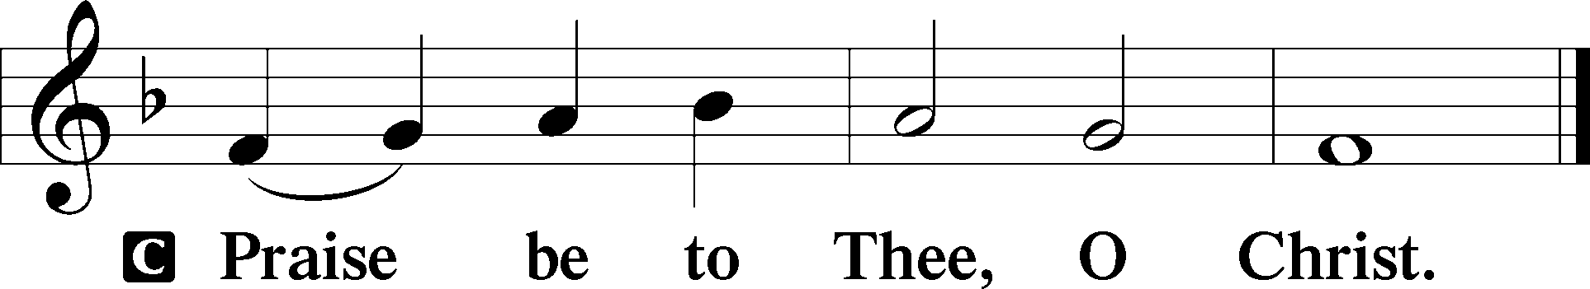

Nicene Creed
C I believe in one God,
the Father Almighty,
maker of heaven and earth
and of all things visible and invisible.
And in one Lord Jesus Christ,
the only-begotten Son of God,
begotten of His Father before all worlds,
God of God, Light of Light,
very God of very God,
begotten, not made,
being of one substance with the Father,
by whom all things were made;
who for us men and for our salvation came down from heaven
and was incarnate by the Holy Spirit of the virgin Mary
and was made man;
and was crucified also for us under Pontius Pilate.
He suffered and was buried.
And the third day He rose again according to the Scriptures
and ascended into heaven
and sits at the right hand of the Father.
And He will come again with glory to judge both the living and the dead,
whose kingdom will have no end.

And I believe in the Holy Spirit,
the Lord and giver of life,
who proceeds from the Father and the Son,
who with the Father and the Son together is worshiped and glorified,
who spoke by the prophets.
And I believe in one holy Christian and apostolic Church,
I acknowledge one Baptism for the remission of sins,
and I look for the resurrection of the dead
and the life T of the world to come. Amen.
Sit

Hymn of the Day: LSB #555 “Salvation unto Us Has Come”

Sermon

Stand

Offertory Psalm 51:10–12
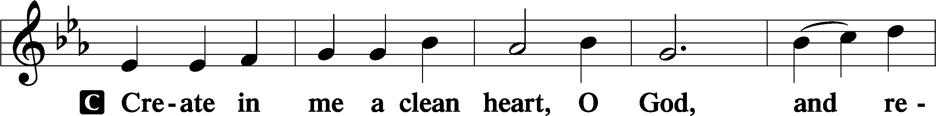
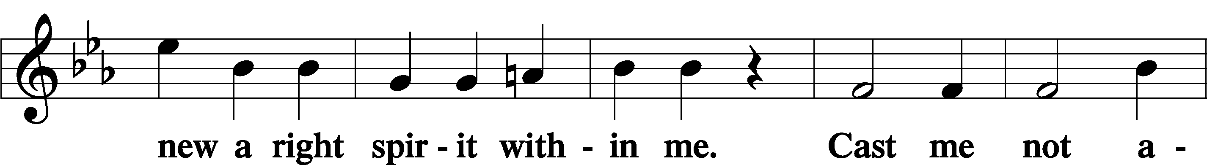
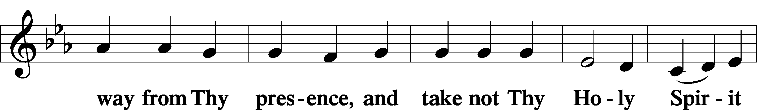
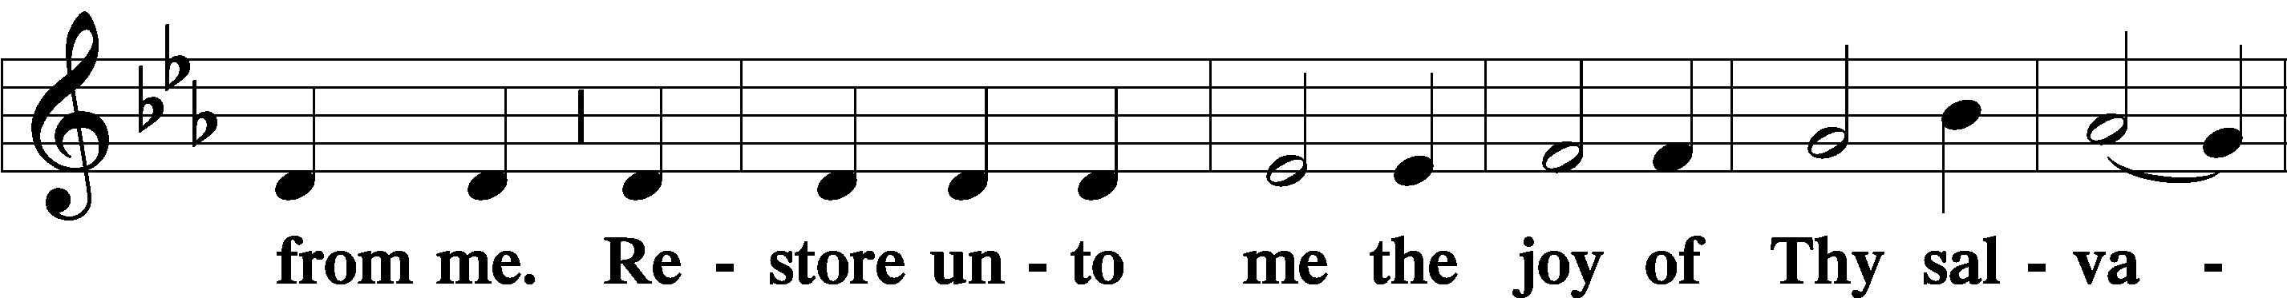
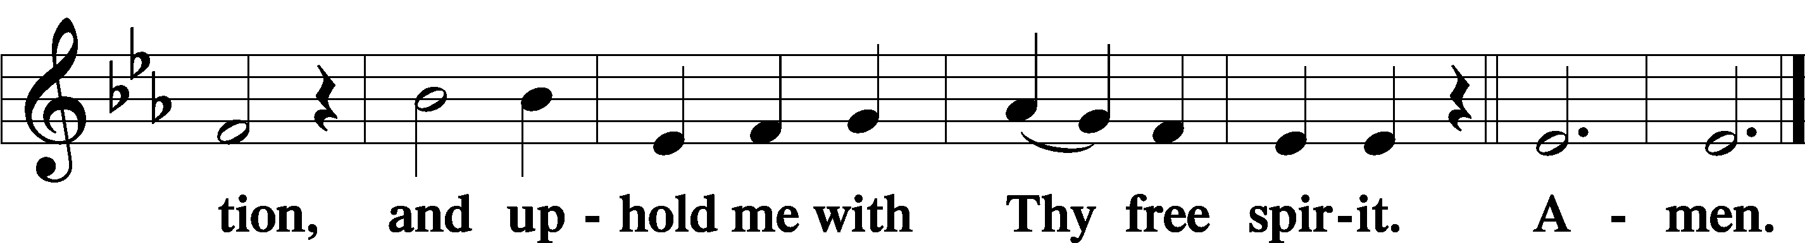

Prayer of the Church

Sit

Preparatory Hymn: LSB #794 “The Lord, My God, Be Praised”

Service of the Sacrament

Preface 2 Timothy 4:22; Colossians 3:1 Psalm 136
P The Lord be with you.
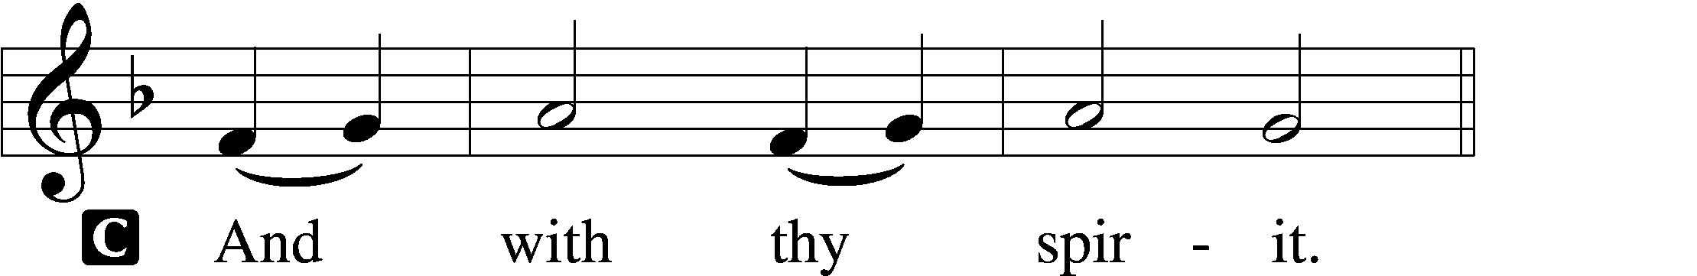

P Lift up your hearts.
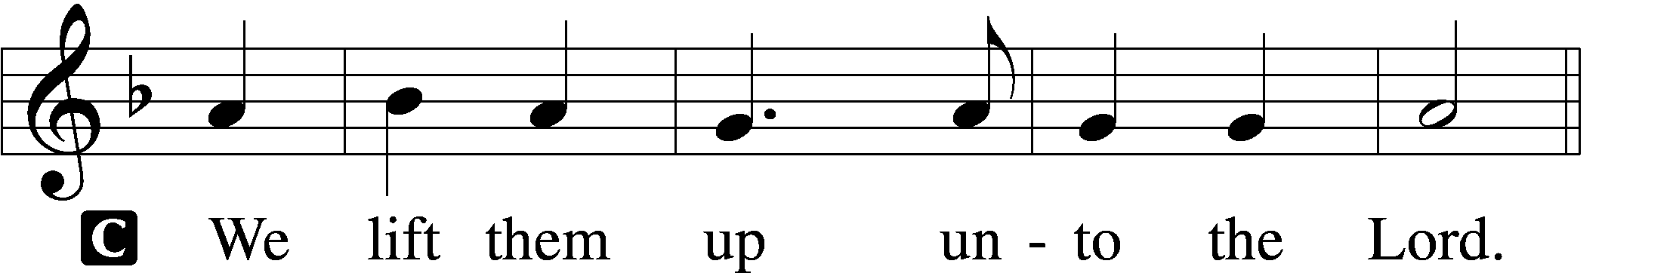

P Let us give thanks unto the Lord, our God.
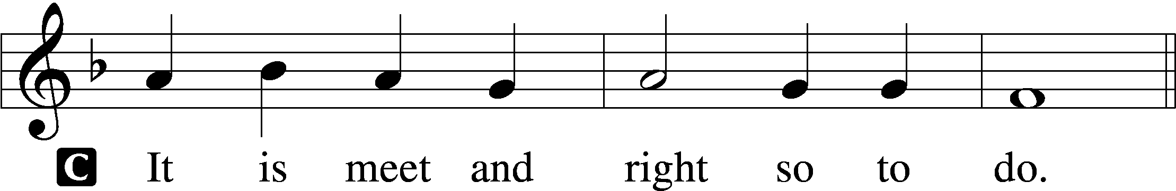

Proper Preface (Abbreviated) LSB 194
P It is truly meet, right, and salutary . . . evermore praising You and saying:

Sanctus Isaiah 6:3; Matthew 21:9
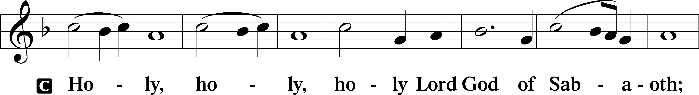
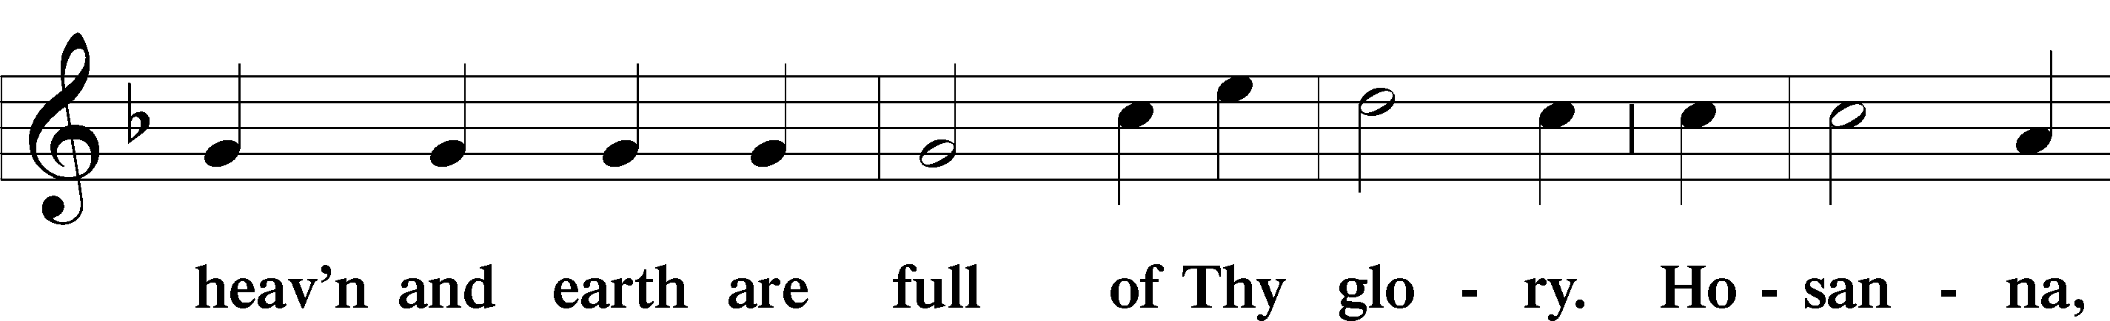
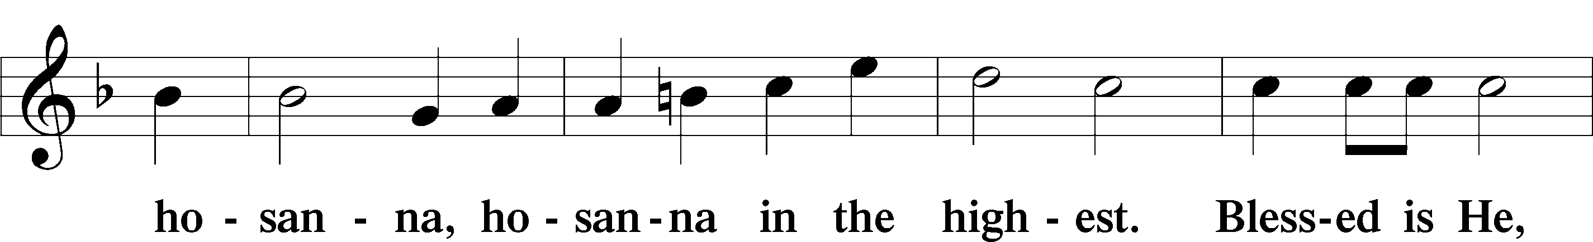
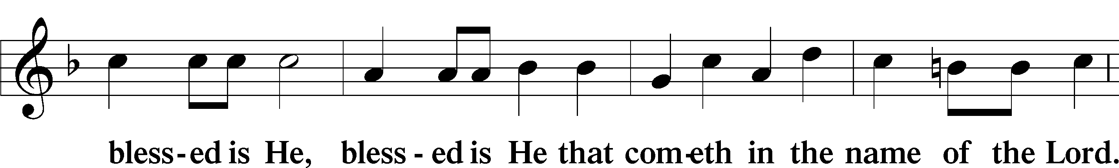
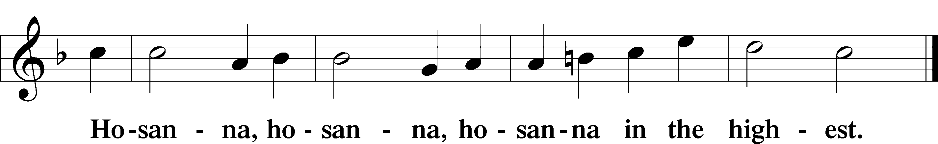

Lord’s Prayer The congregation is encouraged to silently pray the Lord’s Prayer as it is chanted. Matthew 6:9–13
P Our Father who art in heaven,
hallowed be Thy name,
Thy kingdom come,
Thy will be done on earth as it is in heaven;
give us this day our daily bread;
and forgive us our trespasses as we forgive those who trespass against us;
and lead us not into temptation,
but deliver us from evil.
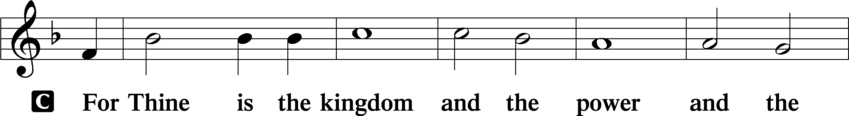
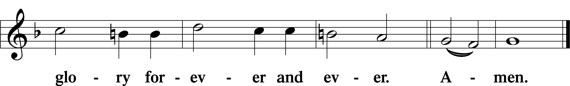

The Words of Our Lord Matthew 26:26–28; Mark 14:22–24; Luke 22:19–20; 1 Corinthians 11:23–25
P Our Lord Jesus Christ, on the night when He was betrayed, took bread, and when He had given thanks, He broke it and gave it to the disciples and said: “Take, eat; this is My T body, which is given for you. This do in remembrance of Me.”

In the same way also He took the cup after supper, and when He had given thanks, He gave it to them, saying: “Drink of it, all of you; this cup is the new testament in My T blood, which is shed for you for the forgiveness of sins. This do, as often as you drink it, in remembrance of Me.”

Pax Domini John 20:19
P The peace of the Lord be with you always.
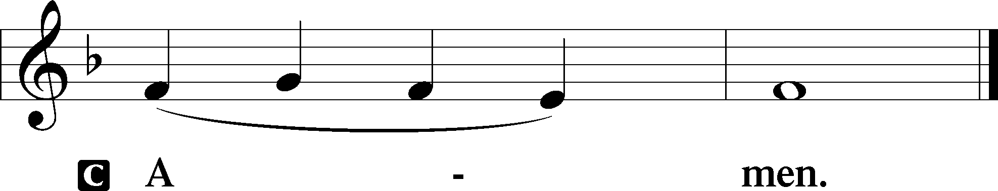
Agnus Dei John 1:29
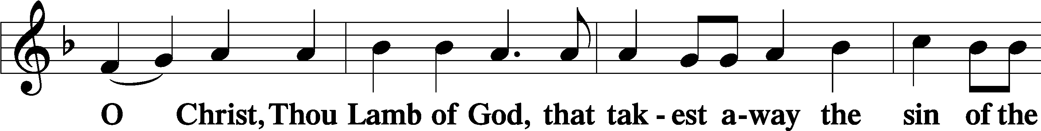
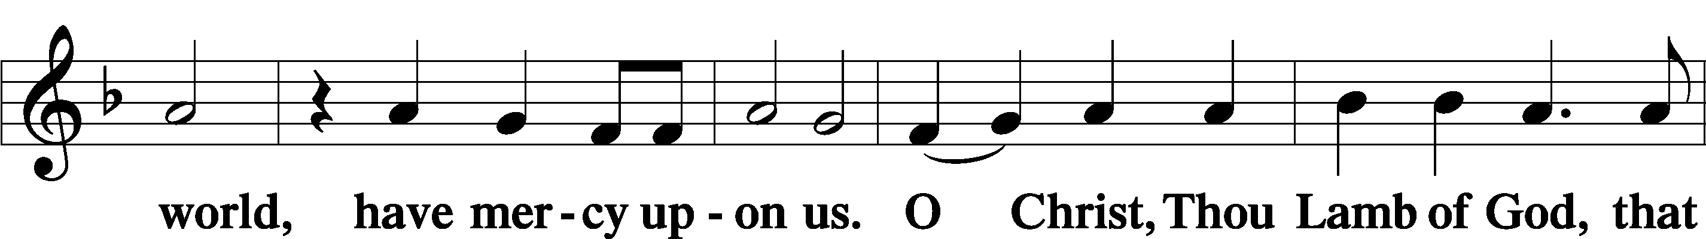
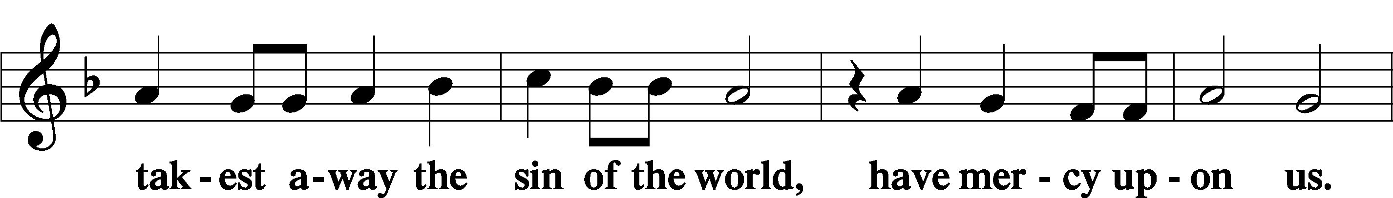
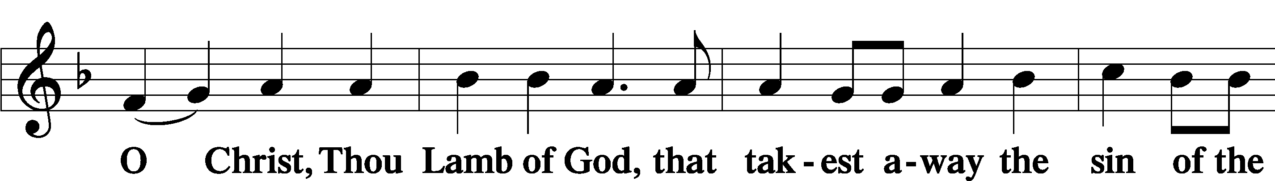
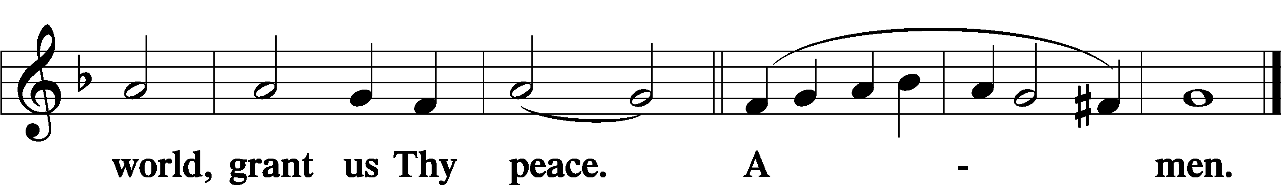
Sit

Distribution
The pastor and those who assist him receive the body and blood of Christ first and then distribute them to those who come to receive, saying:
Take, eat; this is the true body of our Lord and Savior Jesus Christ, given into death for your sins.
Amen.

Take, drink; this is the true blood of our Lord and Savior Jesus Christ, shed for the forgiveness of your sins.
Amen.

In dismissing the communicants, the following is said:
The Dismissal
P The body and blood of our Lord Jesus Christ strengthen and preserve you in body and soul to life everlasting. Depart T in peace.
C Amen.

Distribution Hymn: LSB #506 “Glory Be to God the Father”

Distribution Hymn: LSB #566 “By Grace I’m Saved”

Stand

Nunc Dimittis Luke 2:29–32
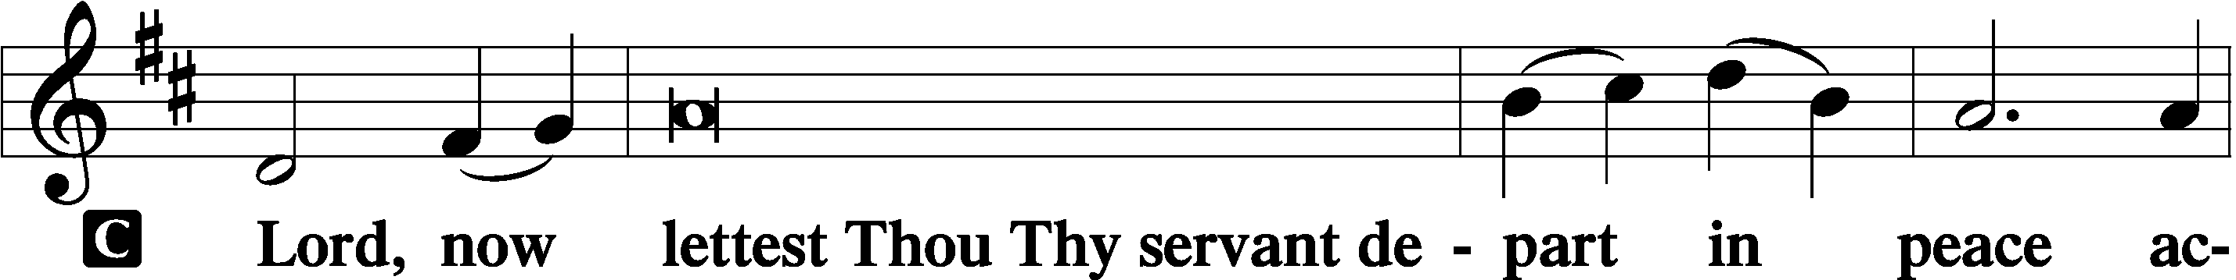
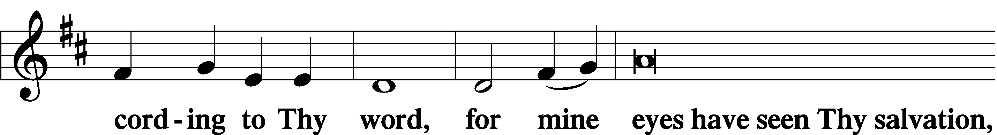
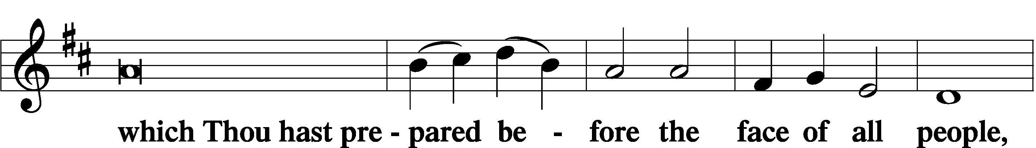
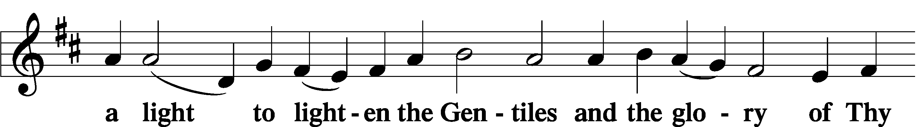
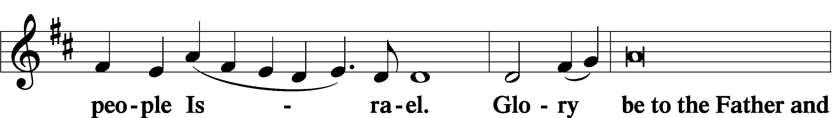
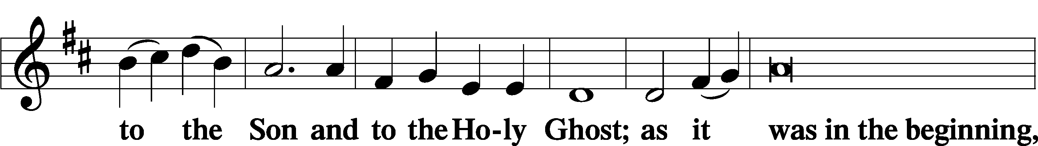
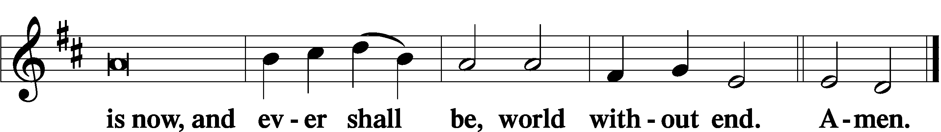

Thanksgiving Psalm 107:1
P O give thanks unto the Lord, for He is good,
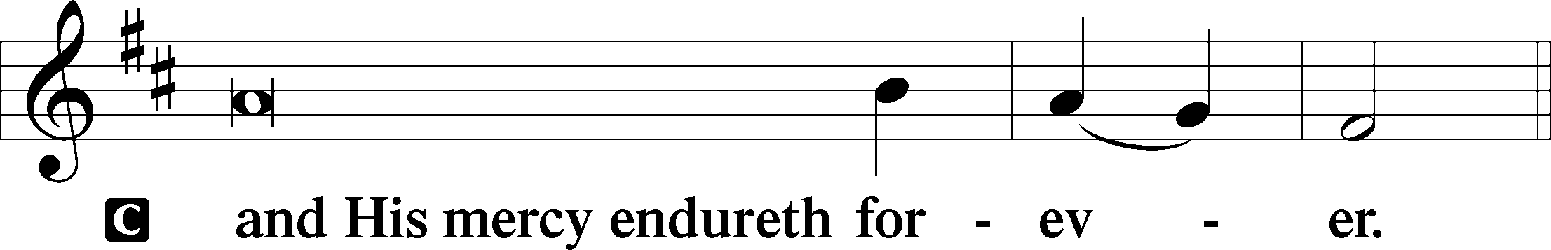

Post-Communion Collect
P Let us pray.
We give thanks to You, almighty God, that You have refreshed us through this salutary gift, and we implore You that of Your mercy You would strengthen us through the same in faith toward You and in fervent love toward one another; through Jesus Christ, Your Son, our Lord, who lives and reigns with You and the Holy Spirit, one God, now and forever.
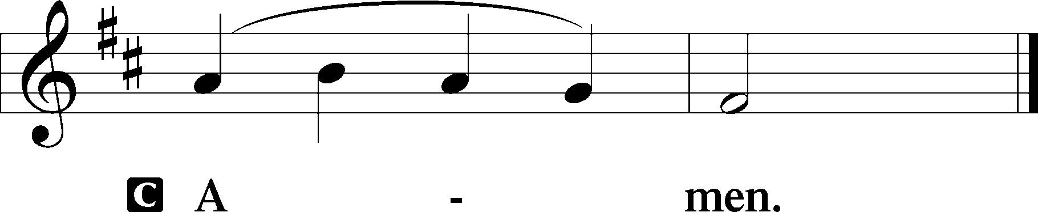

Salutation 2 Timothy 4:22
P The Lord be with you.
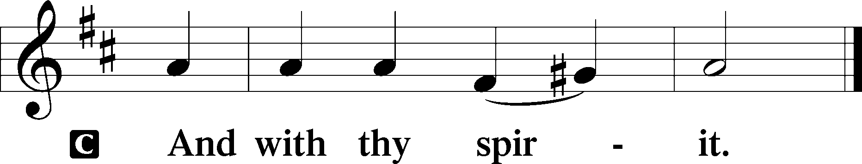

Benedicamus Psalm 103:1
P Bless we the Lord.
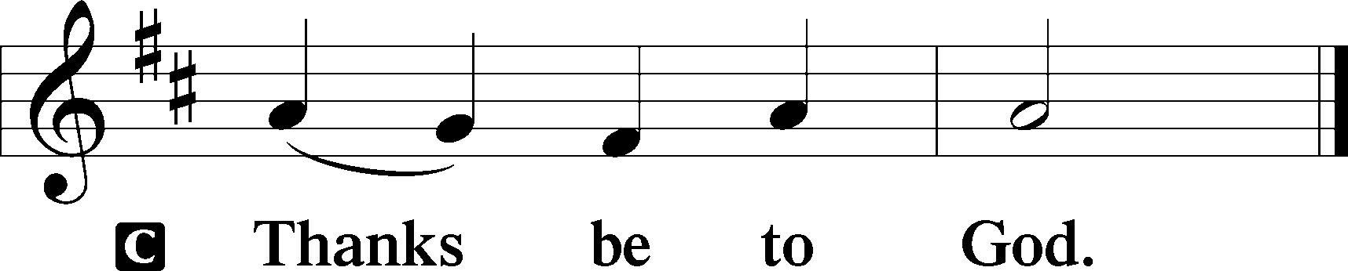

Benediction Numbers 6:24–26
P The Lord bless you and keep you.
The Lord make His face shine upon you and be gracious unto you.
The Lord lift up His countenance upon you and T give you peace.
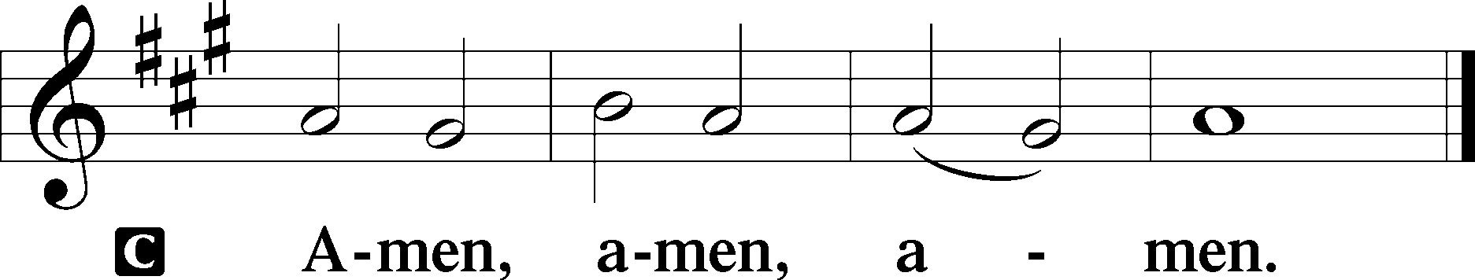

Closing Hymn: LSB #645 “Built on the Rock”
fffffffffffffffffffffffffffffffffff
Silent prayer after worship: Dearest Jesus, help me to always remember that Your Word is not confined to the church building. As I leave this worship service, keep Your Word in my heart so that the Holy Spirit may work in my life. Amen.
fffffffffffffffffffffffffffffffffff
Acknowledgments
Unless otherwise indicated, Scripture quotations are from the ESV® Bible (The Holy Bible, English Standard Version®), copyright © 2001 by Crossway, a publishing ministry of Good News Publishers. Used by permission. All rights reserved.
Created by Lutheran Service Builder © 2023 Concordia Publishing House.

