Sts. Peter & Paul
Evangelical Lutheran Church
Lutheran Church-Missouri Synod
Founded-1917

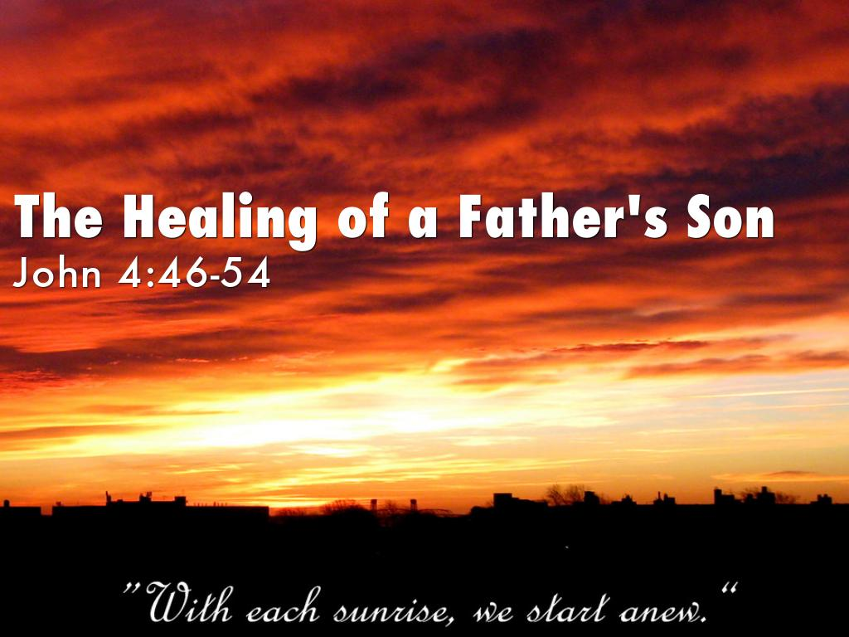

October 29, 2023

699 Stambaugh Ave.
Sharon, Pennsylvania 16146

“I was glad when they said to me,
Let us go to the house of the LORD!”
Psalm 122:1
Sts. Peter & Paul Evangelical Lutheran Church, LC-MS
THE TWENTY-FIRST SUNDAY AFTER TRINITY
October 29, 2023
A special welcome to our guests this day! If you would like more information about The Lutheran Church - Missouri Synod, or this congregation, please speak with Pastor Deal or an Elder after the service.
Members & Guests: Don’t be embarrassed if your children make noise during the worship service, all children do. We encourage families to worship together but, if you feel the need, there are pews in the rear of the Church which are reserved for young families on both sides of the sanctuary. There is also a quiet room available to you, located next to the sanctuary (formerly the Pastor’s office), where you would be able to follow along with the service.

Today’s service includes the Sacrament of Holy Communion. If during this past year, you have not worshipped with us and been communed, we respectfully ask that you do not partake of this sacrament this day before first speaking with Pastor Deal.
If visiting from a sister congregation of the LC-MS and are in good standing, please inform Pastor Deal of your desire to commune prior to the service.
If wishing to receive a blessing during communion, please approach with your arms crossed.

CONTACT INFORMATION
Pastor Deal: pastordeal@saintspeterandpaul.net or 724-347-3620 (opt. 2)
Church Office: church@saintspeterandpaul.net or 724-347-3620 (opt. 3)
Secretary’s Office: The office will be open Mon. (8:30 am–5 pm) & Thurs. (8:30 am-10 am; 11 am-5 pm).

Silent prayer before worship: Dear Heavenly Father, You have clothed me with righteousness and have offered me life and salvation through Jesus Christ. Cause my faith to grow, that I may look only to You for eternal life. In Jesus’ name. Amen.
Confession and Absolution

Opening Hymn: LSB #734 “I Trust, O Lord, Your Holy Name”

The sign of the cross may be made by all in remembrance of their Baptism.

Invocation
P In the name of the Father and of the T Son and of the Holy Spirit.
C Amen.

Exhortation Hebrews 10:22; Psalm 124:8; Psalm 32:5
P Beloved in the Lord! Let us draw near with a true heart and confess our sins unto God our Father, beseeching Him in the name of our Lord Jesus Christ to grant us forgiveness.

P Our help is in the name of the Lord,
C who made heaven and earth.
P I said, I will confess my transgressions unto the Lord,
C and You forgave the iniquity of my sin.

Silence for reflection on God’s Word and for self-examination.

Confession of Sins
P O almighty God, merciful Father,
C I, a poor, miserable sinner, confess unto You all my sins and iniquities with which I have ever offended You and justly deserved Your temporal and eternal punishment. But I am heartily sorry for them and sincerely repent of them, and I pray You of Your boundless mercy and for the sake of the holy, innocent, bitter sufferings and death of Your beloved Son, Jesus Christ, to be gracious and merciful to me, a poor, sinful being.

Absolution [John 20:19–23]
P Upon this your confession, I, by virtue of my office, as a called and ordained servant of the Word, announce the grace of God unto all of you, and in the stead and by the command of my Lord Jesus Christ I forgive you all your sins in the name of the Father and of the T Son and of the Holy Spirit.
C Amen.
Service of the Word

Introit Psalm 119:1, 38–40; antiphon: Liturgical Text
The whole world is | in your power;*
O Lord, King Almighty, no one can | gainsay you.
For you have made | heaven and earth;*
you are | Lord of all!
Blessèd are those whose way is | blameless,*
who walk in the law | of the Lord!
Confirm to your servant your | promise,*
that you | may be feared.
Turn away the reproach | that I dread,*
for your just de- | crees are good.
Behold, I long for your | precepts;*
in your righteousness | give me life!
The whole world is | in your power;*
O Lord, King Almighty, no one can | gainsay you.
For you have made | heaven and earth;*
you are | Lord of all!

Gloria Patri
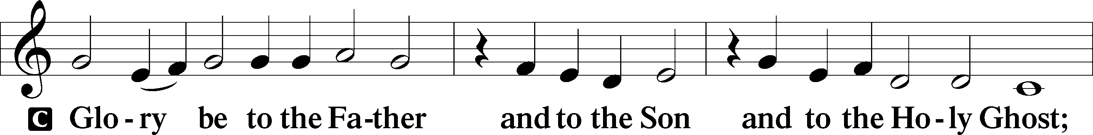
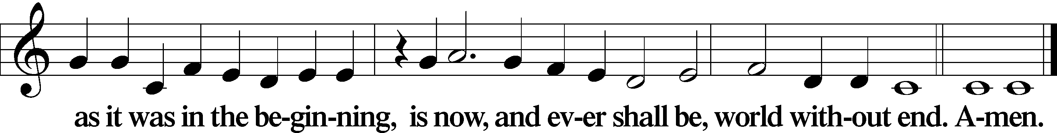
Kyrie Mark 10:47
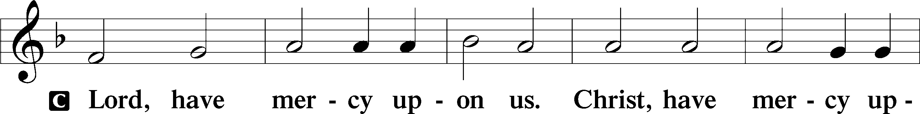
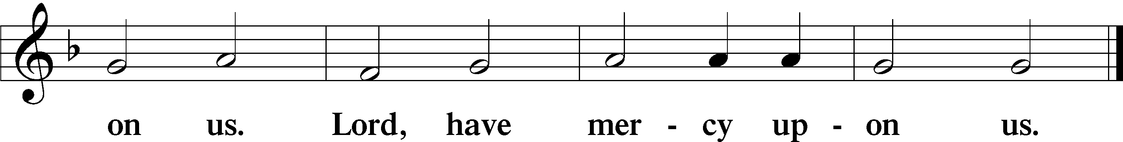

Gloria in Excelsis Luke 2:14; John 1:29
P Glory be to God on high:
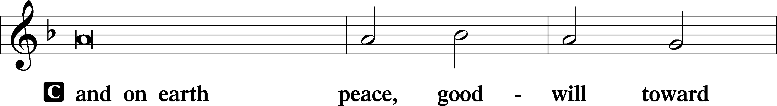
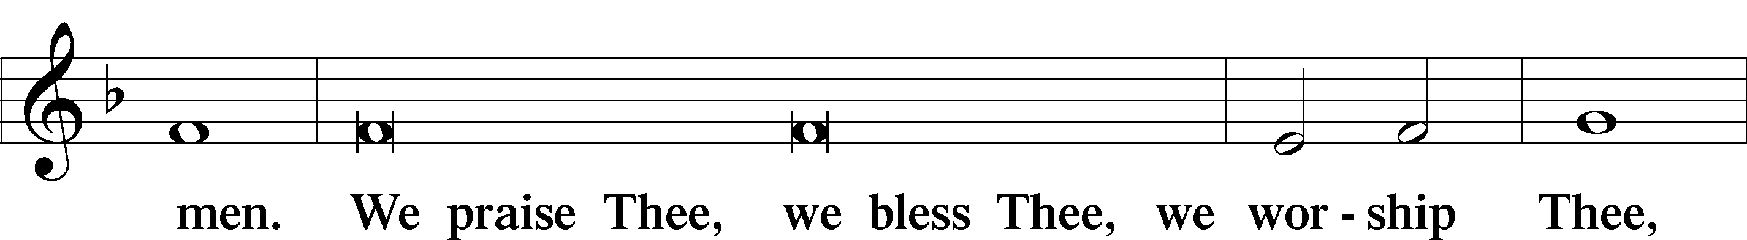
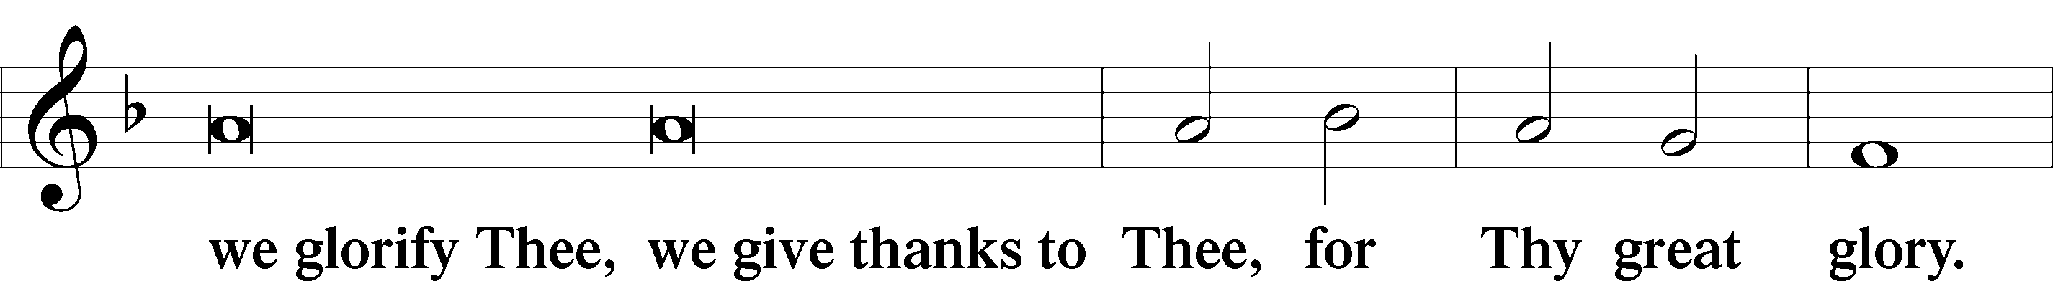
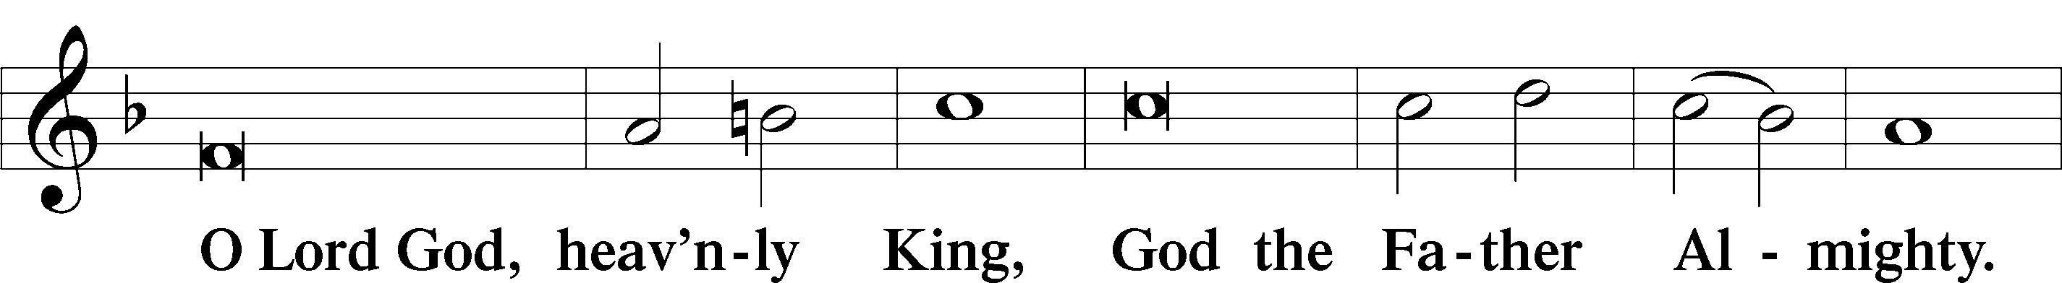
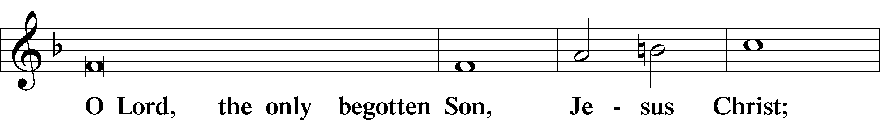
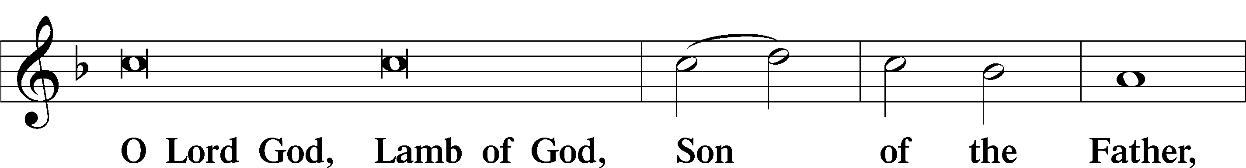
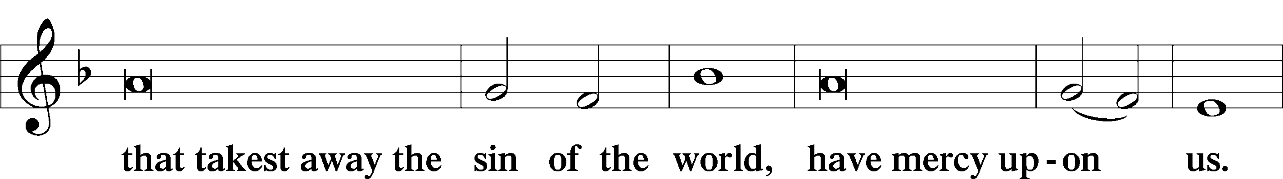
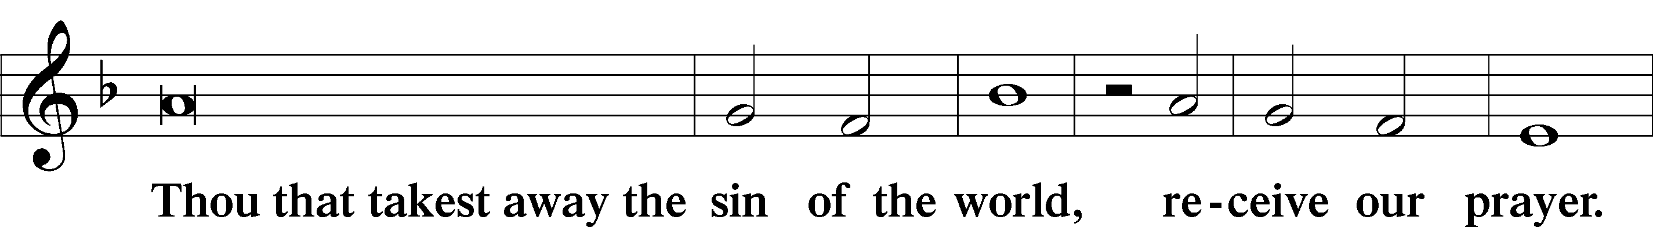
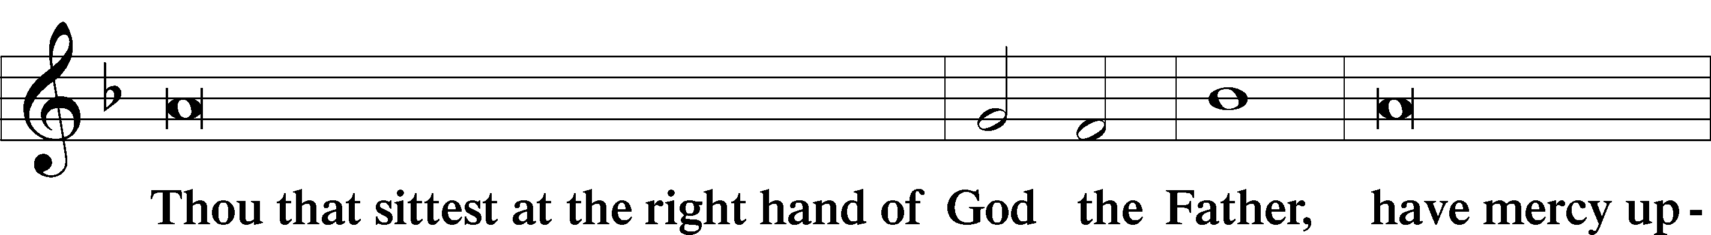
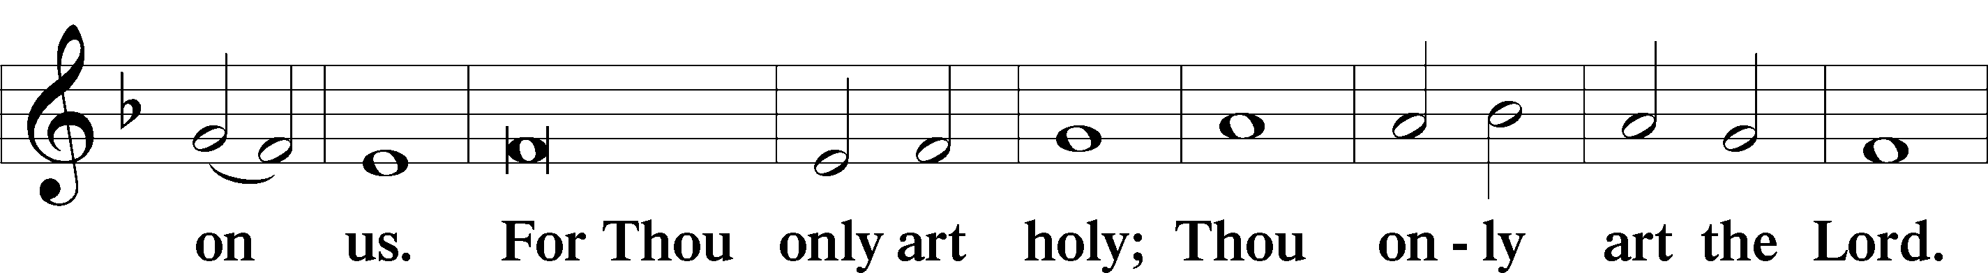
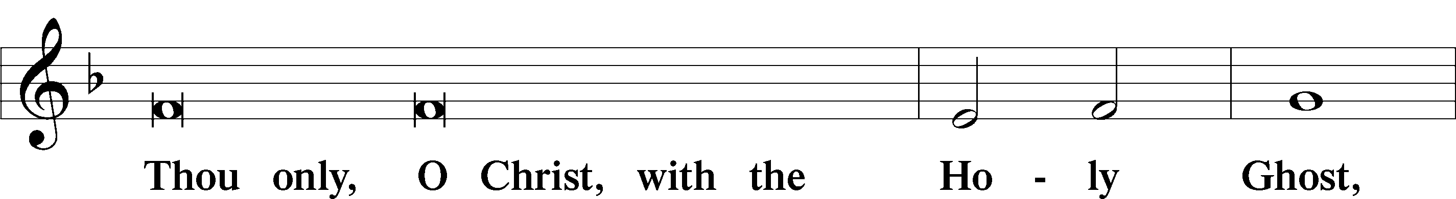
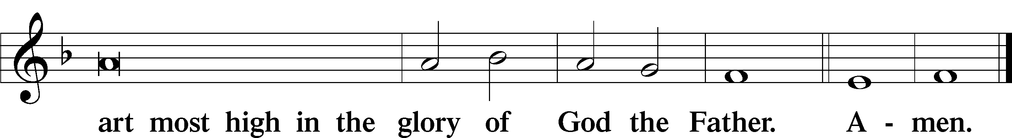

Salutation and Collect of the Day: Trinity 21
P The Lord be with you.
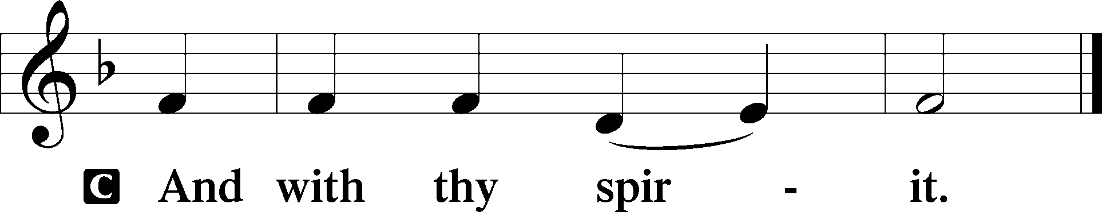

P Let us pray.
O Lord, keep Your household, the Church, in continual godliness that through Your protection she may be free from all adversities and devoutly given to serve You in good works; through Jesus Christ, Your Son, our Lord, who lives and reigns with You and the Holy Spirit, one God, now and forever.
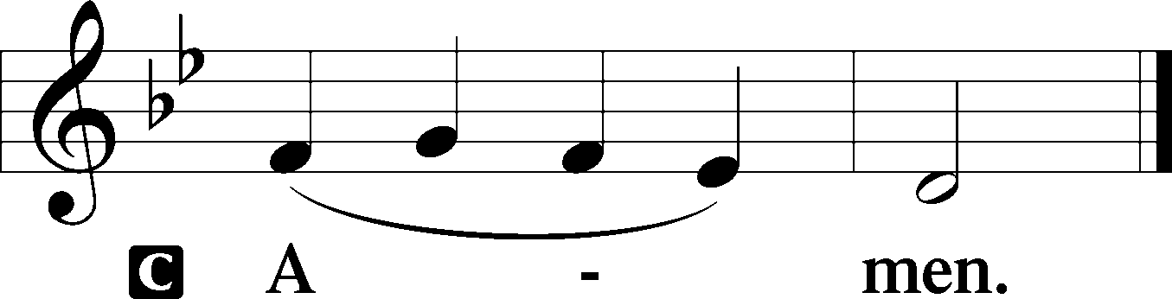
Sit

Prophecy: Isaiah 29:6-9 (NKJV)
Thus says the Lord God: In this mountain the Lord of hosts will make for all people a feast of choice pieces, a feast of wines on the lees, of fat things full of marrow, of well-refined wines on the lees. And He will destroy on this mountain the surface of the covering cast over all people, and the veil that is spread over all nations. He will swallow up death forever, and the Lord God will wipe away tears from all faces; the rebuke of His people He will take away from all the earth; for the Lord has spoken. And it will be said in that day: “Behold, this is our God; we have waited for Him, and He will save us. This is the Lord; we have waited for Him; we will be glad and rejoice in His salvation.”

P This is the Word of the Lord.
C Thanks be to God.

Gradual Psalm 90:1–2
Lord, you have been our | dwelling place*
in all gener- | ations.
Before the mountains were brought forth, or ever you had formed the earth | and the world,*
from everlasting to everlasting | you are God.

Epistle: Ephesians 6:10–17 (NKJV)
Brethren: Be strong in the Lord and in the power of His might. Put on the whole armor of God, that you may be able to stand against the wiles of the devil. For we do not wrestle against flesh and blood, but against principalities, against powers, against the rulers of the darkness of this age, against spiritual hosts of wickedness in the heavenly places. Therefore take up the whole armor of God, that you may be able to withstand in the evil day, and having done all, to stand. Stand therefore, having girded your waist with truth, having put on the breastplate of righteousness, and having shod your feet with the preparation of the gospel of peace; above all, taking the shield of faith with which you will be able to quench all the fiery darts of the wicked one. And take the helmet of salvation, and the sword of the Spirit, which is the word of God.

P This is the Word of the Lord.
C Thanks be to God.
Stand
Verse Psalm 125:1
Alleluia. Those who trust in the Lord are like Mount Zion, which cannot be moved, but abides forever. Alleluia.

Alleluia
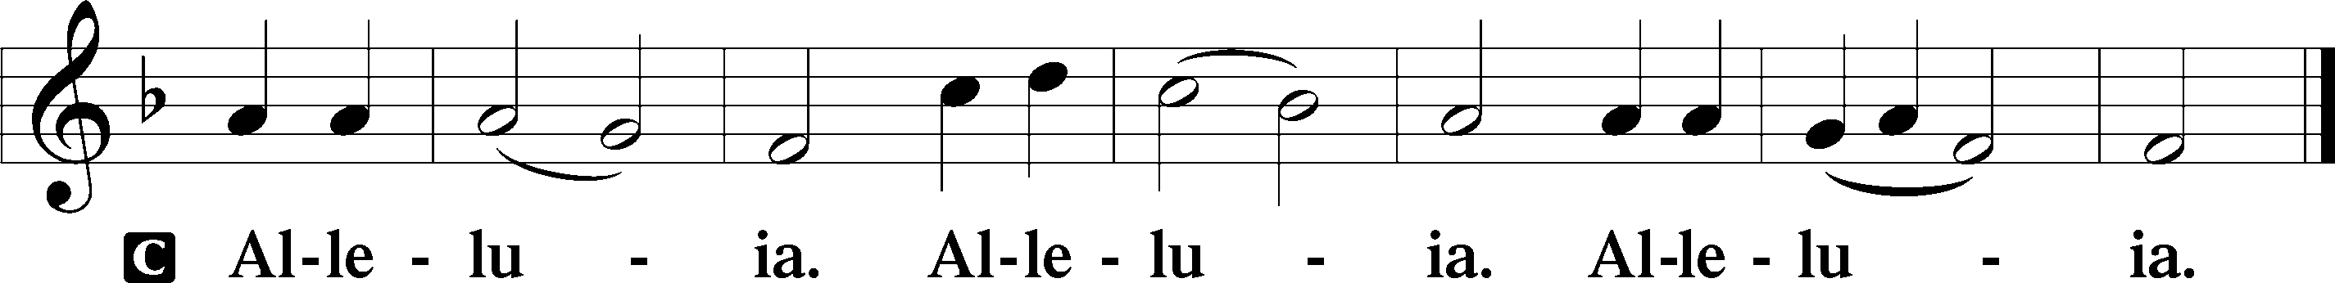

Holy Gospel: John 4:46b–53 (NKJV)
P The Holy Gospel according to St. John, the fourth chapter.
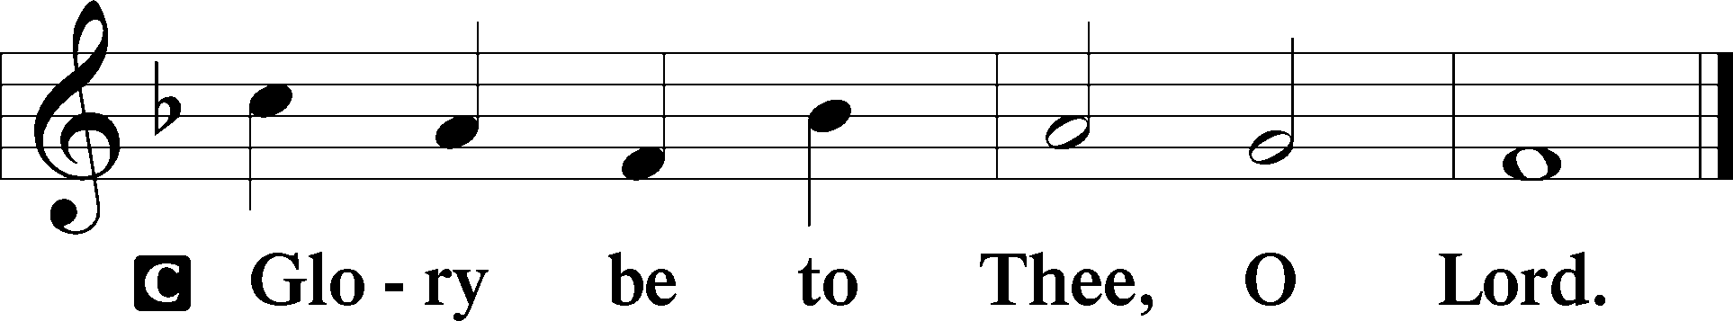

At that time: There was a certain nobleman whose son was sick at Capernaum. When he heard that Jesus had come out of Judea into Galilee, he went to Him and implored Him to come down and heal his son, for he was at the point of death. Then Jesus said to him, “Unless you people see signs and wonders, you will by no means believe.” The nobleman said to Him, “Sir, come down before my child dies!” Jesus said to him, “Go your way; your son lives.” So the man believed the word that Jesus spoke to him, and he went his way. And as he was now going down, his servants met him and told him, saying, “Your son lives!” Then he inquired of them the hour when he got better. And they said to him, “Yesterday at the seventh hour the fever left him.” So the father knew that it was at the same hour in which Jesus said to him, “Your son lives.” And he himself believed, and his whole household.

P This is the Gospel of the Lord.
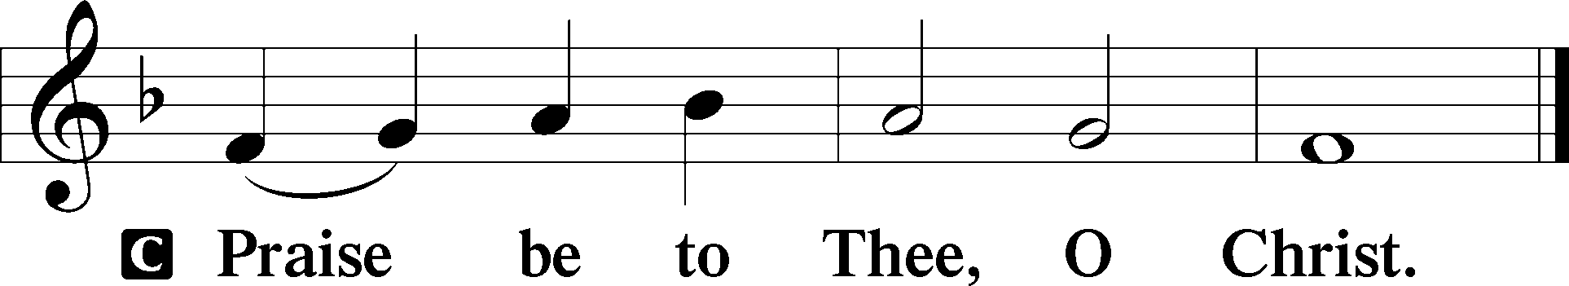

Nicene Creed
C I believe in one God,
the Father Almighty,
maker of heaven and earth
and of all things visible and invisible.

And in one Lord Jesus Christ,
the only-begotten Son of God,
begotten of His Father before all worlds,
God of God, Light of Light,
very God of very God,
begotten, not made,
being of one substance with the Father,
by whom all things were made;
who for us men and for our salvation came down from heaven
and was incarnate by the Holy Spirit of the virgin Mary
and was made man;
and was crucified also for us under Pontius Pilate.
He suffered and was buried.
And the third day He rose again according to the Scriptures
and ascended into heaven
and sits at the right hand of the Father.
And He will come again with glory to judge both the living and the dead,
whose kingdom will have no end.

And I believe in the Holy Spirit,
the Lord and giver of life,
who proceeds from the Father and the Son,
who with the Father and the Son together is worshiped and glorified,
who spoke by the prophets.
And I believe in one holy Christian and apostolic Church,
I acknowledge one Baptism for the remission of sins,
and I look for the resurrection of the dead
and the life T of the world to come. Amen.
Sit

Hymn of the Day: LSB #607 “From Depths of Woe I Cry to Thee”

Sermon

Stand

Offertory Psalm 51:10–12
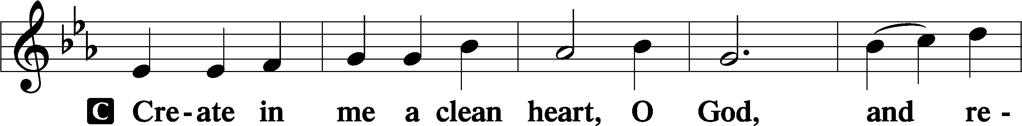
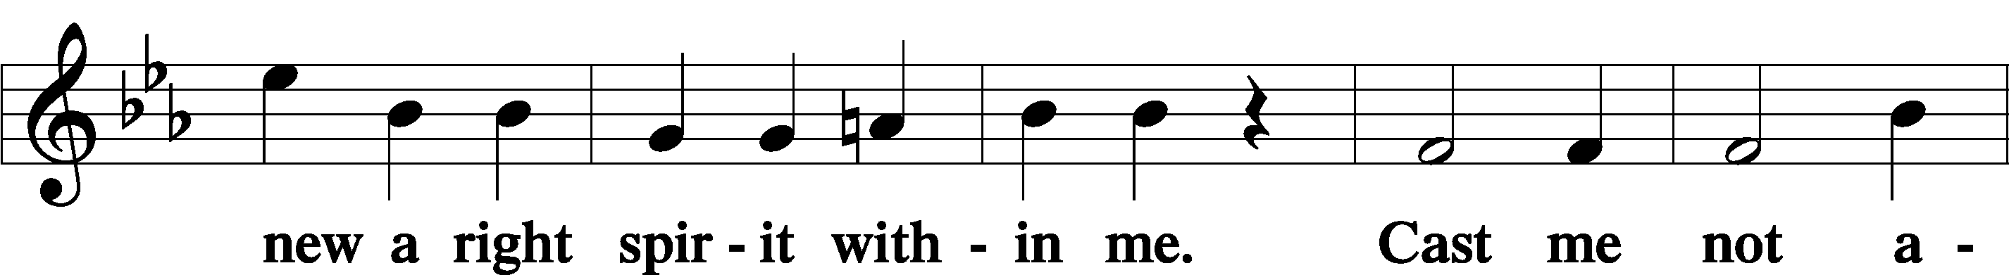
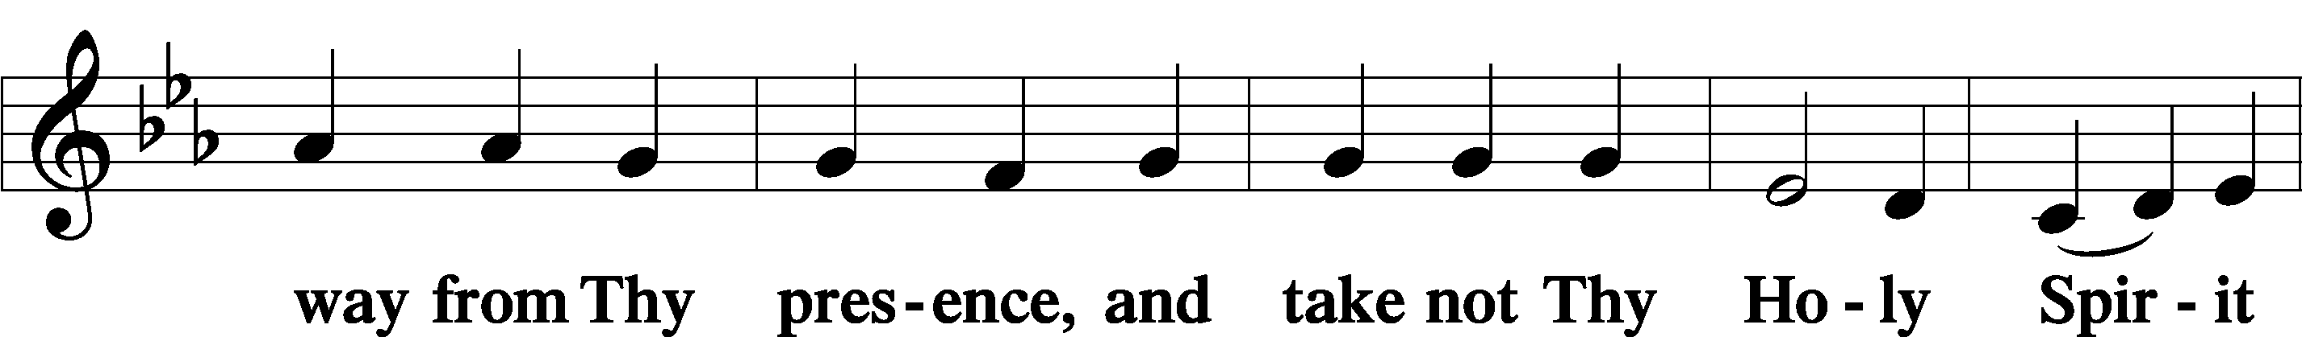
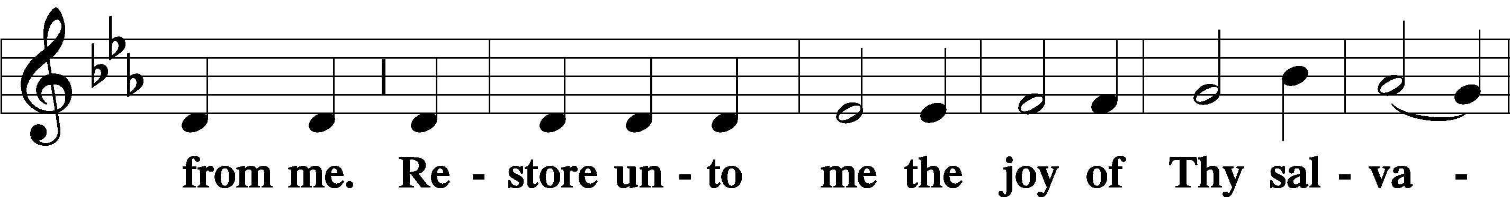
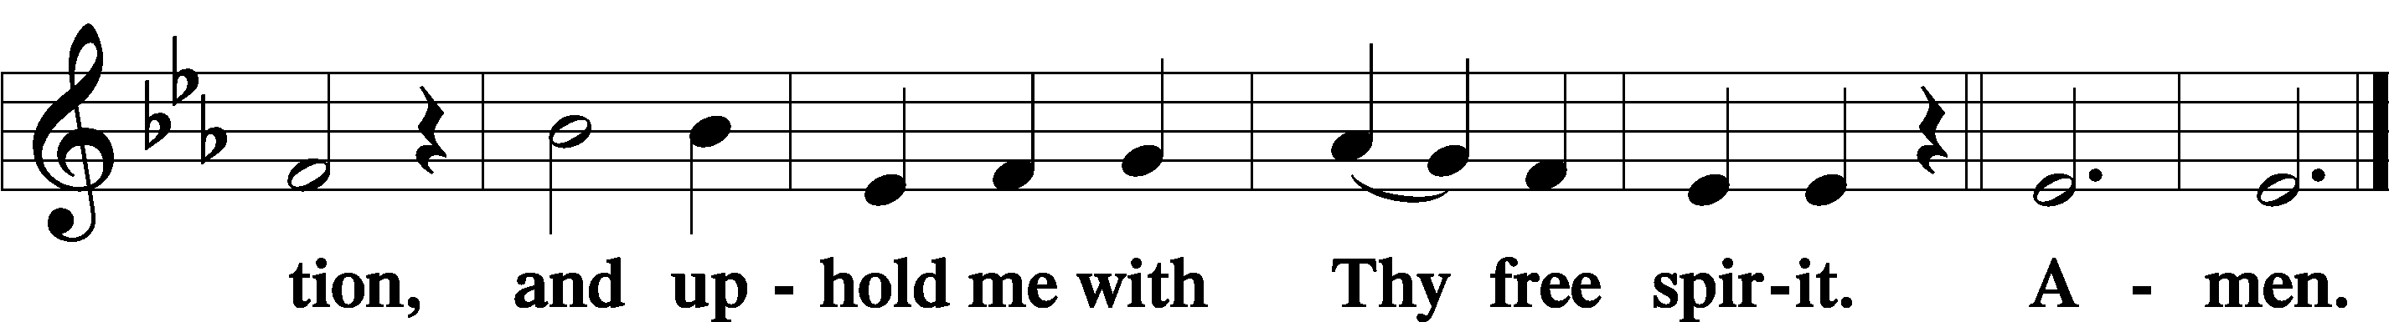

Prayer of the Church

Sit

Preparatory Hymn: LSB #839 “O Christ, Our True and Only Light”

Stand
Service of the Sacrament

Preface 2 Timothy 4:22; Colossians 3:1 Psalm 136
P The Lord be with you.
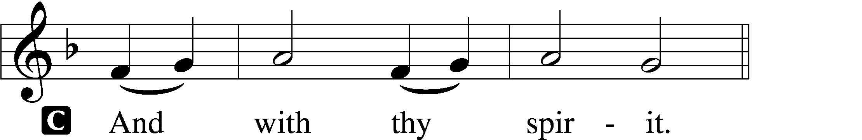

P Lift up your hearts.
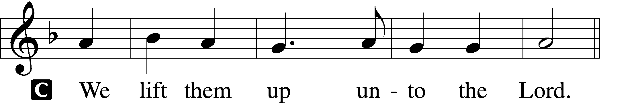

P Let us give thanks unto the Lord, our God.
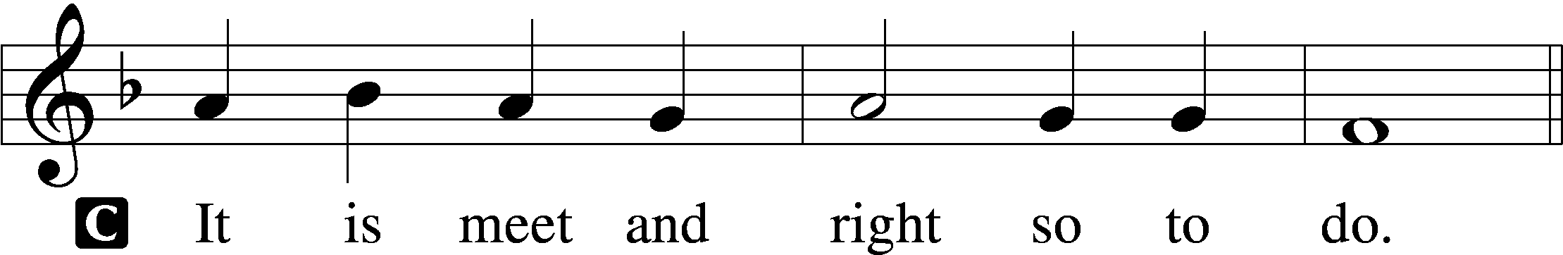

Proper Preface (Abbreviated) LSB 194
P It is truly meet, right, and salutary . . . evermore praising You and saying:

Sanctus Isaiah 6:3; Matthew 21:9
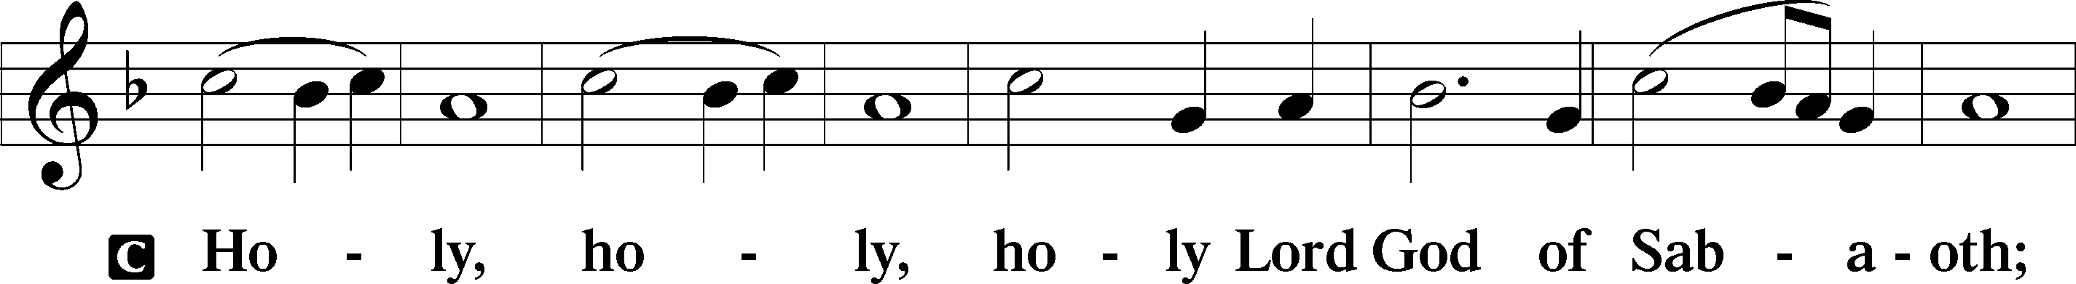
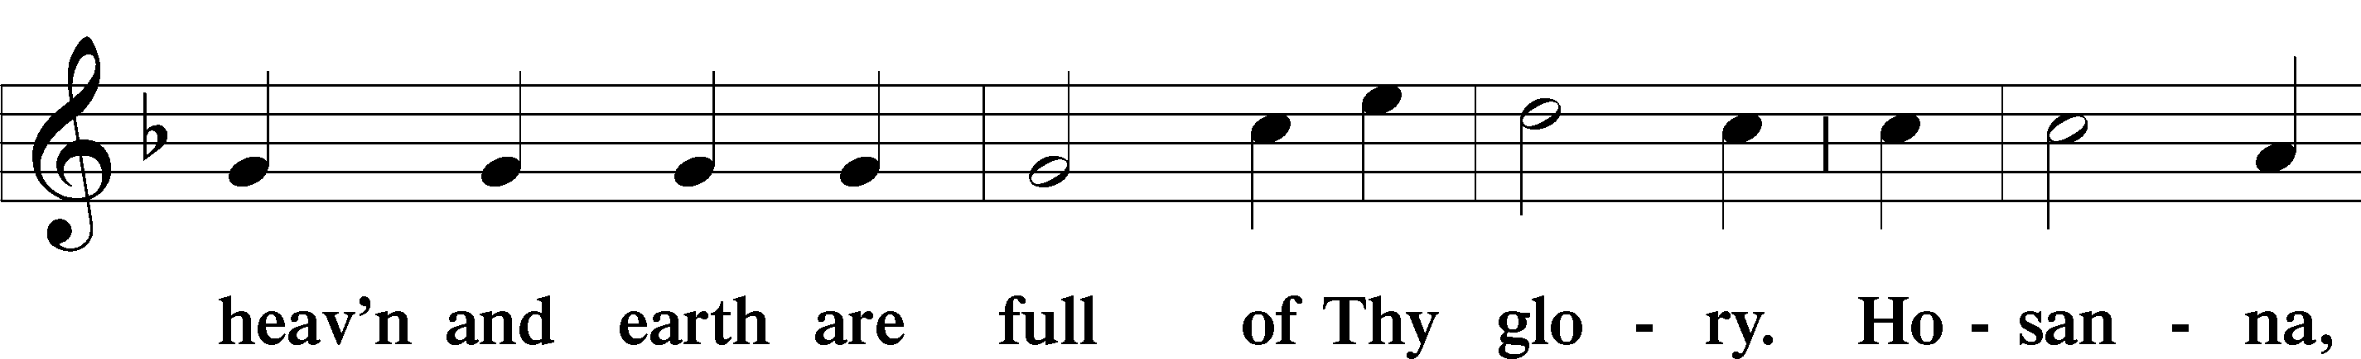
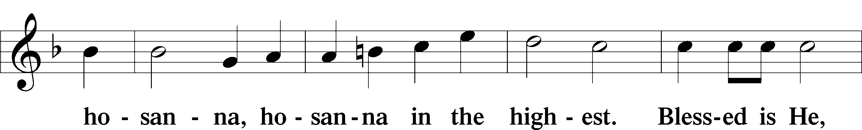
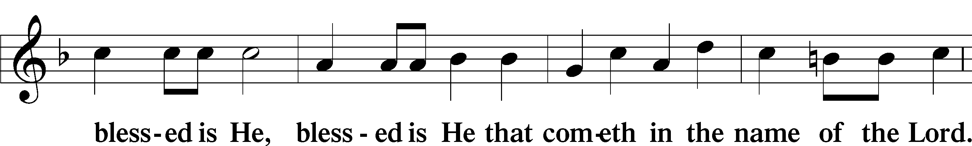
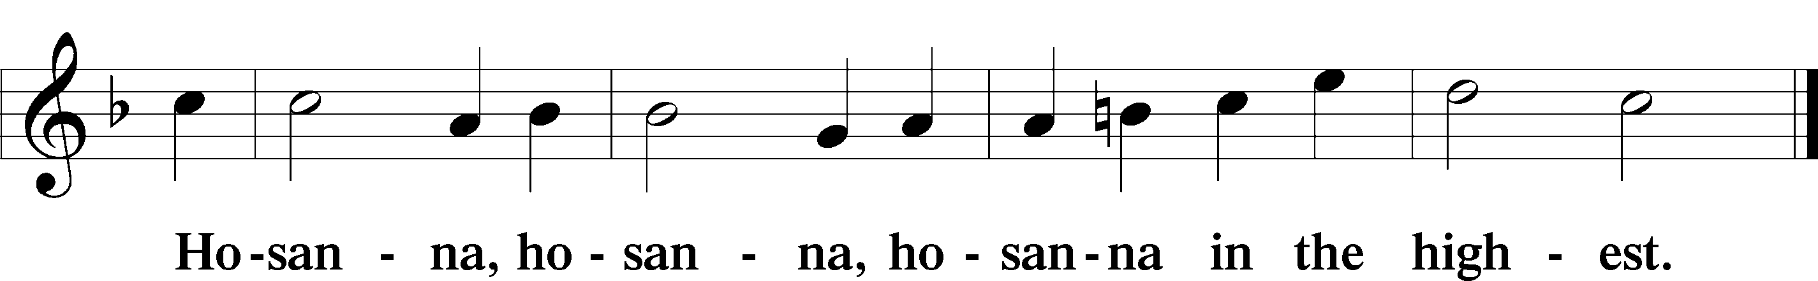

Lord’s Prayer The congregation is encouraged to silently pray the Lord’s Prayer as it is chanted. Matthew 6:9–13
P Our Father who art in heaven,
hallowed be Thy name,
Thy kingdom come,
Thy will be done on earth as it is in heaven;
give us this day our daily bread;
and forgive us our trespasses as we forgive those who trespass against us;
and lead us not into temptation,
but deliver us from evil.
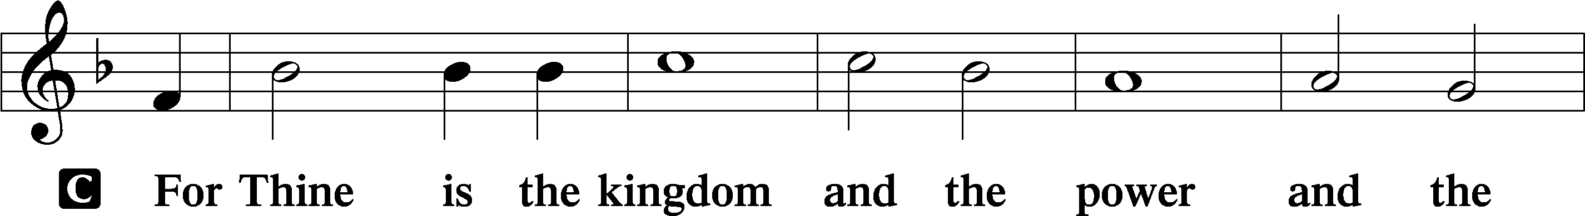
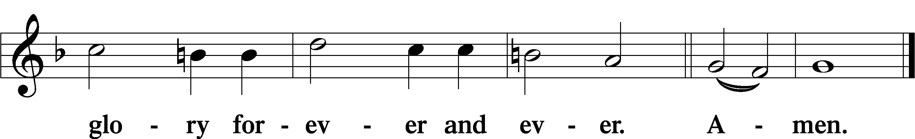

The Words of Our Lord Matthew 26:26–28; Mark 14:22–24; Luke 22:19–20; 1 Corinthians 11:23–25
P Our Lord Jesus Christ, on the night when He was betrayed, took bread, and when He had given thanks, He broke it and gave it to the disciples and said: “Take, eat; this is My T body, which is given for you. This do in remembrance of Me.”

In the same way also He took the cup after supper, and when He had given thanks, He gave it to them, saying: “Drink of it, all of you; this cup is the new testament in My T blood, which is shed for you for the forgiveness of sins. This do, as often as you drink it, in remembrance of Me.”

Pax Domini John 20:19
P The peace of the Lord be with you always.
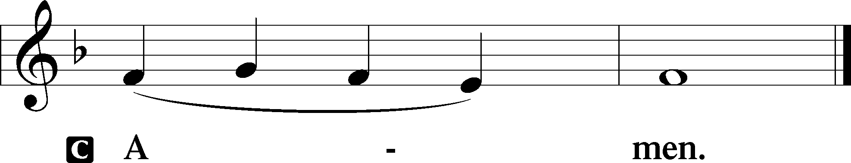
Agnus Dei John 1:29
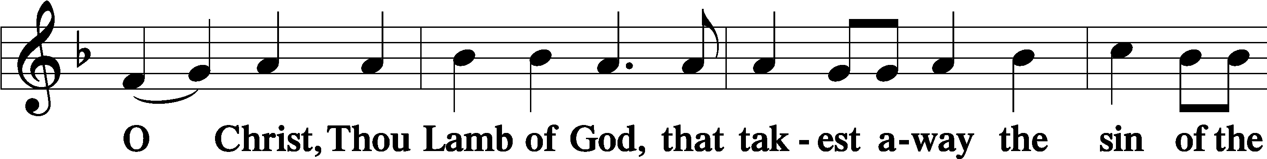
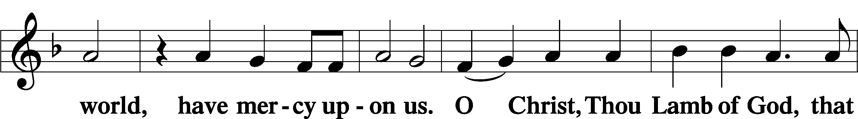
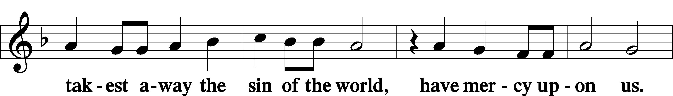
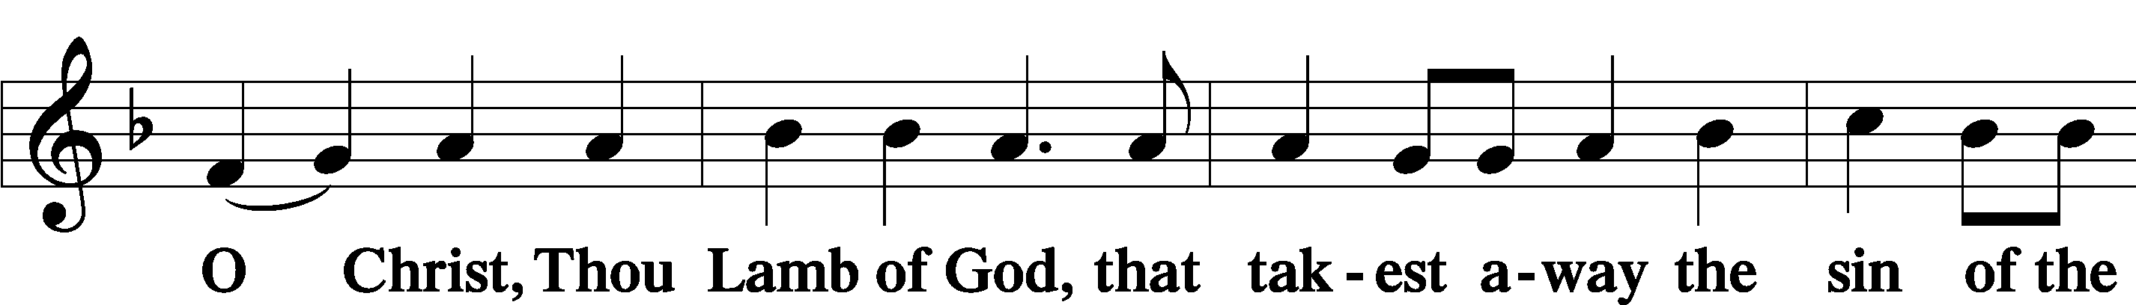
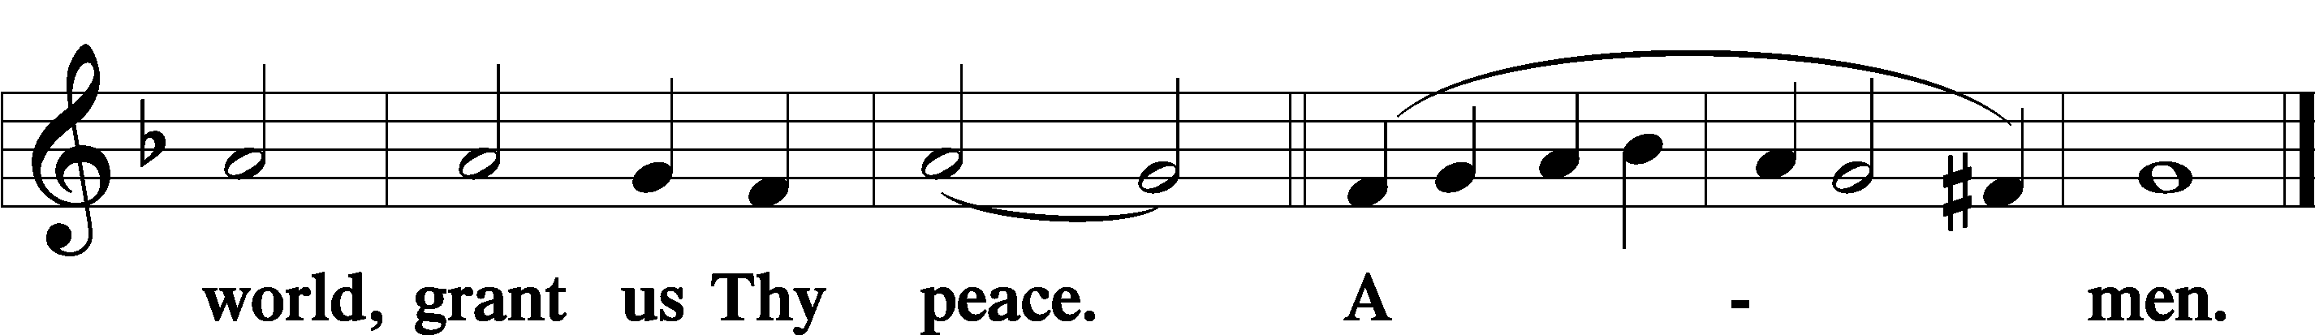
Sit

Distribution
The pastor and those who assist him receive the body and blood of Christ first and then distribute them to those who come to receive, saying:
Take, eat; this is the true body of our Lord and Savior Jesus Christ, given into death for your sins.
Amen.

Take, drink; this is the true blood of our Lord and Savior Jesus Christ, shed for the forgiveness of your sins.
Amen.

In dismissing the communicants, the following is said:
The Dismissal
P The body and blood of our Lord Jesus Christ strengthen and preserve you in body and soul to life everlasting. Depart T in peace.
C Amen.

Distribution Hymn: LSB #587 “I Know My Faith Is Founded”

Distribution Hymn: LSB #737 “Rejoice, My Heart, Be Glad and Sing”

Distribution Hymn: LSB #655 “Lord, Keep Us Steadfast in Your Word”

Stand

Nunc Dimittis Luke 2:29–32
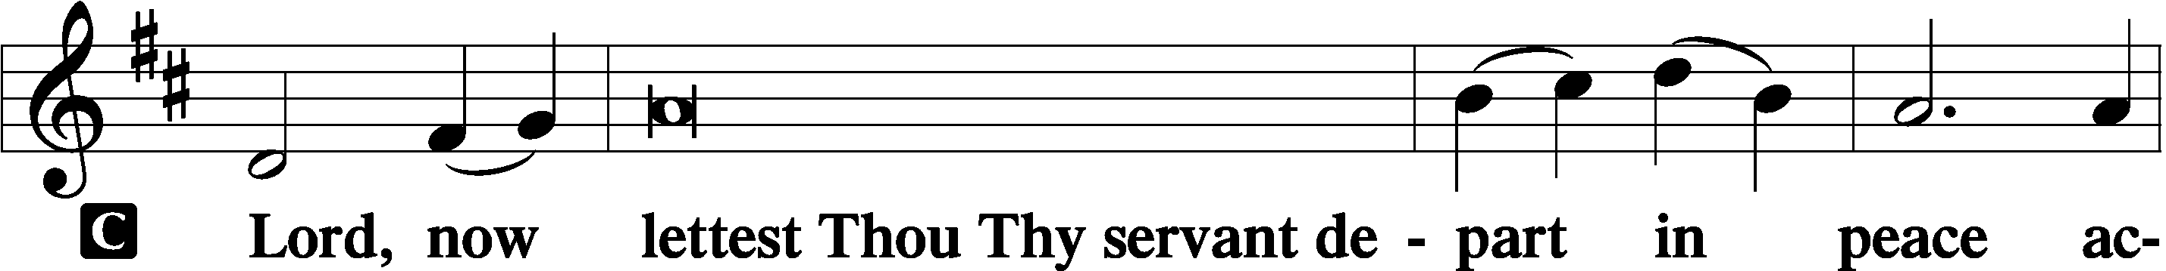
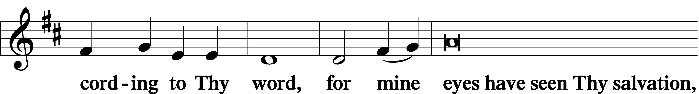
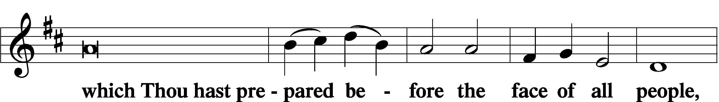
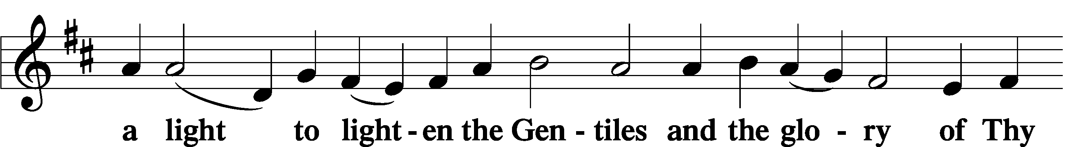
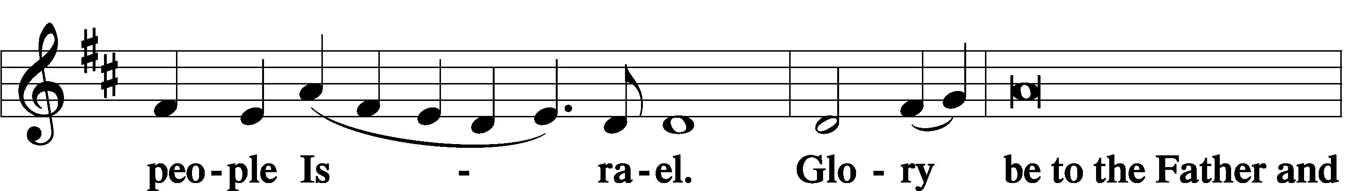
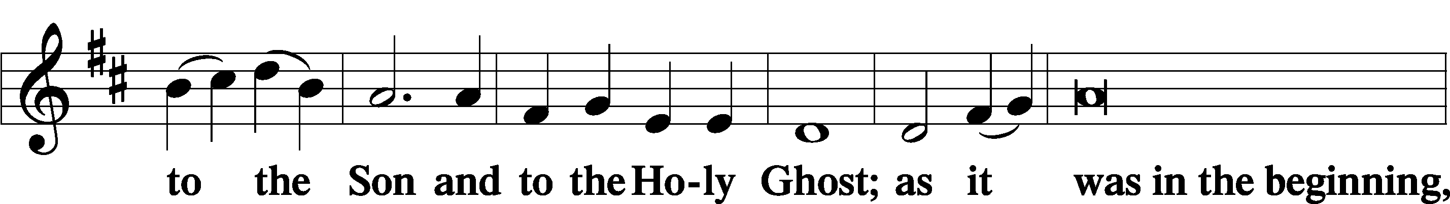
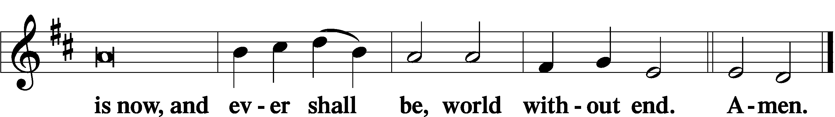

Thanksgiving Psalm 107:1
P O give thanks unto the Lord, for He is good,
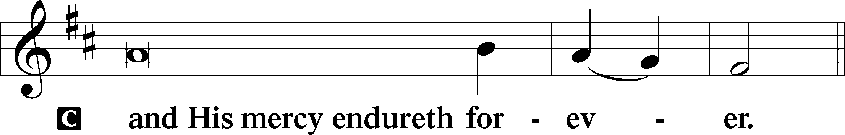

Post-Communion Collect
P Let us pray.
We give thanks to You, almighty God, that You have refreshed us through this salutary gift, and we implore You that of Your mercy You would strengthen us through the same in faith toward You and in fervent love toward one another; through Jesus Christ, Your Son, our Lord, who lives and reigns with You and the Holy Spirit, one God, now and forever.
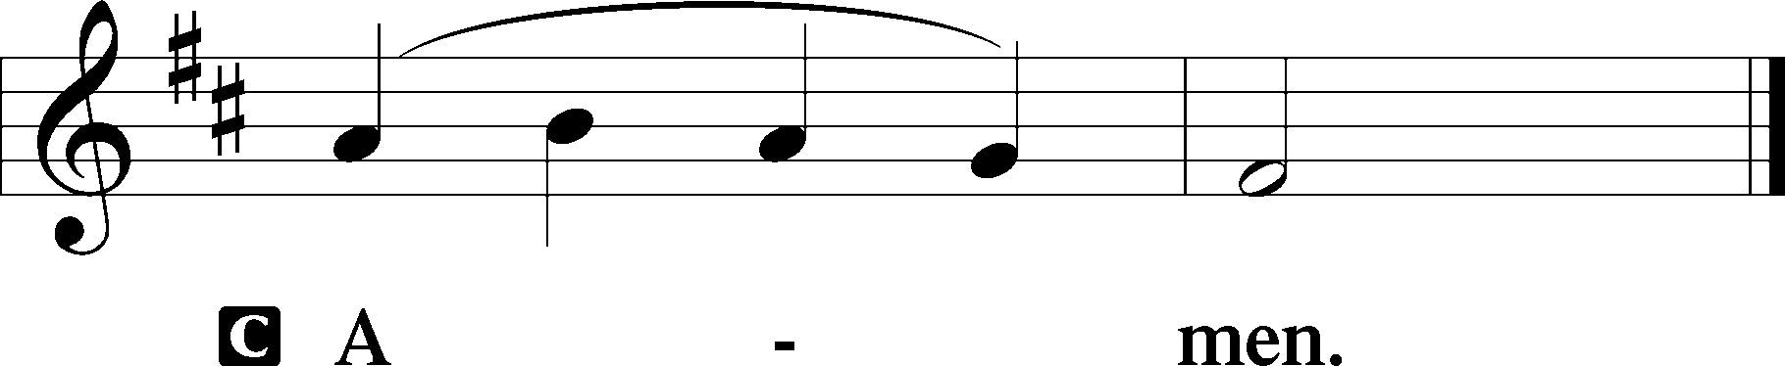

Salutation 2 Timothy 4:22
P The Lord be with you.
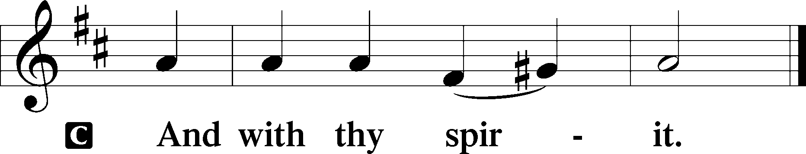

Benedicamus Psalm 103:1
P Bless we the Lord.
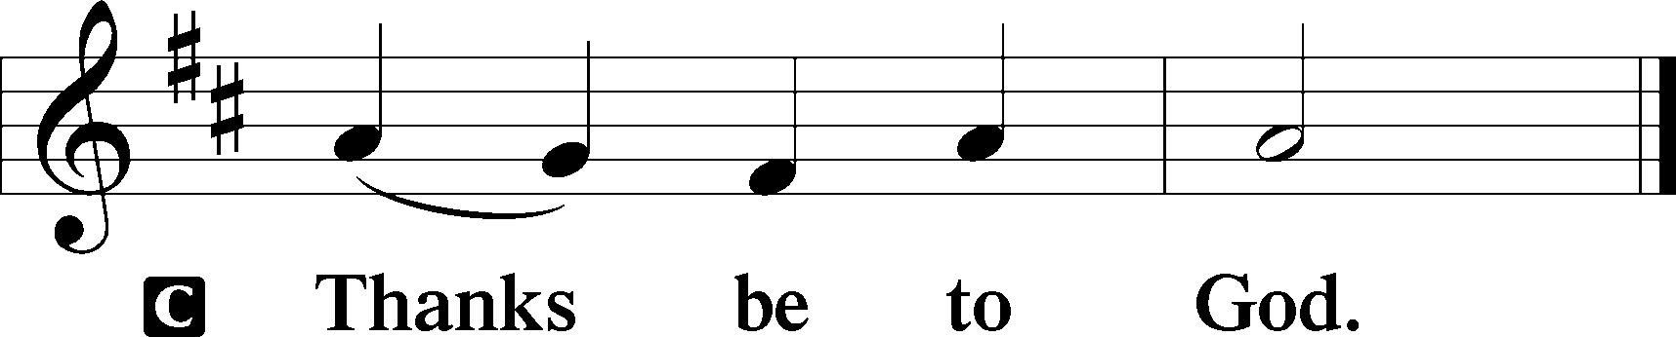

Benediction Numbers 6:24–26
P The Lord bless you and keep you.
The Lord make His face shine upon you and be gracious unto you.
The Lord lift up His countenance upon you and T give you peace.
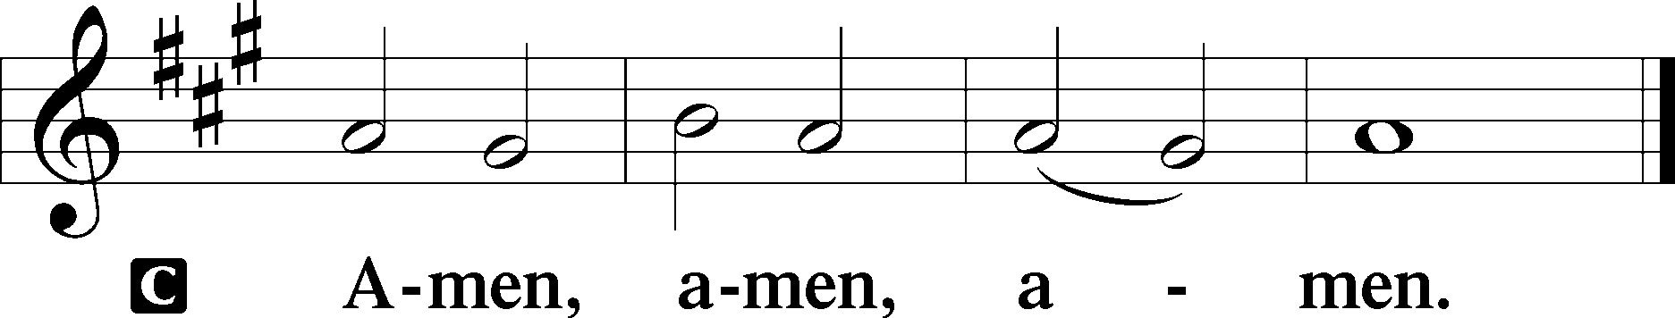

Closing Hymn: LSB #659 “Lord of Our Life”
fffffffffffffffffffffffffffffffffff
Silent prayer after worship: Gracious Lord, as I leave worship today, remain in my heart so that by the working of the Holy Spirit through Your Word I may continually grow in my faith, share my faith, and be assured of my salvation. In Jesus’ name. Amen.
fffffffffffffffffffffffffffffffffff
Acknowledgments
Unless otherwise indicated, Scripture quotations are from the ESV® Bible (The Holy Bible, English Standard Version®), copyright © 2001 by Crossway, a publishing ministry of Good News Publishers. Used by permission. All rights reserved.
Created by Lutheran Service Builder © 2023 Concordia Publishing House.
fffffffffffffffffffffffffffffffffff
fffffffffffffffffffffffffffffffffff
In Loving Memory of Barry Nelson: Anna Mae Daris and Karen Psznick.
fffffffffffffffffffffffffffffffffff

SCHEDULE THROUGH NOVEMBER 5, 2023:

:

Today, 3 pm, First Trinity Lutheran Church, Pgh, PA: Reformation Service
7 pm, Fellowship Hall: AA Meeting
Tuesday, 7 pm, Sanctuary: Reformation Day Divine Service
7-9 pm, Fellowship Hall: Penn-Ohio Singers
Wednesday, 7 pm, Sanctuary: All Saints’ Day Divine Service
7:30 pm, Fellowship Hall: NA Meeting
Thursday, 10 am, Fellowship Hall: Women’s Bible Study
Next Sunday, 8 am, Fellowship Hall: Bible Study
9 am, Sanctuary: Divine Service
7 pm, Fellowship Hall: AA Meeting
fffffffffffffffffffffffffffffffffff
During the Divine Service next Sunday, November 5th will be the dedication of the Memorial Book and Display Case, which have been an Altar Guild project this past year. All Altar Guild members are encouraged to be in attendance and to sit together for this service.
Our Stewardship of Treasures for the Lord:
In order to do the Lord’s work, we need $2,553.63 each week to meet our 2023 budget for general purposes and $76.92 for the SELC.

Figures for Sunday, October 22, 2023
General Fund: $1,109.25 Behind for the week: -$1,444.38
SELC: $0.00 Behind for the week: -$76.92
Quarterly Missions: $0.00
Capital Campaign: $215.00

For online giving, check out https://www.saintspeterandpaul.net/online-giving.
fffffffffffffffffffffffffffffffffff
THANK YOU FOR SERVING IN OCTOBER: Elder: Jonathan Baisch; Ushers: Matt Berent, Mark Gabriel, Michael Laird, & Jerome Thomas; Altarware ~ Sundays: (prior) Diane Riefstahl; (after) Oct. 29th~Elizabeth Haenftling; Special Divine Service: Oct. 31st ~ Elizabeth Haenftling.
fffffffffffffffffffffffffffffffffff
Bible Memory Verses ~ Week of October 29th:
For Adults: Not everyone who says to me, ‘Lord, Lord,’ will enter the kingdom of heaven, but the one who does the will of my Father who is in heaven.
Matthew 7:21

For Children: An athlete is not crowned unless he competes according to the rules. 2 Timothy 2:5
fffffffffffffffffffffffffffffffffff
It’s time to renew subscriptions for the “Lutheran Witness” magazine for 2024. The price has increased to $19.25. If wishing to renew, place a check made out to Sts. Peter & Paul’s in a pew envelope and label the envelope with your name and that it is for the LW. Please make sure to note any change in address with your renewal. Renewals are due on or before Sunday, November 19, 2023.

fffffffffffffffffffffffffffffffffff
Attendance: Sunday, October 22, 2023: 35
Monday, October 23, 2023: 9
fffffffffffffffffffffffffffffffffff
Remember the following in Prayer…
~The Hurting and Healing: Amy, Steve Antolovich, Ellen Baron^{CA}, Amy Blomenberg, Lois Bortner^{CA}, Sara Brubaker, Dee Bullock, Bev & Joe Chlpka, Susan Davies, Loretta Deal, Tim Dudash, Judith & Eddy Furey, Griffin, Austin Hamilton, Pastor Charles Henrickson, Joan, Keith Jozwiakowski, Darla Krajci, Barbara Kreske, Jess Lavoie, Paul Lucas^{CA}, Sandy Marshall, Frank Niemeyer^{CA}, Juanita Rentschler, Richard Reuning^{CA}, Nancy Robertson^{CA}, Kriss Svidro^{CA}, Rudy Tomko, Joel & Peggy Wasson, Angela Weser^{CA}, Betty Wolf, and Ruth Wolf.
~The Homebound: Anna Mae Daris, Millie Elavsky, Jean Tomko, and Ed & Millie Zachar.
~Celebrating this Week: Birthdays: Hailey Bale (10.31), Hunter Bale (10.31), Maria Marks (11.02), & Jerome Thomas (11.03).
~Serving in the Military: Alex (Sasha) Carr, Duncan Vaupel, Curtis Sinewe, and Joshua Solyan.
~Community & World Needs: Those suffering due to the conflicts in the Middle East and between Ukraine and Russia; those suffering from loss and dislocation because weather disasters; those suffering from addiction and their families; Local, State, and National Government Leaders; safety for all Police Officers, Firefighters, & First Responders; the unemployed; our Fourth Quarter Local Mission: Willow Women’s Center.
*CA represents cancer.
fffffffffffffffffffffffffffffffffff
UP-COMING SPECIAL DIVINE SERVICES (7 pm):
- Tuesday, October 31: Reformation Day
- Wednesday, November 1: All Saints Day ~ Remembering those members of our congregation who passed into the arms of our Lord this past year (Anson Holcroft, February 22, 2023; Viola Sakony, March 25, 2023; Barry Nelson, April 25, 2023; and those whom we hold dear in our hearts.)
fffffffffffffffffffffffffffffffffff
THANK YOU FOR SERVING IN NOVEMBER: Elder: Jonathan Baisch; Ushers: Mark Kleindienst, Jerry Krivosh, & Gordon Marquette; Altarware ~ Sundays: (prior) Marie Flaugher (11.12) & Diane Riefstahl; (after) Evelyn Baisch & Arlene Sutton; Special Divine Services: Nov. 1st ~ Marie Flaugher & Nov. 30th ~ Elizabeth Haenftling.
UP-COMING MEETINGS:
Church Council: Monday, November 6th at 7 pm.
Trustees: Wednesday, November 8th at 7 pm.
Voters’ Assembly: Sunday, November 19th following worship.
Auditors: Sunday, November 26th following worship.
fffffffffffffffffffffffffffffffffff
Sincere “thanks” are extended to those who planned, assisted with, and attended last evening’s Appreciation Dinner for Pastor Deal and his family. It is always wonderful to share fellowship with one another and to express our heartfelt gratitude. We are especially grateful to the core committee members: Mark & Bess Kleindienst, Mike & Marie Flaugher, Catherine Carr, Arlene Sutton, and Linda Tomko!
Currently, this congregation is uniquely blessed with multiple families who have dedicated their lives to sharing the ministry of our Lord and Savior: the Baisches, Kuceras, and Carrs. We give thanks and praise to our Lord for their service.
fffffffffffffffffffffffffffffffffff
All are invited to attend a special Reformation Service this afternoon at 3 pm at Trinity Lutheran Church, 531 N. Neville St., Pittsburgh, PA.
fffffffffffffffffffffffffffffffffff
Pastor Deal will be attending a pastoral conference tomorrow, Monday, October 30th in Pittsburgh, PA.
fffffffffffffffffffffffffffffffffff
Here is some updated information for our members who are currently convalescing:
- Rudy Tomko: Room 8, Nugent’s Skilled Nursing & Rehabilitation, 500 Clarksville Rd., Hermitage, PA 16148
- Betty Wolf: Room 28, Jameson Care Center, 3349 Wilmington Rd., New Castle, PA 16105.
fffffffffffffffffffffffffffffffffff
Copies of the November issue of “The Rock and the Sword” are available today and may be picked up on the tables in the narthex and next to the nursery.
fffffffffffffffffffffffffffffffffff

Here to Serve
Pastor………………………………………………...……………Rev. Jacob Deal
E-mail …………………………….……pastordeal@saintspeterandpaul.net
Phone Number……………………..…………………724-347-3620 (Option 2)
Church Office………………………..…………………724-347-3620 (Option 3)
Website …………………………………………www.saintspeterandpaul.net
Secretary…………………………………………………………Diane Riefstahl
E-mail ………………………………………church@saintspeterandpaul.net
Website …………………………………………www.saintspeterandpaul.net
Food Pantry (email): ……………foodpantry@saintspeterandpaul.net
Congregation President………………………………….…Jonathan Baisch
Church Elder …………………………………………...……. Jonathan Baisch
Organist………………………………………………..….…Rebecca Marquette
Choir Director…………………………………………………….…Chris Nelson
AA Contact: Steve………………………………………………...…724-813-2358
NA Contact: Larry……………………………………..…………..724-977-8733
fffffffffffffffffffffffffffffffffff
If needing to get into the church building during the week, please phone first to make certain someone is here to let you in.

