Sts. Peter & Paul
Evangelical Lutheran Church
Lutheran Church-Missouri Synod
Founded-1917

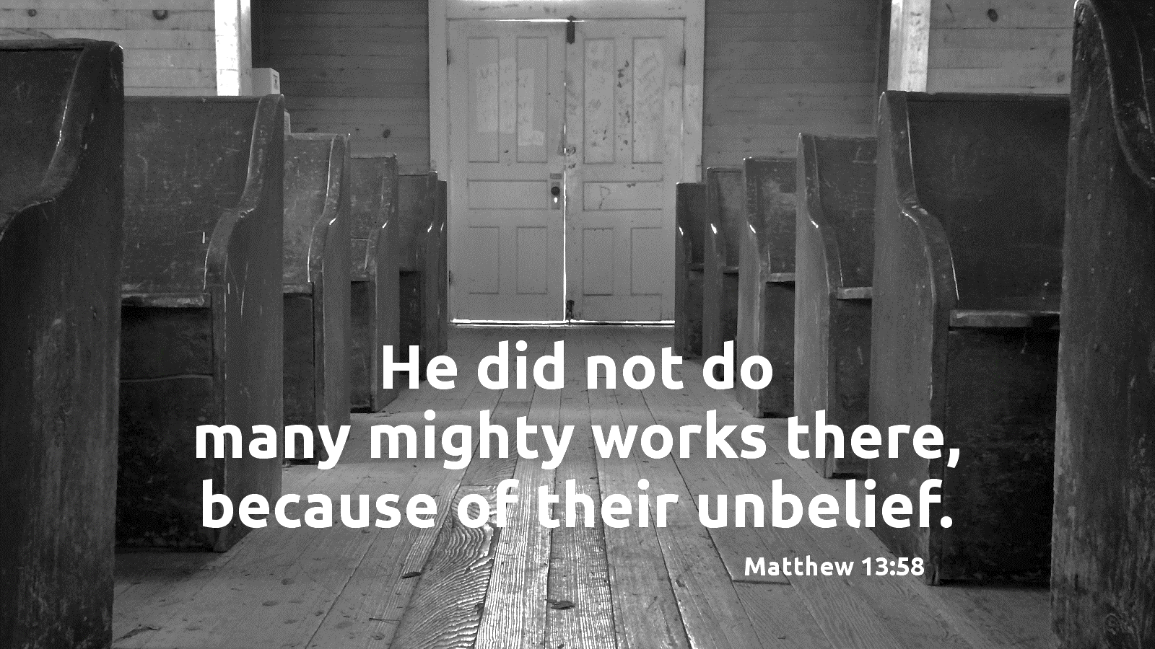

October 23, 2023

699 Stambaugh Ave.
Sharon, Pennsylvania 16146

“I was glad when they said to me,
Let us go to the house of the LORD!”
Psalm 122:1
Sts. Peter & Paul Evangelical Lutheran Church, LC-MS
FEAST OF ST. JAMES OF JERUSALEM,
BROTHER OF JESUS AND MARTYR
October 23, 2023

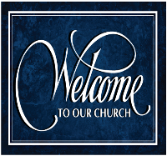
A special welcome to our guests this day! If you would like more information about The Lutheran Church - Missouri Synod, or this congregation, please speak with Pastor Deal or an Elder after the service.
Members & Guests: Don’t be embarrassed if your children make noise during the worship service, all children do. We encourage families to worship together but, if you feel the need, there are pews in the rear of the Church which are reserved for young families on both sides of the sanctuary. There is also a quiet room available to you, located next to the sanctuary (formerly the Pastor’s office), where you would be able to follow along with the service.

Today’s service includes the Sacrament of Holy Communion. If during this past year, you have not worshipped with us and been communed, we respectfully ask that you do not partake of this sacrament this day before first speaking with Pastor Deal.
If visiting from a sister congregation of the LC-MS and are in good standing, please inform Pastor Deal of your desire to commune prior to the service.
If wishing to receive a blessing during communion, please approach with your arms crossed.

CONTACT INFORMATION
Pastor Deal: pastordeal@saintspeterandpaul.net or 724-347-3620 (opt. 2)
Church Office: church@saintspeterandpaul.net or 724-347-3620 (opt. 3)
Secretary’s Office: The office will be open Thurs. & Fri. (8:30 am-4:30 pm).

Silent prayer before worship: Dear Lord, open my ears and my heart to Your holy Word, so that I can grow in faith and knowledge of You, and may remain sure of my salvation through Jesus Christ alone. Amen.
Confession and Absolution

Opening Hymn: LSB #566 “By Grace I’m Saved”

Stand

The sign of the cross may be made by all in remembrance of their Baptism.

Invocation
P In the name of the Father and of the T Son and of the Holy Spirit.
C Amen.

Exhortation Hebrews 10:22; Psalm 124:8; Psalm 32:5
P Beloved in the Lord! Let us draw near with a true heart and confess our sins unto God our Father, beseeching Him in the name of our Lord Jesus Christ to grant us forgiveness.

P Our help is in the name of the Lord,
C who made heaven and earth.
P I said, I will confess my transgressions unto the Lord,
C and You forgave the iniquity of my sin.

Silence for reflection on God’s Word and for self-examination.

Confession of Sins
P O almighty God, merciful Father,
C I, a poor, miserable sinner, confess unto You all my sins and iniquities with which I have ever offended You and justly deserved Your temporal and eternal punishment. But I am heartily sorry for them and sincerely repent of them, and I pray You of Your boundless mercy and for the sake of the holy, innocent, bitter sufferings and death of Your beloved Son, Jesus Christ, to be gracious and merciful to me, a poor, sinful being.

Absolution [John 20:19–23]
P Upon this your confession, I, by virtue of my office, as a called and ordained servant of the Word, announce the grace of God unto all of you, and in the stead and by the command of my Lord Jesus Christ I forgive you all your sins in the name of the Father and of the T Son and of the Holy Spirit.
C Amen.

Service of the Word

Introit Psalm 31:1, 3, 5; antiphon: Revelation 7:14b
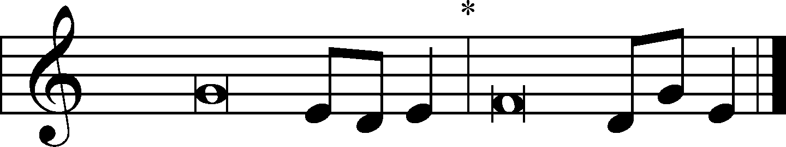
These are the ones coming out of the great tribu- | lation.*
They have washed their robes and made them white in the blood | of the Lamb.
In you, O Lord, do I take refuge; let me never be | put to shame;*
in your righteousness de- | liver me.
For you are my rock and my | fortress;*
and for your name’s sake you lead me and | guide me.
Into your hand I commit my | spirit;*
you have redeemed me, O Lord, | faithful God.
These are the ones coming out of the great tribu- | lation.*
They have washed their robes and made them white in the blood | of the Lamb.

Gloria Patri
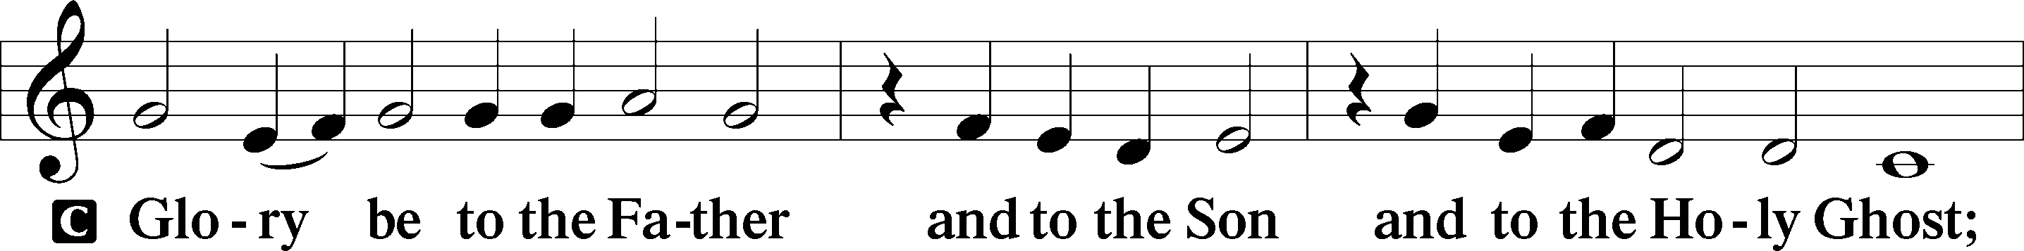
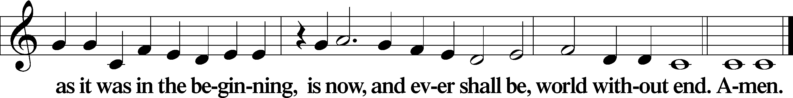
Kyrie Mark 10:47
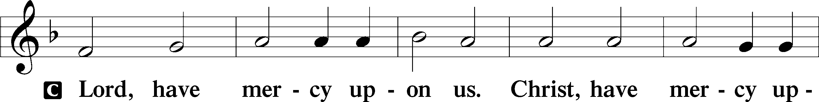
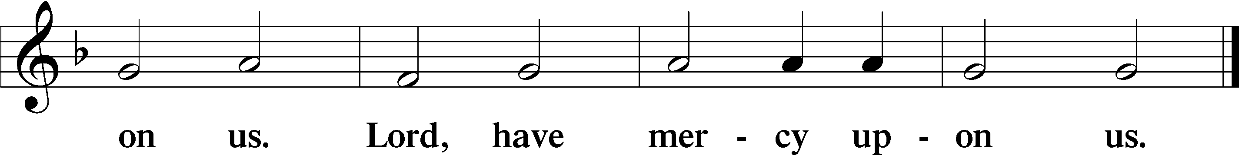

Gloria in Excelsis Luke 2:14; John 1:29
P Glory be to God on high:
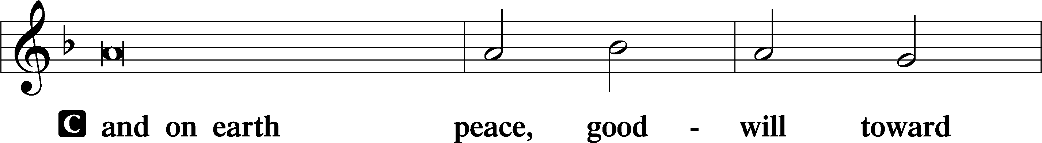
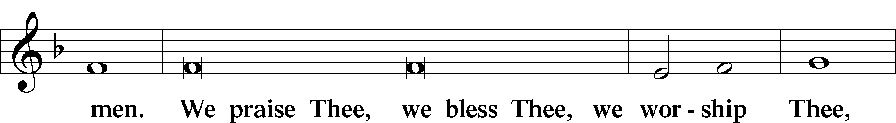
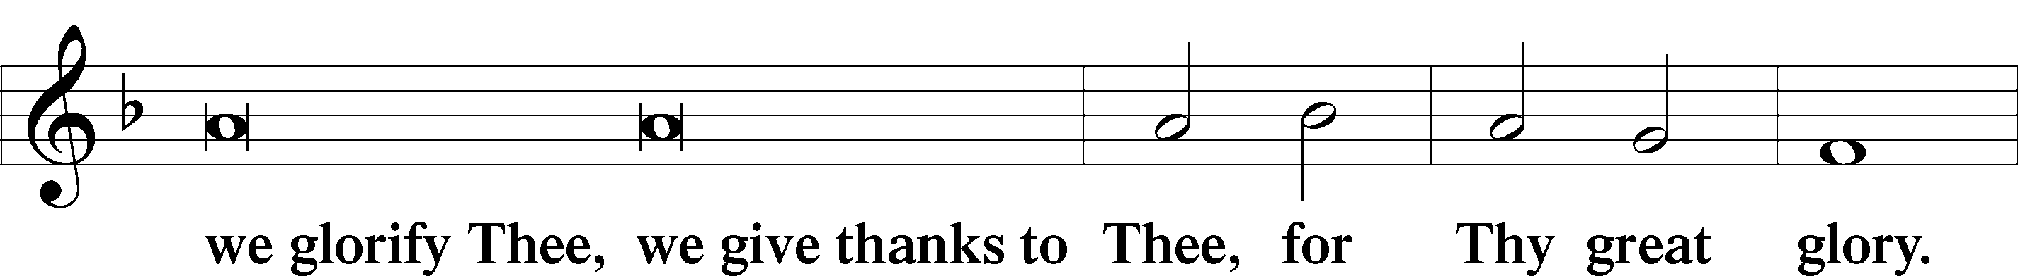
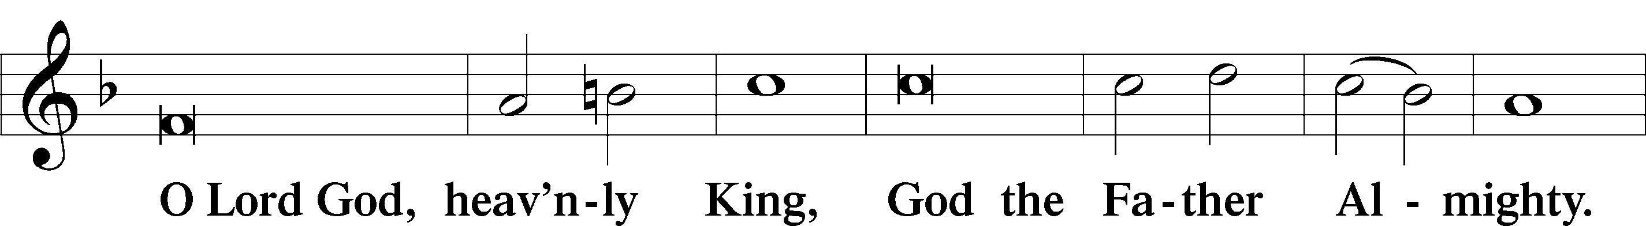
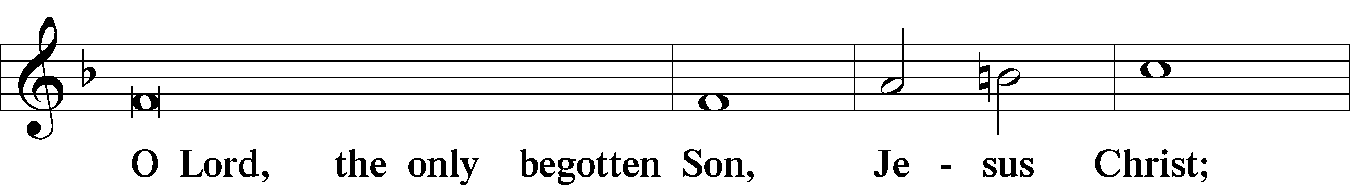
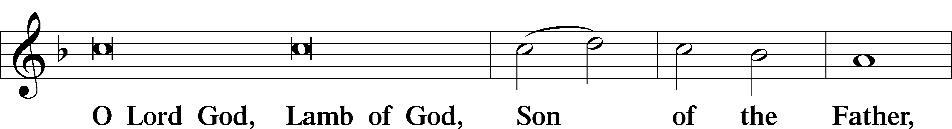
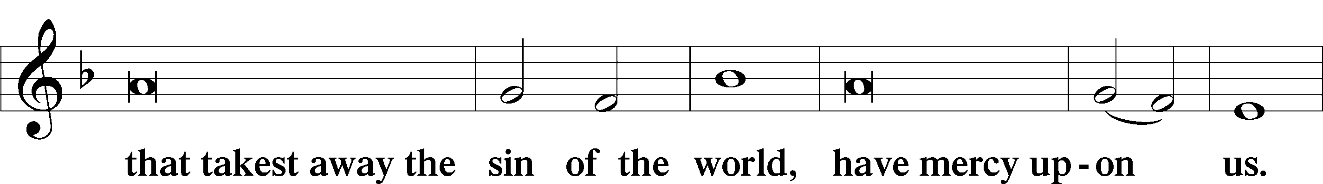
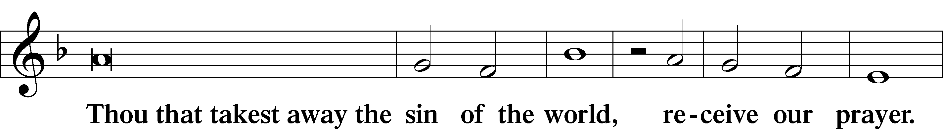
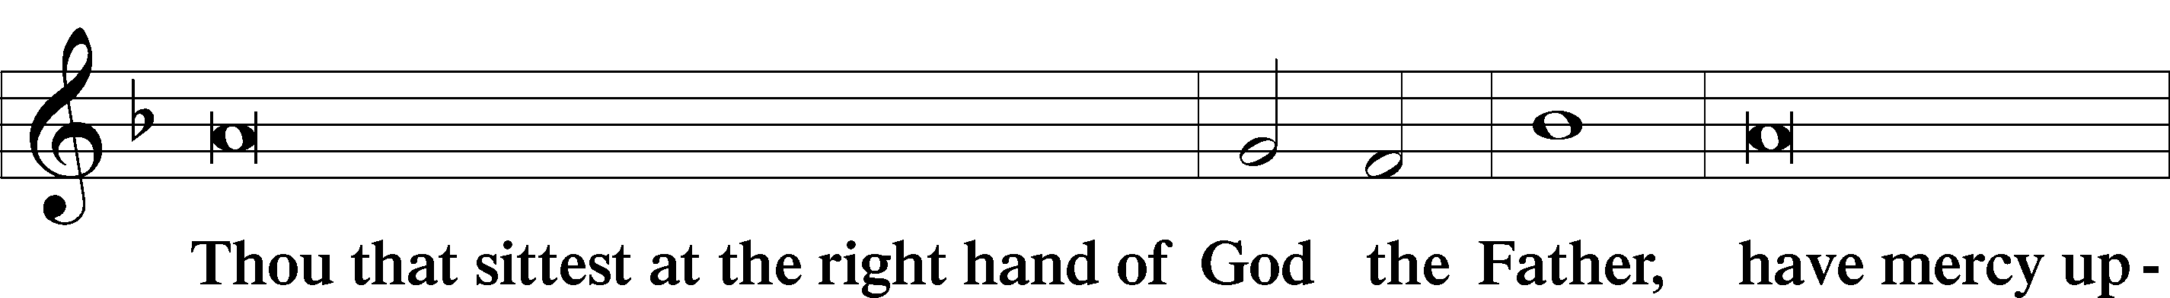
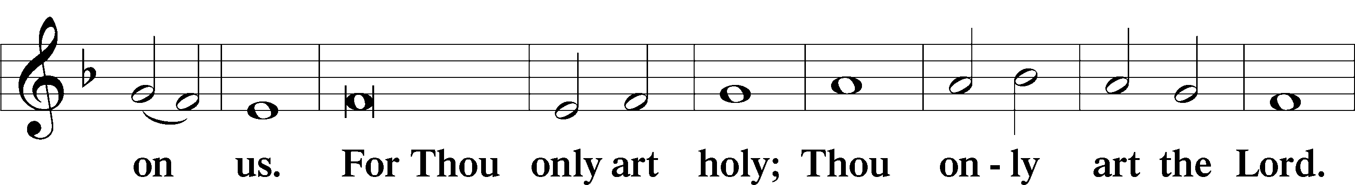
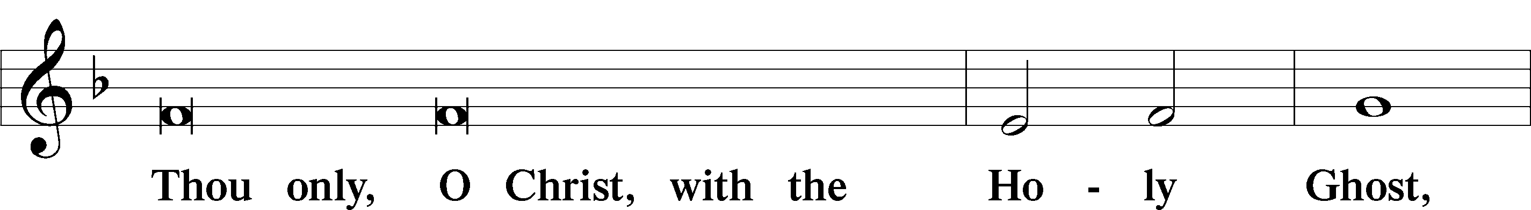
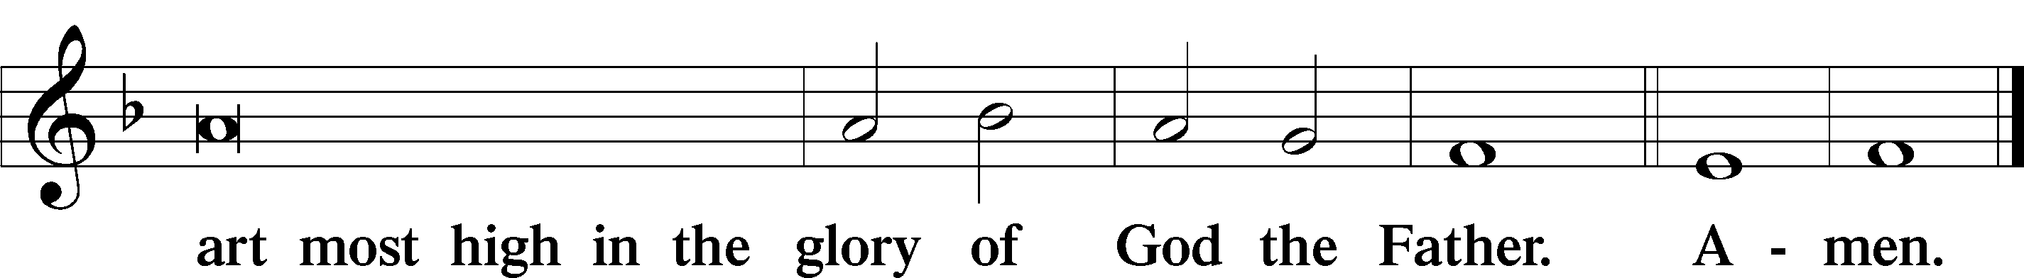

Salutation and Collect of the Day: Saint James of Jerusalem
P The Lord be with you.
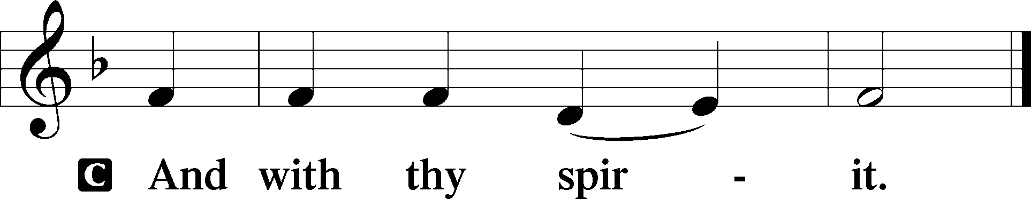

P Let us pray.
Heavenly Father, shepherd of Your people, You raised up James the Just, brother of our Lord, to lead and guide Your Church. Grant that we may follow his example of prayer and reconciliation and be strengthened by the witness of his death; through Jesus Christ, Your Son, our Lord, who lives and reigns with You and the Holy Spirit, one God, now and forever.
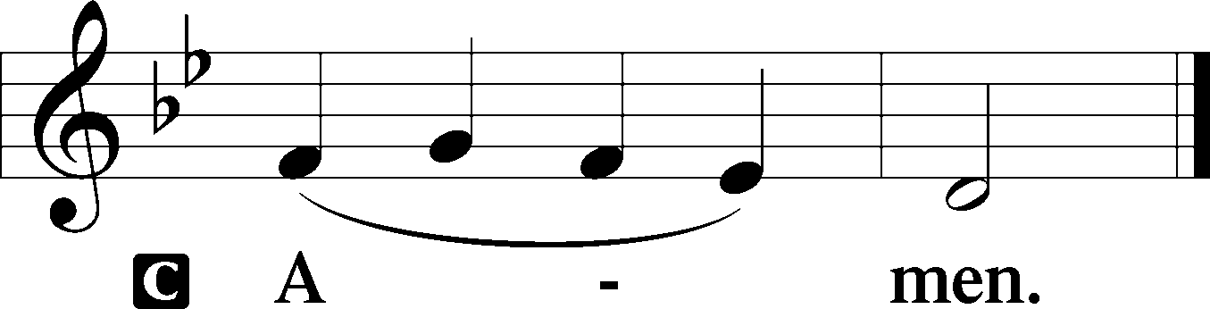

Sit

First Reading: Acts 15:12–22a (NKJV)
Then all the multitude kept silent and listened to Barnabas and Paul declaring how many miracles and wonders God had worked through them among the Gentiles. And after they had become silent, James answered, saying, “Men and brethren, listen to me: Simon has declared how God at the first visited the Gentiles to take out of them a people for His name. And with this the words of the prophets agree, just as it is written:
‘After this I will return
And will rebuild the tabernacle of David, which has fallen down;
I will rebuild its ruins,
And I will set it up;
So that the rest of mankind may seek the Lord,
Even all the Gentiles who are called by My name,
Says the Lord who does all these things.’
“Known to God from eternity are all His works. Therefore I judge that we should not trouble those from among the Gentiles who are turning to God, but that we write to them to abstain from things polluted by idols, from sexual immorality, from things strangled, and from blood. For Moses has had throughout many generations those who preach him in every city, being read in the synagogues every Sabbath.”
Then it pleased the apostles and elders, with the whole church, to send chosen men of their own company to Antioch with Paul and Barnabas,

P This is the Word of the Lord.
C Thanks be to God.

Gradual Psalm 48:10–11
As your name, O God, so your praise reaches to the ends | of the earth.*
Your right hand is filled with | righteousness.
Let Mount Zi- | on be glad!*
Let the daughters of Judah rejoice because of your | judgments!

Epistle: James 1:1–12 (NKJV)
James, a bondservant of God and of the Lord Jesus Christ,
To the twelve tribes which are scattered abroad:
Greetings.
My brethren, count it all joy when you fall into various trials, knowing that the testing of your faith produces patience. But let patience have its perfect work, that you may be perfect and complete, lacking nothing. If any of you lacks wisdom, let him ask of God, who gives to all liberally and without reproach, and it will be given to him. But let him ask in faith, with no doubting, for he who doubts is like a wave of the sea driven and tossed by the wind. For let not that man suppose that he will receive anything from the Lord; he is a double-minded man, unstable in all his ways.
Let the lowly brother glory in his exaltation, but the rich in his humiliation, because as a flower of the field he will pass away. For no sooner has the sun risen with a burning heat than it withers the grass; its flower falls, and its beautiful appearance perishes. So the rich man also will fade away in his pursuits.
Blessed is the man who endures temptation; for when he has been approved, he will receive the crown of life which the Lord has promised to those who love Him.

P This is the Word of the Lord.
C Thanks be to God.

Stand

Verse Psalm 116:15
Alleluia. Precious in the sight of the Lord is the death of his saints. Alleluia.

Alleluia
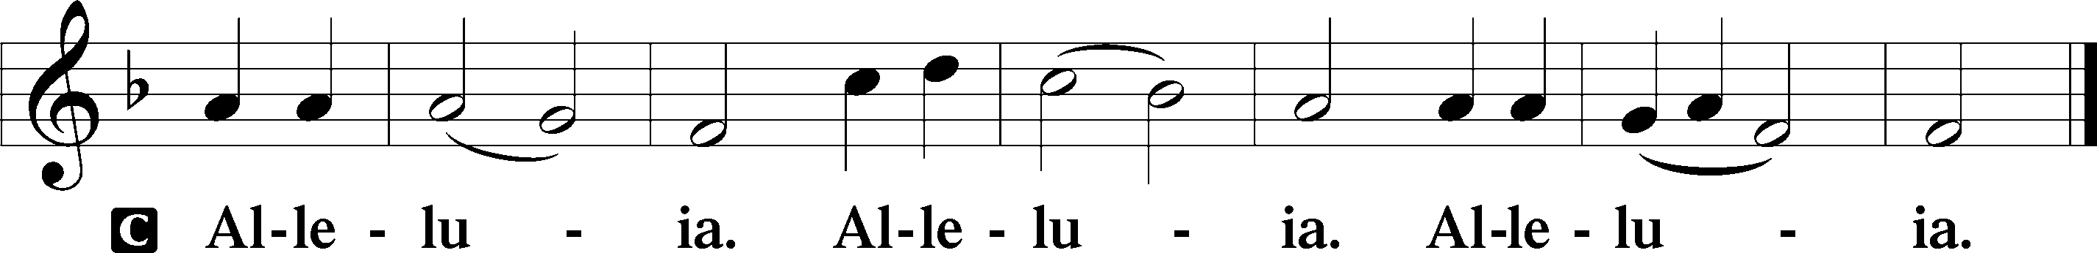

Holy Gospel: Matthew 13:54–58 (NKJV)
P The Holy Gospel according to St. Matthew, the thirteenth chapter.
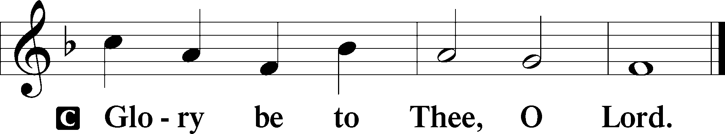

When He had come to His own country, He taught them in their synagogue, so that they were astonished and said, “Where did this Man get this wisdom and these mighty works? Is this not the carpenter’s son? Is not His mother called Mary? And His brothers James, Joses, Simon, and Judas? And His sisters, are they not all with us? Where then did this Man get all these things?” So they were offended at Him.
But Jesus said to them, “A prophet is not without honor except in his own country and in his own house.” Now He did not do many mighty works there because of their unbelief.

P This is the Gospel of the Lord.
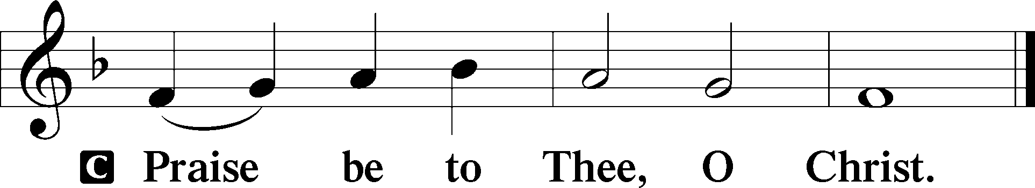

Nicene Creed
C I believe in one God,
the Father Almighty,
maker of heaven and earth
and of all things visible and invisible.

And in one Lord Jesus Christ,
the only-begotten Son of God,
begotten of His Father before all worlds,
God of God, Light of Light,
very God of very God,
begotten, not made,
being of one substance with the Father,
by whom all things were made;
who for us men and for our salvation came down from heaven
and was incarnate by the Holy Spirit of the virgin Mary
and was made man;
and was crucified also for us under Pontius Pilate.
He suffered and was buried.
And the third day He rose again according to the Scriptures
and ascended into heaven
and sits at the right hand of the Father.
And He will come again with glory to judge both the living and the dead,
whose kingdom will have no end.

And I believe in the Holy Spirit,
the Lord and giver of life,
who proceeds from the Father and the Son,
who with the Father and the Son together is worshiped and glorified,
who spoke by the prophets.
And I believe in one holy Christian and apostolic Church,
I acknowledge one Baptism for the remission of sins,
and I look for the resurrection of the dead
and the life T of the world to come. Amen.
Sit

Hymn of the Day: LSB #797 “Praise the Almighty”

Sermon

Stand

Offertory Psalm 51:10–12
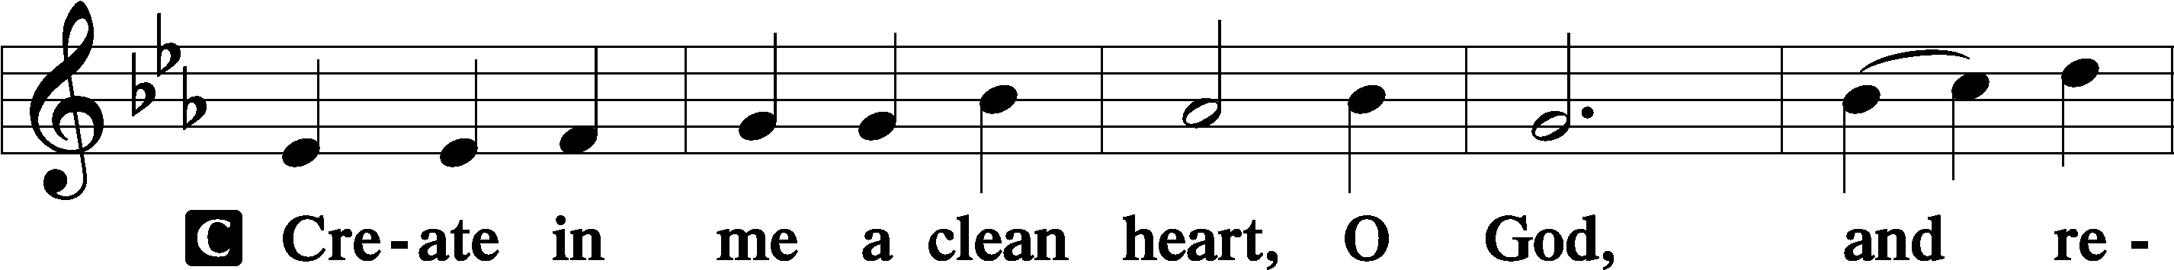
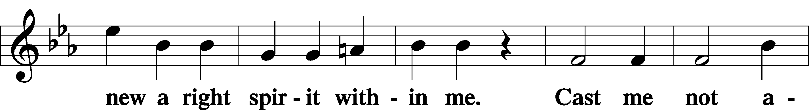
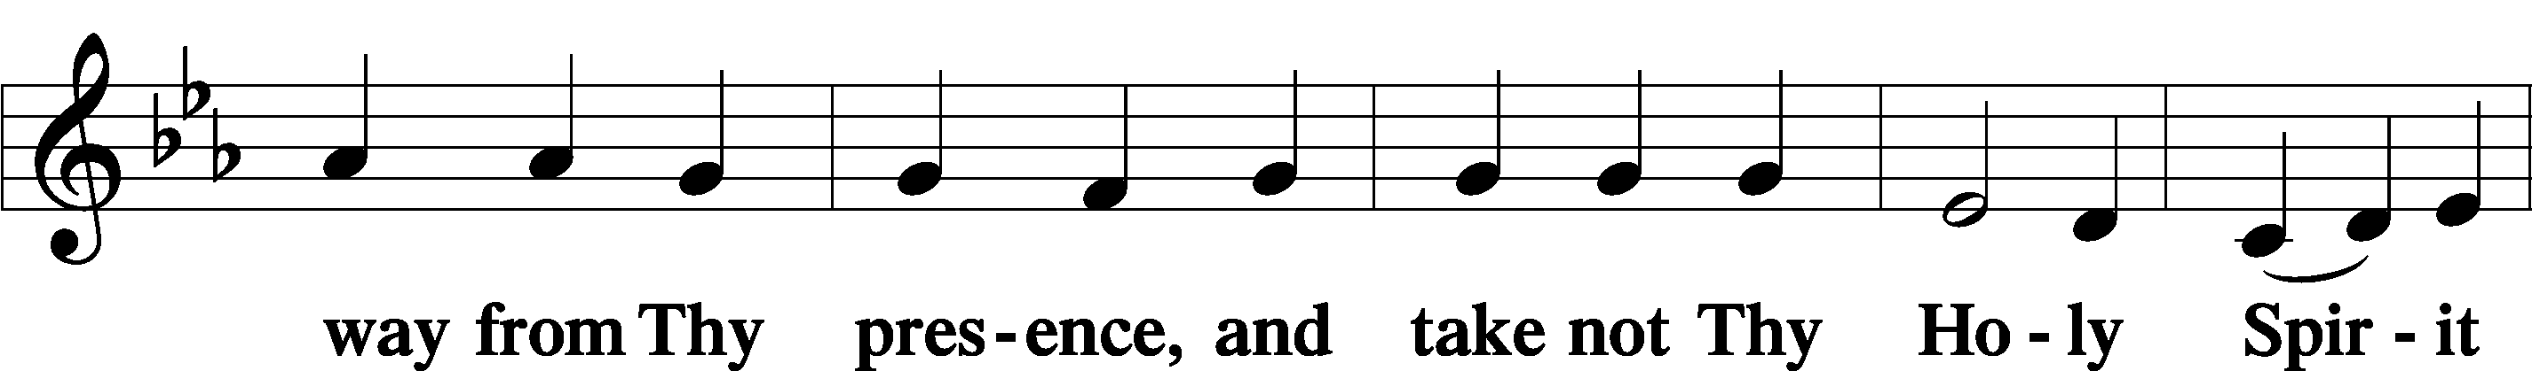
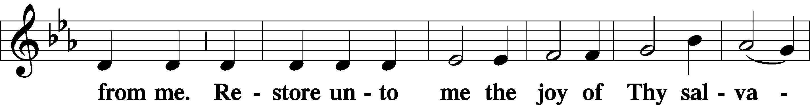
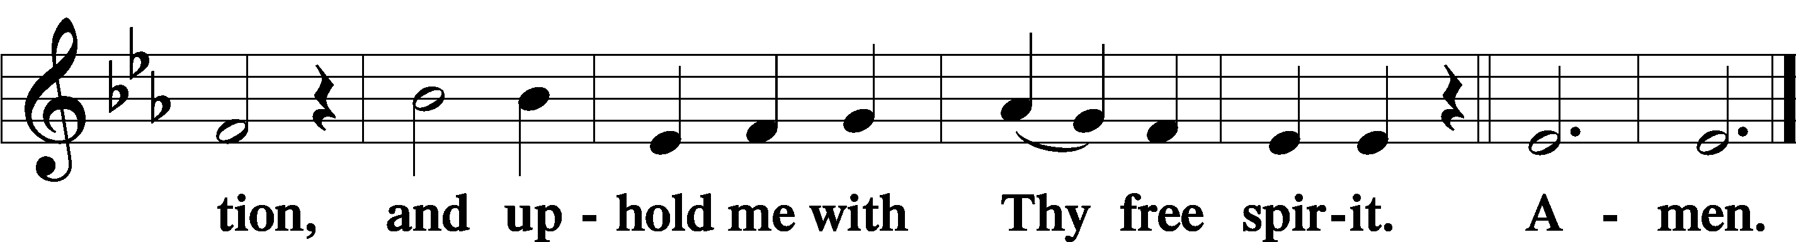

Prayer of the Church

Sit

Preparatory Hymn: LSB#531 “Hail, Thou Once Despised Jesus”

Stand
Service of the Sacrament

Preface 2 Timothy 4:22; Colossians 3:1 Psalm 136
P The Lord be with you.
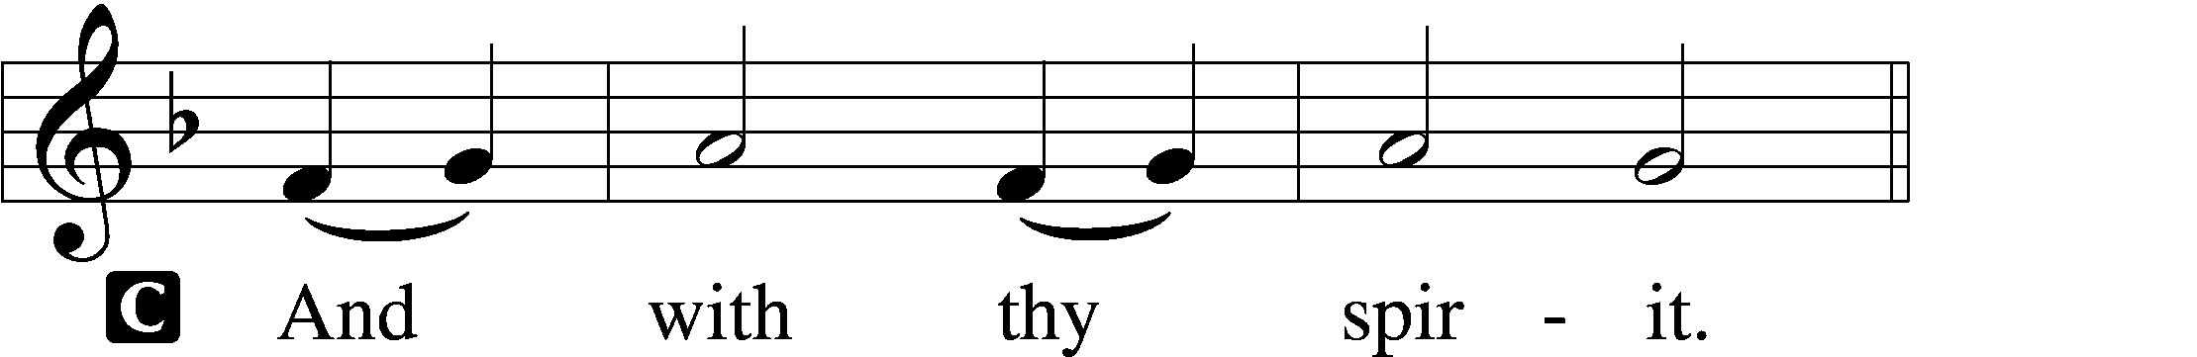

P Lift up your hearts.
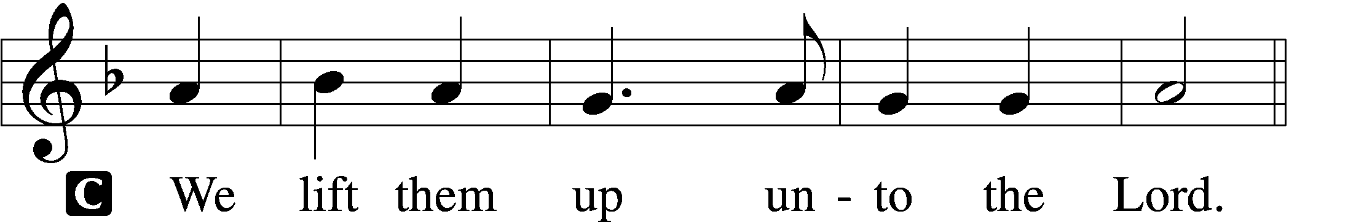

P Let us give thanks unto the Lord, our God.
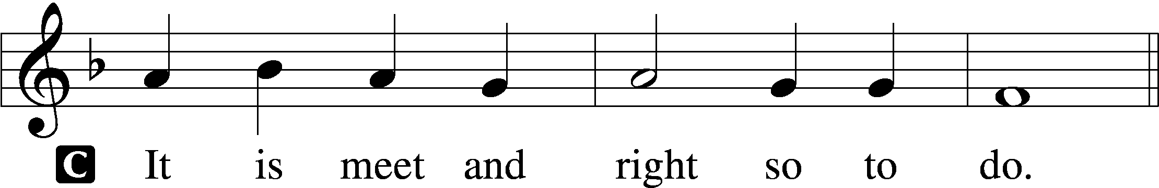

Proper Preface (Abbreviated) LSB 194
P It is truly meet, right, and salutary . . . evermore praising You and saying:

Sanctus Isaiah 6:3; Matthew 21:9
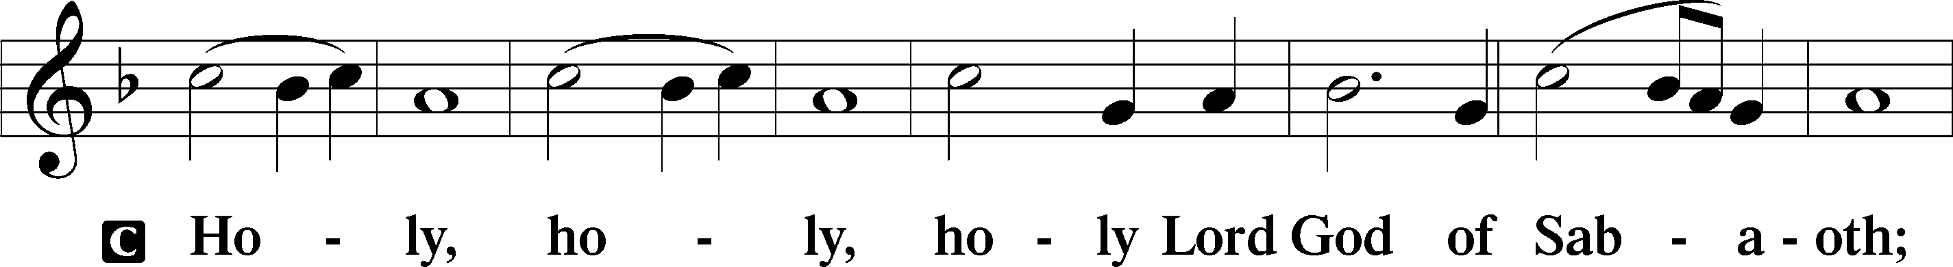
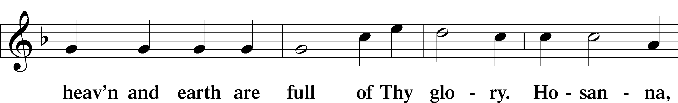
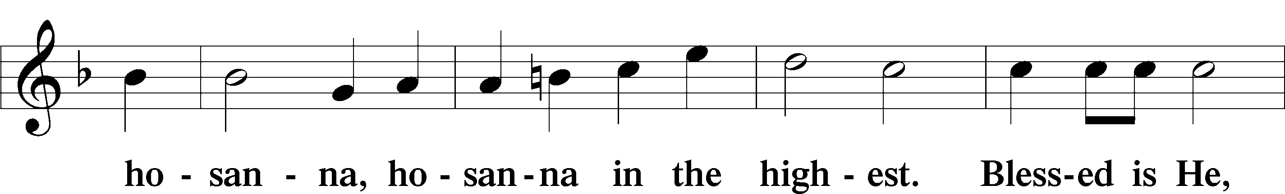
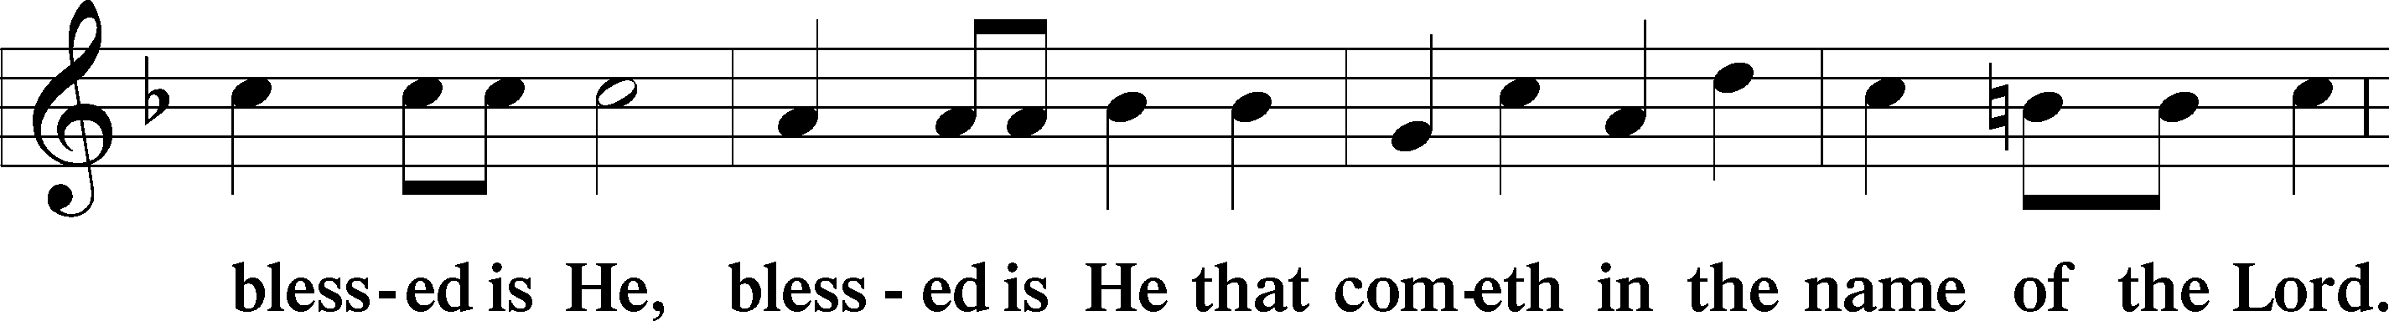
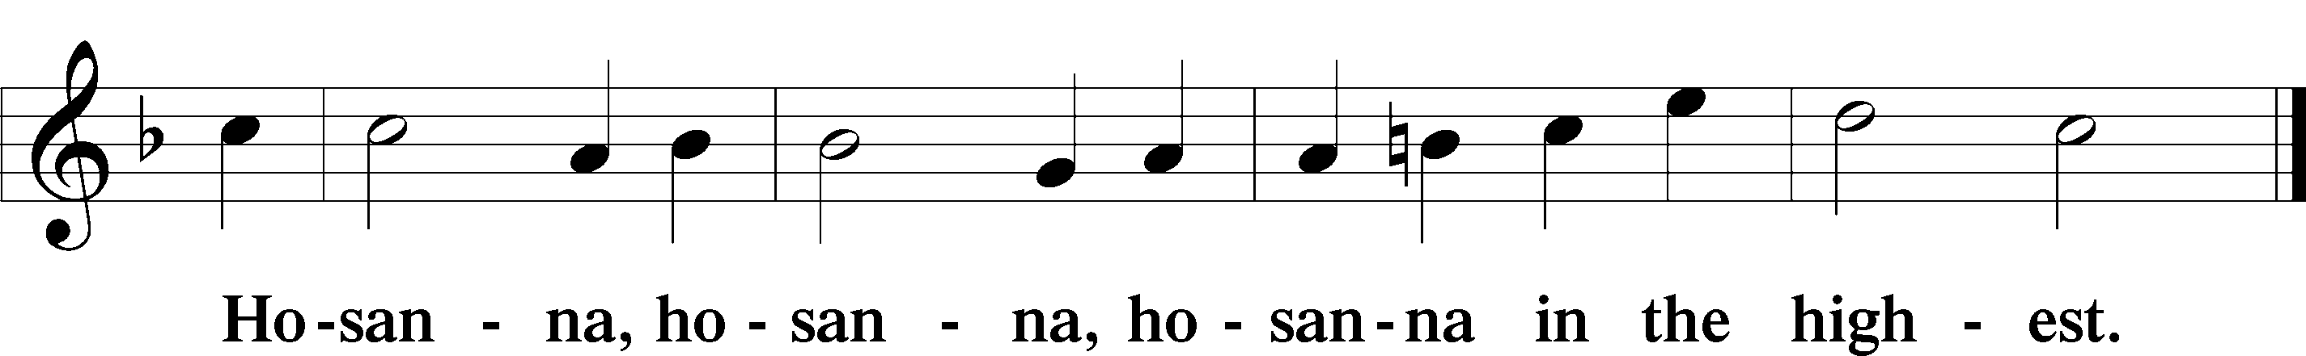

Lord’s Prayer The congregation is encouraged to silently pray the Lord’s Prayer as it is chanted. Matthew 6:9–13
P Our Father who art in heaven,
hallowed be Thy name,
Thy kingdom come,
Thy will be done on earth as it is in heaven;
give us this day our daily bread;
and forgive us our trespasses as we forgive those who trespass against us;
and lead us not into temptation,
but deliver us from evil.
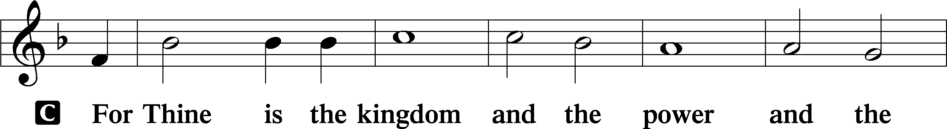
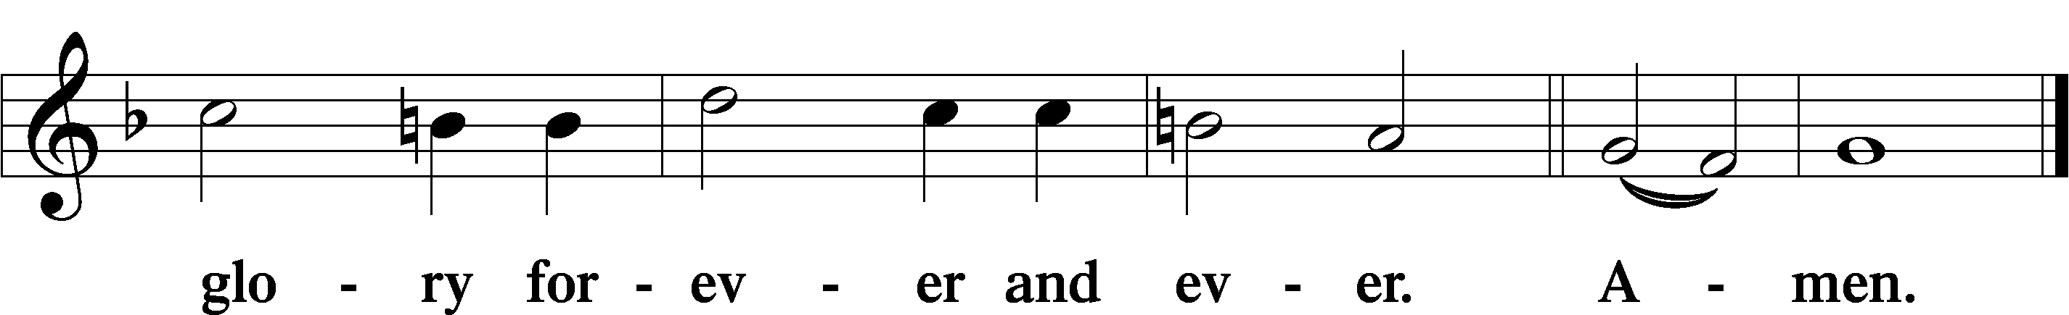
The Words of Our Lord Matthew 26:26–28; Mark 14:22–24; Luke 22:19–20; 1 Corinthians 11:23–25
P Our Lord Jesus Christ, on the night when He was betrayed, took bread, and when He had given thanks, He broke it and gave it to the disciples and said: “Take, eat; this is My T body, which is given for you. This do in remembrance of Me.”

In the same way also He took the cup after supper, and when He had given thanks, He gave it to them, saying: “Drink of it, all of you; this cup is the new testament in My T blood, which is shed for you for the forgiveness of sins. This do, as often as you drink it, in remembrance of Me.”

Pax Domini John 20:19
P The peace of the Lord be with you always.
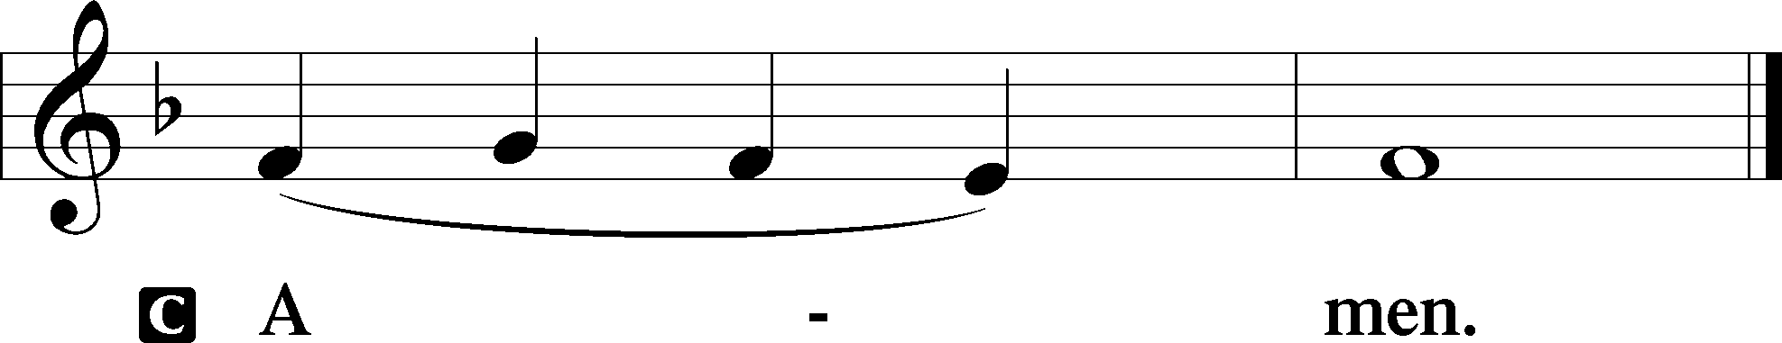

Agnus Dei John 1:29
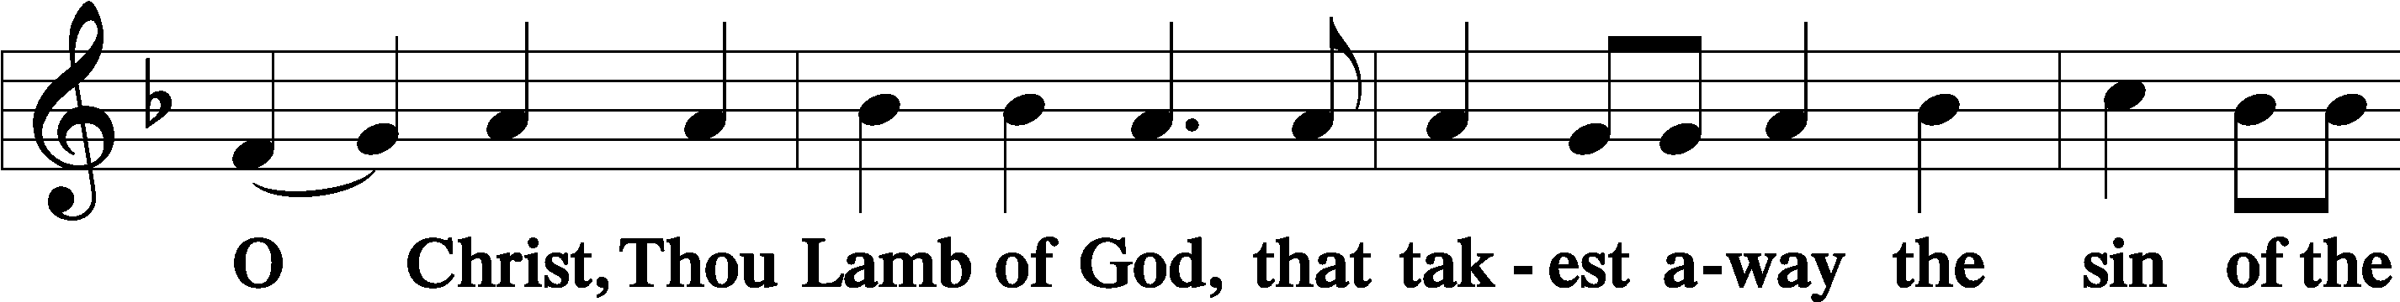
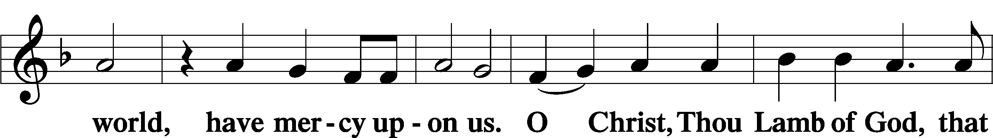
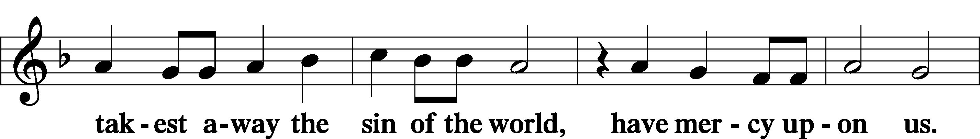
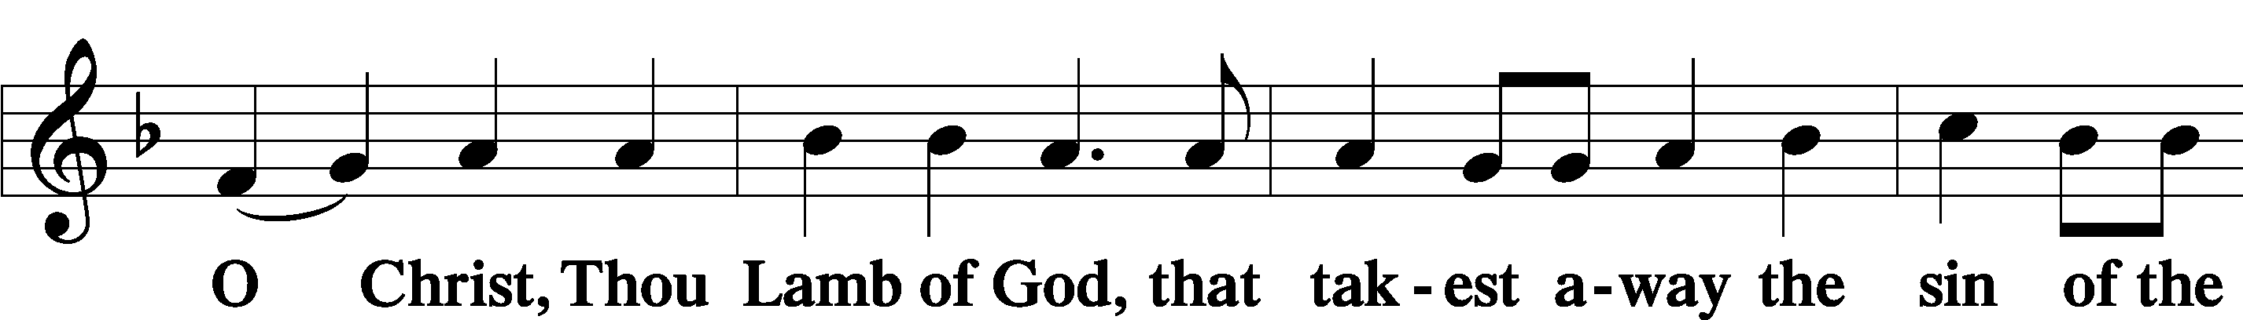
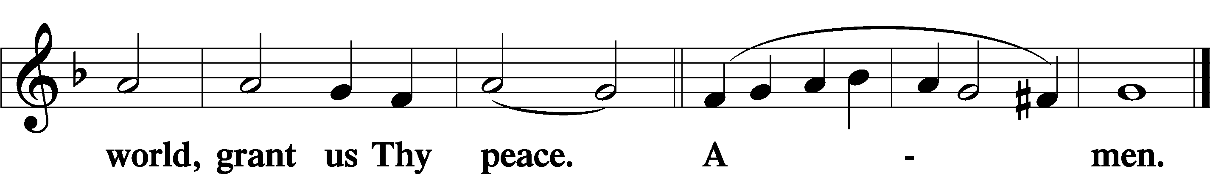
Sit
Distribution
The pastor and those who assist him receive the body and blood of Christ first and then distribute them to those who come to receive, saying:
Take, eat; this is the true body of our Lord and Savior Jesus Christ, given into death for your sins.
Amen.

Take, drink; this is the true blood of our Lord and Savior Jesus Christ, shed for the forgiveness of your sins.
Amen.

In dismissing the communicants, the following is said:
The Dismissal
P The body and blood of our Lord Jesus Christ strengthen and preserve you in body and soul to life everlasting. Depart T in peace.
C Amen.

Distribution Hymn: LSB#559 “Oh, How Great Is Your Compassion”

Distribution Hymn: LSB#694 “Thee Will I Love, My Strength, My Tower”

Stand

Nunc Dimittis Luke 2:29–32
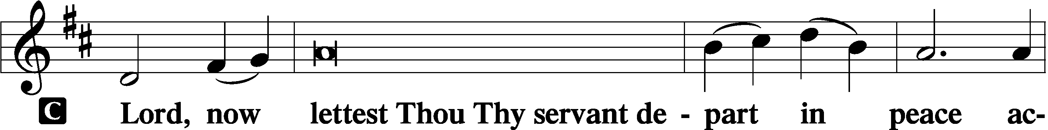
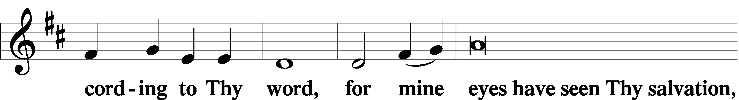
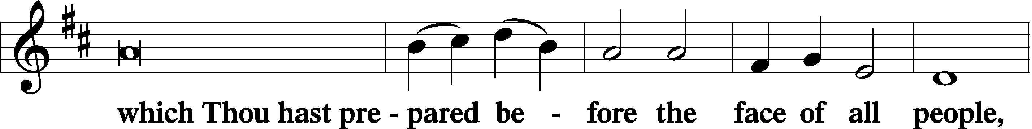
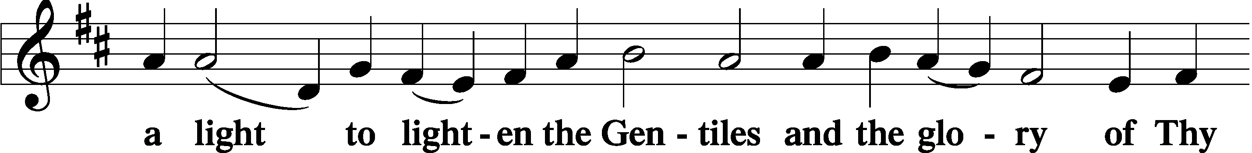
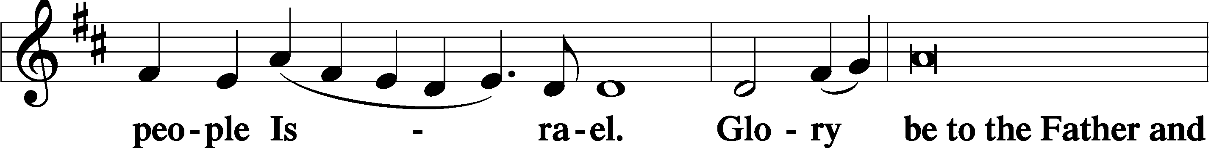
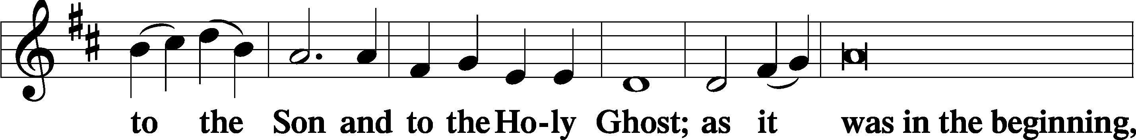
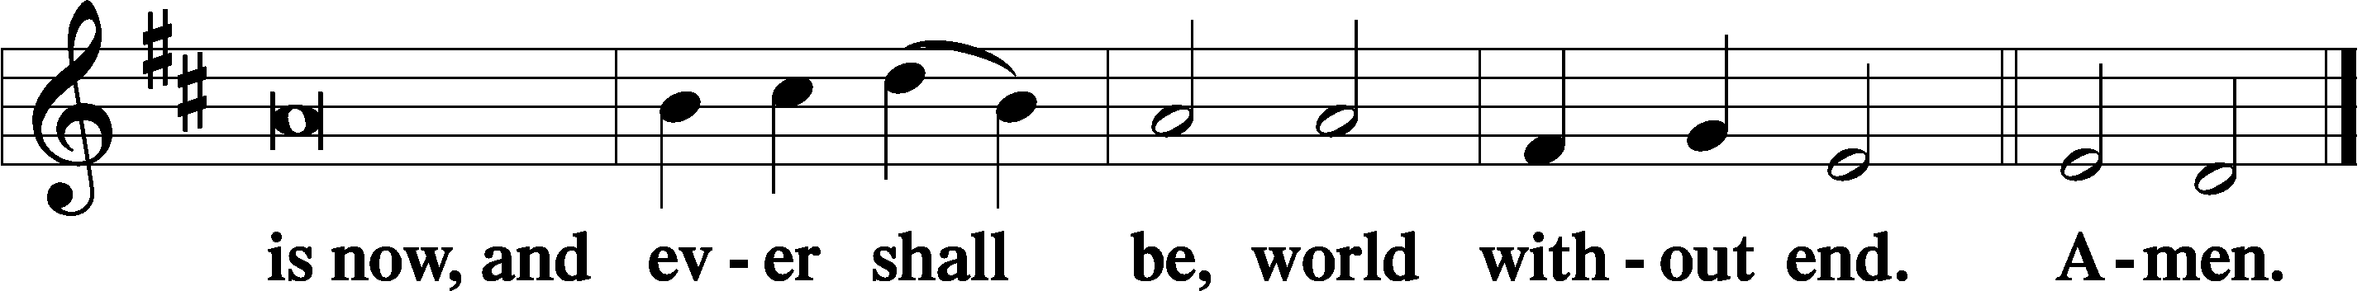

Thanksgiving Psalm 107:1
P O give thanks unto the Lord, for He is good,
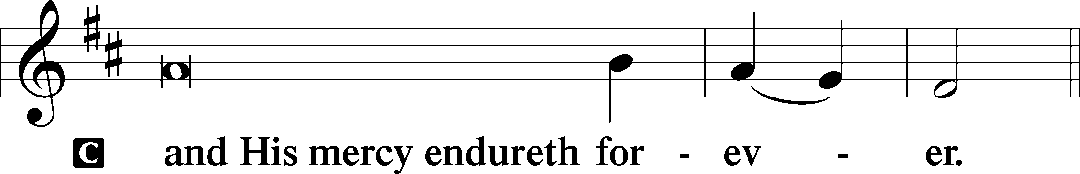

Post-Communion Collect
P Let us pray.
We give thanks to You, almighty God, … through Jesus Christ, Your Son, our Lord, who lives and reigns with You and the Holy Spirit, one God, now and forever.
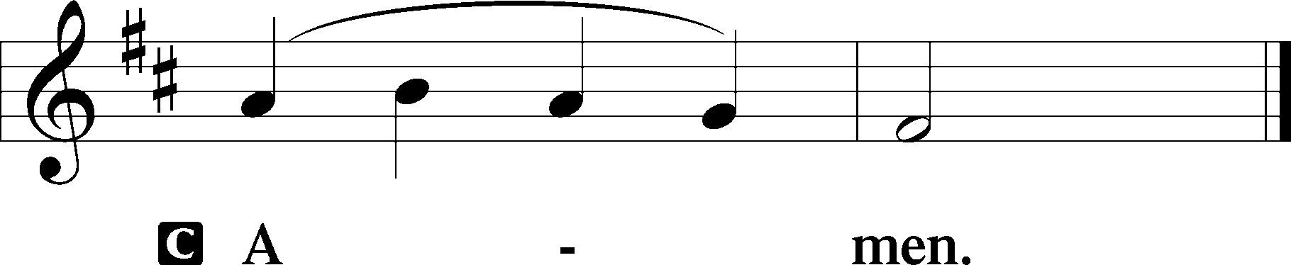

Salutation 2 Timothy 4:22
P The Lord be with you.
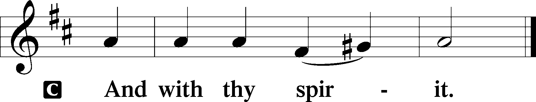

Benedicamus Psalm 103:1
P Bless we the Lord.
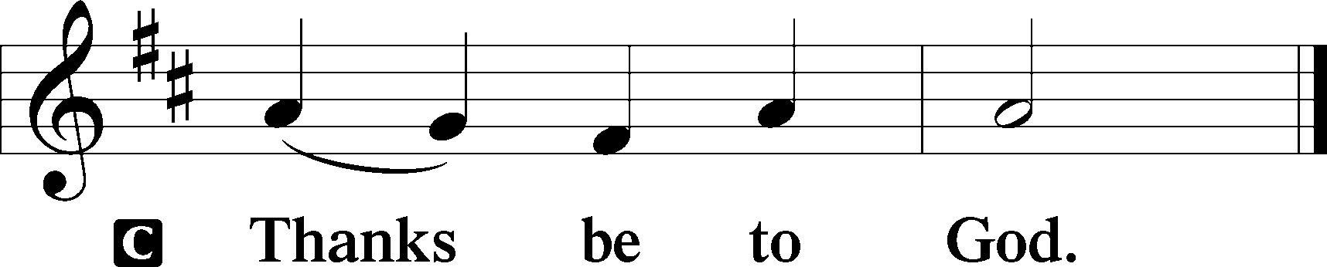
Benediction Numbers 6:24–26
P The Lord bless you and keep you.
The Lord make His face shine upon you and be gracious unto you.
The Lord lift up His countenance upon you and T give you peace.
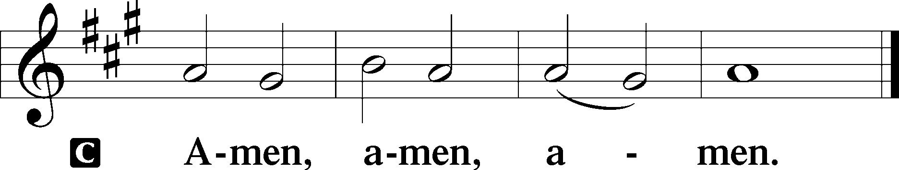

Closing Hymn: LSB #681 “Send, O Lord, Your Holy Spirit”
fffffffffffffffffffffffffffffffffff
Silent prayer after worship: Heavenly Father, lead me to read Your Word and pray daily so that I will not drift from the true Gospel into disbelief or despair, but may trust only in Christ for forgiveness and eternal life. Amen.
fffffffffffffffffffffffffffffffffff
Acknowledgments
Unless otherwise indicated, Scripture quotations are from the ESV® Bible (The Holy Bible, English Standard Version®), copyright © 2001 by Crossway, a publishing ministry of Good News Publishers. Used by permission. All rights reserved.
Created by Lutheran Service Builder © 2023 Concordia Publishing House.

