From the Pastor…

**Sts. Peter & Paul Evangelical Lutheran Church LC-MS**

Monthly Newsletter --- October 2020

699 Stambaugh Avenue, Sharon, PA 16146

Phone: 724.347.3620 (Opt. 2, Pastor Deal; Opt. 3, Office)

E-mail: church@saintspeterandpaul.net [www.saintspeterandpaul.net](http://www.saintspeterandpaul.net)

“THE ROCK and THE SWORD”

“Built upon the Rock of Christ and wielding the

Sword of the Spirit, the Word of God.”

**Cancel Culture: “Dear God, Cancel Our Culture.”**

*“Dear God, please cancel our culture.”* A few weeks ago, I wouldn’t have thought to say this, but God should cancel our culture. The idea behind “cancel culture” is to withdraw support or tolerance of certain people, places, or organizations so that they topple and fall or are left to hang out and dry. God should cancel us in order to put an end to evil that is tolerated in this country. In my first article on “cancel culture,” I surveyed how the wicked try to cancel culture, individuals, and the Church, in order for their evil to prevail via rioting, violence, murder, homosexuality, abortion, and many other unnatural perversions of the flesh. This is what has grown to frustrate, discourage, and even anger us. There is a good deal of comfort for us Christians that, even though the voices of wickedness continue to get louder and louder among us, they are not heard by God and their plans will fail in time. All their plans must inevitably serve the good will of God to save us. Their shouts and railing cannot drown out our prayers to God (Proverbs 15:29). We, dear Christians, are heard by God; our prayers do reach His ears. He has also promised to answer them. As I previously said, rise to arms and with prayer employ you. Pray that God would cancel our culture so that the plans of hate, evil, and wickedness would topple and fall with peace and justice prevailing. **​“Grant not, O LORD, the desires of the wicked; do not further their evil plot, or they will be exalted”** (Psalm 140:8)!

Psalm 140 isn’t among the first psalms

chosen by Christians to pray. That’s because it is numbered among the imprecatory psalms. These psalms are praying for God to curse His enemies with His judgement over sin. Some Christians say this is an unloving prayer and, therefore, cannot be prayed by Christians. This is simply bad advice. We need the Lord to put an end to the wicked by canceling our culture. If hearts will not be converted unto the Lord, then their will and way must be suppressed or evil will be exalted. It is leveled that the Christian who prays this has a heart of hate. This is not true. These psalms do not come from a heart of hate, but from a heart that trusts in the God who maintains the cause of the afflicted. God has promised to execute justice for the needy. Should we not believe this with all faith and sincerity? God’s Church simultaneously prays for the conversion of enemies to faith and for their evil plans to be brought to an end. If their hearts are hardened on the path of evil, then we ask for their plans to fail and their poisonous words to overwhelm them, so that they end up dying in the pit of hell that they’ve made for themselves (Psalm 140:9-11). Jesus said to love our enemies and pray for those who persecute us (Matthew 5:43-44). The Christian Church throughout the world must do this, but this does not mean we stop praying for God’s will to be done. Let me explain.

The imprecatory psalms are prayed in line with God’s will. In the Third Petition of the Lord’s Prayer, Thy will be done on earth as it is done in heaven, we pray for God to cancel our own will and the will of the devil! Luther rightly explains this in the Small Catechism. *​“How is God’s Will done? “When God breaks and hinders every evil counsel and will which would not let us hallow the name of God nor let His kingdom come, such as the will of the devil, the world, and our flesh; but strengthens and keeps us steadfast in His Word and in faith unto our end. This is His gracious and good will.”*​ I am reminded of a quote by Walt Kelly, “We’ve met the enemy, and he is us.” Without the power of God to cancel our own will, the devil, and the world, we would be left to die eternally with the devil and his angels. We would despair and be filled with all hopelessness. But it is the will of God to bring to an end the plan of the wicked. So we confidently pray, “Dear God: Cancel our wicked culture. Cancel our perversion of marriage. Cancel our lusts. Cancel our hate for life from womb to grave. Cancel our ingratitude for Your Word. Cancel our sinful flesh. By the precious blood of Christ, His resurrection, and for His sake, dear God: Cancel all our sins. Cancel our temporal and eternal death. Cancel hell and all its horde. Cancel the devil and all his lies. Cancel all those who would not see your name hallowed or let your kingdom come.”

I know that your eyes see destruction, hate, and wickedness flourishing, same as mine. I know that your ears hear the railing madness of a perverse generation, but there is never so much evil that the will of God cannot be done. There is never so much evil that it cannot be used to the good of our salvation. The triune God is reigning, the devil is defeated, and the will of man is not stronger than the will of God. Even the wicked Pharaoh was raised up so that the will of God would be accomplished. Romans 9 verse 17 says, **“For the Scripture says to Pharaoh​, ​‘For this very purpose I have raised you up, that I might show my power in you, and that my name might be proclaimed in all the earth.’” ​**We really have no reason to be discouraged, as God cancels all that would keep us from Him; He also strengthens and keeps us steadfast in His Word and faith. Even if the mountains should fall into the heart of the sea (Psalm 46:2); still we know that God’s good and gracious will is being done. While men go about canceling our culture for their own purposes, God will bring all their wickedness around for His purpose so that His works are glorified and His name known in all the earth.

God is canceling and hindering the plans of the evil one. If anyone is to be frustrated, it should be the devil. Not you. Not us. **“​If God is for us, who can be against us”​** (Romans 8:31-32)? **​“The LORD is on my side; I will not fear. What can man do to me? The LORD is on my side as my helper; I shall look in triumph on those who hate me”** ​(Psalm 118:6-7). Can anyone thwart God’s will? Can anyone change His purpose? No, at last we must confess that in time all wickedness will come to an end and the voices of the arrogant will fall silent. Do not be discouraged for there are always more with us than with them. I’m reminded of the story of triumph when God canceled the plans of the King of Syria. There came a time when Elisha was awakened by his servant to see that he had been surrounded by the King of Syria’s soldiers, chariots, and horses. They wanted Elisha dead since he had been ruining the king’s plans of attack. His servant was deeply discouraged and feared for his life thinking that he was about to die at the end of a sword, but Elisha said to him, **​“Do not be afraid, for those who are with us are more than those who are with them.” Then Elisha prayed and said, “O Lord, please open his eyes that he may see.” So the Lord opened the eyes of the young man, and he saw, and behold, the mountain was full of horses and chariots of fire all around Elisha. not even this army could stop the will of God”** ​(2 Kings 6:16-17).

If we could see how many angels are fighting off the legions of demons around us, and if we could see how many attempts of Satan have failed, how many flaming arrows have been extinguished, we’d be overwhelmed with joy. God is canceling more than we know each day. Trust in Him to keep us steadfast in the Word and faith until the end. God has already set an end to all our sorrows, all our afflictions, and even the wickedness of men. All of it has an appointed end. It can only go so far and, even then, it must serve the purposes of God (Romans 8:28). What man means for evil, God will worketh for good (Genesis 50:20).Through God’s Word and Spirit, we know that everything is going better than it would be, because God is with us canceling our culture whether that be in us or outside of us. We also know that we truly deserve far worse, but the Holy Spirit is constantly canceling the devil's attacks so that we are defended against all danger, and guarded and protected from all evil. Greater is He who is in us, than he who is in the world. “Dear God, give us faith to see that there are more with us than there are with them. Mercifully, bring an end to all injustices and evil pursuits of men. And since we can do no good thing apart from You, grant that all our doings being ordered by Your governance may be righteous in Your sight. And since there is no one who is good among us, grant us, by Your mercy, the cancelation of all our transgressions for the sake of Your Son Jesus Christ, our Lord. Amen.”

In Jesus’s blessed name,

Pastor Jacob Deal

****

**THRIVENT POP TAB CHALLENGE!**

The 2019 Thrivent Pop Tab Challenge to benefit the Ronald McDonald House was truly a fun project! Our church collected 62 pounds of tabs qualifying us for a free lunch courtesy of Thrivent. Don’t forget to pick-up your pre-ordered “take-out box lunch” the first weekend in October! Your packaged Subway meal and pop will be available in the library following worship.

On that note, Thrivent has decided to delay the 2020 Challenge until Spring 2021. However, we are still collecting! The large drop box is still in the Narthex and a smaller drop box is on the windowsill in the hallway by the offices. This year Marie Flaugher has made boxes for your family to take home and use! These will be available when you pick up your Subway meal. Simply fill, empty into the collection boxes, and take it back home to fill again!

Since we have more time to collect, Marie is challenging Sts. Peter and Paul to collect 70# of tabs! Can we do it? (Well, she already has a 10# bag saved!)

Thank you all for your continuing contributions!

If you have any questions, call Marie Flaugher at 724-301-8278.

****

**Word of Hope: 1-888-217-8679**

The only 24/7 CONFIDENTIAL Hotline that is distinctly Lutheran, bringing healing found in Christ, to those whose hearts have been broken by abortion.

****

**LIKE & FOLLOW our Church’s Facebook page (Saints Peter and Paul Evangelical Lutheran Church)!**



Remember to like, comment, and share to help us reach as many people as possible.

****

We are currently looking for someone to serve as **vice president** for the remainder of this year. If you wish to know more about the duties or are willing to consider filling this position, please contact Jonathan Baisch (724-816-6866).

Also, we have an opening on the **Trustees’ Board** at this time. If interested in knowing more about the position, please contact Trustees’ Chairman, Mike Flaugher (724-301-8277).



**Be sure to check out our church’s website** [**www.saintspeterandpaul.net**](http://www.saintspeterandpaul.net) **for current service bulletins, newsletters, an up-dated church calendar and more!**

****



Join us Saturday, October 31st

at 5 pm for a special

Reformation Day Divine Service.

This year marks the five hundred third anniversary of Martin Luther’s nailing of his ninety-five theses on the door of the Castle Church in Wittenberg, Germany.

Join us as we commemorate this anniversary and are reminded of the events which have shaped our church.

****

Sincere thanks go out to those individuals and families who signed up to sponsor various items for the September 29-30 **General Pastors’ Conference**.

Remember the following in Prayer…

**~The Mourning:** *The friends and family of James Carr, Catherine Carr’s father-in-law and Alex Carr and Ana Deal’s grandfather, who passed away August 28, 2020.*

**~The Hurting and Healing:** *Sue BenderCA, Darlene Berent, Lois BortnerCA, Kim, George, Tim Dudash, Joseph Fleet, Judith Furey, Henrietta (Hank) Holcroft, Neale & Melissa Huston, Donna Kennedy, Betty KnauffCA, Regis Knauff, Jess Lavoie, Virginia LehmanCA, Paul Lucas****CA****, Ernie Meszaros, Rhonda MoatsCA, Sandy Marshall, Tom MulliganCA, Steve Parkany, Richard ReuningCA, Marty Scott, Martin Weisenborn, Angela WeserCA, and Millie Zachar.*

**~The Homebound:**  *Helen Bender, Mary Chmielewski, Dan Davis, Mary Ann Krajci, Robert Murchek, and Marion Roberts.*

**~Serving in the Military:**  *Clayton Drnek, Curtis Sinewe, and Joshua Solyan.*

**~Community & World Needs:**  *Those suffering from or affected by the coronavirus, victims of violence and terrorism; those suffering from loss and dislocation because weather disasters; those suffering from addiction and their families; Local, State, and National Government Leaders; Safety for all Police Officers, Firefighters, & First Responders; the unemployed; our Third Quarter Local Mission: Community Food Warehouse of Mercer County.*

*\*CA represents cancer; number after other names represents weeks on the prayer list. Please submit prayer requests in writing to the church office.*

****

**Scrip/Gift Card Program** The next date for turning in SCRIP/Gift Card orders and payments is **Sunday, October 4th**. Please make all checks out to Sts. Peter & Paul’s. Order forms for this program may be found on the table in the narthex as well in the main hallway. Both orders and payments may be placed in the offering plate.



**REMINDER:** Please let the church office know of any changes to your address, phone, cell phone or your e-mail address!



**New phone directories are available.**

**See Diane to get yours!**

**Homebound Members & Friends**

***Please keep the following people in your prayers:***

Helen Bender

920 Pleasantview Dr.

New Castle, PA 16101



Mary Chmielewski

87 S. Neshannock Rd.

Hermitage, PA 16148



Dan Davis, Avalon Springs

745 Greenville Road

Mercer, PA 16137



Mary Ann Krajci, John XXIII

2250 Shenango Valley Freeway

Hermitage, PA 16148

724-981-3200



Virginia Lehman

92 Wet Track Rd.

West Middlesex, PA 16159



Robert Murchek

394 Fisher Hill St.

Sharon, PA 16146-5801



Marion Roberts (NEW ADDRESS!)

287 East 2nd St. Apt. #103

Hummelstown, PA 17036

717-798-5330



**CELEBRATING IN OCTOBER!**

**Birthdays**

Cheryl Fedele 10-4

Mildred Zachar 10-7

Staci Taylor 10-9

Kelsey Zurawsky 10-10

Nancy Robertson 10-13

Loretta Deal 10-18

Joyce Solyan 10-19

Irene Kucera 10-19

Beckie Gansca 10-30

Hailey Bale 10-31

Hunter Bale 10-31

**Anniversaries:**

Jonathan & Rebekah Baisch 10-15

Jeff & Rachel Myers 10-20

*If birthdays or anniversaries have been omitted, please let the church office know. Thank You!



**OUR FOURTH QUARTER LOCAL MISSION:**



**PITTSBURGH AREA LUTHERAN MINISTRIES (PALM)**

At the July 27, 2020, Voters’ Assembly Meeting, the voters agreed to name Pittsburgh Area Lutheran Ministries (PALM) as our fourth quarter local mission.

The following information about PALM is taken from their webpage (www.palmpa.org).

*The mission of the Pittsburgh Area Lutheran Ministries (PALM) is to facilitate cooperation among the* [*Lutheran Church–Missouri Synod*](http://www.lcms.org) *congregations in the Pittsburgh region and outer lying areas in supporting the mission work of the church. PALM is a* [*Recognized Service Organization*](https://www.lcms.org/how-we-serve/mercy/recognized-service-organizations) *of the LCMS.*

*Pittsburgh Area Lutheran Ministries (PALM) was born out of its predecessor, the Lutheran Church Extension Society (LCES), at a delegate meeting of member congregations of The Lutheran Church – Missouri Synod held on September 9, 1997. PALM challenges LCMS congregations in the Pittsburgh region to forge new partnerships with each other for the purpose of expanding and supporting the mission and ministry work of the church. Each September delegates of member congregations gather to review the work of PALM and elect a PALM Board of Directors to oversee PALM Ministries.*

*Congregations from the four Pittsburgh area Circuits of the* [*Eastern District*](http://www.lcmsed.org)*, the Pittsburgh Circuit of the* [*English District*](http://www.englishdistrict.org)*, and the* [*SELC District*](http://www.selc.lcms.org) *are all eligible for membership in Pittsburgh Area Lutheran Ministries (PALM) by notifying the President of PALM, by letter, of such intention.*

*PALM exists to accomplish objectives that require the cooperation of all or several of the members. Some objectives being pursued are:*

* The initiation of new ministries.
* The support of new ministries or of ministries that are inherently unable to support themselves.
* The publication of the [Pittsburgh Lutheran](http://www.palmpa.org/pittsburgh-lutheran).
* The joint celebratory worship services such as the [Reformation Festival](http://www.palmpa.org/reformation-festival/).
* The management of local assets owned jointly by the members and the LCMS-owned [Minersville Cemetery](http://www.palmpa.org/minersville-cemetery/).
* The allocation of available resources among prospective ministries.

**Bible Memory Verses from September:**

**For Adults:**

**Sept. 6:** *He who did not spare his own Son but gave him up for us all, how will he not also with him graciously give us all things? Romans 8:32*

**Sept. 13:** *Humble yourselves, therefore, under the mighty hand of God so that at the proper time he may exalt you, 1 Peter 5:6*

**Sept. 20:** *For it has been granted to you that for the sake of Christ you should not only believe in him but also suffer for his sake. Philippians 1:29*

**Sept. 27:** *In the world you will have tribulation. But take heart; I have overcome the world. John 16:33*

**For Children:**

**Sept. 6:** *As you did it to one of the least of these my brothers, you did it to me. Matthew 25:40*

**Sept. 13:** *Bless the Lord, O my soul, and forget not all his benefits. Psalm 103:2*

**Sept. 20:** *Cast all your anxieties on him, because he cares for you. 1 Peter 5:7*

**Sept. 27:** *Our Savior Christ Jesus…abolished death and brought life and immortality to light. 2 Timothy 1:10*

****

**Thank You for Serving in October:**

**Assisting Elder:** Jonathan Baisch

**Altarware:** (Before service) Diane Riefstahl; (After service) Anne Colt & Joani Rice

**Note:** Our greeting and ushering programs are temporarily suspended at this time.



**ALTAR FLOWERS**

An up-dated **Altar Flower Donation list** has been posted on the bulletin board in the narthex. Until the time a new provider is found, those wishing to donate flowers are asked to do the following:

1. Sign the sign-up sheet in the narthex at least one week in advance.
2. Leave a note for the church secretary as to the dedication to be listed in the weekly bulletin.
3. Purchase flowers from a vendor *of your choice* and deliver the flowers to the church by 9:30 Sunday morning ready to be displayed.
4. Remove the flowers from the altar following the church service.

Artificial arrangements will adorn the altar on Sundays for which there is no donor.

**Sts. Peter & Paul’s Food Pantry is able to assist those in need of emergency food!**

If you or someone you know is in need of emergency food during this time, please contact John Dyll (724-734-7016). Our food pantry operates through the Community Food Warehouse of Mercer County and distributes food the second and fourth Thursdays of each month beginning at 9 am.

If you would like to get involved with our Food Pantry and help either stock or distribute food, please contact John Dyll. This is a monumental task which relies on the generosity of our members to operate and fund.

Please consider “lending a hand up” to those in need.

‘Truly, I say to you, as you did it to one of the least of these my brothers, you did it to me.’ Matthew 25:40





**“Stock the Food Pantry Sunday” is October 11th!**

***Let us remember those in need!***

Your financial contributions to this outreach mission will be greatly appreciated!

(At this time, we are unable to accept direct donations of food products.)

****

**Sts. Peter & Paul’s Food Pantry** was notified in September that it was the recipient of a SFPP 2020-2021 grant in the amount of $1,078 through the Community Food Warehouse of Mercer County. Congratulations to all those responsible for this grant!



**IMPORTANT MEETING DATES**



**Trustees:** Mon., Oct. 5th at 6:30 pm

**Finance Committee:** Wed., Oct. 7th from 6:30-8 pm.

**Altar Guild:** Sat., Oct. 10th at 3 pm

**Auditors:** Sun., Oct. 11th following worship

**Elders:** Sat., Oct. 17th at 10 am

**Church Council:** Mon., Oct. 19th at 7 pm

**Thank you for supporting Community Day 2020’s “Night at the Movies”!**

In spite of the “brisk” September night’s weather, a good time was had by all those attending Community Day 2020’s “Night at the Movies”. The themes of the film “Remember the Titans” resonated with those in attendance as they viewed the movie on our new 25 foot screen.

There are several individuals who devoted countless hours to making this event possible. Special thanks go out to Bob Sulek and Pastor Deal for constructing the frame on which the movie screen was stretched and to Jesse Riffle, Barry Nelson, and Diane Riefstahl for their efforts as well.

Most of all, we are indebted to this year’s sponsors:

* *Steel Valley Logistics*
* *Thrivent Care Team*
* *Tupperware with Lex*
* *Pittsburgh Area Lutheran Ministries (PALM)*
* *and, of course, the members of Sts. Peter & Paul’s for their donations.*

Thanks to these sponsors, we were able to purchase our *large* movie screen, supports for building a frame, a projector, and movie license. All but the movie license are durable goods which will see repeated use.

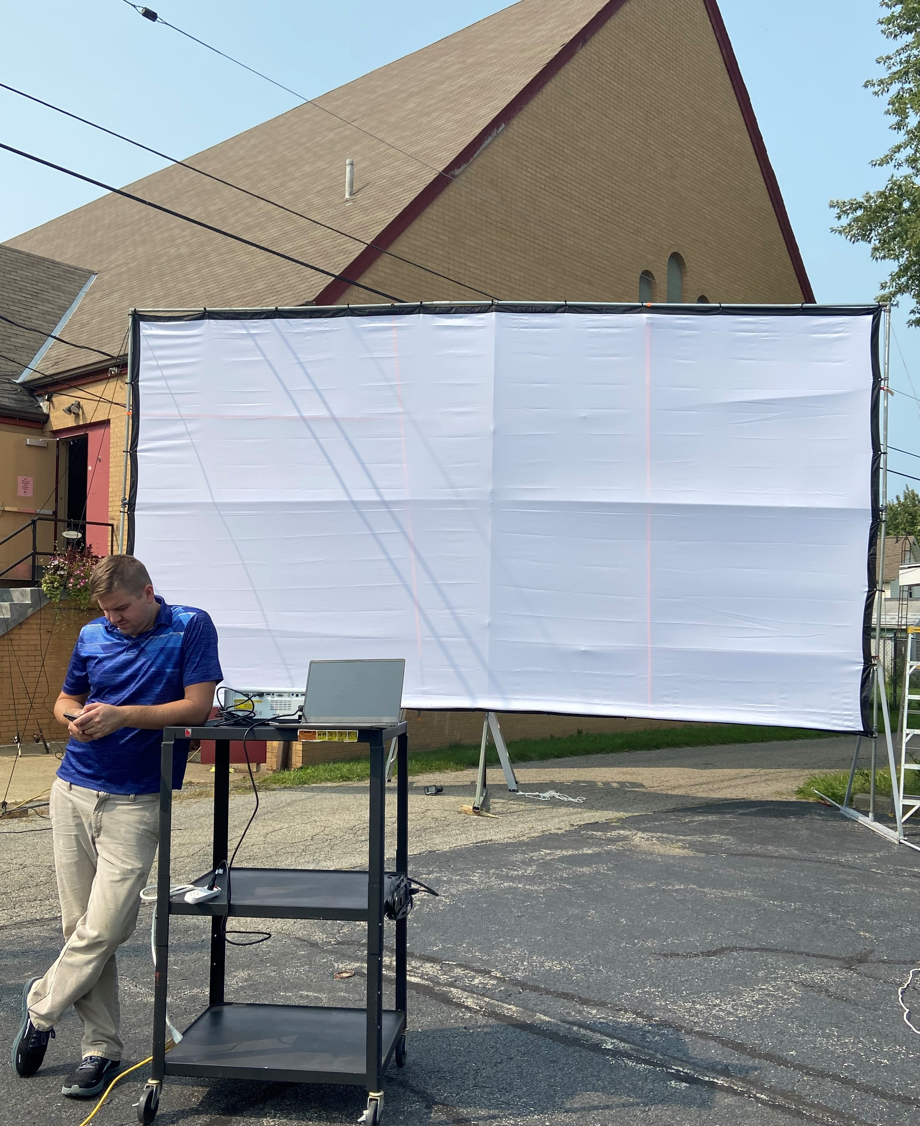

Thank you, again, for your support of this community outreach project.



Sunday morning Divine Services will start at 10 am beginning October 4th.

FROM YOUR ALTAR GUILD:

DID YOU KNOW the Church Year does not begin on January 1? (It actually begins with Advent.) And, did you know that the Seasons of the Church are not spring, summer, autumn and winter?

When you enter the sanctuary each week, you will find the altar adorned with a specific color. These colors represent the season of the church year. The Church has chosen specific colors for each season based on the significance of that color.

**WHITE** represents purity and eternity. Expect to see white during Christmas and Easter seasons. You will also see white used for specific celebrations of saints, such as Saints Peter and Paul.

**RED** represents fire and blood. Red adorns our altar from Pentecost until Trinity. Red is also used for Reformation.

**GREEN** Just like our spring and summer, green represents life and regeneration. When you are in church you will see the altar clothed in green from the 2nd Sunday after Pentecost until Advent.

**VIOLET** represents royalty, also sorrow and repentance. What do those three words remind you of? Yes, of course, the season of Lent!

**BLUE** represents anticipation and hope. Also spiritual love and fidelity. Used during Advent, blue represents the anticipation of the coming of Christ.

**BLACK** Yes, black denotes death and sorrow. It is used on Good Friday.

**ROSE** is the color of anticipation and joy. In the One-Year Lectionary (which we use), it is used for *Gaudete* (Advent) and *Laetare* (Lent) *Sundays*.

Watch for more information from your Altar Guild in the months to come!

****

**IT’S TIME TO START PLANNING!** Proposed 2021 Budget Sheets are in library mailboxes for the chairs of the Elders, Trustees, Financial Staff, and Auditors. Completed forms are due back to Jonathan Baisch by Friday, Oct. 16th.

**To listen to Pastor Deal’s sermons, phone 724-347-3620 and press Option 6.**

**Current sermons will be available by Sunday evening.**

**SEPTEMBER MEMORIAL**

**CONTRIBUTIONS**

**(Bulletins September 6-27, 2020)**

**In Honor of Sister, Ruth Meszaros’ 80th Birthday:** *Joani Rice (Major Repair).*

**In Loving Memory of James Carr:** *Anne Colt, Judith Furey (Altar Guild), Mark Gabriel, Anson & Hank Holcroft, Diane Riefstahl, Viola Sakony, and Bob & Traudi Sulek.*

**In Loving Memory of Edna Krajci:** *Ken & Ruth (Krajci) Fitzgerald, Rev. Ed & Irene Kucera, Joani Rice, and Diane Riefstahl.*

**In Loving Memory of Vi Morris:** *Joani Rice (Food Pantry) and Viola Sakony..*

**In Loving Memory of Father’s Birthday, August 25, 1933:** *Cheryl Fedele (Food Pantry).*

**In Loving Memory of Husband, Don Voytik:** *Pat Voytik.*

**In Loving Memory of Mother, Mary Fee (09.09.1996):** *Dolores Fee.*



**Our Stewardship of Treasures for the Lord:** In order to do the Lord’s work, we need $2,487.81* each week to meet our 2020 budget for general purposes and $39.62 for missions.

**Sat., Aug. 29 & Sun., Aug. 30, 2020*:**

General Offering: $1,260.60

SELC Missions: $10.00

Other: $90.00

**Sat., Sept. 5 & Sun., Sept. 6, 2020*:**

General Offering: $4,123.30

SELC Missions: $210.00

Other: $150.00

**Sat., Sept. 12 & Sun., Sept. 13, 2020*:**

General Offering: $1,755.00

SELC Missions: $20.00

Other: $640.00

**Sat., Sept. 19 & Sun., Sept. 20, 2020*:**

General Offering: $1,855.00

SELC Missions: $26.00

Other: $572.00

***Remember, you now have the option of on-line giving! Check out https://www.saintspeterandpaul.net/online-giving.***