Sts. Peter & Paul
Evangelical Lutheran Church
Lutheran Church-Missouri Synod
Founded-1917

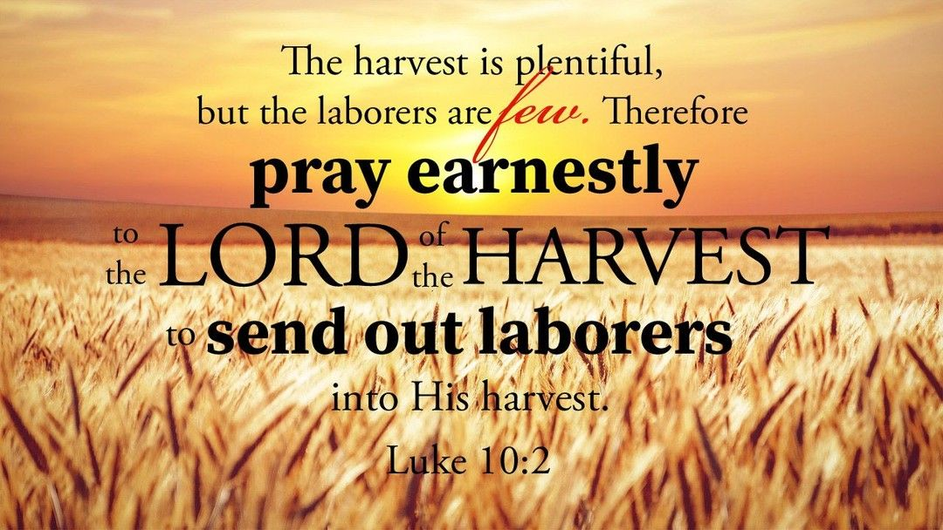

October 18, 2023

699 Stambaugh Ave.
Sharon, Pennsylvania 16146

“I was glad when they said to me,
Let us go to the house of the LORD!”
Psalm 122:1
Sts. Peter & Paul Evangelical Lutheran Church, LC-MS
FESTIVAL OF St. LUKE, EVANGELIST
October 18, 2023
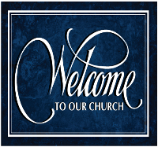
A special welcome to our guests this day! If you would like more information about The Lutheran Church - Missouri Synod, or this congregation, please speak with Pastor Deal or an Elder after the service.
Members & Guests: Don’t be embarrassed if your children make noise during the worship service, all children do. We encourage families to worship together but, if you feel the need, there are pews in the rear of the Church which are reserved for young families on both sides of the sanctuary. There is also a quiet room available to you, located next to the sanctuary (formerly the Pastor’s office), where you would be able to follow along with the service.

Today’s service includes the Sacrament of Holy Communion. If during this past year, you have not worshipped with us and been communed, we respectfully ask that you do not partake of this sacrament this day before first speaking with Pastor Deal.
If visiting from a sister congregation of the LC-MS and are in good standing, please inform Pastor Deal of your desire to commune prior to the service.
If wishing to receive a blessing during communion, please approach with your arms crossed.

CONTACT INFORMATION
Pastor Deal: pastordeal@saintspeterandpaul.net or 724-347-3620 (opt. 2)
Church Office: church@saintspeterandpaul.net or 724-347-3620 (opt. 3)
Secretary’s Office: The office will be open Mon. (8:30 am-5 pm) & Thurs (8:30 am-10 am; 11 am-5 pm).

Silent prayer before worship: Lord Jesus, You are true God, yet You lowered Yourself to live among us and to suffer and die that we might have eternal life. As I worship You today, lead me to lift You up in praise with my heart and my lips. Amen.
Confession and Absolution

Opening Hymn: LSB #666 “O Little Flock, Fear Not the Foe”

Stand

The sign of the cross may be made by all in remembrance of their Baptism.

Invocation
P In the name of the Father and of the T Son and of the Holy Spirit.
C Amen.

Exhortation Hebrews 10:22; Psalm 124:8; Psalm 32:5
P Beloved in the Lord! Let us draw near with a true heart and confess our sins unto God our Father, beseeching Him in the name of our Lord Jesus Christ to grant us forgiveness.

P Our help is in the name of the Lord,
C who made heaven and earth.
P I said, I will confess my transgressions unto the Lord,
C and You forgave the iniquity of my sin.

Silence for reflection on God’s Word and for self-examination.

Confession of Sins
P O almighty God, merciful Father,
C I, a poor, miserable sinner, confess unto You all my sins and iniquities with which I have ever offended You and justly deserved Your temporal and eternal punishment. But I am heartily sorry for them and sincerely repent of them, and I pray You of Your boundless mercy and for the sake of the holy, innocent, bitter sufferings and death of Your beloved Son, Jesus Christ, to be gracious and merciful to me, a poor, sinful being.

Absolution [John 20:19–23]
P Upon this your confession, I, by virtue of my office, as a called and ordained servant of the Word, announce the grace of God unto all of you, and in the stead and by the command of my Lord Jesus Christ I forgive you all your sins in the name of the Father and of the T Son and of the Holy Spirit.
C Amen.

Service of the Word

Introit Psalm 92:1–5; antiphon: Luke 24:46–47
Thus it is written, that the Christ should suffer and on the third day rise | from the dead,*
and that repentance and forgiveness of sins should be proclaimed in his name to all nations, beginning from Je- | rusalem.
It is good to give thanks | to the Lord,*
to sing praises to your name, | O Most High;
to declare your steadfast love in the | morning,*
and your faithful- | ness by night,
to the music of the lute | and the harp,*
to the melody | of the lyre.
For you, O Lord, have made me glad | by your work;*
at the works of your hands I | sing for joy.
How great are your works, | O Lord!*
Your thoughts are | very deep!
Thus it is written, that the Christ should suffer and on the third day rise | from the dead,*
and that repentance and forgiveness of sins should be proclaimed in his name to all nations, beginning from Je- | rusalem.

Gloria Patri
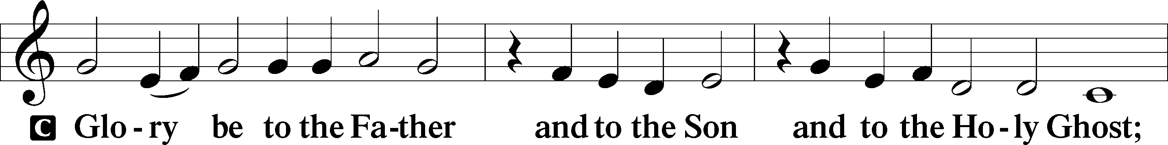
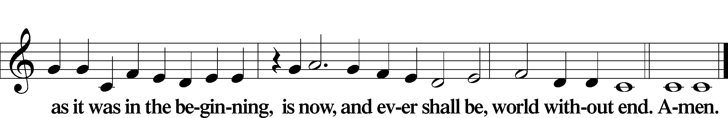

Kyrie Mark 10:47
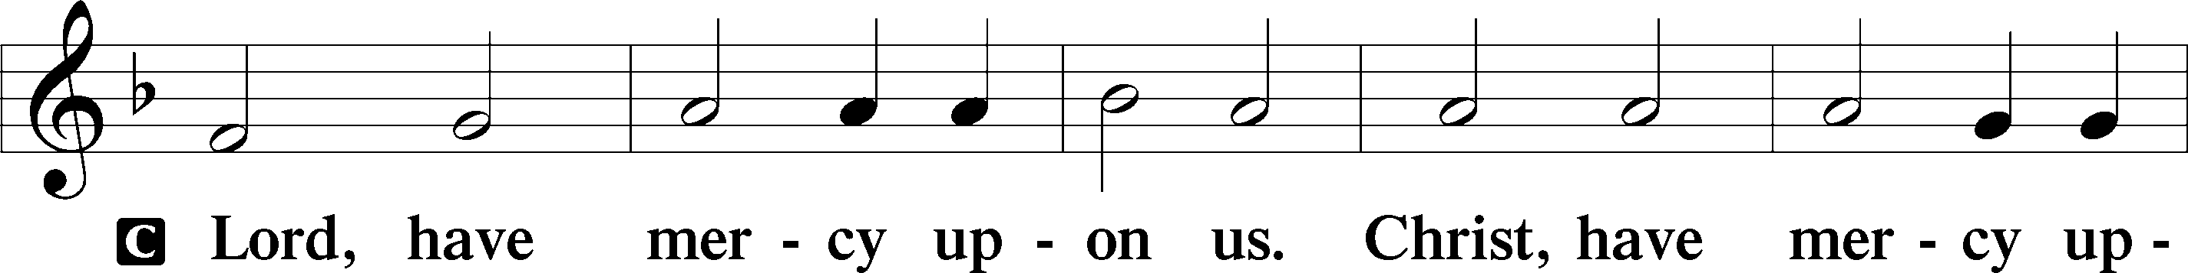
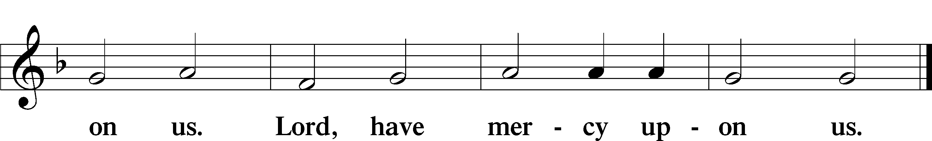

Gloria in Excelsis Luke 2:14; John 1:29
P Glory be to God on high:
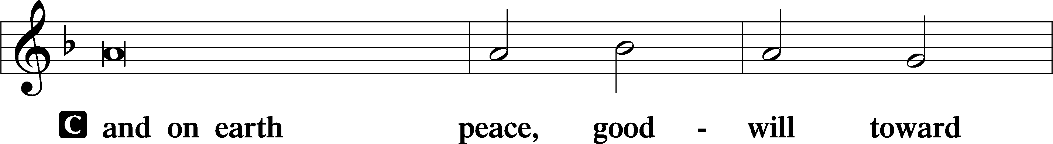
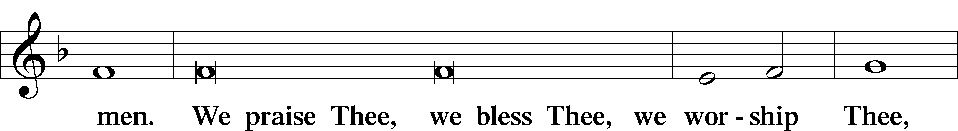
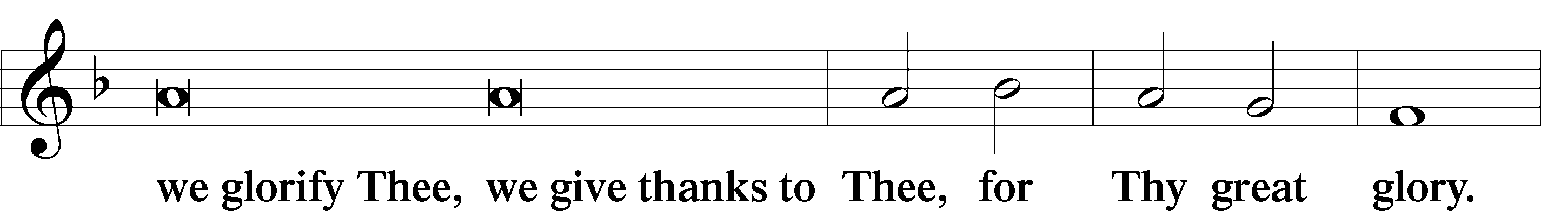
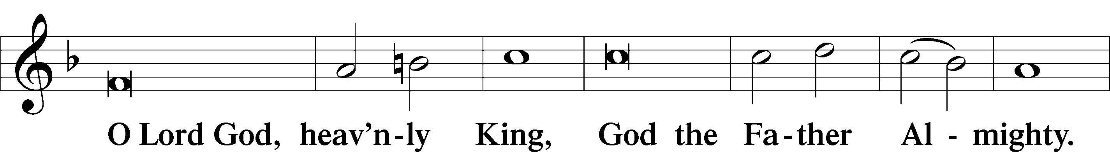
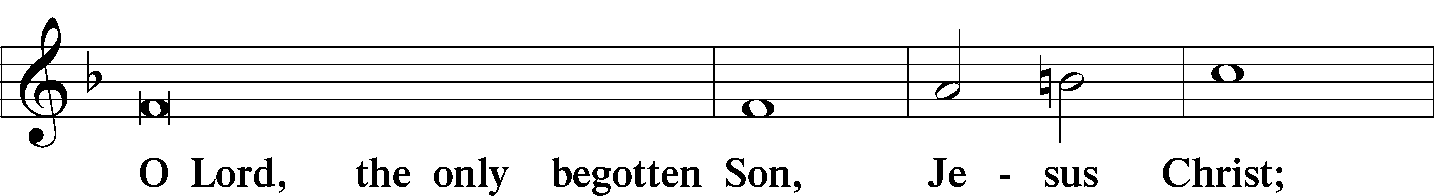
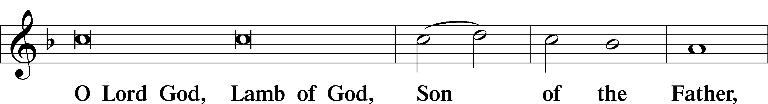
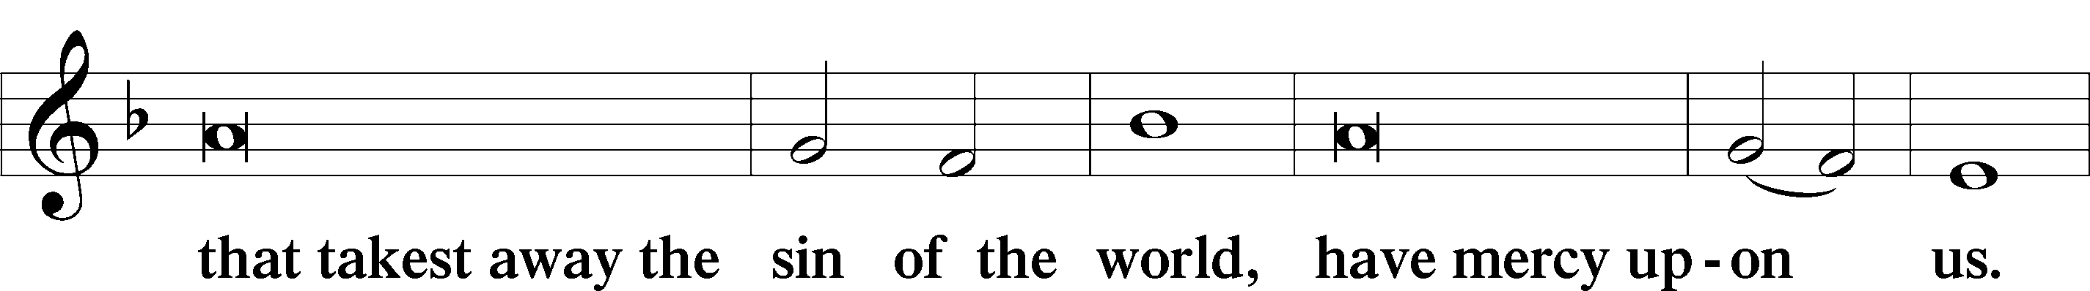
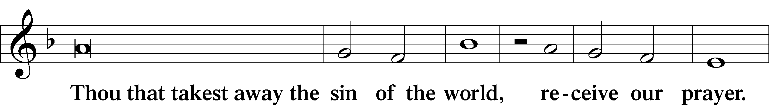
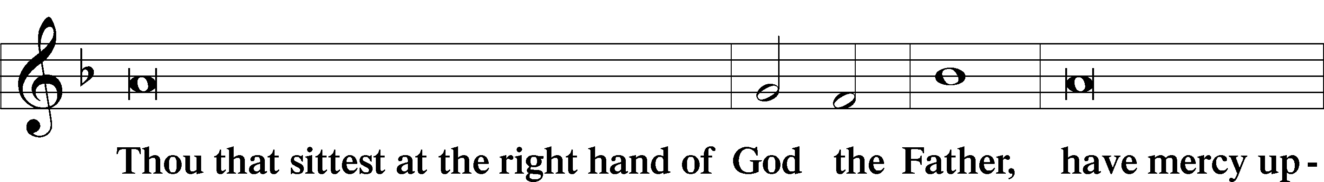
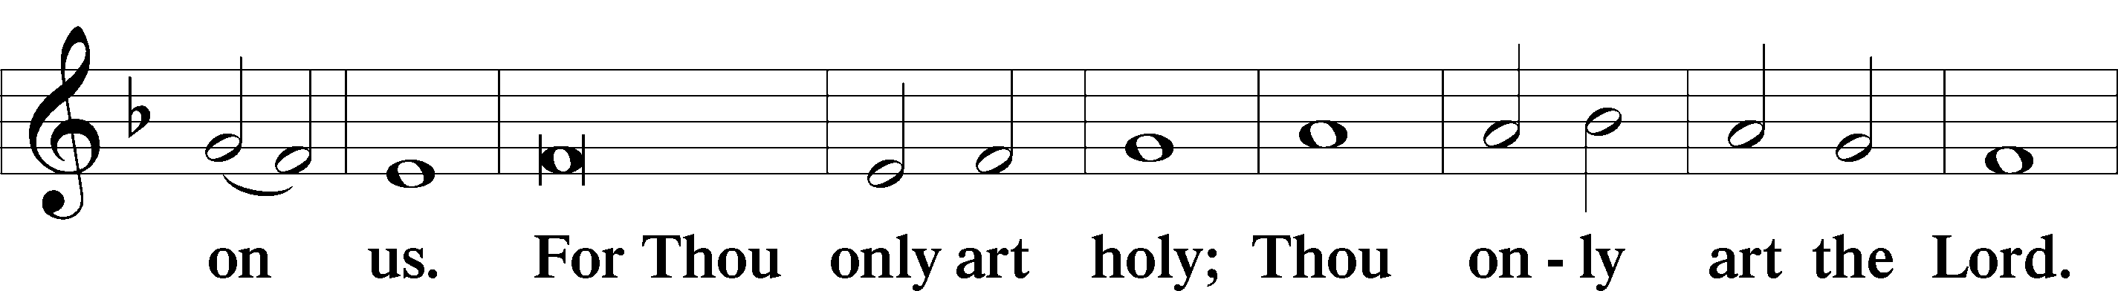
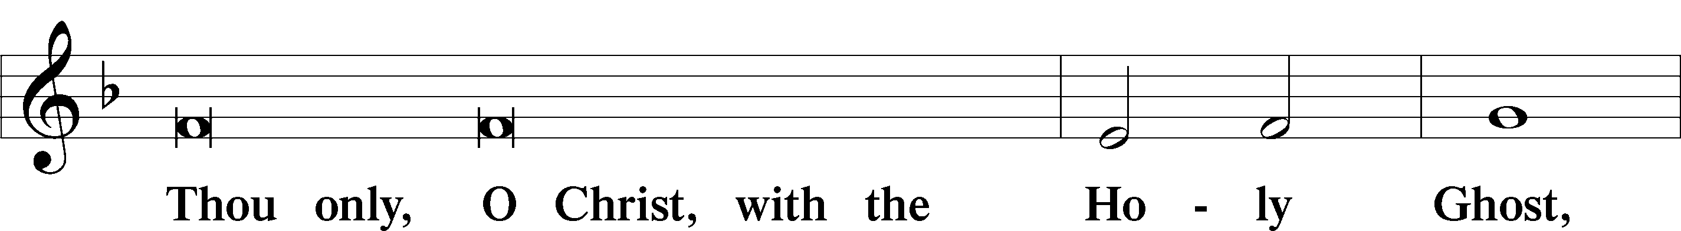
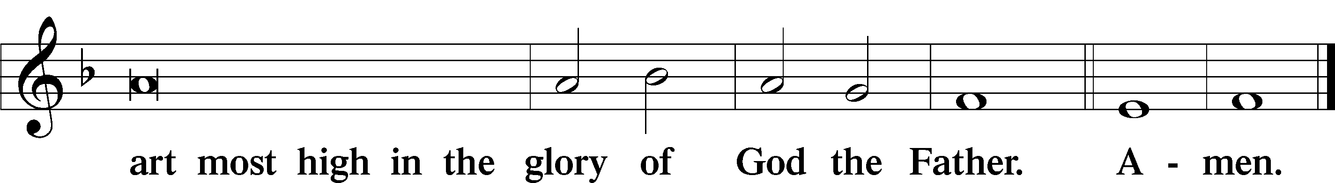

Salutation and Collect of the Day: Festival of Saint Luke
P The Lord be with you.
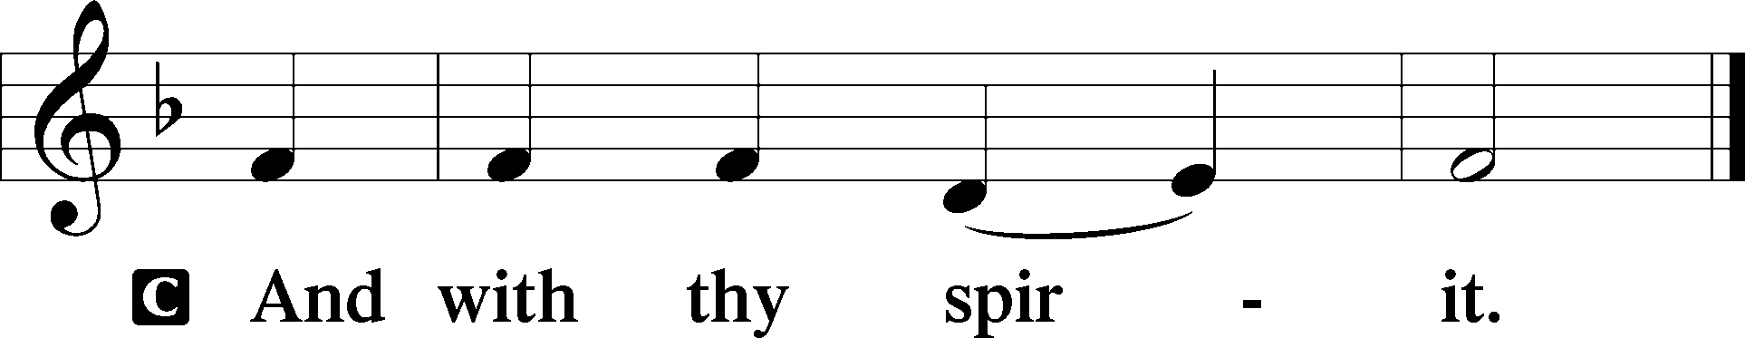

P Let us pray.
Almighty God, our Father, Your blessed Son called Luke the physician to be an evangelist and physician of the soul. Grant that the healing medicine of the Gospel and the Sacraments may put to flight the diseases of our souls that with willing hearts we may ever love and serve You; through Jesus Christ, Your Son, our Lord, who lives and reigns with You and the Holy Spirit, one God, now and forever.
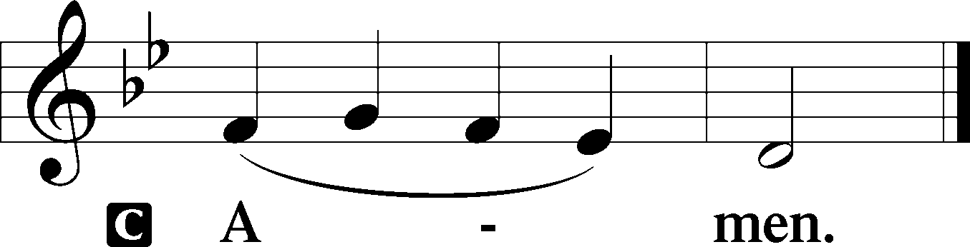
Sit

Prophecy: Ezekiel 1:10-14 (NKJV)
As for the likeness of the faces of the living creatures, each had the face of a man; each of the four had the face of a lion on the right side, each of the four had the face of an ox on the left side, and each of the four had the face of an eagle. Thus were their faces. Their wings stretched upward; two wings of each one touched one another, and two covered their bodies. And each one went straight forward; they went wherever the spirit wanted to go, and they did not turn when they went. As for the likeness of the living creatures, their appearance was like burning coals of fire, like the appearance of torches going back and forth among the living creatures. The fire was bright, and out of the fire went lightning. And the living creatures ran back and forth, in appearance like a flash of lightning.

P This is the Word of the Lord.
C Thanks be to God.

Gradual Psalm 119:105, 103; 45:1a, c
Your word is a lamp | to my feet*
and a light | to my path.
How sweet are your words | to my taste,*
sweeter than honey | to my mouth!
My heart overflows with a | pleasing theme;*
my tongue is like the pen of a | ready scribe.

Epistle: 2 Timothy 4:1-8 (NKJV)
Dearly Beloved: I charge you before God and the Lord Jesus Christ, who will judge the living and the dead at His appearing and His kingdom: preach the word! Be ready in season and out of season. Convince, rebuke, exhort, with all longsuffering and teaching. For the time will come when they will not endure sound doctrine, but according to their own desires, because they have itching ears, they will heap up for themselves teachers; and they will turn their ears away from the truth, and be turned aside to fables. But you be watchful in all things, endure afflictions, do the work of an evangelist, fulfill your ministry. For I am already being poured out as a drink offering, and the time of my departure is at hand. I have fought the good fight, I have finished the race, I have kept the faith. Finally, there is laid up for me the crown of righteousness, which the Lord, the righteous Judge, will give to me on that Day, and not to me only but also to all who have loved His appearing.

P This is the Word of the Lord.
C Thanks be to God.

Stand

Verse Luke 19:9b, 10
Alleluia. Today salvation has come to this house, since he also is a son of Abraham. For the Son of Man came to seek and to save the lost. Alleluia.

Alleluia
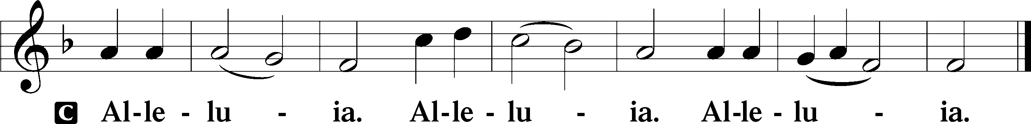

Holy Gospel: Luke 10:1–7a (NKJV)
P The Holy Gospel according to St. Luke, the tenth chapter.
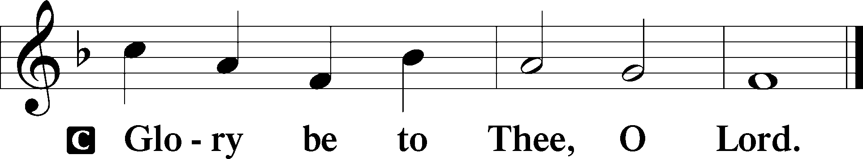

At that time: The Lord appointed seventy others also, and sent them two by two before His face into every city and place where He Himself was about to go. Then He said to them, “The harvest truly is great, but the laborers are few; therefore pray the Lord of the harvest to send out laborers into His harvest. Go your way; behold, I send you out as lambs among wolves. Carry neither money bag, knapsack, nor sandals; and greet no one along the road. But whatever house you enter, first say, ‘Peace to this house.’ And if a son of peace is there, your peace will rest on it; if not, it will return to you. And remain in the same house, eating and drinking such things as they give, for the laborer is worthy of his wages.”

P This is the Gospel of the Lord.
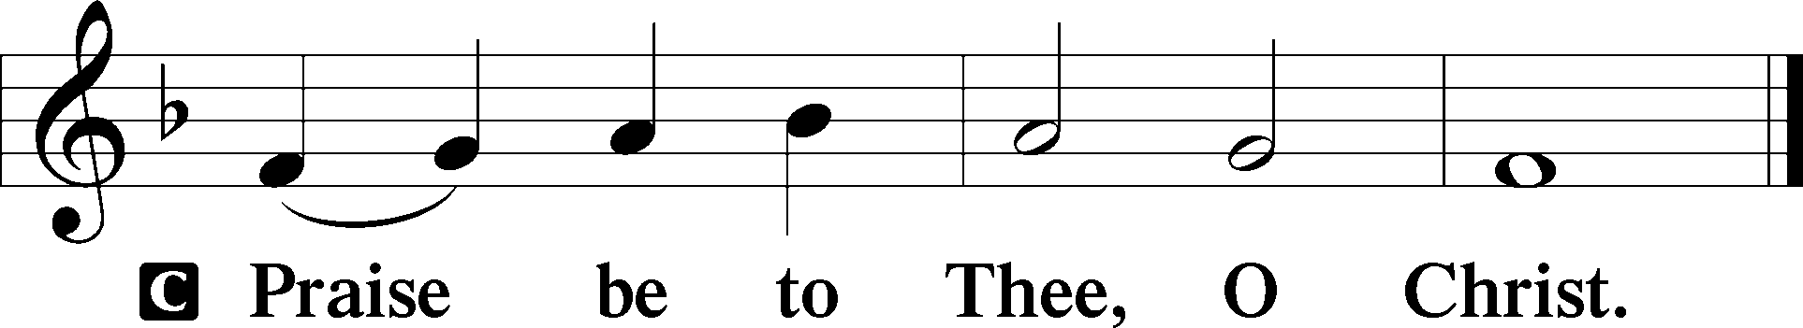

Nicene Creed
C I believe in one God,
the Father Almighty,
maker of heaven and earth
and of all things visible and invisible.

And in one Lord Jesus Christ,
the only-begotten Son of God,
begotten of His Father before all worlds,
God of God, Light of Light,
very God of very God,
begotten, not made,
being of one substance with the Father,
by whom all things were made;
who for us men and for our salvation came down from heaven
and was incarnate by the Holy Spirit of the virgin Mary
and was made man;
and was crucified also for us under Pontius Pilate.
He suffered and was buried.
And the third day He rose again according to the Scriptures
and ascended into heaven
and sits at the right hand of the Father.
And He will come again with glory to judge both the living and the dead,
whose kingdom will have no end.

And I believe in the Holy Spirit,
the Lord and giver of life,
who proceeds from the Father and the Son,
who with the Father and the Son together is worshiped and glorified,
who spoke by the prophets.
And I believe in one holy Christian and apostolic Church,
I acknowledge one Baptism for the remission of sins,
and I look for the resurrection of the dead
and the life T of the world to come. Amen.
Sit

Hymn of the Day: LSB #810 “O God of God, O Light of Light”

Sermon

Stand

Offertory Psalm 51:10–12
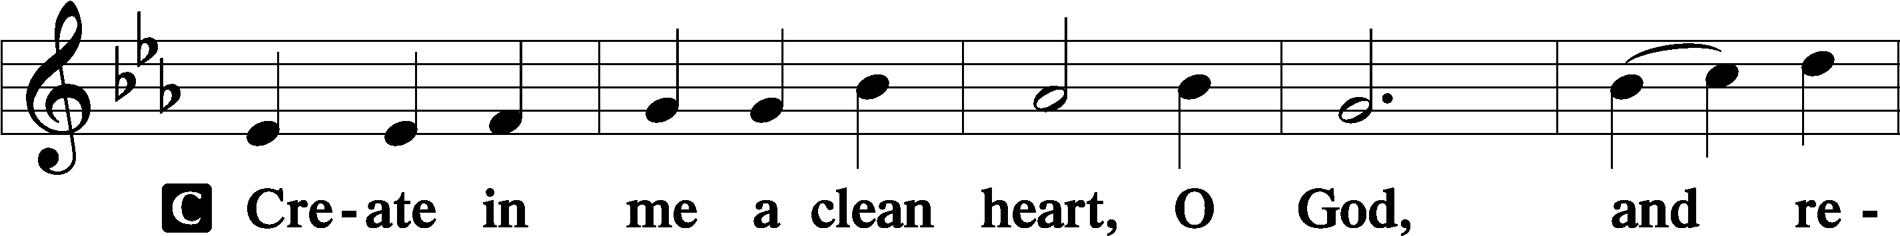
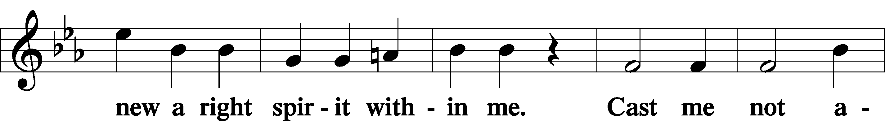
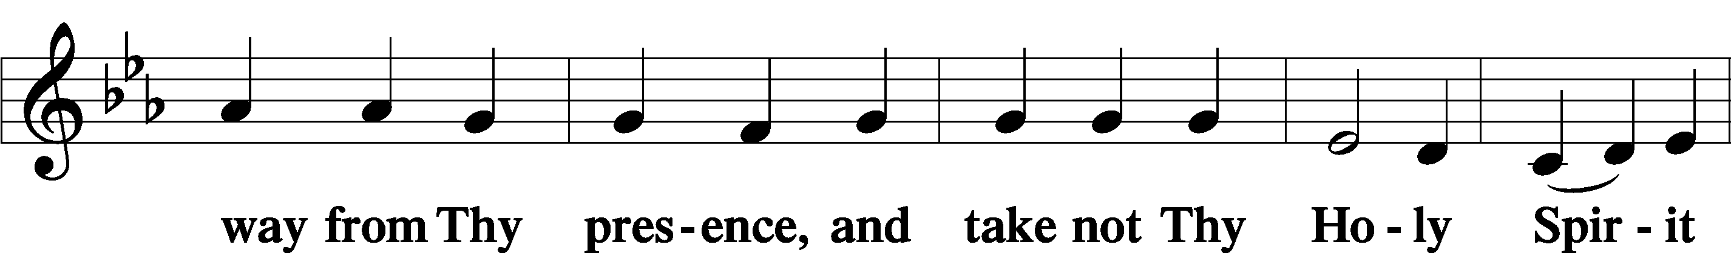
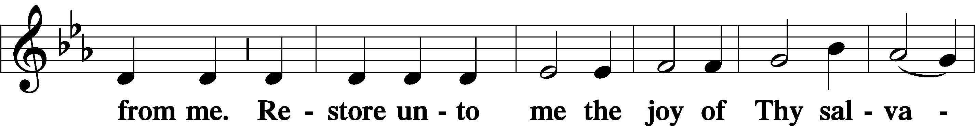
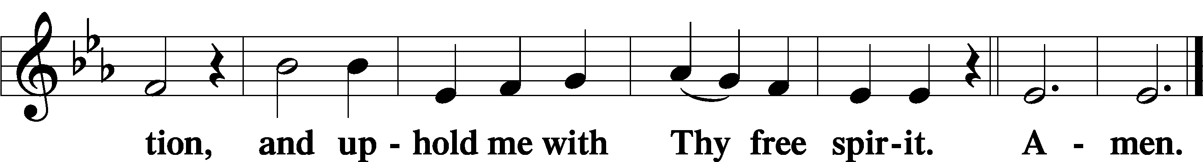

Prayer of the Church

Sit

Preparatory Hymn: LSB #589 “Speak, O Lord, Your Servant Listens”

Stand

Service of the Sacrament

Preface 2 Timothy 4:22; Colossians 3:1 Psalm 136
P The Lord be with you.
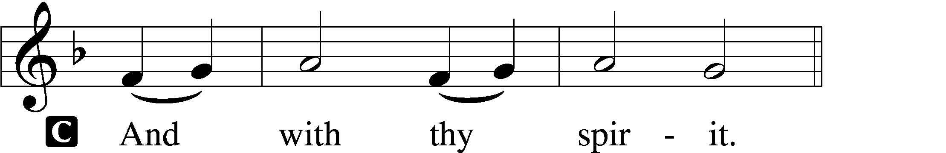

P Lift up your hearts.
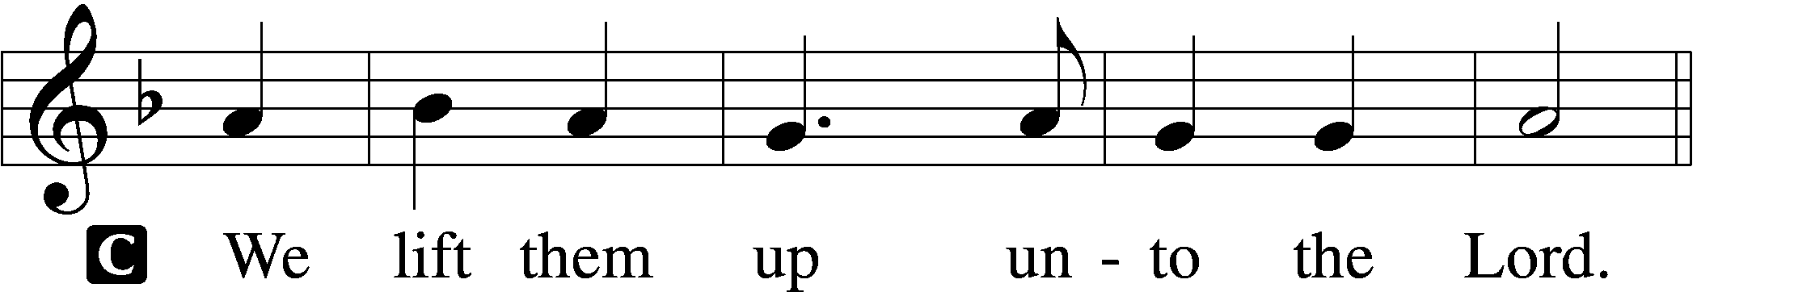

P Let us give thanks unto the Lord, our God.
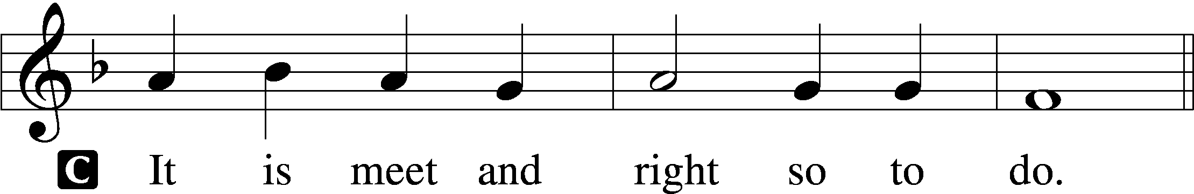

Proper Preface (Abbreviated) LSB 194
P It is truly meet, right, and salutary . . . evermore praising You and saying:

Sanctus Isaiah 6:3; Matthew 21:9
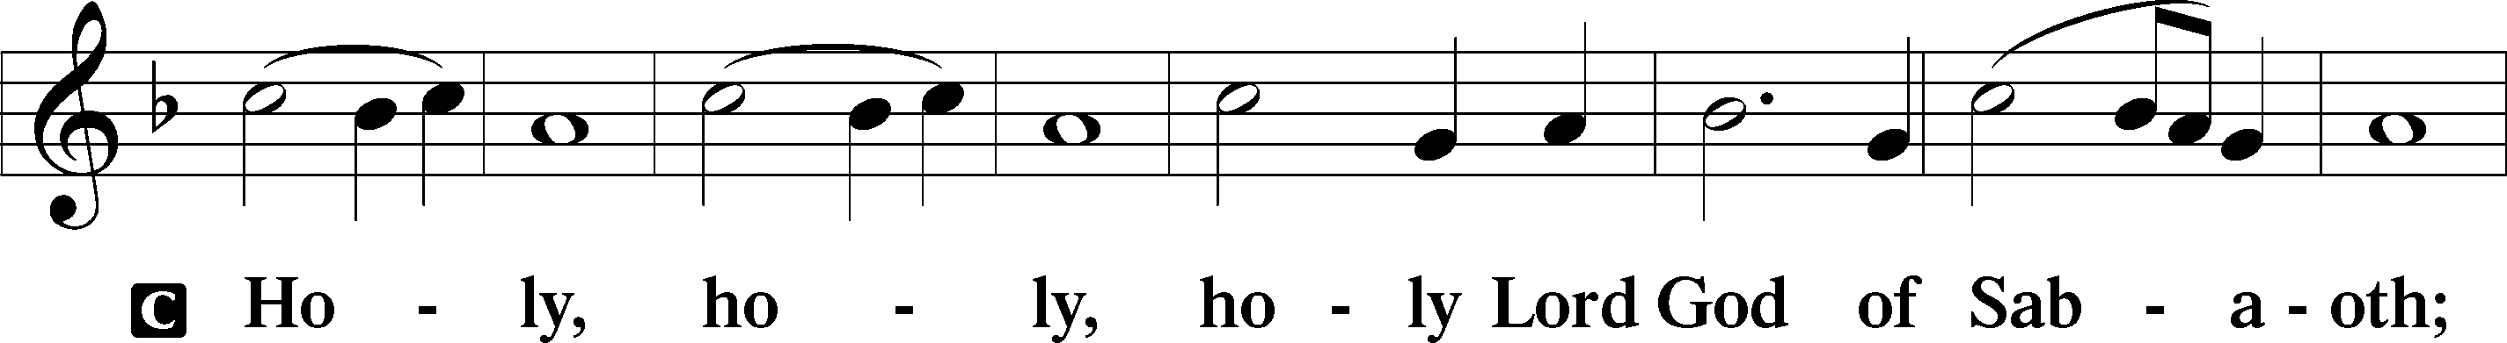
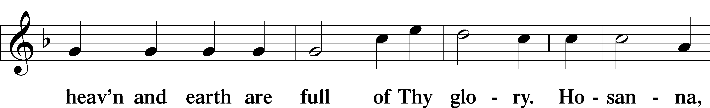
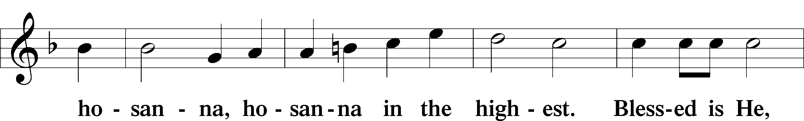
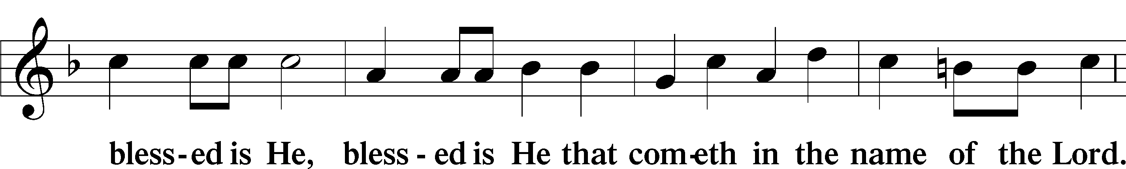
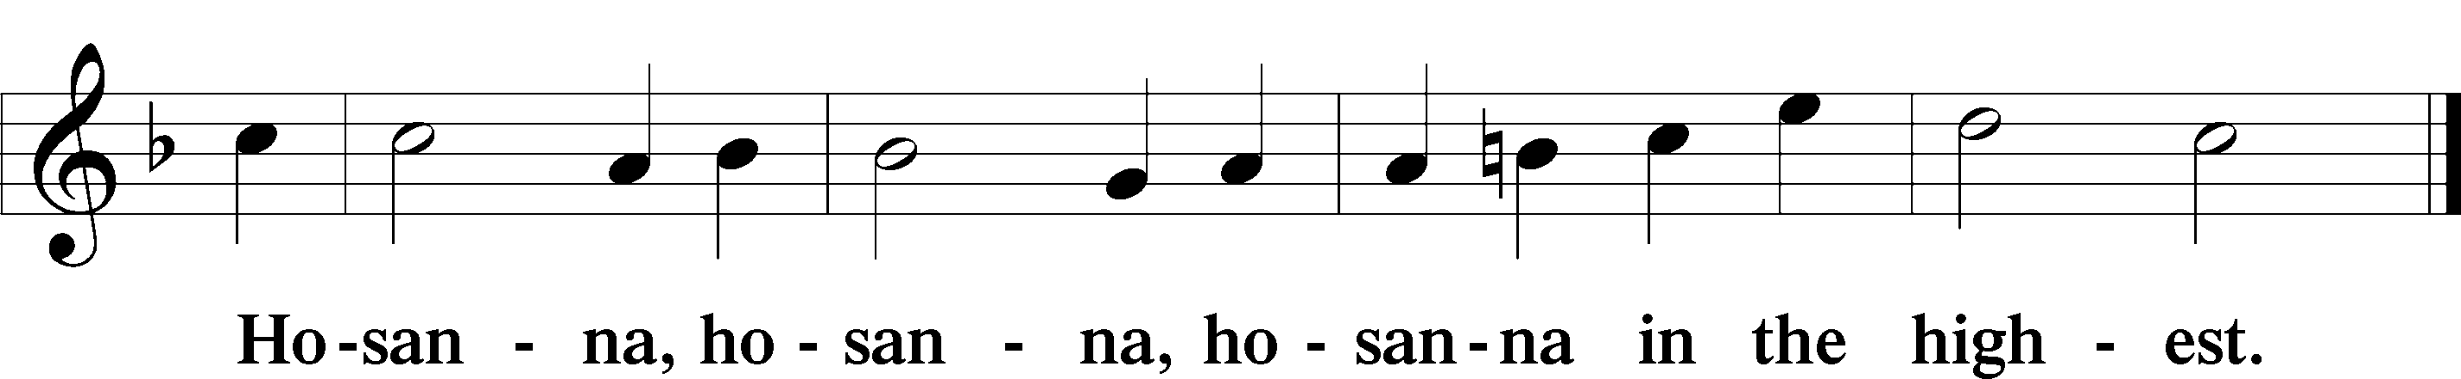

Lord’s Prayer The congregation is encouraged to silently pray the Lord’s Prayer as it is chanted. Matthew 6:9–13
P Our Father who art in heaven,
hallowed be Thy name,
Thy kingdom come,
Thy will be done on earth as it is in heaven;
give us this day our daily bread;
and forgive us our trespasses as we forgive those who trespass against us;
and lead us not into temptation,
but deliver us from evil.
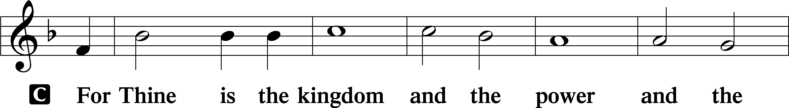
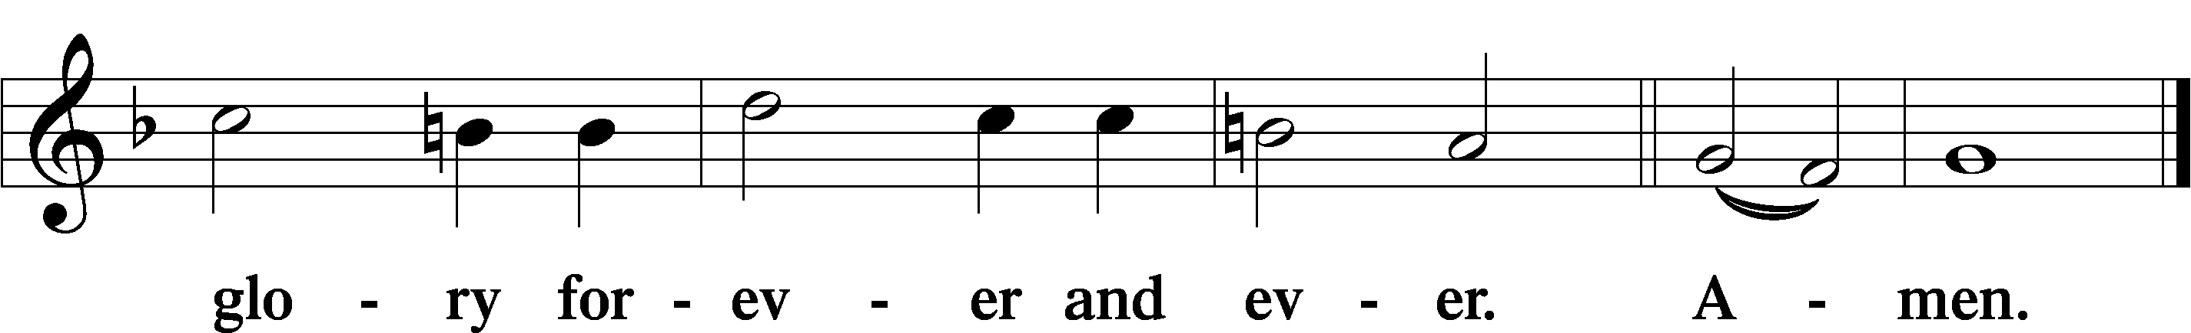

The Words of Our Lord Matthew 26:26–28; Mark 14:22–24; Luke 22:19–20; 1 Corinthians 11:23–25
P Our Lord Jesus Christ, on the night when He was betrayed, took bread, and when He had given thanks, He broke it and gave it to the disciples and said: “Take, eat; this is My T body, which is given for you. This do in remembrance of Me.”

In the same way also He took the cup after supper, and when He had given thanks, He gave it to them, saying: “Drink of it, all of you; this cup is the new testament in My T blood, which is shed for you for the forgiveness of sins. This do, as often as you drink it, in remembrance of Me.”

Pax Domini John 20:19
P The peace of the Lord be with you always.
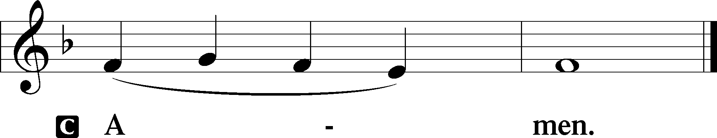

Agnus Dei John 1:29
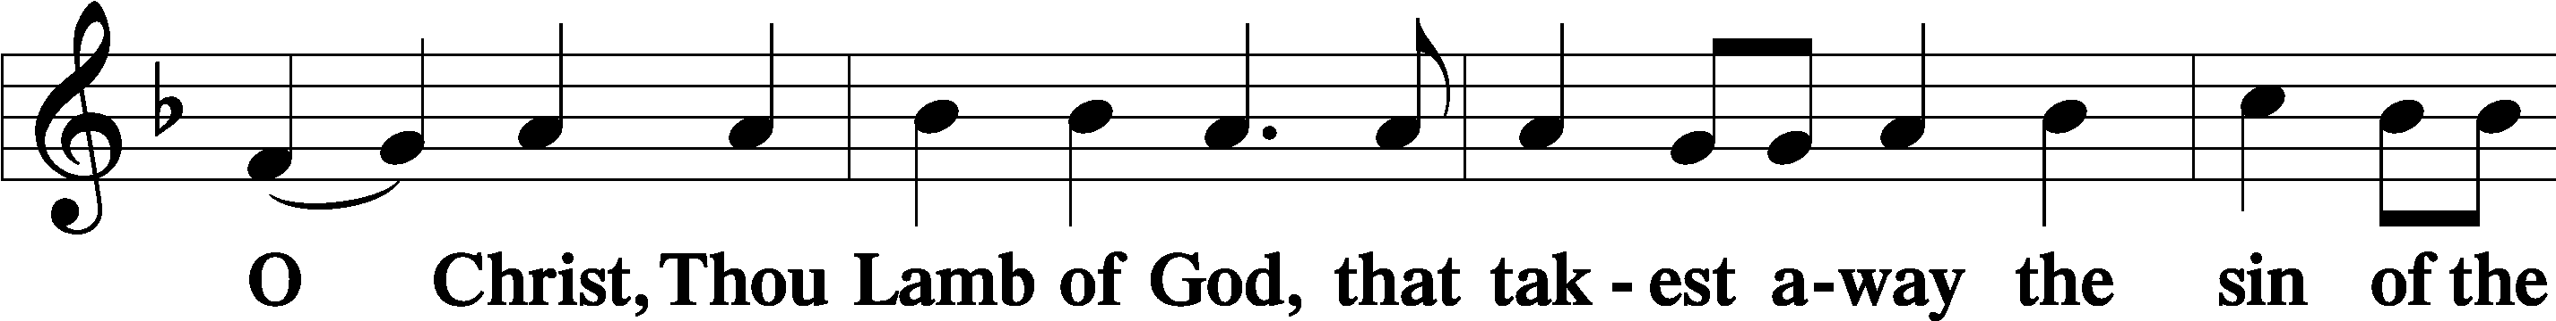
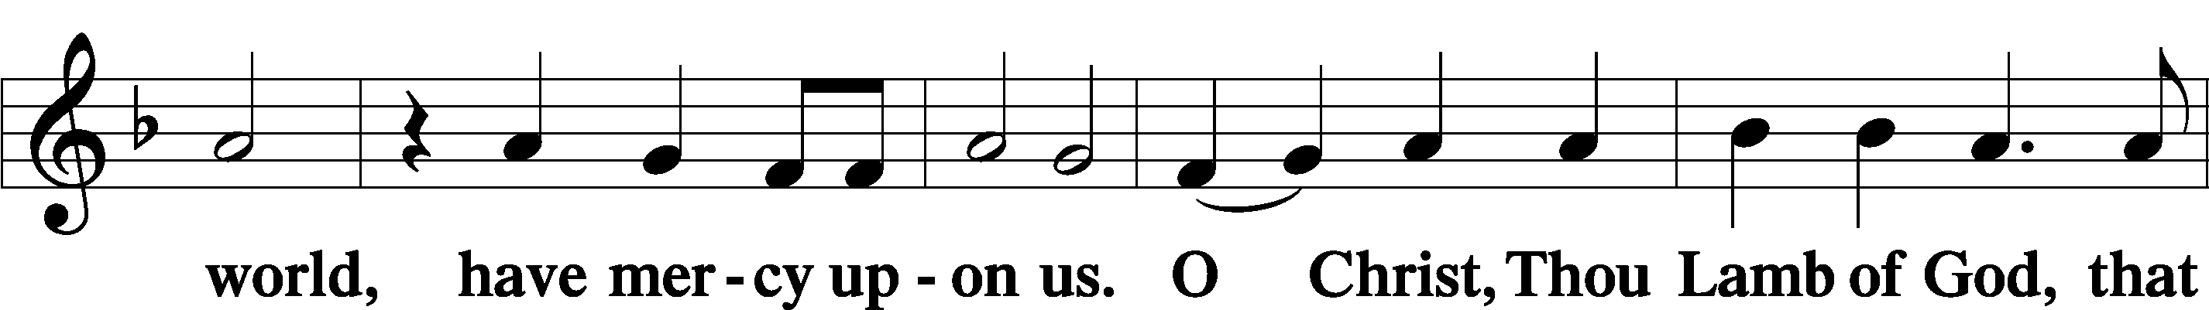
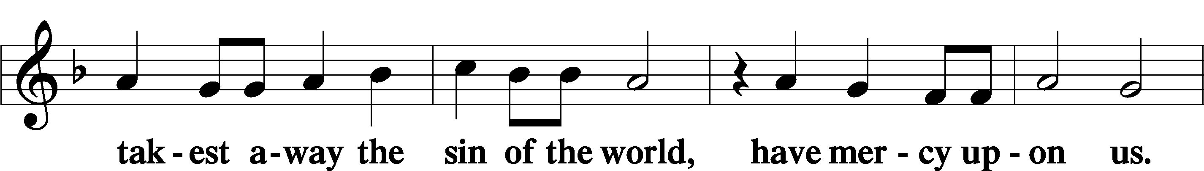
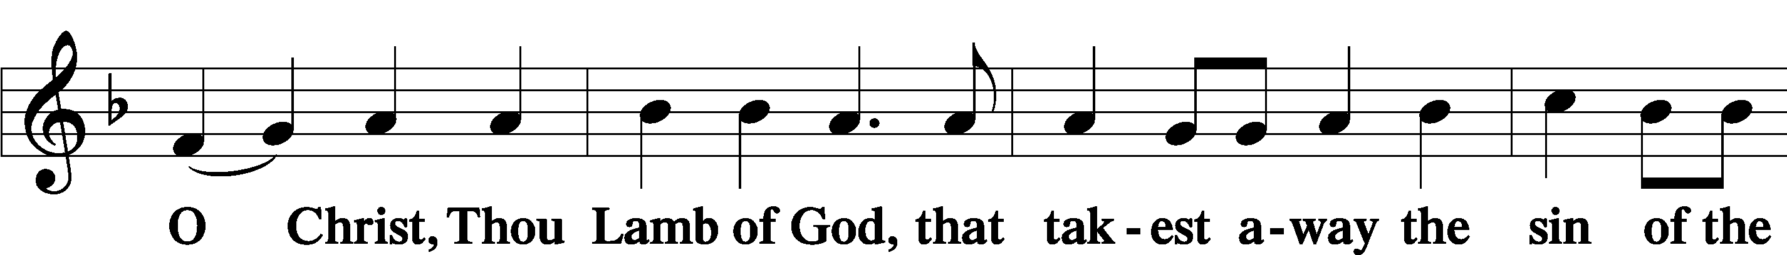
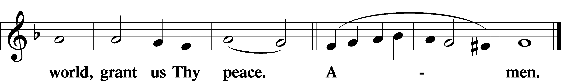
Sit

Distribution
The pastor and those who assist him receive the body and blood of Christ first and then distribute them to those who come to receive, saying:
Take, eat; this is the true body of our Lord and Savior Jesus Christ, given into death for your sins.
Amen.

Take, drink; this is the true blood of our Lord and Savior Jesus Christ, shed for the forgiveness of your sins.
Amen.

In dismissing the communicants, the following is said:
The Dismissal
P The body and blood of our Lord Jesus Christ strengthen and preserve you in body and soul to life everlasting. Depart T in peace.
C Amen.

Distribution Hymn: LSB #849 “Praise the One Who Breaks the Darkness”

Stand

Nunc Dimittis Luke 2:29–32
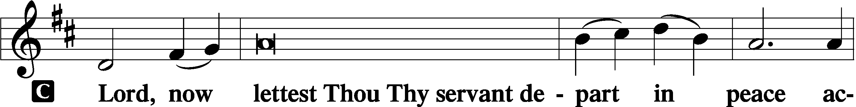
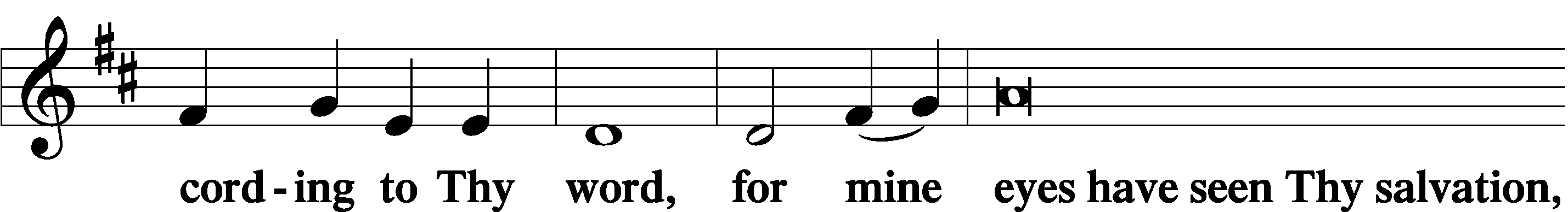
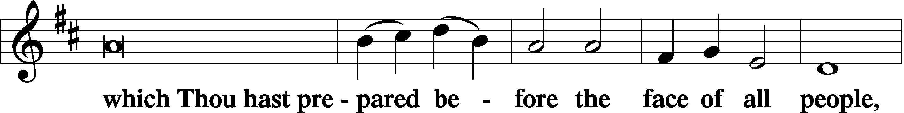
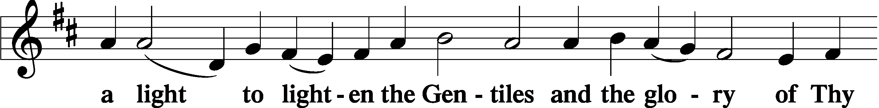
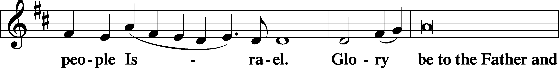
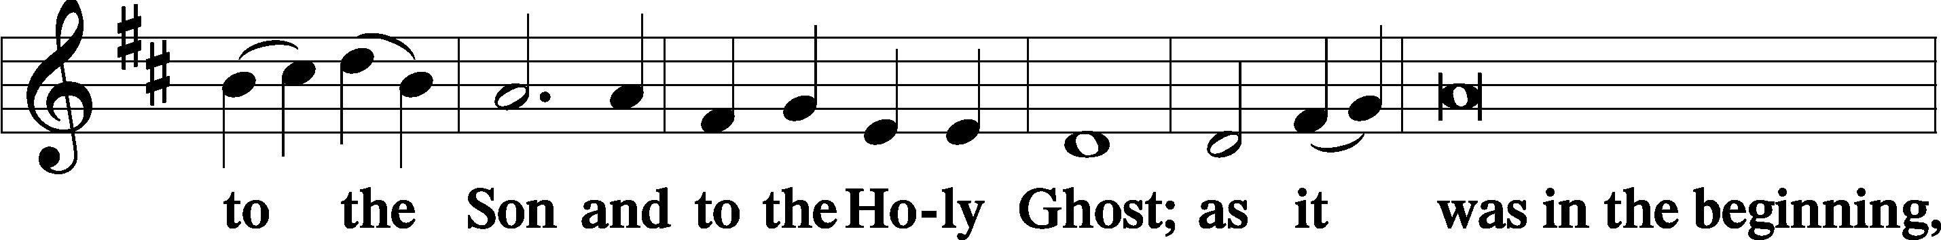
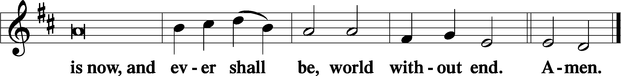

Thanksgiving Psalm 107:1
P O give thanks unto the Lord, for He is good,
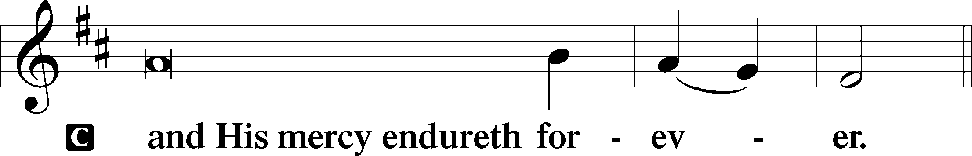

Post-Communion Collect
P Let us pray.
We give thanks to You, almighty God, … through Jesus Christ, Your Son, our Lord, who lives and reigns with You and the Holy Spirit, one God, now and forever.
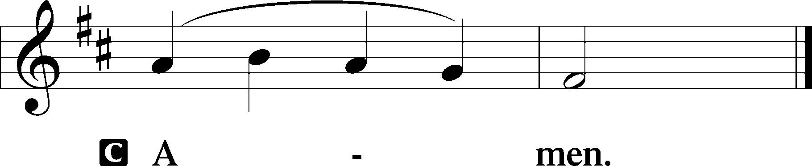

Salutation 2 Timothy 4:22
P The Lord be with you.
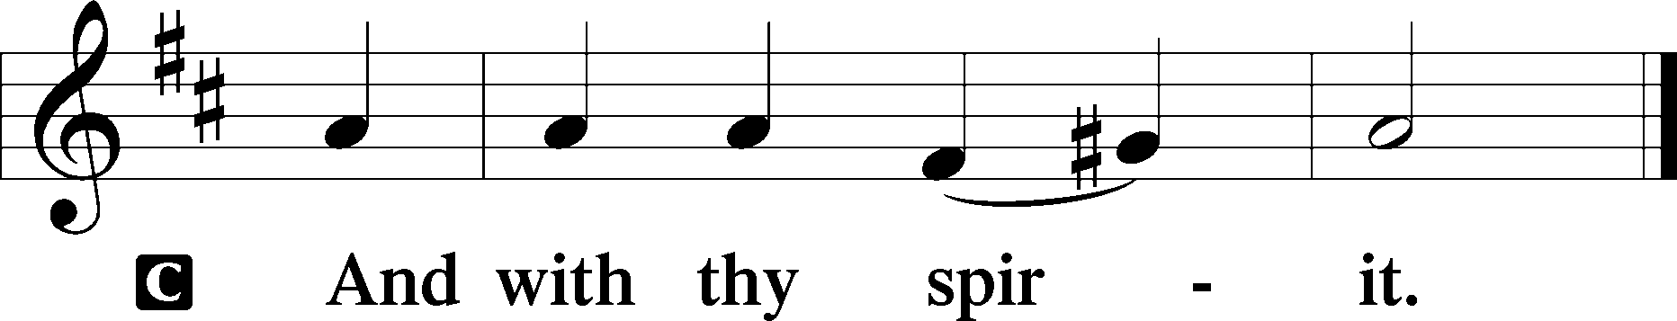

Benedicamus Psalm 103:1
P Bless we the Lord.
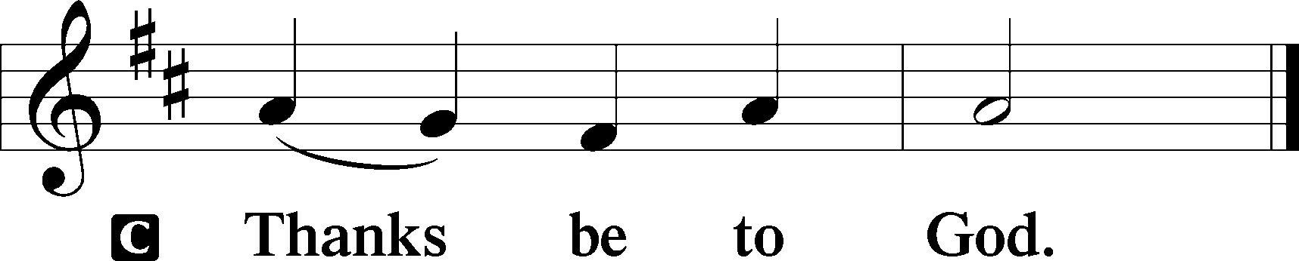

Benediction Numbers 6:24–26
P The Lord bless you and keep you.
The Lord make His face shine upon you and be gracious unto you.
The Lord lift up His countenance upon you and T give you peace.
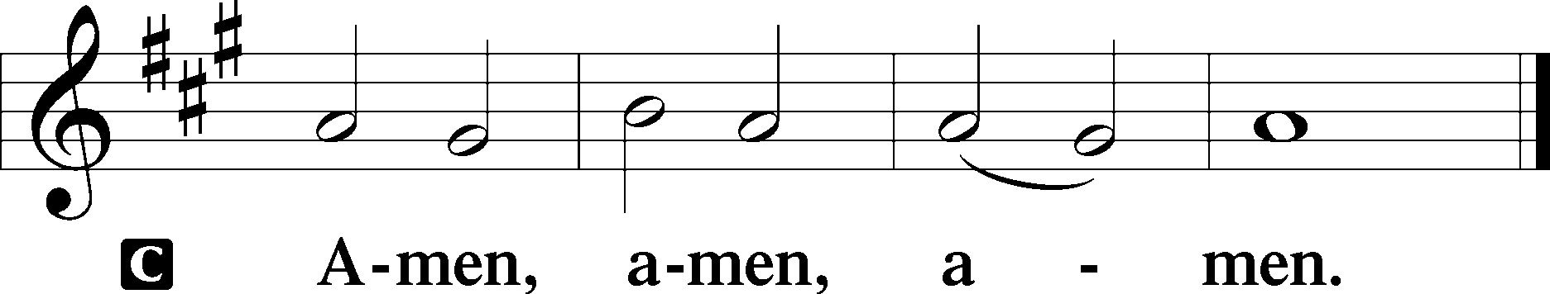

Closing Hymn: LSB #525 “Crown Him with Many Crowns”
fffffffffffffffffffffffffffffffffff
Silent prayer after worship: Heavenly Father, never allow me to forget that by the power of the Gospel I am Your dear child in Jesus Christ. Lead me to boldly share Your Gospel and to honor and serve You in all I do and say. In Jesus’ name. Amen.
fffffffffffffffffffffffffffffffffff
Acknowledgments
Unless otherwise indicated, Scripture quotations are from the ESV® Bible (The Holy Bible, English Standard Version®), copyright © 2001 by Crossway, a publishing ministry of Good News Publishers. Used by permission. All rights reserved.
Created by Lutheran Service Builder © 2023 Concordia Publishing House.

