Sts. Peter & Paul
Evangelical Lutheran Church
Lutheran Church-Missouri Synod
Founded-1917

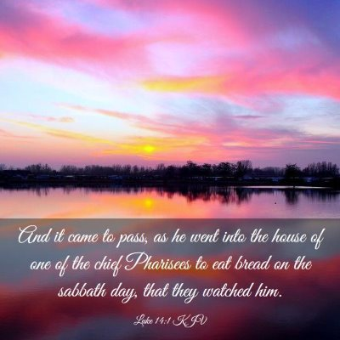

October 1, 2023

699 Stambaugh Ave.
Sharon, Pennsylvania 16146

“I was glad when they said to me,
Let us go to the house of the LORD!”
Psalm 122:1
Sts. Peter & Paul Evangelical Lutheran Church, LC-MS
THE SEVENTEENTH SUNDAY AFTER TRINITY
October 1, 2023
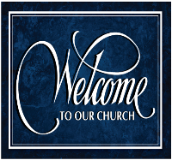
A special welcome to our guests this day! If you would like more information about The Lutheran Church - Missouri Synod, or this congregation, please speak with Pastor Deal or an Elder after the service.
Members & Guests: Don’t be embarrassed if your children make noise during the worship service, all children do. We encourage families to worship together but, if you feel the need, there are pews in the rear of the Church which are reserved for young families on both sides of the sanctuary. There is also a quiet room available to you, located next to the sanctuary (formerly the Pastor’s office), where you would be able to follow along with the service.

Today’s service includes the Sacrament of Holy Communion. If during this past year, you have not worshipped with us and been communed, we respectfully ask that you do not partake of this sacrament this day before first speaking with Pastor Deal.
If visiting from a sister congregation of the LC-MS and are in good standing, please inform Pastor Deal of your desire to commune prior to the service.
If wishing to receive a blessing during communion, please approach with your arms crossed.

CONTACT INFORMATION
Pastor Deal: pastordeal@saintspeterandpaul.net or 724-347-3620 (opt. 2)
Church Office: church@saintspeterandpaul.net or 724-347-3620 (opt. 3)
Secretary’s Office: The office will be open Mon. & Thurs (8:30 am-4:30 pm).

Silent prayer before worship: Lord Jesus, You have invited me to follow You. Cause Your Holy Spirit to work through Your word to strengthen my faith and to give me peace in my heart and mind. In Jesus’ name. Amen.

Acknowledgments: Unless otherwise indicated, Scripture quotations are from the ESV® Bible (The Holy Bible, English Standard Version®), copyright © 2001 by Crossway, a publishing ministry of Good News Publishers. Used by permission. All rights reserved. Created by Lutheran Service Builder © 2023 Concordia Publishing House.
Confession and Absolution

Opening Hymn: LSB #587 “I Know My Faith Is Founded”

Stand

The sign of the cross may be made by all in remembrance of their Baptism.
Invocation
P In the name of the Father and of the T Son and of the Holy Spirit.
C Amen.

Exhortation Hebrews 10:22; Psalm 124:8; Psalm 32:5
P Beloved in the Lord! Let us draw near with a true heart and confess our sins unto God our Father, beseeching Him in the name of our Lord Jesus Christ to grant us forgiveness.

P Our help is in the name of the Lord,
C who made heaven and earth.
P I said, I will confess my transgressions unto the Lord,
C and You forgave the iniquity of my sin.

Silence for reflection on God’s Word and for self-examination.
Confession of Sins
P O almighty God, merciful Father,
C I, a poor, miserable sinner, confess unto You all my sins and iniquities with which I have ever offended You and justly deserved Your temporal and eternal punishment. But I am heartily sorry for them and sincerely repent of them, and I pray You of Your boundless mercy and for the sake of the holy, innocent, bitter sufferings and death of Your beloved Son, Jesus Christ, to be gracious and merciful to me, a poor, sinful being.

Absolution [John 20:19–23]
P Upon this your confession, I, by virtue of my office, as a called and ordained servant of the Word, announce the grace of God unto all of you, and in the stead and by the command of my Lord Jesus Christ I forgive you all your sins in the name of the Father and of the T Son and of the Holy Spirit.
C Amen.
Service of the Word

Introit Psalm 119:1–2, 5–6; antiphon: vv. 137, 124
Righteous are you, | O Lord,*
and right are your | just decrees.
Deal with your servant according to your | steadfast love,*
and teach me your | statutes.
Blessèd are those whose way is | blameless,*
who walk in the law | of the Lord!
Blessèd are those who keep his testi- | monies,*
who seek him with their | whole heart.
Oh that my ways may be | steadfast*
in keeping your | statutes!
Then I shall not be | put to shame,*
having my eyes fixed on all your com- | mandments.
Righteous are you, | O Lord,*
and right are your | just decrees.
Deal with your servant according to your | steadfast love,*
and teach me your | statutes.

Gloria Patri
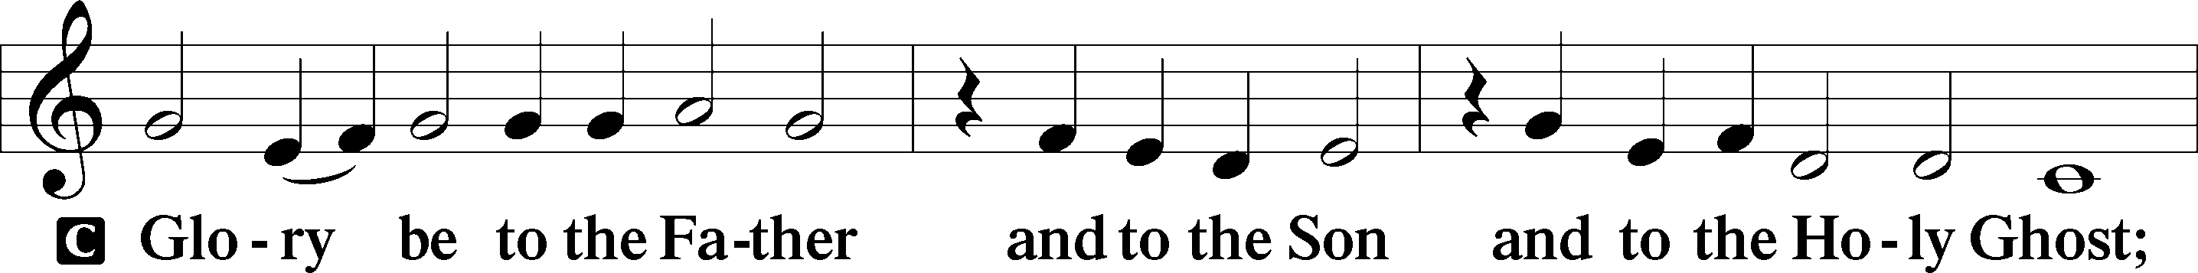
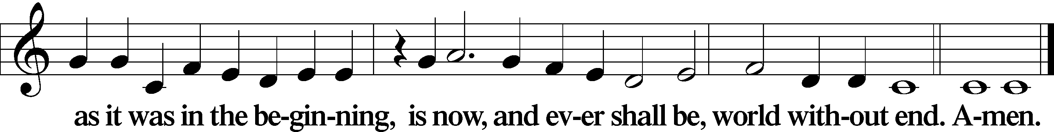
Kyrie Mark 10:47
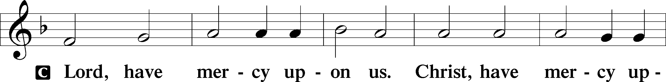
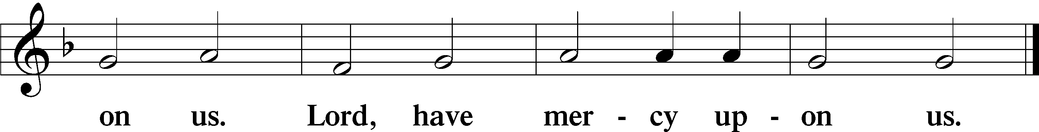

Gloria in Excelsis Luke 2:14; John 1:29
P Glory be to God on high:
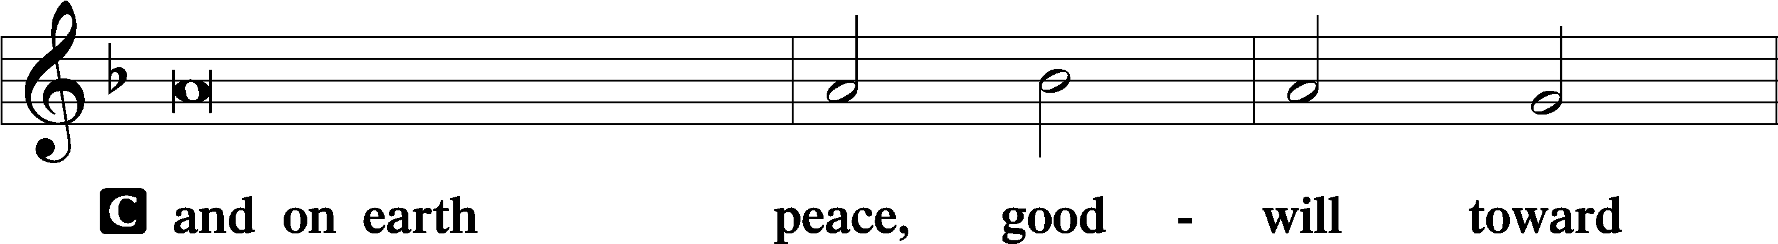
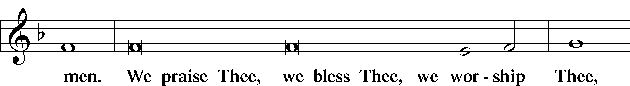
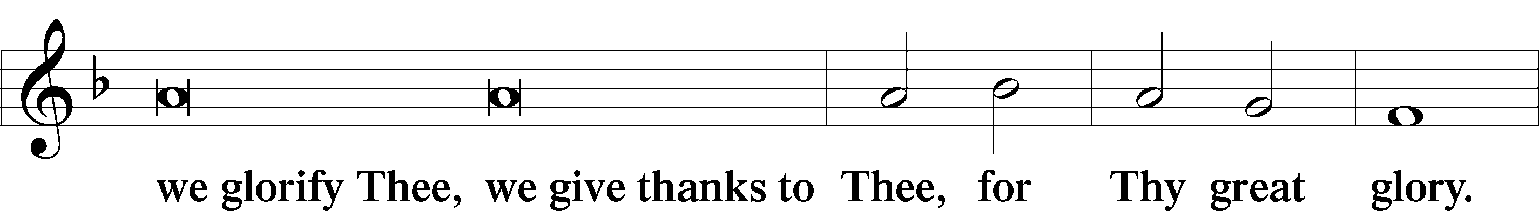
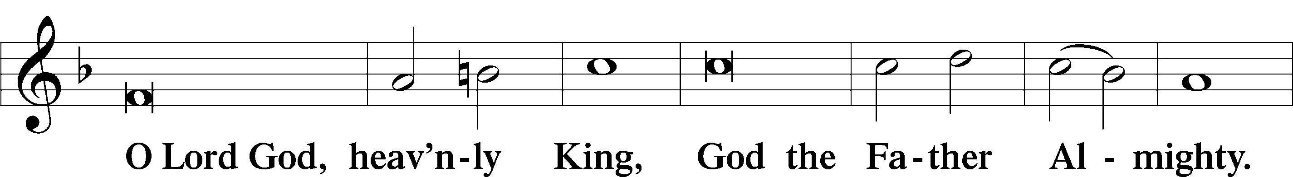
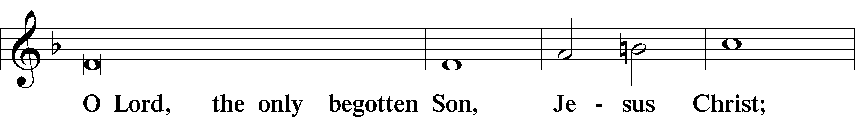
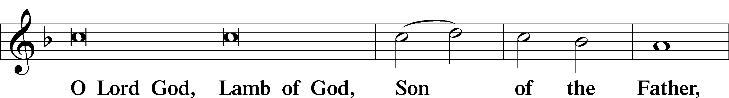
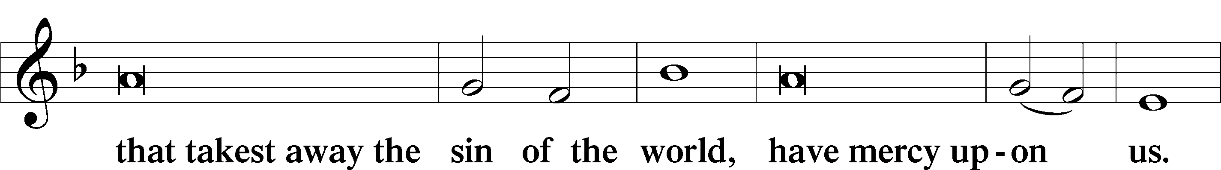
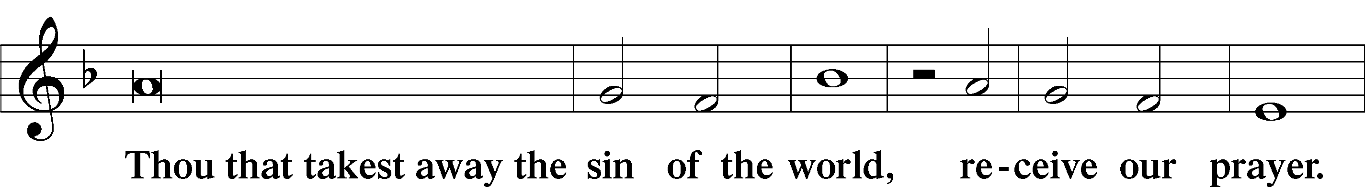
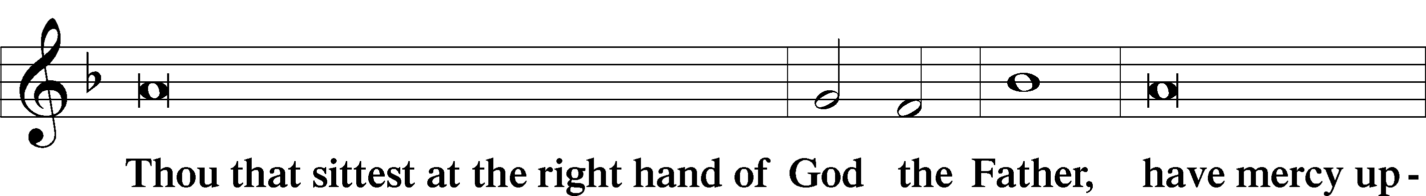
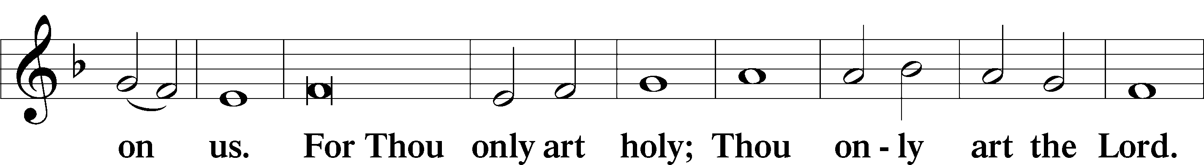
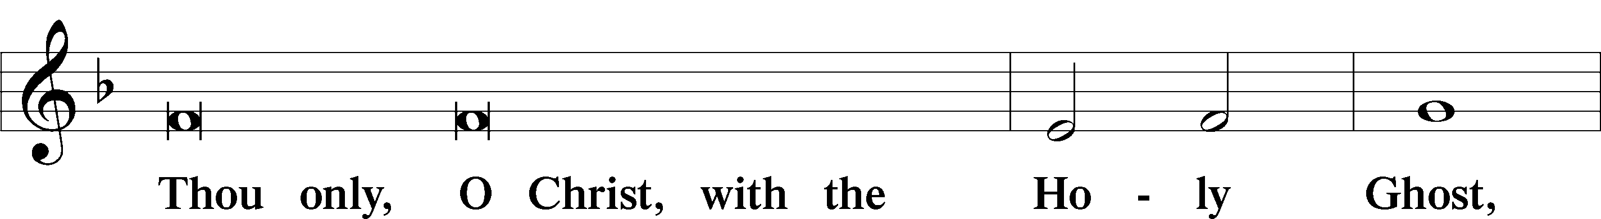
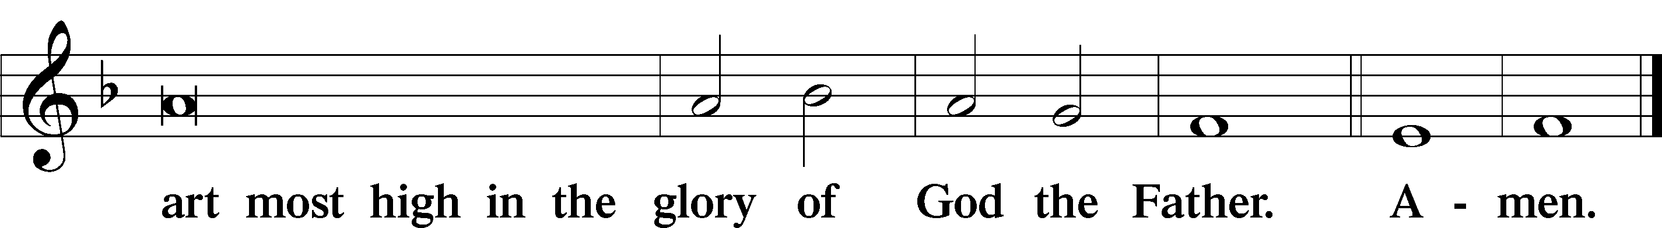

Salutation and Collect of the Day: Trinity 17
P The Lord be with you.
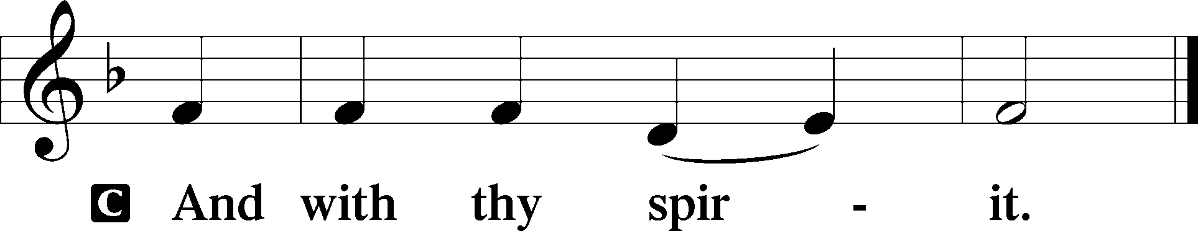

P Let us pray.
Lord, we implore You, grant Your people grace to withstand the temptations of the devil and with pure hearts and minds to follow You, the only God; through Jesus Christ, Your Son, our Lord, who lives and reigns with You and the Holy Spirit, one God, now and forever.
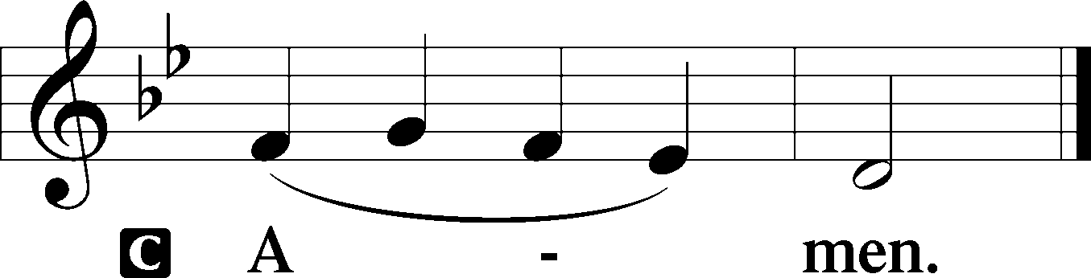
Sit

Prophecy: Proverbs 25:6–14 (NKJV)
Do not exalt yourself in the presence of the king, and do not stand in the place of the great; for it is better that he say to you, “Come up here,” Than that you should be put lower in the presence of the prince, whom your eyes have seen. Do not go hastily to court; for what will you do in the end, when your neighbor has put you to shame? Debate your case with your neighbor, and do not disclose the secret to another; lest he who hears it expose your shame, and your reputation be ruined. A word fitly spoken is like apples of gold in settings of silver. Like an earring of gold and an ornament of fine gold is a wise rebuker to an obedient ear. Like the cold of snow in time of harvest is a faithful messenger to those who send him, for he refreshes the soul of his masters. Whoever falsely boasts of giving is like clouds and wind without rain.

P This is the Word of the Lord.
C Thanks be to God.

Gradual Psalm 33:12, 6
Blessèd is the nation whose God | is the Lord,*
the people whom he has chosen as his | heritage!
By the word of the Lord the heav- | ens were made,*
and by the breath of his mouth | all their host.

Epistle: Ephesians 4:1–6 (NKJV)
Brethren: I, the prisoner of the Lord, beseech you to walk worthy of the calling with which you were called, with all lowliness and gentleness, with longsuffering, bearing with one another in love, endeavoring to keep the unity of the Spirit in the bond of peace. There is one body and one Spirit, just as you were called in one hope of your calling; one Lord, one faith, one baptism; one God and Father of all, who is above all, and through all, and in us all, who is blessed forever and ever. Amen.

P This is the Word of the Lord.
C Thanks be to God.

Stand
Verse Psalm 116:1
Alleluia. I love the Lord, because he has heard my voice and my pleas for mercy. Alleluia.

Alleluia
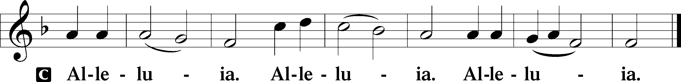

Holy Gospel: Luke 14:1–11 (NKJV)
P The Holy Gospel according to St. Luke, the fourteenth chapter.
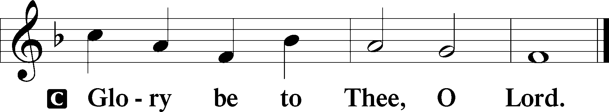

At that time: As Jesus went into the house of one of the rulers of the Pharisees to eat bread on the Sabbath, they watched Him closely. And behold, there was a certain man before Him who had dropsy. And Jesus, answering, spoke to the lawyers and Pharisees, saying, “Is it lawful to heal on the Sabbath?” But they kept silent. And He took him and healed him, and let him go. Then He answered them, saying, “Which of you, having a donkey or an ox that has fallen into a pit, will not immediately pull him out on the Sabbath day?” And they could not answer Him regarding these things. So He told a parable to those who were invited, when He noted how they chose the best places, saying to them: “When you are invited by anyone to a wedding feast, do not sit down in the best place, lest one more honorable than you be invited by him; and he who invited you and him come and say to you, ‘Give place to this man,’ and then you begin with shame to take the lowest place. But when you are invited, go and sit down in the lowest place, so that when he who invited you comes he may say to you, ‘Friend, go up higher.’ Then you will have glory in the presence of those who sit at the table with you. For whoever exalts himself will be humbled, and he who humbles himself will be exalted.”

P This is the Gospel of the Lord.
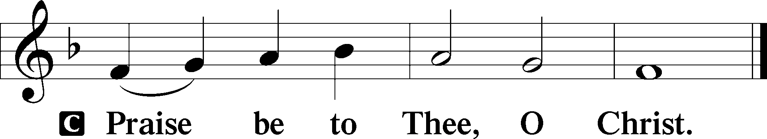

Nicene Creed
C I believe in one God,
the Father Almighty,
maker of heaven and earth
and of all things visible and invisible.

And in one Lord Jesus Christ,
the only-begotten Son of God,
begotten of His Father before all worlds,
God of God, Light of Light,
very God of very God,
begotten, not made,
being of one substance with the Father,
by whom all things were made;
who for us men and for our salvation came down from heaven
and was incarnate by the Holy Spirit of the virgin Mary
and was made man;
and was crucified also for us under Pontius Pilate.
He suffered and was buried.
And the third day He rose again according to the Scriptures
and ascended into heaven
and sits at the right hand of the Father.
And He will come again with glory to judge both the living and the dead,
whose kingdom will have no end.

And I believe in the Holy Spirit,
the Lord and giver of life,
who proceeds from the Father and the Son,
who with the Father and the Son together is worshiped and glorified,
who spoke by the prophets.
And I believe in one holy Christian and apostolic Church,
I acknowledge one Baptism for the remission of sins,
and I look for the resurrection of the dead
and the life T of the world to come. Amen.
Sit

Hymn of the Day: LSB #557 “Seek Where You May to Find a Way”

Sermon

Stand

Offertory Psalm 51:10–12
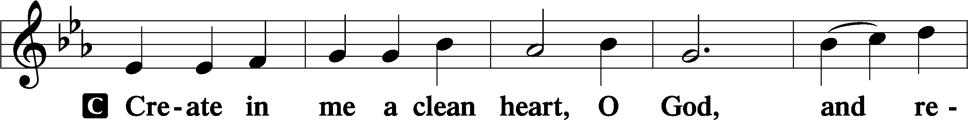
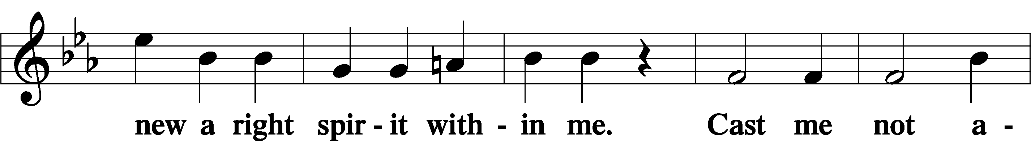
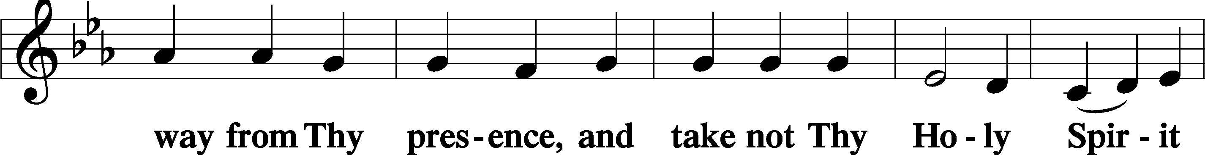
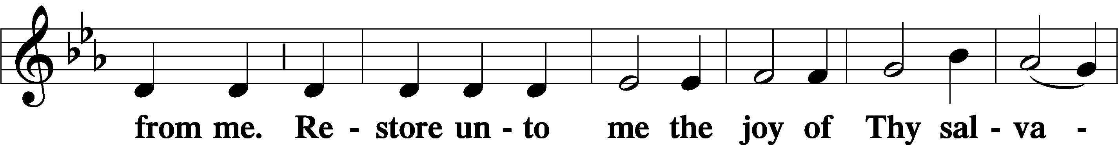
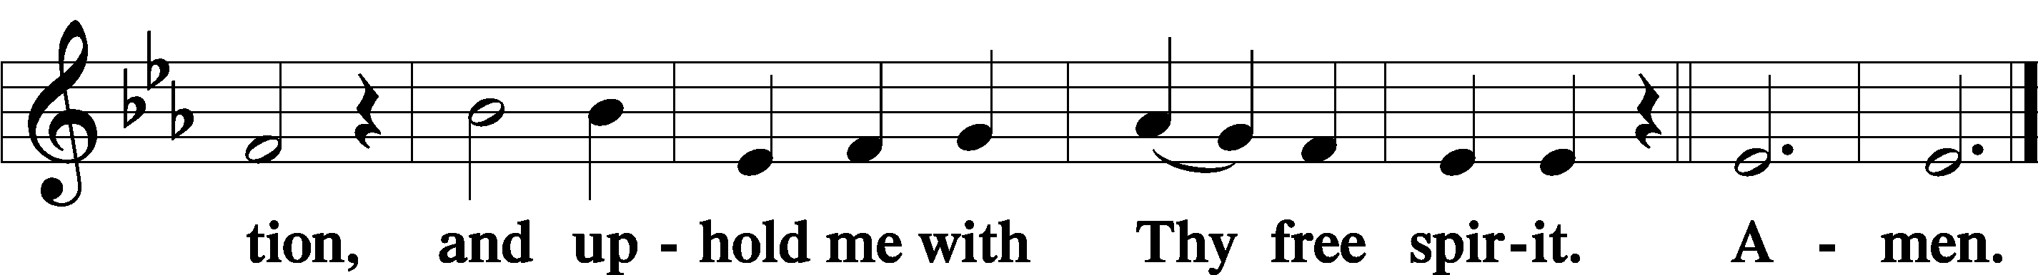

Prayer of the Church

Sit
Preparatory Hymn: LSB #625 “Lord Jesus Christ, Life-Giving Bread”

Stand
Service of the Sacrament

Preface 2 Timothy 4:22; Colossians 3:1 Psalm 136
P The Lord be with you.
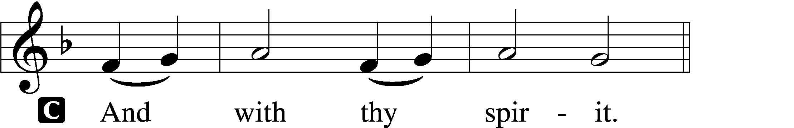

P Lift up your hearts.
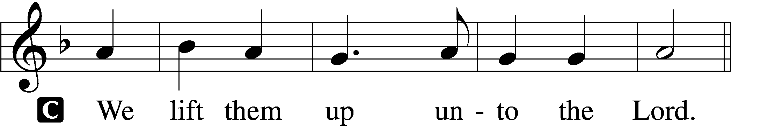

P Let us give thanks unto the Lord, our God.
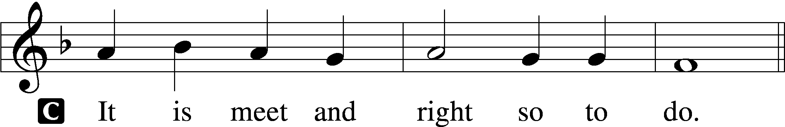

Proper Preface (Abbreviated) LSB 194
P It is truly meet, right, and salutary . . . evermore praising You and saying:

Sanctus Isaiah 6:3; Matthew 21:9
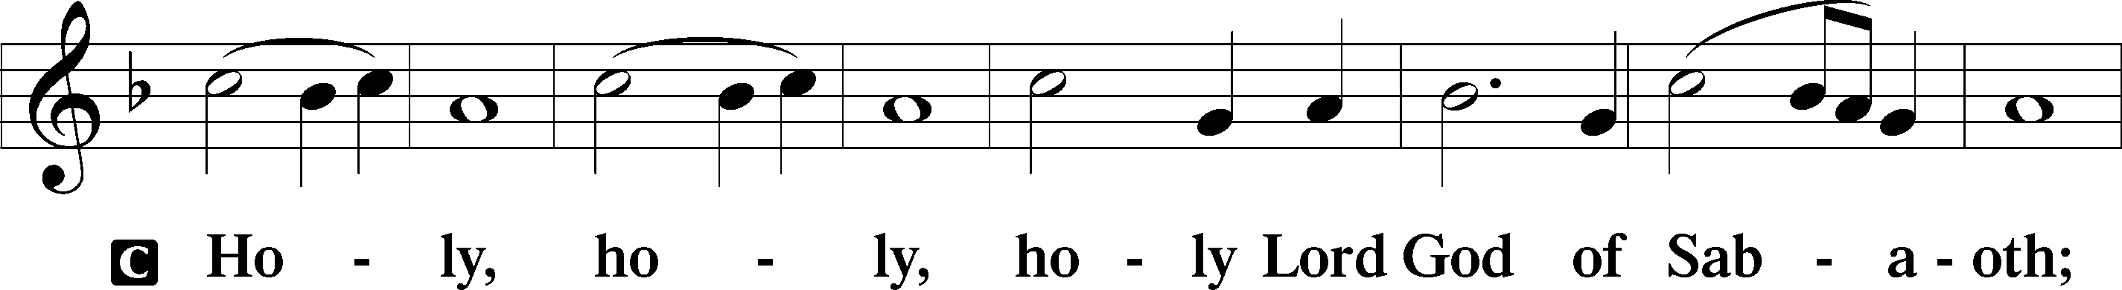
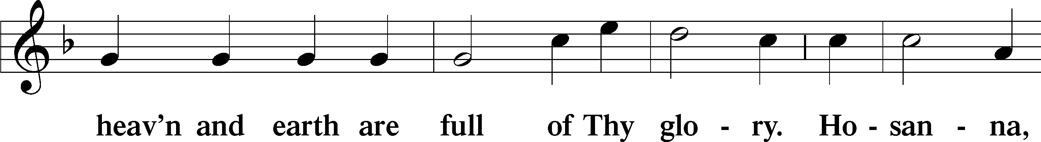
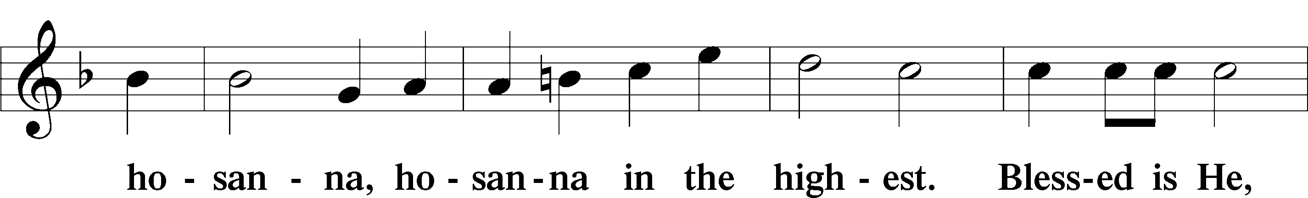
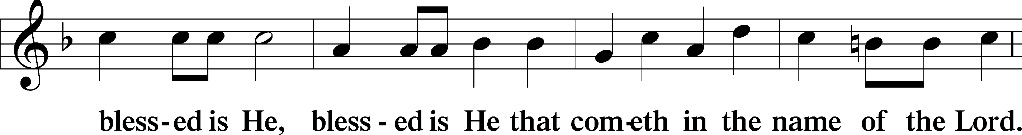
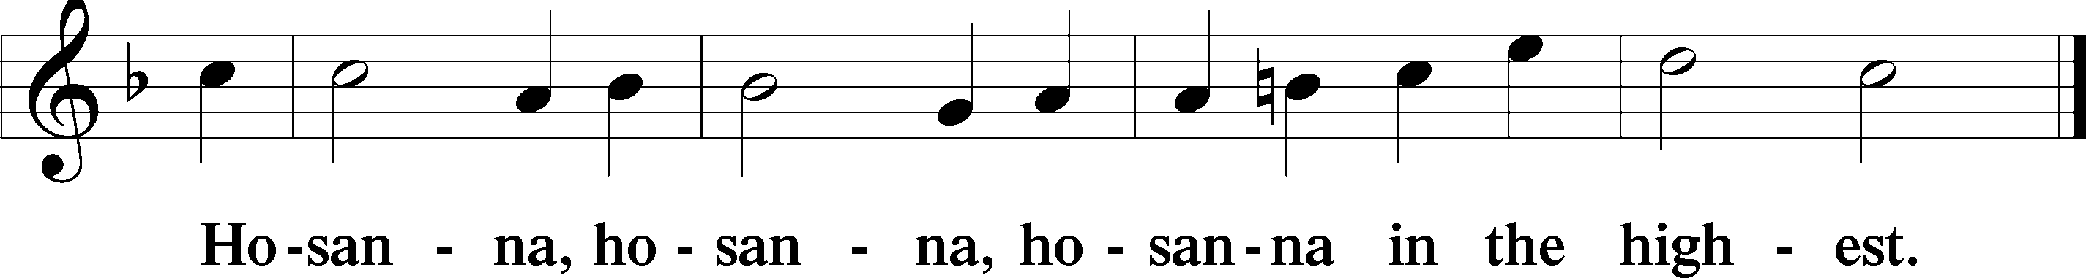

Lord’s Prayer The congregation is encouraged to silently pray the Lord’s Prayer as it is chanted. Matthew 6:9–13
P Our Father who art in heaven,
hallowed be Thy name,
Thy kingdom come,
Thy will be done on earth as it is in heaven;
give us this day our daily bread;
and forgive us our trespasses as we forgive those who trespass against us;
and lead us not into temptation,
but deliver us from evil.
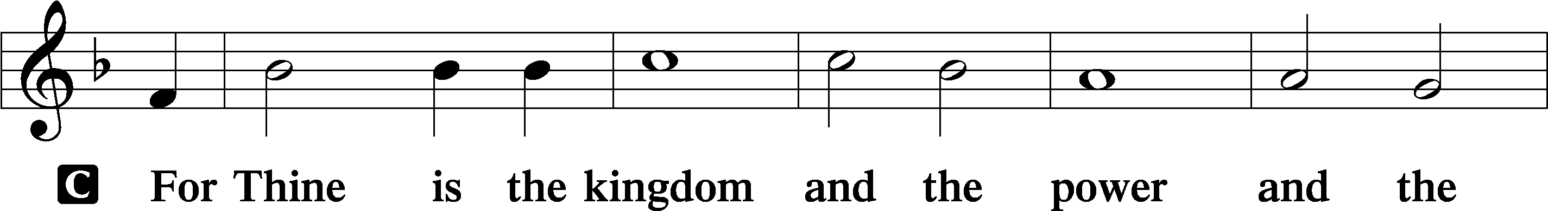
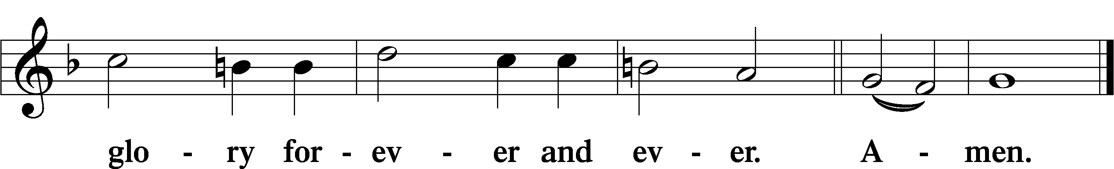

The Words of Our Lord Matthew 26:26–28; Mark 14:22–24; Luke 22:19–20; 1 Corinthians 11:23–25
P Our Lord Jesus Christ, on the night when He was betrayed, took bread, and when He had given thanks, He broke it and gave it to the disciples and said: “Take, eat; this is My T body, which is given for you. This do in remembrance of Me.”

In the same way also He took the cup after supper, and when He had given thanks, He gave it to them, saying: “Drink of it, all of you; this cup is the new testament in My T blood, which is shed for you for the forgiveness of sins. This do, as often as you drink it, in remembrance of Me.”

Pax Domini John 20:19
P The peace of the Lord be with you always.
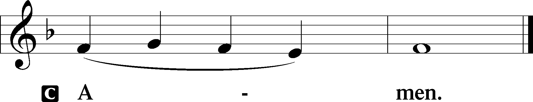
Agnus Dei John 1:29
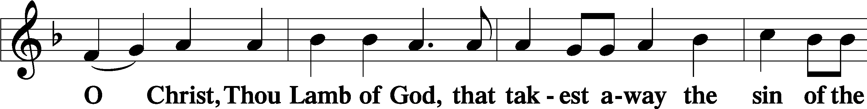
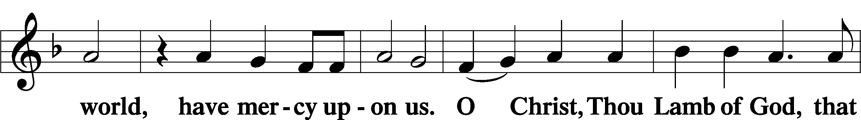
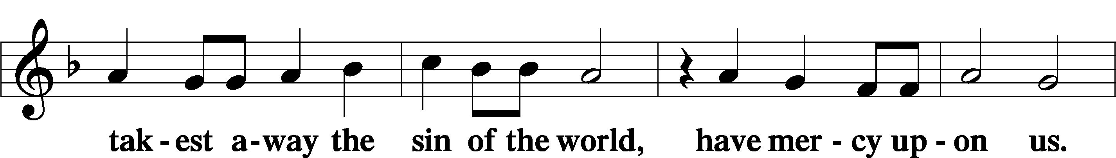
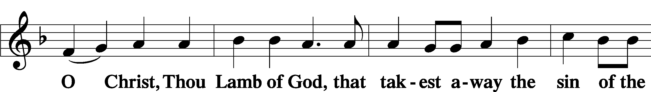
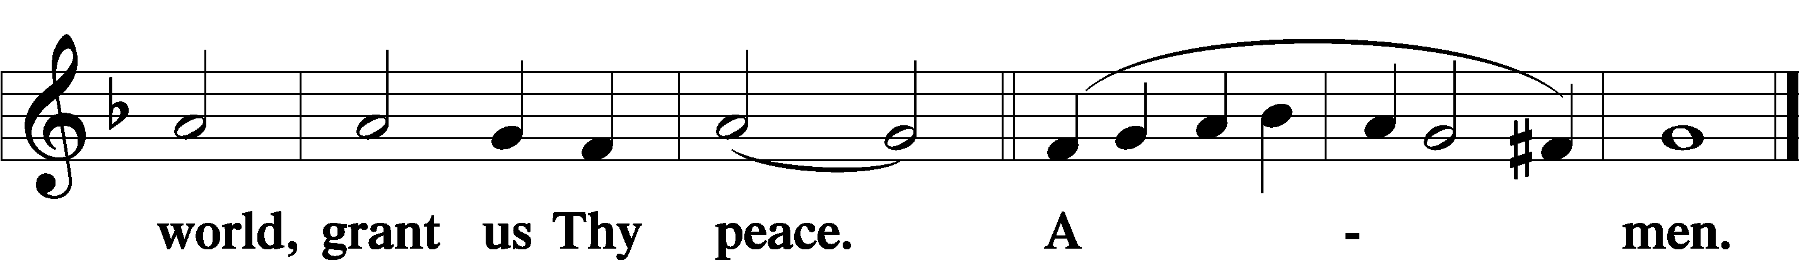
Sit

Distribution
The pastor and those who assist him receive the body and blood of Christ first and then distribute them to those who come to receive, saying:
Take, eat; this is the true body of our Lord and Savior Jesus Christ, given into death for your sins.
Amen.

Take, drink; this is the true blood of our Lord and Savior Jesus Christ, shed for the forgiveness of your sins.
Amen.

In dismissing the communicants, the following is said:
The Dismissal
P The body and blood of our Lord Jesus Christ strengthen and preserve you in body and soul to life everlasting. Depart T in peace.
C Amen.

Distribution Hymn: LSB #714 “Who Trusts in God a Strong Abode”

Distribution Hymn: LSB #585 “Lord Jesus Christ, with Us Abide”

Distribution Hymn: LSB #905 “Come, Thou Almighty King”

Stand

Nunc Dimittis Luke 2:29–32
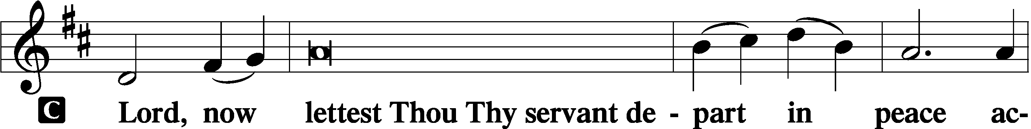
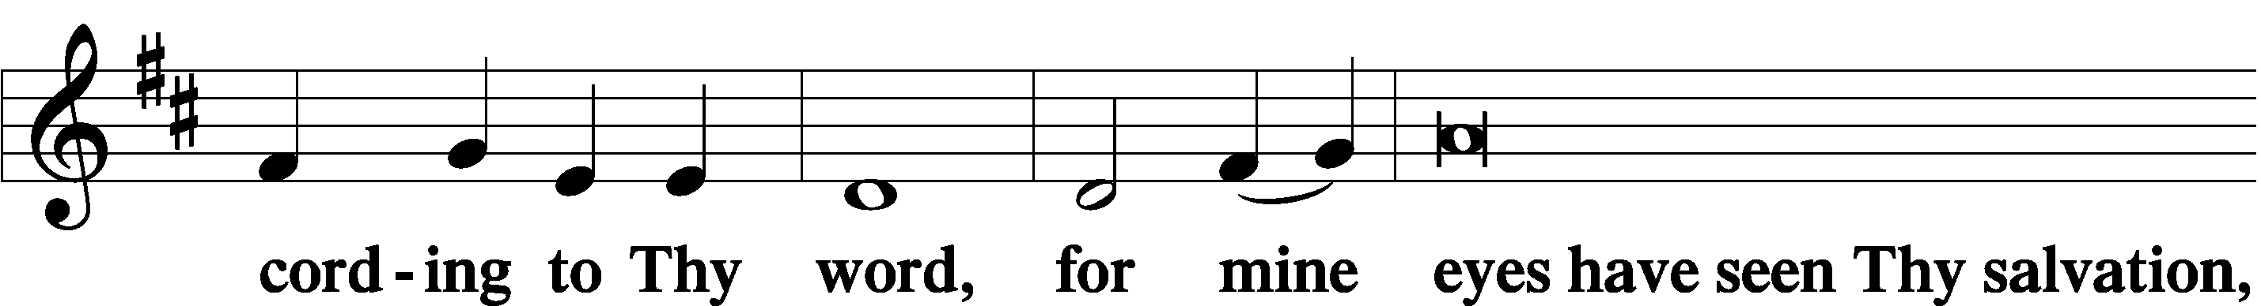
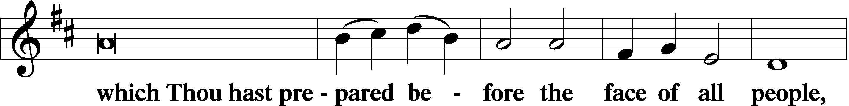
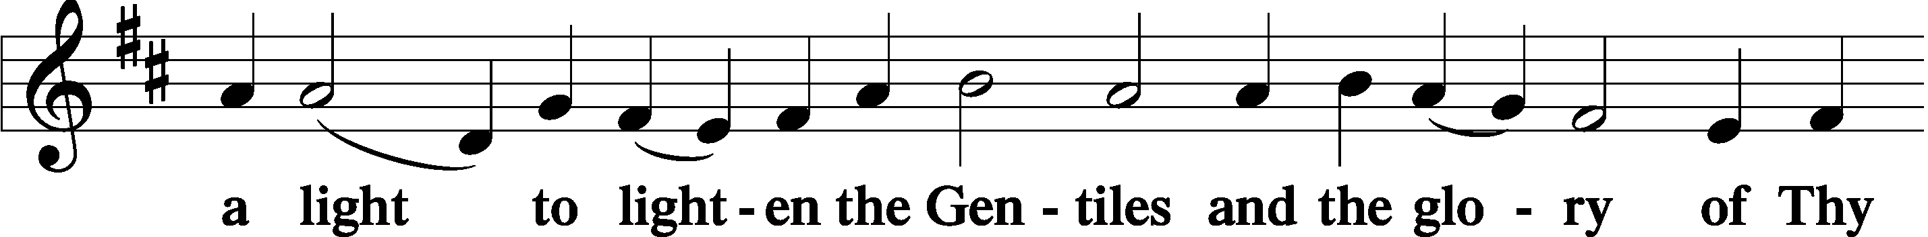
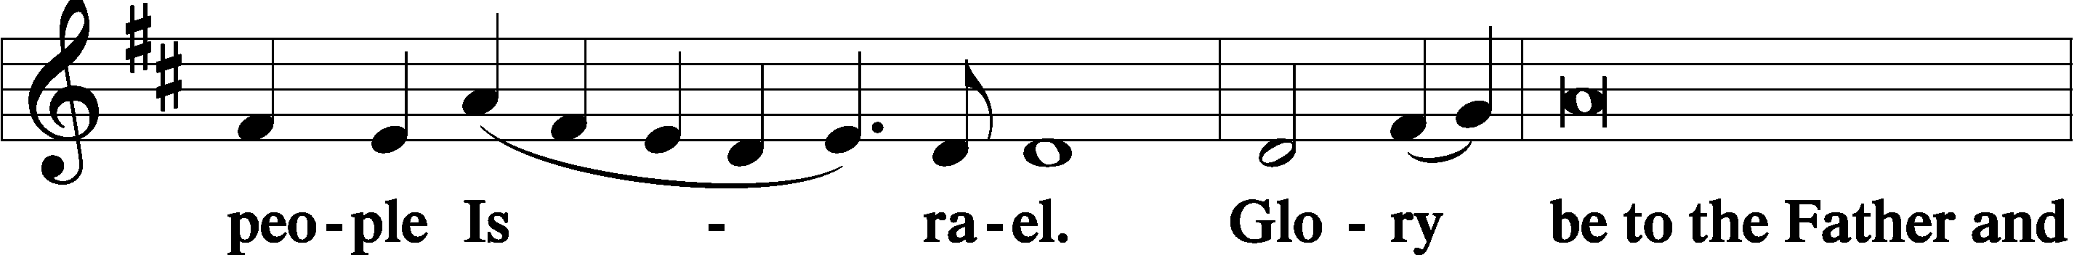
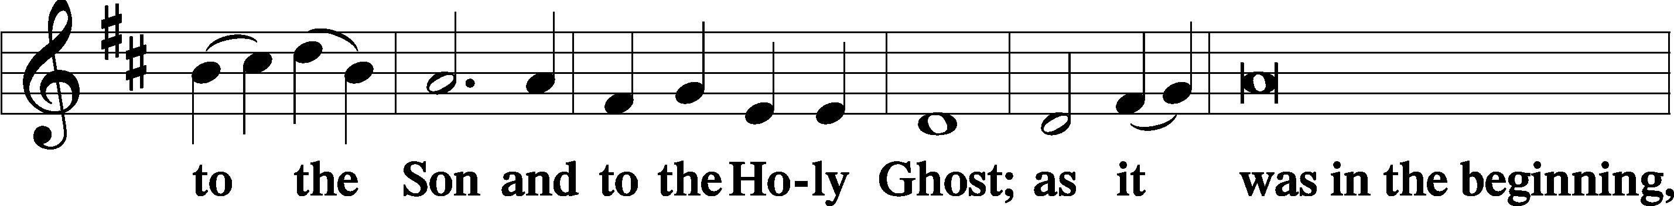
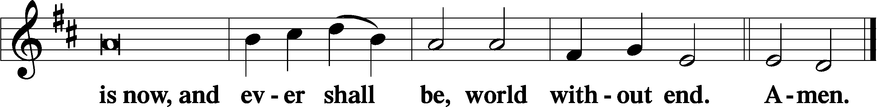

Thanksgiving Psalm 107:1
P O give thanks unto the Lord, for He is good,
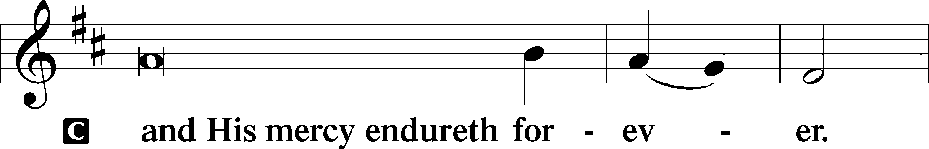

Post-Communion Collect
P Let us pray.
We give thanks to You, almighty God, … through Jesus Christ, Your Son, our Lord, who lives and reigns with You and the Holy Spirit, one God, now and forever.
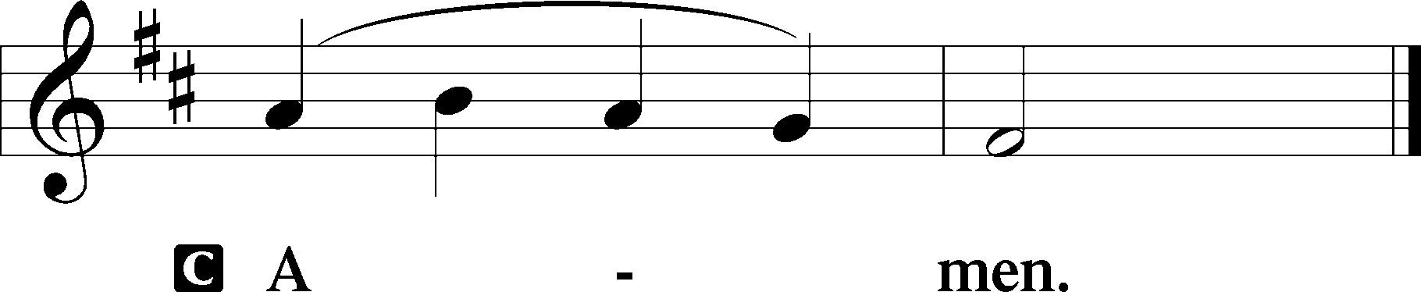

Salutation 2 Timothy 4:22
P The Lord be with you.
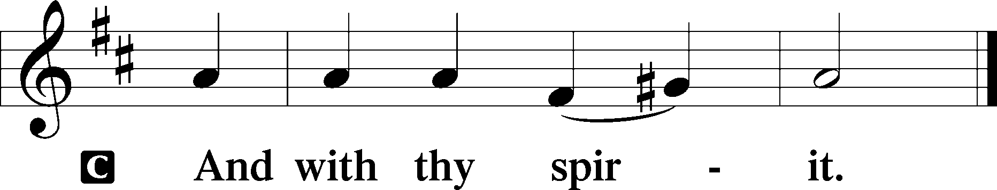

Benedicamus Psalm 103:1
P Bless we the Lord.
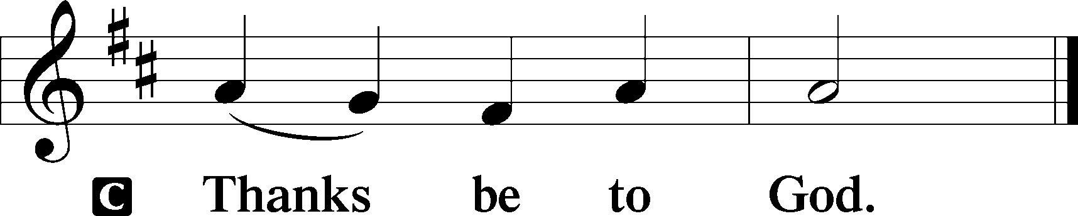

Benediction Numbers 6:24–26
P The Lord bless you and keep you.
The Lord make His face shine upon you and be gracious unto you.
The Lord lift up His countenance upon you and T give you peace.
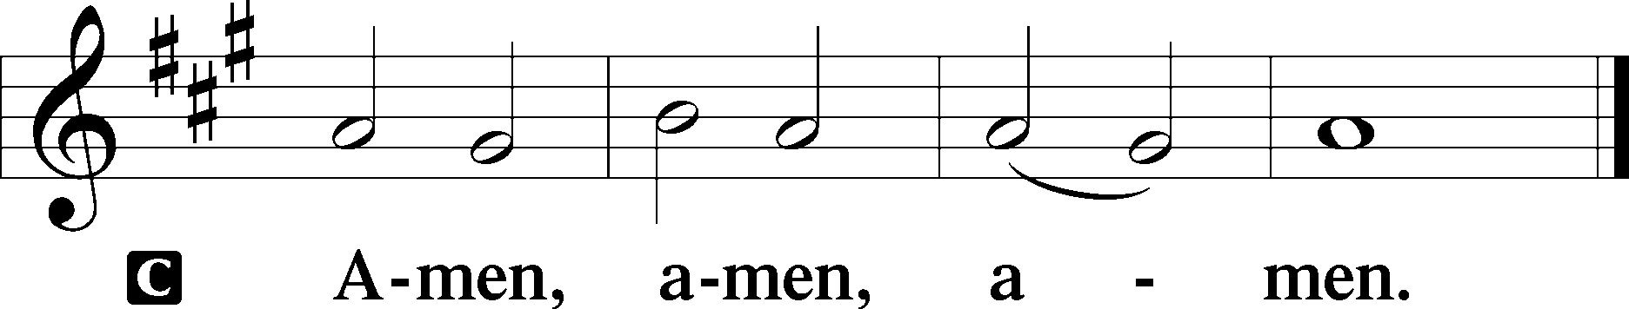

Closing Hymn: TLH #561 “Now That the Day Hath Reached Its Close”
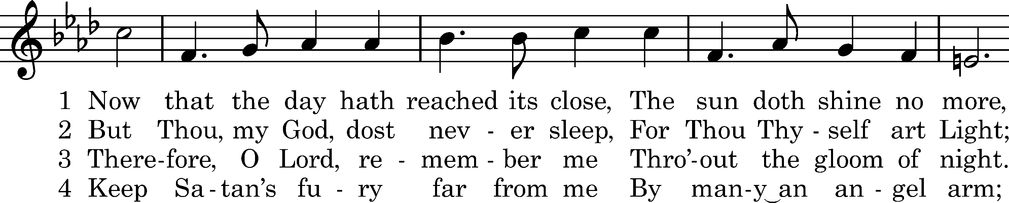
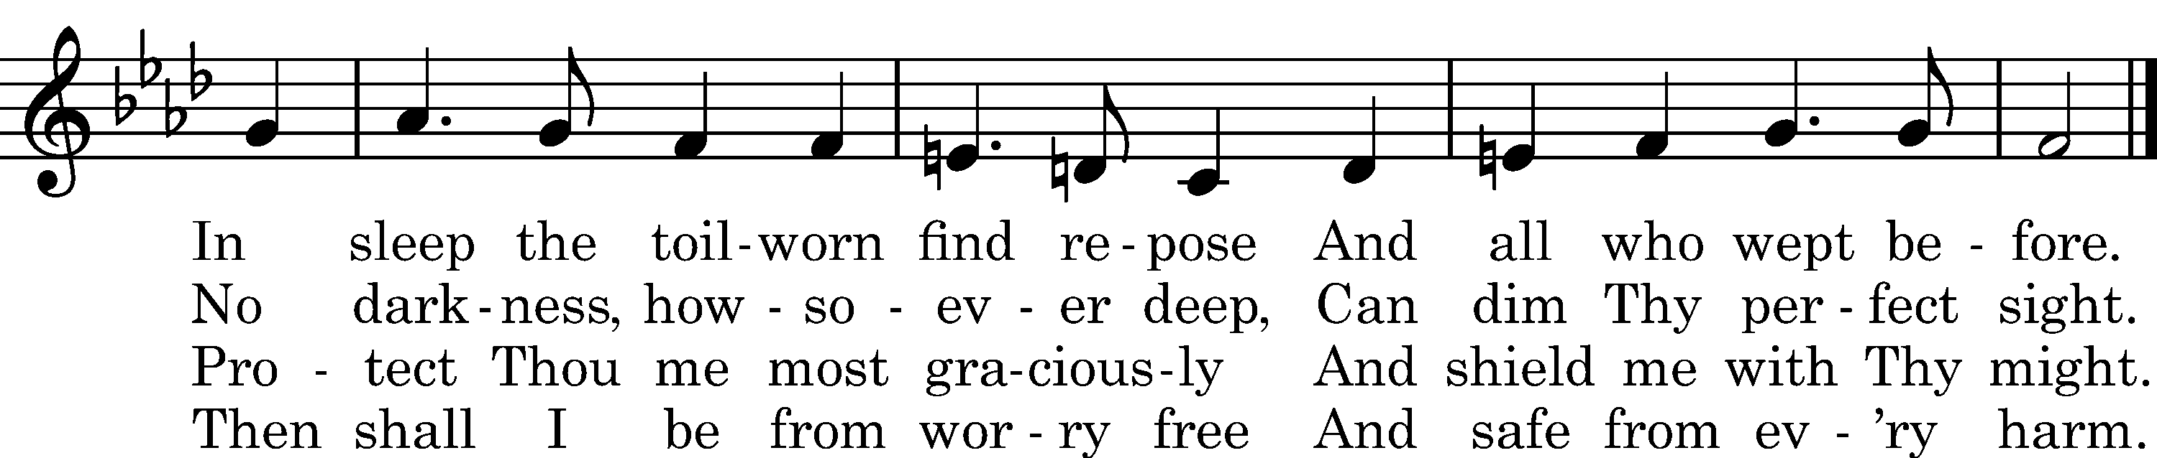

5 I know the evil I have done 6 In Him accepted I shall be
Doth cry aloud to Thee; When suppliant at Thy feet,
But yet in mercy Thy dear Son He is my Surety and my Plea
Hath full atoned for me. Before Thy judgment-seat.

7 And so I close my weary eyes, 8 Should this night prove the last for me
Sweet peace within my breast, In this sad vale of cares,
Why toss about in fears or sighs? Then lead me, Lord, to dwell with Thee
God watches while I rest. And all Thy chosen heirs.

9 And thus I live and die to Thee,
Strong Lord of hosts indeed.
In life, in death, deliver me
From ev'ry fear and need.

Text: tr. composite; (sts. 1–8): Johann F. Hertzog, 1670, alt.; (st. 9): author unknown, 1693 Tune: Adam Krieger, 1667 Text and tune: Public domain
fffffffffffffffffffffffffffffffffff
Silent prayer after worship: Heavenly Father, cause Your Holy Spirit to work through the Gospel to increase my faith. Lead me to pray for all people and to share with others the good news of salvation through Your Son, Jesus Christ. Amen.

SCHEDULE THROUGH OCTOBER 8, 2023:

:

Today, 7 pm, Fellowship Hall: AA Meeting
Tuesday, 7-9 pm, Fellowship Hall: Penn-Ohio Singers
Wednesday, 7:30 pm, Fellowship Hall: NA Meeting
Next Sunday, 8 am, Fellowship Hall: Bible Study
9 am, Sanctuary: Divine Service
Following, Fellowship Hall: Coffee Fellowship
7 pm, Fellowship Hall: AA Meeting
fffffffffffffffffffffffffffffffffff
Attendance: Sunday, September 24, 2023: 29
fffffffffffffffffffffffffffffffffff
Our Stewardship of Treasures for the Lord:
In order to do the Lord’s work, we need $2,553.63 each week to meet our 2023 budget for general purposes and $76.92 for the SELC.

Figures for Sunday, September 24, 2023
General Fund: $1,034.00 Behind for the week: -$1,519.63
SELC: $0.00 Behind for the week: -$76.92
Capital Campaign: $410.00
Other: $20.00

For online giving, check out https://www.saintspeterandpaul.net/online-giving.
fffffffffffffffffffffffffffffffffff
Bible Memory Verses ~ Week of October 1st:
For Adults: Put on then, as God's chosen ones, holy and beloved, compassionate hearts, kindness, humility, meekness, and patience, bearing with one another and, if one has a complaint against another, forgiving each other; as the Lord has forgiven you, so you also must forgive. Colossians 3:12-13

For Children: He has told you, O man, what is good; and what does the Lord require of you but to do justice, and to love kindness, and to walk humbly with your God? Micah 6:8
fffffffffffffffffffffffffffffffffff
THANK YOU FOR SERVING IN OCTOBER: Elder: Jonathan Baisch; Ushers: Matt Berent, Mark Gabriel, Michael Laird, & Jerome Thomas; Altarware ~ Sundays: (prior) Diane Riefstahl; (after) Oct. 29th~Elizabeth Haenftling; other~Cheryl Fedele & Clara Krivosh; Special Divine Services: Oct. 18th ~Diane Riefstahl; Oct. 23rd & 31st: Elizabeth Haenftling.
fffffffffffffffffffffffffffffffffff
Remember the following in Prayer…
~The Hurting and Healing: Amy, Steve Antolovich, Ellen Baron^{CA}, Amy Blomenberg, Lois Bortner^{CA}, Sara Brubaker, Dee Bullock, Bev & Joe Chlpka, Susan Davies, Loretta Deal, Tim Dudash, Judith & Eddy Furey, Griffin, Peter Haenftling, Austin Hamilton, Pastor Charles Henrickson, Joan, Keith Jozwiakowski, Darla Krajci, Barbara Kreske, Jess Lavoie, Elizabeth Loughan, Paul Lucas^{CA}, Sandy Marshall, Frank Niemeyer^{CA}, Juanita Rentschler, Richard Reuning^{CA}, Nancy Robertson^{CA}, Kriss Svidro^{CA}, Joel & Peggy Wasson, Angela Weser^{CA}, and Ruth Wolf.
~The Homebound: Anna Mae Daris, Millie Elavsky, Rudy & Jean Tomko, Betty Wolf, and Ed & Millie Zachar.
~Celebrating this Week: Birthdays: Cheryl Fedele (10.04) and Mildred Zachar (10.07).
~Serving in the Military: Alex (Sasha) Carr, Duncan Vaupel (grandson of Rev. Arthur & Evelyn Baisch), Curtis Sinewe, and Joshua Solyan.
~Community & World Needs: Those suffering due to the conflict between Ukraine and Russia; those suffering from loss and dislocation because weather disasters; those suffering from addiction and their families; Local, State, and National Government Leaders; safety for all Police Officers, Firefighters, & First Responders; the unemployed; our Fourth Quarter Local Mission: Willow Women’s Center.
*CA represents cancer.
fffffffffffffffffffffffffffffffffff
The October issue of “The Rock and the Sword” newsletter is available on tables in the narthex and by the parking lot entrance. Please also remember to pick up your copy of “Portals of Prayer” for October, November, and December. Note: If you had previously picked up a large print version which had been damaged by rain, there are now new, undamaged copies available.
fffffffffffffffffffffffffffffffffff

PASTOR & FAMILY APPRECIATION DINNER - SATURDAY, OCT. 28th, 5 PM
Come and join us for some good food and fellowship with a special dinner in appreciation of Pastor Deal and family. There will also be a birthday cake in celebration of Loretta's 5th birthday! Mark your calendars now! You don't want to miss this time with your church family.
The organizing team will be contacting everyone to make sure all are advised and to ask what you can do to help - pray for the event, set up, prepare a salad or side dish, clean up. Main entrée and dessert will be provided! If you have any questions, you can call Bess Kleindienst at 973-768-8874.
If planning to attend, please sign either the sheet located in the narthex or by the parking lot entrance so plans can be made. We look forward to sharing in this time together and pray God's blessings on us all!
fffffffffffffffffffffffffffffffffff
Pastor Deal will be on vacation Monday through Friday of this week.
Please contact Elder Jonathan Baisch (724-816-6866) if in need of care during this time.
fffffffffffffffffffffffffffffffffff
Please join us following worship next Sunday for Coffee Fellowship! This month’s fellowship will be sponsored by past freewill offerings.
We are still seeking a sponsor for November’s fellowship. If interested, please sign the sheet posted in the narthex.
fffffffffffffffffffffffffffffffffff
Up-Coming Meetings:
- Monday, October 9 at 6 pm ~ Interior Committee
- Tuesday, October 16 at 6 pm ~ Constitution & Bylaws Committee
fffffffffffffffffffffffffffffffffff
Next Sunday is “Stock the Food Pantry” Sunday. Your financial contributions will be greatly appreciated.
fffffffffffffffffffffffffffffffffff

Here to Serve
Pastor………………………………………………...……………Rev. Jacob Deal
E-mail …………………………….……pastordeal@saintspeterandpaul.net
Phone Number……………………..…………………724-347-3620 (Option 2)
Church Office………………………..…………………724-347-3620 (Option 3)
Website …………………………………………www.saintspeterandpaul.net
Secretary…………………………………………………………Diane Riefstahl
E-mail ………………………………………church@saintspeterandpaul.net
Website …………………………………………www.saintspeterandpaul.net
Food Pantry (email): ……………foodpantry@saintspeterandpaul.net
Congregation President………………………………….…Jonathan Baisch
Church Elder …………………………………………...……. Jonathan Baisch
Organist………………………………………………..….…Rebecca Marquette
Choir Director…………………………………………………….…Chris Nelson
AA Contact: Steve………………………………………………...…724-813-2358
NA Contact: Larry……………………………………..…………..724-977-8733
fffffffffffffffffffffffffffffffffff
If needing to get into the church building during the week, please phone first to make certain someone is here to let you in.

