Sts. Peter & Paul
Evangelical Lutheran Church
Lutheran Church-Missouri Synod
Founded-1917

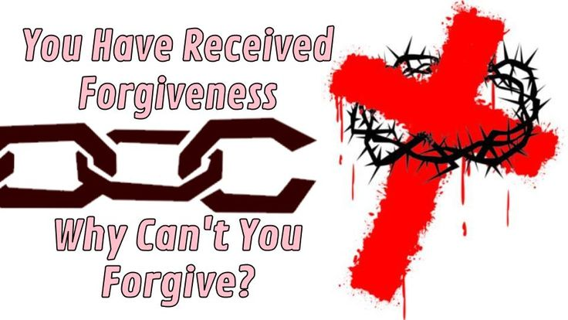

November 5, 2023

699 Stambaugh Ave.
Sharon, Pennsylvania 16146

“I was glad when they said to me,
Let us go to the house of the LORD!”
Psalm 122:1
Sts. Peter & Paul Evangelical Lutheran Church, LC-MS
THE TWENTY-SECOND SUNDAY
AFTER TRINITY
November 5, 2023

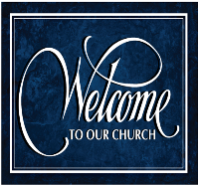
A special welcome to our guests this day! If you would like more information about The Lutheran Church - Missouri Synod, or this congregation, please speak with Pastor Deal or an Elder after the service.
Members & Guests: Don’t be embarrassed if your children make noise during the worship service, all children do. We encourage families to worship together but, if you feel the need, there are pews in the rear of the Church which are reserved for young families on both sides of the sanctuary. There is also a quiet room available to you, located next to the sanctuary (formerly the Pastor’s office), where you would be able to follow along with the service.

Today’s service includes the Sacrament of Holy Communion. If during this past year, you have not worshipped with us and been communed, we respectfully ask that you do not partake of this sacrament this day before first speaking with Pastor Deal.
If visiting from a sister congregation of the LC-MS and are in good standing, please inform Pastor Deal of your desire to commune prior to the service.
If wishing to receive a blessing during communion, please approach with your arms crossed.

CONTACT INFORMATION
Pastor Deal: pastordeal@saintspeterandpaul.net or 724-347-3620 (opt. 2)
Church Office: church@saintspeterandpaul.net or 724-347-3620 (opt. 3)
Secretary’s Office: The office will be open Monday & Thursday (8:30 am–4:30 pm).

Silent prayer before worship: Gracious Lord, cause the Holy Spirit to work in my heart through Your Word, so that my faith and love may grow and I may always be prepared for the Day Christ will return. In Jesus’ name. Amen.

General Rite of Blessing

P In the name of the Father and of the T Son and of the Holy Spirit.
C Amen.

P Beloved in the Lord, Moses was commanded by the Lord to receive gifts from the people for the beautification of the sanctuary. Everyone whose heart stirred and whose spirit was moved brought a contribution to the Lord to be used in the Lord’s house in all its services.

Since the Lord has taught us in His holy Word that everything is sanctified by the Word of God and prayer, it is fitting that we bless and sanctify this memorial book and case for use in God’s holy house.

P Our help is in the name of the Lord,
C who made heaven and earth.

P The Lord be with you.
C And also with you.

P Let us pray.
O God, You have directed us to bring offerings for Your glory. We implore You to bless this memorial book and case. Grant that they may reflect our love for You, benefit Your Church, and bring joy to those who use them; through Jesus Christ, Your Son, our Lord, who lives and reigns with You and the Holy Spirit, one God, now and forever.
C Amen.

P The Lord Almighty, the Father, the T Son, and the Holy Spirit, bless this memorial book and case and those who use them.
C Amen.
Confession and Absolution

Opening Hymn: LSB #606 “I Lay My Sins on Jesus”

Stand

The sign of the cross may be made by all in remembrance of their Baptism.

Invocation
P In the name of the Father and of the T Son and of the Holy Spirit.
C Amen.

Exhortation Hebrews 10:22; Psalm 124:8; Psalm 32:5
P Beloved in the Lord! Let us draw near with a true heart and confess our sins unto God our Father, beseeching Him in the name of our Lord Jesus Christ to grant us forgiveness.
P Our help is in the name of the Lord,
C who made heaven and earth.
P I said, I will confess my transgressions unto the Lord,
C and You forgave the iniquity of my sin.

Silence for reflection on God’s Word and for self-examination.

Confession of Sins
P O almighty God, merciful Father,
C I, a poor, miserable sinner, confess unto You all my sins and iniquities with which I have ever offended You and justly deserved Your temporal and eternal punishment. But I am heartily sorry for them and sincerely repent of them, and I pray You of Your boundless mercy and for the sake of the holy, innocent, bitter sufferings and death of Your beloved Son, Jesus Christ, to be gracious and merciful to me, a poor, sinful being.

Absolution [John 20:19–23]
P Upon this your confession, I, by virtue of my office, as a called and ordained servant of the Word, announce the grace of God unto all of you, and in the stead and by the command of my Lord Jesus Christ I forgive you all your sins in the name of the Father and of the T Son and of the Holy Spirit.
C Amen.
Service of the Word

Introit Psalm 130:1–2, 7–8; antiphon: vv. 3–4
If you, O Lord, should mark in- | iquities,*
O Lord, | who could stand?
But with you there is for- | giveness,*
that you | may be feared.
Out | of the depths*
I cry to you, | O Lord!
O Lord, | hear my voice!*
Let your ears be attentive to the voice of my pleas for | mercy!
O Israel, hope in the Lord! For with the Lord there is | steadfast love,*
and with him is plentiful re- | demption.
And he will redeem | Israel*
from all his in- | iquities.
If you, O Lord, should mark in- | iquities,*
O Lord, | who could stand?
But with you there is for- | giveness,*
that you | may be feared.

Gloria Patri
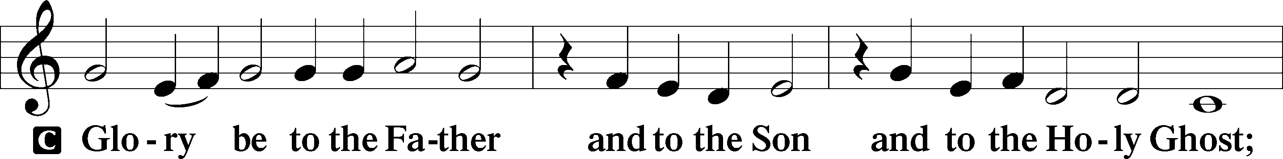
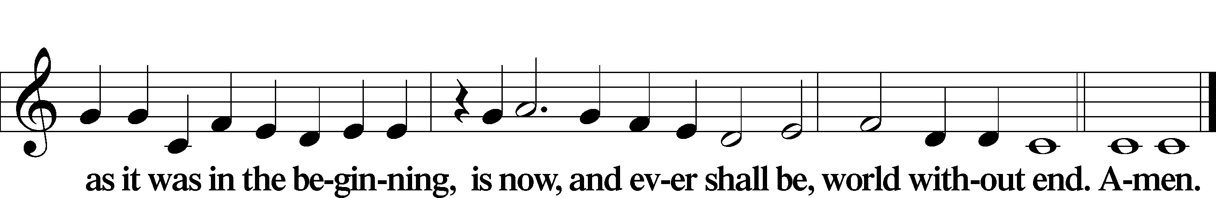

Kyrie Mark 10:47
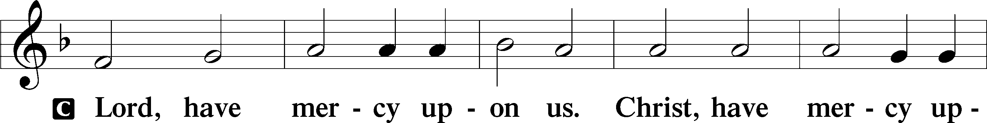
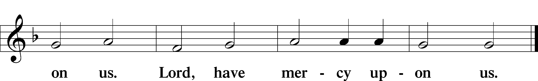

Gloria in Excelsis Luke 2:14; John 1:29
P Glory be to God on high:
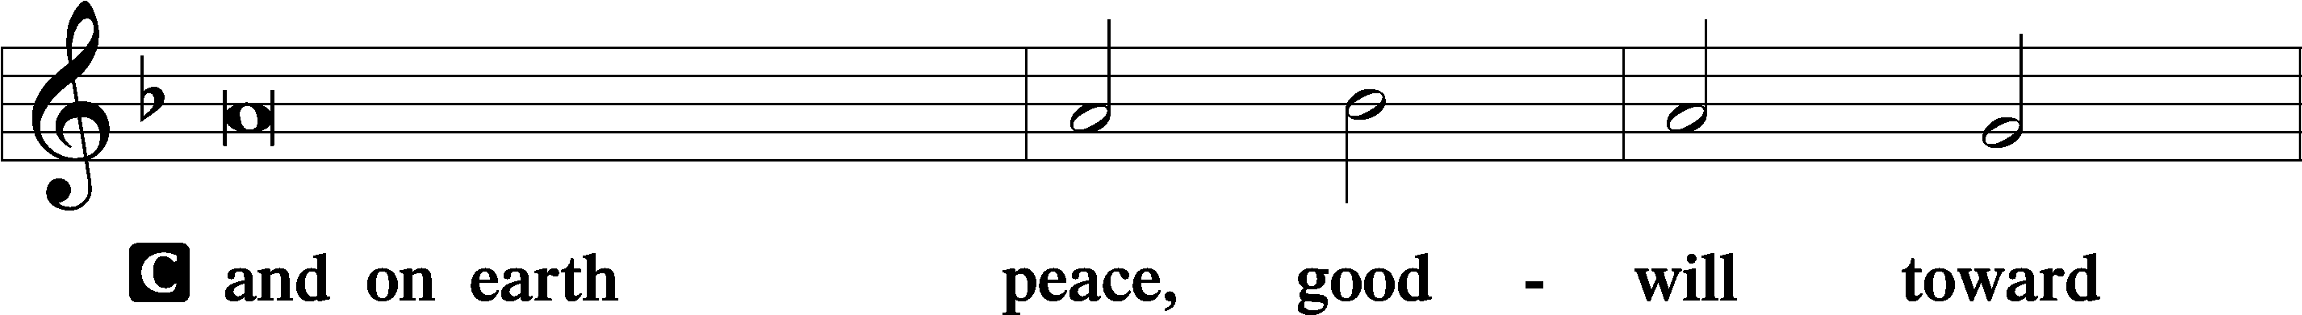
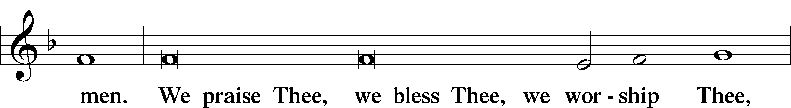
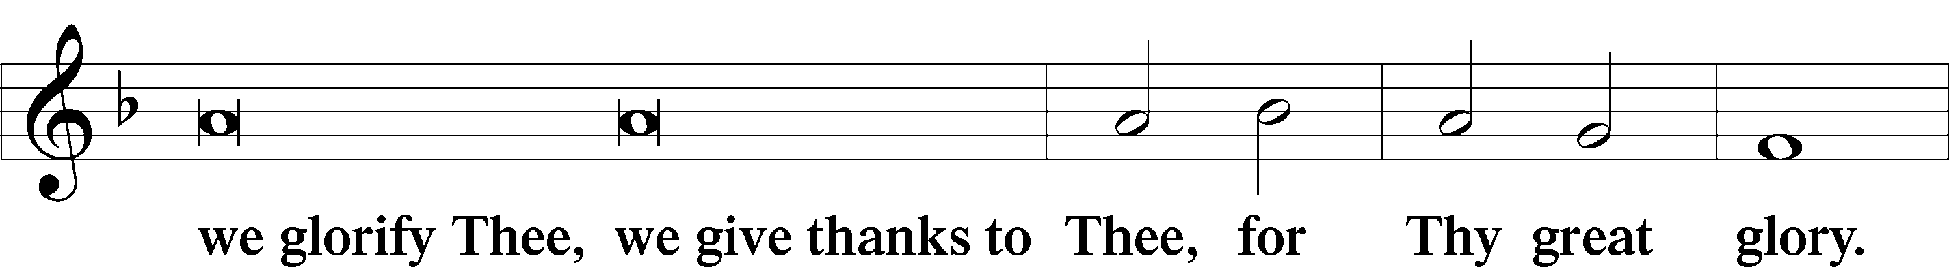
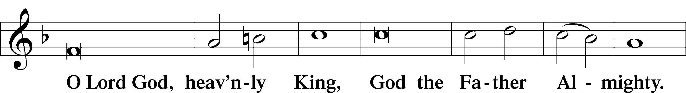
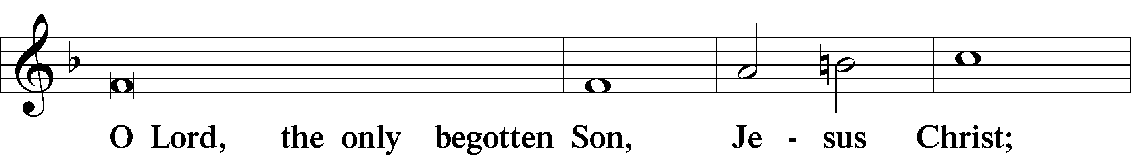
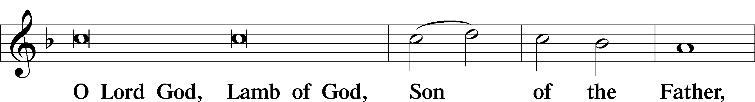
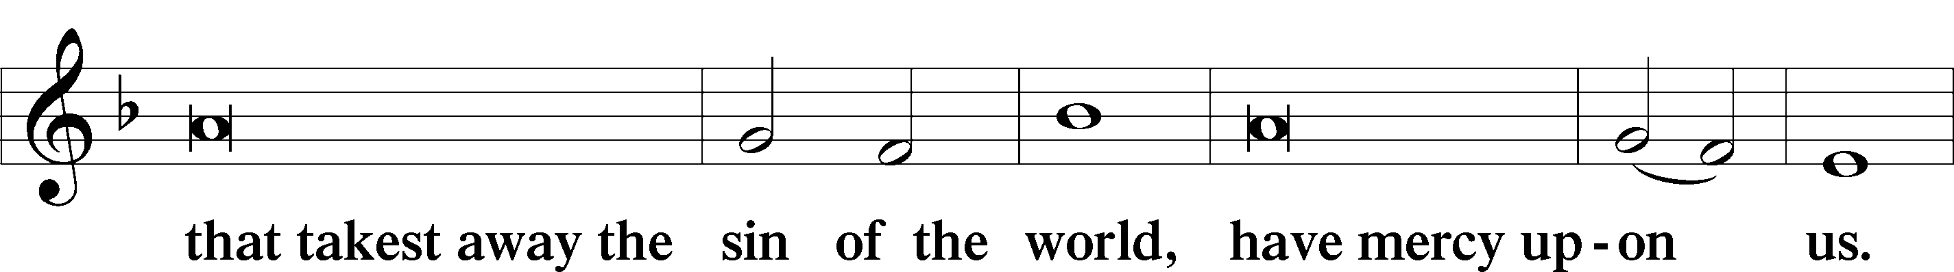
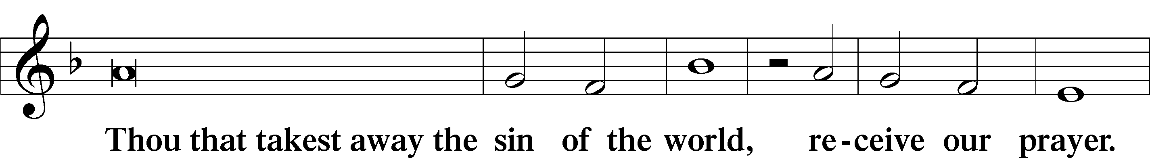
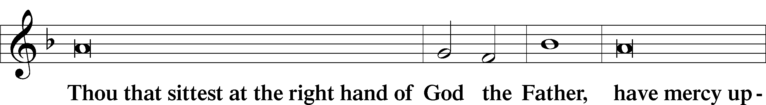
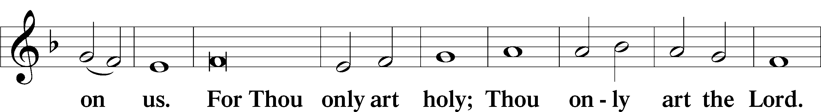
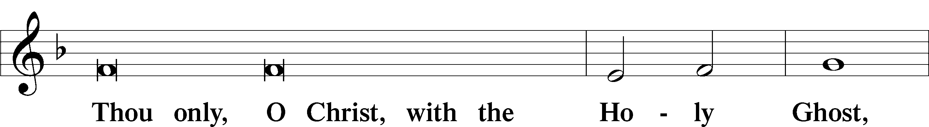
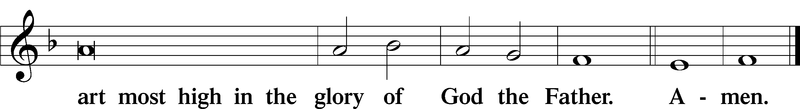

Salutation and Collect of the Day: Trinity 22
P The Lord be with you.
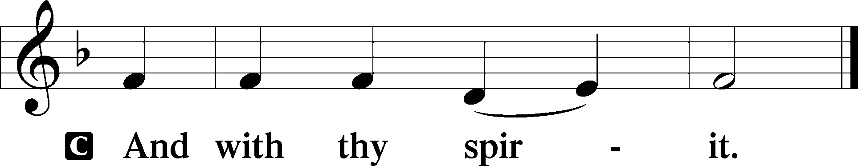

P Let us pray.
O God, our refuge and strength, the author of all godliness, hear the devout prayers of Your Church, especially in times of persecution, and grant that what we ask in faith we may obtain; through Jesus Christ, Your Son, our Lord, who lives and reigns with You and the Holy Spirit, one God, now and forever.
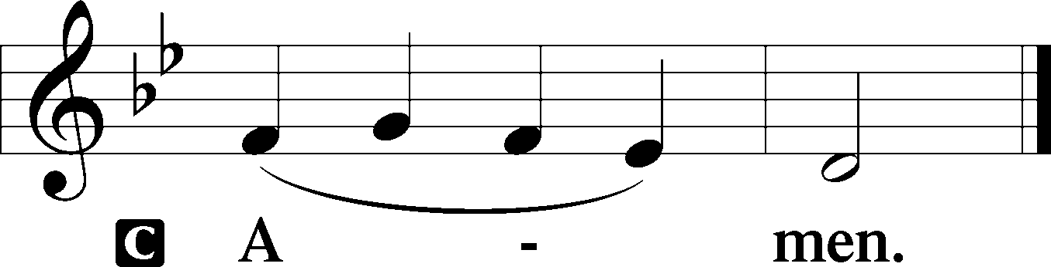
Sit

Prophecy: Micah 6:6–8 (NKJV)
With what shall I come before the Lord, and bow myself before the High God? Shall I come before Him with burnt offerings, with calves a year old? Will the Lord be pleased with thousands of rams, ten thousand rivers of oil? Shall I give my firstborn for my transgression, the fruit of my body for the sin of my soul? He has shown you, O man, what is good; and what does the Lord require of you but to do justly, to love mercy, and to walk humbly with your God?

P This is the Word of the Lord.
C Thanks be to God.

Gradual Psalm 133:1, 3b
Behold, how good and pleas- | ant it is*
when brothers dwell in | unity!
For the Lord has commanded the | blessing,*
life for- | evermore.

Epistle: Philippians 1:3–11 (NKJV)
Brethren: I thank my God upon every remembrance of you, always in every prayer of mine making request for you all with joy, for your fellowship in the gospel from the first day until now, being confident of this very thing, that He who has begun a good work in you will complete it until the day of Jesus Christ; just as it is right for me to think this of you all, because I have you in my heart, inasmuch as both in my chains and in the defense and confirmation of the gospel, you all are partakers with me of grace. For God is my witness, how greatly I long for you all with the affection of Jesus Christ. And this I pray, that your love may abound still more and more in knowledge and all discernment, that you may approve the things that are excellent, that you may be sincere and without offense till the day of Christ, being filled with the fruits of righteousness which are by Jesus Christ, to the glory and praise of God.

P This is the Word of the Lord.
C Thanks be to God.

Stand

Verse Psalm 147:3
Alleluia. He heals the brokenhearted and binds up their wounds. Alleluia.

Alleluia
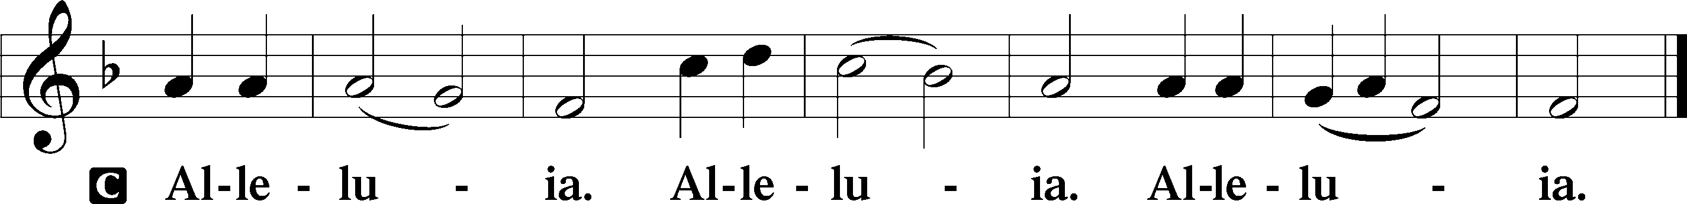

Holy Gospel: Matthew 18:23–35 (NKJV)
P The Holy Gospel according to St. Matthew, the eighteenth chapter.
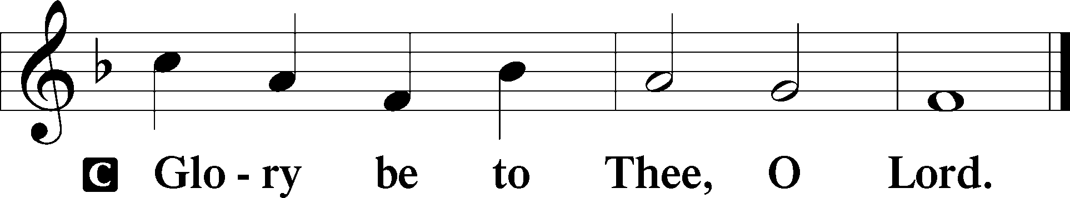

At that time Jesus spoke this parable to His disciples: “The kingdom of heaven is like a certain king who wanted to settle accounts with his servants. And when he had begun to settle accounts, one was brought to him who owed him ten thousand talents. But as he was not able to pay, his master commanded that he be sold, with his wife and children and all that he had, and that payment be made. The servant therefore fell down before him, saying, ‘Master, have patience with me, and I will pay you all.’ Then the master of that servant was moved with compassion, released him, and forgave him the debt. But that servant went out and found one of his fellow servants who owed him a hundred denarii; and he laid hands on him and took him by the throat, saying, ‘Pay me what you owe!’ So his fellow servant fell down at his feet and begged him, saying, ‘Have patience with me, and I will pay you all.’ And he would not, but went and threw him into prison till he should pay the debt. So when his fellow servants saw what had been done, they were very grieved, and came and told their master all that had been done. Then his master, after he had called him, said to him, ‘You wicked servant! I forgave you all that debt because you begged me. Should you not also have had compassion on your fellow servant, just as I had pity on you?’ And his master was angry, and delivered him to the torturers until he should pay all that was due to him. So My heavenly Father also will do to you if each of you, from his heart, does not forgive his brother his trespasses.”

P This is the Gospel of the Lord.
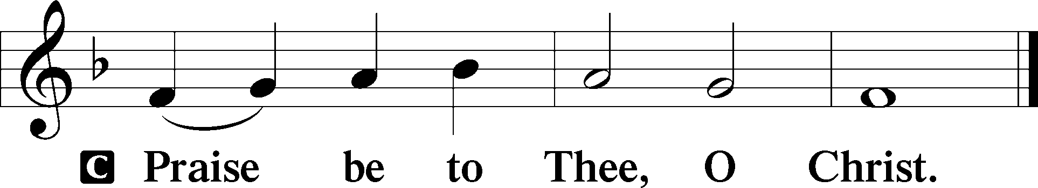

Nicene Creed
C I believe in one God,
the Father Almighty,
maker of heaven and earth
and of all things visible and invisible.

And in one Lord Jesus Christ,
the only-begotten Son of God,
begotten of His Father before all worlds,
God of God, Light of Light,
very God of very God,
begotten, not made,
being of one substance with the Father,
by whom all things were made;
who for us men and for our salvation came down from heaven
and was incarnate by the Holy Spirit of the virgin Mary
and was made man;
and was crucified also for us under Pontius Pilate.
He suffered and was buried.
And the third day He rose again according to the Scriptures
and ascended into heaven
and sits at the right hand of the Father.
And He will come again with glory to judge both the living and the dead,
whose kingdom will have no end.
And I believe in the Holy Spirit,
the Lord and giver of life,
who proceeds from the Father and the Son,
who with the Father and the Son together is worshiped and glorified,
who spoke by the prophets.
And I believe in one holy Christian and apostolic Church,
I acknowledge one Baptism for the remission of sins,
and I look for the resurrection of the dead
and the life T of the world to come. Amen.
Sit

Hymn of the Day: LSB #611 “Chief of Sinners Though I Be”

Sermon

Stand

Offertory Psalm 51:10–12
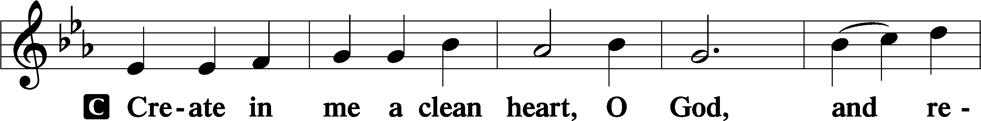
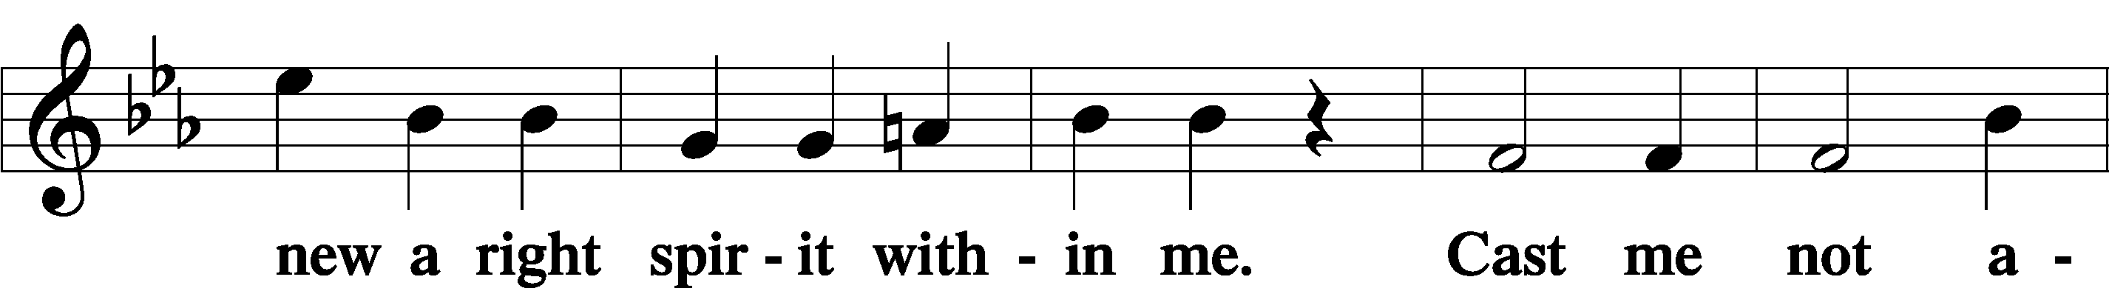
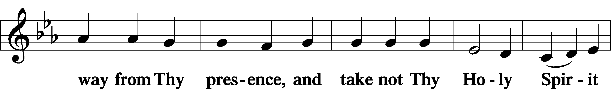
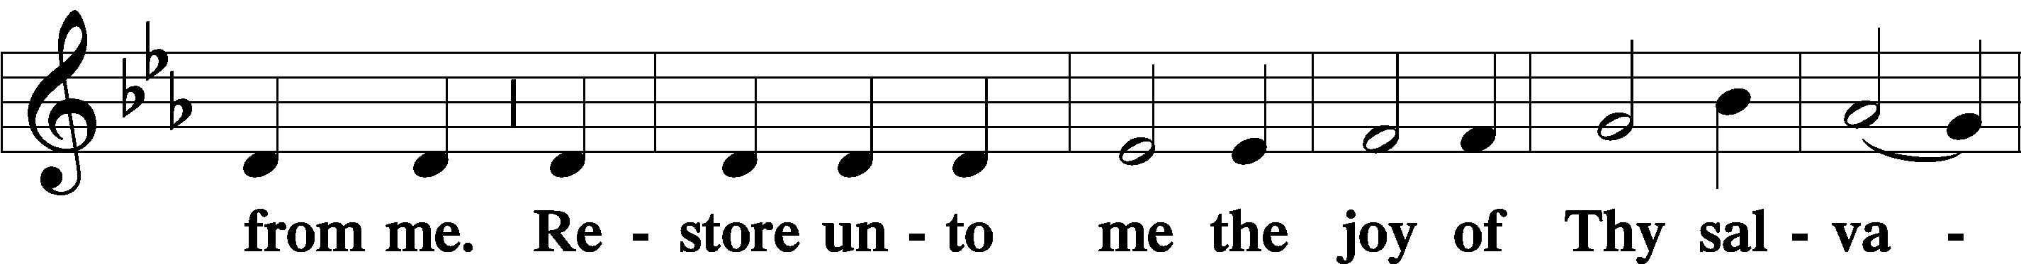
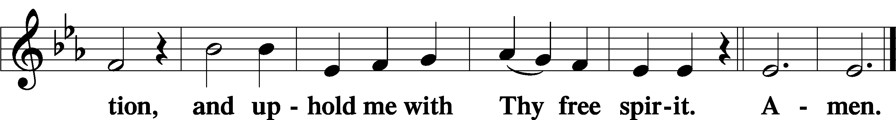

Prayer of the Church

Sit

Preparatory Hymn: LSB #815 “All Praise to Thee, for Thou, O King Divine”

Stand
Service of the Sacrament

Preface 2 Timothy 4:22; Colossians 3:1 Psalm 136
P The Lord be with you.
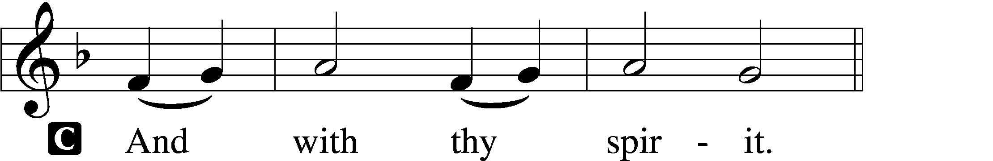

P Lift up your hearts.
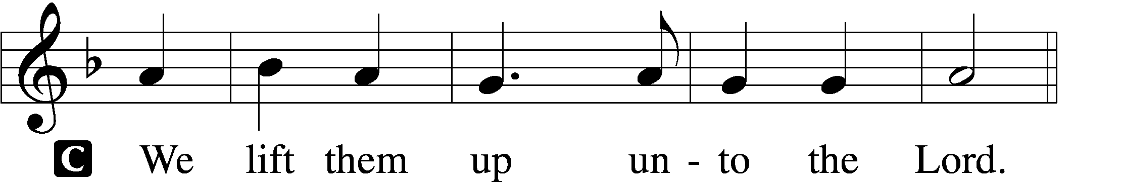

P Let us give thanks unto the Lord, our God.
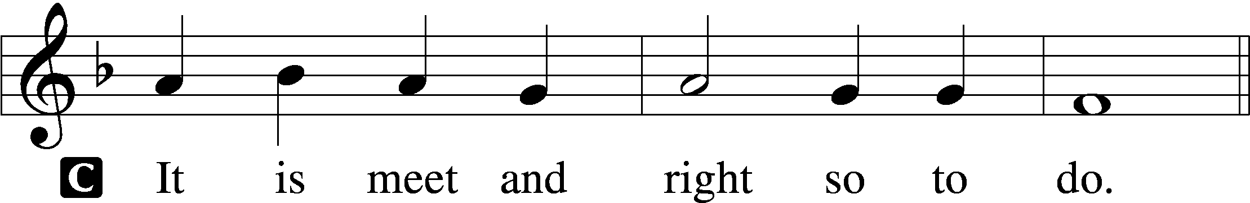

Proper Preface (Abbreviated) LSB 194
P It is truly meet, right, and salutary . . . evermore praising You and saying:

Sanctus Isaiah 6:3; Matthew 21:9
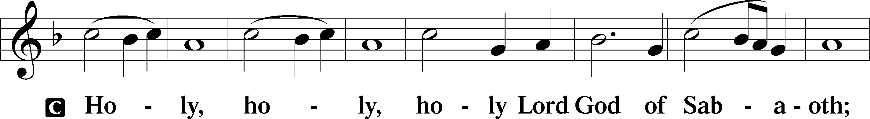
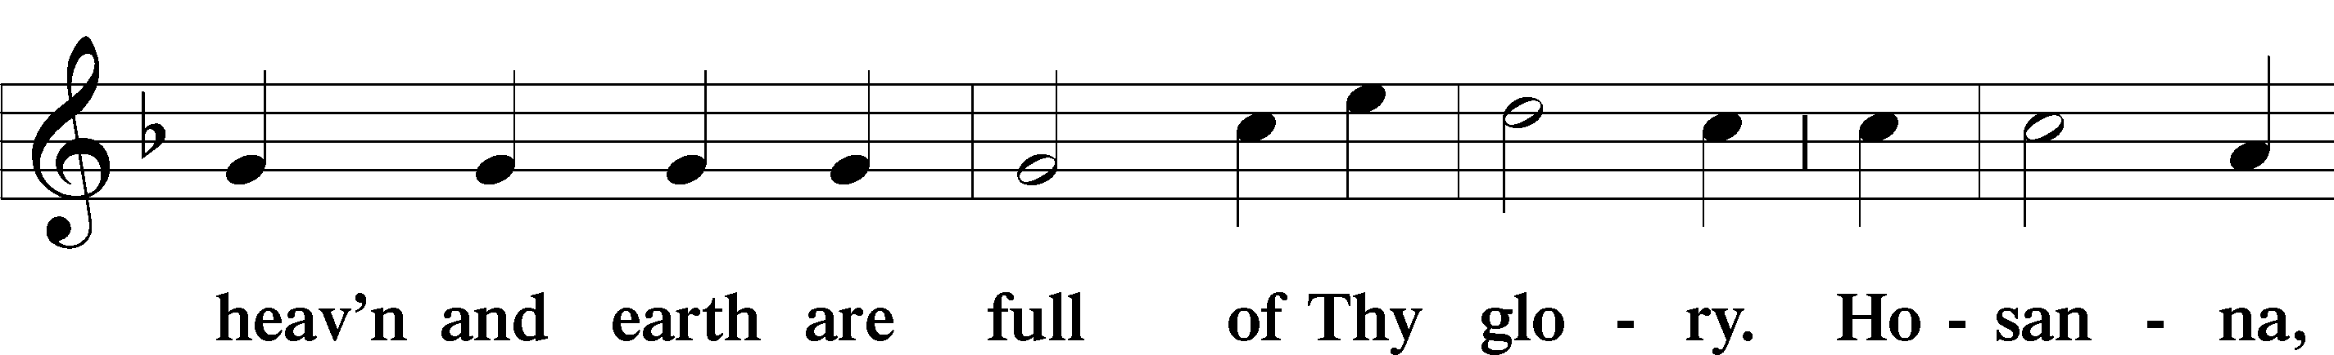
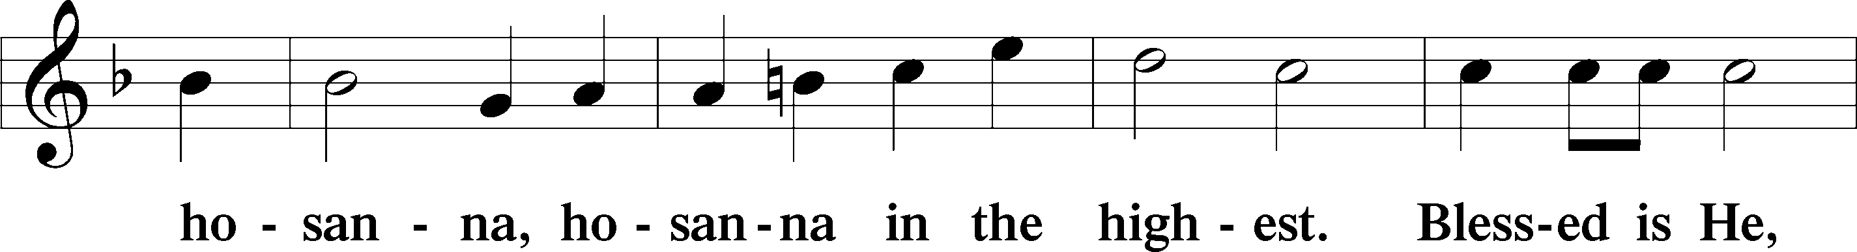
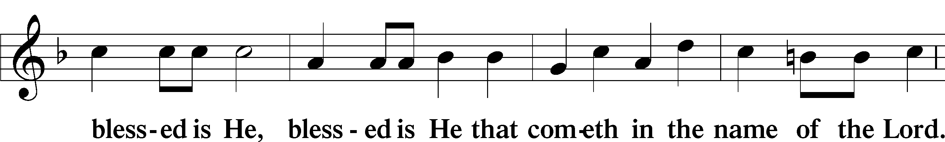
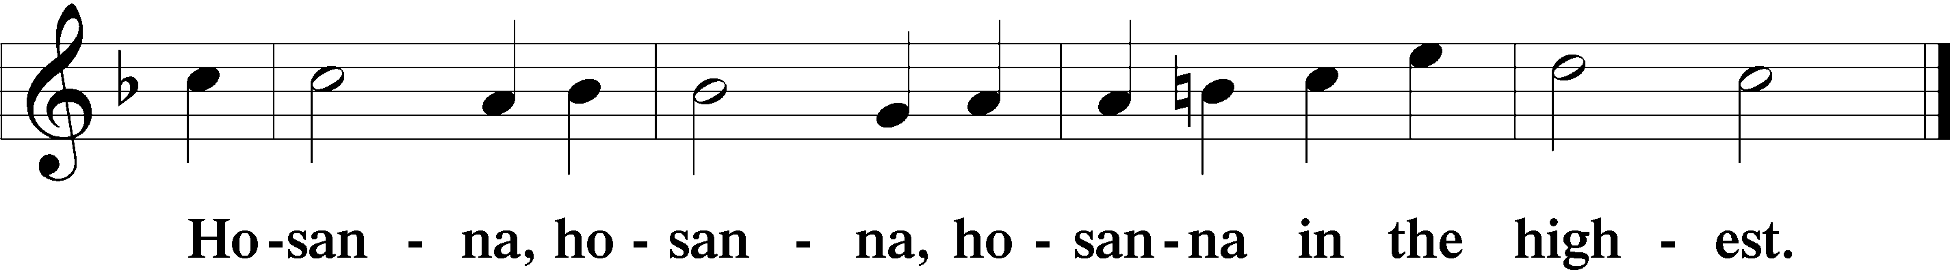

Lord’s Prayer The congregation is encouraged to silently pray the Lord’s Prayer as it is chanted. Matthew 6:9–13
P Our Father who art in heaven,
hallowed be Thy name,
Thy kingdom come,
Thy will be done on earth as it is in heaven;
give us this day our daily bread;
and forgive us our trespasses as we forgive those who trespass against us;
and lead us not into temptation,
but deliver us from evil.
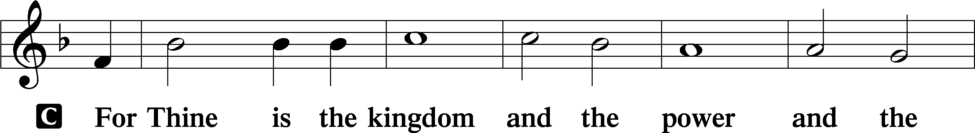
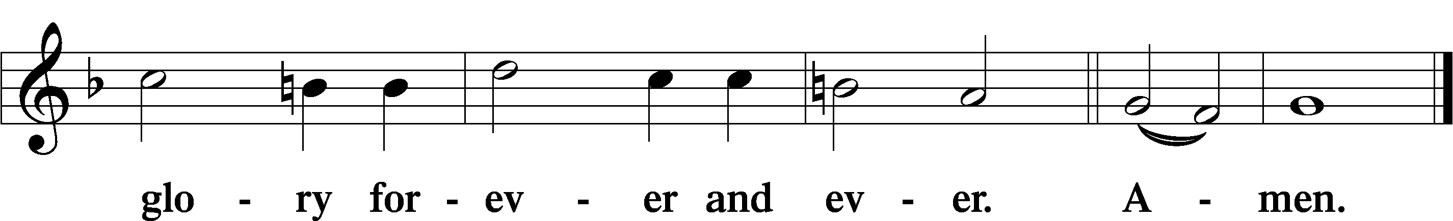

The Words of Our Lord Matthew 26:26–28; Mark 14:22–24; Luke 22:19–20; 1 Corinthians 11:23–25
P Our Lord Jesus Christ, on the night when He was betrayed, took bread, and when He had given thanks, He broke it and gave it to the disciples and said: “Take, eat; this is My T body, which is given for you. This do in remembrance of Me.”

In the same way also He took the cup after supper, and when He had given thanks, He gave it to them, saying: “Drink of it, all of you; this cup is the new testament in My T blood, which is shed for you for the forgiveness of sins. This do, as often as you drink it, in remembrance of Me.”

Pax Domini John 20:19
P The peace of the Lord be with you always.
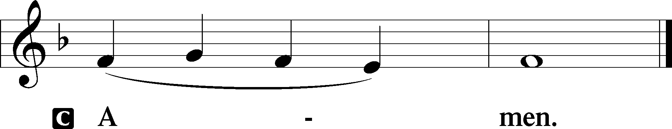

Agnus Dei John 1:29
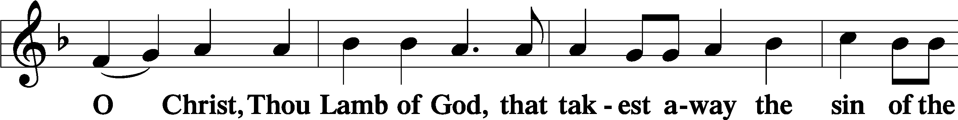
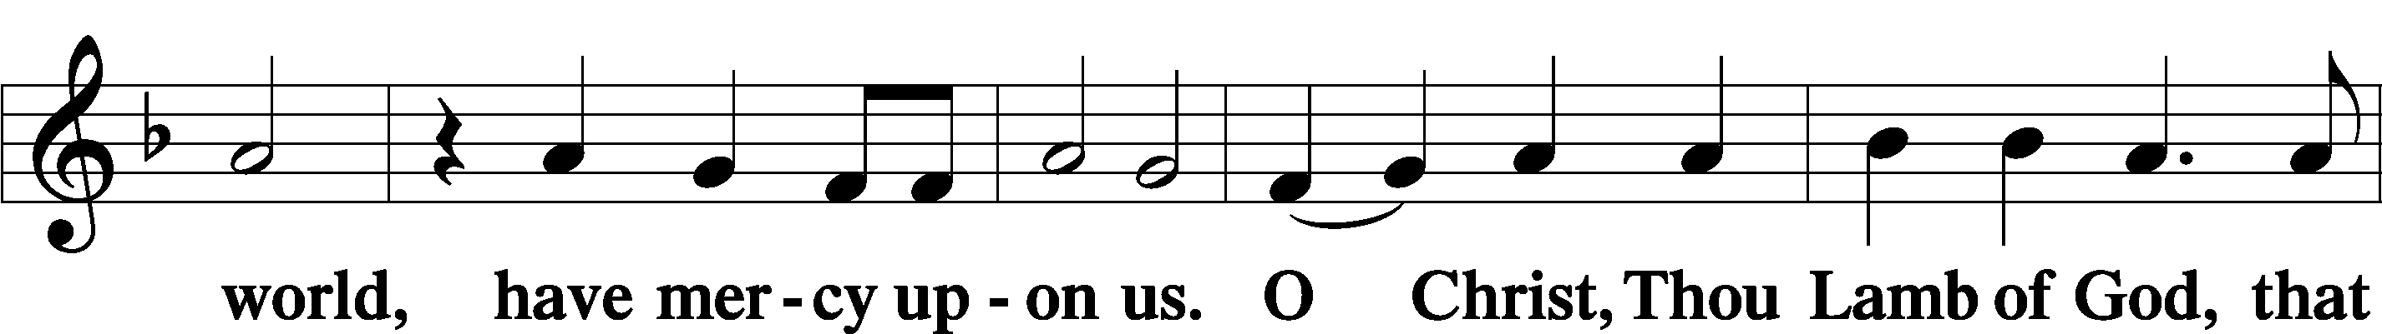
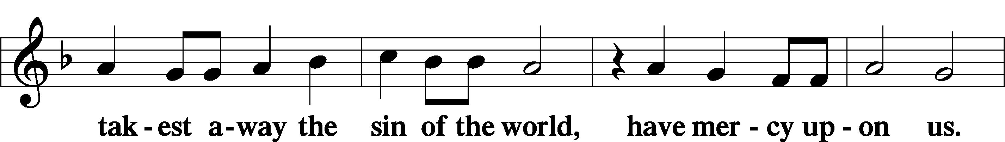
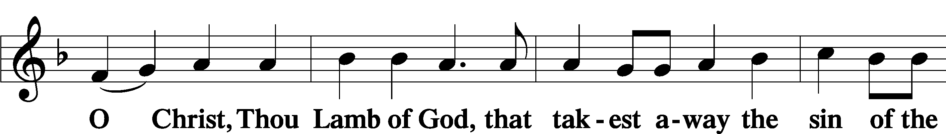
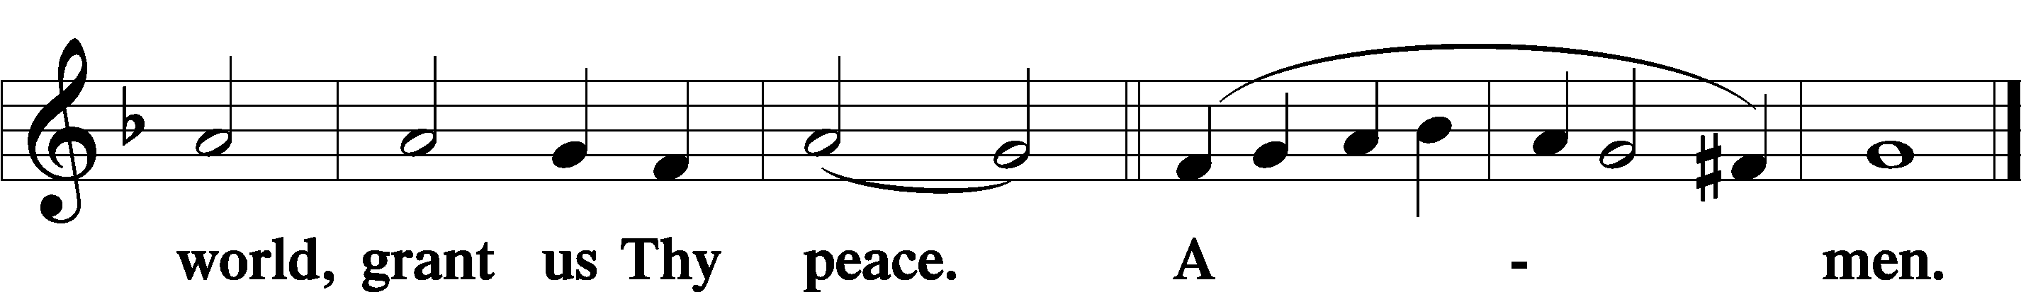
Sit
Distribution
The pastor and those who assist him receive the body and blood of Christ first and then distribute them to those who come to receive, saying:
Take, eat; this is the true body of our Lord and Savior Jesus Christ, given into death for your sins.
Amen.

Take, drink; this is the true blood of our Lord and Savior Jesus Christ, shed for the forgiveness of your sins.
Amen.

In dismissing the communicants, the following is said:
The Dismissal
P The body and blood of our Lord Jesus Christ strengthen and preserve you in body and soul to life everlasting. Depart T in peace.
C Amen.

Distribution Hymn: LSB #621 “Let All Mortal Flesh Keep Silence”

Distribution Hymn: LSB #334 “O Lord, How Shall I Meet You”

Distribution Hymn: LSB #614 “’As Surely as I Live,’ God Said”

Nunc Dimittis Luke 2:29–32
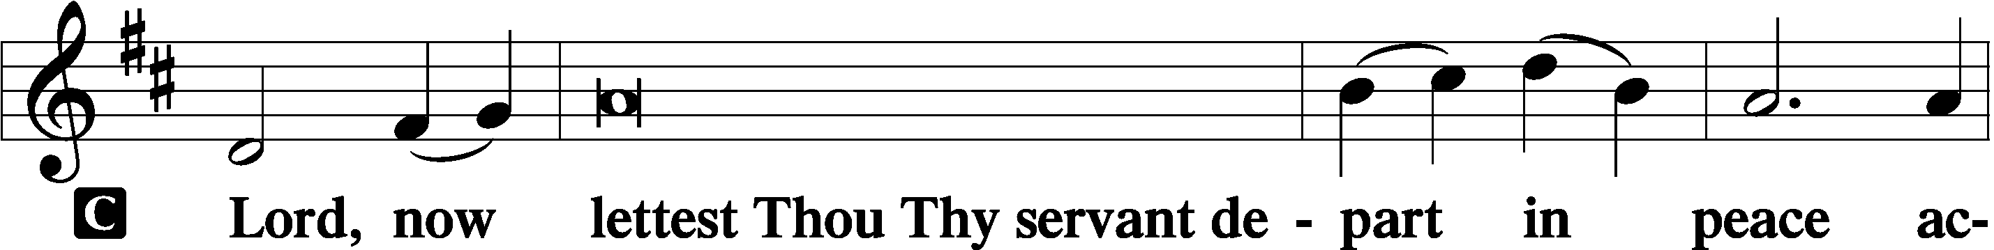
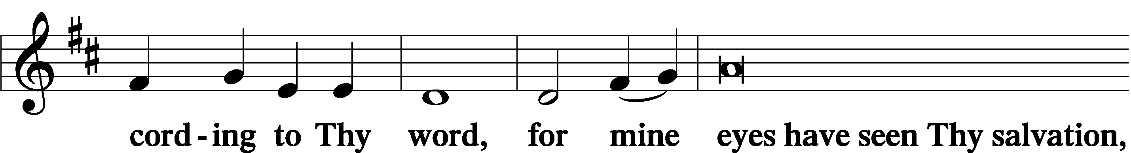
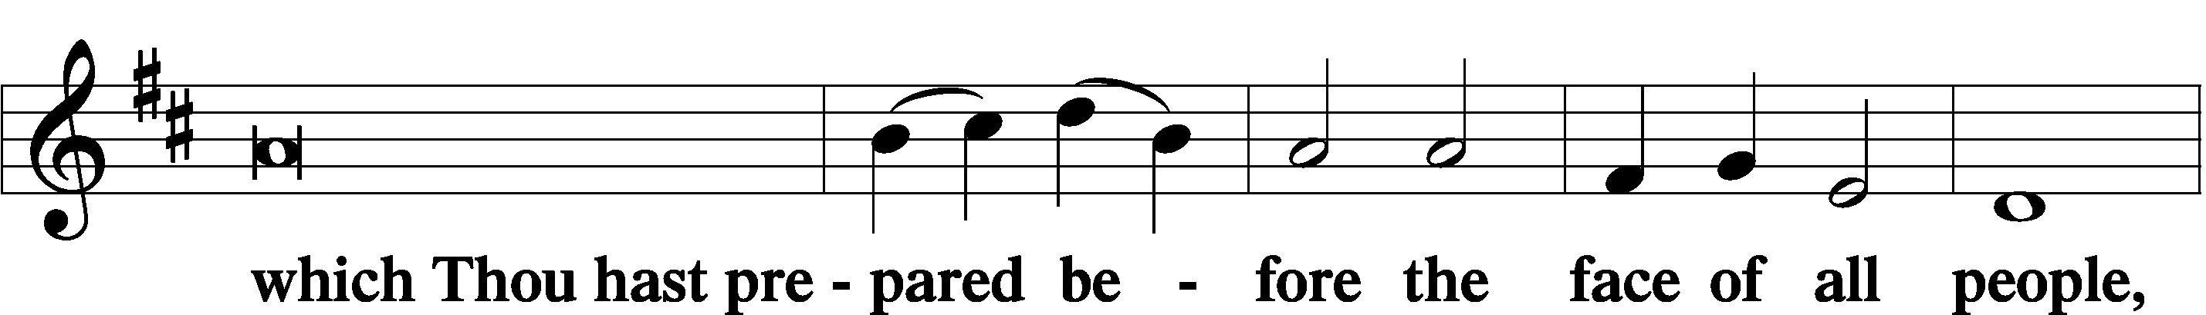
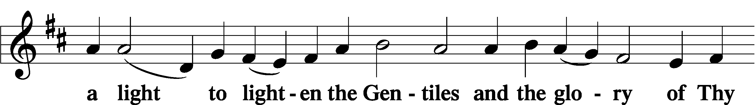
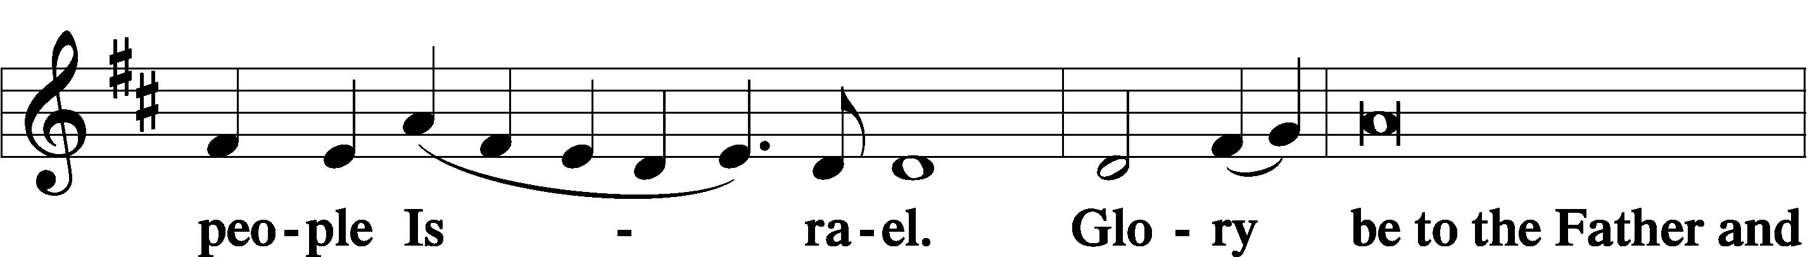
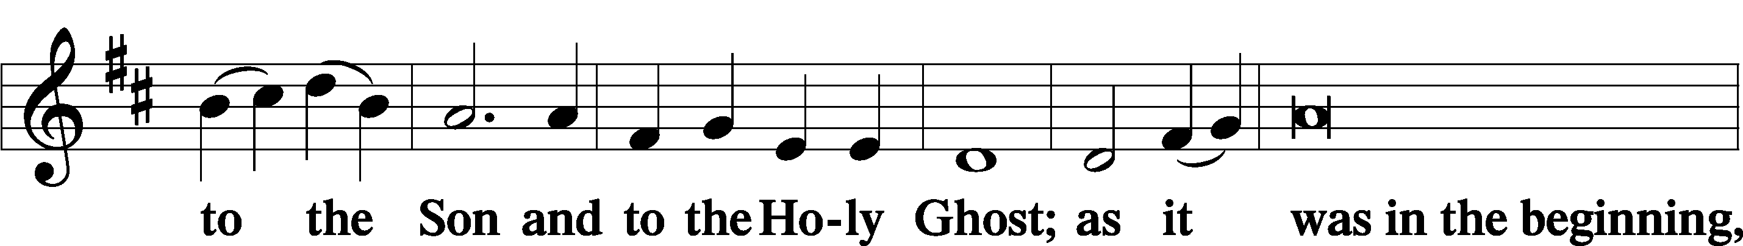
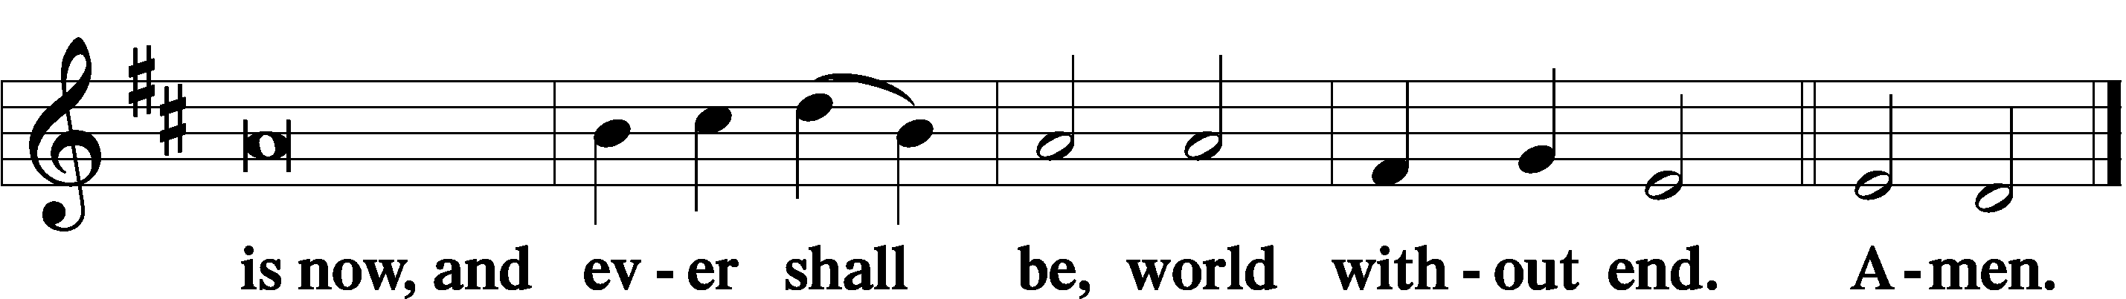

Thanksgiving Psalm 107:1
P O give thanks unto the Lord, for He is good,
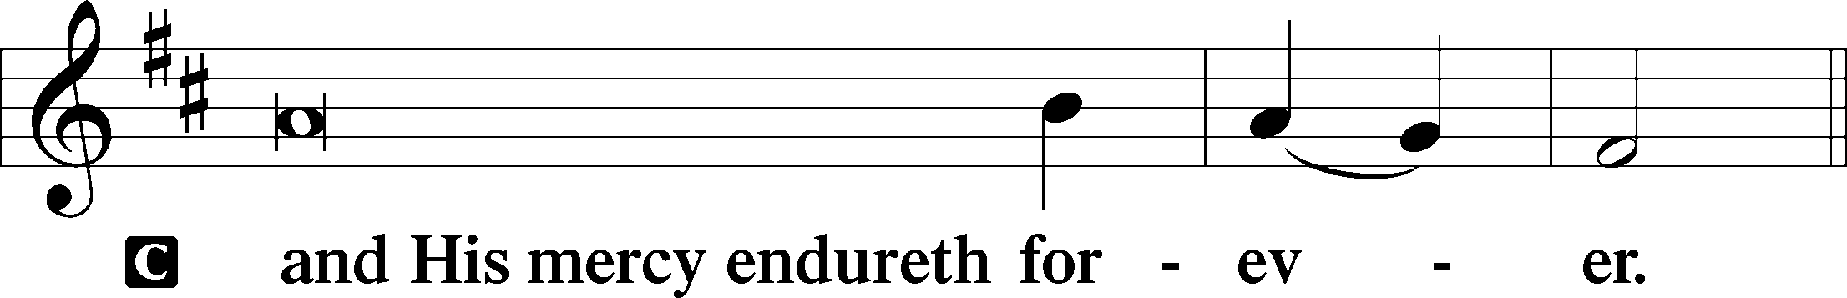

Post-Communion Collect
P Let us pray.
We give thanks to You, almighty God, that You have refreshed us through this salutary gift, and we implore You that of Your mercy You would strengthen us through the same in faith toward You and in fervent love toward one another; through Jesus Christ, Your Son, our Lord, who lives and reigns with You and the Holy Spirit, one God, now and forever.
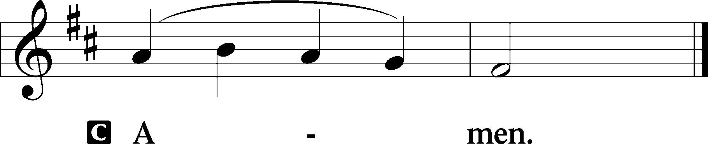

Salutation 2 Timothy 4:22
P The Lord be with you.
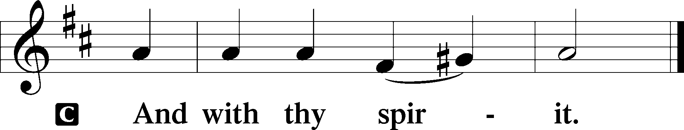

Benedicamus Psalm 103:1
P Bless we the Lord.
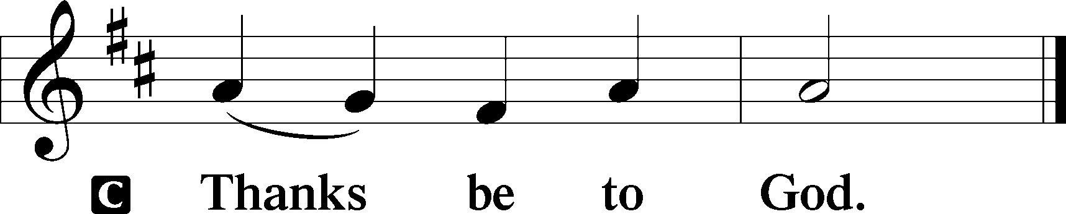

Benediction Numbers 6:24–26
P The Lord bless you and keep you.
The Lord make His face shine upon you and be gracious unto you.
The Lord lift up His countenance upon you and T give you peace.
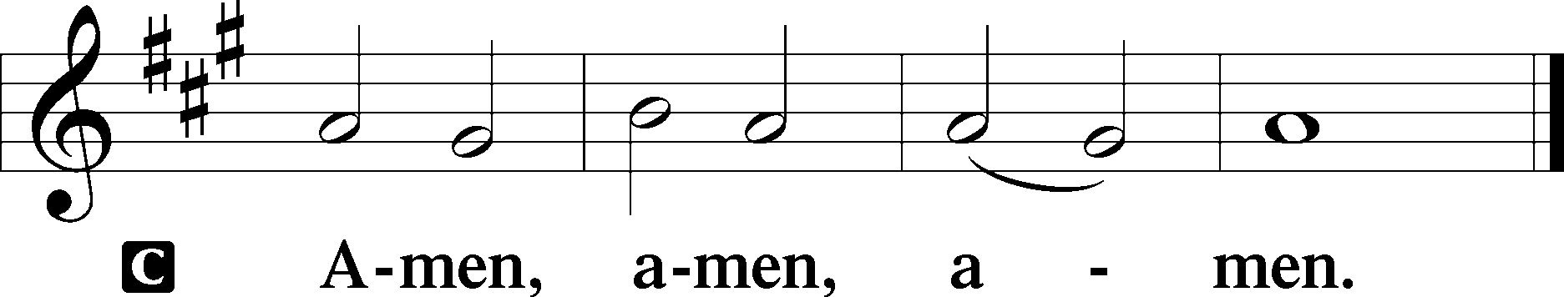

Closing Hymn: LSB #663 “Rise, My Soul, to Watch and Pray”
fffffffffffffffffffffffffffffffffff
Silent prayer after worship: Heavenly Father, You shower me with an everlasting and unwavering love in Jesus Christ. Lead me to be in Your Word and in prayer daily so I can live now in You and forever with You. In Jesus’ name. Amen.
fffffffffffffffffffffffffffffffffff
Acknowledgments
Unless otherwise indicated, Scripture quotations are from the ESV® Bible (The Holy Bible, English Standard Version®), copyright © 2001 by Crossway, a publishing ministry of Good News Publishers. Used by permission. All rights reserved.
Created by Lutheran Service Builder © 2023 Concordia Publishing House.
fffffffffffffffffffffffffffffffffff

SCHEDULE THROUGH NOVEMBER 12, 2023:

:

Today, 7 pm, Fellowship Hall: AA Meeting
Monday, 7 pm, Fellowship Hall: Church Council Meeting
Tuesday, 7-9 pm, Fellowship Hall: Penn-Ohio Singers
Wednesday, 7 pm, Library: Trustees’ Meeting
7:30 pm, Fellowship Hall: NA Meeting
Thursday, 9 am, Downstairs: Food Pantry
9-11 am, Fellowship Hall: Food Pantry Breakfast
Next Sunday, 8 am, Fellowship Hall: Bible Study
9 am, Sanctuary: Divine Service
Following Worship, Fellowship Hall: Coffee Fellowship
7 pm, Fellowship Hall: AA Meeting
fffffffffffffffffffffffffffffffffff

Our Stewardship of Treasures for the Lord:
In order to do the Lord’s work, we need $2,553.63 each week to meet our 2023 budget for general purposes and $76.92 for the SELC.

Online Figure for Thursday, October 26, 2023
General Fund: $80.00
Figures for Sunday, October 29, 2023
General Fund: $1,745.00 Behind for the week*: -$728.63
SELC: $0.00 Behind for the week: -$76.92
Quarterly Missions: $0.00 *Includes above online figure.
Capital Campaign: $726.00

For online giving, check out https://www.saintspeterandpaul.net/online-giving.
fffffffffffffffffffffffffffffffffff
Bible Memory Verses ~ Week of November 5th:
For Adults: For this is the will of my Father, that everyone who looks on the Son and believes in him should have eternal life, and I will raise him up on the last day.
John 6:40
For Children: With you there is forgiveness, that you may be feared.
Psalm 130:4
fffffffffffffffffffffffffffffffffff
It’s time to renew subscriptions for the “Lutheran Witness” magazine for 2024. The price has increased to $19.25. If wishing to renew, place a check made out to Sts. Peter & Paul’s in a pew envelope and label the envelope with your name and that it is for the LW. Please make sure to note any change in address with your renewal. Renewals are due on or before Sunday, November 19, 2023.

fffffffffffffffffffffffffffffffffff
Attendance: Sunday, October 29, 2023: 32
Tuesday, October 31, 2023: 9
Wednesday, November 1, 2023: 14
fffffffffffffffffffffffffffffffffff
Copies of the November issue of “The Rock and the Sword” are available and may be picked up on the tables in the narthex and next to the nursery.
Remember the following in Prayer…
~The Hurting and Healing: Amy, Steve Antolovich, Ellen Baron^{CA}, Amy Blomenberg, Lois Bortner^{CA}, Sara Brubaker, Dee Bullock, Bev & Joe Chlpka, Susan Davies, Loretta Deal, Tim Dudash, Judith & Eddy Furey, Griffin, Austin Hamilton, Pastor Charles Henrickson, Joan, Keith Jozwiakowski, Darla Krajci, Barbara Kreske, Jess Lavoie, Paul Lucas^{CA}, Sandy Marshall, Frank Niemeyer^{CA}, Juanita Rentschler, Richard Reuning^{CA}, Nancy Robertson^{CA}, Kriss Svidro^{CA}, Rudy Tomko, Joel & Peggy Wasson, Angela Weser^{CA}, Betty Wolf, and Ruth Wolf.
~The Homebound: Anna Mae Daris, Millie Elavsky, Jean Tomko, and Ed & Millie Zachar.
~Celebrating this Week: Birthdays: Rev. Arthur Baisch (11.10) & Judith Furey (11.10)..
~Serving in the Military: Alex (Sasha) Carr, Duncan Vaupel, Curtis Sinewe, and Joshua Solyan.
~Community & World Needs: Those suffering due to the conflicts in the Middle East and between Ukraine and Russia; those suffering from loss and dislocation because weather disasters; those suffering from addiction and their families; Local, State, and National Government Leaders; safety for all Police Officers, Firefighters, & First Responders; the unemployed; our Fourth Quarter Local Mission: Willow Women’s Center.
*CA represents cancer.
fffffffffffffffffffffffffffffffffff
THANK YOU FOR SERVING IN NOVEMBER: Elder: Jonathan Baisch; Ushers: Mark Kleindienst, Jerry Krivosh, & Gordon Marquette; Altarware ~ Sundays: (prior) Marie Flaugher (11.12) & Diane Riefstahl; (after) Evelyn Baisch & Arlene Sutton; Special Divine Services: Nov. 1st ~ Marie Flaugher & Nov. 30th ~ Elizabeth Haenftling.
fffffffffffffffffffffffffffffffffff
UP-COMING MEETINGS:
Church Council: Monday, November 6th at 7 pm.
Trustees: Wednesday, November 8th at 7 pm.
Altar Guild: Saturday, November 11th at 1 pm. (This is a change!)
Voters’ Assembly: Sunday, November 19th following worship.
Auditors: Sunday, November 26th following worship.
Here to Serve
Pastor………………………………………………...……………Rev. Jacob Deal
E-mail …………………………….……pastordeal@saintspeterandpaul.net
Phone Number……………………..…………………724-347-3620 (Option 2)
Church Office………………………..…………………724-347-3620 (Option 3)
Website …………………………………………www.saintspeterandpaul.net
Secretary…………………………………………………………Diane Riefstahl
E-mail ………………………………………church@saintspeterandpaul.net
Website …………………………………………www.saintspeterandpaul.net
Food Pantry (email): ……………foodpantry@saintspeterandpaul.net
Congregation President………………………………….…Jonathan Baisch
Church Elder …………………………………………...……. Jonathan Baisch
Organist………………………………………………..….…Rebecca Marquette
Choir Director…………………………………………………….…Chris Nelson
AA Contact: Steve………………………………………………...…724-813-2358
NA Contact: Larry……………………………………..…………..724-977-8733
fffffffffffffffffffffffffffffffffff
If needing to get into the church building during the week, please phone first to make certain someone is here to let you in.

