Sts. Peter & Paul
Evangelical Lutheran Church
Lutheran Church-Missouri Synod
Founded-1917

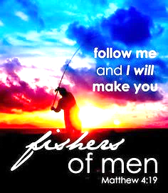

November 30, 2023

699 Stambaugh Ave.
Sharon, Pennsylvania 16146

“I was glad when they said to me,
Let us go to the house of the LORD!”
Psalm 122:1
Sts. Peter & Paul Evangelical Lutheran Church, LC-MS
FESTIVAL OF SAINT ANDREW, APOSTLE
November 30, 2023

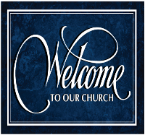
A special welcome to our guests this day! If you would like more information about The Lutheran Church - Missouri Synod, or this congregation, please speak with Pastor Deal or an Elder after the service.
Members & Guests: Don’t be embarrassed if your children make noise during the worship service, all children do. We encourage families to worship together but, if you feel the need, there are pews in the rear of the Church which are reserved for young families on both sides of the sanctuary. There is also a quiet room available to you, located next to the sanctuary (formerly the Pastor’s office), where you would be able to follow along with the service.

Today’s service includes the Sacrament of Holy Communion. If during this past year, you have not worshipped with us and been communed, we respectfully ask that you do not partake of this sacrament this day before first speaking with Pastor Deal.
If visiting from a sister congregation of the LC-MS and are in good standing, please inform Pastor Deal of your desire to commune prior to the service.
If wishing to receive a blessing during communion, please approach with your arms crossed.

CONTACT INFORMATION
Pastor Deal: pastordeal@saintspeterandpaul.net or 724-347-3620 (opt. 2)
Church Office: church@saintspeterandpaul.net or 724-347-3620 (opt. 3)
Secretary’s Office: The office will be open Monday (8:30 am–5 pm).& Thursday (8:30 am–10; 11 am-5 pm).

Silent prayer before worship: Dear Lord Jesus, You have promised to return and take me home to be with You. Lead me to worship You with a joyful and sincere heart now, that I may worship You in glory when You come to receive me to Yourself. Amen.

Confession and Absolution

Opening Hymn: LSB #517 “By All Your Saints in Warfare” (sts. 1,5,3)
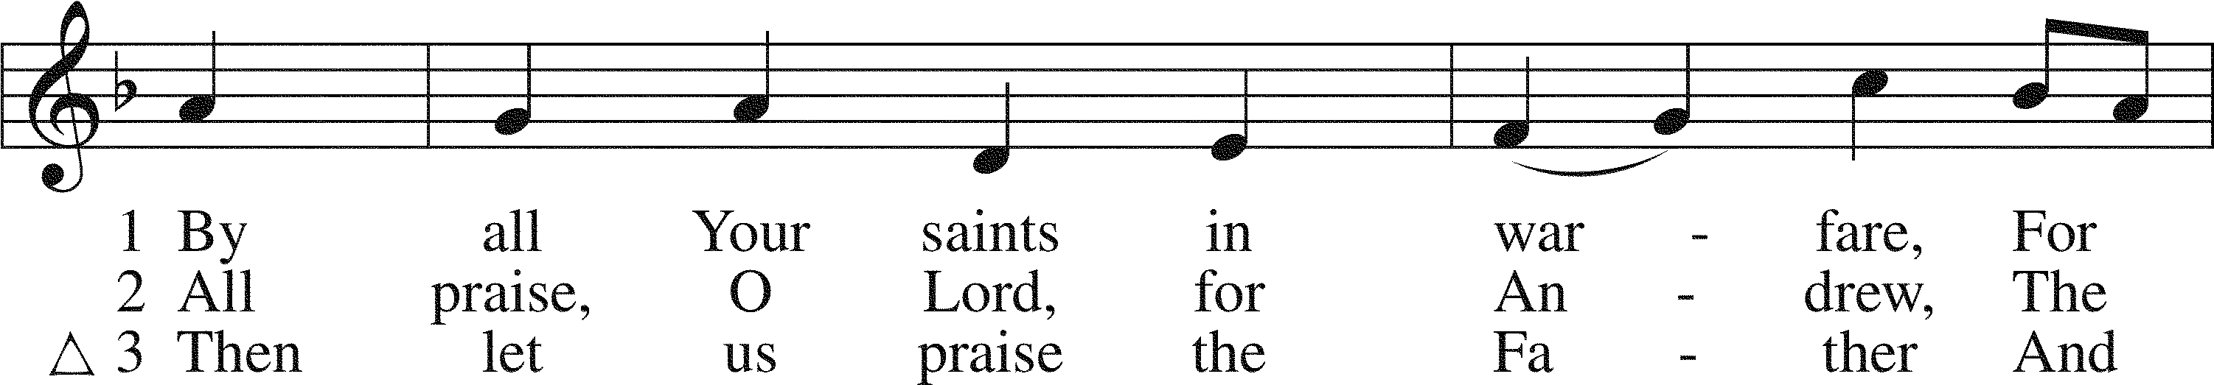
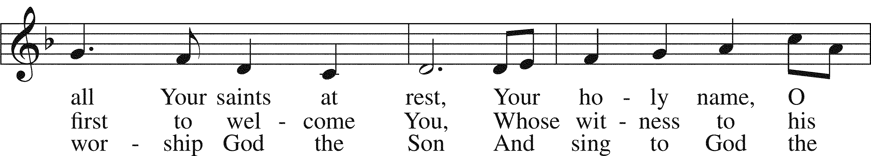
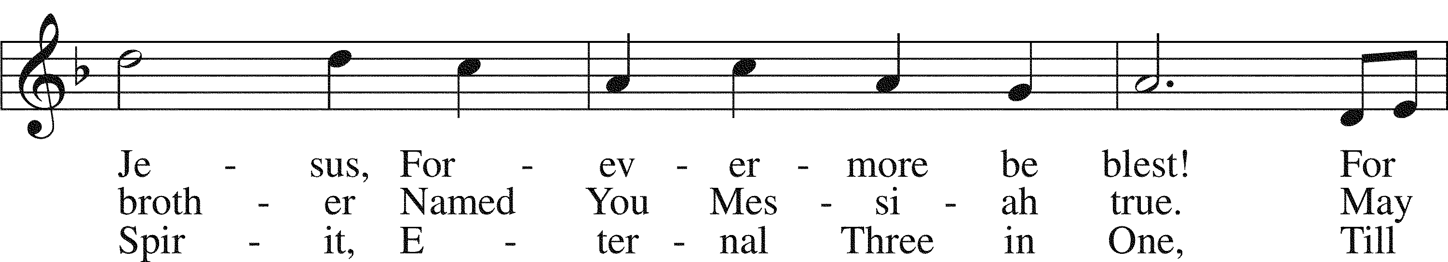
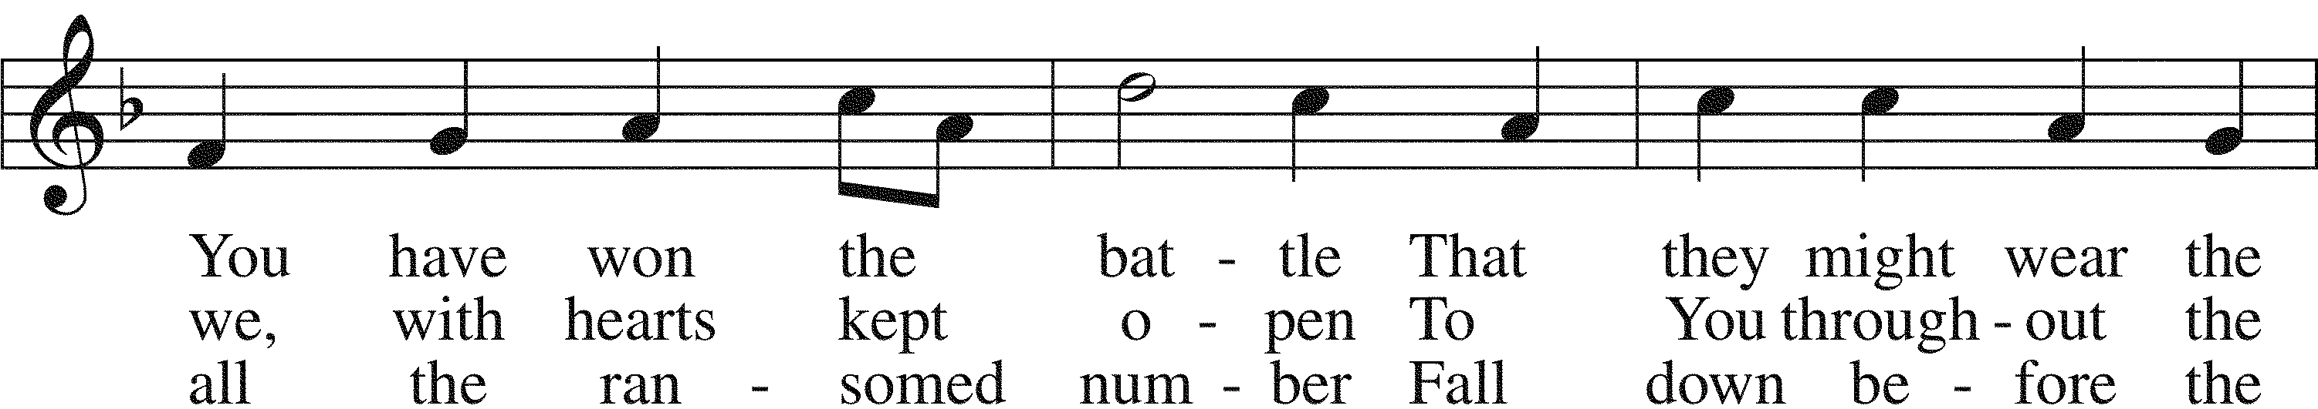
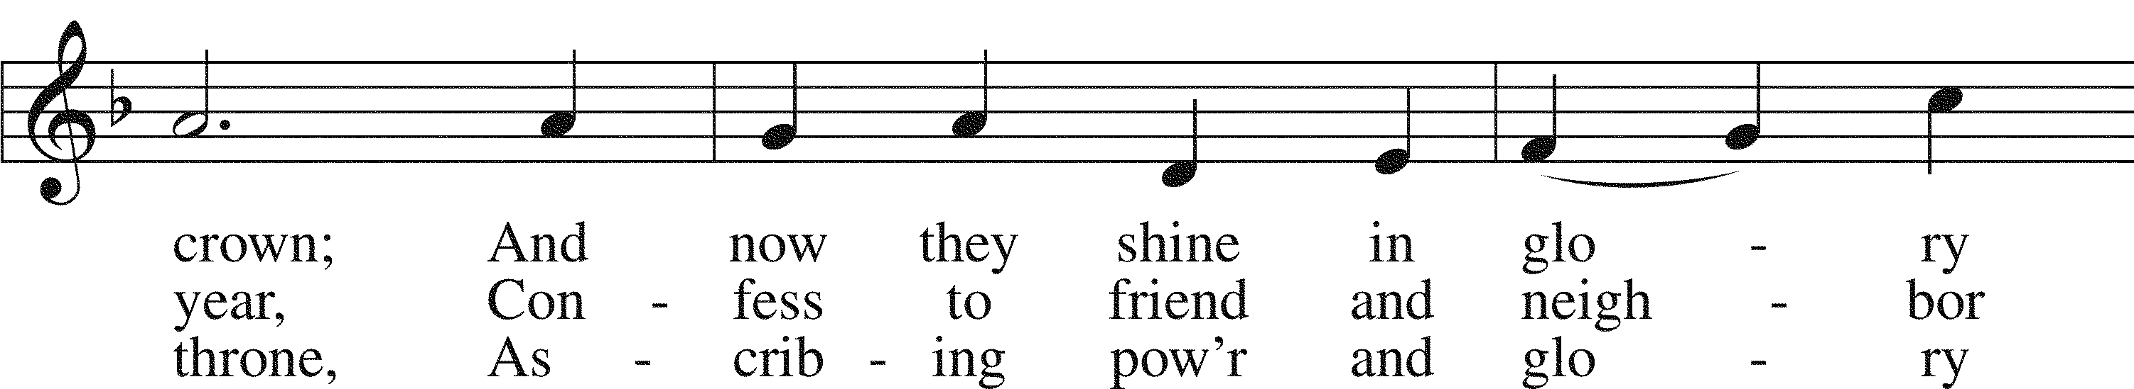
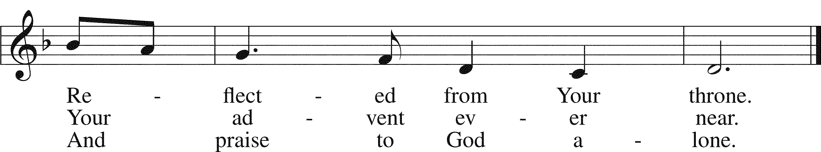

Text: Horatio Bolton Nelson, 1823–1913, alt. Tune: English; coll. and arr. Ralph Vaughan Williams, 1872–1958 Text: Public domain Tune: Public domain

The sign of the cross may be made by all in remembrance of their Baptism.

Invocation
P In the name of the Father and of the T Son and of the Holy Spirit.
C Amen.

Exhortation Hebrews 10:22; Psalm 124:8; Psalm 32:5
P Beloved in the Lord! Let us draw near with a true heart and confess our sins unto God our Father, beseeching Him in the name of our Lord Jesus Christ to grant us forgiveness.

P Our help is in the name of the Lord,
C who made heaven and earth.
P I said, I will confess my transgressions unto the Lord,
C and You forgave the iniquity of my sin.

Silence for reflection on God’s Word and for self-examination.

Confession of Sins
P O almighty God, merciful Father,
C I, a poor, miserable sinner, confess unto You all my sins and iniquities with which I have ever offended You and justly deserved Your temporal and eternal punishment. But I am heartily sorry for them and sincerely repent of them, and I pray You of Your boundless mercy and for the sake of the holy, innocent, bitter sufferings and death of Your beloved Son, Jesus Christ, to be gracious and merciful to me, a poor, sinful being.

Absolution [John 20:19–23]
P Upon this your confession, I, by virtue of my office, as a called and ordained servant of the Word, announce the grace of God unto all of you, and in the stead and by the command of my Lord Jesus Christ I forgive you all your sins in the name of the Father and of the T Son and of the Holy Spirit.
C Amen.

Service of the Word

Introit Psalm 89:1, 5, 15–16; antiphon: John 15:27
You also will bear | witness,*
because you have been with me from the be- | ginning.
I will sing of the steadfast love of the Lord, for- | ever;*
with my mouth I will make known your faithfulness to all gener- | ations.
Let the heavens praise your wonders, | O Lord,*
your faithfulness in the assembly of the | holy ones!
Blessèd are the people who know the | festal shout,*
who walk, O Lord, in the light | of your face,
who exult in your name | all the day*
and in your righteousness are ex- | alted.
You also will bear | witness,*
because you have been with me from the be- | ginning.

Gloria Patri
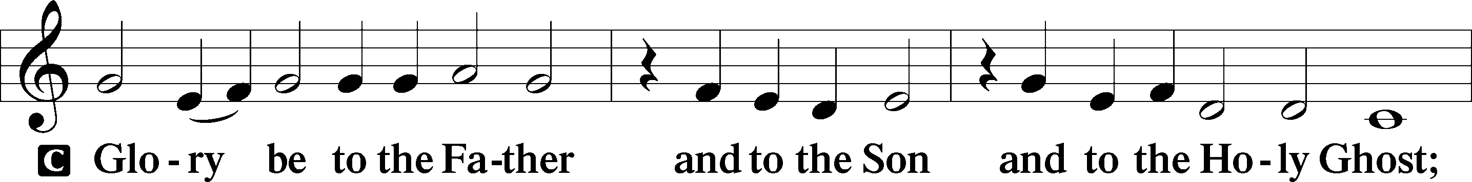
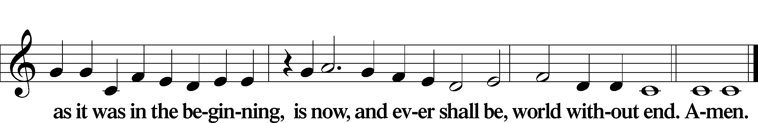

Kyrie Mark 10:47
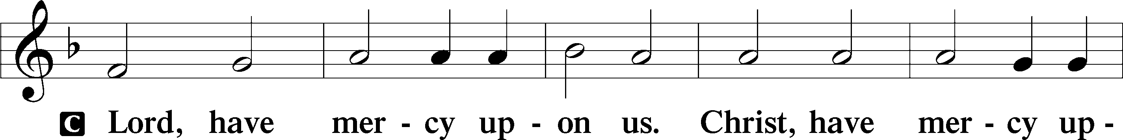
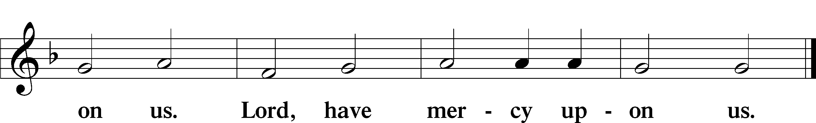

Gloria in Excelsis Luke 2:14; John 1:29
P Glory be to God on high:
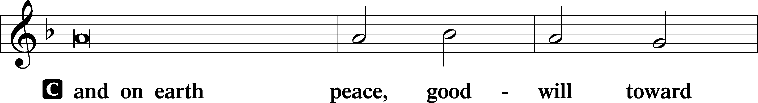
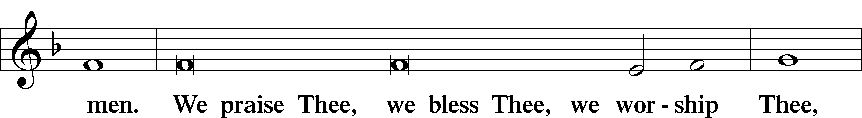
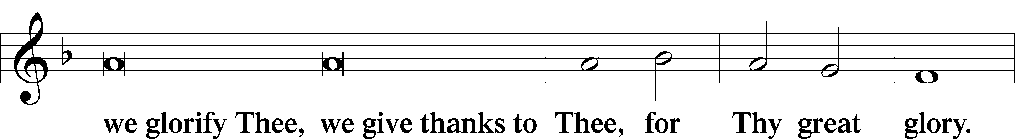
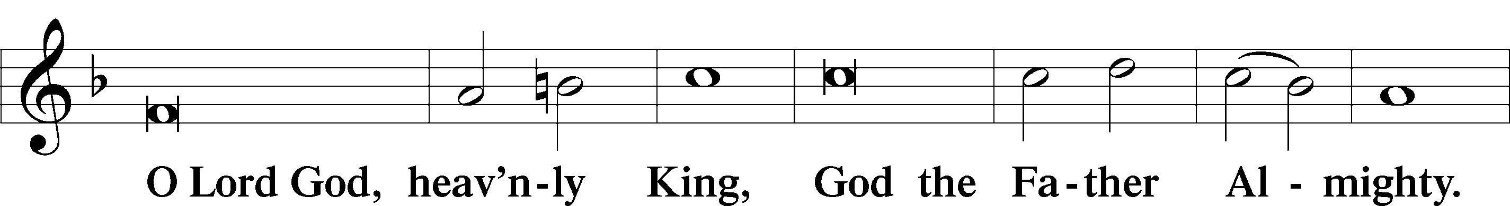
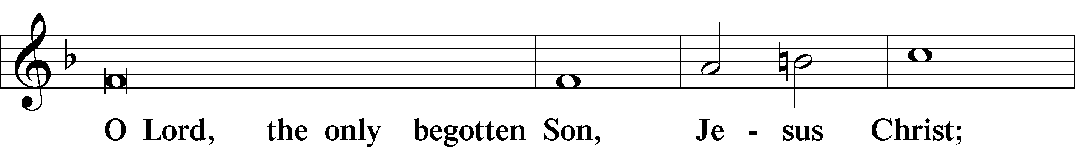
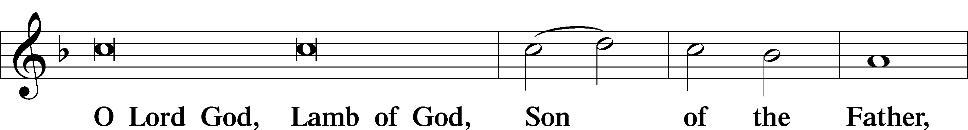
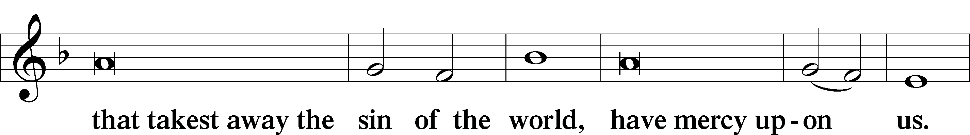
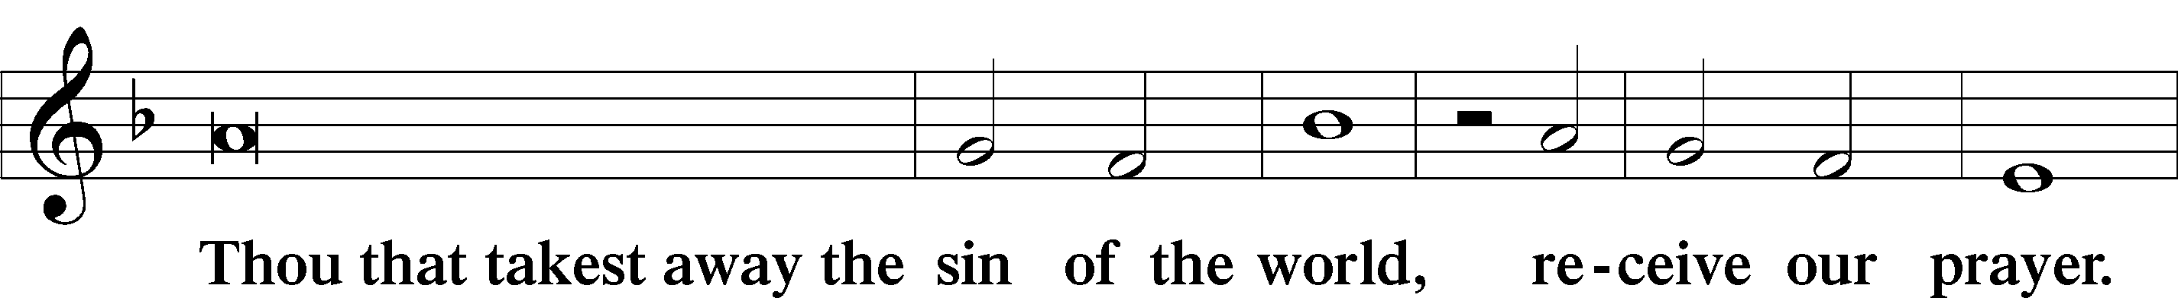
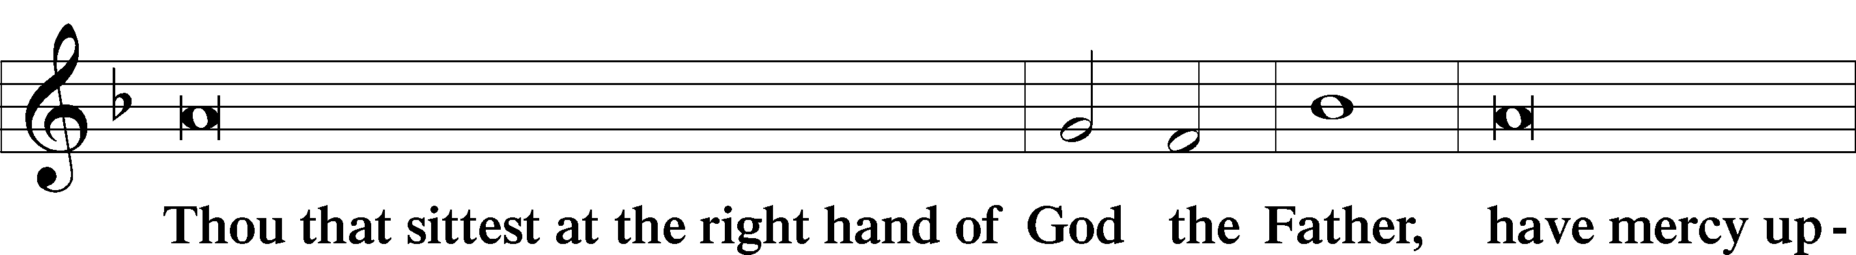
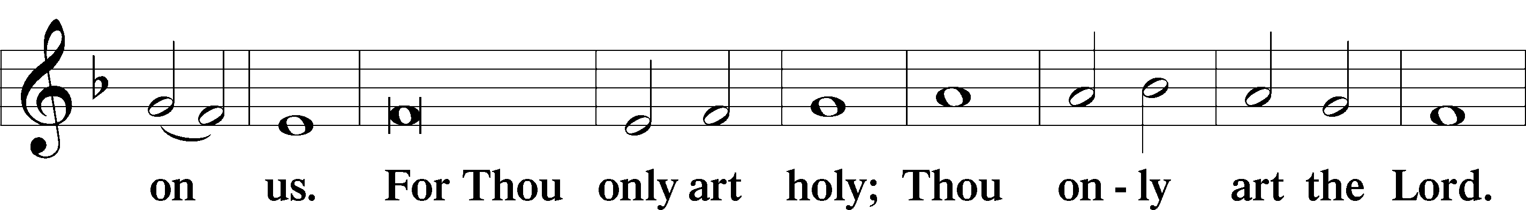
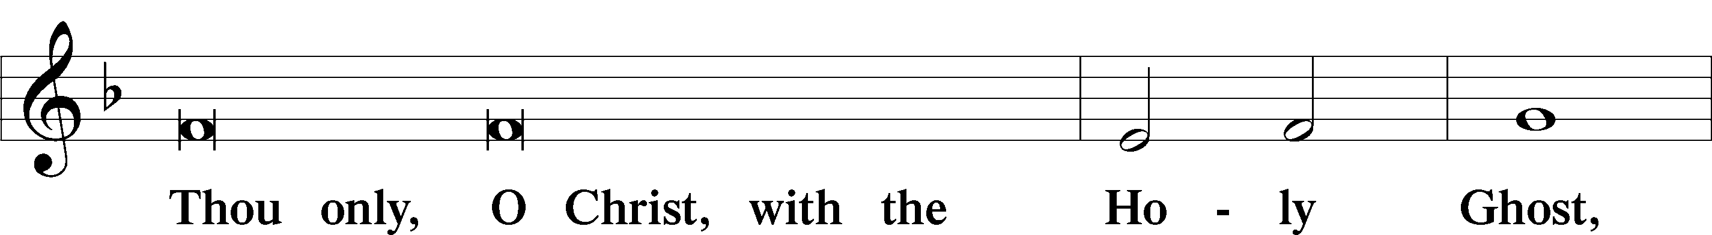
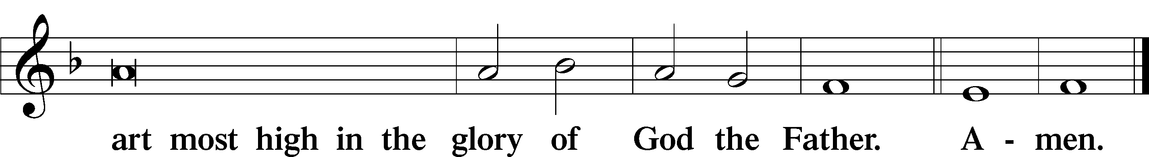

Salutation and Collect of the Day: Festival of Saint Andrew, Apostle
P The Lord be with you.
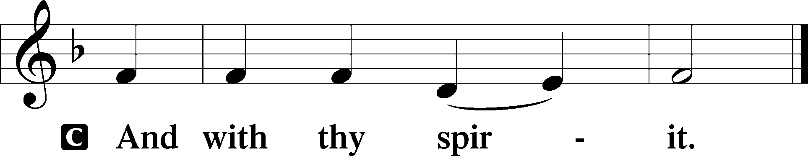

P Let us pray.
Almighty God, by Your grace the apostle Andrew obeyed the call of Your Son to be a disciple. Grant us also to follow the same Lord Jesus Christ in heart and life, who lives and reigns with You and the Holy Spirit, one God, now and forever.
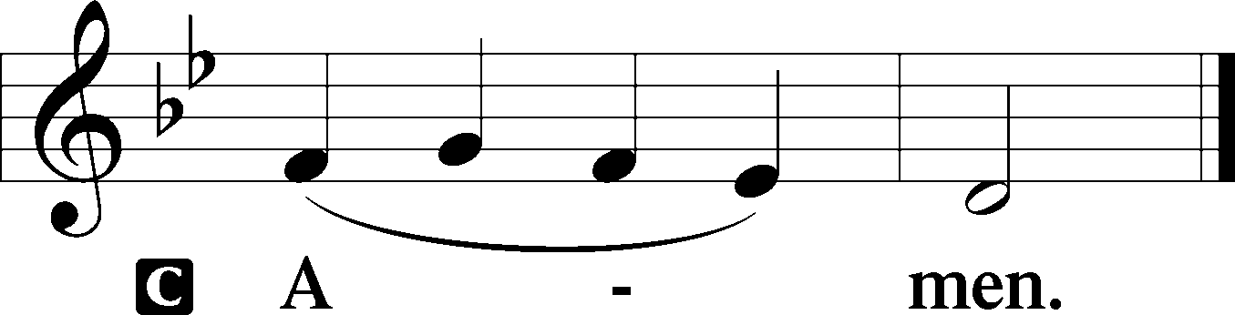
Sit

Prophecy: Ezekiel 3:16–21 (NKJV)
In those days: The word of the Lord came to me, saying, “Son of man, I have made you a watchman for the house of Israel; therefore hear a word from My mouth, and give them warning from Me: When I say to the wicked, ‘You shall surely die,’ and you give him no warning, nor speak to warn the wicked from his wicked way, to save his life, that same wicked man shall die in his iniquity; but his blood I will require at your hand. Yet, if you warn the wicked, and he does not turn from his wickedness, nor from his wicked way, he shall die in his iniquity; but you have delivered your soul. Again, when a righteous man turns from his righteousness and commits iniquity, and I lay a stumbling block before him, he shall die; because you did not give him warning, he shall die in his sin, and his righteousness which he has done shall not be remembered; but his blood I will require at your hand. Nevertheless if you warn the righteous man that the righteous should not sin, and he does not sin, he shall surely live because he took warning; also you will have delivered your soul.”

P This is the Word of the Lord.
C Thanks be to God.

Gradual Romans 10:15b, 18b; Isaiah 52:7b, alt.
How beautiful are the feet of those who preach the | good news,*
who publish peace and bring good news of sal- | vation.
Their voice has gone out to | all the earth,*
and their words to the ends | of the world.

Epistle: Romans 10:10–18 (NKJV)
Brethren: With the heart one believes unto righteousness, and with the mouth confession is made unto salvation. For the Scripture says, “Whoever believes on Him will not be put to shame.” For there is no distinction between Jew and Greek, for the same Lord over all is rich to all who call upon Him. For “whoever calls on the name of the Lord shall be saved.” How then shall they call on Him in whom they have not believed? And how shall they believe in Him of whom they have not heard? And how shall they hear without a preacher? And how shall they preach unless they are sent? As it is written: “How beautiful are the feet of those who preach the gospel of peace, who bring glad tidings of good things!” But they have not all obeyed the gospel. For Isaiah says, “Lord, who has believed our report?” So then faith comes by hearing, and hearing by the word of God. But I say, have they not heard? Yes indeed: “Their sound has gone out to all the earth, and their words to the ends of the world.”
P This is the Word of the Lord.
C Thanks be to God.

Stand

Verse John 1:39a
Alleluia. [Jesus] said to them, “Come and you will see.” So they came and saw where he was staying, and they stayed with him that day. Alleluia.

Alleluia
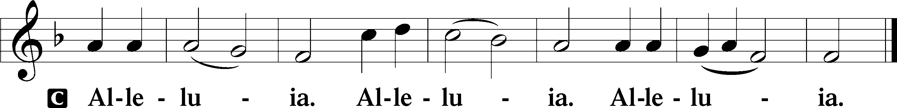

Holy Gospel: Matthew 4:18-22 (NKJV)
P The Holy Gospel according to St. Matthew, the fourth chapter.
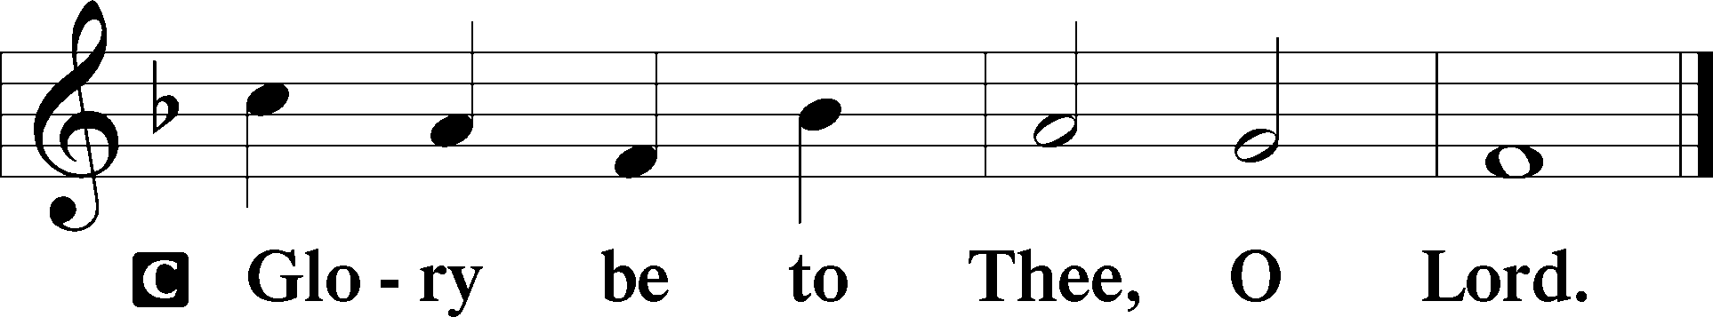

At that time: Jesus, walking by the Sea of Galilee, saw two brothers, Simon called Peter, and Andrew his brother, casting a net into the sea; for they were fishermen. Then He said to them, “Follow Me, and I will make you fishers of men.” They immediately left their nets and followed Him. Going on from there, He saw two other brothers, James the son of Zebedee, and John his brother, in the boat with Zebedee their father, mending their nets. He called them, and immediately they left the boat and their father, and followed Him.

P This is the Gospel of the Lord.
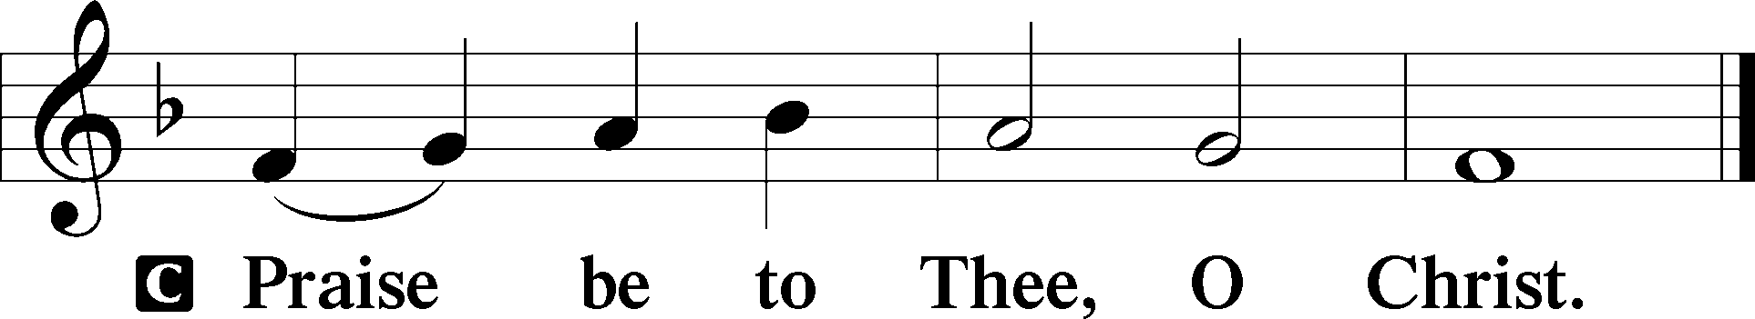

Nicene Creed
C I believe in one God,
the Father Almighty,
maker of heaven and earth
and of all things visible and invisible.

And in one Lord Jesus Christ,
the only-begotten Son of God,
begotten of His Father before all worlds,
God of God, Light of Light,
very God of very God,
begotten, not made,
being of one substance with the Father,
by whom all things were made;
who for us men and for our salvation came down from heaven
and was incarnate by the Holy Spirit of the virgin Mary
and was made man;
and was crucified also for us under Pontius Pilate.
He suffered and was buried.
And the third day He rose again according to the Scriptures
and ascended into heaven
and sits at the right hand of the Father.
And He will come again with glory to judge both the living and the dead,
whose kingdom will have no end.

And I believe in the Holy Spirit,
the Lord and giver of life,
who proceeds from the Father and the Son,
who with the Father and the Son together is worshiped and glorified,
who spoke by the prophets.
And I believe in one holy Christian and apostolic Church,
I acknowledge one Baptism for the remission of sins,
and I look for the resurrection of the dead
and the life T of the world to come. Amen.
Sit
Hymn of the Day: LSB #586 “Preach You the Word”

Sermon

Stand

Offertory Psalm 51:10–12
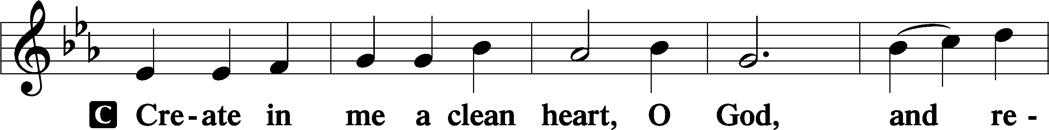
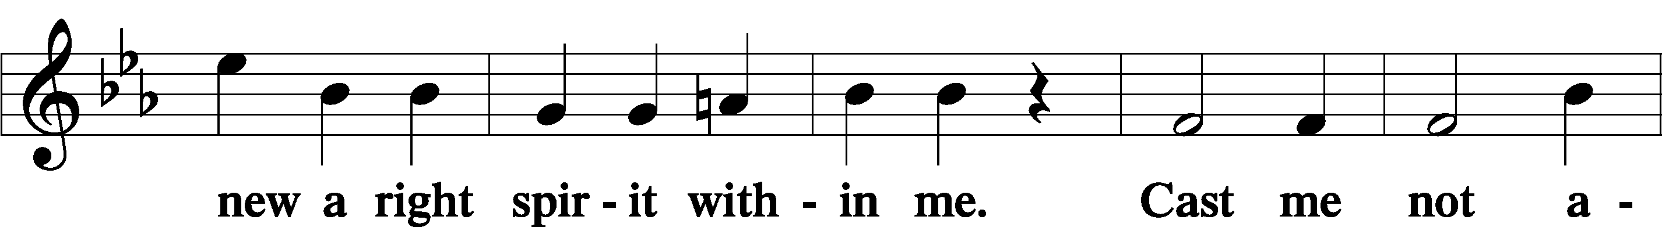
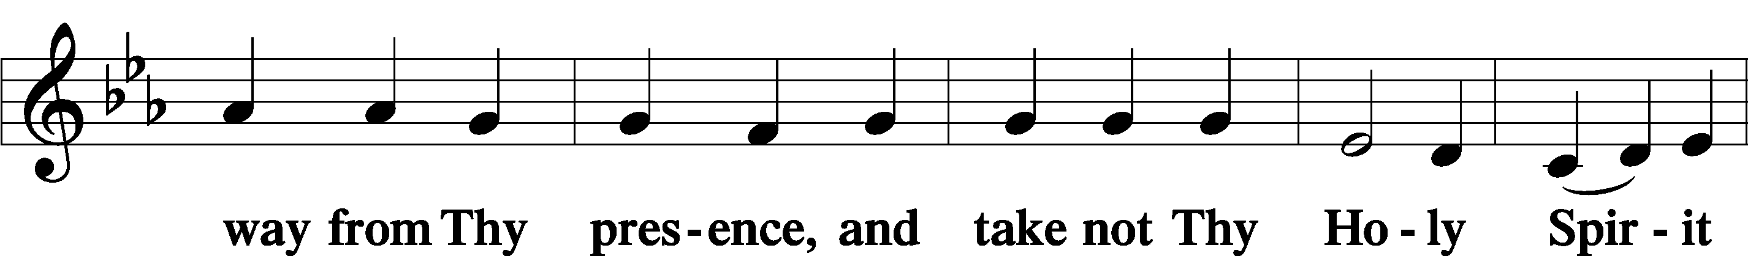
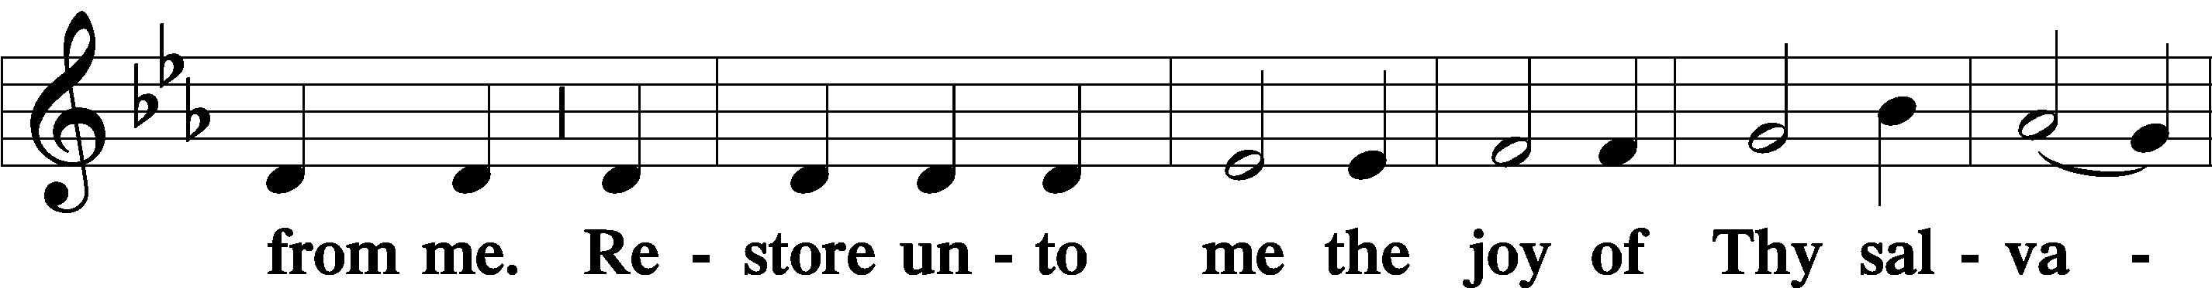
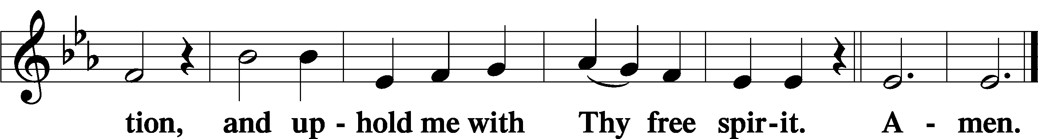

Prayer of the Church

Sit

Preparatory Hymn: LSB #828 “We Are Called to Stand Together”

Stand
Service of the Sacrament

Preface 2 Timothy 4:22; Colossians 3:1 Psalm 136
P The Lord be with you.
P Lift up your hearts.
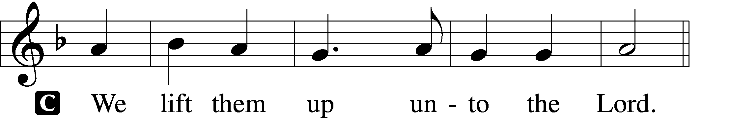

P Let us give thanks unto the Lord, our God.
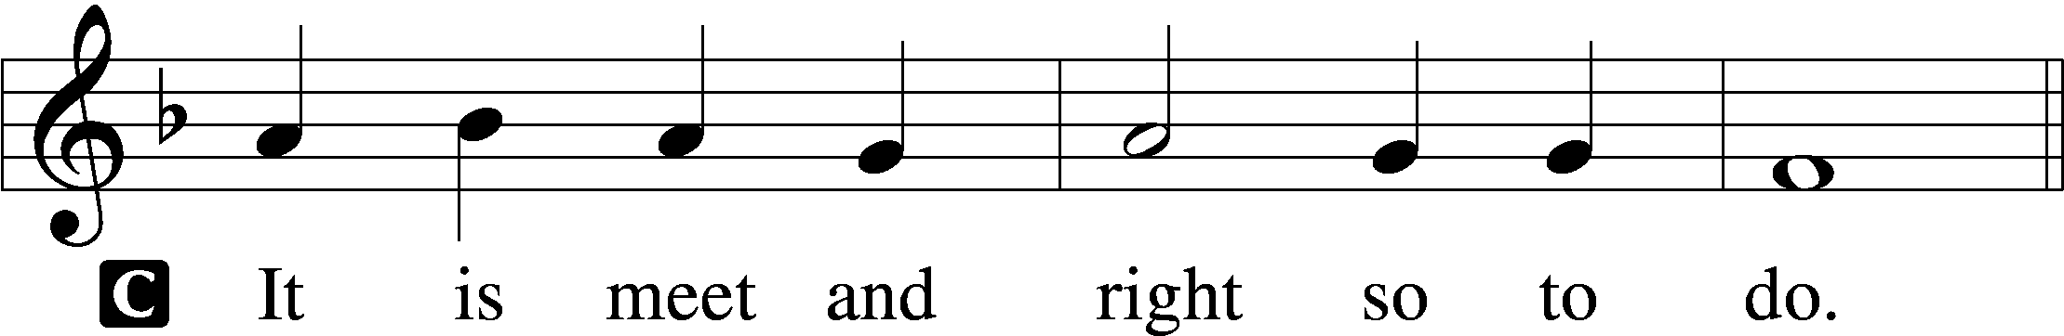

Proper Preface (Abbreviated) LSB 194
P It is truly meet, right, and salutary . . . evermore praising You and saying:

Sanctus Isaiah 6:3; Matthew 21:9
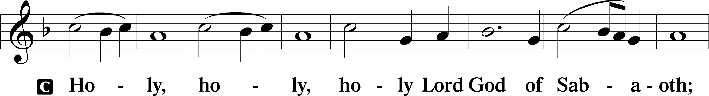
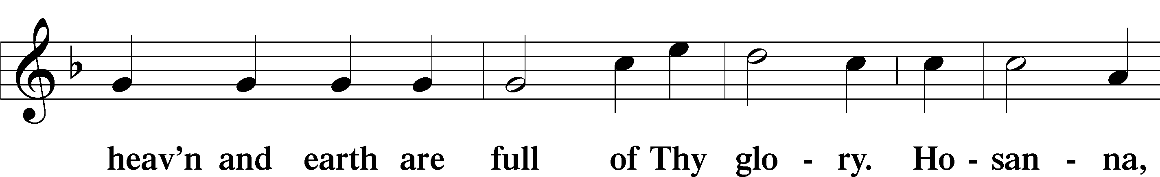
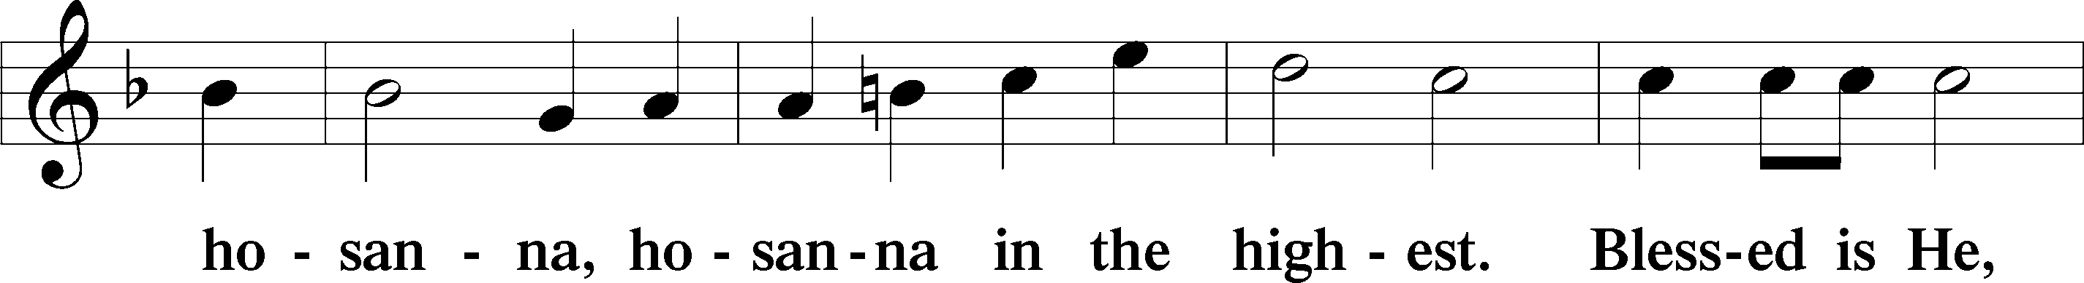
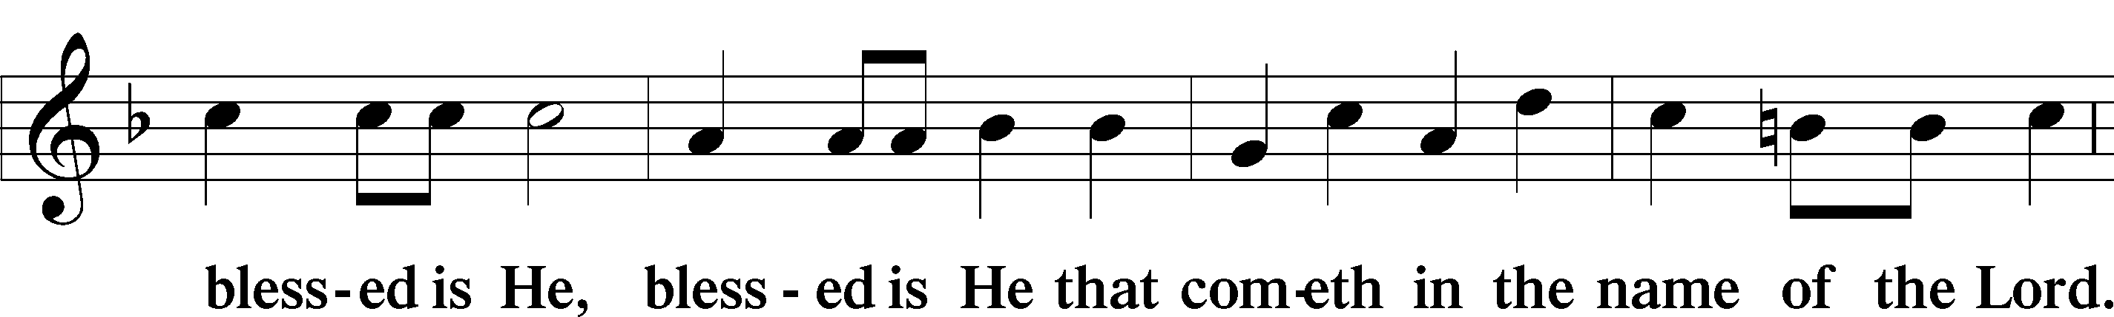
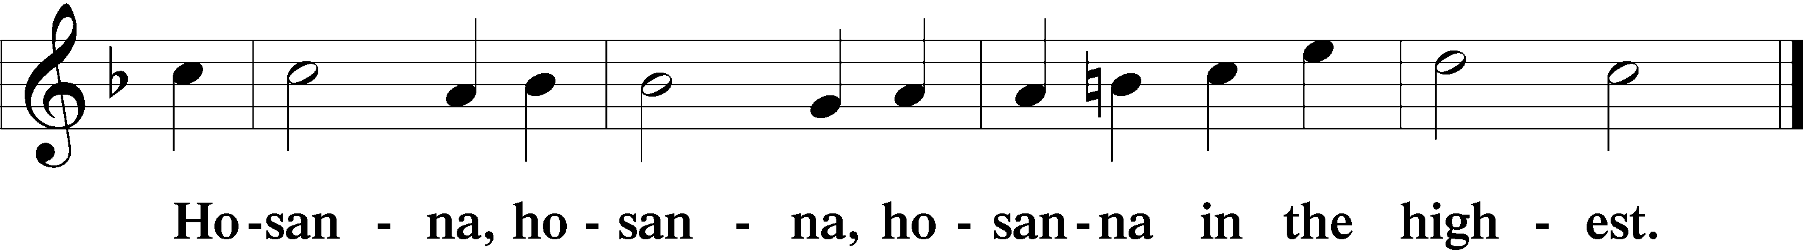

Lord’s Prayer The congregation is encouraged to silently pray the Lord’s Prayer as it is chanted. Matthew 6:9–13
P Our Father who art in heaven,
hallowed be Thy name,
Thy kingdom come,
Thy will be done on earth as it is in heaven;
give us this day our daily bread;
and forgive us our trespasses as we forgive those who trespass against us;
and lead us not into temptation,
but deliver us from evil.
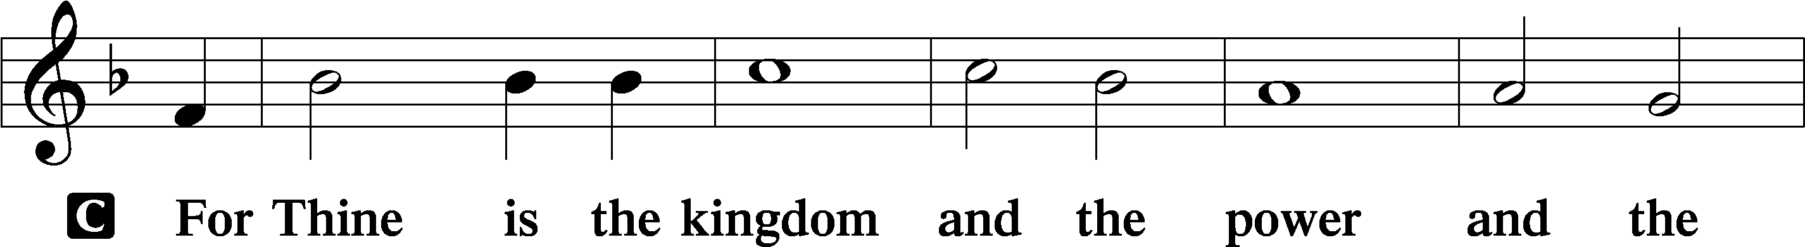
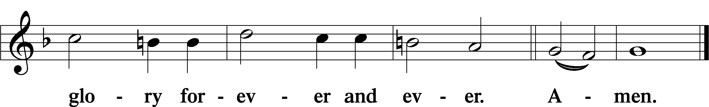

The Words of Our Lord Matthew 26:26–28; Mark 14:22–24; Luke 22:19–20; 1 Corinthians 11:23–25
P Our Lord Jesus Christ, on the night when He was betrayed, took bread, and when He had given thanks, He broke it and gave it to the disciples and said: “Take, eat; this is My T body, which is given for you. This do in remembrance of Me.”

In the same way also He took the cup after supper, and when He had given thanks, He gave it to them, saying: “Drink of it, all of you; this cup is the new testament in My T blood, which is shed for you for the forgiveness of sins. This do, as often as you drink it, in remembrance of Me.”

Pax Domini John 20:19
P The peace of the Lord be with you always.
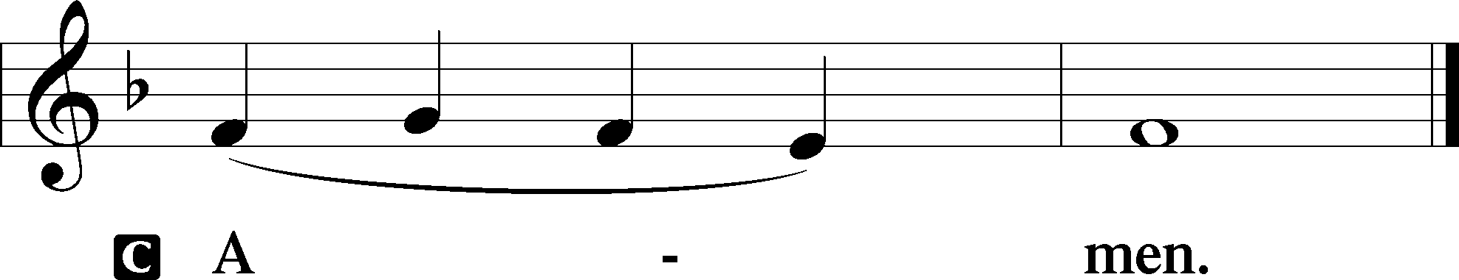

Agnus Dei John 1:29
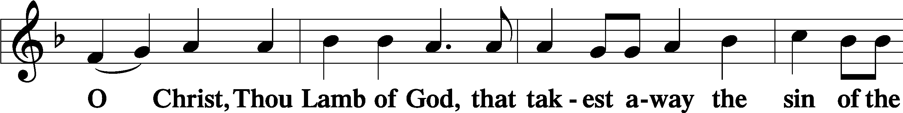
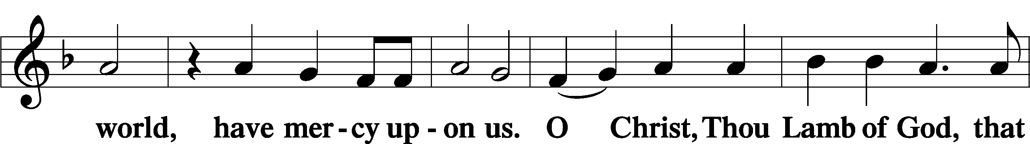
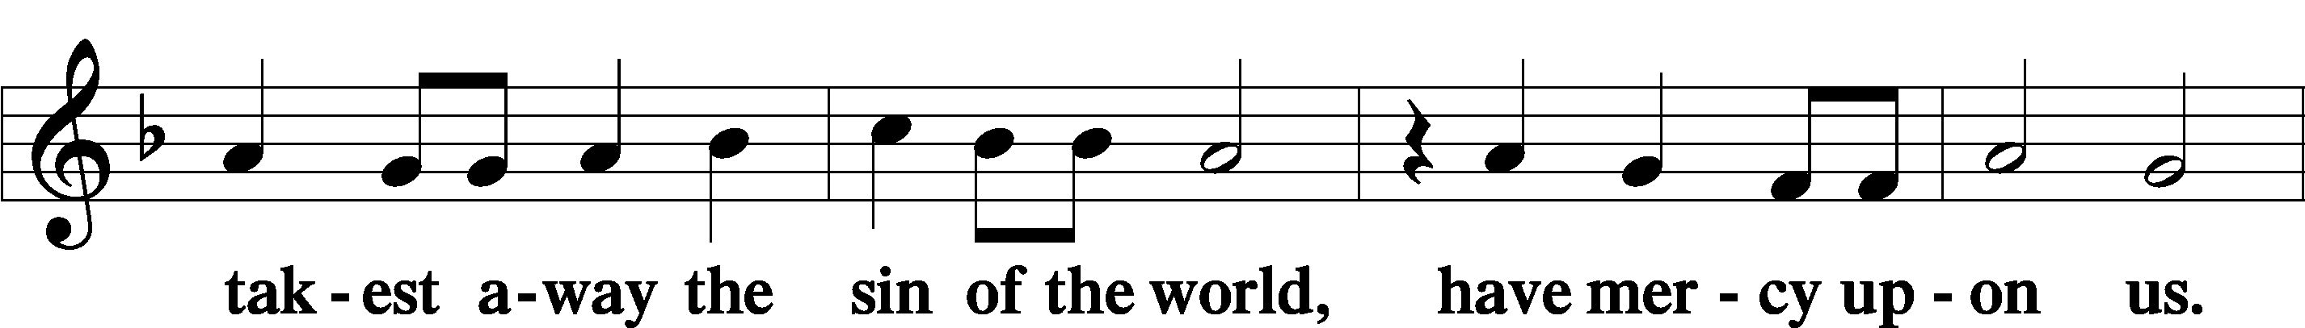
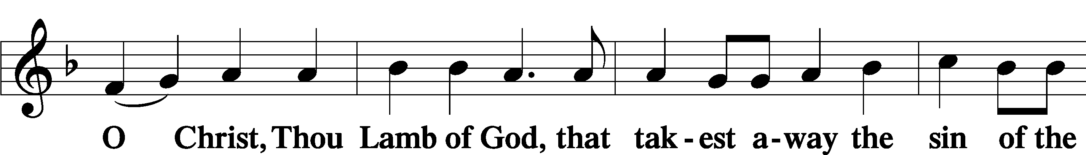
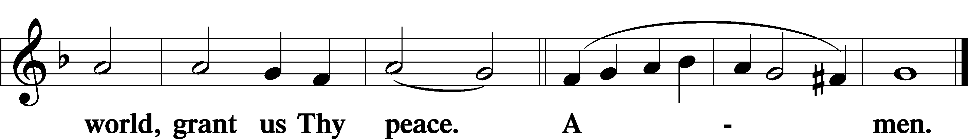
Sit
Distribution
The pastor and those who assist him receive the body and blood of Christ first and then distribute them to those who come to receive, saying:
Take, eat; this is the true body of our Lord and Savior Jesus Christ, given into death for your sins.
Amen.

Take, drink; this is the true blood of our Lord and Savior Jesus Christ, shed for the forgiveness of your sins.
Amen.

In dismissing the communicants, the following is said:
The Dismissal
P The body and blood of our Lord Jesus Christ strengthen and preserve you in body and soul to life everlasting. Depart T in peace.
C Amen.

Distribution Hymn: LSB #623 “Lord Jesus Christ, We Humbly Pray”

Stand

Nunc Dimittis Luke 2:29–32
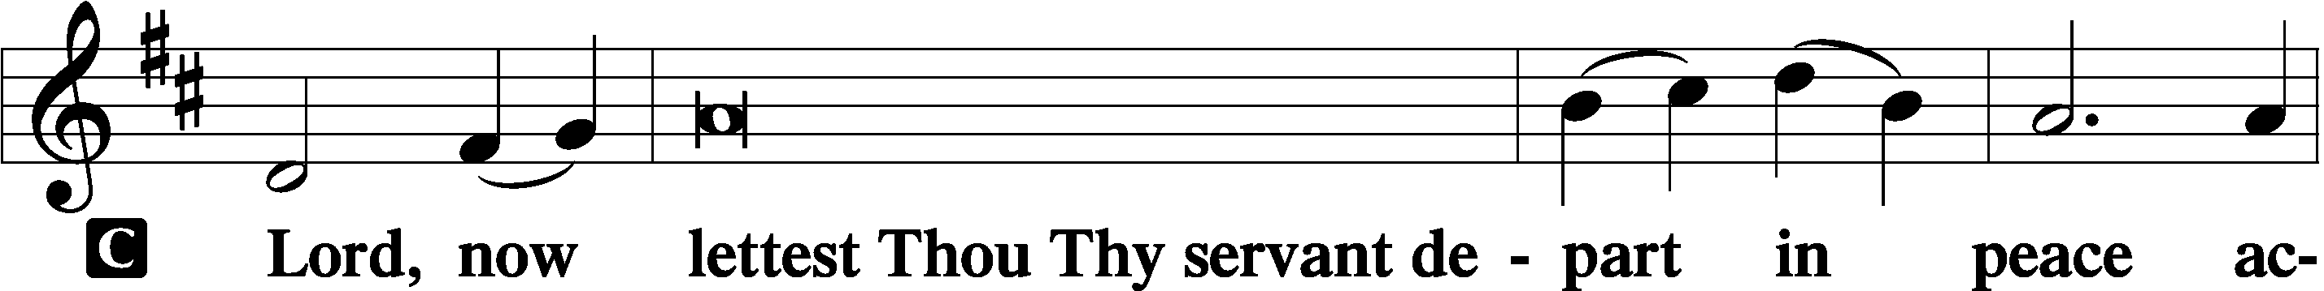
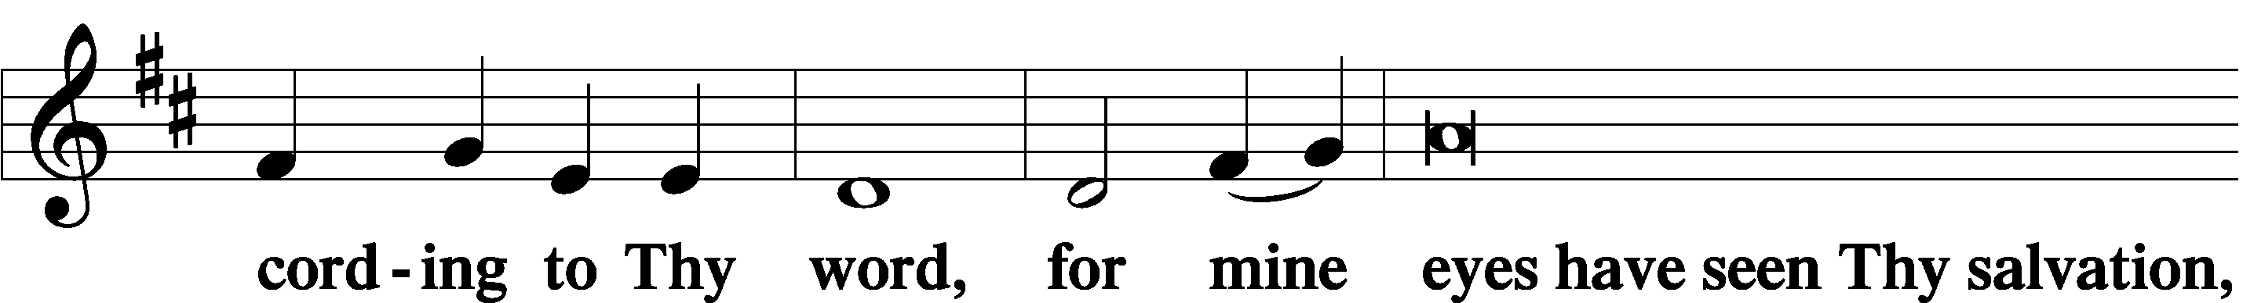
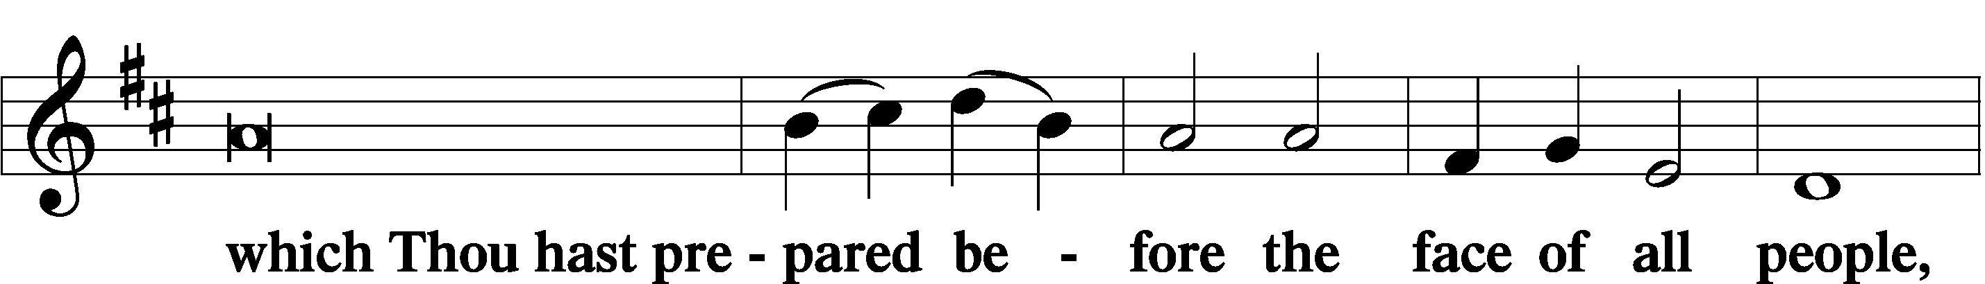
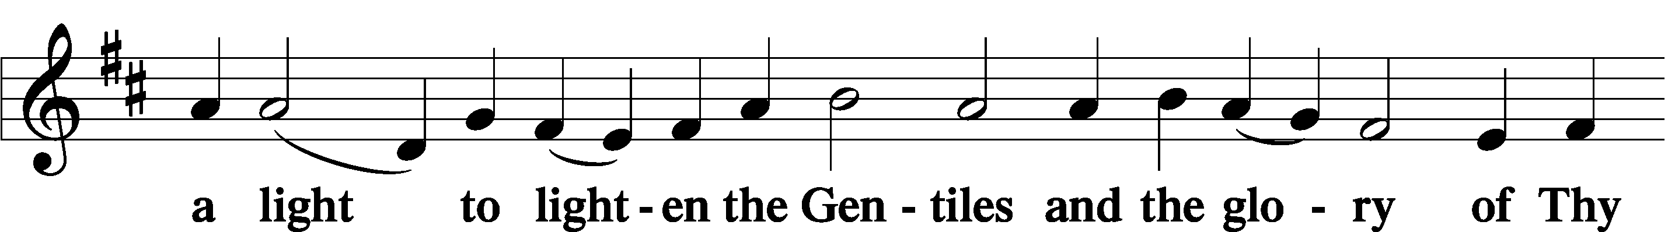
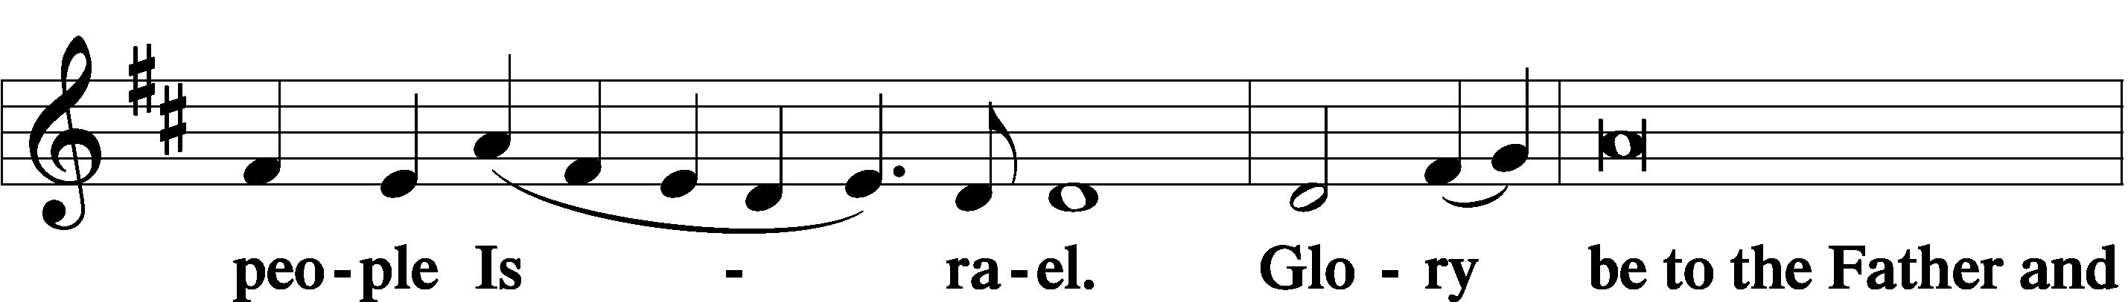
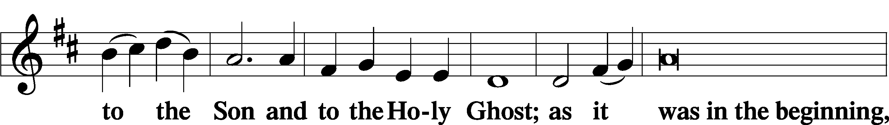
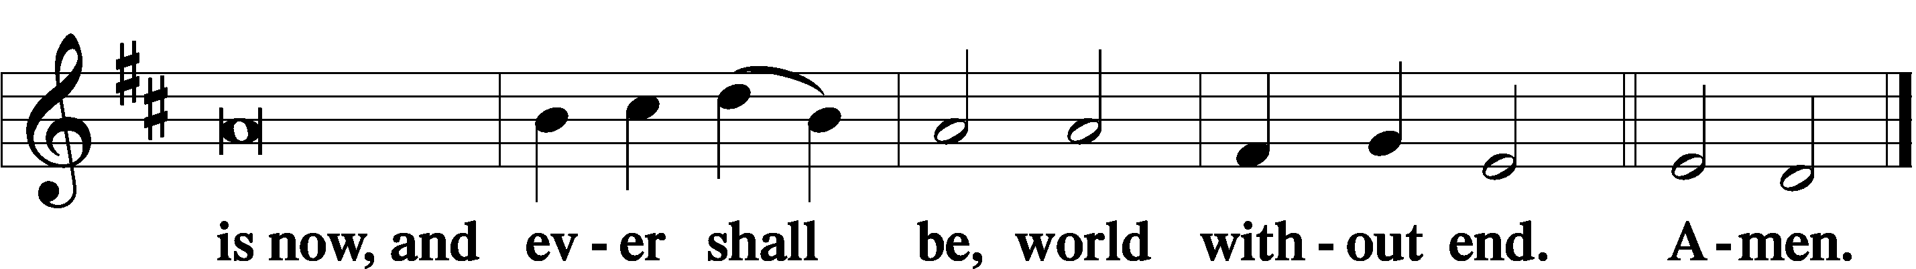

Thanksgiving Psalm 107:1
P O give thanks unto the Lord, for He is good,
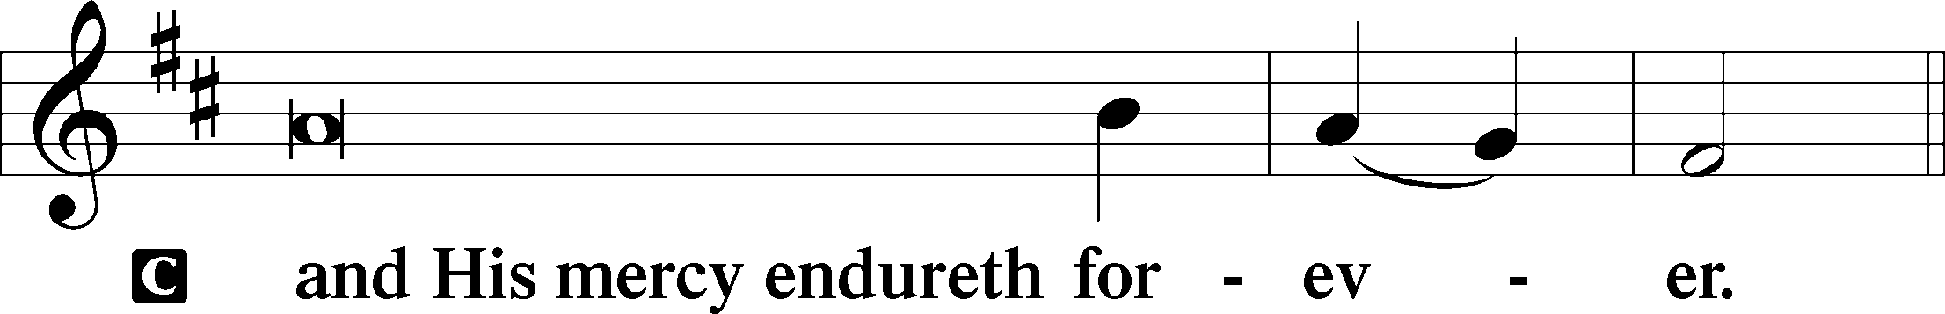

Post-Communion Collect
P Let us pray.
We give thanks to You, almighty God, that You have refreshed us through this salutary gift, and we implore You that of Your mercy You would strengthen us through the same in faith toward You and in fervent love toward one another; through Jesus Christ, Your Son, our Lord, who lives and reigns with You and the Holy Spirit, one God, now and forever.
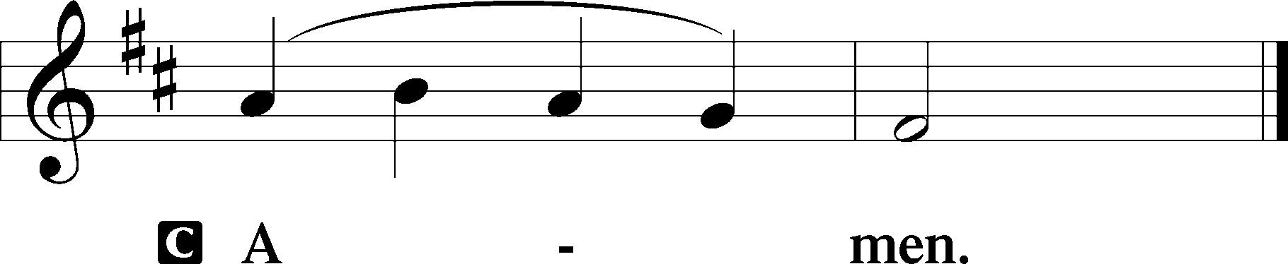

Salutation 2 Timothy 4:22
P The Lord be with you.
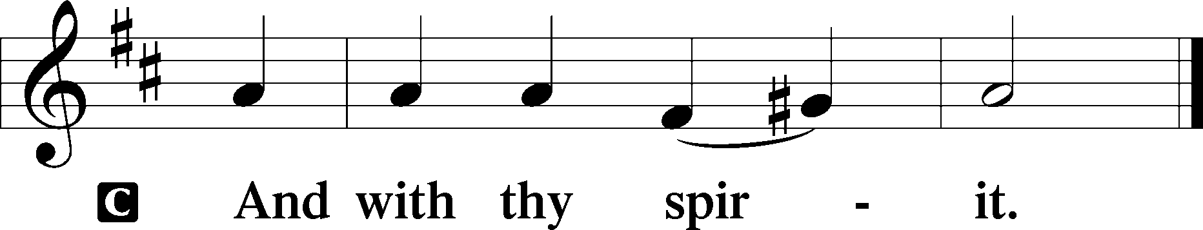

Benedicamus Psalm 103:1
P Bless we the Lord.
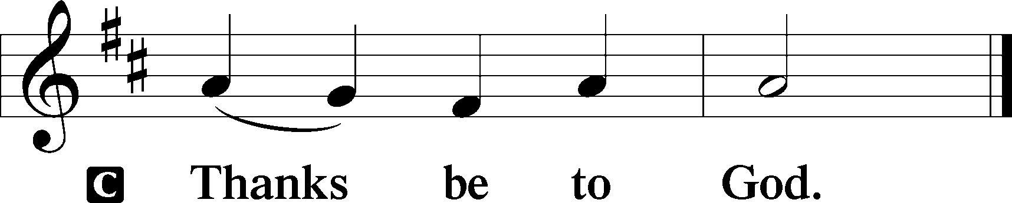

Benediction Numbers 6:24–26
P The Lord bless you and keep you.
The Lord make His face shine upon you and be gracious unto you.
The Lord lift up His countenance upon you and T give you peace.
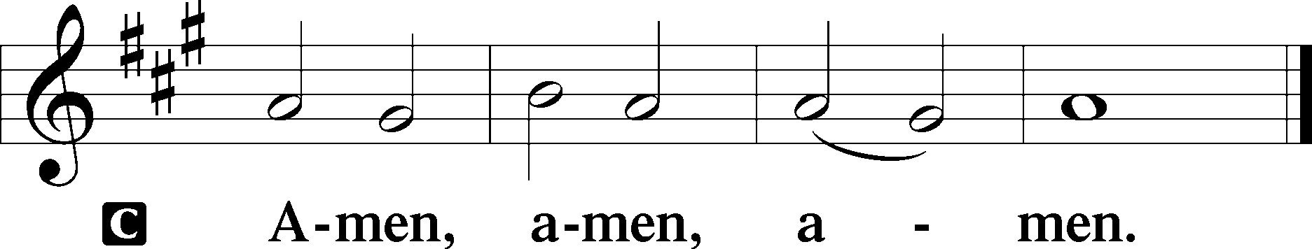

Closing Hymn: LSB #880 “Now Rest beneath Night’s Shadow”
fffffffffffffffffffffffffffffffffff
Silent prayer after worship: Heavenly Father, enable me to daily live in Christ with a true faith so that I can be ready for the day He comes to deliver me from this life and to grant me everlasting life with You. In Jesus’ name. Amen.
fffffffffffffffffffffffffffffffffff
Acknowledgments
Unless otherwise indicated, Scripture quotations are from the ESV® Bible (The Holy Bible, English Standard Version®), copyright © 2001 by Crossway, a publishing ministry of Good News Publishers. Used by permission. All rights reserved.
Created by Lutheran Service Builder © 2023 Concordia Publishing House.

