Sts. Peter & Paul
Evangelical Lutheran Church
Lutheran Church-Missouri Synod
Founded-1917

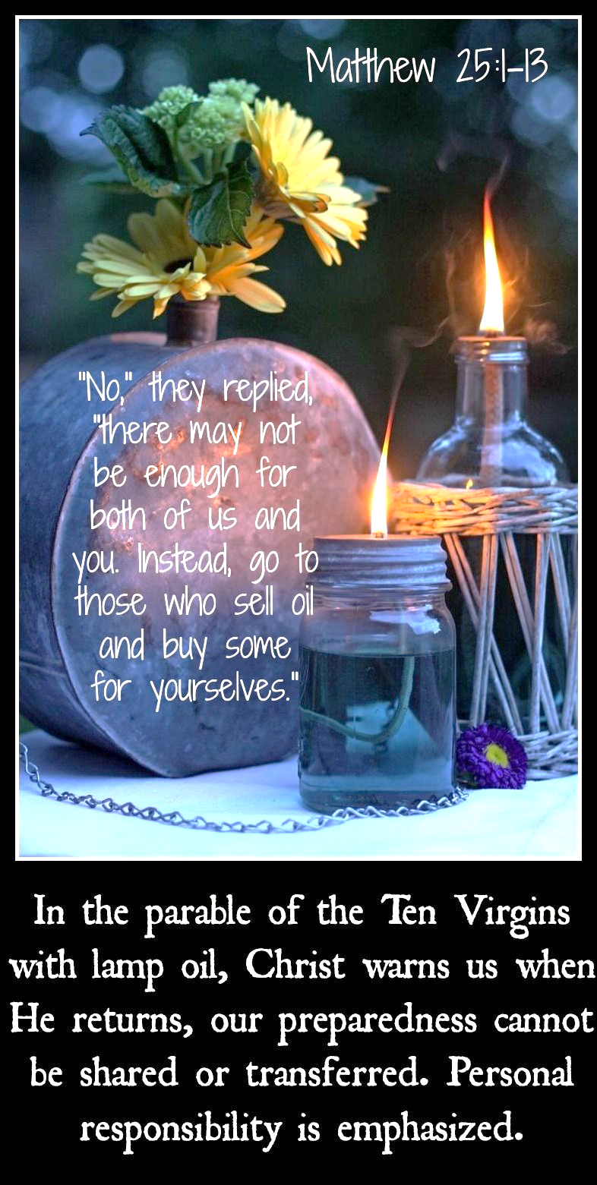

November 26, 2023

699 Stambaugh Ave.
Sharon, Pennsylvania 16146

“I was glad when they said to me,
Let us go to the house of the LORD!”
Psalm 122:1
Sts. Peter & Paul Evangelical Lutheran Church, LC-MS
THE LAST SUNDAY OF THE CHURCH YEAR
November 26, 2023

A special welcome to our guests this day! If you would like more information about The Lutheran Church - Missouri Synod, or this congregation, please speak with Pastor Deal or an Elder after the service.
Members & Guests: Don’t be embarrassed if your children make noise during the worship service, all children do. We encourage families to worship together but, if you feel the need, there are pews in the rear of the Church which are reserved for young families on both sides of the sanctuary. There is also a quiet room available to you, located next to the sanctuary (formerly the Pastor’s office), where you would be able to follow along with the service.

Today’s service includes the Sacrament of Holy Communion. If during this past year, you have not worshipped with us and been communed, we respectfully ask that you do not partake of this sacrament this day before first speaking with Pastor Deal.
If visiting from a sister congregation of the LC-MS and are in good standing, please inform Pastor Deal of your desire to commune prior to the service.
If wishing to receive a blessing during communion, please approach with your arms crossed.

CONTACT INFORMATION
Pastor Deal: pastordeal@saintspeterandpaul.net or 724-347-3620 (opt. 2)
Church Office: church@saintspeterandpaul.net or 724-347-3620 (opt. 3)
Secretary’s Office: The office will be open Monday (8:30–5) & Thursday (8:30-10; 11-5).

Silent prayer before worship: Dear Lord Jesus, You have promised to return and take me home to be with You. Lead me to worship You with a joyful and sincere heart now, that I may worship You in glory when You come to receive me to Yourself. Amen.

Confession and Absolution

Opening Hymn: LSB #510 “A Multitude Comes from the East and the West”

Stand

The sign of the cross may be made by all in remembrance of their Baptism.

Invocation
P In the name of the Father and of the T Son and of the Holy Spirit.
C Amen.

Exhortation Hebrews 10:22; Psalm 124:8; Psalm 32:5
P Beloved in the Lord! Let us draw near with a true heart and confess our sins unto God our Father, beseeching Him in the name of our Lord Jesus Christ to grant us forgiveness.

P Our help is in the name of the Lord,
C who made heaven and earth.
P I said, I will confess my transgressions unto the Lord,
C and You forgave the iniquity of my sin.

Silence for reflection on God’s Word and for self-examination.

Confession of Sins
P O almighty God, merciful Father,
C I, a poor, miserable sinner, confess unto You all my sins and iniquities with which I have ever offended You and justly deserved Your temporal and eternal punishment. But I am heartily sorry for them and sincerely repent of them, and I pray You of Your boundless mercy and for the sake of the holy, innocent, bitter sufferings and death of Your beloved Son, Jesus Christ, to be gracious and merciful to me, a poor, sinful being.

Absolution [John 20:19–23]
P Upon this your confession, I, by virtue of my office, as a called and ordained servant of the Word, announce the grace of God unto all of you, and in the stead and by the command of my Lord Jesus Christ I forgive you all your sins in the name of the Father and of the T Son and of the Holy Spirit.
C Amen.
Service of the Word

Introit Psalm 39:4–5, 7–8; antiphon: Isaiah 35:10
The ransomed of the Lord shall return and come to Zion with | singing;*
everlasting joy shall be up- | on their heads.
They shall obtain glad- | ness and joy,*
and sorrow and sighing shall | flee away.
O Lord, make me know my end and what is the measure | of my days;*
let me know how fleeting | I am!
Behold, you have made my days a few handbreadths, and my lifetime is as nothing be- | fore you.*
Surely all mankind stands as a | mere breath!
And now, O Lord, for what | do I wait?*
My hope | is in you.
Deliver me from all my trans- | gressions.*
Do not make me the scorn | of the fool!
The ransomed of the Lord shall return and come to Zion with | singing;*
everlasting joy shall be up- | on their heads.
They shall obtain glad- | ness and joy,*
and sorrow and sighing shall | flee away.

Gloria Patri
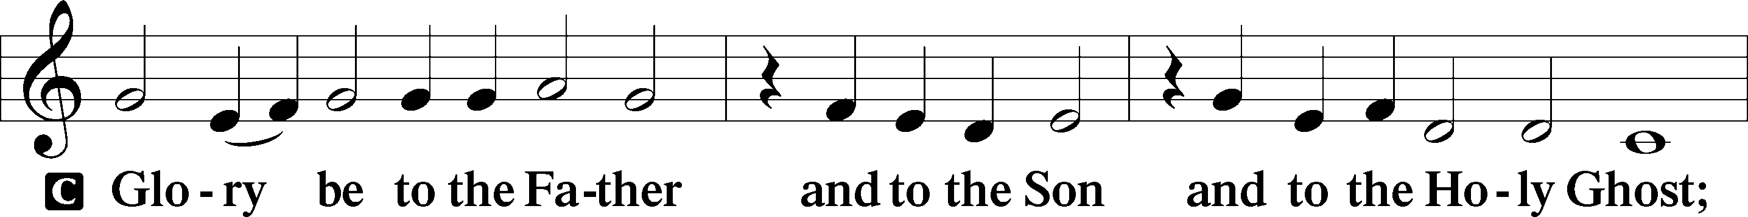
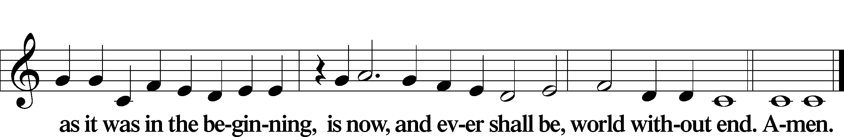

Kyrie Mark 10:47
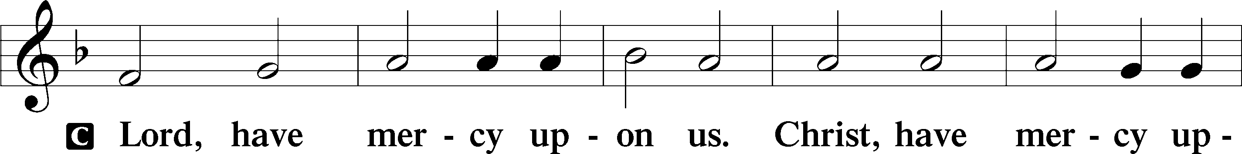
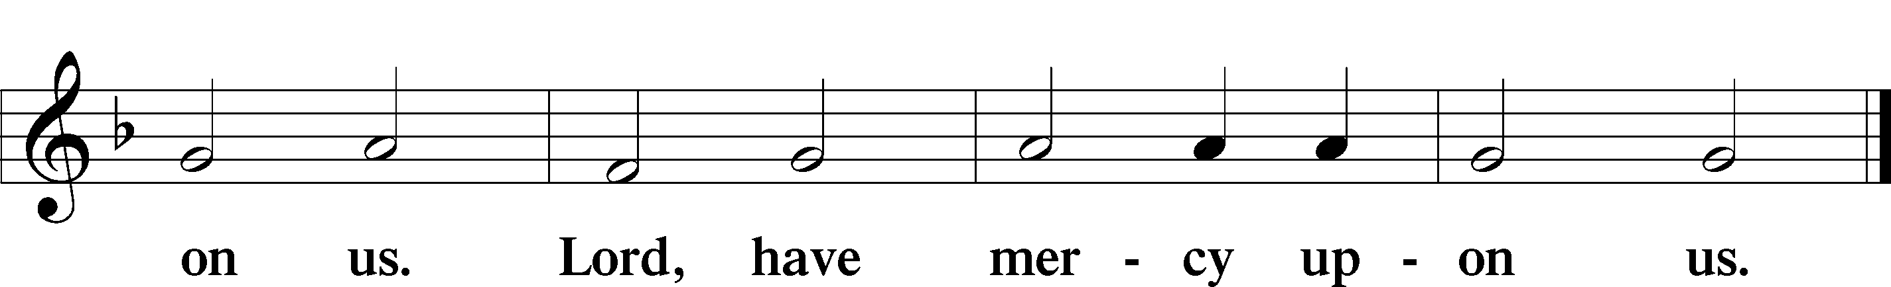

Gloria in Excelsis Luke 2:14; John 1:29
P Glory be to God on high:
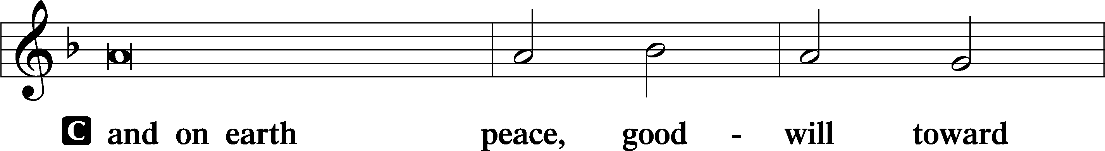
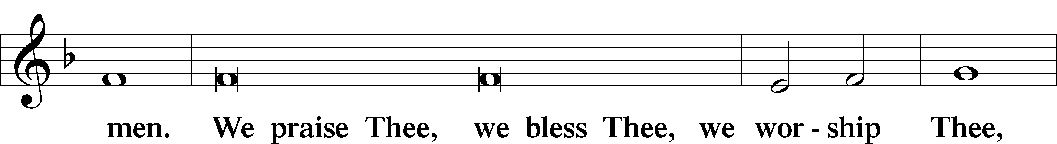
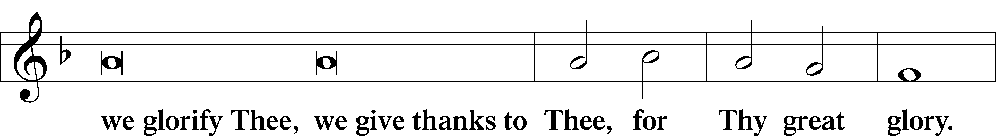
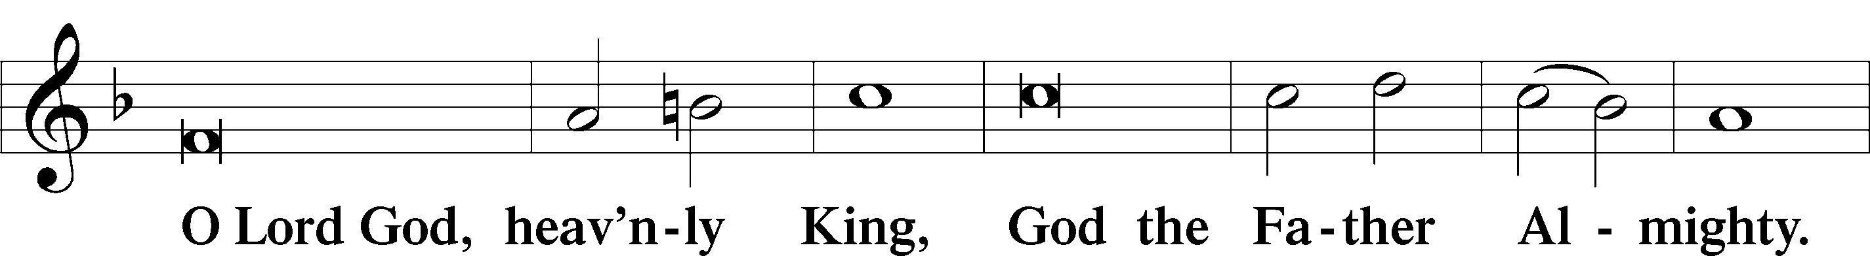
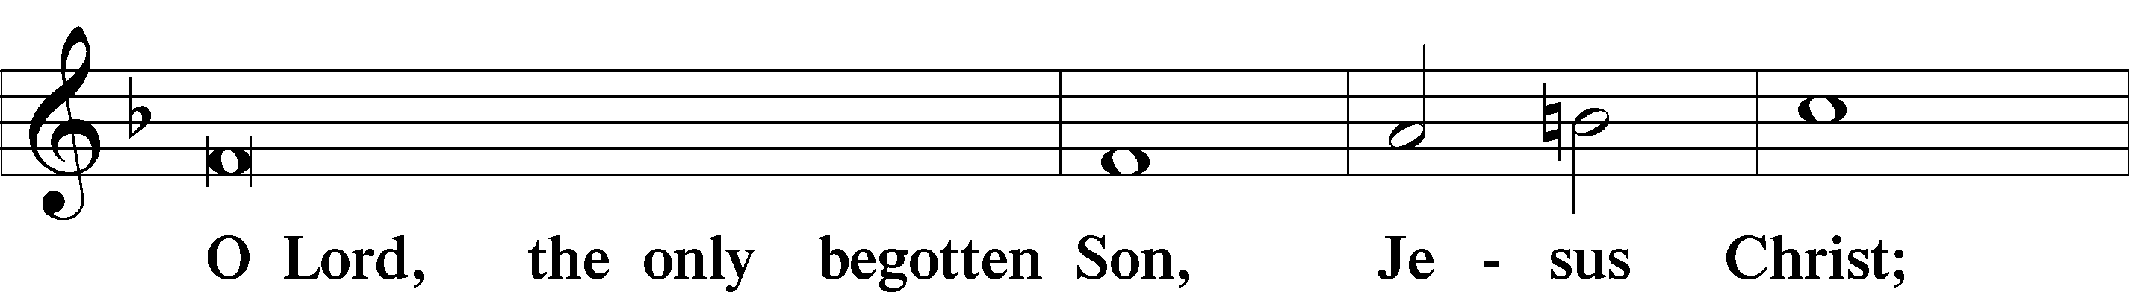
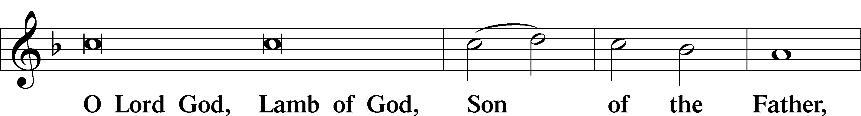
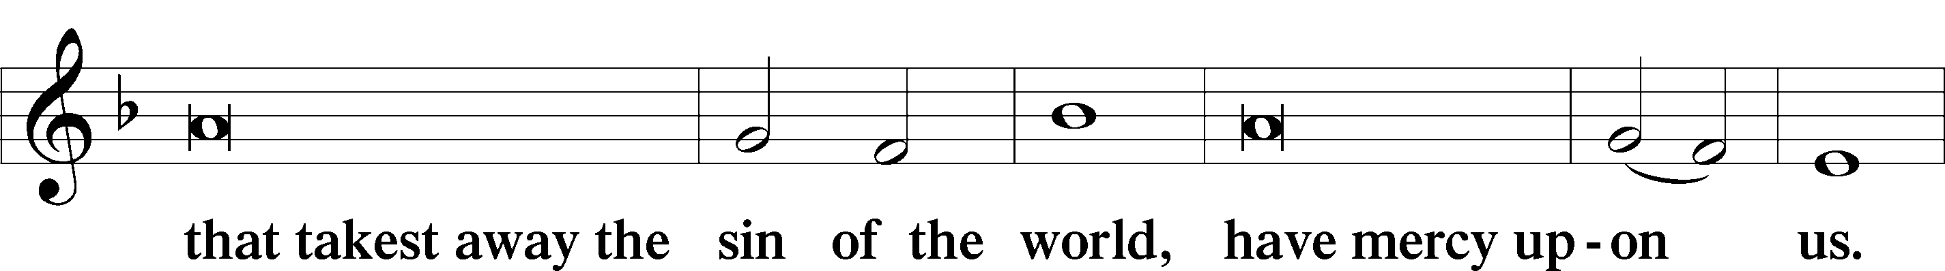
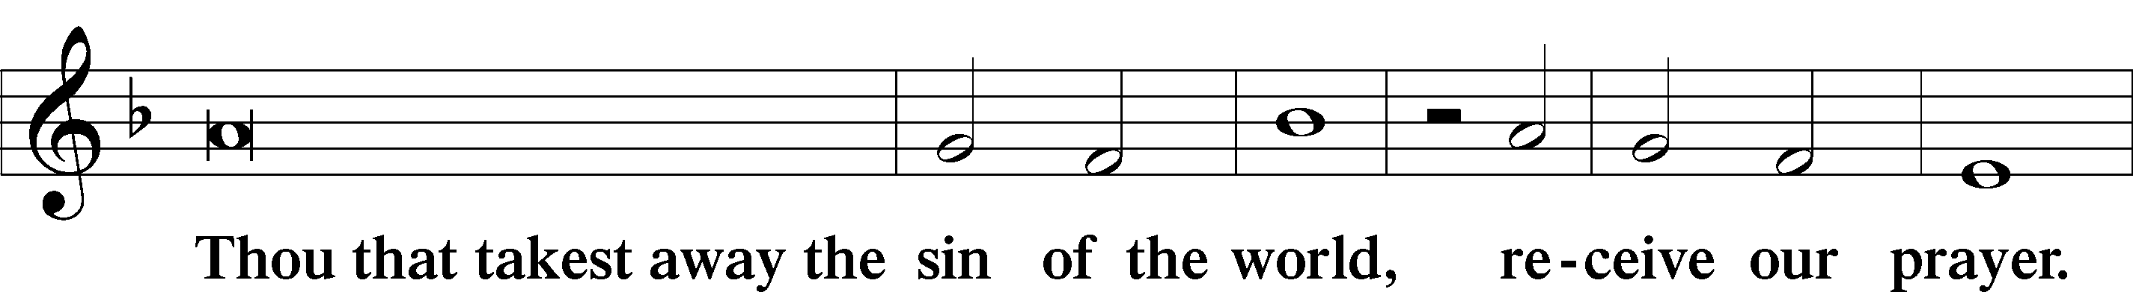
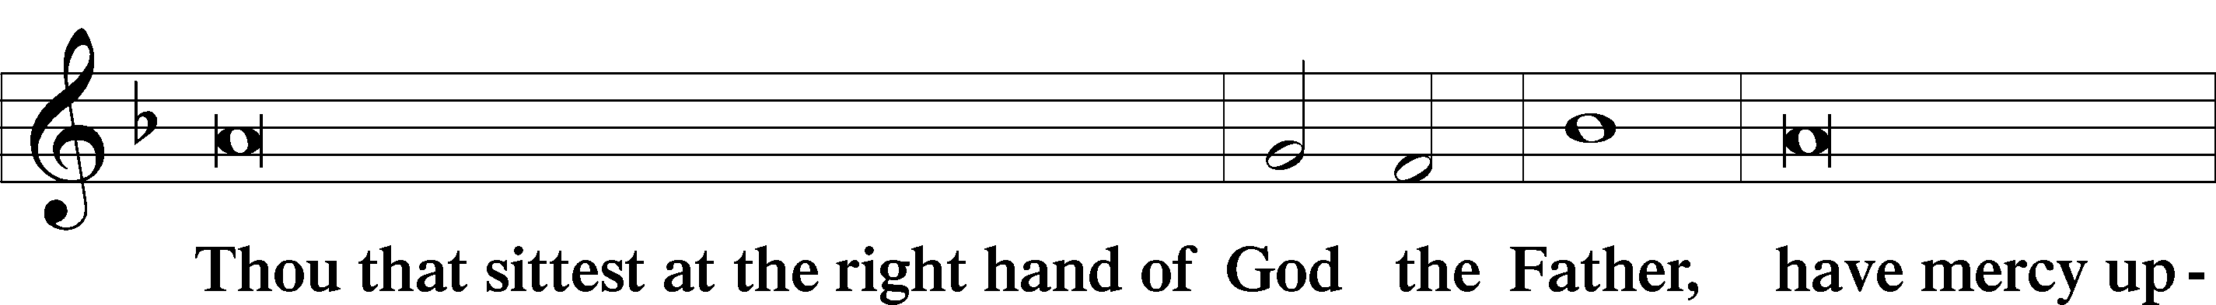
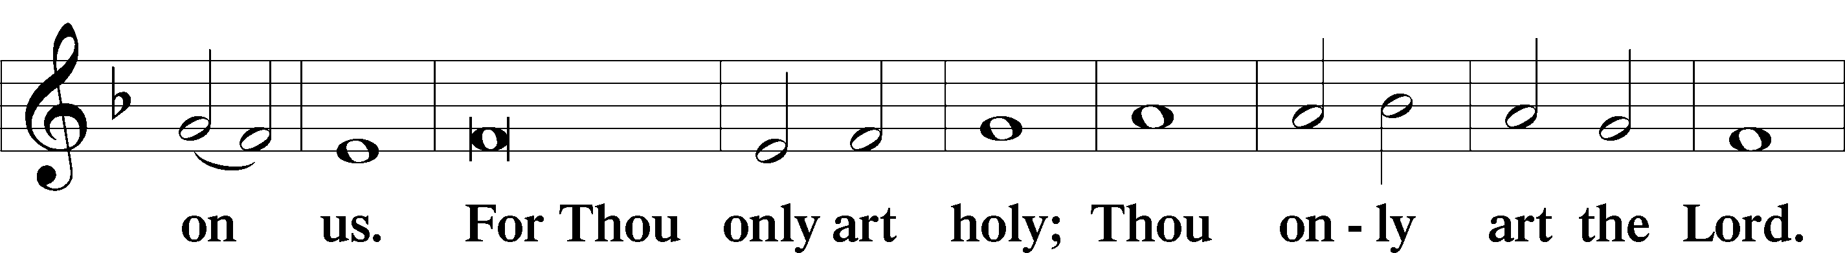
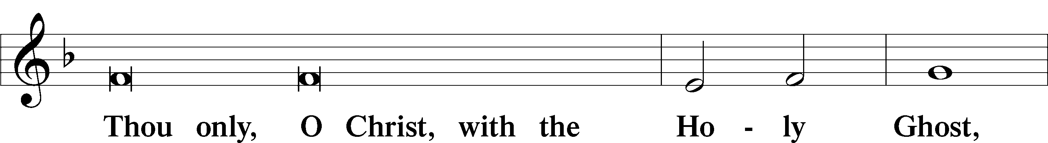
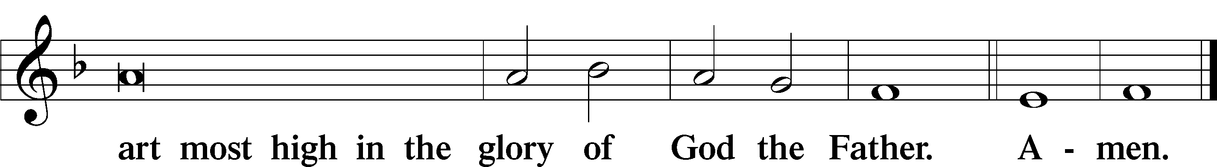

Salutation and Collect of the Day: Last Sunday of the Church Year
P The Lord be with you.
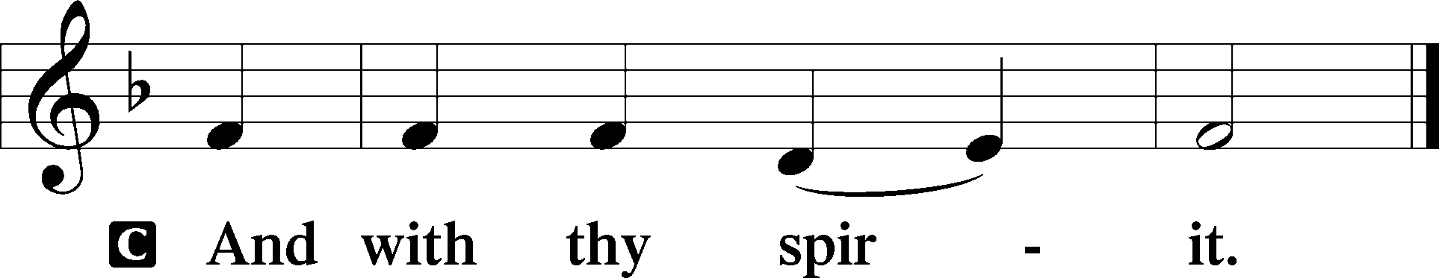

P Let us pray.
O Lord, absolve Your people from their offenses that, from the bonds of our sins which by reason of our frailty we have brought upon ourselves, we may be delivered by Your bountiful goodness; through Jesus Christ, Your Son, our Lord, who lives and reigns with You and the Holy Spirit, one God, now and forever.
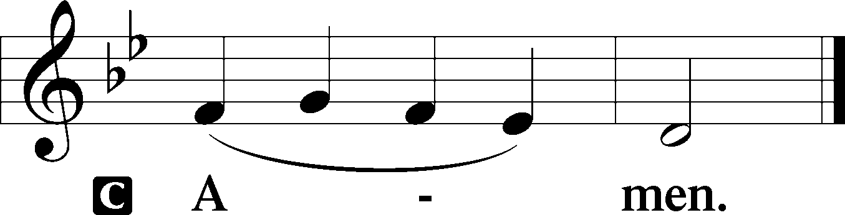
Sit

Prophecy: Isaiah 65:17–25 (NKJV)
Thus says the Lord God: “Behold, I create new heavens and a new earth; and the former shall not be remembered or come to mind. But be glad and rejoice forever in what I create; for behold, I create Jerusalem as a rejoicing, and her people a joy. I will rejoice in Jerusalem, and joy in My people; the voice of weeping shall no longer be heard in her, nor the voice of crying. No more shall an infant from there live but a few days, nor an old man who has not fulfilled his days; for the child shall die one hundred years old, but the sinner being one hundred years old shall be accursed. They shall build houses and inhabit them; they shall plant vineyards and eat their fruit. They shall not build and another inhabit; they shall not plant and another eat; for as the days of a tree, so shall be the days of My people, and My elect shall long enjoy the work of their hands. They shall not labor in vain, nor bring forth children for trouble; for they shall be the descendants of the blessed of the Lord, and their offspring with them. It shall come to pass that before they call, I will answer; and while they are still speaking, I will hear. The wolf and the lamb shall feed together, the lion shall eat straw like the ox, and dust shall be the serpent’s food. They shall not hurt nor destroy in all My holy mountain,” says the Lord Almighty.

P This is the Word of the Lord.
C Thanks be to God.

Gradual Psalm 45:14–15
In many-colored robes [the king’s daughter] is led | to the king,*
with her virgin companions following be- | hind her.
With joy and gladness they are | led along*
as they enter the palace | of the king.
Epistle: 1 Thessalonians 5:1–11 (NKJV)
Brethren: Concerning the times and the seasons, you have no need that I should write to you. For you yourselves know perfectly that the day of the Lord so comes as a thief in the night. For when they say, “Peace and safety!” then sudden destruction comes upon them, as labor pains upon a pregnant woman. And they shall not escape. But you, brethren, are not in darkness, so that this Day should overtake you as a thief. You are all sons of light and sons of the day. We are not of the night nor of darkness. Therefore let us not sleep, as others do, but let us watch and be sober. For those who sleep, sleep at night, and those who get drunk are drunk at night. But let us who are of the day be sober, putting on the breastplate of faith and love, and as a helmet the hope of salvation. For God did not appoint us to wrath, but to obtain salvation through our Lord Jesus Christ, who died for us, that whether we wake or sleep, we should live together with Him. Therefore comfort each other and edify one another, just as you also are doing.

P This is the Word of the Lord.
C Thanks be to God.
Stand

Verse Revelation 21:2
Alleluia. I saw the holy city, new Jerusalem, coming down out of heaven from God, prepared as a bride adorned for her husband. Alleluia.

Alleluia
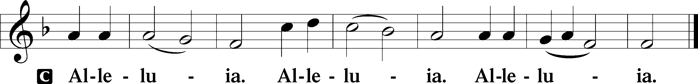

Holy Gospel: Matthew 25:1–13 (NKJV)
P The Holy Gospel according to St. Matthew, the twenty-fifth chapter.
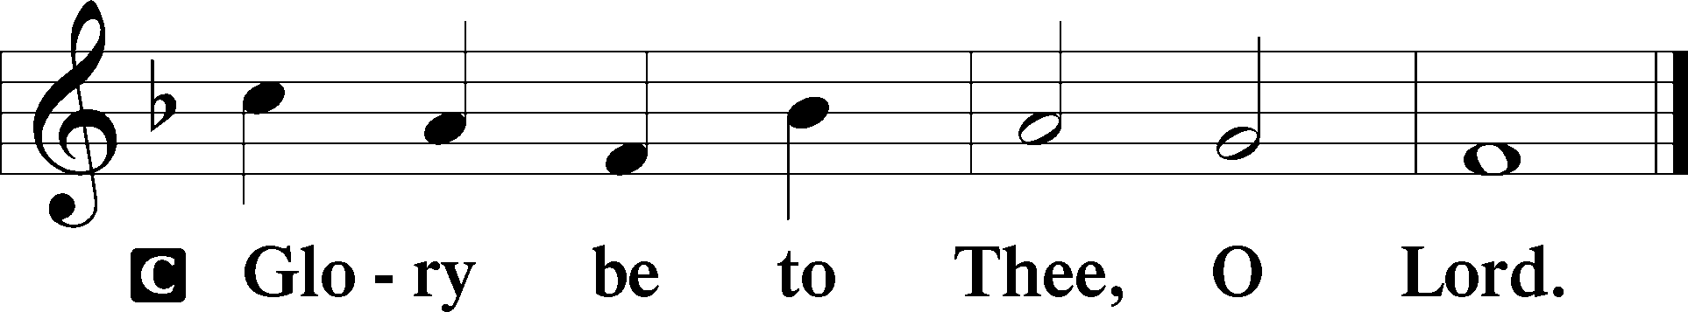
At that time Jesus spoke this parable to His disciples: “The kingdom of heaven shall be likened to ten virgins who took their lamps and went out to meet the bridegroom. Now five of them were wise, and five were foolish. Those who were foolish took their lamps and took no oil with them, but the wise took oil in their vessels with their lamps. But while the bridegroom was delayed, they all slumbered and slept. And at midnight a cry was heard: ‘Behold, the bridegroom is coming; go out to meet him!’ Then all those virgins arose and trimmed their lamps. And the foolish said to the wise, ‘Give us some of your oil, for our lamps are going out.’ But the wise answered, saying, ‘No, lest there should not be enough for us and you; but go rather to those who sell, and buy for yourselves.’ And while they went to buy, the bridegroom came, and those who were ready went in with him to the wedding; and the door was shut. Afterward the other virgins came also, saying, ‘Lord, Lord, open to us!’ But he answered and said, ‘Assuredly, I say to you, I do not know you.’ Watch therefore, for you know neither the day nor the hour in which the Son of Man is coming.”

P This is the Gospel of the Lord.
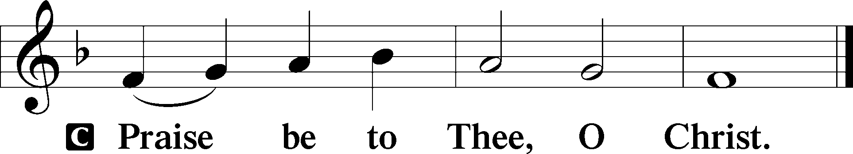

Nicene Creed
C I believe in one God,
the Father Almighty,
maker of heaven and earth
and of all things visible and invisible.

And in one Lord Jesus Christ,
the only-begotten Son of God,
begotten of His Father before all worlds,
God of God, Light of Light,
very God of very God,
begotten, not made,
being of one substance with the Father,
by whom all things were made;
who for us men and for our salvation came down from heaven
and was incarnate by the Holy Spirit of the virgin Mary
and was made man;
and was crucified also for us under Pontius Pilate.
He suffered and was buried.
And the third day He rose again according to the Scriptures
and ascended into heaven
and sits at the right hand of the Father.
And He will come again with glory to judge both the living and the dead,
whose kingdom will have no end.

And I believe in the Holy Spirit,
the Lord and giver of life,
who proceeds from the Father and the Son,
who with the Father and the Son together is worshiped and glorified,
who spoke by the prophets.
And I believe in one holy Christian and apostolic Church,
I acknowledge one Baptism for the remission of sins,
and I look for the resurrection of the dead
and the life T of the world to come. Amen.
Sit

Hymn of the Day: LSB #516 “Wake, Awake, for Night Is Flying”

Sermon

Stand

Offertory Psalm 51:10–12
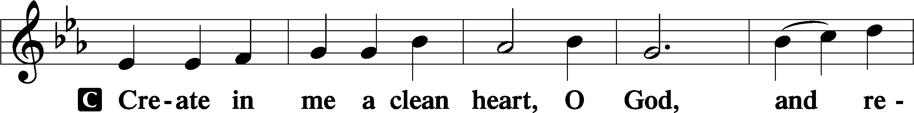
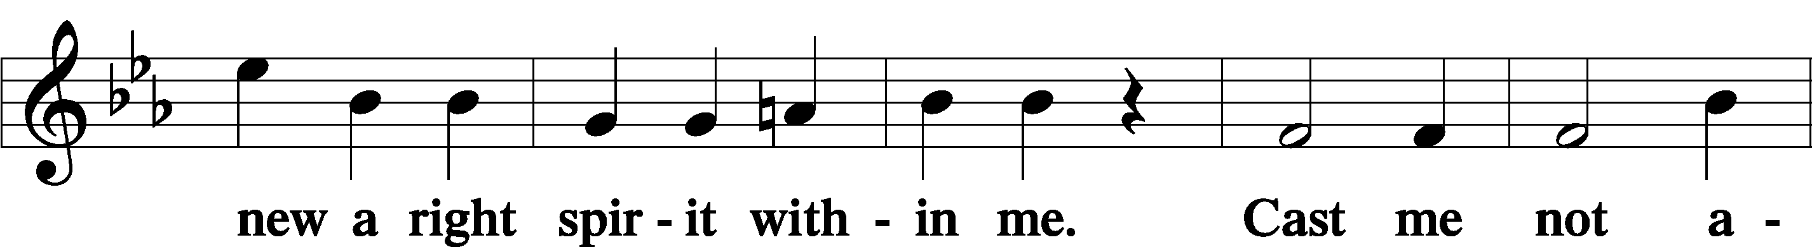
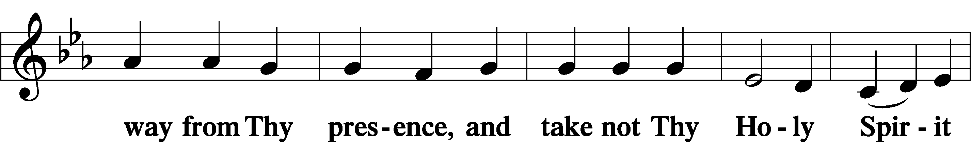
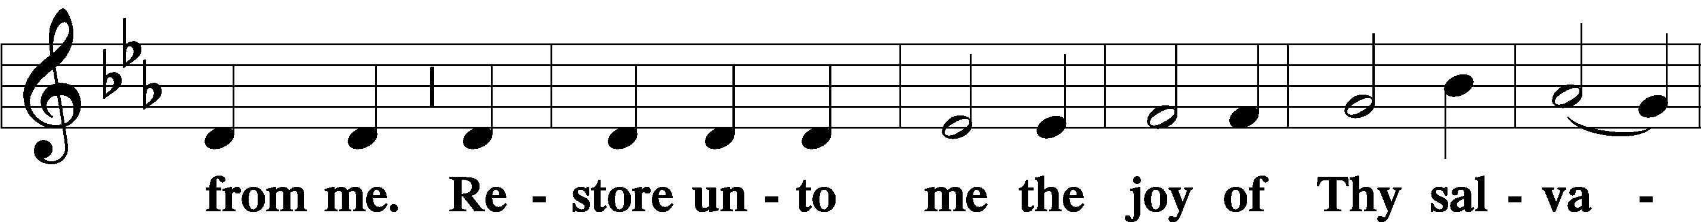
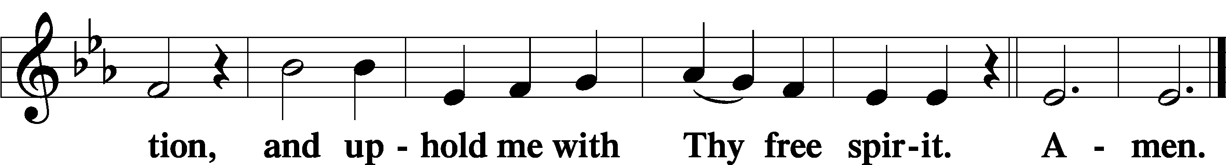

Prayer of the Church

Sit

Preparatory Hymn: LSB #663 “Rise, My Soul, to Watch and Pray”

Stand
Service of the Sacrament

Preface 2 Timothy 4:22; Colossians 3:1 Psalm 136
P The Lord be with you.
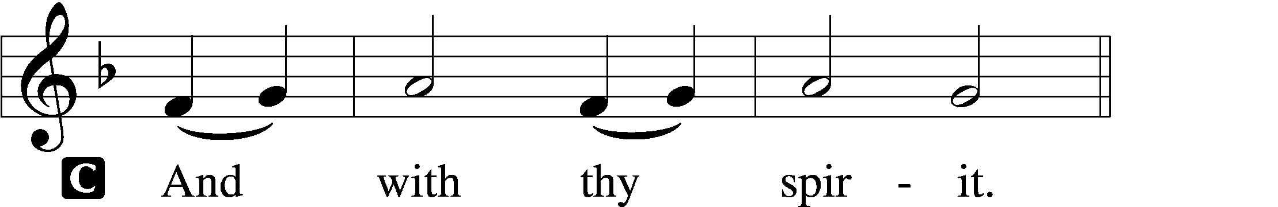

P Lift up your hearts.
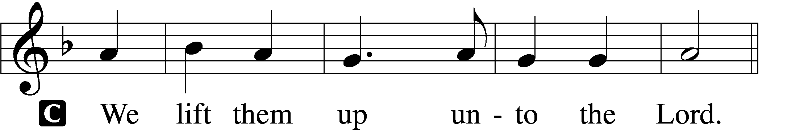

P Let us give thanks unto the Lord, our God.
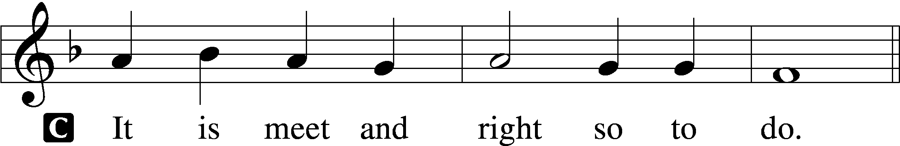
Proper Preface (Abbreviated) LSB 194
P It is truly meet, right, and salutary . . . evermore praising You and saying:

Sanctus Isaiah 6:3; Matthew 21:9
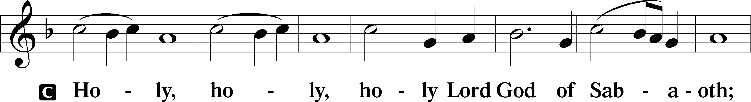
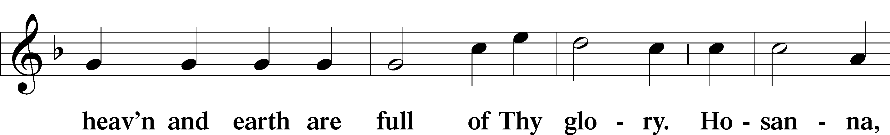
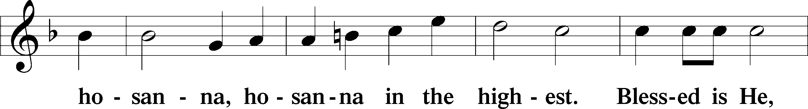
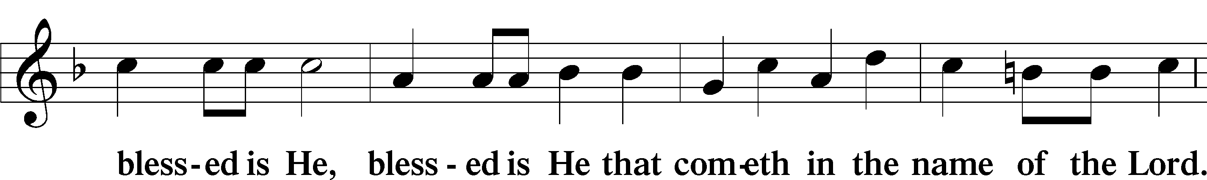
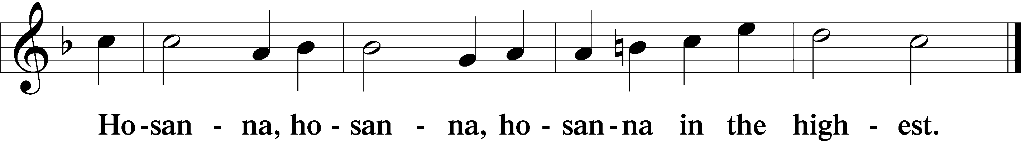

Lord’s Prayer The congregation is encouraged to silently pray the Lord’s Prayer as it is chanted. Matthew 6:9–13
P Our Father who art in heaven,
hallowed be Thy name,
Thy kingdom come,
Thy will be done on earth as it is in heaven;
give us this day our daily bread;
and forgive us our trespasses as we forgive those who trespass against us;
and lead us not into temptation,
but deliver us from evil.
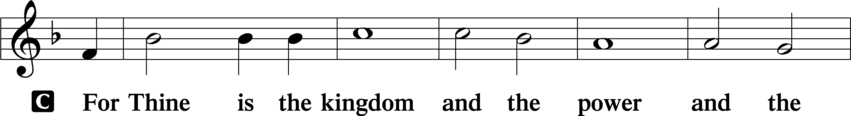
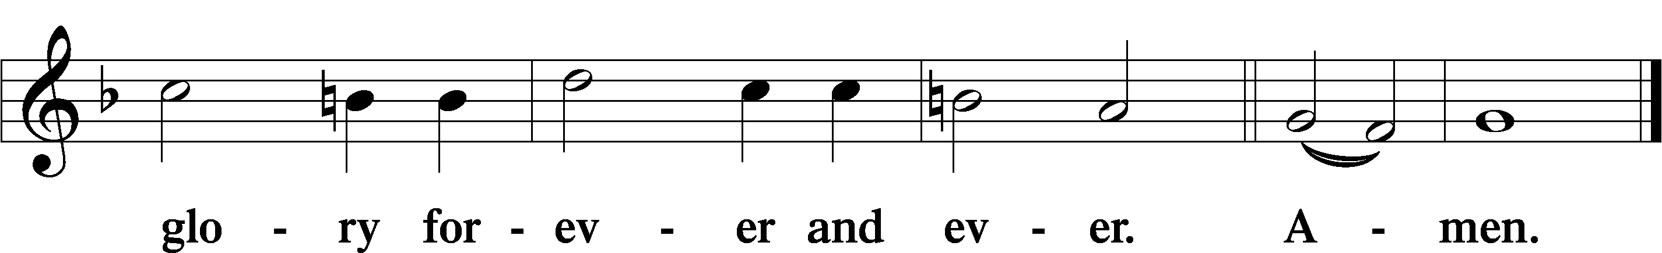

The Words of Our Lord Matthew 26:26–28; Mark 14:22–24; Luke 22:19–20; 1 Corinthians 11:23–25
P Our Lord Jesus Christ, on the night when He was betrayed, took bread, and when He had given thanks, He broke it and gave it to the disciples and said: “Take, eat; this is My T body, which is given for you. This do in remembrance of Me.”

In the same way also He took the cup after supper, and when He had given thanks, He gave it to them, saying: “Drink of it, all of you; this cup is the new testament in My T blood, which is shed for you for the forgiveness of sins. This do, as often as you drink it, in remembrance of Me.”

Pax Domini John 20:19
P The peace of the Lord be with you always.
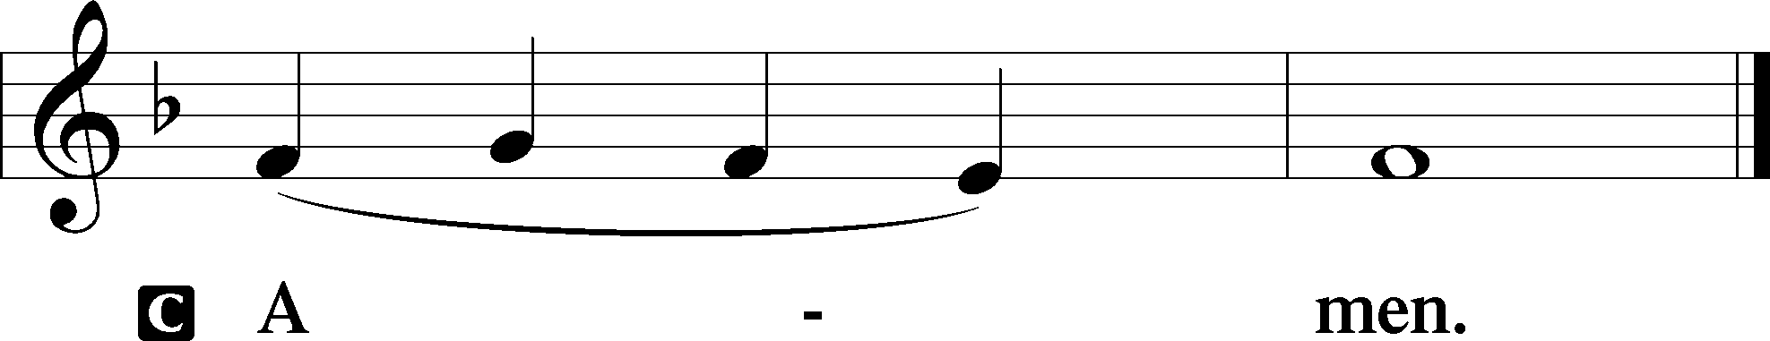

Agnus Dei John 1:29
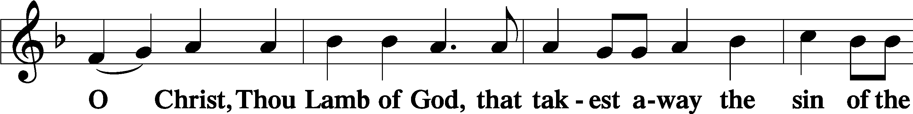
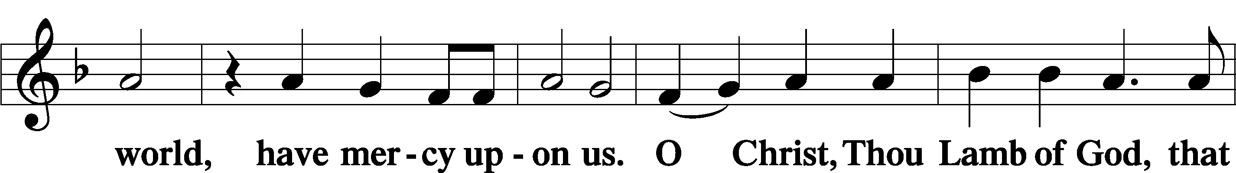
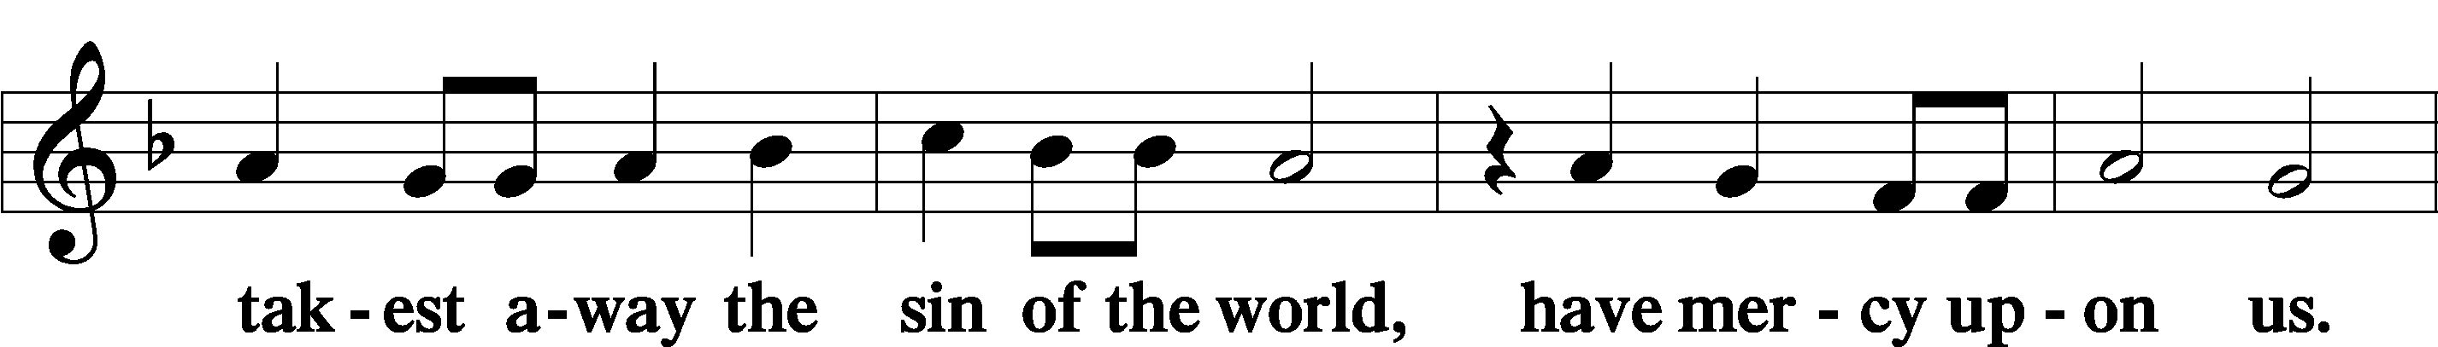
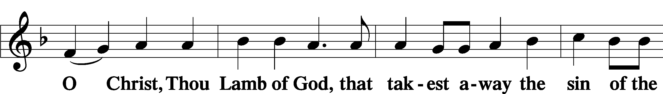
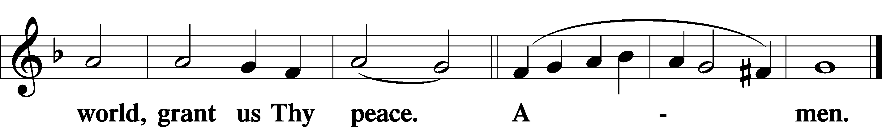
Sit
Distribution
The pastor and those who assist him receive the body and blood of Christ first and then distribute them to those who come to receive, saying:
Take, eat; this is the true body of our Lord and Savior Jesus Christ, given into death for your sins.
Amen.

Take, drink; this is the true blood of our Lord and Savior Jesus Christ, shed for the forgiveness of your sins.
Amen.

In dismissing the communicants, the following is said:
The Dismissal
P The body and blood of our Lord Jesus Christ strengthen and preserve you in body and soul to life everlasting. Depart T in peace.
C Amen.

Distribution Hymn: LSB #620 “Jesus Comes Today with Healing”

Distribution Hymn: LSB #639 “Wide Open Stand the Gates”

Distribution Hymn: LSB #672 “Jerusalem the Golden”

Nunc Dimittis Luke 2:29–32
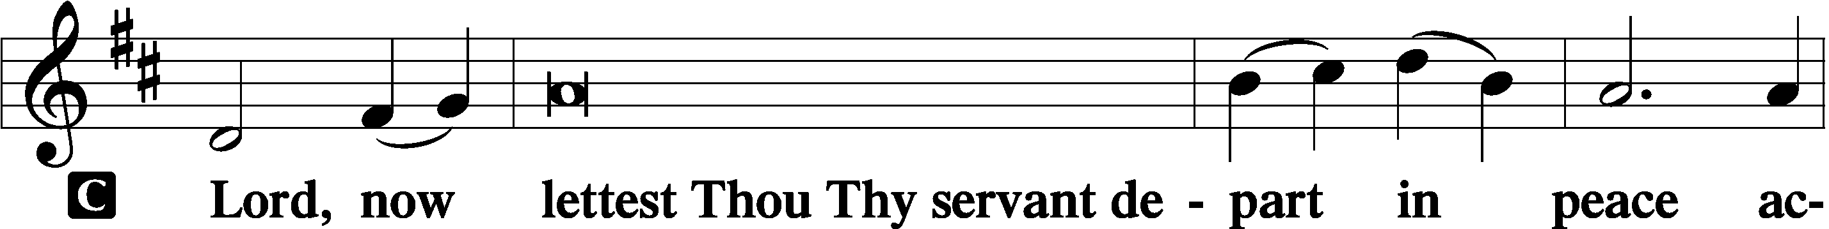
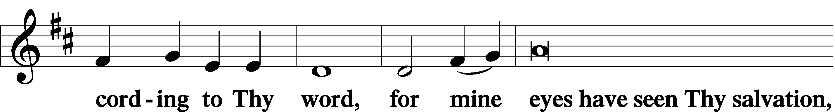
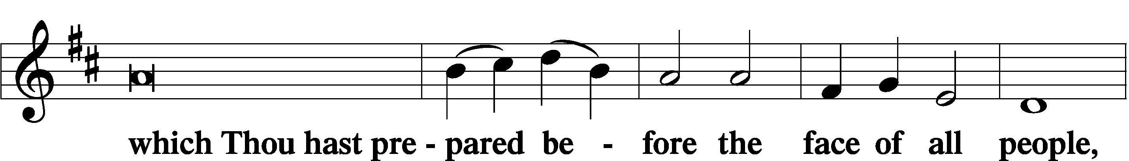
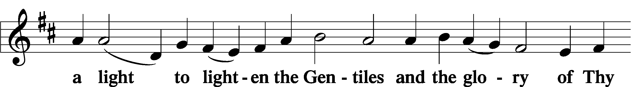
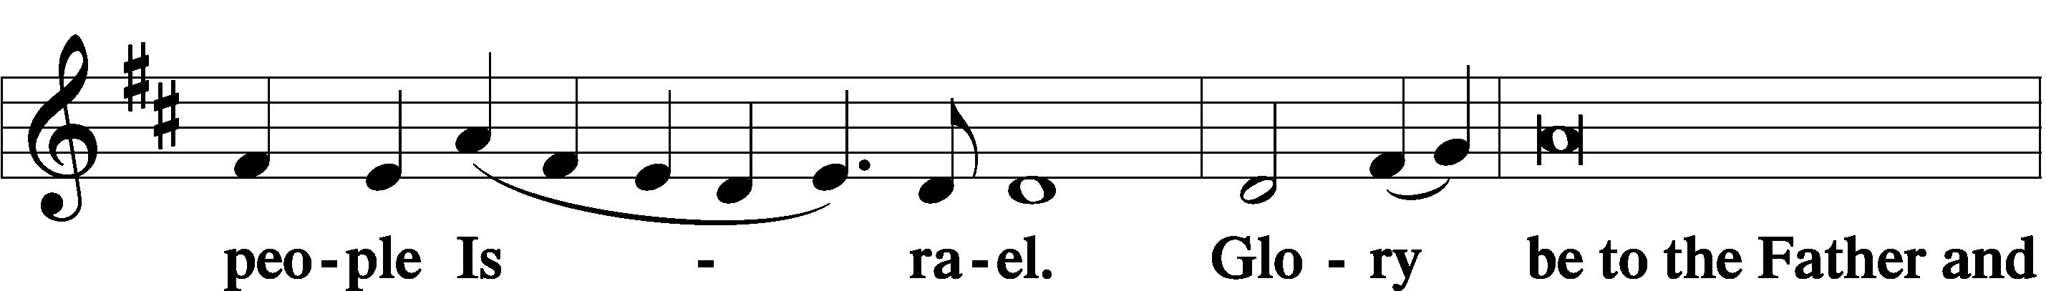
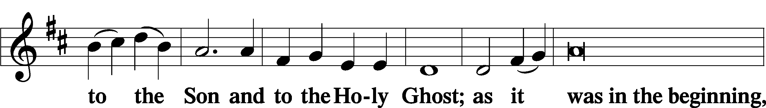
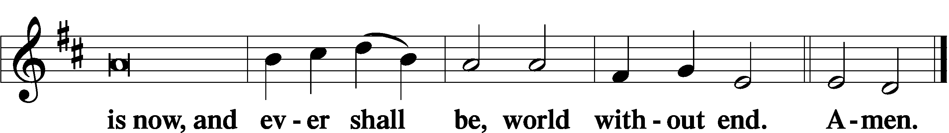

Thanksgiving Psalm 107:1
P O give thanks unto the Lord, for He is good,
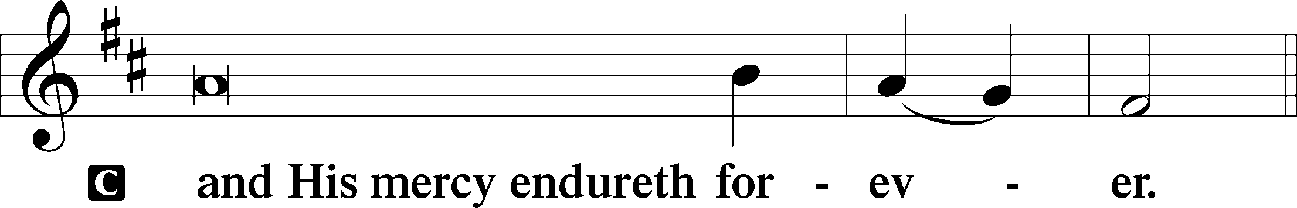

Post-Communion Collect
P Let us pray.
We give thanks to You, almighty God, that You have refreshed us through this salutary gift, and we implore You that of Your mercy You would strengthen us through the same in faith toward You and in fervent love toward one another; through Jesus Christ, Your Son, our Lord, who lives and reigns with You and the Holy Spirit, one God, now and forever.
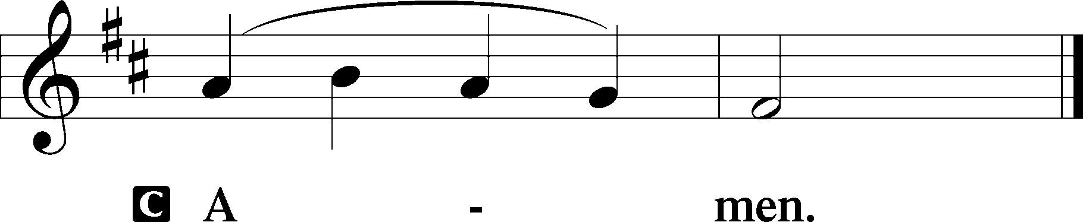

Salutation 2 Timothy 4:22
P The Lord be with you.
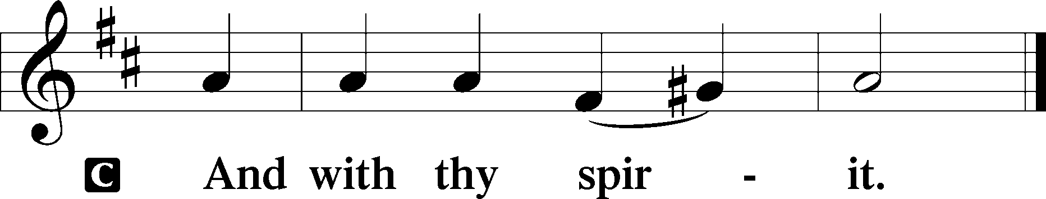

Benedicamus Psalm 103:1
P Bless we the Lord.
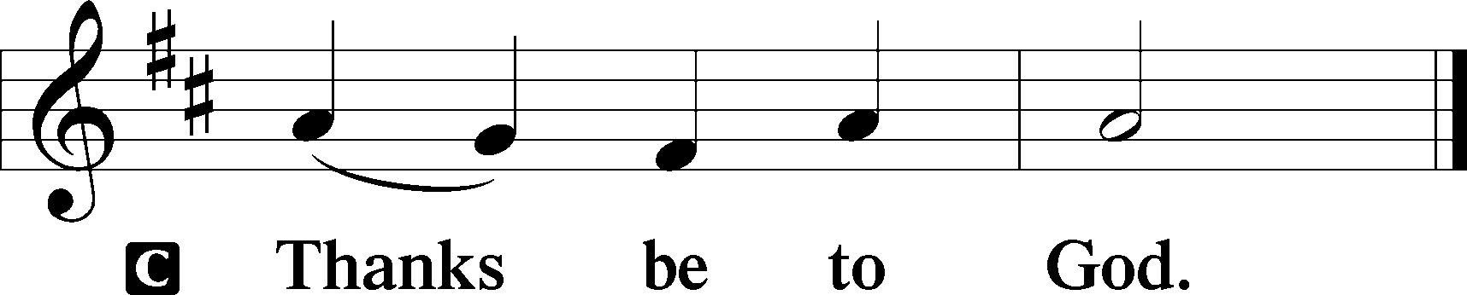

Benediction Numbers 6:24–26
P The Lord bless you and keep you.
The Lord make His face shine upon you and be gracious unto you.
The Lord lift up His countenance upon you and T give you peace.
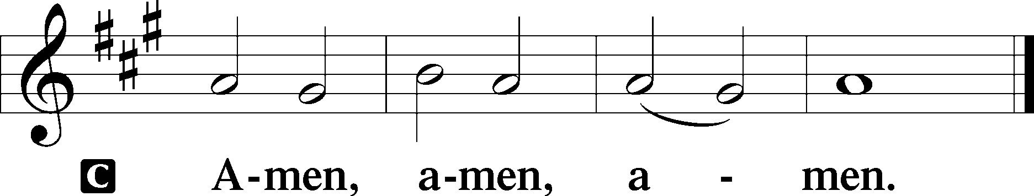

Closing Hymn: LSB #515 “Rejoice, Rejoice, Believers”
fffffffffffffffffffffffffffffffffff
Silent prayer after worship: Heavenly Father, enable me to daily live in Christ with a true faith so that I can be ready for the day He comes to deliver me from this life and to grant me everlasting life with You. In Jesus’ name. Amen.
fffffffffffffffffffffffffffffffffff
Acknowledgments
Unless otherwise indicated, Scripture quotations are from the ESV® Bible (The Holy Bible, English Standard Version®), copyright © 2001 by Crossway, a publishing ministry of Good News Publishers. Used by permission. All rights reserved.
Created by Lutheran Service Builder © 2023 Concordia Publishing House.
fffffffffffffffffffffffffffffffffff

fffffffffffffffffffffffffffffffffff
In Loving Memory of Mother, Betty Petro, and Husband, Larry Parker: Patty Parker (Capital Campaign).
fffffffffffffffffffffffffffffffffff

SCHEDULE THROUGH DECEMBER 3, 2023:

:

Today, following Worship, Fellowship Hall: Church Council Meeting
Following Worship, Library: Audit of Monthly Deposits
7 pm, Fellowship Hall: AA Meeting
Tuesday, 7-9 pm, Fellowship Hall: Penn-Ohio Singers
Wednesday, 7:30 pm, Fellowship Hall: NA Meeting
Thursday, 10 am, Fellowship Hall: Women’s Bible Study
7 pm, Sanctuary: Divine Service Celebrating the Feast of St. Andrew, Apostle
Next Sunday, 8 am, Fellowship Hall: Bible Study
9 am, Sanctuary: Divine Service
Following Worship, Fellowship Hall: Voters’ Assembly
7 pm, Fellowship Hall: AA Meeting
fffffffffffffffffffffffffffffffffff
Attendance: Sunday, November 19, 2023: 41
fffffffffffffffffffffffffffffffffff
THANK YOU FOR SERVING IN NOVEMBER: Elder: Jonathan Baisch; Ushers: Mark Kleindienst, Jerry Krivosh, & Gordon Marquette; Altarware ~ Sundays: Diane Riefstahl; (after) Evelyn Baisch & Arlene Sutton; Special Divine Service: Nov. 30th ~ Elizabeth Haenftling.
fffffffffffffffffffffffffffffffffff
Poinsettia order forms are available on the tables in the narthex and next to the nursery. Forms and payment are due to the secretary’s office no later than next Sunday, December 3rd.
fffffffffffffffffffffffffffffffffff
The December issue of “The Rock and the Sword” newsletter is available this morning on the tables in the narthex and next to the nursery.
Our Stewardship of Treasures for the Lord:
In order to do the Lord’s work, we need $2,553.63 each week to meet our 2023 budget for general purposes and $76.92 for the SELC.

Figures for Sunday, November 12, 2023
General Fund: $1,364.00
SELC: $0.00
Food Pantry: $0.00
Quarterly Missions: $0.00
Capital Campaign: $1,531.00
Other: $71.00

For online giving, check out https://www.saintspeterandpaul.net/online-giving.
fffffffffffffffffffffffffffffffffff
Bible Memory Verses ~ Week of November 26th:
For Adults: But since we belong to the day, let us be sober, having put on the breastplate of faith and love, and for a helmet the hope of salvation.
1 Thessalonians 5:8

For Children: Stay dressed for action and keep your lamps burning.
Luke 12:35
fffffffffffffffffffffffffffffffffff
Advent Midweek Services will begin Wednesday, December 6th. Two services will be offered this year: a 10 am Matins Service and a 7 pm Vesper Service. This year’s theme will focus on Christ in the Old Testament, “The Seen Yahweh”.
fffffffffffffffffffffffffffffffffff
Important: A Voters’ Assembly will be held this morning in the Fellowship Hall 10 minutes following the conclusion of worship. Your attendance will be greatly appreciated at this meeting. Among items to be discussed are the 2024 Church Budget and the election of 2024 Church Officers and Boards. Copies of the tentative agenda and proposed budget are on the table in the narthex.
fffffffffffffffffffffffffffffffffff
At our last session, the Women’s Bible Study group agreed to meet this Thursday, November 30th at 10 am. We will be taking a hiatus during the month of December.
Remember the following in Prayer…
~The Hurting and Healing: Amy, Steve Antolovich, Ellen Baron^{CA}, Amy Blomenberg, Lois Bortner^{CA}, Sara Brubaker, Dee Bullock, Bev & Joe Chlpka, Susan Davies, Loretta Deal, Tim Dudash, Judith & Eddy Furey, Griffin, Austin Hamilton, Pastor Charles Henrickson, Joan, Keith Jozwiakowski, Darla Krajci, Barbara Kreske, Jess Lavoie, Paul Lucas^{CA}, Sandy Marshall, Frank Niemeyer^{CA}, Juanita Rentschler, Richard Reuning^{CA}, Nancy Robertson^{CA}, Kriss Svidro^{CA}, Rudy Tomko, Joel & Peggy Wasson, Angela Weser^{CA}, Betty Wolf, and Ruth Wolf.
~The Homebound: Anna Mae Daris, Millie Elavsky, Jean Tomko, and Ed & Millie Zachar.
~Celebrating this Week: Birthdays: Elizabeth Shreffler (11.26) and Paul Andolina (11.29).
~Serving in the Military: Alex (Sasha) Carr, Duncan Vaupel, Curtis Sinewe, and Joshua Solyan.
~Community & World Needs: Those suffering due to the conflicts in the Middle East and between Ukraine and Russia; those suffering from loss and dislocation because weather disasters; those suffering from addiction and their families; Local, State, and National Government Leaders; safety for all Police Officers, Firefighters, & First Responders; the unemployed; our Fourth Quarter Local Mission: Willow Women’s Center.
*CA represents cancer.
fffffffffffffffffffffffffffffffffff
Altar Guild members are encouraged to sign up on the cookie donation sheet which is available on the table in the narthex for bringing 1-2 dozen cookies (no more, please) to the Coffee Fellowship, Sunday, December 10th.
Also available on the table are the 2024 “How May I Serve” sheets. If you haven’t already done so, please return yours to Marie Flaugher ASAP.
fffffffffffffffffffffffffffffffffff
Copies of the 2023 Advent Devotions, “The Seen Yahweh”, are available on the tables in the narthex and next to the nursery. Feel free to take one for a friend!
fffffffffffffffffffffffffffffffffff

Here to Serve
Pastor………………………………………………...……………Rev. Jacob Deal
E-mail …………………………….……pastordeal@saintspeterandpaul.net
Phone Number……………………..…………………724-347-3620 (Option 2)
Church Office………………………..…………………724-347-3620 (Option 3)
Website …………………………………………www.saintspeterandpaul.net
Secretary…………………………………………………………Diane Riefstahl
E-mail ………………………………………church@saintspeterandpaul.net
Website …………………………………………www.saintspeterandpaul.net
Food Pantry (email): ……………foodpantry@saintspeterandpaul.net
Congregation President………………………………….…Jonathan Baisch
Church Elder …………………………………………...……. Jonathan Baisch
Organist………………………………………………..….…Rebecca Marquette
AA Contact: Steve………………………………………………...…724-813-2358
NA Contact: Larry……………………………………..…………..724-977-8733
fffffffffffffffffffffffffffffffffff
If needing to get into the church building during the week, please phone first to make certain someone is here to let you in.

