Sts. Peter & Paul
Evangelical Lutheran Church
Lutheran Church-Missouri Synod
Founded-1917

NOVEMBER 22, 2023

699 Stambaugh Avenue
Sharon, Pennsylvania 16146

“I was glad when they said to me,
Let us go to the house of the LORD!”
Psalm 122:1
Sts. Peter & Paul Evangelical Lutheran Church, LC-MS

THANKSGIVING EVE
November 22, 2023

Silent prayer before worship: Dear Jesus, my Lord and my God, You have invited me to worship in Your house. Help me to worship You with all of my heart and soul, and to keep in mind that one day You will invite me to worship forever at Your side in heaven. Amen.
fffffffffffffffffffffffffffffffffff

VESPERS
Lutheran Service Book pp 229-234

Opening Hymn: LSB #803 “Joyful, Joyful We Adore Thee”

Stand

Common Versicles

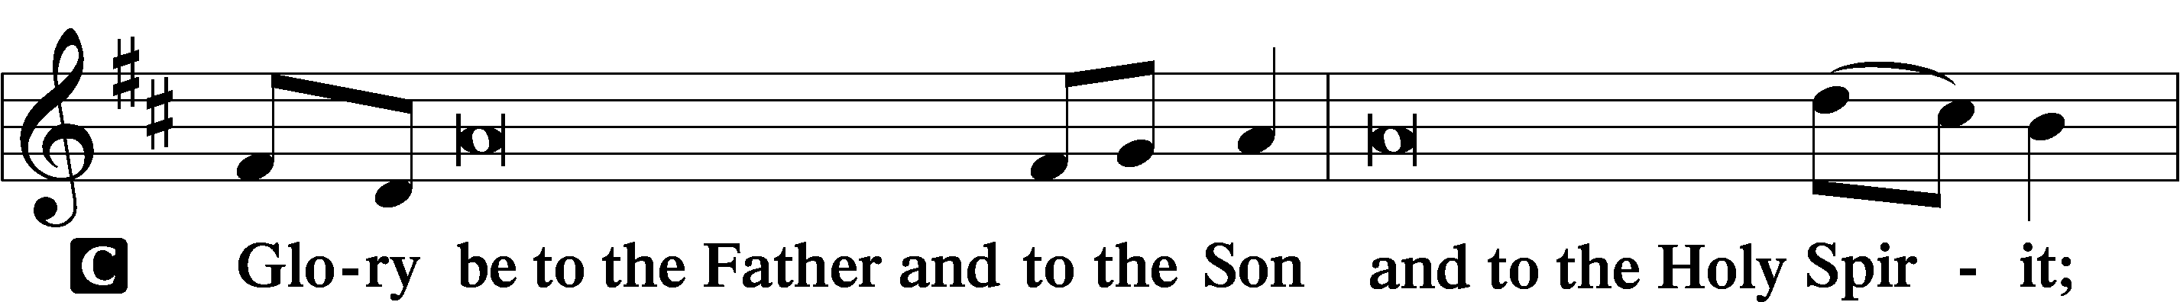
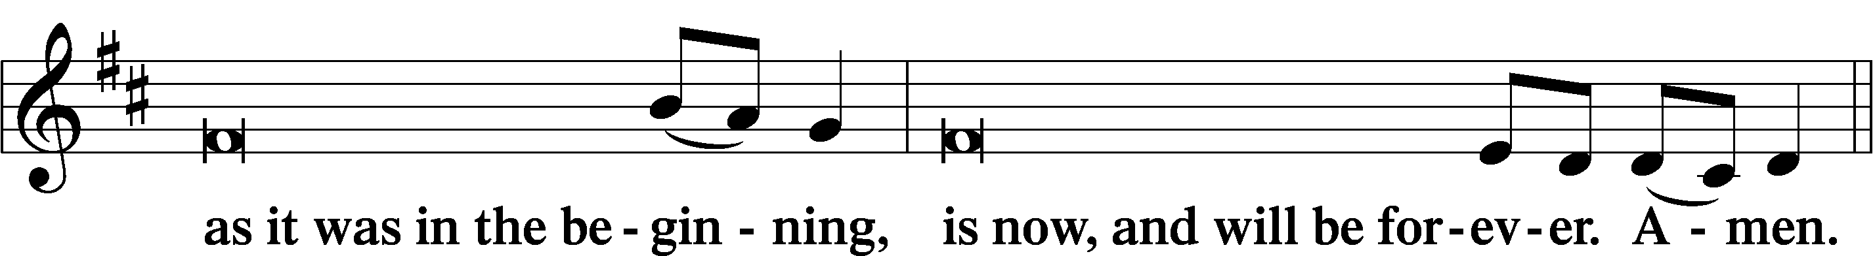
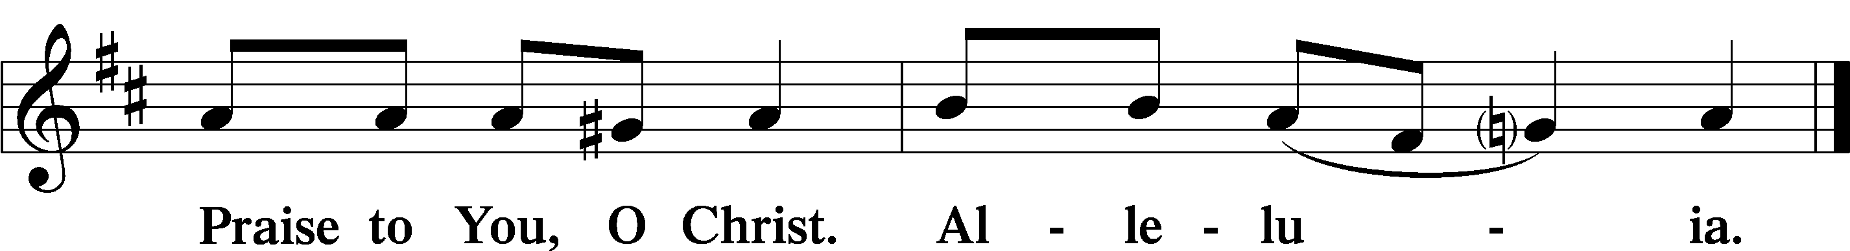

Psalmody

Psalm: Psalm 67 (Read responsively.)
P May God be gracious to us and bless us
and make his face to shine upon us,
C that your way may be known on earth,
your saving power among all nations.
Let the peoples praise you, O God;
let all the peoples praise you!
Let the nations be glad and sing for joy,
for you judge the peoples with equity
and guide the nations upon earth.
Let the peoples praise you, O God;
let all the peoples praise you!
The earth has yielded its increase;
God, our God, shall bless us.
God shall bless us;
let all the ends of the earth fear him!
Sit

Hymn of the Day: LSB #820 “My Soul, Now Praise Your Maker”

Readings

Prophecy: Deuteronomy 8:1–10 (NKJV)
P A reading from Deuteronomy, chapter 8.

“Every commandment which I command you today you must be careful to observe, that you may live and multiply, and go in and possess the land of which the Lord swore to your fathers. And you shall remember that the Lord your God led you all the way these forty years in the wilderness, to humble you and test you, to know what was in your heart, whether you would keep His commandments or not. So He humbled you, allowed you to hunger, and fed you with manna which you did not know nor did your fathers know, that He might make you know that man shall not live by bread alone; but man lives by every word that proceeds from the mouth of the Lord. Your garments did not wear out on you, nor did your foot swell these forty years. You should know in your heart that as a man chastens his son, so the Lord your God chastens you.

“Therefore you shall keep the commandments of the Lord your God, to walk in His ways and to fear Him. For the Lord your God is bringing you into a good land, a land of brooks of water, of fountains and springs, that flow out of valleys and hills; a land of wheat and barley, of vines and fig trees and pomegranates, a land of olive oil and honey; a land in which you will eat bread without scarcity, in which you will lack nothing; a land whose stones are iron and out of whose hills you can dig copper. When you have eaten and are full, then you shall bless the Lord your God for the good land which He has given you.

P O Lord, have mercy on us.
C Thanks be to God.

Epistle: 1 Timothy 2:1–4 (NKJV)
P A reading from 1 Timothy, chapter 2.

Brethren: Therefore I exhort first of all that supplications, prayers, intercessions, and giving of thanks be made for all men, for kings and all who are in authority, that we may lead a quiet and peaceable life in all godliness and reverence. For this is good and acceptable in the sight of God our Savior, who desires all men to be saved and to come to the knowledge of the truth.

P O Lord, have mercy on us.
C Thanks be to God.

Gospel: Luke 17:11–19 (NKJV)
P A reading from Luke, chapter 17.

Now it happened as He went to Jerusalem that He passed through the midst of Samaria and Galilee. Then as He entered a certain village, there met Him ten men who were lepers, who stood afar off. And they lifted up their voices and said, “Jesus, Master, have mercy on us!”

So when He saw them, He said to them, “Go, show yourselves to the priests.” And so it was that as they went, they were cleansed.

And one of them, when he saw that he was healed, returned, and with a loud voice glorified God, and fell down on his face at His feet, giving Him thanks. And he was a Samaritan.

So Jesus answered and said, “Were there not ten cleansed? But where are the nine? Were there not any found who returned to give glory to God except this foreigner?” And He said to him, “Arise, go your way. Your faith has made you well.”

P O Lord, have mercy on us.
C Thanks be to God.

Responsory LSB 230
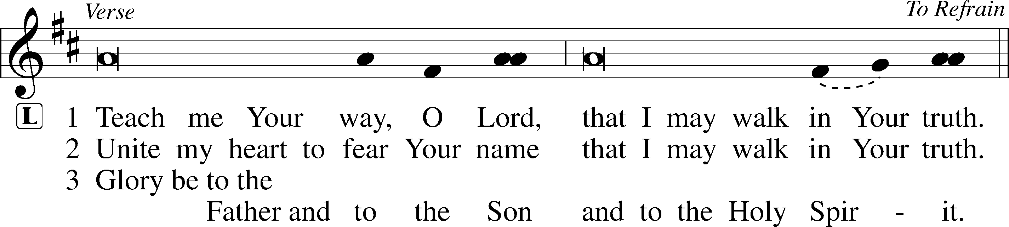
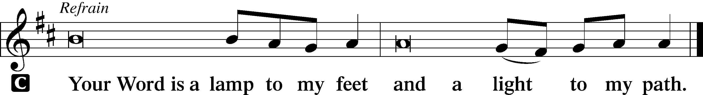

Sermon
Canticle
Stand
Antiphon
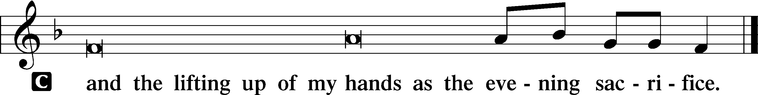

Hymn of Praise: LSB #933 “My Soul Rejoices”
Prayer

Kyrie LSB 233
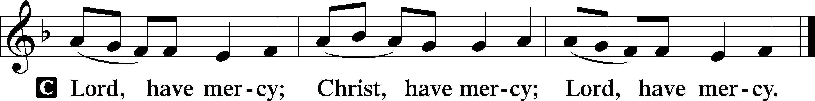

Lord’s Prayer
C Our Father who art in heaven,
hallowed be Thy name,
Thy kingdom come,
Thy will be done on earth as it is in heaven;
give us this day our daily bread;
and forgive us our trespasses as we forgive those who trespass against us;
and lead us not into temptation,
but deliver us from evil.
For Thine is the kingdom and the power and the glory forever and ever. Amen.

Collects
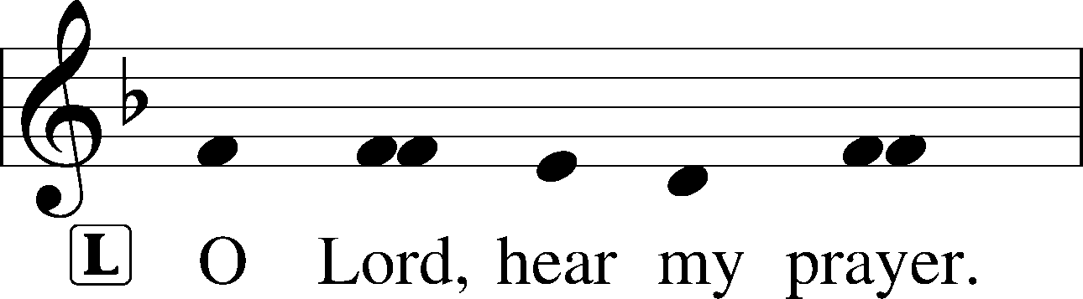
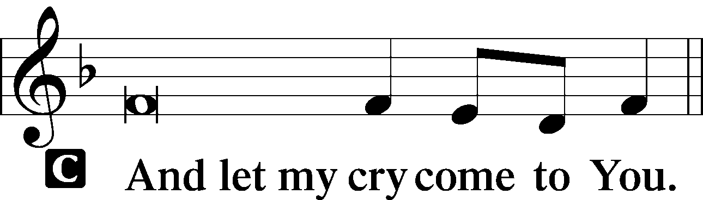

Collect of the Day
P Stir up, O Lord, the wills of Your faithful people that they, plenteously bringing forth the fruit of good works, may by You be plenteously rewarded; through Jesus Christ, Your Son, our Lord, who lives and reigns with You and the Holy Spirit, one God, now and forever.
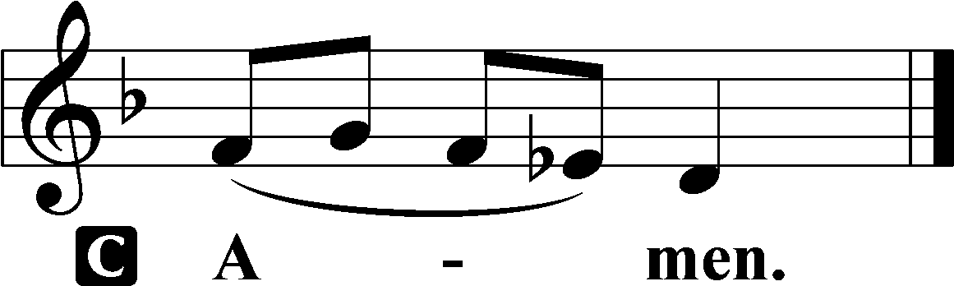

Collect for Peace
P O God, from whom come all holy desires, all good counsels, and all just works, give to us, Your servants, that peace which the world cannot give, that our hearts may be set to obey Your commandments and also that we, being defended from the fear of our enemies, may live in peace and quietness; through Jesus Christ, Your Son, our Lord, who lives and reigns with You and the Holy Spirit, one God, now and forever.
Benedicamus LSB 234
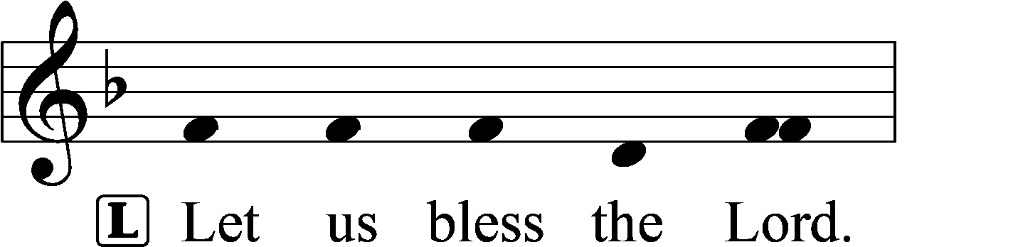
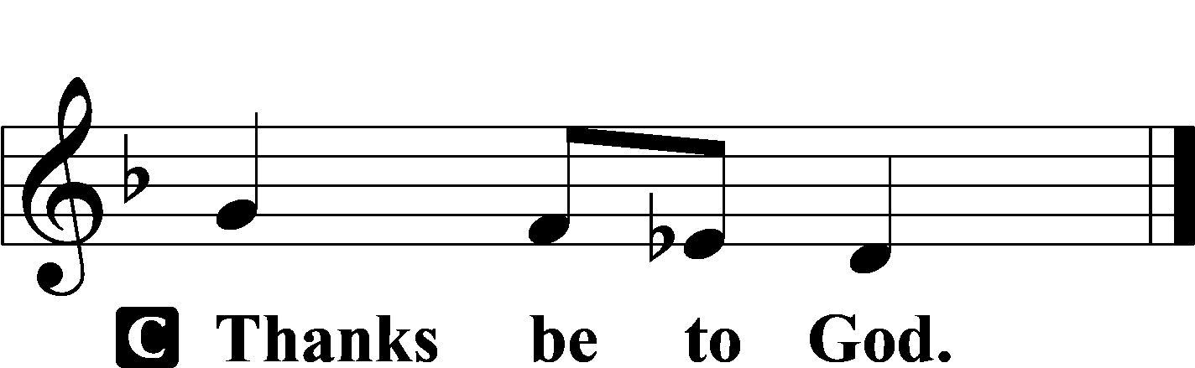

Benediction LSB 234
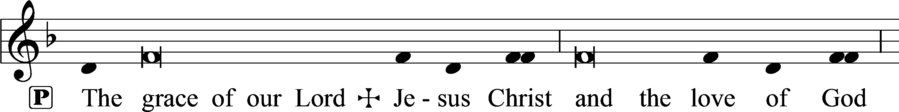
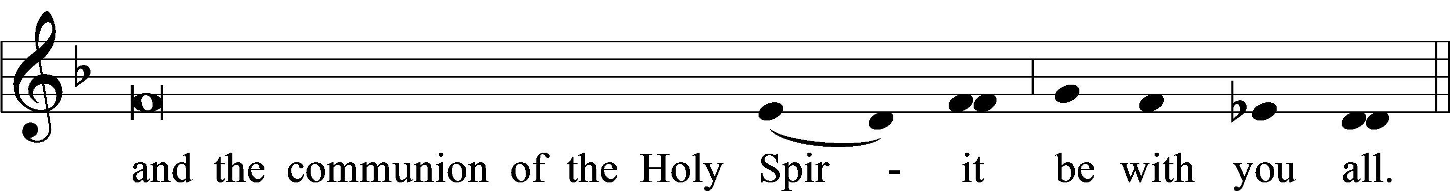

Closing Hymn: LSB #806 “Give Thanks with a Grateful Heart”
fffffffffffffffffffffffffffffffffff
Silent prayer after worship: Holy Lord Jesus, be with me every hour. Cause me to be keenly aware of Your presence in all I do. By Your Spirit, keep me ready at all times for Your coming as King and Judge. Amen.
fffffffffffffffffffffffffffffffffff
Acknowledgments
Unless otherwise indicated, Scripture quotations are from the ESV® Bible (The Holy Bible, English Standard Version®), copyright © 2001 by Crossway, a publishing ministry of Good News Publishers. Used by permission. All rights reserved. Created by Lutheran Service Builder © 2023 Concordia Publishing House.
fffffffffffffffffffffffffffffffffff

We are grateful to Rev. Arthur Baisch, Pastor Emeritus, for leading our worship this evening.

