Sts. Peter & Paul
Evangelical Lutheran Church
Lutheran Church-Missouri Synod
Founded-1917

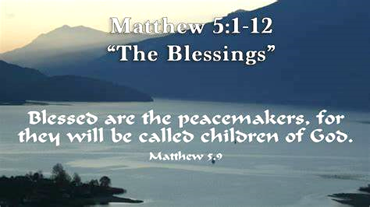

November 1, 2023

699 Stambaugh Ave.
Sharon, Pennsylvania 16146

“I was glad when they said to me,
Let us go to the house of the LORD!”
Psalm 122:1
Sts. Peter & Paul Evangelical Lutheran Church, LC-MS
ALL SAINTS’ DAY
November 1, 2023

On this All Saints’ Day, we fondly remember

Anson Holcroft (August 20, 1929 – February 22, 2023)
Viola Sakony (December 19, 1929 – March 25, 2023)
Barry Nelson (March 17, 1956 ~ April 25, 2023)

and those we hold dear in our hearts.

Today’s service includes the Sacrament of Holy Communion. If during this past year, you have not worshipped with us and been communed, we respectfully ask that you do not partake of this sacrament this day before first speaking with Pastor Deal.
If visiting from a sister congregation of the LC-MS and are in good standing, please inform Pastor Deal of your desire to commune prior to the service.
If wishing to receive a blessing during communion, please approach with your arms crossed.

CONTACT INFORMATION
Pastor Deal: pastordeal@saintspeterandpaul.net or 724-347-3620 (opt. 2)
Church Office: church@saintspeterandpaul.net or 724-347-3620 (opt. 3)
Secretary’s Office: The office will be open Mon. (8:30 am–5 pm) & Thurs. (8:30 am-10 am; 11 am-5 pm).

Silent prayer before worship: Almighty God, heavenly Father, thank You for making me one of Your saints by grace through faith in Your Son, Jesus Christ. Lead me to praise You continually with all the saints in heaven and on earth! In Jesus’ name. Amen.

Confession and Absolution

Opening Hymn: LSB #510 “A Multitude Comes from the East and the West”

Stand

The sign of the cross may be made by all in remembrance of their Baptism.

Invocation
P In the name of the Father and of the T Son and of the Holy Spirit.
C Amen.

Exhortation Hebrews 10:22; Psalm 124:8; Psalm 32:5
P Beloved in the Lord! Let us draw near with a true heart and confess our sins unto God our Father, beseeching Him in the name of our Lord Jesus Christ to grant us forgiveness.

P Our help is in the name of the Lord,
C who made heaven and earth.
P I said, I will confess my transgressions unto the Lord,
C and You forgave the iniquity of my sin.

Silence for reflection on God’s Word and for self-examination.

Confession of Sins
P O almighty God, merciful Father,
C I, a poor, miserable sinner, confess unto You all my sins and iniquities with which I have ever offended You and justly deserved Your temporal and eternal punishment. But I am heartily sorry for them and sincerely repent of them, and I pray You of Your boundless mercy and for the sake of the holy, innocent, bitter sufferings and death of Your beloved Son, Jesus Christ, to be gracious and merciful to me, a poor, sinful being.

Absolution [John 20:19–23]
P Upon this your confession, I, by virtue of my office, as a called and ordained servant of the Word, announce the grace of God unto all of you, and in the stead and by the command of my Lord Jesus Christ I forgive you all your sins in the name of the Father and of the T Son and of the Holy Spirit.
C Amen.

Service of the Word

Introit Psalm 31:1, 3, 5; antiphon: Revelation 7:14b
These are the ones coming out of the great tribu- | lation.*
They have washed their robes and made them white in the blood | of the Lamb.
In you, O Lord, do I take refuge; let me never be | put to shame;*
in your righteousness de- | liver me.
For you are my rock and my | fortress;*
and for your name’s sake you lead me and | guide me.
Into your hand I commit my | spirit;*
you have redeemed me, O Lord, | faithful God.
These are the ones coming out of the great tribu- | lation.*
They have washed their robes and made them white in the blood | of the Lamb.

Gloria Patri
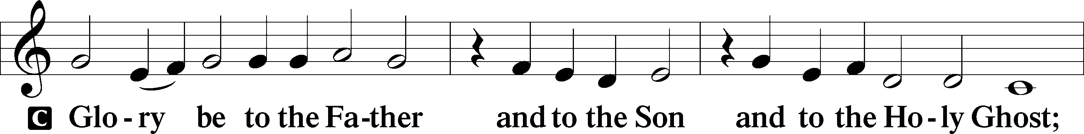
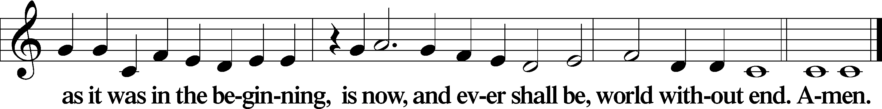
Kyrie Mark 10:47
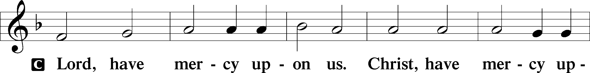
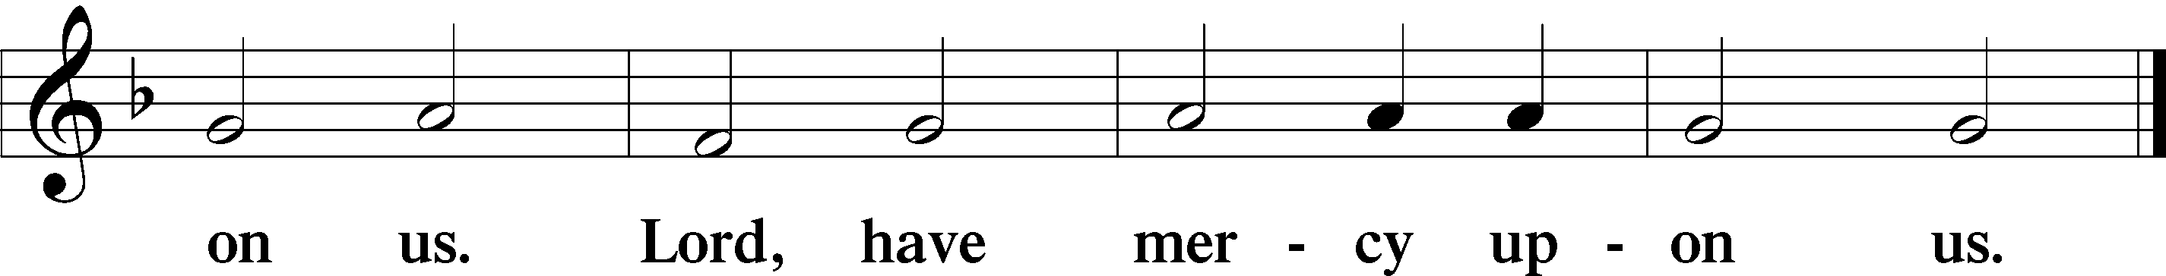

Gloria in Excelsis Luke 2:14; John 1:29
P Glory be to God on high:
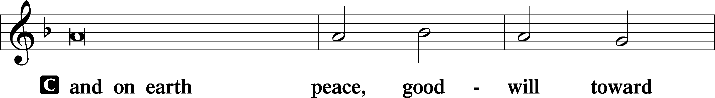
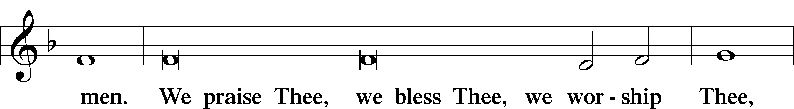
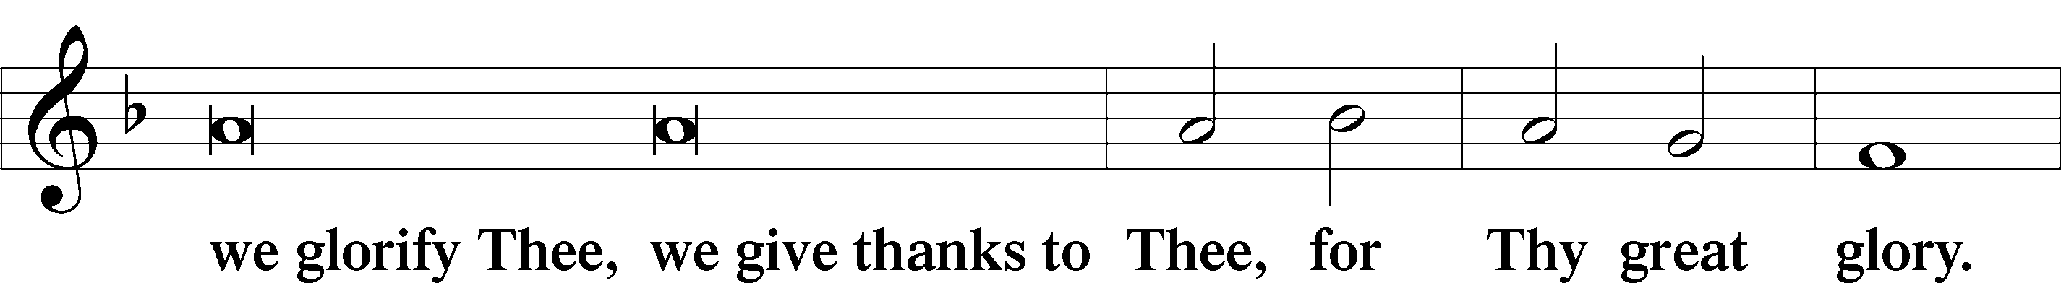
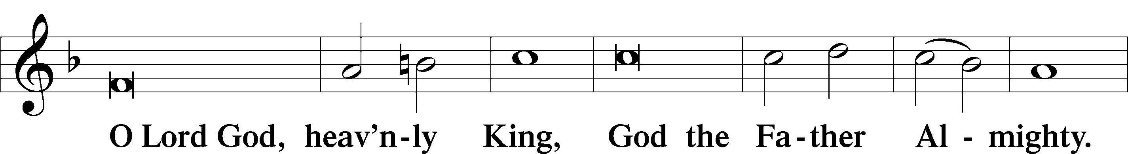
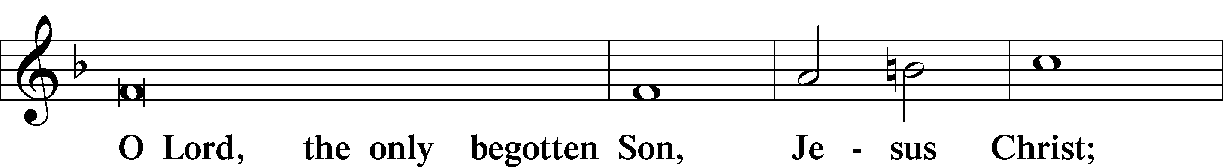
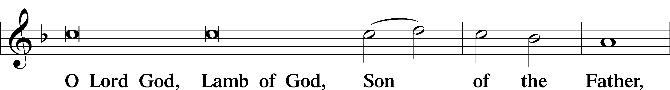
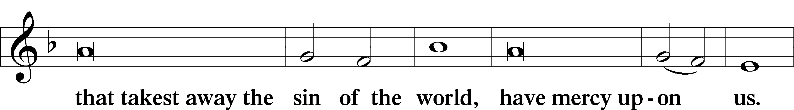
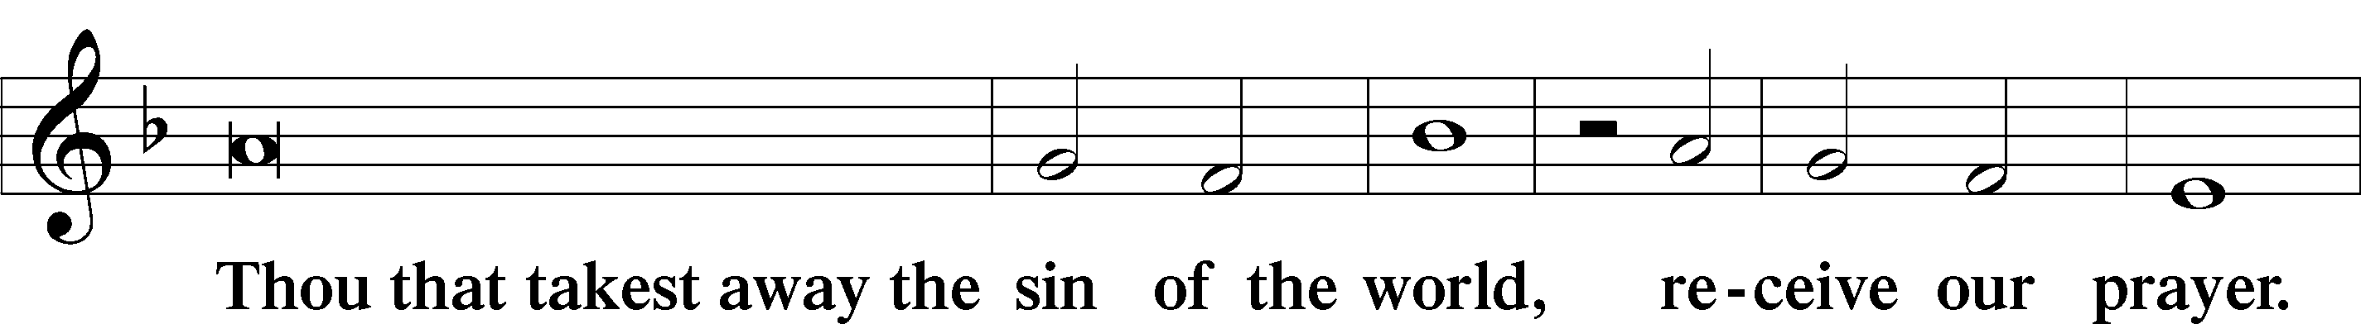
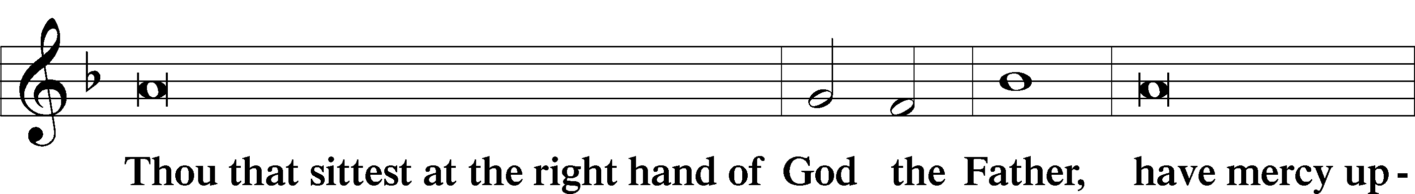
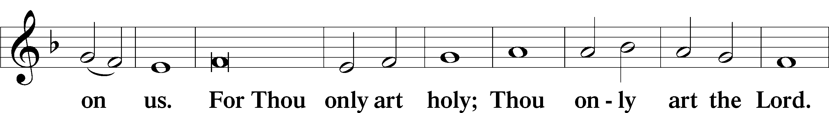
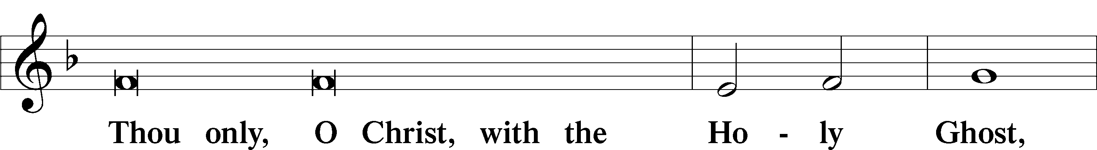
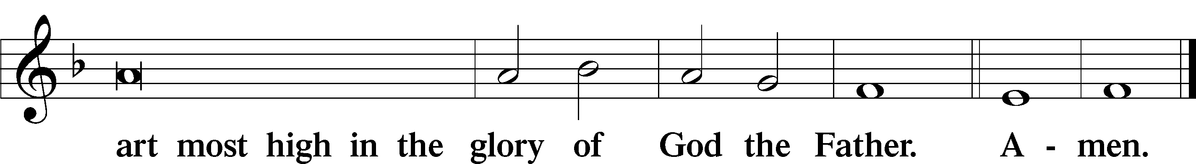

Salutation and Collect of the Day: All Saints’ Day
P The Lord be with you.
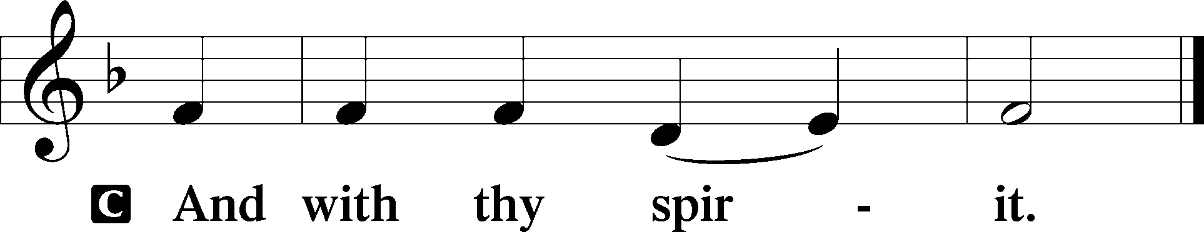

P Let us pray.
Almighty and everlasting God, You knit together Your faithful people of all times and places into one holy communion, the mystical body of Your Son, Jesus Christ. Grant us so to follow Your blessed saints in all virtuous and godly living that, together with them, we may come to the unspeakable joys You have prepared for those who love You; through Jesus Christ, our Lord, who lives and reigns with You and the Holy Spirit, one God, now and forever.
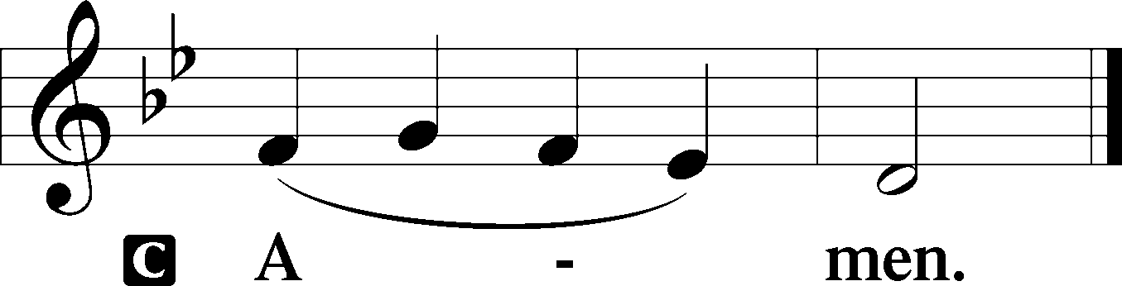
Sit

Prophecy: Revelation 7:2–17 (NKJV)
In those days: Behold, I, John, saw another angel ascending from the east, having the seal of the living God. And he cried with a loud voice to the four angels to whom it was granted to harm the earth and the sea, saying, “Do not harm the earth, the sea, or the trees till we have sealed the servants of our God on their foreheads.” And I heard the number of those who were sealed. One hundred and forty-four thousand of all the tribes of the children of Israel were sealed: of the tribe of Judah twelve thousand were sealed; of the tribe of Reuben twelve thousand were sealed; of the tribe of Gad twelve thousand were sealed; of the tribe of Asher twelve thousand were sealed; of the tribe of Naphtali twelve thousand were sealed; of the tribe of Manasseh twelve thousand were sealed; of the tribe of Simeon twelve thousand were sealed; of the tribe of Levi twelve thousand were sealed; of the tribe of Issachar twelve thousand were sealed; of the tribe of Zebulun twelve thousand were sealed; of the tribe of Joseph twelve thousand were sealed; of the tribe of Benjamin twelve thousand were sealed. After these things I looked, and behold, a great multitude which no one could number, of all nations, tribes, peoples, and tongues, standing before the throne and before the Lamb, clothed with white robes, with palm branches in their hands, and crying out with a loud voice, saying, “Salvation belongs to our God who sits on the throne, and to the Lamb!” All the angels stood around the throne and the elders and the four living creatures, and fell on their faces before the throne and worshiped God, saying: “Amen! Blessing and glory and wisdom, thanksgiving and honor and power and might, be to our God forever and ever. Amen.” Then one of the elders answered, saying to me, “Who are these arrayed in white robes, and where did they come from?” And I said to him, “Sir, you know.” So he said to me, “These are the ones who come out of the great tribulation, and washed their robes and made them white in the blood of the Lamb. Therefore they are before the throne of God, and serve Him day and night in His temple. And He who sits on the throne will dwell among them. They shall neither hunger anymore nor thirst anymore; the sun shall not strike them, nor any heat; for the Lamb who is in the midst of the throne will shepherd them and lead them to living fountains of waters. And God will wipe away every tear from their eyes.”

P This is the Word of the Lord.
C Thanks be to God.

Gradual Revelation 7:14b; Psalm 84:5
These are the ones coming out of the great tribu- | lation.*
They have washed their robes and made them white in the blood | of the Lamb.
Blessèd are those whose strength is | in you,*
in whose heart are the highways to | Zion.

Epistle: 1 John 3:1–3 (NKJV)
Dearly Beloved: Behold what manner of love the Father has bestowed on us, that we should be called children of God! Therefore the world does not know us, because it did not know Him. Beloved, now we are children of God; and it has not yet been revealed what we shall be, but we know that when He is revealed, we shall be like Him, for we shall see Him as He is. And everyone who has this hope in Him purifies himself, just as He is pure.

P This is the Word of the Lord.
C Thanks be to God.

Stand

Verse Hebrews 12:1a, 2a
Alleluia. Since we are surrounded by so great a cloud of witnesses, let us [look] to Jesus, the founder and perfecter of our faith. Alleluia.

Alleluia
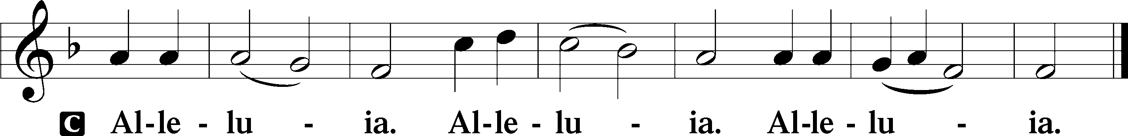

Holy Gospel: Matthew 5:1–12 (NKJV)
P The Holy Gospel according to St. Matthew, the fifth chapter.

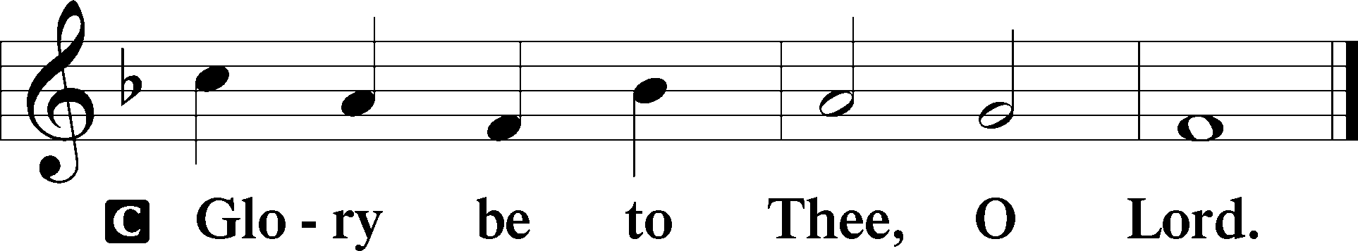

At that time: Seeing the multitudes, Jesus went up on a mountain, and when He was seated His disciples came to Him. Then He opened His mouth and taught them, saying: “Blessed are the poor in spirit, for theirs is the kingdom of heaven. Blessed are those who mourn, for they shall be comforted. Blessed are the meek, for they shall inherit the earth. Blessed are those who hunger and thirst for righteousness, for they shall be filled. Blessed are the merciful, for they shall obtain mercy. Blessed are the pure in heart, for they shall see God. Blessed are the peacemakers, for they shall be called sons of God. Blessed are those who are persecuted for righteousness’ sake, for theirs is the kingdom of heaven. Blessed are you when they revile and persecute you, and say all kinds of evil against you falsely for My sake. Rejoice and be exceedingly glad, for great is your reward in heaven, for so they persecuted the prophets who were before you.”

P This is the Gospel of the Lord.
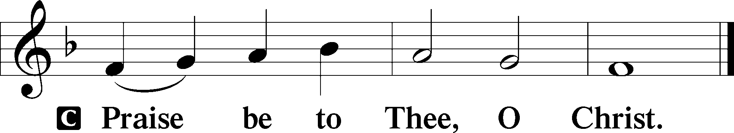

Nicene Creed
C I believe in one God,
the Father Almighty,
maker of heaven and earth
and of all things visible and invisible.

And in one Lord Jesus Christ,
the only-begotten Son of God,
begotten of His Father before all worlds,
God of God, Light of Light,
very God of very God,
begotten, not made,
being of one substance with the Father,
by whom all things were made;
who for us men and for our salvation came down from heaven
and was incarnate by the Holy Spirit of the virgin Mary
and was made man;
and was crucified also for us under Pontius Pilate.
He suffered and was buried.
And the third day He rose again according to the Scriptures
and ascended into heaven
and sits at the right hand of the Father.
And He will come again with glory to judge both the living and the dead,
whose kingdom will have no end.

And I believe in the Holy Spirit,
the Lord and giver of life,
who proceeds from the Father and the Son,
who with the Father and the Son together is worshiped and glorified,
who spoke by the prophets.
And I believe in one holy Christian and apostolic Church,
I acknowledge one Baptism for the remission of sins,
and I look for the resurrection of the dead
and the life T of the world to come. Amen.
Sit

Hymn of the Day: LSB #677 “For All the Saints”

Sermon

Stand

Prayer of the Church

Offertory Psalm 51:10–12
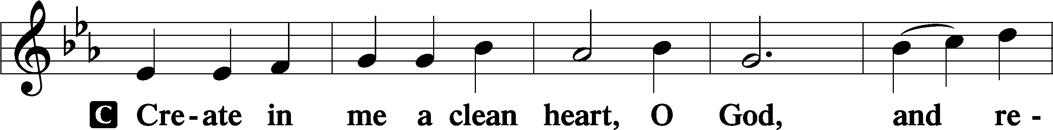
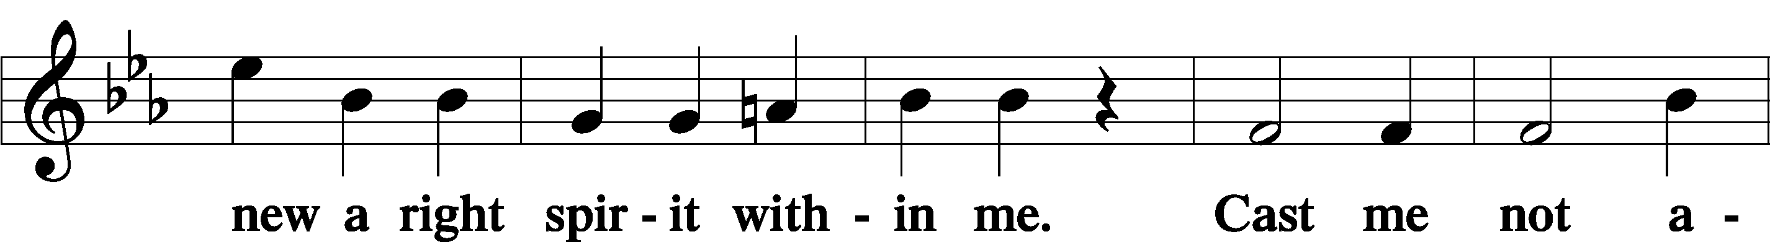
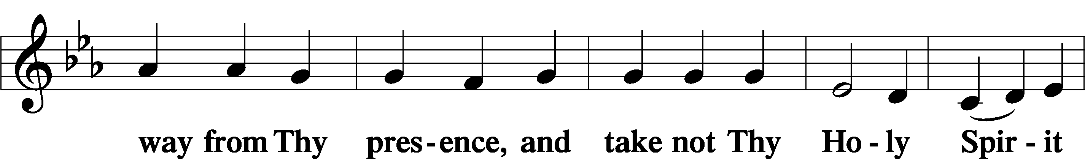
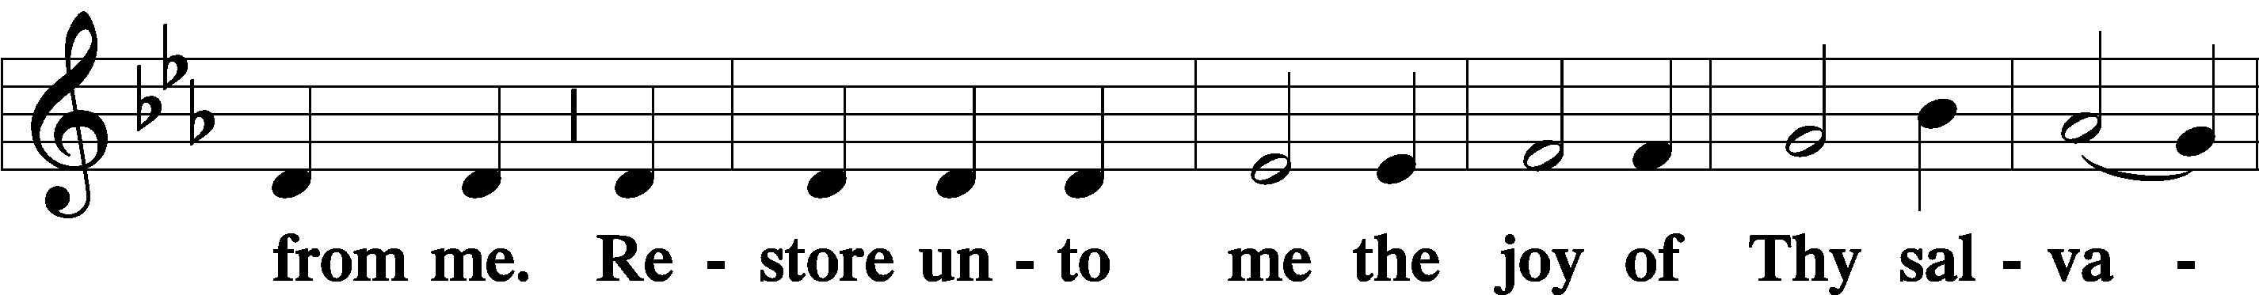
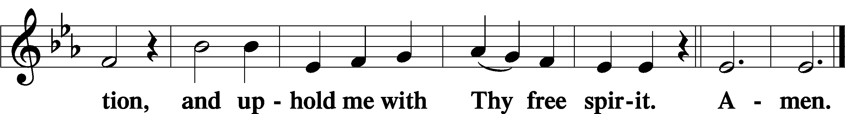
Sit

Preparatory Hymn: LSB #633 “At the Lamb’s High Feast We Sing”

Service of the Sacrament

Preface 2 Timothy 4:22; Colossians 3:1 Psalm 136
P The Lord be with you.

P Lift up your hearts.
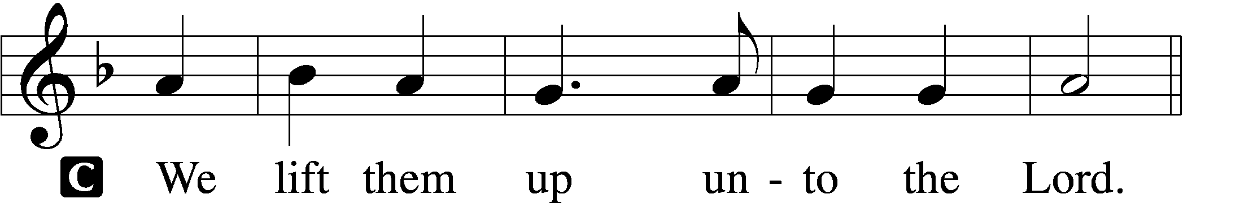

P Let us give thanks unto the Lord, our God.
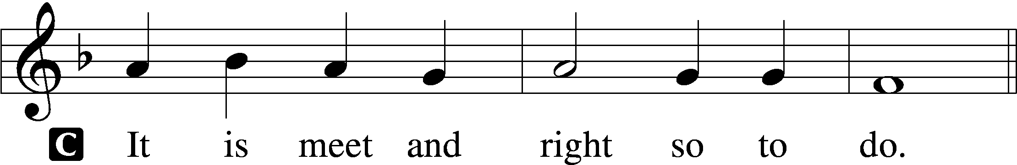

Proper Preface (Abbreviated) LSB 194
P It is truly meet, right, and salutary . . . evermore praising You and saying:

Sanctus Isaiah 6:3; Matthew 21:9
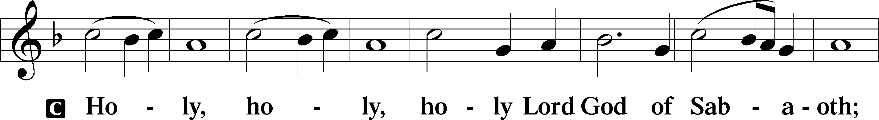
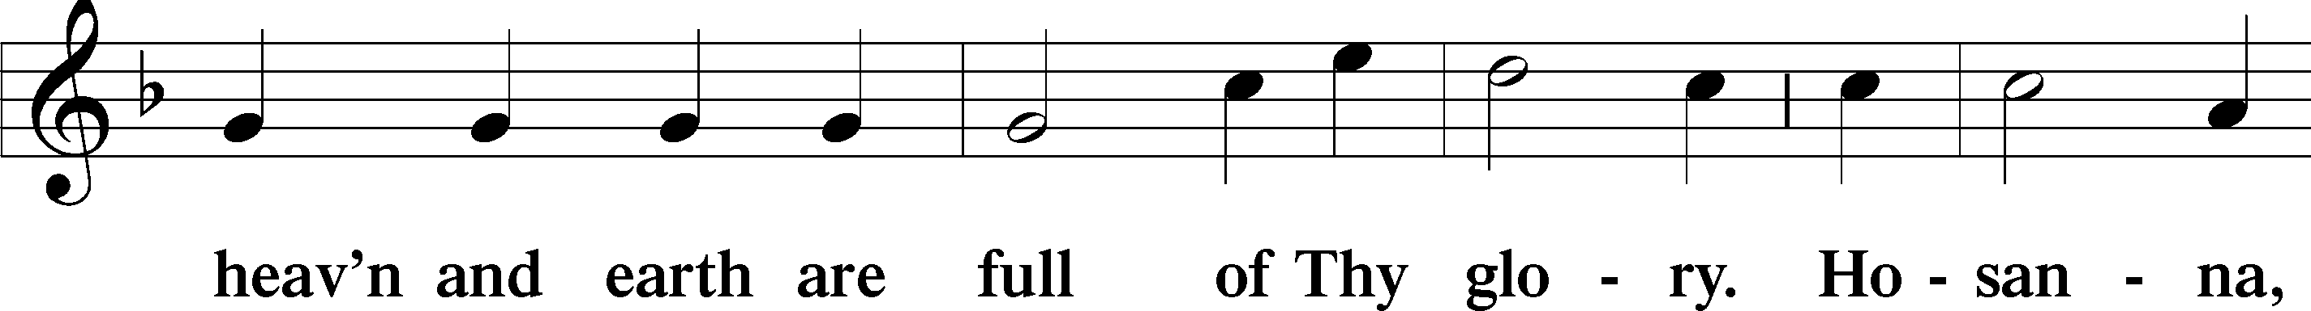
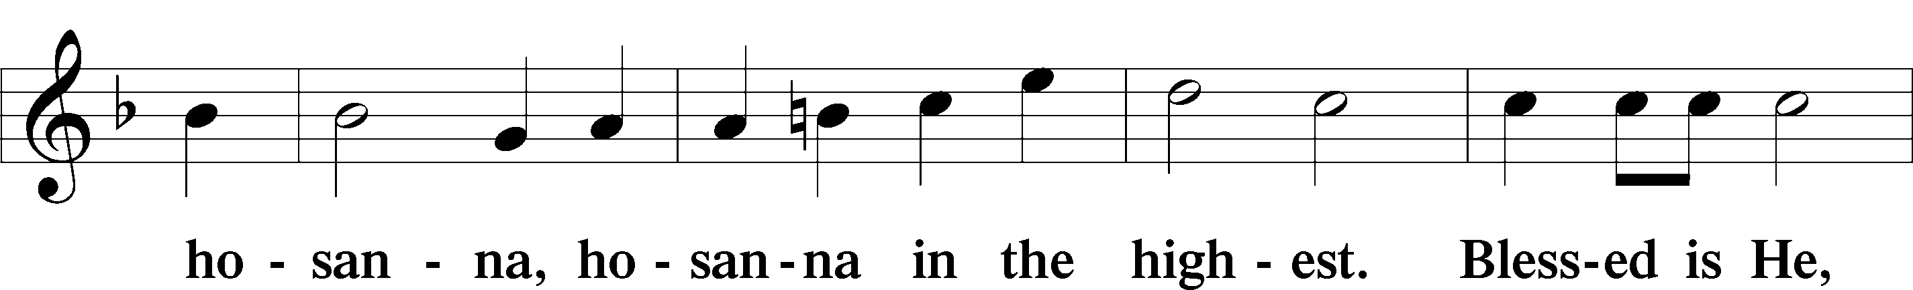
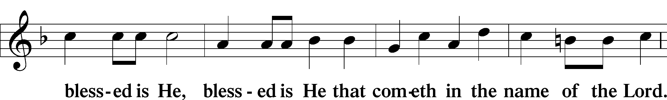
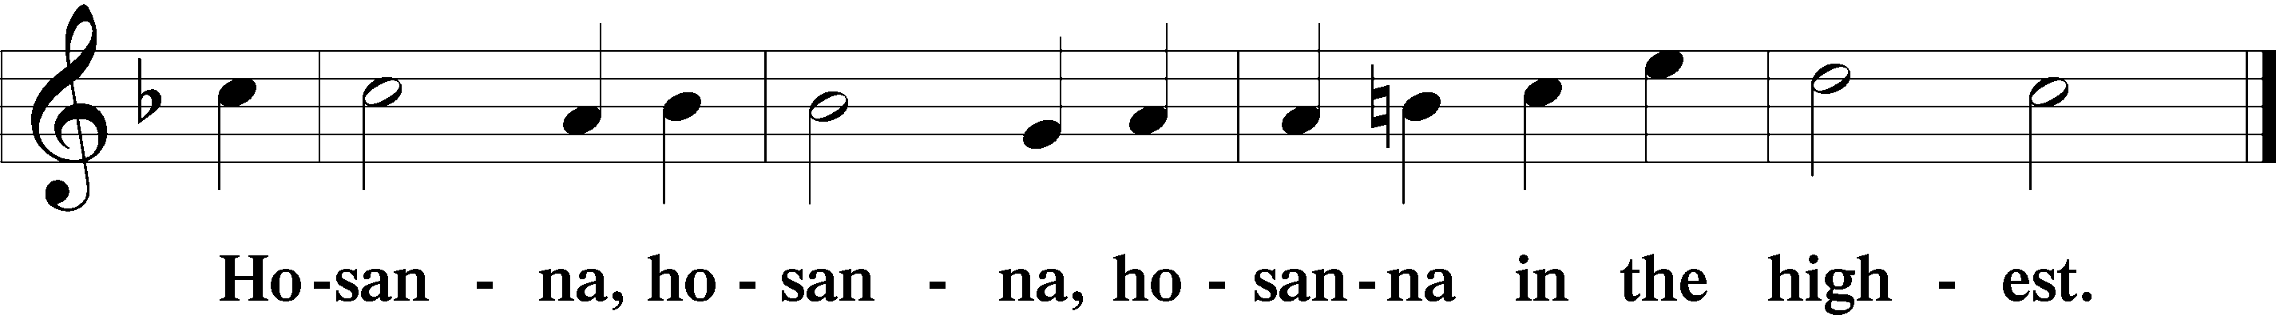

Lord’s Prayer The congregation is encouraged to silently pray the Lord’s Prayer as it is chanted. Matthew 6:9–13
P Our Father who art in heaven,
hallowed be Thy name,
Thy kingdom come,
Thy will be done on earth as it is in heaven;
give us this day our daily bread;
and forgive us our trespasses as we forgive those who trespass against us;
and lead us not into temptation,
but deliver us from evil.
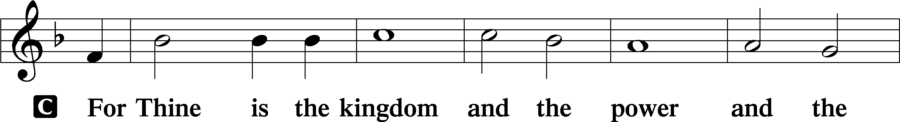
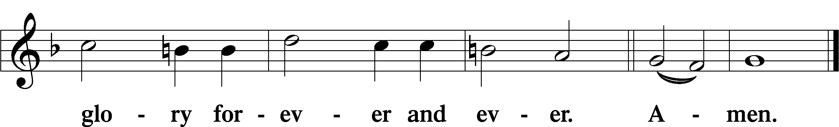

The Words of Our Lord Matthew 26:26–28; Mark 14:22–24; Luke 22:19–20; 1 Corinthians 11:23–25
P Our Lord Jesus Christ, on the night when He was betrayed, took bread, and when He had given thanks, He broke it and gave it to the disciples and said: “Take, eat; this is My T body, which is given for you. This do in remembrance of Me.”

In the same way also He took the cup after supper, and when He had given thanks, He gave it to them, saying: “Drink of it, all of you; this cup is the new testament in My T blood, which is shed for you for the forgiveness of sins. This do, as often as you drink it, in remembrance of Me.”

Pax Domini John 20:19
P The peace of the Lord be with you always.
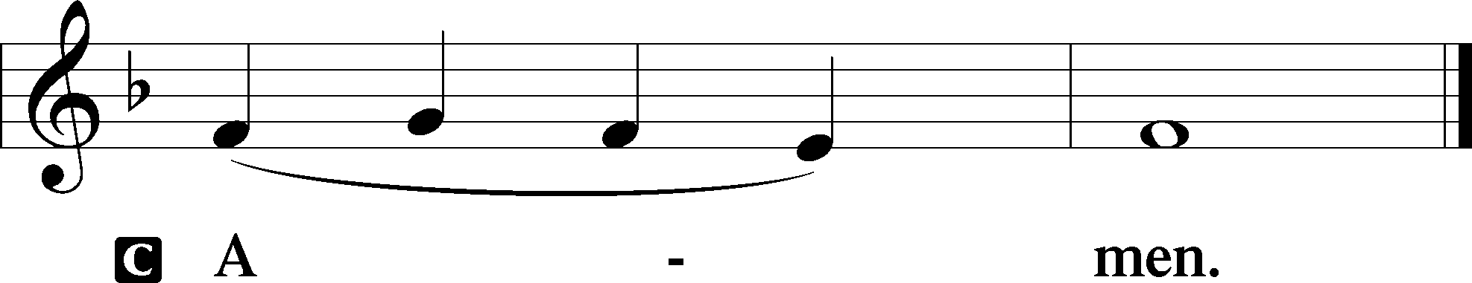

Agnus Dei John 1:29
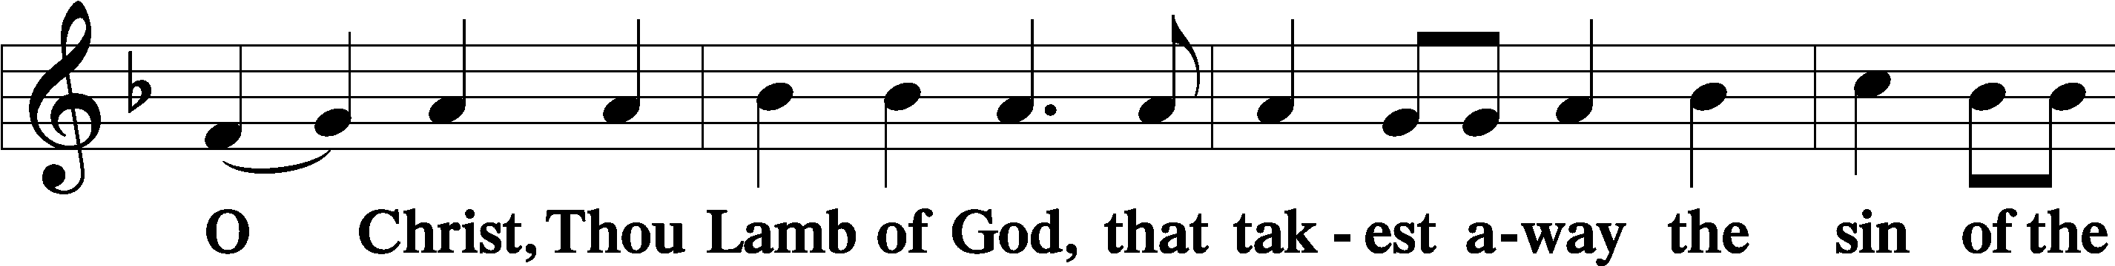
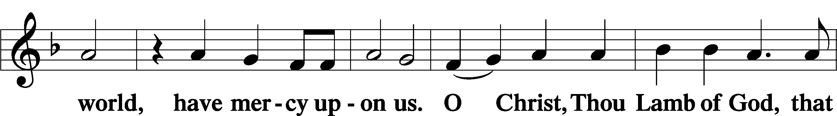
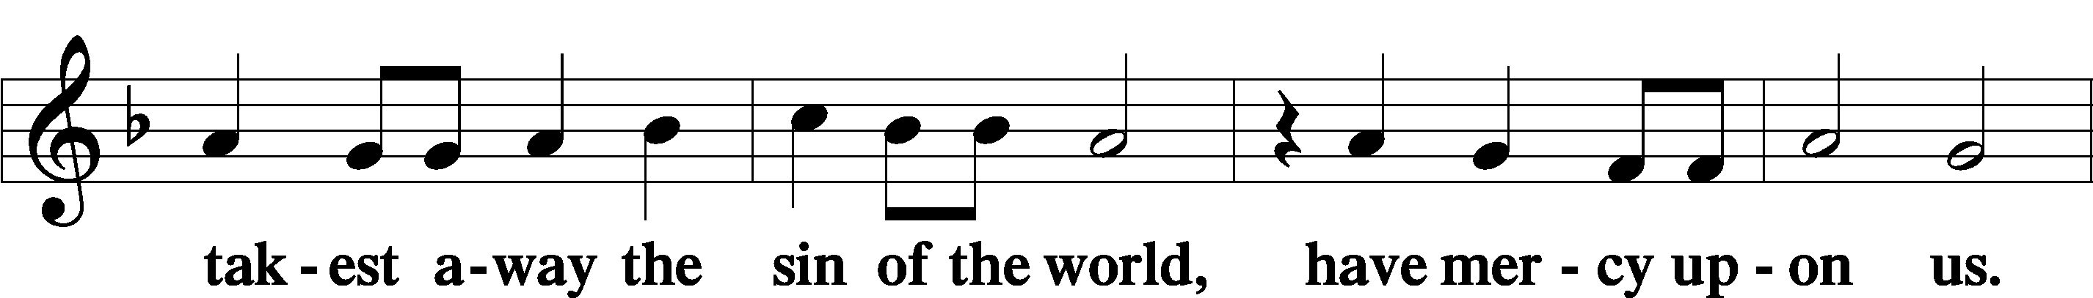
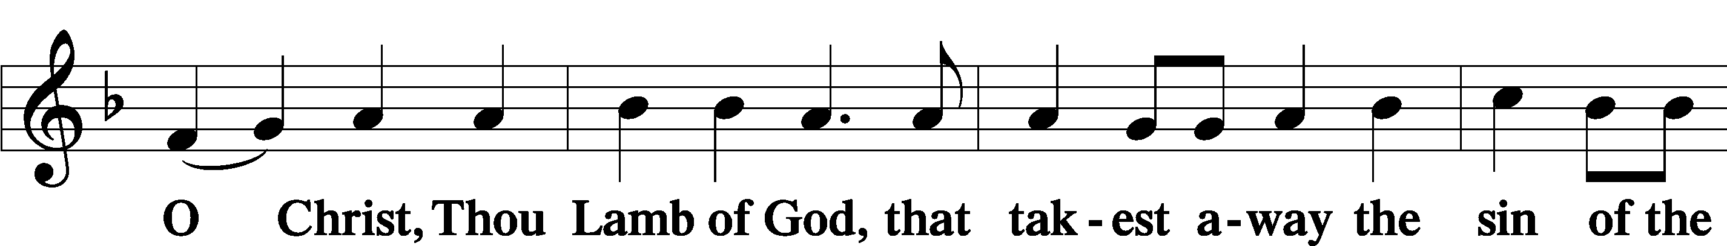
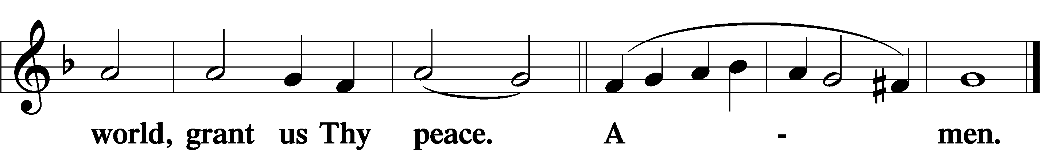
Sit

Distribution
The pastor and those who assist him receive the body and blood of Christ first and then distribute them to those who come to receive, saying:
Take, eat; this is the true body of our Lord and Savior Jesus Christ, given into death for your sins.
Amen.

Take, drink; this is the true blood of our Lord and Savior Jesus Christ, shed for the forgiveness of your sins.
Amen.

In dismissing the communicants, the following is said:
The Dismissal
P The body and blood of our Lord Jesus Christ strengthen and preserve you in body and soul to life everlasting. Depart T in peace.
C Amen.

Distribution Hymn: LSB #672 “Jerusalem the Golden”

Nunc Dimittis Luke 2:29–32
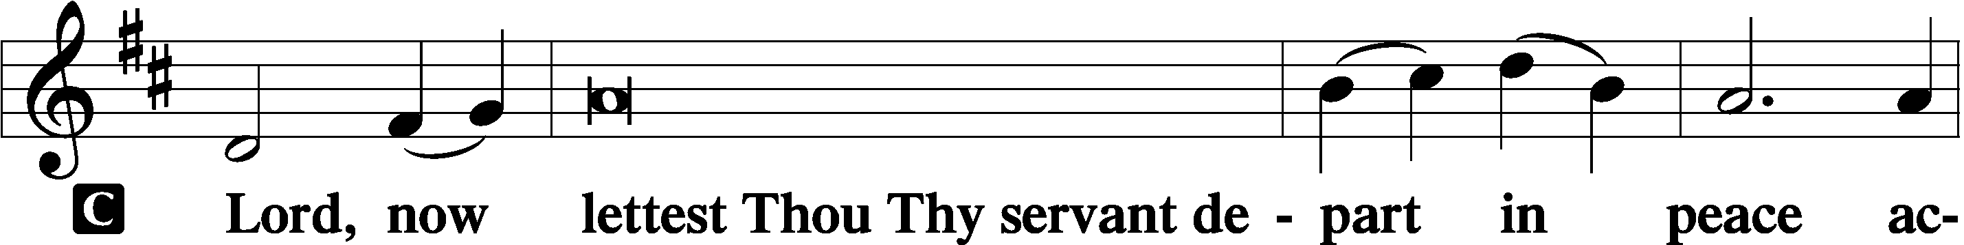
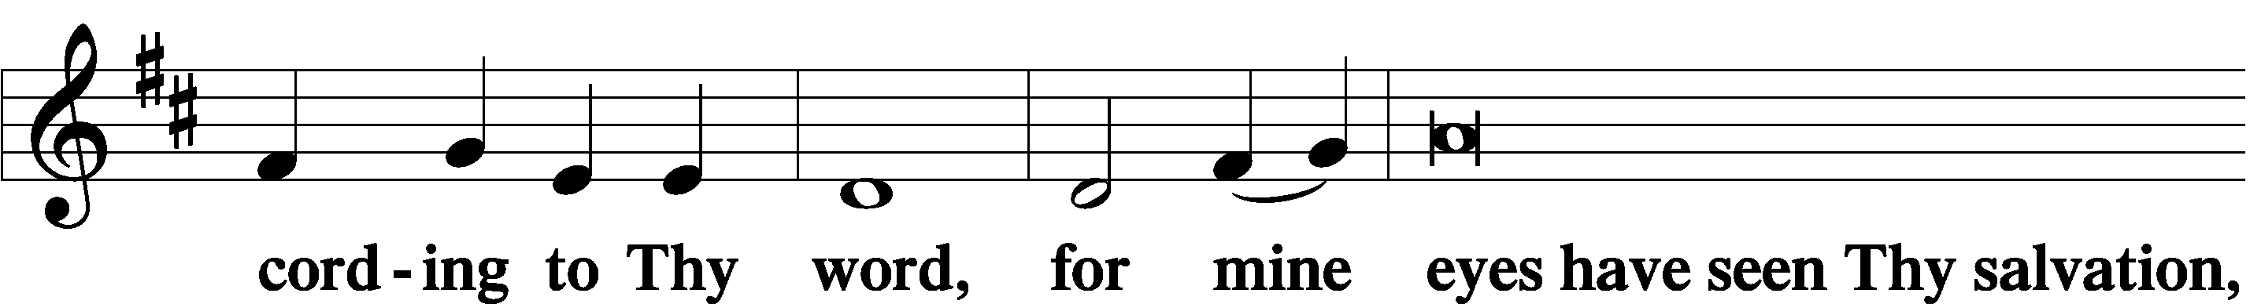
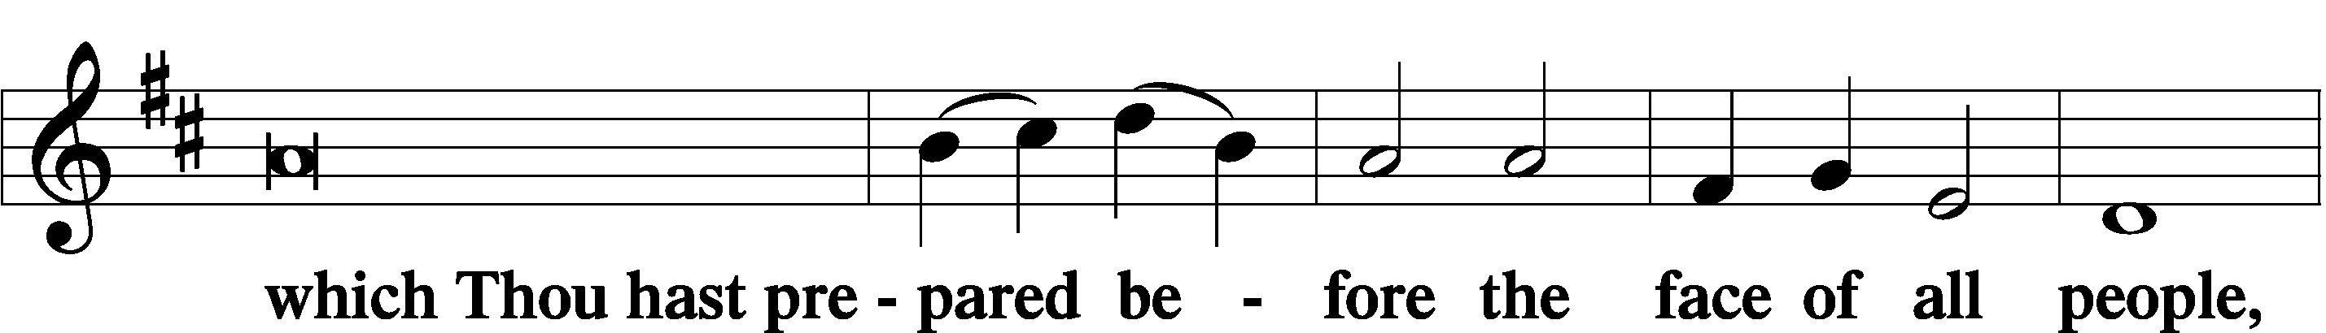
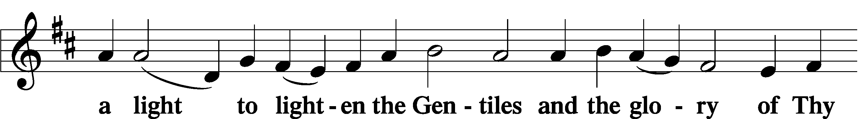
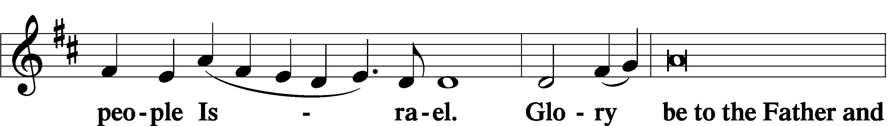
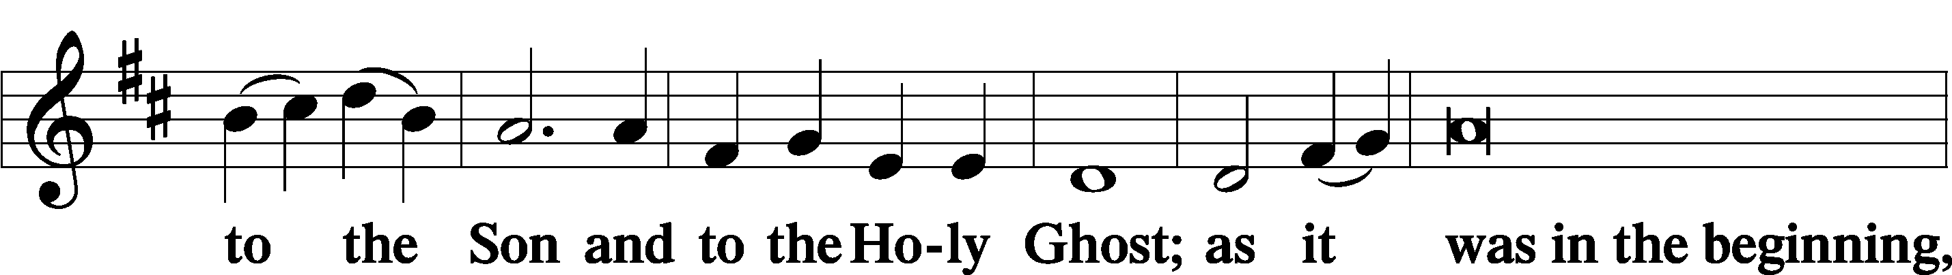
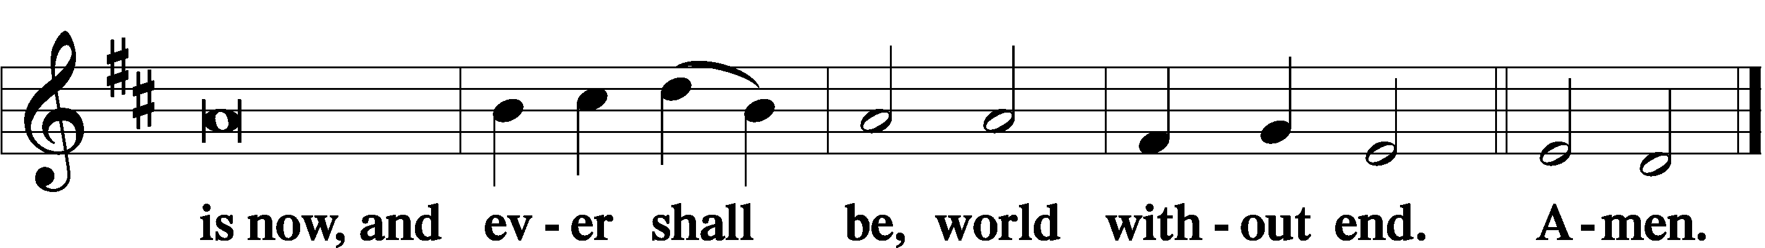

Thanksgiving Psalm 107:1
P O give thanks unto the Lord, for He is good,
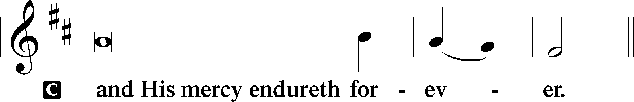

Post-Communion Collect
P Let us pray.
We give thanks to You, almighty God, that You have refreshed us through this salutary gift, and we implore You that of Your mercy You would strengthen us through the same in faith toward You and in fervent love toward one another; through Jesus Christ, Your Son, our Lord, who lives and reigns with You and the Holy Spirit, one God, now and forever.
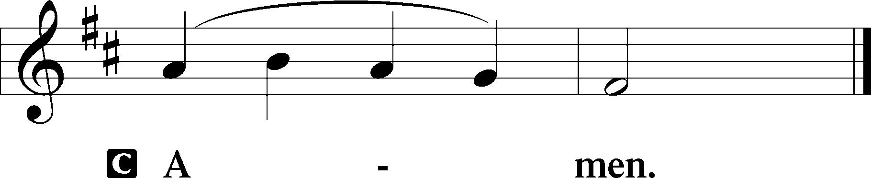

Salutation 2 Timothy 4:22
P The Lord be with you.
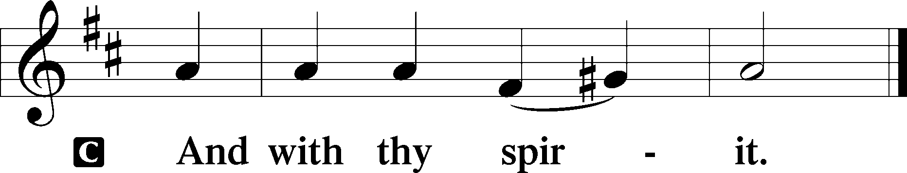

Benedicamus Psalm 103:1
P Bless we the Lord.
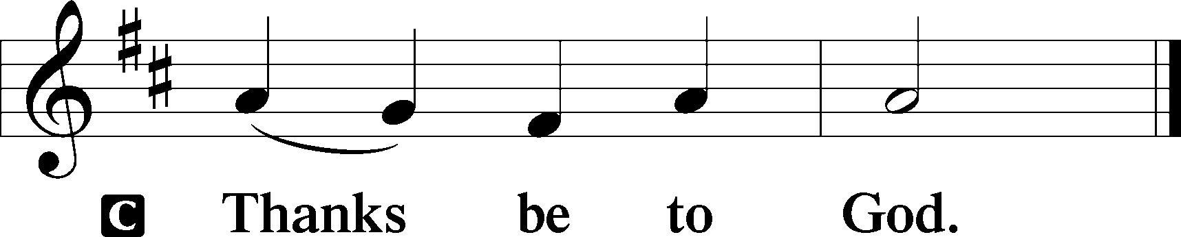

Benediction Numbers 6:24–26
P The Lord bless you and keep you.
The Lord make His face shine upon you and be gracious unto you.
The Lord lift up His countenance upon you and T give you peace.
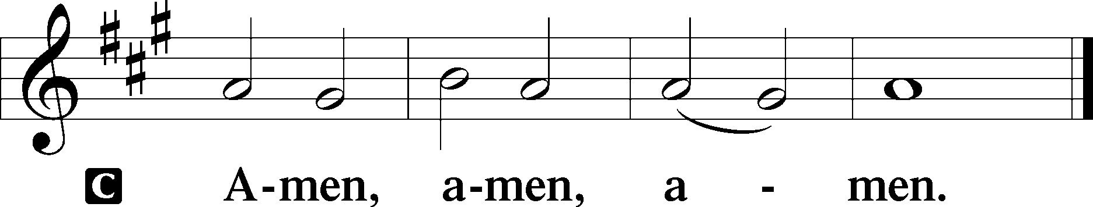

Closing Hymn: LSB #676 “Behold a Host, Arrayed in White”
fffffffffffffffffffffffffffffffffff
Silent prayer after worship: Dear Lord Jesus, You are worthy of praise, honor and worship every day of my life. Lead me to joyfully worship and serve You as Your dear child wherever I am and in all I do. In Jesus’ name. Amen.
fffffffffffffffffffffffffffffffffff
Acknowledgments
Unless otherwise indicated, Scripture quotations are from the ESV® Bible (The Holy Bible, English Standard Version®), copyright © 2001 by Crossway, a publishing ministry of Good News Publishers. Used by permission. All rights reserved.
Created by Lutheran Service Builder © 2023 Concordia Publishing House.

