Sts. Peter & Paul
Evangelical Lutheran Church
Lutheran Church-Missouri Synod
Founded-1917

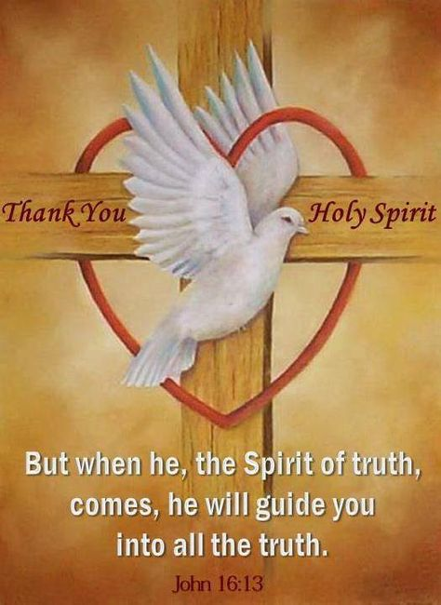

May 7, 2023

699 Stambaugh Ave.
Sharon, Pennsylvania 16146

“I was glad when they said to me,
Let us go to the house of the LORD!”
Psalm 122:1
Sts. Peter & Paul Evangelical Lutheran Church, LC-MS
CANTATE
May 7, 2023

A special welcome to our guests this day! If you would like more information about The Lutheran Church - Missouri Synod, or this congregation, please speak with Pastor Deal or an Elder after the service.
Members & Guests: Don’t be embarrassed if your children make noise during the worship service, all children do. We encourage families to worship together but, if you feel the need, there are pews in the rear of the Church which are reserved for young families on both sides of the sanctuary. There is also a quiet room available to you during our service which is located down the hallway past the offices on the right side of the church as well as a children’s area in the Fellowship Hall where you are able to follow along with the service.

Today’s service includes the Sacrament of Holy Communion. If during this past year, you have not worshipped with us and been communed, we respectfully ask that you do not partake of this sacrament this day before first speaking with Pastor Deal.
If visiting from a sister congregation of the LC-MS and are in good standing, please inform Pastor Deal of your desire to commune prior to the service.
If wishing to receive a blessing during communion, please approach with your arms crossed.

CONTACT INFORMATION
Pastor Deal: pastordeal@saintspeterandpaul.net or 724-347-3620 (opt. 2)
Church Office: church@saintspeterandpaul.net or 724-347-3620 (opt. 3)
Secretary’s Office will be closed this week.

Silent prayer before worship: Dear Lord, You have claimed me as Your child in Christ, and have given me a family of faith, Your church. Lead me to read Your Word daily so that I may grow in faith, love, and knowledge of You. In Jesus’ name. Amen.
Confession and Absolution

Opening Hymn: LSB #822 “Alleluia! Let Praises Ring”

Stand

The sign of the cross may be made by all in remembrance of their Baptism.

Invocation
P In the name of the Father and of the T Son and of the Holy Spirit.
C Amen.

Exhortation Hebrews 10:22; Psalm 124:8; Psalm 32:5
P Beloved in the Lord! Let us draw near with a true heart and confess our sins unto God our Father, beseeching Him in the name of our Lord Jesus Christ to grant us forgiveness.

P Our help is in the name of the Lord,
C who made heaven and earth.
P I said, I will confess my transgressions unto the Lord,
C and You forgave the iniquity of my sin.

Silence for reflection on God’s Word and for self-examination.

Confession of Sins
P O almighty God, merciful Father,
C I, a poor, miserable sinner, confess unto You all my sins and iniquities with which I have ever offended You and justly deserved Your temporal and eternal punishment. But I am heartily sorry for them and sincerely repent of them, and I pray You of Your boundless mercy and for the sake of the holy, innocent, bitter sufferings and death of Your beloved Son, Jesus Christ, to be gracious and merciful to me, a poor, sinful being.

Absolution [John 20:19–23]
P Upon this your confession, I, by virtue of my office, as a called and ordained servant of the Word, announce the grace of God unto all of you, and in the stead and by the command of my Lord Jesus Christ I forgive you all your sins in the name of the Father and of the T Son and of the Holy Spirit.
C Amen.
Service of the Word

Introit Psalm 98:1b, 3–4; antiphon: vv. 1a, 2b
Sing to the Lord a new song, Alle- | luia,*
for he has revealed his righteousness in the sight of the nations. Alle- | luia.
His right hand and his | holy arm*
have worked salva- | tion for him.
He has remembered his steadfast love and faithfulness to the house of | Israel.*
All the ends of the earth have seen the salvation | of our God.
Make a joyful noise to the Lord, | all the earth;*
break forth into joyous song and sing | praises!
Sing to the Lord a new song, Alle- | luia,*
for he has revealed his righteousness in the sight of the nations. Alle- | luia.

Gloria Patri
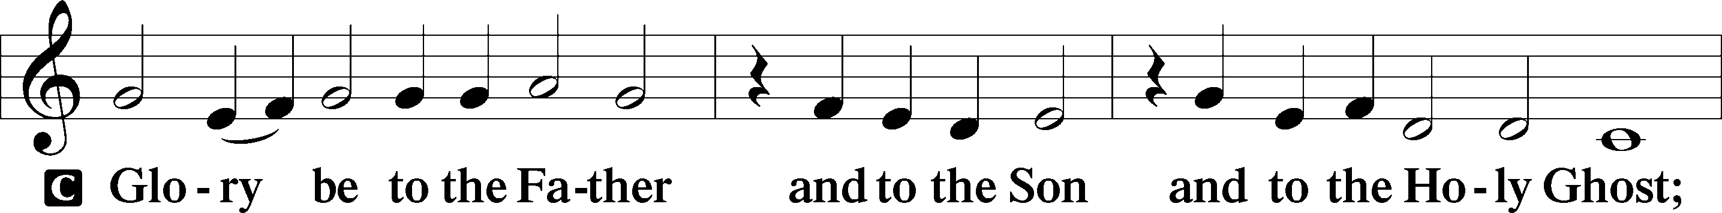
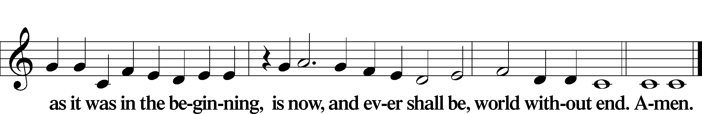

Kyrie Mark 10:47
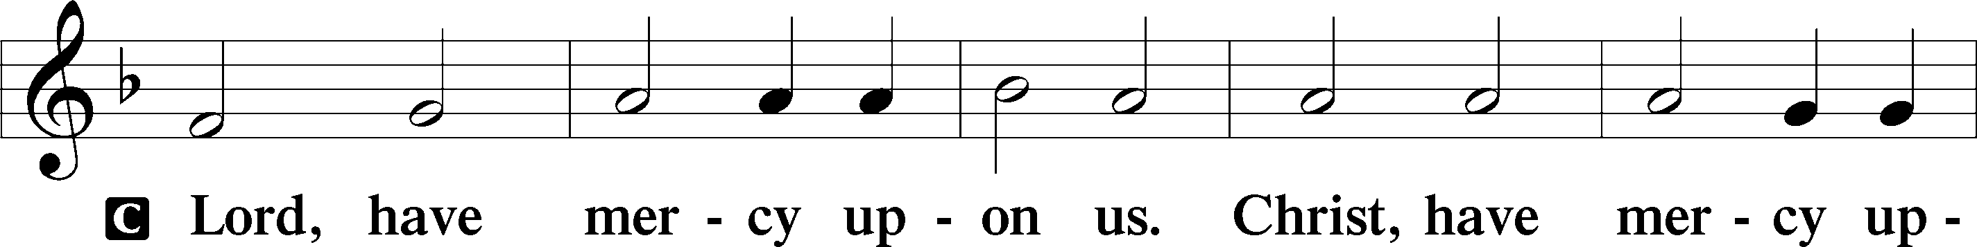
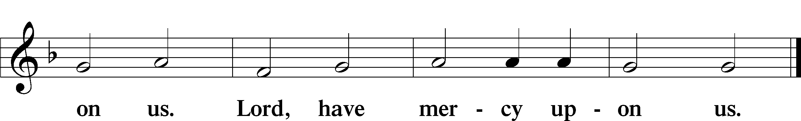

Gloria in Excelsis Luke 2:14; John 1:29
P Glory be to God on high:
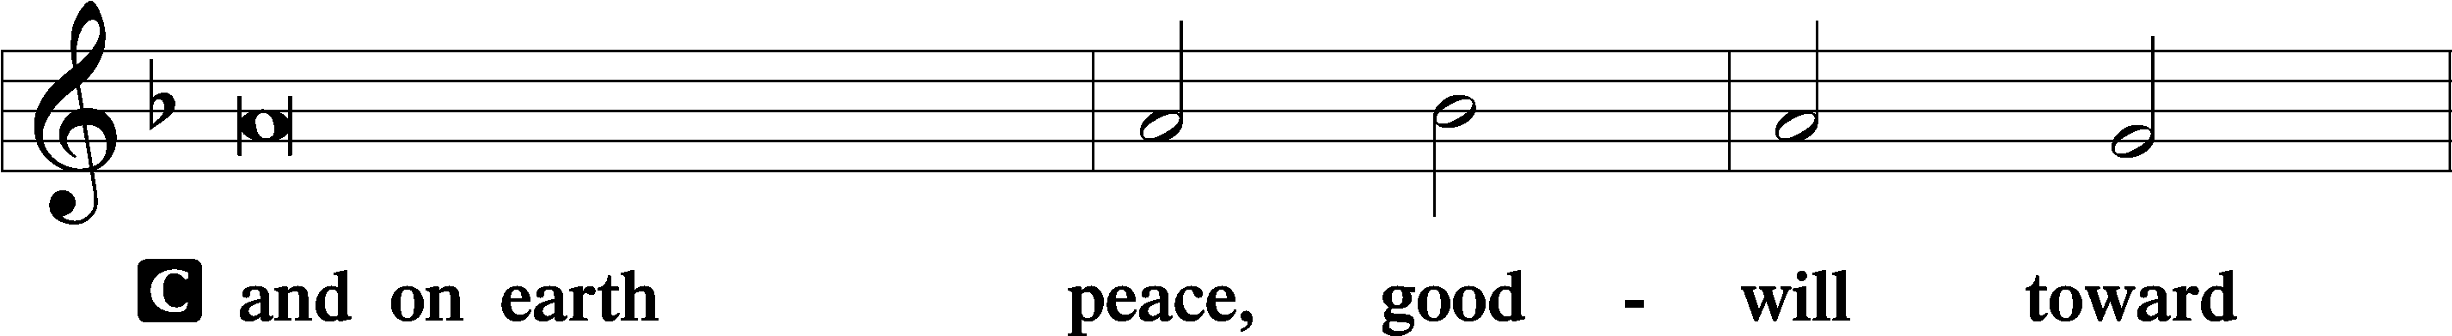
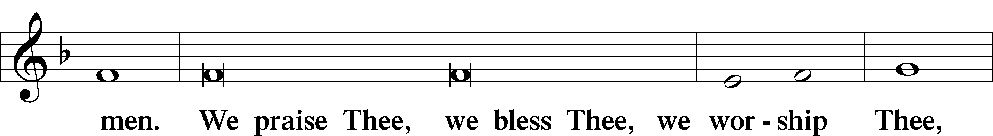
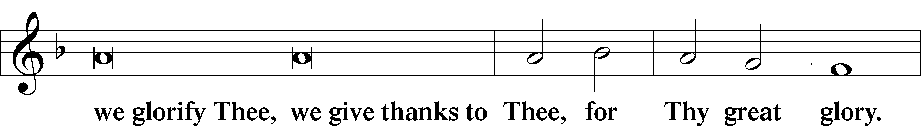
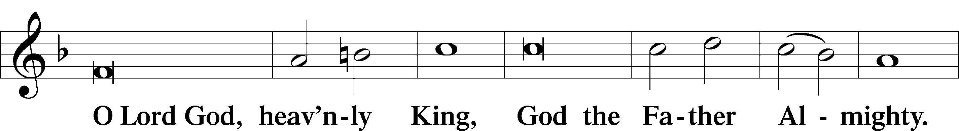
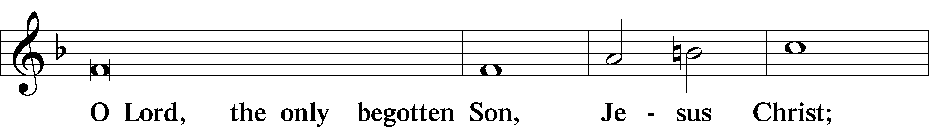
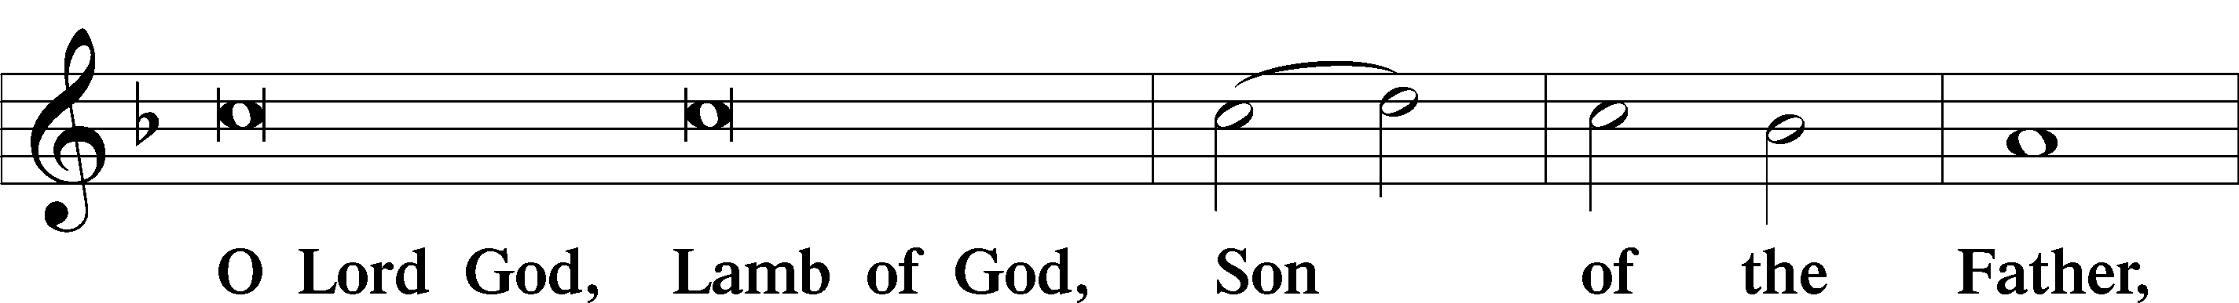
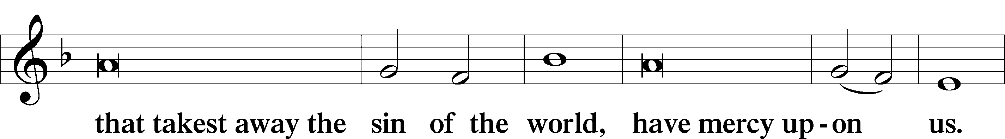
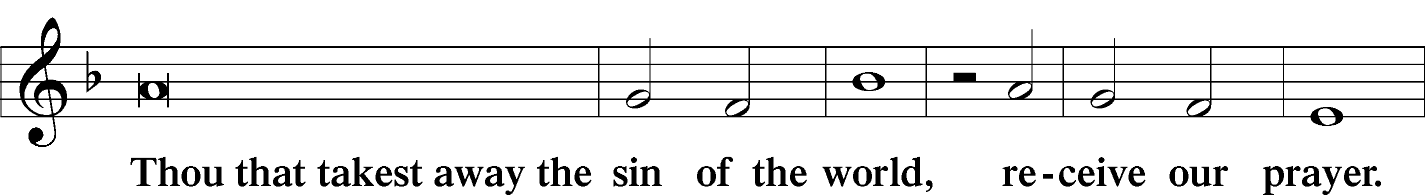
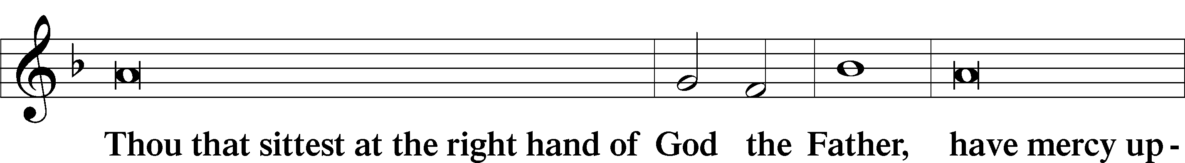
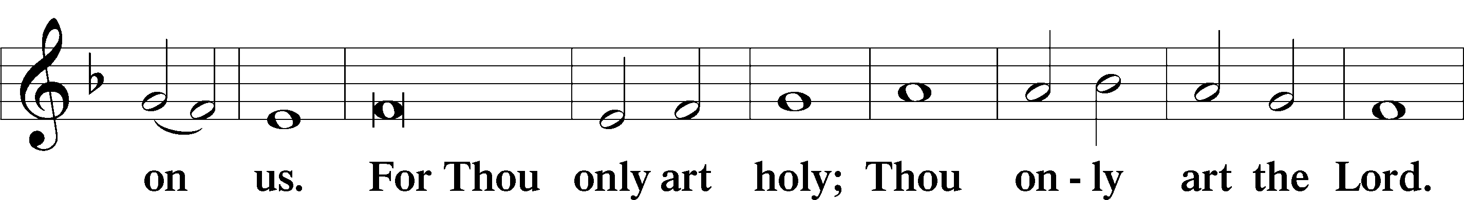
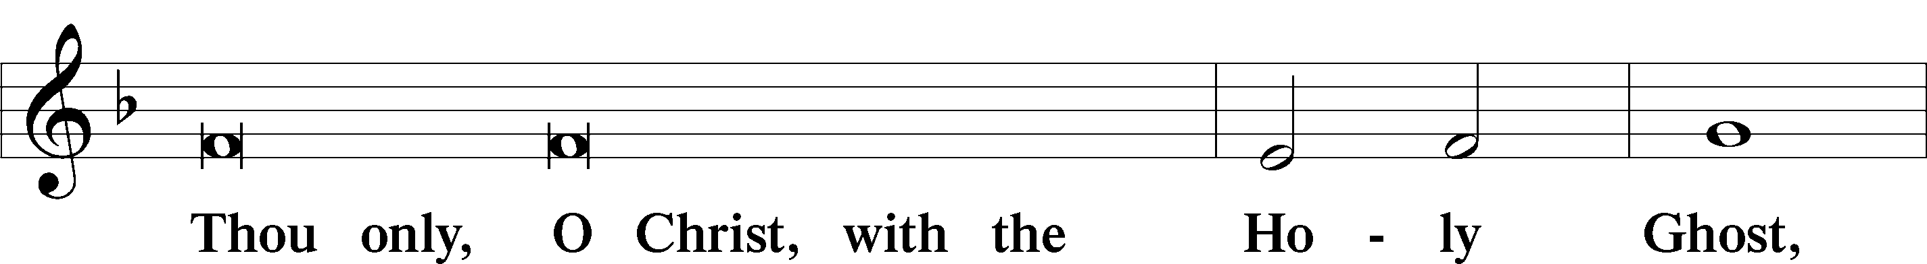
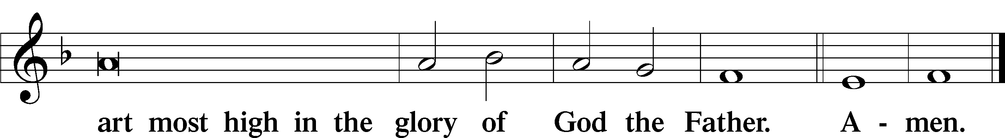

Salutation and Collect of the Day: Cantate
P The Lord be with you.
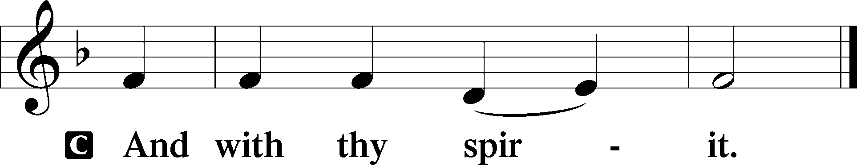

P Let us pray.
O God, You make the minds of Your faithful to be of one will. Grant that we may love what You have commanded and desire what You promise, that among the many changes of this world our hearts may be fixed where true joys are found; through Jesus Christ, Your Son, our Lord, who lives and reigns with You and the Holy Spirit, one God, now and forever.
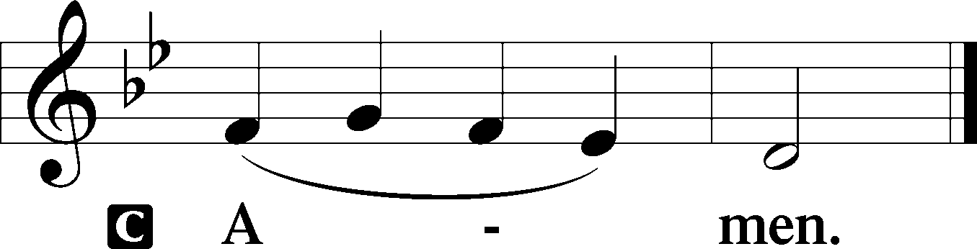
Sit

Prophecy: Isaiah 12:1–6 (NKJV)
Thus says the Lord God: In that day you will say: “O Lord, I will praise You; though You were angry with me, Your anger is turned away, and You comfort me. Behold, God is my salvation, I will trust and not be afraid; ‘For Yah, the Lord, is my strength and song; He also has become my salvation.’ ” Therefore with joy you will draw water from the wells of salvation. And in that day you will say: “Praise the Lord, call upon His name; declare His deeds among the peoples, make mention that His name is exalted. Sing to the Lord, for He has done excellent things; this is known in all the earth. Cry out and shout, O inhabitant of Zion, for great is the Holy One of Israel in your midst!”

P This is the Word of the Lord.
C Thanks be to God.

Psalm: Psalm 66:1–8
Shout for joy to God, all the earth;
sing the glory of his name;
give to him glorious praise!
Say to God, “How awesome are your deeds!
So great is your power that your enemies come cringing to you.
All the earth worships you
and sings praises to you;
they sing praises to your name.”
Come and see what God has done:
he is awesome in his deeds toward the children of man.
He turned the sea into dry land;
they passed through the river on foot.
There did we rejoice in him,
who rules by his might forever,
whose eyes keep watch on the nations—
let not the rebellious exalt themselves.
Bless our God, O peoples;
let the sound of his praise be heard,

Epistle: James 1:17–21 (NKJV)
Dearly Beloved: Every good gift and every perfect gift is from above, and comes down from the Father of lights, with whom there is no variation or shadow of turning. Of His own will He brought us forth by the word of truth, that we might be a kind of firstfruits of His creatures. So then, my beloved brethren, let every man be swift to hear, slow to speak, slow to wrath; for the wrath of man does not produce the righteousness of God. Therefore lay aside all filthiness and overflow of wickedness, and receive with meekness the implanted word, which is able to save your souls.

P This is the Word of the Lord.
C Thanks be to God.

Stand

Verse Psalm 118:16; Romans 6:9
Alleluia. The right hand of the Lord exalts, the right hand of the Lord does valiantly! Alleluia. We know that Christ being raised from the dead will never die again; death no longer has dominion over him. Alleluia.

Alleluia
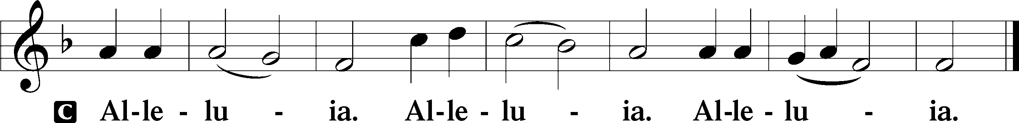

Holy Gospel: John 16:5–15 (NKJV)
P The Holy Gospel according to St. John, the sixteenth chapter.
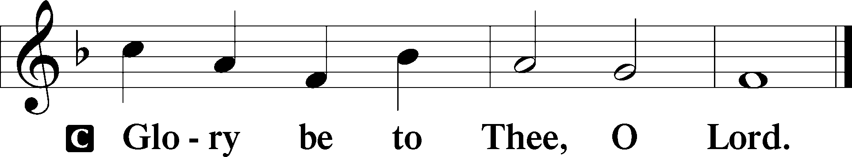

At that time Jesus said to His disciples: “Now I go away to Him who sent Me, and none of you asks Me, ‘Where are You going?’ But because I have said these things to you, sorrow has filled your heart. Nevertheless I tell you the truth. It is to your advantage that I go away; for if I do not go away, the Helper will not come to you; but if I depart, I will send Him to you. And when He has come, He will convict the world of sin, and of righteousness, and of judgment: of sin, because they do not believe in Me; of righteousness, because I go to My Father and you see Me no more; of judgment, because the ruler of this world is judged. I still have many things to say to you, but you cannot bear them now. However, when He, the Spirit of truth, has come, He will guide you into all truth; for He will not speak on His own authority, but whatever He hears He will speak; and He will tell you things to come. He will glorify Me, for He will take of what is Mine and declare it to you. All things that the Father has are Mine. Therefore I said that He will take of Mine and declare it to you.”

P This is the Gospel of the Lord.
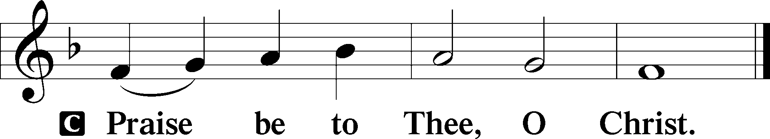

Nicene Creed
C I believe in one God,
the Father Almighty,
maker of heaven and earth
and of all things visible and invisible.

And in one Lord Jesus Christ,
the only-begotten Son of God,
begotten of His Father before all worlds,
God of God, Light of Light,
very God of very God,
begotten, not made,
being of one substance with the Father,
by whom all things were made;
who for us men and for our salvation came down from heaven
and was incarnate by the Holy Spirit of the virgin Mary
and was made man;
and was crucified also for us under Pontius Pilate.
He suffered and was buried.
And the third day He rose again according to the Scriptures
and ascended into heaven
and sits at the right hand of the Father.
And He will come again with glory to judge both the living and the dead,
whose kingdom will have no end.

And I believe in the Holy Spirit,
the Lord and giver of life,
who proceeds from the Father and the Son,
who with the Father and the Son together is worshiped and glorified,
who spoke by the prophets.
And I believe in one holy Christian and apostolic Church,
I acknowledge one Baptism for the remission of sins,
and I look for the resurrection of the dead
and the life T of the world to come. Amen.
Sit

Hymn of the Day: LSB #556 “Dear Christians, One and All, Rejoice”

Sermon

Stand

Prayer of the Church

Offertory Psalm 51:10–12
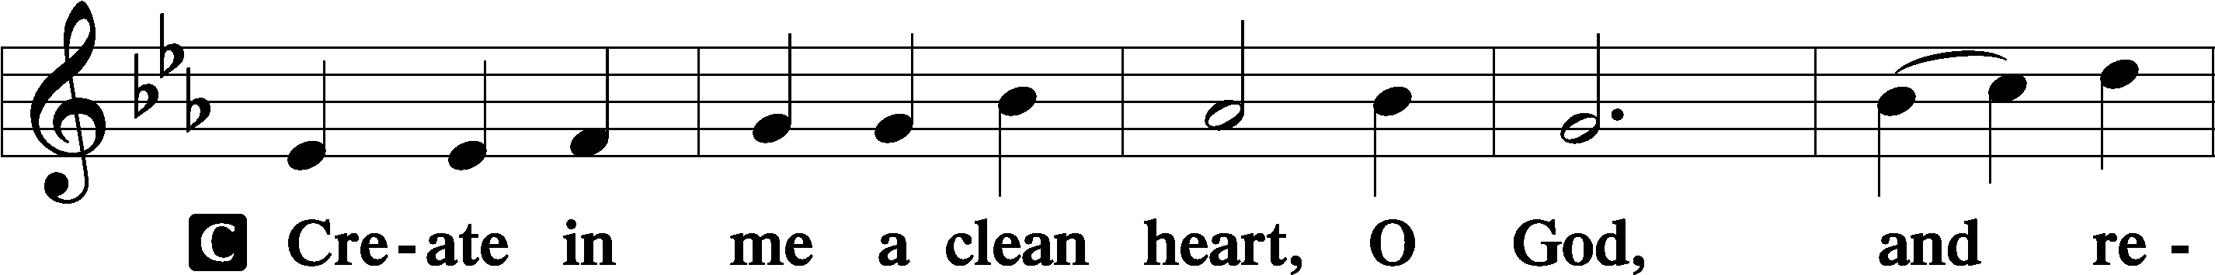
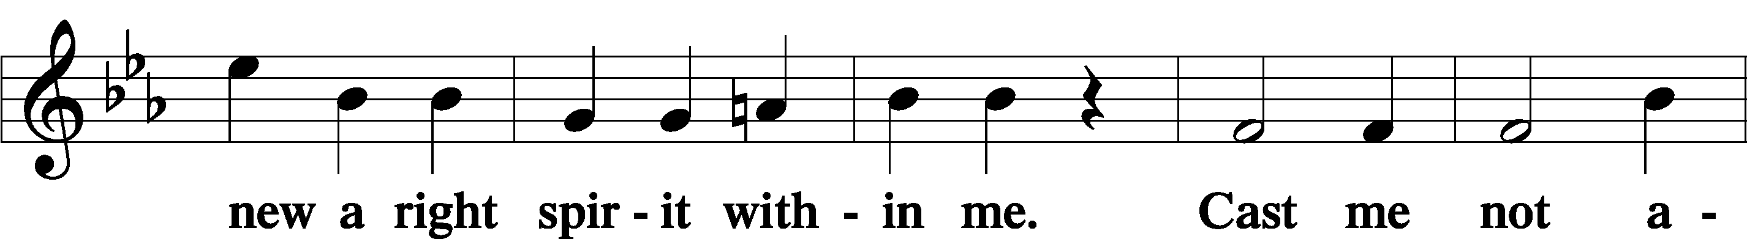
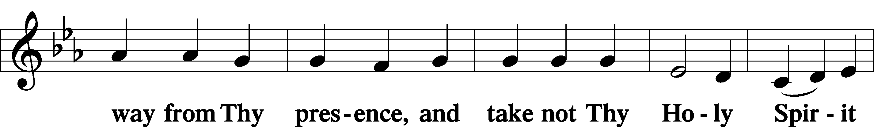
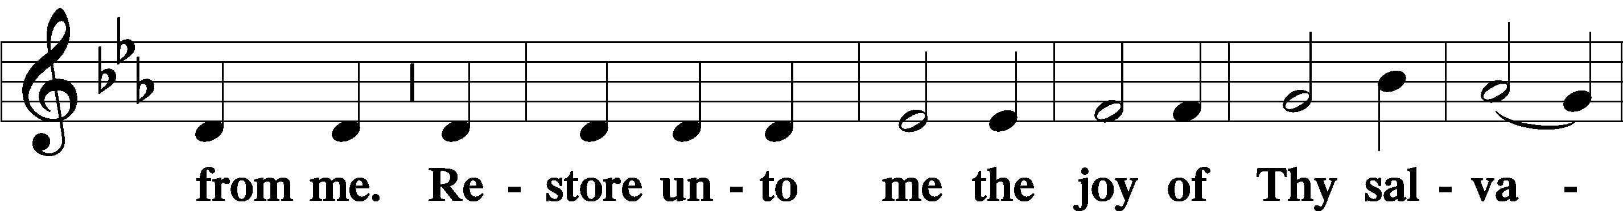
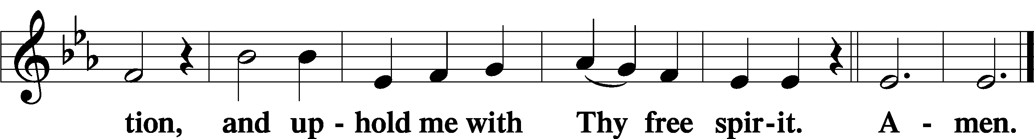
Sit

Preparatory Hymn: LSB #632 “O Jesus, Blessed Lord, to Thee”

Stand
Service of the Sacrament

Preface 2 Timothy 4:22; Colossians 3:1 Psalm 136
P The Lord be with you.
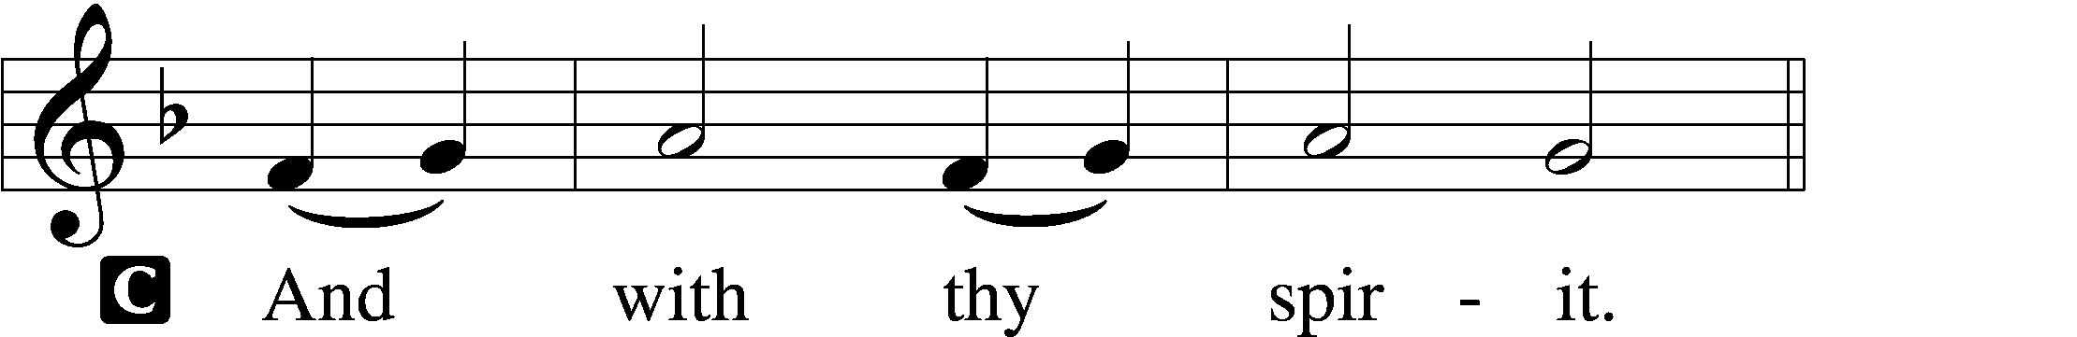

P Lift up your hearts.
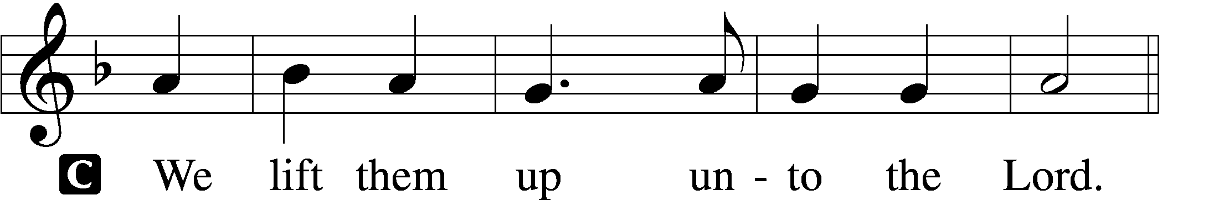

P Let us give thanks unto the Lord, our God.
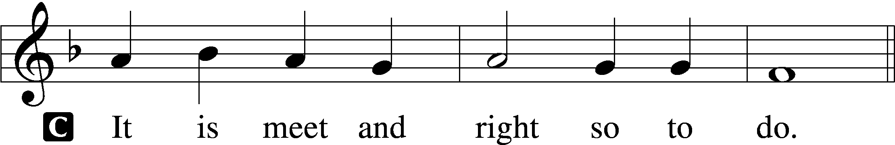

Proper Preface (Abbreviated) LSB 194
P It is truly meet, right, and salutary . . . evermore praising You and saying:

Sanctus Isaiah 6:3; Matthew 21:9
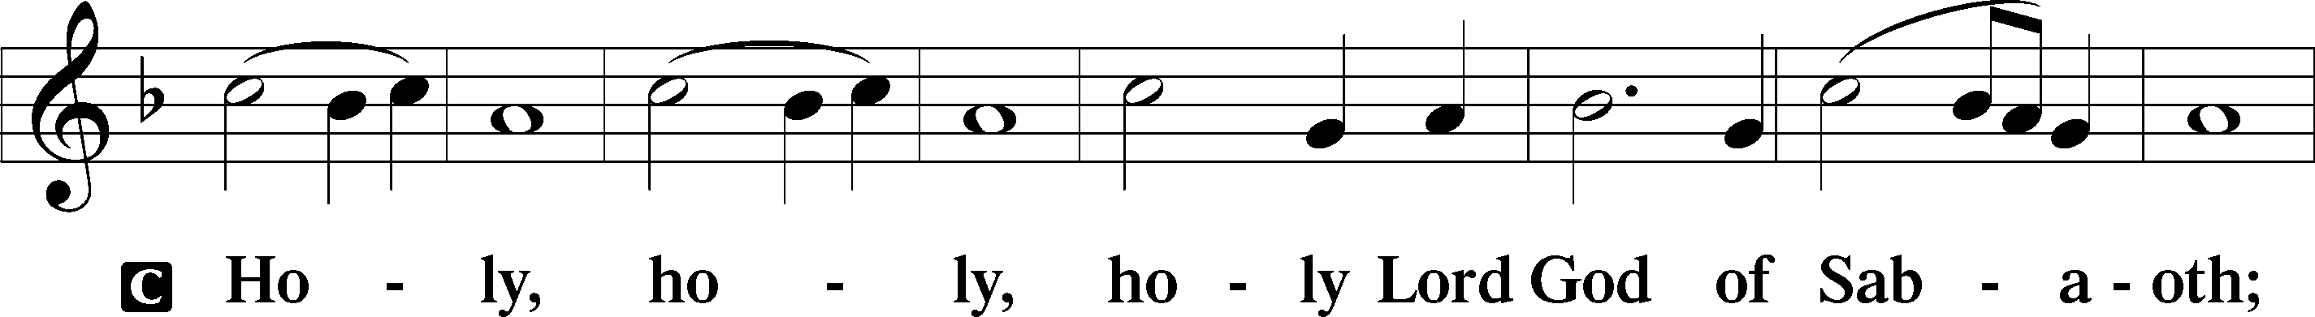
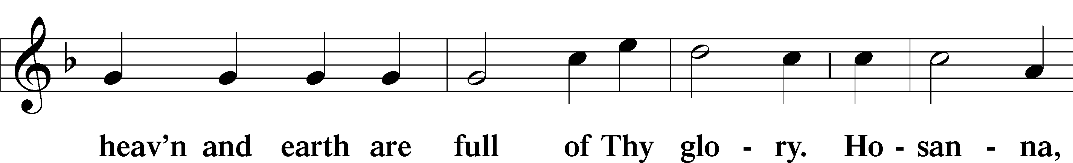
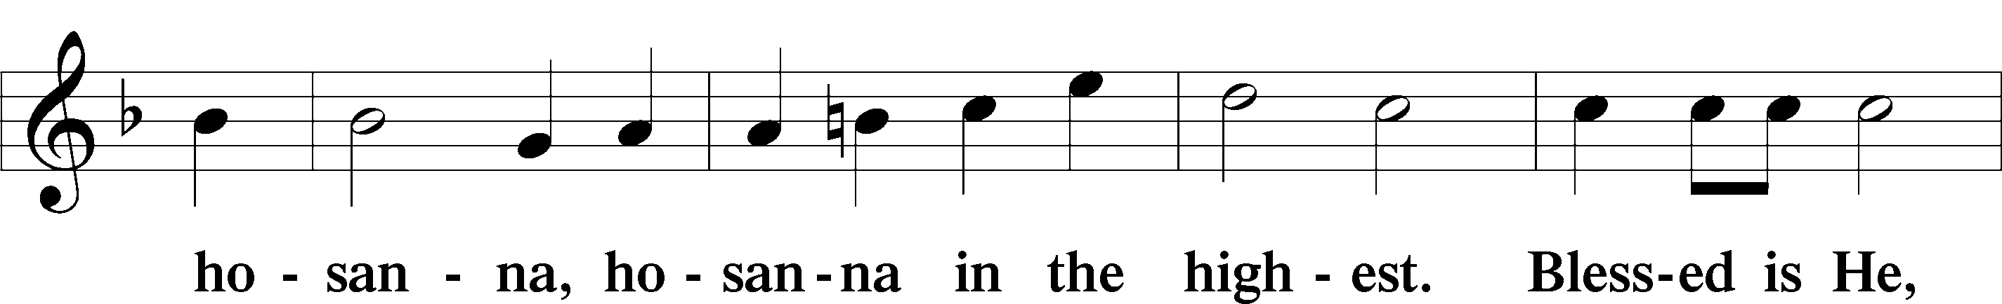
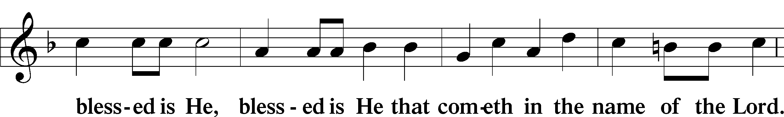
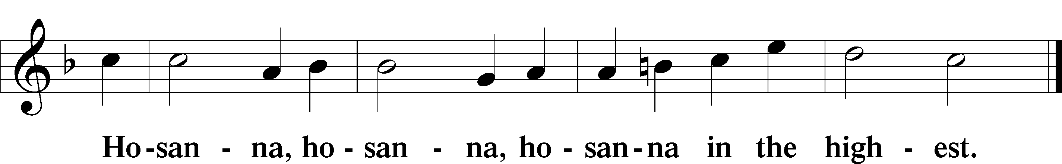

Lord’s Prayer Matthew 6:9–13
C Our Father who art in heaven,
hallowed be Thy name,
Thy kingdom come,
Thy will be done on earth as it is in heaven;
give us this day our daily bread;
and forgive us our trespasses as we forgive those who trespass against us;
and lead us not into temptation,
but deliver us from evil.
For Thine is the kingdom and the power and the glory forever and ever. Amen.
The Words of Our Lord Matthew 26:26–28; Mark 14:22–24; Luke 22:19–20; 1 Corinthians 11:23–25
P Our Lord Jesus Christ, on the night when He was betrayed, took bread, and when He had given thanks, He broke it and gave it to the disciples and said: “Take, eat; this is My T body, which is given for you. This do in remembrance of Me.”

In the same way also He took the cup after supper, and when He had given thanks, He gave it to them, saying: “Drink of it, all of you; this cup is the new testament in My T blood, which is shed for you for the forgiveness of sins. This do, as often as you drink it, in remembrance of Me.”

Pax Domini John 20:19
P The peace of the Lord be with you always.
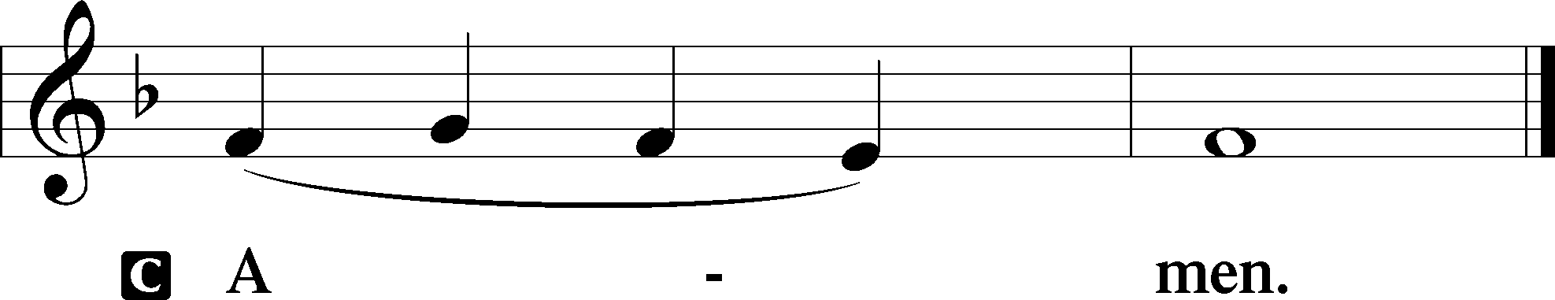

Agnus Dei John 1:29
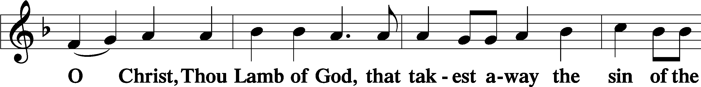
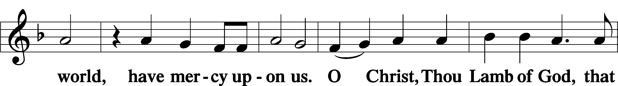
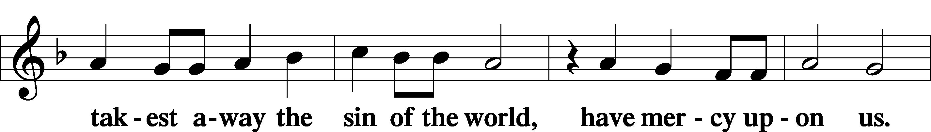
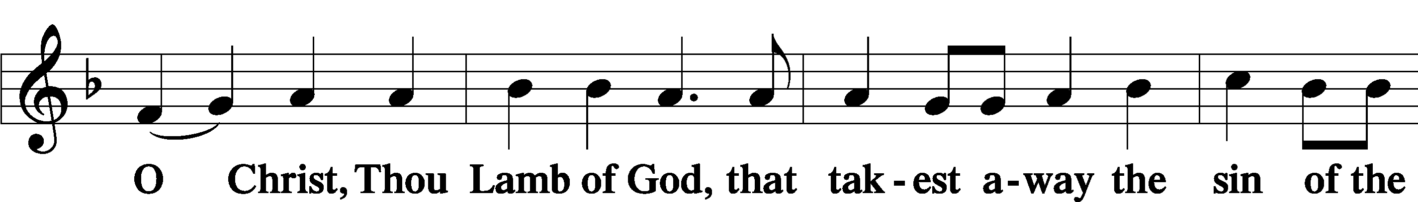
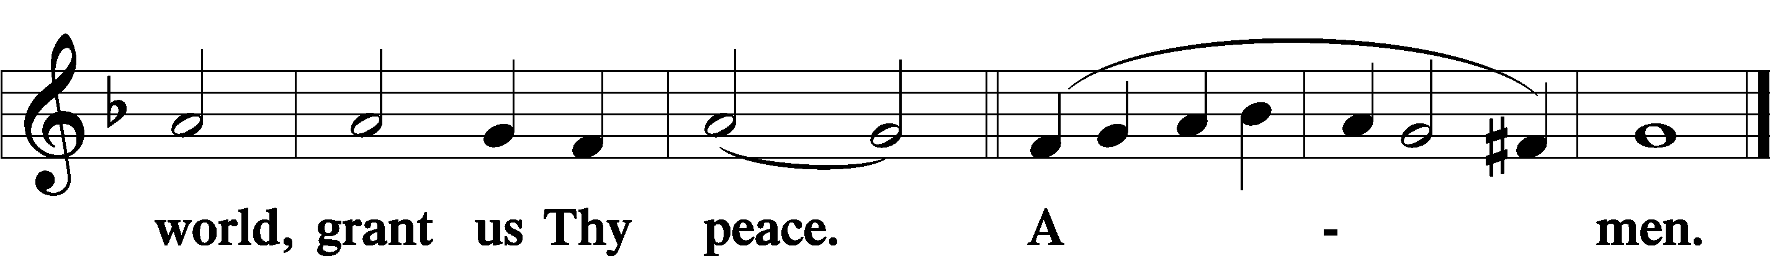
Sit
Distribution
The pastor and those who assist him receive the body and blood of Christ first and then distribute them to those who come to receive, saying:
Take, eat; this is the true body of our Lord and Savior Jesus Christ, given into death for your sins.
Amen.

Take, drink; this is the true blood of our Lord and Savior Jesus Christ, shed for the forgiveness of your sins.
Amen.

In dismissing the communicants, the following is said:
The Dismissal
P The body and blood of our Lord Jesus Christ strengthen and preserve you in body and soul to life everlasting. Depart T in peace.
C Amen.

Distribution Hymn: LSB #528 “Oh, for a Thousand Tongues to Sing”

Distribution Hymn: LSB #819 “Sing Praise to God, the Highest Good”

Distribution Hymn: LSB #790 “Praise to the Lord, the Almighty”

Stand

Nunc Dimittis Luke 2:29–32
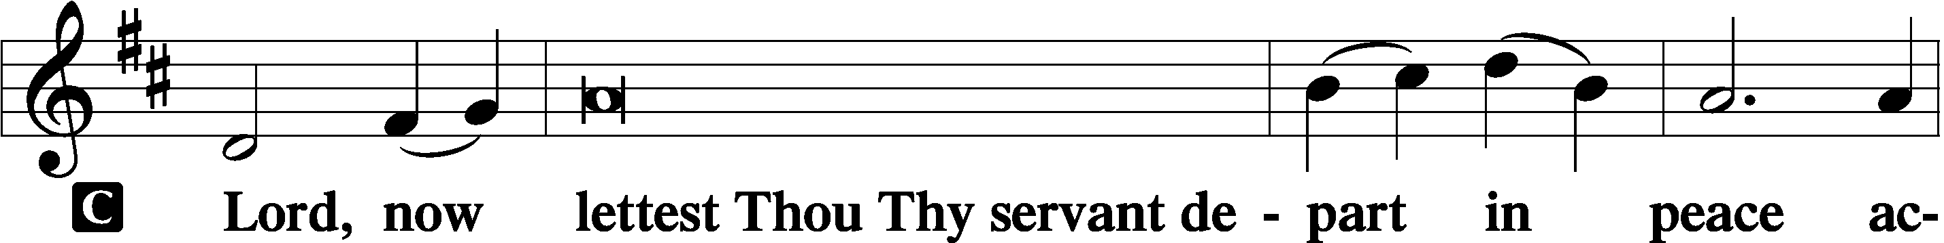
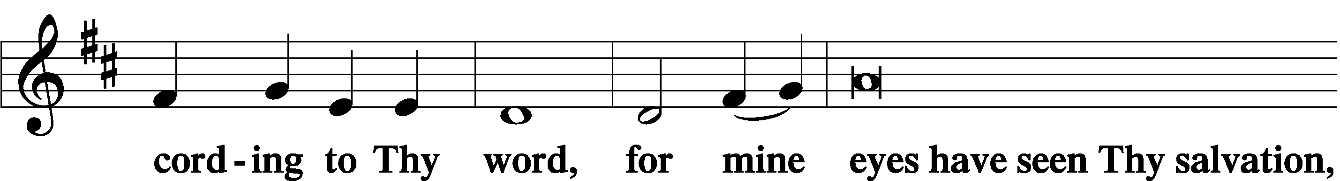
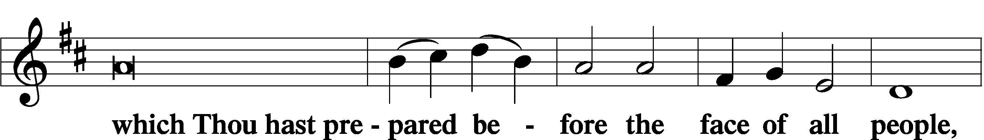
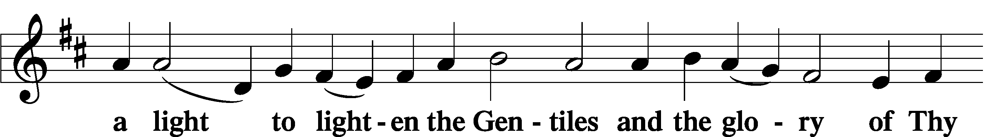
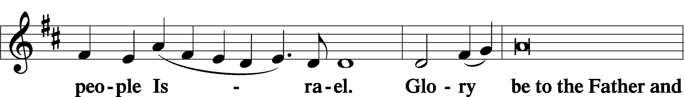
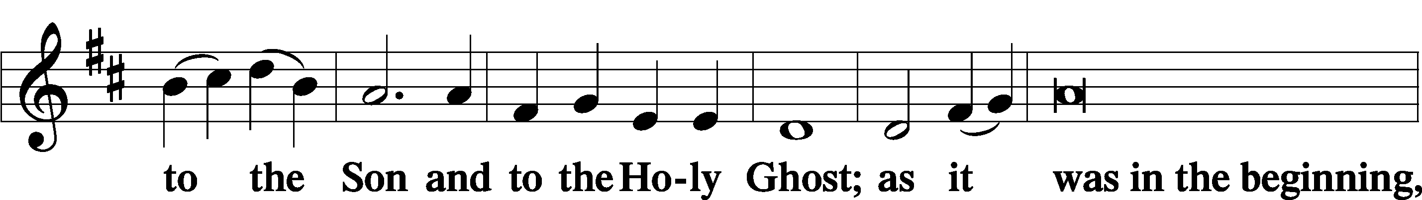
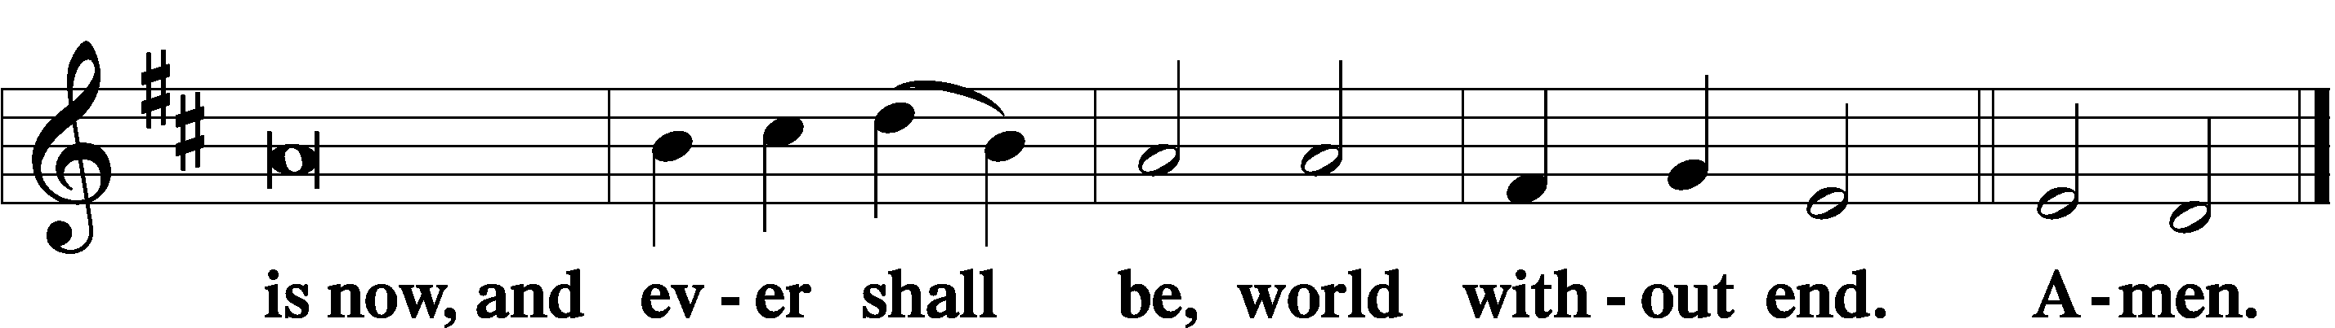

Thanksgiving Psalm 107:1
P O give thanks unto the Lord, for He is good,
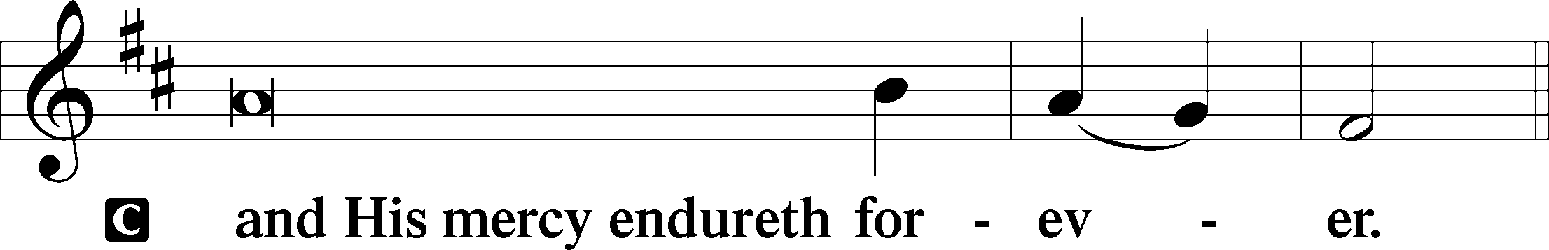

Post-Communion Collect
P Let us pray.
We give thanks to You, almighty God, that You have refreshed us through this salutary gift, and we implore You that of Your mercy You would strengthen us through the same in faith toward You and in fervent love toward one another; through Jesus Christ, Your Son, our Lord, who lives and reigns with You and the Holy Spirit, one God, now and forever.
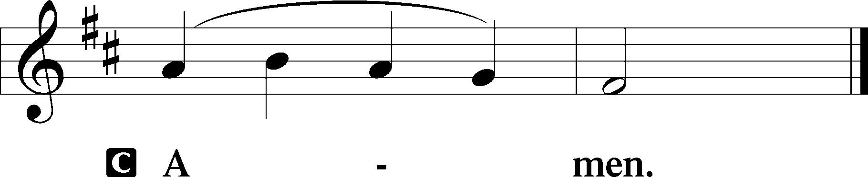

Salutation 2 Timothy 4:22
P The Lord be with you.
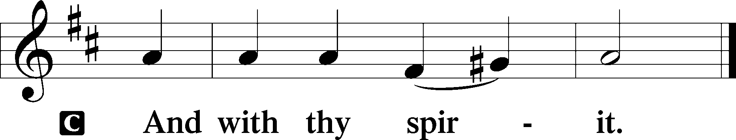

Benedicamus Psalm 103:1
P Bless we the Lord.
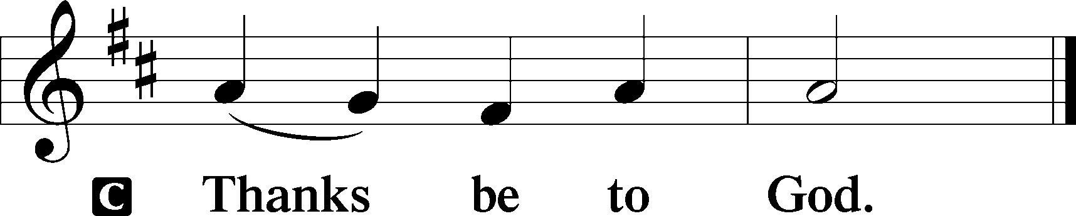

Benediction Numbers 6:24–26
P The Lord bless you and keep you.
The Lord make His face shine upon you and be gracious unto you.
The Lord lift up His countenance upon you and T give you peace.
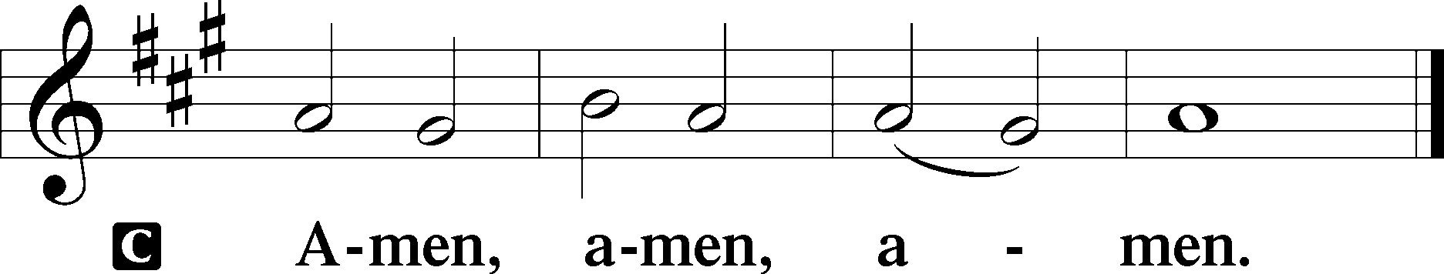

Closing Hymn: LSB #811 “Oh, That I Had a Thousand Voices”

Silent prayer after worship: Dear Lord Jesus, by Your great love You died on the cross for me and for all the world. Make me bold to shine brightly with Your love so that others may also know You as their loving Savior. Amen.
fffffffffffffffffffffffffffffffffff
Acknowledgments: Unless otherwise indicated, Scripture quotations are from the ESV® Bible (The Holy Bible, English Standard Version®), copyright © 2001 by Crossway, a publishing ministry of Good News Publishers. Used by permission. All rights reserved. Created by Lutheran Service Builder © 2023 Concordia Publishing House.
fffffffffffffffffffffffffffffffffff

fffffffffffffffffffffffffffffffffff
In Loving Memory of Barry Nelson: Unknown (Food Pantry), Sue Bender (Food Pantry), Joe & Bev Chlpka (Food Pantry), Dolores Fee (Food Pantry), Mark Gabriel, Clara Krivosh (Food Pantry), Gerald Krivosh, Jr (Food Pantry), Joani Rice (Food Pantry), Diane Riefstahl (Food Pantry), Nancy Robertson (Food Pantry), Edeltraud Sulek (Capital Campaign), Linda Tomko, Betty & Bill Wolf (SELC & Gen’l Fund).
fffffffffffffffffffffffffffffffffff
SCHEDULE THROUGH MAY 14, 2023:

:

Today, following Worship, Fellowship Hall: Coffee Fellowship
7 pm, Fellowship Hall: AA Meeting
Tuesday, 7-9 pm, Fellowship Hall: Penn-Ohio Singers
Wednesday, 7:30 pm, Fellowship Hall: NA Meeting
Saturday, 9:30 am, All Saints~Slippery Rock: Catechism Class
Next Sunday, 8 am, Fellowship Hall: Bible Study
9 am, Sanctuary: Divine Service
7 pm, Fellowship Hall: AA Meeting
fffffffffffffffffffffffffffffffffff
Our Stewardship of Treasures for the Lord:
In order to do the Lord’s work, we need $2,553.63 each week to meet our 2023 budget for general purposes and $76.92 for the SELC. Figures for Sunday, April 23, 2023
General Fund: $1,111.00 Behind for the week: -$1,442.63
SELC: $0.00 Behind for the week: -$76.92
Food Pantry: $535.00
Capital Campaign: $3,185.00
Other: $80.00

For online giving, check out https://www.saintspeterandpaul.net/online-giving.
fffffffffffffffffffffffffffffffffff
Attendance: Sunday, April 30, 2023: 47
fffffffffffffffffffffffffffffffffff
Remember the following in Prayer…
~The Hurting and Healing: The family and friends of Barry Nelson, who passed away April 25, 2023; also, Amy, Gerald Arthur, Ellen Baron^{CA}, Lois Bortner^{CA}, John Burdette, Bev & Joe Chlpka, Kathleen Coughenour, Kim, Anna Mae Daris, Susan Davies, Tim Dudash, Millie Elavsky, Joseph Fleet, Judith & Eddy Furey, Tim Haenftling, Austin Hamilton, Joan, Darla Krajci, Barbara Kreske, Donna Kennedy, Jess Lavoie, Joanne Lozier, Paul Lucas^{CA}, Sandy Marshall, Frank Niemeyer^{CA}, Linda Parkany, Juanita Rentschler, Richard Reuning^{CA}, Nancy Robertson^{CA}, Marty Scott, Kara, Fred Tonty, Angela Weser^{CA}, and Ruth Wolf.
~The Homebound: Rudy & Jean Tomko, Betty Wolf, and Ed & Millie Zachar.
~Serving in the Military: Curtis Sinewe and Joshua Solyan.
~Community & World Needs: Those suffering from or affected by the coronavirus; those suffering due to the conflict between Ukraine and Russia; those suffering from loss and dislocation because weather disasters; those suffering from addiction and their families; Local, State, and National Government Leaders; safety for all Police Officers, Firefighters, & First Responders; the unemployed; our Second Quarter Local Mission: The Support of a Concordia, Fort Wayne Seminarian.
*CA represents cancer.
fffffffffffffffffffffffffffffffffff
Bible Memory Verses ~ Week of May 7th:
For Adults: Do not be conformed to this world, but be transformed by the renewal of your mind, that by testing you may discern what is the will of God, what is good and acceptable and perfect. Romans 12:2

For Children: Oh sing to the Lord a new song, for he has done marvelous things!
Psalm 98:1
fffffffffffffffffffffffffffffffffff
Sincere sympathy is expressed to the family and friends of Barry Nelson, who passed away suddenly April 25, 2023.
May all be comforted by the fervent faith Barry had and the knowledge that he now rests in the arms of our Lord.
fffffffffffffffffffffffffffffffffff
The Secretary’s Office will be closed this week.
fffffffffffffffffffffffffffffffffff
The Altar Flowers this day are given In Loving Memory of Barry Nelson by the Nelson Family. We are grateful for this beautiful, heartfelt gift.
fffffffffffffffffffffffffffffffffff
Church Council members are reminded of the May meeting date change. We will now be meeting Monday, May 15th at 7 pm in the Fellowship Hall. Please be certain to submit your Council reports to the secretary’s office by noon that day so that packets can be put together.
fffffffffffffffffffffffffffffffffff
Join us following worship this morning for Coffee Fellowship. May’s sponsor is Linda Tomko.
If interested in sponsoring a Coffee Fellowship, please sign the sheet posted on the bulletin board in the narthex. Sponsors are asked to bring 2-1/2 to 3 dozen “treats” and 1 quart of juice to the Fellowship Hall kitchen prior to worship. All else, including set-up and clean-up, will be provided.
fffffffffffffffffffffffffffffffffff
Scrip orders and payments for May are due to Matt Berent today. Order forms are available on the tables in the narthex and by the parking lot entrance.
fffffffffffffffffffffffffffffffffff
THANK YOU FOR SERVING IN MAY: Elder: Jonathan Baisch; Ushers: Matt Berent, Mark Gabriel, Michael Laird, & Jerome Thomas; Altarware: (prior) Diane Riefstahl & Marie Flaugher (05/14); (after) Evelyn Baisch & Arlene Sutton.
fffffffffffffffffffffffffffffffffff
Available in the narthex:
- May issue of “The Rock and the Sword” newsletter.
- Copies of the “Lutherans Engage” magazine.
fffffffffffffffffffffffffffffffffff
Altar Guild members should note that our next meeting, scheduled for Saturday, May 20th, will begin at 1 pm. All ladies are welcome to join us!
fffffffffffffffffffffffffffffffffff

Here to Serve
Pastor………………………………………………...……………Rev. Jacob Deal
E-mail …………………………….……pastordeal@saintspeterandpaul.net
Phone Number……………………..…………………724-347-3620 (Option 2)
Church Office………………………..…………………724-347-3620 (Option 3)
Website …………………………………………www.saintspeterandpaul.net
Secretary…………………………………………………………Diane Riefstahl
E-mail ………………………………………church@saintspeterandpaul.net
Website …………………………………………www.saintspeterandpaul.net
Food Pantry: Please leave message……………724-347-3620 (Option 3)
AA Contact: Steve………………………………………………..…724-813-2358
NA Contact: Larry………………………………………………..724-977-8733
Choir Director………………………………………………………Chris Nelson
Congregation President……………………………………Jonathan Baisch
Church Elder …………………………………………...…… Jonathan Baisch
fffffffffffffffffffffffffffffffffff
If needing to get into the church building during the week, please phone first to make certain someone is here to let you in.

