Sts. Peter & Paul
Evangelical Lutheran Church
Lutheran Church-Missouri Synod
Founded-1917

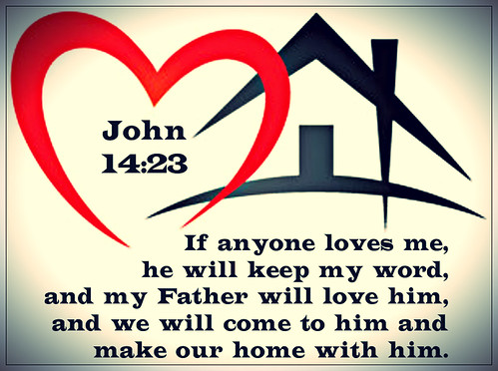

May 28, 2023

699 Stambaugh Ave.
Sharon, Pennsylvania 16146

“I was glad when they said to me,
Let us go to the house of the LORD!”
Psalm 122:1
Sts. Peter & Paul Evangelical Lutheran Church, LC-MS
THE DAY OF PENTECOST
May 28, 2023

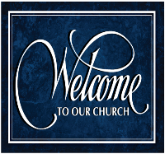
A special welcome to our guests this day! If you would like more information about The Lutheran Church - Missouri Synod, or this congregation, please speak with Pastor Deal or an Elder after the service.
Members & Guests: Don’t be embarrassed if your children make noise during the worship service, all children do. We encourage families to worship together but, if you feel the need, there are pews in the rear of the Church which are reserved for young families on both sides of the sanctuary. There is also a quiet room available to you during our service which is located down the hallway past the offices on the right side of the church as well as a children’s area in the Fellowship Hall where you are able to follow along with the service.

Today’s service includes the Sacrament of Holy Communion. If during this past year, you have not worshipped with us and been communed, we respectfully ask that you do not partake of this sacrament this day before first speaking with Pastor Deal.
If visiting from a sister congregation of the LC-MS and are in good standing, please inform Pastor Deal of your desire to commune prior to the service.
If wishing to receive a blessing during communion, please approach with your arms crossed.

CONTACT INFORMATION
Pastor Deal: pastordeal@saintspeterandpaul.net or 724-347-3620 (opt. 2)
Church Office: church@saintspeterandpaul.net or 724-347-3620 (opt. 3)

Silent prayer before worship: O Lord, thank You for the gift of the Holy Spirit through whom I can believe and come to You in prayer. Cause me to be in Your Word daily that the Holy Spirit may strengthen my faith in You. Amen.

Confession and Absolution

Opening Hymn: LSB #913 “O Holy Spirit, Enter In”

Stand

The sign of the cross may be made by all in remembrance of their Baptism.

Reception of Members by Transfer or Profession of Faith
P Beloved in the Lord, our Lord Jesus Christ said to His apostles: “Whoever confesses Me before men, I will also confess before My Father who is in heaven. But whoever denies Me before men, I will also deny before My Father who is in heaven.” Lift up your hearts, therefore, to the God of all grace and joyfully give answer to what I now ask you in the name of the Lord.

P Do you this day in the presence of God and of this congregation acknowledge the gifts that God gave you in your Baptism?
R Yes, I do.

P Do you renounce the devil and all his works and all his ways?
R Yes, I renounce them.

P Do you believe in God, the Father Almighty, in Jesus Christ, His only Son our Lord, and in the Holy Spirit?
R Yes, I believe in God the Father, Son, and Holy Spirit.

P Do you hold all the prophetic and apostolic Scriptures to be the inspired Word of God and the doctrine of the Evangelical Lutheran Church, drawn from them and confessed in the Small Catechism, to be faithful and true?
R I do.

P Do you intend to hear the Word of God and receive the Lord’s Supper faithfully?
R I do, by the grace of God.

P Do you intend to live according to the Word of God, and in faith, word, and deed to remain true to God, Father, Son, and Holy Spirit, even to death?
R I do, by the grace of God.

P Do you intend to continue steadfast in this confession and Church and to suffer all, even death, rather than fall away from it?
R I do, by the grace of God.

P Do you desire to become a member of this congregation?
R I do.

P Will you support the work our gracious Lord has given this congregation with your prayers and the gifts God has given you?
R I will, with the help of God.

P Upon this your confession of faith, I acknowledge publicly that you are members of the Evangelical Lutheran Church and of this congregation. Receive the Lord’s Supper and participate with us in all the blessings of salvation that our Lord has given to His Church, in the name of the Father and of the T Son and of the Holy Spirit.
C Amen.

Stand
P Let us pray.
Lord God, heavenly Father, we thank and praise You for Your great goodness in bringing these Your sons and daughters to the knowledge of Your Son, our Savior, Jesus Christ, and enabling them both with the heart to believe and with the mouth to confess His saving name. Grant that by Your Word and Spirit they may continue steadfast in the one true faith in the fellowship of this congregation as together we await the day when all who have fought the good fight of faith shall receive the crown of righteousness; through Jesus Christ, Your Son, our Lord, who lives and reigns with You and the Holy Spirit, one God, now and forever.
C Amen.

The pastor may extend the right hand of fellowship, greeting each by name. The rite concludes with the following blessing:
P The grace of our T Lord Jesus Christ be with you.
C Amen.

The new members return to their places.

Invocation
P In the name of the Father and of the T Son and of the Holy Spirit.
C Amen.

Exhortation Hebrews 10:22; Psalm 124:8; Psalm 32:5
P Beloved in the Lord! Let us draw near with a true heart and confess our sins unto God our Father, beseeching Him in the name of our Lord Jesus Christ to grant us forgiveness.

P Our help is in the name of the Lord,
C who made heaven and earth.
P I said, I will confess my transgressions unto the Lord,
C and You forgave the iniquity of my sin.

Silence for reflection on God’s Word and for self-examination.

Confession of Sins
P O almighty God, merciful Father,
C I, a poor, miserable sinner, confess unto You all my sins and iniquities with which I have ever offended You and justly deserved Your temporal and eternal punishment. But I am heartily sorry for them and sincerely repent of them, and I pray You of Your boundless mercy and for the sake of the holy, innocent, bitter sufferings and death of Your beloved Son, Jesus Christ, to be gracious and merciful to me, a poor, sinful being.

Absolution [John 20:19–23]
P Upon this your confession, I, by virtue of my office, as a called and ordained servant of the Word, announce the grace of God unto all of you, and in the stead and by the command of my Lord Jesus Christ I forgive you all your sins in the name of the Father and of the T Son and of the Holy Spirit.
C Amen.

Service of the Word

Introit Psalm 68:1, 4a, c, 11a, 33b, 35a; antiphon: Liturgical Text; Psalm 68:3
The Spirit of the Lord fills the world. Alle- | luia.*
The righteous | shall be glad.
They shall exult be- | fore God;*
they shall be jubilant with joy! Alle- | luia.
God shall arise, his enemies shall be | scattered;*
and those who hate him shall flee be- | fore him!
Sing to God, sing praises | to his name;*
exult be- | fore him!
The Lord | gives the word;*
behold, he sends out his voice, his | mighty voice.
Awesome is God from his sanctu- | ary;*
the God of Israel—he is the one who gives power and strength to his | people.
The Spirit of the Lord fills the world. Alle- | luia.*
The righteous | shall be glad.
They shall exult be- | fore God;*
they shall be jubilant with joy! Alle- | luia.

Gloria Patri
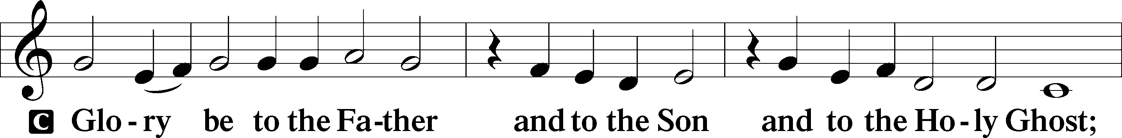
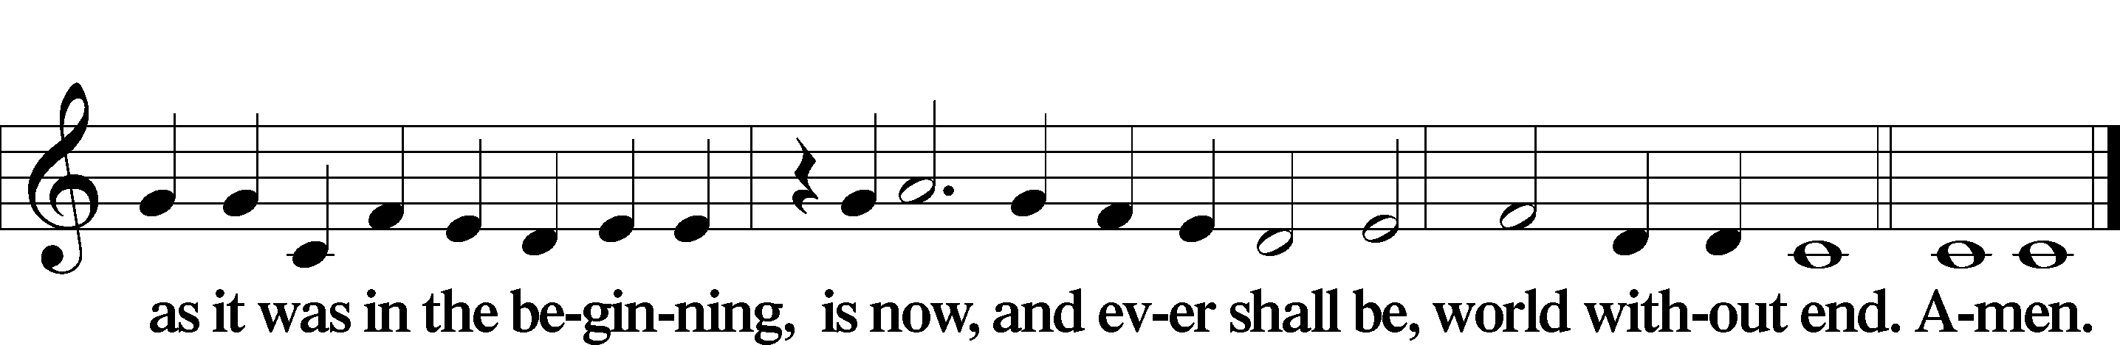

Kyrie Mark 10:47
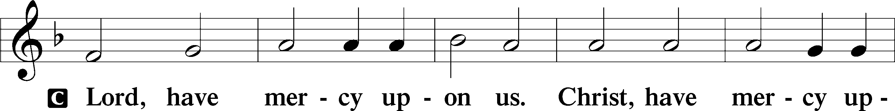
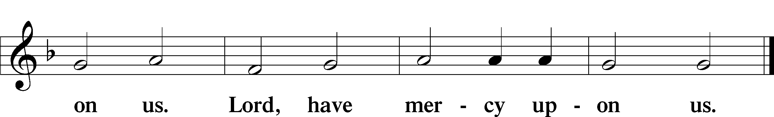

Gloria in Excelsis Luke 2:14; John 1:29
P Glory be to God on high:
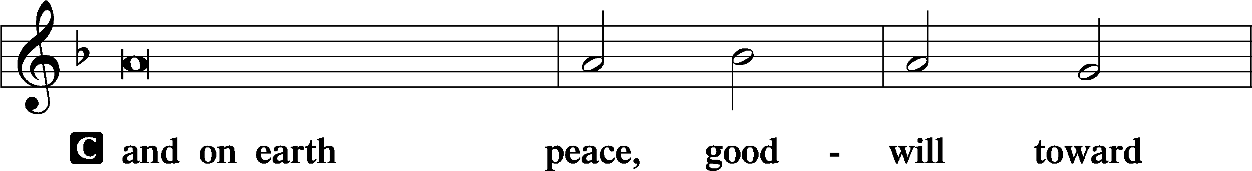
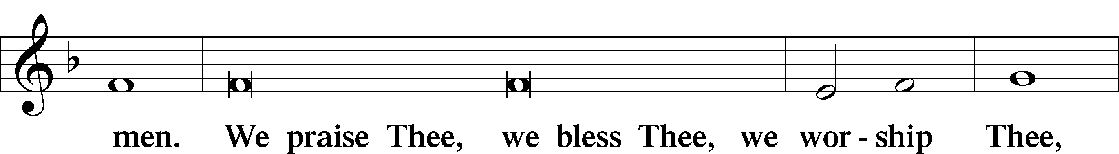
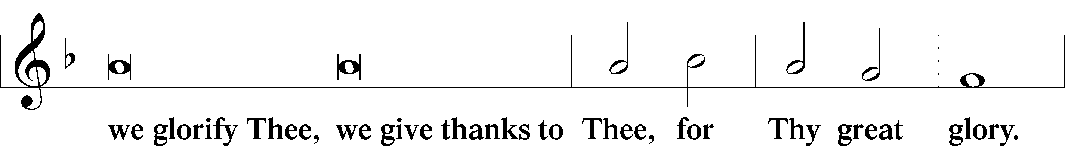
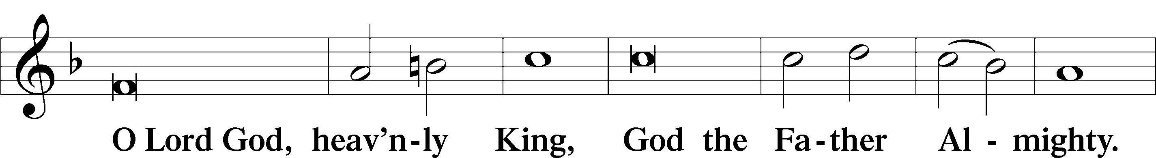
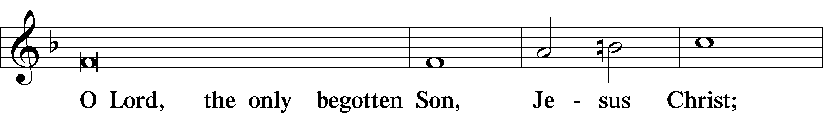
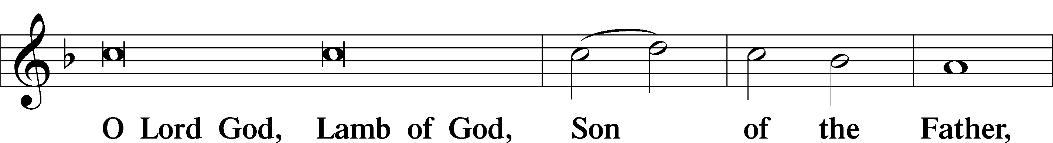
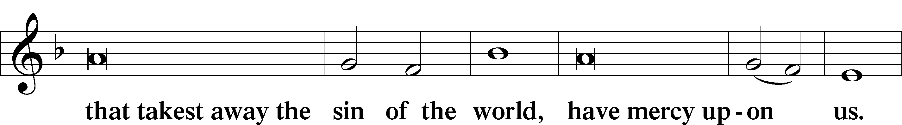
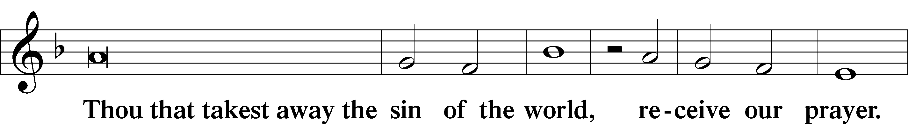
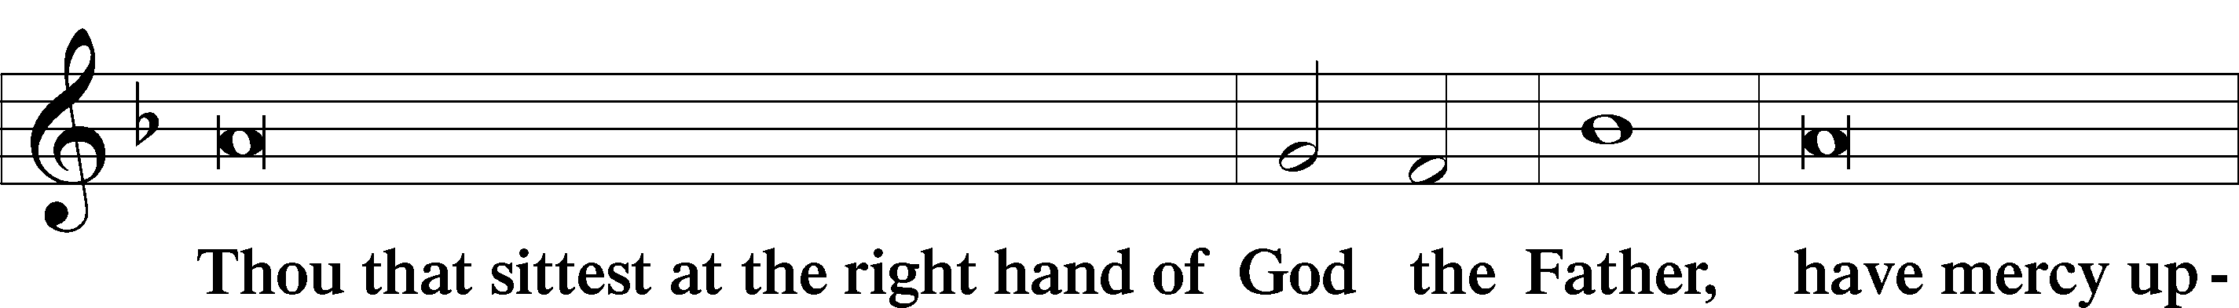
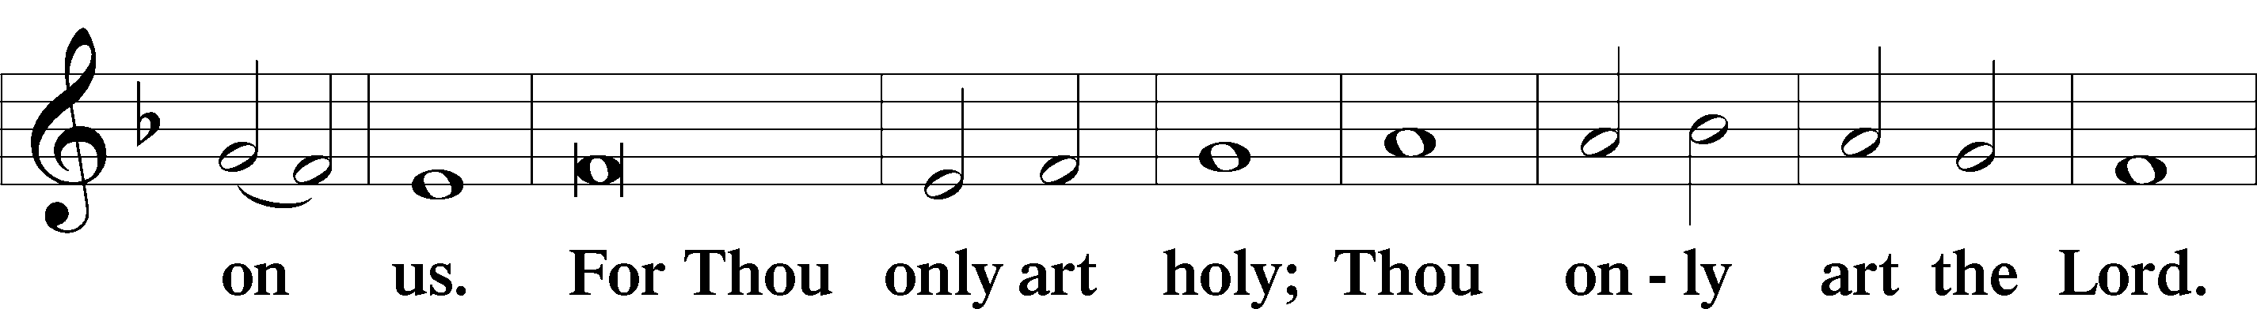
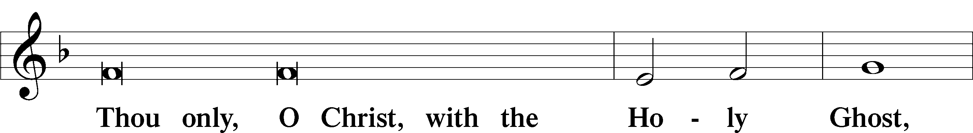
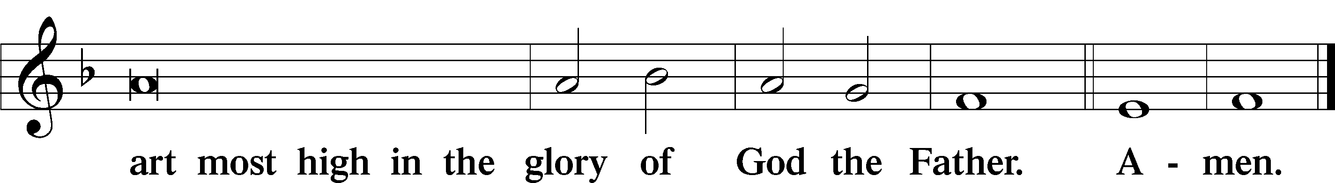

Salutation and Collect of the Day: Pentecost Day
P The Lord be with you.
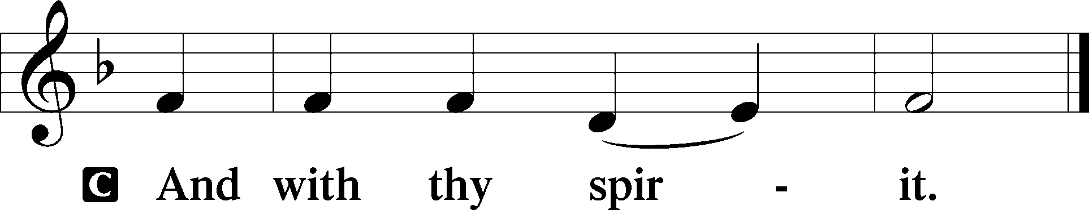

P Let us pray.
O God, on this day You once taught the hearts of Your faithful people by sending them the light of Your Holy Spirit. Grant us in our day by the same Spirit to have a right understanding in all things and evermore to rejoice in His holy consolation; through Jesus Christ, Your Son, our Lord, who lives and reigns with You and the Holy Spirit, one God, now and forever.
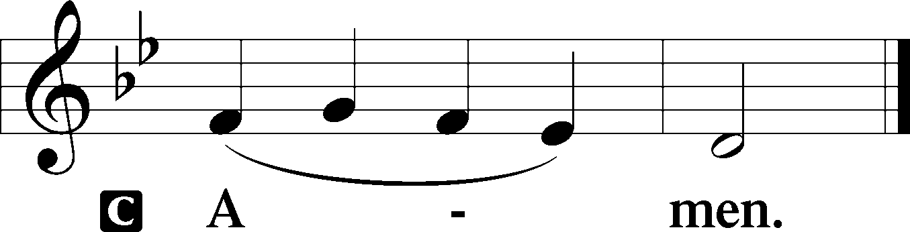

Sit
Prophecy: Genesis 11:1–9 (NKJV)
In those days: The whole earth had one language and one speech. And it came to pass, as they journeyed from the east, that they found a plain in the land of Shinar, and they dwelt there. Then they said to one another, “Come, let us make bricks and bake them thoroughly.” They had brick for stone, and they had asphalt for mortar. And they said, “Come, let us build ourselves a city, and a tower whose top is in the heavens; let us make a name for ourselves, lest we be scattered abroad over the face of the whole earth.” But the Lord came down to see the city and the tower which the sons of men had built. And the Lord said, “Indeed the people are one and they all have one language, and this is what they begin to do; now nothing that they propose to do will be withheld from them. Come, let Us go down and there confuse their language, that they may not understand one another’s speech.” So the Lord scattered them abroad from there over the face of all the earth, and they ceased building the city. Therefore its name is called Babel, because there the Lord confused the language of all the earth; and from there the Lord scattered them abroad over the face of all the earth.

P This is the Word of the Lord.
C Thanks be to God.

Psalm: Psalm 143
Hear my prayer, O Lord;
give ear to my pleas for mercy!
In your faithfulness answer me, in your righteousness!
Enter not into judgment with your servant,
for no one living is righteous before you.
For the enemy has pursued my soul;
he has crushed my life to the ground;
he has made me sit in darkness like those long dead.
Therefore my spirit faints within me;
my heart within me is appalled.
I remember the days of old;
I meditate on all that you have done;
I ponder the work of your hands.
I stretch out my hands to you;
my soul thirsts for you like a parched land.
Answer me quickly, O Lord!
My spirit fails!
Hide not your face from me,
lest I be like those who go down to the pit.
Let me hear in the morning of your steadfast love,
for in you I trust.
Make me know the way I should go,
for to you I lift up my soul.
Deliver me from my enemies, O Lord!
I have fled to you for refuge!
Teach me to do your will,
for you are my God!
Let your good Spirit lead me
on level ground!
For your name’s sake, O Lord, preserve my life!
In your righteousness bring my soul out of trouble!
And in your steadfast love you will cut off my enemies,
and you will destroy all the adversaries of my soul,
for I am your servant.

Second Reading: Acts 2:1–11 (NKJV)
In those days: When the Day of Pentecost had fully come, they were all with one accord in one place. And suddenly there came a sound from heaven, as of a rushing mighty wind, and it filled the whole house where they were sitting. Then there appeared to them divided tongues, as of fire, and one sat upon each of them. And they were all filled with the Holy Spirit and began to speak with other tongues, as the Spirit gave them utterance. And there were dwelling in Jerusalem Jews, devout men, from every nation under heaven. And when this sound occurred, the multitude came together, and were confused, because everyone heard them speak in his own language. Then they were all amazed and marveled, saying to one another, “Look, are not all these who speak Galileans? And how is it that we hear, each in our own language in which we were born? Parthians and Medes and Elamites, those dwelling in Mesopotamia, Judea and Cappadocia, Pontus and Asia, Phrygia and Pamphylia, Egypt and the parts of Libya adjoining Cyrene, visitors from Rome, both Jews and proselytes, Cretans and Arabs—we hear them speaking in our own tongues the wonderful works of God.”

P This is the Word of the Lord.
C Thanks be to God.

Stand

Verse Psalm 104:30; Liturgical Text
Alleluia. When you send forth your Spirit, they are created, and you renew the face of the ground. Alleluia. Come, Holy Spirit, fill the hearts of the faithful, and kindle in them the fire of your love. Alleluia.

Alleluia
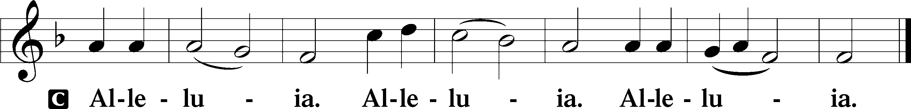

Holy Gospel: John 14:23–31a (NKJV)
P The Holy Gospel according to St. John, the fourteenth chapter.
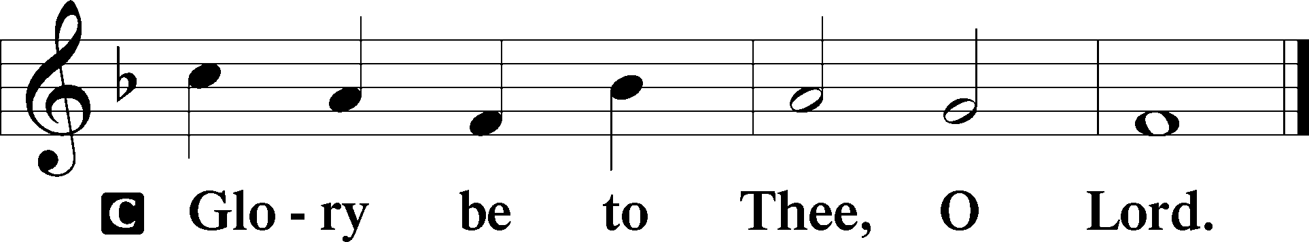

At that time Jesus said to His disciples: “If anyone loves Me, he will keep My word; and My Father will love him, and We will come to him and make Our home with him. He who does not love Me does not keep My words; and the word which you hear is not Mine but the Father’s who sent Me. These things I have spoken to you while being present with you. But the Helper, the Holy Spirit, whom the Father will send in My name, He will teach you all things, and bring to your remembrance all things that I said to you. Peace I leave with you, My peace I give to you; not as the world gives do I give to you. Let not your heart be troubled, neither let it be afraid. You have heard Me say to you, ‘I am going away and coming back to you.’ If you loved Me, you would rejoice because I said, ‘I am going to the Father,’ for My Father is greater than I. And now I have told you before it comes, that when it does come to pass, you may believe. I will no longer talk much with you, for the ruler of this world is coming, and he has nothing in Me. But that the world may know that I love the Father, and as the Father gave Me commandment, so I do.”

P This is the Gospel of the Lord.
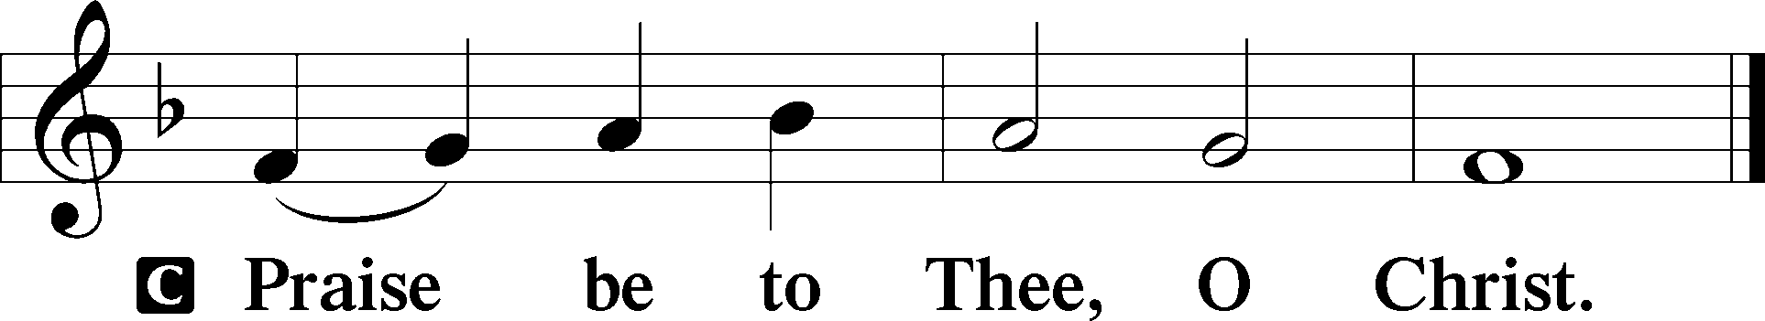

Nicene Creed
C I believe in one God,
the Father Almighty,
maker of heaven and earth
and of all things visible and invisible.

And in one Lord Jesus Christ,
the only-begotten Son of God,
begotten of His Father before all worlds,
God of God, Light of Light,
very God of very God,
begotten, not made,
being of one substance with the Father,
by whom all things were made;
who for us men and for our salvation came down from heaven
and was incarnate by the Holy Spirit of the virgin Mary
and was made man;
and was crucified also for us under Pontius Pilate.
He suffered and was buried.
And the third day He rose again according to the Scriptures
and ascended into heaven
and sits at the right hand of the Father.
And He will come again with glory to judge both the living and the dead,
whose kingdom will have no end.

And I believe in the Holy Spirit,
the Lord and giver of life,
who proceeds from the Father and the Son,
who with the Father and the Son together is worshiped and glorified,
who spoke by the prophets.
And I believe in one holy Christian and apostolic Church,
I acknowledge one Baptism for the remission of sins,
and I look for the resurrection of the dead
and the life T of the world to come. Amen.
Sit

Hymn of the Day: LSB #497 “Come, Holy Ghost, God and Lord”

Sermon

Stand

Prayer of the Church

Offertory Psalm 51:10–12
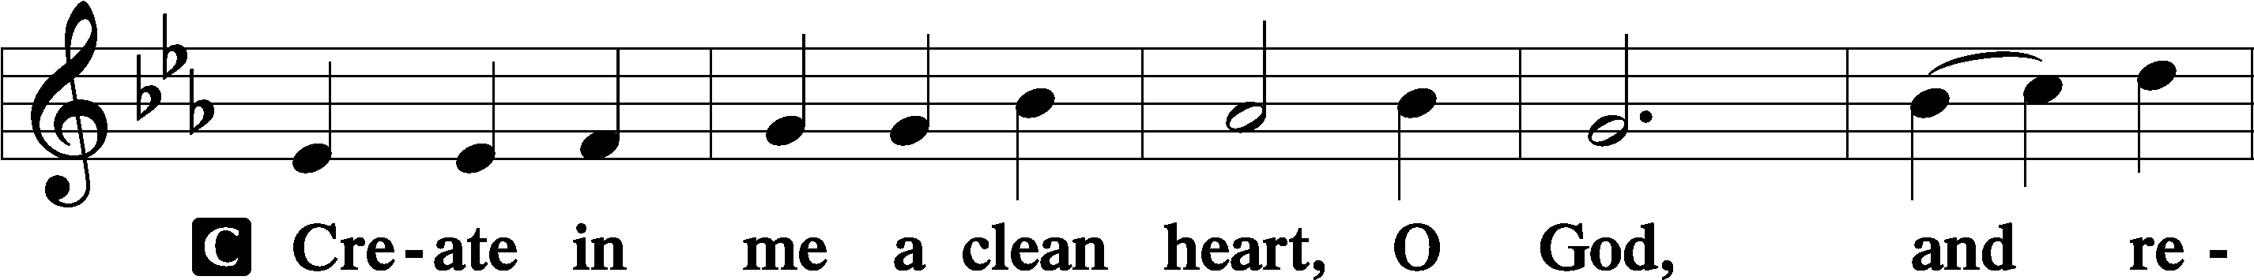
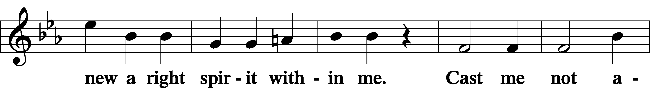
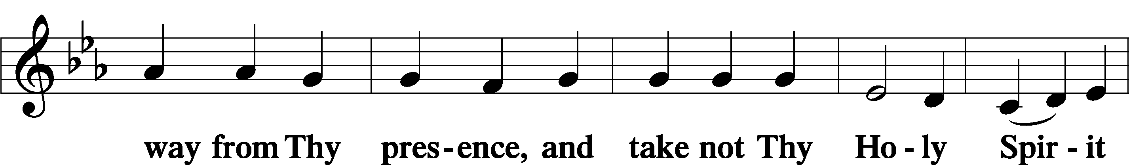
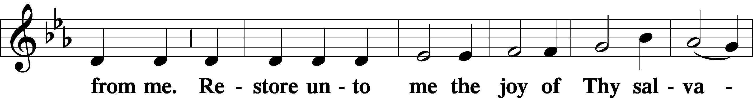
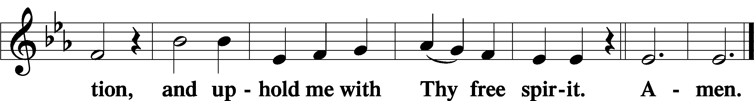
Sit

Preparatory Hymn: LSB #503 “O Day Full of Grace”

Stand

Service of the Sacrament

Preface 2 Timothy 4:22; Colossians 3:1 Psalm 136
P The Lord be with you.

P Lift up your hearts.
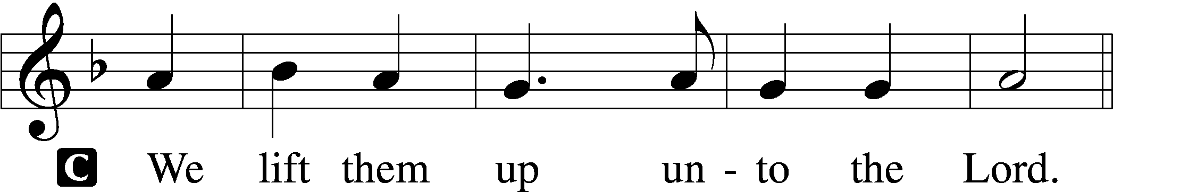

P Let us give thanks unto the Lord, our God.
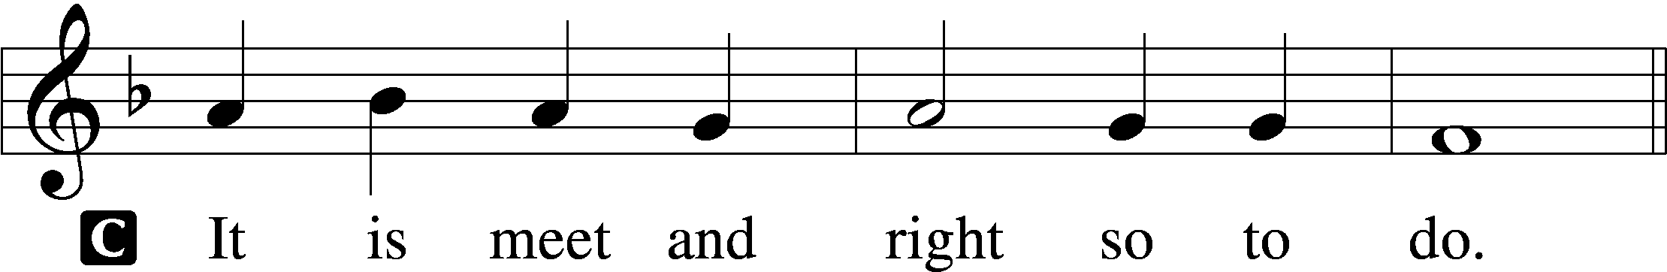

Proper Preface (Abbreviated) LSB 194
P It is truly meet, right, and salutary . . . evermore praising You and saying:

Sanctus Isaiah 6:3; Matthew 21:9
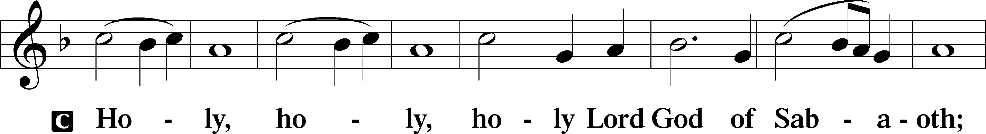
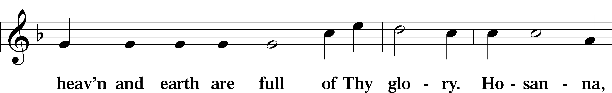
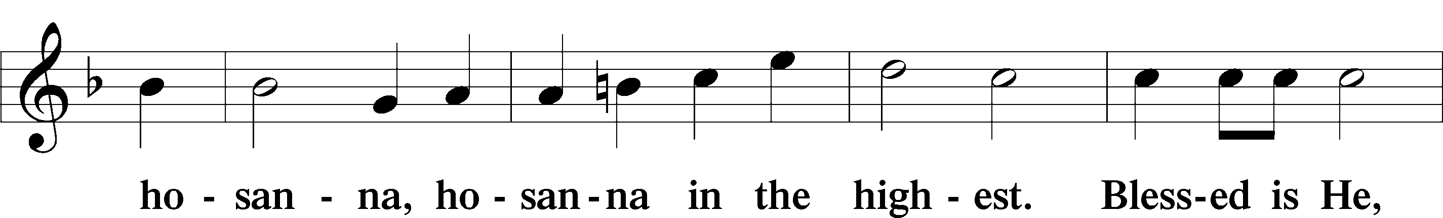
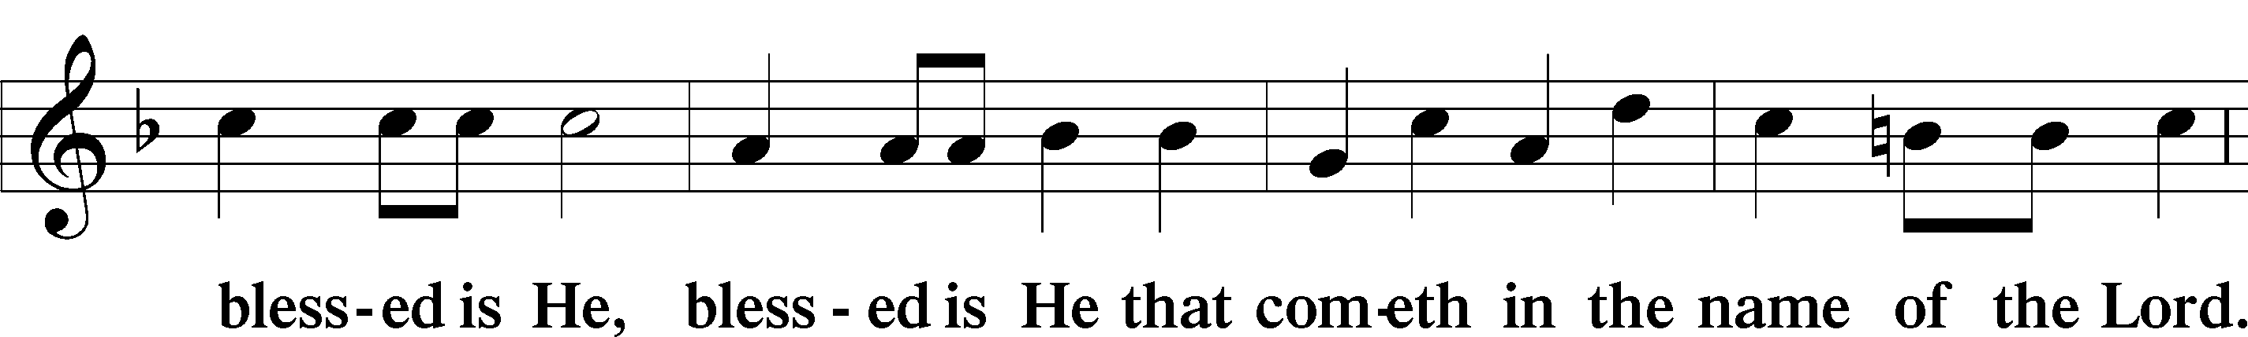
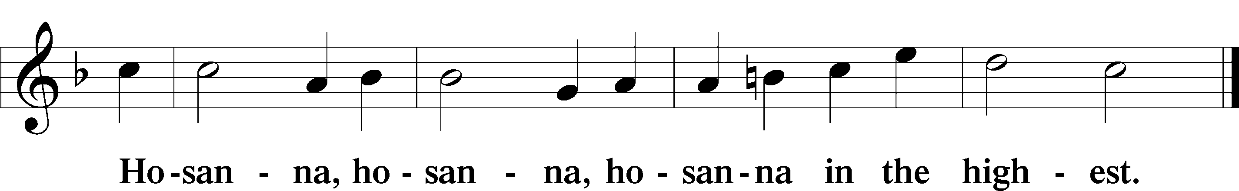

Lord’s Prayer Matthew 6:9–13
C Our Father who art in heaven,
hallowed be Thy name,
Thy kingdom come,
Thy will be done on earth as it is in heaven;
give us this day our daily bread;
and forgive us our trespasses as we forgive those who trespass against us;
and lead us not into temptation,
but deliver us from evil.
For Thine is the kingdom and the power and the glory forever and ever. Amen.
The Words of Our Lord Matthew 26:26–28; Mark 14:22–24; Luke 22:19–20; 1 Corinthians 11:23–25
P Our Lord Jesus Christ, on the night when He was betrayed, took bread, and when He had given thanks, He broke it and gave it to the disciples and said: “Take, eat; this is My T body, which is given for you. This do in remembrance of Me.”

In the same way also He took the cup after supper, and when He had given thanks, He gave it to them, saying: “Drink of it, all of you; this cup is the new testament in My T blood, which is shed for you for the forgiveness of sins. This do, as often as you drink it, in remembrance of Me.”

Pax Domini John 20:19
P The peace of the Lord be with you always.
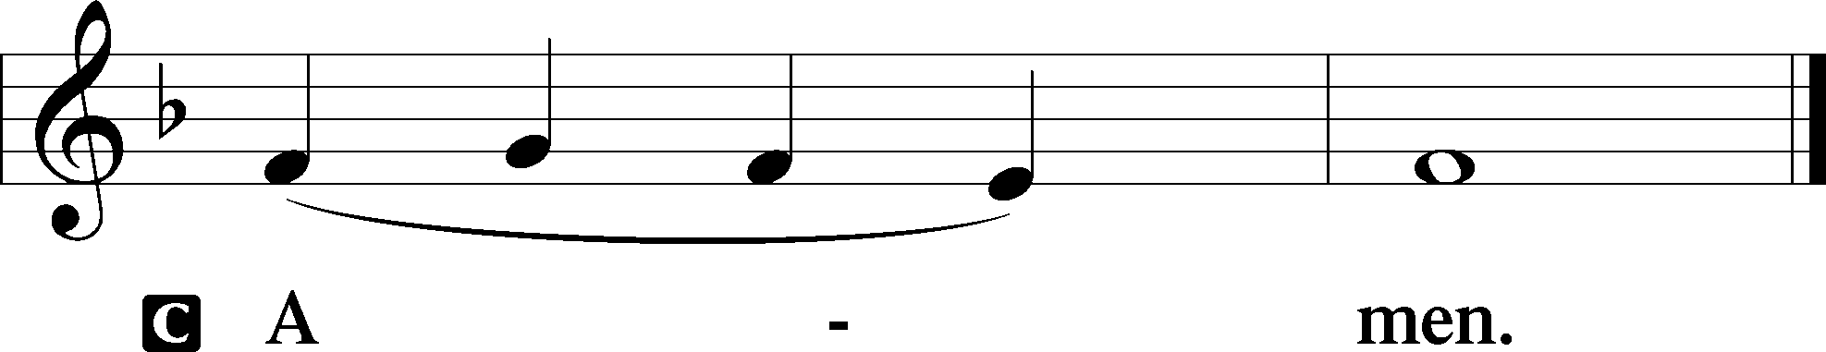

Agnus Dei John 1:29
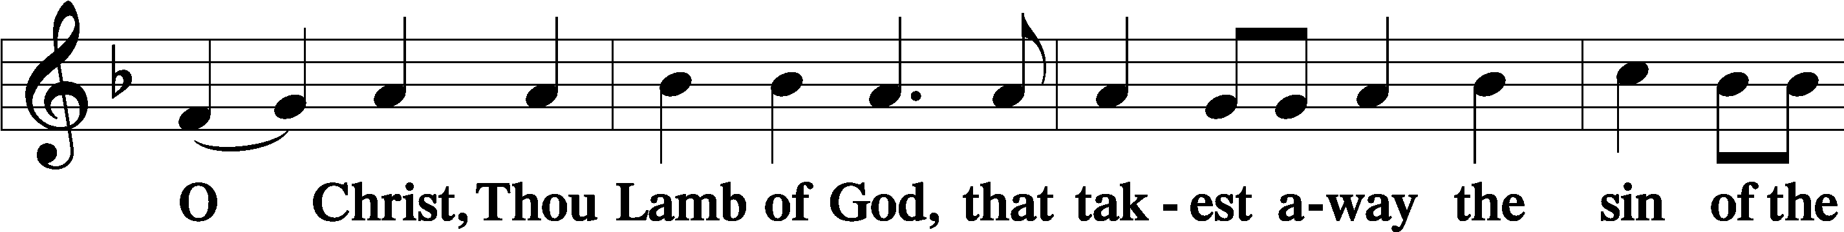
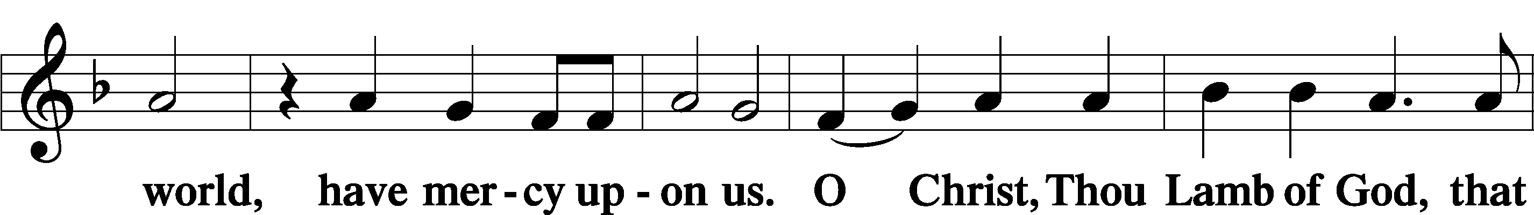
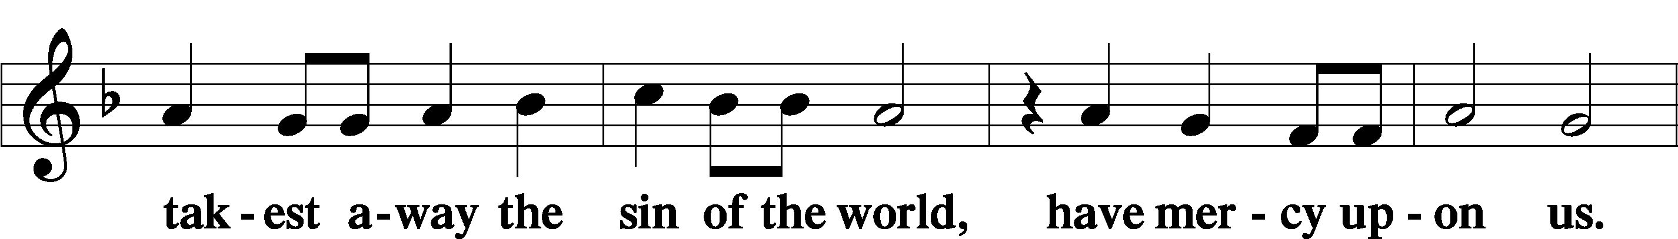
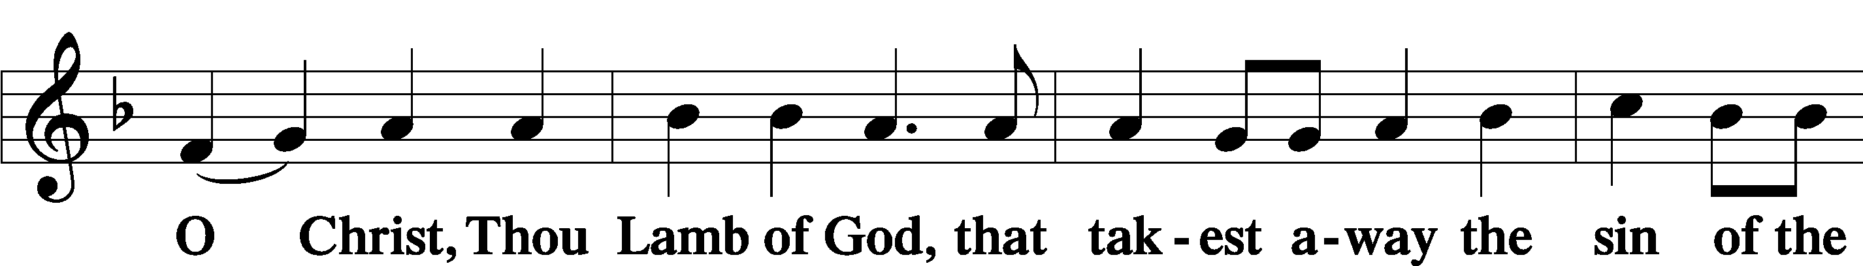
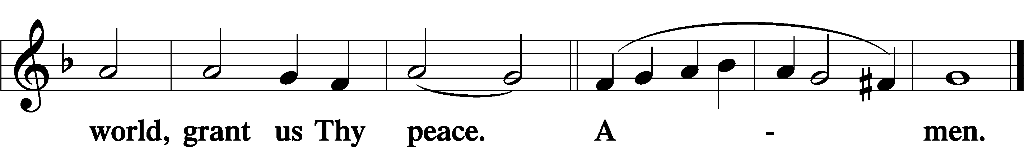
Sit
Distribution
The pastor and those who assist him receive the body and blood of Christ first and then distribute them to those who come to receive, saying:
Take, eat; this is the true body of our Lord and Savior Jesus Christ, given into death for your sins.
Amen.

Take, drink; this is the true blood of our Lord and Savior Jesus Christ, shed for the forgiveness of your sins.
Amen.

In dismissing the communicants, the following is said:
The Dismissal
P The body and blood of our Lord Jesus Christ strengthen and preserve you in body and soul to life everlasting. Depart T in peace.
C Amen.

Distribution Hymn: LSB #496 “Holy Spirit, Light Divine”

Distribution Hymn: LSB #797 “Praise the Almighty”

Distribution Hymn: LSB #500 “Creator Spirit, by Whose Aid”

Stand

Nunc Dimittis Luke 2:29–32
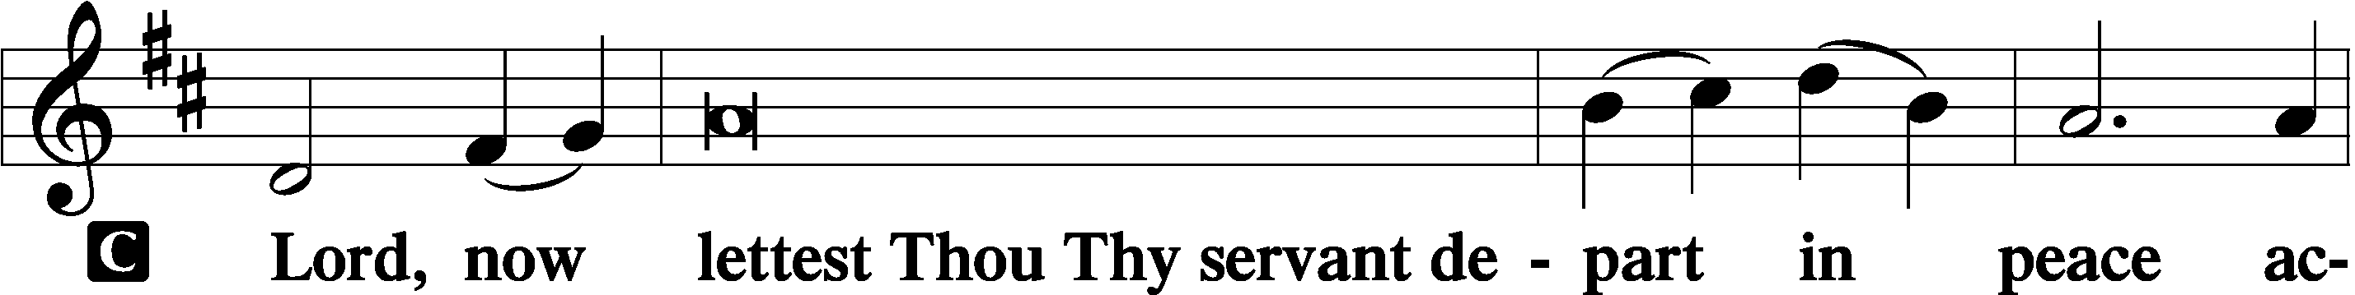
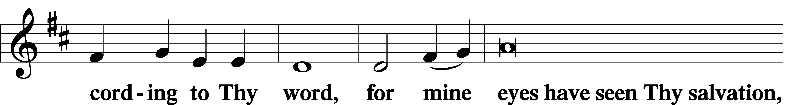
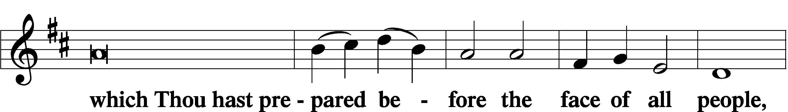
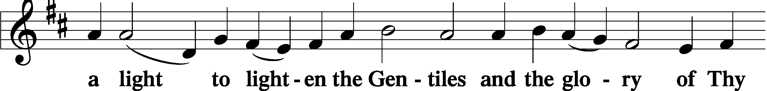
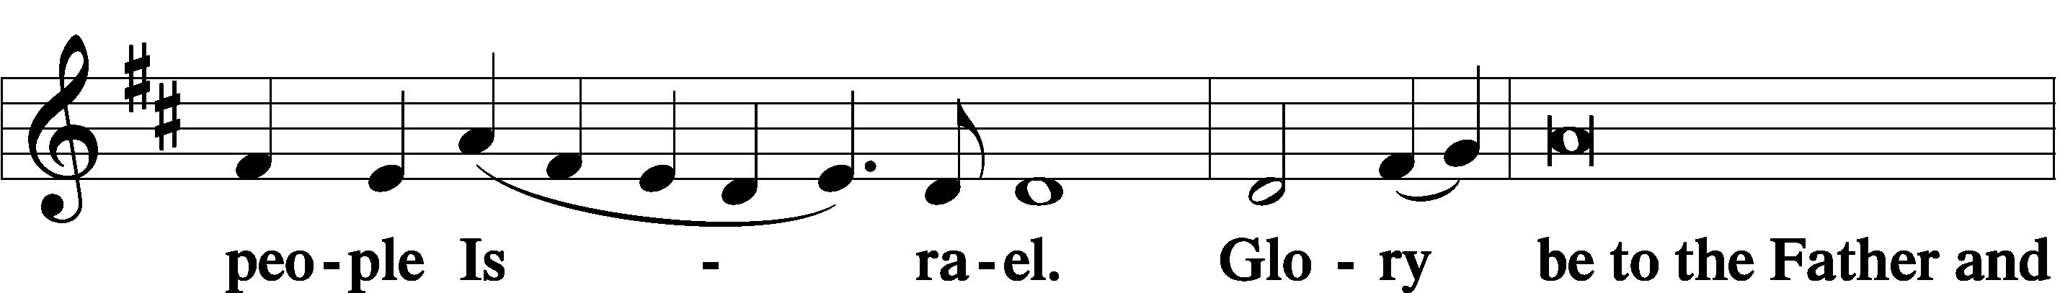
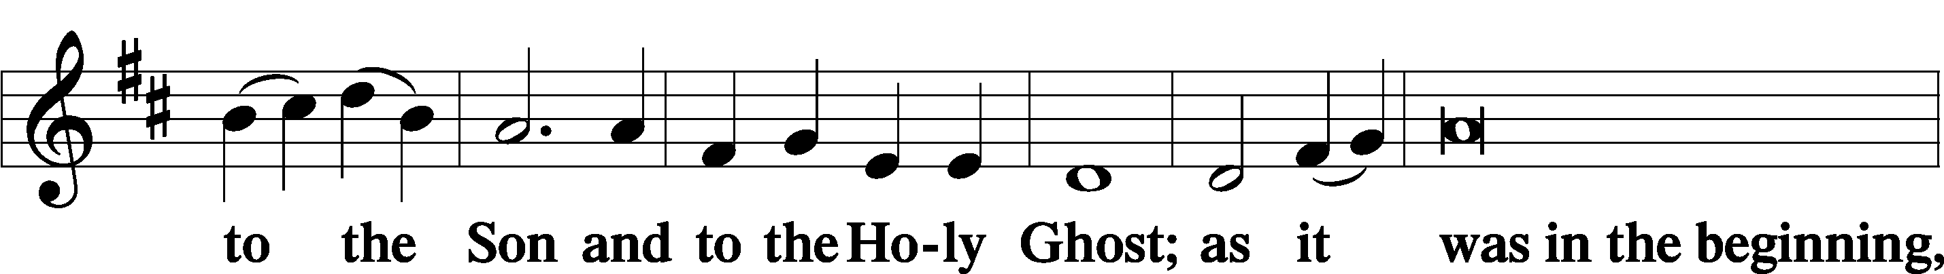
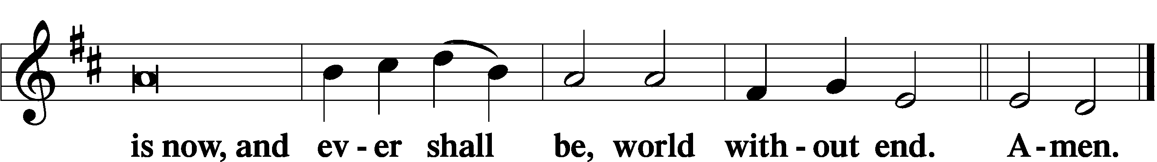

Thanksgiving Psalm 107:1
P O give thanks unto the Lord, for He is good,
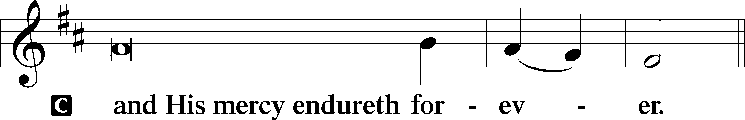

Post-Communion Collect
P Let us pray.
We give thanks to You, almighty God, that You have refreshed us through this salutary gift, and we implore You that of Your mercy You would strengthen us through the same in faith toward You and in fervent love toward one another; through Jesus Christ, Your Son, our Lord, who lives and reigns with You and the Holy Spirit, one God, now and forever.
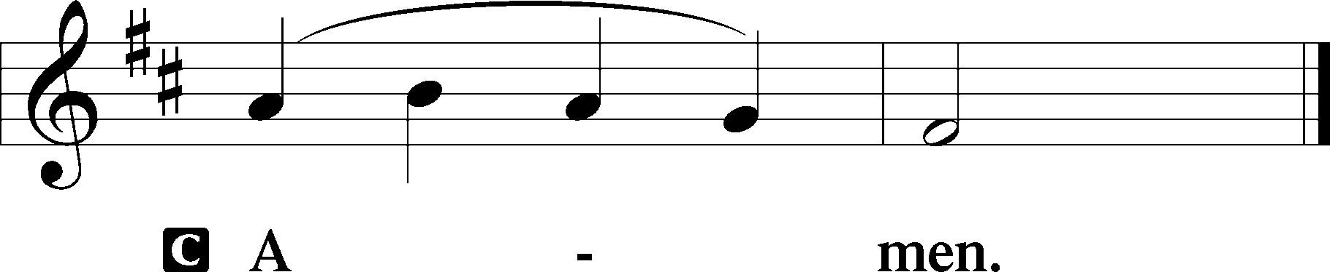

Salutation 2 Timothy 4:22
P The Lord be with you.
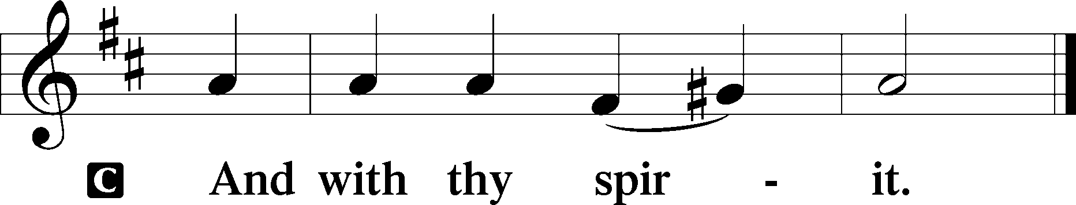
Benedicamus Psalm 103:1
P Bless we the Lord.
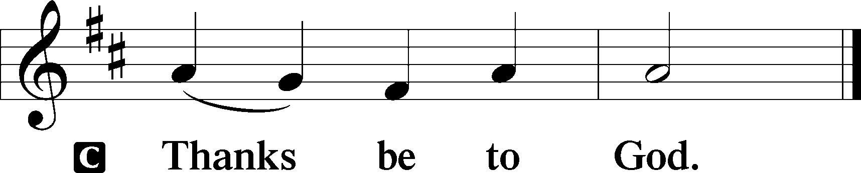

Benediction Numbers 6:24–26
P The Lord bless you and keep you.
The Lord make His face shine upon you and be gracious unto you.
The Lord lift up His countenance upon you and T give you peace.
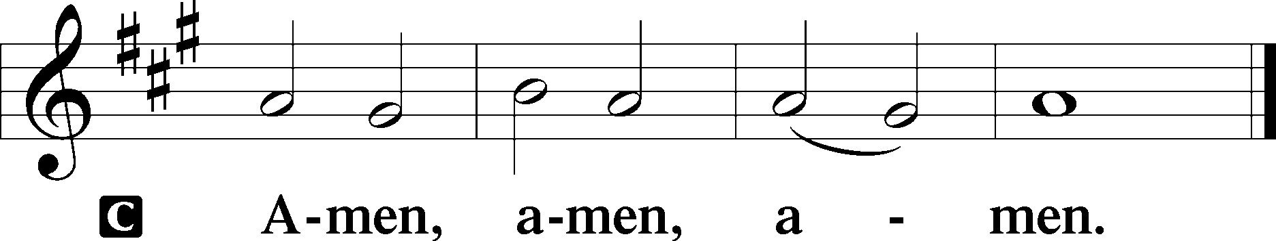

Closing Hymn: TLH #229 “Holy Spirit, Hear Us”
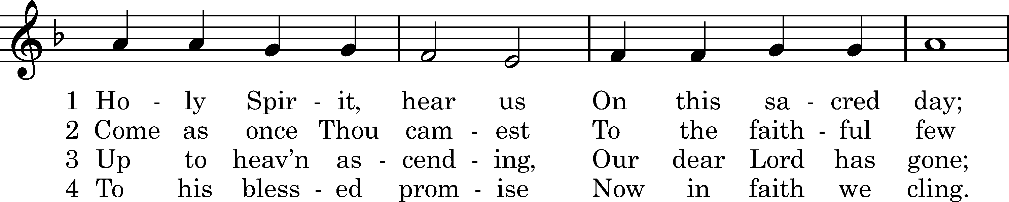
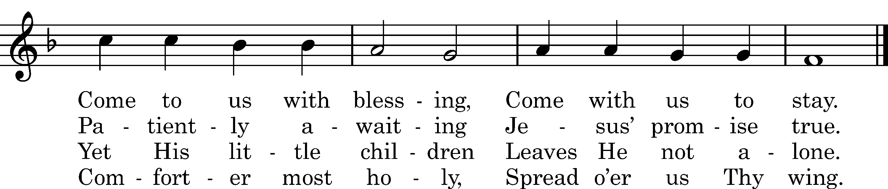

5 Lighten Thou our darkness,
Be Thyself our Light;
Strengthen Thou our weakness,
Spirit of all might.

6 Spirit of Adoption,
Make us overflow
With Thy sev'nfold blessing
And in grace to grow.

7 Into Christ baptizèd
Grant that we may be
Day and night, dear Spirit,
Perfected by Thee!

Text: tr. Claudia F. Hernaman, 1898; Joseph Mohr, 1816 Tune: Friedrich Filitz, 1847 Text and tune: Public domain

Silent prayer after worship: Help me, O Lord, to go forth from Your house with Your message of salvation in my heart and on my lips. Make me bold to speak to others about Your love in Christ. In Jesus’ name. Amen.
fffffffffffffffffffffffffffffffffff
Acknowledgments: Unless otherwise indicated, Scripture quotations are from the ESV® Bible (The Holy Bible, English Standard Version®), copyright © 2001 by Crossway, a publishing ministry of Good News Publishers. Used by permission. All rights reserved. Created by Lutheran Service Builder © 2023 Concordia Publishing House.
fffffffffffffffffffffffffffffffffff
fffffffffffffffffffffffffffffffffff
In Loving Memory of Aunt, Jacky Shaffer: Edeltraud Sulek (Capital Campaign).
In Loving Memory of Barry Nelson: Cottage Garden Designs (Food Pantry), Ken & Ruth Krajci Fitzgerald (Food Pantry & Gen’l Fund), Ruth & Jim Leone (Food Pantry), and Patty Parker (Food Pantry).
In Loving Memory of Mother, Betty Petro: Patty Parker (Capital Campaign).
fffffffffffffffffffffffffffffffffff
The Altar Flowers today are given by Diane Riefstahl in Loving Memory of her parents, Donald L. and Lucile M. Riefstahl, and brother, Donald C. Riefstahl.
fffffffffffffffffffffffffffffffffff
We are happy this morning to welcome Mark & Bess Kleindienst and Gordon & Rebecca Marquette as new members of our congregation! Welcome to our church family!
fffffffffffffffffffffffffffffffffff
The Women’s Bible Study of the book of Philippians continues this Thursday, June 1st from 10-11 am. All women are welcome to join! Please enter using the Clover St. entrance.
fffffffffffffffffffffffffffffffffff
SCHEDULE THROUGH JUNE 4, 2023:

:

Today, following Worship, Fellowship Hall: Finance Committee Meeting
7 pm, Fellowship Hall: AA Meeting
Tuesday, 7-9 pm, Fellowship Hall: Penn-Ohio Singers
Wednesday, 7:30 pm, Fellowship Hall: NA Meeting
Thursday, 10 am, Fellowship Hall: Women’s Bible Study
Next Sunday, 8 am, Fellowship Hall: Bible Study
9 am, Sanctuary: Divine Service
Following Worship, Fellowship Hall: Voters’ Assembly
2 pm, Willow Women’s Center: Open House
2-5 pm, Fellowship Hall: Graduation Party for Alex (Sasha) Carr
7 pm, Fellowship Hall: AA Meeting
fffffffffffffffffffffffffffffffffff
Our Stewardship of Treasures for the Lord:
In order to do the Lord’s work, we need $2,553.63 each week to meet our 2023 budget for general purposes and $76.92 for the SELC.
Figures for Thursday, May 18, 2023
General Fund: $175.00
Food Pantry: $10.00
Figures for Sunday, May 21, 2023
General Fund: $885.00 Behind for the week*: -$1,493.63
SELC: $0.00 Behind for the week: -$76.92
Food Pantry: $275.00 *Includes above figures.
Capital Campaign: $310.00
Other: $1,025.00

For online giving, check out https://www.saintspeterandpaul.net/online-giving.
fffffffffffffffffffffffffffffffffff
THANK YOU FOR SERVING IN MAY: Elder: Jonathan Baisch; Ushers: Matt Berent, Mark Gabriel, Michael Laird, & Jerome Thomas; Altarware: (prior) Diane Riefstahl; (after) Ruth Meszaros & Arlene Sutton.
fffffffffffffffffffffffffffffffffff
Attendance: Sunday, May 21, 2023: 31
All are invited to celebrate Alex (Sasha) Carr’s Graduation and Army Reception at an Open House, Sunday, June 4 from 2-5 pm in the Fellowship Hall. Join us as we give thanks for Alex’s service to our church and wish him success in his future.
fffffffffffffffffffffffffffffffffff
Bible Memory Verses ~ Week of May 28th:
For Adults: For this light momentary affliction is preparing for us an eternal weight of glory beyond all comparison, as we look not to the things that are seen but to the things that are unseen. For the things that are seen are transient, but the things that are unseen are eternal. 2 Corinthians 4:17-18

For Children: Not by might, nor by power, but by my Spirit, says the Lord of hosts.
Zechariah 4:6
fffffffffffffffffffffffffffffffffff
Remember the following in Prayer…
~The Hurting and Healing: Amy, Gerald Arthur, Ellen Baron^{CA}, Lois Bortner^{CA}, John Burdette, Bev & Joe Chlpka, Kathleen Coughenour, Kim, Anna Mae Daris, Susan Davies, Tim Dudash, Millie Elavsky, Joseph Fleet, Judith & Eddy Furey, Tim Haenftling, Austin Hamilton, Joan, Darla Krajci, Barbara Kreske, Donna Kennedy, Jess Lavoie, Joanne Lozier, Paul Lucas^{CA}, Sandy Marshall, Frank Niemeyer^{CA}, Linda Parkany, Juanita Rentschler, Richard Reuning^{CA}, Nancy Robertson^{CA}, Marty Scott, Kara, Fred Tonty, Joel & Peggy Wasson, Angela Weser^{CA}, and Ruth Wolf.
~The Homebound: Rudy & Jean Tomko, Betty Wolf, and Ed & Millie Zachar.
~Celebrating this Week: Birthdays: Kati Laird (05.31), Gerald Krivosh, Jr. (06.01), Ana Deal (06.02), and June Thomas (06.02). Anniversary: Tony & Tiffany Bale (06.02).
~Serving in the Military: Curtis Sinewe and Joshua Solyan.
~Community & World Needs: Those suffering from or affected by the coronavirus; those suffering due to the conflict between Ukraine and Russia; those suffering from loss and dislocation because weather disasters; those suffering from addiction and their families; Local, State, and National Government Leaders; safety for all Police Officers, Firefighters, & First Responders; the unemployed; our Second Quarter Local Mission: The Support of a Concordia, Fort Wayne Seminarian.
*CA represents cancer.
Sincere thanks are extended to Rebecca Marquette for sharing her talents with us this morning as our organist. We are very grateful!
fffffffffffffffffffffffffffffffffff
Nominations are being sought for a Missionary/Mission to support as our 3rd Quarter Mission project. Please submit nominations and supporting materials to Jonathan Baisch today if possible.
fffffffffffffffffffffffffffffffffff
THANK YOU FOR SERVING IN JUNE: Elder: Jonathan Baisch; Ushers: Cheryl Fedele, Mike Flaugher, & Jesse Riffle; Altarware: (prior) Diane Riefstahl & Marie Flaugher (06/11); (after) Elizabeth Haenftling & Traudi Sulek.
fffffffffffffffffffffffffffffffffff
Available in the narthex:
- Minutes from the May 15, 2023, Church Council meeting.
- Minutes from the May 20, 2023, Altar Guild meeting
- Tentative agendas for the June 4, 2023, Voters’ Assembly.
- June issue of “The Rock and the Sword” newsletter.
fffffffffffffffffffffffffffffffffff
Due to the Memorial Day holiday, the church offices will be closed Monday, May 29th. The secretary’s office will be open Tuesday (05.30) from 8:30 – 5 and Thursday (06.01) from 8:30-10; 11-5 this week.
fffffffffffffffffffffffffffffffffff
DON’T FORGET! There will be a Voters’ Assembly following worship next Sunday, June 4th. Join us before the meeting for a brief Coffee Fellowship sponsored by Mark & Bess Kleindienst. Your attendance will be greatly appreciated!
fffffffffffffffffffffffffffffffffff
Next Sunday (June 4th) afternoon, at 2 pm, will be the dedication of the new Willow Women’s Center at 295 N. Kerrwood Dr., Suite 106, in Hermitage. All are welcome to attend!
fffffffffffffffffffffffffffffffffff
Members of the Finance Committee are reminded that there will be a meeting today following worship in the Fellowship Hall.

Here to Serve
Pastor………………………………………………...……………Rev. Jacob Deal
E-mail …………………………….……pastordeal@saintspeterandpaul.net
Phone Number……………………..…………………724-347-3620 (Option 2)
Church Office………………………..…………………724-347-3620 (Option 3)
Website …………………………………………www.saintspeterandpaul.net
Secretary…………………………………………………………Diane Riefstahl
E-mail ………………………………………church@saintspeterandpaul.net
Website …………………………………………www.saintspeterandpaul.net
Food Pantry: Please leave message……………724-347-3620 (Option 3)
AA Contact: Steve………………………………………………..…724-813-2358
NA Contact: Larry………………………………………………..724-977-8733
Choir Director………………………………………………………Chris Nelson
Congregation President……………………………………Jonathan Baisch
Church Elder …………………………………………...…… Jonathan Baisch
fffffffffffffffffffffffffffffffffff
If needing to get into the church building during the week, please phone first to make certain someone is here to let you in.

