Sts. Peter & Paul Evangelical Lutheran Church LC-MS
Monthly Newsletter --- May 2021
699 Stambaugh Avenue, Sharon, PA 16146
Phone: 724.347.3620 (Opt. 2, Pastor Deal; Opt. 3, Office)
E-mail: church@saintspeterandpaul.net www.saintspeterandpaul.net

“THE ROCK and THE SWORD”
“Built upon the Rock of Christ and wielding the
Sword of the Spirit, the Word of God.”

THE MONTH OF MAY is replete with key occasions of the church year. Among them are the Ascension of our Lord, Pentecost, and Trinity Sunday. The following passages are taken from “Planning the Service: A Workbook for Pastors, Organists, and Choirmasters” written by Ralph Gehrke and authorized by the Commission on Worship, Liturgics, and Hymnology of the Lutheran Church—Missouri Synod.

ASCENSION OF OUR LORD (May 13)
“And I, if I be lifted up from the earth, will draw all men unto Me.”
The Festival of the Ascension of our Lord is not a special “cycle” standing independently by itself but deals rather with another stage in that climactic exaltation of our Savior which began with His resurrection and continues now through His sending of the Holy Ghost on Pentecost and will be fully revealed on the Last Day. Ascension Day is our Lord’s coronation day, when He was made the King of the universe. His ascension to the Father is not fully understood if it is limited merely to a spatial movement from one place to another (as it were, from the Mount of Olives to “the right hand of God”) but is, more important, His entrance – the entrance of our own elder Brother – upon a greater and fuller mode of existence beyond the confines of time and space, “filling heaven and earth.” His sitting down “at the right hand of God” means not that our Lord is now confined to a certain space in the heavenly world from which He cannot come forth, but rather it means His taking up all power and authority in heaven and earth. The “right hand of God,” as Luther correctly maintained, is everywhere. Our living and risen Savior is all over at all times, no longer bound, as in His state of humiliation, to one place and one time. He has united heaven and earth. He, as man, as our Brother, has opened heaven for us. Yet He is still present with us who are still bound by time and space. He is with us always even unto the end of the world as true God and as true man. And His rulership is exercised in His church through the means of grace which He established: His Word and His sacraments. The Lord of the universe is able to be “grasped” by us earth-bound mortals in those means of grace.
Even as God Himself is in the smallest seed and yet at the same time is so great that the heaven of heavens cannot comprehend Him, even so Christ, the incarnate Savior, who died innocently and rose victoriously, is present in the consecrated host of the Sacrament and at the same time fills the wide expanse of the universe. He is the One who really speaks to us in and through the Holy Scriptures: “unto Him give all the prophets witness.” He is also the true Baptizer, who baptizes us with water and the Spirit. He who humbled Himself and came down from heaven to be born true man with flesh, blood, and bones, is at the same time the one who ascended above all heavens “to fill all in all.” The life of Christ in the heavenly realms is the beginning of a new world, a world reconciled to God. Thus the promise is being fulfilled: “Behold, I make a new heaven and a new earth wherein dwelleth righteousness.”

PENTECOST (May 23)
“’Not by might nor by power but by My Spirit,’ saith the Lord of Hosts”
The fifty-day celebration of the Easter Season climaxes in, and ends with, the Festival of Pentecost. This certainly is a high point in the Easter cycle. The risen and ascended Savior sends the Holy Spirit to take His place and lead us into all truth. By the working of the Holy Spirit God’s revelation in Christ Jesus becomes effective in history. He is our Sanctifier, entering our hearts at our Baptism, nurturing us through the Word, enabling us to understand the Gospel and to live a life filled with Christian virtues, even as by His inspiration the apostles on Pentecost were enabled to proclaim “the wonderful works of God” in many languages. It is by His inspiration that the nations hear God’s message, the curse which ever since the Tower of Babel has prevented one nation from really understanding another is taken away by His sanctifying work.
Thou in the faith dost men unite
Of every land and every tongue;
This to Thy praise, O Lord, our God, be
sung.
Alleluia!
The church lives and moves and has its being though His gracious inspiration. And without Him no one could come to Christ or believe on Him.
The liturgical color for Pentecost is red, the color of fire and of blood, significant of the Holy Spirit and divine love and of our Savior’s blood as well as that of the martyrs. In many regions the entrance to the church and the altar are decorated on this day with Pentecost blossoms, often with the bridal red rose to signify the church as the bride of Christ. And the altar is often illuminated by twelve burning candles, significant of the New Testament church.

TRINITY SUNDAY (May 30)
“Holy, holy, holy is the Lord God of hosts; the whole earth is full of His glory!”
Having celebrated the greatest events in God’s history of salvation, we pause a bit on Trinity Sunday and consider the essence of this selfsame God, who, to be sure, is in His essence far beyond our weak comprehension but who has graciously revealed Himself to us as the Father, the Son, and the Holy Ghost. When we want to summarize all that the Holy Scriptures say of God as our Creator, Redeemer, and Sanctifier, we call Him the Holy Trinity. Only thus can we gather together and say at one time all the many things that the Scriptures say about God. Our worship never ceases confessing our faith in the Triune God and giving “glory to the Father and to the Son and to the Holy Ghost, as it was in the beginning, is now, and ever shall be, world without end. Amen.”
The liturgical color for the octave of Trinity Sunday is white, the color of light. “God is Light, and in Him there is no darkness.” And in the Holy Trinity there has been revealed unto us the entire fullness of the true Light. The Sundays after Trinity have green as their liturgical color unless, of course, some special festival calls for a different color in keeping with the church calendar. Green is not only the color of the sprouting rain, which at this time of year promises a good crop, but also of the church. It is the color to which the world changes under the beneficent rays of the sun’s powerful light, significant for the church of the more important regeneration by water and the Spirit. The altar is usually adorned during the Trinity season with flowers of the season from gardens and fields.
llllllllllllllllllllllllllll
REMINDER: Please let the church office know of any changes to your address, phone, cell phone or your e-mail address!
llllllllllllllllllllllllllll

Thank You for Serving in May:
Assisting Elder: Barry Nelson
Altarware: (Before service) Marie Flaugher & Diane Riefstahl; (After service) Marie Flaugher & Hank Holcroft
Note: Our greeting and ushering programs are temporarily suspended at this time.
llllllllllllllllllllllllllll
We were chosen! By directing designated Choice Dollars through Thrivent Choice, eligible Thrivent members choose where Thrivent Financial for Lutherans distributes some of its charitable outreach grant dollars among thousands of participating Lutheran nonprofit organizations and congregations.
Many thanks to Thrivent Financial member Rudy Tomko who recently directed Choice dollars to our church!
llllllllllllllllllllllllllll
Homebound Members & Friends
Please keep the following people in your prayers:

Marion Roberts
287 East 2nd St. Apt. #103
Hummelstown, PA 17036
724-893-4570

Martin Weisenborn
833 Adams Ave., NW
Warren, OH 44483
330-394-4355
llllllllllllllllllllllllllll
LIKE & FOLLOW our Church’s Facebook page (Saints Peter and Paul Evangelical Lutheran Church)!

Remember to like, comment, and share to help us reach as many people as possible.
llllllllllllllllllllllllllll
VOTERS’ ASSEMBLY MEETING
Following worship, Sun., May 16th.
Please plan to attend.
May 9th is “Stock the Food Pantry Sunday”
Your financial contributions to this outreach mission will be greatly appreciated!
llllllllllllllllllllllllllll
Sts. Peter & Paul’s Food Pantry is able to assist those in need of emergency food!
If you or someone you know is in need of emergency food during this time, please contact Barry Nelson (724-866-7417) or the church office (724-347-3620, option 3). Our food pantry operates through the Community Food Warehouse of Mercer County and distributes food the second and fourth Thursdays of each month beginning at 9 am.
Please consider “lending a hand up” to those in need.

‘Truly, I say to you, as you did it to one of the least of these my brothers, you did it to me.’ Matthew 25:40
llllllllllllllllllllllllllll
Please help us RECYCLE! A bin has been placed next to the parking lot doors for used bulletins. Please help us keep our sanctuary neat by either taking home your service bulletins or disposing of them here.
Additionally, there is a basket by the secretary’s office for donations of already-read Christian materials. These materials are shipped periodically to ICLD (International Christian Literature Distributors, Inc.) who, in turn, send them to Christians in third-world countries.
ATTENTION AUDITORS! The next audit of deposits will be following worship Sunday, May 9th. If unable to attend, please phone Bev Chlpka at 724-962-4806.
llllllllllllllllllllllllllll
2021 THRIVENT POP
TAB CHALLENGE!
Sincere thanks go out to all those who have been collecting and bringing in pop tabs for the 2021 Thrivent Pop Tab Challenge! Collected tabs may be placed in the containers found in the narthex or main hallway. They may also be given to the church secretary.
This project benefits the Ronald McDonald House.
If you have any questions, feel free to contact Marie Flaugher at 724-301-8278.
sssssssssssssssssssssssssssssssssssssssssssss
CELEBRATING IN MAY!
Birthdays
Evan Reichard 5 - 7
Marion Roberts 5 - 14
Anna Mae Daris 5 - 15
Shirley Cerbus 5 - 20
Catherine Carr 5 - 21
Ralph Dorman 5 - 21
Joe Chlpka 5 - 21
Madison McGowan 5 – 28
Kati Laird 5 – 31

Anniversaries
Jim & Kathy McGowan 5 - 4
Robert & Traudi Sulek 5 – 15
Lennie & Kim Revale 5 – 16
Michael & Kati Laird 5 - 21

*If birthdays or anniversaries have been omitted, please let the church office know. Thank You!

llllllllllllllllllllllllllll
FROM YOUR ALTAR GUILD:
-Marie Flaugher

CHANGE IS GOOD!

Wow! 2020 brought about a lot of changes for our congregation due to the Covid-19 pandemic. During this time and into this year, we saw many changes implemented for the health and safety of our members here at church. Among these changes were
- limited or by appointment only church attendance for a period of time.
- “Zoom” and “Google meet” options for some meetings and Bible Study sessions.
- the wearing of face masks as a wardrobe staple.
- the omission of the “sharing of the peace” during services in order to maintain social distancing.
- the elimination of the passing of the offering plate during the course of the service.
- service bulletins expanded to include hymnody.
- pews roped off to “distance” us during worship.
- the implementation of a temporary altar used for Holy Communion.
BUT...2021 is bringing new CHANGES!
- Pews have been re-roped off to allow more room for seating while still distancing.
- Holy Communion is at the main altar again!
- The baptismal font has been returned to its central position.
- Meetings and Bible Study sessions are in person again
As we continue our return to normalcy, we still need to be respectful of one another’s space as not everyone has chosen or is able to be vaccinated.
Have you noticed the changes in the Holy Communion set-up on the altar? Now as you enter church each Sunday you will see the communion chalice and paten covered with a new veil which has been embroidered with a gold cross. Beneath all the items is a cloth called the “corporal”. The chalice has small cloth covering it called a “purificator”. The paten, purchased by the altar guild in honor of its past members, contains a large host and sits on top and is covered by the “pall”. To the left of the veiled items is found the ciborium containing additional communion wafers and, to the right, a flagon of wine. To the upper right is the “burse” in which the pastor places the veil, pall, and purificator as he prepares the table for communion. The individual communion cups are on the credence table and placed on the altar prior to the Service of the Sacrament.
Although we have witnessed some changes over the past year, there is one thing that will never change: God’s promise of eternal life to us. He sent us His Son, Jesus, to be our Savior and die for our sins. As we continue to celebrate His resurrection, we know that this promise is something which will never change! Let all change be to the Glory of God!

REMINDER: Members of the Finance Committee are reminded of the important meeting following worship May 2nd. Lunch will be provided. Please let Jesse know if you are unable to attend prior to the meeting.
llllllllllllllllllllllllllll
Change in Worship Schedule:
The Board of Elders and Pastor Deal have decided to no longer hold our regular Saturday evening Divine Services. We will, however, be adding the following feast days and special observations to our calendar for the remainder of 2021 with services taking place at 6 pm on each date.
- May 1 St. Philip and St. James, Apostles
- May 13 Ascension
- June 24 The Nativity of St. John the Baptist
- June 29 St. Peter and St. Paul, Apostles
- July 22 St. Mary Magdalene
- Aug. 24 St. Bartholomew, Apostle
- Sept. 14 Holy Cross Day
- Sept. 21 St. Matthew, Apostle and Evangelist
- Sept. 29 St. Michael and All Angels
- Oct. 18 St. Luke, Evangelist
- Oct. 23 St. James of Jerusalem, Brother of Jesus and Martyr
- Oct. 28 St. Simon and St. Jude, Apostles
- Nov. 1 All Saints’ Day
- Nov. 30 St. Andrew, Apostle
- Dec. 21 St. Thomas, Apostle
- Dec. 28 The Holy Innocents, Martyrs
If you have any questions concerning this, please speak directly with Pastor Deal.
llllllllllllllllllllllllllll Bible Memory Verses from April:
For Adults:
April 4: I am the resurrection and the life. Whoever believes in me, though he die, yet shall he live, and everyone who lives and believes in me shall never die.
John 11:25-26a
April 11: And when he had said this, he breathed on them and said to them, “Receive the Holy Spirit. If you forgive the sins of any, they are forgiven them; if you withhold forgiveness from any, it is withheld.”
John 20:22-23
April 18: And there is salvation in no one else, for there is no other name under heaven given among men by which we must be saved. Acts 4:12
April 25: In the same way, let your light shine before others, so that they may see your good works and give glory to your Father who is in heaven. Matthew 5:16

For Children:
April 4: I am the living one. I died, and behold I am alive forevermore, and I have the keys of Death and Hades.
Revelation 1:18
April 11: Blessed be the God and Father of our Lord Jesus Christ! According to his great mercy, he has caused us to be born again to a living hope through the resurrection of Jesus Christ from the dead.
1 Peter 1:3
April 18: I am the Good Shepherd…My sheep hear my voice, and I know them, and they follow me. I give them eternal life.
John 10:11, 27-28
April 25: If anyone is in Christ, he is a new creation. The old has passed away; behold, the new has come.
2 Corinthians 5:17
Remember the
following in Prayer…
~The Hurting and Healing: Lois Bortner^{CA}, Richard Brandes, John Burdette, Josh Burns, Kim, Susan Davies, Tim Dudash, Joseph Fleet, Marie Haenftling, Neale & Melissa Huston, Michelle Kelly^{CA}, Donna Kennedy, Jess Lavoie, Paul Lucas^{CA}, Sandy Marshall, Ernie Meszaros, Mike Moats, Rhonda Moats, David Nelson, Juanita Rentschler, Richard Reuning^{CA}, Marty Scott, Angela Weser^{CA}, Betty Wolf, and Millie Zachar.
~Special Thanks: For the healthy birth of a child to Catherine and Mark Pfrenger.
~The Homebound: Marion Roberts and Martin Weisenborn.
~Serving in the Military: Curtis Sinewe and Joshua Solyan.
~Community & World Needs: Those suffering from or affected by the coronavirus; those suffering from loss and dislocation because weather disasters; those suffering from addiction and their families; Local, State, and National Government Leaders; safety for all Police Officers, Firefighters, & First Responders; the unemployed; our Second Quarter Local Mission: Sts. Peter & Paul’s Community Day 2021.
*CA represents cancer
llllllllllllllllllllllllllll
Sunday Morning Bible Study is currently studying the Augsburg Confessions. This Bible Study is open to all ages.
Bible Study begins at 8:45 am prior to the Divine Service.
If you should have a topic which you would like considered for Bible Study or are possibly interested in a midweek Bible Study, please speak with Pastor Deal.
llllllllllllllllllllllllllll

.REMINDER: If you would like someone’s name to be added to or deleted from our prayer list, please put a written note in the secretary’s mail slot by the office door.
llllllllllllllllllllllllllll
If entering the church during the week, please let office staff know that you are in the building. Also, please make certain to turn off lights, lock doors, etc. upon leaving.
llllllllllllllllllllllllllll
If you do not have an email account or do not receive emails from the church but wish to be notified of significant information concerning your fellow church members (such as births or deaths), please put a note in the Secretary’s mail slot asking to receive a phone call. Every attempt will be made to phone you within 24 hours of an email being sent out.
llllllllllllllllllllllllllll
Retiring Bibles
Have you ever wondered the proper way to dispose of a Bible that is no longer in use? Too often, Bibles are discarded at donation centers (most often with good intentions). What happens to these Bibles at this point is questionable.
There is, however, a proper way to dispose of Bibles and that is through a rite during which they will be burned. Sts. Peter & Paul’s will be holding such a rite one evening this summer. This May, there will be a box located in our library for any Bibles you wish to have included in this ceremony. Please note that this is for Bibles only at this time.
Please speak with Pastor Deal if you should have any questions concerning this.
TRUSTEES’ REPORT: The Trustees have had two meetings since the last newsletter and there have been several projects completed.

Roof quotes ~ As stated in past newsletter the roof has many leaks. Quotes are in and final review will be made at the April meeting. Roofing material costs have increased and a decision needs to be made.
Glass Block windows ~ Replacement has been completed. 1/19/2021
Elevator Inspection ~ Elevator was inspected and passed inspection. 1/22/2021
Boiler pump motor ~ This has been an issue. Voters approved the purchase, but there is a difficulty in finding a workable replacement. The search continues.
Boiler System ~ Roth Mechanical was in to clean out steam traps and replace one steam F&T trap. Along with this, an old steam auto temp valve had to be replaced. Total Cost $1867
Other projects worked on:
- We had the fire department to do an assessment of our door lock policies for safety reasons - all was good.
- Room #7 had all the Sunday School craft supplies moved to the fellowship hall storage area.
- Tool room, Youth room and food pantry were reorganized.
- Hymnal holders were repaired in the open pews. If you notice any others needing repaired, please let a Trustee know.
- Kitchen was sprayed to prevent ants from showing up.
- Storm windows were taken down from the hallway.
- Circuit breaker was replaced in the kitchen.
In May there will be a trustees’ meeting. The date will be determined as our meeting was after publication of this newsletter.
llllllllllllllllllllllllllll
Join us Saturday, May 1st
at 6 pm
for a Divine Service honoring the Festival of St. Philip and St. James, Apostles.
SO, WHO WERE SAINT PHILIP AND SAINT JAMES?
St. Philip was one of Christ’s twelve apostles. He is most often mentioned in the Gospel of John. From the city of Bethsaida, Philip was among those with John the Baptist when the latter pointed out Jesus as the Lamb of God.
Saint Philip later spread the Word of God to those in Greece, Syria, and Phrygia.
St. James, often referred to as James the Less (or Lesser), was also one of Christ’s apostles. “The Less” is a term used to distinguish a man younger (or shorter) than another bearing the same name. There were two apostles who shared the name “James”: James, the son of Zebedee (who can be referred to as “James the Great”) and James, the son of Alphaeus, known as James the Less or James the Minor.
llllllllllllllllllllllllllll
Please Support Our
Second Quarter Local Mission: Sts. Peter & Paul’s
Community Day 2021
SCRIP Program: Next order date is May 2nd
The SCRIP/Gift Card order form was recently updated to include additional requested retailers and the percentages rebated to the church for each card ordered. If you have other retailers that you would be interested in knowing if they participate in this program, please contact Matt Berent.
SCRIP orders and payments are due the first Sunday of each month. Checks should be made out to Sts. Peter & Paul’s. You should receive your gift cards the following week.
Profits from this fundraiser have been earmarked for the Fellowship Hall Picture Restoration/Reframing project.
llllllllllllllllllllllllllll
Submissions for the June issue of “The Rock and the Sword” newsletter are due to the secretary’s office Monday, May 24th at noon. This includes meeting dates and times for the church calendar.
llllllllllllllllllllllllllll
Donations for Summer Flowers to be planted in our gardens are due to the secretary’s office Sunday, May 9th. Monies collected will be used to purchase geraniums, other flowers, and mulch to beautify our church grounds. Those who wish may “dedicate” their donations. Dedications will be listed in the May 23rd Pentecost service bulletin.
llllllllllllllllllllllllllll
Word of Hope: 1-888-217-8679
The only 24/7 CONFIDENTIAL Hotline that is distinctly Lutheran, bringing healing found in Christ, to those whose hearts have been broken by abortion.
Sincere thanks are extended to all those who lent a hand or participated in our Holy Week services this year.
We are especially indebted to…
- Jonathan Baisch for his participation in the Saturday Vigil.
- Rev. Art Baisch for helping with both the Tre Ore and Saturday Vigil Services.
- Catherine Carr for her magnificent playing of the organ.
- Alex (Sasha) Carr for his services as acolyte and crucifer.
- Marie Flaugher and Judith Furey who made the beautiful, new fair linen which adorns our altar and veil for the holy sacraments.
- Barry Nelson for his participation in the Tre Ore service.
- Ladies of the Altar Guild for assisting as needed.
- And, of course, Rev. Deal for providing us with so many unique opportunities to worship during this holiest of seasons.
llllllllllllllllllllllllllll

To listen to Pastor Deal’s sermons, phone 724-347-3620 and press Option 6.

llllllllllllllllllllllllllll
A note from Pastor Deal: Please let me know if you or a loved one are in the hospital or have a special need. Also, please ask the hospital or family members to phone me or the church office as I wish to visit those who may be hurting.
llllllllllllllllllllllllllll

PICTURES FROM THE EASTER SEASON

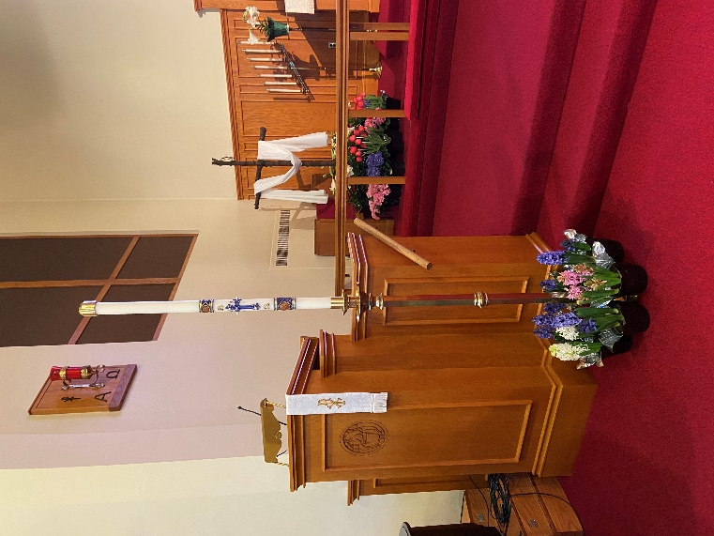
Our new Paschal Candle was first introduced at the Saturday Vigil.

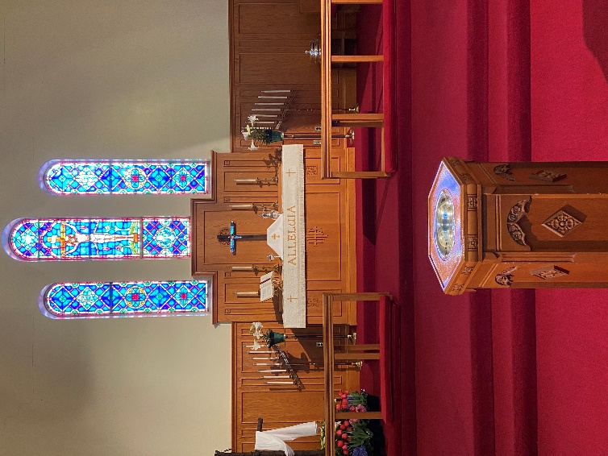
Holy Week provided a return
to the main altar.

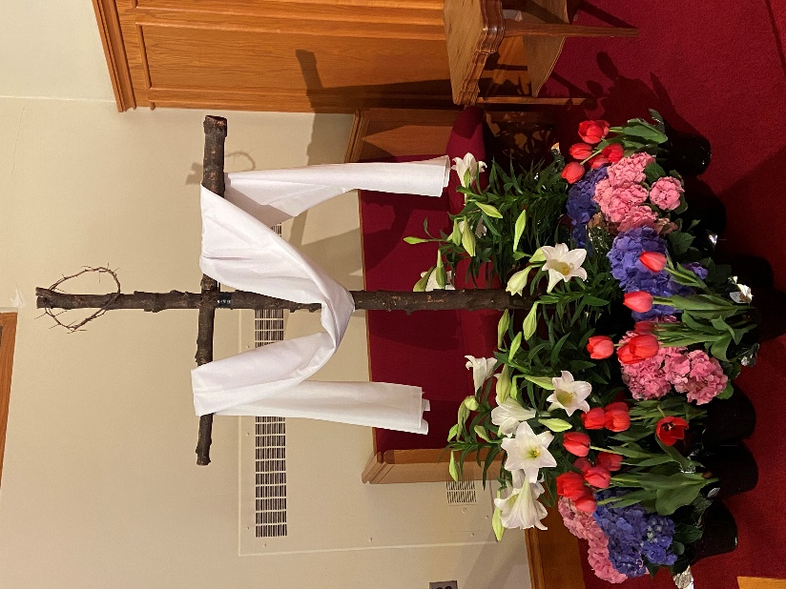
Alleluia! Christ is Risen!
He is Risen Indeed!

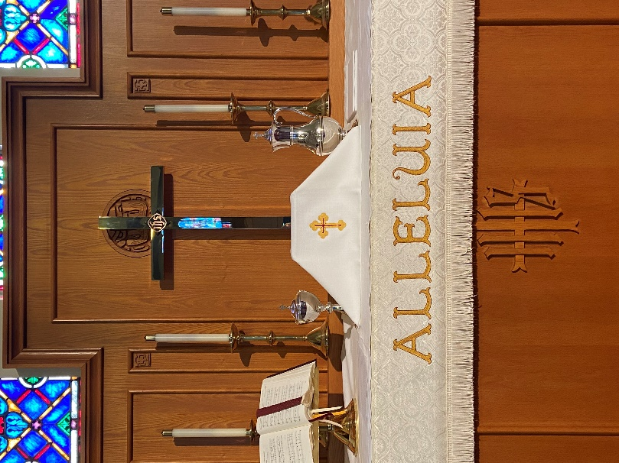
A beautiful new veil, made by Judith Furey, is placed over the sacraments of Holy Communion.

