Sts. Peter & Paul
Evangelical Lutheran Church
Lutheran Church-Missouri Synod
Founded-1917

May 14, 2023

699 Stambaugh Ave.
Sharon, Pennsylvania 16146

“I was glad when they said to me,
Let us go to the house of the LORD!”
Psalm 122:1
Sts. Peter & Paul Evangelical Lutheran Church, LC-MS
ROGATE
May 14, 2023

A special welcome to our guests this day! If you would like more information about The Lutheran Church - Missouri Synod, or this congregation, please speak with Pastor Deal or an Elder after the service.
Members & Guests: Don’t be embarrassed if your children make noise during the worship service, all children do. We encourage families to worship together but, if you feel the need, there are pews in the rear of the Church which are reserved for young families on both sides of the sanctuary. There is also a quiet room available to you during our service which is located down the hallway past the offices on the right side of the church as well as a children’s area in the Fellowship Hall where you are able to follow along with the service.

Today’s service includes the Sacrament of Holy Communion. If during this past year, you have not worshipped with us and been communed, we respectfully ask that you do not partake of this sacrament this day before first speaking with Pastor Deal.
If visiting from a sister congregation of the LC-MS and are in good standing, please inform Pastor Deal of your desire to commune prior to the service.
If wishing to receive a blessing during communion, please approach with your arms crossed.

CONTACT INFORMATION
Pastor Deal: pastordeal@saintspeterandpaul.net or 724-347-3620 (opt. 2)
Church Office: church@saintspeterandpaul.net or 724-347-3620 (opt. 3)
Secretary’s Office will be open Monday and Thursday this week from 8:30 am – 5 pm. Please note that the office will be closed Thursday between 10 - 11 am.

Silent prayer before worship: Dear heavenly Father, nothing can separate me from Your love in Jesus Christ. Strengthen me in this assurance, and lead me to share it with those who don’t know You. In Jesus’ name. Amen.
Confession and Absolution

Opening Hymn: LSB #615 “When in the Hour of Deepest Need”

Stand

The sign of the cross may be made by all in remembrance of their Baptism.

Invocation
P In the name of the Father and of the T Son and of the Holy Spirit.
C Amen.

Exhortation Hebrews 10:22; Psalm 124:8; Psalm 32:5
P Beloved in the Lord! Let us draw near with a true heart and confess our sins unto God our Father, beseeching Him in the name of our Lord Jesus Christ to grant us forgiveness.

P Our help is in the name of the Lord,
C who made heaven and earth.
P I said, I will confess my transgressions unto the Lord,
C and You forgave the iniquity of my sin.

Silence for reflection on God’s Word and for self-examination.

Confession of Sins
P O almighty God, merciful Father,
C I, a poor, miserable sinner, confess unto You all my sins and iniquities with which I have ever offended You and justly deserved Your temporal and eternal punishment. But I am heartily sorry for them and sincerely repent of them, and I pray You of Your boundless mercy and for the sake of the holy, innocent, bitter sufferings and death of Your beloved Son, Jesus Christ, to be gracious and merciful to me, a poor, sinful being.

Absolution [John 20:19–23]
P Upon this your confession, I, by virtue of my office, as a called and ordained servant of the Word, announce the grace of God unto all of you, and in the stead and by the command of my Lord Jesus Christ I forgive you all your sins in the name of the Father and of the T Son and of the Holy Spirit.
C Amen.

Service of the Word

Introit Psalm 66:1–2a, 17, 19–20; antiphon: Isaiah 48:20b
[With a voice of singing,] declare this with a shout of joy to the end of the earth. Alle- | luia.*
The Lord has redeemed his servant Jacob! Alle- | luia.
Shout for joy to God, | all the earth;*
sing the glory | of his name.
I cried to him | with my mouth,*
and high praise was | on my tongue.
But truly God has | listened;*
he has attended to the voice | of my prayer.
Blessèd | be God,*
because he has not rejected my prayer or removed his steadfast | love from me!
[With a voice of singing,] declare this with a shout of joy to the end of the earth. Alle- | luia.*
The Lord has redeemed his servant Jacob! Alle- | luia.

Gloria Patri
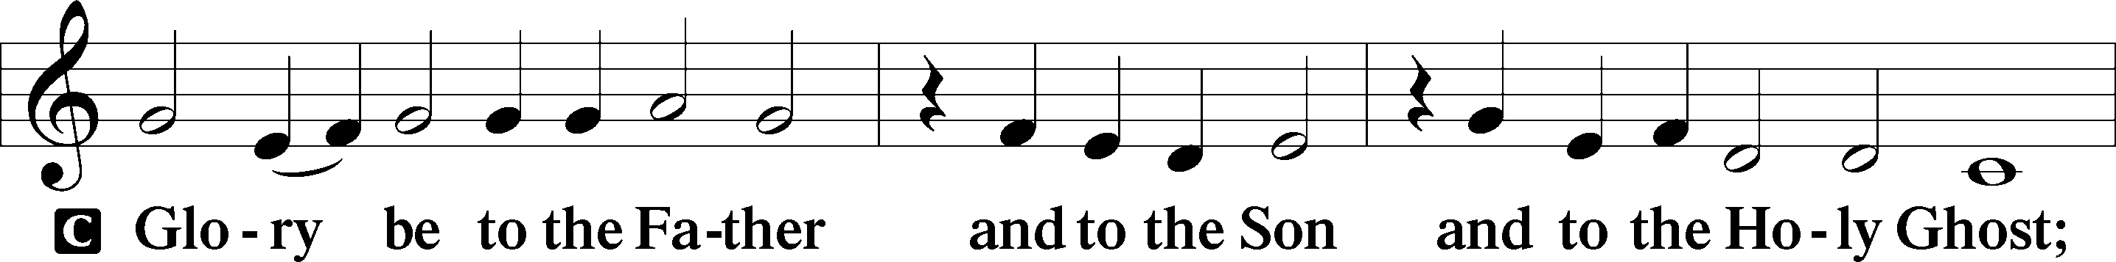
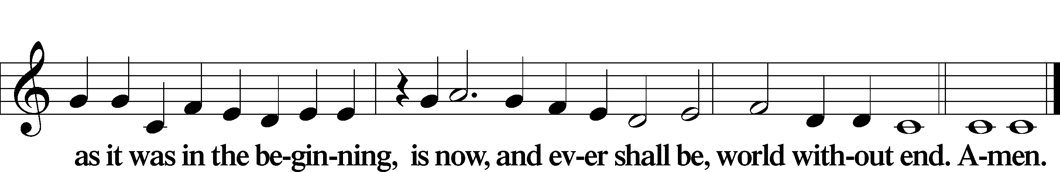

Kyrie Mark 10:47
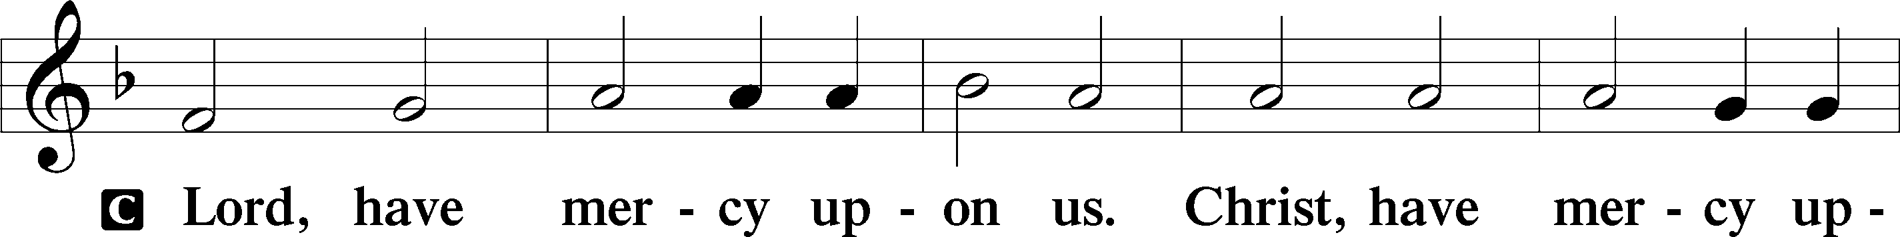
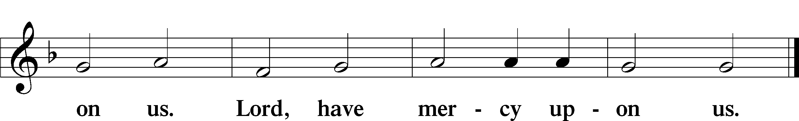

Gloria in Excelsis Luke 2:14; John 1:29
P Glory be to God on high:
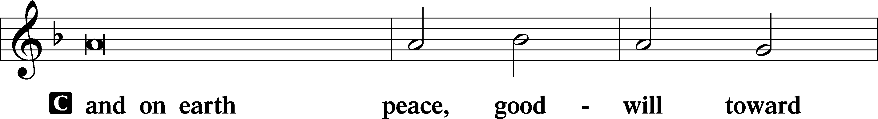
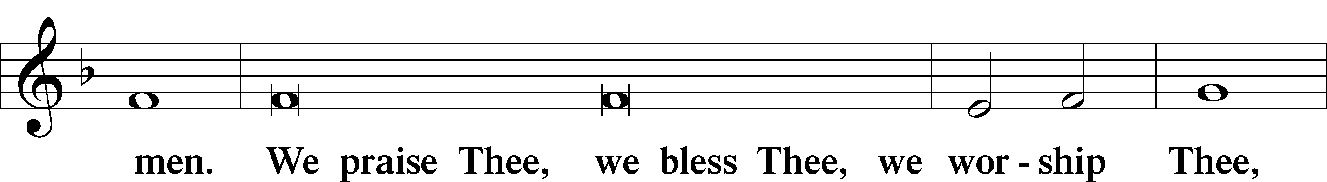
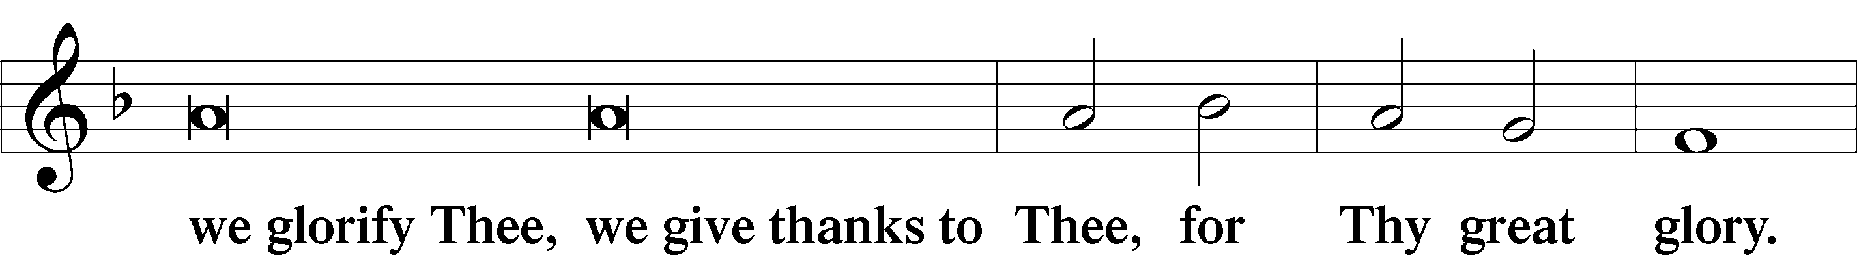
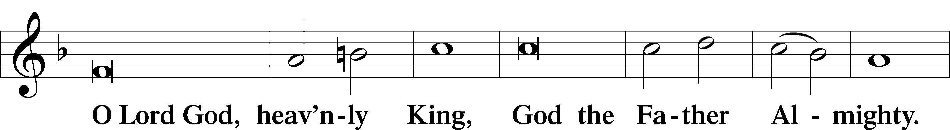
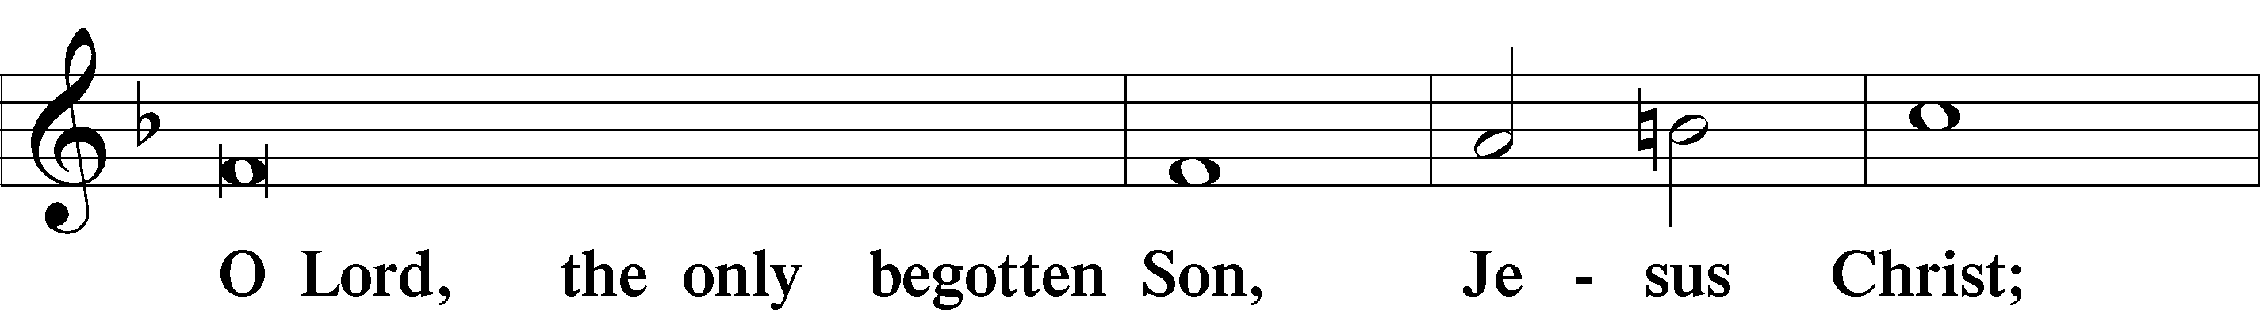
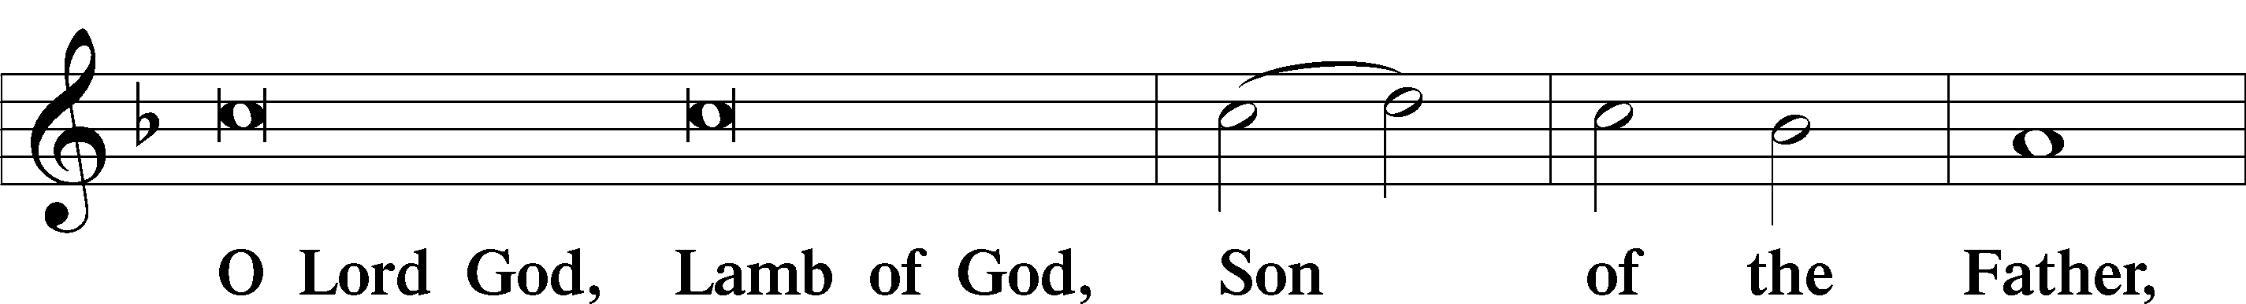
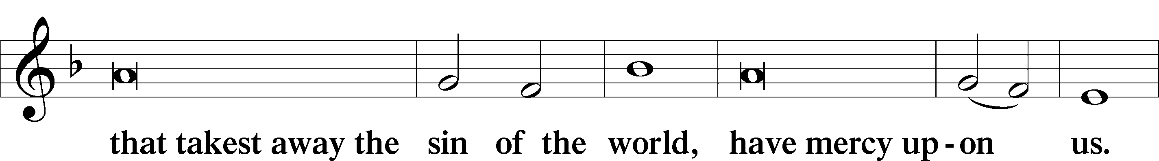
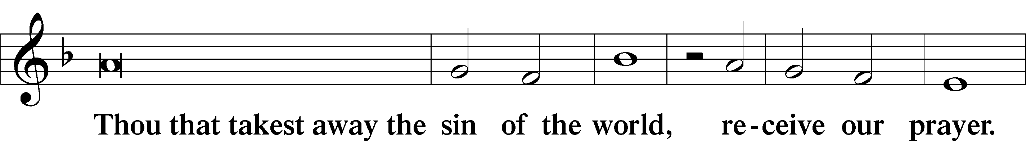
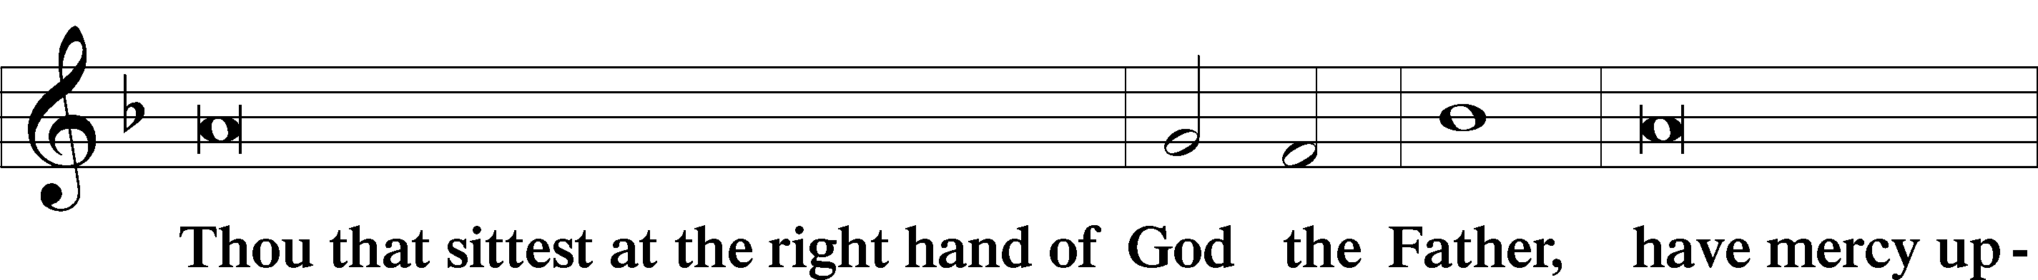
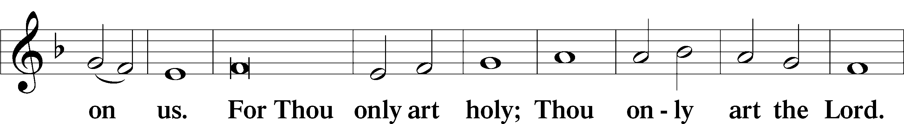
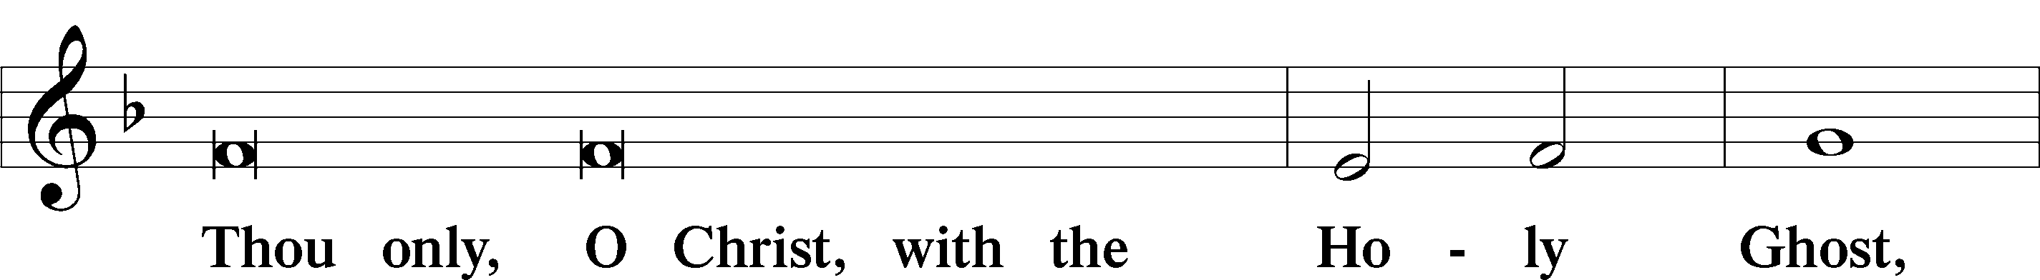
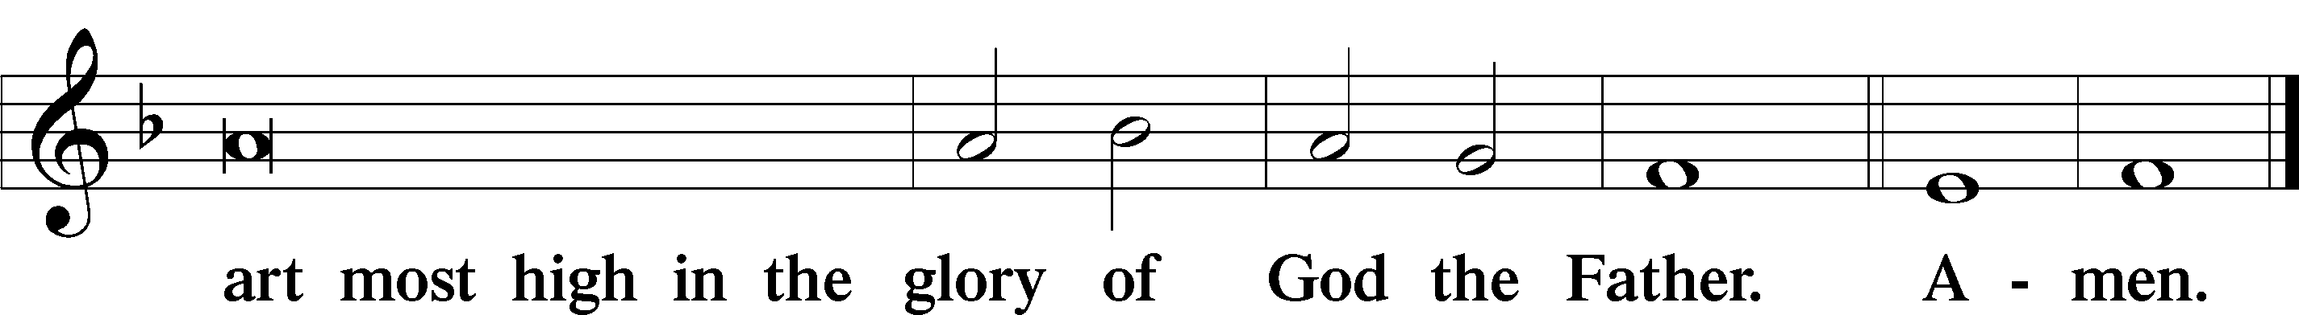

Salutation and Collect of the Day: Rogate
P The Lord be with you.
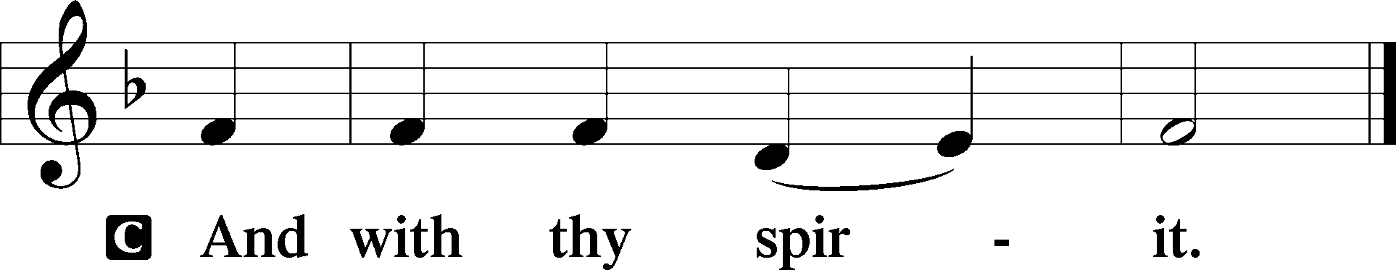

P Let us pray.
O God, the giver of all that is good, by Your holy inspiration grant that we may think those things that are right and by Your merciful guiding accomplish them; through Jesus Christ, Your Son, our Lord, who lives and reigns with You and the Holy Spirit, one God, now and forever.
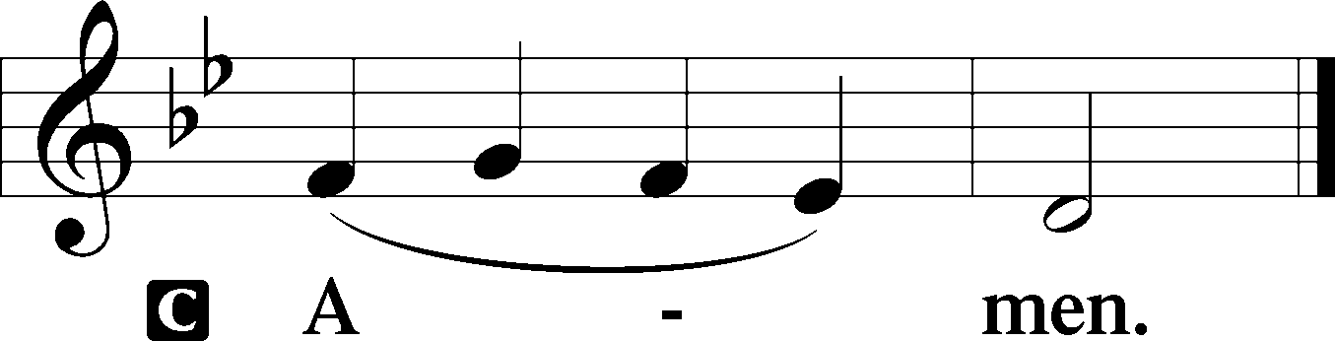
Sit

Prophecy: Numbers 21:4–9 (NKJV)
In those days: The children of Israel journeyed from Mount Hor by the Way of the Red Sea, to go around the land of Edom; and the soul of the people became very discouraged on the way. And the people spoke against God and against Moses: “Why have you brought us up out of Egypt to die in the wilderness? For there is no food and no water, and our soul loathes this worthless bread.” So the Lord sent fiery serpents among the people, and they bit the people; and many of the people of Israel died. Therefore the people came to Moses, and said, “We have sinned, for we have spoken against the Lord and against you; pray to the Lord that He take away the serpents from us.” So Moses prayed for the people. Then the Lord said to Moses, “Make a fiery serpent, and set it on a pole; and it shall be that everyone who is bitten, when he looks at it, shall live.” So Moses made a bronze serpent, and put it on a pole; and so it was, if a serpent had bitten anyone, when he looked at the bronze serpent, he lived.

P This is the Word of the Lord.
C Thanks be to God.

Psalm: Psalm 107:1–9
Oh give thanks to the Lord, for he is good,
for his steadfast love endures forever!
Let the redeemed of the Lord say so,
whom he has redeemed from trouble
and gathered in from the lands,
from the east and from the west,
from the north and from the south.
Some wandered in desert wastes,
finding no way to a city to dwell in;
hungry and thirsty,
their soul fainted within them.
Then they cried to the Lord in their trouble,
and he delivered them from their distress.
He led them by a straight way
till they reached a city to dwell in.
Let them thank the Lord for his steadfast love,
for his wondrous works to the children of men!
For he satisfies the longing soul,
and the hungry soul he fills with good things.

Epistle: James 1:22–27 (NKJV)
Dearly Beloved: Be doers of the word, and not hearers only, deceiving yourselves. For if anyone is a hearer of the word and not a doer, he is like a man observing his natural face in a mirror; for he observes himself, goes away, and immediately forgets what kind of man he was. But he who looks into the perfect law of liberty and continues in it, and is not a forgetful hearer but a doer of the work, this one will be blessed in what he does. If anyone among you thinks he is religious, and does not bridle his tongue but deceives his own heart, this one’s religion is useless. Pure and undefiled religion before God and the Father is this: to visit orphans and widows in their trouble, and to keep oneself unspotted from the world.

P This is the Word of the Lord.
C Thanks be to God.

Stand

Verse Liturgical Text; John 16:28
Alleluia. Christ, who has redeemed us with his blood, is risen and has appeared unto us. Alleluia. I came from the Father and have come into the world, and now I am leaving the world and going to the Father. Alleluia.

Alleluia
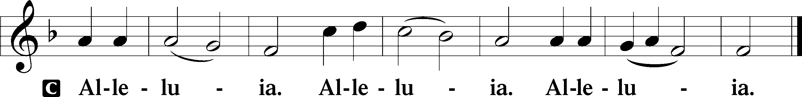

Holy Gospel: John 16:23b–30 (NKJV)
P The Holy Gospel according to St. John, the sixteenth chapter.
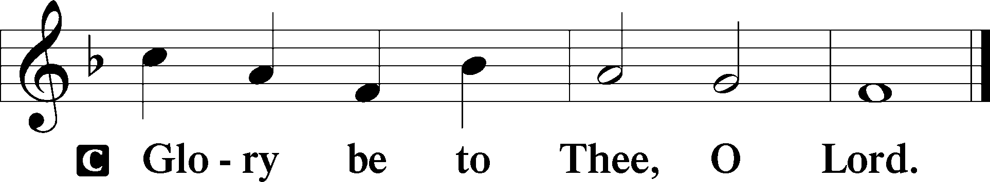

At that time Jesus said to His disciples: “Most assuredly, I say to you, whatever you ask the Father in My name He will give you. Until now you have asked nothing in My name. Ask, and you will receive, that your joy may be full. These things I have spoken to you in figurative language; but the time is coming when I will no longer speak to you in figurative language, but I will tell you plainly about the Father. In that day you will ask in My name, and I do not say to you that I shall pray the Father for you; for the Father Himself loves you, because you have loved Me, and have believed that I came forth from God. I came forth from the Father and have come into the world. Again, I leave the world and go to the Father.” His disciples said to Him, “See, now You are speaking plainly, and using no figure of speech! Now we are sure that You know all things, and have no need that anyone should question You. By this we believe that You came forth from God.”

P This is the Gospel of the Lord.
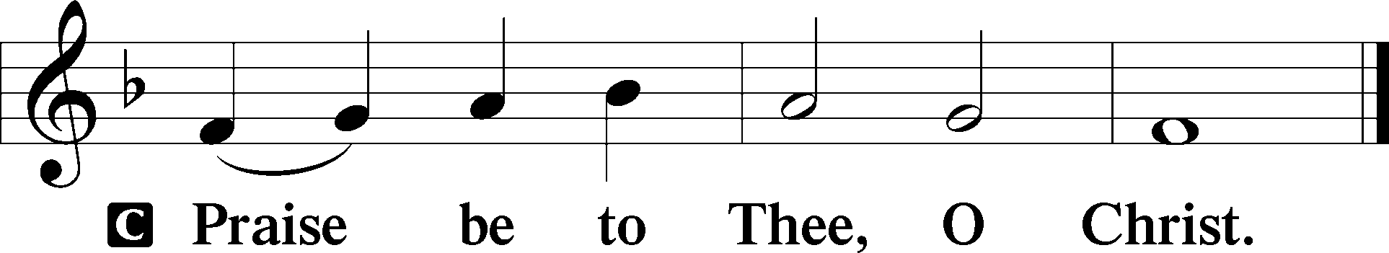

Nicene Creed
C I believe in one God,
the Father Almighty,
maker of heaven and earth
and of all things visible and invisible.
And in one Lord Jesus Christ,
the only-begotten Son of God,
begotten of His Father before all worlds,
God of God, Light of Light,
very God of very God,
begotten, not made,
being of one substance with the Father,
by whom all things were made;
who for us men and for our salvation came down from heaven
and was incarnate by the Holy Spirit of the virgin Mary
and was made man;
and was crucified also for us under Pontius Pilate.
He suffered and was buried.
And the third day He rose again according to the Scriptures
and ascended into heaven
and sits at the right hand of the Father.
And He will come again with glory to judge both the living and the dead,
whose kingdom will have no end.

And I believe in the Holy Spirit,
the Lord and giver of life,
who proceeds from the Father and the Son,
who with the Father and the Son together is worshiped and glorified,
who spoke by the prophets.
And I believe in one holy Christian and apostolic Church,
I acknowledge one Baptism for the remission of sins,
and I look for the resurrection of the dead
and the life T of the world to come. Amen.
Sit

Hymn of the Day: LSB #766 “Our Father, Who from Heaven Above”

Sermon

Stand

Prayer of the Church

Offertory Psalm 51:10–12
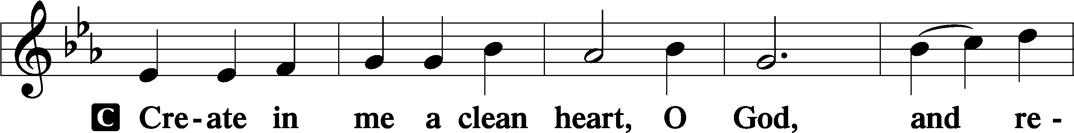
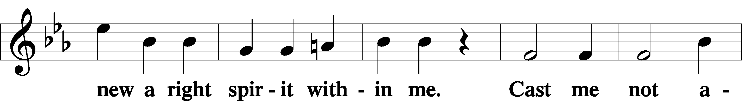
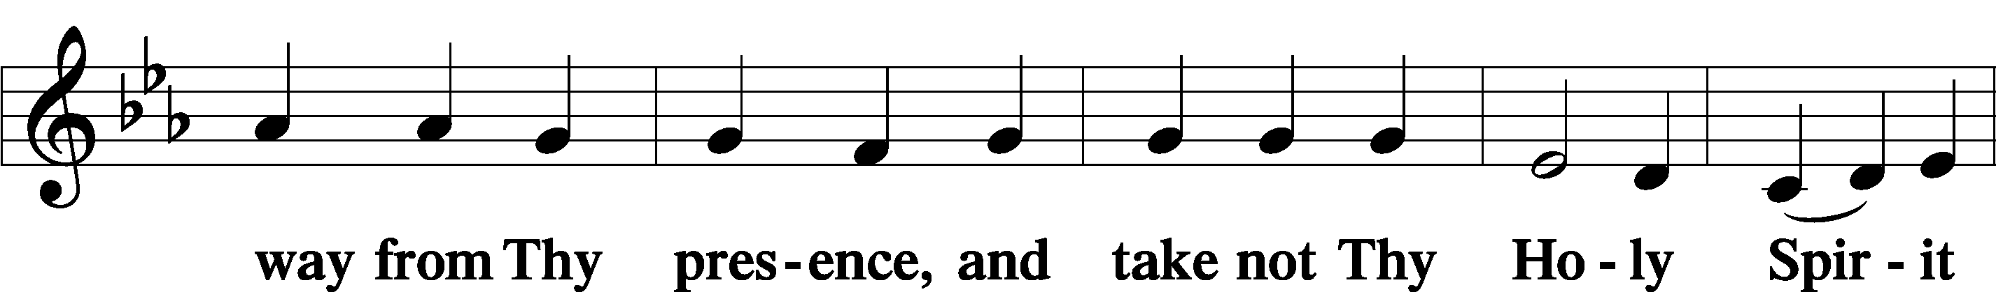
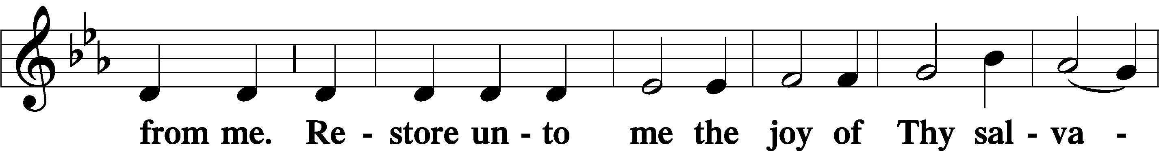
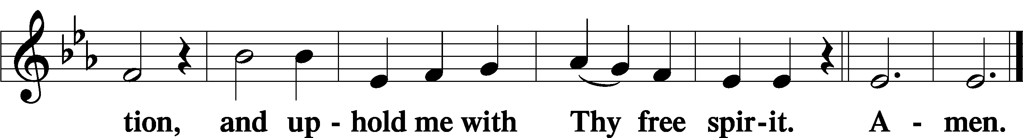
Sit

Preparatory Hymn: LSB #487 “Come, You Faithful, Raise the Strain”

Stand

Service of the Sacrament

Preface 2 Timothy 4:22; Colossians 3:1 Psalm 136
P The Lord be with you.

P Lift up your hearts.
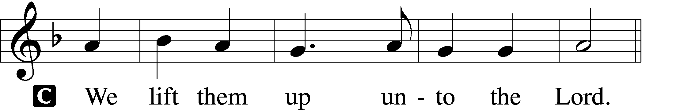

P Let us give thanks unto the Lord, our God.
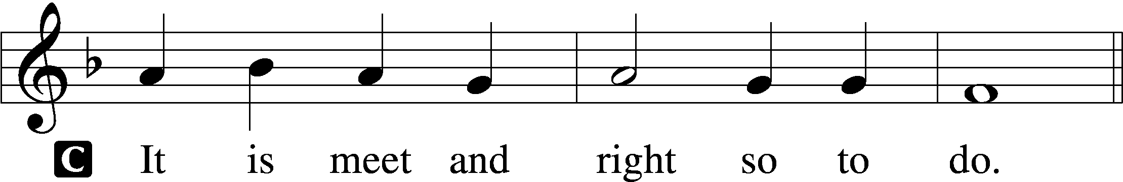

Proper Preface (Abbreviated) LSB 194
P It is truly meet, right, and salutary . . . evermore praising You and saying:

Sanctus Isaiah 6:3; Matthew 21:9
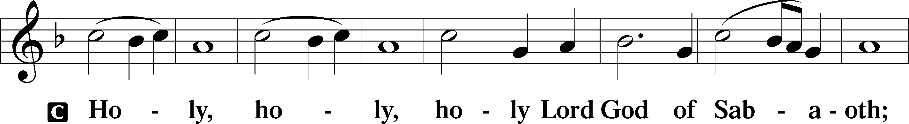
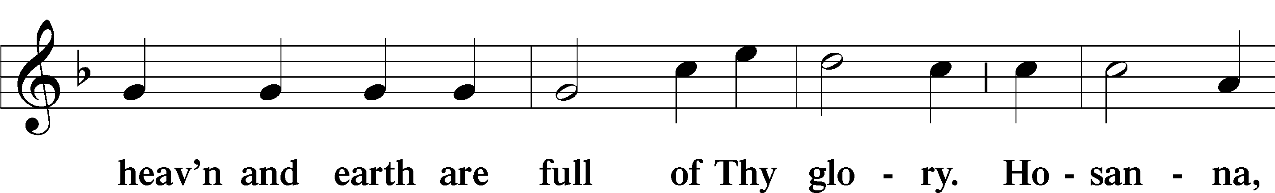
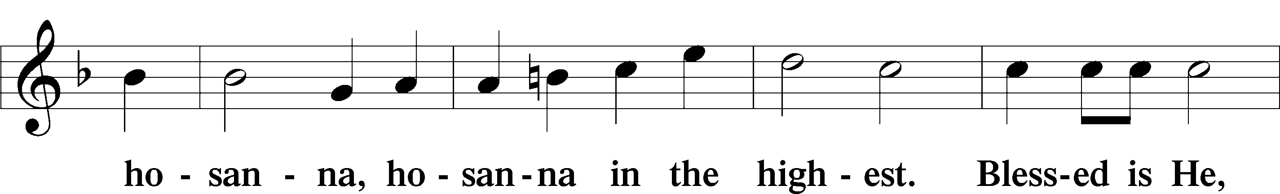
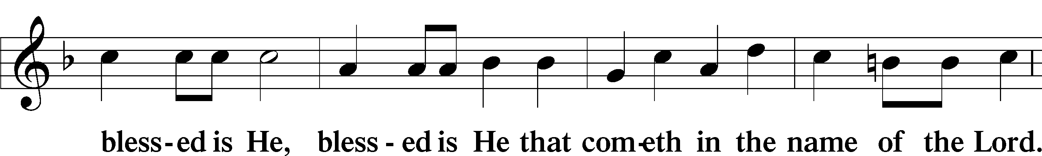
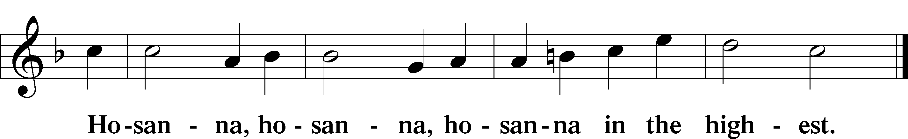

Lord’s Prayer Matthew 6:9–13
C Our Father who art in heaven,
hallowed be Thy name,
Thy kingdom come,
Thy will be done on earth as it is in heaven;
give us this day our daily bread;
and forgive us our trespasses as we forgive those who trespass against us;
and lead us not into temptation,
but deliver us from evil.
For Thine is the kingdom and the power and the glory forever and ever. Amen.

The Words of Our Lord Matthew 26:26–28; Mark 14:22–24; Luke 22:19–20; 1 Corinthians 11:23–25
P Our Lord Jesus Christ, on the night when He was betrayed, took bread, and when He had given thanks, He broke it and gave it to the disciples and said: “Take, eat; this is My T body, which is given for you. This do in remembrance of Me.”

In the same way also He took the cup after supper, and when He had given thanks, He gave it to them, saying: “Drink of it, all of you; this cup is the new testament in My T blood, which is shed for you for the forgiveness of sins. This do, as often as you drink it, in remembrance of Me.”

Pax Domini John 20:19
P The peace of the Lord be with you always.
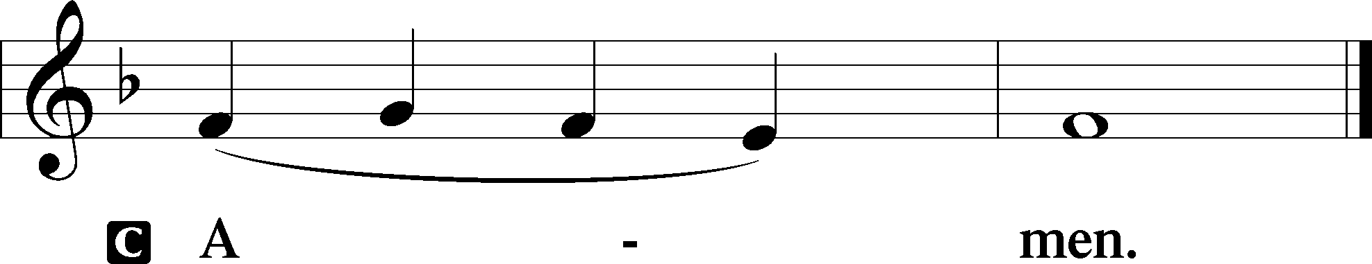

Agnus Dei John 1:29
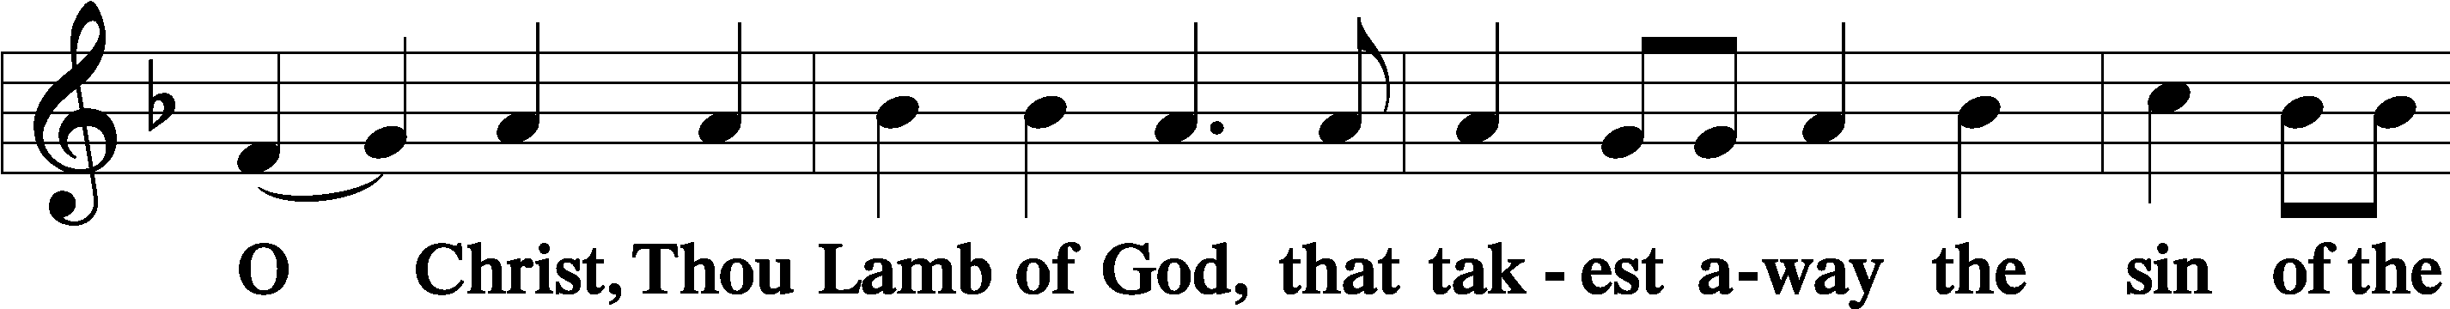
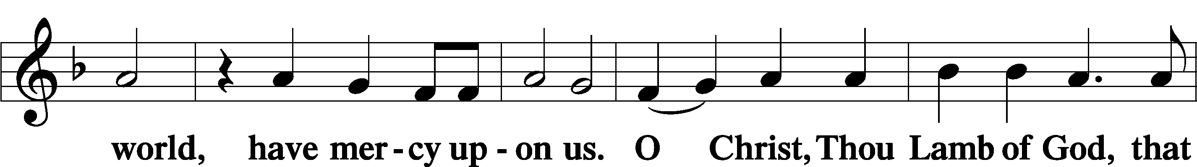
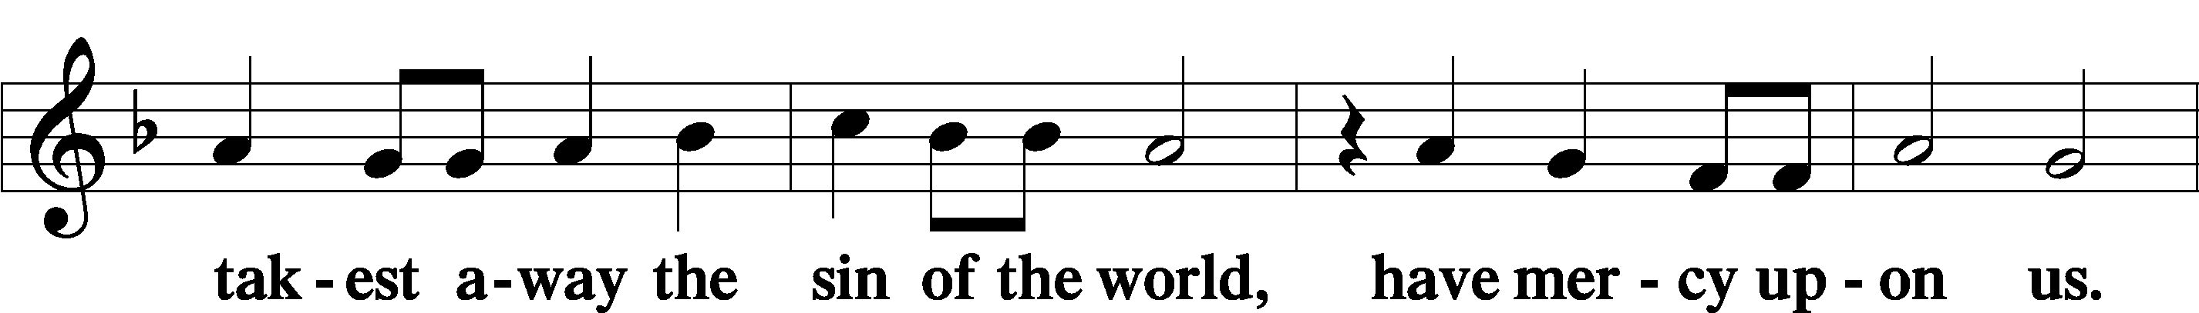
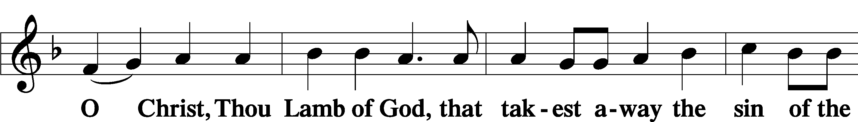
Sit

Distribution
The pastor and those who assist him receive the body and blood of Christ first and then distribute them to those who come to receive, saying:
Take, eat; this is the true body of our Lord and Savior Jesus Christ, given into death for your sins.
Amen.

Take, drink; this is the true blood of our Lord and Savior Jesus Christ, shed for the forgiveness of your sins.
Amen.

In dismissing the communicants, the following is said:
The Dismissal
P The body and blood of our Lord Jesus Christ strengthen and preserve you in body and soul to life everlasting. Depart T in peace.
C Amen.

Distribution Hymn: LSB #719 “I Leave All Things to God’s Direction”

Distribution Hymn: LSB p. 155 “This Is the Feast”

Distribution Hymn: LSB #895 “Now Thank We All Our God”

Nunc Dimittis Luke 2:29–32
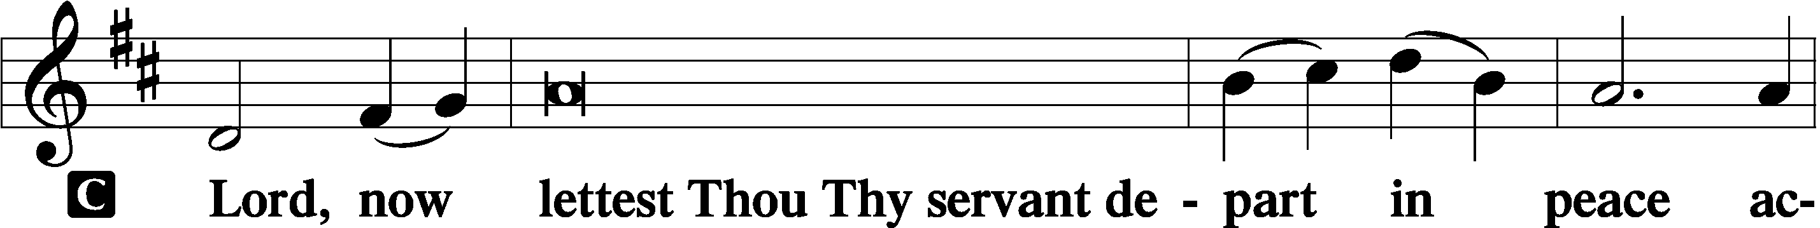
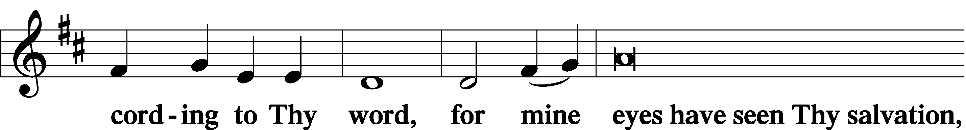
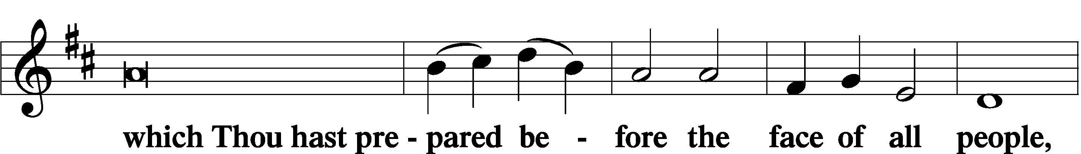
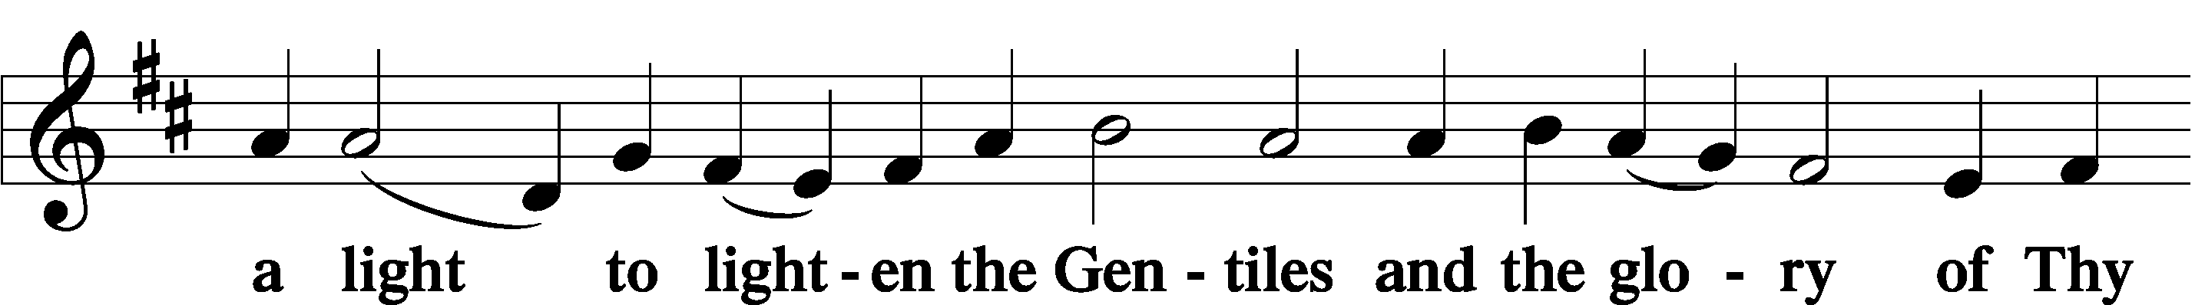
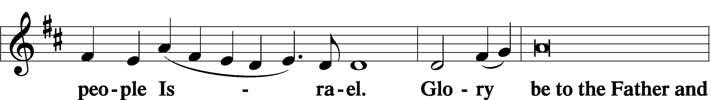
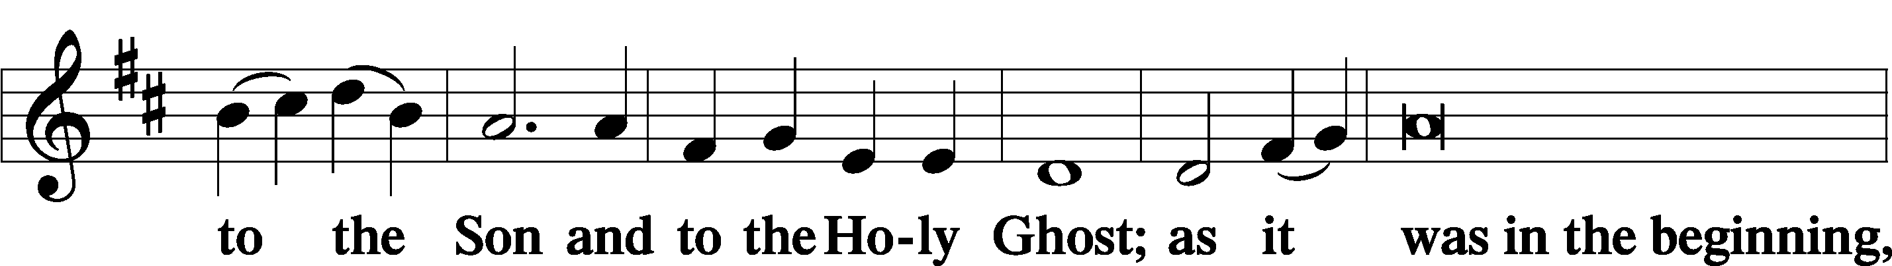
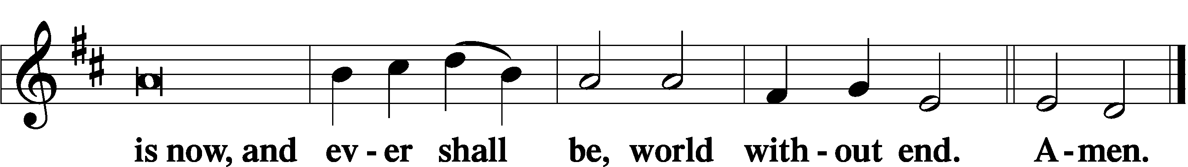

Thanksgiving Psalm 107:1
P O give thanks unto the Lord, for He is good,
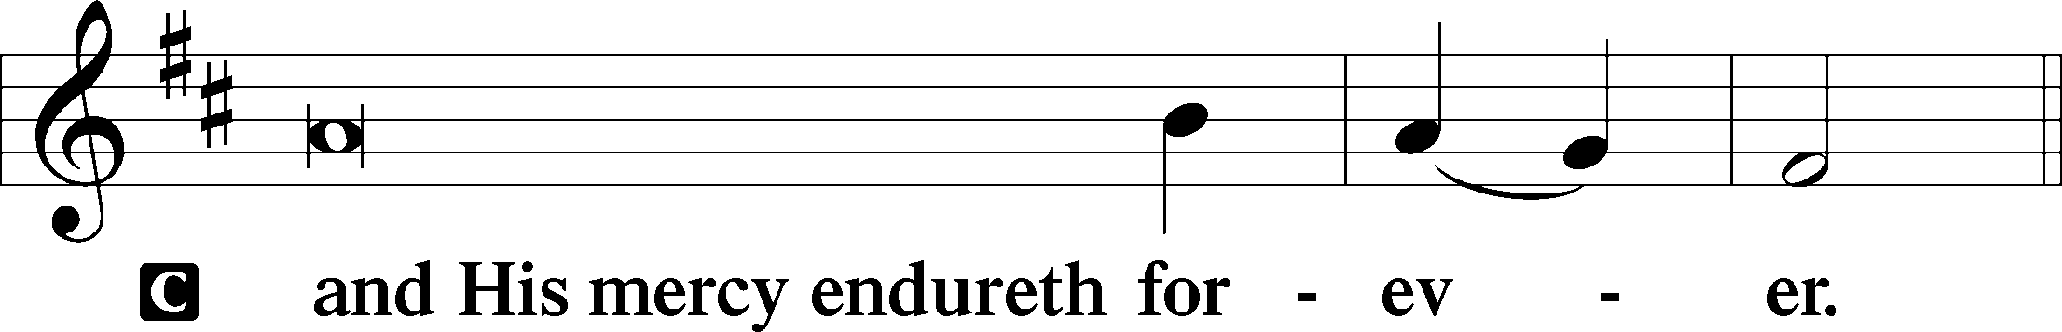

Post-Communion Collect
P Let us pray.
We give thanks to You, almighty God, that You have refreshed us through this salutary gift, and we implore You that of Your mercy You would strengthen us through the same in faith toward You and in fervent love toward one another; through Jesus Christ, Your Son, our Lord, who lives and reigns with You and the Holy Spirit, one God, now and forever.

Salutation 2 Timothy 4:22
P The Lord be with you.
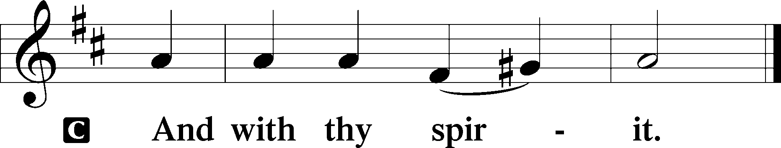

Benedicamus Psalm 103:1
P Bless we the Lord.

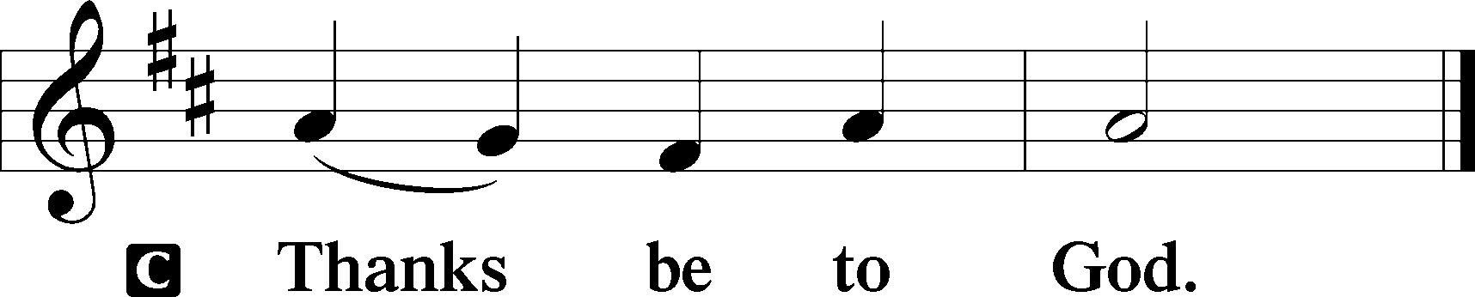

Benediction Numbers 6:24–26
P The Lord bless you and keep you.
The Lord make His face shine upon you and be gracious unto you.
The Lord lift up His countenance upon you and T give you peace.
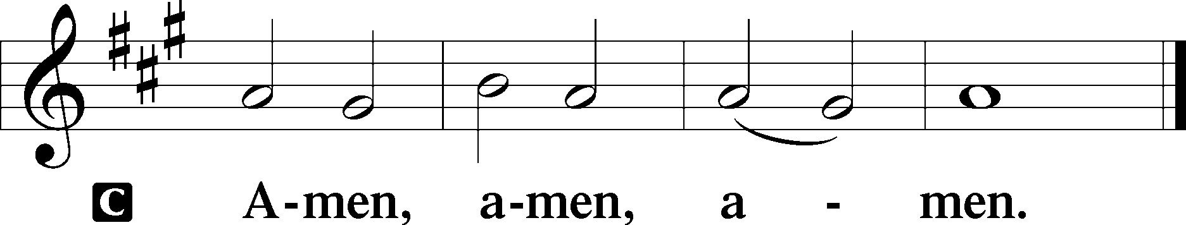

Closing Hymn: LSB #469 “Christ the Lord Is Risen Today”

Silent prayer after worship: Dear Lord Jesus, You promised to never leave me nor forsake me. Lead me to be in Your Word and in prayer daily so that I will always know Your love as well as the peace, hope and life that You offer me. Amen.
fffffffffffffffffffffffffffffffffff
Acknowledgments: Unless otherwise indicated, Scripture quotations are from the ESV® Bible (The Holy Bible, English Standard Version®), copyright © 2001 by Crossway, a publishing ministry of Good News Publishers. Used by permission. All rights reserved. Created by Lutheran Service Builder © 2023 Concordia Publishing House.
fffffffffffffffffffffffffffffffffff
In Loving Memory of Mothers, Mildred Fabri & Mary Rice: Joani Rice (Major Repair).
In Loving Memory of Barry Nelson: Patricia & Charles Bartholomew (Food Pantry); David & Anne Baver (Food Pantry); Becky Beck (Food Pantry); Gary & Eileen Burns (Food Pantry); Catherine Carr (Capital Campaign); Lori Dickson (Food Pantry); Ian E. Van Dyke (Food Pantry); Wayne & Lisa Emhoff (Food Pantry); Thomas & Cheryl Fleet (Food Pantry); Hank Holcroft (Food Pantry); Richard & Wendy Kellogg (Food Pantry); Frank & Monica Krieder (Food Pantry); Rev. Ed & Irene Kucera (Food Pantry); Rhonda & Tony Paglia (Food Pantry); Mark, Lynne, Nick & Dan Spanos (Food Pantry); Paul & Diane Weller (Food Pantry); Sally Wells (Food Pantry)
In Loving Memory of Vi Sakony: Gary & Eileen Burns.
fffffffffffffffffffffffffffffffffff
The Altar Flowers today are given in loving memory of Joanne Wolfe by her daughter, Marilyn Black, and son, David Wolfe. We are greatly appreciative of this gift on this Mother’s Day.
fffffffffffffffffffffffffffffffffff
SCHEDULE THROUGH MAY 21, 2023:

:

Today, 7 pm, Fellowship Hall: AA Meeting
Monday, 7 pm, Fellowship Hall: Church Council Meeting
Tuesday, 7-9 pm, Fellowship Hall: Penn-Ohio Singers
Wednesday, 7:30 pm, Fellowship Hall: NA Meeting
Thursday, 10 am, Fellowship Hall: Women’s Bible Study
7 pm, Sanctuary: Ascension Divine Service
Saturday, 1 pm, Fellowship Hall: Altar Guild Meeting
4 pm, Fellowship Hall: Men’s Bible Study
Next Sunday, 8 am, Fellowship Hall: Bible Study
9 am, Sanctuary: Divine Service
Following Worship, Library: Audit of Deposits
7 pm, Fellowship Hall: AA Meeting
Our Stewardship of Treasures for the Lord:
In order to do the Lord’s work, we need $2,553.63 each week to meet our 2023 budget for general purposes and $76.92 for the SELC. Online Figures (04.27 & 05.03.2023)
General Fund: $1,080.00
SELC: $100.00
Capital Campaign: $200.00
Figures for Sunday, May 7, 2023
General Fund: $1,958.00 Ahead for the week*: +$484.37
SELC: $145.00 Ahead for the week+: +$168.08
Food Pantry: $1,020.00
Quarterly Missions: #35.00
Capital Campaign: $235.00
Other: $25.00

For online giving, check out https://www.saintspeterandpaul.net/online-giving.
fffffffffffffffffffffffffffffffffff
Attendance: Sunday, May 7, 2023: 35
fffffffffffffffffffffffffffffffffff
THANK YOU FOR SERVING IN MAY: Elder: Jonathan Baisch; Ushers: Matt Berent, Mark Gabriel, Michael Laird, & Jerome Thomas; Altarware: (prior) Diane Riefstahl & Marie Flaugher (05/14); (after) Evelyn Baisch (05/07 & 05/14), Hank Holcroft (05/21), Ruth Meszaros (05/28) & Arlene Sutton.
fffffffffffffffffffffffffffffffffff
Available in the narthex:
- Tentative Church Council agendas for May 15, 2023 meeting.
- Copies of the “Lutherans Engage” magazine.
fffffffffffffffffffffffffffffffffff
Women’s Bible Study will take place this Thursday morning from 10-11 am. We will meet in the Fellowship Hall.
fffffffffffffffffffffffffffffffffff
Altar Guild members will meet Saturday, May 20th, at 1 pm. All ladies are welcome to join us!
fffffffffffffffffffffffffffffffffff
Remember the following in Prayer…
~The Hurting and Healing: Amy, Gerald Arthur, Ellen Baron^{CA}, Lois Bortner^{CA}, John Burdette, Bev & Joe Chlpka, Kathleen Coughenour, Kim, Anna Mae Daris, Susan Davies, Tim Dudash, Millie Elavsky, Joseph Fleet, Judith & Eddy Furey, Tim Haenftling, Austin Hamilton, Joan, Darla Krajci, Barbara Kreske, Donna Kennedy, Jess Lavoie, Joanne Lozier, Paul Lucas^{CA}, Sandy Marshall, Frank Niemeyer^{CA}, Linda Parkany, Juanita Rentschler, Richard Reuning^{CA}, Nancy Robertson^{CA}, Marty Scott, Kara, Fred Tonty, Joel & Peggy Wasson, Angela Weser^{CA}, and Ruth Wolf.
~The Homebound: Rudy & Jean Tomko, Betty Wolf, and Ed & Millie Zachar.
~Celebrating this Week: Birthdays: Arlene Sutton (05.14) and Anna Mae Daris (05.15); Anniversary: Lennie & Kim Revale (05.16).
~Serving in the Military: Curtis Sinewe and Joshua Solyan.
~Community & World Needs: Those suffering from or affected by the coronavirus; those suffering due to the conflict between Ukraine and Russia; those suffering from loss and dislocation because weather disasters; those suffering from addiction and their families; Local, State, and National Government Leaders; safety for all Police Officers, Firefighters, & First Responders; the unemployed; our Second Quarter Local Mission: The Support of a Concordia, Fort Wayne Seminarian.
*CA represents cancer.
fffffffffffffffffffffffffffffffffff
Bible Memory Verses ~ Week of May 14th:
For Adults: But godliness with contentment is great gain, for we brought nothing into the world, and we cannot take anything out of the world. But if we have food and clothing, with these we will be content. 1 Timothy 6:6-8

For Children: I, when I am lifted up from the earth, will draw all people to myself.
John 12:32
fffffffffffffffffffffffffffffffffff
Church Council members will be meeting tomorrow, May 15th, at 7 pm in the Fellowship Hall. Please be certain to submit your Council reports to the secretary’s office by noon that day so that packets can be put together.
fffffffffffffffffffffffffffffffffff
Please join us this Thursday evening at 7 pm for a special Ascension Divine Service.
Here to Serve
Pastor………………………………………………...……………Rev. Jacob Deal
E-mail …………………………….……pastordeal@saintspeterandpaul.net
Phone Number……………………..…………………724-347-3620 (Option 2)
Church Office………………………..…………………724-347-3620 (Option 3)
Website …………………………………………www.saintspeterandpaul.net
Secretary…………………………………………………………Diane Riefstahl
E-mail ………………………………………church@saintspeterandpaul.net
Website …………………………………………www.saintspeterandpaul.net
Food Pantry: Please leave message……………724-347-3620 (Option 3)
AA Contact: Steve………………………………………………..…724-813-2358
NA Contact: Larry………………………………………………..724-977-8733
Choir Director………………………………………………………Chris Nelson
Congregation President……………………………………Jonathan Baisch
Church Elder …………………………………………...…… Jonathan Baisch
fffffffffffffffffffffffffffffffffff
If needing to get into the church building during the week, please phone first to make certain someone is here to let you in.

