Sts. Peter & Paul
Evangelical Lutheran Church
Lutheran Church-Missouri Synod
Founded-1917
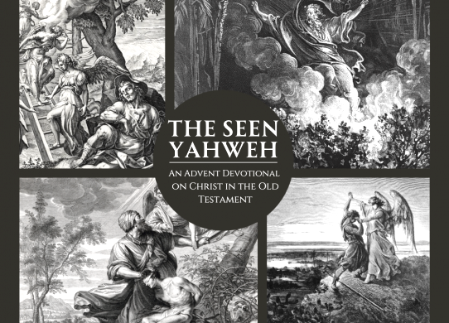

“The Seen Yahweh”

2023 MATINS ADVENT SERVICE

699 Stambaugh Avenue
Sharon, Pennsylvania 16146

“I was glad when they said to me,
Let us go to the house of the LORD!”
Psalm 122:1

Acknowledgments: Matins from Lutheran Service Book Unless otherwise indicated, Scripture quotations are from the ESV® Bible (The Holy Bible, English Standard Version®), copyright © 2001 by Crossway, a publishing ministry of Good News Publishers. Used by permission. All rights reserved. Created by Lutheran Service Builder © 2023 Concordia Publishing House.
MATINS
Opening Hymn:
December 6, 2023 LSB #357 “O Come, O Come, Emmanuel”
December 13, 2023 LSB # 349 “Hark the Glad Sound”
December 20, 2023 LSB #916 “Only-Begotten Word of God Eternal”

Stand
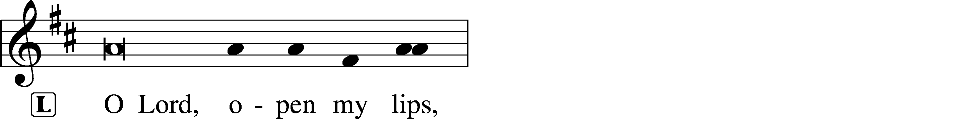
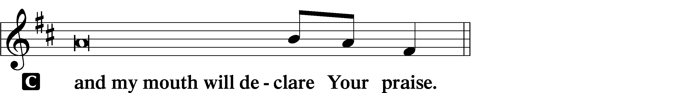

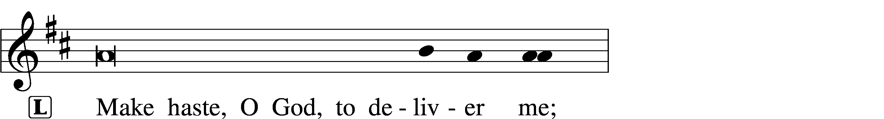
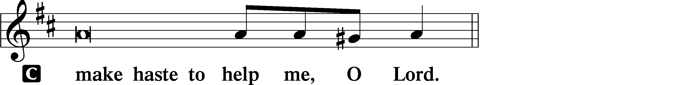

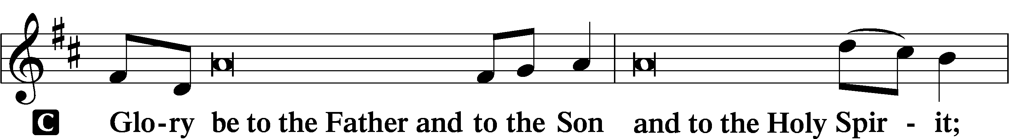
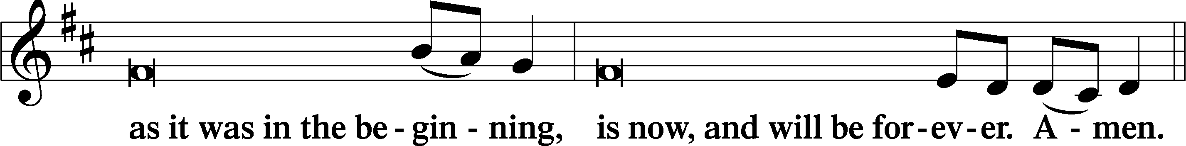
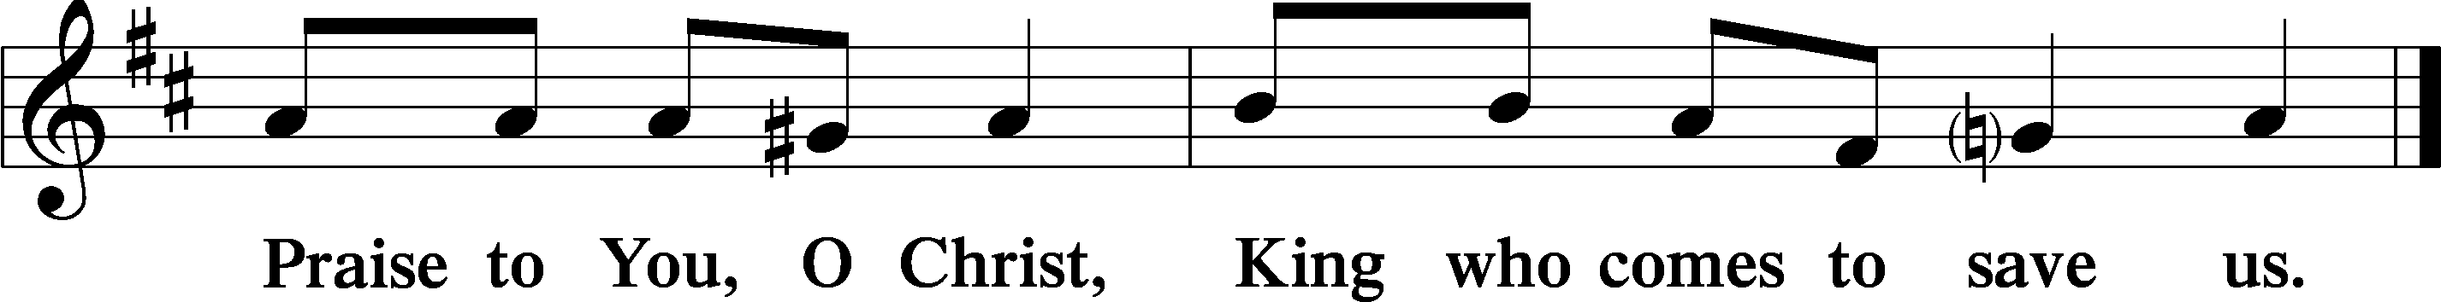
Psalmody
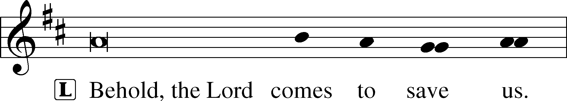
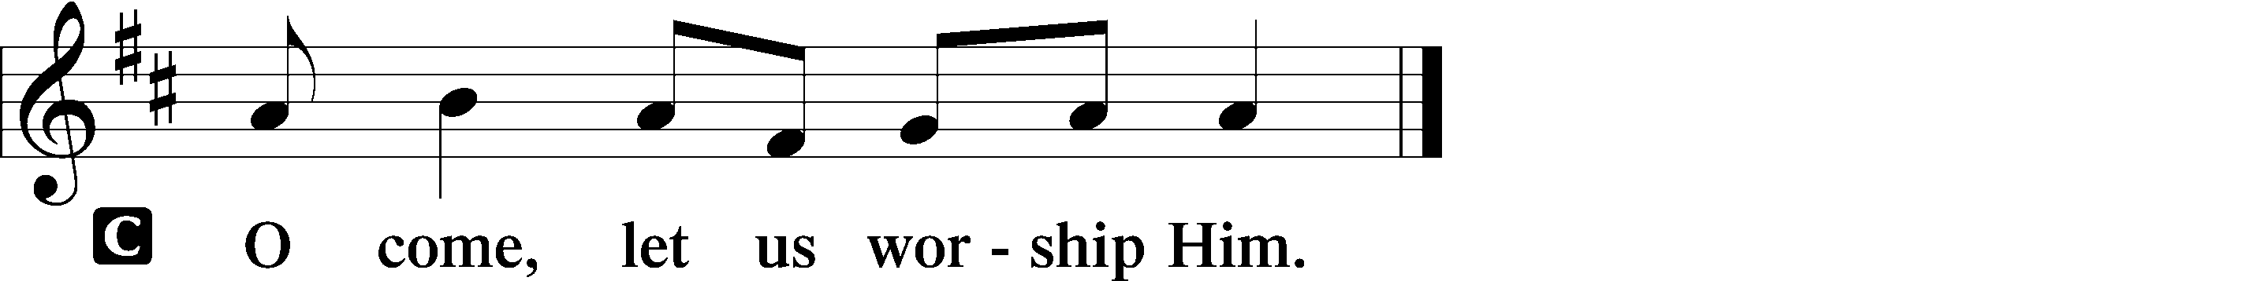

Venite LSB 220
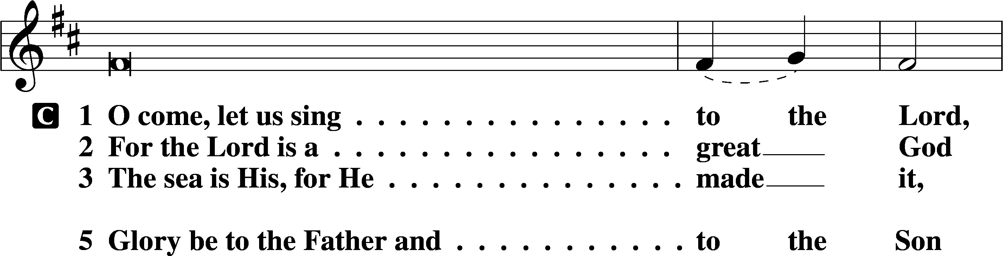
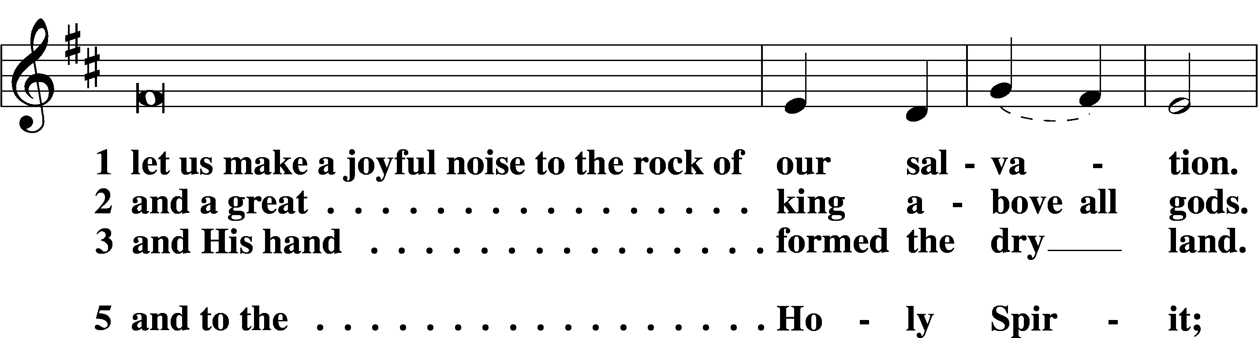
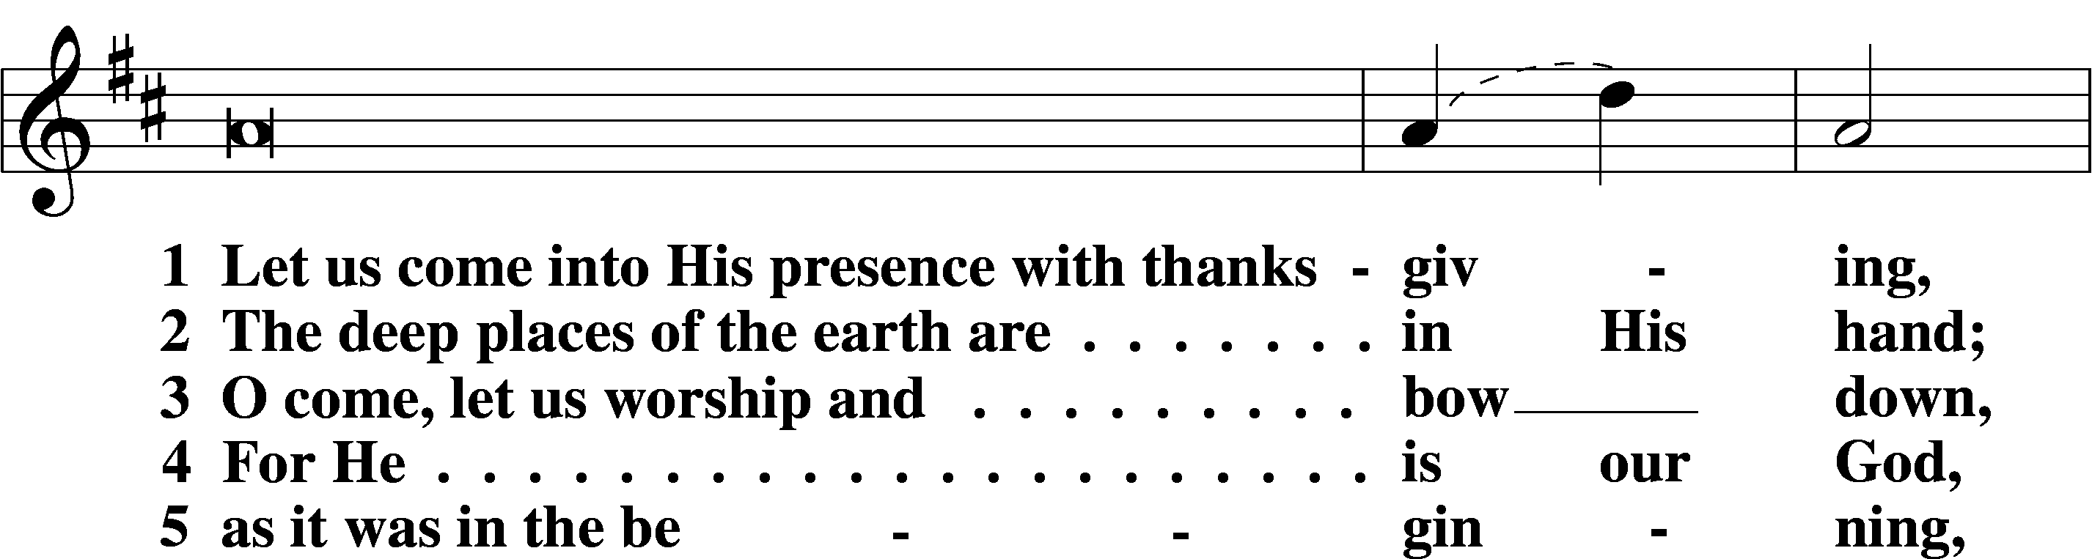
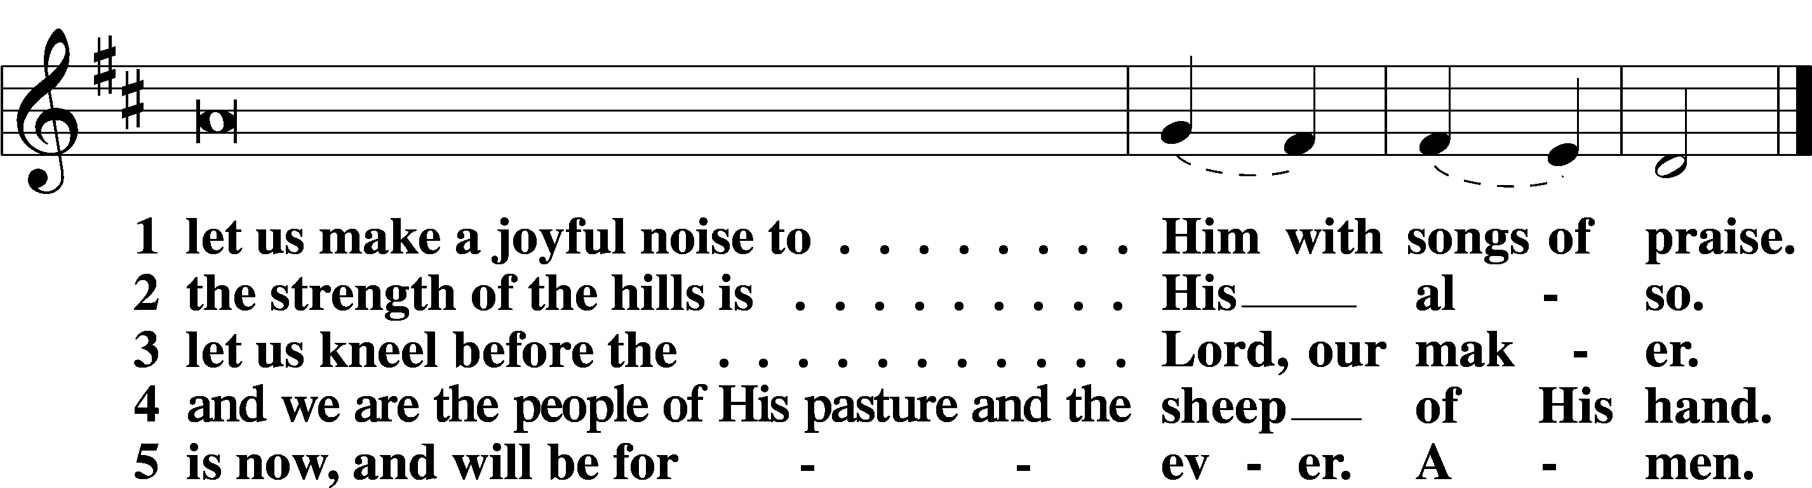
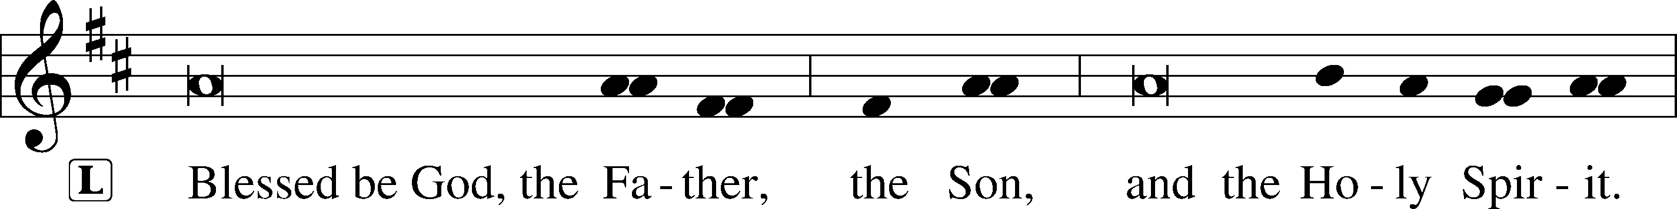

Psalm Reading: (See insert)

Sit
Hymn of the Day:
December 6, 2023 LSB #522 “Lord God, to Thee We Give All Praise”
December 13, 2023 LSB #334 “O Lord, How Shall I Meet You”
December 20, 2023 LSB #332 “Savior of the Nations, Come”

Readings
Prophecy: (See insert)

P O Lord, have mercy on us.
C Thanks be to God.

New Testament: (See insert)

P O Lord, have mercy on us.
C Thanks be to God.

Responsory (Advent)
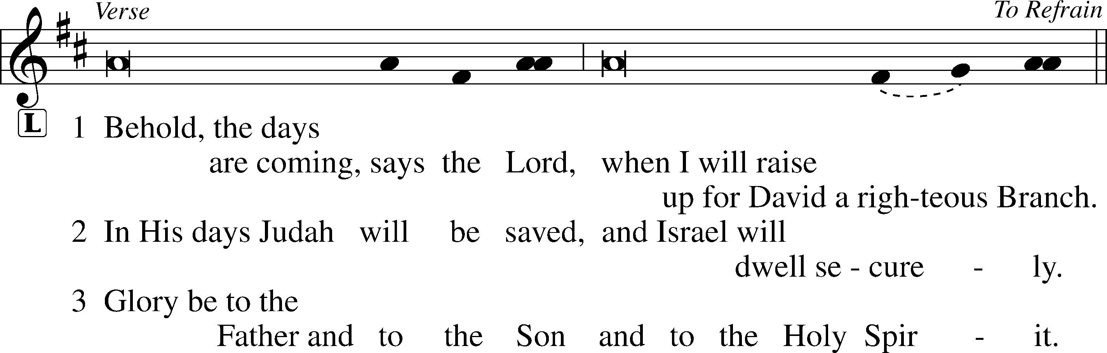
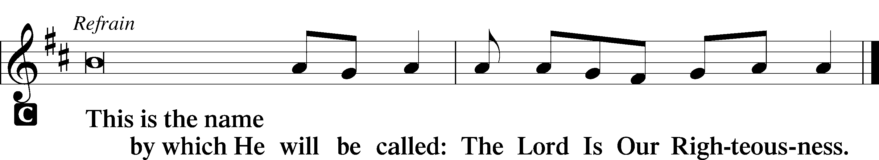

Sermon
Canticle
Stand
Benedictus LSB 226
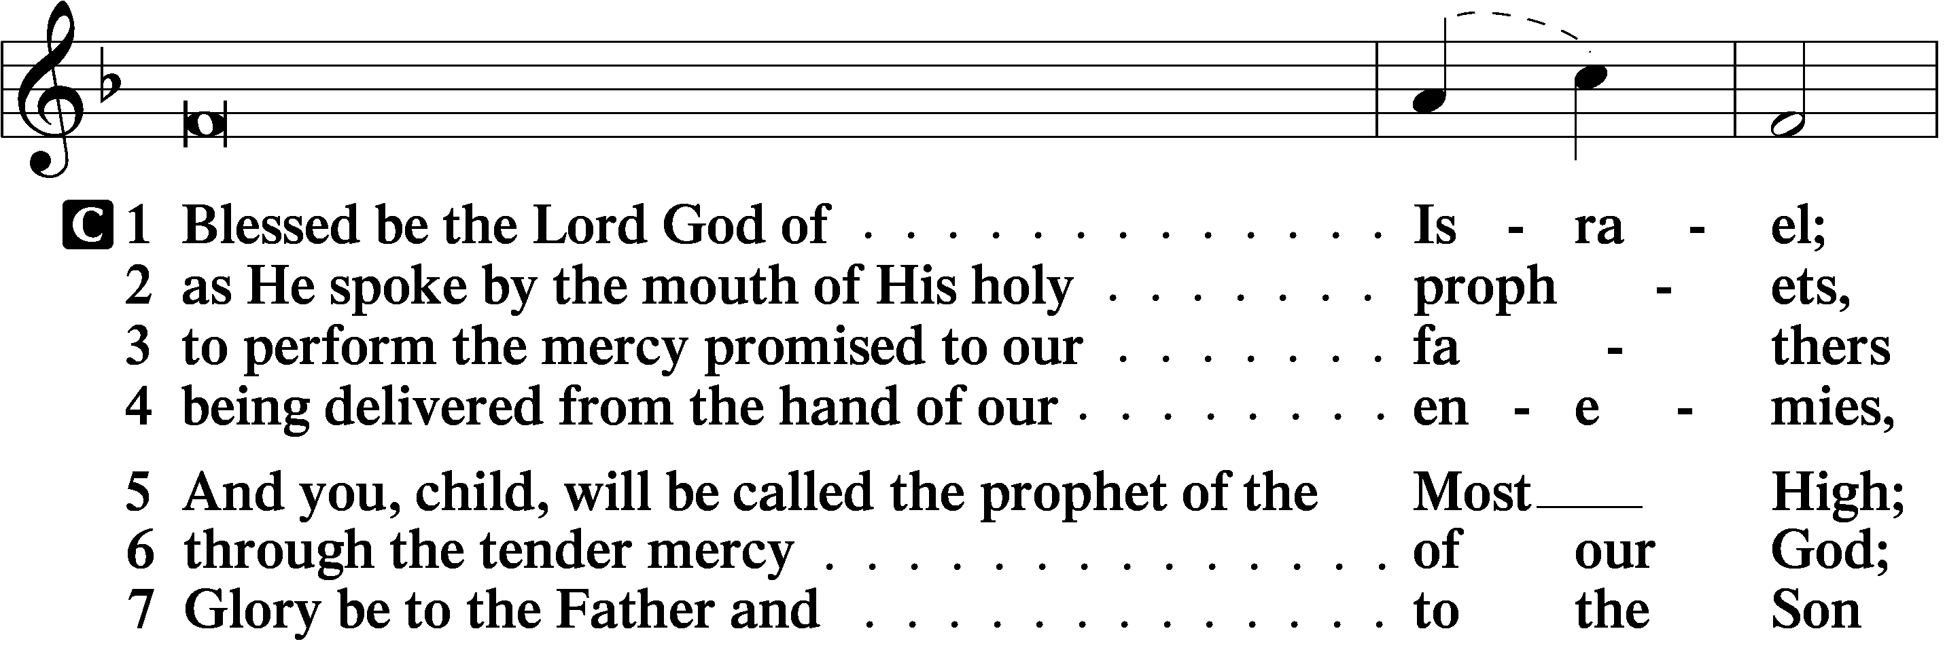
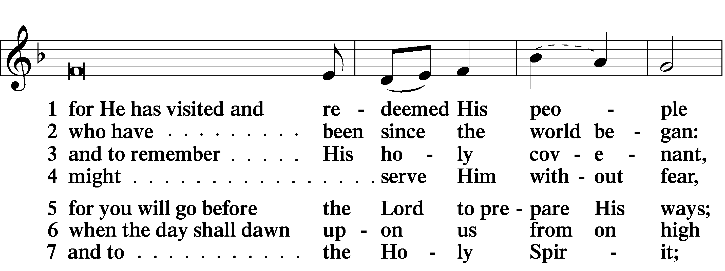
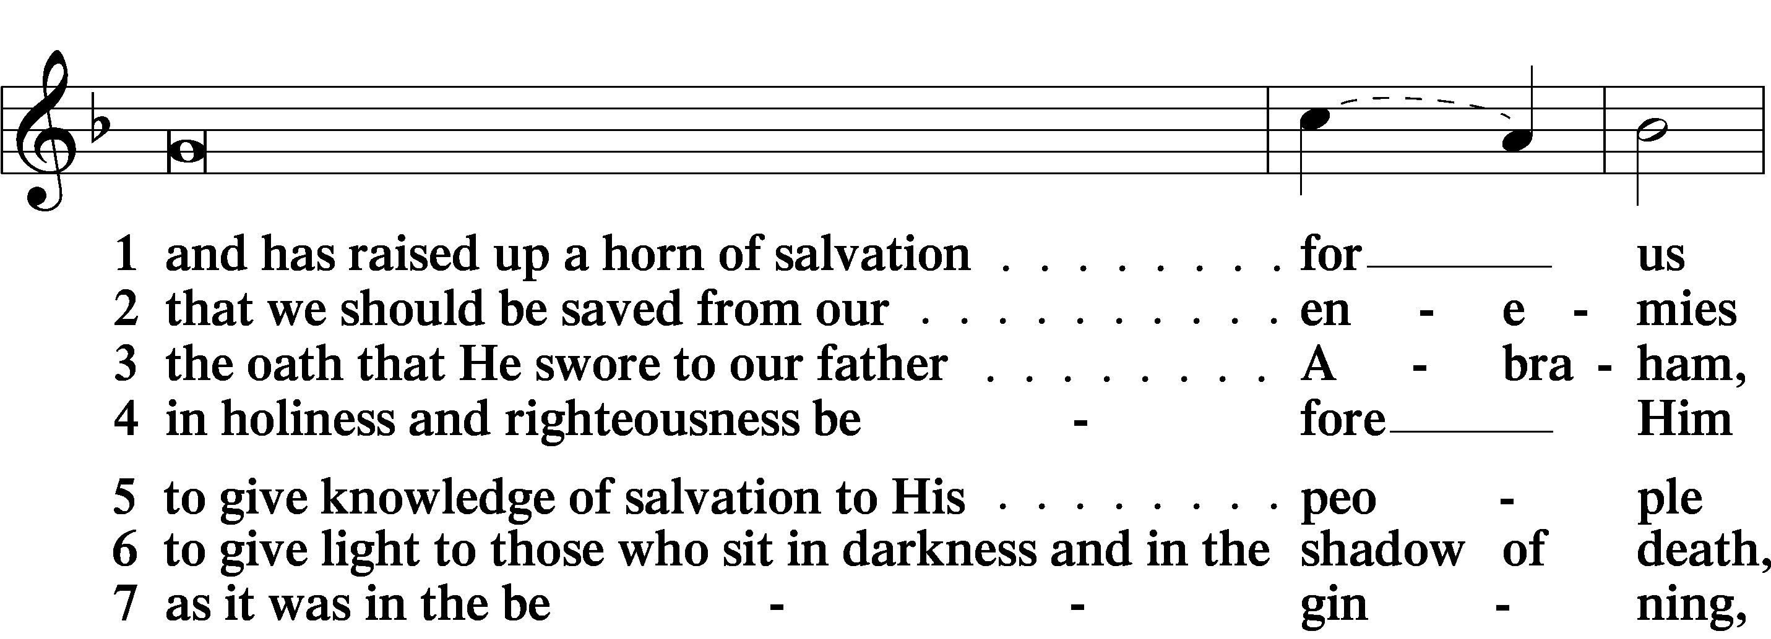
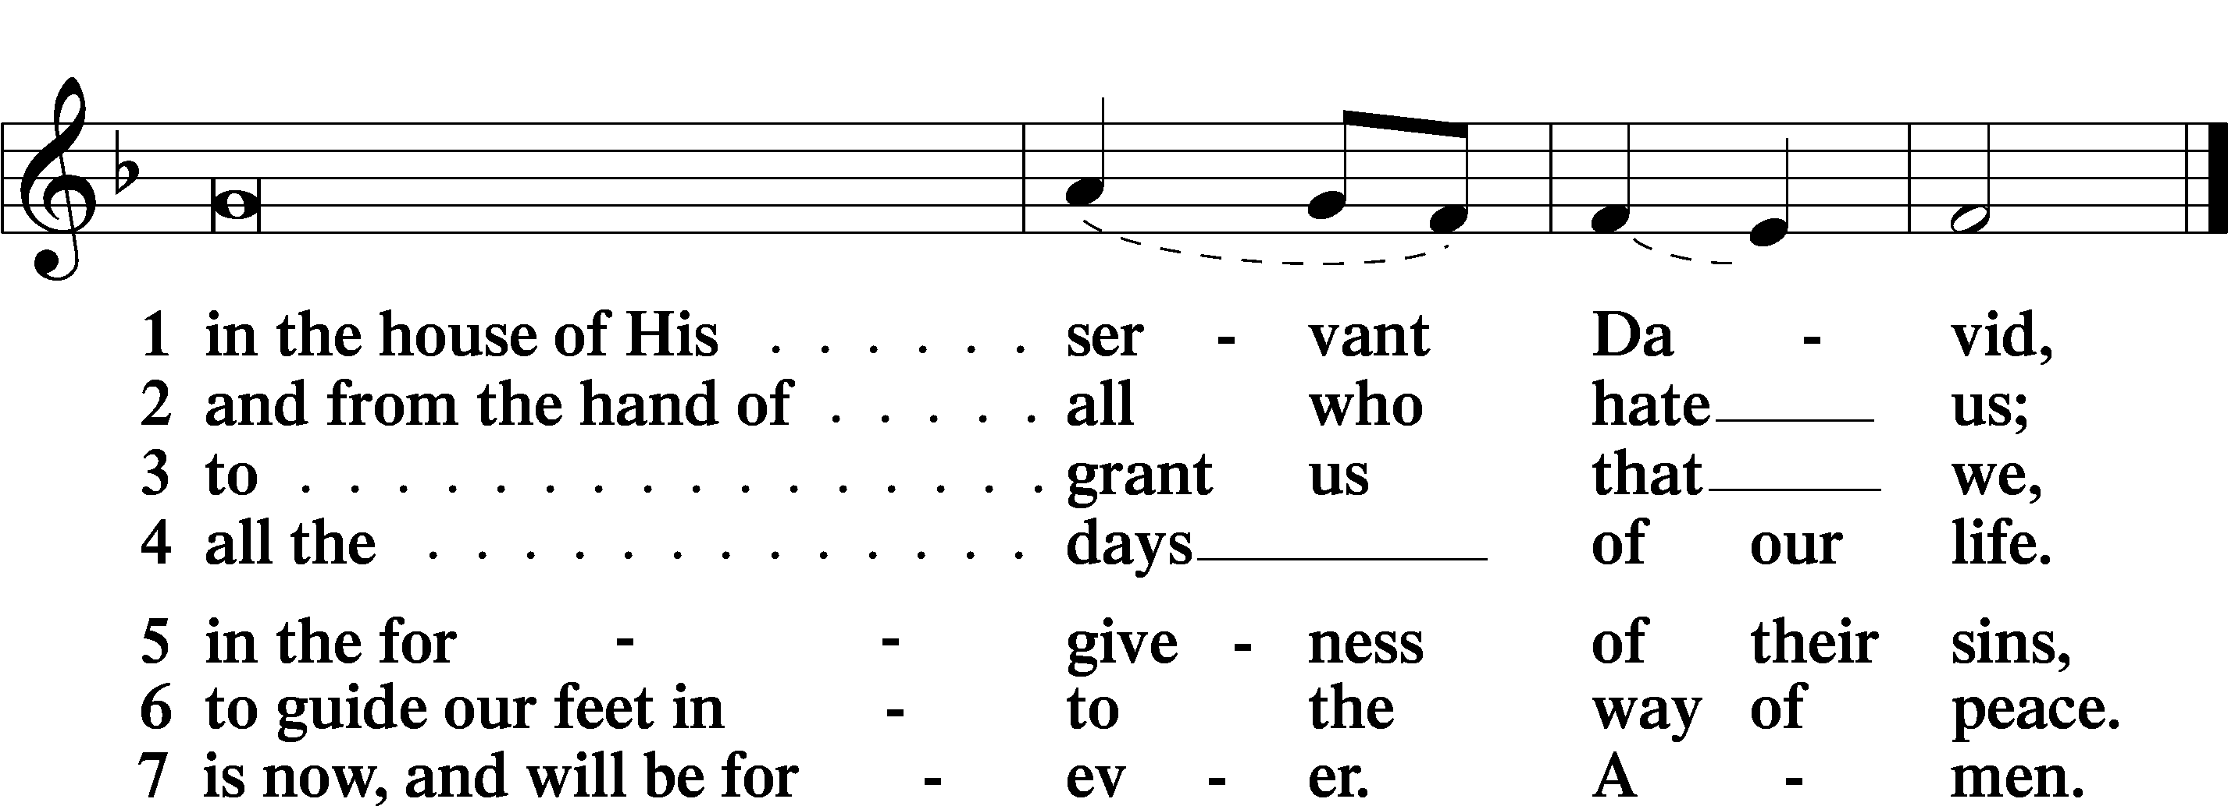
Prayer

Kyrie LSB 227
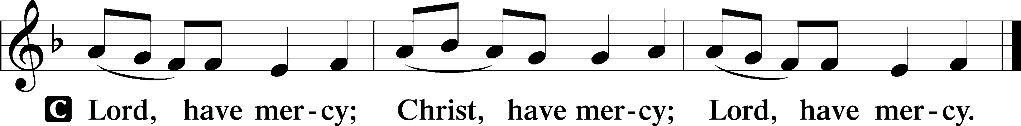

Lord’s Prayer LSB 957
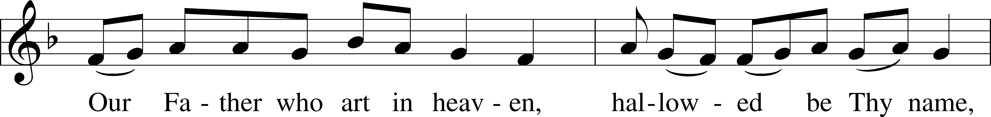
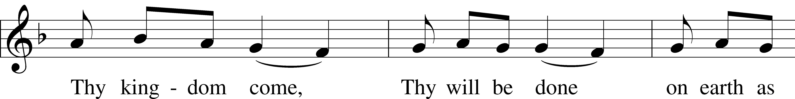
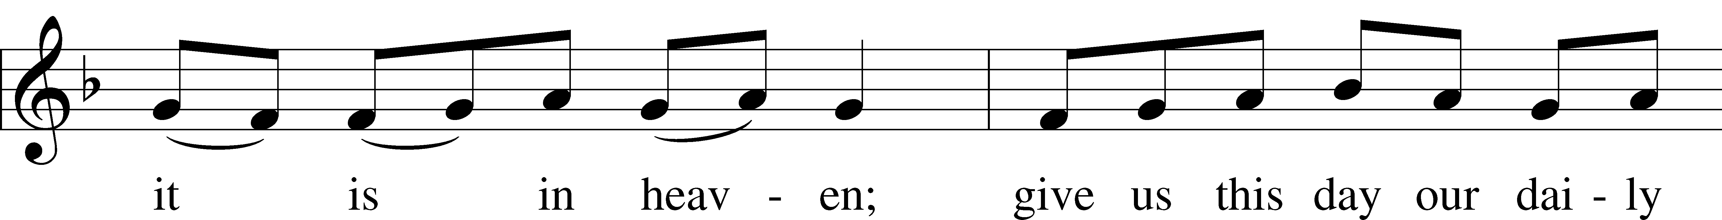
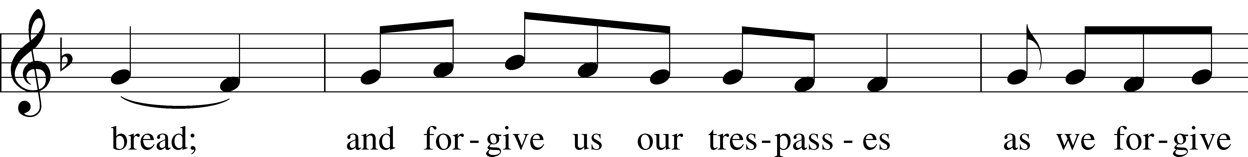
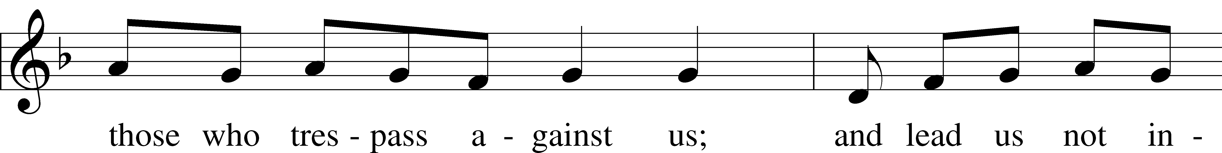
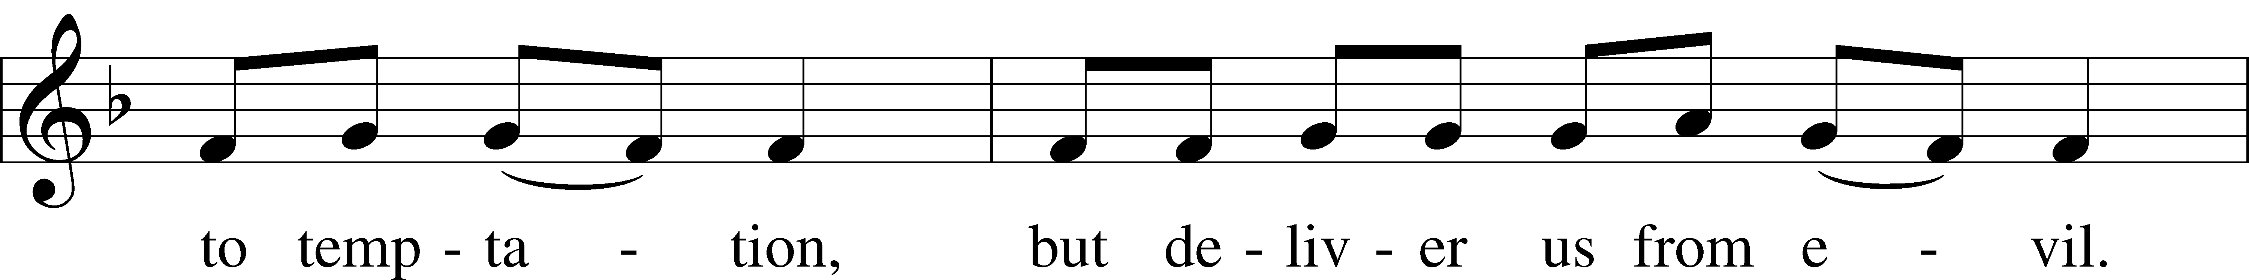
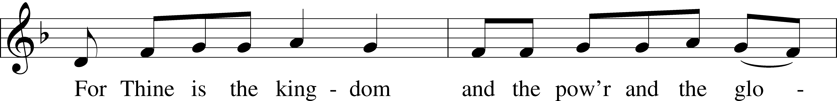
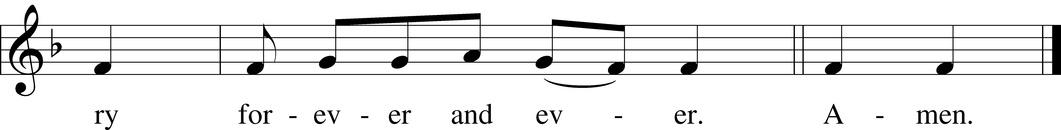
Collects
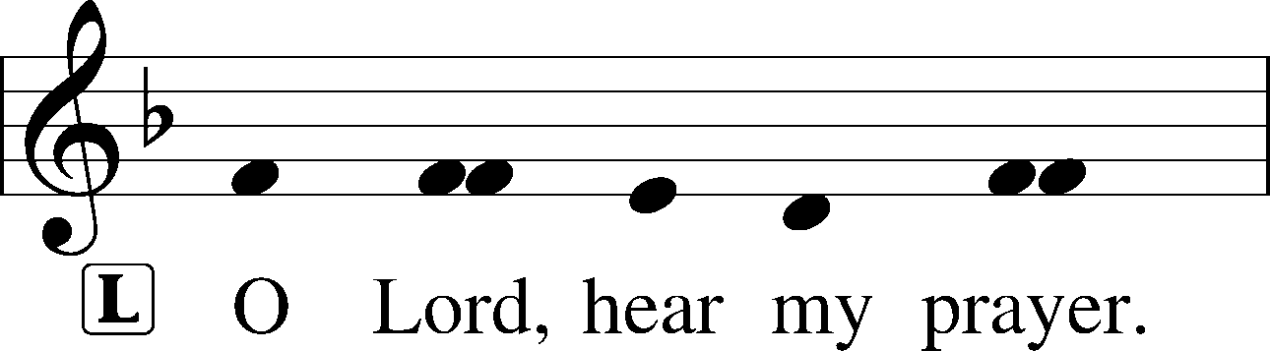
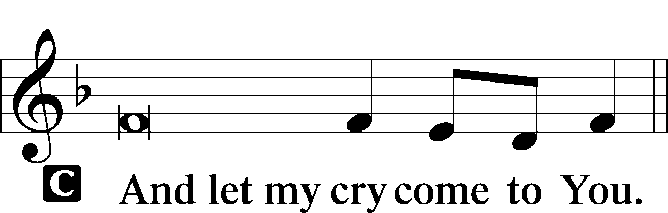

Collect of the Day (See insert)
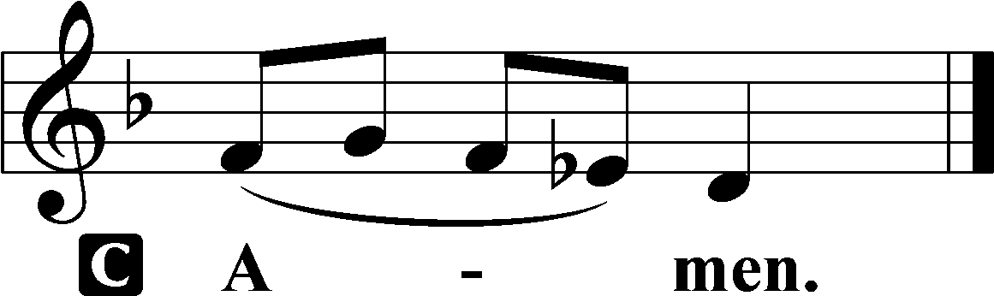

Collect for Grace
P O Lord, our heavenly Father, almighty and everlasting God, You have safely brought us to the beginning of this day. Defend us in the same with Your mighty power and grant that this day we fall into no sin, neither run into any kind of danger, but that all our doings, being ordered by Your governance, may be righteous in Your sight; through Jesus Christ, Your Son, our Lord, who lives and reigns with You and the Holy Spirit, one God, now and forever.

Benedicamus LSB 228
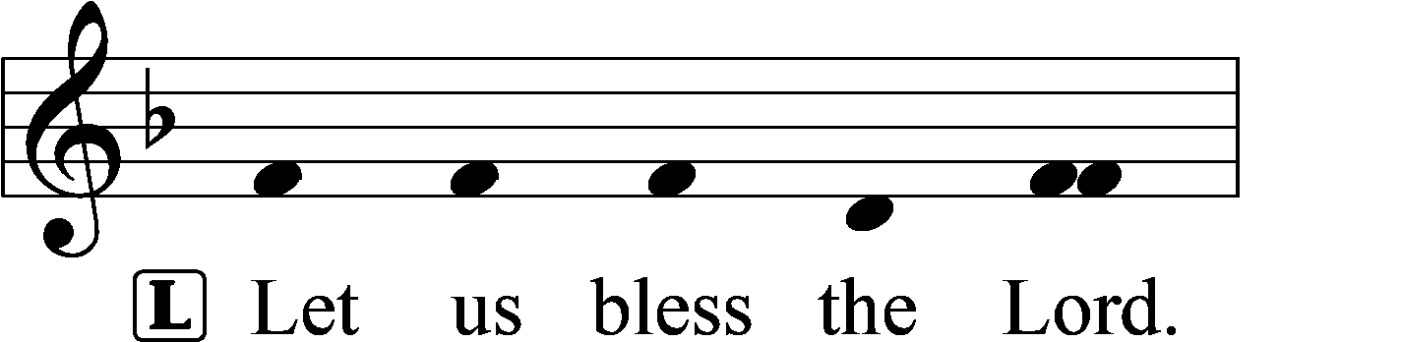
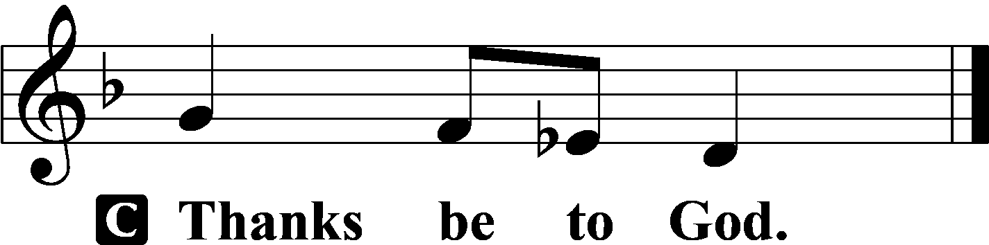

Benediction LSB 228
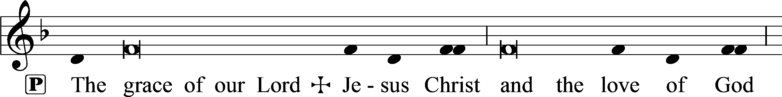
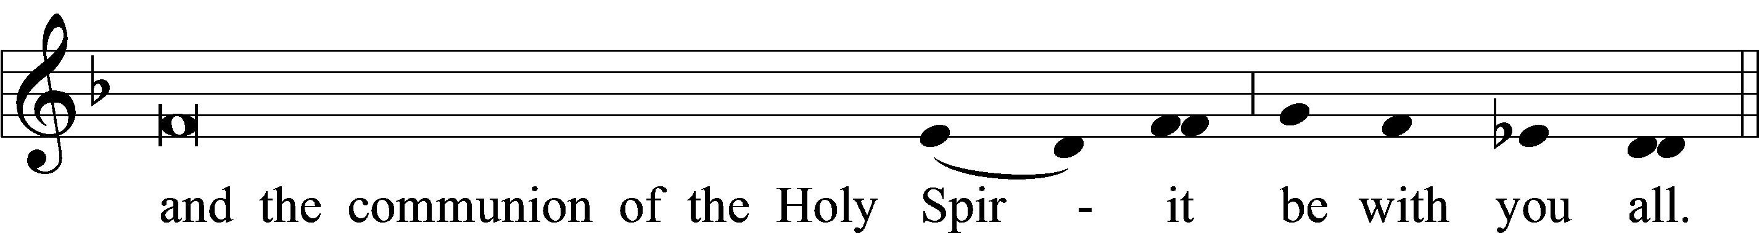

Closing Hymn:
December 6, 2023 LSB #339 “Lift Up Your Heads, You Everlasting Doors”
December 13, 2023 LSB # 352“Let the Earth Now Praise the Lord”
December 20, 2023 LSB #346 “When All the World Was Cursed”
sssssssssssssssssssssssssssssssssssssssssssssssssssssssssssssssssssssssssssss

Kindly return your service bulletin for future Advent Matins services.

