Sts. Peter & Paul
Evangelical Lutheran Church
Lutheran Church-Missouri Synod
Founded-1917

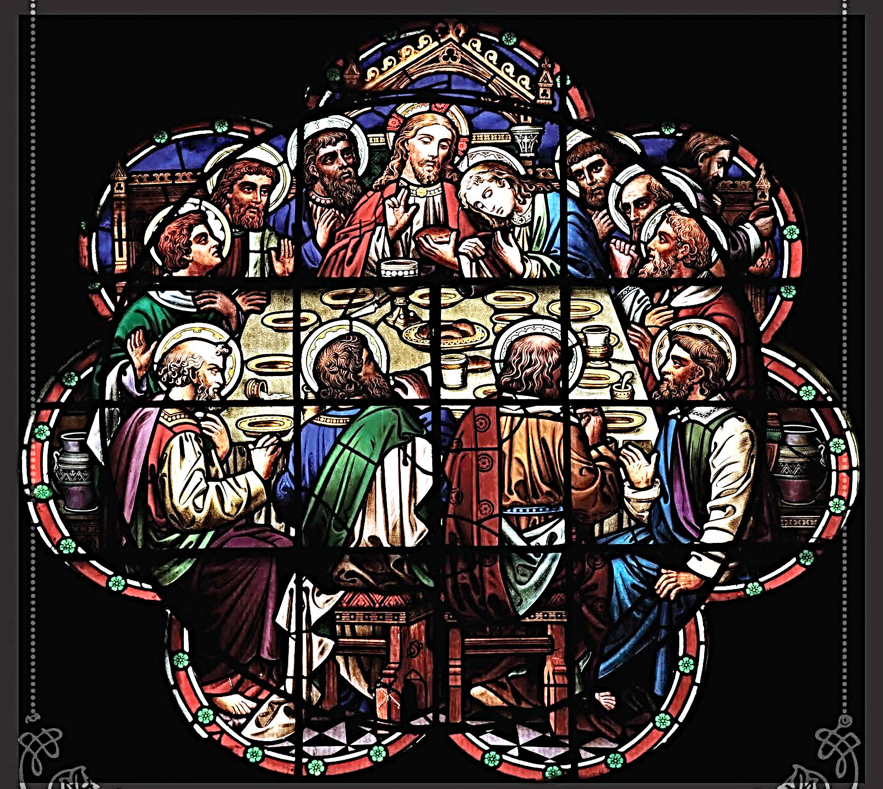

2023 Lenten Midweek Matins Service

699 Stambaugh Avenue
Sharon, Pennsylvania 16146

“I was glad when they said to me,
Let us go to the house of the LORD!”
Psalm 122:1
Sts. Peter & Paul Evangelical Lutheran Church, LC-MS
LENTEN MIDWEEK MATINS SERVICE

Opening Hymns:
March 1: LSB #619 “Thy Body, Given for Me, O Savior”
March 8: LSB #433 “Glory Be to Jesus”
March 15: LSB #618 “I Come, O Savior, to Thy Table”
March 22: LSB #623 “Lord Jesus Christ, We Humbly Pray”
March 29: LSB #636 “Soul, Adorn Yourself with Gladness”

Stand
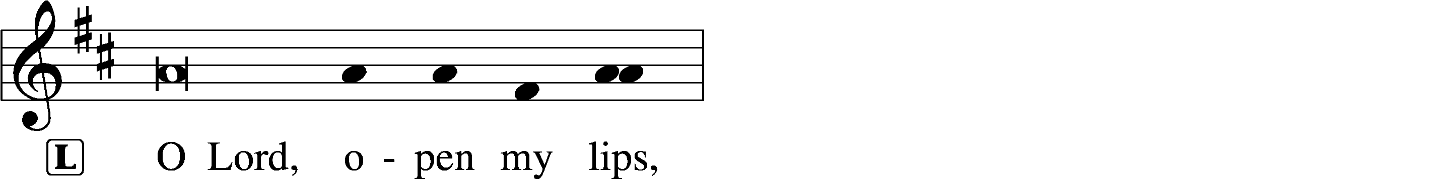
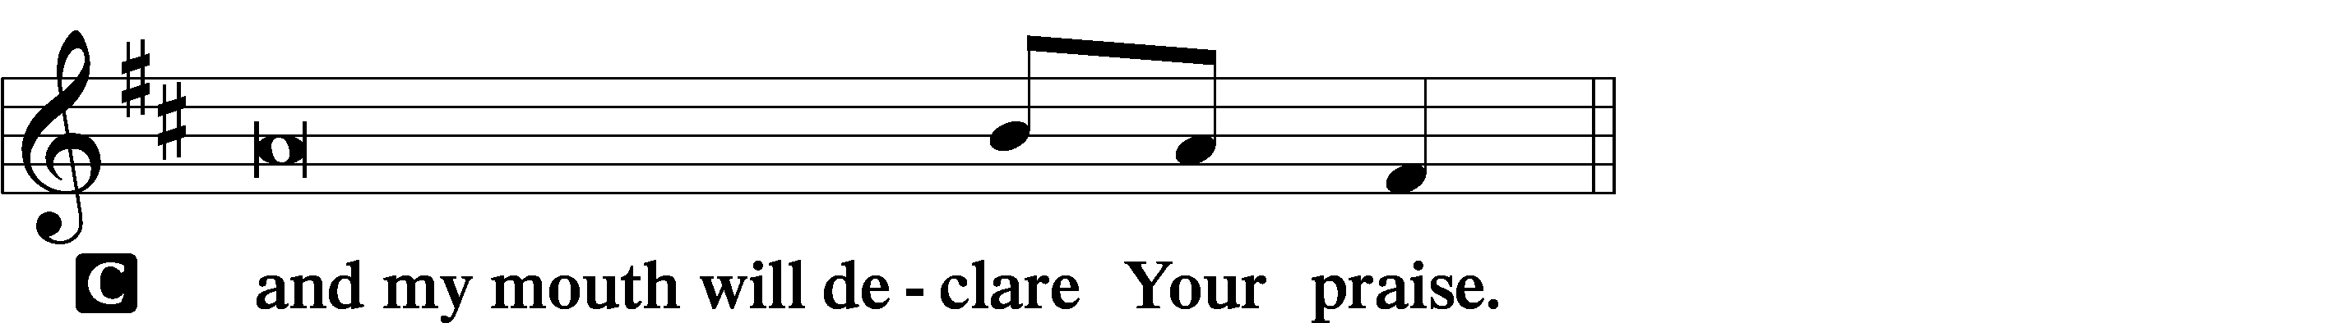

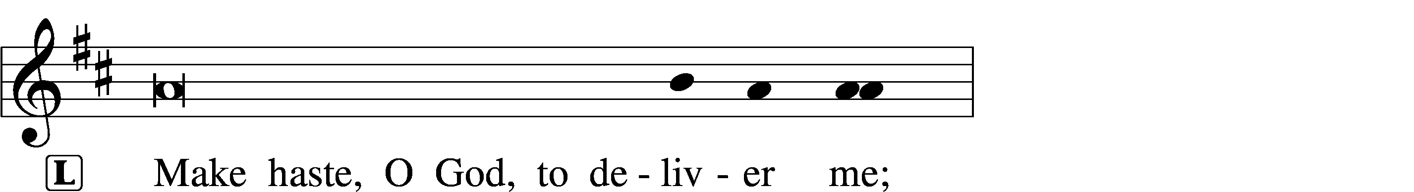
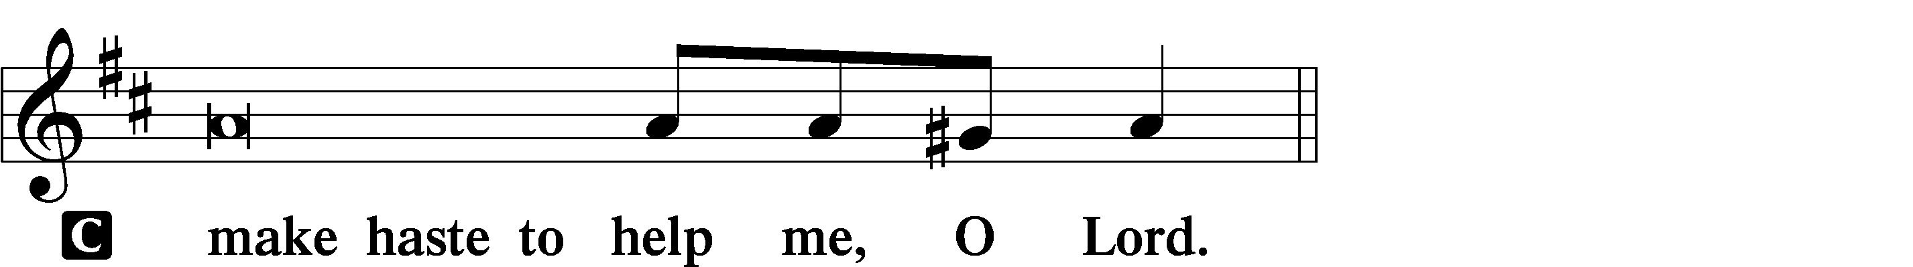

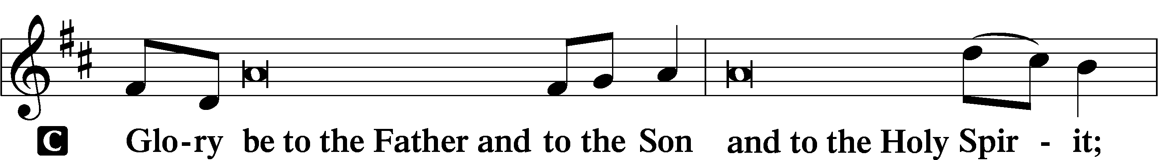
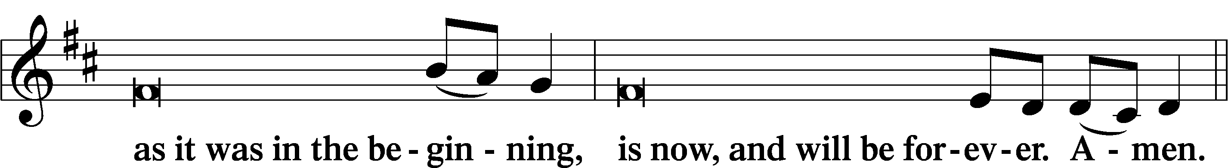
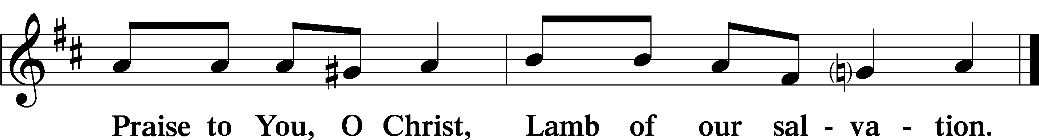

Psalmody

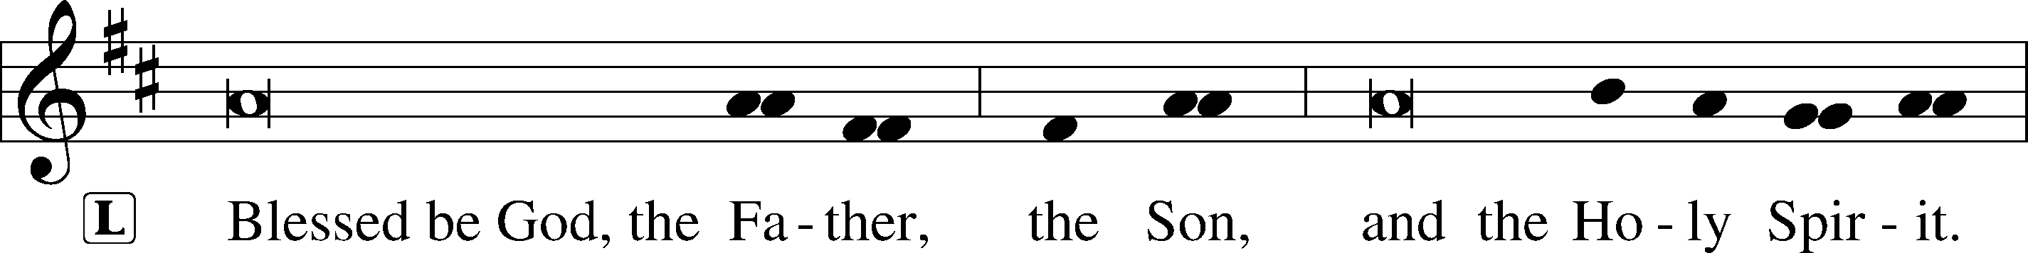

Venite LSB 220
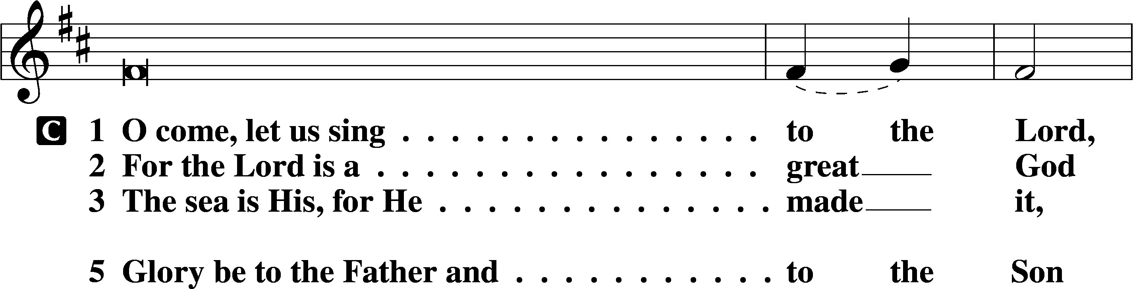
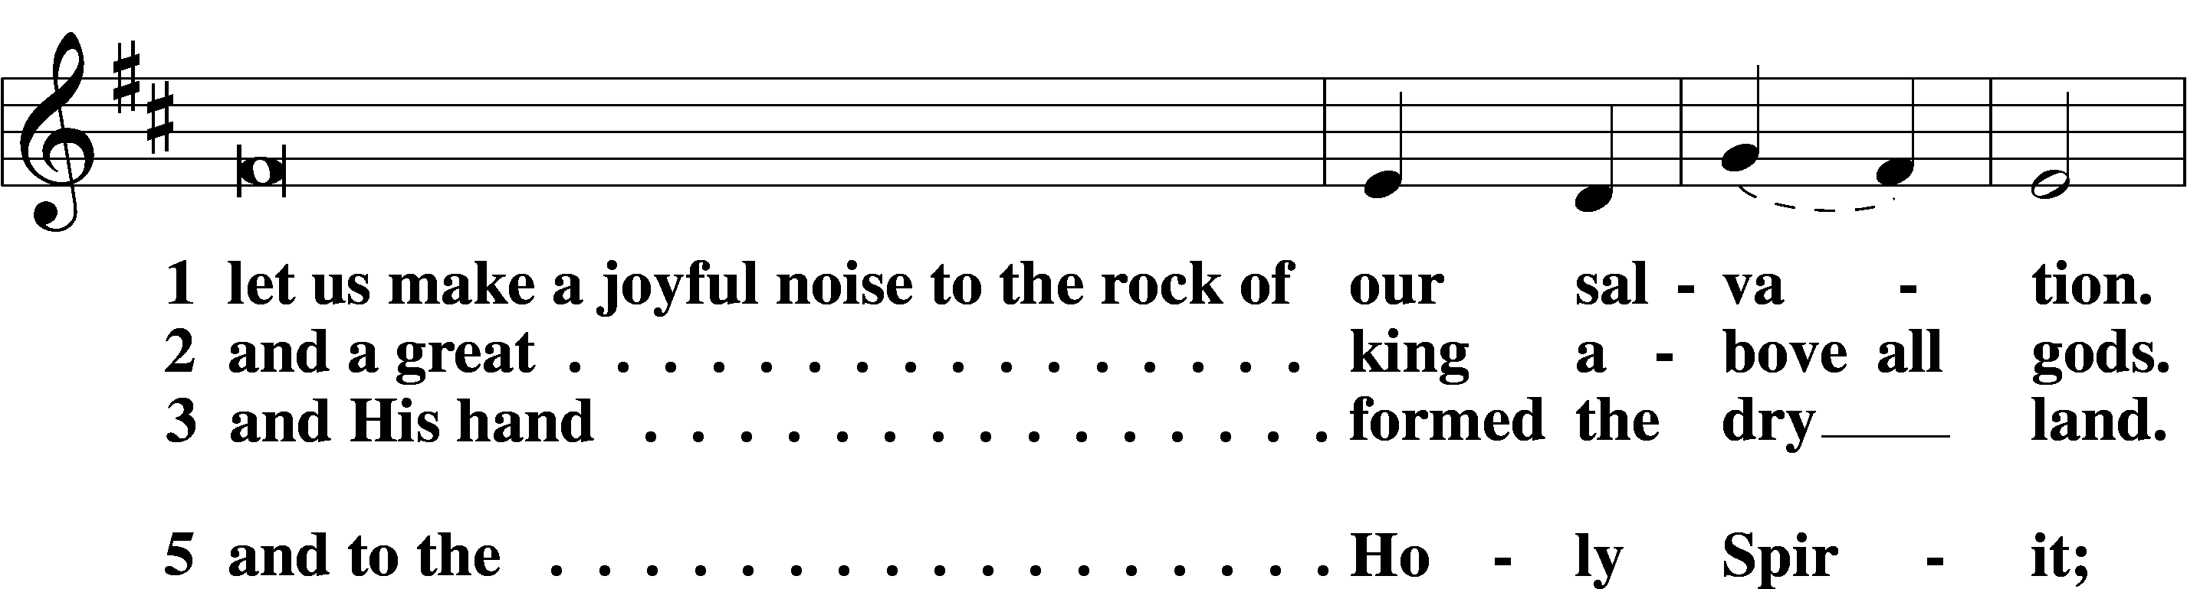
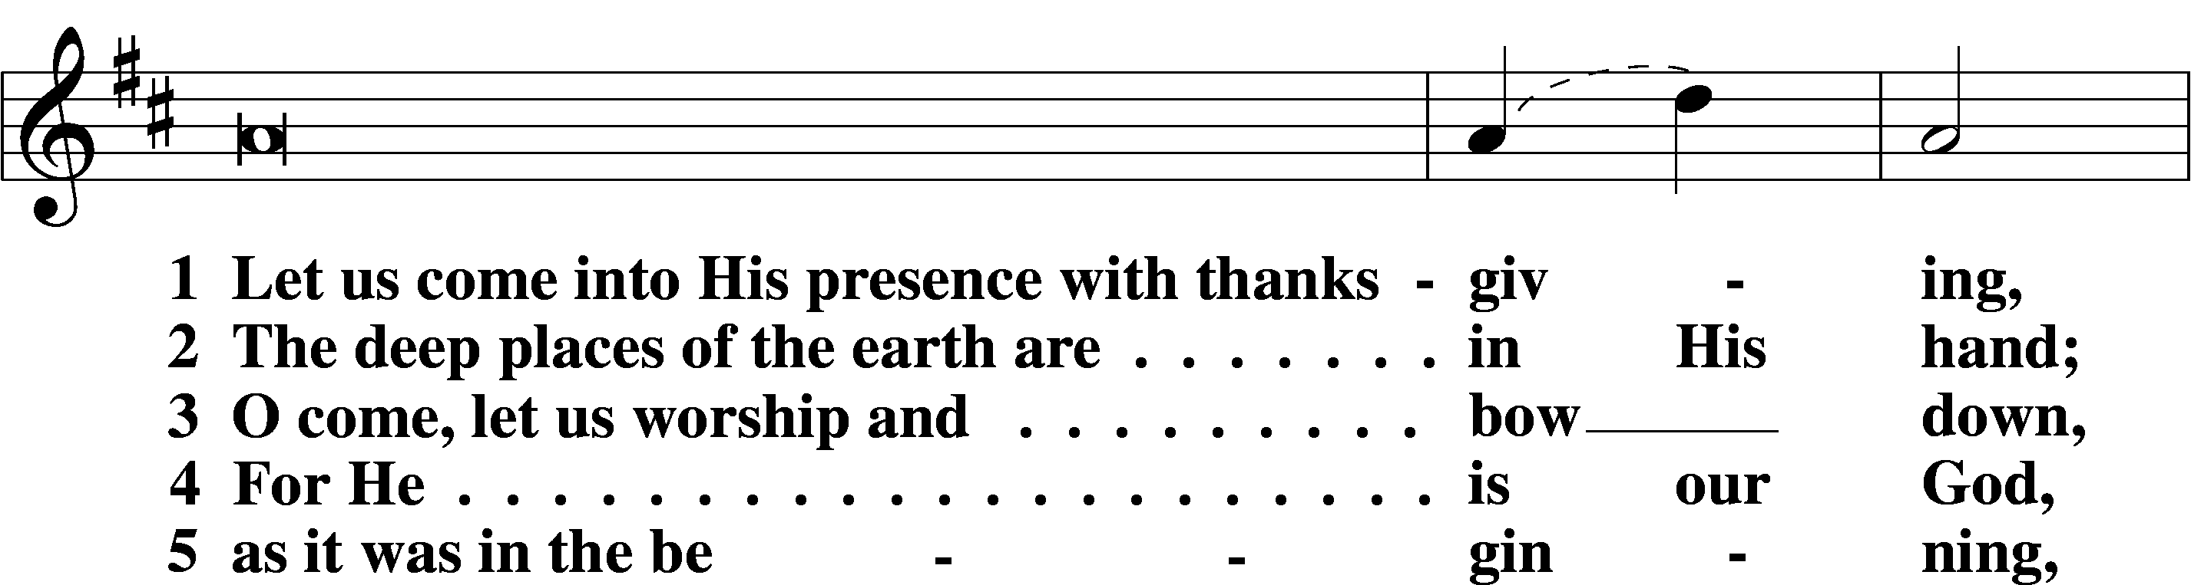
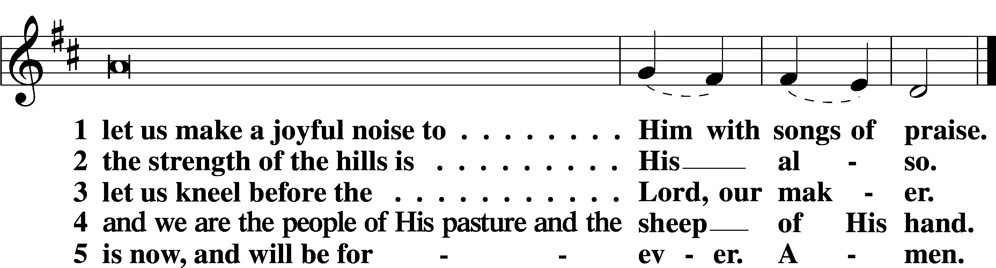

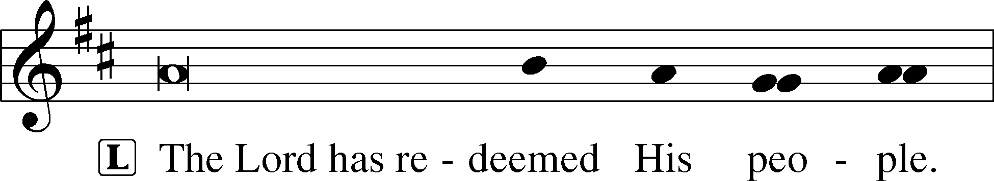
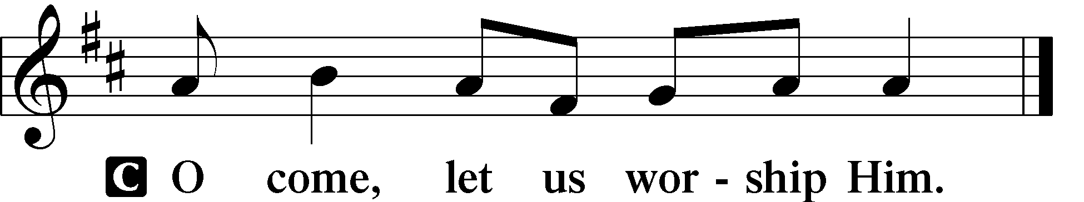

Psalms:
March 1: Psalm 23
March 8: Psalm 111
March 15: Psalm 116
March 22: Psalm 34
March 29: Psalm 50

Sit

Hymn of the Day:
March 1: LSB #627 “Jesus Christ, Our Blessed Savior”
March 8: LSB #634 “The Death of Jesus Christ, Our Lord”
March 15: LSB #620 “Jesus Comes Today with Healing”
March 22: LSB #622 “Lord Jesus Christ, You Have Prepared”
March 29: LSB #625 “Lord Jesus Christ, Life-Giving Bread”
Readings

First Reading:
March 1: 1 Corinthians 10:1–22
March 8: Exodus 12:43-51
March 15: Acts 2:42-47
March 22: Exodus 16:1-35
March 29: John 6:47-58

Reading Response:
P O Lord, have mercy on us.
C Thanks be to God.
Second Reading:
March 1: Matthew 26:26–29
March 8: Mark 14:22-25
March 15: Luke 22:19-20
March 22: 1 Corinthians 11:23-26
March 29: 1 Corinthians 11:27-34

Reading Response:
P O Lord, have mercy on us.
C Thanks be to God.

Responsory (Lent) LSB 222
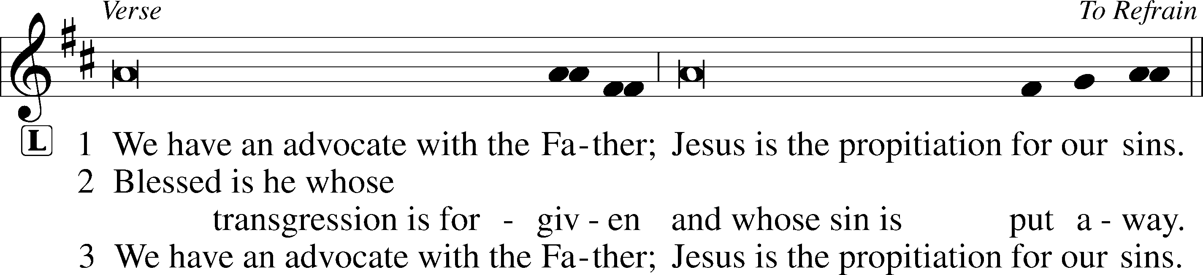
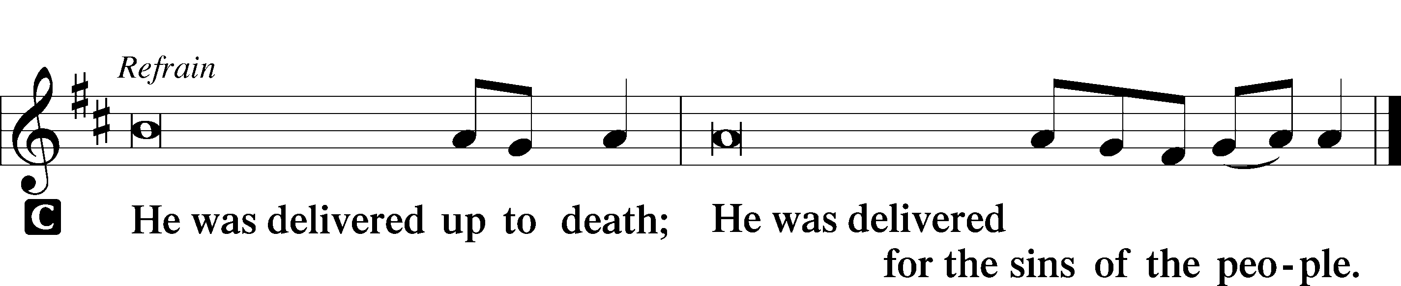

Sermon

Canticle

Stand
Te Deum LSB 223
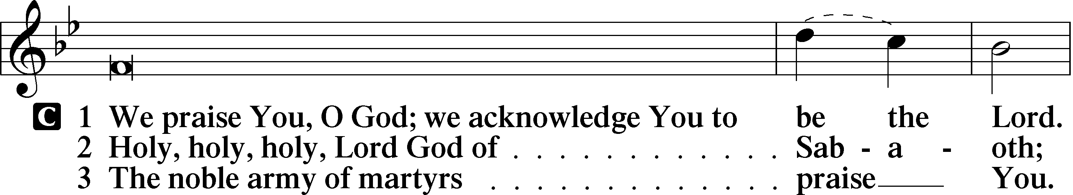
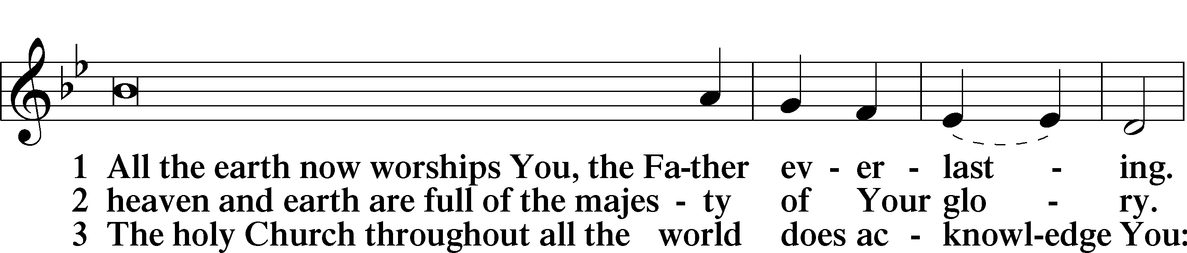
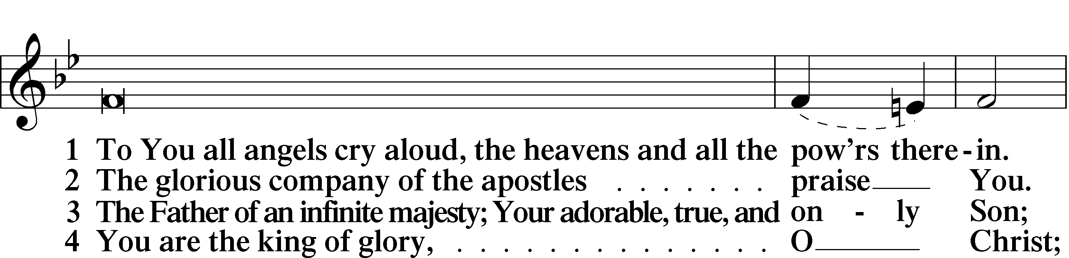
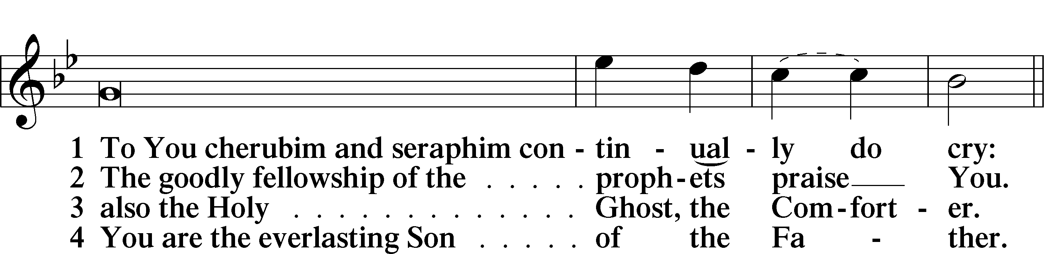
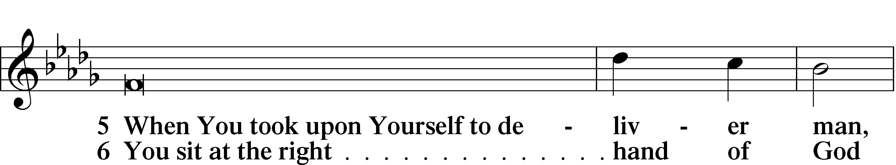
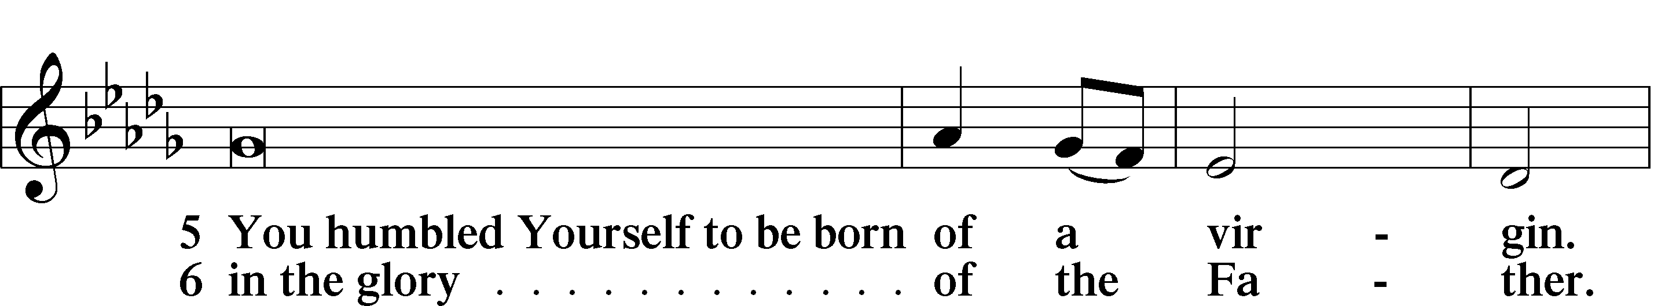
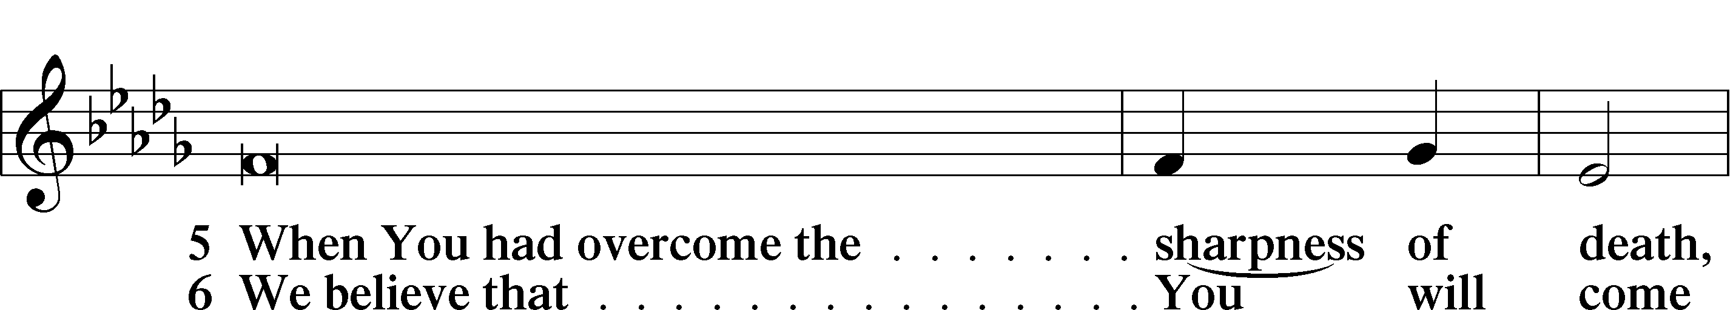
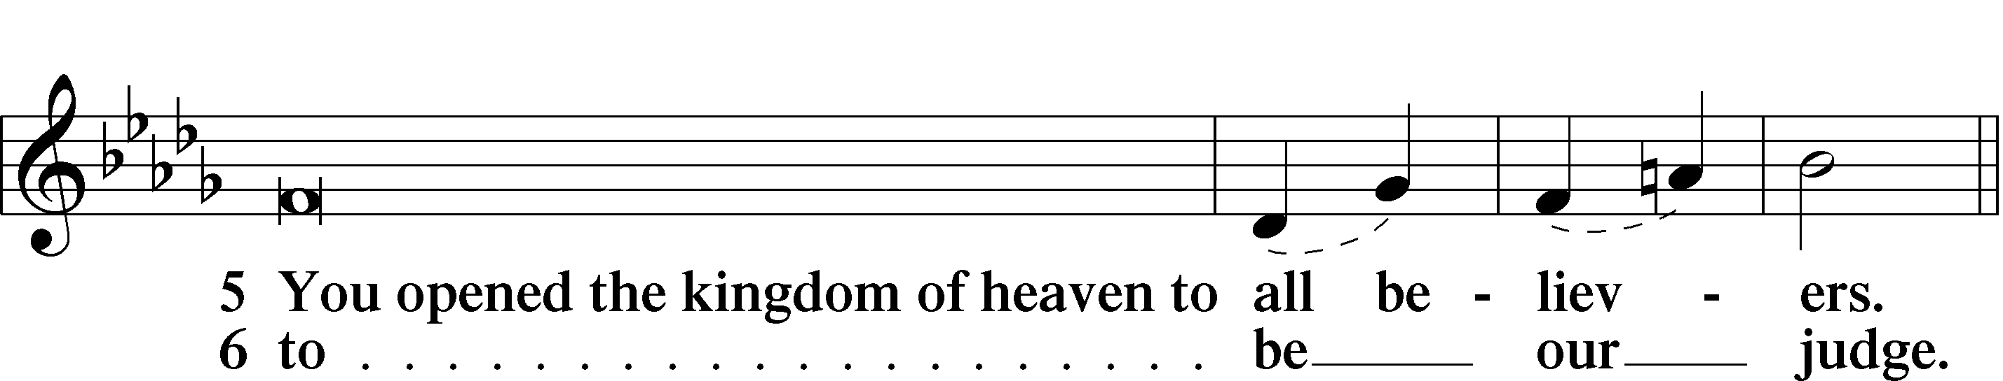
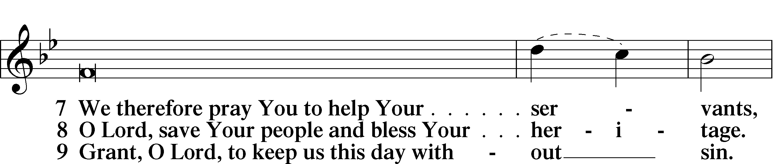
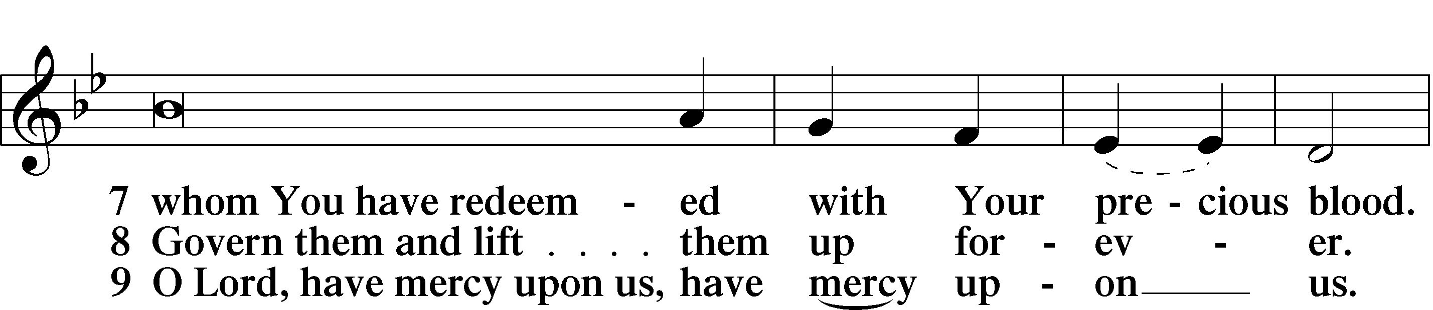
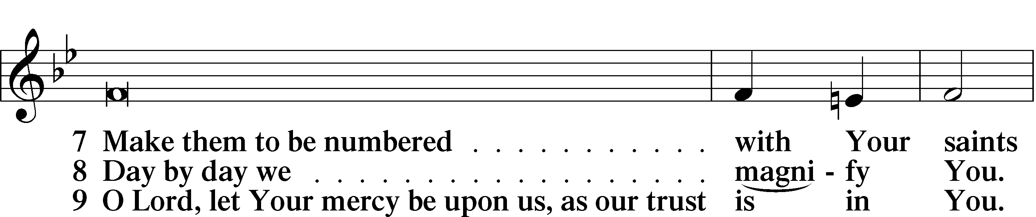
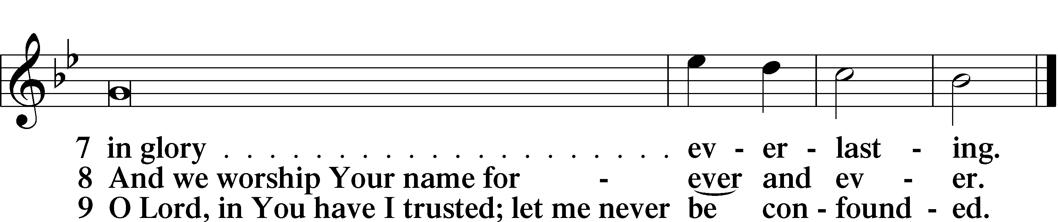

Prayer

Kyrie LSB 227
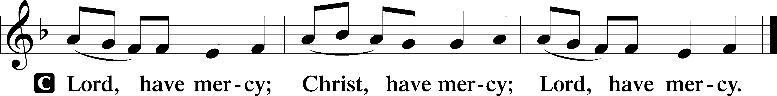

The Lord’s Prayer: LSB #957 “Our Father Who Art in Heaven” LSB 957
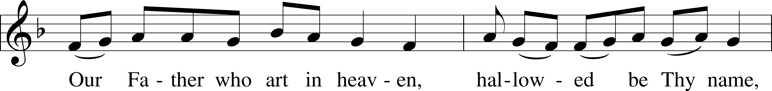
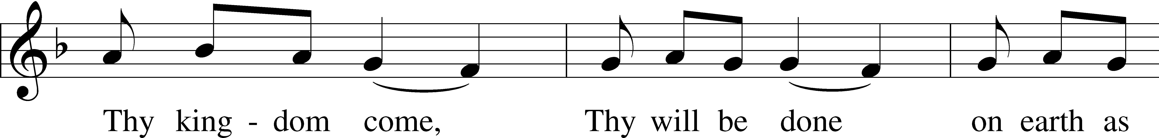
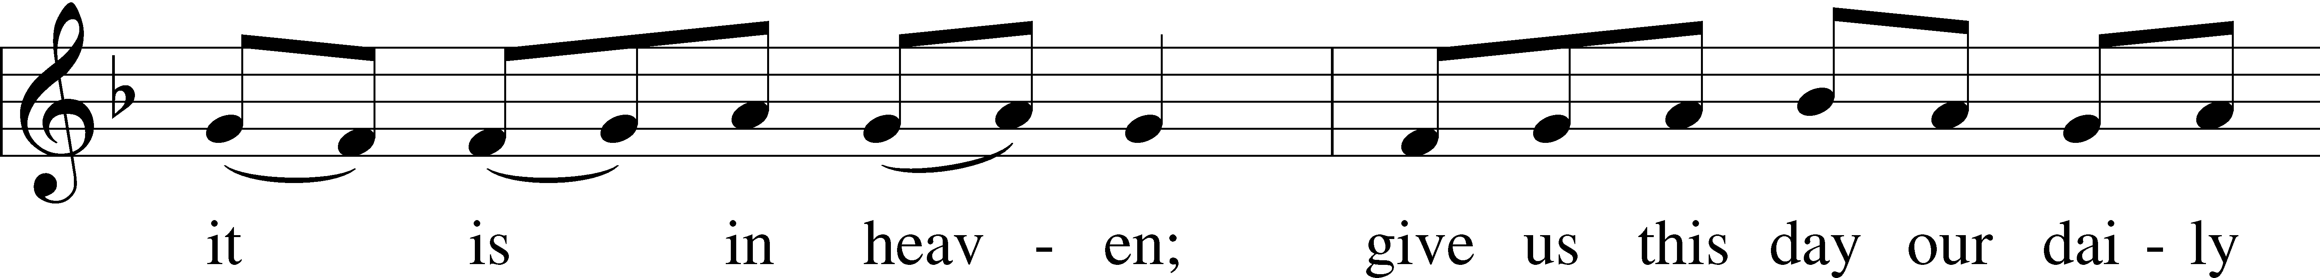
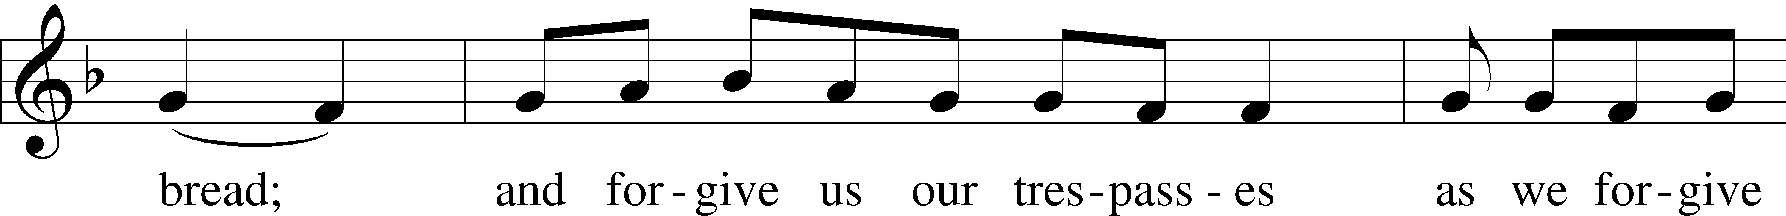
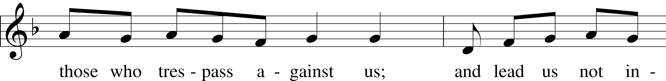
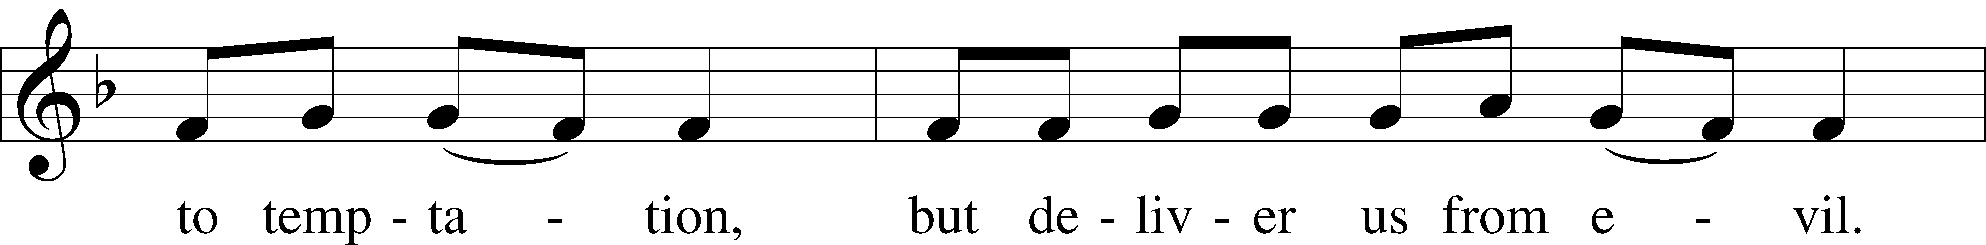
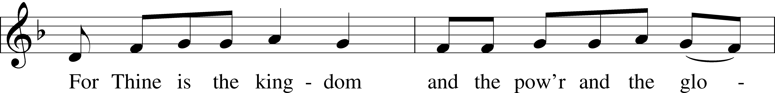
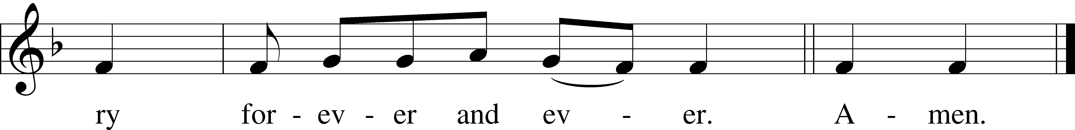
Text: Traditional
Tune: Plainsong, mode VII
Text and tune: Public domain
Collects
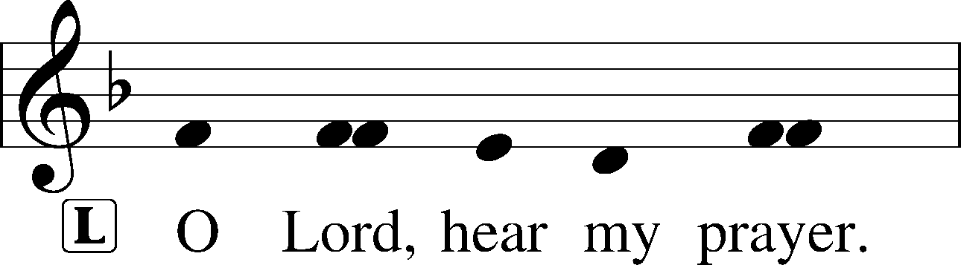
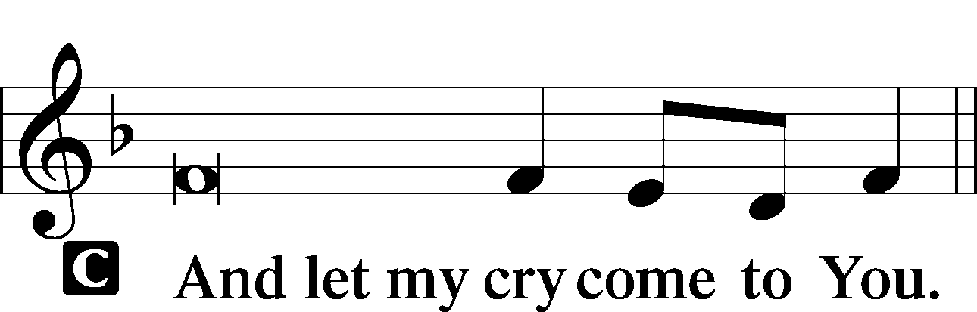

Collect of the Day
P … through Jesus Christ, Your Son, our Lord, who lives and reigns with You and the Holy Spirit, one God, now and forever.
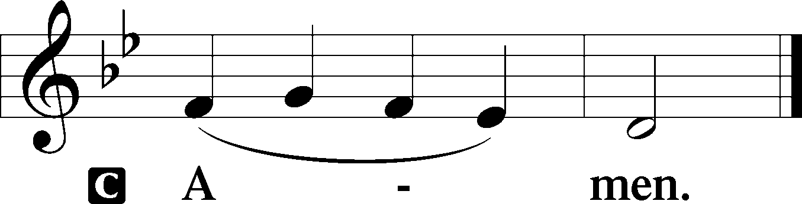

Collect for Grace
P O Lord, our heavenly Father, almighty and everlasting God, You have safely brought us to the beginning of this day. Defend us in the same with Your mighty power and grant that this day we fall into no sin, neither run into any kind of danger, but that all our doings, being ordered by Your governance, may be righteous in Your sight; through Jesus Christ, Your Son, our Lord, who lives and reigns with You and the Holy Spirit, one God, now and forever.
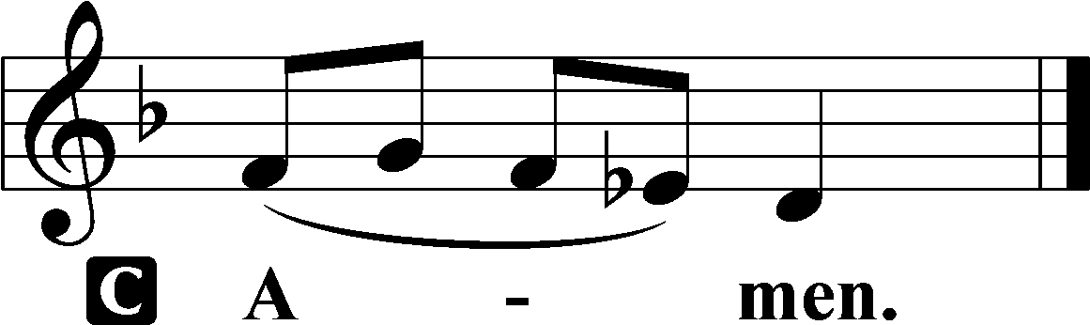

Benedicamus LSB 228
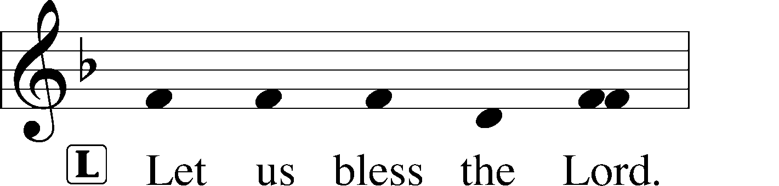
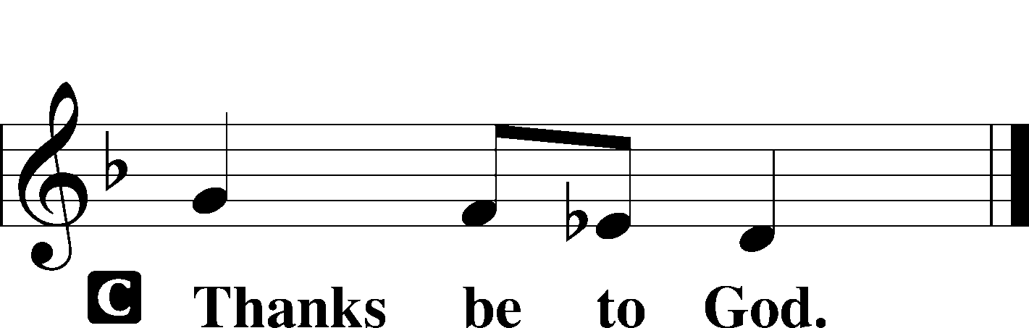

Benediction LSB 228
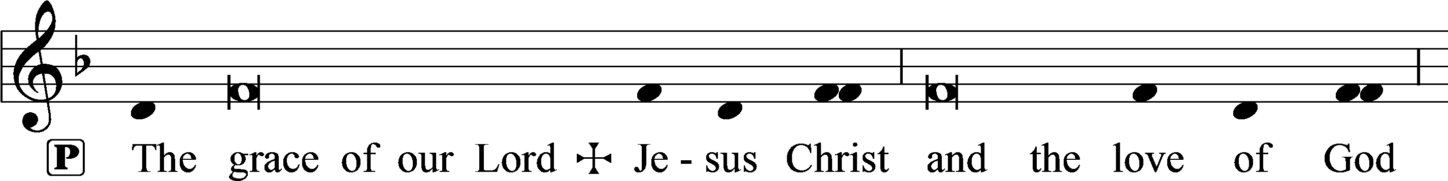
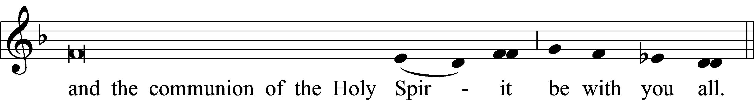

Closing Hymn:
March 1: LSB #585 “Lord Jesus Christ, with Us Abide”
March 8: LSB #559 “Oh, How Great Is Your Compassion”
March 15: LSB #617 “O Lord, We Praise Thee”
March 22: LSB #865 “Lord, Help Us Ever to Retain”
March 29: LSB #627 “Jesus Christ, Our Blessed Savior”

Acknowledgments
Matins from Lutheran Service Book
Unless otherwise indicated, Scripture quotations are from the ESV® Bible (The Holy Bible, English Standard Version®), copyright © 2001 by Crossway, a publishing ministry of Good News Publishers. Used by permission. All rights reserved.
Created by Lutheran Service Builder © 2023 Concordia Publishing House.

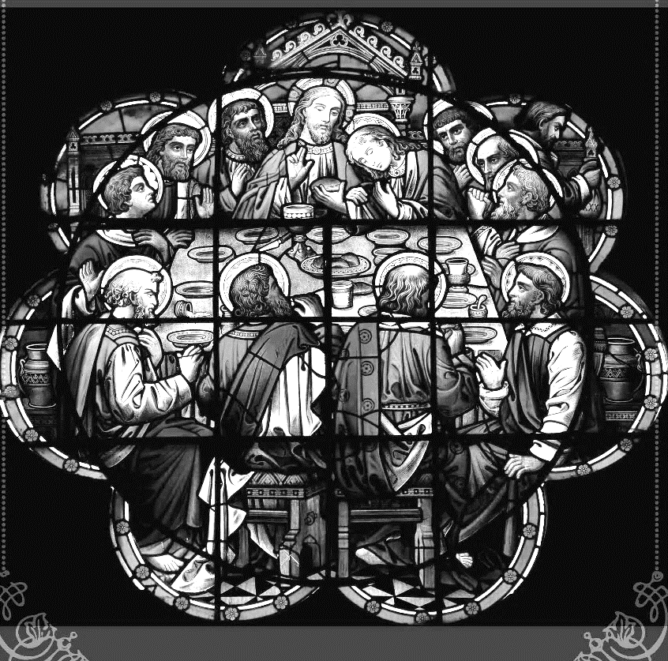

Join us this Lenten season
as we focus on the
Lord’s Supper
with the following Midweek Lenten services,
Matins Service at noon
Vesper’s Service at 7 pm
Beginning March 1st – 29th

and continue with our Holy Week services,
Maundy Thursday, Thursday, April 6th at 7 pm
Tre Ore, Friday, April 7th at noon
Stations of the Cross, Friday, April 7th at 7 pm
Easter Vigil, Saturday, April 8th at 7 pm

culminating with our Easter Sunday celebration!
Sunday, April 9th at 9 am

