Sts. Peter & Paul
Evangelical Lutheran Church
Lutheran Church-Missouri Synod
Founded-1917

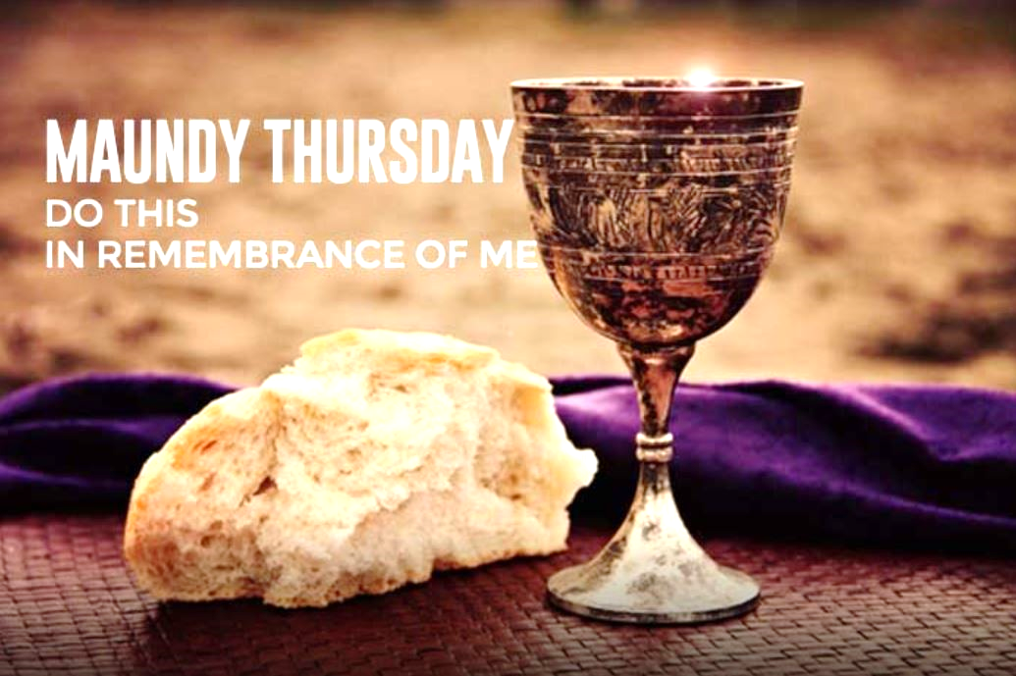

March 28, 2024

699 Stambaugh Ave.
Sharon, Pennsylvania 16146

“I was glad when they said to me,
Let us go to the house of the LORD!”
Psalm 122:1
Sts. Peter & Paul Evangelical Lutheran Church, LC-MS
MAUNDY THURSDAY
March 28, 2023

A special welcome to our guests this day! If you would like more information about The Lutheran Church - Missouri Synod, or this congregation, please speak with Pastor Deal or an Elder after the service.
Members & Guests: Don’t be embarrassed if your children make noise during the worship service, all children do. We encourage families to worship together but, if you feel the need, there are pews in the rear of the Church which are reserved for young families on both sides of the sanctuary. There is also a quiet room available to you during our service which is located down the hallway past the offices on the right side of the church as well as a children’s area in the Fellowship Hall where you are able to follow along with the service.

Today’s service includes the Sacrament of Holy Communion. If during this past year, you have not worshipped with us and been communed, we respectfully ask that you do not partake of this sacrament this day before first speaking with Pastor Deal.
If visiting from a sister congregation of the LC-MS and are in good standing, please inform Pastor Deal of your desire to commune prior to the service.
If wishing to receive a blessing during communion, please approach with your arms crossed.

CONTACT INFORMATION
Pastor Deal: pastordeal@saintspeterandpaul.net or 724-347-3620 (opt. 2)
Church Office: church@saintspeterandpaul.net or 724-347-3620 (opt. 3)
Church Office is opened Monday, Thursday, and Friday (8:30 am -4:30 pm).


Service of Corporate Confession and Absolution
Opening Hymn: “Now, My Tongue, the Mystery Telling”
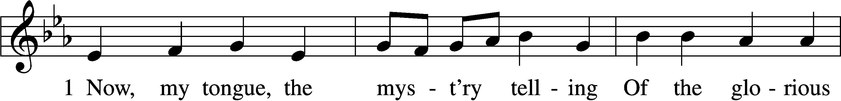
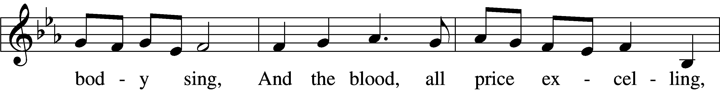
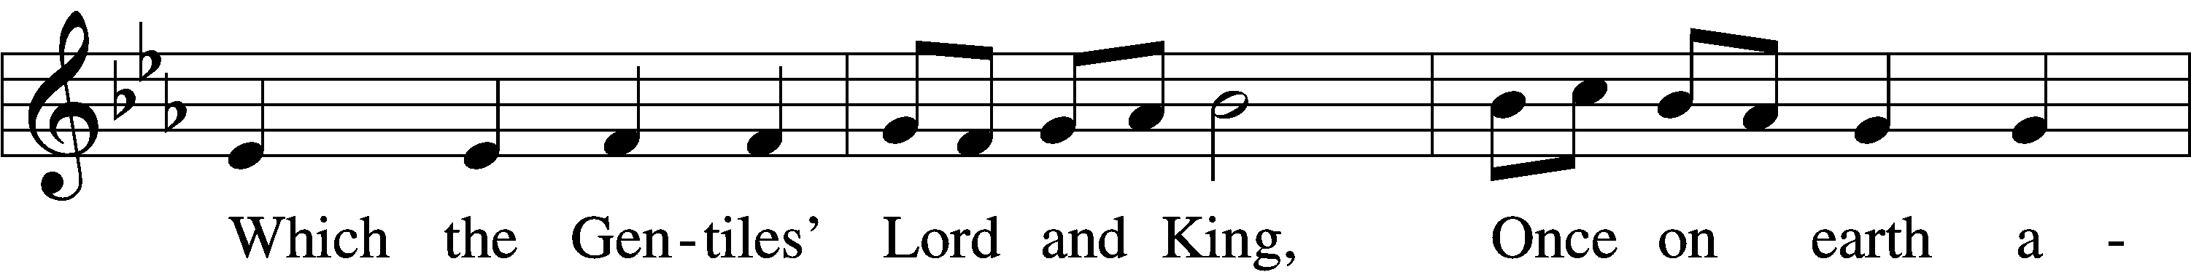
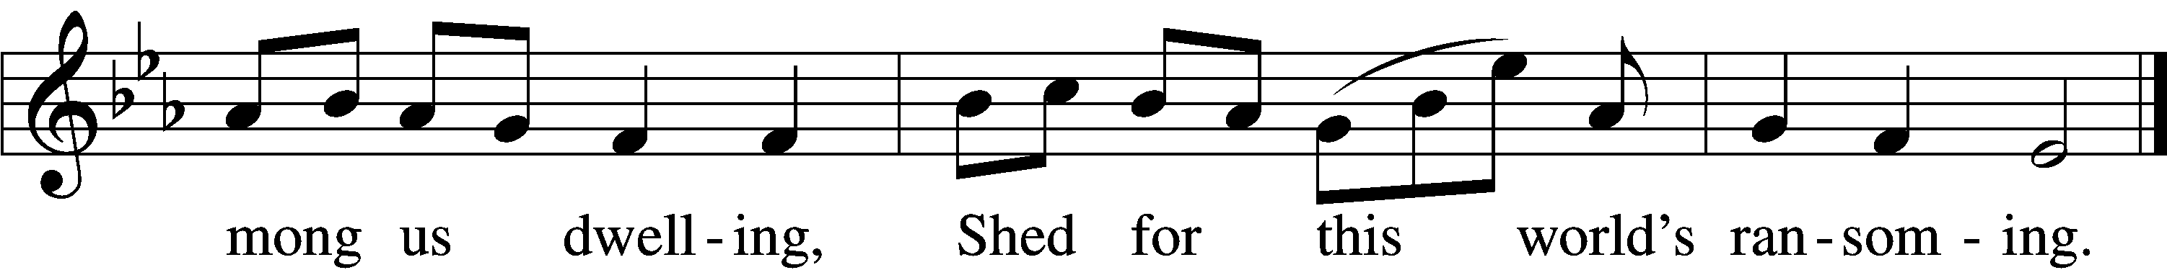

2 Giv’n for us, and condescending
To be born for us below,
He with men in converse blending,
Dwelt, the seed of truth to sow,
Till he closed with wondrous ending
His most patient life of woe.

3 That last night at supper lying,
'Mid the Twelve, His chosen band,
Jesus, with the Law complying,
Keeps the Feast its rites demand;
Then, more precious food supplying,
Gives Himself with His own hand.

4 Word-made-flesh, true Bread He maketh
By His Word His Flesh to be,
Wine His Blood; which whoso taketh
Must from carnal thoughts be free:
Faith alone, though sight forsaketh,
Shows true hearts the mystery.

5 Therefore we, before Him bending,
This great Sacrament revere:
Types and shadows have their ending,
For the newer rite is here;
Faith, our outward sense befriending,
Makes our inward vision clear.

6 Glory let us give and blessing
To the Father and the Son,
Honor, might, and praise addressing,
While eternal ages run;
Ever too His love confessing,
Who, from Both, with Both is One.

The sign of the cross may be made by all in remembrance of their Baptism.

P In the name of the Father and of the T Son and of the Holy Spirit.
C Amen.

P I will go to the altar of God,
C to God my exceeding joy.
P Our help is in the name of the Lord,
C who made heaven and earth.

Sit

P During this Lenten season we have heard our Lord’s call to intensify our struggle against sin, death, and the devil—all that prevents us from trusting in God and loving each other. Since it is our intention to receive the Holy Supper of our Lord Jesus Christ on this night when He instituted this blessed meal for our salvation, it is proper that we complete our Lenten discipline by diligently examining ourselves, as St. Paul urges us to do. This holy Sacrament has been instituted for the special comfort of those who are troubled because of their sin and who humbly confess their sins, fear God’s wrath, and hunger and thirst for righteousness.

But when we examine our hearts and consciences, we find nothing in us but sin and death, from which we are incapable of delivering ourselves. Therefore, our Lord Jesus Christ has had mercy on us. For our benefit He became man so that He might fulfill for us the whole will and law of God and, to deliver us, took upon Himself our sin and the punishment we deserve.

So that we may more confidently believe this and be strengthened in the faith and in holy living, our Lord Jesus Christ took bread, broke it, and gave it to His disciples and said: “Take, eat; this is My body, which is given for you.” It is as if He said, “I became man, and all that I do and suffer is for your good. As a pledge of this, I give you My body to eat.”

In the same way also He took the cup, gave thanks, and gave it to them, saying: “Drink of it, all of you; this cup is the new testament in My blood, which is shed for you for the forgiveness of sins.” Again, it is as if He said, “I have had mercy on you by taking into Myself all your iniquities. I give Myself into death, shedding My blood to obtain grace and forgiveness of sins, and to comfort and establish the new testament, which gives forgiveness and everlasting salvation. As a pledge of this, I give you My blood to drink.”

Therefore, whoever eats this bread and drinks this cup, confidently believing this Word and promise of Christ, dwells in Christ and Christ in him and has eternal life.

We should also do this in remembrance of Him, showing His death—that He was delivered for our offenses and raised for our justification. Giving Him our most heartfelt thanks, we take up our cross and follow Him and, according to His commandment, love one another as He has loved us. As our Lord on this night exemplified this love by washing His disciples’ feet, so we by our words and actions serve one another in love. For we are all one bread and one body, even as we are all partakers of this one bread and drink from the one cup. For just as the one cup is filled with the wine of many grapes and one bread made from countless grains, so also we, being many, are one body in Christ. Because of Him, we love one another, not only in word, but in deed and in truth.

May the almighty and merciful God and Father of our Lord Jesus Christ, by His Holy Spirit, accomplish this in us.
C Amen.

P Having heard the Word of God, let us confess our sins, imploring God our Father for the sake of His Son, Jesus Christ, to grant us forgiveness.

Stand

Silence for reflection on God’s Word and for self-examination.

P O almighty God, merciful Father,
C I, a poor, miserable sinner, confess unto You all my sins and iniquities with which I have ever offended You and justly deserved Your temporal and eternal punishment. But I am heartily sorry for them and sincerely repent of them, and I pray You of Your boundless mercy and for the sake of the holy, innocent, bitter sufferings and death of Your beloved Son, Jesus Christ, to be gracious and merciful to me, a poor, sinful being.

P God be merciful to you and strengthen your faith.
C Amen.

Members of the congregation will approach the altar individually as instructed by the ushers.
P Do you believe that the forgiveness I speak is not my forgiveness but God’s?
C Yes.

P Let it be done for you as you believe.

P In the stead and by the command of my Lord Jesus Christ I forgive you all your sins in the name of the Father and of the T Son and of the Holy Spirit.
C Amen.

P Now may the God of peace Himself sanctify you completely, and may your whole spirit, soul, and body be kept blameless at the coming of our Lord Jesus Christ. He who calls you is faithful; He will surely do it. Go in T peace.
C Amen.

Return to your pew and use this time for prayer and thanksgiving by reading the following Psalms found in the front of your hymnal: Psalm 30, 31, 32, 34, 103, or 118.

Service of the Word
Introit Galatians 6:14a; Liturgical Text; Psalm 67:1
P God forbid that I should | glory:*
Save in the Cross of our Lord | Jesus Christ.
In Him is salvation, life, and resurrection | from the dead:*
By Him we are redeemed and set at | liberty.
God be merciful unto us, and | bless us:*
And cause His face to shine u- | pon us.

Kyrie Mark 10:47
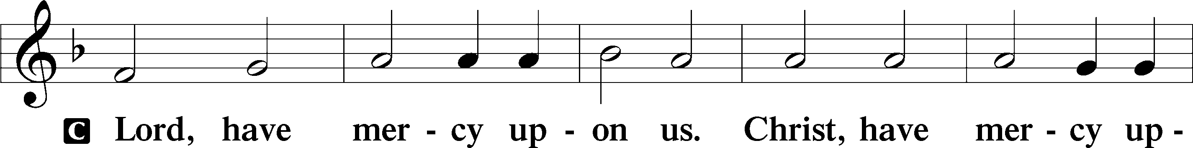
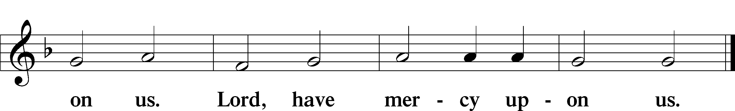

Salutation and Collect of the Day: Maundy Thursday
P The Lord be with you.
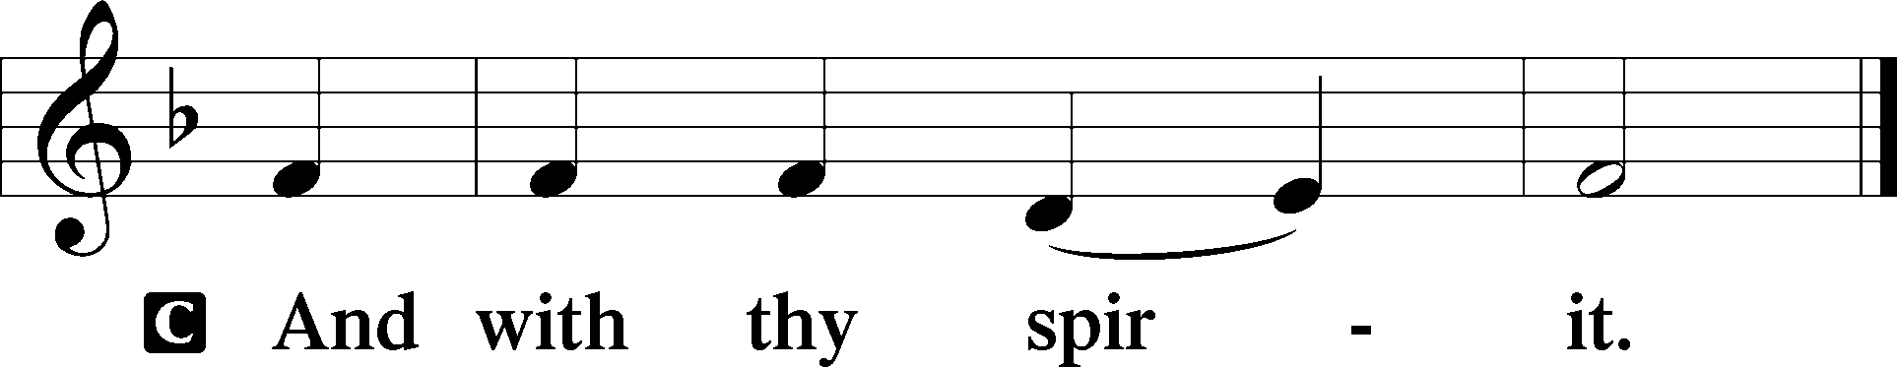

P Let us pray.
O Lord God, who hast left unto us in a wonderful Sacrament a memorial of Thy Passion, grant, we beseech Thee, that we may so use this Sacrament of Thy Body and Blood that the fruits of Thy redemption may continually be manifest in us, Thou, who livest and reignest with the Father and the Holy Ghost, ever one God, world without end.
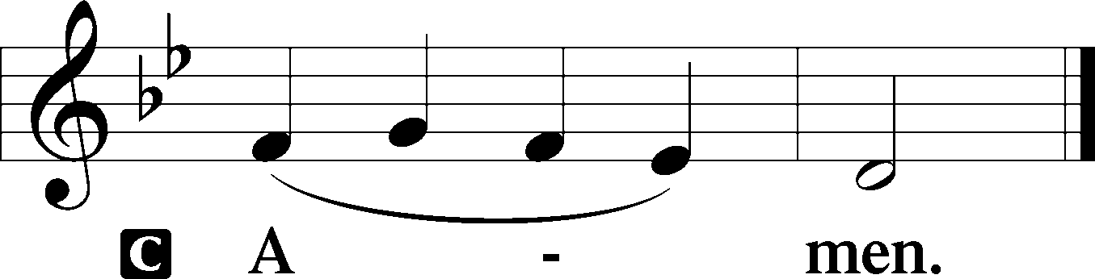

Prophecy: Exodus 24:3-11 (NKJV)
In those days: Moses came and told the people all the words of the Lord and all the judgments. And all the people answered with one voice and said, “All the words which the Lord has said we will do.” And Moses wrote all the words of the Lord. And he rose early in the morning, and built an altar at the foot of the mountain, and twelve pillars according to the twelve tribes of Israel. Then he sent young men of the children of Israel, who offered burnt offerings and sacrificed peace offerings of oxen to the Lord. And Moses took half the blood and put it in basins, and half the blood he sprinkled on the altar. Then he took the Book of the Covenant and read in the hearing of the people. And they said, “All that the Lord has said we will do, and be obedient.” And Moses took the blood, sprinkled it on the people, and said, “This is the blood of the covenant which the Lord has made with you according to all these words.” Then Moses went up, also Aaron, Nadab, and Abihu, and seventy of the elders of Israel, and they saw the God of Israel. And there was under His feet as it were a paved work of sapphire stone, and it was like the very heavens in its clarity. But on the nobles of the children of Israel He did not lay His hand. So they saw God, and they ate and drank.

P This is the Word of the Lord.
C Thanks be to God.
Epistle: 1 Corinthians 11:20–32 (NKJV)
Brethren: When you come together in one place, it is not to eat the Lord’s Supper. For in eating, each one takes his own supper ahead of others; and one is hungry and another is drunk. What! Do you not have houses to eat and drink in? Or do you despise the church of God and shame those who have nothing? What shall I say to you? Shall I praise you in this? I do not praise you. For I received from the Lord that which I also delivered to you: that the Lord Jesus on the same night in which He was betrayed took bread; and when He had given thanks, He broke it and said, “Take, eat; this is My body which is broken for you; do this in remembrance of Me.” In the same manner He also took the cup after supper, saying, “This cup is the new covenant in My blood. This do, as often as you drink it, in remembrance of Me.” For as often as you eat this bread and drink this cup, you proclaim the Lord’s death till He comes. Therefore whoever eats this bread or drinks this cup of the Lord in an unworthy manner will be guilty of the body and blood of the Lord. But let a man examine himself, and so let him eat of the bread and drink of the cup. For he who eats and drinks in an unworthy manner eats and drinks judgment to himself, not discerning the Lord’s body. For this reason many are weak and sick among you, and many sleep. For if we would judge ourselves, we would not be judged. But when we are judged, we are chastened by the Lord, that we may not be condemned with the world.

P This is the Word of the Lord.
C Thanks be to God.

Gradual Philippians 2:8b-9
Christ hath humbled Himself and become obedient | unto death*
Even the death | of the cross.
Wherefore God also hath highly ex | alted Him*
And given Him a name which is above | every name.

Stand

Holy Gospel: John 13:1–15 (NKJV)
P The continuation of the Holy Gospel according to St. John, the thirteenth chapter.
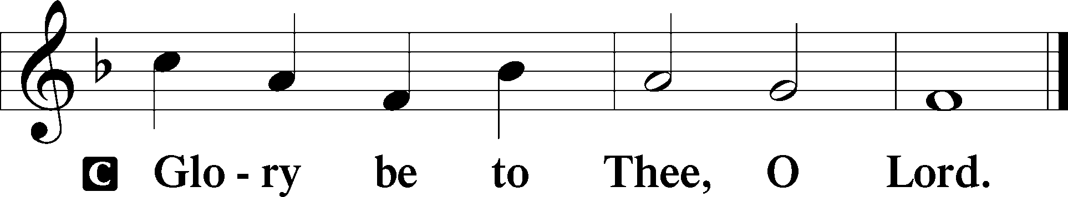

Before the Feast of the Passover, when Jesus knew that His hour had come that He should depart from this world to the Father, having loved His own who were in the world, He loved them to the end. And supper being ended, the devil having already put it into the heart of Judas Iscariot, Simon’s son, to betray Him, Jesus, knowing that the Father had given all things into His hands, and that He had come from God and was going to God, rose from supper and laid aside His garments, took a towel and girded Himself. After that, He poured water into a basin and began to wash the disciples’ feet, and to wipe them with the towel with which He was girded. Then He came to Simon Peter. And Peter said to Him, “Lord, are You washing my feet?” Jesus answered and said to him, “What I am doing you do not understand now, but you will know after this.” Peter said to Him, “You shall never wash my feet!” Jesus answered him, “If I do not wash you, you have no part with Me.” Simon Peter said to Him, “Lord, not my feet only, but also my hands and my head!” Jesus said to him, “He who is bathed needs only to wash his feet, but is completely clean; and you are clean, but not all of you.” For He knew who would betray Him; therefore He said, “You are not all clean.” So when He had washed their feet, taken His garments, and sat down again, He said to them, “Do you know what I have done to you? You call Me Teacher and Lord, and you say well, for so I am. If I then, your Lord and Teacher, have washed your feet, you also ought to wash one another’s feet. For I have given you an example, that you should do as I have done to you.”

P The Gospel of the Lord.
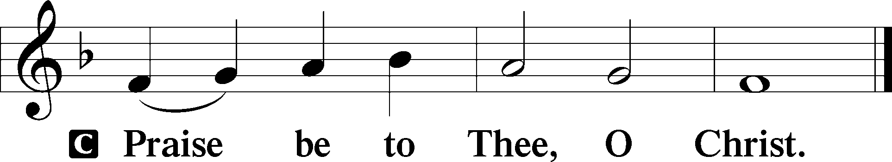

Sit
The Creed is not said on weekdays.

Hymn of the Day: LSB #627 “Jesus Christ, Our Blessed Savior”

Sermon

Stand

Offertory Psalm 51:10–12
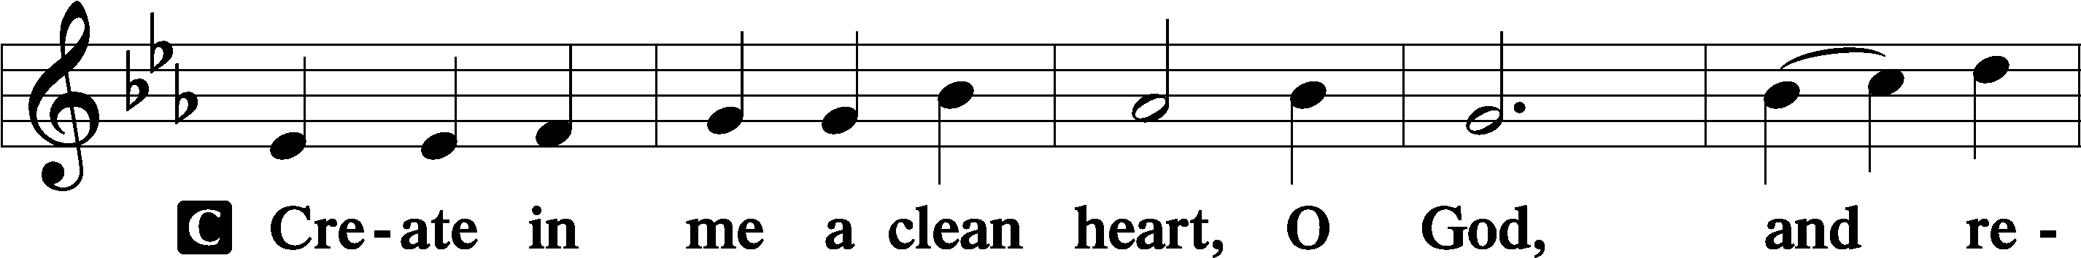
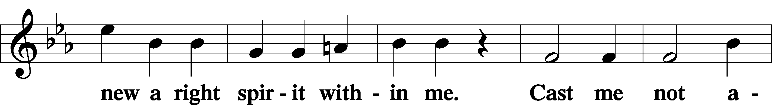
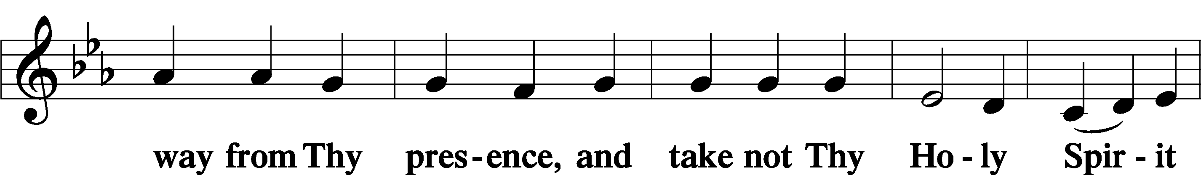
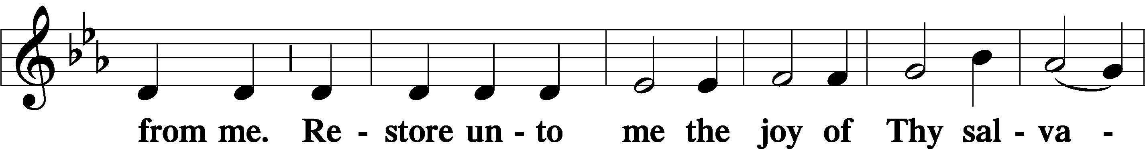
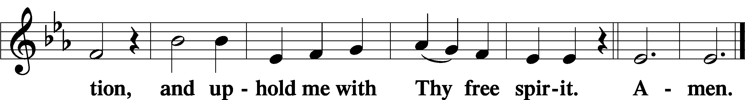

Offering: Please leave your offering in the plate upon entering.

Prayer of the Church

Sit

Preparatory Hymn: ELH #290 “Thy Soul, O Jesus, Hallow Me”
(Sung to the tune of LSB #586.)
- Thy soul, O Jesus, hallow me,
Thy Spirit steep me all in Thee;
Thy body, pierced by ruthless steel,
My wretched soul and body heal.

- The water from Thy side that poured
For me a cleansing bath afford,
And all Thy blood, with life divine,
Revive this weakened heart of mine.

- The sweat of death upon Thy face
Deliver me from death’s embrace,
And all Thy Passion, cross and pain,
With strength my feebleness sustain.

- O Christ, turn not away from me,
Receive and hide me all in Thee,
Within Thy holy wounds enclose,
And keep me safe from all my foes.

- In death’s dark hour with me abide
And place me, Savior, at Thy side,
Where with Thy saints I shall adore
And praise Thee, Lord, forevermore.

Service of the Sacrament

Preface LSB 194
P The Lord be with you.
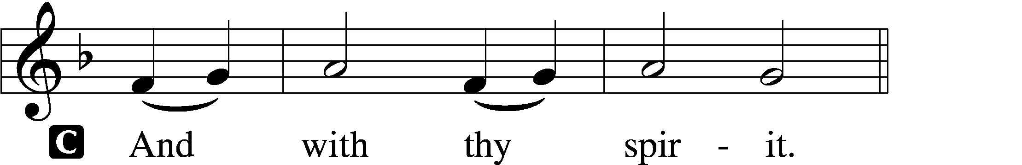

P Lift up your hearts.
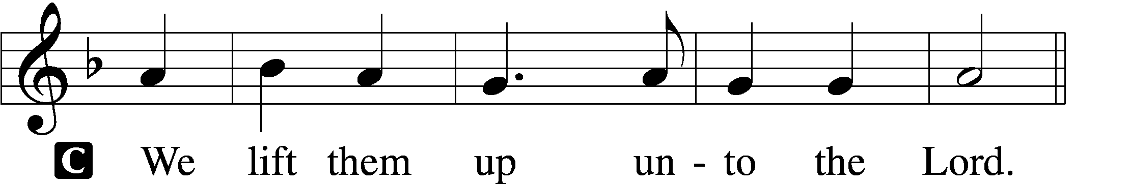

P Let us give thanks unto the Lord, our God.
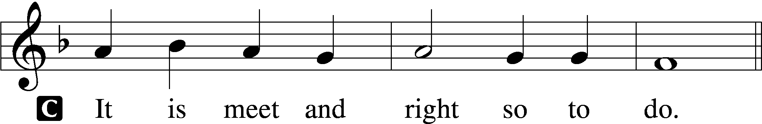

Proper Preface
P It is truly good, right, and salutary that we should at all times and in all places give thanks to You, holy Lord, almighty Father, everlasting God, through Jesus Christ, our Lord, who accomplished the salvation of mankind by the tree of the cross that, where death arose, there life also might rise again and that the serpent who overcame by the tree of the garden might likewise by the tree of the cross be overcome. Therefore with angels and archangels and with all the company of heaven we laud and magnify Your glorious name, evermore praising You and saying:

Sanctus LSB 195
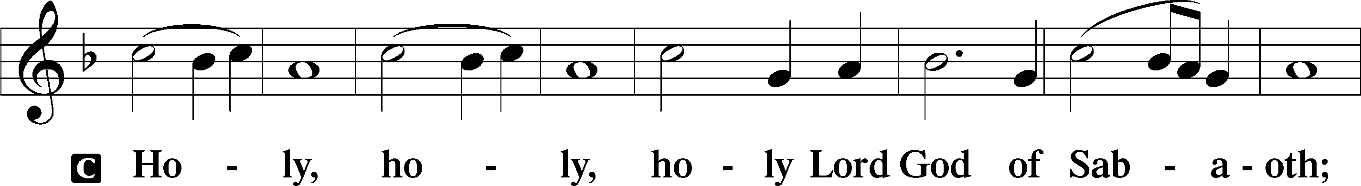
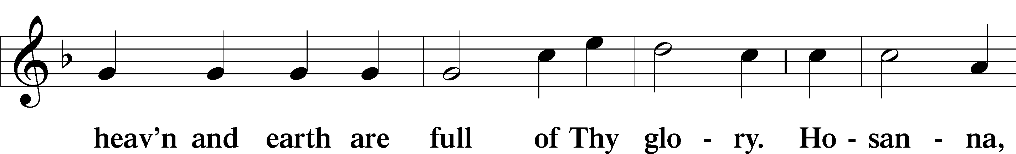
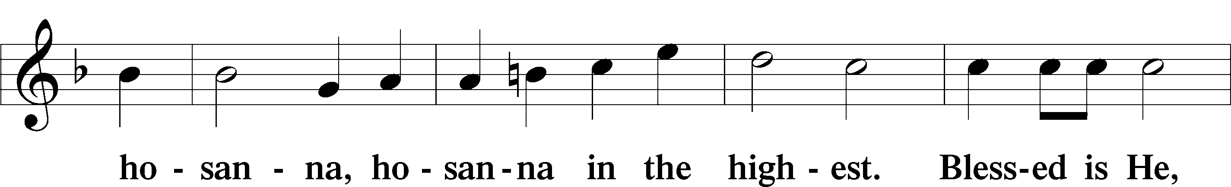
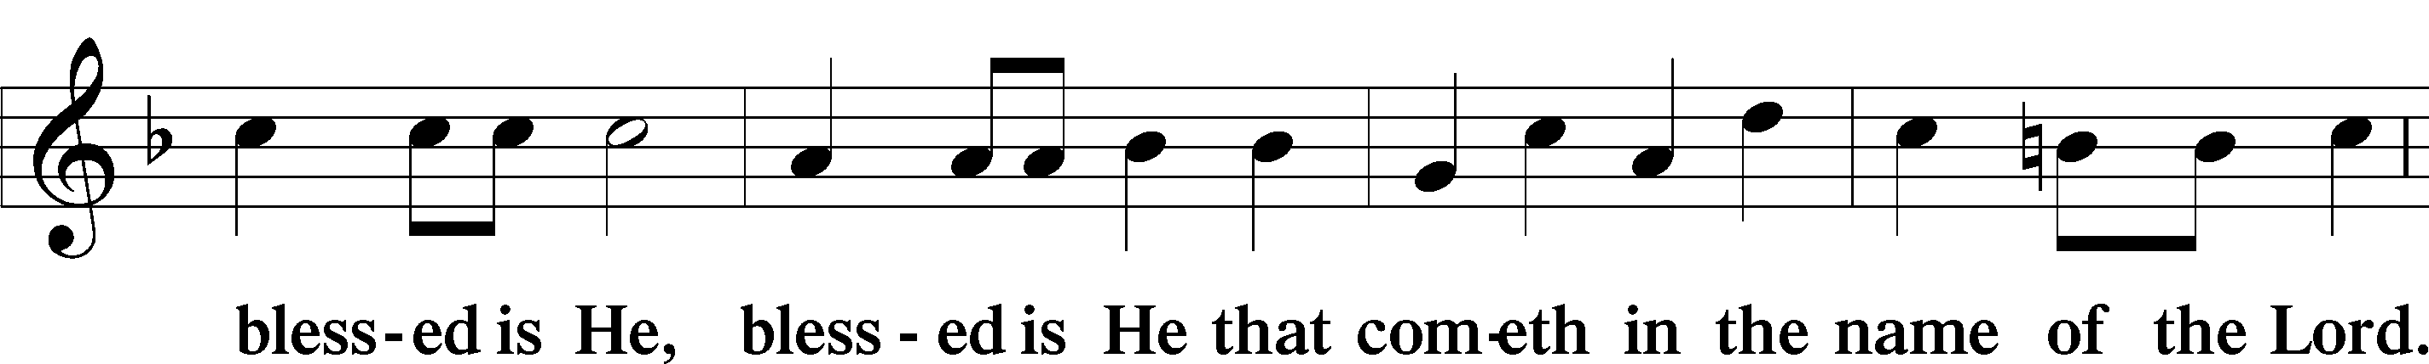
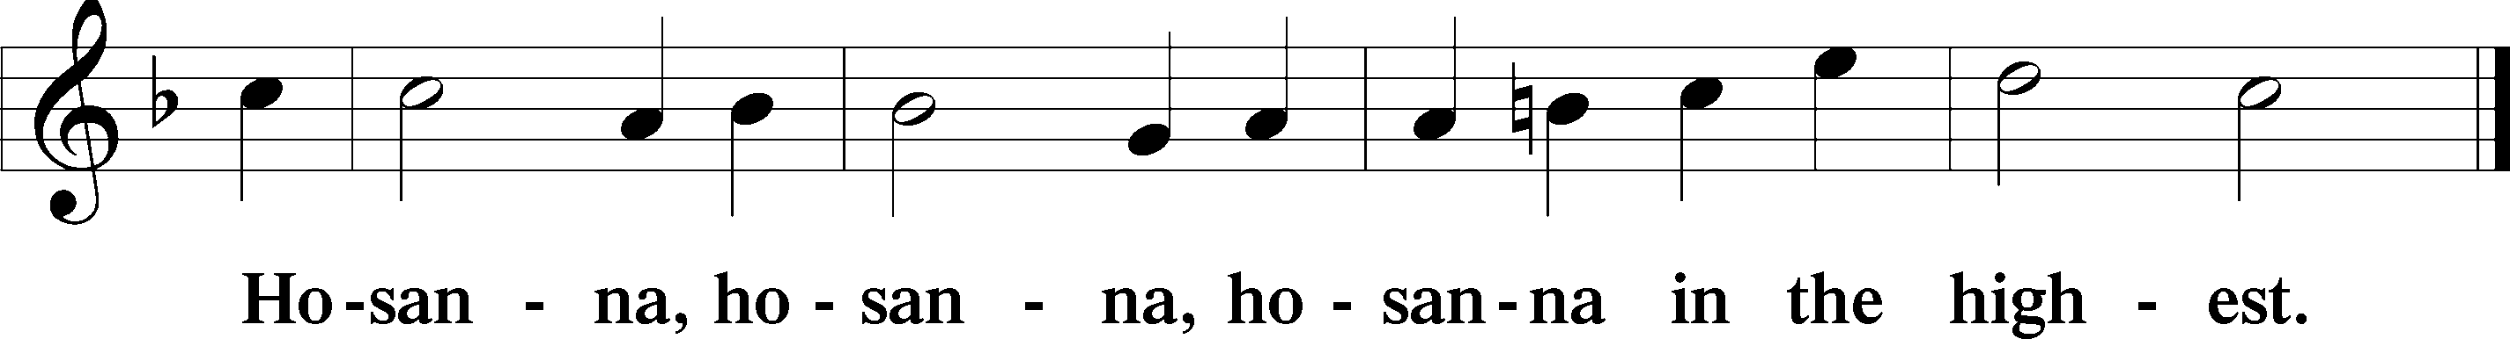
Lord’s Prayer Matthew 6:9–13
C Our Father who art in heaven,
hallowed be Thy name,
Thy kingdom come,
Thy will be done on earth as it is in heaven;
give us this day our daily bread;
and forgive us our trespasses as we forgive those who trespass against us;
and lead us not into temptation,
but deliver us from evil.
For Thine is the kingdom and the power and the glory forever and ever. Amen.

The Words of Our Lord Matthew 26:26–28; Mark 14:22–24; Luke 22:19–20; 1 Corinthians 11:23–25
P Our Lord Jesus Christ, on the night when He was betrayed, took bread, and when He had given thanks, He broke it and gave it to the disciples and said: “Take, eat; this is My T body, which is given for you. This do in remembrance of Me.”

In the same way also He took the cup after supper, and when He had given thanks, He gave it to them, saying: “Drink of it, all of you; this cup is the new testament in My T blood, which is shed for you for the forgiveness of sins. This do, as often as you drink it, in remembrance of Me.”

Pax Domini John 20:19
P The peace of the Lord be with you always.
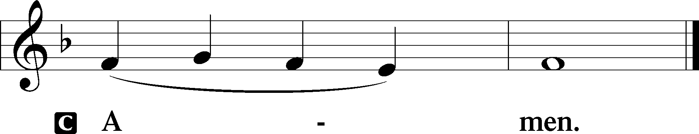

Agnus Dei John 1:29
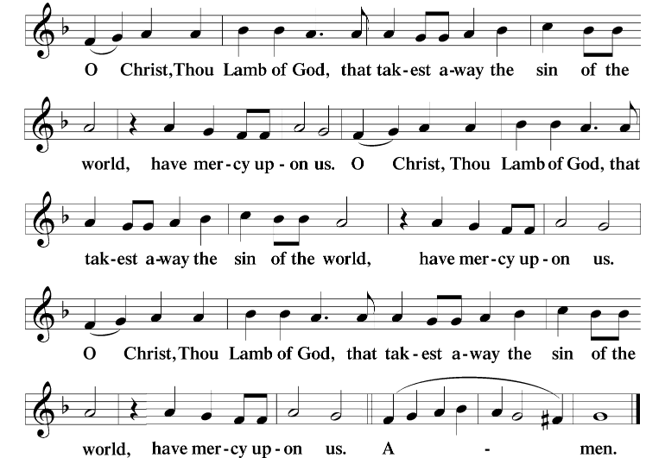
Sit

Private Prayer before Communion
Let not the partaking of Thy Body, O Lord Jesus Christ, which I, though unworthy, do presume to receive, turn to me for judgment and condemnation; but, according to Thy loving-kindness, let it be profitable to me for the forgiveness of sins, life, and salvation, who with the Father and the Holy Ghost livest and reignest, ever one God, world without end. Amen.

Private Prayer during Communion
O Lord, I am not worthy that Thou shouldest come under my roof; but speak the word only, and my soul shall be healed. Amen.

Private Prayer after Communion
Let Thy Body, O Lord, which I have received, and Thy Blood which I have drunk, cleave unto my members; and grant that no stain of sin may remain in me, whom Thou hast refreshed with this pure and holy sacrament, who with the Father and the Holy Ghost livest and reignest, ever one God, world without end. Amen.

Distribution
The pastor and those who assist him receive the body and blood of Christ first and then distribute them to those who come to receive, saying:
Take, eat; this is the true body of our Lord and Savior Jesus Christ, given into death for your sins.
Amen.

Take, drink; this is the true blood of our Lord and Savior Jesus Christ, shed for the forgiveness of your sins.
Amen.

In dismissing the communicants, the following is said:
The Dismissal
P The body and blood of our Lord Jesus Christ strengthen and preserve you in body and soul to life everlasting. Depart T in peace.
C Amen.

During the distribution of the Lord’s Supper, communicants will listen as the following psalms are chanted/spoken.

Psalm 116:10-19, antiphon v. 13
I will take the cup of sal- | vation,
And call upon the name | of the Lord.
I believed, therefore have I | spoken*
I was greatly af- | flicted
I said | in my haste,*
All men are | liars.
What shall I render un- | to the Lord*
for all his benefits | toward me?
I will take the cup of sal- | vation,*
and call upon the name | of the Lord.
I will pay my vows un- | to the Lord*
now in the presence of all His | people.
Precious in the sight | of the Lord*
is the death | of His saints.
O Lord, truly I am Thy servant; I am Thy servant, and the son of Thine | handmaid*
Thou hast | loosed my bonds.
I will offer to Thee the sacrifice of thanks- | giving,*
and will call upon the name | of the Lord.
I will pay my vows un- | to the Lord*
Now in the presence of all His | people.
In the courts of the | Lord’s house,*
in the midst of thee, O Jerusalem. Praise | ye the Lord.
I will take the cup of sal- | vation,
And call upon the name | of the Lord.

Psalm 120, antiphon vv. 6-7
My soul hath long dwelt with him that | hateth peace*
I am for peace, but when I speak, they | are for war.
In my distress I cried un- | to the Lord,*
and He | heard me.
Deliver my soul, O Lord, from | lying lips,*
and from a de- | ceitful tongue.
What shall be given | unto thee?*
or what shall be done unto thee, thou | false tongue?
Sharp arrows of the | mighty,*
with coals of | juniper.
Woe is me, that I sojourn in | Meshech,*
That I dwell in the tents of | Kedar!
My soul hath | long dwelt*
With him that | hateth peace.
I | am for peace*
But when I speak, they | are for war.
My soul hath long dwelt with him that | hateth peace*
I am for peace, but when I speak, they | are for war.

Psalm 140, antiphon v. 4a
Keep me, | O Lord,*
from the hands of the | wicked.
Deliver me, O Lord, from the | evil man*
preserve me from the | violent man;
Which imagine mischiefs | in their heart; *
continually are they gathered togeth- | er for war.
They have sharpened their tongues like a | serpent*;
adders’ poison is under | their lips.
Keep me, O Lord, from the hands of the | wicked;*
preserve me from the violent man; who have purposed to overthrow my | goings.
The proud have hid a snare for me, | and cords;*
they have spread a net by the wayside; they have set | traps for me.
I said unto the Lord, Thou | art my God,*
hear the voice of my supplications, | O Lord.
O God the Lord, the strength of my sal- | vation,*
Thou hast covered my head in the day of | battle.
Grant not, O Lord, the desires of the | wicked,*
further not his wicked device; lest they ex- | alt themselves.
As for the head of those that compass | me about,*
let the mischief of their own lips | cover them.
Let burning coals fall upon them, let them be cast in- | to the fire;*
into deep pits, that they rise not | up again.
Let not an evil speaker be established | in the earth,*
evil shall hunt the violent man to over- | throw him.
I know that the Lord will maintain the cause of the | afflicted,*
and the right | of the poor.
Surely he righteous shall give thank un | to Thy name;*
the upright shall dwell in Thy | presence.
Keep me, | O Lord,*
from the hands of the | wicked.

Psalm 141, antiphon v. 9
Keep me from the snares which they have | laid for me*
And the traps of the workers of | iniquity.
Lord, I cry unto Thee; make haste | unto me;*
give ear unto my voice, when I cry | unto Thee.
Let my prayer be set forth before Thee as |incense;*
and the lifting up of my hands as the evening | sacrifice.
Set a watch, O Lord, be- | fore my mouth;*
keep the door | of my lips.
Incline not my heart to any evil thing, to practice wicked works with men that work in- | iquity;*
and let me not eat of their de- | licacies.
Let the righteous smite me; it shall be a | kindness;*
and let him reprove me; it shall be an excellent oil, which shall not break my head; for yet my prayer also shall be in their ca- | lamities.
When their judges are overthrown in stony | places,*
they shall hear my words; for | they are sweet.
Our bones are scattered at the | grave’s mouth,*
as when one cutteth and cleaveth wood up- | on the earth.
But mine eyes are unto Thee, O | God the Lord,*
in Thee is my trust; leave not my soul | destitute.
Keep me from the snares which they have | laid for me,*
and the traps of the workers of in- | iquity.
Let the wicked fall into their | own nets,*
whilst that I with- | al escape.
Keep me from the snares which they have | laid for me*
And the traps of the workers of | iniquity.

Psalm 142: antiphon v. 4a
I looked on my right hand, | and beheld,*
but there was no man that would | know me.
I cried unto the Lord | with my voice;*
with my voice unto the Lord did I make my suppli- | cation.
I poured out my complaint be- | fore Him;*
I showed before Him my | trouble.
When my spirit was overwhelmed with- | in me,*
then Thou knew- | est my path.
In the way where | in I walked*
have they privily laid a | snare for me.
I looked on my right hand, and beheld, but there was no man that would | know me;*
refuge failed me; no man cared | for my soul.
I cried unto Thee, | O Lord;*
I said, Thou art my refuge and my portion in the land of the | living.
Attend unto my cry; for I am brought | very low;*
deliver me from my persecutors; for they are strong- | er than I.
Bring my soul out of prison, that I may | praise Thy name;*
the righteous shall compass me about; for Thou shalt deal
bountifully | with me.
I looked on my right hand, | and beheld,*
but there was no man that would | know me.
Stand

Magnificat Antiphon
P As they were eating, Je- | sus took bread,*
And blessed it, and brake it, and gave it to the | disciples.

Magnificat
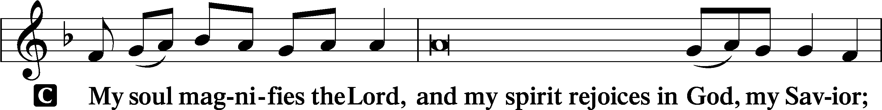
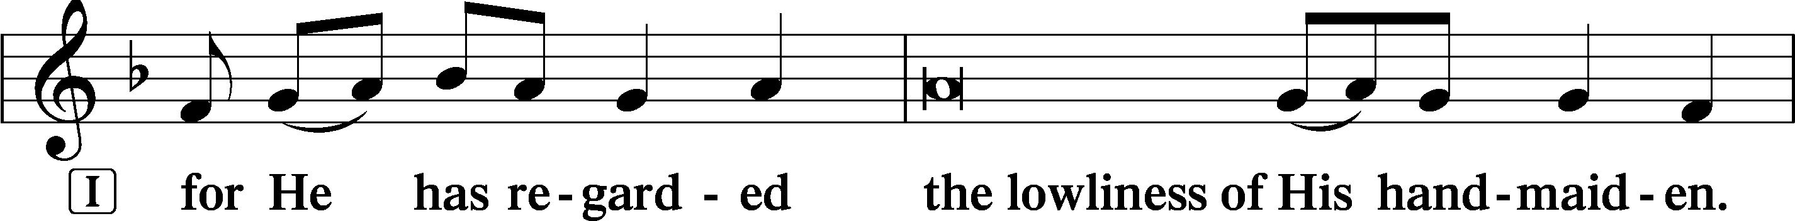
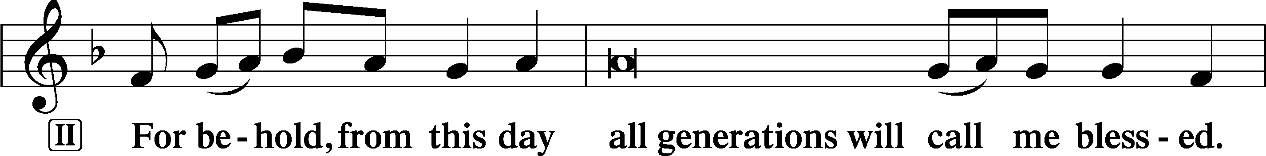
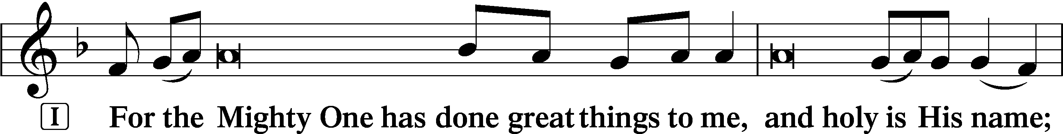
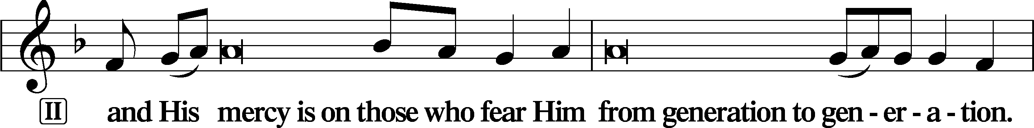
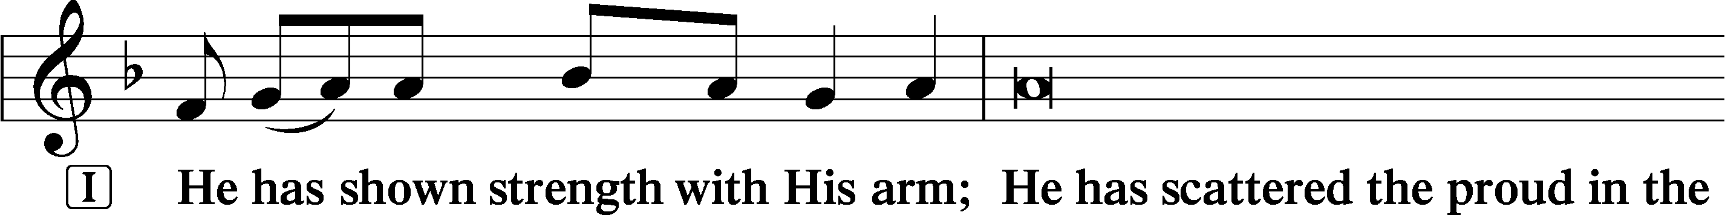
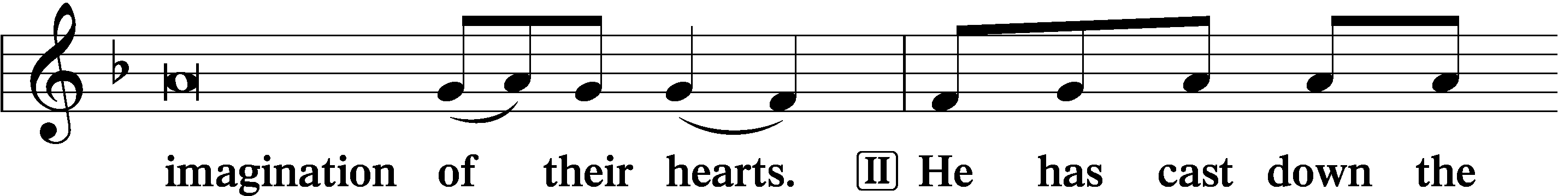
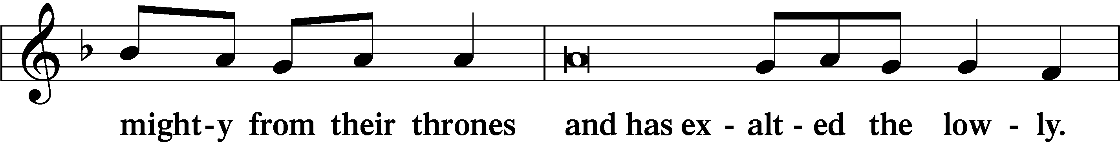
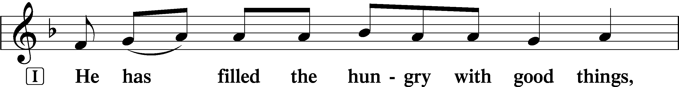
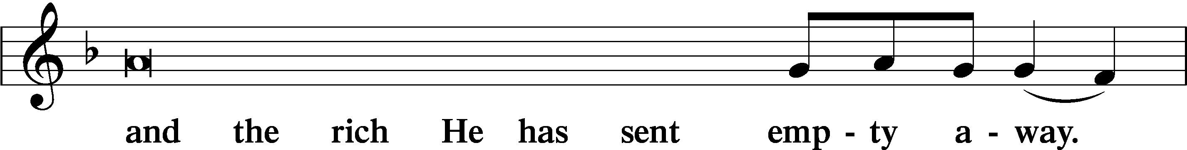
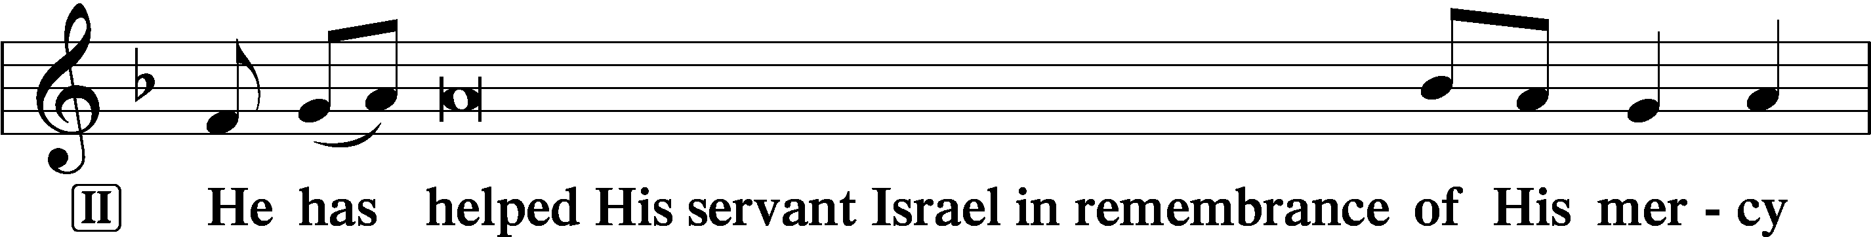
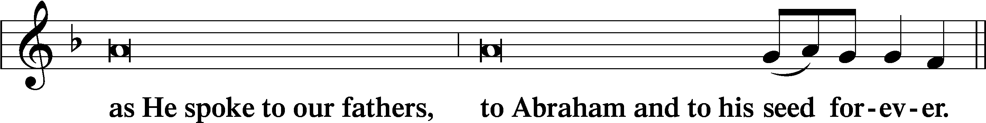

Magnificat Antiphon
P As they were eating, Je- | sus took bread,*
And blessed it, and brake it, and gave it to the | disciples.

Complend 2 Timothy 4:22
P The Lord be with you.
C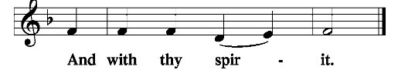

P Let us pray.
O Lord our God, being refreshed with life-giving nourishment, we beseech Thee, that what we pursue in the time of mortality, we may attain by Thy gift of immortality; through Jesus Christ, Thy Son, our Lord, who liveth and reigneth with Thee and the Holy Ghost, ever one God, world without end.
Benedicamus Psalm 103:1
P Bless we the Lord.
C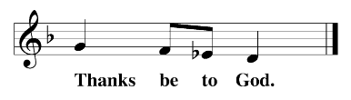
Stripping of the Altar
The communion vessels are reverently removed from the altar, the altar is stripped, and the chancel is cleared in preparation for the solemn services of Good Friday.

Antiphon
This is the Body which shall be delivered for you;
This is the cup of the new testament in My Blood, saith the Lord.
This do ye, as oft as ye drink it,
In remembrance of Me.

Psalm 22 (ESV)
My God, my God, why have you for- | saken me?*
Why are you so far from saving me, from the words of my | groaning?
O my God, I cry by day, but you do not | answer,*
and by night, but I | find no rest.
Yet you are | holy,*
enthroned on the praises of | Israel.
In you our fathers | trusted;*
they trusted, and you de- | livered them.
To you they cried and were | rescued;*
in you they trusted and were not | put to shame.
But I am a worm and | not a man,*
scorned by mankind and despised by the | people.
All who see me | mock me;*
they make mouths at me; they | wag their heads;
“He trusts in the Lord; let him de- | liver him;*
let him rescue him, for he de- | lights in him!”
Yet you are he who took me | from the womb;*
you made me trust you at my | mother’s breasts.
On you was I cast | from my birth,*
and from my mother’s womb you have | been my God.
Be not far from me,
for trouble | is near,*
and there is | none to help.
Many bulls en- | compass me;*
strong bulls of Bashan sur- | round me;
they open wide their | mouths at me,*
like a ravening and roaring | lion.
I am poured out like water,
and all my bones are | out of joint;*
my heart is like wax;
it is melted with- | in my breast;
my strength is dried up like a potsherd,
and my tongue sticks | to my jaws;*
you lay me in the | dust of death.
For dogs en- | compass me;*
a company of evildoers encircles me;
they have pierced my | hands and feet—
I can count | all my bones—*
they stare and gloat | over me;
they divide my garments a- | mong them,*
and for my clothing they | cast lots.
But you, O Lord, do not be | far off!*
O you my help, come quickly | to my aid!
Deliver my soul | from the sword,*
my precious life from the power | of the dog!
Save me from the mouth of the | lion!*
You have rescued me from the horns of the wild | oxen!
I will tell of your name to my | brothers;*
in the midst of the congregation I will | praise you:
You who fear the Lord, praise him!
All you offspring of Jacob, glo- | rify him,*
and stand in awe of him, all you offspring of | Israel!
For he has not despised or abhorred
the affliction of the afflicted,
and he has not hidden his | face from him,*
but has heard, when he | cried to him.
From you comes my praise in the great congre- | gation;*
my vows I will perform before those who | fear him.
The afflicted shall eat and be satisfied;
those who seek him shall | praise the Lord!*
May your hearts live for- | ever!
All the ends of the earth shall remember
and turn | to the Lord,*
and all the families of the nations
shall worship be- | fore you.
For kingship belongs | to the Lord,*
and he rules over the | nations.
All the prosperous of the earth eat and | worship;*
before him shall bow all who go down to the dust,
even the one who could not keep him- | self alive.
Posterity shall | serve him;*
it shall be told of the Lord to the coming gener- | ation;
they shall come and proclaim his righteousness to a people | yet unborn,*
that he has | done it.

All leave the church in silence.

Acknowledgments
Holy Thursday from Lutheran Service Book
Unless otherwise indicated, Scripture quotations are from the ESV® Bible (The Holy Bible, English Standard Version®), copyright © 2001 by Crossway, a publishing ministry of Good News Publishers. Used by permission. All rights reserved.
Created by Lutheran Service Builder © 2023 Concordia Publishing House.

Please join us for the following
Holy Week Services:

Friday, March 29, 2024
Stations of the Cross
8 am Sts. Peter & Paul’s, Sharon
8 am All Saints, Slippery Rock

Tre Ore
Noon – 3 pm Sts. Peter & Paul’s, Sharon

Tenebrae
8 pm Sts. Peter & Paul’s, Sharon
8 pm All Saints, Slippery Rock

Saturday, March 30, 2024
Saturday Easter Vigil
8 pm Sts. Peter & Paul’s, Sharon

Sunday, March 31, 2024
Easter Sunday Divine Service
9 am Sts. Peter & Paul’s, Sharon
11:30 am All Saints, Slippery Rock

Here to Serve

Pastor………………………………………………...……………Rev. Jacob Deal
E-mail …………………………….……pastordeal@saintspeterandpaul.net
Phone Number……………………..…………………724-347-3620 (Option 2)
Church Office………………………..…………………724-347-3620 (Option 3)
Website …………………………………………www.saintspeterandpaul.net
Secretary…………………………………………………………Diane Riefstahl
E-mail ………………………………………church@saintspeterandpaul.net
Website …………………………………………www.saintspeterandpaul.net
Food Pantry (email): ……………foodpantry@saintspeterandpaul.net
Congregation President………………………………….…Jonathan Baisch
Church Elder …………………………………………...……. Jonathan Baisch
Organist………………………………………………..….…Rebecca Marquette
AA Contact: Steve………………………………………………...…724-813-2358
NA Contact: Larry……………………………………..…………..724-977-8733
fffffffffffffffffffffffffffffffffff
If needing to get into the church building during the week, please phone first to make certain someone is here to let you in.

