From the Pastor…

**Sts. Peter & Paul Evangelical Lutheran Church LC-MS**

Monthly Newsletter --- March 2020

699 Stambaugh Avenue, Sharon, PA 16146

Phone: 724.347.3620 Little People Pre-School: 724.347.3620 (option 4)

E-mail: church@saintspeterandpaul.net [www.saintspeterandpaul.net](http://www.saintspeterandpaul.net)

“THE ROCK and THE SWORD”

“Built upon the Rock of Christ and wielding the

Sword of the Spirit, the Word of God.”

Face to Face with Jesus

Jesus said, “O Jerusalem, Jerusalem, the city that kills the prophets and stones those who are sent to it! How often would I have gathered your children together as a hen gathers her brood under her wings, and you were not willing!” Luke 13:34

Typically, these are the three reactions we have to people expressing their legitimate disappointments with us: 1) *I’m sorry; I want to do better.* 2) *I don’t understand; please explain why.*  3) *You’re wrong; get away from me.* Most of us will fall within one of those three reactions. The sincerity and/or intensity are bound to be on a spectrum, but at the heart of the matter, we either know we’ve screwed up or we deny it. In those two particular cases, we either want to be brought closer to the person or we want them far away from us. It is sometimes downright difficult to look the person you’ve let down in the eyes. The eyes may not be the “actual” window to the soul, but they can communicate feelings that often go unsaid.

Saint Luke records later in chapter 19 that when Jesus drew near to the city of Jerusalem, He wept. If only the people of Jerusalem would have listened to Him who told of the things which made for peace with God, but they would not. They were known as the people who murdered the prophets and stoned the messengers of God. Who would be next, but God’s own Son?  Hail, hail the King of the Jews! Jesus wished to gather the city under the wings of His grace and mercy, but the people refused the one that God had sent.

We still do the same today. As Jesus said to the disciples, “Watch and pray, that ye enter not into temptation: the spirit indeed is willing, but the flesh is weak.” We are oppressed by the world, tempted by our self-passions, and led into many sins by the works of the devil. I’m reminded of the Good Friday Chief Service that we will have on April 10th this year. Right before its conclusion, there is a section called, “Reproaches”.  It is a very humbling time because, in a way, it puts us face to face with Jesus. He tells us what He has done for us, and what we have done for Him. Perhaps, you’ve never looked at it quite this way, but we can’t blame only the people who lived at the time of Christ for nailing Him to the cross. That would be running away from our sins. We are still the ones who live as if God does not matter, and as if we matter most.

Here are the three reproaches:

* *Thus says the Lord: What have I done to you, O My people, and wherein have I offended you? Answer Me. For I have raised you up out of the prison house of sin and death and you have delivered up your Redeemer to be scourged. For I have redeemed you from the house of bondage, and you have nailed your Savior to the cross. O My people.*
* *Thus says the Lord: What have I done to you, O My people, and wherein have I offended you? Answer Me. For I have conquered all your foes, and you have given Me over and delivered Me to those who persecute Me. For I have fed you with My Word and refreshed you with living water, and you have given Me gall and vinegar to drink. O My people.*
* *Thus says the Lord: What have I done to you, O My people and wherein have I offended you? Answer Me. What more could have been done for My vineyard than I have done for it? When I looked for good grapes, why did it yield only bad? My people, is this how you thank your God? O My people.*

What is our answer, O people of God? What are we to say to the Lord’s clear reproach of His people? “O Lord, have mercy.” We do not deny it; we can’t. “If we say we have not sinned, we make Him a liar, and His word is not in us.” 1 John 1:8. So we say, “Yes Lord, it is us. We, your people, have done this to you, but you have endured it all for our good and for our salvation. Be merciful and forgive us, we pray.”

As I reread over these reproaches, I don’t find them any easier to hear, but I do know that just as my heart’s guilt increases because sin is revealed, there in His Word, God will meet me with a grace that abounds all the more. At the foot of the cross, the sinner realizes the magnitude of God’s love for His people. Jesus Christ endured all this hostility from sinners, and all the abuse of the peoples to free people from the guilt of their sin and to cover their shame, and to make peace with the Father by way of His blood and righteousness.

The Lenten invitation is to journey with Christ up to Jerusalem where he is going to accomplish all things and return from the dead victorious Easter morning. Let us go with Him, “looking to Jesus, the founder and perfector of our faith, who for the joy that was set before Him endured the cross, despising the shame, and is seated at the right hand of the throne of God.” Focus this Lenten season on beginning again to take up your cross, following the Man of Sorrows, and so separating yourself from the things which lead you away from His path. Our response to the Lord’s reproach should not only be, “I’m sorry, forgive me,” but we should also say, “I want to do better.” These responses are surely the work of the Holy Spirit within you to draw you out of the hands of the world, your flesh, and the devil, and to place you under the wings of Christ’s mercy and grace. He has longed to gather you there, where He might shield you from every attack of the evil foe.

As our 40 day journey begins, I pray you take seriously the faith which God has called you into and earnestly seek to put off the old-self. Take to heart every one of the struggles and victories of Christ over the devil, and all his works, and all his ways because they are also your struggles and your victories. If we are found in Christ, then shall we stand in victory on the last day. Finally, before you put away this article and move on to other things go back and reread the reproaches.  Take note of all that God has done for you. Then take a moment and give Him proper thanks for His mercy endures forever.

God’s blessings,

Pastor Jacob Deal

****

**“Stock the Food Pantry Sunday”**

**is March 8th!**

***Let us remember those in need!***

Please consider making a financial donation to this important function of our church.

Let’s try to bring some joy into the lives of others and help them feel God’s blessings and love.

‘Truly, I say to you, as you did it to one of the least of these my brothers, you did it to me.’ Matthew 25:40



**CELEBRATING IN MARCH!**

**Birthdays:**

Morgan McGowan 3-5

Josh Solyan 3-7

Barry Nelson 3-17

Michael Laird 3-23

**Anniversaries:**

Larry & Robin Hawthorne 3-9

Brian & Liz Shreffler 3-27

*If birthdays or anniversaries have been omitted, please let the church office know. Thank You!



**Scrip/Gift Card Program**

It’s not too late to become part of our Scrip/Gift Card Program!

*How does this program benefit our church?* A varying percentage, based upon the gift card(s) which you purchase, is given back to the church from the company issuing the cards. Simply fill out an order form (found in the narthex) and submit it with payment to Matt Berent the first Sunday of each month. The following Sunday, you will receive the full value of the cards purchased. That’s it!

To date (Nov. 2019 – Feb. 2020), our church has earned $238.78 from this program. Your participation will enhance this amount even more! Pick up your form today and start planning!



**Thank You for Serving in March:**

**Assisting Elders:** Bob Sulek & Jonathan Baisch. **Ushers:**  Hugh Owen, Cheryl Fedele, Jeff Brandes, Bob Sulek, & Jonathan Baisch (alternate). **Altarware:** Hank Holcroft & Kati Laird.

**March Greeters:**

1 ~ Matt & Cathy Berent

8 ~ Anson & Hank Holcroft

15 ~ Dolores Fee & Diane Riefstahl

22 ~ Barry & Chris Nelson

29 ~ Ralph Dorman & Diane Riefstahl

***New Greeters are ALWAYS needed!***

***If you would like to be added to the Greeters’ schedule, please speak with Diane. Thank you!***





**Join us Sunday, March 8th**

**following worship for**

**Coffee & Donuts Fellowship!**

**Many thanks go out to Jennifer & Connor Russell, this month’s sponsors.**

******

Those wishing to send **Virginia Lehman** “get well” wishes may mail them to her at 92 Wet Track Road, West Middlesex, PA 16159.

**Lent Brings Changes**

During Lent, a time of penitence, no flowers will adorn our altar. We will celebrate the Divine Service using Divine Service Setting 4 with the “Gloria in Excelsis” and “Alleluia and Verse” omitted.

Forms for ordering Easter flowering plants will be inserted into the Sunday bulletin March 8th. Completed forms and payments will be due back to the secretary no later than March 29th. Those purchasing plants will once again have the option of taking them home following the service Easter Sunday or donating them to the church gardens.

The 2020 Altar Flower sign-up sheet has been posted in the narthex. Sponsorship costs $30. Payments may be placed in a pew envelope labeled with your name and wording for the dedication.

Pastor Deal is planning to set up another **New Members Class**. Please speak with him if interested in participating or if you know someone who is.



**Welcome, Jennifer and Elizabeth!**

During the February 16th Divine Service, we welcomed Jennifer Russell and Elizabeth Haenftling as new members of our church.

Jennifer is the daughter of members Mike and Marie Flaugher and mother of Connor Russell who was baptized here in February 2nd. Jennifer resides in Hubbard, OH with her son and husband, Joshua.

Elizabeth is the daughter of the Rev. Peter Haenftling and his wife Marie who serve at St. Matthew’s Lutheran Church in Wilkes-Barre, PA. Elizabeth currently lives in Boardman, OH. Coincidentally, Elizabeth and Ana Deal’s mother, Catherine Carr, studied together at the seminary in Fort Wayne.

**Our Home Bound Members:**

***Please keep the following people in your prayers:***

Helen Bender

920 Pleasantview Dr.

New Castle, PA 16101



Mary Chmielewski

87 S. Neshannock Rd.

Hermitage, PA 16148



Dan Davis, Avalon Springs

745 Greenville Road

Mercer, PA 16137



Edna Krajci, **Vista Center at The Ridge**  
3379 Main St   
Mineral Ridge, Ohio 44440  
330-652-9901



Mary Ann Krajci, John XXIII

2250 Shenango Valley Freeway

Hermitage, PA 16148

724-981-3200



Marion Roberts

The Lakes at Jefferson, Room 221

7271 W. Market St.

Mercer, PA 16137

717-798-5330



Barbara Vasconi

880 Mayfield Rd.

Sharpsville, PA 16150

724-962-7960



Sincere “thanks” are extended to all those who helped with the SELC Circuit Conference which was held here February 4th and 5th. Your planning and hospitality were duly appreciated by those in attendance.

****

**Be certain to check out our website:** [**www.saintspeterandpaul.net**](http://www.saintspeterandpaul.net)**.**

Current service bulletins and newsletters may be accessed under the Publications page and there is an audio link to Pastor Deal’s sermons.

******

**REMINDER:** Please let the church office know of any changes to your address, phone, cell phone or your e-mail address!

**We are currently seeking sponsors for the second half of 2020’s**

**Coffee & Donuts Fellowship.**

If interested, please sign your name on the schedule in the narthex.

On the Sunday you’re scheduled, simply bring in 2-1/2 dozen donuts or pastries and 1 qt. orange juice. Please place items in the downstairs kitchen prior to the worship service. Diane will take care of making the coffee, setting up, and cleaning up.

**Available in the narthex:**

* Minutes from the February 24th Church Council meeting
* SCRIP order forms
* 2020 Lenten devotions
* March issue of “The Lutheran Beacon”

**Available as of Sunday, March 8th:**

* Minutes from the March 2nd Preschool Board meeting
* Easter flowering plants order forms





**Recently, we received notice that our church was the recipient of Thrivent Choice dollars. We are grateful to the following individuals who directed their dollars to our church:**

* **David Williams**
* **Traudi Sulek**
* **Robert Sulek**

****

**Please join us throughout the Lenten season Wednesdays at noon and 7 pm for our special Lenten mid-week services.**

**Word of Hope: 1-888-217-8679**

The only 24/7 CONFIDENTIAL Hotline that is distinctly Lutheran, bringing healing found in Christ, to those whose hearts have been broken by abortion.

**Bible Memory Verses**

Have you ever wondered about the origin of the beautiful words which make up our liturgy? What about the basis of our hymns found in our worship hymnal? The source is the same for both: The Holy Bible.

It is to The Bible we should turn, not only to find words of comfort, but for God’s plan as to how our lives should be led. Arm yourselves with these words, and you will see God’s plan for you!

The following are the Bible verses from the month of **February:**

**FOR CHILDREN:**

**Feb. 2:***The creation waits with eager longing for the revealing of the sons of God. Romans 8:19*

**Feb. 9:** *We do not present our pleas before you because of our righteousness, but because of your great mercy. Dan. 9:8*

**Feb. 16:***Today, if you hear his voice, do not harden your hearts. Ps. 95:7-8*

**Feb. 23:***See, we are going up to Jerusalem, and everything that is written about the Son of Man by the prophets will be accomplished. Luke 18:31*

**FOR ADULTS:**

**Feb. 2:***Trust in the Lord with all your heart, and do not lean on your own understanding.  Proverbs 3:5*

**Feb. 9:** *Beloved, let us love one another, for love is from God, and whoever loves has been born of God and knows God.  1 John 4:7*

**Feb. 16:***You shall love the Lord your God with all your heart and with all your soul and with all your mind and with all your strength. Mark 12:30*

**Feb. 23:***You shall love your neighbor as yourself. Mark 12:31*

******

**Bible Study Opportunity**

**Sunday Morning Bible Study** begins at 8:45 am and is held in the Fellowship Hall. We are currently studying The Augsburg Confession. This class is open to all ages.



*If you have an article you would like to share with the congregation, email it to* [*church@saintspeterandpaul.net*](mailto:church@saintspeterandpaul.net)*.*

**MARCH HYMN OF THE MONTH:**

**“I Trust, O Lord, Your Holy Name”**

**(LSB #734)**

I trust, O Lord, Your holy name;   
O let me not be put to shame  
 Nor let me be confounded.   
 My faith, O Lord,   
 Be in Your Word   
 Forever firmly grounded.

Bow down Your gracious ear to me   
And hear my cry, my prayer, my plea;  
 Make haste for my protection,   
 For woes and fear  
 Surround me here.  
 Help me in my affliction.

You are my strength, my shield, my rock,  
My fortress that withstands each shock,  
 My help, my life, my tower,   
 My battle sword,  
 Almighty Lord—  
 Who can resist Your power?

With You, O Lord, I cast my lot;   
O faithful God, forsake me not,  
 To You my soul commending.   
 Lord, be my stay,  
 And lead the way  
 Now and when life is ending.

All honor, praise, and majesty  
To Father, Son, and Spirit be,  
 Our God forever glorious,  
 In whose rich grace  
 We run our race  
 Till we depart victorious.

Public domain



Make certain to pick-up the March issue of ***The Lutheran Beacon*** which is available in the narthex. You may also read the Lutheran Beacon on-line at [**www.selc.lcms.org**](http://www.selc.lcms.org/)**.**



***Sincere sympathy is expressed to the friends and families of the following who recently passed:***

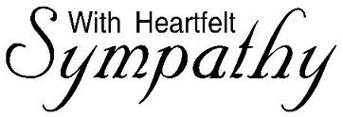

* **Edward Bocko**, Lisa Jelinek’s uncle and brother of the late Sophia Mihm
* **James Owen**, brother of Hugh Owen
* **Beverly Grexa**, Dolores Fee’s aunt and wife of the late Rev. Paul Grexa
* **Elaine Kilar**, a former member of Sts. Peter & Paul’s.

***May those who mourn their passings take comfort in the promises of our Risen Lord!***





**Mission Outreach Project…**

**International Christian Literature Distributors, Inc.** focuses on getting the Bible and study materials to learn the Bible into the hands of Christian leaders in the least-fortunate places of the world. They supply churches and schools of Bible learning throughout the English speaking world. Your old Portals of Prayer, Advent/Lenten devotions, and other materials are greatly appreciated. For more information about ICLD, check out their website: [www.icld.org](http://www.icld.org/). **Please recycle these items by dropping them in the basket in the hallway by the offices. Thank you!**

******

**OUR FIRST QUARTER LOCAL MISSION: CAMPUS MINISTRY AT ALL SAINTS LUTHERAN CHURCH,**

**SLIPPERY ROCK, PA**

March is the final month for our First Quarter Local Mission. Financial donations may be placed in pew envelopes and put in the offering plate. Be certain to note your name, envelope number, and designate that it is for our local mission project.



**LOOKING FOR PART-TIME OR FULL-TIME EMPLOYMENT OR KNOW OF SOMEONE WHO IS?**

The U.S. Census Bureau has employment possibilities in Mercer Country. The following positions are available:

* Recruiting assistant
* Census field supervisor
* Enumerator.

Pay rates are $16.00-$17.50 / hour. For more information about available jobs or assistance with applying online, call 1-800-562-2020.

****

PRESCHOOL NEWS!

February was a busy month for our preschoolers! They entertained the attendees of the SELC Circuit Conference with musical selections, celebrated Valentine’s Day, and took a field trip to Dr. Stigliano’s office where they learned about a “trip to the dentist”. All this while continuing their studies, Monday music lessons with Mrs. Bartholomew, and God’s Time with Pastor Deal.

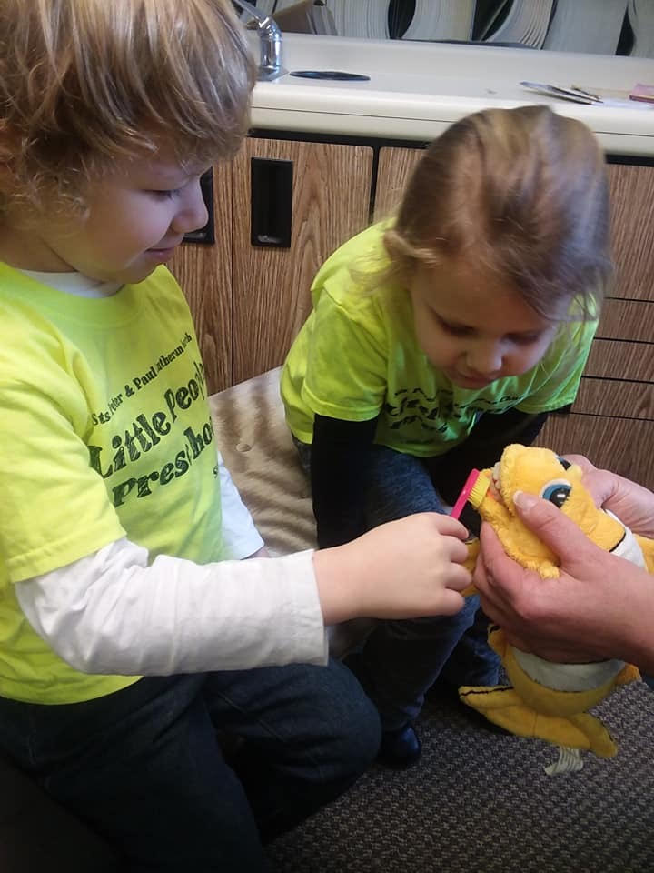

**2020 CHURCH COUNCIL AND VOTERS’ ASSEMBLY MEETINGS**



**Church Council Voters’ Assembly**

Mondays, April 20th Sundays, March 15th

July 20th  May 17th

October 19th August 16th

December 6th

**Church Council** meetings begin at 7 pm and will be held downstairs.

**Voters’ Assembly** meetings begin ten minutes after the conclusion of Sunday worship and will be held in the Fellowship Hall.



Don’t forget to turn your clocks ahead one hour Sunday, March 8th!





Anyone with baby bottles supporting Willow Women’s Center is asked to drop off their coin-filled bottles in the secretary’s office during the month of March so that they can be delivered to the center.

On behalf of Willow Women’s Center and those whom it serves, many thanks for your continued support of their work.



***Please* make a habit of checking off your name on the sign-in sheet each Sunday you are in attendance at church.** Attendance and communion participation are tracked for annual reporting and are useful to our Elders. Sign-in sheets are found on clipboards in the narthex and main hallway.





**Worship Schedule**

**Wednesdays thru April 1st**

Midweek Lenten Worship Services

Noon & 7 pm

The noon service will follow the Morning Prayer liturgy and the evening service will be a Vespers Service.

**Thursday, April 9th at 7 pm**

Maundy Thursday Divine Service

**Friday, April 10th at 7 pm**

Good Friday Chief Service

**Saturday, April 11th at 7 pm**

Saturday Vigil

**Sunday, April 12th at 10 am**

Easter Sunday Divine Service

******

The City of Sharon is sponsoring a **Community City-Wide Clean-up Day** Saturday, April 18th. We would like to put together a team to represent the church for this endeavor. Please speak with Pastor Deal or Diane if interested in participating.



Additionally, efforts are scheduled for Saturday, March 8th at 9 am to clean up the alley which extends between Orchard and Florence Streets. For further information, check out Sharon Beautification Commission’s Facebook page or phone 724-301-5413.