Sts. Peter & Paul
Evangelical Lutheran Church
Lutheran Church-Missouri Synod
Founded-1917

699 Stambaugh Avenue
Sharon, Pennsylvania 16146

March 19, 2024

“I was glad when they said to me,
Let us go to the house of the LORD!”
Psalm 122:1
Sts. Peter & Paul Evangelical Lutheran Church, LC-MS
THE FEAST OF SAINT JOSEPH,
GUARDIAN OF JESUS
March 19, 2024

A special welcome to our guests this day! If you would like more information about The Lutheran Church - Missouri Synod, or this congregation, please speak with Pastor Deal or an Elder after the service.
Members & Guests: Don’t be embarrassed if your children make noise during the worship service, all children do. We encourage families to worship together but, if you feel the need, there are pews in the rear of the Church which are reserved for young families on both sides of the sanctuary. There is also a quiet room available to you, located next to the sanctuary (formerly the Pastor’s office), where you would be able to follow along with the service.

CONTACT INFORMATION
Pastor Deal: pastordeal@saintspeterandpaul.net or 724-347-3620 (opt. 2)
Church Office: church@saintspeterandpaul.net or 724-347-3620 (opt. 3)
Secretary’s Office: The office will be open Monday (8:30 am – 5 pm) & Wednesday (8:30 – 10 am; 12-4:30 pm) and Thursday/Friday, as needed.
Church Website: www.saintspeterandpaul.net
Food Pantry email: foodpantry@saintspeterandpaul.net
Food Pantry phone number: 724-347-3620 (opt. 4)
AA Contact: Steve @ 724-813-2358
NA Contact: Larry @ 724-977-8733

Silent prayer before worship: Heavenly Father, through Your Son Jesus I have freedom from sin and death. Cause Your Word to work in my heart that I may trust in Your grace alone through Christ to save me from sin and death. Amen.

Stand

Versicles
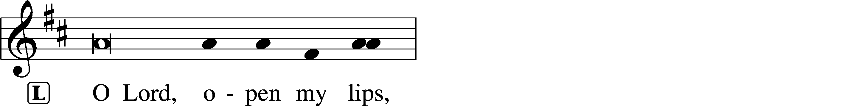
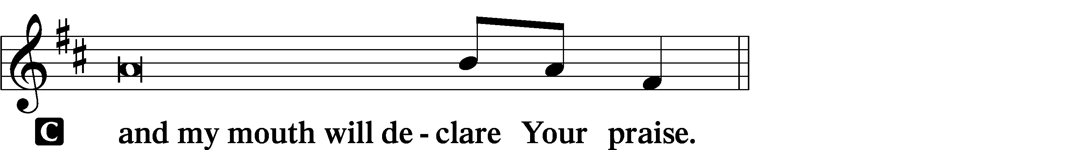

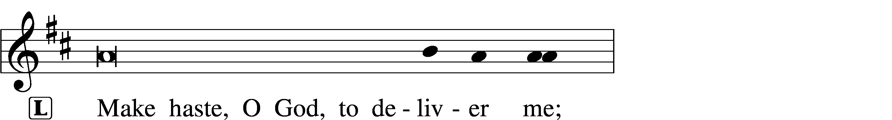
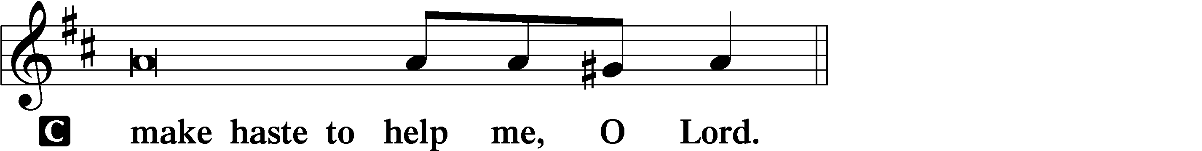

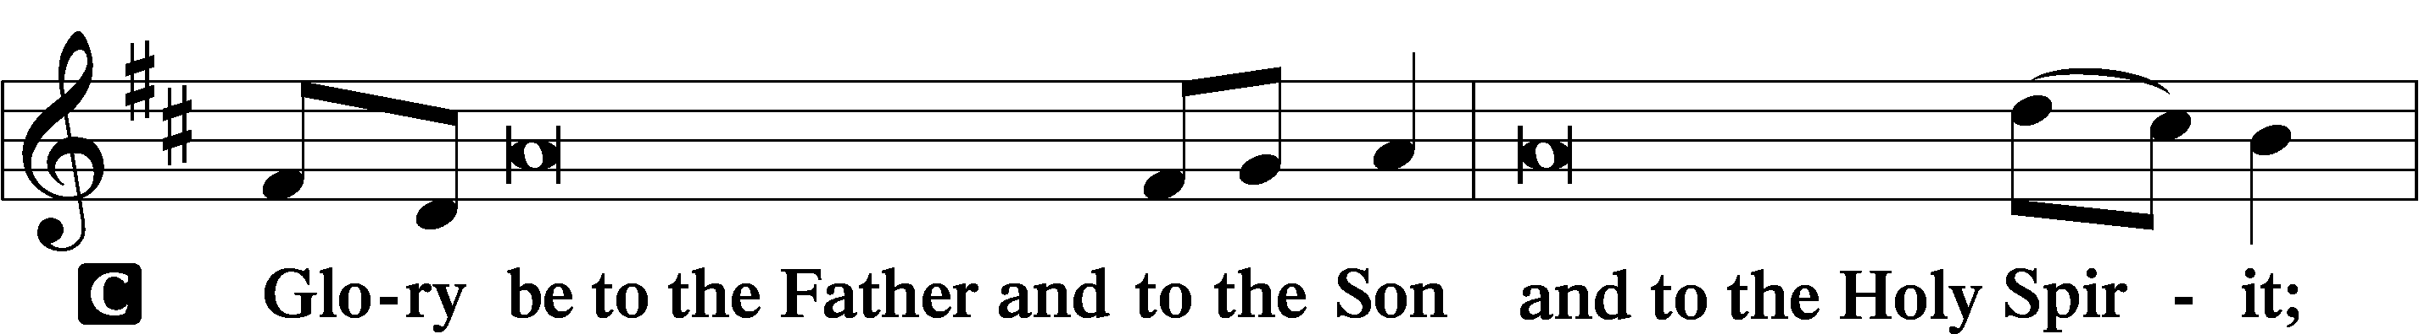
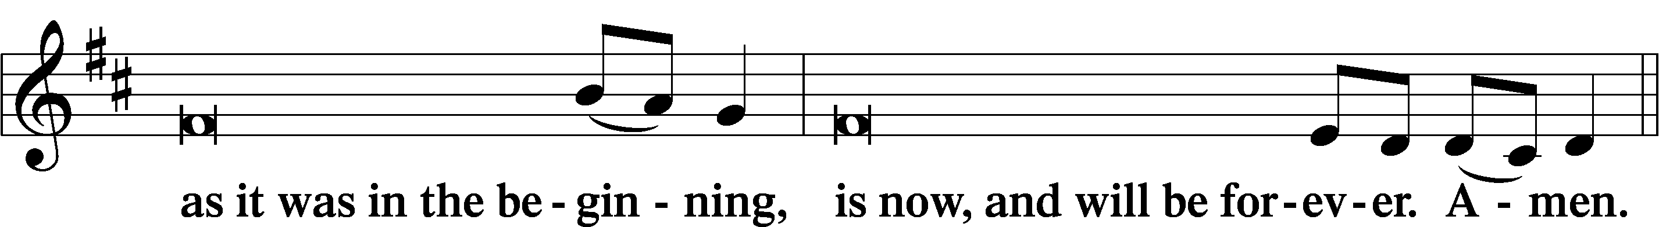
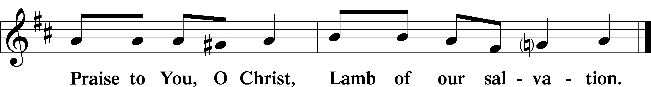

Psalmody
Psalm: Psalm 127
Unless the Lord builds the house,
those who build it labor in vain.
Unless the Lord watches over the city,
the watchman stays awake in vain.
It is in vain that you rise up early
and go late to rest,
eating the bread of anxious toil;
for he gives to his belovèd sleep.
Behold, children are a heritage from the Lord,
the fruit of the womb a reward.
Like arrows in the hand of a warrior
are the children of one’s youth.
Blessèd is the man
who fills his quiver with them!
He shall not be put to shame
when he speaks with his enemies in the gate.
Sit

Office Hymn: LSB #863 “Our Father, by Whose Name”
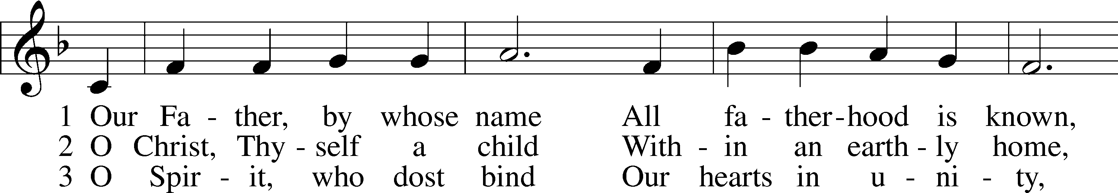
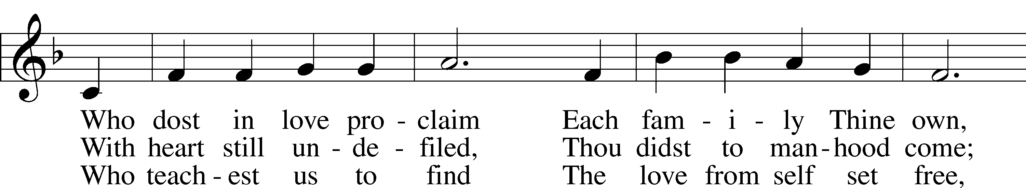
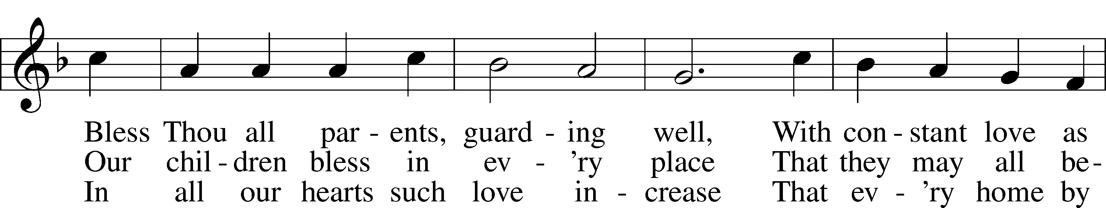
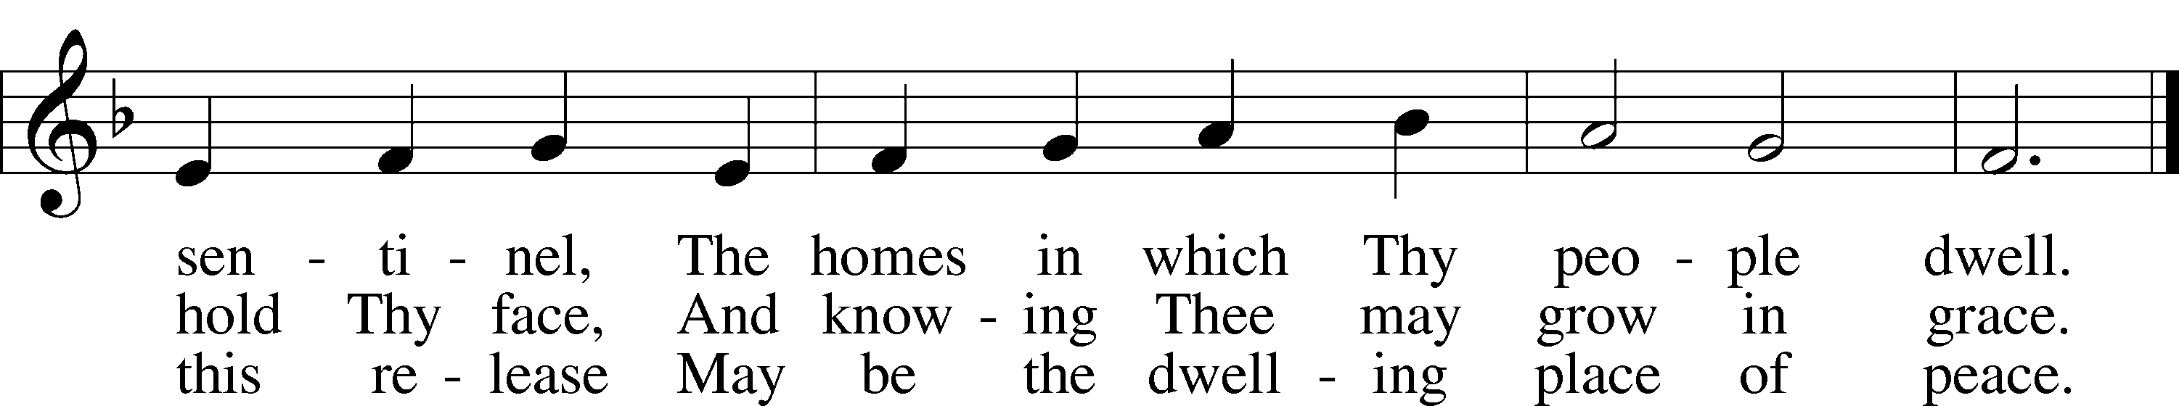

Text: F. Bland Tucker, 1895–1984 Tune: John D. Edwards, 1805–85 Text: © The Church Pension Fund. Used by permission: LSB Hymn License no. 110004782 Tune: Public domain

Readings

First Reading: Wisdom 10:10b–14 (NKJV)
The Lord guided the righteous man on straight paths; He showed him the reign of God and gave him knowledge of holy things. He prospered him in his labors and increased the fruit of his toil. When his oppressors were covetous, the Lord stood by him and made him rich. He protected him from his enemies and kept him safe from those who lay in wait for him. In his arduous contest He gave him the victory, so that he might learn that godliness is more powerful than anything. When the righteous man was sold, the Lord did not desert him, but delivered him from sin. He descended with him into the dungeon, and when he was in prison the Lord did not leave him, until He brought him the scepter of a kingdom and authority over his masters. Those who accused him the Lord showed to be false, and gave him everlasting honor, even the Lord our God.

P O Lord, have mercy on us.
C Thanks be to God.

Epistle: Romans 4:13–18 (NKJV)
Brethren: The promise that Abraham would be the heir of the world was not to him or to his seed through the law, but through the righteousness of faith. For if those who are of the law are heirs, faith is made void and the promise made of no effect, because the law brings about wrath; for where there is no law there is no transgression. Therefore it is of faith that it might be according to grace, so that the promise might be sure to all the seed, not only to those who are of the law, but also to those who are of the faith of Abraham, who is the father of us all (as it is written, “I have made you a father of many nations”) in the presence of Him whom he believed—God, who gives life to the dead and calls those things which do not exist as though they did; who, contrary to hope, in hope believed, so that he became the father of many nations, according to what was spoken, “So shall your descendants be.”

P O Lord, have mercy on us.
C Thanks be to God.

Gospel: Matthew 1:18b-25 (NKJV)
At that time: After Mary the mother of Jesus was betrothed to Joseph, before they came together, she was found with child of the Holy Spirit. Then Joseph her husband, being a just man, and not wanting to make her a public example, was minded to put her away secretly. But while he thought about these things, behold, an angel of the Lord appeared to him in a dream, saying, “Joseph, son of David, do not be afraid to take to you Mary your wife, for that which is conceived in her is of the Holy Spirit. And she will bring forth a Son, and you shall call His name Jesus, for He will save His people from their sins.” So all this was done that it might be fulfilled which was spoken by the Lord through the prophet, saying: “Behold, the virgin shall be with child, and bear a Son, and they shall call His name Immanuel,” which is translated, “God with us.” Then Joseph, being aroused from sleep, did as the angel of the Lord commanded him and took to him his wife, and did not know her till she had brought forth her firstborn Son. And he called His name Jesus.

P O Lord, have mercy on us.
C Thanks be to God.

Responsory (Lent) LSB 231
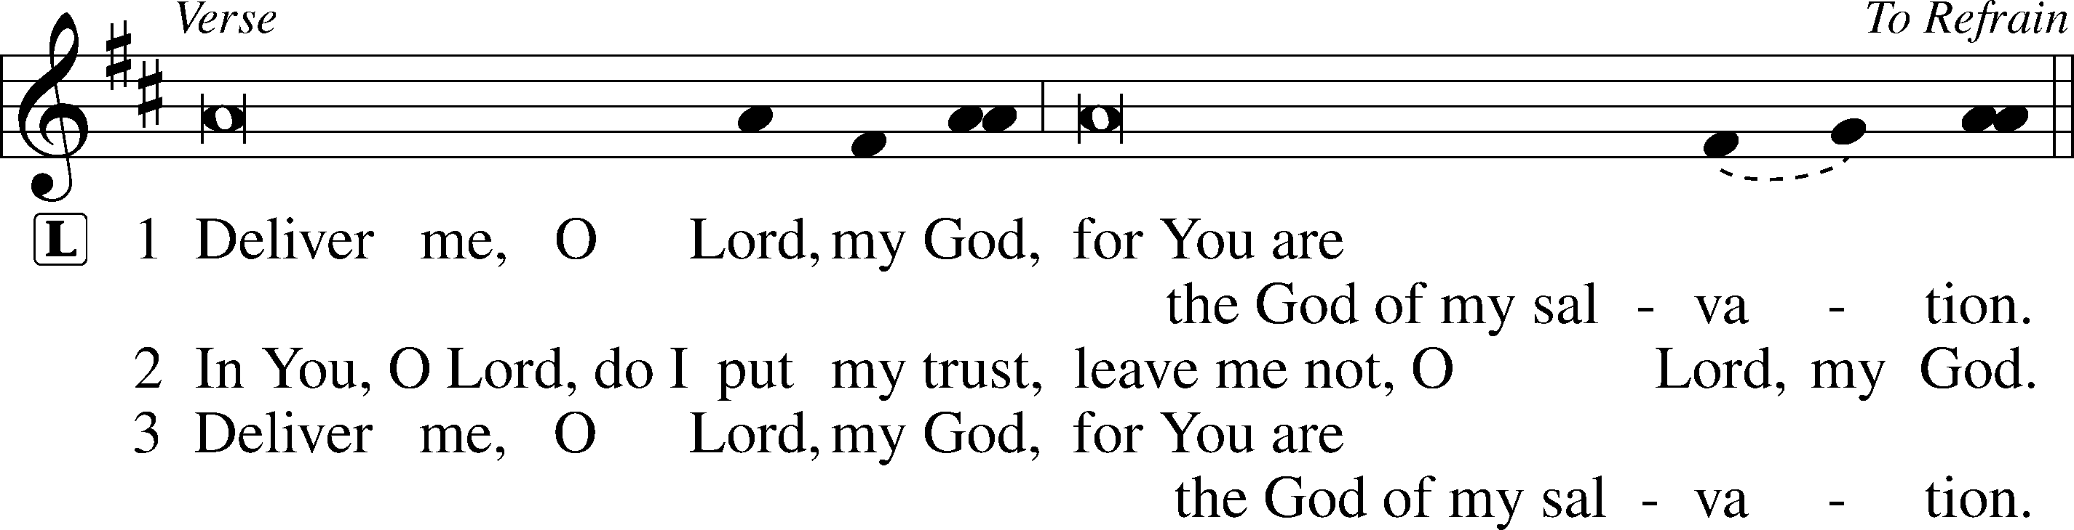
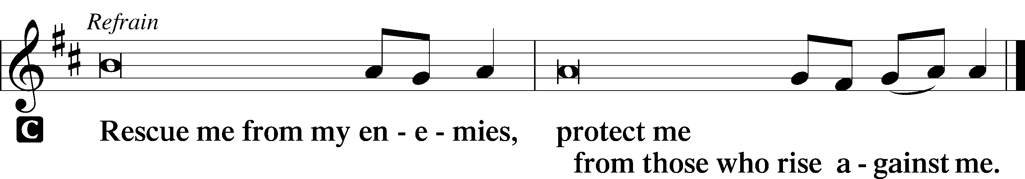

Sermon
Canticle
Stand

Antiphon (Common) 231
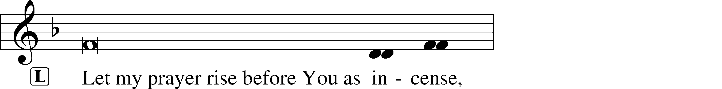
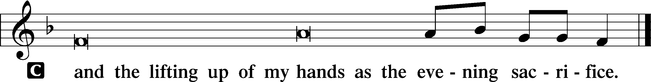

Magnificat 231
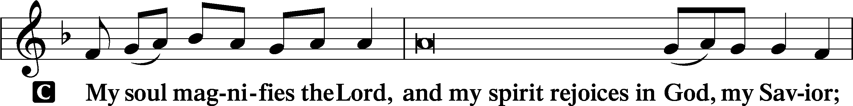
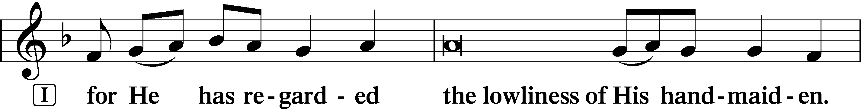
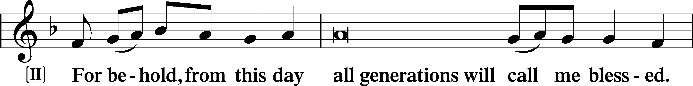
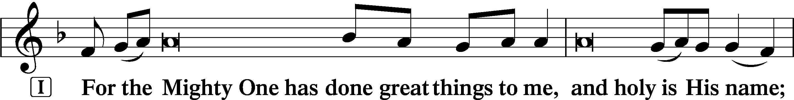
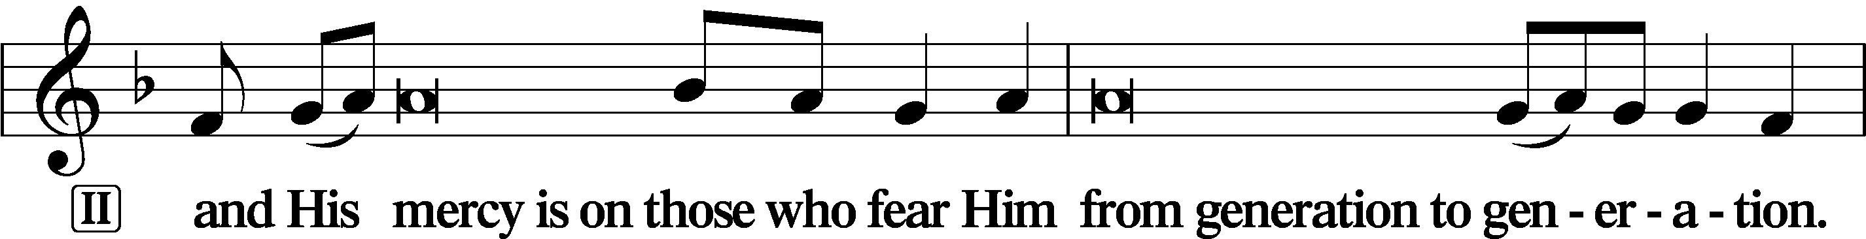
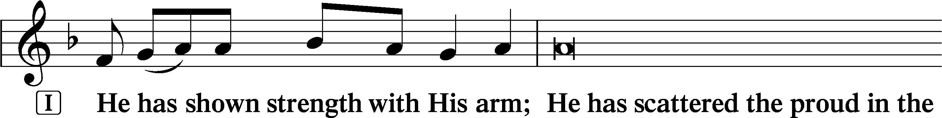
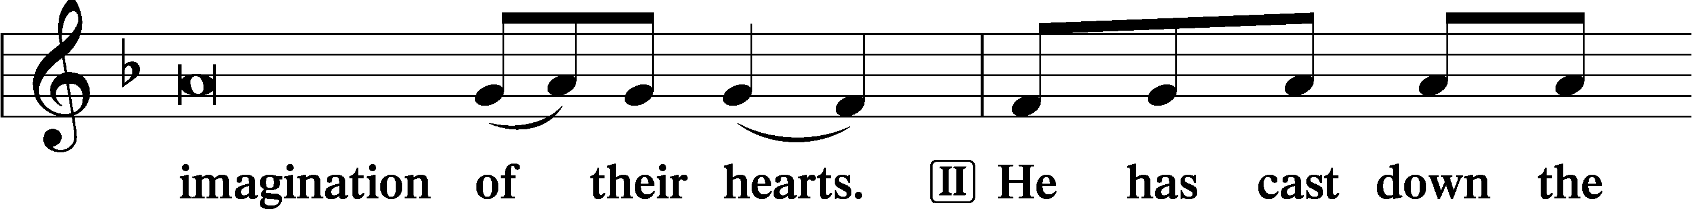
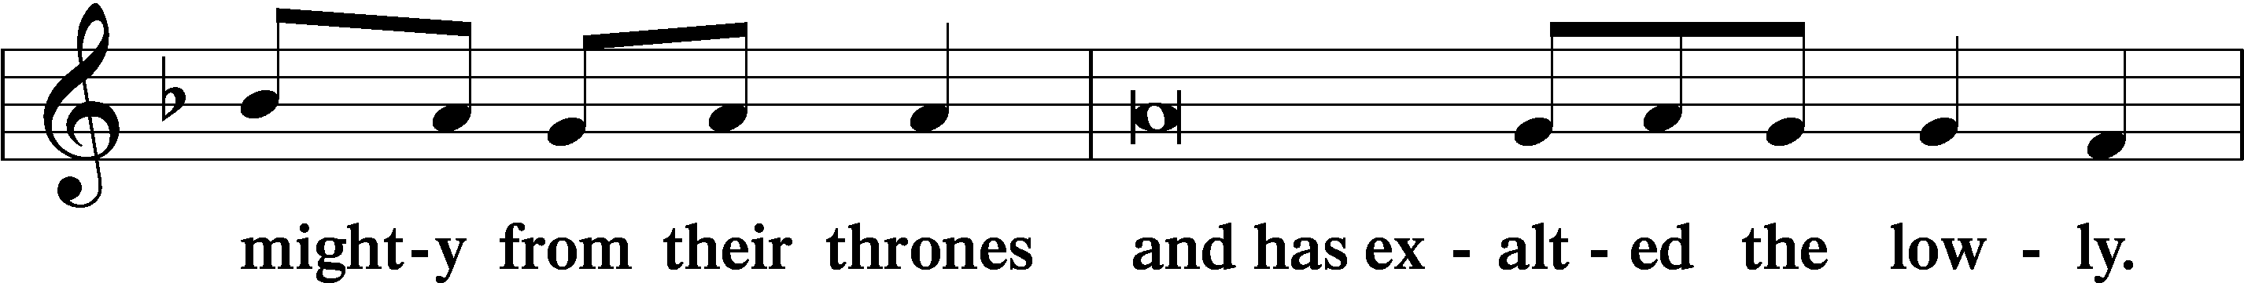
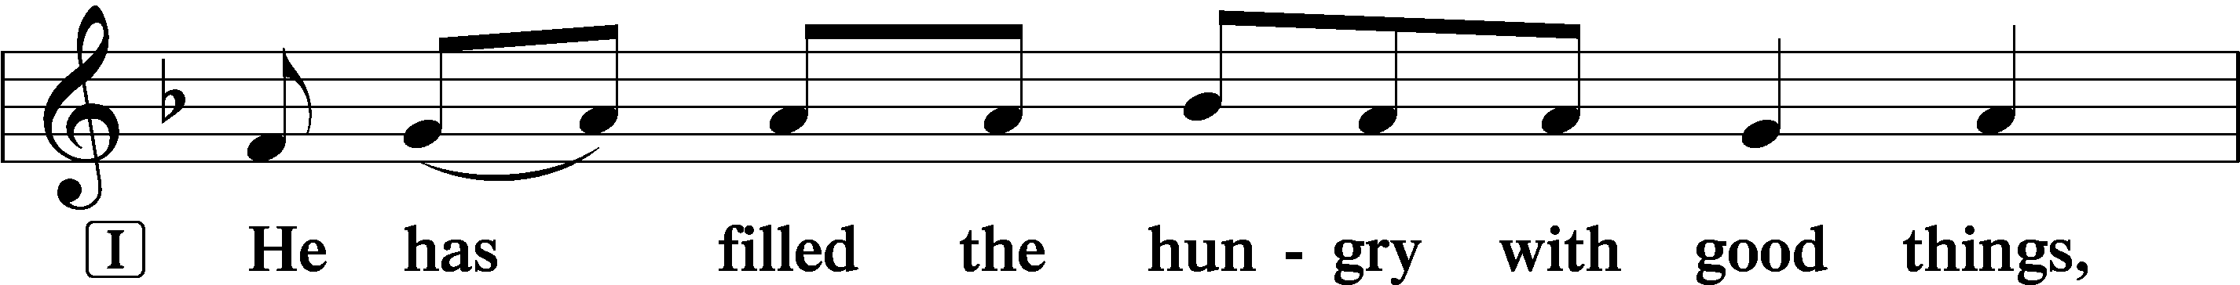
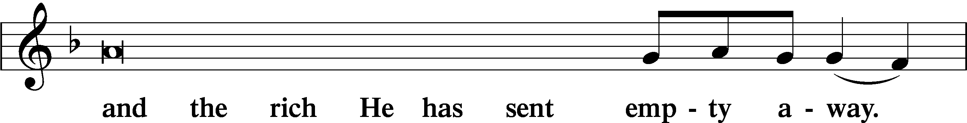
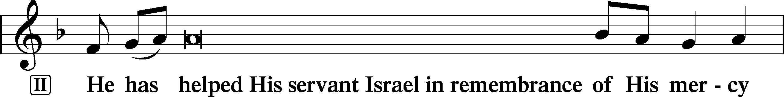
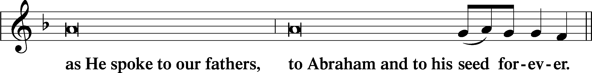
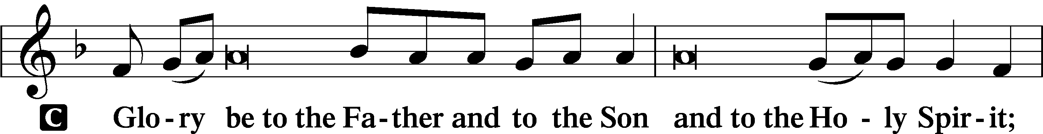
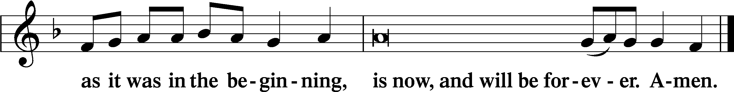

Prayer
Kyrie LSB 233
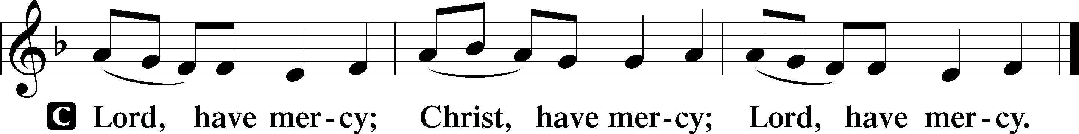

Lord’s Prayer LSB #957 “Our Father Who Art in Heaven”
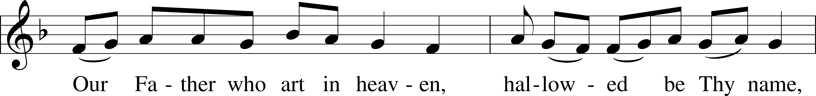
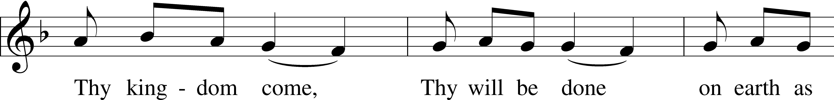
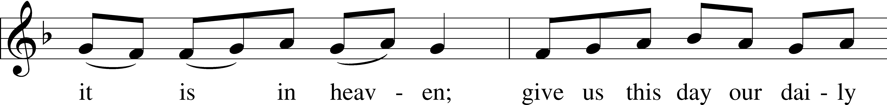
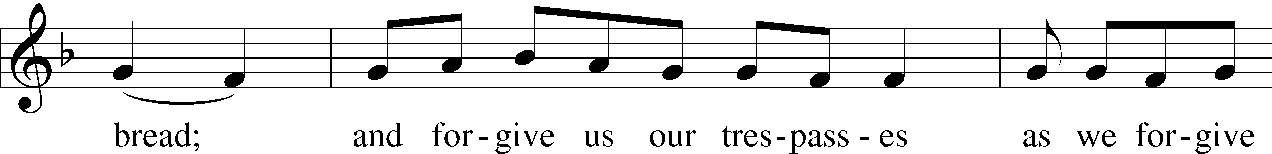
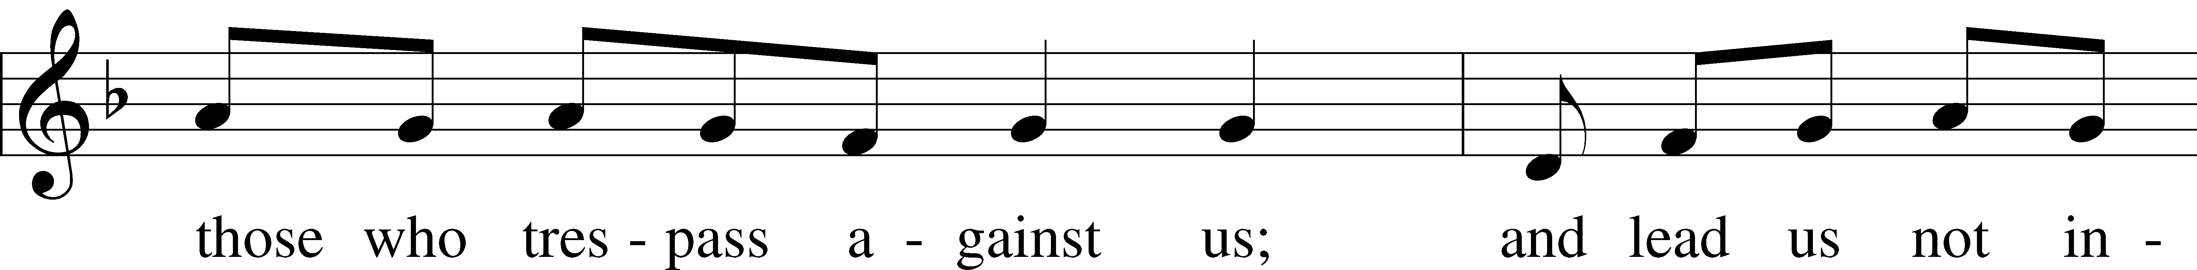
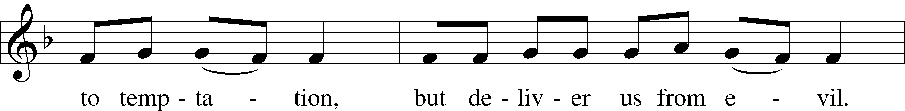
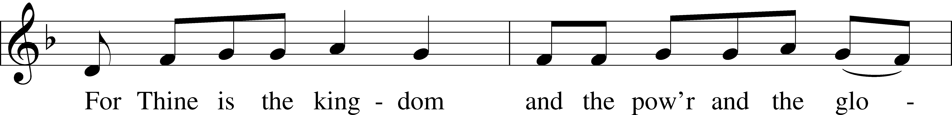
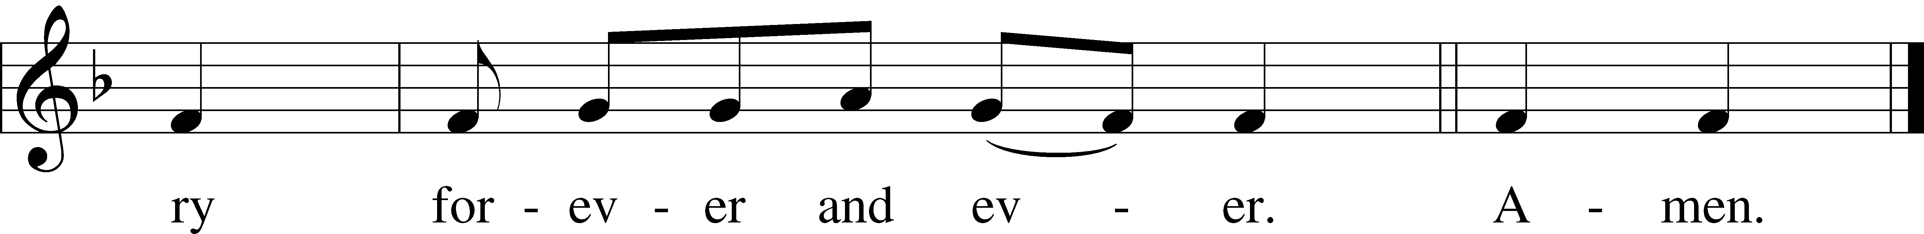
Text: Traditional Tune: Plainsong, mode VII Text and tune: Public domain

Collects LSB 233
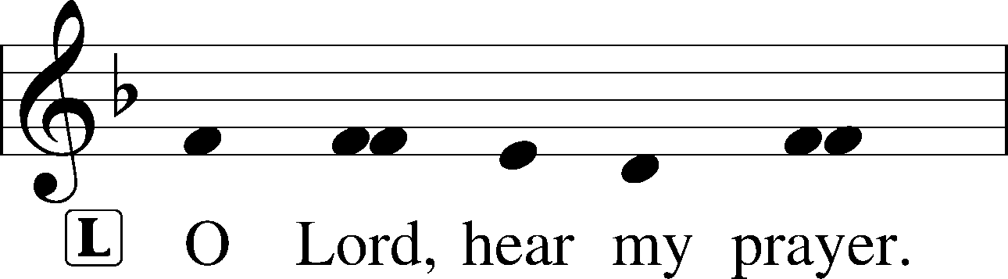
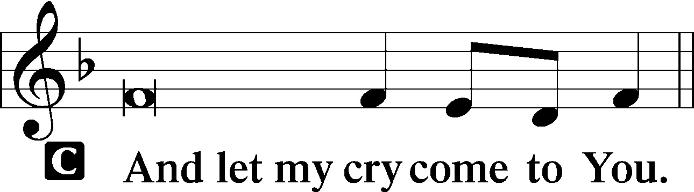

Collect of the Day: Saint Joseph
P Almighty God, from the house of Your servant David You raised up Joseph to be the guardian of Your incarnate Son and the husband of His mother, Mary. Grant us grace to follow the example of this faithful workman in heeding Your counsel and obeying Your commands; through Jesus Christ, our Lord, who lives and reigns with You and the Holy Spirit, one God, now and forever.
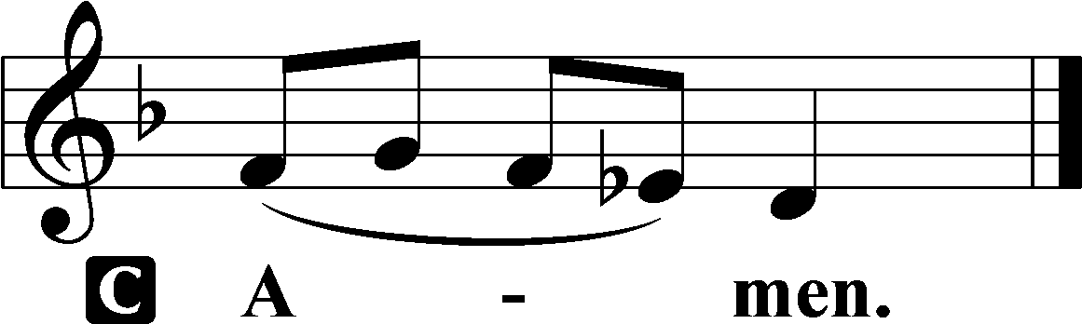

Collect for Peace
P O God, from whom come all holy desires, all good counsels, and all just works, give to us, Your servants, that peace which the world cannot give, that our hearts may be set to obey Your commandments and also that we, being defended from the fear of our enemies, may live in peace and quietness; through Jesus Christ, Your Son, our Lord, who lives and reigns with You and the Holy Spirit, one God, now and forever.

Stand

Benedicamus LSB 234
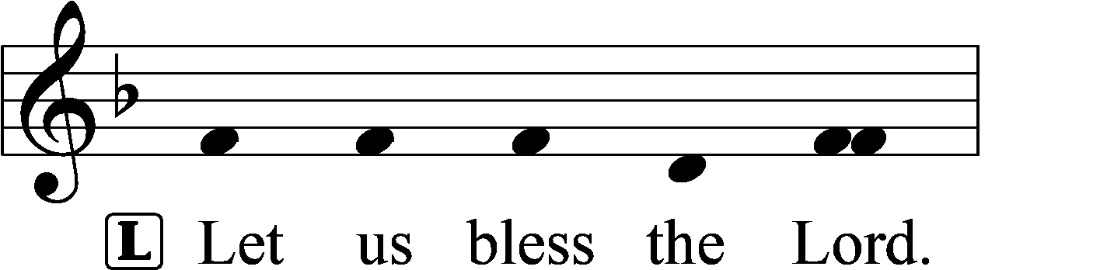
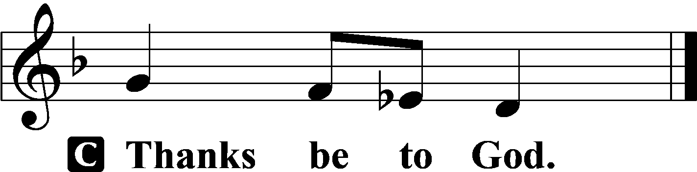

Benediction LSB 234
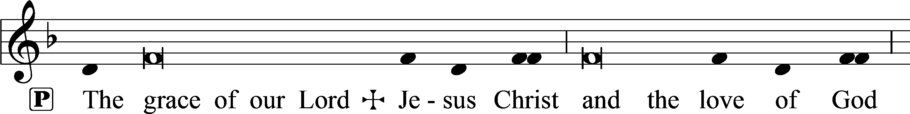
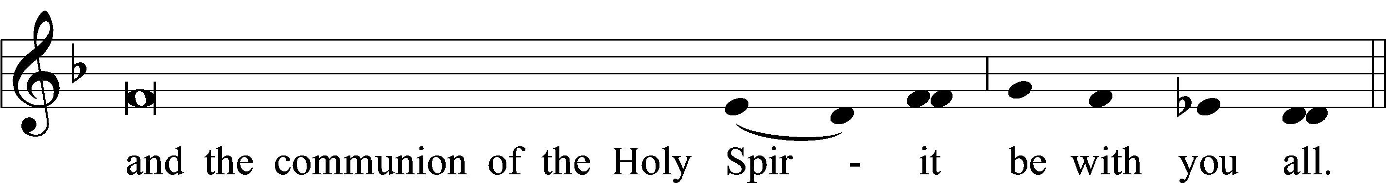

Silent prayer after worship: Almighty God, lead me to honor You above all things, to cherish Your gift of salvation through Christ’s life, death and resurrection, and to share this gift with others. In Jesus’s name. Amen.

Acknowledgments
Unless otherwise indicated, Scripture quotations are from the ESV® Bible (The Holy Bible, English Standard Version®), copyright © 2001 by Crossway, a publishing ministry of Good News Publishers. Used by permission. All rights reserved,
Created by Lutheran Service Builder © 2024 Concordia Publishing House.

Here to Serve
Pastor………………………………………………...……………Rev. Jacob Deal
E-mail …………………………….……pastordeal@saintspeterandpaul.net
Phone Number……………………..…………………724-347-3620 (Option 2)
Church Office………………………..…………………724-347-3620 (Option 3)
Website …………………………………………www.saintspeterandpaul.net
Secretary…………………………………………………………Diane Riefstahl
E-mail ………………………………………church@saintspeterandpaul.net
Food Pantry (phone): ……………………………….…724-347-3620 (opt. 4)
Food Pantry (email): ……………foodpantry@saintspeterandpaul.net
Congregation President………………………………….…Jonathan Baisch
Church Elder …………………………………………...……. Jonathan Baisch
Organist………………………………………………..….…Rebecca Marquette
AA Contact: Steve………………………………………………...…724-813-2358
NA Contact: Larry……………………………………..…………..724-977-8733
fffffffffffffffffffffffffffffffffff
If needing to get into the church building during the week, please phone first to make certain someone is here to let you in.

