Sts. Peter & Paul
Evangelical Lutheran Church
Lutheran Church-Missouri Synod
Founded-1917

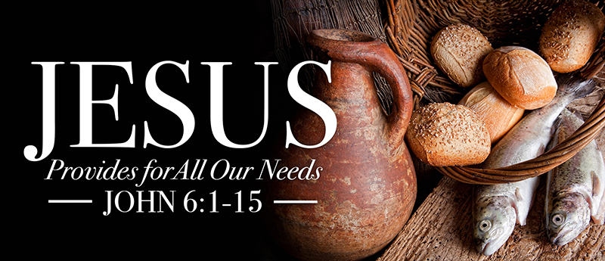

March 19, 2023

699 Stambaugh Ave.
Sharon, Pennsylvania 16146

“I was glad when they said to me,
Let us go to the house of the LORD!”
Psalm 122:1
Sts. Peter & Paul Evangelical Lutheran Church, LC-MS
LAETARE
March 19, 2023

A special welcome to our guests this day! If you would like more information about The Lutheran Church - Missouri Synod, or this congregation, please speak with Pastor Deal or an Elder after the service.
Members & Guests: Don’t be embarrassed if your children make noise during the worship service, all children do. We encourage families to worship together but, if you feel the need, there are pews in the rear of the Church which are reserved for young families on both sides of the sanctuary. There is also a quiet room available to you during our service which is located down the hallway past the offices on the right side of the church as well as a children’s area in the Fellowship Hall where you are able to follow along with the service.

Today’s service includes the Sacrament of Holy Communion. If during this past year, you have not worshipped with us and been communed, we respectfully ask that you do not partake of this sacrament this day before first speaking with Pastor Deal.
If visiting from a sister congregation of the LC-MS and are in good standing, please inform Pastor Deal of your desire to commune prior to the service.
If wishing to receive a blessing during communion, please approach with your arms crossed.

CONTACT INFORMATION
Pastor Deal: pastordeal@saintspeterandpaul.net or 724-347-3620 (opt. 2)
Church Office: church@saintspeterandpaul.net or 724-347-3620 (opt. 3)

Silent prayer before worship: Gracious God, send Your Holy Spirit to work through Your word within my heart to give me new life and to grant me the assurance of forgiveness, life and salvation through Jesus Christ. Amen.

Confession and Absolution

Opening Hymn: LSB #556 “Dear Christians, One and All, Rejoice”

Stand

The sign of the cross may be made by all in remembrance of their Baptism.

Invocation
P In the name of the Father and of the T Son and of the Holy Spirit.
C Amen.

Exhortation Hebrews 10:22; Psalm 124:8; Psalm 32:5
P Beloved in the Lord! Let us draw near with a true heart and confess our sins unto God our Father, beseeching Him in the name of our Lord Jesus Christ to grant us forgiveness.

P Our help is in the name of the Lord,
C who made heaven and earth.
P I said, I will confess my transgressions unto the Lord,
C and You forgave the iniquity of my sin.

Silence for reflection on God’s Word and for self-examination.

Confession of Sins
P O almighty God, merciful Father,
C I, a poor, miserable sinner, confess unto You all my sins and iniquities with which I have ever offended You and justly deserved Your temporal and eternal punishment. But I am heartily sorry for them and sincerely repent of them, and I pray You of Your boundless mercy and for the sake of the holy, innocent, bitter sufferings and death of Your beloved Son, Jesus Christ, to be gracious and merciful to me, a poor, sinful being.

Absolution [John 20:19–23]
P Upon this your confession, I, by virtue of my office, as a called and ordained servant of the Word, announce the grace of God unto all of you, and in the stead and by the command of my Lord Jesus Christ I forgive you all your sins in the name of the Father and of the T Son and of the Holy Spirit.
C Amen.

Service of the Word

Introit Psalm 122:1–2, 6, 8; antiphon: Isaiah 66:10a, 11a
Rejoice with Jerusalem, and be | glad for her,*
all you who | love her;
that you may nurse and be | satisfied*
from her con- | soling breast.
I was glad when they | said to me,*
“Let us go to the house | of the Lord!”
Our feet have been | standing*
within your gates, O Je- | rusalem!
Pray for the peace of Je- | rusalem!*
May they be secure who | love you!
For my brothers and com- | panions’ sake*
I will say, “Peace be with- | in you!”
Glory be to the Father and | to the Son*
and to the Holy | Spirit;
as it was in the be- | ginning,*
is now, and will be forever. | Amen.
Kyrie Mark 10:47
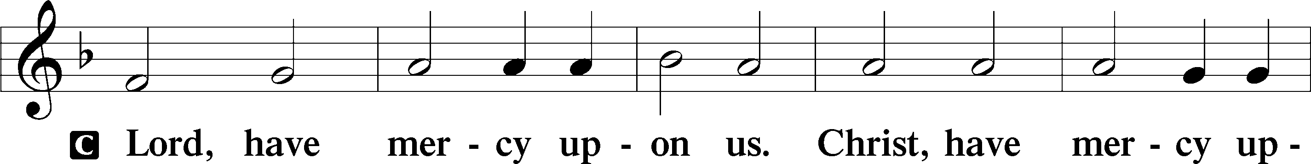
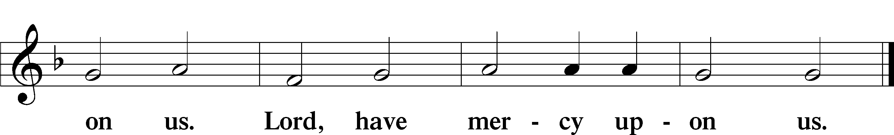

Salutation and Collect of the Day: Laetare
P The Lord be with you.
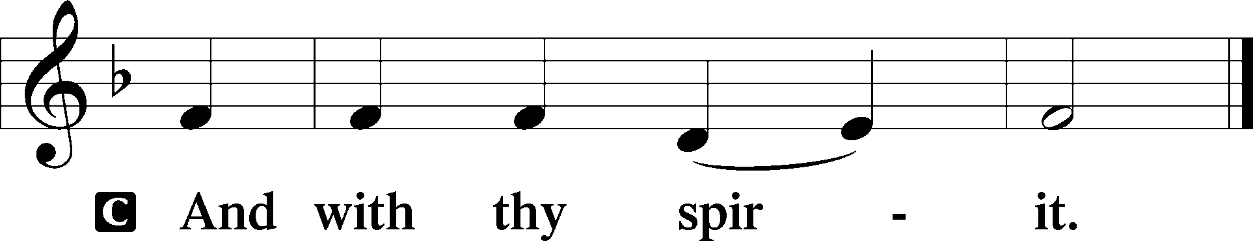

P Let us pray.
Almighty God, our heavenly Father, Your mercies are new every morning; and though we deserve only punishment, You receive us as Your children and provide for all our needs of body and soul. Grant that we may heartily acknowledge Your merciful goodness, give thanks for all Your benefits, and serve You in willing obedience; through Jesus Christ, Your Son, our Lord, who lives and reigns with You and the Holy Spirit, one God, now and forever.
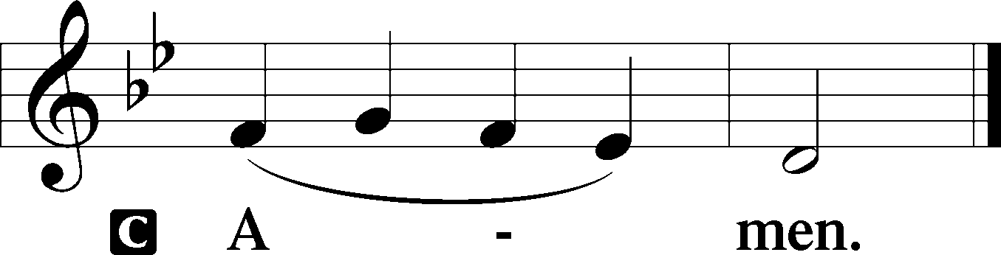
Sit

Prophecy: Exodus 16:2–21 (NKJV)
In those days: The whole congregation of the children of Israel complained against Moses and Aaron in the wilderness. And the children of Israel said to them, “Oh, that we had died by the hand of the Lord in the land of Egypt, when we sat by the pots of meat and when we ate bread to the full! For you have brought us out into this wilderness to kill this whole assembly with hunger.” Then the Lord said to Moses, “Behold, I will rain bread from heaven for you. And the people shall go out and gather a certain quota every day, that I may test them, whether they will walk in My law or not. And it shall be on the sixth day that they shall prepare what they bring in, and it shall be twice as much as they gather daily.” Then Moses and Aaron said to all the children of Israel, “At evening you shall know that the Lord has brought you out of the land of Egypt. And in the morning you shall see the glory of the Lord; for He hears your complaints against the Lord. But what are we, that you complain against us?” Also Moses said, “This shall be seen when the Lord gives you meat to eat in the evening, and in the morning bread to the full; for the Lord hears your complaints which you make against Him. And what are we? Your complaints are not against us but against the Lord.” Then Moses spoke to Aaron, “Say to all the congregation of the children of Israel, ‘Come near before the Lord, for He has heard your complaints.’ ” Now it came to pass, as Aaron spoke to the whole congregation of the children of Israel, that they looked toward the wilderness, and behold, the glory of the Lord appeared in the cloud. And the Lord spoke to Moses, saying, “I have heard the complaints of the children of Israel. Speak to them, saying, ‘At twilight you shall eat meat, and in the morning you shall be filled with bread. And you shall know that I am the Lord your God.’ ” So it was that quail came up at evening and covered the camp, and in the morning the dew lay all around the camp. And when the layer of dew lifted, there, on the surface of the wilderness, was a small round substance, as fine as frost on the ground. So when the children of Israel saw it, they said to one another, “What is it?” For they did not know what it was. And Moses said to them, “This is the bread which the Lord has given you to eat. This is the thing which the Lord has commanded: ‘Let every man gather it according to each one’s need, one omer for each person, according to the number of persons; let every man take for those who are in his tent.’ ” Then the children of Israel did so and gathered, some more, some less. So when they measured it by omers, he who gathered much had nothing left over, and he who gathered little had no lack. Every man had gathered according to each one’s need. And Moses said, “Let no one leave any of it till morning.” Notwithstanding they did not heed Moses. But some of them left part of it until morning, and it bred worms and stank. And Moses was angry with them. So they gathered it every morning, every man according to his need. And when the sun became hot, it melted.

P This is the Word of the Lord.
C Thanks be to God.

Gradual Psalm 122:1, 7
I was glad when they | said to me,*
“Let us go to the house | of the Lord!”
Peace be with- | in your walls*
and security within your | towers!

Epistle: Galatians 4:22—5:1a (NKJV)
Brethren: It is written that Abraham had two sons: the one by a bondwoman, the other by a freewoman. But he who was of the bondwoman was born according to the flesh, and he of the freewoman through promise, which things are symbolic. For these are the two covenants: the one from Mount Sinai which gives birth to bondage, which is Hagar—for this Hagar is Mount Sinai in Arabia, and corresponds to Jerusalem which now is, and is in bondage with her children—but the Jerusalem above is free, which is the mother of us all. For it is written: “Rejoice, O barren, you who do not bear! Break forth and shout, you who are not in labor! For the desolate has many more children than she who has a husband.” Now we, brethren, as Isaac was, are children of promise. But, as he who was born according to the flesh then persecuted him who was born according to the Spirit, even so it is now. Nevertheless what does the Scripture say? “Cast out the bondwoman and her son, for the son of the bondwoman shall not be heir with the son of the freewoman.” So then, brethren, we are not children of the bondwoman but of the free, in the liberty by which Christ has made us free.

P This is the Word of the Lord.
C Thanks be to God.

Stand
Holy Gospel: John 6:1–15 (NKJV)
P The Holy Gospel according to St. John, the sixth chapter.
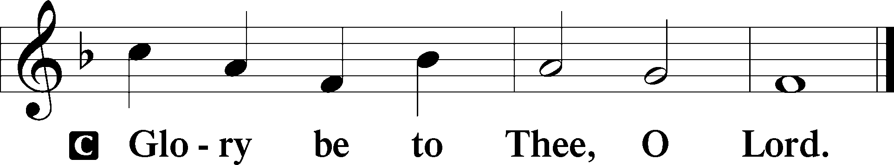

At that time: Jesus went over the Sea of Galilee, which is the Sea of Tiberias. Then a great multitude followed Him, because they saw His signs which He performed on those who were diseased. And Jesus went up on the mountain, and there He sat with His disciples. Now the Passover, a feast of the Jews, was near. Then Jesus lifted up His eyes, and seeing a great multitude coming toward Him, He said to Philip, “Where shall we buy bread, that these may eat?” But this He said to test him, for He Himself knew what He would do. Philip answered Him, “Two hundred denarii worth of bread is not sufficient for them, that every one of them may have a little.” One of His disciples, Andrew, Simon Peter’s brother, said to Him, “There is a lad here who has five barley loaves and two small fish, but what are they among so many?” Then Jesus said, “Make the people sit down.” Now there was much grass in the place. So the men sat down, in number about five thousand. And Jesus took the loaves, and when He had given thanks He distributed them to the disciples, and the disciples to those sitting down; and likewise of the fish, as much as they wanted. So when they were filled, He said to His disciples, “Gather up the fragments that remain, so that nothing is lost.” Therefore they gathered them up, and filled twelve baskets with the fragments of the five barley loaves which were left over by those who had eaten. Then those men, when they had seen the sign that Jesus did, said, “This is truly the Prophet who is to come into the world.” Therefore when Jesus perceived that they were about to come and take Him by force to make Him king, He departed again to the mountain by Himself alone.

P This is the Gospel of the Lord.
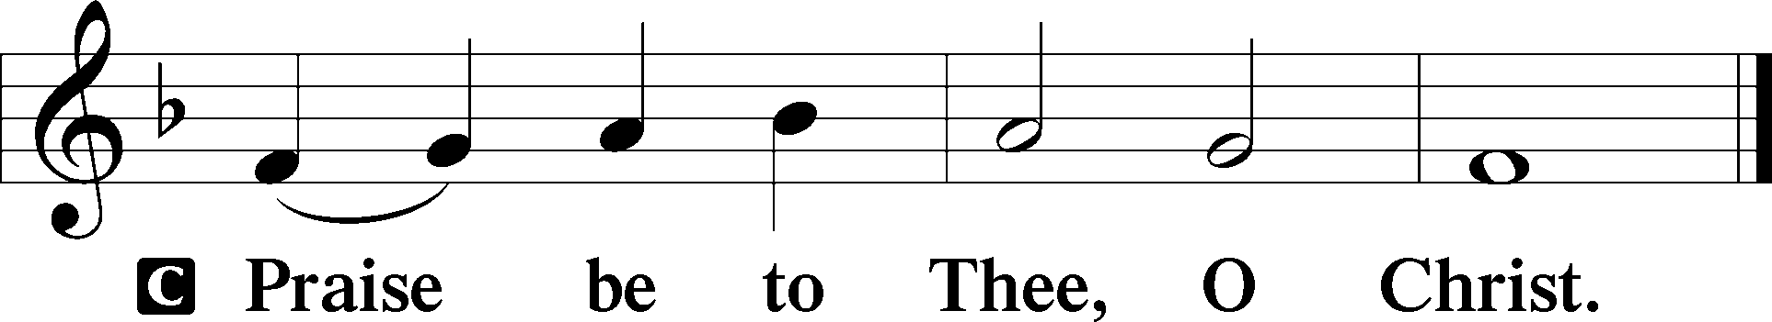

Nicene Creed
C I believe in one God,
the Father Almighty,
maker of heaven and earth
and of all things visible and invisible.

And in one Lord Jesus Christ,
the only-begotten Son of God,
begotten of His Father before all worlds,
God of God, Light of Light,
very God of very God,
begotten, not made,
being of one substance with the Father,
by whom all things were made;
who for us men and for our salvation came down from heaven
and was incarnate by the Holy Spirit of the virgin Mary
and was made man;
and was crucified also for us under Pontius Pilate.
He suffered and was buried.
And the third day He rose again according to the Scriptures
and ascended into heaven
and sits at the right hand of the Father.
And He will come again with glory to judge both the living and the dead,
whose kingdom will have no end.

And I believe in the Holy Spirit,
the Lord and giver of life,
who proceeds from the Father and the Son,
who with the Father and the Son together is worshiped and glorified,
who spoke by the prophets.
And I believe in one holy Christian and apostolic Church,
I acknowledge one Baptism for the remission of sins,
and I look for the resurrection of the dead
and the life T of the world to come. Amen.
Sit

Hymn of the Day: LSB #743 “Jesus, Priceless Treasure”

Sermon

Stand

Prayer of the Church

Offertory Psalm 51:10–12
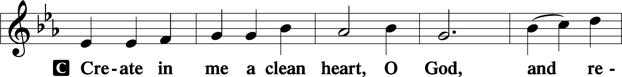
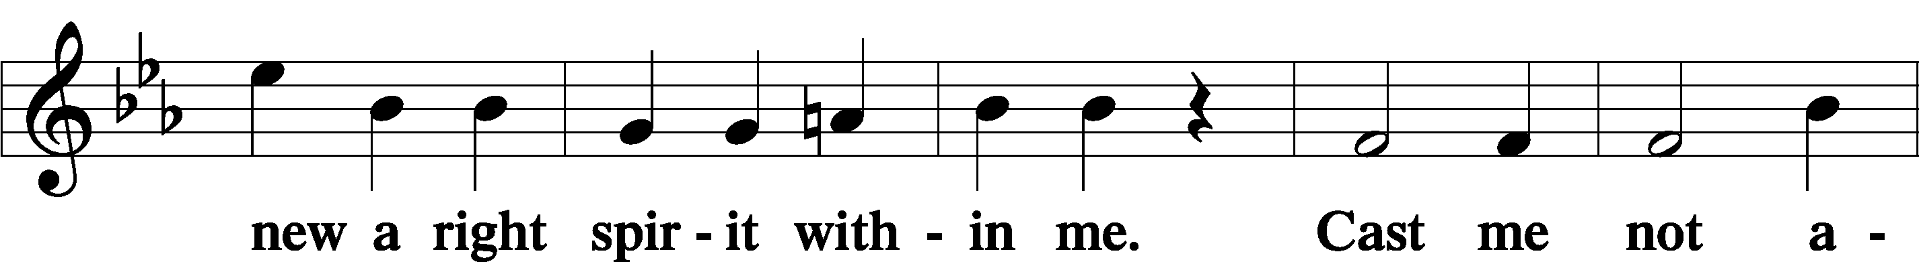
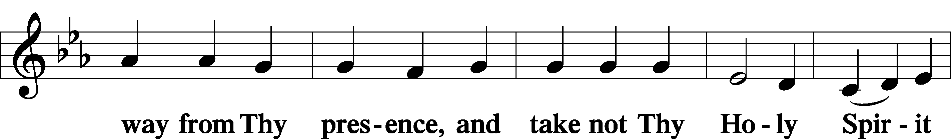
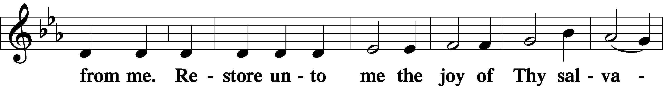
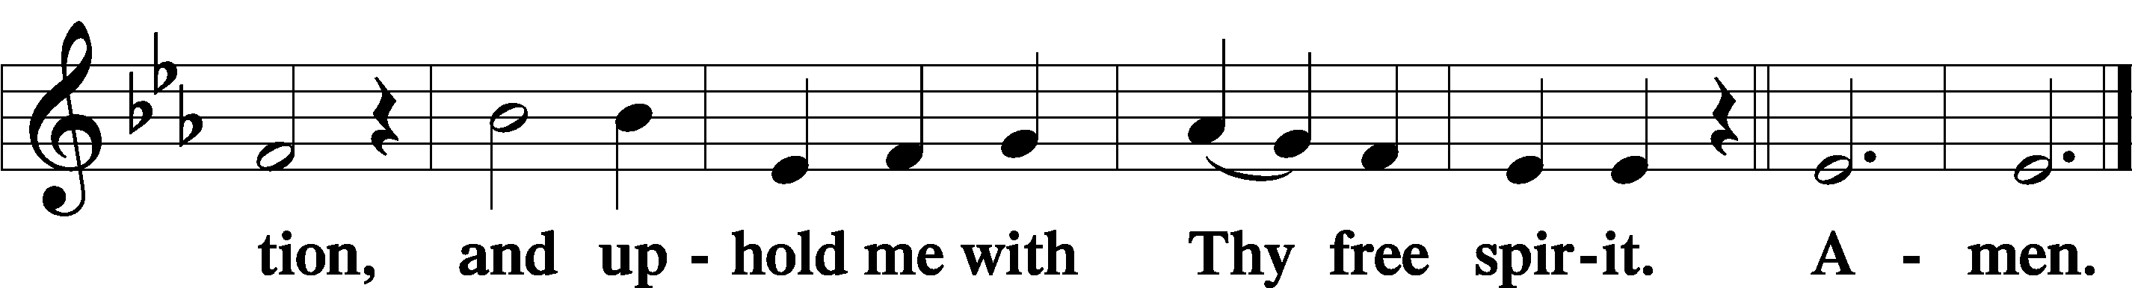
Sit

Preparatory Hymn: LSB #625 “Lord Jesus Christ, Life-Giving Bread”

Stand

Service of the Sacrament

Preface 2 Timothy 4:22; Colossians 3:1 Psalm 136
P The Lord be with you.

P Lift up your hearts.
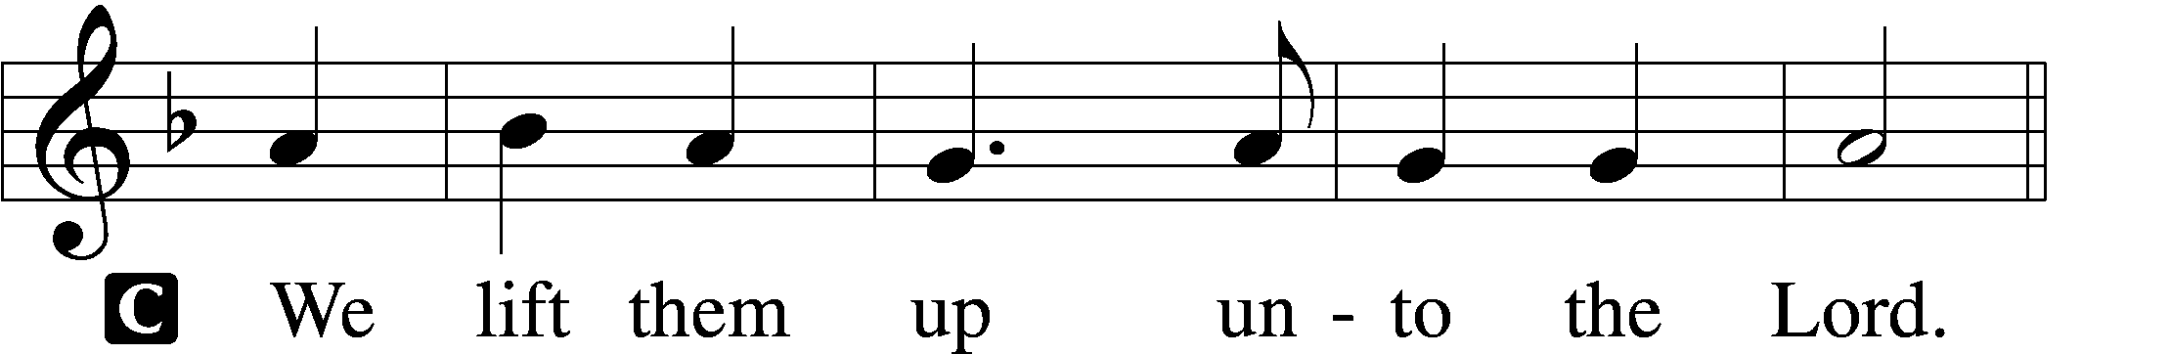

P Let us give thanks unto the Lord, our God.
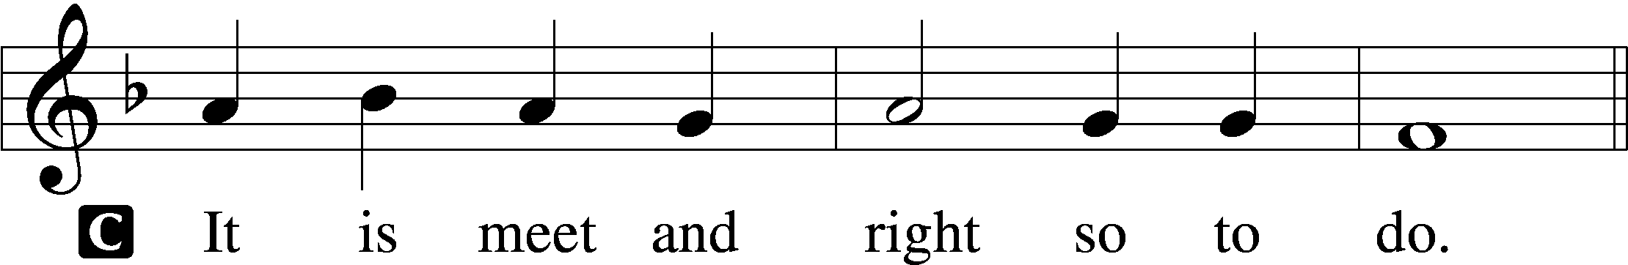

Proper Preface (Abbreviated) LSB 194
P It is truly meet, right, and salutary . . . evermore praising You and saying:

Sanctus Isaiah 6:3; Matthew 21:9
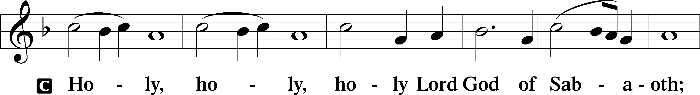
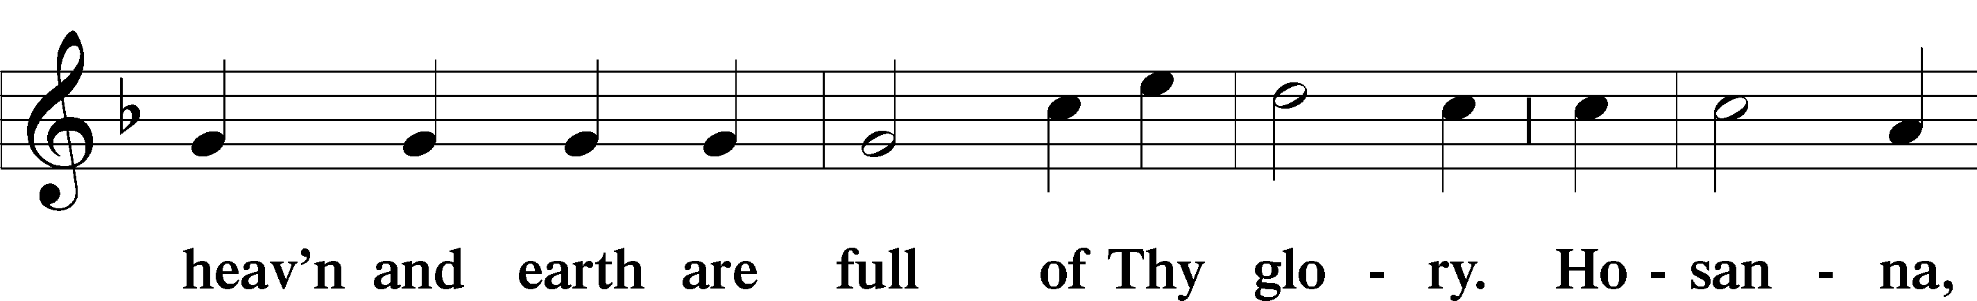
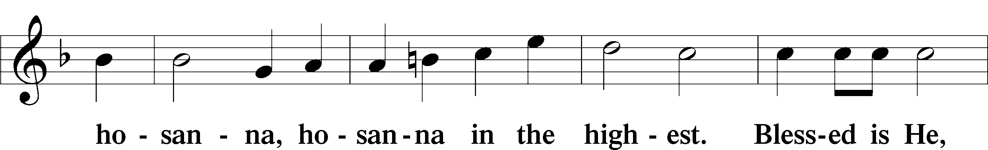
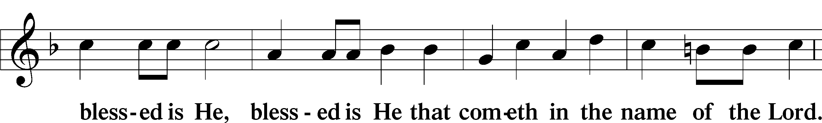
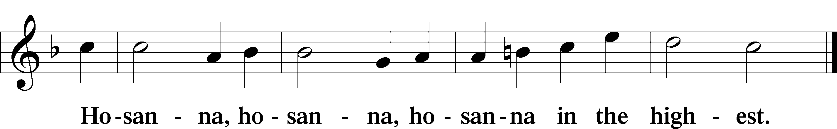

Lord’s Prayer Matthew 6:9–13
C Our Father who art in heaven,
hallowed be Thy name,
Thy kingdom come,
Thy will be done on earth as it is in heaven;
give us this day our daily bread;
and forgive us our trespasses as we forgive those who trespass against us;
and lead us not into temptation,
but deliver us from evil.
For Thine is the kingdom and the power and the glory forever and ever. Amen.

The Words of Our Lord Matthew 26:26–28; Mark 14:22–24; Luke 22:19–20; 1 Corinthians 11:23–25
P Our Lord Jesus Christ, on the night when He was betrayed, took bread, and when He had given thanks, He broke it and gave it to the disciples and said: “Take, eat; this is My T body, which is given for you. This do in remembrance of Me.”

In the same way also He took the cup after supper, and when He had given thanks, He gave it to them, saying: “Drink of it, all of you; this cup is the new testament in My T blood, which is shed for you for the forgiveness of sins. This do, as often as you drink it, in remembrance of Me.”

Pax Domini John 20:19
P The peace of the Lord be with you always.
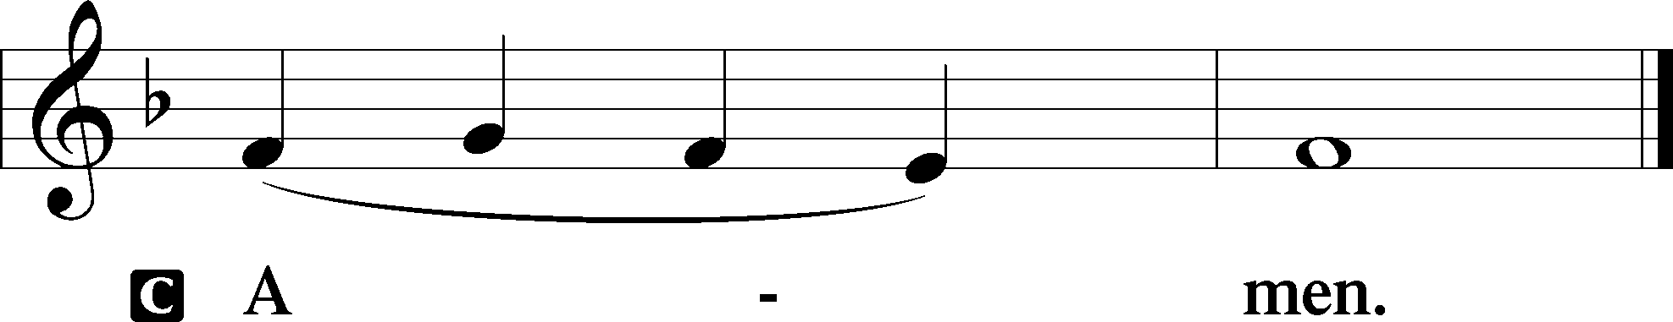

Agnus Dei John 1:29
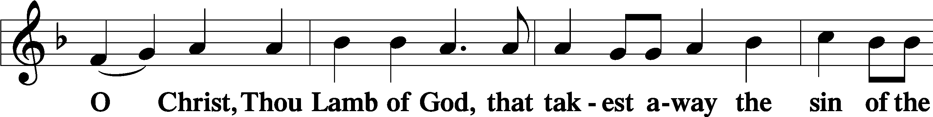
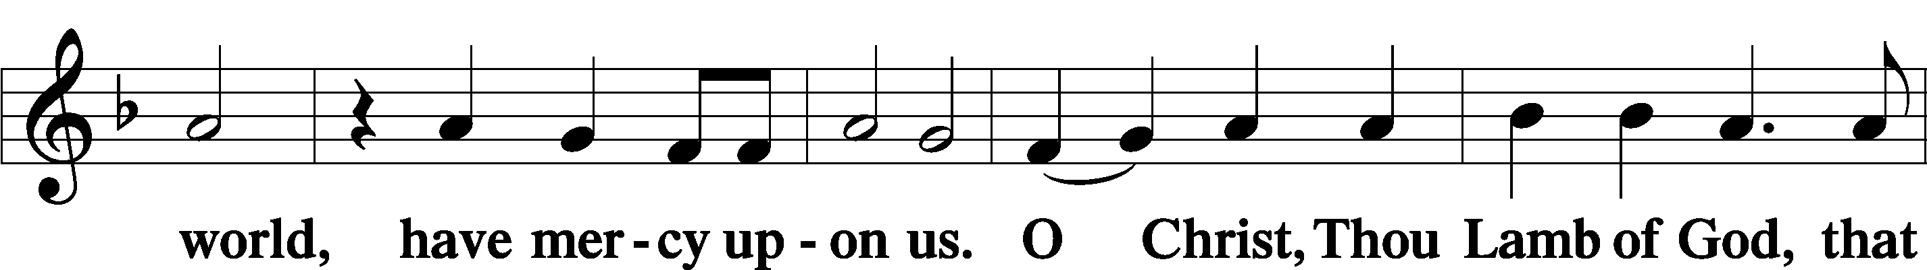
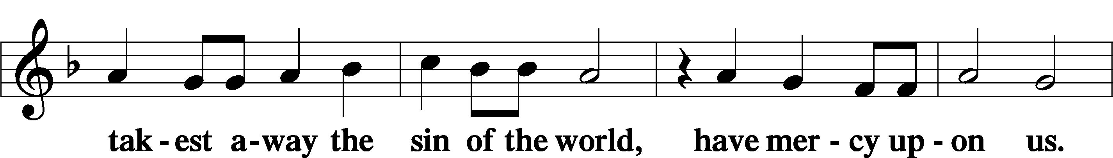
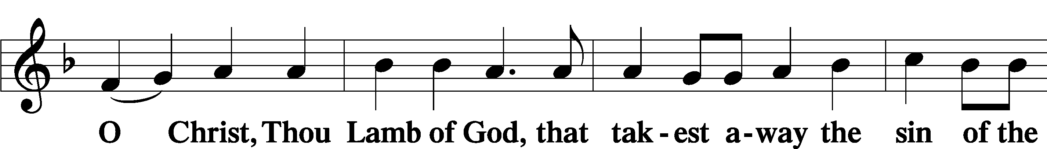
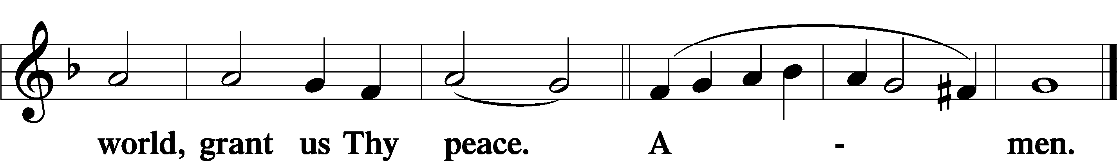
Sit

Distribution
The pastor and those who assist him receive the body and blood of Christ first and then distribute them to those who come to receive, saying:
Take, eat; this is the true body of our Lord and Savior Jesus Christ, given into death for your sins.
Amen.

Take, drink; this is the true blood of our Lord and Savior Jesus Christ, shed for the forgiveness of your sins.
Amen.

In dismissing the communicants, the following is said:
The Dismissal
P The body and blood of our Lord Jesus Christ strengthen and preserve you in body and soul to life everlasting. Depart T in peace.
C Amen.

Distribution Hymn: LSB #622 “Lord Jesus Christ, You Have Prepared”

Distribution Hymn: LSB #630 “Now, My Tongue, the Mystery Telling”

Distribution Hymn: LSB #820 “My Soul, Now Praise Your Maker”

Stand

Nunc Dimittis Luke 2:29–32
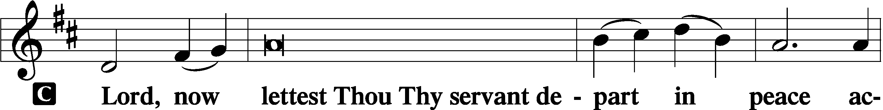
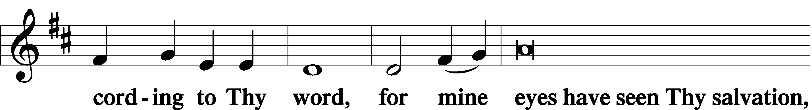
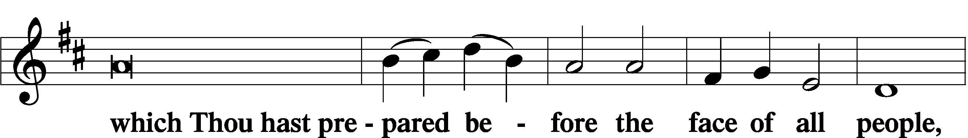
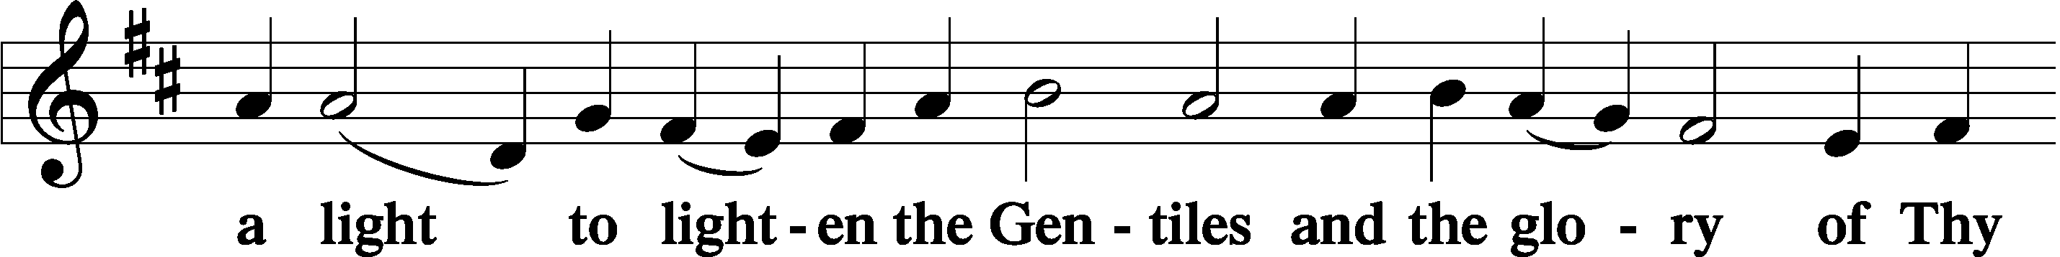
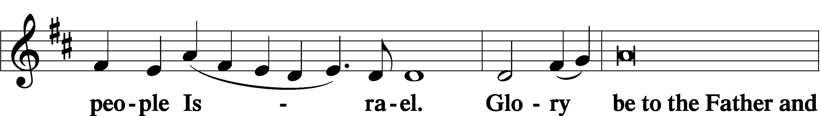
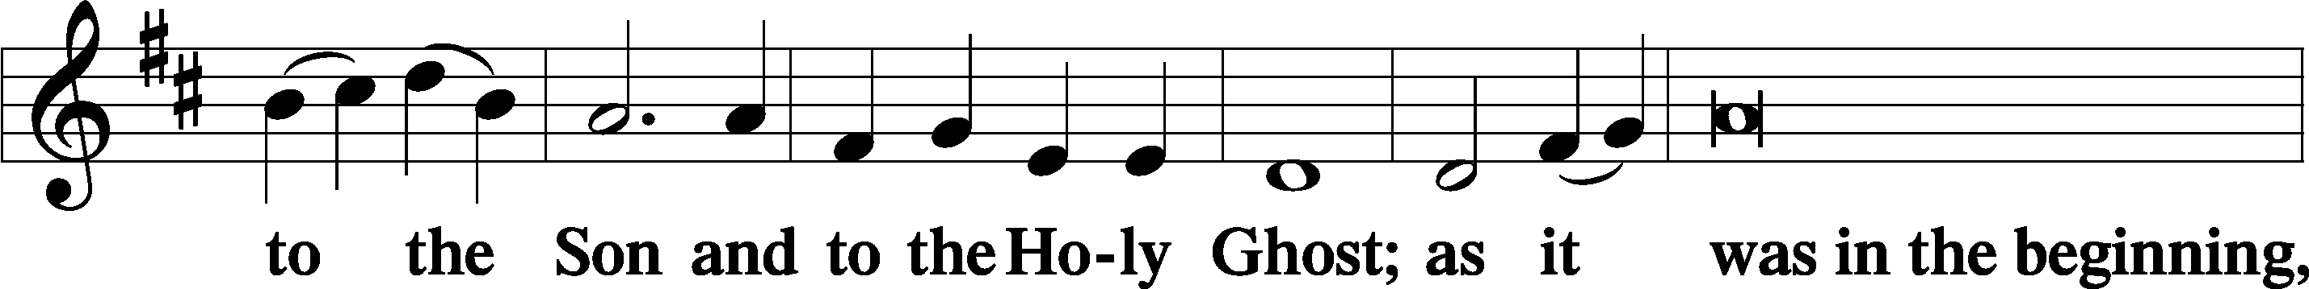
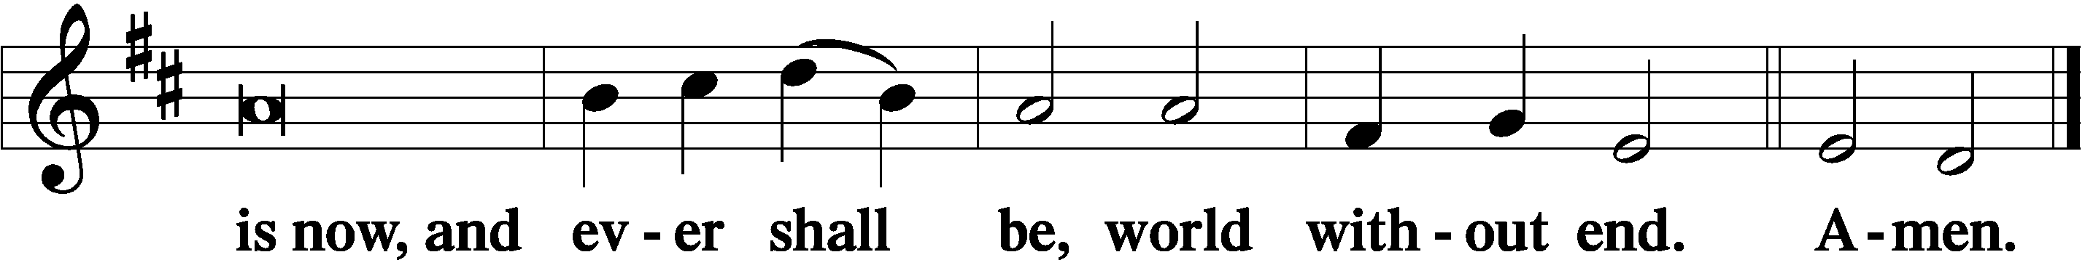

Thanksgiving Psalm 107:1
P O give thanks unto the Lord, for He is good,
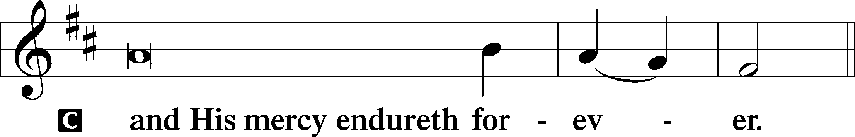

Post-Communion Collect
P Let us pray.
We give thanks to You, almighty God, that You have refreshed us through this salutary gift, and we implore You that of Your mercy You would strengthen us through the same in faith toward You and in fervent love toward one another; through Jesus Christ, Your Son, our Lord, who lives and reigns with You and the Holy Spirit, one God, now and forever.
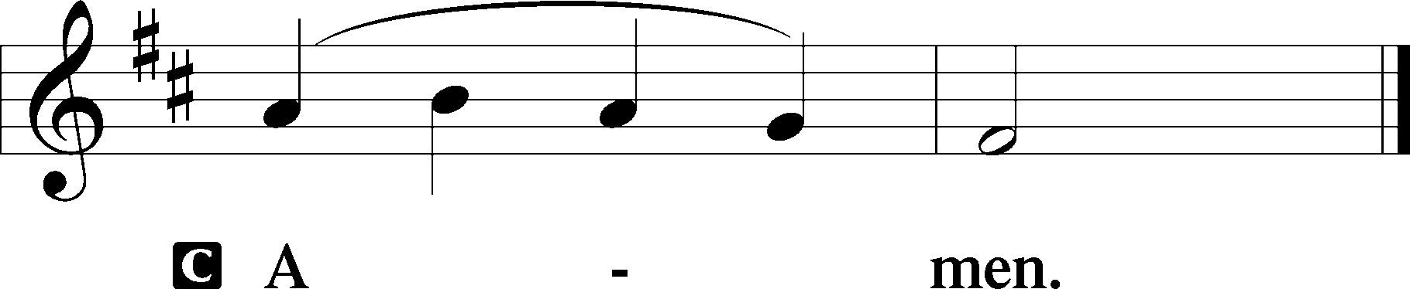

Salutation 2 Timothy 4:22
P The Lord be with you.
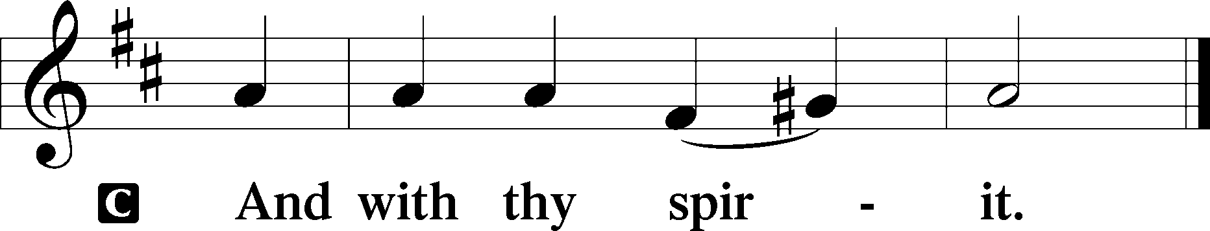

Benedicamus Psalm 103:1
P Bless we the Lord.
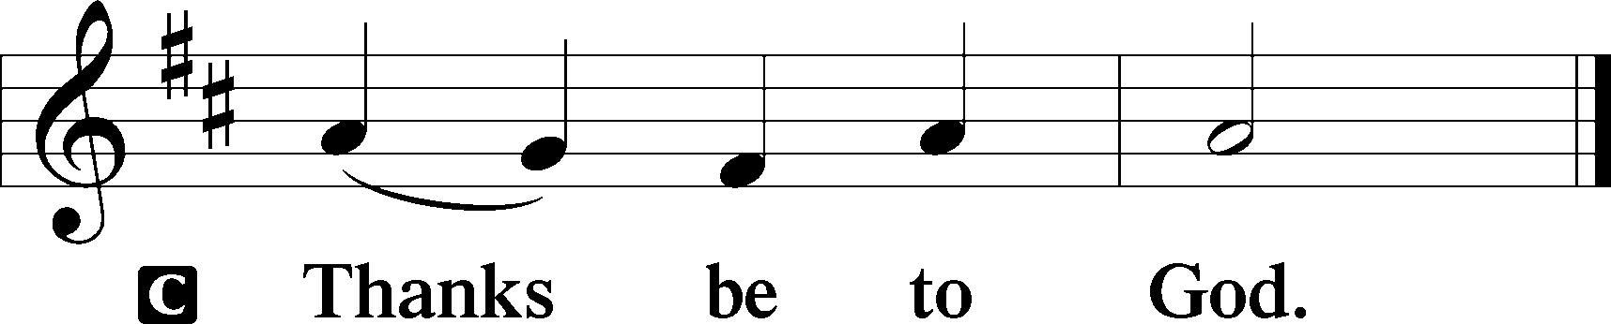

Benediction Numbers 6:24–26
P The Lord bless you and keep you.
The Lord make His face shine upon you and be gracious unto you.
The Lord lift up His countenance upon you and T give you peace.
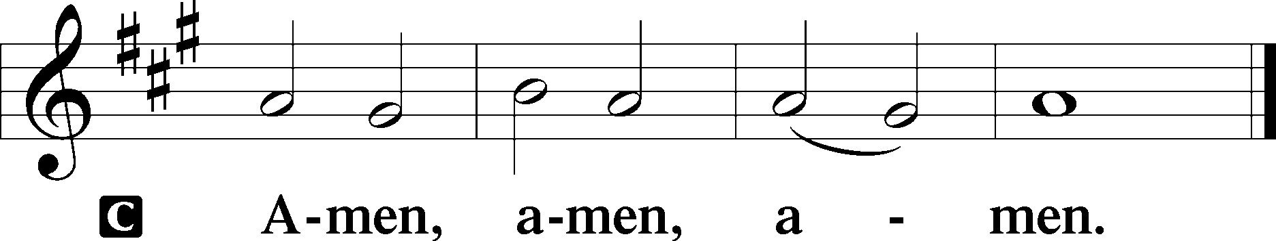

Closing Hymn: LSB #897 “O Rejoice, Ye Christians, Loudly”

Silent prayer after worship: O Heavenly Father, You have entrusted me with a priceless inheritance: the Gospel of Christ. Give me faith to believe the Gospel and boldness to share it with others. In Jesus’ name. Amen.
fffffffffffffffffffffffffffffffffff
Acknowledgments
Unless otherwise indicated, Scripture quotations are from the ESV® Bible (The Holy Bible, English Standard Version®), copyright © 2001 by Crossway, a publishing ministry of Good News Publishers. Used by permission. All rights reserved.
Created by Lutheran Service Builder © 2023 Concordia Publishing House.
fffffffffffffffffffffffffffffffffff
fffffffffffffffffffffffffffffffffff
In Loving Memory of Anson Holcroft: Michael & Kati Laird (Food Pantry), Frances Pavcik, Roger Thomsen & Darlene Christen (Food Pantry & Capital Campaign), Linda Tomko.
In Loving Memory of David Nelson: Diane Riefstahl (Food Pantry).
fffffffffffffffffffffffffffffffffff
Attendance: Sunday, March 12, 2023: 26
Wednesday, March 15: 27 (10~noon; 17~7pm)
fffffffffffffffffffffffffffffffffff
THANK YOU FOR SERVING IN MARCH: Elder: Jonathan Baisch; Ushers: Cheryl Fedele, Mike Flaugher, and Jesse Riffle; Altarware: (prior) Diane Riefstahl & Marie Flaugher (03/12); (after) Elizabeth Haenftling & Traudi Sulek.
fffffffffffffffffffffffffffffffffff
Submissions for the April calendar and issue of “The Rock and the Sword” are due to the secretary’s office no later than noon, Monday, March 20th.
fffffffffffffffffffffffffffffffffff
Minutes from the March 5th VOTERS’ ASSEMBLY are available on the table in the narthex.
SCHEDULE THROUGH MARCH 26, 2023:

:

Today, Following Worship, Library: Audit of Deposits
7 pm, Fellowship Hall: AA Meeting
Tuesday, 7 pm, All Saints~Slippery Rock: Lenten Midweek Vespers Service
7-9 pm, Fellowship Hall: Penn-Ohio Singers
Wednesday, Noon, Sanctuary: Lenten Midweek Matins Service
1 pm, Sonshine Room: Altar Guild Polishing
5:30 pm, Sanctuary: Choir Rehearsal
7 pm, Sanctuary: Lenten Midweek Vespers Service
7:30 pm, Fellowship Hall: NA Meeting
Thursday, 9 am, Downstairs: Food Pantry
Saturday, 9 am, All Saints~Slippery Rock: Catechism Class
7 pm, Sanctuary: Vespers Service celebrating the Annunciation of Our Lord
Next Sunday, 8 am, Fellowship Hall: Bible Study
9 am, Sanctuary: Divine Service
7 pm, Fellowship Hall: AA Meeting
fffffffffffffffffffffffffffffffffff
Bible Memory Verses ~ Week of March 19th:
For Adults: My son, keep your father's commandment, and forsake not your mother's teaching. Listen to your father who gave you life, and do not despise your mother when she is old. Proverbs 6:20; 23:22
For Children: Unless a grain of wheat falls into the earth and dies, it remains alone; but if it dies, it bears much fruit. John 12:24
fffffffffffffffffffffffffffffffffff
Members of the Altar Guild polishing committee will be meeting this coming Wednesday at 1 pm to polish items in preparation for the Easter season. We will meet in the Sonshine Room.
fffffffffffffffffffffffffffffffffff
There is an insert in today’s bulletin for those interested in purchasing Easter flowers (Easter lilies and daffodils) to adorn our sanctuary Easter Sunday. The choice of flowers this year is limited to accommodate those with allergies. Orders and payment are due next Sunday, March 26th.
Our Stewardship of Treasures for the Lord:
In order to do the Lord’s work, we need $2,553.63 each week to meet our 2023 budget for general purposes and $76.92 for the SELC.
Figures for Wednesday, March 8, 2023
General Fund: $205.00
Food Pantry: $25.00
Capital Campaign: $150.00
Other: $9.00
Figures for Sunday, March 12, 2023
General Fund: $3,388.00^ Ahead for the week*: +$1,039.37
SELC: $35.00 Behind for the week*: -$41.92
Food Pantry: $110.00
Quarterly Missions: $150.00 ^2 deposits combined.
Capital Campaign: $60.00 *Includes above figures.
Other: $26.00

For online giving, check out https://www.saintspeterandpaul.net/online-giving.
fffffffffffffffffffffffffffffffffff
Choir members are reminded that there will be practice this Wednesday.
fffffffffffffffffffffffffffffffffff
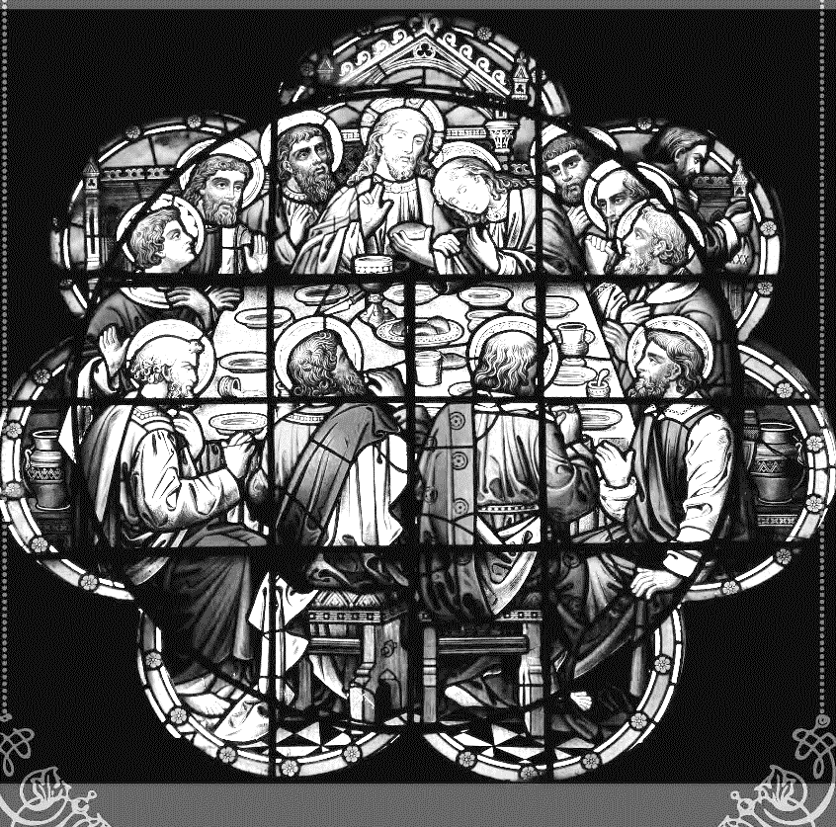
Join us this Lenten season as we focus on the Lord’s Supper with the following Wednesday midweek services through the end of March:
Matins Service at Noon
Vespers Service at 7 pm

fffffffffffffffffffffffffffffffffff
Copies of the “Portals of Prayer” for April, May, and June 2023 are available in the narthex and main hallway.
fffffffffffffffffffffffffffffffffff

Remember the following in Prayer…
~The Hurting and Healing: The family and friends of David Nelson, brother of Barry Nelson, who passed away March 5th; Amy, Gerald Arthur, Evelyn Baisch, Ellen Baron^{CA}, Lois Bortner^{CA}, John Burdette, Bev & Joe Chlpka, Kathleen Coughenour, Kim, Anna Mae Daris, Susan Davies, Tim Dudash, Millie Elavsky, Joseph Fleet, Judith & Eddy Furey, Tim Haenftling, Austin Hamilton, Neil Huston, Joan, Darla Krajci, Barbara Kreske, Donna Kennedy, Jess Lavoie, Paul Lucas^{CA}, Sandy Marshall, Frank Niemeyer^{CA}, Linda Parkany, Juanita Rentschler, Richard Reuning^{CA}, Diane Riefstahl, Nancy Robertson^{CA}, Viola Sakony, Marty Scott, Kara, Fred Tonty, Angela Weser^{CA}, and Ruth Wolf.
~The Homebound: Rudy & Jean Tomko, Betty Wolf, and Ed & Millie Zachar.
~Celebrating: Birthday ~ Michael Laird (03.23).
~Serving in the Military: Curtis Sinewe and Joshua Solyan.
~Community & World Needs: Those suffering from or affected by the coronavirus; those suffering due to the conflict between Ukraine and Russia; those suffering from loss and dislocation because weather disasters; those suffering from addiction and their families; Local, State, and National Government Leaders; safety for all Police Officers, Firefighters, & First Responders; the unemployed; our First Quarter Local Mission: Sts. Peter & Paul’s Community Day 2023. *CA represents cancer.
fffffffffffffffffffffffffffffffffff
Join us Saturday, March 25th,
at 7 pm,
for a Vespers Service
celebrating the
Annunciation of Our Lord.

fffffffffffffffffffffffffffffffffff

Here to Serve
Pastor………………………………………………...……………Rev. Jacob Deal
E-mail …………………………….……pastordeal@saintspeterandpaul.net
Phone Number……………………..…………………724-347-3620 (Option 2)
Church Office………………………..…………………724-347-3620 (Option 3)
Website …………………………………………www.saintspeterandpaul.net
Secretary…………………………………………………………Diane Riefstahl
E-mail ………………………………………church@saintspeterandpaul.net
Website …………………………………………www.saintspeterandpaul.net
Food Pantry: Please leave message……………724-347-3620 (Option 3)
AA Contact: Steve………………………………………………..…724-813-2358
NA Contact: Larry………………………………………………..724-977-8733
Choir Director………………………………………………………Chris Nelson
Congregation President……………………………………Jonathan Baisch
Church Elder …………………………………………...…… Jonathan Baisch
fffffffffffffffffffffffffffffffffff
If needing to get into the church building during the week, please phone first to make certain someone is here to let you in.

