Sts. Peter & Paul
Evangelical Lutheran Church
Lutheran Church-Missouri Synod
Founded-1917

June 4, 2023

699 Stambaugh Ave.
Sharon, Pennsylvania 16146

“I was glad when they said to me,
Let us go to the house of the LORD!”
Psalm 122:1
Sts. Peter & Paul Evangelical Lutheran Church, LC-MS
TRINITY SUNDAY
June 4, 2023

A special welcome to our guests this day! If you would like more information about The Lutheran Church - Missouri Synod, or this congregation, please speak with Pastor Deal or an Elder after the service.
Members & Guests: Don’t be embarrassed if your children make noise during the worship service, all children do. We encourage families to worship together but, if you feel the need, there are pews in the rear of the Church which are reserved for young families on both sides of the sanctuary. There is also a quiet room available to you during our service which is located down the hallway past the offices on the right side of the church as well as a children’s area in the Fellowship Hall where you are able to follow along with the service.

Today’s service includes the Sacrament of Holy Communion. If during this past year, you have not worshipped with us and been communed, we respectfully ask that you do not partake of this sacrament this day before first speaking with Pastor Deal.
If visiting from a sister congregation of the LC-MS and are in good standing, please inform Pastor Deal of your desire to commune prior to the service.
If wishing to receive a blessing during communion, please approach with your arms crossed.

CONTACT INFORMATION
Pastor Deal: pastordeal@saintspeterandpaul.net or 724-347-3620 (opt. 2)
Church Office: church@saintspeterandpaul.net or 724-347-3620 (opt. 3)
Secretary’s Office will be open Monday and Thursday (8:30-4:30) this week.

Silent prayer before worship: Heavenly Father, I thank You for the many blessings I enjoy each day. Jesus, I thank You for dying and rising so that I can have life now and forever. Holy Spirit, I thank You for enabling me to believe and be saved. Amen.
Holy Baptism

Opening Hymn: LSB #590 “Baptized Into Your Name Most Holy””

Rite of Holy Baptism LSB pp 268-271.

Confession and Absolution

Exhortation Hebrews 10:22; Psalm 124:8; Psalm 32:5
P Beloved in the Lord! Let us draw near with a true heart and confess our sins unto God our Father, beseeching Him in the name of our Lord Jesus Christ to grant us forgiveness.

P Our help is in the name of the Lord,
C who made heaven and earth.
P I said, I will confess my transgressions unto the Lord,
C and You forgave the iniquity of my sin.

Silence for reflection on God’s Word and for self-examination.

Confession of Sins
P O almighty God, merciful Father,
C I, a poor, miserable sinner, confess unto You all my sins and iniquities with which I have ever offended You and justly deserved Your temporal and eternal punishment. But I am heartily sorry for them and sincerely repent of them, and I pray You of Your boundless mercy and for the sake of the holy, innocent, bitter sufferings and death of Your beloved Son, Jesus Christ, to be gracious and merciful to me, a poor, sinful being.

Absolution [John 20:19–23]
P Upon this your confession, I, by virtue of my office, as a called and ordained servant of the Word, announce the grace of God unto all of you, and in the stead and by the command of my Lord Jesus Christ I forgive you all your sins in the name of the Father and of the T Son and of the Holy Spirit.
C Amen.

Service of the Word

Introit Psalm 8:1–2a, 3–5; antiphon: Liturgical Text
Blessèd be the Holy Trinity and the undivided | Unity.*
Let us give glory to him because he has shown his mer- | cy to us.
O | Lord, our Lord,*
how majestic is your name in | all the earth!
You have set your glory above the | heavens.*
Out of the mouth of babes and infants, you have es- | tablished strength.
When I look at your heavens, the work of your | fingers,*
the moon and the stars, which you have | set in place,
what is man that you are mind- | ful of him,*
and the son of man that you | care for him?
Yet you have made him a little lower than the heavenly | beings*
and crowned him with glory and | honor.
Blessèd be the Holy Trinity and the undivided | Unity.*
Let us give glory to him because he has shown his mer- | cy to us.

Gloria Patri
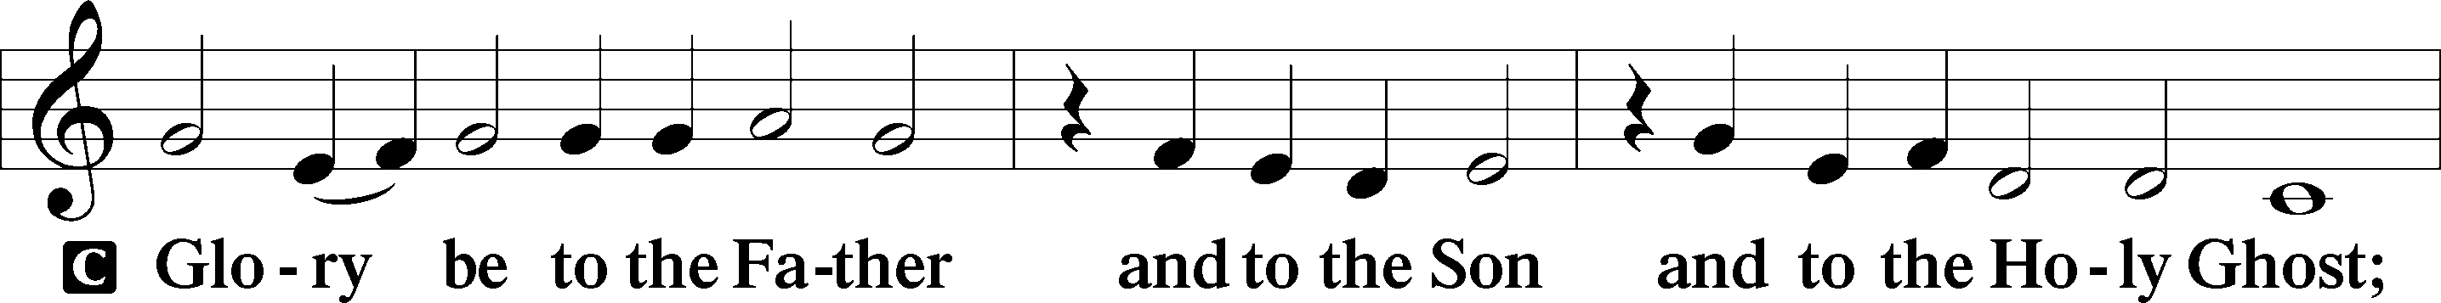
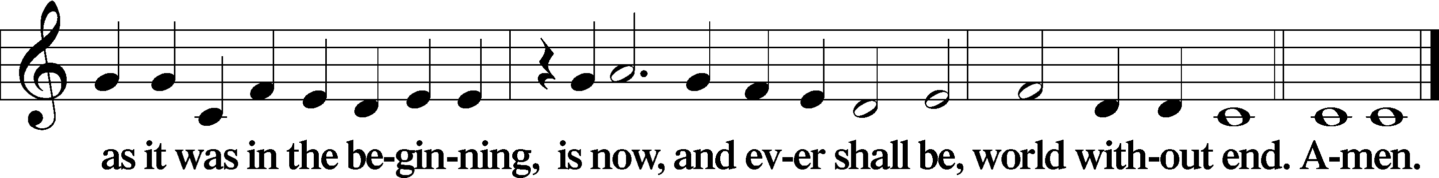

Kyrie Mark 10:47
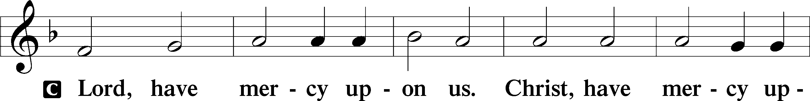
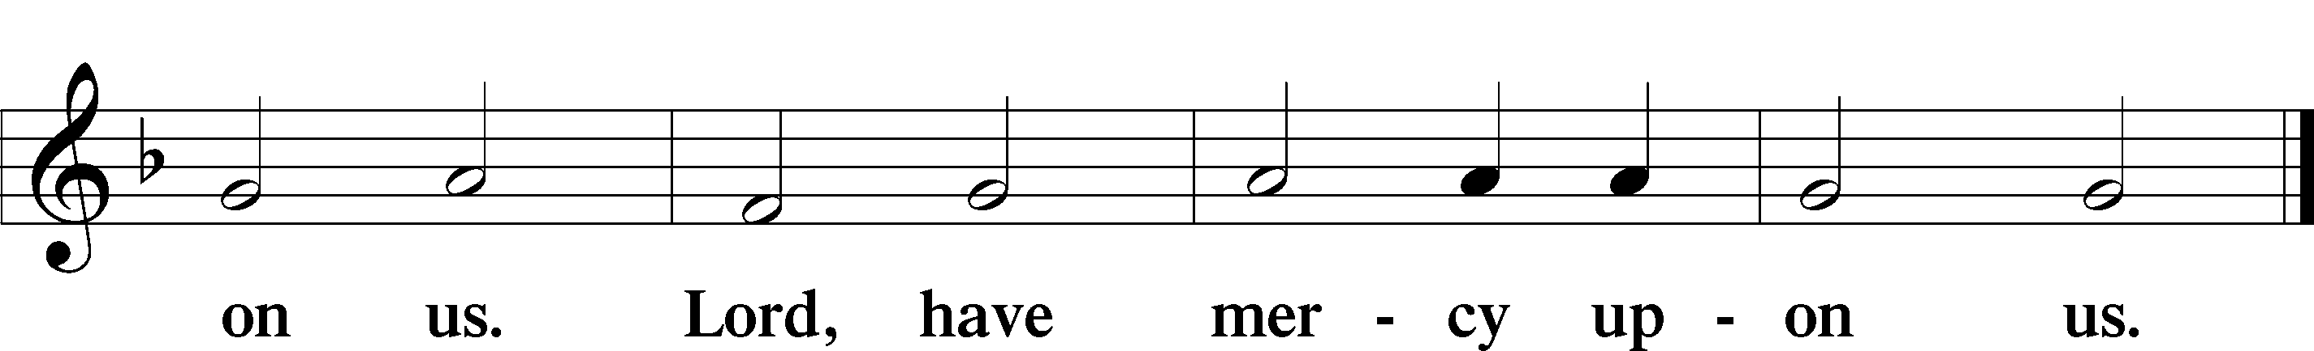

Gloria in Excelsis Luke 2:14; John 1:29
P Glory be to God on high:
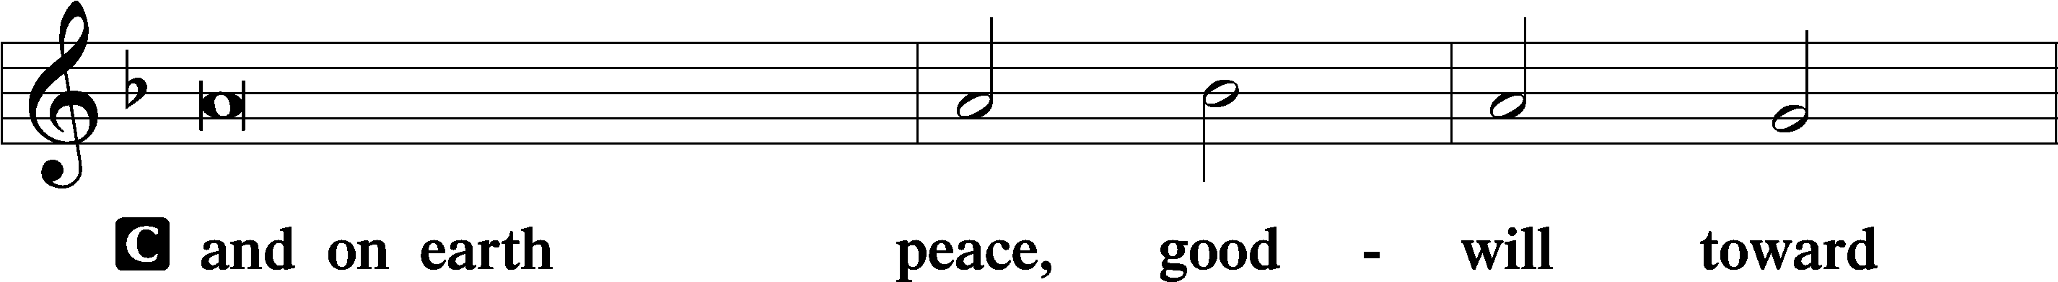
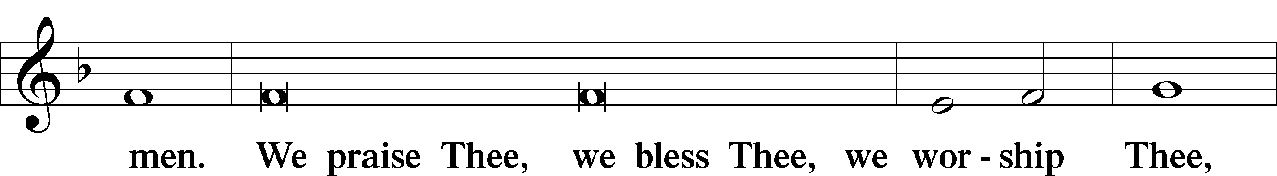
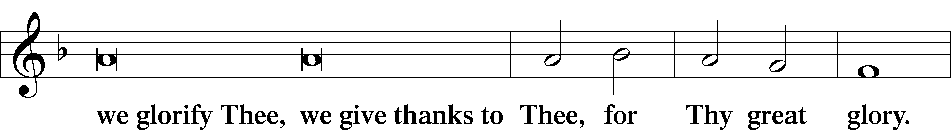
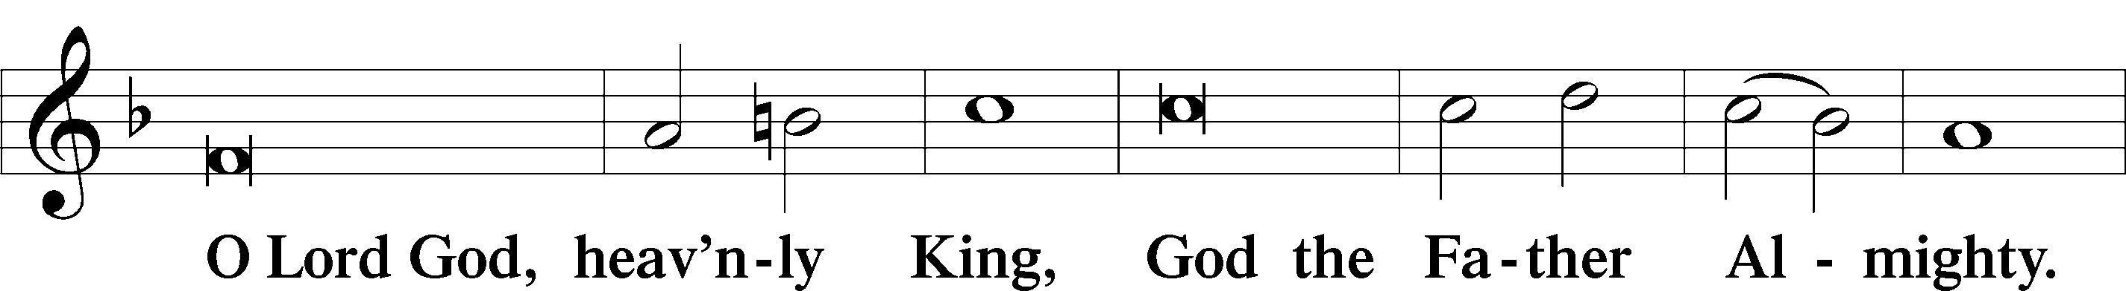
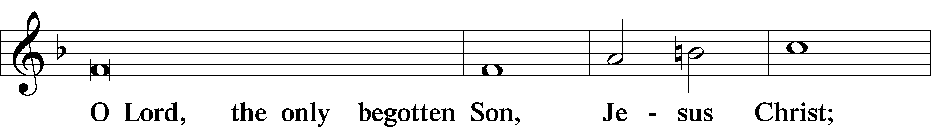
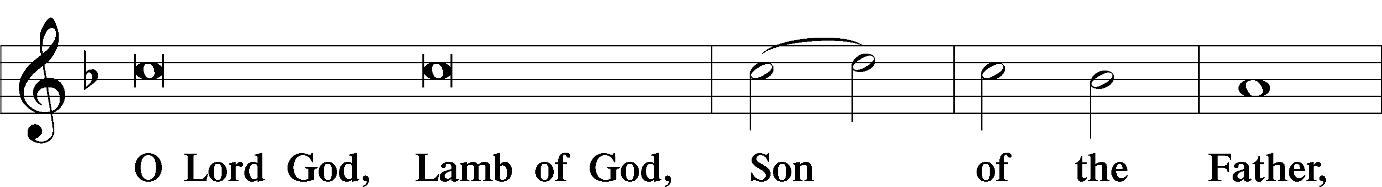
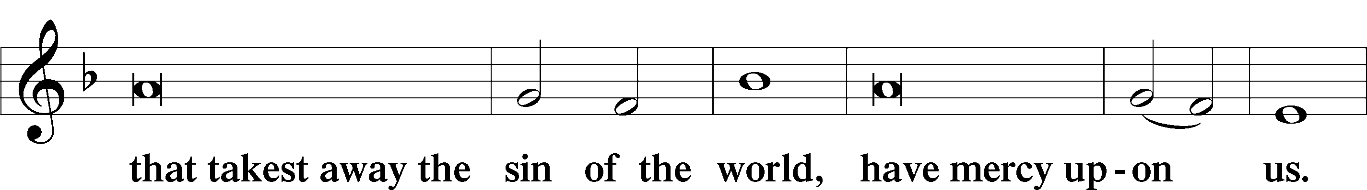
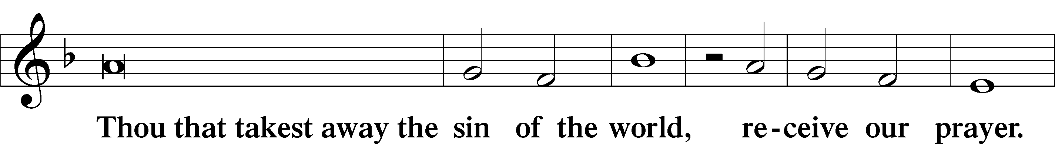
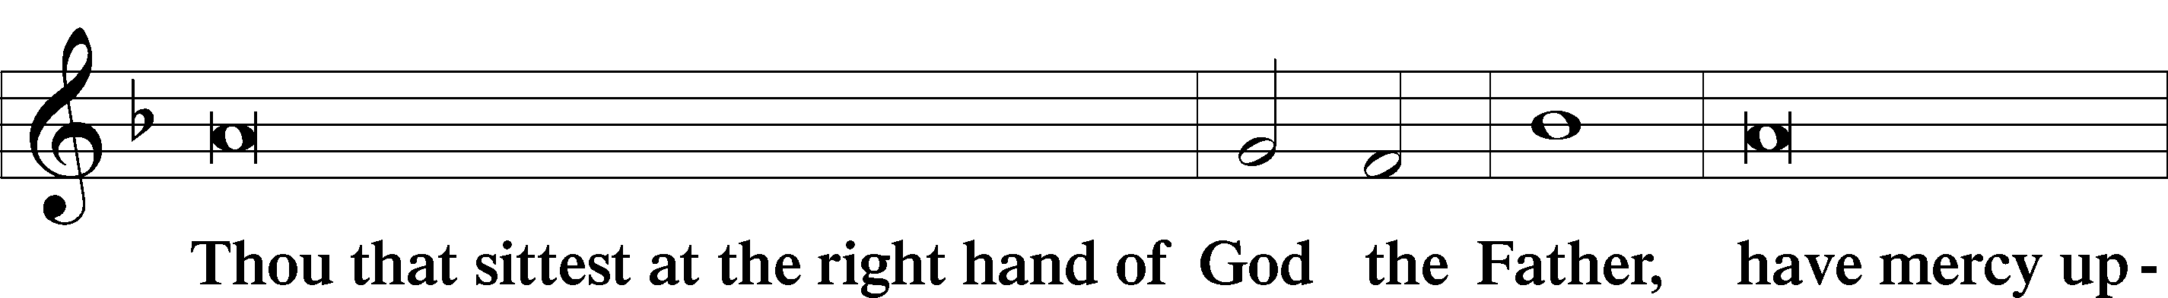
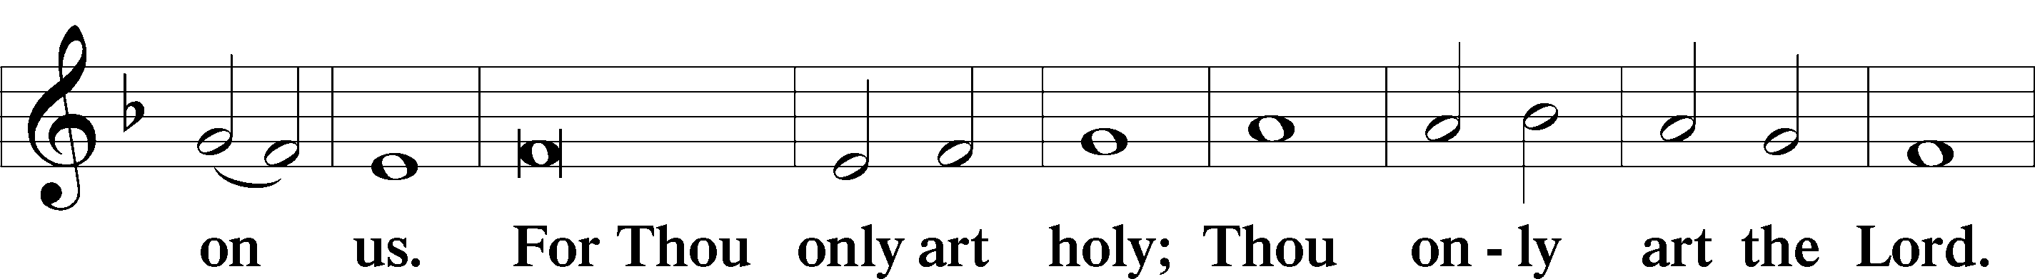
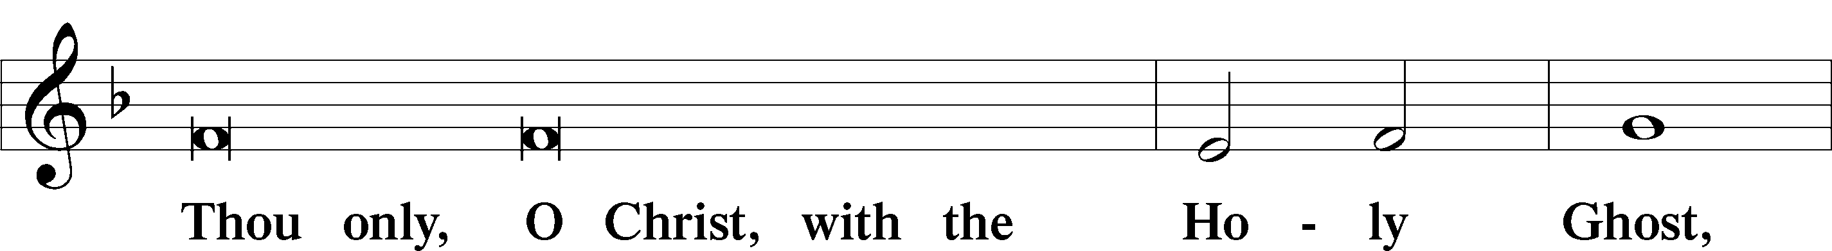
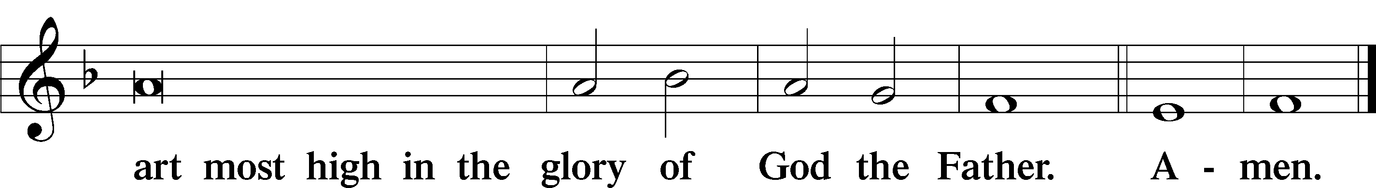

Salutation and Collect of the Day: Holy Trinity
P The Lord be with you.
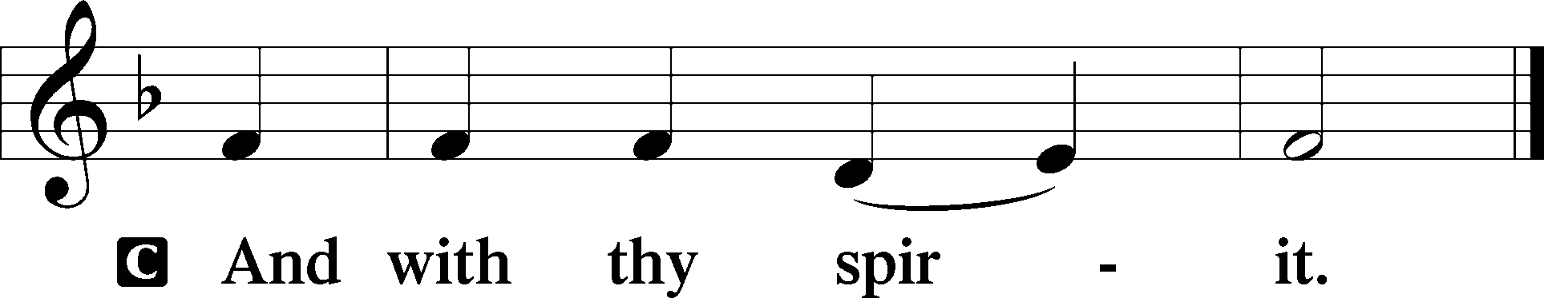

P Let us pray.
Almighty and everlasting God, You have given us grace to acknowledge the glory of the eternal Trinity by the confession of a true faith and to worship the Unity in the power of the Divine Majesty. Keep us steadfast in this faith and defend us from all adversities; for You, O Father, Son, and Holy Spirit, live and reign, one God, now and forever.
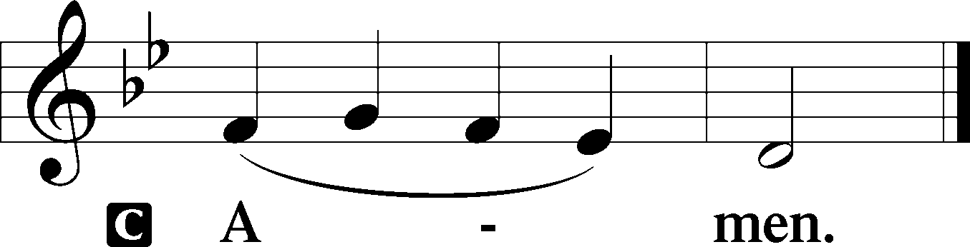
Sit

Prophecy: Isaiah 6:1–7 (NKJV)
In those days: In the year that King Uzziah died, I saw the Lord sitting on a throne, high and lifted up, and the train of His robe filled the temple. Above it stood seraphim; each one had six wings: with two he covered his face, with two he covered his feet, and with two he flew. And one cried to another and said: “Holy, holy, holy is the Lord of hosts; the whole earth is full of His glory!” And the posts of the door were shaken by the voice of him who cried out, and the house was filled with smoke. So I said: “Woe is me, for I am undone! Because I am a man of unclean lips, and I dwell in the midst of a people of unclean lips; for my eyes have seen the King, the Lord of hosts.” Then one of the seraphim flew to me, having in his hand a live coal which he had taken with the tongs from the altar. And he touched my mouth with it, and said: “Behold, this has touched your lips; your iniquity is taken away, and your sin purged.”

P This is the Word of the Lord.
C Thanks be to God.

Gradual Liturgical Text
Blessèd are You, O Lord, who be- | holds the deep,*
and who dwells between the | cherubim.
Blessèd are You, O Lord, in the firmament of | heaven,*
and greatly to be praised for- | ever.

Epistle: Romans 11:33–36 (NKJV)
Brethren: Oh, the depth of the riches both of the wisdom and knowledge of God! How unsearchable are His judgments and His ways past finding out! “For who has known the mind of the Lord? Or who has become His counselor?” “Or who has first given to Him and it shall be repaid to him?” For of Him and through Him and to Him are all things, to whom be glory forever. Amen.

P This is the Word of the Lord.
C Thanks be to God.

Stand

Verse Liturgical Text
Alleluia. Blessed are you, O Lord God of our fathers, and greatly to be praised and glorified forever. Alleluia.

Alleluia
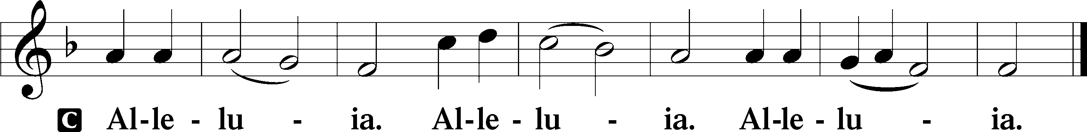

Holy Gospel: John 3:1–15 (NKJV)
P The Holy Gospel according to St. John, the third chapter.
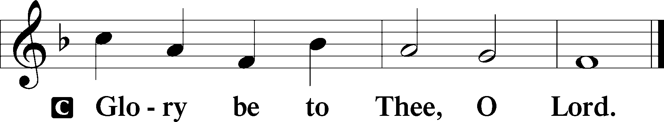

At that time: There was a man of the Pharisees named Nicodemus, a ruler of the Jews. This man came to Jesus by night and said to Him, “Rabbi, we know that You are a teacher come from God; for no one can do these signs that You do unless God is with him.” Jesus answered and said to him, “Most assuredly, I say to you, unless one is born again, he cannot see the kingdom of God.” Nicodemus said to Him, “How can a man be born when he is old? Can he enter a second time into his mother’s womb and be born?” Jesus answered, “Most assuredly, I say to you, unless one is born of water and the Spirit, he cannot enter the kingdom of God. That which is born of the flesh is flesh, and that which is born of the Spirit is spirit. Do not marvel that I said to you, ‘You must be born again.’ The wind blows where it wishes, and you hear the sound of it, but cannot tell where it comes from and where it goes. So is everyone who is born of the Spirit.” Nicodemus answered and said to Him, “How can these things be?” Jesus answered and said to him, “Are you the teacher of Israel, and do not know these things? Most assuredly, I say to you, We speak what We know and testify what We have seen, and you do not receive Our witness. If I have told you earthly things and you do not believe, how will you believe if I tell you heavenly things? No one has ascended to heaven but He who came down from heaven, that is, the Son of Man who is in heaven. And as Moses lifted up the serpent in the wilderness, even so must the Son of Man be lifted up, that whoever believes in Him should not perish but have eternal life.”

P This is the Gospel of the Lord.
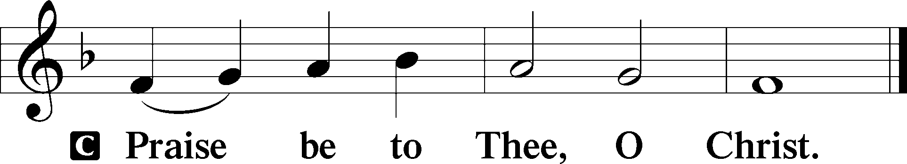

Athanasian Creed
C Whoever desires to be saved must, above all, hold the catholic faith.
Whoever does not keep it whole and undefiled will without doubt perish eternally.
And the catholic faith is this,
that we worship one God in Trinity and Trinity in Unity, neither confusing the persons nor dividing the substance.
For the Father is one person, the Son is another, and the Holy Spirit is another.
But the Godhead of the Father and of the Son and of the Holy Spirit is one: the glory equal, the majesty coeternal.
Such as the Father is, such is the Son, and such is the Holy Spirit:
the Father uncreated, the Son uncreated, the Holy Spirit uncreated;
the Father infinite, the Son infinite, the Holy Spirit infinite;
the Father eternal, the Son eternal, the Holy Spirit eternal.
And yet there are not three Eternals, but one Eternal,
just as there are not three Uncreated or three Infinites, but one Uncreated and one Infinite.
In the same way, the Father is almighty, the Son almighty, the Holy Spirit almighty;
and yet there are not three Almighties, but one Almighty.
So the Father is God, the Son is God, the Holy Spirit is God;
and yet there are not three Gods, but one God.
So the Father is Lord, the Son is Lord, the Holy Spirit is Lord;
and yet there are not three Lords, but one Lord.
Just as we are compelled by the Christian truth to acknowledge each distinct person as God and Lord, so also are we prohibited by the catholic religion to say that there are three Gods or Lords.
The Father is not made nor created nor begotten by anyone.
The Son is neither made nor created, but begotten of the Father alone.
The Holy Spirit is of the Father and of the Son, neither made nor created nor begotten, but proceeding.
Thus, there is one Father, not three Fathers; one Son, not three Sons; one Holy Spirit, not three Holy Spirits.
And in this Trinity none is before or after another; none is greater or less than another;
but the whole three persons are coeternal with each other and coequal, so that in all things, as has been stated above, the Trinity in Unity and Unity in Trinity is to be worshiped.
Therefore, whoever desires to be saved must think thus about the Trinity.
But it is also necessary for everlasting salvation that one faithfully believe the incarnation of our Lord Jesus Christ.
Therefore, it is the right faith that we believe and confess that our Lord Jesus Christ, the Son of God, is at the same time both God and man.
He is God, begotten from the substance of the Father before all ages; and He is man, born from the substance of His mother in this age:
perfect God and perfect man, composed of a rational soul and human flesh;
equal to the Father with respect to His divinity, less than the Father with respect to His humanity.
Although He is God and man, He is not two, but one Christ:
one, however, not by the conversion of the divinity into flesh, but by the assumption of the humanity into God;
one altogether, not by confusion of substance, but by unity of person.
For as the rational soul and flesh is one man, so God and man is one Christ,
who suffered for our salvation, descended into hell, rose again the third day from the dead,
ascended into heaven, and is seated at the right hand of the Father, God Almighty, from whence He will come to judge the living and the dead.
At His coming all people will rise again with their bodies and give an account concerning their own deeds.
And those who have done good will enter into eternal life, and those who have done evil into eternal fire.
This is the catholic faith; whoever does not believe it faithfully and firmly cannot be saved.
Sit

Hymn of the Day: LSB #954 “We All Believe in One True God”

Sermon

Stand

Prayer of the Church

Offertory Psalm 51:10–12
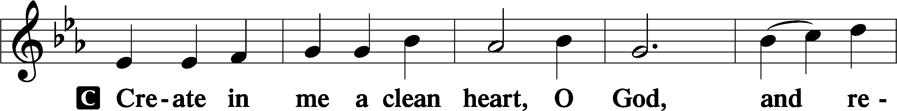
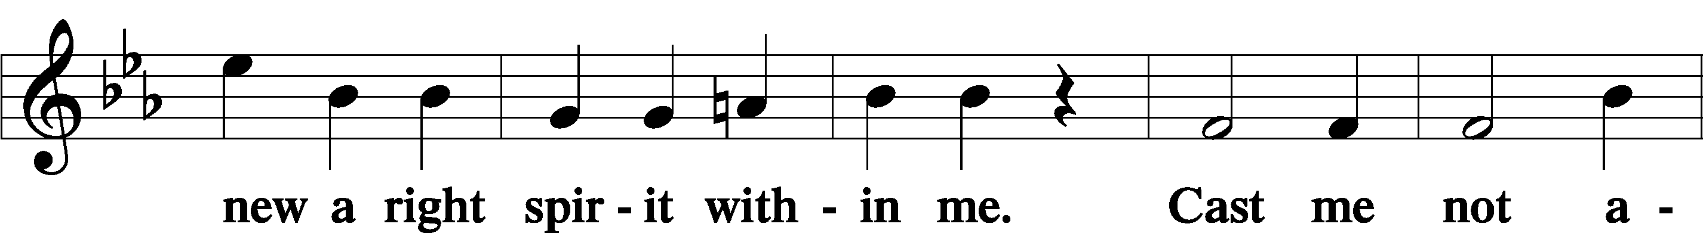
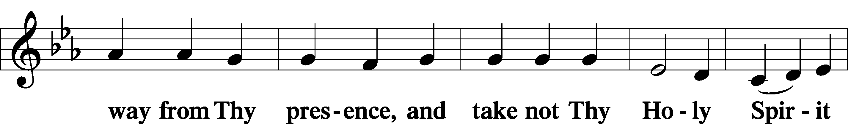
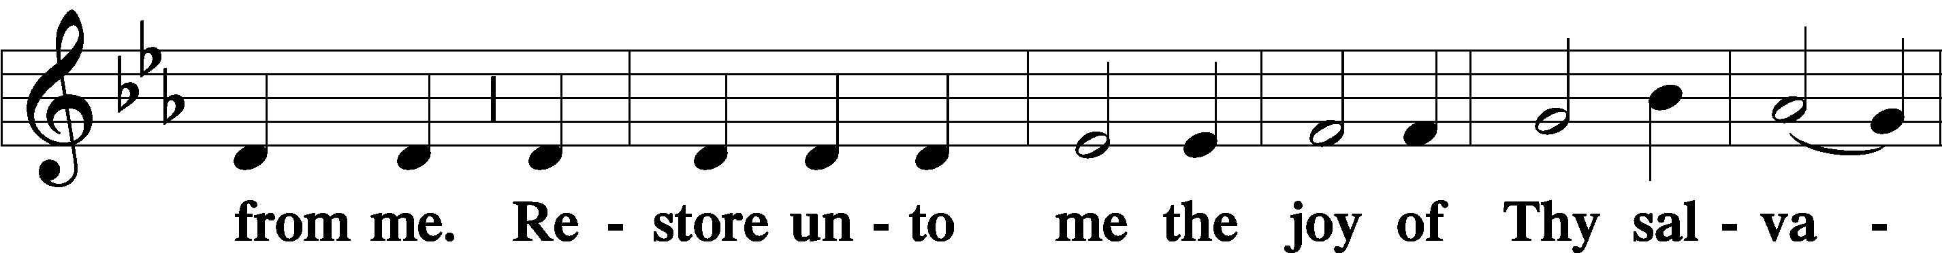
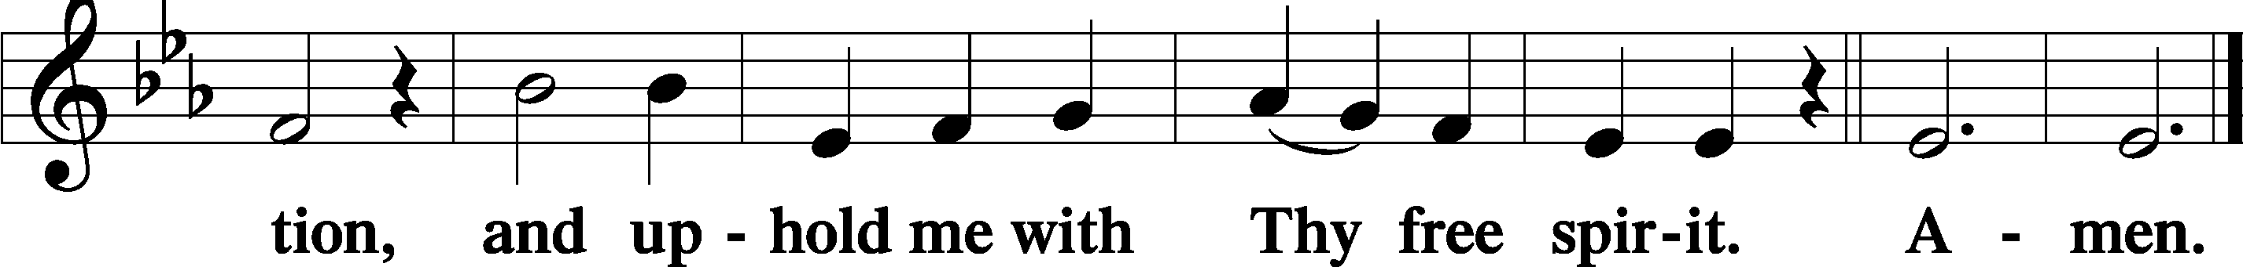
Sit

Preparatory Hymn: LSB #507 “Holy, Holy, Holy”

Stand
Service of the Sacrament

Preface 2 Timothy 4:22; Colossians 3:1 Psalm 136
P The Lord be with you.

P Lift up your hearts.
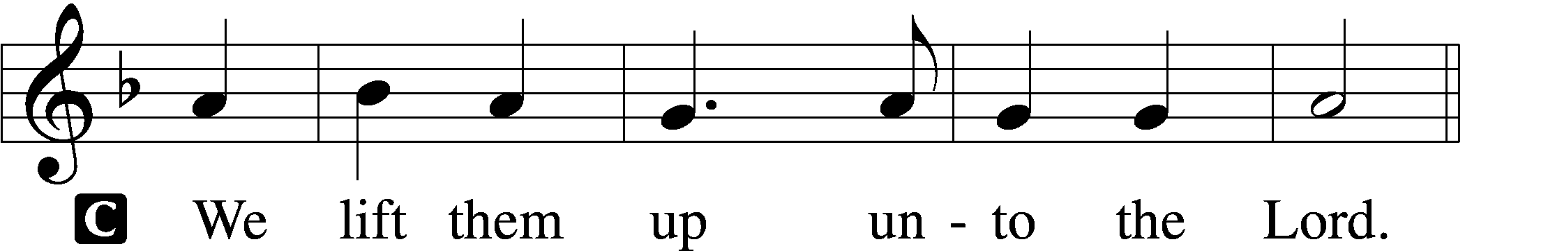

P Let us give thanks unto the Lord, our God.
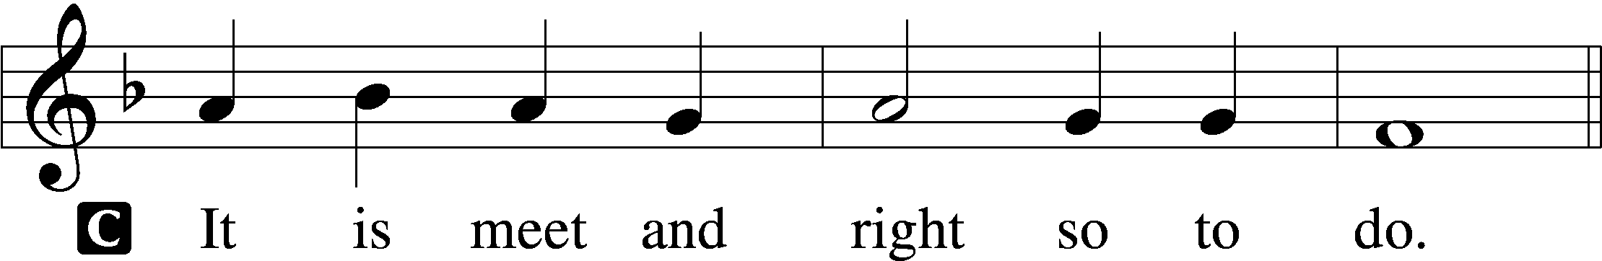

Proper Preface (Abbreviated) LSB 194
P It is truly meet, right, and salutary . . . evermore praising You and saying:

Sanctus Isaiah 6:3; Matthew 21:9
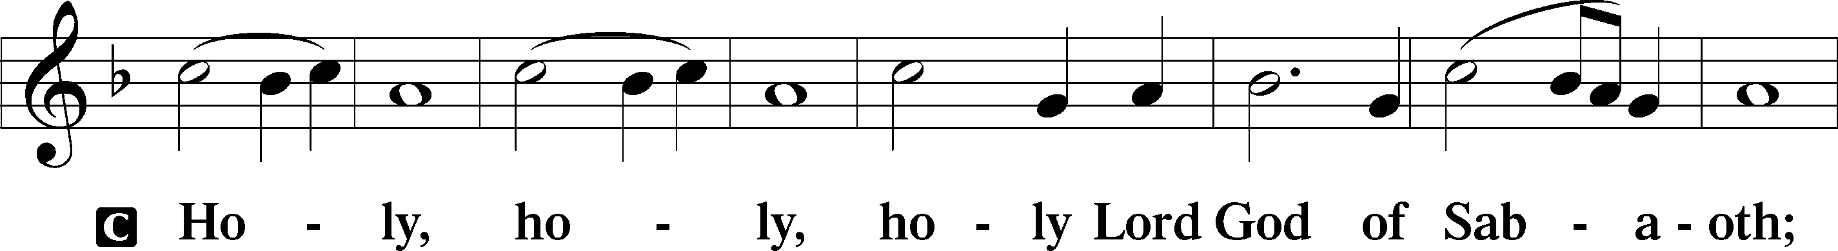
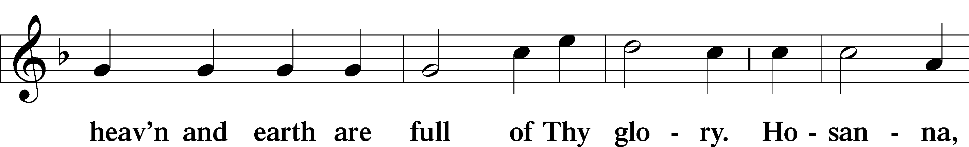
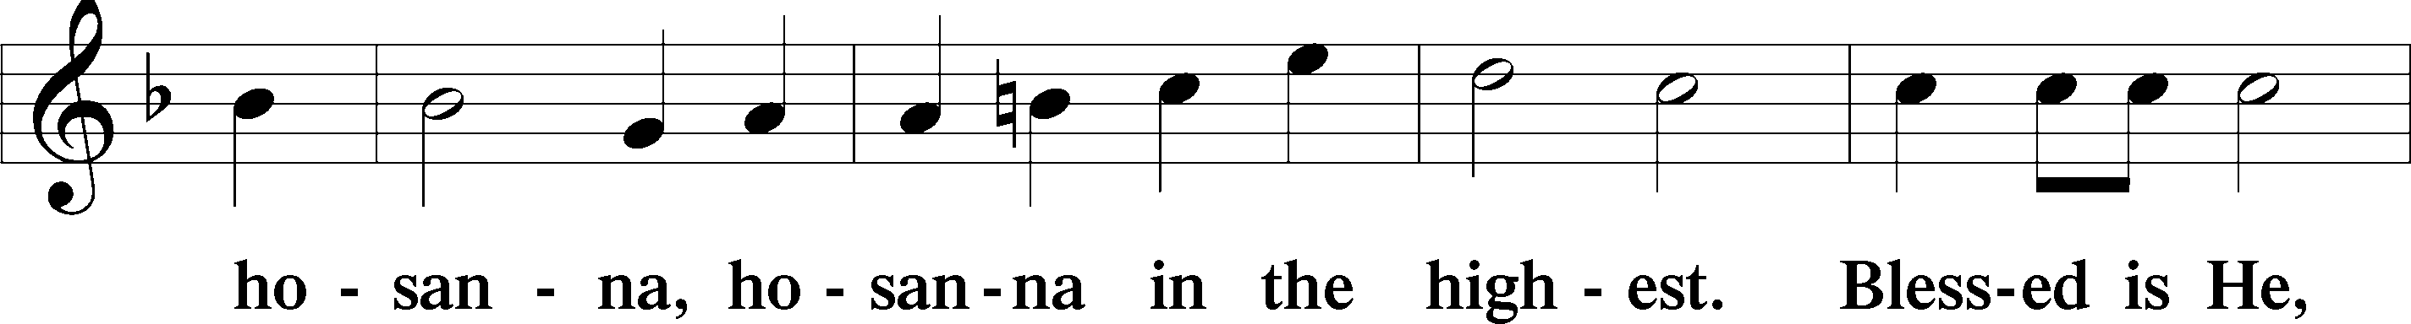
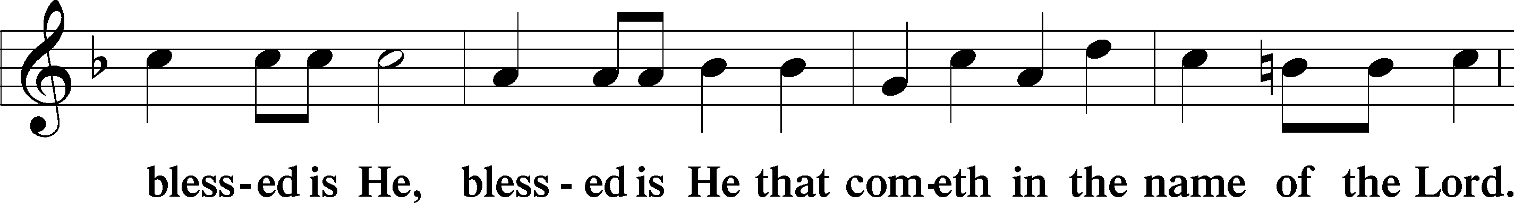
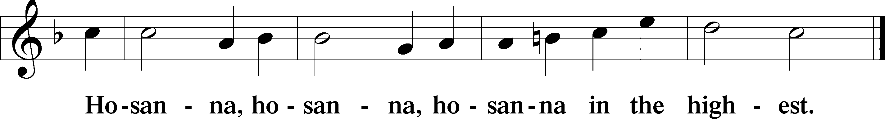

Lord’s Prayer Matthew 6:9–13
C Our Father who art in heaven,
hallowed be Thy name,
Thy kingdom come,
Thy will be done on earth as it is in heaven;
give us this day our daily bread;
and forgive us our trespasses as we forgive those who trespass against us;
and lead us not into temptation,
but deliver us from evil.
For Thine is the kingdom and the power and the glory forever and ever. Amen.

The Words of Our Lord Matthew 26:26–28; Mark 14:22–24; Luke 22:19–20; 1 Corinthians 11:23–25
P Our Lord Jesus Christ, on the night when He was betrayed, took bread, and when He had given thanks, He broke it and gave it to the disciples and said: “Take, eat; this is My T body, which is given for you. This do in remembrance of Me.”

In the same way also He took the cup after supper, and when He had given thanks, He gave it to them, saying: “Drink of it, all of you; this cup is the new testament in My T blood, which is shed for you for the forgiveness of sins. This do, as often as you drink it, in remembrance of Me.”

Pax Domini John 20:19
P The peace of the Lord be with you always.
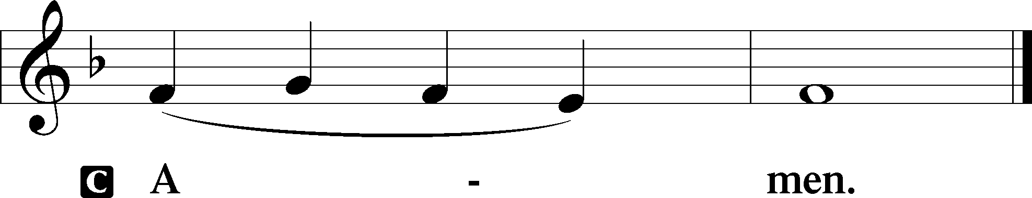

Agnus Dei John 1:29
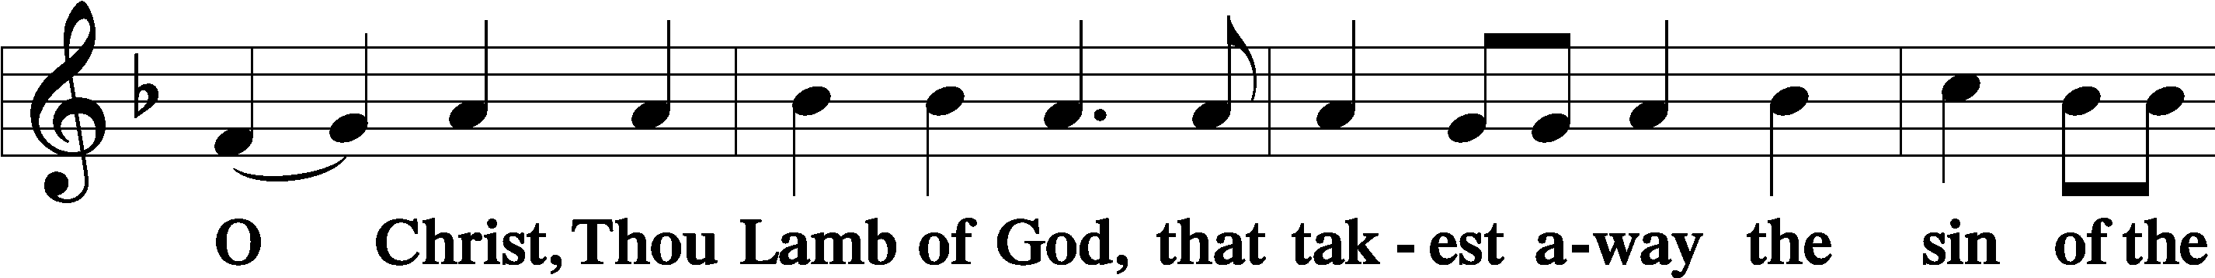
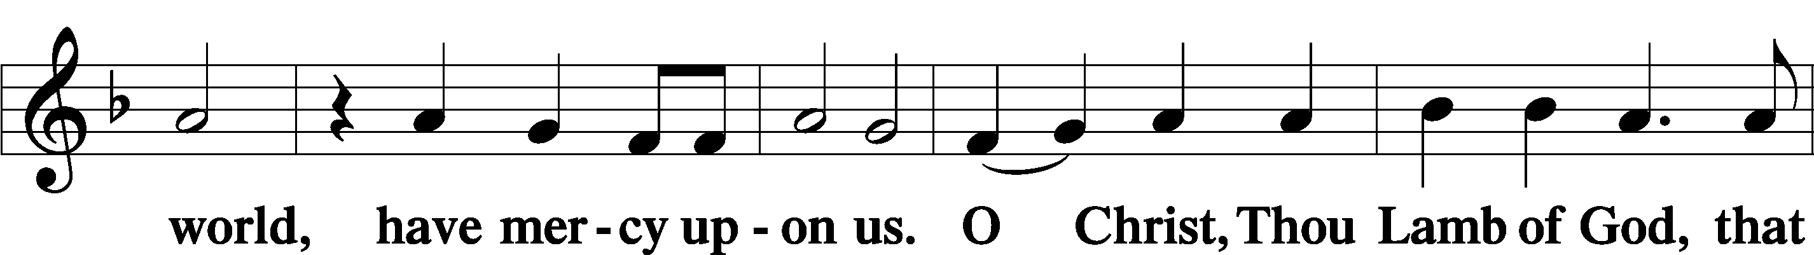
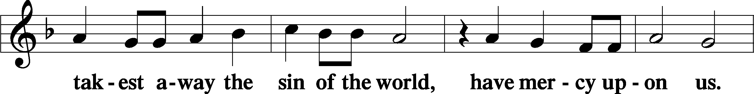
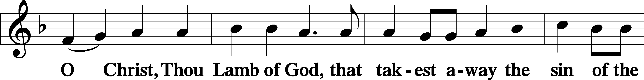
Sit

Distribution
The pastor and those who assist him receive the body and blood of Christ first and then distribute them to those who come to receive, saying:
Take, eat; this is the true body of our Lord and Savior Jesus Christ, given into death for your sins.
Amen.

Take, drink; this is the true blood of our Lord and Savior Jesus Christ, shed for the forgiveness of your sins.
Amen.

In dismissing the communicants, the following is said:
The Dismissal
P The body and blood of our Lord Jesus Christ strengthen and preserve you in body and soul to life everlasting. Depart T in peace.
C Amen.
Distribution Hymn: LSB #639 “Wide Open Stand the Gates”

Distribution Hymn: LSB #621” Let All Mortal Flesh Keep Silence”

Distribution Hymn: LSB #506 “Glory Be to God the Father”

Stand
Nunc Dimittis Luke 2:29–32
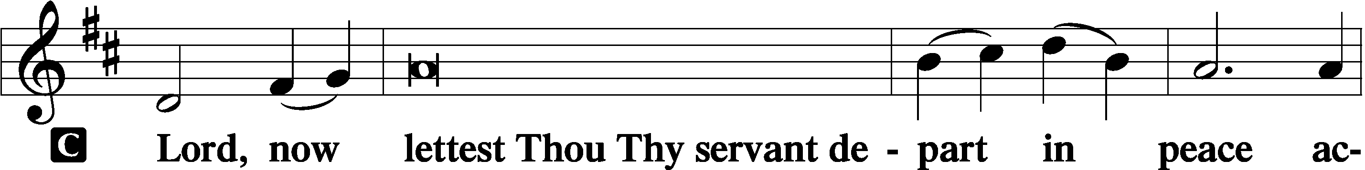
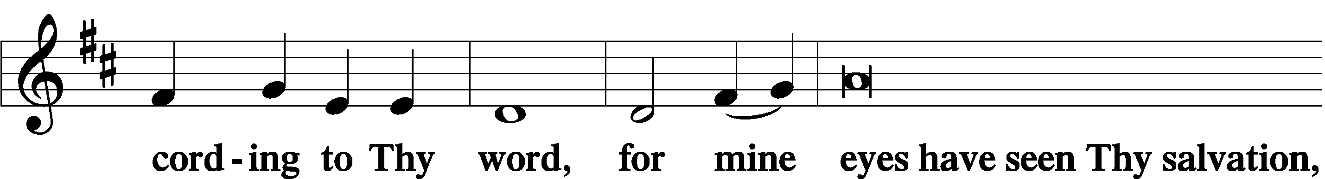
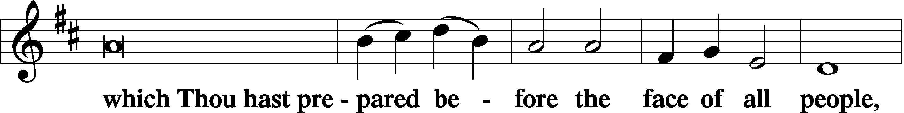
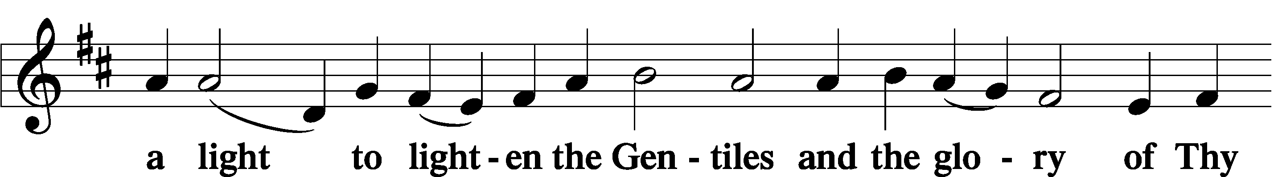
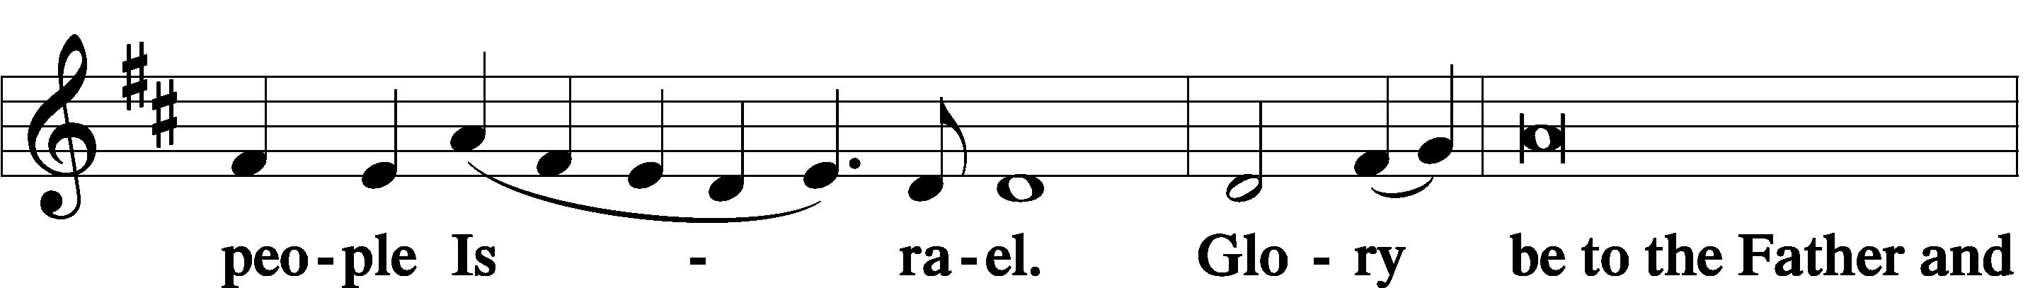
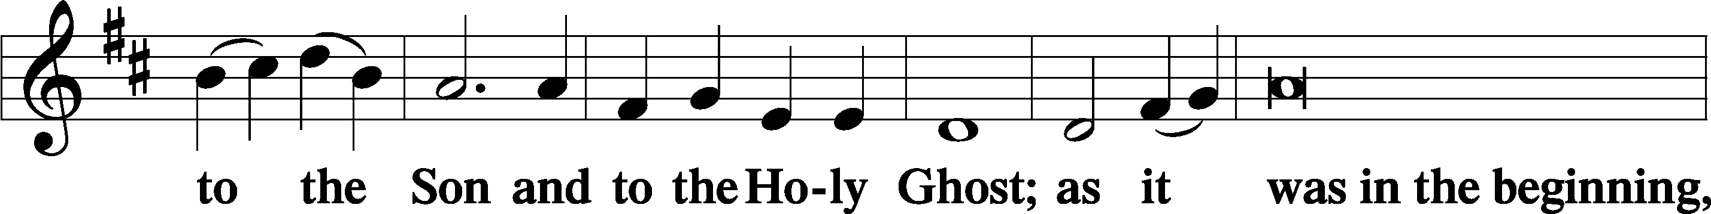
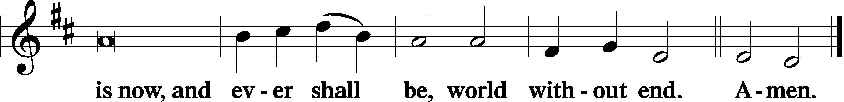

Thanksgiving Psalm 107:1
P O give thanks unto the Lord, for He is good,
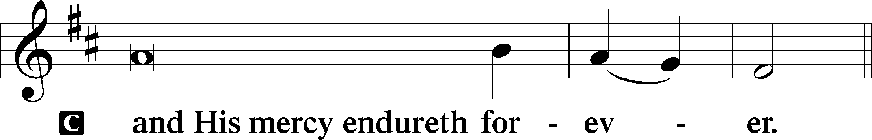

Post-Communion Collect
P Let us pray.
We give thanks to You, almighty God, that You have refreshed us through this salutary gift, and we implore You that of Your mercy You would strengthen us through the same in faith toward You and in fervent love toward one another; through Jesus Christ, Your Son, our Lord, who lives and reigns with You and the Holy Spirit, one God, now and forever.
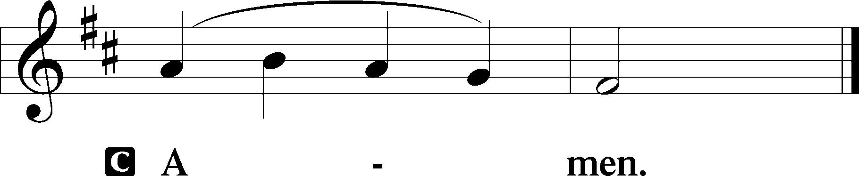

Salutation 2 Timothy 4:22
P The Lord be with you.
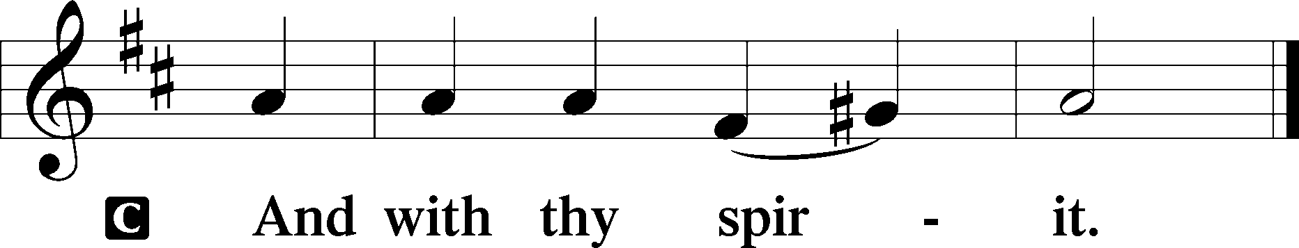

Benedicamus Psalm 103:1
P Bless we the Lord.
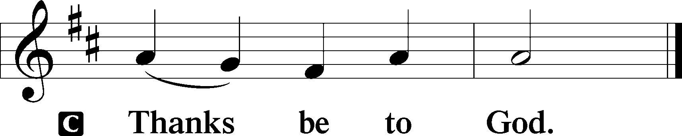

Farewell and Godspeed to Alex (Sasha) Carr
P Beloved in the Lord, in Holy Baptism you became a member of the holy Christian Church, and our Lord’s Word and Sacraments have nourished you in this congregation for four years. As we bid you farewell and Godspeed, hear the words of the apostle Paul:

I thank my God in all my remembrance of you, always in every prayer of mine for you all making my prayer with joy, because of your partnership in the gospel from the first day until now. And I am sure of this, that he who began a good work in you will bring it to completion at the day of Jesus Christ.

P The Lord be with you.
C And also with you.
P Let us pray.
Lord God, heavenly Father, we give thanks that You have so faithfully nourished our brother with us in the communion of this congregation. Bless, protect, and defend him as he now departs from us. Preserve him in the confession of Your name and in loving service to others. Keep us in fellowship with all Your saints, and bring us at last to the joys of Your heavenly kingdom; through Jesus Christ, Your Son, our Lord, who lives and reigns with You and the Holy Spirit, one God, now and forever.
C Amen.

P Go in peace and joy. The grace of our T Lord Jesus Christ be with you.
C Amen.

Benediction Numbers 6:24–26
P The Lord bless you and keep you.
The Lord make His face shine upon you and be gracious unto you.
The Lord lift up His countenance upon you and T give you peace.
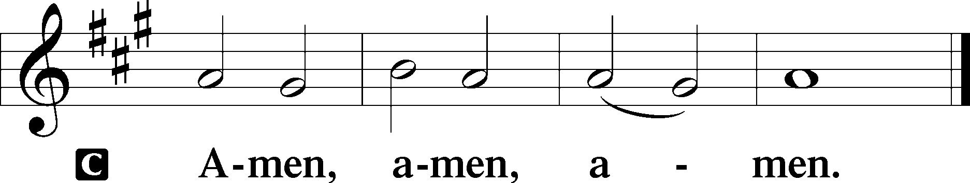

Closing Hymn: LSB #941 “We Praise You and Acknowledge You, O God”

Silent prayer after worship: O almighty God, Father, Son and Holy Spirit, by Your grace, enable me to believe and trust even without understanding. Lead me to be in Your Word so that I may grow in my trust in You and my love for You above all things. Amen.
fffffffffffffffffffffffffffffffffff
Acknowledgments: Unless otherwise indicated, Scripture quotations are from the ESV® Bible (The Holy Bible, English Standard Version®), copyright © 2001 by Crossway, a publishing ministry of Good News Publishers. Used by permission. All rights reserved. Created by Lutheran Service Builder © 2023 Concordia Publishing House.
fffffffffffffffffffffffffffffffffff

fffffffffffffffffffffffffffffffffff
In Loving Memory of Barry Nelson: Gloria Minner & Bill Madden (Food Pantry), Cathy J. Smith (Food Pantry), Ed & Millie Zachar.
In Loving Memory of Viola Sakony: Ed & Millie Zachar.
fffffffffffffffffffffffffffffffffff
All are invited to celebrate Alex (Sasha) Carr’s Graduation and Army Reception at an Open House, today from 2-5 pm in the Fellowship Hall. Join us as we give thanks for Alex’s service to our church and wish him success in his future.
fffffffffffffffffffffffffffffffffff
Attendance: Sunday, May 28, 2023: 40
fffffffffffffffffffffffffffffffffff
SCHEDULE THROUGH JUNE 11, 2023:

:

Today, following Worship, Fellowship Hall: Voters’ Assembly
2-5 pm, Fellowship Hall: Graduation Party for Alex (Sasha) Carr
2 pm, 295 N. Kerrwood Dr., Suite 106, Hermitage: Dedication of new Willow
Women’s Center
7 pm, Fellowship Hall: AA Meeting
Tuesday, 7-9 pm, Fellowship Hall: Penn-Ohio Singers
Wednesday, 10 am – 2 pm, 295 N. Kerrwood Dr., Suite 106, Hermitage: Willow
Women’s Center Open House
7:30 pm, Fellowship Hall: NA Meeting
Thursday, 9 am, Downstairs: Food Pantry
11 am, Library: Altar Guild Polishing
Next Sunday, 8 am, Fellowship Hall: Bible Study
9 am, Sanctuary: Divine Service
Following Worship, Fellowship Hall: Coffee Fellowship
7 pm, Fellowship Hall: AA Meeting
fffffffffffffffffffffffffffffffffff
Available in the narthex: June issue of “The Rock and the Sword” newsletter.
Our Stewardship of Treasures for the Lord:
In order to do the Lord’s work, we need $2,553.63 each week to meet our 2023 budget for general purposes and $76.92 for the SELC.
Online Figures for Thursday, May 25, 2023 and Sunday, May 28, 2023
General Fund: $80.00
Food Pantry: $50.00
Figures for Sunday, May 28, 2023
General Fund: $2,115.00 Behind for the week*: -$358.63
SELC: $35.00 Behind for the week: -$41.92
Food Pantry: $375.00 *Includes above figures.
Quarterly Missions: $135.00
Capital Campaign: $535.00

For online giving, check out https://www.saintspeterandpaul.net/online-giving.
fffffffffffffffffffffffffffffffffff
Bible Memory Verses ~ Week of June 4th:
For Adults: All authority in heaven and on earth has been given to me. Go therefore and make disciples of all nations, baptizing them in the name of the Father and of the Son and of the Holy Spirit. Matthew 28:18b-19

For Children: Holy, holy, holy is the Lord of hosts; the whole earth is full of his glory! Isaiah 6:3
fffffffffffffffffffffffffffffffffff
Congratulations to Jesse & Alyxis Riffle on the birth of their daughter, Gwendolynne Maree, May 26th! As we celebrate her Baptism today, we pray that God continues to bestow His blessings on both parents and child!
fffffffffffffffffffffffffffffffffff
Scrip orders and payments for June are due to Matt Berent today. Order forms are available on the tables in the narthex and by the parking lot entrance.
fffffffffffffffffffffffffffffffffff
THANK YOU FOR SERVING IN JUNE: Elder: Jonathan Baisch; Ushers: Cheryl Fedele, Mike Flaugher, & Jesse Riffle; Altarware: (prior) Diane Riefstahl & Marie Flaugher (06/11); (after) Elizabeth Haenftling & Traudi Sulek.
Remember the following in Prayer…
~The Hurting and Healing: Amy, Gerald Arthur, Ellen Baron^{CA}, Lois Bortner^{CA}, John Burdette, Bev & Joe Chlpka, Kathleen Coughenour, Kim, Anna Mae Daris, Susan Davies, Tim Dudash, Millie Elavsky, Joseph Fleet, Judith & Eddy Furey, Tim Haenftling, Austin Hamilton, Joan, Darla Krajci, Barbara Kreske, Donna Kennedy, Jess Lavoie, Joanne Lozier, Paul Lucas^{CA}, Sandy Marshall, Augusta Mennell, Frank Niemeyer^{CA}, Linda Parkany, Juanita Rentschler, Richard Reuning^{CA}, Nancy Robertson^{CA}, Marty Scott, Kara, Fred Tonty, Joel & Peggy Wasson, Angela Weser^{CA}, and Ruth Wolf.
~The Homebound: Rudy & Jean Tomko, Betty Wolf, and Ed & Millie Zachar.
~Celebrating this Week: Birthdays: Jonathan Baisch (06.09) & Lisa Jelinek (06.09). Anniversary: Rev. Ed & Irene Kucera (06.09).
~Serving in the Military: Curtis Sinewe and Joshua Solyan.
~Community & World Needs: Those suffering from or affected by the coronavirus; those suffering due to the conflict between Ukraine and Russia; those suffering from loss and dislocation because weather disasters; those suffering from addiction and their families; Local, State, and National Government Leaders; safety for all Police Officers, Firefighters, & First Responders; the unemployed; our Second Quarter Local Mission: The Support of a Concordia, Fort Wayne Seminarian.
*CA represents cancer.
fffffffffffffffffffffffffffffffffff
DON’T FORGET! There will be a Voters’ Assembly in the Fellowship Hall following worship this morning! Join us before the meeting for a brief Coffee Fellowship sponsored by Mark & Bess Kleindienst. Your attendance will be greatly appreciated!
fffffffffffffffffffffffffffffffffff
Pastor Deal’s E-mail: pastordeal@saintspeterandpaul.net
Church Website: www.saintspeterandpaul.net
Church E-mail: church@saintspeterandpaul.net
Food Pantry: [Please leave message]: 724-347-3620 (Option 3)
AA Contact: [Steve] 724-813-2358
NA Contact: [Larry] 724-977-8733
If needing to get into the church building during the week, please phone first to make certain someone is here to let you in.

