Sts. Peter & Paul
Evangelical Lutheran Church
Lutheran Church-Missouri Synod
Founded-1917

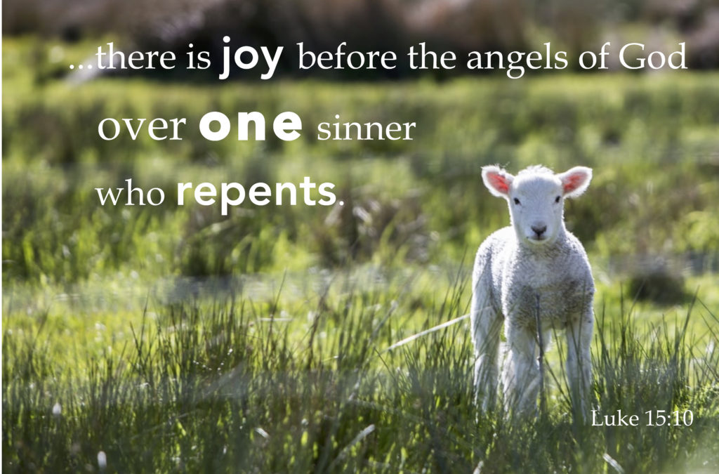

June 25, 2023

699 Stambaugh Ave.
Sharon, Pennsylvania 16146

“I was glad when they said to me,
Let us go to the house of the LORD!”
Psalm 122:1
Sts. Peter & Paul Evangelical Lutheran Church, LC-MS
THIRD SUNDAY AFTER TRINITY
June 25, 2023

A special welcome to our guests this day! If you would like more information about The Lutheran Church - Missouri Synod, or this congregation, please speak with Pastor Deal or an Elder after the service.
Members & Guests: Don’t be embarrassed if your children make noise during the worship service, all children do. We encourage families to worship together but, if you feel the need, there are pews in the rear of the Church which are reserved for young families on both sides of the sanctuary. There is also a quiet room available to you during our service which is located down the hallway past the offices on the right side of the church as well as a children’s area in the Fellowship Hall where you are able to follow along with the service.

Today’s service includes the Sacrament of Holy Communion. If during this past year, you have not worshipped with us and been communed, we respectfully ask that you do not partake of this sacrament this day before first speaking with Pastor Deal.
If visiting from a sister congregation of the LC-MS and are in good standing, please inform Pastor Deal of your desire to commune prior to the service.
If wishing to receive a blessing during communion, please approach with your arms crossed.

CONTACT INFORMATION
Pastor Deal: pastordeal@saintspeterandpaul.net or 724-347-3620 (opt. 2)
Church Office: church@saintspeterandpaul.net or 724-347-3620 (opt. 3)
Secretary’s Office will be open Monday and Thursday (8:30-4:30) this week.

Silent prayer before worship: Almighty God, by Your mercy You made me a new creation in Christ Jesus and You claim me as Your own dear child. Cause the Holy Spirit to work in my heart so that I may live my life for You. In Jesus’ name. Amen.

Confession and Absolution

Opening Hymn: LSB #562 “All Mankind Fell in Adam’s Fall”

Stand

The sign of the cross may be made by all in remembrance of their Baptism.

Invocation
P In the name of the Father and of the T Son and of the Holy Spirit.
C Amen.

Exhortation Hebrews 10:22; Psalm 124:8; Psalm 32:5
P Beloved in the Lord! Let us draw near with a true heart and confess our sins unto God our Father, beseeching Him in the name of our Lord Jesus Christ to grant us forgiveness.

P Our help is in the name of the Lord,
C who made heaven and earth.
P I said, I will confess my transgressions unto the Lord,
C and You forgave the iniquity of my sin.

Silence for reflection on God’s Word and for self-examination.

Confession of Sins
P O almighty God, merciful Father,
C I, a poor, miserable sinner, confess unto You all my sins and iniquities with which I have ever offended You and justly deserved Your temporal and eternal punishment. But I am heartily sorry for them and sincerely repent of them, and I pray You of Your boundless mercy and for the sake of the holy, innocent, bitter sufferings and death of Your beloved Son, Jesus Christ, to be gracious and merciful to me, a poor, sinful being.

Absolution [John 20:19–23]
P Upon this your confession, I, by virtue of my office, as a called and ordained servant of the Word, announce the grace of God unto all of you, and in the stead and by the command of my Lord Jesus Christ I forgive you all your sins in the name of the Father and of the T Son and of the Holy Spirit.
C Amen.

Service of the Word

Introit Psalm 25:1–2a, 5b, 15, 20; antiphon: vv. 16, 18
Turn to me and be gra- | cious to me,*
for I am lonely and af- | flicted.
Consider my affliction and my | trouble,*
and forgive | all my sins.
To you, O Lord, I lift | up my soul.*
O my God, in you I trust; let me not be | put to shame.
You are the God of my sal- | vation;*
for you I wait all the | day long.
My eyes are ever | toward the Lord,*
for he will pluck my feet out | of the net.
Oh, guard my soul, and de- | liver me!*
Let me not be put to shame, for I take ref- | uge in you.
Turn to me and be gra- | cious to me,*
for I am lonely and af- | flicted.
Consider my affliction and my | trouble,*
and forgive | all my sins.

Gloria Patri
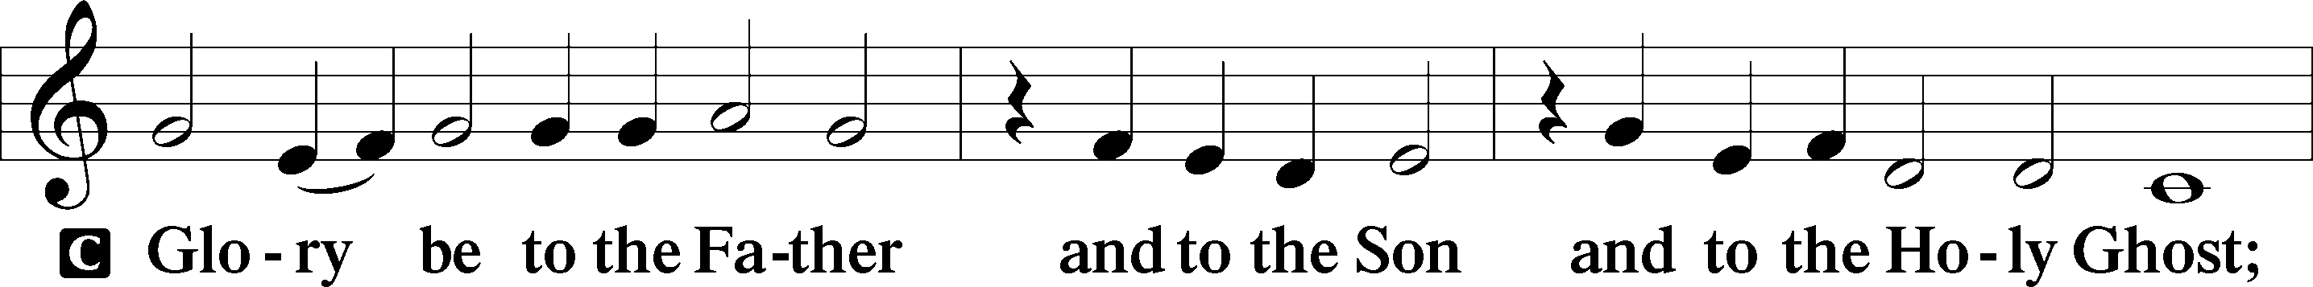
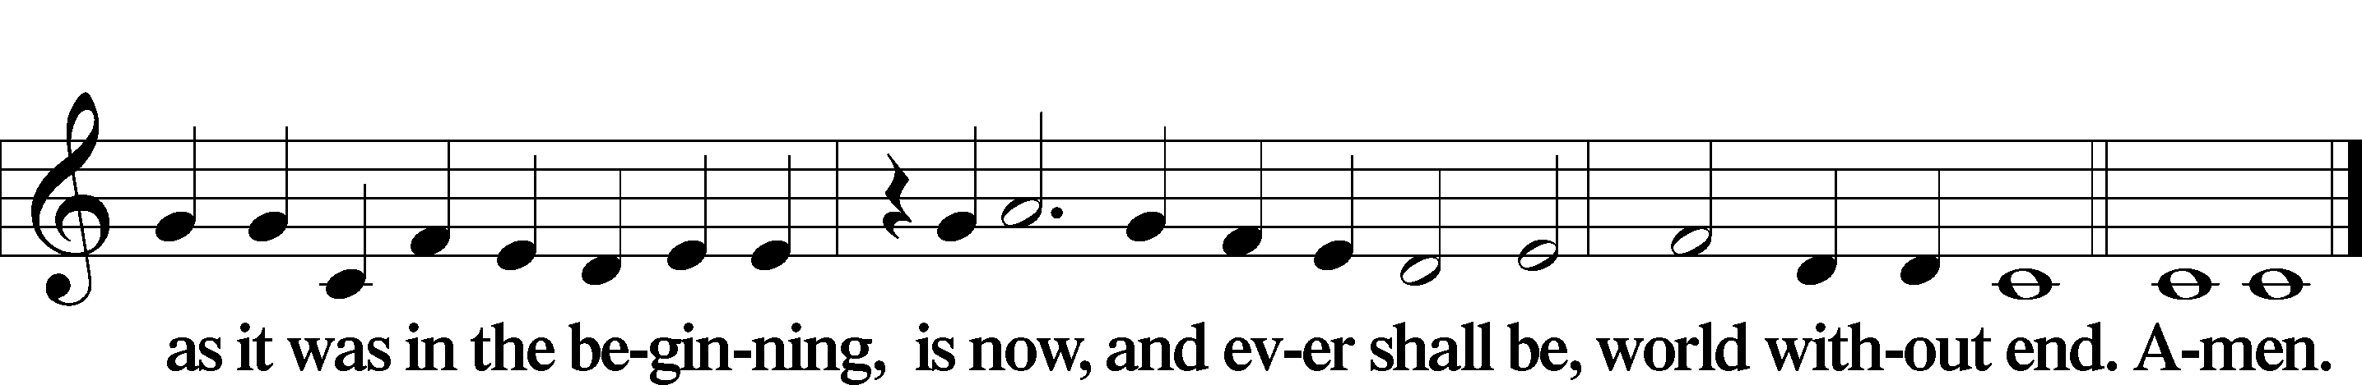

Kyrie Mark 10:47
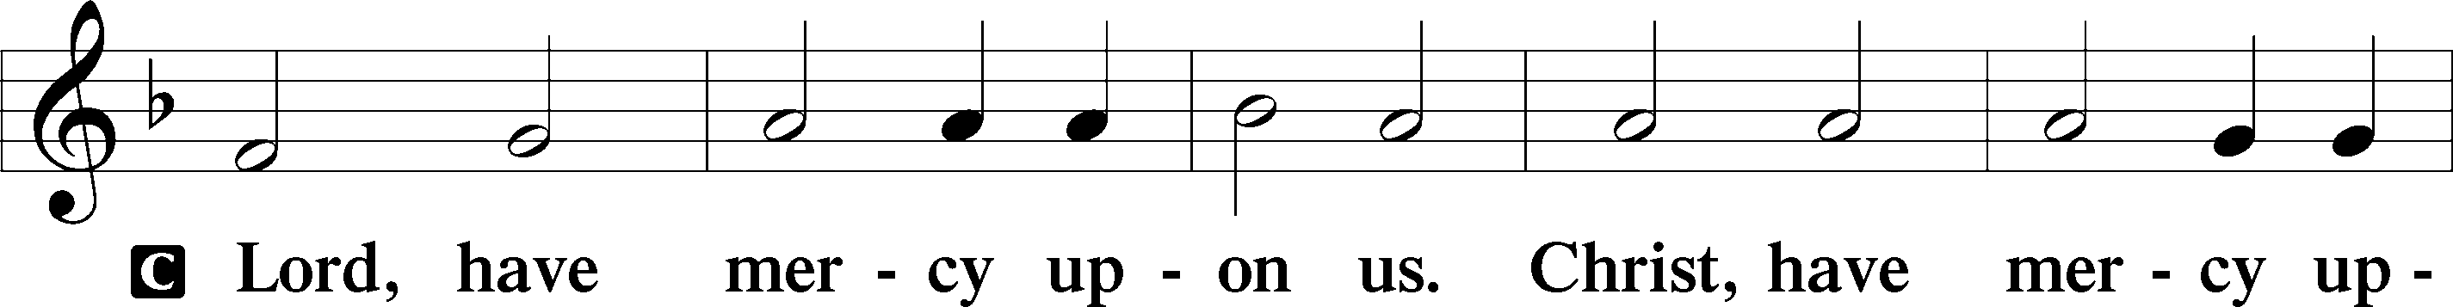
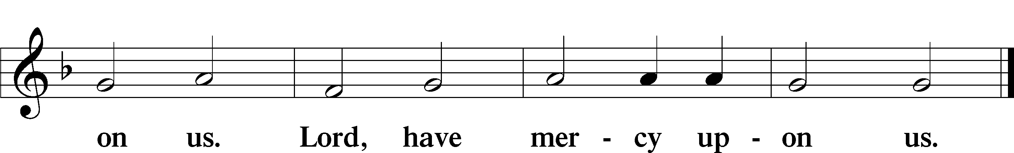

Gloria in Excelsis Luke 2:14; John 1:29
P Glory be to God on high:
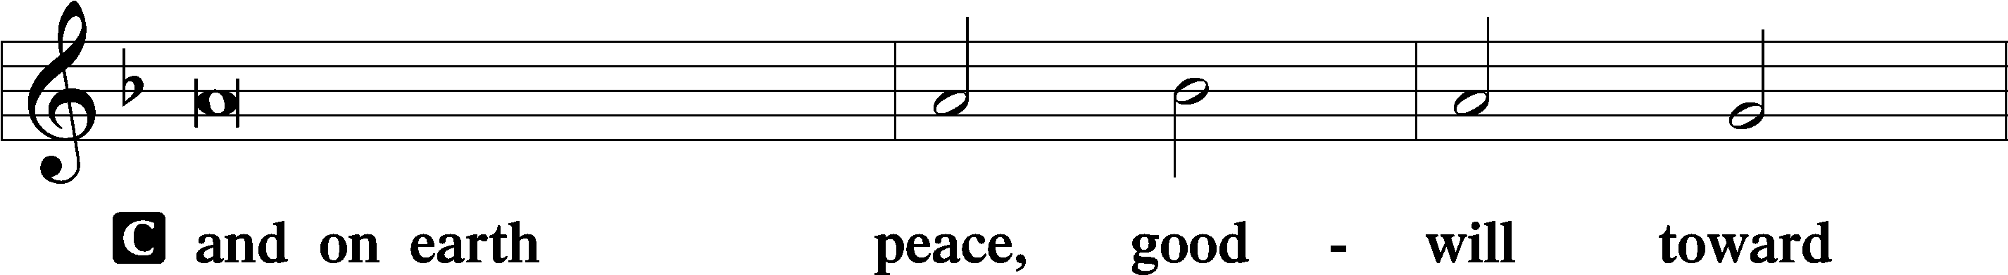
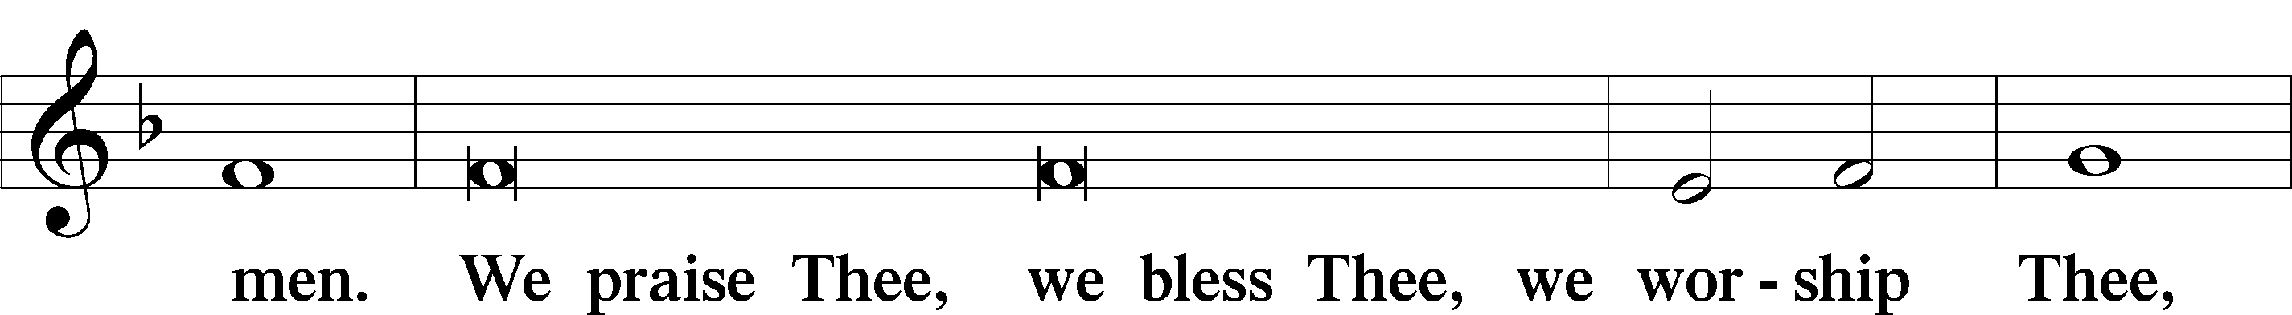
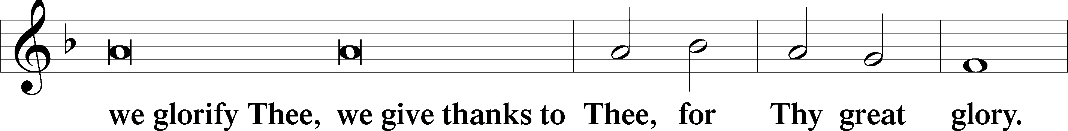
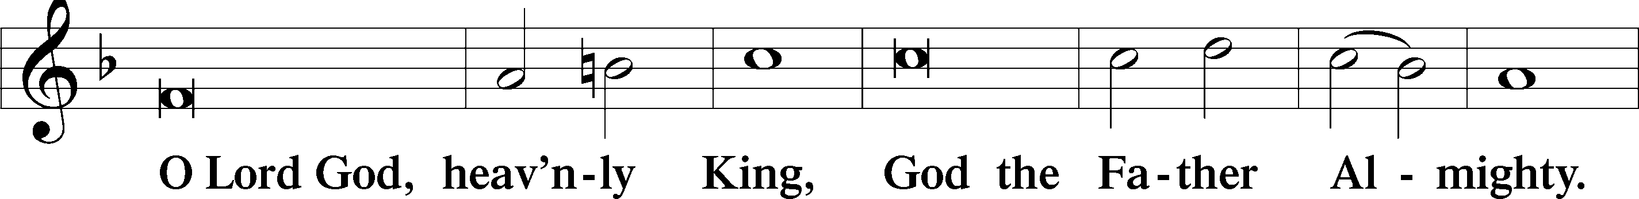
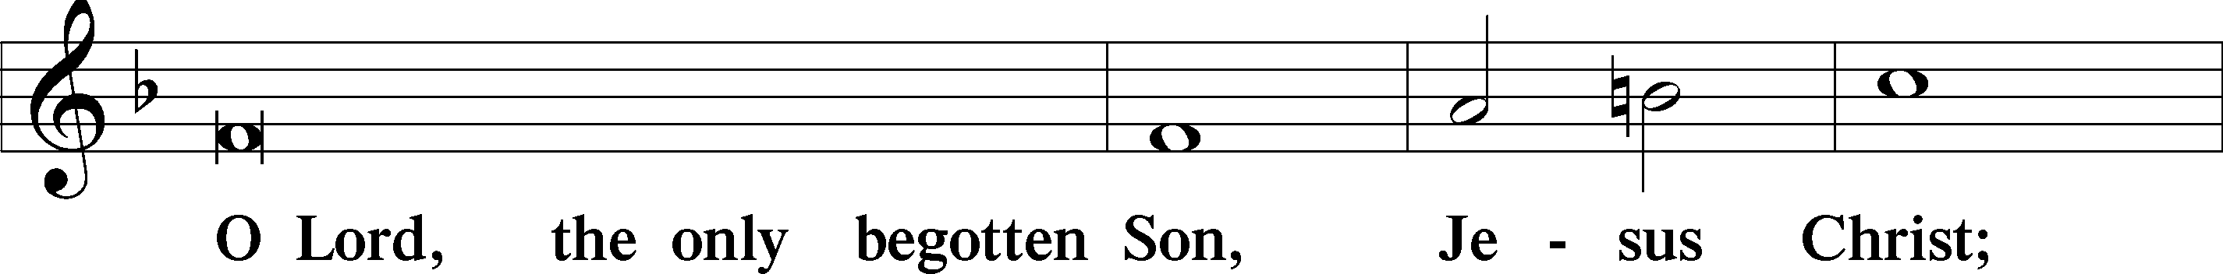
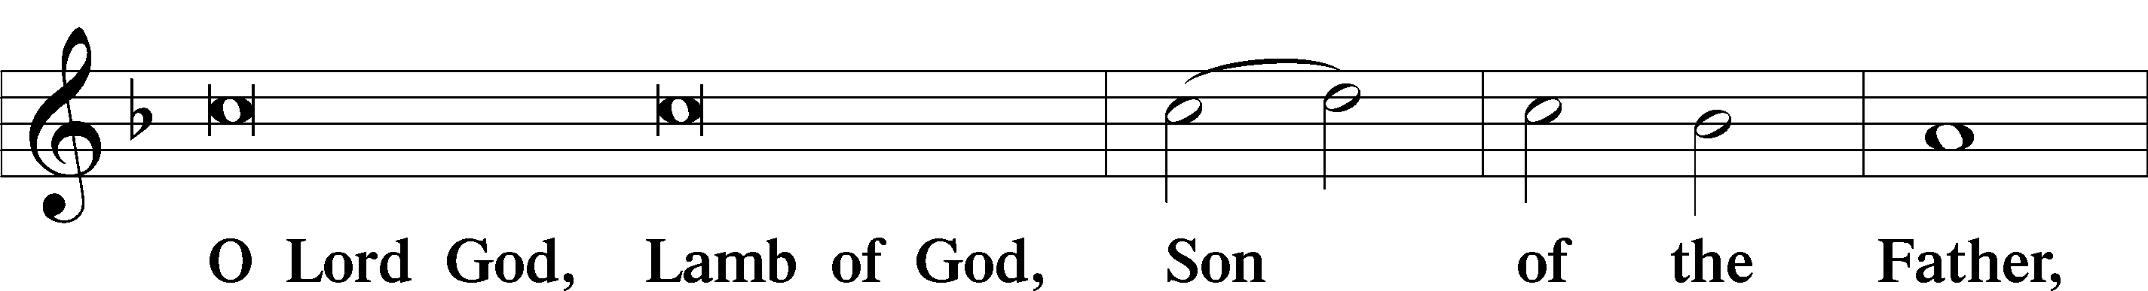
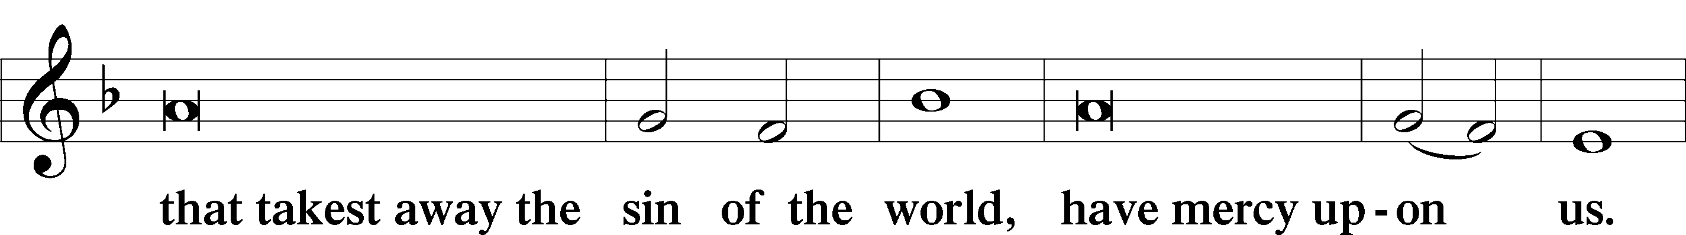
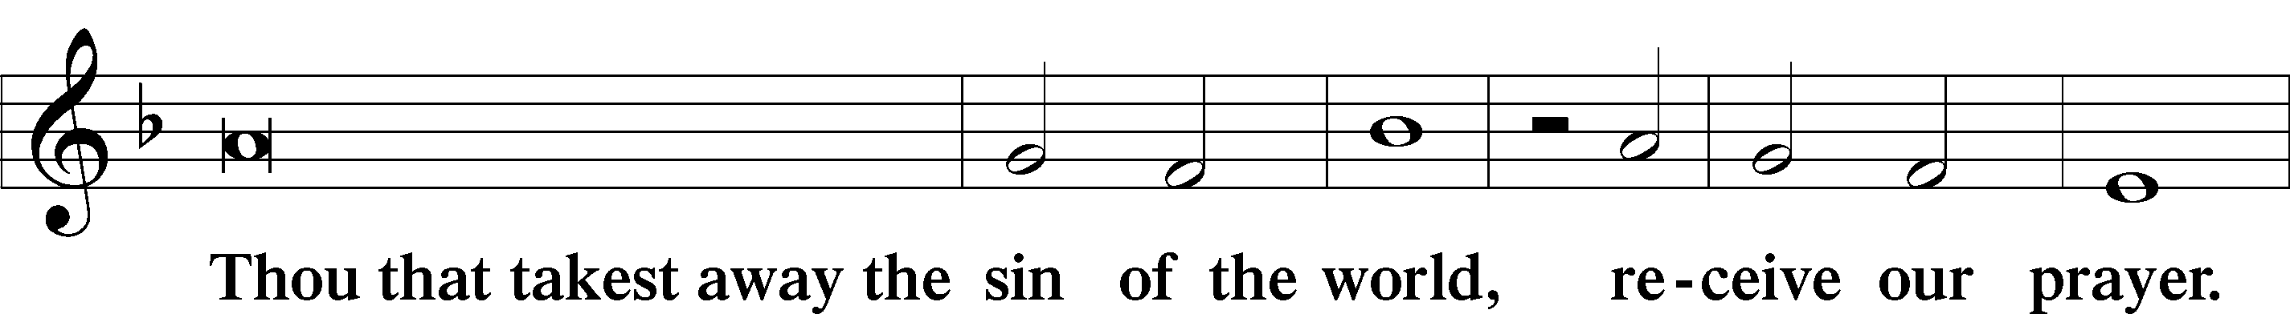
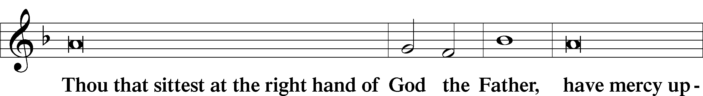
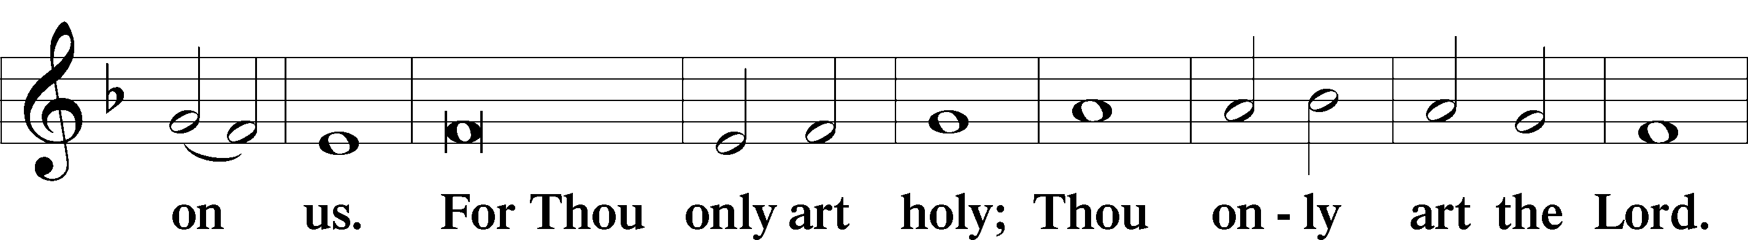
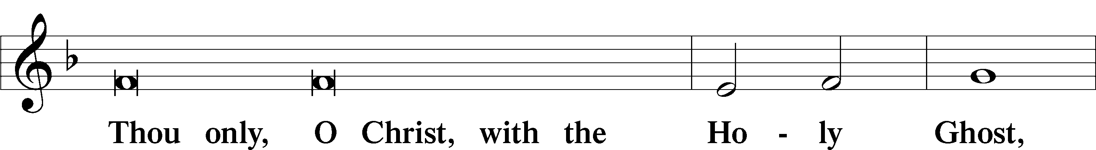
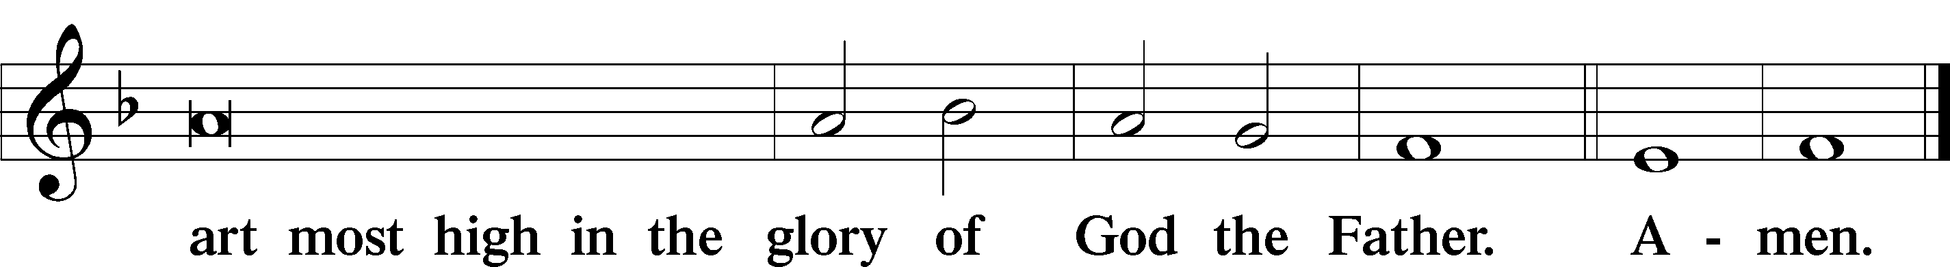

Salutation and Collect of the Day: Trinity 3
P The Lord be with you.
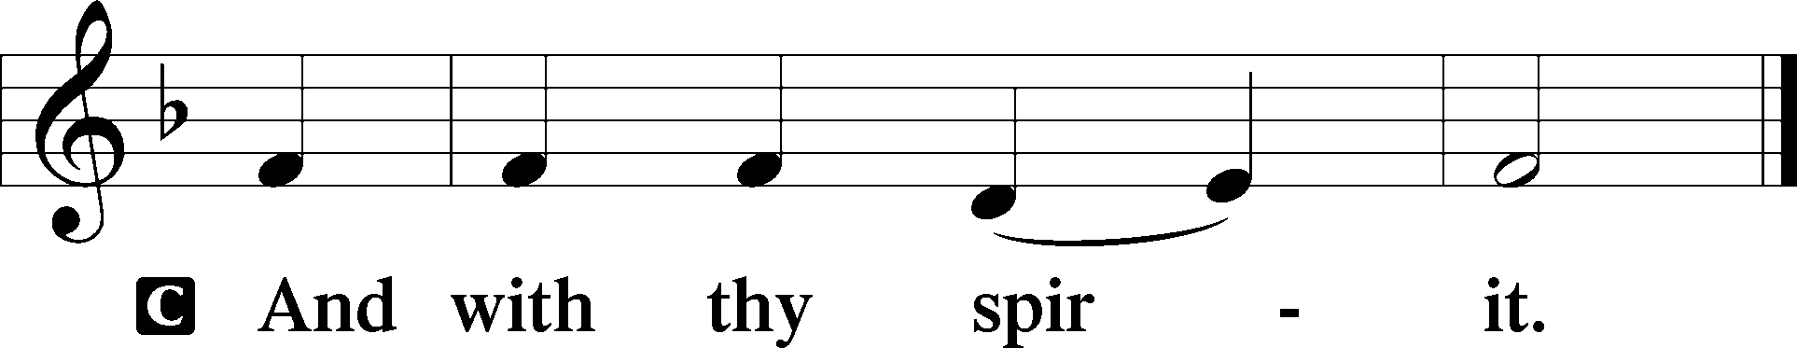

P Let us pray.
O God, the protector of all who trust in You, without whom nothing is strong and nothing is holy, multiply Your mercy on us that, with You as our ruler and guide, we may so pass through things temporal that we lose not the things eternal; through Jesus Christ, our Lord, who lives and reigns with You and the Holy Spirit, one God, now and forever.
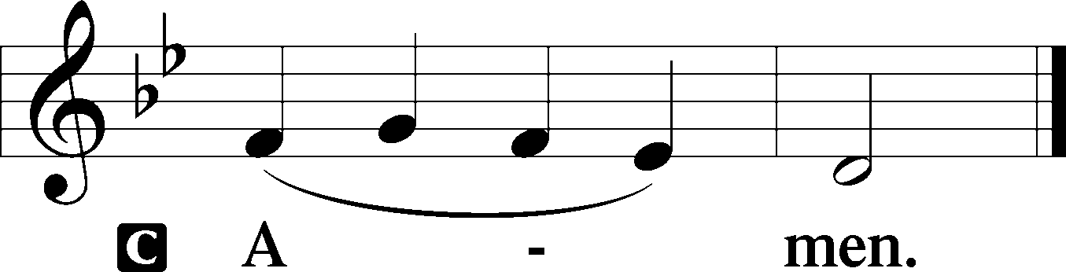
Sit

Prophecy: Micah 7:18–20 (NKJV)
O Lord our God: Who is a God like You, pardoning iniquity and passing over the transgression of the remnant of His heritage? He does not retain His anger forever, because He delights in mercy. He will again have compassion on us, and will subdue our iniquities. You will cast all our sins into the depths of the sea. You will give truth to Jacob and mercy to Abraham, which You have sworn to our fathers from days of old, O Lord our God.

P This is the Word of the Lord.
C Thanks be to God.

Gradual Psalm 55:22a, 16, 18a
Cast your burden | on the Lord,*
and he will sus- | tain you.
I call to God, and the Lord will | save me.*
He redeems my soul in | safety.

Epistle: 1 Peter 5:6-11 (NKJV)
Dearly Beloved: Humble yourselves under the mighty hand of God, that He may exalt you in due time, casting all your care upon Him, for He cares for you. Be sober, be vigilant; because your adversary the devil walks about like a roaring lion, seeking whom he may devour. Resist him, steadfast in the faith, knowing that the same sufferings are experienced by your brotherhood in the world. But may the God of all grace, who called us to His eternal glory by Christ Jesus, after you have suffered a while, perfect, establish, strengthen, and settle you. To Him be the glory and the dominion forever and ever. Amen.

P This is the Word of the Lord.
C Thanks be to God.

Stand

Verse Psalm 18:1–2a
Alleluia. I love you, O Lord, my strength. The Lord is my rock and my fortress and my deliverer. Alleluia.

Alleluia
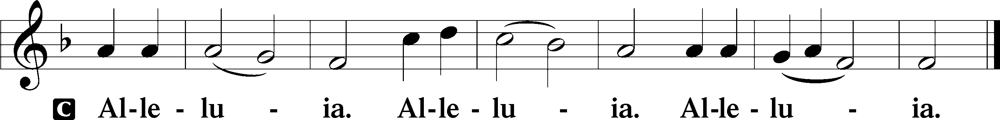

Holy Gospel: Luke 15:1–10 (NKJV)
P The Holy Gospel according to St. Luke, the fifteenth chapter.
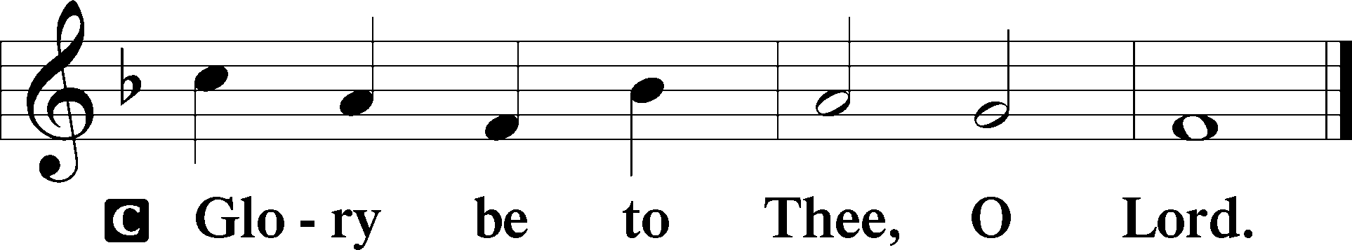

At that time: All the tax collectors and the sinners drew near to Jesus to hear Him. And the Pharisees and scribes complained, saying, “This Man receives sinners and eats with them.” So He spoke this parable to them, saying: “What man of you, having a hundred sheep, if he loses one of them, does not leave the ninety-nine in the wilderness, and go after the one which is lost until he finds it? And when he has found it, he lays it on his shoulders, rejoicing. And when he comes home, he calls together his friends and neighbors, saying to them, ‘Rejoice with me, for I have found my sheep which was lost!’ I say to you that likewise there will be more joy in heaven over one sinner who repents than over ninety-nine just persons who need no repentance. Or what woman, having ten silver coins, if she loses one coin, does not light a lamp, sweep the house, and search carefully until she finds it? And when she has found it, she calls her friends and neighbors together, saying, ‘Rejoice with me, for I have found the piece which I lost!’ Likewise, I say to you, there is joy in the presence of the angels of God over one sinner who repents.”
P This is the Gospel of the Lord.
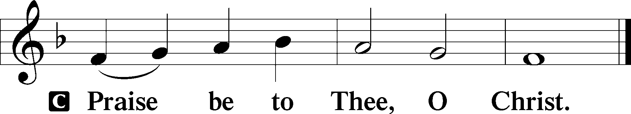

Nicene Creed
C I believe in one God,
the Father Almighty,
maker of heaven and earth
and of all things visible and invisible.

And in one Lord Jesus Christ,
the only-begotten Son of God,
begotten of His Father before all worlds,
God of God, Light of Light,
very God of very God,
begotten, not made,
being of one substance with the Father,
by whom all things were made;
who for us men and for our salvation came down from heaven
and was incarnate by the Holy Spirit of the virgin Mary
and was made man;
and was crucified also for us under Pontius Pilate.
He suffered and was buried.
And the third day He rose again according to the Scriptures
and ascended into heaven
and sits at the right hand of the Father.
And He will come again with glory to judge both the living and the dead,
whose kingdom will have no end.

And I believe in the Holy Spirit,
the Lord and giver of life,
who proceeds from the Father and the Son,
who with the Father and the Son together is worshiped and glorified,
who spoke by the prophets.
And I believe in one holy Christian and apostolic Church,
I acknowledge one Baptism for the remission of sins,
and I look for the resurrection of the dead
and the life T of the world to come. Amen.
Sit

Hymn of the Day: LSB #608 “Lord, to You I Make Confession”

Sermon

Stand

Prayer of the Church

Offertory Psalm 51:10–12
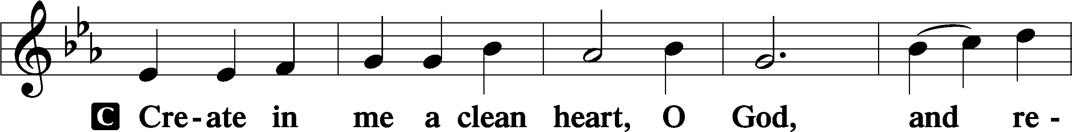
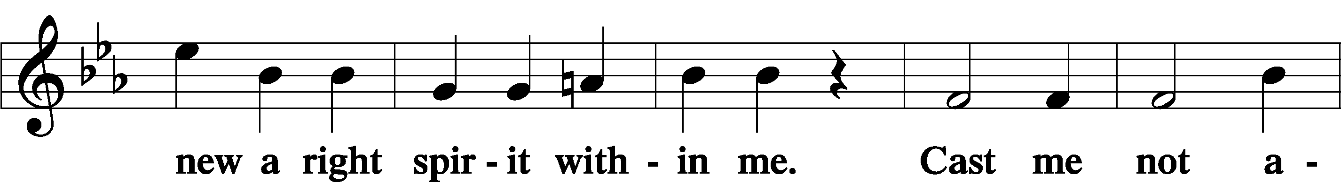
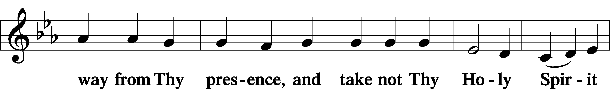
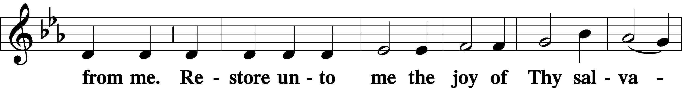
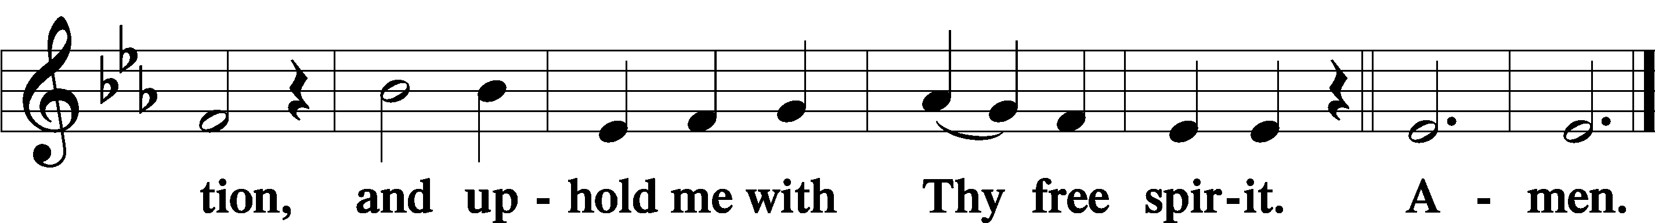
Sit

Preparatory Hymn: LSB #637 “Draw Near and Take the Body of the Lord”

Stand
Service of the Sacrament

Preface 2 Timothy 4:22; Colossians 3:1 Psalm 136
P The Lord be with you.
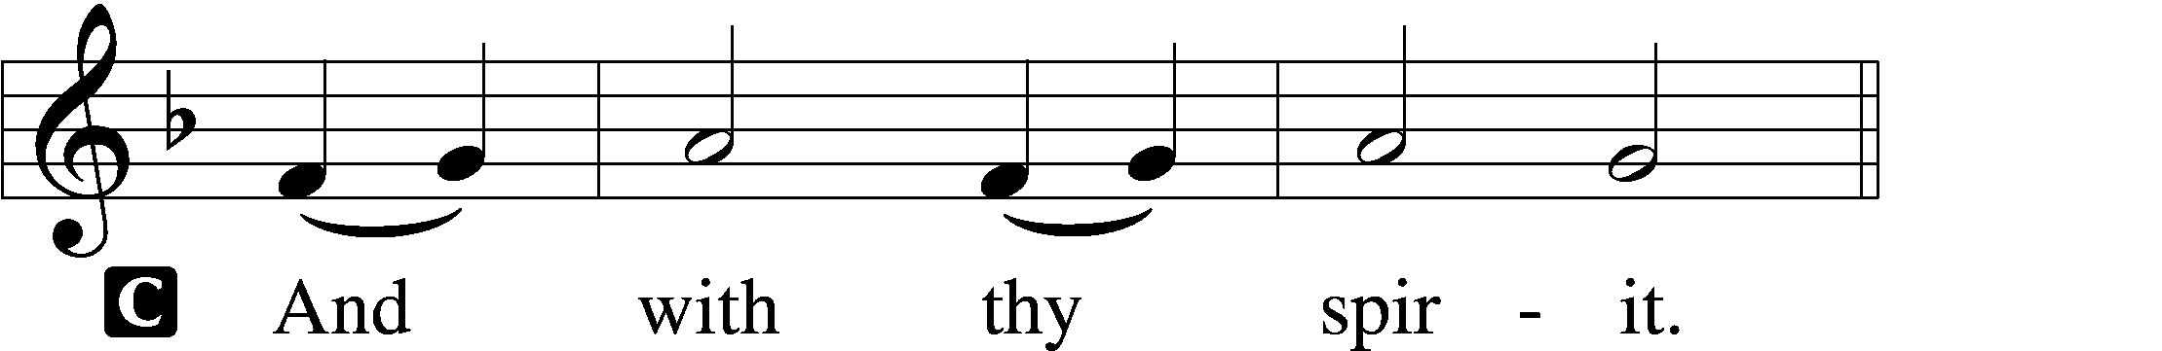

P Lift up your hearts.
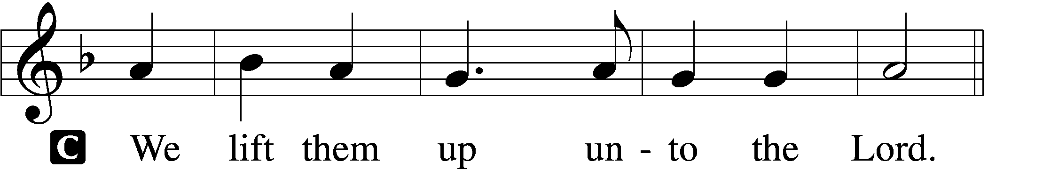

P Let us give thanks unto the Lord, our God.
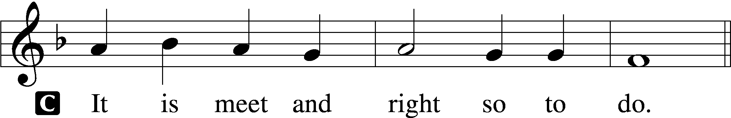

Proper Preface (Abbreviated) LSB 194
P It is truly meet, right, and salutary . . . evermore praising You and saying:

Sanctus Isaiah 6:3; Matthew 21:9
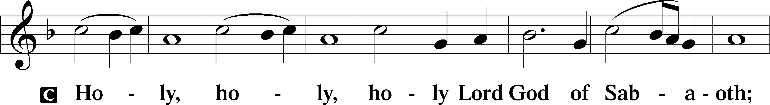
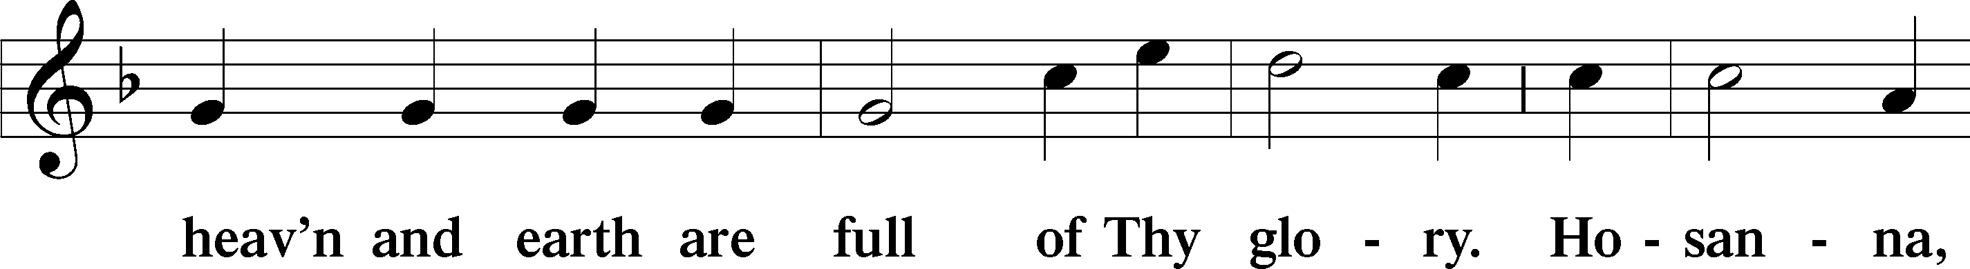
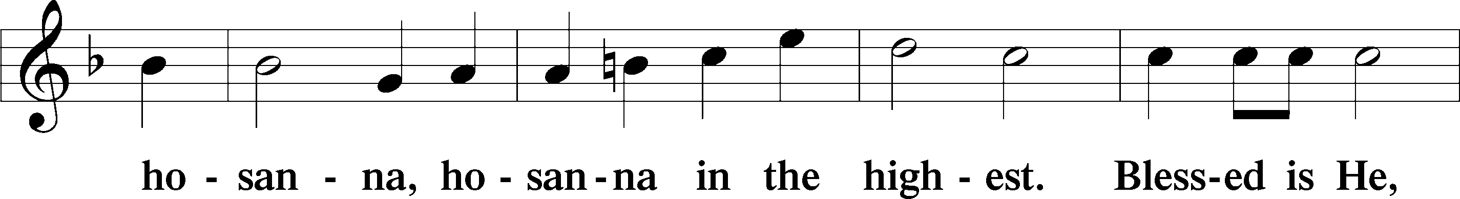
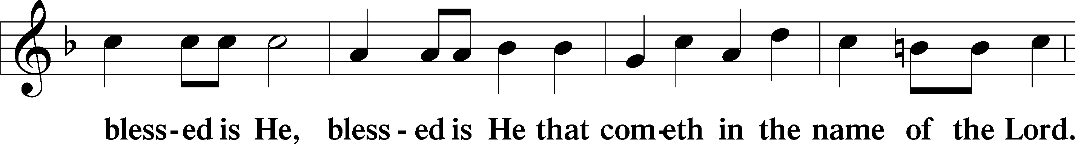
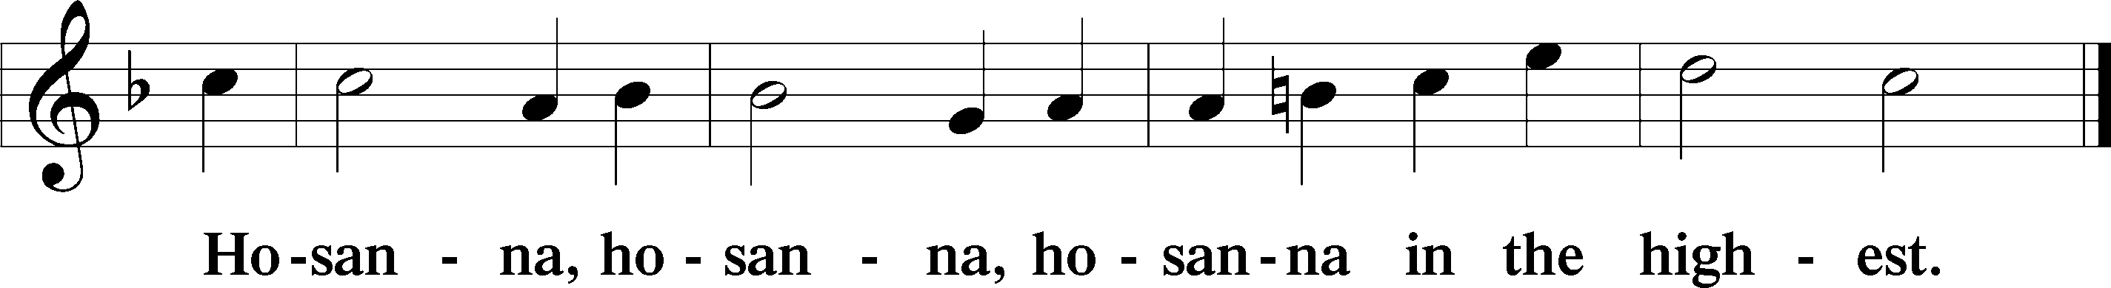

Lord’s Prayer Matthew 6:9–13
C Our Father who art in heaven,
hallowed be Thy name,
Thy kingdom come,
Thy will be done on earth as it is in heaven;
give us this day our daily bread;
and forgive us our trespasses as we forgive those who trespass against us;
and lead us not into temptation,
but deliver us from evil.
For Thine is the kingdom and the power and the glory forever and ever. Amen.

The Words of Our Lord Matthew 26:26–28; Mark 14:22–24; Luke 22:19–20; 1 Corinthians 11:23–25
P Our Lord Jesus Christ, on the night when He was betrayed, took bread, and when He had given thanks, He broke it and gave it to the disciples and said: “Take, eat; this is My T body, which is given for you. This do in remembrance of Me.”

In the same way also He took the cup after supper, and when He had given thanks, He gave it to them, saying: “Drink of it, all of you; this cup is the new testament in My T blood, which is shed for you for the forgiveness of sins. This do, as often as you drink it, in remembrance of Me.”

Pax Domini John 20:19
P The peace of the Lord be with you always.
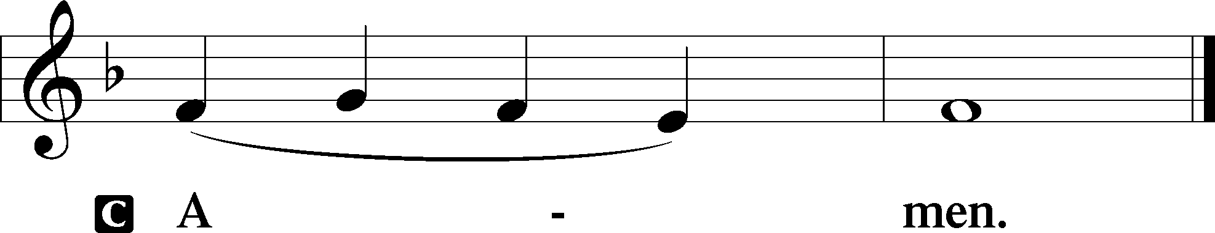

Agnus Dei John 1:29
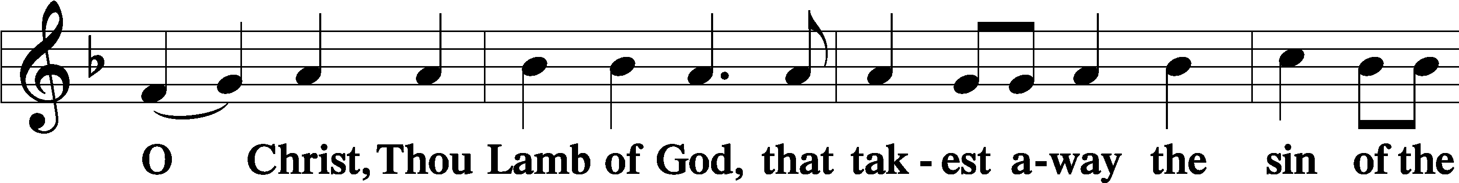
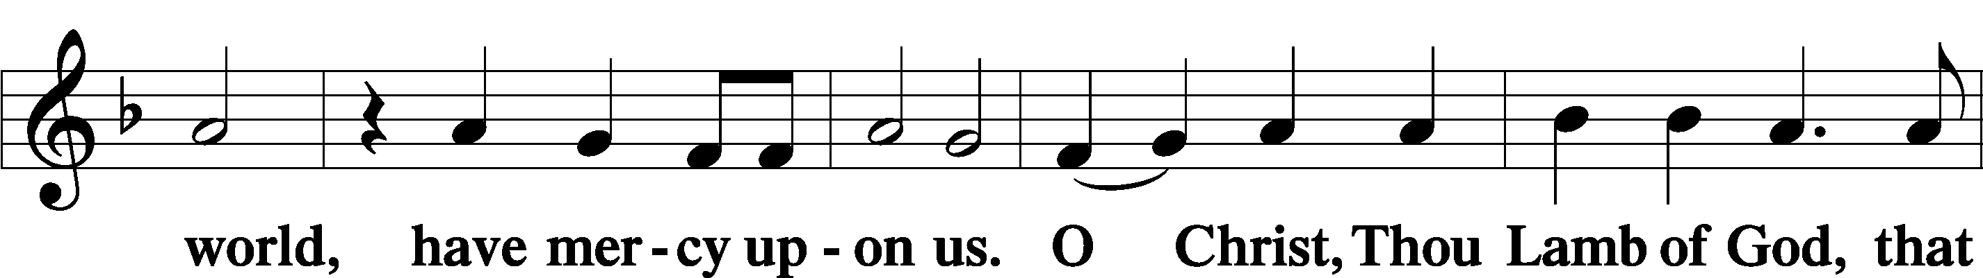
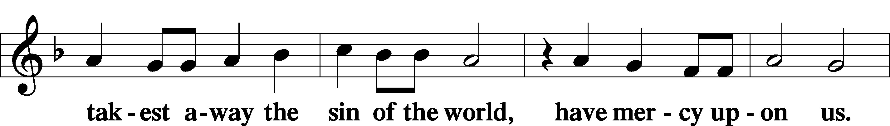
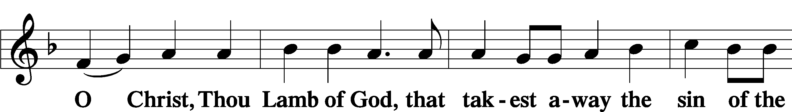
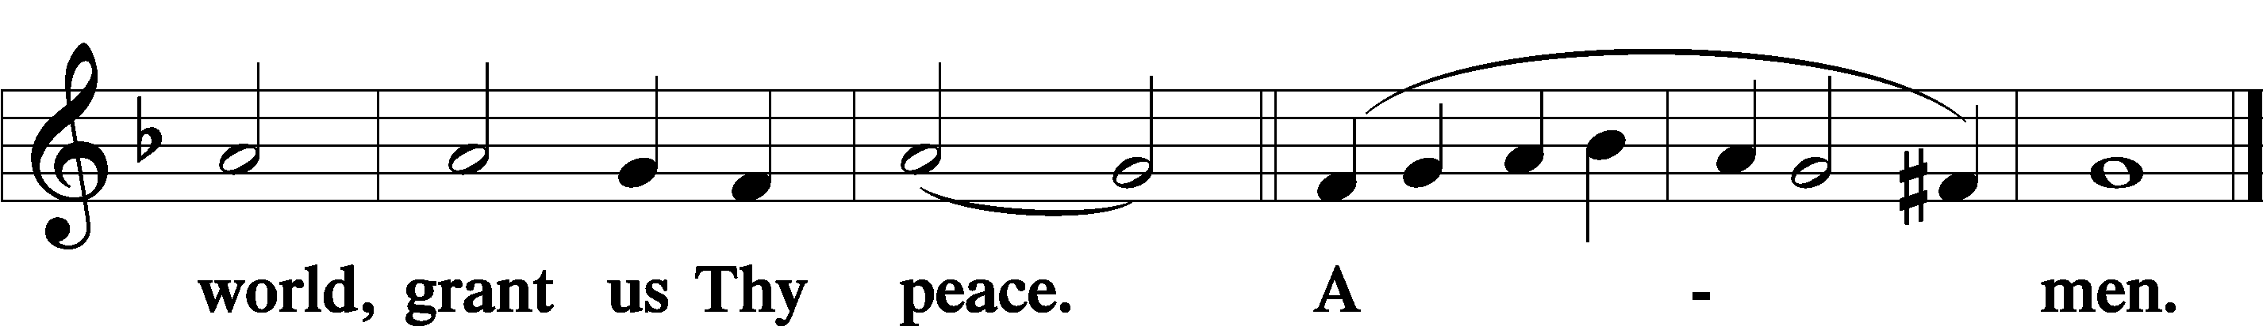
Sit

Distribution
The pastor and those who assist him receive the body and blood of Christ first and then distribute them to those who come to receive, saying:
Take, eat; this is the true body of our Lord and Savior Jesus Christ, given into death for your sins.
Amen.

Take, drink; this is the true blood of our Lord and Savior Jesus Christ, shed for the forgiveness of your sins.
Amen.

In dismissing the communicants, the following is said:
The Dismissal
P The body and blood of our Lord Jesus Christ strengthen and preserve you in body and soul to life everlasting. Depart T in peace.
C Amen.

Distribution Hymn: LSB #774 “Feed Thy Children, God Most Holy”

Distribution Hymn: LSB #607 “From Depths of Woe I Cry to Thee”

Distribution Hymn: LSB #655 “Lord, Keep Us Steadfast in Your Word”

Stand
Nunc Dimittis Luke 2:29–32
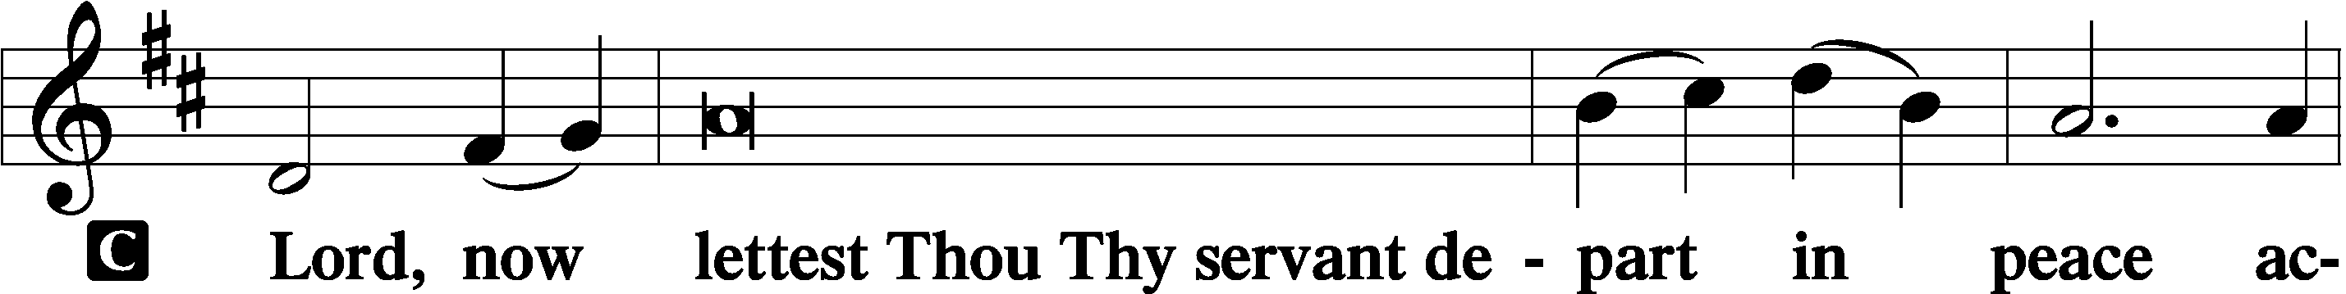
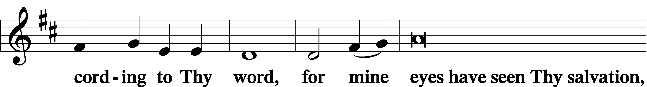
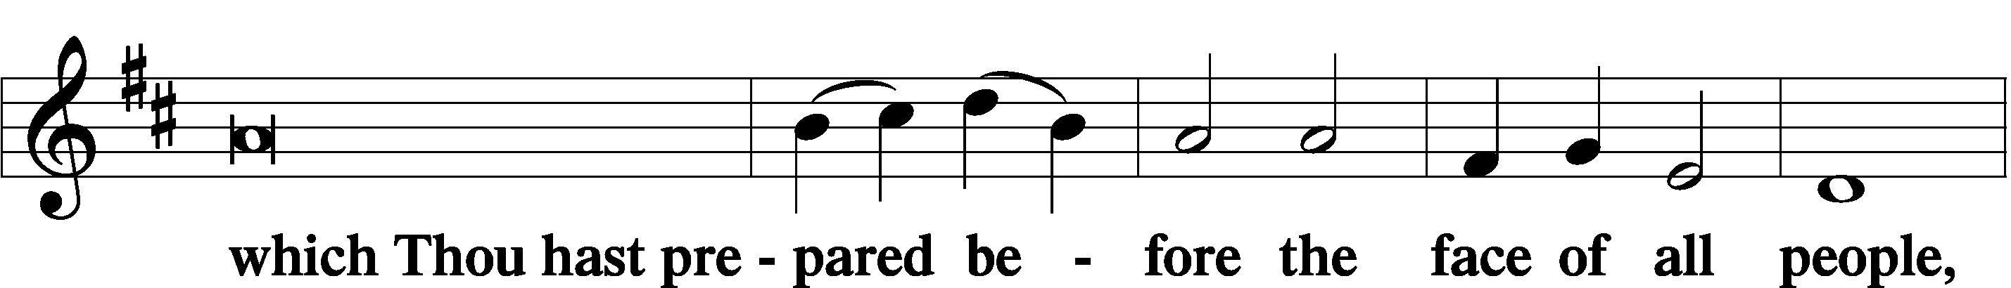
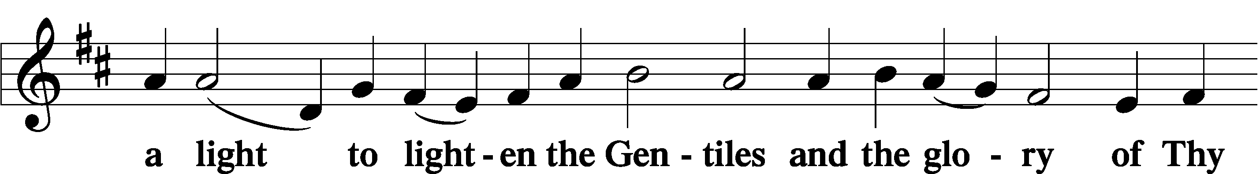
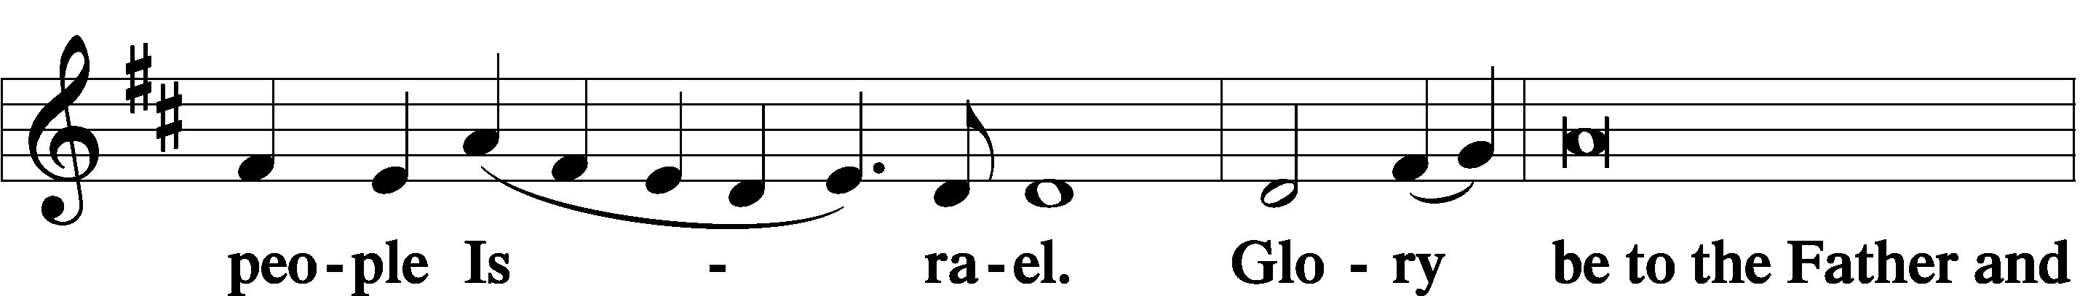
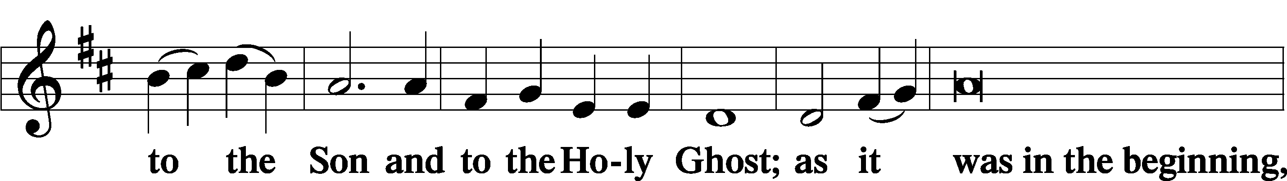
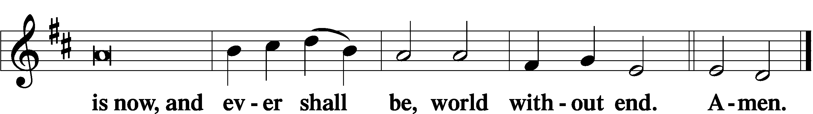

Thanksgiving Psalm 107:1
P O give thanks unto the Lord, for He is good,
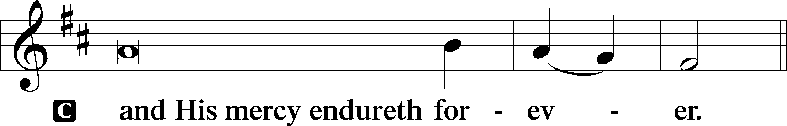
Post-Communion Collect
P Let us pray.
We give thanks to You, almighty God, that You have refreshed us through this salutary gift, and we implore You that of Your mercy You would strengthen us through the same in faith toward You and in fervent love toward one another; through Jesus Christ, Your Son, our Lord, who lives and reigns with You and the Holy Spirit, one God, now and forever.
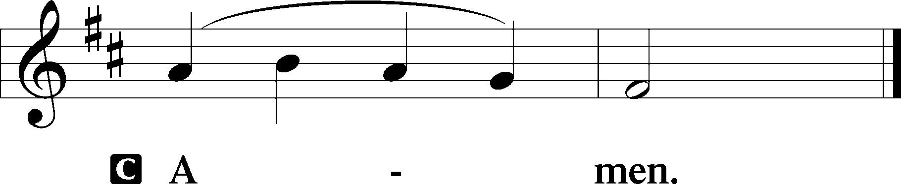

Salutation 2 Timothy 4:22
P The Lord be with you.
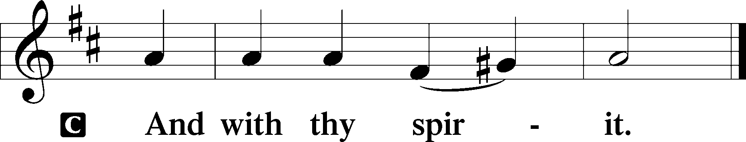

Benedicamus Psalm 103:1
P Bless we the Lord.
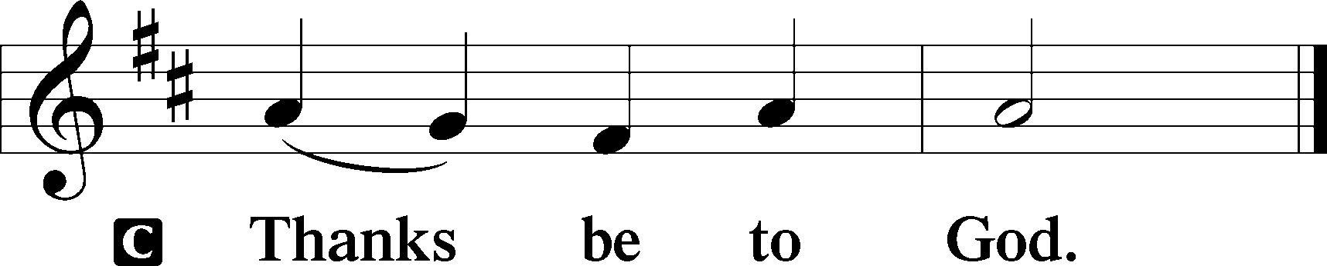

Benediction Numbers 6:24–26
P The Lord bless you and keep you.
The Lord make His face shine upon you and be gracious unto you.
The Lord lift up His countenance upon you and T give you peace.
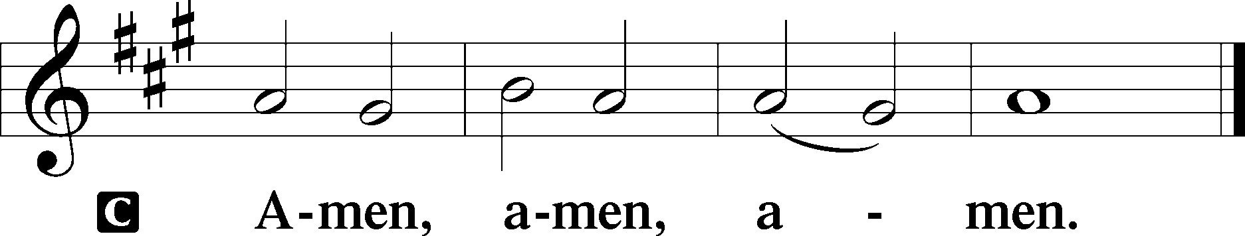

Closing Hymn: LSB #745 “In God, My Faithful God”

Silent prayer after worship: Lord Jesus, You freely gave Your life for me, so that I might have forgiveness and eternal life. Make me constantly aware of Your love, so I will always be thankful and will want to share Your love every day. Amen.
fffffffffffffffffffffffffffffffffff
Acknowledgments
Unless otherwise indicated, Scripture quotations are from the ESV® Bible (The Holy Bible, English Standard Version®), copyright © 2001 by Crossway, a publishing ministry of Good News Publishers. Used by permission. All rights reserved.
Created by Lutheran Service Builder © 2023 Concordia Publishing House.
fffffffffffffffffffffffffffffffffff
fffffffffffffffffffffffffffffffffff
In Loving Memory of Barry Nelson: Millie Elavsky (Food Pantry)
fffffffffffffffffffffffffffffffffff
Attendance: Sunday, June 18, 2023: 40
fffffffffffffffffffffffffffffffffff
SCHEDULE THROUGH JULY 2, 2023:

:

Today, 7 pm, Fellowship Hall: AA Meeting
Tuesday, 7-9 pm, Fellowship Hall: Penn-Ohio Singers
Wednesday, 7:30 pm, Fellowship Hall: NA Meeting
Thursday, 7 pm, Sanctuary: Festival of St. Peter & St. Paul Divine Service
Next Sunday, 8 am, Fellowship Hall: Bible Study
9 am, Sanctuary: Divine Service
7 pm, Fellowship Hall: AA Meeting
fffffffffffffffffffffffffffffffffff
THANK YOU FOR SERVING IN JUNE: Elder: Jonathan Baisch; Ushers: Cheryl Fedele, Mike Flaugher, & Jesse Riffle; Altarware: (prior) Diane Riefstahl & Marie Flaugher (06/11); (after) Elizabeth Haenftling & Traudi Sulek.
fffffffffffffffffffffffffffffffffff
Bible Memory Verses ~ Week of June 25th:
For Adults: Behold, I am with you always, to the end of the age. Matthew 28:20
For Children: The Son of Man came to seek and to save the lost. Luke 19:10
fffffffffffffffffffffffffffffffffff
Our Stewardship of Treasures for the Lord:
In order to do the Lord’s work, we need $2,553.63 each week to meet our 2023 budget for general purposes and $76.92 for the SELC.
Online Figures for June 18 & June 13, 2023
General Fund: $230.00
Capital Campaign: $200.00
Figures for Sunday, June 11, 2023
General Fund: $1,043.00 Behind for the week: -$1,280.63
SELC: $50.00 Behind for the week: -$26.92
Food Pantry: $60.00
Quarterly Missions: $125.00
Capital Campaign: $685.00
Other: $12.00

For online giving, check out https://www.saintspeterandpaul.net/online-giving.
fffffffffffffffffffffffffffffffffff
Mark Your Calendar!
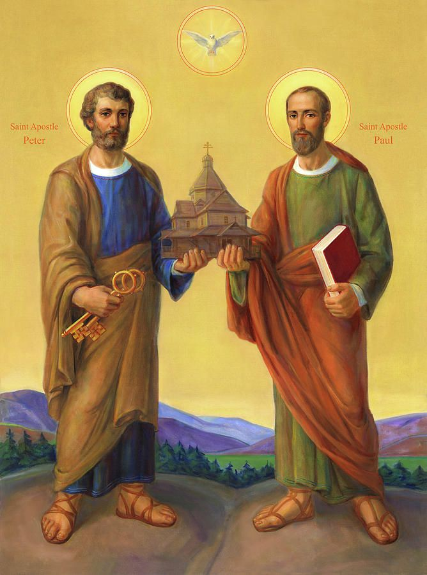

The Festival of Saint Peter and Saint Paul
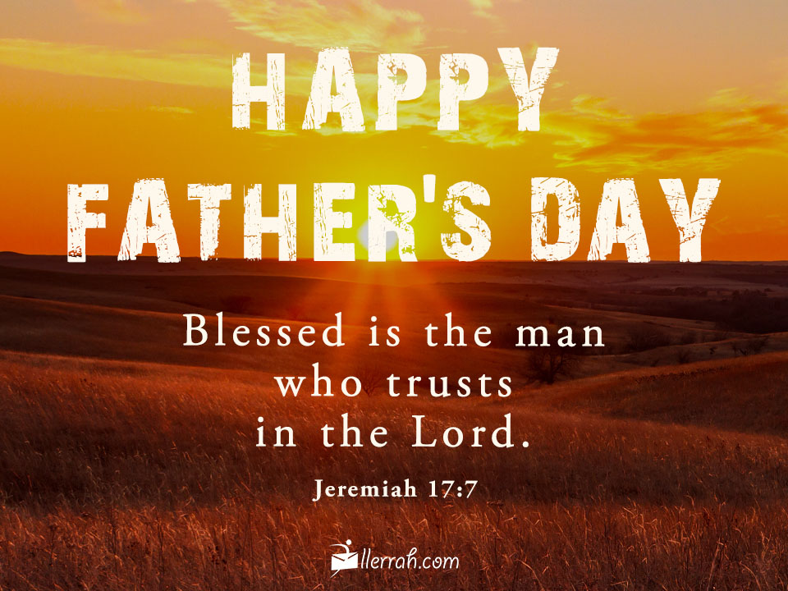
will be celebrated with a Divine Service,
this Thursday, June 29th at 7 pm.

fffffffffffffffffffffffffffffffffff
THANK YOU FOR SERVING IN JULY: Elder: Jonathan Baisch; Ushers: TBD Altarware: (prior) Diane Riefstahl & Marie Flaugher (07/09 & 07/30); (after) Elizabeth Haenftling (07/02 & 07/16) & Marie Flaugher (07/09, 07/23, & 07/30).
fffffffffffffffffffffffffffffffffff

Remember the following in Prayer…
~The Hurting and Healing: Amy, Steve Antolovich, Gerald Arthur, Ellen Baron^{CA}, Lois Bortner^{CA}, John Burdette, Bev & Joe Chlpka, Kathleen Coughenour, Kim, Anna Mae Daris, Susan Davies, Tim Dudash, Millie Elavsky, Joseph Fleet, Judith & Eddy Furey, Tim Haenftling, Austin Hamilton, Joan, Darla Krajci, Barbara Kreske, Donna Kennedy, Jess Lavoie, Elizabeth Loughan, Paul Lucas^{CA}, Sandy Marshall, Augusta Mennell, Frank Niemeyer^{CA}, Linda Parkany, Juanita Rentschler, Richard Reuning^{CA}, Nancy Robertson^{CA}, Marty Scott, Kara, Fred Tonty, Joel & Peggy Wasson, Angela Weser^{CA}, and Ruth Wolf.
~The Homebound: Rudy & Jean Tomko, Betty Wolf, and Ed & Millie Zachar.
~Celebrating this Week: Birthdays: Chris Nelson (06.28) and Mark Gabriel (06.30).
~Serving in the Military: Alex (Sasha) Carr, Curtis Sinewe, and Joshua Solyan.
~Community & World Needs: Those suffering from or affected by the coronavirus; those suffering due to the conflict between Ukraine and Russia; those suffering from loss and dislocation because weather disasters; those suffering from addiction and their families; Local, State, and National Government Leaders; safety for all Police Officers, Firefighters, & First Responders; the unemployed; our Second Quarter Local Mission: The Support of a Concordia, Fort Wayne Seminarian.
*CA represents cancer.
fffffffffffffffffffffffffffffffffff
Copies of the July issue of “The Rock and the Sword” newsletter are available on the tables next to the nursery and in the narthex.
fffffffffffffffffffffffffffffffffff
“Portals of Prayer” for July~August~September are available on the tables next to the nursery and in the narthex. Take one for a friend!
Old copies of the “Portals of Prayer” and other published devotions (this does not include our weekly bulletins, newsletters, or seasonal devotions) may be recycled in the basket next to the secretary’s office. Recycled materials are periodically mailed to ICLD (International Christian Literature Distributors) for distribution in third-world countries.
fffffffffffffffffffffffffffffffffff
SCRIP orders and payments for July are due to Matt Berent next Sunday, July 2nd. Order forms are available on the tables in the narthex and next to the nursery.
Pastor Deal will be attending the SELC Summer Conference Tuesday and Wednesday of this week. Please contact Elder Jonathan Baisch (724-816-6866) if in need of pastoral care.
fffffffffffffffffffffffffffffffffff
A friendly reminder that the Women’s Bible Study meets the first and third Thursdays of the month. Our next session will be held Thursday, July 6th at 10 am. Please feel free to join us!
fffffffffffffffffffffffffffffffffff

Here to Serve
Pastor………………………………………………...……………Rev. Jacob Deal
E-mail …………………………….……pastordeal@saintspeterandpaul.net
Phone Number……………………..…………………724-347-3620 (Option 2)
Church Office………………………..…………………724-347-3620 (Option 3)
Website …………………………………………www.saintspeterandpaul.net
Secretary…………………………………………………………Diane Riefstahl
E-mail ………………………………………church@saintspeterandpaul.net
Website …………………………………………www.saintspeterandpaul.net
Food Pantry: Please leave message……………724-347-3620 (Option 3)
AA Contact: Steve………………………………………………..…724-813-2358
NA Contact: Larry………………………………………………..724-977-8733
Choir Director………………………………………………………Chris Nelson
Congregation President……………………………………Jonathan Baisch
Church Elder …………………………………………...…… Jonathan Baisch
fffffffffffffffffffffffffffffffffff
If needing to get into the church building during the week, please phone first to make certain someone is here to let you in.

