Sts. Peter & Paul
Evangelical Lutheran Church
Lutheran Church-Missouri Synod
Founded-1917

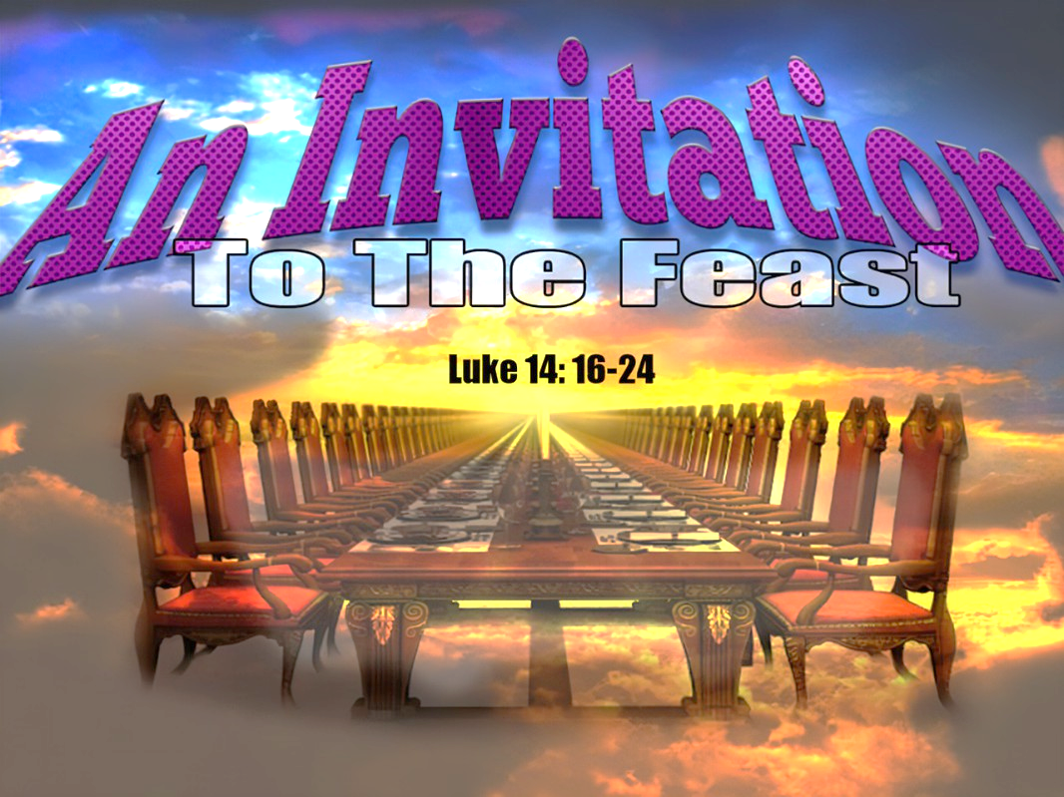

June 18, 2023

699 Stambaugh Ave.
Sharon, Pennsylvania 16146

“I was glad when they said to me,
Let us go to the house of the LORD!”
Psalm 122:1
Sts. Peter & Paul Evangelical Lutheran Church, LC-MS
SECOND SUNDAY AFTER TRINITY
June 18, 2023

A special welcome to our guests this day! If you would like more information about The Lutheran Church - Missouri Synod, or this congregation, please speak with Pastor Deal or an Elder after the service.
Members & Guests: Don’t be embarrassed if your children make noise during the worship service, all children do. We encourage families to worship together but, if you feel the need, there are pews in the rear of the Church which are reserved for young families on both sides of the sanctuary. There is also a quiet room available to you during our service which is located down the hallway past the offices on the right side of the church as well as a children’s area in the Fellowship Hall where you are able to follow along with the service.

Today’s service includes the Sacrament of Holy Communion. If during this past year, you have not worshipped with us and been communed, we respectfully ask that you do not partake of this sacrament this day before first speaking with Pastor Deal.
If visiting from a sister congregation of the LC-MS and are in good standing, please inform Pastor Deal of your desire to commune prior to the service.
If wishing to receive a blessing during communion, please approach with your arms crossed.

CONTACT INFORMATION
Pastor Deal: pastordeal@saintspeterandpaul.net or 724-347-3620 (opt. 2)
Church Office: church@saintspeterandpaul.net or 724-347-3620 (opt. 3)
Secretary’s Office will be open Monday and Thursday (8:30-4:30) this week.

Silent prayer before worship: Heavenly Father, give me a trusting and joyful faith that always wants to be in Your presence that my faith may grow, and I may receive the blessings of life, peace and hope that You freely offer me. In Jesus’ name. Amen.
Confession and Absolution

Opening Hymn: LSB #566 “By Grace I’m Saved”

Stand

The sign of the cross may be made by all in remembrance of their Baptism.

Invocation
P In the name of the Father and of the T Son and of the Holy Spirit.
C Amen.

Exhortation Hebrews 10:22; Psalm 124:8; Psalm 32:5
P Beloved in the Lord! Let us draw near with a true heart and confess our sins unto God our Father, beseeching Him in the name of our Lord Jesus Christ to grant us forgiveness.

P Our help is in the name of the Lord,
C who made heaven and earth.
P I said, I will confess my transgressions unto the Lord,
C and You forgave the iniquity of my sin.

Silence for reflection on God’s Word and for self-examination.

Confession of Sins
P O almighty God, merciful Father,
C I, a poor, miserable sinner, confess unto You all my sins and iniquities with which I have ever offended You and justly deserved Your temporal and eternal punishment. But I am heartily sorry for them and sincerely repent of them, and I pray You of Your boundless mercy and for the sake of the holy, innocent, bitter sufferings and death of Your beloved Son, Jesus Christ, to be gracious and merciful to me, a poor, sinful being.

Absolution [John 20:19–23]
P Upon this your confession, I, by virtue of my office, as a called and ordained servant of the Word, announce the grace of God unto all of you, and in the stead and by the command of my Lord Jesus Christ I forgive you all your sins in the name of the Father and of the T Son and of the Holy Spirit.
C Amen.

Service of the Word

Introit Psalm 18:1–2a, 27, 30a, 49; antiphon: vv. 18b–19
The Lord was | my support*
in the day of my ca- | lamity.
He brought me out into a | broad place;*
he rescued me, because he delight- | ed in me.
I love you, O | Lord, my strength.*
The Lord is my rock and my fortress and my de- | liverer.
For you save a humble | people,*
but the haughty eyes | you bring down.
This God—his way is | perfect;*
the word of the | Lord proves true.
For this I will praise you, O Lord, among the | nations,*
and sing | to your name.
The Lord was | my support*
in the day of my ca- | lamity.
He brought me out into a | broad place;*
he rescued me, because he delight- | ed in me.

Gloria Patri
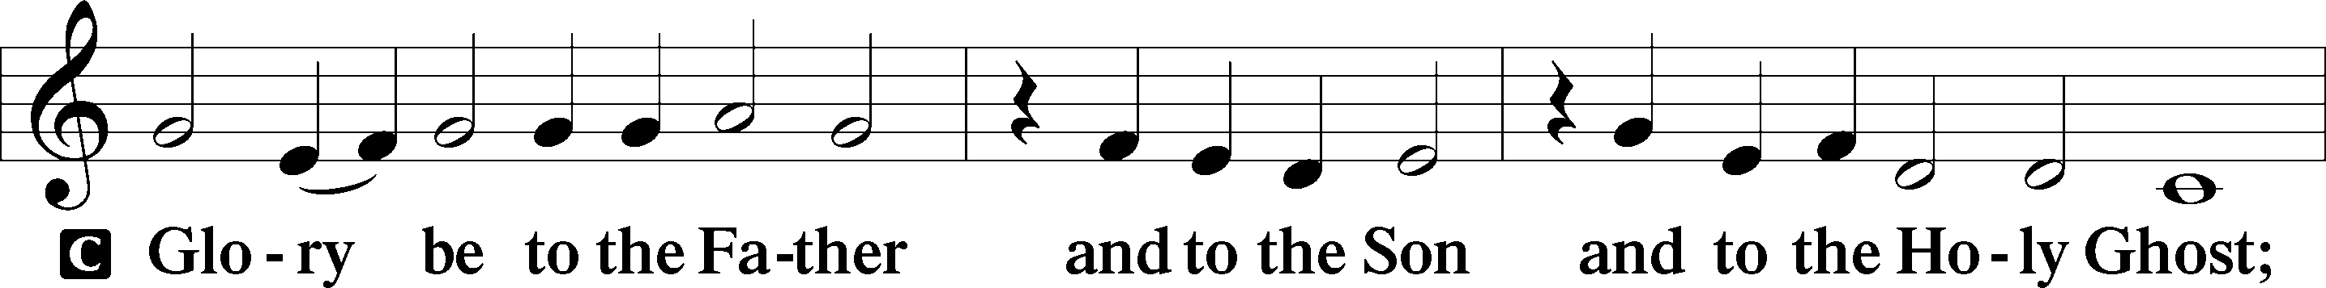
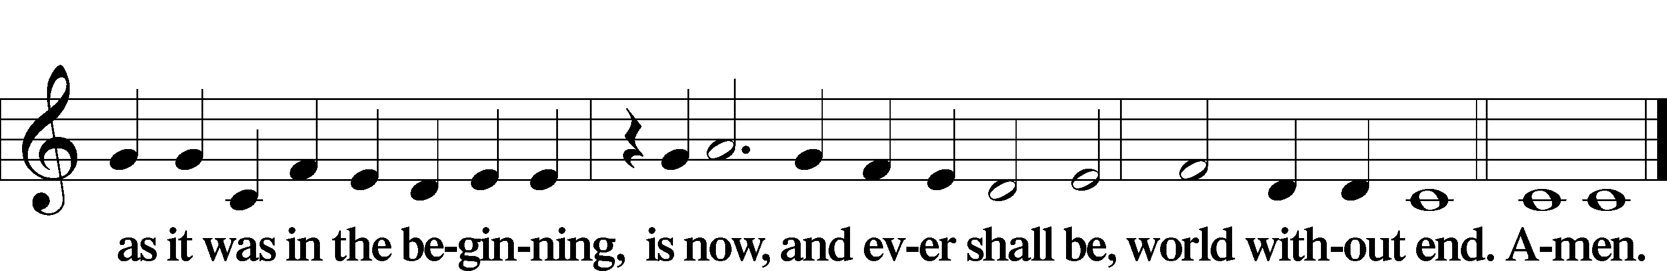

Kyrie Mark 10:47
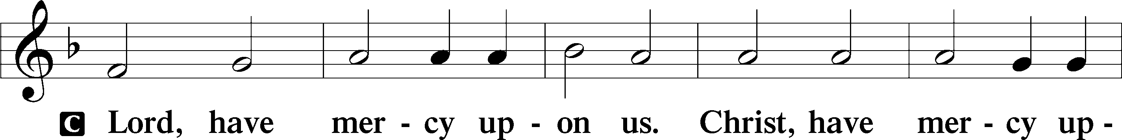
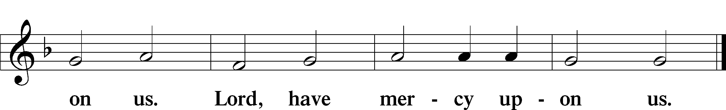

Gloria in Excelsis Luke 2:14; John 1:29
P Glory be to God on high:
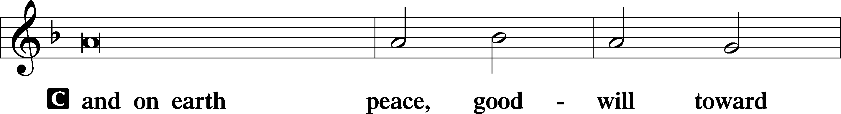
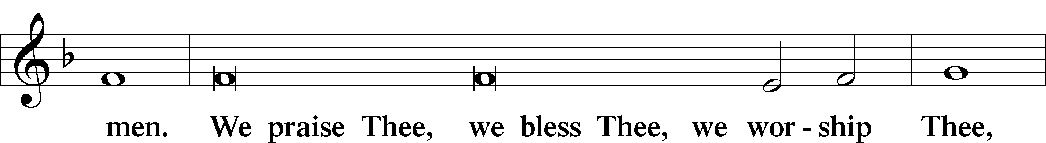
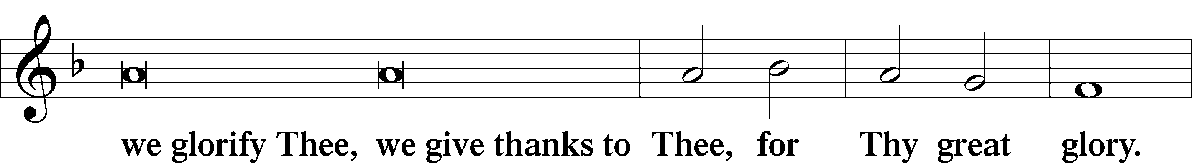
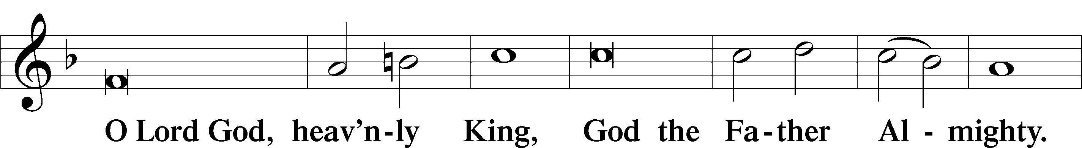
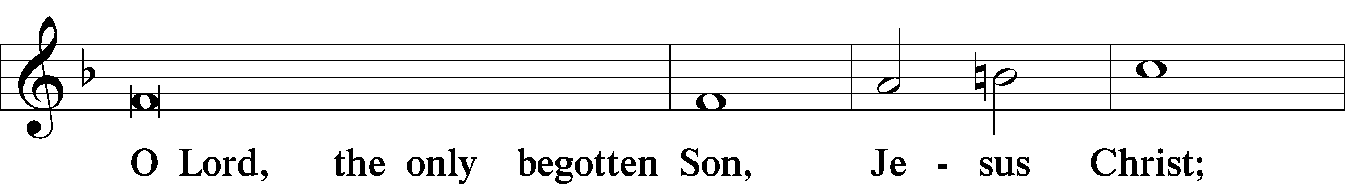
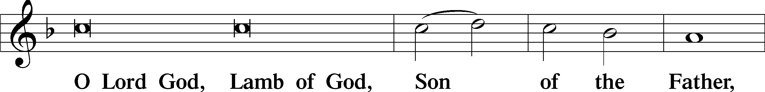
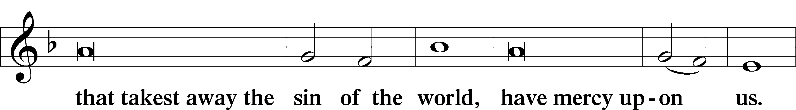
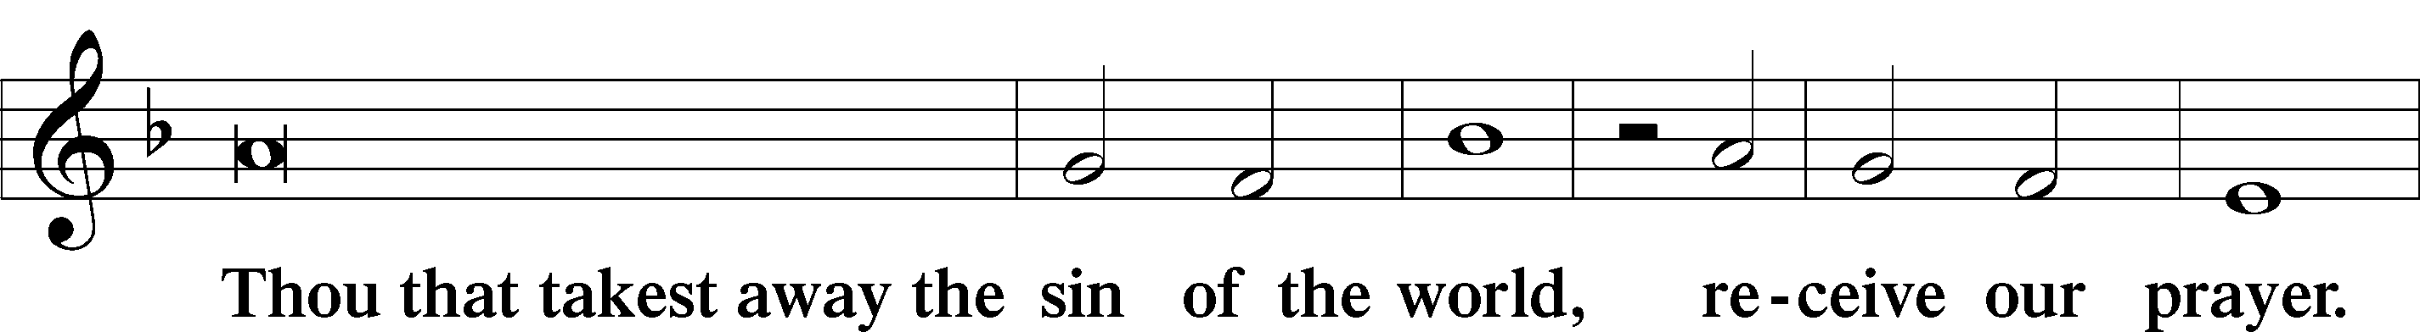
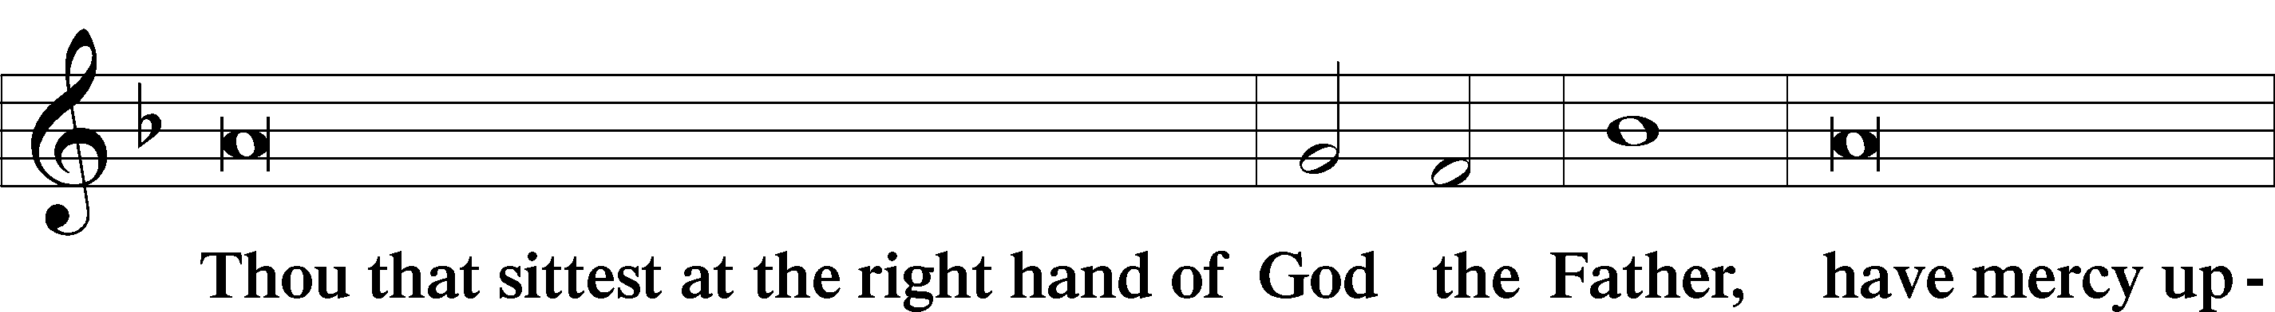
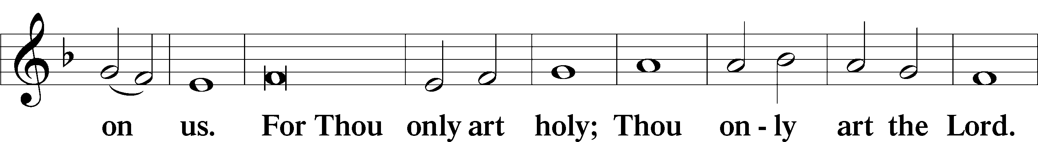
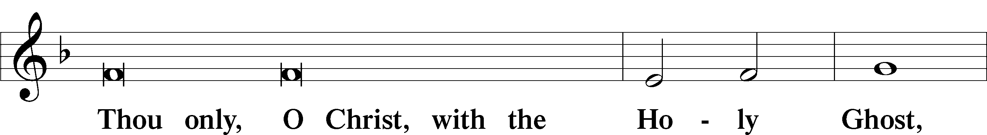
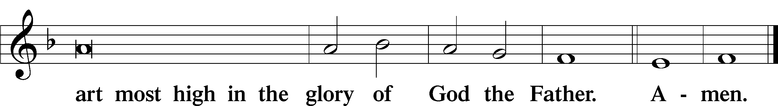

Salutation and Collect of the Day: Trinity 2
P The Lord be with you.
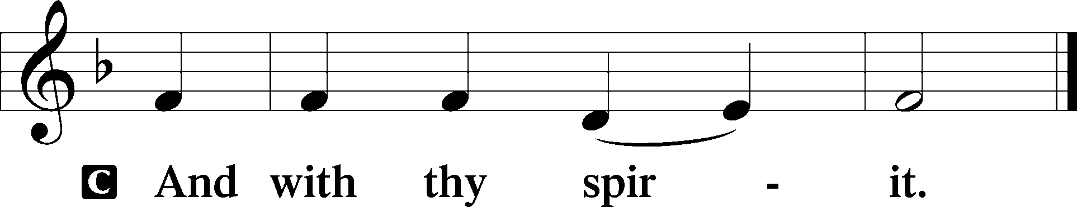

P Let us pray.
O Lord, since You never fail to help and govern those whom You nurture in Your steadfast fear and love, work in us a perpetual fear and love of Your holy name; through Jesus Christ, our Lord, who lives and reigns with You and the Holy Spirit, one God, now and forever.

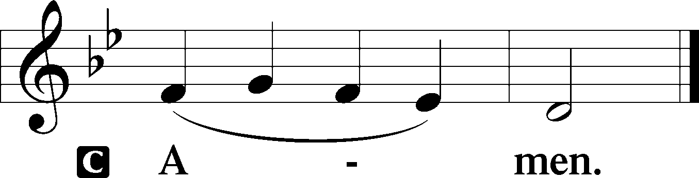
Sit

Prophecy: Proverbs 9:1–10 (NKJV)
Wisdom has built her house, she has hewn out her seven pillars; she has slaughtered her meat, she has mixed her wine, she has also furnished her table. She has sent out her maidens, she cries out from the highest places of the city, “Whoever is simple, let him turn in here!” As for him who lacks understanding, she says to him, “Come, eat of my bread and drink of the wine I have mixed. Forsake foolishness and live, and go in the way of understanding. “He who corrects a scoffer gets shame for himself, and he who rebukes a wicked man only harms himself. Do not correct a scoffer, lest he hate you; rebuke a wise man, and he will love you. Give instruction to a wise man, and he will be still wiser; teach a just man, and he will increase in learning. “The fear of the Lord is the beginning of wisdom, and the knowledge of the Holy One is understanding.

P This is the Word of the Lord.
C Thanks be to God.

Gradual Psalm 120:1–2
In my distress I called | to the Lord,*
and he | answered me.
Deliver me, O Lord, from | lying lips,*
from a de- | ceitful tongue.

Epistle: 1 John 3:13-18 (NKJV)
Dearly Beloved: Do not marvel if the world hates you. We know that we have passed from death to life, because we love the brethren. He who does not love his brother abides in death. Whoever hates his brother is a murderer, and you know that no murderer has eternal life abiding in him. By this we know love, because He laid down His life for us. And we also ought to lay down our lives for the brethren. But whoever has this world’s goods, and sees his brother in need, and shuts up his heart from him, how does the love of God abide in him? My little children, let us not love in word or in tongue, but in deed and in truth.

P This is the Word of the Lord.
C Thanks be to God.

Stand
Verse Psalm 7:17
Alleluia. I will give to the Lord the thanks due to his righteousness, and I will sing praise to the name of the Lord, the Most High. Alleluia.

Alleluia
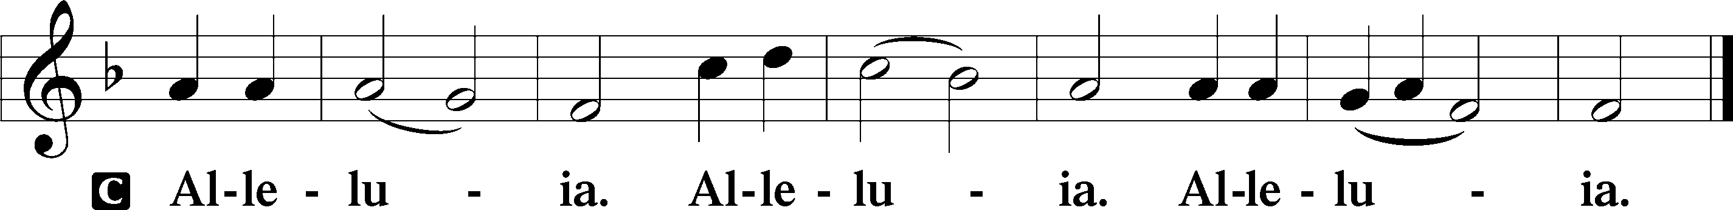

Holy Gospel: Luke 14:16–24 (NKJV)
P The Holy Gospel according to St. Luke, the fourteenth chapter.
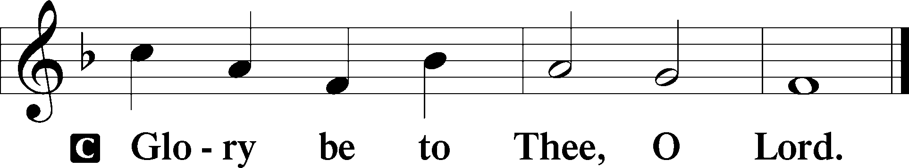

At that time Jesus spoke this parable to His disciples: “A certain man gave a great supper and invited many, and sent his servant at supper time to say to those who were invited, ‘Come, for all things are now ready.’ But they all with one accord began to make excuses. The first said to him, ‘I have bought a piece of ground, and I must go and see it. I ask you to have me excused.’ And another said, ‘I have bought five yoke of oxen, and I am going to test them. I ask you to have me excused.’ Still another said, ‘I have married a wife, and therefore I cannot come.’ So that servant came and reported these things to his master. Then the master of the house, being angry, said to his servant, ‘Go out quickly into the streets and lanes of the city, and bring in here the poor and the maimed and the lame and the blind.’ And the servant said, ‘Master, it is done as you commanded, and still there is room.’ Then the master said to the servant, ‘Go out into the highways and hedges, and compel them to come in, that my house may be filled. For I say to you that none of those men who were invited shall taste my supper.’ ”

P This is the Gospel of the Lord.
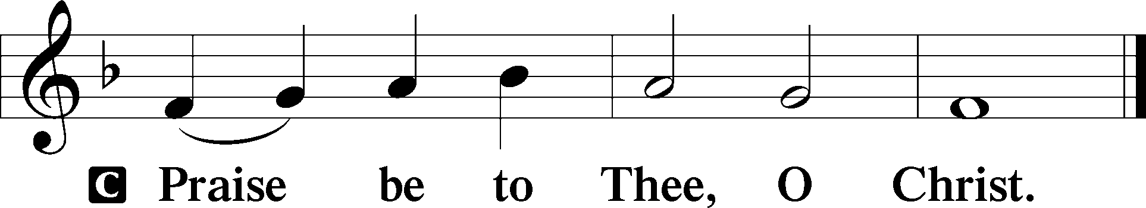

Nicene Creed
C I believe in one God,
the Father Almighty,
maker of heaven and earth
and of all things visible and invisible.

And in one Lord Jesus Christ,
the only-begotten Son of God,
begotten of His Father before all worlds,
God of God, Light of Light,
very God of very God,
begotten, not made,
being of one substance with the Father,
by whom all things were made;
who for us men and for our salvation came down from heaven
and was incarnate by the Holy Spirit of the virgin Mary
and was made man;
and was crucified also for us under Pontius Pilate.
He suffered and was buried.
And the third day He rose again according to the Scriptures
and ascended into heaven
and sits at the right hand of the Father.
And He will come again with glory to judge both the living and the dead,
whose kingdom will have no end.

And I believe in the Holy Spirit,
the Lord and giver of life,
who proceeds from the Father and the Son,
who with the Father and the Son together is worshiped and glorified,
who spoke by the prophets.
And I believe in one holy Christian and apostolic Church,
I acknowledge one Baptism for the remission of sins,
and I look for the resurrection of the dead
and the life T of the world to come. Amen.
Sit

Hymn of the Day: LSB #622 “Lord Jesus Christ, You Have Prepared”

Sermon

Stand

Prayer of the Church

Offertory Psalm 51:10–12
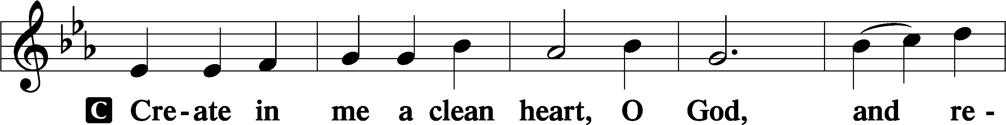
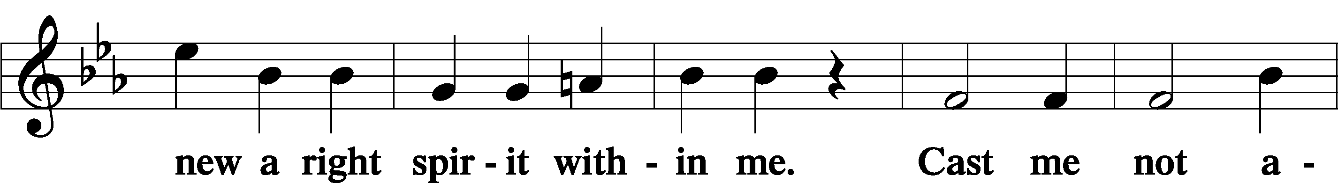
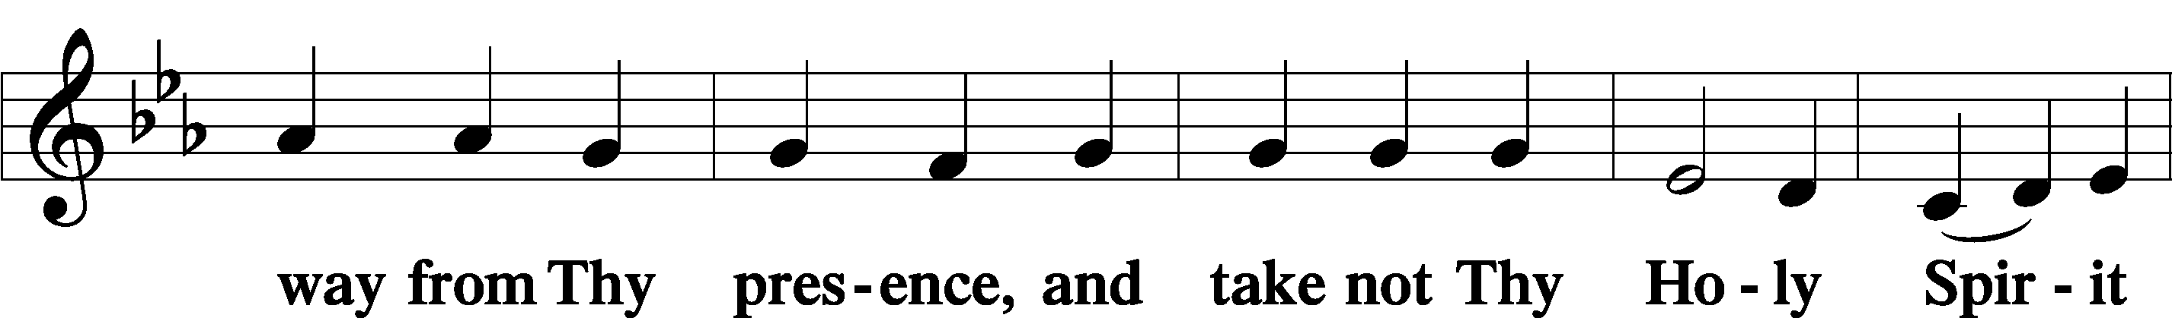
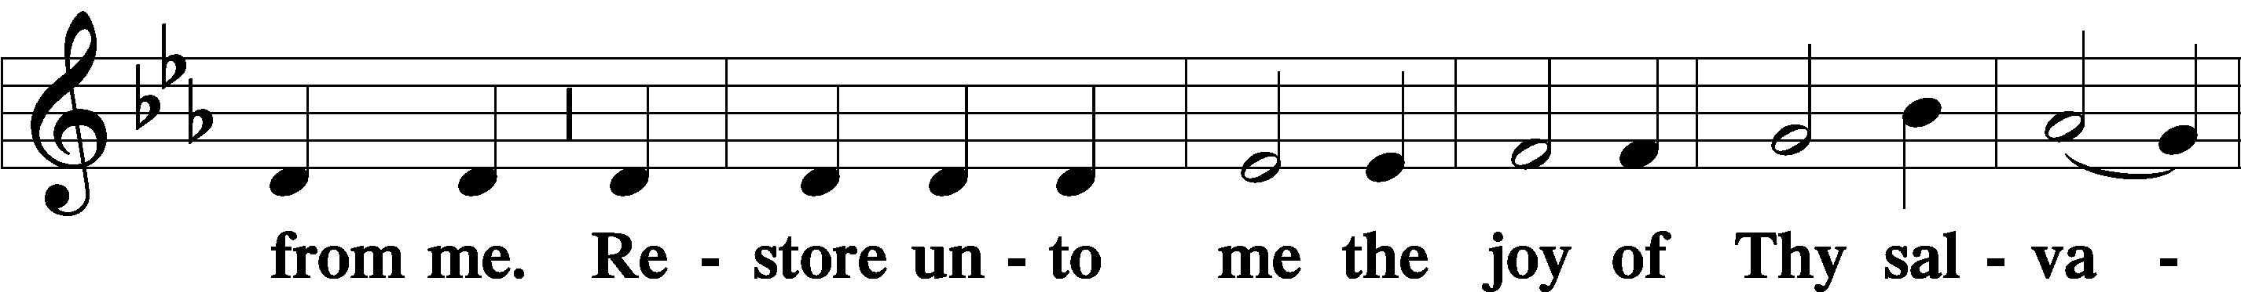
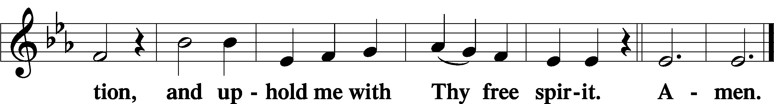
Sit
Preparatory Hymn: LSB #909 “Christ Is Made the Sure Foundation”

Service of the Sacrament

Preface 2 Timothy 4:22; Colossians 3:1 Psalm 136
P The Lord be with you.
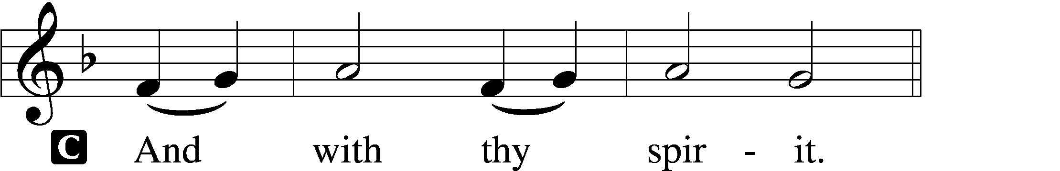

P Lift up your hearts.
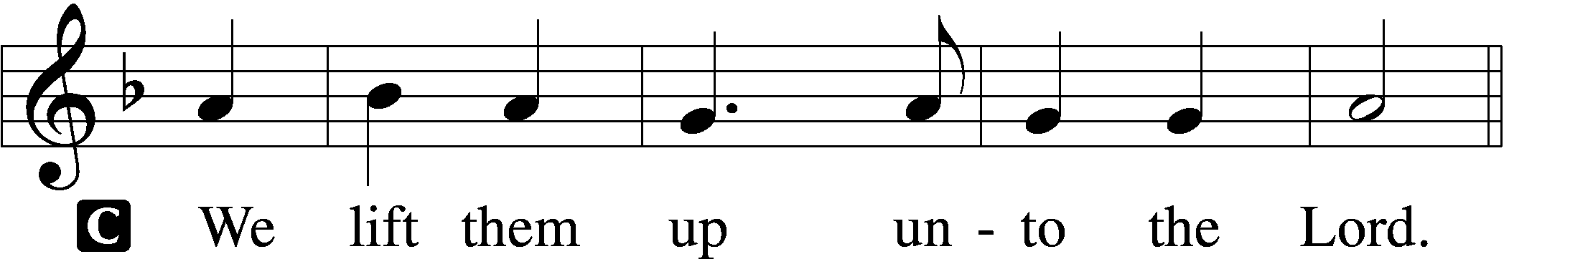

P Let us give thanks unto the Lord, our God.
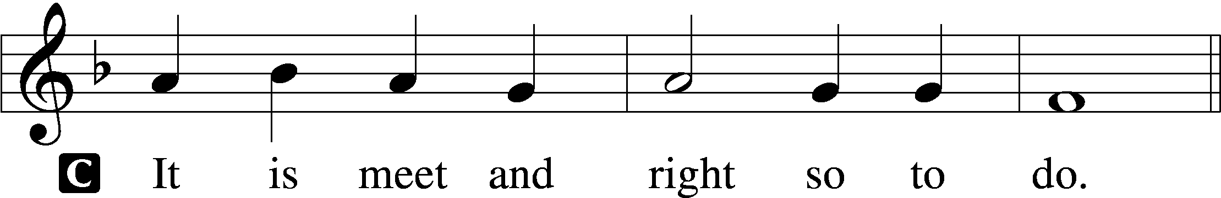

Proper Preface (Abbreviated) LSB 194
P It is truly meet, right, and salutary . . . evermore praising You and saying:

Sanctus Isaiah 6:3; Matthew 21:9
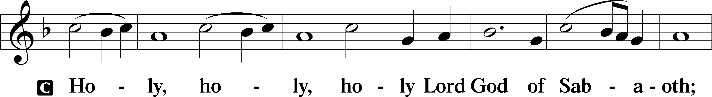
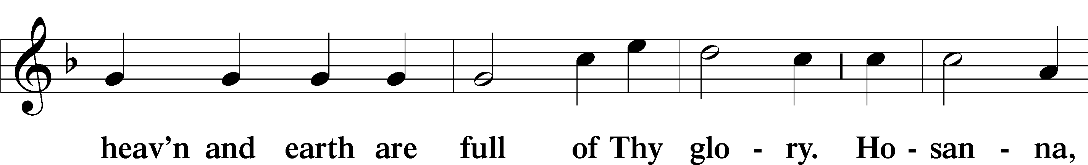
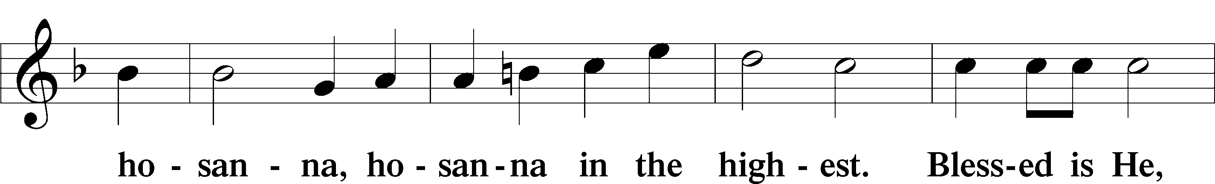
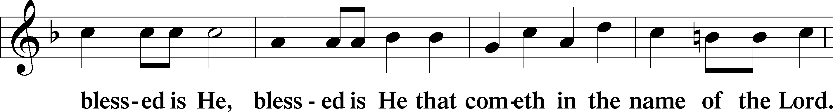
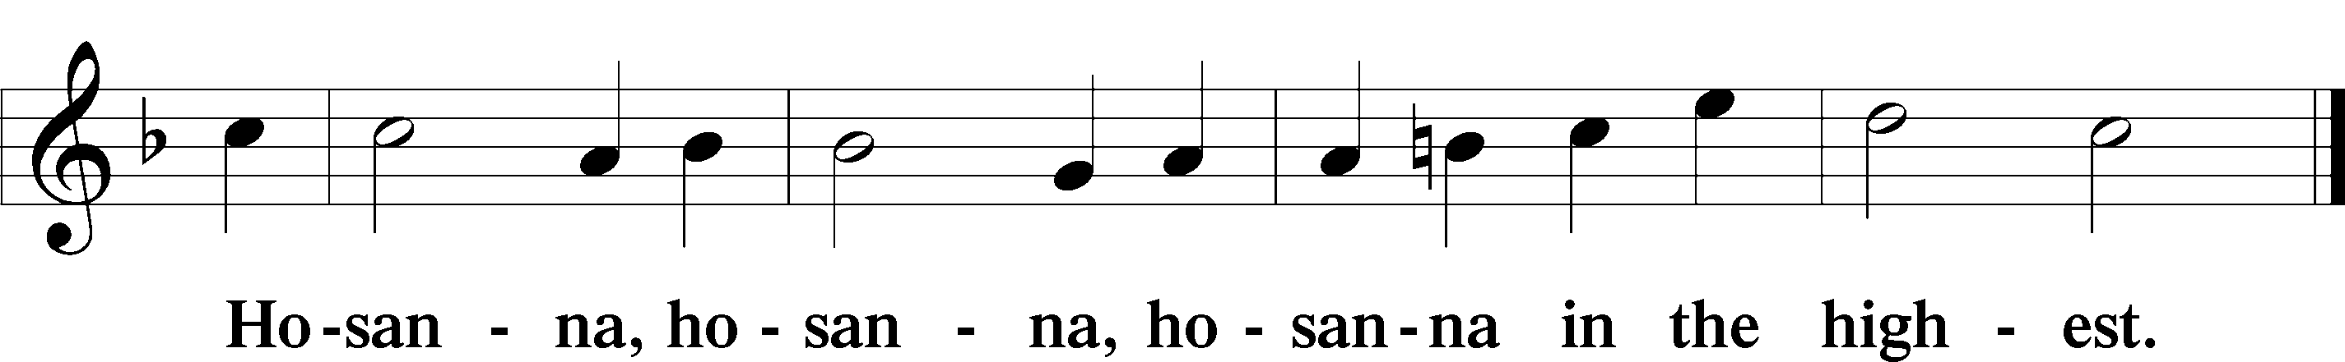

Lord’s Prayer Matthew 6:9–13
C Our Father who art in heaven,
hallowed be Thy name,
Thy kingdom come,
Thy will be done on earth as it is in heaven;
give us this day our daily bread;
and forgive us our trespasses as we forgive those who trespass against us;
and lead us not into temptation,
but deliver us from evil.
For Thine is the kingdom and the power and the glory forever and ever. Amen.

The Words of Our Lord Matthew 26:26–28; Mark 14:22–24; Luke 22:19–20; 1 Corinthians 11:23–25
P Our Lord Jesus Christ, on the night when He was betrayed, took bread, and when He had given thanks, He broke it and gave it to the disciples and said: “Take, eat; this is My T body, which is given for you. This do in remembrance of Me.”

In the same way also He took the cup after supper, and when He had given thanks, He gave it to them, saying: “Drink of it, all of you; this cup is the new testament in My T blood, which is shed for you for the forgiveness of sins. This do, as often as you drink it, in remembrance of Me.”

Pax Domini John 20:19
P The peace of the Lord be with you always.
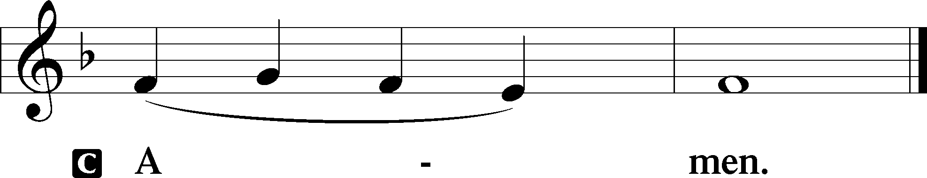

Agnus Dei John 1:29
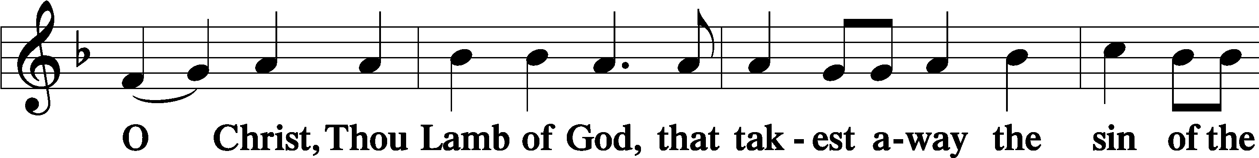
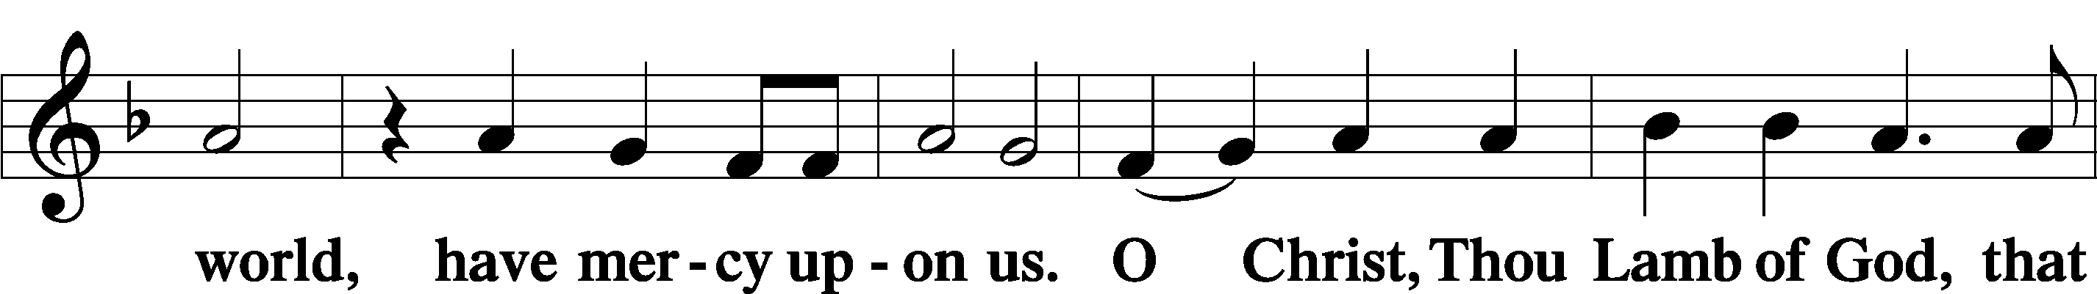
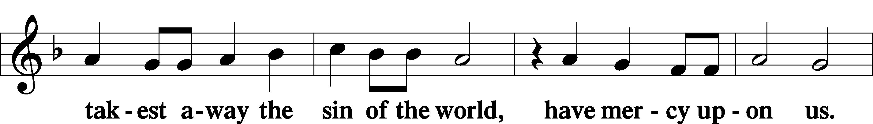
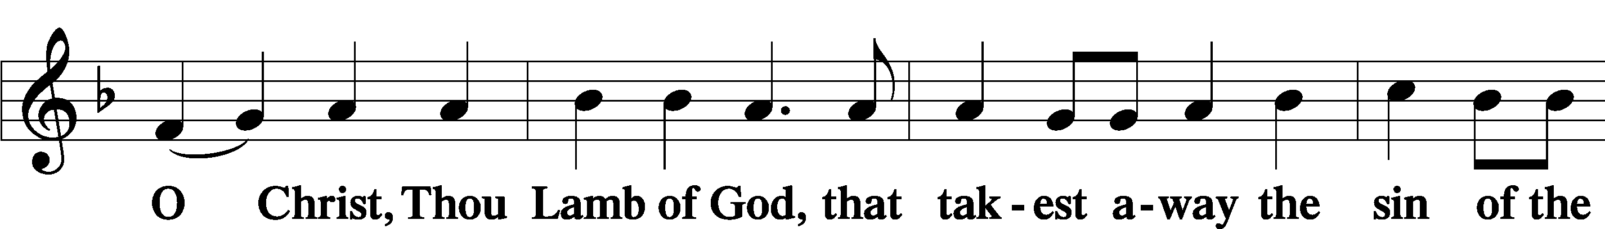
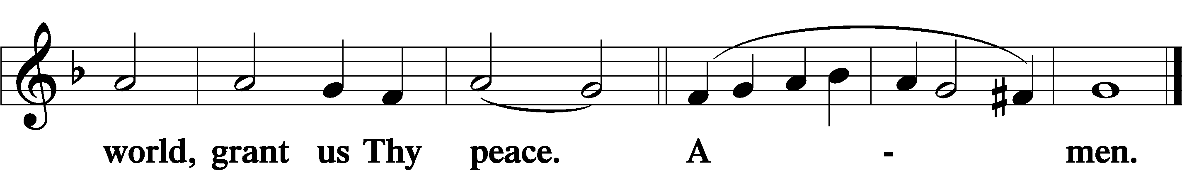
Sit

Distribution
The pastor and those who assist him receive the body and blood of Christ first and then distribute them to those who come to receive, saying:
Take, eat; this is the true body of our Lord and Savior Jesus Christ, given into death for your sins.
Amen.

Take, drink; this is the true blood of our Lord and Savior Jesus Christ, shed for the forgiveness of your sins.
Amen.

In dismissing the communicants, the following is said:
The Dismissal
P The body and blood of our Lord Jesus Christ strengthen and preserve you in body and soul to life everlasting. Depart T in peace.
C Amen.

Distribution Hymn: LSB #647”Lord Jesus Christ, the Church’s Head”

Distribution Hymn: LSB #570 “Just as I Am, without One Plea”

Distribution Hymn: LSB #683 “Jesus, Thy Boundless Love to Me”

Stand
Nunc Dimittis Luke 2:29–32
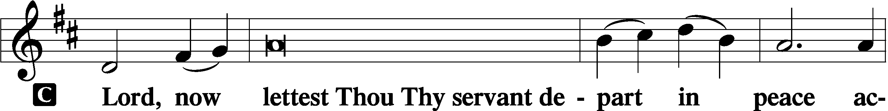
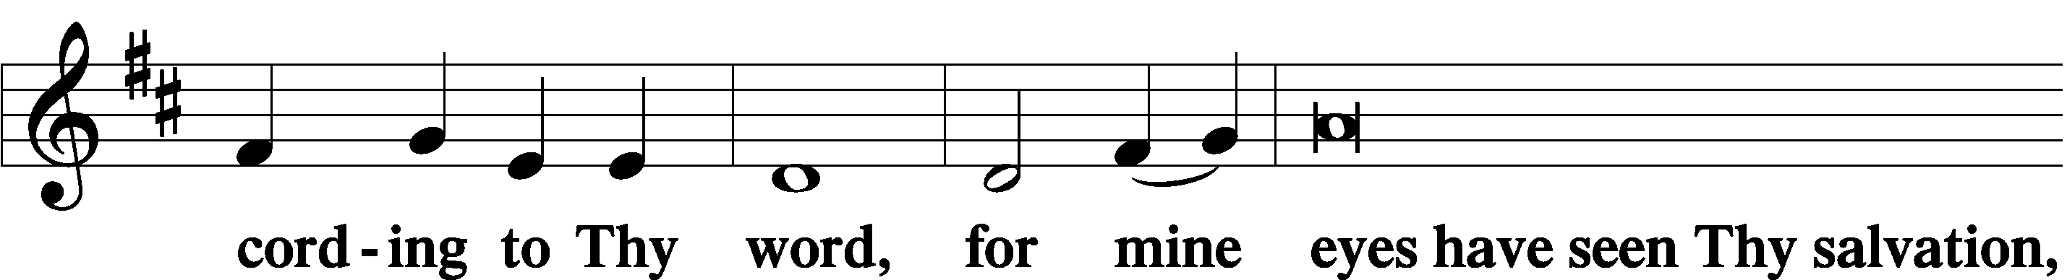
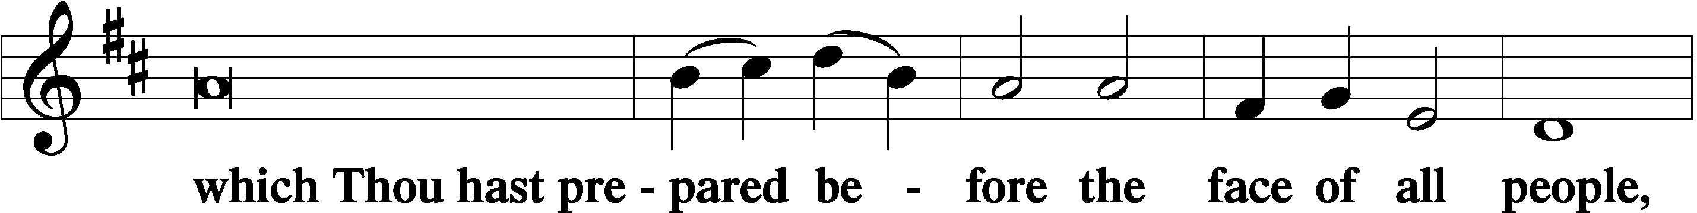
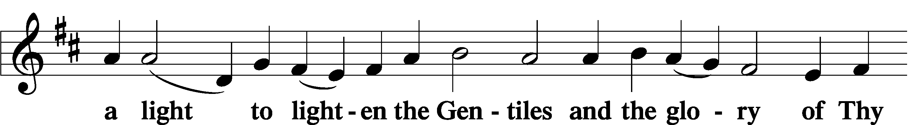
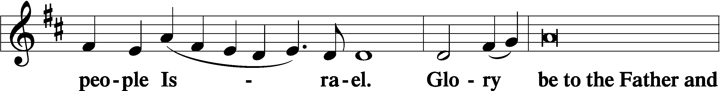
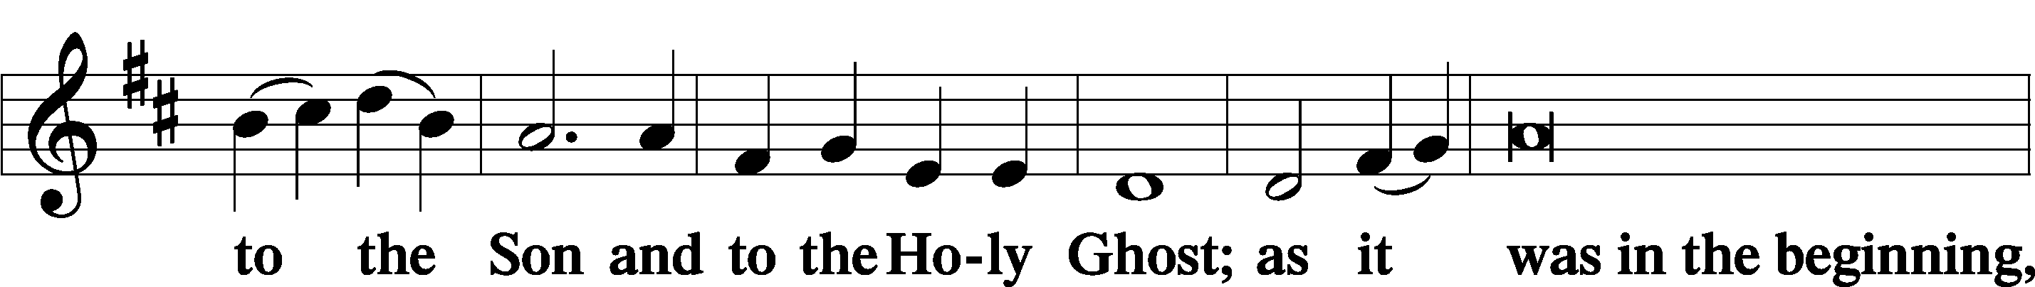
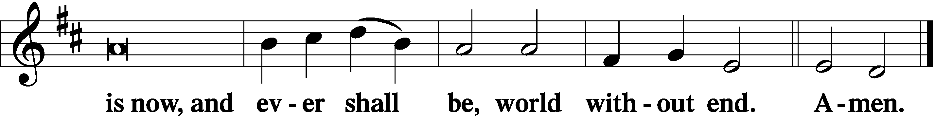

Thanksgiving Psalm 107:1
P O give thanks unto the Lord, for He is good,
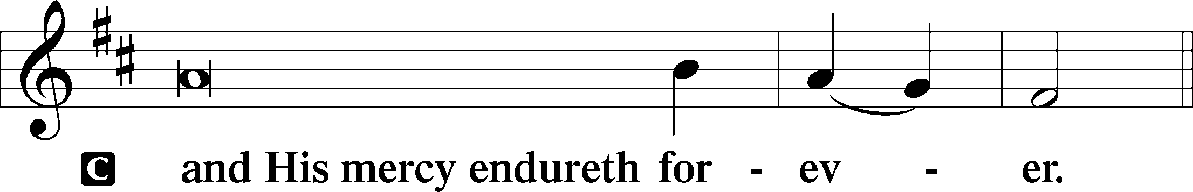

Post-Communion Collect
P Let us pray.
We give thanks to You, almighty God, that You have refreshed us through this salutary gift, and we implore You that of Your mercy You would strengthen us through the same in faith toward You and in fervent love toward one another; through Jesus Christ, Your Son, our Lord, who lives and reigns with You and the Holy Spirit, one God, now and forever.
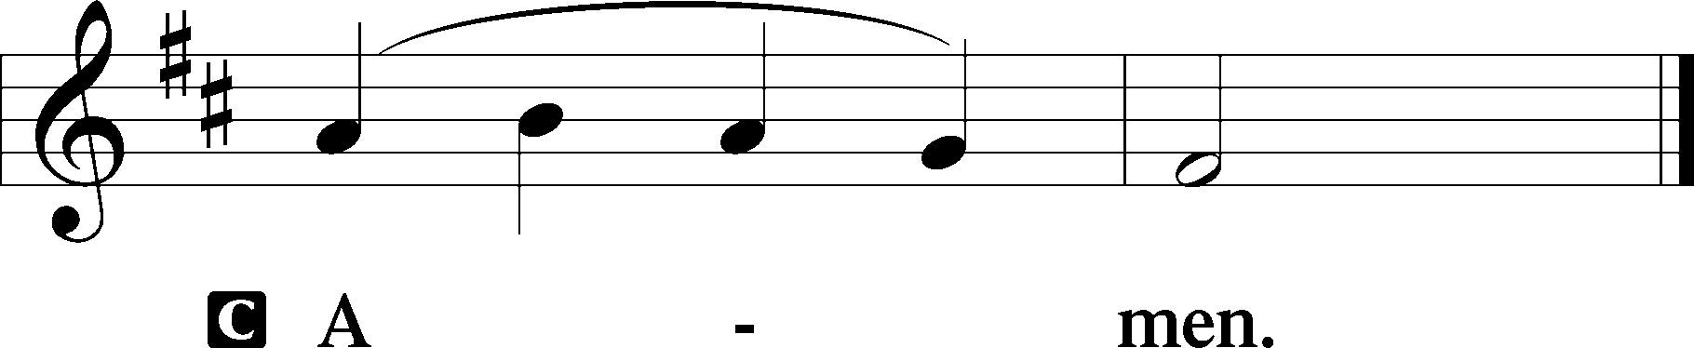

Salutation 2 Timothy 4:22
P The Lord be with you.
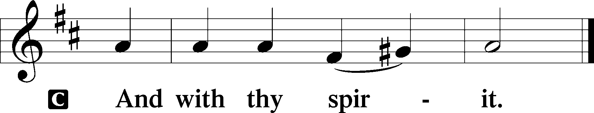

Benedicamus Psalm 103:1
P Bless we the Lord.
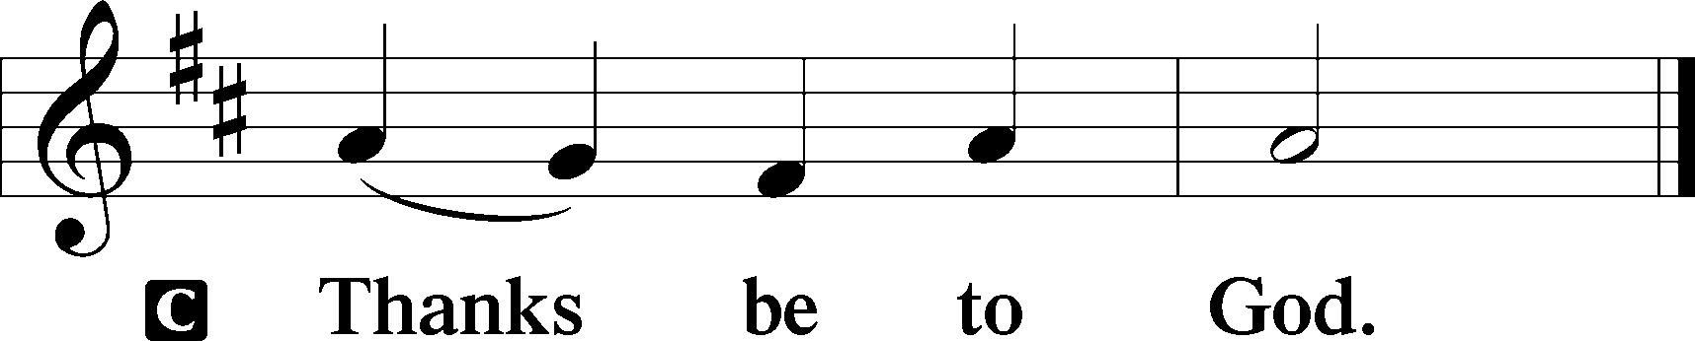

Benediction Numbers 6:24–26
P The Lord bless you and keep you.
The Lord make His face shine upon you and be gracious unto you.
The Lord lift up His countenance upon you and T give you peace.
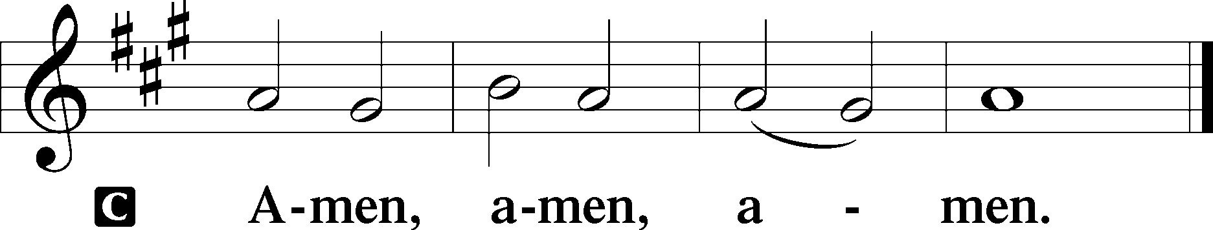

Closing Hymn: LSB #824 “May God Bestow on Us His Grace”

Silent prayer after worship: Lord Jesus, give me a faith that is always alive, active and growing so that it will bear fruit. Keep my close to You every day, and give me a desire to share with others the life You have given me. Amen.
fffffffffffffffffffffffffffffffffff
Acknowledgments
Unless otherwise indicated, Scripture quotations are from the ESV® Bible (The Holy Bible, English Standard Version®), copyright © 2001 by Crossway, a publishing ministry of Good News Publishers. Used by permission. All rights reserved.
Created by Lutheran Service Builder © 2023 Concordia Publishing House.
fffffffffffffffffffffffffffffffffff
fffffffffffffffffffffffffffffffffff
In Loving Memory of Husband, Robert Sulek, and Father, Michael Dorfi: Edeltraud Sulek (Capital Campaign).
In Loving Memory of Father, Paul Petro: Patty Parker (Capital Campaign).
fffffffffffffffffffffffffffffffffff
Attendance: Sunday, June 11, 2023: 42
fffffffffffffffffffffffffffffffffff
SCHEDULE THROUGH JUNE 25, 2023:

:

Today, following Worship, Library: Audit of Deposits
7 pm, Fellowship Hall: AA Meeting
Tuesday, 7-9 pm, Fellowship Hall: Penn-Ohio Singers
Wednesday, 7:30 pm, Fellowship Hall: NA Meeting
Thursday, 9 am, Downstairs: Food Pantry
Next Sunday, 8 am, Fellowship Hall: Bible Study
9 am, Sanctuary: Divine Service
7 pm, Fellowship Hall: AA Meeting
fffffffffffffffffffffffffffffffffff
Items for the July calendar and newsletter are due to the Secretary’s office no later than noon, tomorrow, June 19th.
Our Stewardship of Treasures for the Lord:
In order to do the Lord’s work, we need $2,553.63 each week to meet our 2023 budget for general purposes and $76.92 for the SELC.
Figures for Sunday, June 11, 2023
General Fund: $2,430.00 Behind for the week: -$123.63
SELC: $5.00 Behind for the week: -$71.92
Food Pantry: $5.00
Capital Campaign: $682.00
Other: $841.00

For online giving, check out https://www.saintspeterandpaul.net/online-giving.
fffffffffffffffffffffffffffffffffff
Bible Memory Verses ~ Week of June 18th:
For Adults: Whoever believes and is baptized will be saved, but whoever does not believe will be condemned. Mark 16:16
For Children: Come to me, all who labor and are heavy laden, and I will give you rest. Matthew 11:28
fffffffffffffffffffffffffffffffffff
THANK YOU FOR SERVING IN JUNE: Elder: Jonathan Baisch; Ushers: Cheryl Fedele, Mike Flaugher, & Jesse Riffle; Altarware: (prior) Diane Riefstahl & Marie Flaugher (06/11); (after) Elizabeth Haenftling & Traudi Sulek.
fffffffffffffffffffffffffffffffffff
Mark Your Calendar!
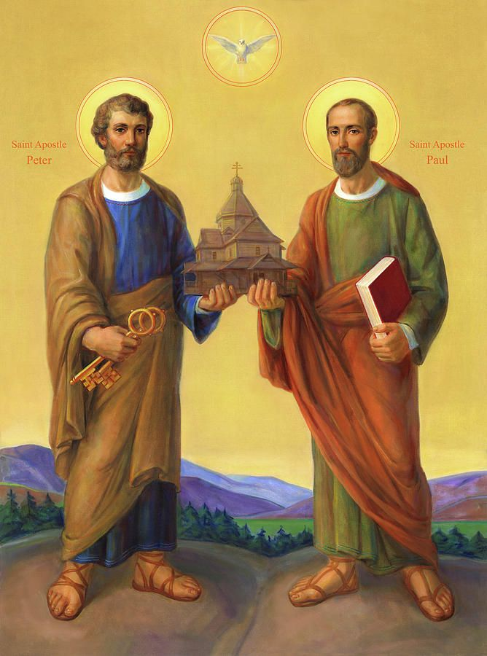

The Festival of Saint Peter and Saint Paul
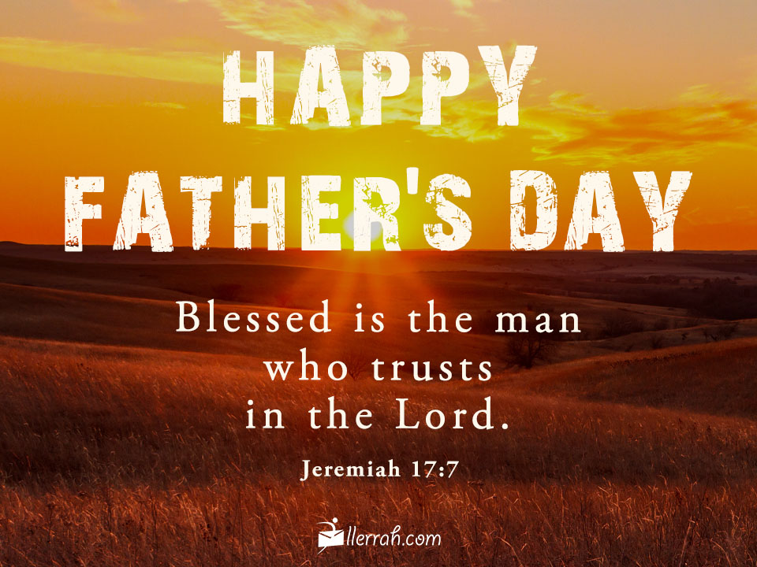
will be celebrated with a Divine Service,
Thursday, June 29th at 7 pm.

Remember the following in Prayer…
~The Hurting and Healing: Amy, Steve Antolovich, Gerald Arthur, Ellen Baron^{CA}, Lois Bortner^{CA}, John Burdette, Bev & Joe Chlpka, Kathleen Coughenour, Kim, Anna Mae Daris, Susan Davies, Tim Dudash, Millie Elavsky, Joseph Fleet, Judith & Eddy Furey, Tim Haenftling, Austin Hamilton, Joan, Darla Krajci, Barbara Kreske, Donna Kennedy, Jess Lavoie, Elizabeth Loughan, Paul Lucas^{CA}, Sandy Marshall, Augusta Mennell, Frank Niemeyer^{CA}, Linda Parkany, Juanita Rentschler, Richard Reuning^{CA}, Nancy Robertson^{CA}, Marty Scott, Kara, Fred Tonty, Joel & Peggy Wasson, Angela Weser^{CA}, and Ruth Wolf.
~The Homebound: Rudy & Jean Tomko, Betty Wolf, and Ed & Millie Zachar.
~Celebrating this Week: Birthdays: Rudy Tomko (06.20) and Sue Bender (06.21). Anniversary: Matt & Cathy Berent (06.23).
~Serving in the Military: Alex (Sasha) Carr, Curtis Sinewe and Joshua Solyan.
~Community & World Needs: Those suffering from or affected by the coronavirus; those suffering due to the conflict between Ukraine and Russia; those suffering from loss and dislocation because weather disasters; those suffering from addiction and their families; Local, State, and National Government Leaders; safety for all Police Officers, Firefighters, & First Responders; the unemployed; our Second Quarter Local Mission: The Support of a Concordia, Fort Wayne Seminarian.
*CA represents cancer.
fffffffffffffffffffffffffffffffffff
Copies of the minutes from the recent Voters’ Assembly are available on the table in the narthex.
fffffffffffffffffffffffffffffffffff
“Portals of Prayer” for July~August~September are available on the tables next to the nursery and in the narthex. Take one for a friend!
fffffffffffffffffffffffffffffffffff

Wishing a
Blessed Father’s Day
to all fathers in our lives!

Here to Serve
Pastor………………………………………………...……………Rev. Jacob Deal
E-mail …………………………….……pastordeal@saintspeterandpaul.net
Phone Number……………………..…………………724-347-3620 (Option 2)
Church Office………………………..…………………724-347-3620 (Option 3)
Website …………………………………………www.saintspeterandpaul.net
Secretary…………………………………………………………Diane Riefstahl
E-mail ………………………………………church@saintspeterandpaul.net
Website …………………………………………www.saintspeterandpaul.net
Food Pantry: Please leave message……………724-347-3620 (Option 3)
AA Contact: Steve………………………………………………..…724-813-2358
NA Contact: Larry………………………………………………..724-977-8733
Choir Director………………………………………………………Chris Nelson
Congregation President……………………………………Jonathan Baisch
Church Elder …………………………………………...…… Jonathan Baisch
fffffffffffffffffffffffffffffffffff
If needing to get into the church building during the week, please phone first to make certain someone is here to let you in.

