Sts. Peter & Paul
Evangelical Lutheran Church
Lutheran Church-Missouri Synod
Founded-1917

July 9, 2023

699 Stambaugh Ave.
Sharon, Pennsylvania 16146

“I was glad when they said to me,
Let us go to the house of the LORD!”
Psalm 122:1
Sts. Peter & Paul Evangelical Lutheran Church, LC-MS
THE FIFTH SUNDAY AFTER TRINITY
July 9, 2023
A special welcome to our guests this day! If you would like more information about The Lutheran Church - Missouri Synod, or this congregation, please speak with Pastor Deal or an Elder after the service.
Members & Guests: Don’t be embarrassed if your children make noise during the worship service, all children do. We encourage families to worship together but, if you feel the need, there are pews in the rear of the Church which are reserved for young families on both sides of the sanctuary. There is also a quiet room available to you during our service which is located down the hallway past the offices on the right side of the church as well as a children’s area in the Fellowship Hall where you are able to follow along with the service.

Today’s service includes the Sacrament of Holy Communion. If during this past year, you have not worshipped with us and been communed, we respectfully ask that you do not partake of this sacrament this day before first speaking with Pastor Deal.
If visiting from a sister congregation of the LC-MS and are in good standing, please inform Pastor Deal of your desire to commune prior to the service.
If wishing to receive a blessing during communion, please approach with your arms crossed.

CONTACT INFORMATION
Pastor Deal: pastordeal@saintspeterandpaul.net or 724-347-3620 (opt. 2)
Church Office: church@saintspeterandpaul.net or 724-347-3620 (opt. 3)
Secretary’s Office will be open Monday and Thursday (8:30-4:30) this week.

Silent prayer before worship: Heavenly Father, You sent Your only begotten Son into the world so that all people could have forgiveness, life and salvation. Lead me to worship You with a heart of thanksgiving and praise for Your grace. In Jesus’ name. Amen.
Confession and Absolution

Opening Hymn: LSB #876 “O Blessed, Holy Trinity”

Stand

The sign of the cross may be made by all in remembrance of their Baptism.

Invocation
P In the name of the Father and of the T Son and of the Holy Spirit.
C Amen.

Exhortation Hebrews 10:22; Psalm 124:8; Psalm 32:5
P Beloved in the Lord! Let us draw near with a true heart and confess our sins unto God our Father, beseeching Him in the name of our Lord Jesus Christ to grant us forgiveness.

P Our help is in the name of the Lord,
C who made heaven and earth.
P I said, I will confess my transgressions unto the Lord,
C and You forgave the iniquity of my sin.

Silence for reflection on God’s Word and for self-examination.

Confession of Sins
P O almighty God, merciful Father,
C I, a poor, miserable sinner, confess unto You all my sins and iniquities with which I have ever offended You and justly deserved Your temporal and eternal punishment. But I am heartily sorry for them and sincerely repent of them, and I pray You of Your boundless mercy and for the sake of the holy, innocent, bitter sufferings and death of Your beloved Son, Jesus Christ, to be gracious and merciful to me, a poor, sinful being.

Absolution [John 20:19–23]
P Upon this your confession, I, by virtue of my office, as a called and ordained servant of the Word, announce the grace of God unto all of you, and in the stead and by the command of my Lord Jesus Christ I forgive you all your sins in the name of the Father and of the T Son and of the Holy Spirit.
C Amen.

Service of the Word

Introit Psalm 27:1a, 11–12, 14; antiphon: vv. 7, 9b
Hear, O Lord, when I | cry aloud;*
be gracious to me and | answer me!
O you who have | been my help,*
forsake me not, O God of my sal- | vation!
The Lord is my light and my sal- | vation;*
whom | shall I fear?
Teach me your way, | O Lord,*
and lead me on a level path because of my | enemies.
Give me not up to the will of my adver- | saries;*
for false witnesses have risen against me, and they breathe out | violence.
Wait | for the Lord;*
be strong, and let your heart take courage; wait | for the Lord!
Hear, O Lord, when I | cry aloud;*
be gracious to me and | answer me!
O you who have | been my help,*
forsake me not, O God of my sal- | vation!

Gloria Patri
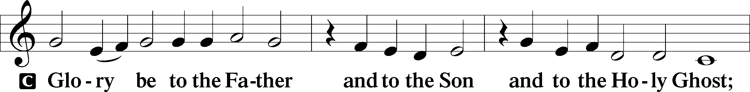
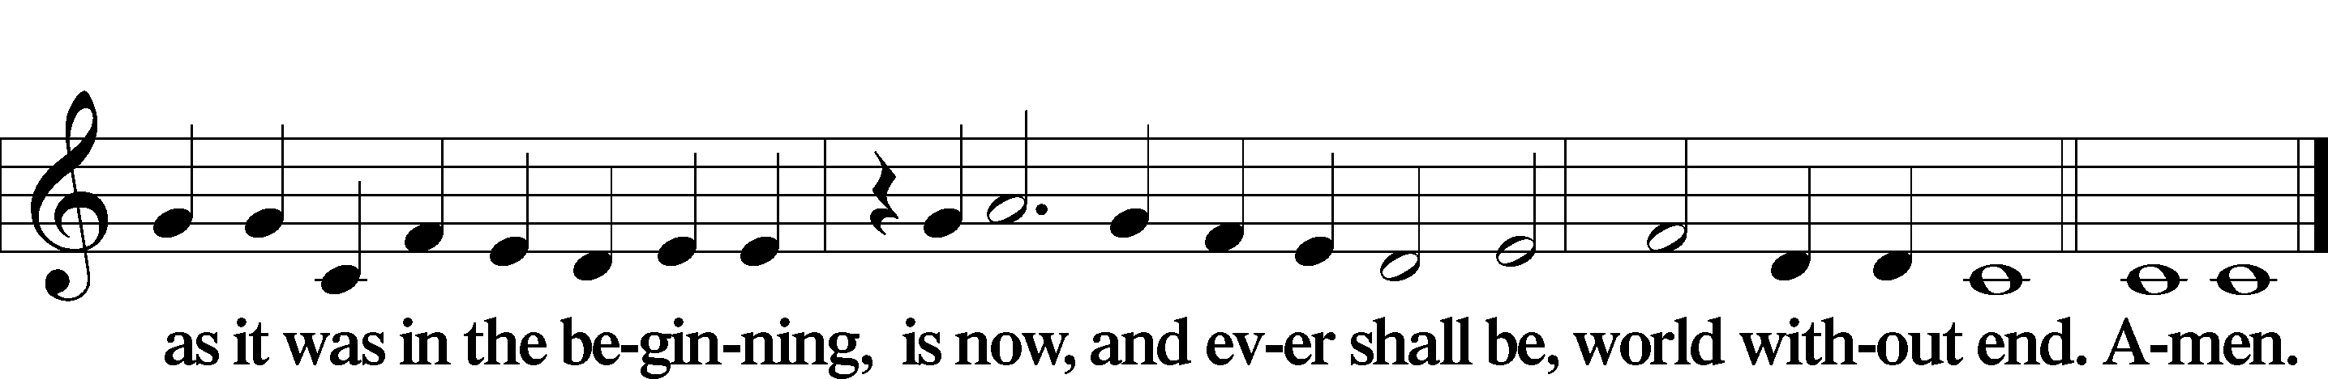

Kyrie Mark 10:47
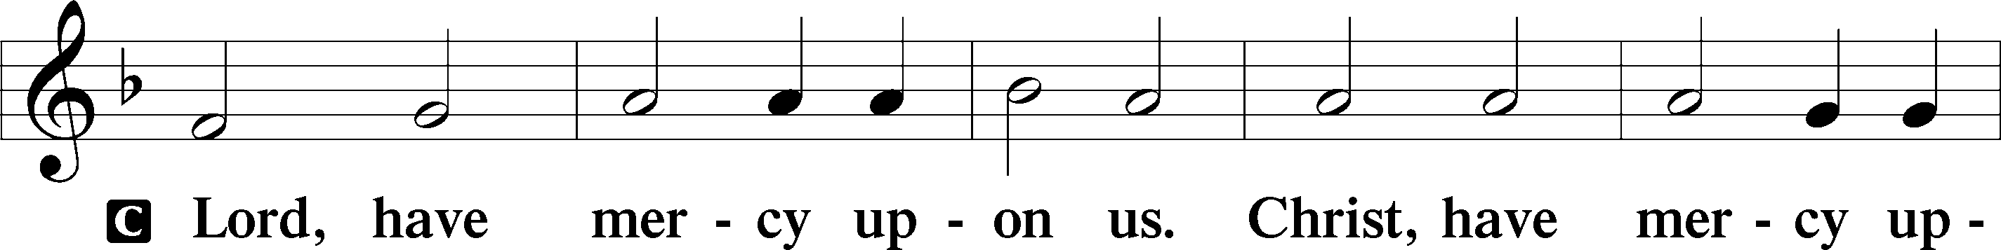
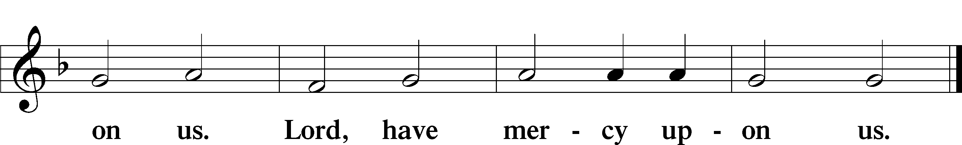

Gloria in Excelsis Luke 2:14; John 1:29
P Glory be to God on high:
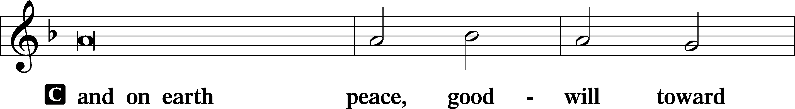
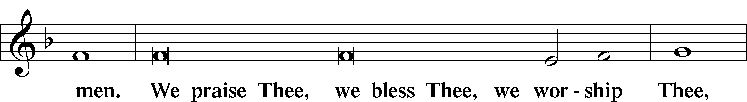
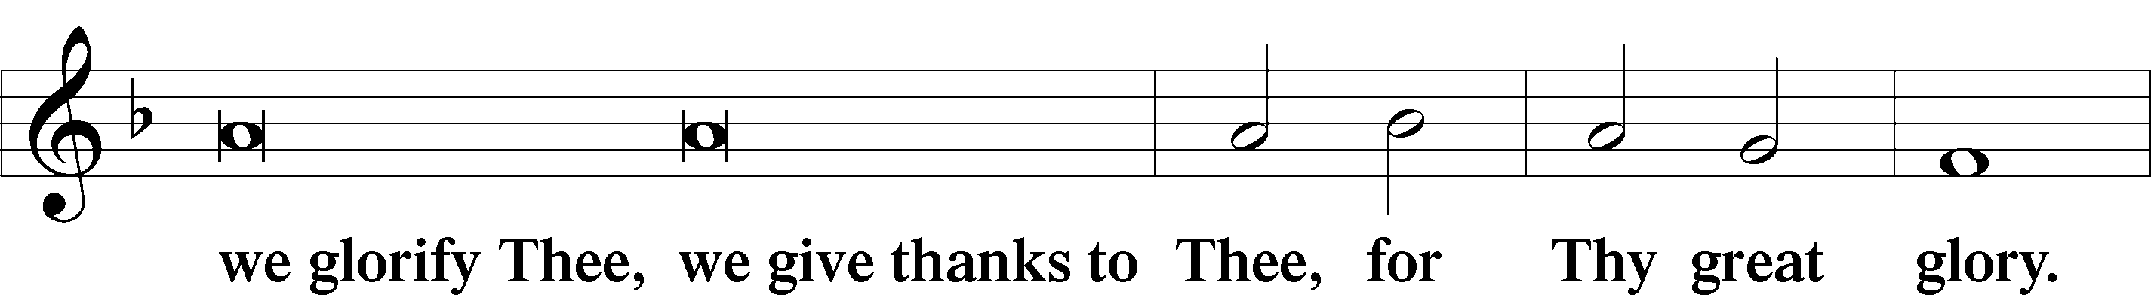
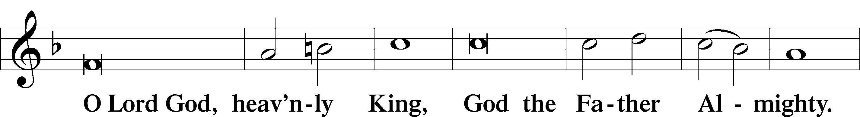
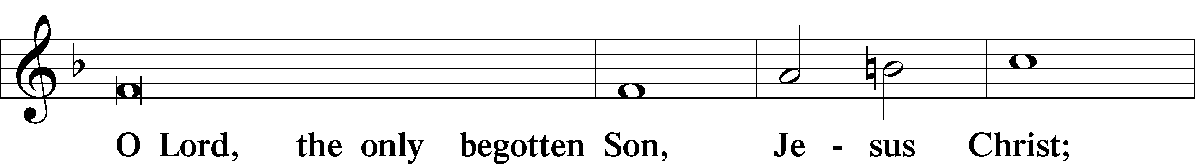
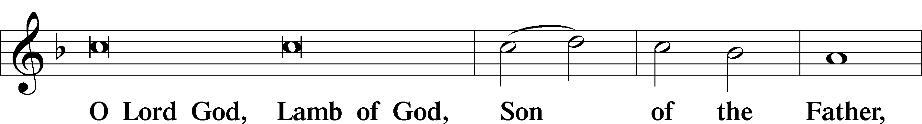
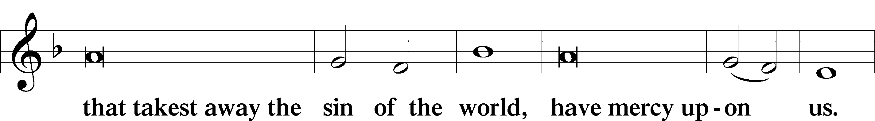
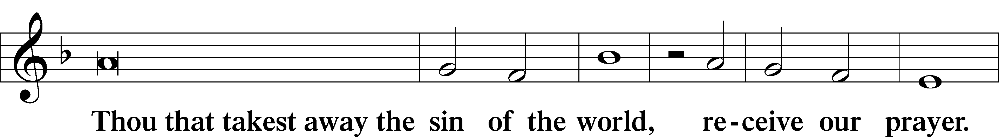
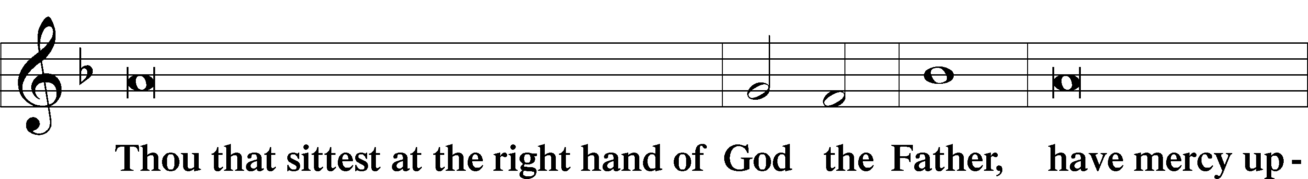
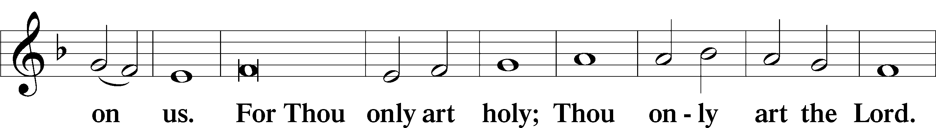
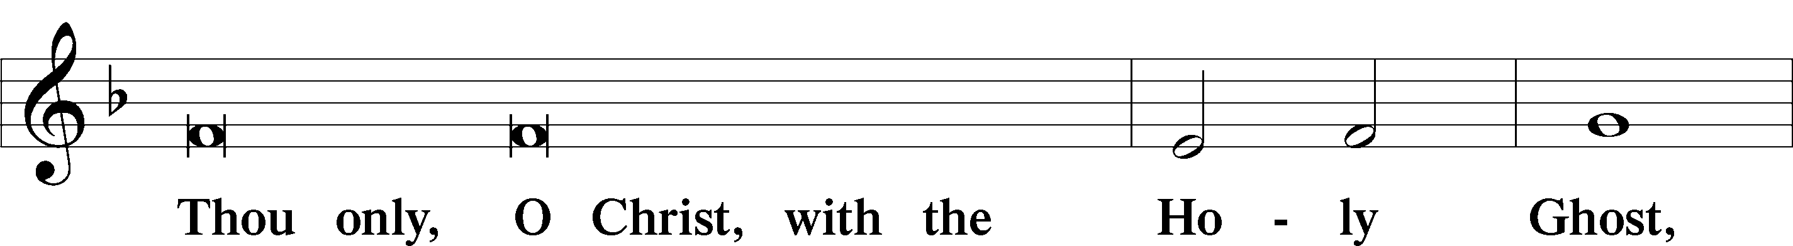
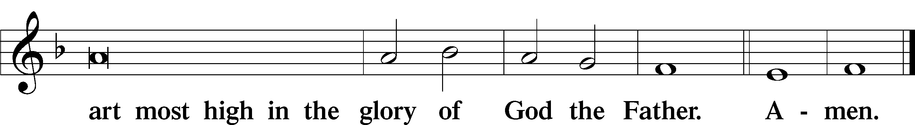

Salutation and Collect of the Day: Trinity 5
P The Lord be with you.
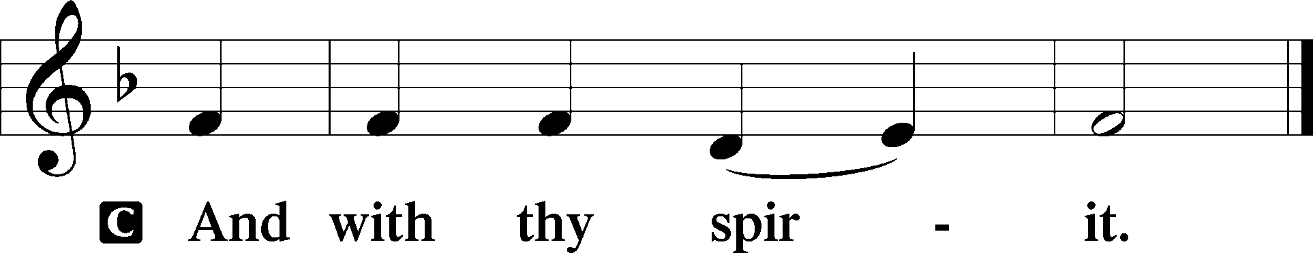

P Let us pray.
O God, You have prepared for those who love You good things that surpass all understanding. Pour into our hearts such love toward You that we, loving You above all things, may obtain Your promises, which exceed all that we can desire; through Jesus Christ, Your Son, our Lord, who lives and reigns with You and the Holy Spirit, one God, now and forever.
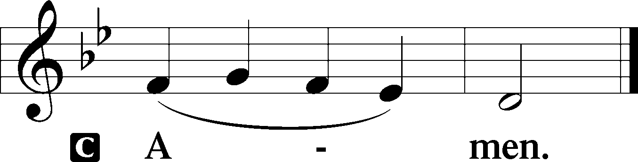
Sit

Prophecy: 1 Kings 19:11–21 (NKJV)
In those days the Lord spoke to Elijah, saying: “Go out, and stand on the mountain before the Lord.” And behold, the Lord passed by, and a great and strong wind tore into the mountains and broke the rocks in pieces before the Lord, but the Lord was not in the wind; and after the wind an earthquake, but the Lord was not in the earthquake; and after the earthquake a fire, but the Lord was not in the fire; and after the fire a still small voice. So it was, when Elijah heard it, that he wrapped his face in his mantle and went out and stood in the entrance of the cave. Suddenly a voice came to him, and said, “What are you doing here, Elijah?” And he said, “I have been very zealous for the Lord God of hosts; because the children of Israel have forsaken Your covenant, torn down Your altars, and killed Your prophets with the sword. I alone am left; and they seek to take my life.” Then the Lord said to him: “Go, return on your way to the Wilderness of Damascus; and when you arrive, anoint Hazael as king over Syria. Also you shall anoint Jehu the son of Nimshi as king over Israel. And Elisha the son of Shaphat of Abel Meholah you shall anoint as prophet in your place. It shall be that whoever escapes the sword of Hazael, Jehu will kill; and whoever escapes the sword of Jehu, Elisha will kill. Yet I have reserved seven thousand in Israel, all whose knees have not bowed to Baal, and every mouth that has not kissed him.” So he departed from there, and found Elisha the son of Shaphat, who was plowing with twelve yoke of oxen before him, and he was with the twelfth. Then Elijah passed by him and threw his mantle on him. And he left the oxen and ran after Elijah, and said, “Please let me kiss my father and my mother, and then I will follow you.” And he said to him, “Go back again, for what have I done to you?” So Elisha turned back from him, and took a yoke of oxen and slaughtered them and boiled their flesh, using the oxen’s equipment, and gave it to the people, and they ate. Then he arose and followed Elijah, and became his servant.

P This is the Word of the Lord.
C Thanks be to God.
Gradual Psalm 84:9, 8
Behold our shield, | O God;*
look on the face of your a- | nointed!
O Lord God of hosts, | hear my prayer;*
give ear, O God of | Jacob!

Epistle: 1 Peter 3:8–15a (NKJV)
Dearly Beloved: All of you be of one mind, having compassion for one another; love as brothers, be tenderhearted, be courteous; not returning evil for evil or reviling for reviling, but on the contrary blessing, knowing that you were called to this, that you may inherit a blessing. For “He who would love life and see good days, let him refrain his tongue from evil, and his lips from speaking deceit. Let him turn away from evil and do good; let him seek peace and pursue it. For the eyes of the Lord are on the righteous, and His ears are open to their prayers; but the face of the Lord is against those who do evil.” And who is he who will harm you if you become followers of what is good? But even if you should suffer for righteousness’ sake, you are blessed. “And do not be afraid of their threats, nor be troubled.” But sanctify the Lord God in your hearts.

P This is the Word of the Lord.
C Thanks be to God.

Stand

Verse Psalm 21:1
Alleluia. O Lord, in your strength the king rejoices, and in your salvation how greatly he exults! Alleluia.

Alleluia
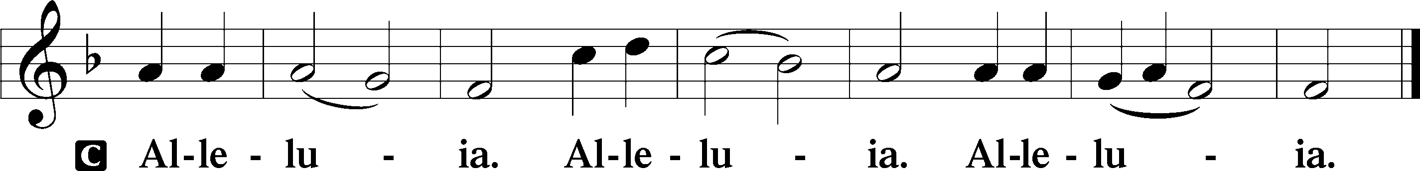
Holy Gospel: Luke 5:1–11 (NKJV)
P The Holy Gospel according to St. Luke, the fifth chapter.
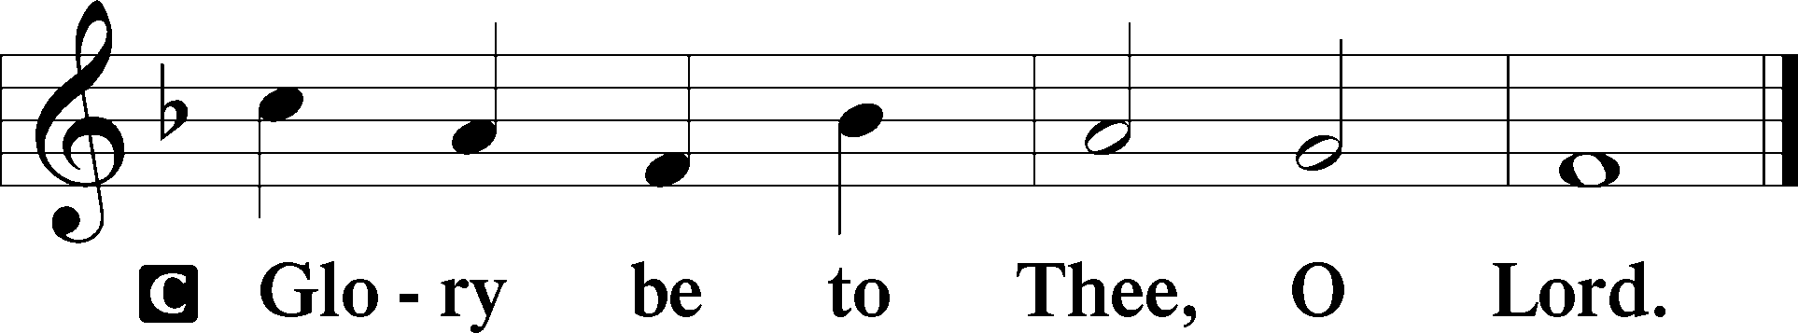

At that time: As the multitude pressed about Jesus to hear the word of God, He stood by the Lake of Gennesaret, and saw two boats standing by the lake; but the fishermen had gone from them and were washing their nets. Then He got into one of the boats, which was Simon’s, and asked him to put out a little from the land. And He sat down and taught the multitudes from the boat. When He had stopped speaking, He said to Simon, “Launch out into the deep and let down your nets for a catch.” But Simon answered and said to Him, “Master, we have toiled all night and caught nothing; nevertheless at Your word I will let down the net.” And when they had done this, they caught a great number of fish, and their net was breaking. So they signaled to their partners in the other boat to come and help them. And they came and filled both the boats, so that they began to sink. When Simon Peter saw it, he fell down at Jesus’ knees, saying, “Depart from me, for I am a sinful man, O Lord!” For he and all who were with him were astonished at the catch of fish which they had taken; and so also were James and John, the sons of Zebedee, who were partners with Simon. And Jesus said to Simon, “Do not be afraid. From now on you will catch men.” So when they had brought their boats to land, they forsook all and followed Him.

P This is the Gospel of the Lord.
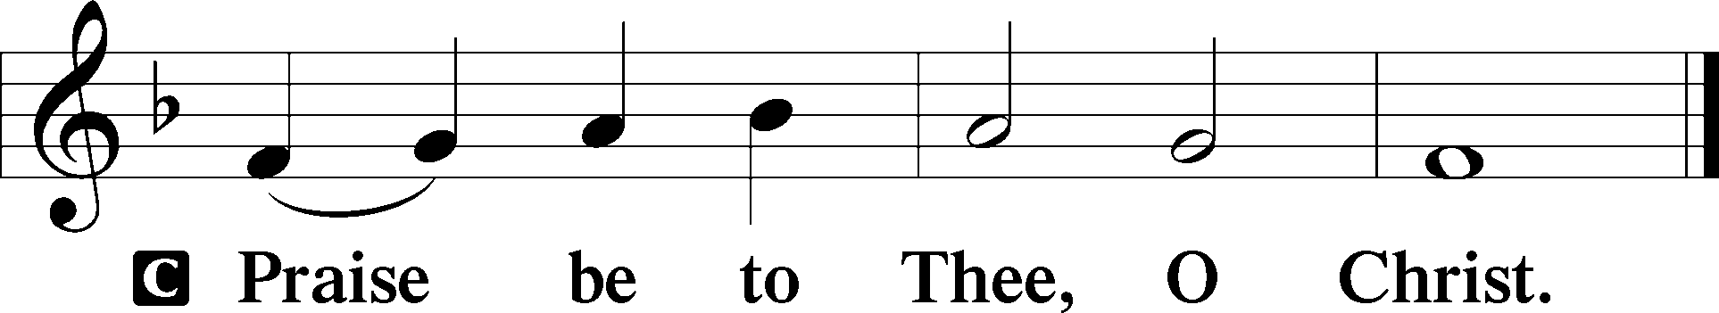

Nicene Creed
C I believe in one God,
the Father Almighty,
maker of heaven and earth
and of all things visible and invisible.

And in one Lord Jesus Christ,
the only-begotten Son of God,
begotten of His Father before all worlds,
God of God, Light of Light,
very God of very God,
begotten, not made,
being of one substance with the Father,
by whom all things were made;
who for us men and for our salvation came down from heaven
and was incarnate by the Holy Spirit of the virgin Mary
and was made man;
and was crucified also for us under Pontius Pilate.
He suffered and was buried.
And the third day He rose again according to the Scriptures
and ascended into heaven
and sits at the right hand of the Father.
And He will come again with glory to judge both the living and the dead,
whose kingdom will have no end.

And I believe in the Holy Spirit,
the Lord and giver of life,
who proceeds from the Father and the Son,
who with the Father and the Son together is worshiped and glorified,
who spoke by the prophets.
And I believe in one holy Christian and apostolic Church,
I acknowledge one Baptism for the remission of sins,
and I look for the resurrection of the dead
and the life T of the world to come. Amen.
Sit

Hymn of the Day: LSB #688 “’Come, Follow Me,’ the Savior Spake”

Sermon

Stand

Prayer of the Church

Offertory Psalm 51:10–12
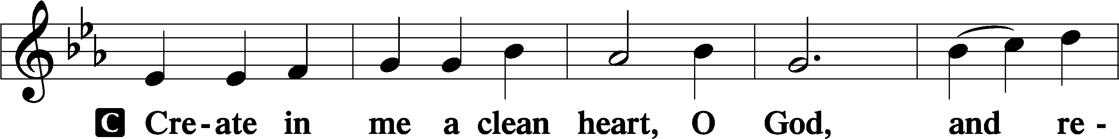
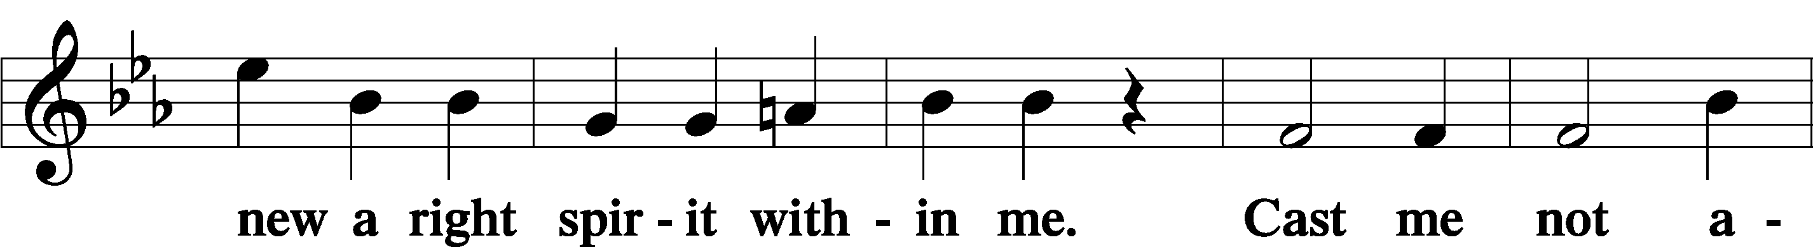
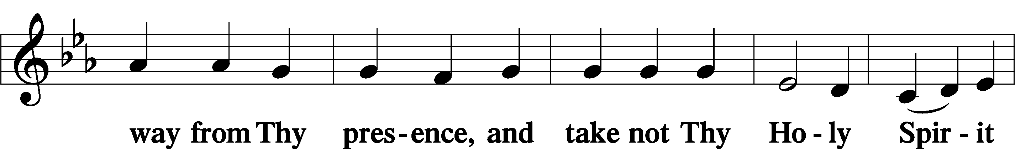
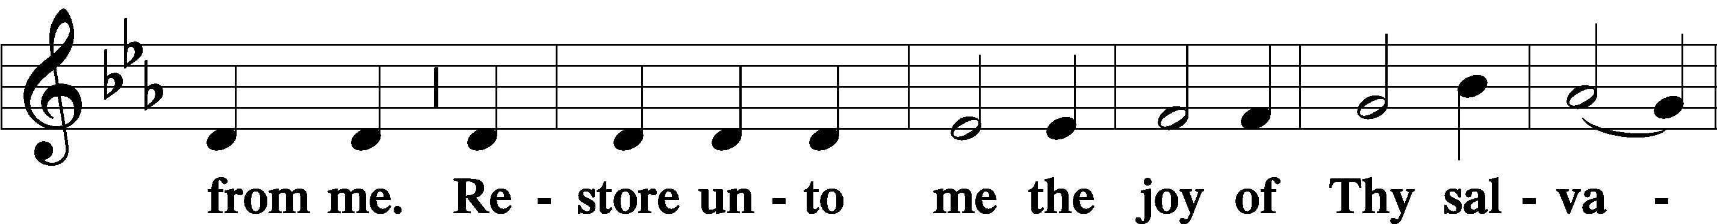
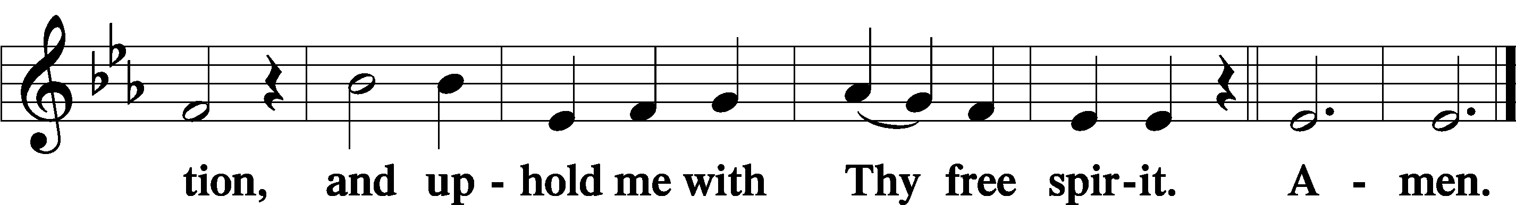
Sit

Preparatory Hymn: LSB #750 “If Thou But Trust in God to Guide Thee”

Stand

Service of the Sacrament

Preface 2 Timothy 4:22; Colossians 3:1 Psalm 136
P The Lord be with you.

P Lift up your hearts.
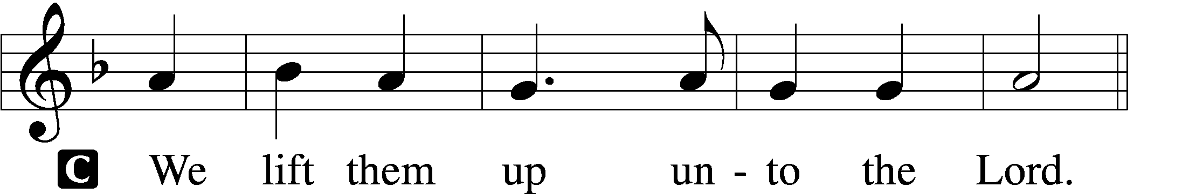

P Let us give thanks unto the Lord, our God.
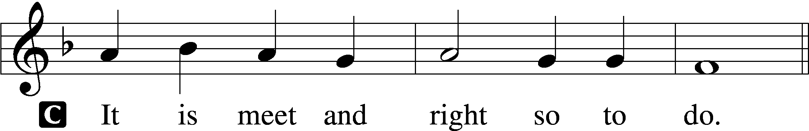

Proper Preface (Abbreviated) LSB 194
P It is truly meet, right, and salutary . . . evermore praising You and saying:

Sanctus Isaiah 6:3; Matthew 21:9
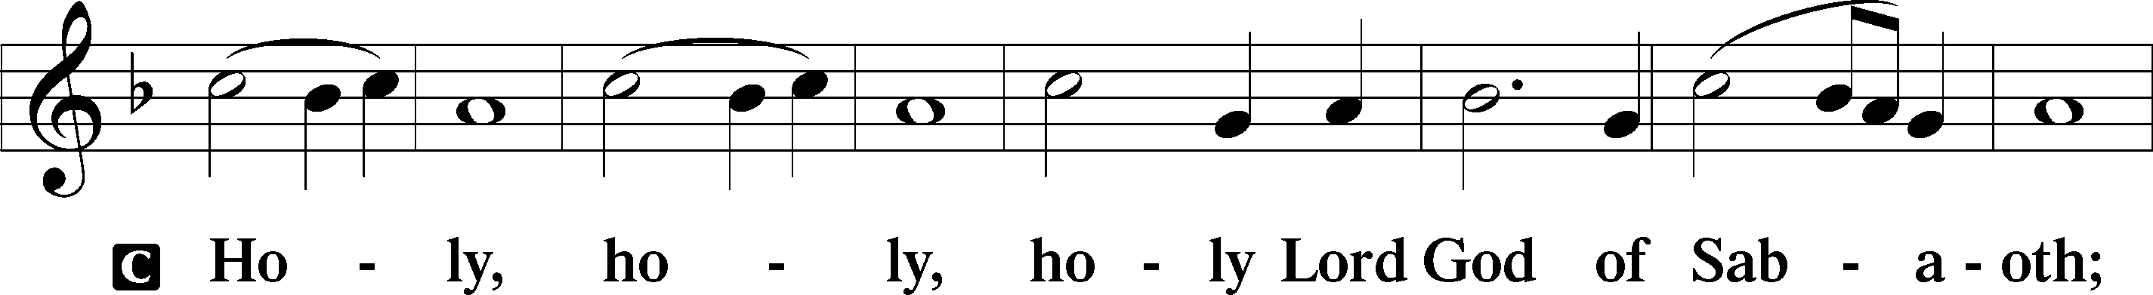
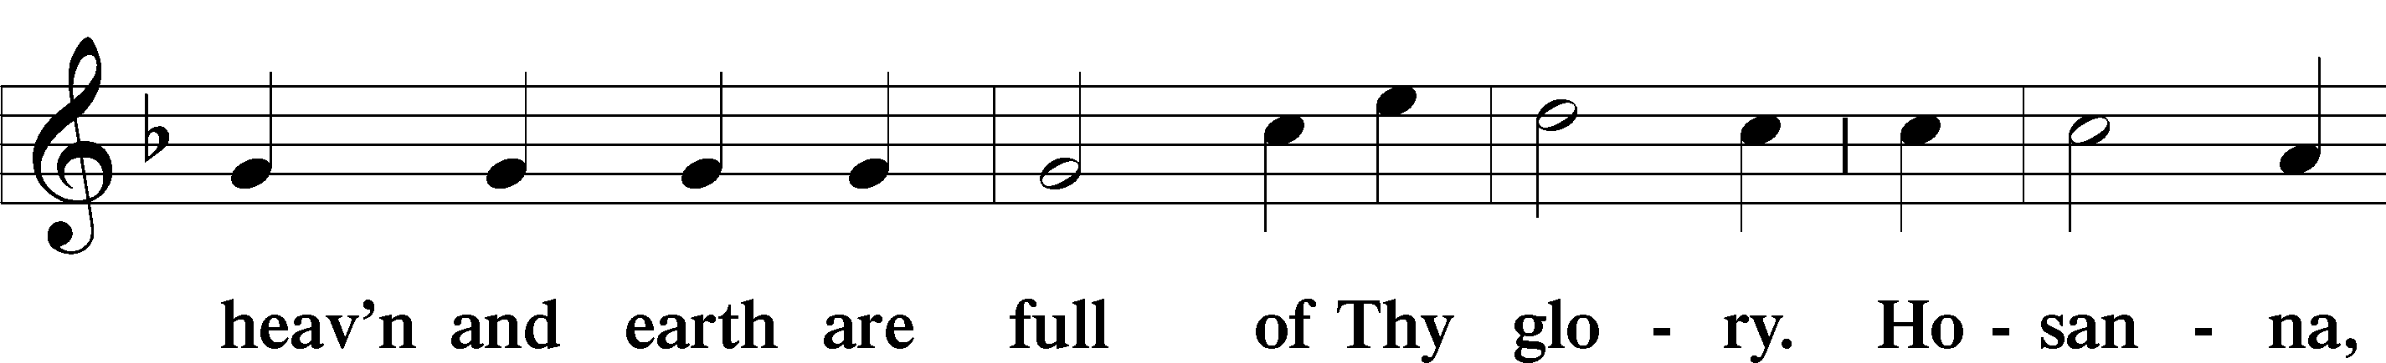
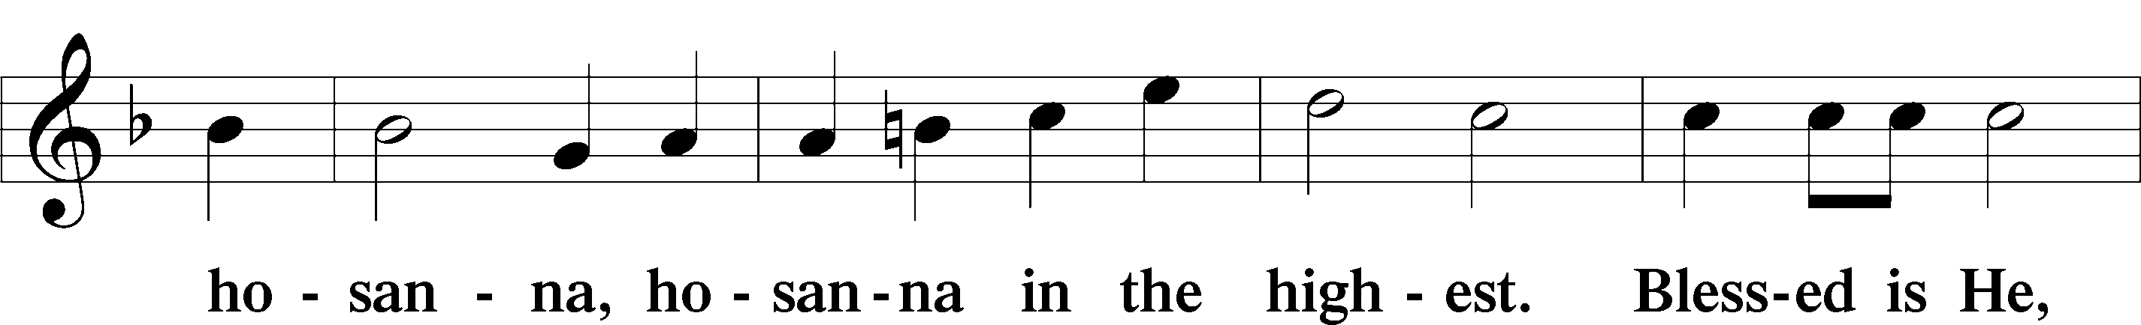
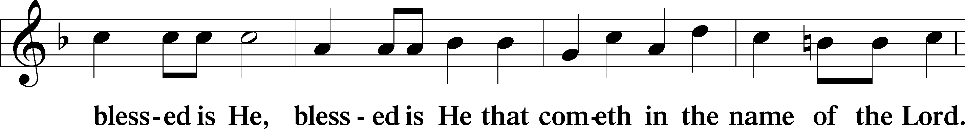
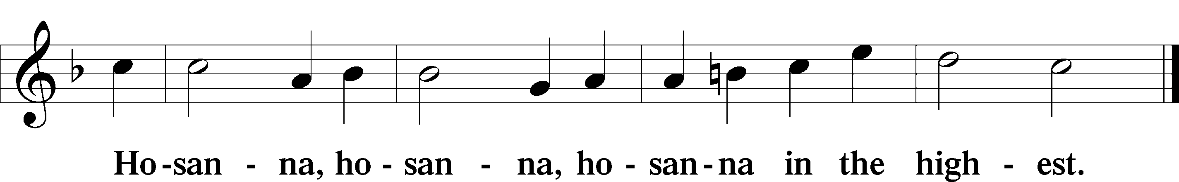

Lord’s Prayer Matthew 6:9–13
C Our Father who art in heaven,
hallowed be Thy name,
Thy kingdom come,
Thy will be done on earth as it is in heaven;
give us this day our daily bread;
and forgive us our trespasses as we forgive those who trespass against us;
and lead us not into temptation,
but deliver us from evil.
For Thine is the kingdom and the power and the glory forever and ever. Amen.

The Words of Our Lord Matthew 26:26–28; Mark 14:22–24; Luke 22:19–20; 1 Corinthians 11:23–25
P Our Lord Jesus Christ, on the night when He was betrayed, took bread, and when He had given thanks, He broke it and gave it to the disciples and said: “Take, eat; this is My T body, which is given for you. This do in remembrance of Me.”

In the same way also He took the cup after supper, and when He had given thanks, He gave it to them, saying: “Drink of it, all of you; this cup is the new testament in My T blood, which is shed for you for the forgiveness of sins. This do, as often as you drink it, in remembrance of Me.”

Pax Domini John 20:19
P The peace of the Lord be with you always.
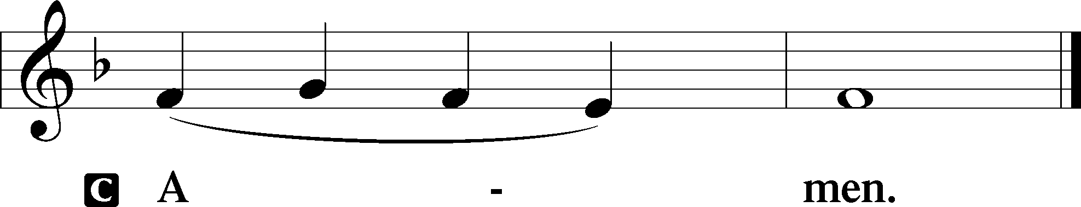

Agnus Dei John 1:29
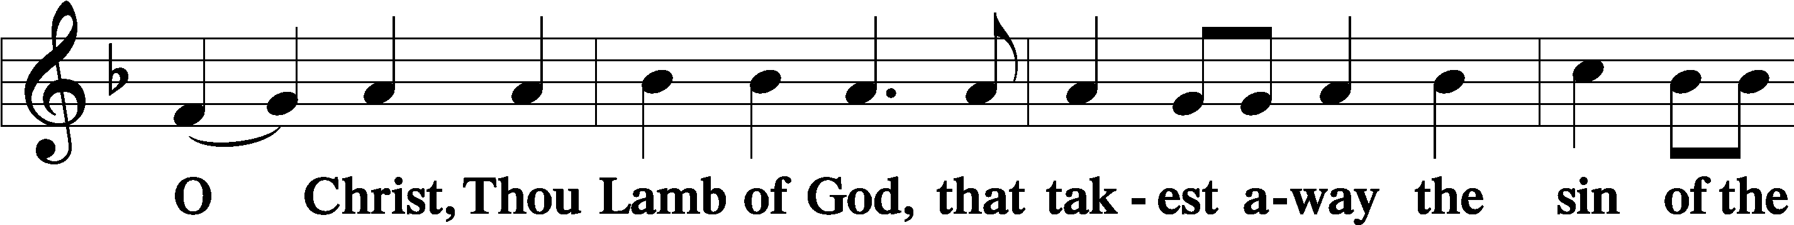
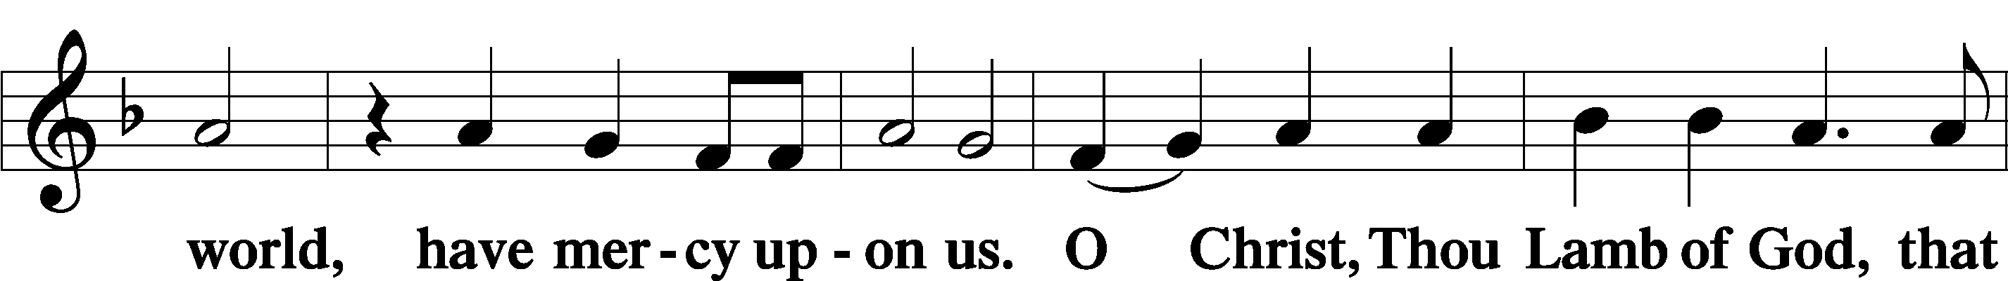
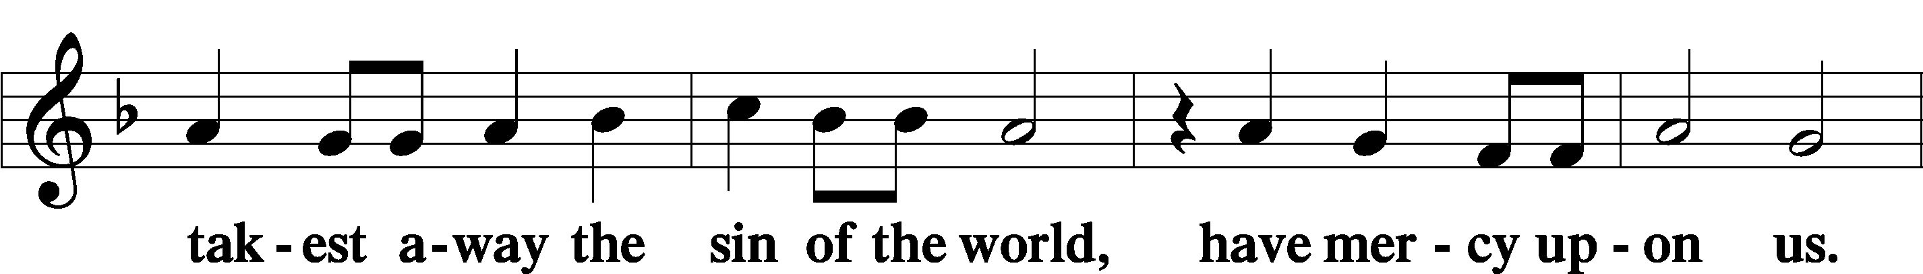
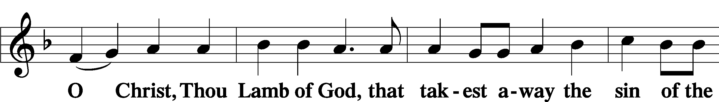
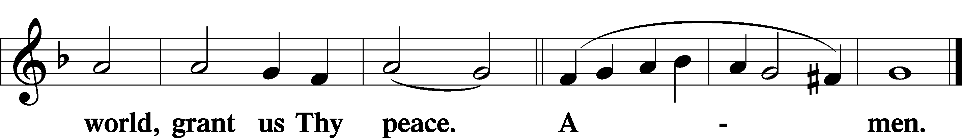
Sit

Distribution
The pastor and those who assist him receive the body and blood of Christ first and then distribute them to those who come to receive, saying:
Take, eat; this is the true body of our Lord and Savior Jesus Christ, given into death for your sins.
Amen.

Take, drink; this is the true blood of our Lord and Savior Jesus Christ, shed for the forgiveness of your sins.
Amen.

In dismissing the communicants, the following is said:
The Dismissal
P The body and blood of our Lord Jesus Christ strengthen and preserve you in body and soul to life everlasting. Depart T in peace.
C Amen.

Distribution Hymn: LSB #454 “Sing, My Tongue, the Glorious Battle”

Distribution Hymn: LSB #617 “O Lord, We Praise Thee”

Distribution Hymn: LSB #578 “Thy Strong Word”

Nunc Dimittis Luke 2:29–32
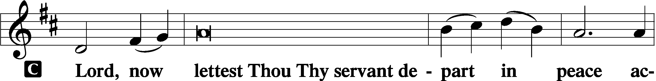
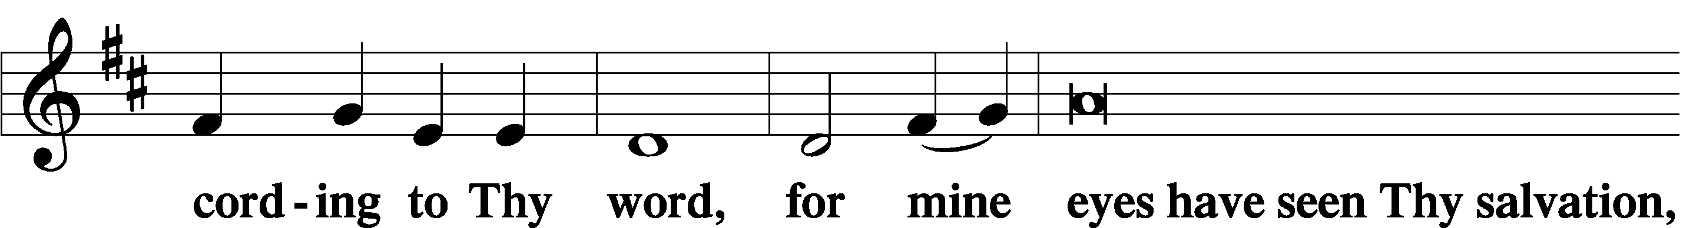
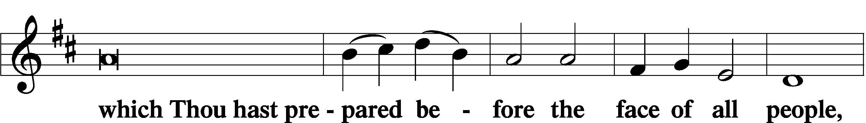
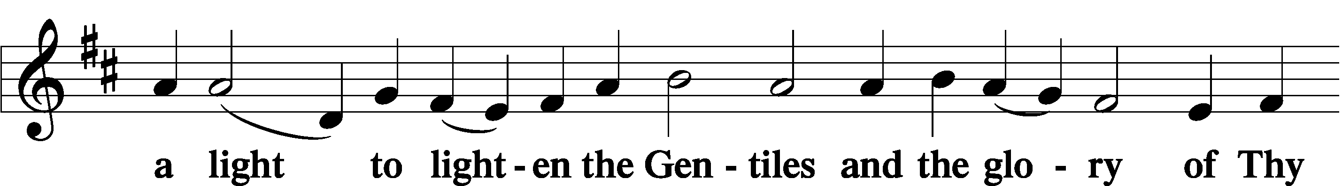
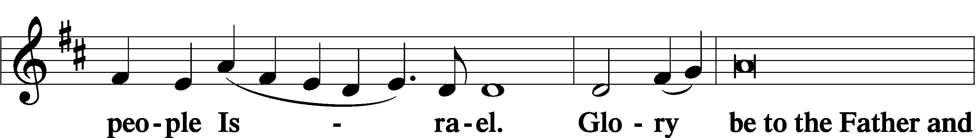
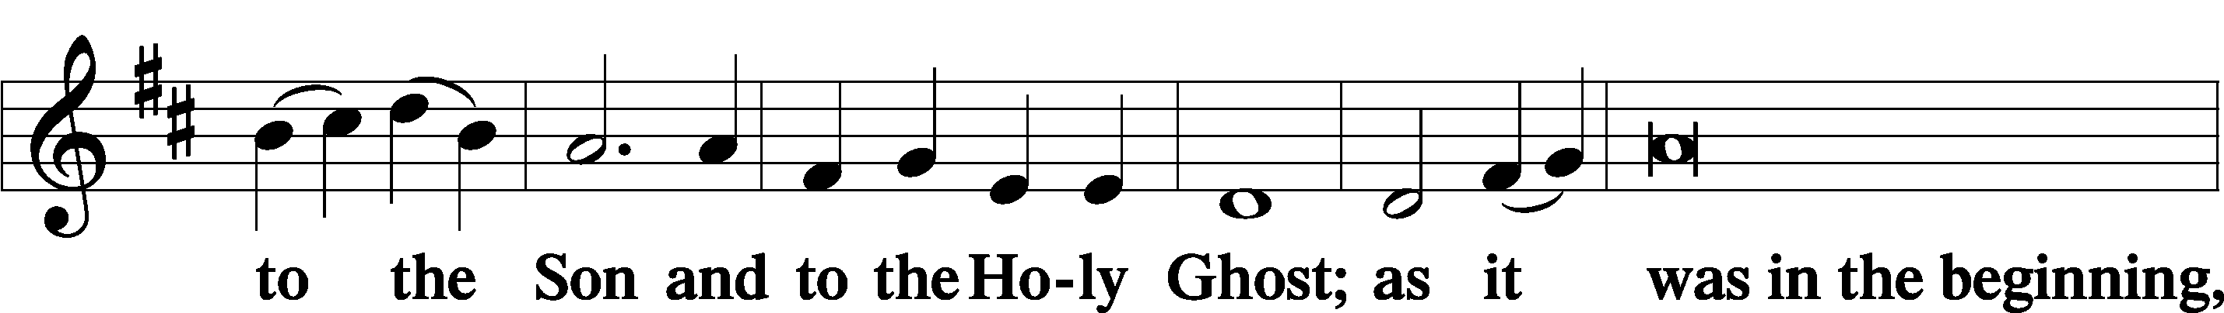
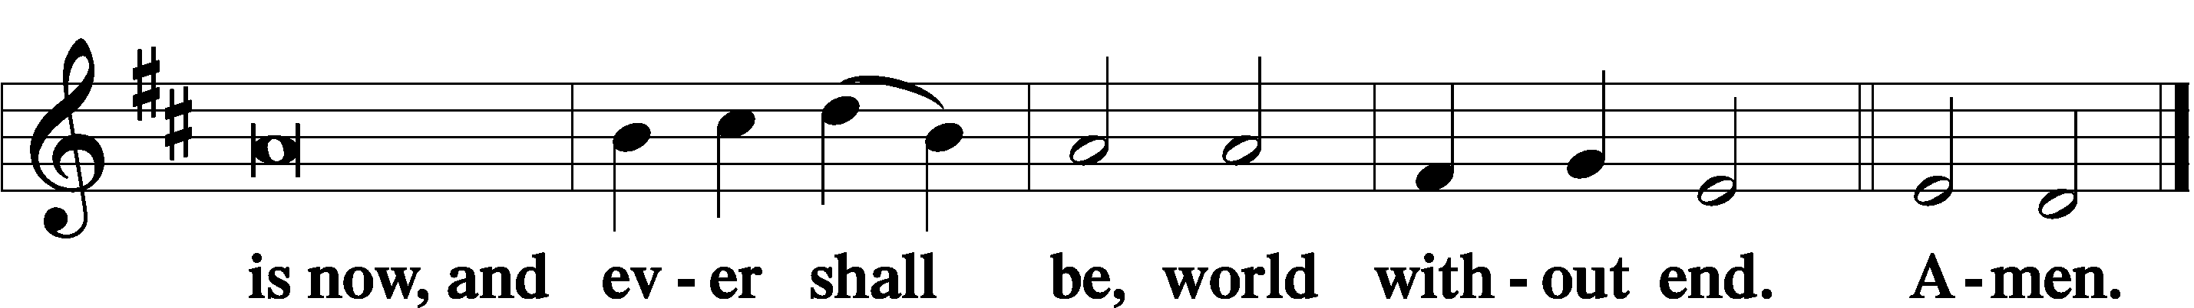

Thanksgiving Psalm 107:1
P O give thanks unto the Lord, for He is good,
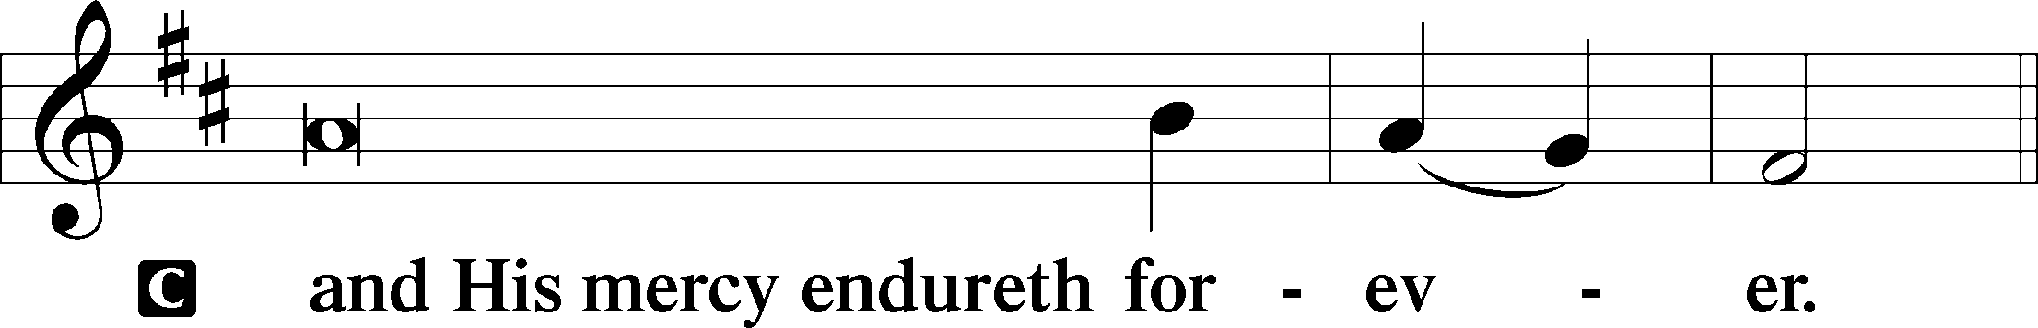

Post-Communion Collect
P Let us pray.
We give thanks to You, almighty God, that You have refreshed us through this salutary gift, and we implore You that of Your mercy You would strengthen us through the same in faith toward You and in fervent love toward one another; through Jesus Christ, Your Son, our Lord, who lives and reigns with You and the Holy Spirit, one God, now and forever.
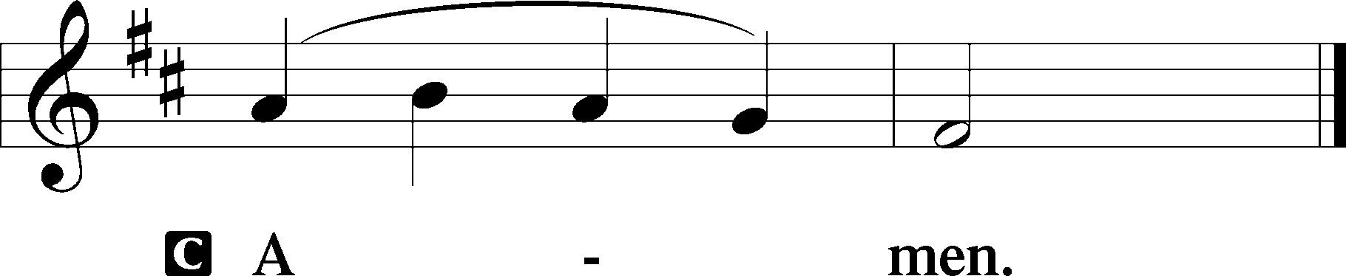

Salutation 2 Timothy 4:22
P The Lord be with you.
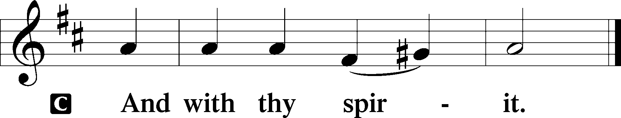

Benedicamus Psalm 103:1
P Bless we the Lord.
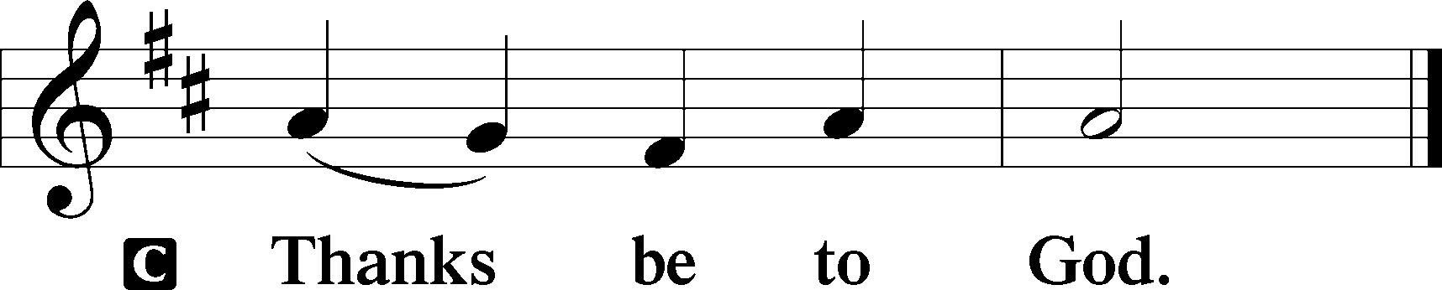

Benediction Numbers 6:24–26
P The Lord bless you and keep you.
The Lord make His face shine upon you and be gracious unto you.
The Lord lift up His countenance upon you and T give you peace.
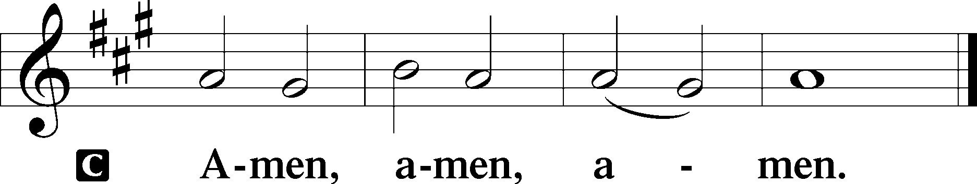

Closing Hymn: LSB #919 “Abide, O Dearest Jesus”

Silent prayer after worship: Dear Jesus, by Your death and resurrection You have given me a new life of peace, joy and hope. Lead me to share the good news of salvation with others so they also may have these wonderful gifts of Your love. Amen.
fffffffffffffffffffffffffffffffffff
fffffffffffffffffffffffffffffffffff
In Loving Memory of Mother-in-Law, Betty Sulek: Edeltraud Sulek (Capital Campaign).
fffffffffffffffffffffffffffffffffff
SCHEDULE THROUGH JULY 16, 2023:

:

Today, Following Worship, Fellowship Hall: Coffee Fellowship
7 pm, Fellowship Hall: AA Meeting
Tuesday, 7-9 pm, Fellowship Hall: Penn-Ohio Singers
Wednesday, 7:30 pm, Fellowship Hall: NA Meeting
Thursday, 9 am, Downstairs: Food Pantry
Saturday, 4 pm, Fellowship Hall: Men’s Bible Study
Next Sunday, 8 am, Fellowship Hall: Bible Study
9 am, Sanctuary: Divine Service
Following Worship, Library: Quarterly and Monthly Auditing
7 pm, Fellowship Hall: AA Meeting
fffffffffffffffffffffffffffffffffff
Attendance: Thursday, June 29, 2023: 18
Sunday, July 2, 2023: 30
fffffffffffffffffffffffffffffffffff
THANK YOU FOR SERVING IN JULY: Elder: Jonathan Baisch; Ushers: Matt Berent, Mark Gabriel, Michael Laird, & Jerome Thomas; Altarware: (prior) Diane Riefstahl & Marie Flaugher (07/09 & 07/30); (after) Elizabeth Haenftling (07/02 & 07/16) & Marie Flaugher (07/09, 07/23, & 07/30).
fffffffffffffffffffffffffffffffffff
Bible Memory Verses ~ Week of July 9th:
For Adults: For the word of the cross is folly to those who are perishing, but to us who are being saved it is the power of God. 1 Corinthians 1:18
For Children: No one who puts his hand to the plow and looks back is fit for the kingdom of God. Luke 9:62
fffffffffffffffffffffffffffffffffff
Our Stewardship of Treasures for the Lord:
In order to do the Lord’s work, we need $2,553.63 each week to meet our 2023 budget for general purposes and $76.92 for the SELC.
Figures for Sunday, July 2, 2023
General Fund: $1,662.00 Behind for the week: -$891.63
SELC: $145.00 Ahead for the week: +$68.08
Capital Campaign: $435.00

For online giving, check out https://www.saintspeterandpaul.net/online-giving.
fffffffffffffffffffffffffffffffffff
Remember the following in Prayer…
~The Hurting and Healing: Amy, Martin Anderson (Rebecca Marquette’s father), Steve Antolovich, Gerald Arthur, Ellen Baron^{CA}, Lois Bortner^{CA}, John Burdette, Bev & Joe Chlpka, Kathleen Coughenour, Kim, Anna Mae Daris, Susan Davies, Tim Dudash, Millie Elavsky, Joseph Fleet, Judith & Eddy Furey, Austin Hamilton, Joan, Darla Krajci, Barbara Kreske, Donna Kennedy, Jess Lavoie, Elizabeth Loughan, Paul Lucas^{CA}, Sandy Marshall, Augusta Mennell, Frank Niemeyer^{CA}, Linda Parkany, Juanita Rentschler, Richard Reuning^{CA}, Nancy Robertson^{CA}, Marty Scott, Kara, Fred Tonty, Joel & Peggy Wasson, Angela Weser^{CA}, and Ruth Wolf.
~The Homebound: Rudy & Jean Tomko, Betty Wolf, and Ed & Millie Zachar.
~Celebrating this Week: Birthdays: Morgan Psznick (07.12) & Elizabeth Haenftling (07.15).
~Serving in the Military: Alex (Sasha) Carr, Curtis Sinewe, and Joshua Solyan.
~Community & World Needs: Those suffering from or affected by the coronavirus; those suffering due to the conflict between Ukraine and Russia; those suffering from loss and dislocation because weather disasters; those suffering from addiction and their families; Local, State, and National Government Leaders; safety for all Police Officers, Firefighters, & First Responders; the unemployed; our Second Quarter Local Mission: The Support of a Concordia, Fort Wayne Seminarian.
*CA represents cancer.
fffffffffffffffffffffffffffffffffff
CORRECTION: The Men’s Bible Study this coming Saturday, July 15th, will begin at 4 pm, not 4:30 pm as listed on the church calendar in the July newsletter.
fffffffffffffffffffffffffffffffffff
Join us downstairs following worship this morning for Coffee Fellowship! This month’s sponsors are Pastor & Evelyn Baisch. We are grateful for their sponsorship!
fffffffffffffffffffffffffffffffffff
We are grateful this morning to Rebecca Marquette for sharing her musical talents with us as our guest organist.
fffffffffffffffffffffffffffffffffff
The Altar Guild Work Day originally scheduled for this coming Saturday has been postponed until 9:30 am, Saturday, August 19th.
fffffffffffffffffffffffffffffffffff
August calendar and newsletter items will be due to the secretary’s office by noon July 24th. Church Council members are reminded that reports for that evening’s council meeting are due by noon that day as well.
fffffffffffffffffffffffffffffffffff

Here to Serve
Pastor………………………………………………...……………Rev. Jacob Deal
E-mail …………………………….……pastordeal@saintspeterandpaul.net
Phone Number……………………..…………………724-347-3620 (Option 2)
Church Office………………………..…………………724-347-3620 (Option 3)
Website …………………………………………www.saintspeterandpaul.net
Secretary…………………………………………………………Diane Riefstahl
E-mail ………………………………………church@saintspeterandpaul.net
Website …………………………………………www.saintspeterandpaul.net
Food Pantry: Please leave message……………724-347-3620 (Option 3)
AA Contact: Steve………………………………………………..…724-813-2358
NA Contact: Larry………………………………………………..724-977-8733
Choir Director………………………………………………………Chris Nelson
Congregation President……………………………………Jonathan Baisch
Church Elder …………………………………………...…… Jonathan Baisch
fffffffffffffffffffffffffffffffffff
If needing to get into the church building during the week, please phone first to make certain someone is here to let you in.

