Sts. Peter & Paul
Evangelical Lutheran Church
Lutheran Church-Missouri Synod
Founded-1917

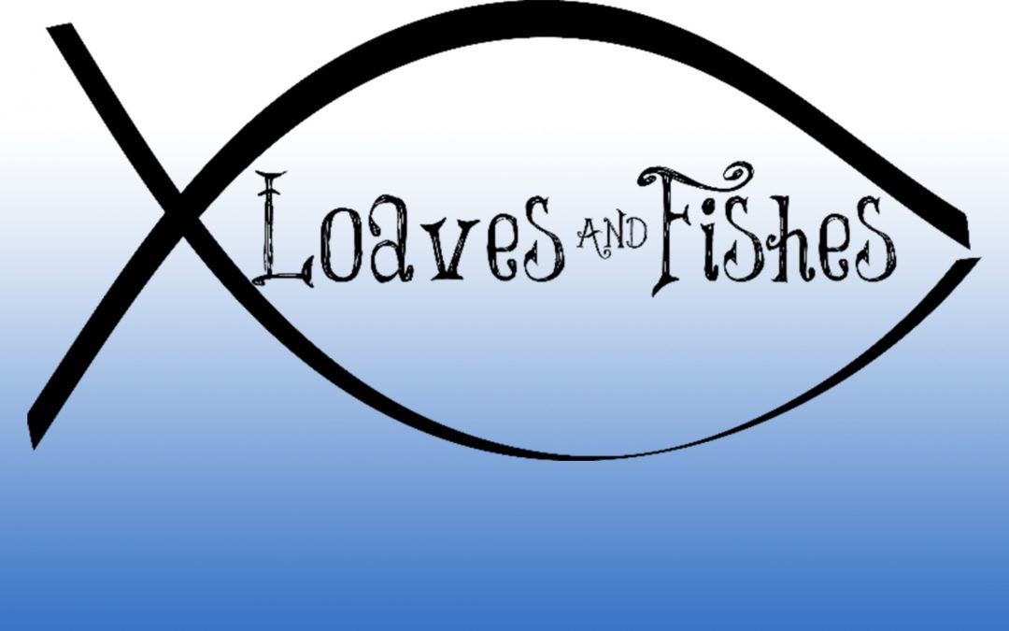

July 23, 2023

699 Stambaugh Ave.
Sharon, Pennsylvania 16146

“I was glad when they said to me,
Let us go to the house of the LORD!”
Psalm 122:1
Sts. Peter & Paul Evangelical Lutheran Church, LC-MS
THE SEVENTH SUNDAY AFTER TRINITY
July 23, 2023
A special welcome to our guests this day! If you would like more information about The Lutheran Church - Missouri Synod, or this congregation, please speak with Pastor Deal or an Elder after the service.
Members & Guests: Don’t be embarrassed if your children make noise during the worship service, all children do. We encourage families to worship together but, if you feel the need, there are pews in the rear of the Church which are reserved for young families on both sides of the sanctuary. There is also a quiet room available to you, located next to the sanctuary (formerly the Pastor’s office), where you would be able to follow along with the service.

Today’s service includes the Sacrament of Holy Communion. If during this past year, you have not worshipped with us and been communed, we respectfully ask that you do not partake of this sacrament this day before first speaking with Pastor Deal.
If visiting from a sister congregation of the LC-MS and are in good standing, please inform Pastor Deal of your desire to commune prior to the service.
If wishing to receive a blessing during communion, please approach with your arms crossed.

CONTACT INFORMATION
Pastor Deal: pastordeal@saintspeterandpaul.net or 724-347-3620 (opt. 2)
Church Office: church@saintspeterandpaul.net or 724-347-3620 (opt. 3)
Secretary’s Office will be open Monday and Thursday (8:30-4:30) this week.

Silent prayer before worship: Heavenly Father, receive me into Your presence as I worship You today. Accept my praise and thanks, strengthen my faith and give me the comfort and assurance of Your love. In Jesus’ name. Amen.

Confession and Absolution

Opening Hymn: LSB #642 “O Living Bread from Heaven”

Stand

The sign of the cross may be made by all in remembrance of their Baptism.

Invocation
P In the name of the Father and of the T Son and of the Holy Spirit.
C Amen.

Exhortation Hebrews 10:22; Psalm 124:8; Psalm 32:5
P Beloved in the Lord! Let us draw near with a true heart and confess our sins unto God our Father, beseeching Him in the name of our Lord Jesus Christ to grant us forgiveness.

P Our help is in the name of the Lord,
C who made heaven and earth.
P I said, I will confess my transgressions unto the Lord,
C and You forgave the iniquity of my sin.

Silence for reflection on God’s Word and for self-examination.

Confession of Sins
P O almighty God, merciful Father,
C I, a poor, miserable sinner, confess unto You all my sins and iniquities with which I have ever offended You and justly deserved Your temporal and eternal punishment. But I am heartily sorry for them and sincerely repent of them, and I pray You of Your boundless mercy and for the sake of the holy, innocent, bitter sufferings and death of Your beloved Son, Jesus Christ, to be gracious and merciful to me, a poor, sinful being.

Absolution [John 20:19–23]
P Upon this your confession, I, by virtue of my office, as a called and ordained servant of the Word, announce the grace of God unto all of you, and in the stead and by the command of my Lord Jesus Christ I forgive you all your sins in the name of the Father and of the T Son and of the Holy Spirit.
C Amen.

Service of the Word

Introit Psalm 47:3, 6–8; antiphon: vv. 1–2
Clap your hands, all | peoples!*
Shout to God with loud | songs of joy!
For the Lord, the Most High, is | to be feared,*
a great king over | all the earth.
He subdued peoples | under us,*
and nations un- | der our feet.
Sing praises to God, sing | praises!*
Sing praises to our King, sing | praises!
For God is the King of | all the earth;*
sing praises | with a psalm!
God reigns over the | nations;*
God sits on his | holy throne.
Clap your hands, all | peoples!*
Shout to God with loud | songs of joy!
For the Lord, the Most High, is | to be feared,*
a great king over | all the earth.

Gloria Patri
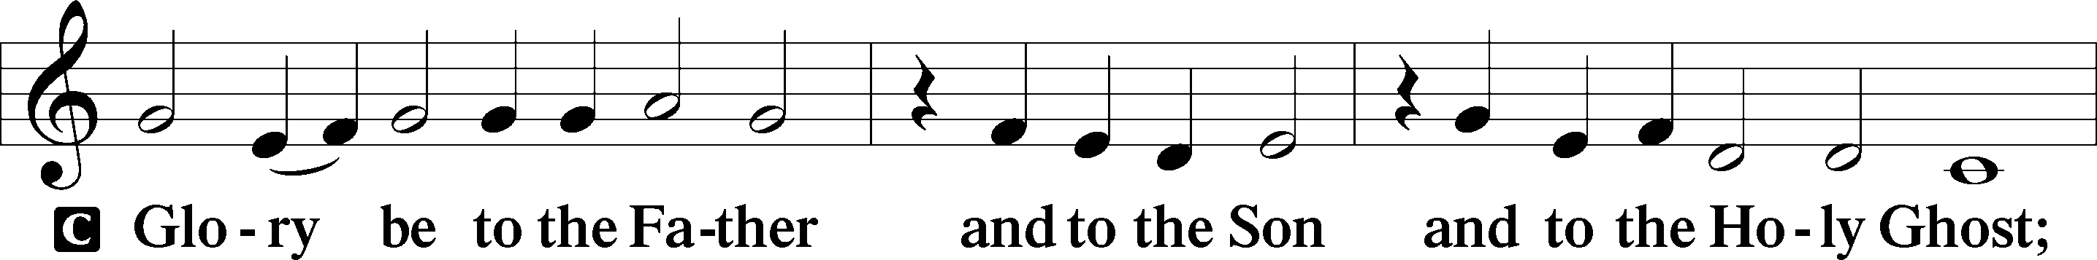
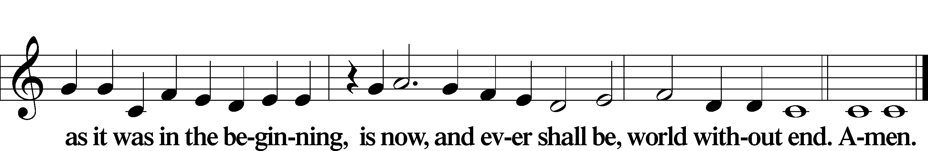

Kyrie Mark 10:47
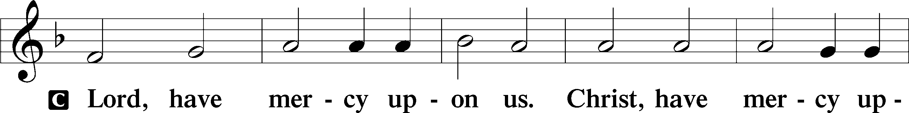
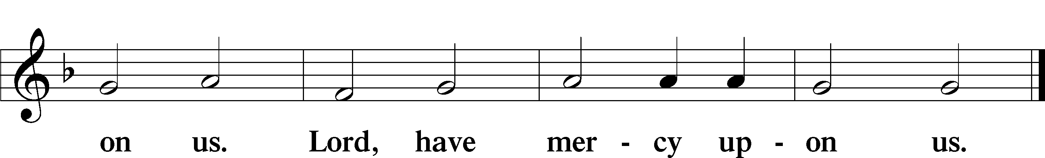

Gloria in Excelsis Luke 2:14; John 1:29
P Glory be to God on high:
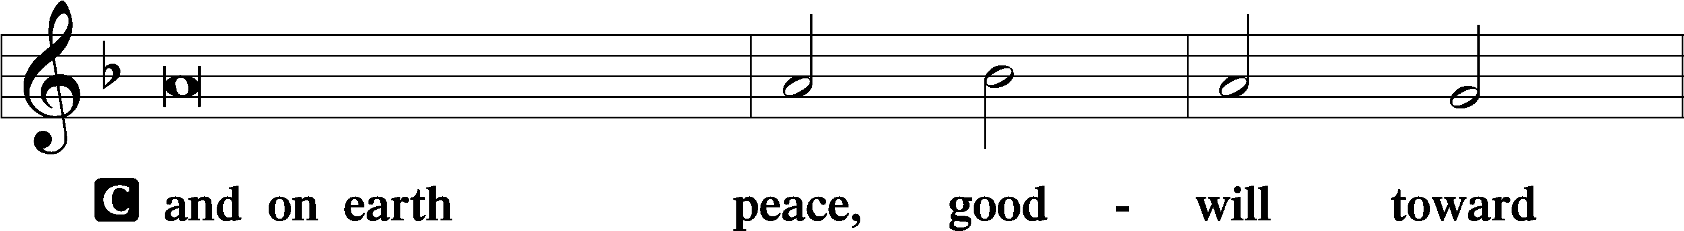
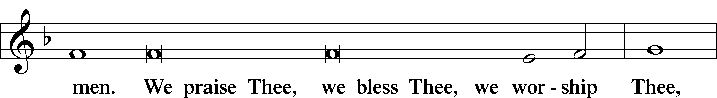
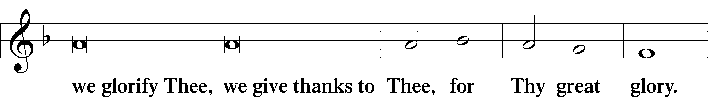
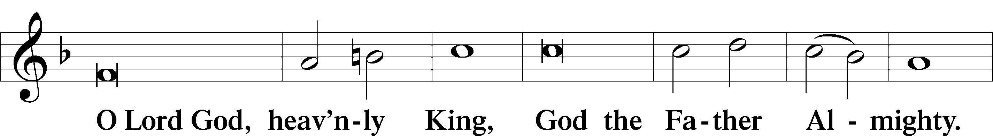
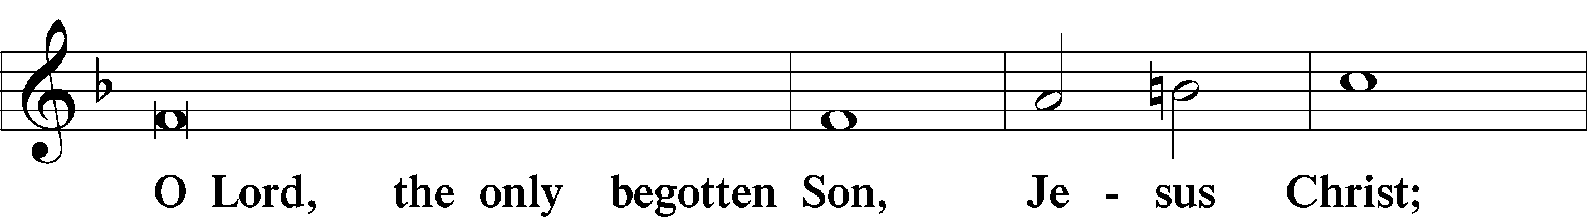
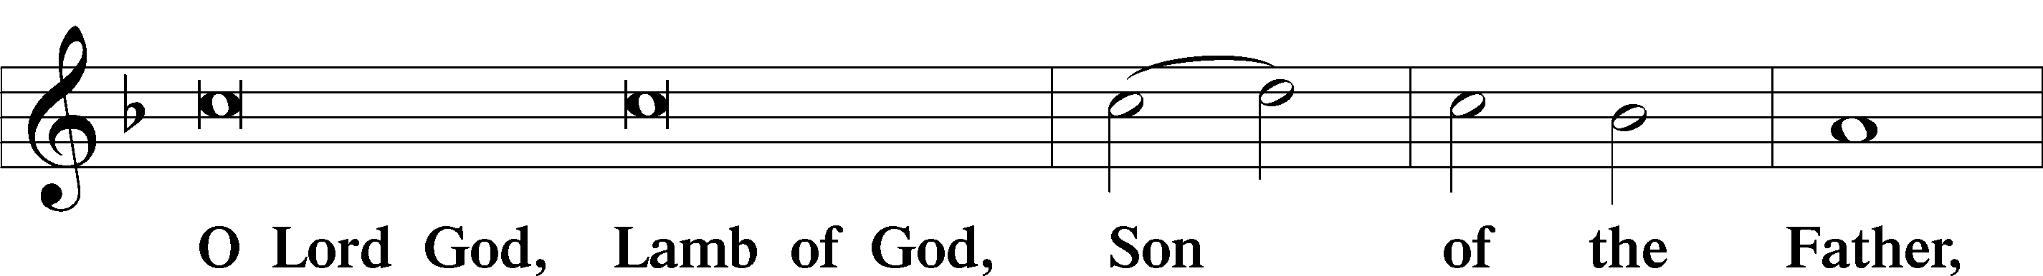
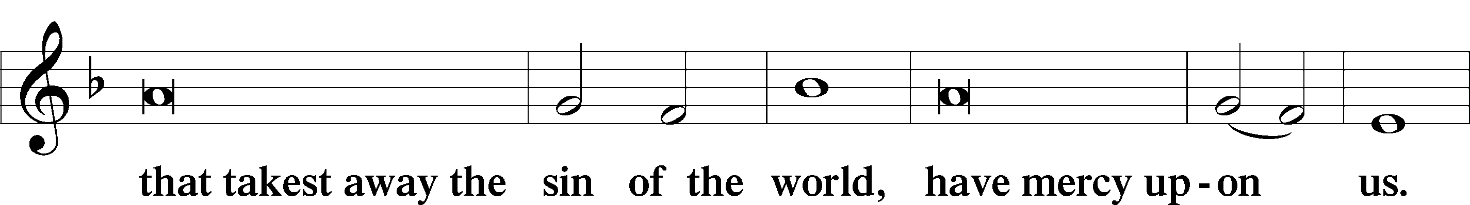
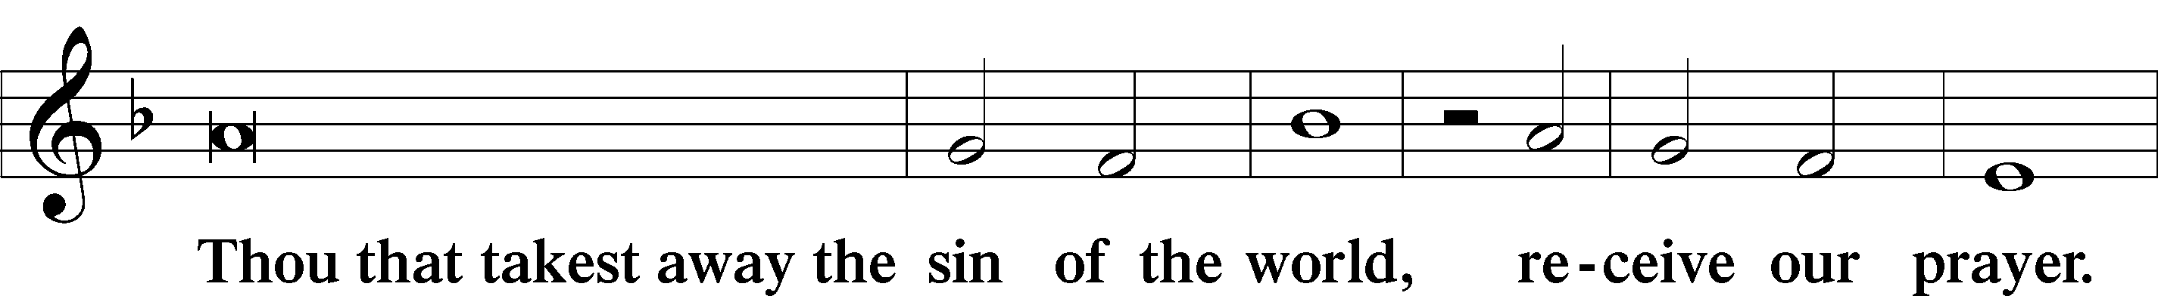
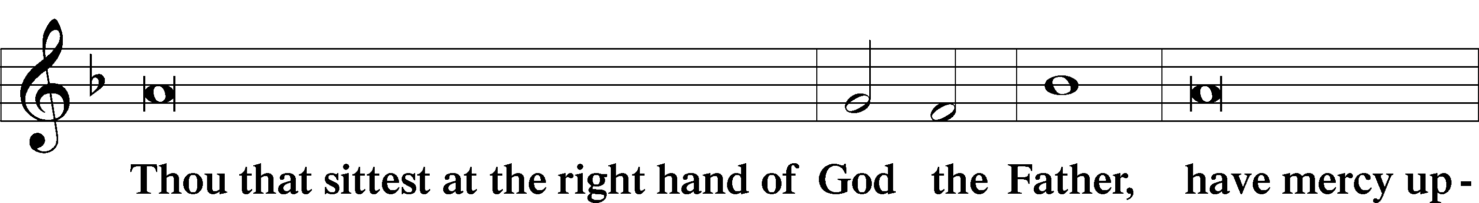
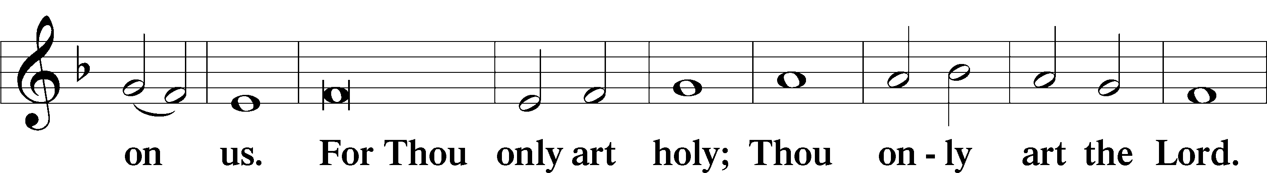
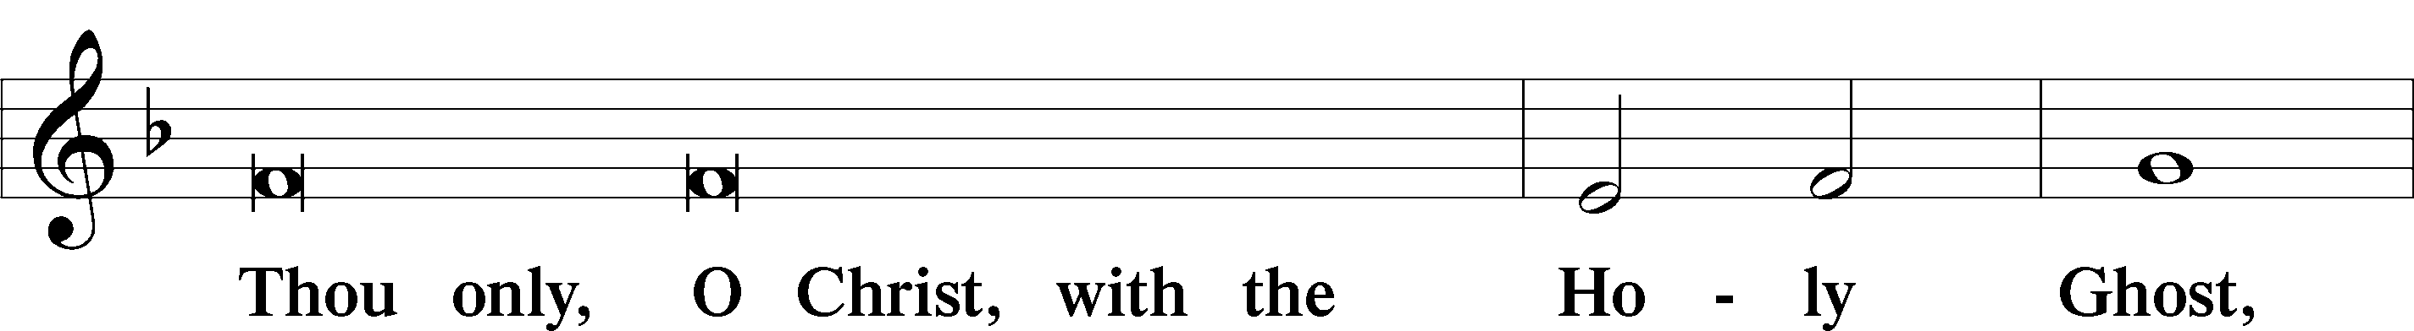
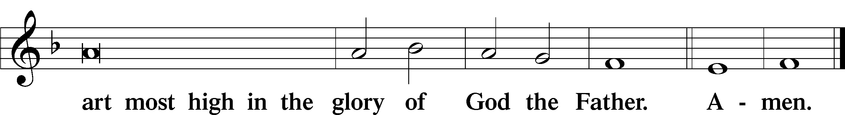

Salutation and Collect of the Day: Trinity 7
P The Lord be with you.
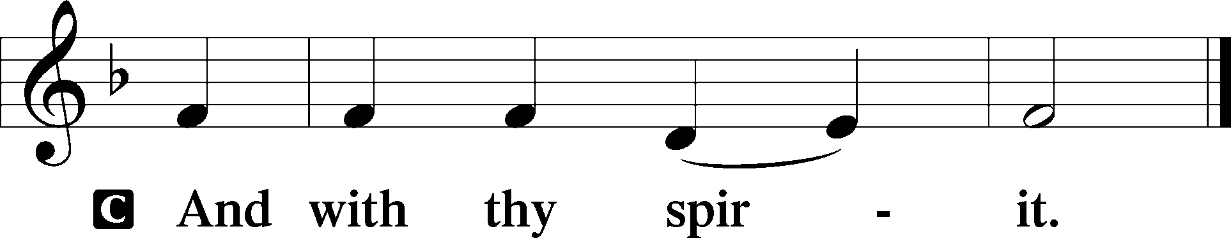

P Let us pray.
O God, whose never-failing providence orders all things both in heaven and earth, we humbly implore You to put away from us all hurtful things and to give us those things that are profitable for us; through Jesus Christ, Your Son, our Lord, who lives and reigns with You and the Holy Spirit, one God, now and forever.
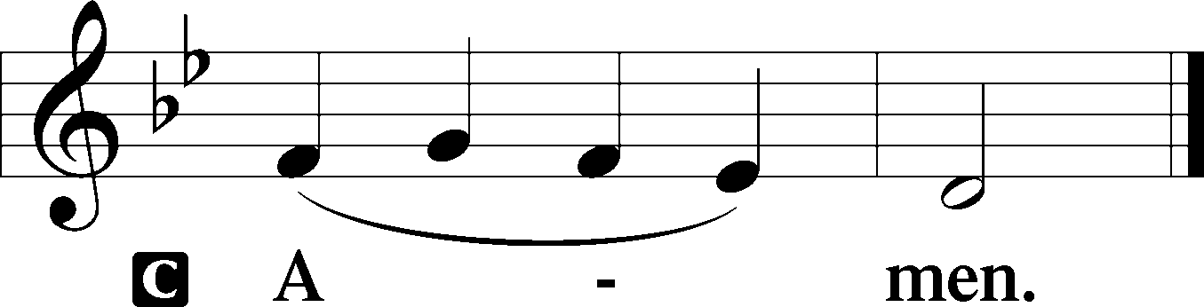
Sit

Prophecy: Isaiah 62:6-12 (NKJV)
Thus says the Lord God: I have set watchmen on your walls, O Jerusalem; they shall never hold their peace day or night. You who make mention of the Lord, do not keep silent, and give Him no rest till He establishes and till He makes Jerusalem a praise in the earth. The Lord has sworn by His right hand and by the arm of His strength: “Surely I will no longer give your grain as food for your enemies; and the sons of the foreigner shall not drink your new wine, for which you have labored. But those who have gathered it shall eat it, and praise the Lord; those who have brought it together shall drink it in My holy courts.” Go through, go through the gates! Prepare the way for the people; build up, build up the highway! Take out the stones, lift up a banner for the peoples! Indeed the Lord has proclaimed to the end of the world: “Say to the daughter of Zion, ‘Surely your salvation is coming; behold, His reward is with Him, and His work before Him.’ ” And they shall call them The Holy People, the Redeemed of the Lord; and you shall be called Sought Out, a City Not Forsaken.

P This is the Word of the Lord.
C Thanks be to God.

Gradual Psalm 34:11, 5
Come, O children, lis- | ten to me;*
I will teach you the fear | of the Lord.
Those who look to him are | radiant,*
and their faces shall never | be ashamed.

Epistle: Romans 6:19–23 (NKJV)
Brethren: I speak in human terms because of the weakness of your flesh. For just as you presented your members as slaves of uncleanness, and of lawlessness leading to more lawlessness, so now present your members as slaves of righteousness for holiness. For when you were slaves of sin, you were free in regard to righteousness. What fruit did you have then in the things of which you are now ashamed? For the end of those things is death. But now having been set free from sin, and having become slaves of God, you have your fruit to holiness, and the end, everlasting life. For the wages of sin is death, but the gift of God is eternal life in Christ Jesus our Lord.

P This is the Word of the Lord.
C Thanks be to God.

Stand

Verse Psalm 47:1
Alleluia. Clap your hands, all peoples! Shout to God with loud songs of joy! Alleluia.

Alleluia
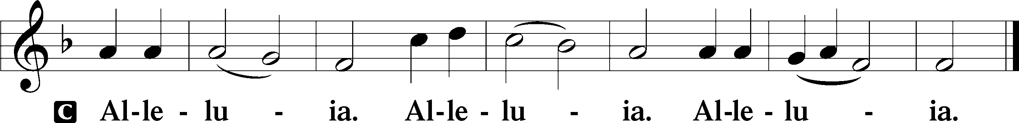

Holy Gospel: Mark 8:1–9 (NKJV)
P The Holy Gospel according to St. Mark, the eighth chapter.
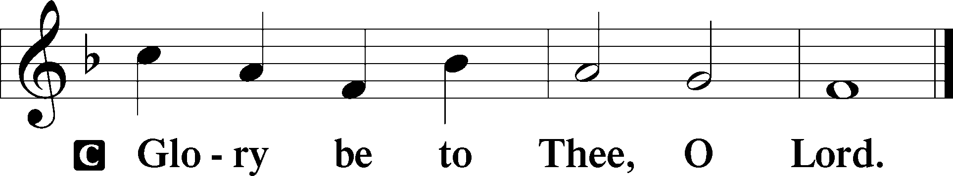

At that time: The multitude being very great and having nothing to eat, Jesus called His disciples to Him and said to them, “I have compassion on the multitude, because they have now continued with Me three days and have nothing to eat. And if I send them away hungry to their own houses, they will faint on the way; for some of them have come from afar.” Then His disciples answered Him, “How can one satisfy these people with bread here in the wilderness?” He asked them, “How many loaves do you have?” And they said, “Seven.” So He commanded the multitude to sit down on the ground. And He took the seven loaves and gave thanks, broke them and gave them to His disciples to set before them; and they set them before the multitude. They also had a few small fish; and having blessed them, He said to set them also before them. So they ate and were filled, and they took up seven large baskets of leftover fragments. Now those who had eaten were about four thousand. And He sent them away.

P This is the Gospel of the Lord.
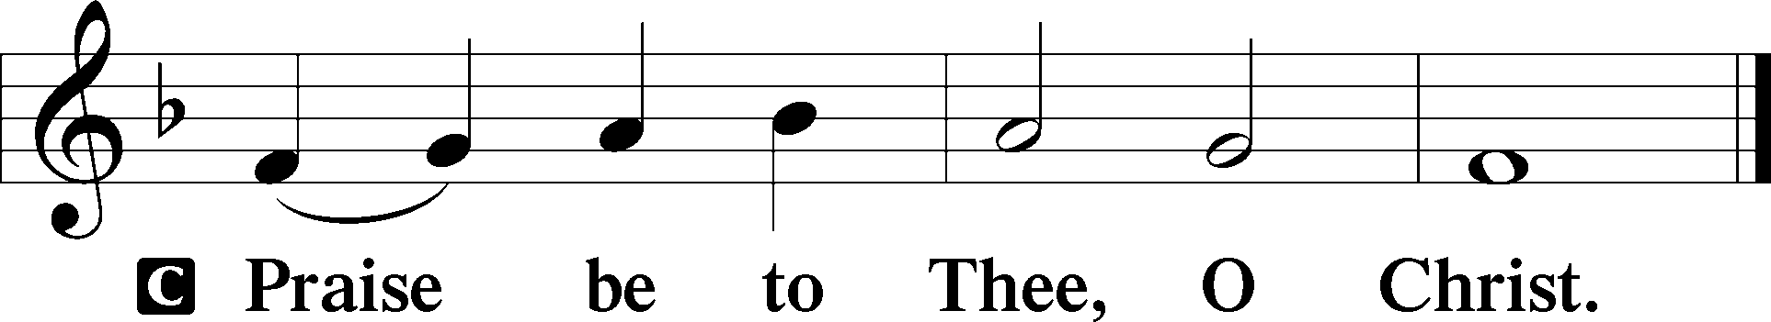

Nicene Creed
C I believe in one God,
the Father Almighty,
maker of heaven and earth
and of all things visible and invisible.

And in one Lord Jesus Christ,
the only-begotten Son of God,
begotten of His Father before all worlds,
God of God, Light of Light,
very God of very God,
begotten, not made,
being of one substance with the Father,
by whom all things were made;
who for us men and for our salvation came down from heaven
and was incarnate by the Holy Spirit of the virgin Mary
and was made man;
and was crucified also for us under Pontius Pilate.
He suffered and was buried.
And the third day He rose again according to the Scriptures
and ascended into heaven
and sits at the right hand of the Father.
And He will come again with glory to judge both the living and the dead,
whose kingdom will have no end.

And I believe in the Holy Spirit,
the Lord and giver of life,
who proceeds from the Father and the Son,
who with the Father and the Son together is worshiped and glorified,
who spoke by the prophets.
And I believe in one holy Christian and apostolic Church,
I acknowledge one Baptism for the remission of sins,
and I look for the resurrection of the dead
and the life T of the world to come. Amen.
Sit

Hymn of the Day: LSB #625 “Lord Jesus Christ, Life-Giving Bread”

Sermon

Stand

Prayer of the Church

Offertory Psalm 51:10–12
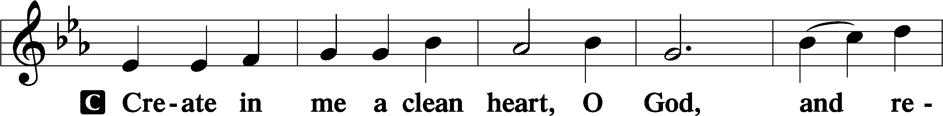
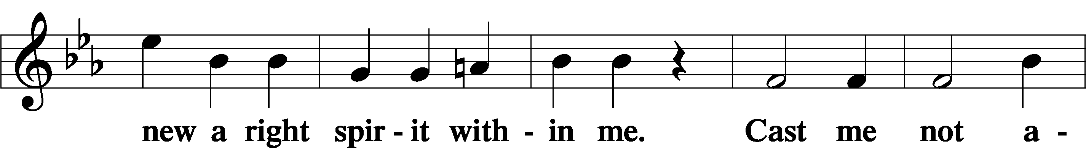
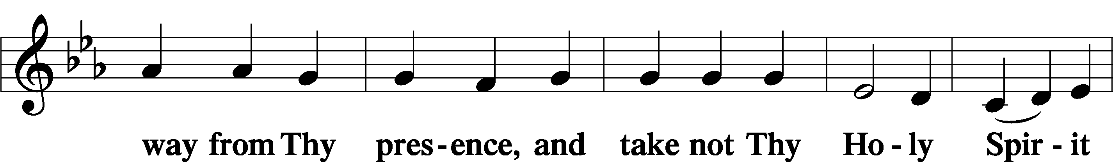
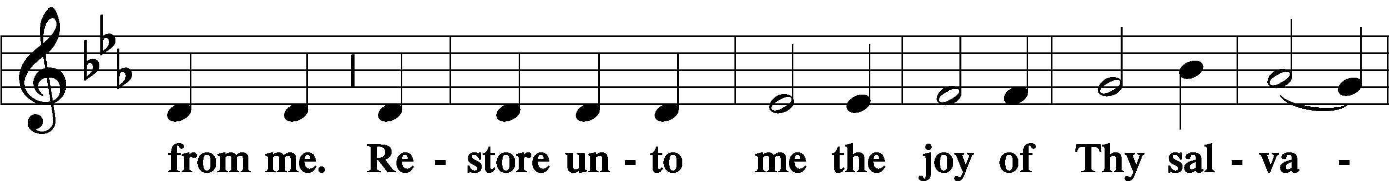
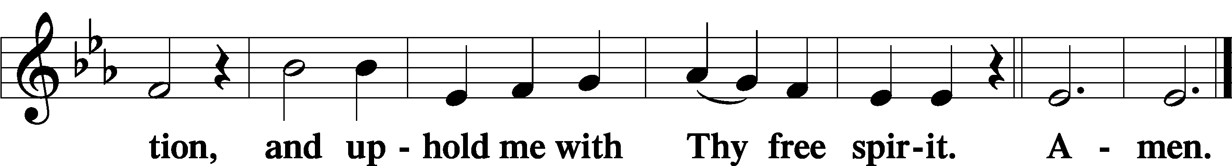
Sit

Preparatory Hymn: LSB #636 “Soul, Adorn Yourself with Gladness”

Stand
Service of the Sacrament

Preface 2 Timothy 4:22; Colossians 3:1 Psalm 136
P The Lord be with you.
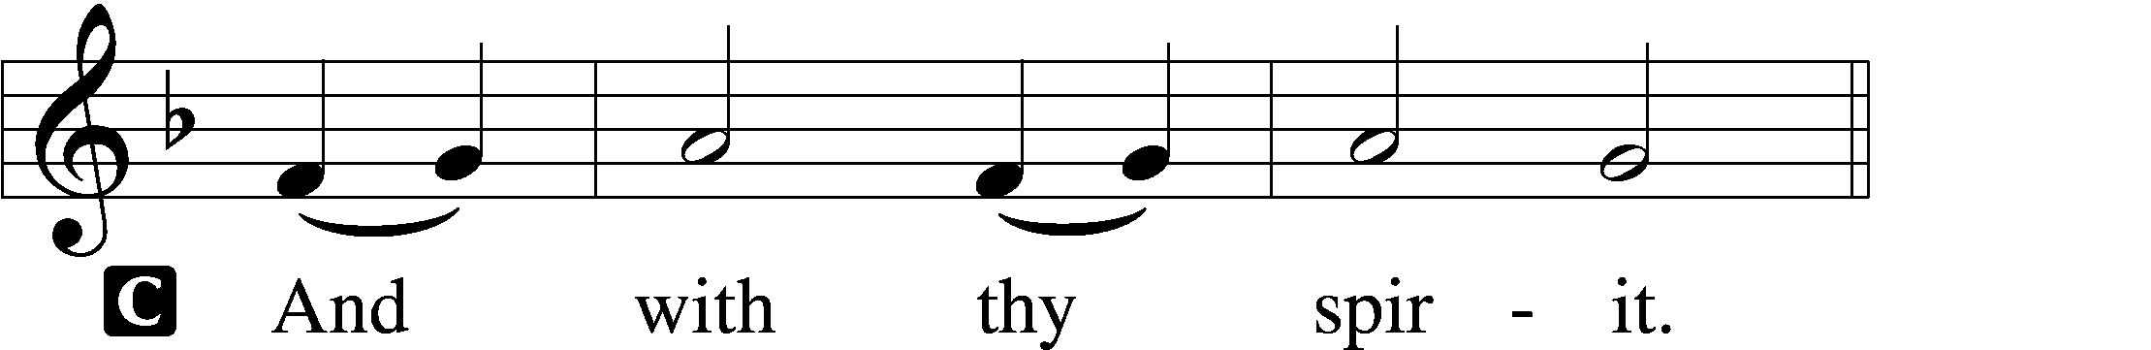

P Lift up your hearts.
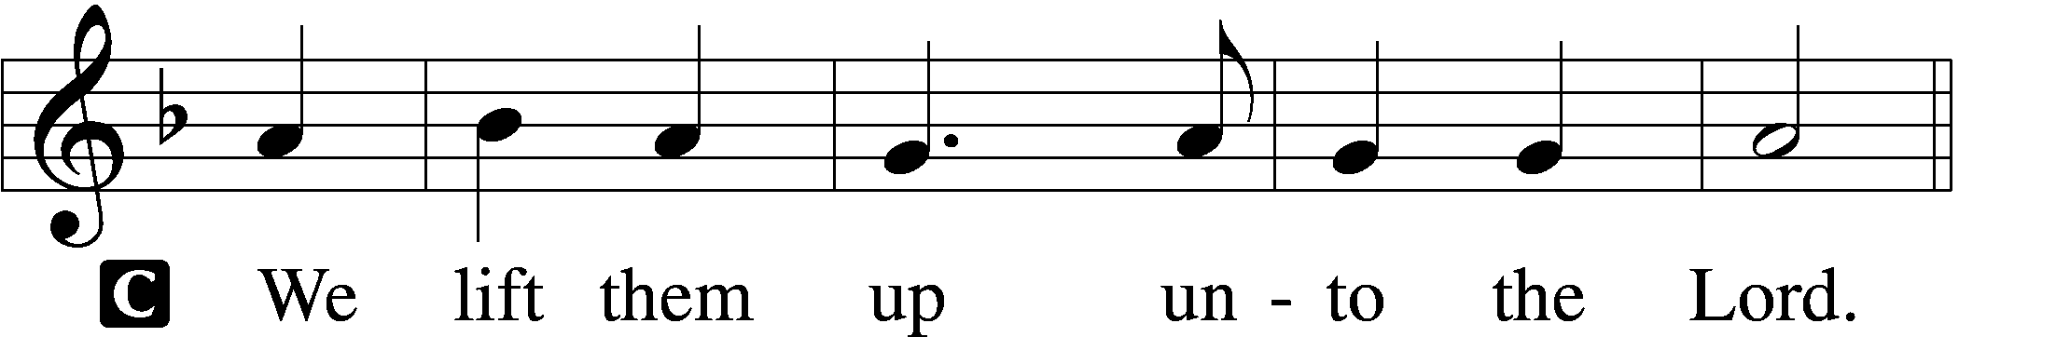

P Let us give thanks unto the Lord, our God.
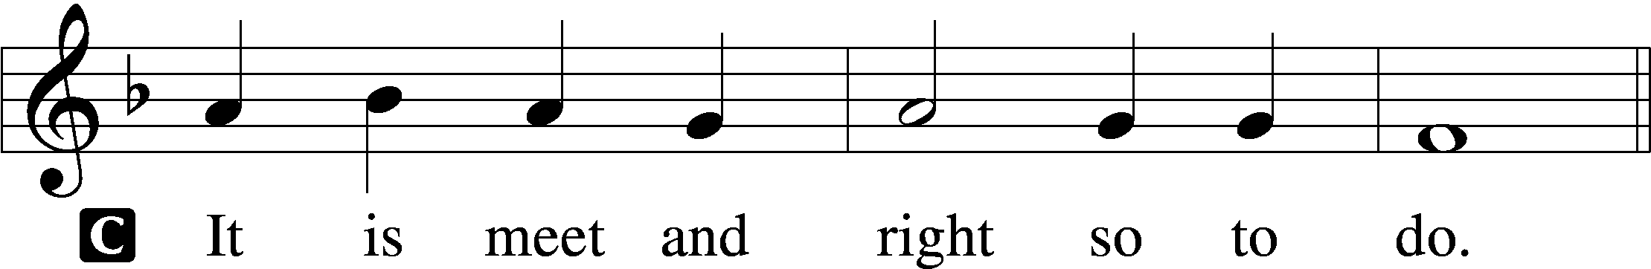

Proper Preface (Abbreviated) LSB 194
P It is truly meet, right, and salutary . . . evermore praising You and saying:

Sanctus Isaiah 6:3; Matthew 21:9
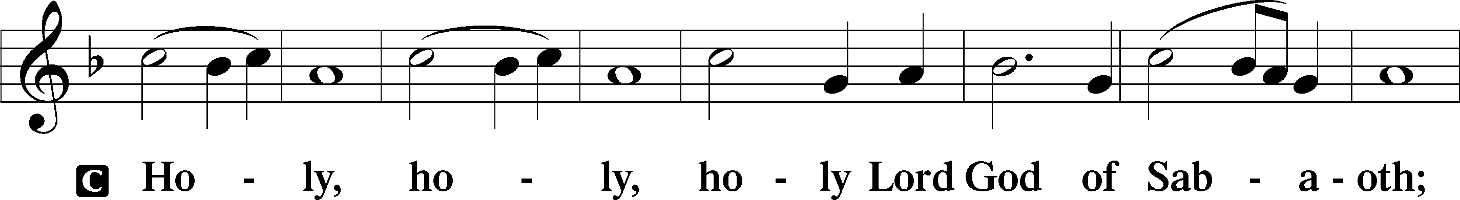
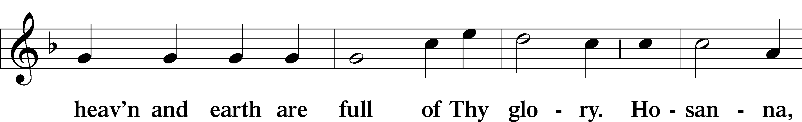
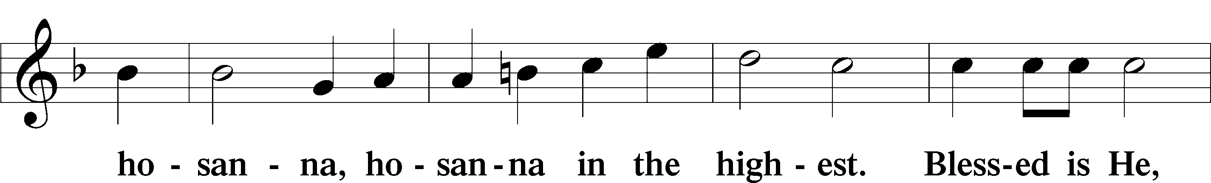
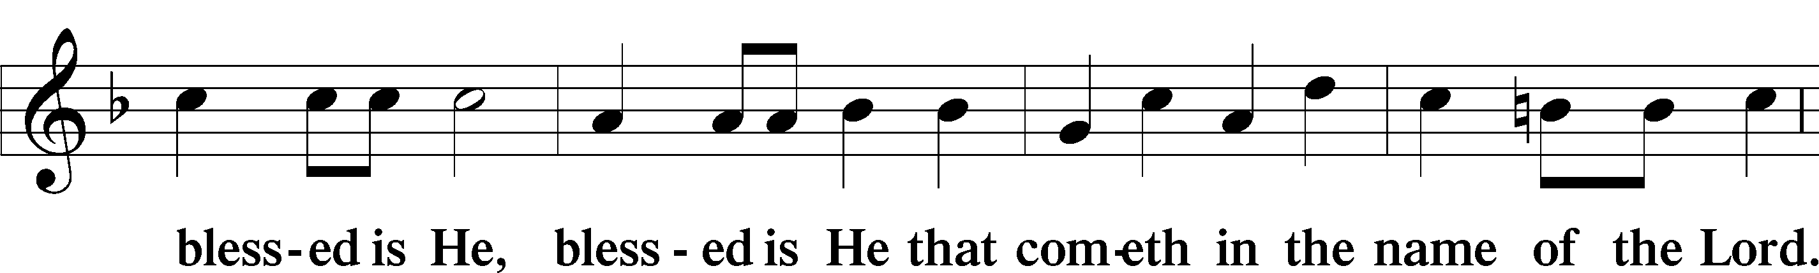
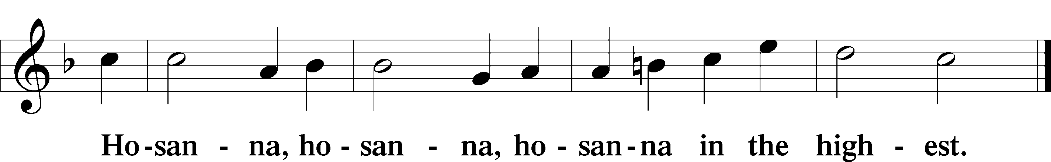

Lord’s Prayer Matthew 6:9–13
C Our Father who art in heaven,
hallowed be Thy name,
Thy kingdom come,
Thy will be done on earth as it is in heaven;
give us this day our daily bread;
and forgive us our trespasses as we forgive those who trespass against us;
and lead us not into temptation,
but deliver us from evil.
For Thine is the kingdom and the power and the glory forever and ever. Amen.

The Words of Our Lord Matthew 26:26–28; Mark 14:22–24; Luke 22:19–20; 1 Corinthians 11:23–25
P Our Lord Jesus Christ, on the night when He was betrayed, took bread, and when He had given thanks, He broke it and gave it to the disciples and said: “Take, eat; this is My T body, which is given for you. This do in remembrance of Me.”

In the same way also He took the cup after supper, and when He had given thanks, He gave it to them, saying: “Drink of it, all of you; this cup is the new testament in My T blood, which is shed for you for the forgiveness of sins. This do, as often as you drink it, in remembrance of Me.”

Pax Domini John 20:19
P The peace of the Lord be with you always.
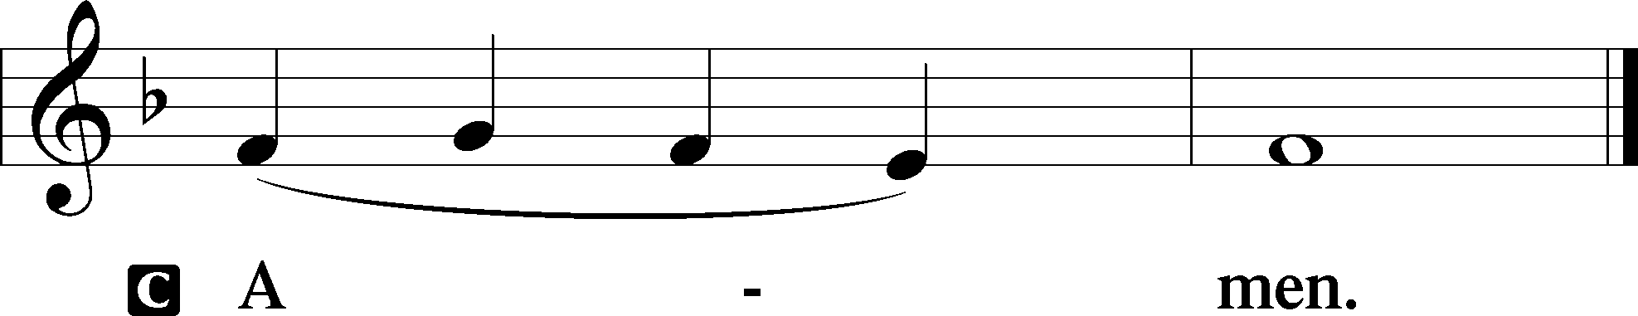

Agnus Dei John 1:29
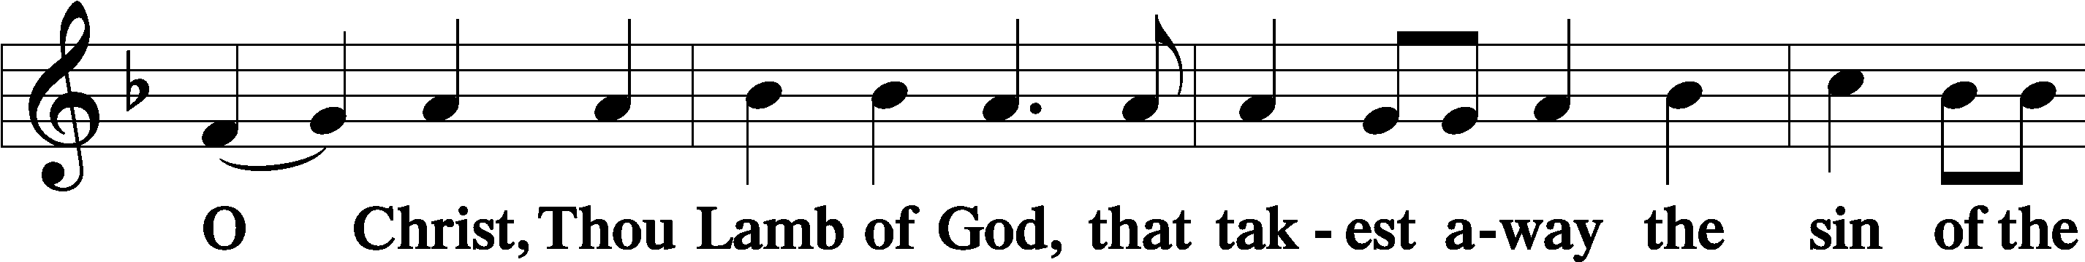
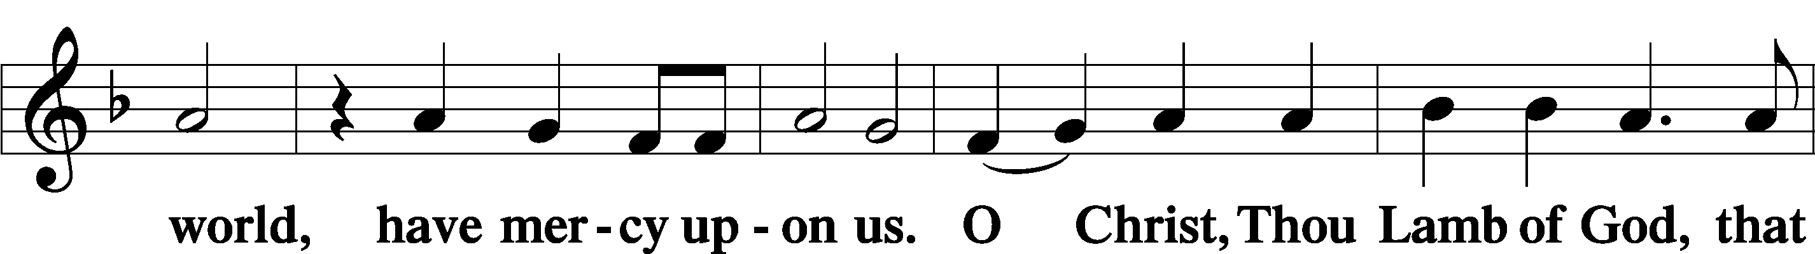
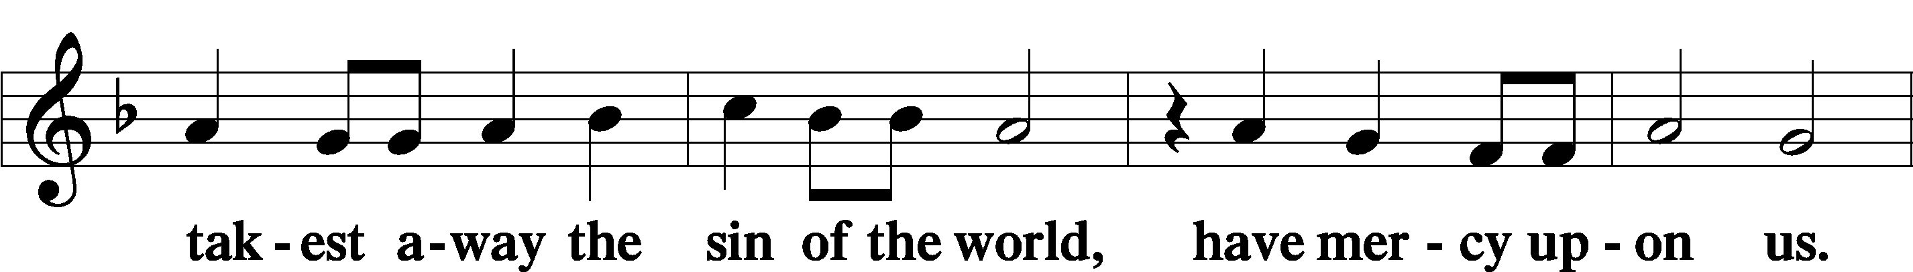
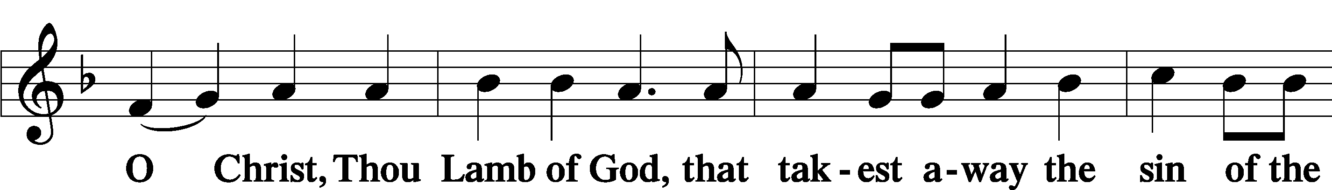
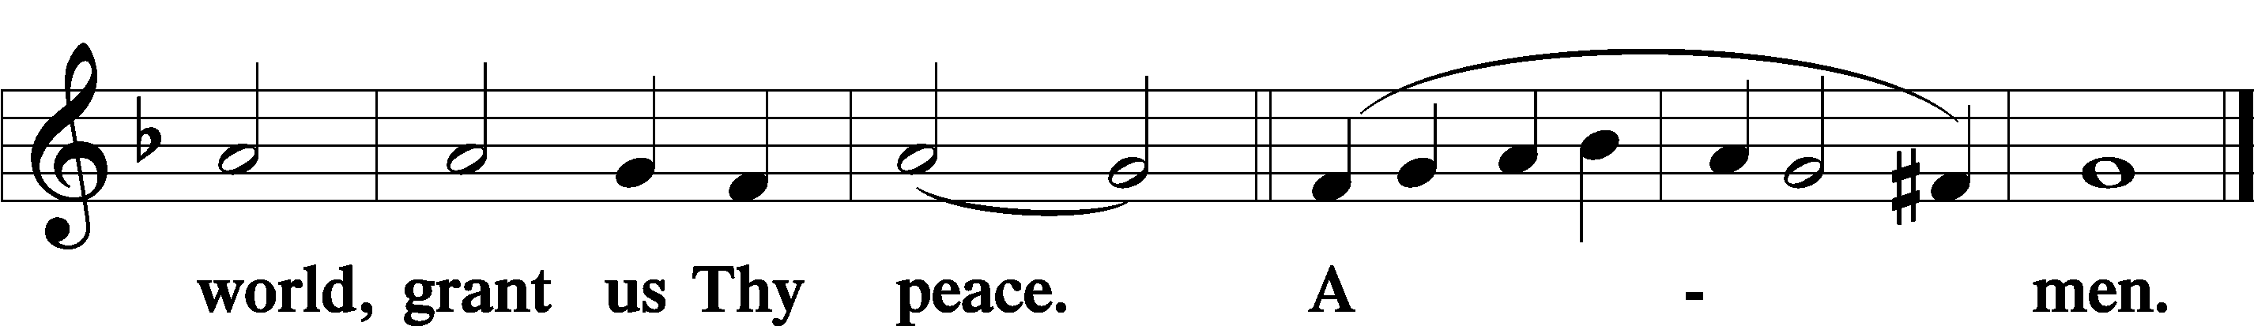
Sit
Distribution
The pastor and those who assist him receive the body and blood of Christ first and then distribute them to those who come to receive, saying:
Take, eat; this is the true body of our Lord and Savior Jesus Christ, given into death for your sins.
Amen.

Take, drink; this is the true blood of our Lord and Savior Jesus Christ, shed for the forgiveness of your sins.
Amen.

In dismissing the communicants, the following is said:
The Dismissal
P The body and blood of our Lord Jesus Christ strengthen and preserve you in body and soul to life everlasting. Depart T in peace.
C Amen.

Distribution Hymn: LSB #632 “O Jesus, Blessed Lord, to Thee”

Distribution Hymn: LSB #602 “The Gifts Christ Freely Gives”

Distribution Hymn: LSB #631 “Here, O My Lord, I See Thee Face to Face”

Stand

Nunc Dimittis Luke 2:29–32
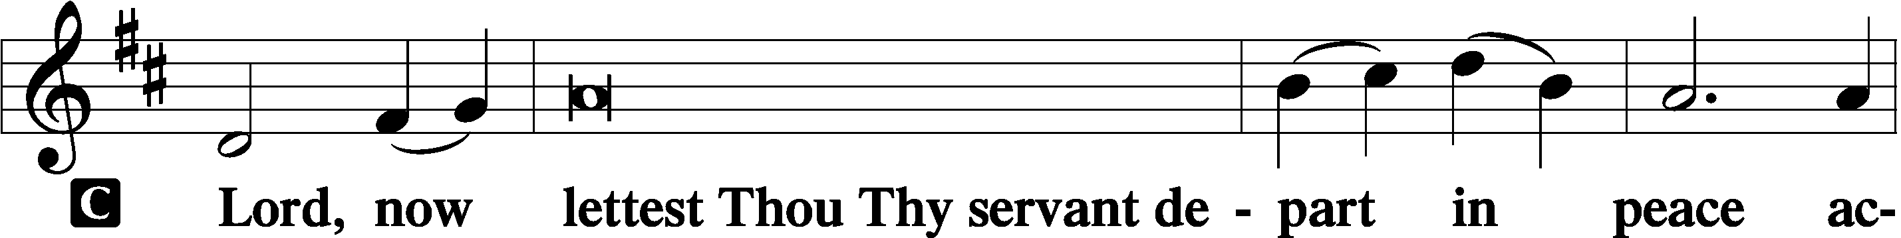
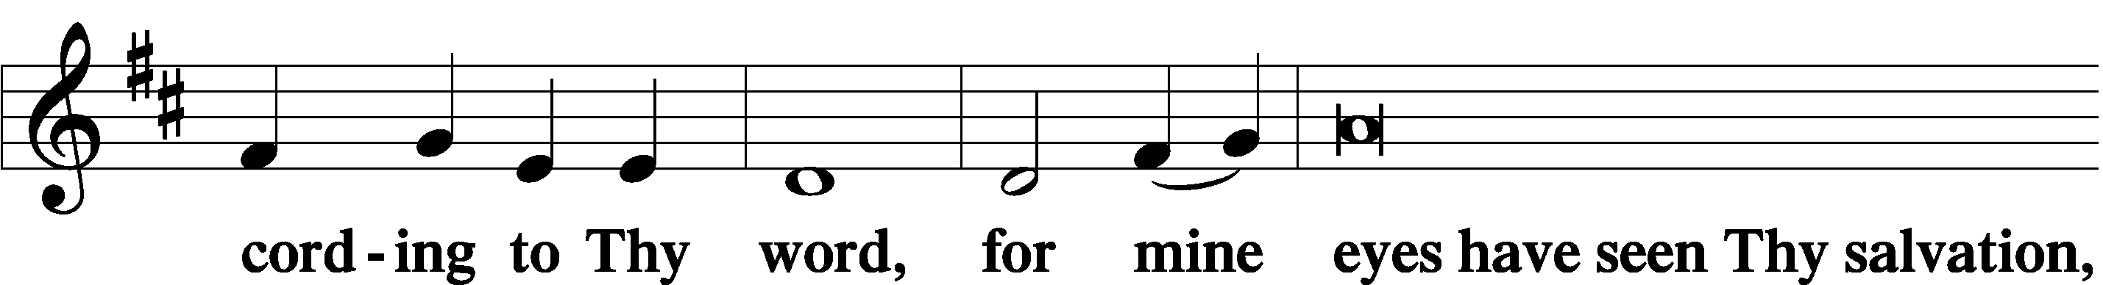
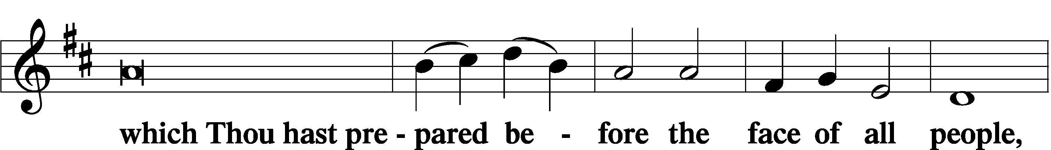
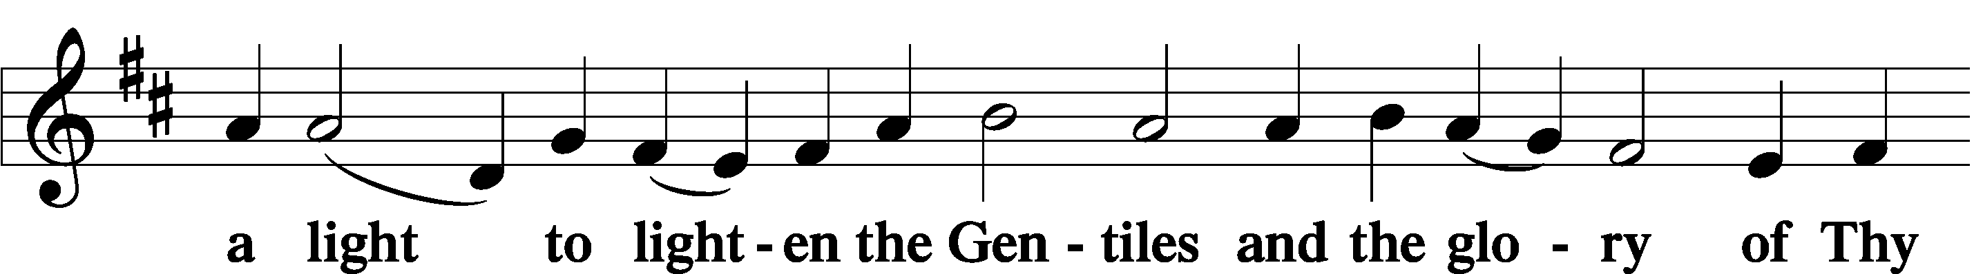
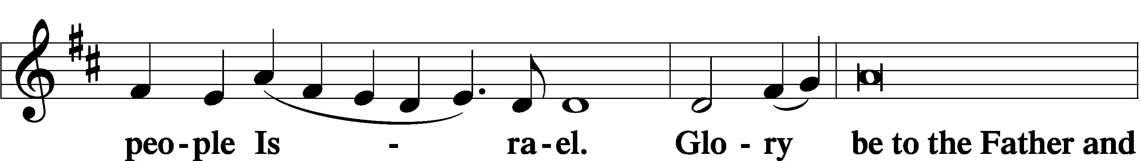
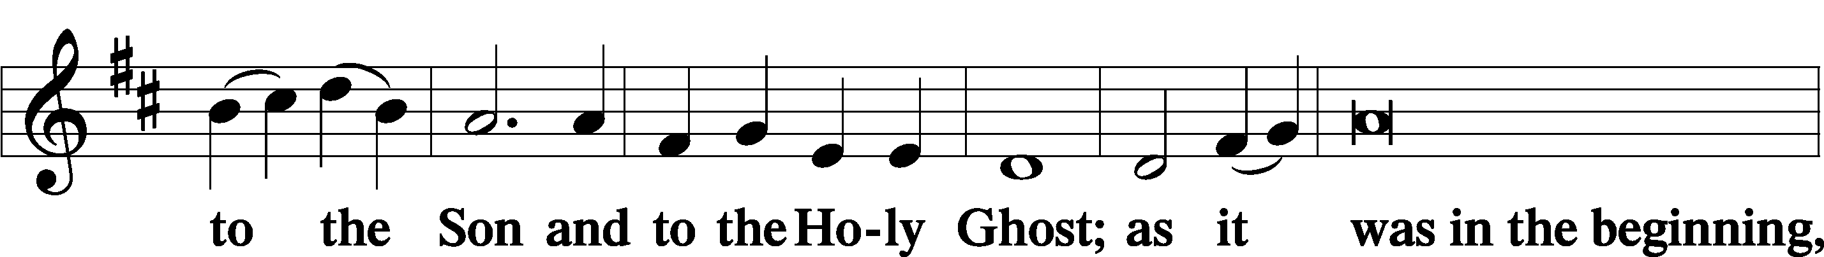
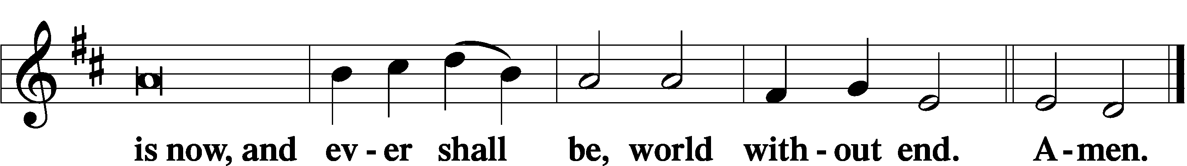

Thanksgiving Psalm 107:1
P O give thanks unto the Lord, for He is good,
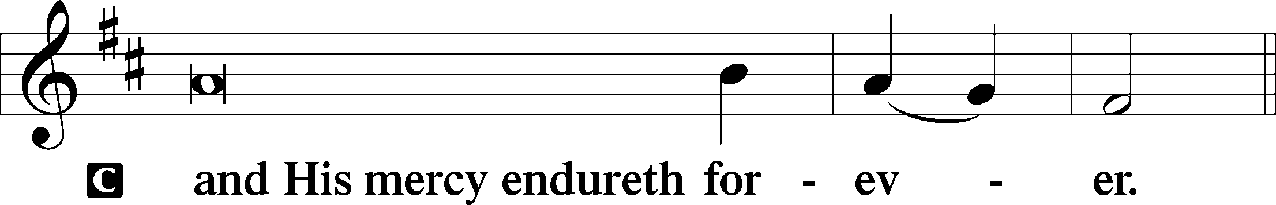

Post-Communion Collect
P Let us pray.
We give thanks to You, almighty God, that You have refreshed us through this salutary gift, and we implore You that of Your mercy You would strengthen us through the same in faith toward You and in fervent love toward one another; through Jesus Christ, Your Son, our Lord, who lives and reigns with You and the Holy Spirit, one God, now and forever.
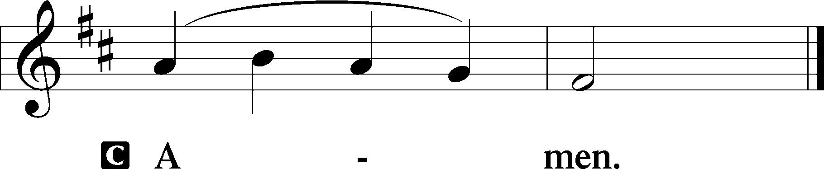

Salutation 2 Timothy 4:22
P The Lord be with you.
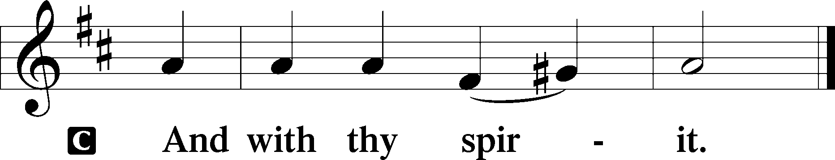

Benedicamus Psalm 103:1
P Bless we the Lord.
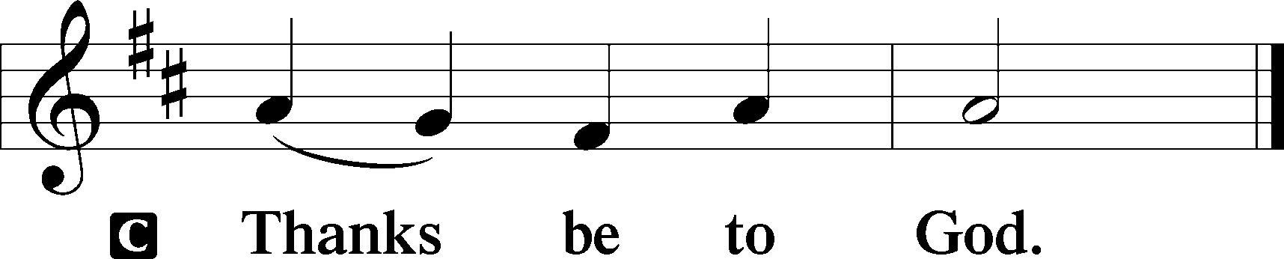

Benediction Numbers 6:24–26
P The Lord bless you and keep you.
The Lord make His face shine upon you and be gracious unto you.
The Lord lift up His countenance upon you and T give you peace.
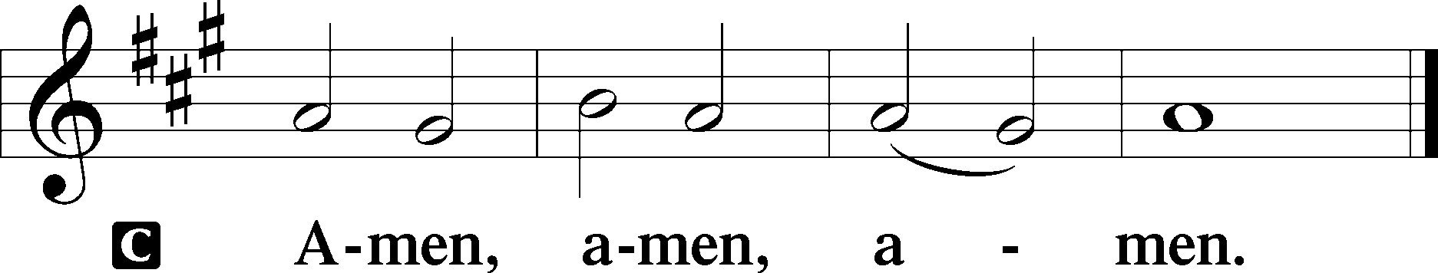

Closing Hymn: LSB #819 “Sing Praise to God, the Highest Good”

Silent prayer after worship: Gracious Lord, lead me to be in Your Word daily so that the Holy Spirit may cause my faith to grow and I will be able to share my faith with others so they also may believe and be saved. Amen.
fffffffffffffffffffffffffffffffffff
Acknowledgments
Unless otherwise indicated, Scripture quotations are from the ESV® Bible (The Holy Bible, English Standard Version®), copyright © 2001 by Crossway, a publishing ministry of Good News Publishers. Used by permission. All rights reserved.
Created by Lutheran Service Builder © 2023 Concordia Publishing House.
fffffffffffffffffffffffffffffffffff
fffffffffffffffffffffffffffffffffff
In Loving Memory of Husband, Robert Sulek’s Birthday: Edeltraud Sulek (Capital Campaign).
In Loving Memory of Martin Anderson: Diane Riefstahl (Food Pantry).
fffffffffffffffffffffffffffffffffff
SCHEDULE THROUGH JULY 30, 2023:

:

Today, 7 pm, Fellowship Hall: AA Meeting
Monday, 7 pm, Fellowship Hall: Church Council Meeting
Tuesday, 7-9 pm, Fellowship Hall: Penn-Ohio Singers
Wednesday, 7:30 pm, Fellowship Hall: NA Meeting
Thursday, 9 am, Downstairs: Food Pantry
Next Sunday, 9 am, Sanctuary: Divine Service
7 pm, Fellowship Hall: AA Meeting
fffffffffffffffffffffffffffffffffff
Attendance: Sunday, July 16, 2023: 41
fffffffffffffffffffffffffffffffffff
THANK YOU FOR SERVING IN JULY: Elder: Jonathan Baisch; Ushers: Matt Berent, Mark Gabriel, Michael Laird, & Jerome Thomas; Altarware: (prior) Diane Riefstahl & Marie Flaugher (07/09 & 07/30); (after) Elizabeth Haenftling (07/02 & 07/16) & Marie Flaugher (07/09, 07/23, & 07/30).
fffffffffffffffffffffffffffffffffff
Bible Memory Verses ~ Week of July 23rd:
For Adults: Heaven and earth will pass away, but my words will not pass away.
Mark 13:31
For Children: Fear not, for I have redeemed you; I have called you by name, you are mine. Isaiah 43:1
fffffffffffffffffffffffffffffffffff
August calendar and newsletter items are due to the secretary’s office by noon tomorrow, July 24th. Church Council members are reminded that reports for that evening’s council meeting are due by noon tomorrow as well.
fffffffffffffffffffffffffffffffffff
This morning, we are pleased to welcome Rebecca Marquette as our regular church organist! We are blessed by her willingness to share her time and talents with us.
We also give heartful thanks to Catherine Carr who has served in this capacity for the past few years. Catherine will now serve as Rebecca’s substitute when needed.
fffffffffffffffffffffffffffffffffff
Our Stewardship of Treasures for the Lord:
In order to do the Lord’s work, we need $2,553.63 each week to meet our 2023 budget for general purposes and $76.92 for the SELC.
Figures for Sunday, July 16, 2023
General Fund: $1,501.00 Behind for the week: -$1,052.63
SELC: $0.00 Behind for the week: -$76.92
Food Pantry: $20.00
Capital Campaign: $50.00
Capital Campaign (Online): $25.00

For online giving, check out https://www.saintspeterandpaul.net/online-giving.
fffffffffffffffffffffffffffffffffff
Remember the following in Prayer…
~The Hurting and Healing: Amy, Steve Antolovich, Ellen Baron^{CA}, Lois Bortner^{CA}, Bev & Joe Chlpka, Kathleen Coughenour, Susan Davies, Tim Dudash, Judith & Eddy Furey, Griffin, Austin Hamilton, Joan, Darla Krajci, Barbara Kreske, Jess Lavoie, Elizabeth Loughan, Paul Lucas^{CA}, Sandy Marshall, Gene Moore, Frank Niemeyer^{CA}, Juanita Rentschler, Richard Reuning^{CA}, Nancy Robertson^{CA}, Joel & Peggy Wasson, Angela Weser^{CA}, and Ruth Wolf.
~The Homebound: Anna Mae Daris, Millie Elavsky, Rudy & Jean Tomko, Betty Wolf, and Ed & Millie Zachar.
~Celebrating this Week: Birthday: Suellen Burns (07.26); Anniversary: Carl & Maria Marks (07.26) and Jerome & June Thomas (07.28).
~Serving in the Military: Alex (Sasha) Carr, Curtis Sinewe, and Joshua Solyan.
~Community & World Needs: Those suffering from or affected by the coronavirus; those suffering due to the conflict between Ukraine and Russia; those suffering from loss and dislocation because weather disasters; those suffering from addiction and their families; Local, State, and National Government Leaders; safety for all Police Officers, Firefighters, & First Responders; the unemployed; our Third Quarter Local Mission: Luther Classical College.
*CA represents cancer.
fffffffffffffffffffffffffffffffffff
There are additional copies of the “Reading the Bible in Six Months” schedule on the tables in the narthex and adjacent to the nursery.
Alex (Sasha) Carr would welcome cards/letters (no packages) as he completes his basic training for the US Army. His address is (capitalization is intentional)…
PVT Alexander Carr RN 141
CO C 2nd BN 47th INFANTRY
197th INFANTRY BRIGADE
9375 CONWAY DRIVE 3425
FORT MOORE, GA 31905-4931
fffffffffffffffffffffffffffffffffff
Church Council members are reminded that there will be a meeting tomorrow evening, July 24th at 7 pm. The next Voters’ Assembly will take place following worship, Sunday, August 20th.
fffffffffffffffffffffffffffffffffff
Our prayer list has been updated. If you would like someone’s name added or deleted from our Prayer List, please put a note in the secretary’s mail slot. Thank you!
fffffffffffffffffffffffffffffffffff
Recently, our Food Pantry was blessed with a $1000.00 donation from the NLMK workers and their 50-50 raffle. This donation, through the Shenango Valley Charitable Foundation fund, will go a long way in assisting those families who depend on our Food Pantry to make ends meet.
fffffffffffffffffffffffffffffffffff
Our Food Pantry now has its own email address: foodpantry@saintspeterandpaul.net.
Please encourage anyone who needs to contact it to do so !
fffffffffffffffffffffffffffffffffff
Pastor Deal will be attending the Bugenhagen Conference Monday through Thursday of this week. For any needs of care, please reach out to either Pastor Baisch (501-253-8292) or Elder Jonathan Baisch (724-816-6866).
fffffffffffffffffffffffffffffffffff

Here to Serve
Pastor………………………………………………...……………Rev. Jacob Deal
E-mail …………………………….……pastordeal@saintspeterandpaul.net
Phone Number……………………..…………………724-347-3620 (Option 2)
Church Office………………………..…………………724-347-3620 (Option 3)
Website …………………………………………www.saintspeterandpaul.net
Secretary…………………………………………………………Diane Riefstahl
E-mail ………………………………………church@saintspeterandpaul.net
Website …………………………………………www.saintspeterandpaul.net
Food Pantry (email): ……………foodpantry@saintspeterandpaul.net
Congregation President………………………………….…Jonathan Baisch
Church Elder …………………………………………...……. Jonathan Baisch
Organist………………………………………………..….…Rebecca Marquette
Choir Director…………………………………………………….…Chris Nelson
AA Contact: Steve………………………………………………...…724-813-2358
NA Contact: Larry……………………………………..…………..724-977-8733
fffffffffffffffffffffffffffffffffff
If needing to get into the church building during the week, please phone first to make certain someone is here to let you in.

