Sts. Peter & Paul
Evangelical Lutheran Church
Lutheran Church-Missouri Synod
Founded-1917

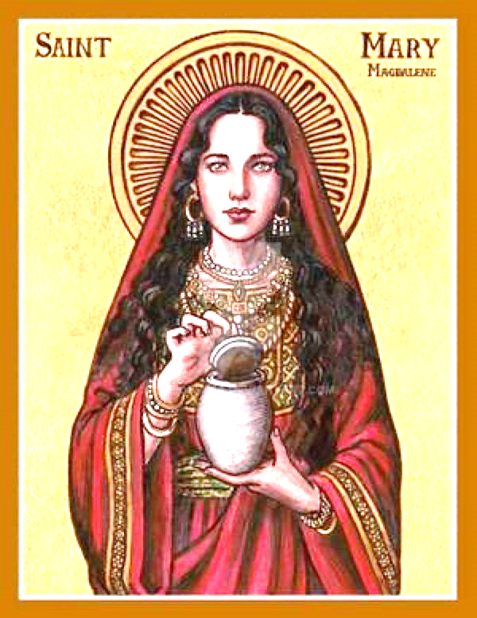

July 22, 2023

699 Stambaugh Ave.
Sharon, Pennsylvania 16146

“I was glad when they said to me,
Let us go to the house of the LORD!”
Psalm 122:1
Sts. Peter & Paul Evangelical Lutheran Church, LC-MS
THE FESTIVAL OF ST. MARY MAGDALENE
July 22, 2023
A special welcome to our guests this day! If you would like more information about The Lutheran Church - Missouri Synod, or this congregation, please speak with Pastor Deal or an Elder after the service.
Members & Guests: Don’t be embarrassed if your children make noise during the worship service, all children do. We encourage families to worship together but, if you feel the need, there are pews in the rear of the Church which are reserved for young families on both sides of the sanctuary. There is also a quiet room available to you, located next to the sanctuary (formerly the Pastor’s office), where you would be able to follow along with the service.

Today’s service includes the Sacrament of Holy Communion. If during this past year, you have not worshipped with us and been communed, we respectfully ask that you do not partake of this sacrament this day before first speaking with Pastor Deal.
If visiting from a sister congregation of the LC-MS and are in good standing, please inform Pastor Deal of your desire to commune prior to the service.
If wishing to receive a blessing during communion, please approach with your arms crossed.

CONTACT INFORMATION
Pastor Deal: pastordeal@saintspeterandpaul.net or 724-347-3620 (opt. 2)
Church Office: church@saintspeterandpaul.net or 724-347-3620 (opt. 3)
Secretary’s Office will be open Monday and Thursday (8:30-4:30) this coming week.

Silent prayer before worship: Dear Lord, through Your Word the Holy Spirit enables me to believe. By Your grace, lead me to trust You not only for eternal life, but to strengthen me and lead me through each day. In Jesus’ name. Amen.

Confession and Absolution

Opening Hymn: LSB #609 “Jesus Sinners Doth Receive”

Stand

The sign of the cross may be made by all in remembrance of their Baptism.

Invocation
P In the name of the Father and of the T Son and of the Holy Spirit.
C Amen.

Exhortation Hebrews 10:22; Psalm 124:8; Psalm 32:5
P Beloved in the Lord! Let us draw near with a true heart and confess our sins unto God our Father, beseeching Him in the name of our Lord Jesus Christ to grant us forgiveness.

P Our help is in the name of the Lord,
C who made heaven and earth.
P I said, I will confess my transgressions unto the Lord,
C and You forgave the iniquity of my sin.

Silence for reflection on God’s Word and for self-examination.

Confession of Sins
P O almighty God, merciful Father,
C I, a poor, miserable sinner, confess unto You all my sins and iniquities with which I have ever offended You and justly deserved Your temporal and eternal punishment. But I am heartily sorry for them and sincerely repent of them, and I pray You of Your boundless mercy and for the sake of the holy, innocent, bitter sufferings and death of Your beloved Son, Jesus Christ, to be gracious and merciful to me, a poor, sinful being.

Absolution [John 20:19–23]
P Upon this your confession, I, by virtue of my office, as a called and ordained servant of the Word, announce the grace of God unto all of you, and in the stead and by the command of my Lord Jesus Christ I forgive you all your sins in the name of the Father and of the T Son and of the Holy Spirit.
C Amen.
Service of the Word

Introit Psalm 30:1a, 2–3, 12b; antiphon: Psalm 31:1a
In you, O Lord, do I take | refuge;*
let me never be | put to shame.
I will extol you, | O Lord,*
for you have drawn me up [out | of the depths].
O Lord my God, I cried to | you for help,*
and you have | healed me.
O Lord, you have brought up my soul | from Sheol;*
you restored me to life from among those who go down | to the pit.
O | Lord my God,*
I will give thanks to you for- | ever!
In you, O Lord, do I take | refuge;*
let me never be | put to shame.
Gloria Patri
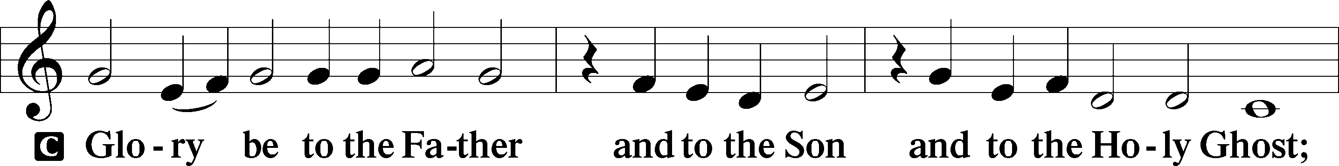
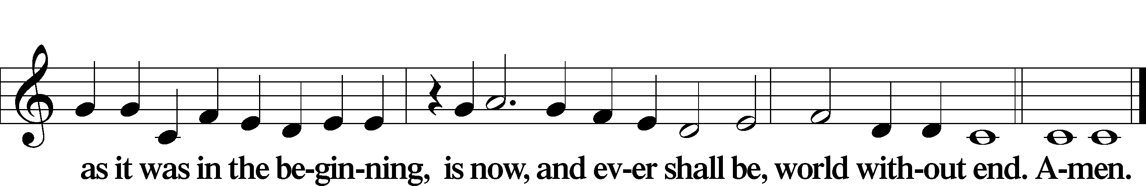
Kyrie Mark 10:47
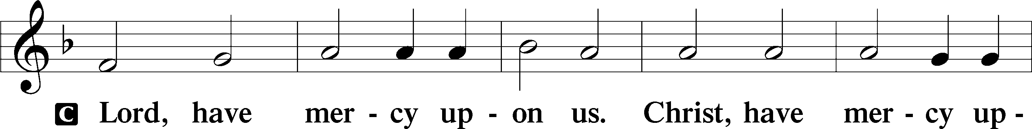
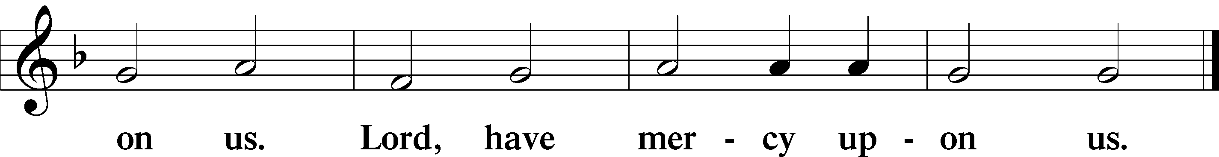

Gloria in Excelsis Luke 2:14; John 1:29
P Glory be to God on high:
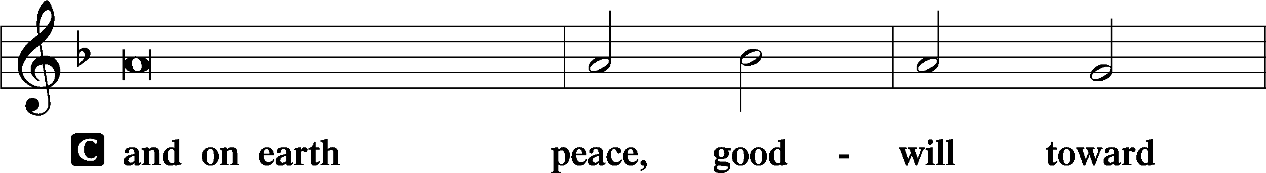
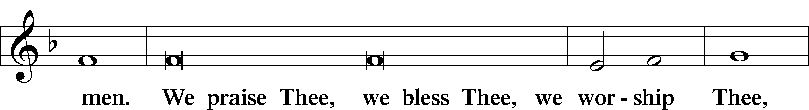
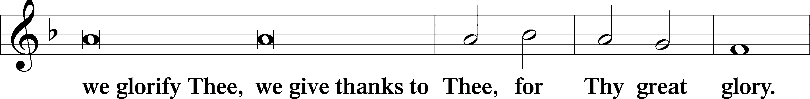
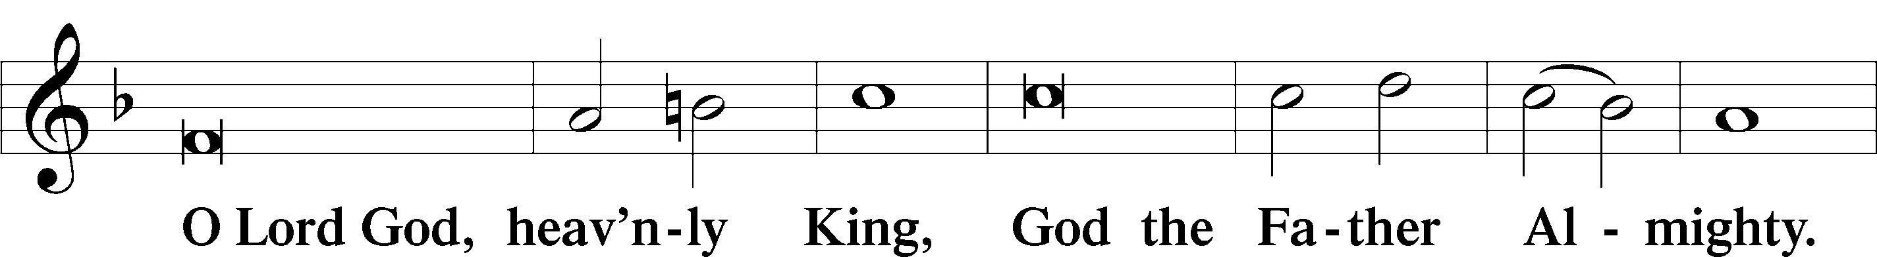
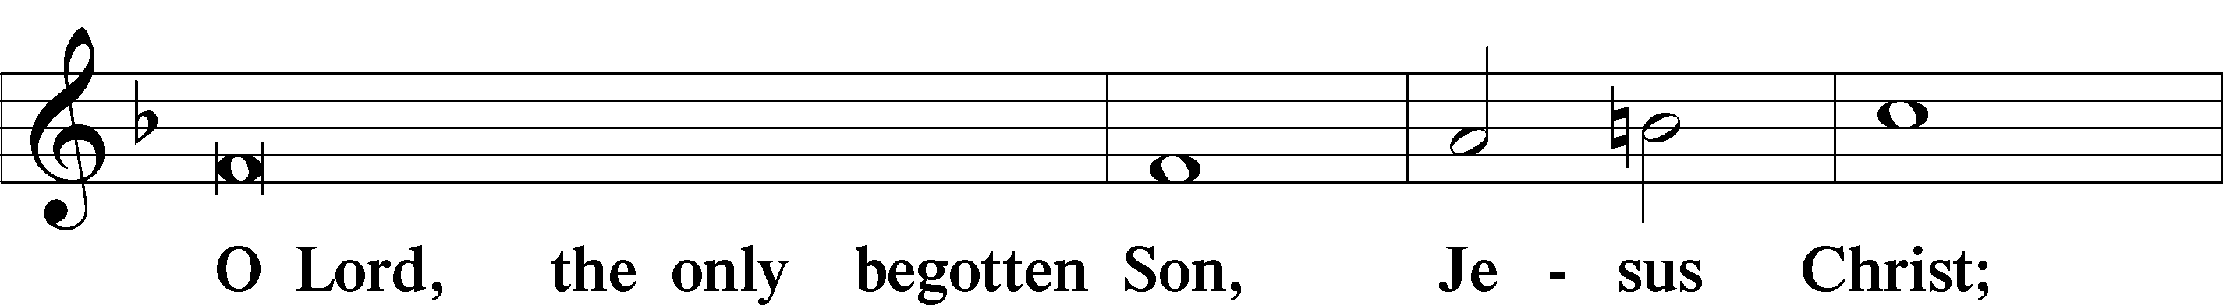
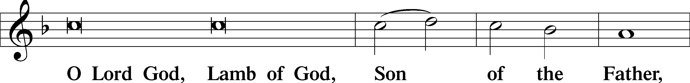
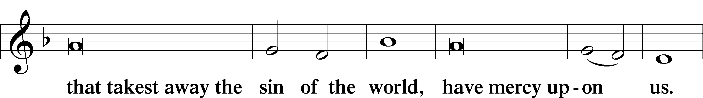
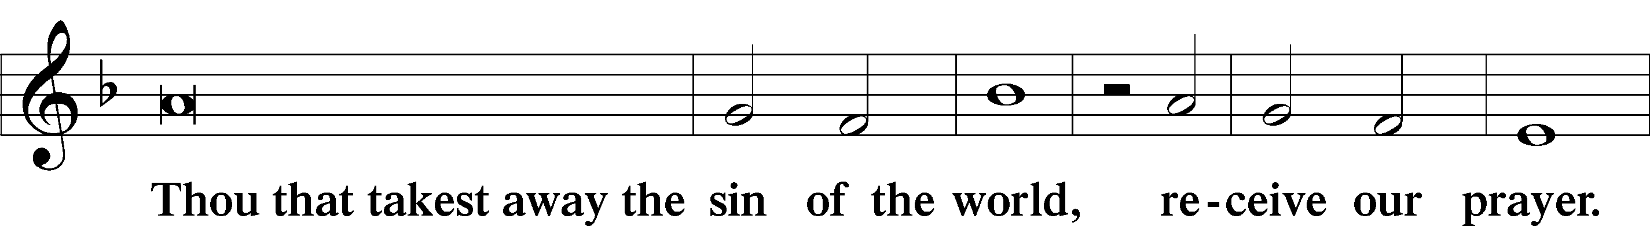
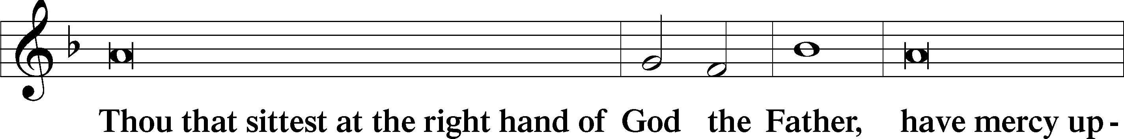
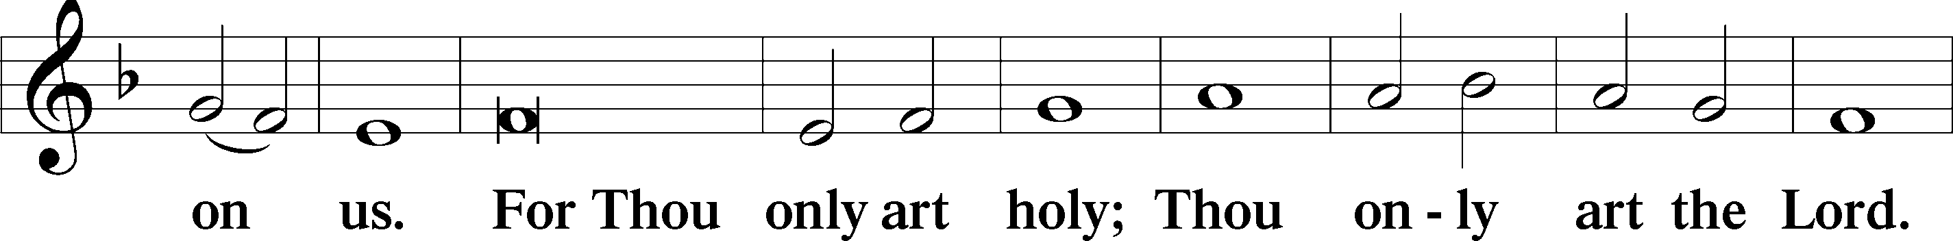
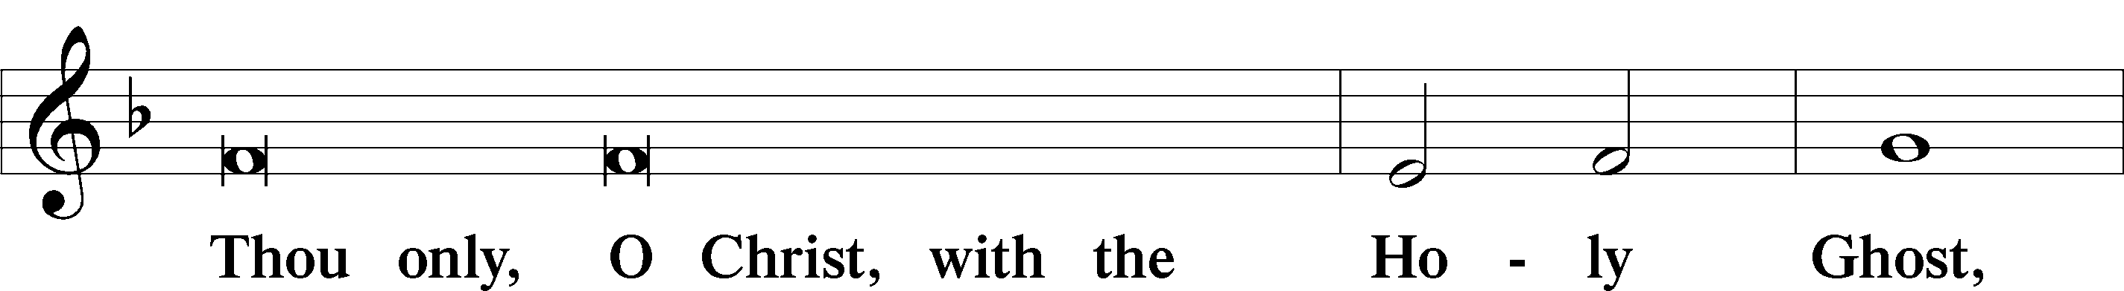
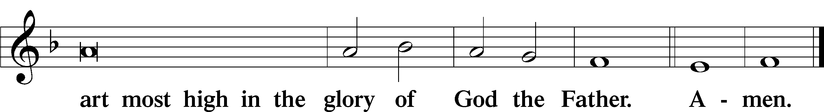

Salutation and Collect of the Day: Mary Magdalene
P The Lord be with you.
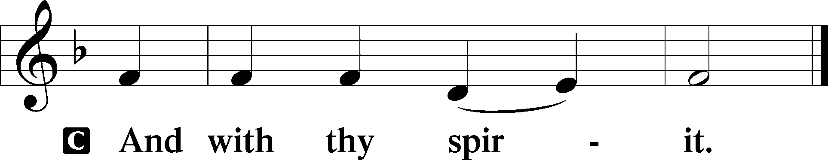

P Let us pray.
Almighty God, Your Son, Jesus Christ, restored Mary Magdalene to health and called her to be the first witness of His resurrection. Heal us from all our infirmities, and call us to know You in the power of Your Son’s unending life; through the same Jesus Christ, our Lord, who lives and reigns with You and the Holy Spirit, one God, now and forever.
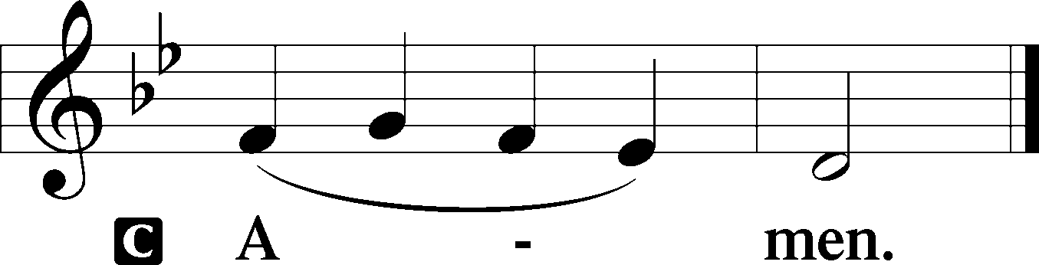
Sit

Prophecy: Proverbs 31:10–31 (NKJV)
Who can find a virtuous wife? For her worth is far above rubies. The heart of her husband safely trusts her; so he will have no lack of gain. She does him good and not evil all the days of her life. She seeks wool and flax, and willingly works with her hands. She is like the merchant ships, she brings her food from afar. She also rises while it is yet night, and provides food for her household, and a portion for her maidservants. She considers a field and buys it; from her profits she plants a vineyard. She girds herself with strength, and strengthens her arms. She perceives that her merchandise is good, and her lamp does not go out by night. She stretches out her hands to the distaff, and her hand holds the spindle. She extends her hand to the poor, yes, she reaches out her hands to the needy. She is not afraid of snow for her household, for all her household is clothed with scarlet. She makes tapestry for herself; her clothing is fine linen and purple. Her husband is known in the gates, when he sits among the elders of the land. She makes linen garments and sells them, and supplies sashes for the merchants. Strength and honor are her clothing; she shall rejoice in time to come. She opens her mouth with wisdom, and on her tongue is the law of kindness. She watches over the ways of her household, and does not eat the bread of idleness. Her children rise up and call her blessed; her husband also, and he praises her: “Many daughters have done well, but you excel them all.” Charm is deceitful and beauty is passing, but a woman who fears the Lord, she shall be praised. Give her of the fruit of her hands, and let her own works praise her in the gates.

P This is the Word of the Lord.
C Thanks be to God.

Gradual Psalm 45:10; John 10:11b, 10b, 3b, 16c
Hear, O daughter, and consider, and in- | cline your ear:*
forget your people and your | father’s house.
The good shepherd lays down his life | for the sheep,*
that they may have life and have it a- | bundantly.
The sheep hear his voice, and he calls his own | sheep by name.*
So there will be one flock, one | shepherd.

Epistle: Romans 5:18-21 (NKJV)
Brethren: As through one man’s offense judgment came to all men, resulting in condemnation, even so through one Man’s righteous act the free gift came to all men, resulting in justification of life. For as by one man’s disobedience many were made sinners, so also by one Man’s obedience many will be made righteous. Moreover the law entered that the offense might abound. But where sin abounded, grace abounded much more, so that as sin reigned in death, even so grace might reign through righteousness to eternal life through Jesus Christ our Lord.
P This is the Word of the Lord.
C Thanks be to God.

Stand
Verse John 20:18a
Alleluia. Mary Magdalene went and announced to the disciples, “I have seen the Lord.” Alleluia.

Alleluia
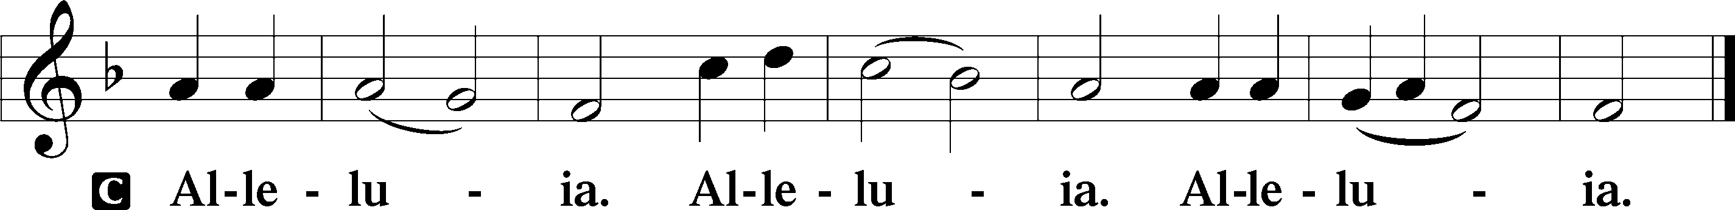

Holy Gospel: Luke 7:36-50 (NKJV)
P The Holy Gospel according to St. Luke, the seventh chapter.
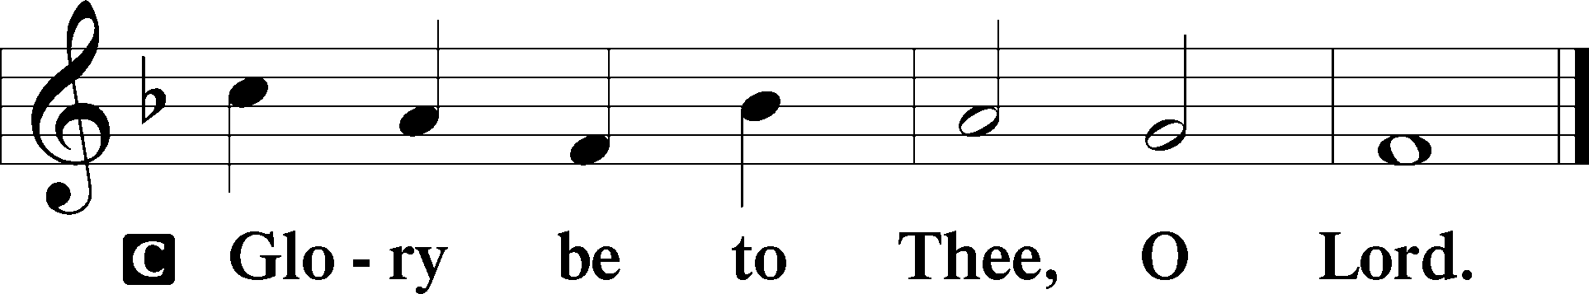

At that time: One of the Pharisees asked Jesus to eat with him. And He went to the Pharisee’s house, and sat down to eat. And behold, a woman in the city who was a sinner, when she knew that Jesus sat at the table in the Pharisee’s house, brought an alabaster flask of fragrant oil, and stood at His feet behind Him weeping; and she began to wash His feet with her tears, and wiped them with the hair of her head; and she kissed His feet and anointed them with the fragrant oil. Now when the Pharisee who had invited Him saw this, he spoke to himself, saying, “This Man, if He were a prophet, would know who and what manner of woman this is who is touching Him, for she is a sinner.” And Jesus answered and said to him, “Simon, I have something to say to you.” So he said, “Teacher, say it.” “There was a certain creditor who had two debtors. One owed five hundred denarii, and the other fifty. And when they had nothing with which to repay, he freely forgave them both. Tell Me, therefore, which of them will love him more?” Simon answered and said, “I suppose the one whom he forgave more.” And He said to him, “You have rightly judged.” Then He turned to the woman and said to Simon, “Do you see this woman? I entered your house; you gave Me no water for My feet, but she has washed My feet with her tears and wiped them with the hair of her head. You gave Me no kiss, but this woman has not ceased to kiss My feet since the time I came in. You did not anoint My head with oil, but this woman has anointed My feet with fragrant oil. Therefore I say to you, her sins, which are many, are forgiven, for she loved much. But to whom little is forgiven, the same loves little.” Then He said to her, “Your sins are forgiven.” And those who sat at the table with Him began to say to themselves, “Who is this who even forgives sins?” Then He said to the woman, “Your faith has saved you. Go in peace.”

P This is the Gospel of the Lord.
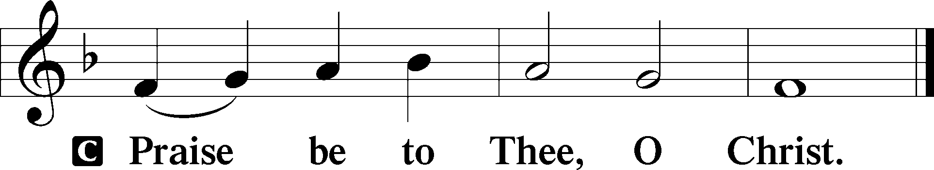

Nicene Creed
C I believe in one God,
the Father Almighty,
maker of heaven and earth
and of all things visible and invisible.

And in one Lord Jesus Christ,
the only-begotten Son of God,
begotten of His Father before all worlds,
God of God, Light of Light,
very God of very God,
begotten, not made,
being of one substance with the Father,
by whom all things were made;
who for us men and for our salvation came down from heaven
and was incarnate by the Holy Spirit of the virgin Mary
and was made man;
and was crucified also for us under Pontius Pilate.
He suffered and was buried.
And the third day He rose again according to the Scriptures
and ascended into heaven
and sits at the right hand of the Father.
And He will come again with glory to judge both the living and the dead,
whose kingdom will have no end.

And I believe in the Holy Spirit,
the Lord and giver of life,
who proceeds from the Father and the Son,
who with the Father and the Son together is worshiped and glorified,
who spoke by the prophets.
And I believe in one holy Christian and apostolic Church,
I acknowledge one Baptism for the remission of sins,
and I look for the resurrection of the dead
and the life T of the world to come. Amen.
Sit

Hymn of the Day: LSB #855 “For All the Faithful Women” Sts. 1, 11, 3–4
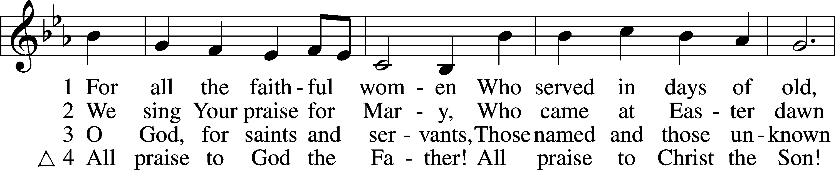
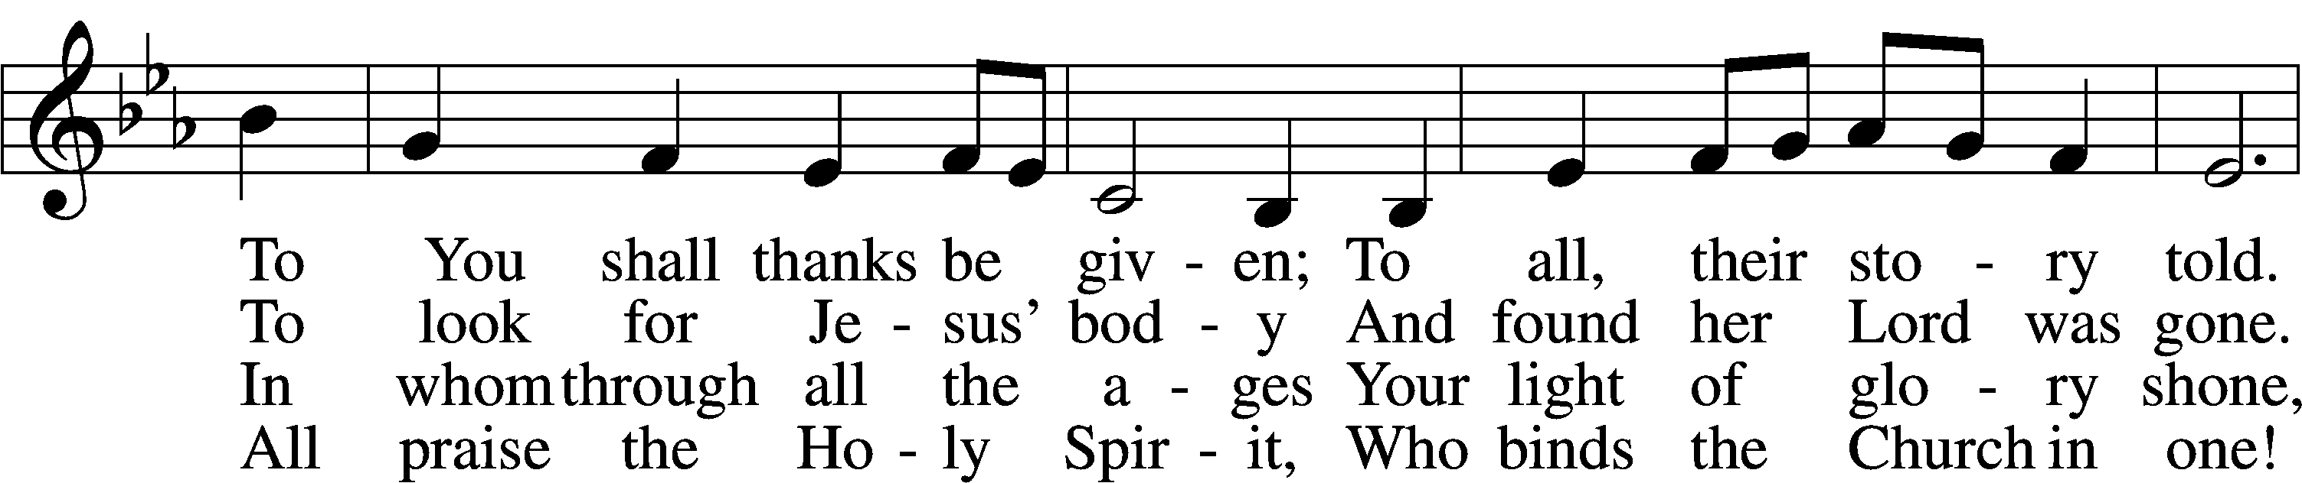
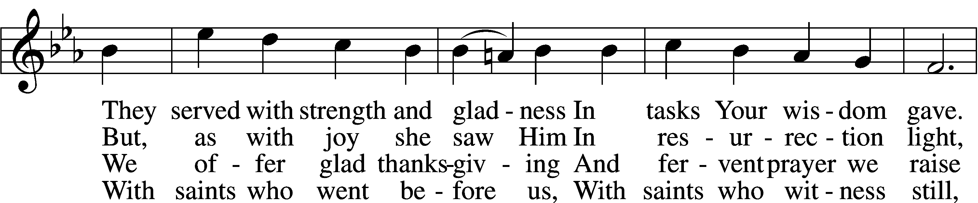
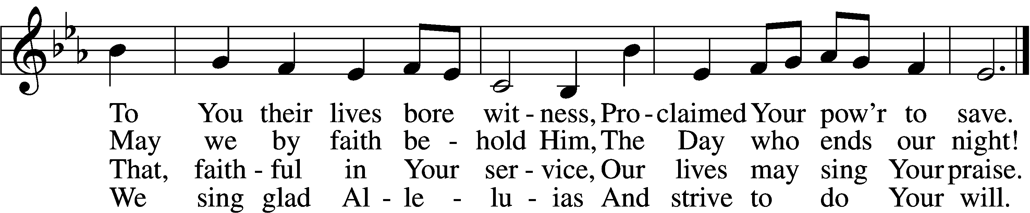

Text: Herman G. Stuempfle, Jr., 1923–2007, alt. Tune: Finnish, 19th cent. Text: © 1993, 1997, 2003 GIA Publications, Inc. Used by permission: LSB Hymn License no. 110004782 Tune: Public domain
Sermon

Stand

Prayer of the Church

Offertory Psalm 51:10–12
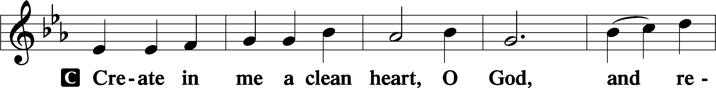
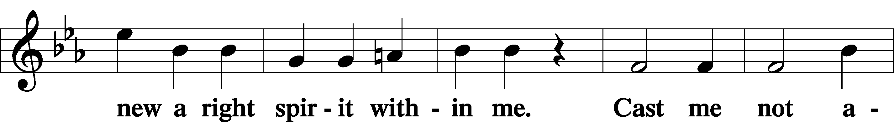
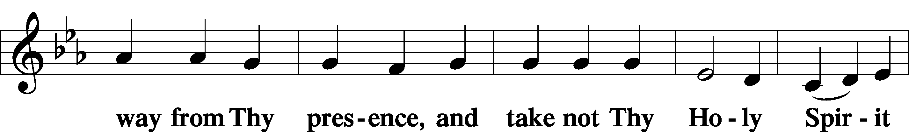
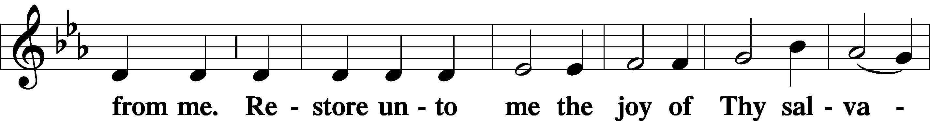
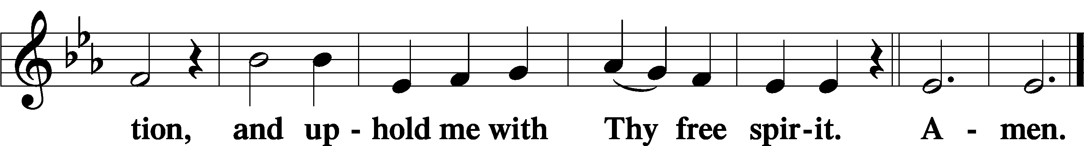
Sit

Preparatory Hymn: LSB #611 “Chief of Sinners Though I Be”

Stand
Service of the Sacrament

Preface 2 Timothy 4:22; Colossians 3:1 Psalm 136
P The Lord be with you.

P Lift up your hearts.
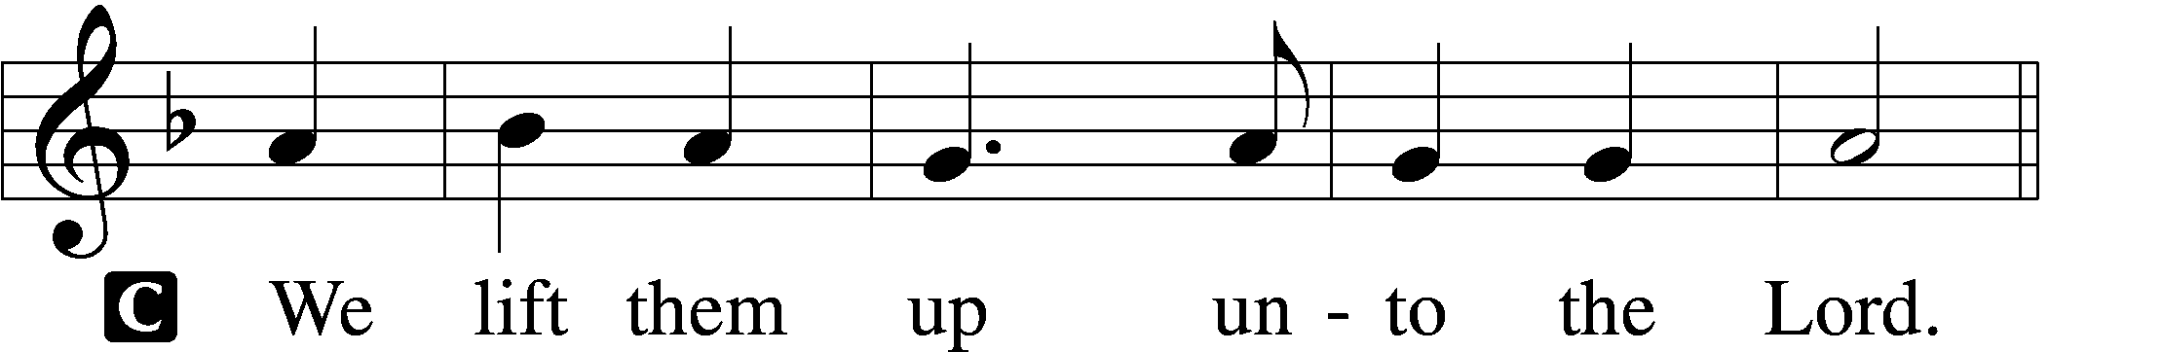

P Let us give thanks unto the Lord, our God.
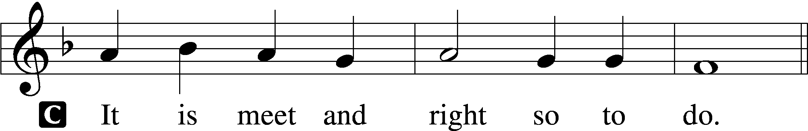

Proper Preface (Abbreviated) LSB 194
P It is truly meet, right, and salutary . . . evermore praising You and saying:

Sanctus Isaiah 6:3; Matthew 21:9
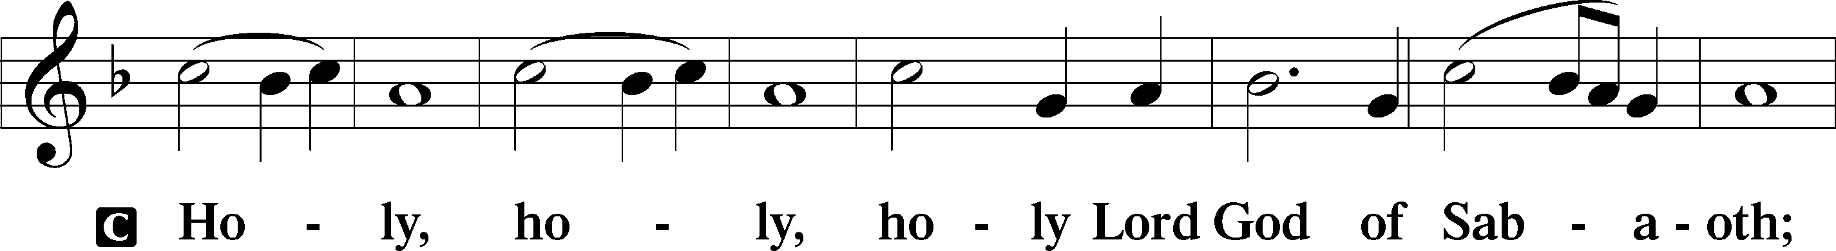
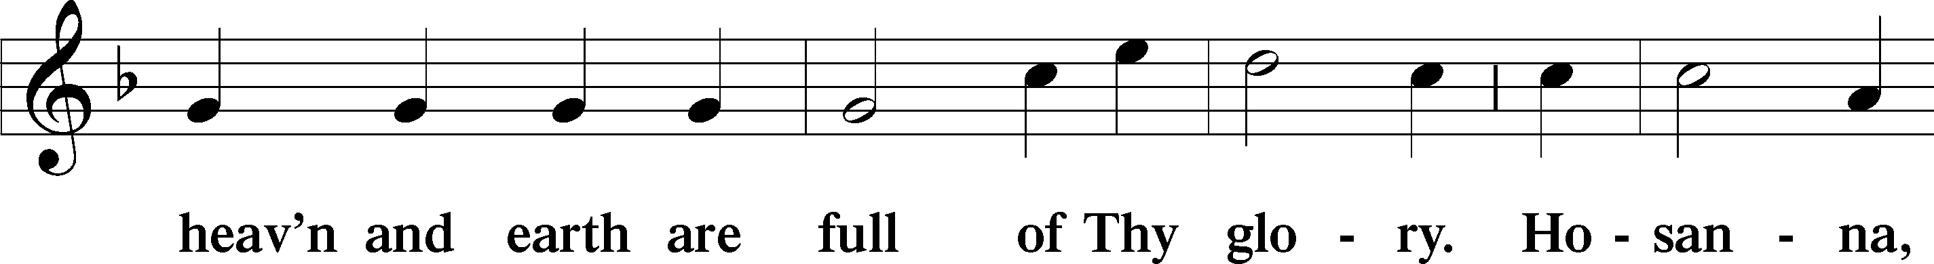
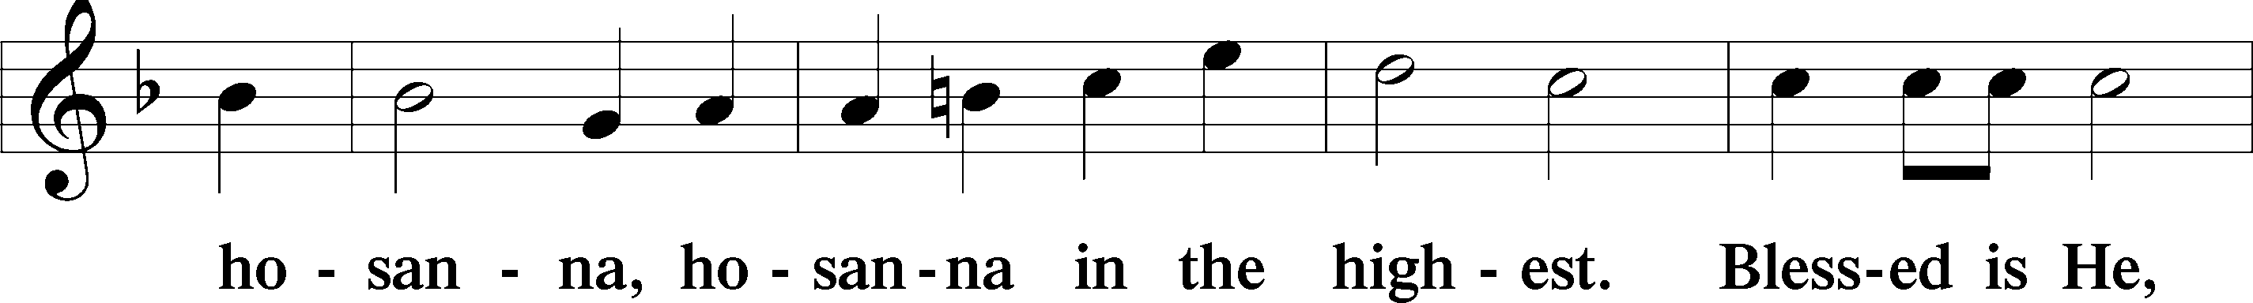
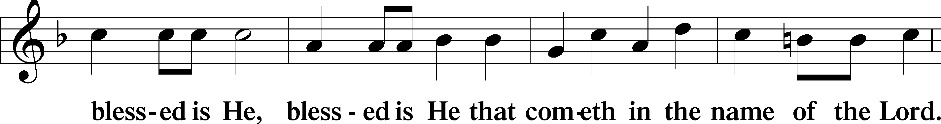
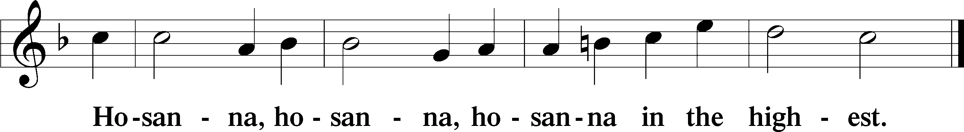

Lord’s Prayer Matthew 6:9–13
C Our Father who art in heaven,
hallowed be Thy name,
Thy kingdom come,
Thy will be done on earth as it is in heaven;
give us this day our daily bread;
and forgive us our trespasses as we forgive those who trespass against us;
and lead us not into temptation,
but deliver us from evil.
For Thine is the kingdom and the power and the glory forever and ever. Amen.

The Words of Our Lord Matthew 26:26–28; Mark 14:22–24; Luke 22:19–20; 1 Corinthians 11:23–25
P Our Lord Jesus Christ, on the night when He was betrayed, took bread, and when He had given thanks, He broke it and gave it to the disciples and said: “Take, eat; this is My T body, which is given for you. This do in remembrance of Me.”

In the same way also He took the cup after supper, and when He had given thanks, He gave it to them, saying: “Drink of it, all of you; this cup is the new testament in My T blood, which is shed for you for the forgiveness of sins. This do, as often as you drink it, in remembrance of Me.”

Pax Domini John 20:19
P The peace of the Lord be with you always.
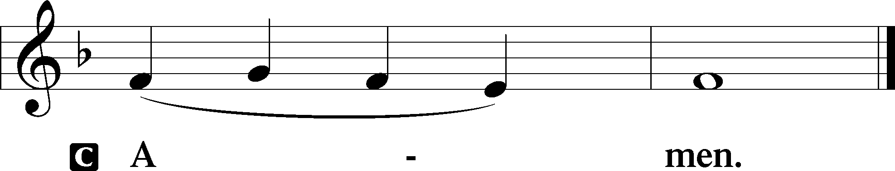

Agnus Dei John 1:29
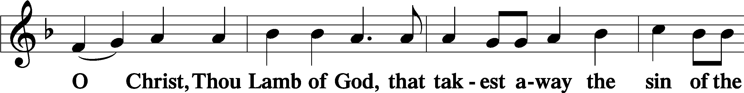
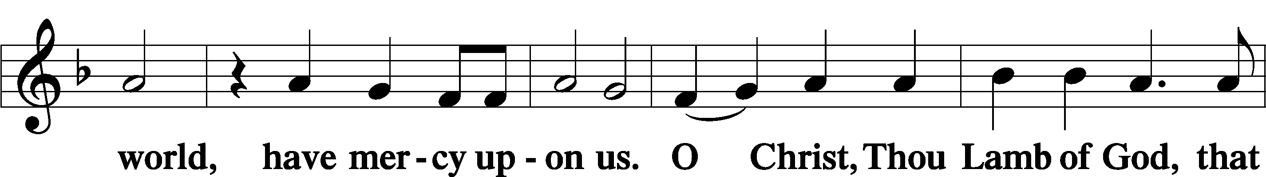
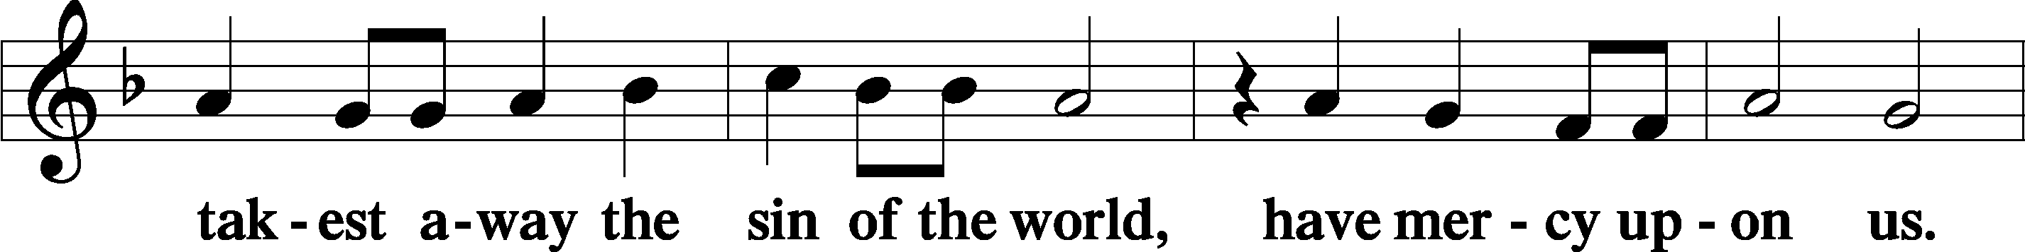
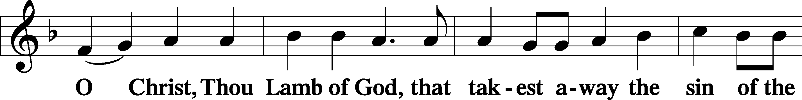
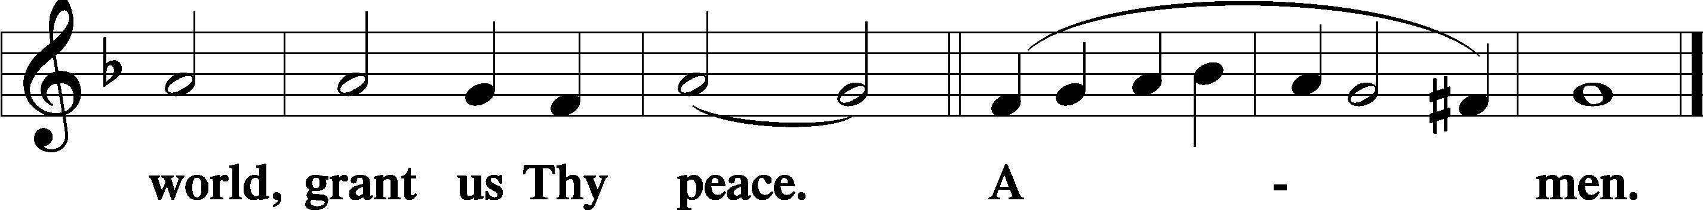
Sit
Distribution
The pastor and those who assist him receive the body and blood of Christ first and then distribute them to those who come to receive, saying:
Take, eat; this is the true body of our Lord and Savior Jesus Christ, given into death for your sins.
Amen.

Take, drink; this is the true blood of our Lord and Savior Jesus Christ, shed for the forgiveness of your sins.
Amen.

In dismissing the communicants, the following is said:
The Dismissal
P The body and blood of our Lord Jesus Christ strengthen and preserve you in body and soul to life everlasting. Depart T in peace.
C Amen.

Distribution Hymn: LSB #475 “Good Christian Friends, Rejoice and Sing”

Distribution Hymn: LSB #430 “My Song Is Love Unknown”

Distribution Hymn: LSB #465 “Now All the Vault of Heaven Resounds”

Nunc Dimittis Luke 2:29–32
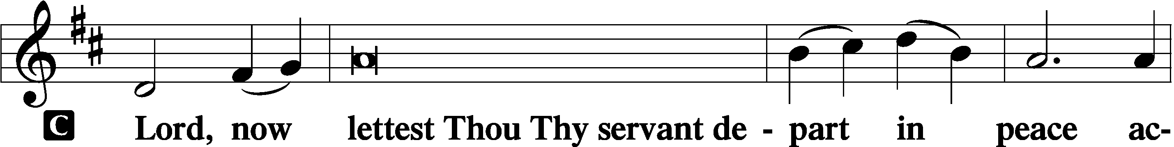

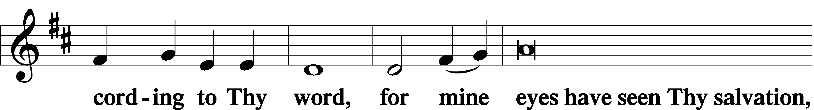
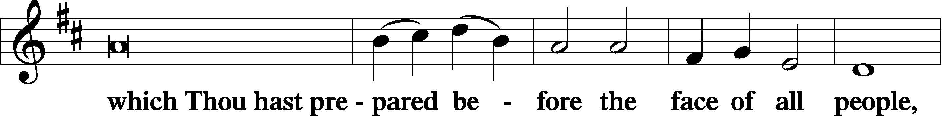
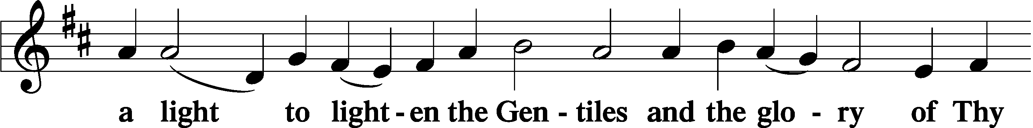
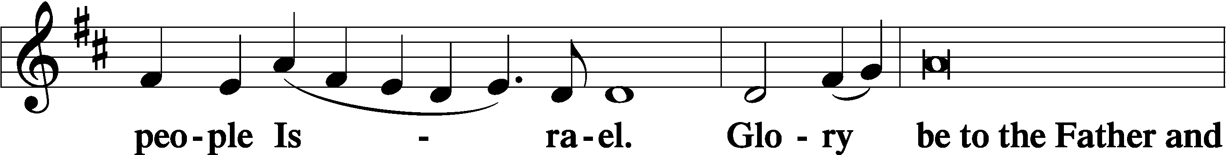
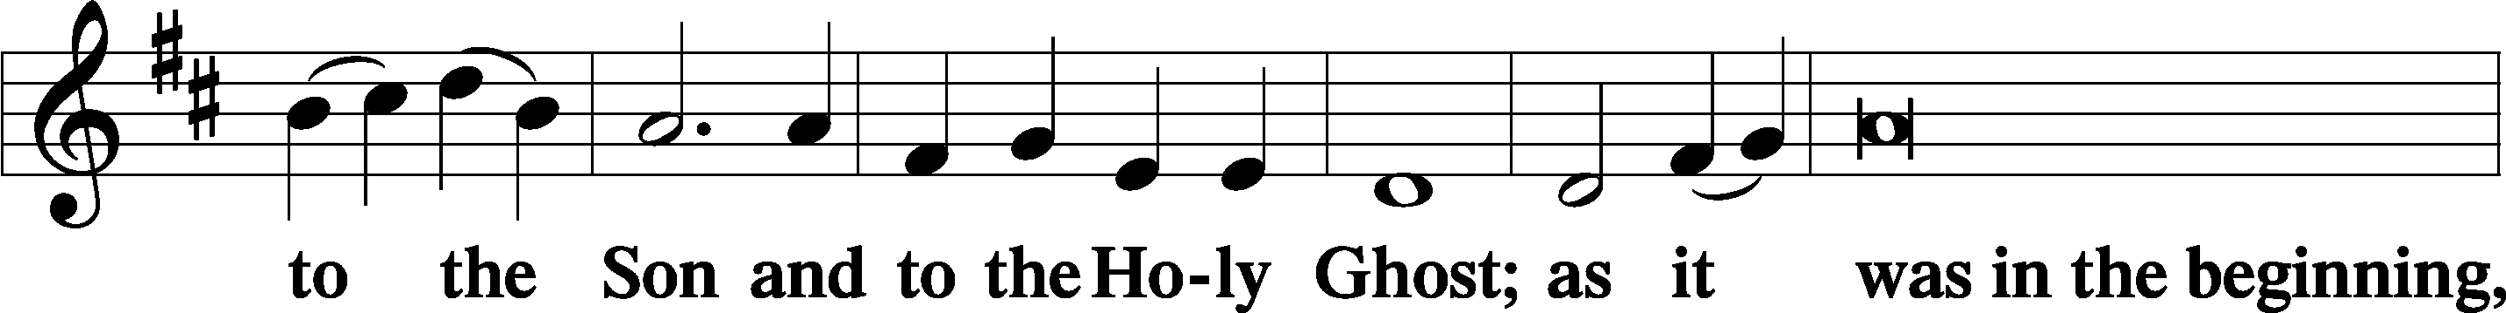
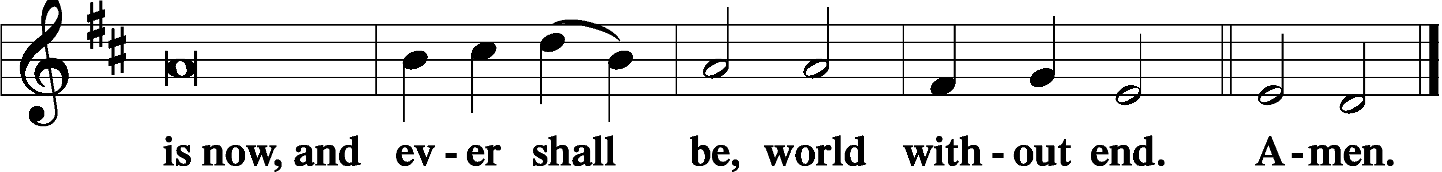

Thanksgiving Psalm 107:1
P O give thanks unto the Lord, for He is good,
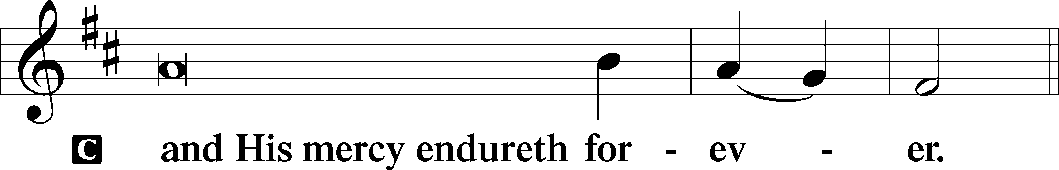

Post-Communion Collect
P Let us pray.
We give thanks to You, almighty God, that You have refreshed us through this salutary gift, and we implore You that of Your mercy You would strengthen us through the same in faith toward You and in fervent love toward one another; through Jesus Christ, Your Son, our Lord, who lives and reigns with You and the Holy Spirit, one God, now and forever.
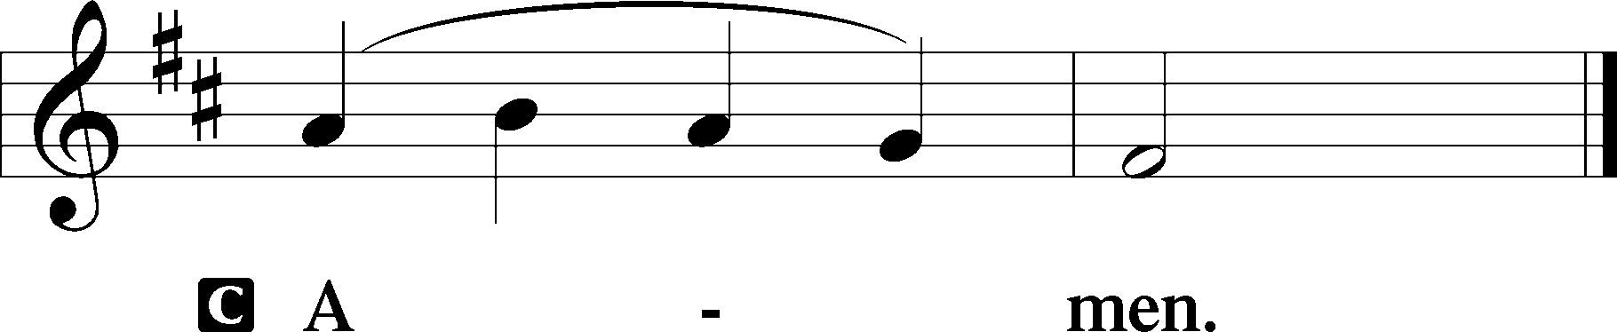

Salutation 2 Timothy 4:22
P The Lord be with you.
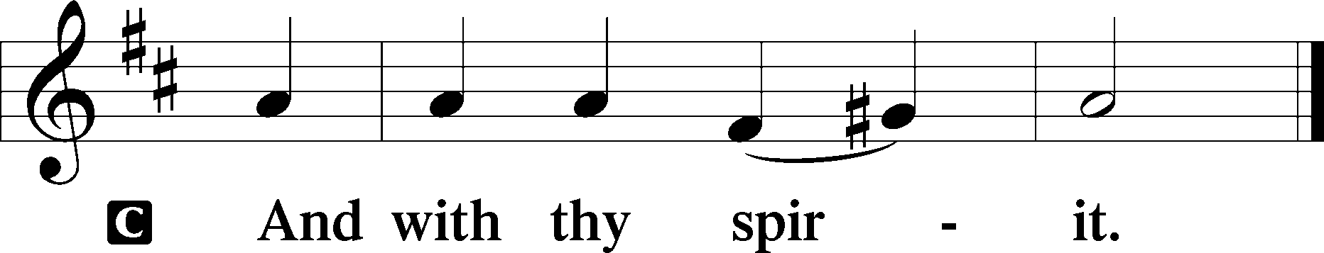

Benedicamus Psalm 103:1
P Bless we the Lord.
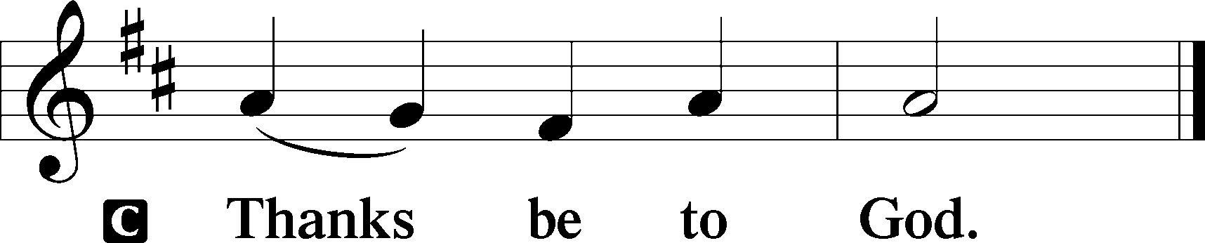

Benediction Numbers 6:24–26
P The Lord bless you and keep you.
The Lord make His face shine upon you and be gracious unto you.
The Lord lift up His countenance upon you and T give you peace.
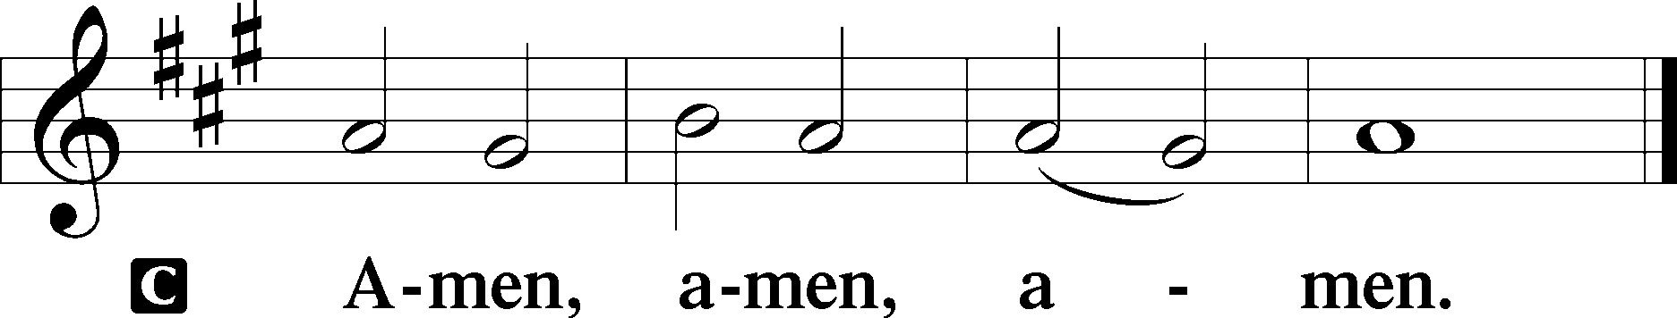

Closing Hymn: LSB #333 “Once He Came in Blessing”

Silent prayer after worship: Dear Jesus, lead me to daily pray and read Your Word so the Holy Spirit can draw me closer to You. As Your child and heir of Your kingdom, help me to live my life for You. Amen.
fffffffffffffffffffffffffffffffffff
Acknowledgments
Unless otherwise indicated, Scripture quotations are from the ESV® Bible (The Holy Bible, English Standard Version®), copyright © 2001 by Crossway, a publishing ministry of Good News Publishers. Used by permission. All rights reserved.
Created by Lutheran Service Builder © 2023 Concordia Publishing House.
fffffffffffffffffffffffffffffffffff

