Sts. Peter & Paul Evangelical Lutheran Church LC-MS
Monthly Newsletter --- July 2022
699 Stambaugh Avenue, Sharon, PA 16146
Phone: 724.347.3620 (Opt. 2, Pastor Deal; Opt. 3, Office)
E-mail: church@saintspeterandpaul.net www.saintspeterandpaul.net

“THE ROCK and THE SWORD”
“Built upon the Rock of Christ and wielding the
Sword of the Spirit, the Word of God.”

From the Pastor:
The Seventh Chief Part of the Catechism

Yes, that’s right, I titled this the Seventh Chief part of the Small Catechism because there is a section of the Small Catechism that often goes largely ignored and unused: The Table of Duties. What are these? “Certain passages of scripture for various holy orders and positions, admonishing them about their duties and responsibilities.” This is the section in the Small Catechism Luther added because, as he searched the Scriptures, he found that there were actually “holy orders” that God gives to his people on earth. Now the Table of Duties is by no means an exhaustive list of passages from the Bible concerning each duty, but it is a beginning to recognize that God does actually have orders which every Christian should do well to follow.
I remember growing up when I would look at my mom and dad and say, “I’m bored, there’s nothing to do around here.” My parents just loved to hear me say that. I know this because without hesitation their response was almost immediately, “I have something for you to do; get over here and finish this chore.” Ha-ha, they were just waiting for me to say it.
There is no reason that the Christian should ever find himself with nothing to do. The Christian life is filled with many tasks as we serve the Lord. The Table of Duties teaches us how we are to act in relationship with one another. So why should we make the Table of Duties an important aspect of our life? Because it teaches us not to be lazy or slothful. God teaches us that there is yet work to be done in every station of life, which in His eyes is good and pleasing to Him. Take a moment of your time before you go on and open your catechism and read from the Table of Duties.

The headings for the Table of Duties are
- For Bishops, Pastors, and Preachers.
- What the Hearers Owe to Their Pastors.
- Concerning Civil Government.
- What Subjects Owe to the Magistrates.
- For Husbands.
- For Wives.
- For Parents.
- For Children.
- For Male and Female Servants, Hired Men, and Laborers.
- For Masters and Mistresses.
- For Young Persons in General.
- For Widows.
- For All in Common.
What have you learned? Hopefully, you have seen that the Christian life is a transformed life of service. It’s really quite humbling. Luther once said, “A Christian is a perfectly free lord of all, subject to none. A Christian is a perfectly dutiful servant of all, subject of all, subject to all.” This I have found to be absolutely true. In and through Christ Jesus, we are liberated from all servitude, but we love because He first loved us. Therefore, our liberation in Christ frees us to freely serve as God has done for us.
I wonder why the emphasis on the Table of Duties has been lacking among believers? One cause could be that the catechism has fallen out of daily use among adult Christians. Ask yourself when was the last time you read through your Small Catechism? We are constantly in need of being reminded of the basic tenants of the Christian faith.
The second reason these go largely unnoticed and unused deals with sinful human nature that doesn’t like to be told what to do. These Scripture passages clearly mark lines in the sand to what is required of you in every station of life. God doesn’t let you live the life you want to live. He guides and directs your life to be in accord with His will. Of course, you, of your own free will, can fight against God’s own, but remember that God’s will is done when He breaks and hinders every evil plan and counsel of the devil, the world, and our sinful nature. God’s will is and will always be accomplished despite our or the devil’s attempts to thwart it. So, all there is for us to do is to pray that God breaks our hearts and fashions them again in the image of His son’s heart of grace.
To that end, we mustn’t look at the Table of Duties as an impervious wall that we crash up against, being broken like waves against the sea wall. Sure, it has that effect, but not only that. The other side of it is this: God wants you, his saints, to have faithful preachers. And he wants his faithful servants to respect and honor those they serve so that their task may be accomplished joyfully. God wants to protect you with a good government so that the things which you possess remain yours being defended from all terrorists, foreign and domestic. God wants authorities respected so that their duties may be accomplished with joy and a willingness to put your life above their own. God wants for families to be seen as gifts and remain intact. He desires for husbands to be in the image of Christ so that their wives may see Christ in them and so submit joyfully to their care. Parents must consider the goodness and honor that God gives to them to raise up the next generation in the fear and love of the Lord. And children should make this task joyful for their parents by honoring their authority. For all workers, all that they do should be to the Lord, since it is ultimately His hand by which they are fed and cared for in this life. Also, those who hire them should be respectful so that it will be a joy to work since it is God who watches over them. The young, in general, are to be examples of the work of the Lord through his Word which instructs their hearts. As for widows, God is the god of the widows and sojourners, so they who trust in the Lord have nothing to fear, but those who turn toward wickedness will have gained nothing.
God grant us to learn again the blessed words of the Small Catechism so that we may better live in harmony with one another in Christian love and charity with forgiveness and peace.
In Christ,
Pastor Deal
llllllllllllllllllllllllllll
Evangelism Outreach
A note from Pastor Deal
Recently, it was reported by a Gallup poll that only 81% of Americans say they believe in God. Just five years ago that number was 87%. One of the biggest declines was in the ages of 18-29 which dropped by 10% since 2013-2017. This is the next generation of people who will be caring for you in every place of your life.
Some people want to become lost and never found, but others are just lost in a world of confusion and lies. We possess the clear and unaltered truth and have an obligation to bring the Good News of Christ to this generation. You may be wondering how?
I am looking for a few individuals that can work with me as we make a concerted effort to bring Christ to those around us. Outreach into a community isn’t accomplished by just one person; in fact, the best outreach is through existing relationships with people you already know and spend time with on a regular basis. Together, we will provide resources and encouragement to members of the congregation who are going to be reaching out through their normal life.
We will stay current with ongoing issues that are facing our country and our world in order to prepare people with a godly and Christian response. We will work together to build up our website so that those searching can always find us and easily see the truth. Finally, we will organize community events where the Gospel will be shared.
Time commitments will probably be once a month initially. If this sounds like something you would be interested in learning more about, get in touch with me during the week by calling the church and pressing option 2.
llllllllllllllllllllllllllll
To listen to Pastor Deal’s sermons, phone 724-347-3620 and press Opt. 6.

llllllllllllllllllllllllllll
Thank You for Your Generosity
If the air conditioning in your car dies, you just need some WD-40.
Windows Down - 40mph!

We couldn’t drive our house down the road at 40 miles per hour, so it was getting pretty hot after our air conditioning unit went out. Thanks to all of you, my family and I have a wonderfully cool house to enjoy this summer. You all really stepped up to help us. We are all very grateful for you and give God thanks for your help!
Sincerely,
Pastor Deal, Anna, Isaiah, Titus, and Loretta.
CAPITAL CAMPAIGN AT A GLANCE

Blue: Pledged as of 06.19.2022 $169,320 (84.66%)
Orange: Remaining
$30,680(15.34%)

Total Contributions
as of 06.19.2022: $117,634
(58.81%)
Previous: $116,283 (58.14%)
New: $1,351 (0.68%)
Remaining: $83,717.00 (41.18%)

It’s not too late to submit a Capital Campaign pledge card! Pledge cards are available on the table outside Pastor’s office. If circumstances have changed and you need to update your pledge card, please see Nancy Robertson. Updated pledges help our Trustees plan more effectively and efficiently.
llllllllllllllllllllllllllll
Submissions for the August issue of “The Rock and the Sword” newsletter are due to the secretary’s office Monday, July 25th at noon. This includes meeting dates and times for the church calendar.
TRUSTEES’ UPDATE
By Mike Flaugher, Chairman
The Trustees met Tuesday, June 14, 2022, and discussed the following matters:
- Water pressure issues. Working with Grainger to find the correct pump so we can get it installed.
- Mold remediation in attic. There will be a company from Pittsburgh coming in to assess the situation.
- Fellowship Hall floor stripping and waxing. This will be scheduled for after Community Day.
- Parking lot asphalt sealing. This will also be scheduled for after Community Day.
- Penn Ohio Singers. Their request to use our Fellowship Hall for rehearsals was approved.
- WIFI. Approval was given to upgrade our WIFI on the east end of building.
- Shrub removal and drainage. Greenwalt Construction will remove the bushes and baseball along with installing the new drainage the week of June 13th. (The following are photos taken as the work was completed.)

CELEBRATING IN JULY!
Birthdays
Paul M. Petro 7- 2
Jesse Riffle 7- 4
April Bosnjak 7- 8
Betty Wolf 7- 8
Morgan Psznick 7-12
Elizabeth Haenftling 7-15
Clara Krivosh 7-16
Casonddra Thomas 7-20
Suellen Burns 7-26
Selena Thomas 7-30

Anniversaries
Paul M. & Joyce Petro 7- 2
Barry & Chris Nelson 7- 6
Mark & Janelle Gabriel 7-19
Carl & Maria Marks 7-26
Jerome & June Thomas 7-28
*If birthdays or anniversaries have been omitted, please let the church office know. Thank You!
llllllllllllllllllllllllllll
Pastor Deal continues to serve as Vacancy Pastor for All Saints Lutheran Church in Slippery Rock, PA until further notice. As he must leave shortly following our worship service in order to travel safely to Slippery Rock, Pastor is generally available one hour prior to our Divine Service for those wishing to speak with him.
llllllllllllllllllllllllllll
July Secretary’s Office Hours: During the month of July, the secretary’s office will be open as follows:
Week of July 4: Wednesday* and Friday**
Week of July 11: Monday* and Friday*
Week of July 18: TBD (Jury Duty)
Week of July 25: Monday** and Wednesday*
*8:30-4:15; **9:00-1:15 or as needed
Please phone ahead if needing to gain entry to the church to make certain someone is able to let you in.
Homebound Members & Friends
Please keep the following in your prayers:
Rudy & Jean Tomko
2629 Romar Dr.
Hermitage, PA 16148
724-979-4360
lll lll lll lll lll lll lll lll lll lll lll lll lll lll lll
Betty Ann Wolf
7777 Arthur St., SC
Masury, OH 44438
330-448-1080
lll lll lll lll lll lll lll lll lll lll lll lll lll lll lll
Ed & Millie Zachar
1320 Old Forge Rd.
Niles, OH 44446
330-652-9316
llllllllllllllllllllllllllll
LIKE & FOLLOW our Church’s Facebook page (Saints Peter and Paul Evangelical Lutheran Church)!
Remember to like, comment, and share to help us reach as many people as possible.
llllllllllllllllllllllllllll
Thank You for Serving in July:
Head Elder: Barry Nelson
Assisting Elder: Jonathan Baisch
Altarware: (Before service) Diane Riefstahl; (After service) Marie Flaugher
llllllllllllllllllllllllllll
SCRIP Program:
The next date for SCRIP orders and payments is Sunday, July 3rd. Checks should be made out to Sts. Peter & Paul’s and are to be given to Matt Berent or placed in the offering plate. You should receive your gift cards the following week.
If you should be absent the Sunday on which cards are ready, please see either Jonathan Baisch or Delores Fee after church the following week to get your cards from the church safe
Forms for ordering gift cards are available in both the narthex and on the parking lot entrance sign-in table.
ALLIANCE DEFENDING FREEDOM (ADF)
At our last Voters’ Assembly, voters agreed to continue our membership with the Alliance Defending Freedom Church Alliance (ADF). As part of this alliance, we have access to their lawyers in matters of religious liberty, procedures, and guidelines.
The following case is one in which the ADF is involved. It is cited simply as an educational tool and to let you know the type of work the ADF does.

County Mill Farms VS City of East Lansing
Steve and Bridget Tennes, both veterans, have served their local community through their family farm, Country Mill Farms. They grow apples, peaches, blueberries, sweet corn, and pumpkins, and they host community events throughout the year.
Since 2010, they also sold their produce at a farmer’s market in East Lansing. Their customer service was so impeccable that the city invited Country Mill Farms back year after year. Until something changed.

Who are Steve and Bridget Tennes of Country Mill Farms?
Steve Tennes grew up at Country Mill Farms in Charlotte, Michigan—he was born the day after one of the apple orchards was planted. The two met in ROTC when Bridget was studying to become a nurse. After both serving in the military—Steve in the U.S. Marine Corps and Bridget in the U.S. Army—they decided to move back to Michigan to take over the operation of his family’s farm where they are now raising their own children.
“Our family farm here is very personal to us,” says Steve. “One of the things we really enjoy about our family farm here is [that] we are able to raise our... children here at the farm in accordance with our faith.”
And they do just that. Their Catholic faith shines through in everything they do at the farm, where their mission is “to glorify God by facilitating family fun on the farm and feeding families.”
One way they fulfill their mission is through the annual Pick a Peck for People event, where they invite groups, families, and individuals to come to the farm to pick as many apples as possible. The Tennes family then donates those apples to local food banks, providing fresh fruit to families through the winter.
They also employ and provide quality, exceptional housing for the seasonal workers who are considered part of their farm family. And they actively support the Farmer Veteran Coalition, which helps veterans enter the farming profession after military service.

Country Mill Farms v. City of East Lansing
In August 2016, someone posted on Country Mill Farms’ Facebook page, asking about their beliefs on marriage. Steve and Bridget are Catholic, so they answered honestly, expressing their belief that marriage is between one man and one woman.
Officials in the City of East Lansing disagreed with Tennes’s beliefs. So starting less than two days after his post, they began pushing Tennes to leave the market.
First, these officials asked the Tennes family to agree not to vend at the upcoming market. When Steve Tennes decided to continue serving all of his customers at the Market, the City created a new policy designed specifically to bar Tennes from future markets.
The City then barred the vendor selection committee from inviting Tennes to the 2017 Market, as they had every year since 2010. And when Tennes applied on his own, the City pulled his application from committee review and rejected it.
The city had banned Steve and Bridget from the farmer’s market not because of something they did, but because of their beliefs about marriage.

What's at Stake?
Steve and Bridget Tennes have served their community, not only with their U-Pick programs and fresh produce, but by donating thousands of apples to food banks. All they want to do is run their farm consistently with their deeply held beliefs.
“All Americans should be free to live and speak according to their deeply held religious beliefs without fear of government punishment,” said ADF attorney Kate Anderson. “Yet East Lansing officials changed their market policy to target and shut out Steve Tennes because they don’t like his Catholic beliefs regarding marriage.”
This is a violation of the First Amendment. And it should concern all of us who want to live and speak freely.
This Case is currently at the U.S. District Court for the Western District of Michigan. ADF filed a complaint and injunction against the City of East Lancing to allow County Mill Farms to sell at the market until the case is resolved.
SOURCE: https://adflegal.org/blog/country-mill-farms-banned-east-lansing-market-because-facebook-post
Word of Hope: 1-888-217-8679
The only 24/7 CONFIDENTIAL Hotline that is distinctly Lutheran, bringing healing found in Christ, to those whose hearts have been broken by abortion.
llllllllllllllllllllllllllll
JOIN US FOR COFFEE FELLOWSHIP
FOLLOWING WORSHIP
JULY 10th
July’s sponsors are
Jesse & Alyxis Riffle.

Several of the remaining months of 2022 are available for sponsorship.
To sponsor, bring 2-3 dozen donuts/muffins (or other treats!) and 1 qt. juice on the day you are scheduled and place them in the Fellowship Hall prior to the worship service. Set up and clean-up will be done for you. Freewill donations will help cover the cost of coffee, tea, and other supplies.
llllllllllllllllllllllllllll
Sincere “thanks” is extended to Joani Rice for her work in purchasing, re-potting, and planting of the church’s geraniums for Pentecost Sunday. The flowers were purchased with the funds remaining from the purchase of Easter plants.
We also give thanks to Joani and her helpers who keep our grounds tidied, gardens weeded, and shrubs trimmed. You are a blessing to us all!
llllllllllllllllllllllllllll
REMINDER: Please let the church office know of any changes to your address, phone, cell phone or your e-mail address!
llllllllllllllllllllllllllll
105th Anniversary of
Sts. Peter & Paul’s Celebrated
Members of Sts. Peter & Paul’s and their guests gathered together Saturday, June 18th to commemorate the 105th anniversary of the congregation.
Following a Vespers Service, a potluck dinner was shared, and a Hymn Sing followed.
Sincere thanks go out to our Altar Guild who set up for the event, provided the delicious entrée, and all others who pitched in to help clean up.
A fun time was had by all!
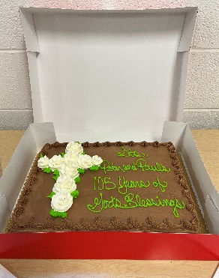
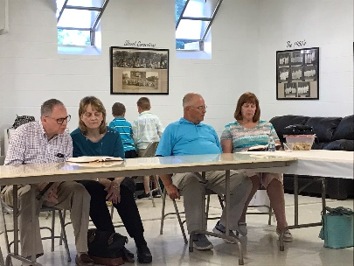
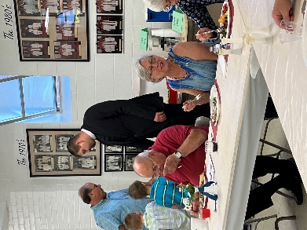
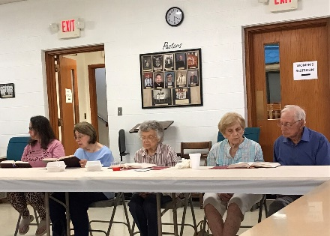
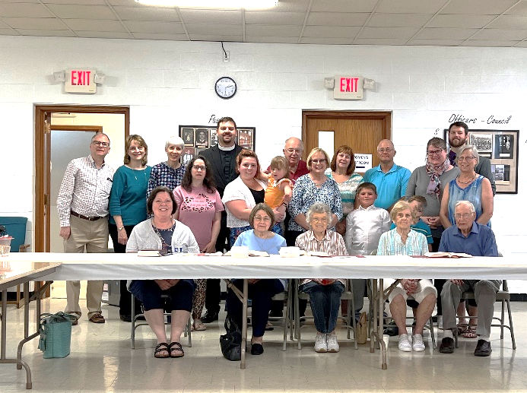
Community Day 2022 Postponed until September
After prayerful consideration, the Community Day organizers have made the difficult decision to postpone Community Day 2022 until September. Although everything had been lining up nicely (funding, food, entertainment), what was most lacking were volunteers to help out.
In addition to the arduous tasks of setting-up and cleaning-up, a minimum of 10 volunteers are needed to run the event itself (food prep and serving, running children’s games, registering guests, leading crafts, etc.). As of late, we only had commitments for half that many people.
So, it’s back to the drawing board. We will soon select another date in September and then reach out to congregation members to see if we can get people to commit to helping out. This event has become something our neighbors associate with us and has had positive feedback in the past.
It can’t be done without you…
llllllllllllllllllllllllllll
Bible Studies
The Sunday morning Bible Study class completed its study of Revelation 1-12 before deciding to take a break for the summer months.
If you have not taken part in this Bible Study, but would like the materials in order to get caught up before next fall, please speak with Pastor Deal.
The Women’s Monthly Bible Study will continue this month meeting Saturday, July 23 at 11 am.
The Men’s Monthly Bible Study will also meet that day at 4 pm.
BIBLE MEMORY VERSES FROM JUNE
FOR ADULTS
June 5: For this light momentary affliction is preparing for us an eternal weight of glory beyond all comparison, as we look not to the things that are seen but to the things that are unseen. For the things that are seen are transient, but the things that are unseen are eternal. 2 Corinthians 4:17-18
June 12: All authority in heaven and on earth has been given to me. Go therefore and make disciples of all nations, baptizing them in the name of the Father and of the Son and of the Holy Spirit. Matthew 28:18b-19

June 19: The Lord is good to those who wait for him, to the soul who seeks him. It is good that one should wait quietly for the salvation of the Lord. Lamentations 3:25-26

June 26: Whoever believes and is baptized will be saved, but whoever does not believe will be condemned. Mark 16:16

FOR CHILDREN
June 5: Not by might, nor by power, but by my Spirit, says the Lord of hosts. Zechariah 4:6

June 12: Holy, holy, holy is the Lord of hosts; the whole earth is full of his glory!
Isaiah 6:3

June 19: The one who hears you hears me, and the one who rejects you rejects me, and the one who rejects me rejects him who sent me. Luke 10:16

June 26: Come to me, all who labor and are heavy laden, and I will give you rest.
Matthew 11:28
llllllllllllllllllllllllllll
ATTENTION AUDITORS! The Second Quarter audit and the July monthly audit of deposits will take place following worship, Sunday, July 17th in the library. If unable to attend, please phone Bev Chlpka at 724-962-4806.
Remember the
following in Prayer…
~The Hurting and Healing: Gerald Arthur, Ellen Baron^{CA}, Lois Bortner^{CA}, Richard Brandes, John Burdette, Bev & Joe Chlpka, Kathleen Coughenour, Kim, Susan Davies, Tim Dudash, Joseph Fleet, Eddy Furey, Dale Hesse^{CA}, Neil Huston, Barbara Kreske, Michelle Kelly^{CA}, Donna Kennedy, Gerald Krivosh, Jess Lavoie, Paul Lucas^{CA}, Sandy Marshall, Ernie Meszaros, David Nelson, Juanita Rentschler, Richard Reuning^{CA}, Nancy Robertson^{CA}, Viola Sakony, Marty Scott, Fred Tonty, and Angela Weser^{CA}.
~The Homebound: Rudy & Jean Tomko, Betty Wolf, and Ed & Millie Zachar.
~Celebrating: Birthdays Rudy Tomko (06.19) and Sue Bender (06.20).
~Serving in the Military: Curtis Sinewe and Joshua Solyan.
~Community & World Needs: Those suffering from or affected by the coronavirus; those suffering due to the conflict between Ukraine and Russia; those suffering from loss and dislocation because weather disasters; those suffering from addiction and their families; Local, State, and National Government Leaders; safety for all Police Officers, Firefighters, & First Responders; the unemployed; our Third Quarter Local Mission: Support of a Missionary. *CA represents cancer.
llllllllllllllllllllllllllll
REMINDER: If you would like someone’s name to be added to or deleted from our prayer list, please put a written note in the secretary’s mail slot by the office door.
llllllllllllllllllllllllllll
Mission Outreach Project…
International Christian Literature Distributors, Inc. focuses on getting the Bible and study materials to learn the Bible into the hands of Christian leaders in the least-fortunate places of the world. They supply churches and schools of Bible learning throughout the English-speaking world. Copies of old Portals of Prayer are greatly appreciated (Please note that weekly service bulletins and Advent / Lenten devotions are not accepted). For more information about ICLD, check out their website: www.icld.org. Please recycle items by dropping them in the basket in the hallway by the offices. Thank you!
llllllllllllllllllllllllllll
Our Third Quarter Local Mission is
Support of a Missionary.
If you have any specific Missionary you would like to see us direct our funds to, please contact Council President Jonathan Baisch by Friday, July 14th.
Suggestions will be presented to Church Council and a recommendation will be made at the next Voters’ Assembly, Sunday, August 14th.
llllllllllllllllllllllllllll
If you do not have an email account or do not receive emails from the church but wish to be notified of significant information concerning your fellow church members (such as births or deaths), please put a note in the Secretary’s mail slot asking to receive a phone call. Every attempt will be made to phone you within 24 hours of an email being sent out.
llllllllllllllllllllllllllll
MARK YOUR CALENDARS!
- Tues., July 12th at 7 pm: Constitution & Bylaws Committee meeting
- Sun., July 17th following worship: Auditors’ meeting
- Fri., July 22nd at 6 pm: Festival of Mary Magdalene, Vespers Service
- Monday, July 25 at 7 pm, Church Council meeting.
llllllllllllllllllllllllllll
Pastor Deal will be attending a conference July 25-28th in Wisconsin. Please contact Elder Chairman Barry Nelson (724-866-7417) if in need of pastoral care during this time.
llllllllllllllllllllllllllll
2022 OFFICERS, BOARDS,
and CHURCH WORKERS
- President: Jonathan Baisch
- Vice President: Matt Berent
- Secretary: Diane Riefstahl
- Treasurer: Rebekah Baisch
- Financial Secretary: Dolores Fee
Trustees: Cheryl Fedele, Mike Flaugher, Anson Holcroft, Henrietta (Hank) Holcroft, Michael Laird, Jesse Riffle

Auditors: Bev Chlpka, Marie Flaugher, Elizabeth Haenftling, Kati Laird, Jerome Thomas

Financial Staff: Rev. Art Baisch, Susan Bender, Joani Rice, Nancy Robertson

Custodians: Ana Deal and Cheryl Fedele

Organists: Catherine Carr and Chris Nelson

Church Secretary: Diane Riefstahl
llllllllllllllllllllllllllll
CAPITAL CAMPAIGN STAGES
(In Completion Order)

Project: Roof & Fascia
Watertight Roofing Systems
DONE
(50 yr single / 10 yr labor)
Cost: $64,500.00
Completion: Immediate
Project: Gutters
Watertight Roofing Systems
DONE
Cost: $7,950.00
Completion: Immediate
Project: Drainage Repair
Contractor to be determined
Anticipated Cost: $20,000.00
DONE
Completion: Immediate
Project: Mold Mitigation in Old Church Attic
Contractor to be determined
$10,000.00
Completion: Immediate
Project: Masonry Work
Contractor to be determined
Description: Repointing of chancel end of church, narthex end of church, north wall windows (right of entrance)
Estimated cost: $40,414.00
Completion: When campaign reaches $75,000.00 goal
Project: Replacement of Narthex Doors
(Note: The cost of this project was underestimated. As a result, it has been recommended that the “worst” door on the building, which is the exterior door to the food pantry, should be replaced at this point. Replacement of Narthex Doors will have to be a special project or an “add on” to the Capital Campaign at a later time.)
Estimated cost: $3,500.00
Completion: When campaign reaches $95,000.00 goal
Nave Renovations
Project: Plaster repair / coverings in Chancel and other locations
Estimated cost: $3,000.00
Completion: When campaign reaches $105,000.00 goal
Project: Flooring
Estimated cost: $8,000.00
Completion: When campaign reaches $145,000.00 goal
Project: Air Conditioning
Estimated cost: $25,000.00
Completion: When campaign reaches $165,000.00 goal
Project: Window Replacement
Anticipated contractor: Pella
Estimated cost: $68,500.00
Completion: When campaign reaches $200,000.00 goal

After one year into our Capital Campaign, significant improvements have been made thanks to all of you!

