Sts. Peter & Paul Evangelical Lutheran Church LC-MS
Monthly Newsletter --- July 2021
699 Stambaugh Avenue, Sharon, PA 16146
Phone: 724.347.3620 (Opt. 2, Pastor Deal; Opt. 3, Office)
E-mail: church@saintspeterandpaul.net www.saintspeterandpaul.net

“THE ROCK and THE SWORD”
“Built upon the Rock of Christ and wielding the
Sword of the Spirit, the Word of God.”

From the Pastor:
Stewardship Under the Cross: Why should I Tithe?
A Bible Study on Money Offerings
We do not make God poor when we fail to give money to Him properly, but we do make ourselves poor spiritually (and not in the good way) if we do not give according to what He has spoken in His Word, the Bible. To be clear, God does not need our money. Recap: Why do we give? We give the way the Bible tells us in order to overcome the negative influence the love of money and the things of this world can have on us. We give the way the Bible tells us as a response to knowing God will care for us no matter what.
Jesus said, “No one can serve two masters. For you will hate one and love the other, or be devoted to one and despise the other. You cannot serve both God and money.” Matthew 6:24
Money itself isn’t the “root of all evil.” It is the desire/love of money. There are some teachings of the Bible which are more difficult than others for us to swallow. Whenever pastors speak about money, people become tense. I suppose for many the teachings about money, possessions, and offerings are among the most difficult. But God’s instructions are for our good, not for our harm. If we follow His instructions, we will be free and content. Jesus said in John 8:36 “If the Son sets you free, you will indeed be free.” We also read in 1 Timothy 6:6 that “...godliness with contentment is great wealth.” That is God’s desire for His people: freedom, godliness, and contentment even in matters of money and wealth. That is also the desire of this church for its members. That is why this short Bible study is presented to you for your devotions. Please pray for the Lord to make you open to His message, then go through the study. If you live in a family setting, it would probably be good for you to do this together.
- To whom does my money belong?
  - Haggai 2:8 'The silver is mine, and the gold is mine,’ says the Lord Almighty.
- 1 Chronicles 29:14 King David said to God, “But who am I, and who are my people, that we could give anything to you? Everything we have has come from you, and we give you only what you have already given us!”

So, everything I have really belongs to God. I am merely His manager of those things.

- What 5 requirements does God make of every Christian regarding money offerings?
  - 2 Corinthians 9:7 “You must each make up your own mind as to how much you should give. Don’t give reluctantly or in response to pressure. For God loves the person who gives cheerfully.”

So, the Lord wants me to make my money offerings willingly.

- Proverbs 3:9-10 “Honor the Lord with your wealth and with the first part of everything your land produces. Then he will fill your barns with grain, and your vats will overflow with the finest wine.”

The Lord wants me to make my money offerings to Him first. Sometimes you hear this as an offering of your first fruits. He is not pleased when I give Him my leftovers.

- 1 Corinthians 16:2 “On the first day of every week, each of you should put aside some amount of money in relation to what you have earned and save it for this offering. Don’t wait until I get there and then try to collect it all at once.”

This tells me that the Lord wants me to make my money offerings to Him regularly, that is, whenever I have income, whether I am able to go to church that week or not.

- 1 Corinthians 16:2 “On every Lord’s Day, each of you should put aside some amount of money in relation to what you have earned and save it for this offering. Don’t wait until I get there and then try to collect it all at once.”
- Deuteronomy 16:17 “Each of you must bring a gift in proportion to the way the LORD your God has blessed you.”
- Luke 12:48 “Much is required from those to whom much is given, and much more is required from those to whom much more is given.”

The Lord tells me that it is not the amount itself that is important. What is important is that I make my money offerings proportionately. In other words, I should give a generous percentage of the income the Lord enables me to earn through my work and investments.

- 2 Corinthians 8:1-4 “Now I want to tell you, dear brothers and sisters, what God in his kindness has done for the churches in Macedonia. Though they have been going through much trouble and hard times, their wonderful joy and deep poverty have overflowed in rich generosity. For I can testify that they gave not only what they could afford but far more. And they did it of their own free will. They begged us again and again for the gracious privilege of sharing in the gift for the Christians in Jerusalem.”
- Luke 7:47 Jesus said, “I tell you, her sins—and they are many— have been forgiven, so she has shown me much love. But a person who is forgiven little shows only little love.”

So, my money offerings to the Lord should also be made generously.

Here’s the list of Biblical principles when it comes to making money offerings:
1. Willingly
2. First Fruits
3. Regularly (whenever I have income)
4. Proportionately (percentage)
5. Generously (Start where you can and set goals to work towards where you are faithfully giving 10% or more)

- What if I serve the Lord faithfully, even exceptionally, in other areas? Does that mean I don’t need to follow these directions about money offerings?
  - 2 Corinthians 8:7 “Since you excel in so many ways—you have so much faith, such gifted speakers, such knowledge, such enthusiasm, and such love for us—now I want you to excel also in this gracious ministry of giving.”
- Matthew 23:23 Jesus once compared offerings with “the important things of the law—justice, mercy, and faith.” And he said, “You should tithe, yes, but you should not leave undone the more important things.”

So, no matter how well or faithfully I may serve in some areas, the Lord expects me to follow His directions regarding money offerings, also, and even to excel in this area.

- What exactly is “tithing” and what does God say about it?
- “To tithe” literally means “to give 10%.” The command about tithing was part of the Old Testament laws for the nation of Israel. So, what God said in the Law is no longer a requirement, although the principle remains. (The principle in the Bible is that offerings begin at 10%.) But the Lord’s promises never change. And consider this promise about tithing:
- Malachi 3:10-11 “‘Bring all the tithes into the storehouse so there will be enough food in my Temple. If you do,’ says the Lord Almighty, ‘I will open the windows of heaven for you. I will pour out a blessing so great you won’t have enough room to take it in! Try it! Let me prove it to you! Your crops will be abundant, for I will guard them from insects and disease. Your grapes will not shrivel before they are ripe,’ says the Lord Almighty.”

- Is it true that some people have tried tithing and it didn’t work for them?
- If that’s true, then God’s Word is not true. We should remember that the Bible does not say that tithing can be done without sacrifice. But God does say that the blessings will far outweigh any hardship if the tithing is done consistently and from the heart.

- Is getting a blessing from God my motivation for tithing?
  - No, the motivation is His amazing love for me. Consider these three Scriptures:
- Galatians 2:20 “I myself no longer live, but Christ lives in me. So I live my life in this earthly body by trusting in the Son of God, who loved me and gave himself for me.”
- 2 Corinthians 8:9 “You know how full of love and kindness our Lord Jesus Christ was. Though he was very rich, yet for your sakes he became poor, so that by his poverty he could make you rich.”
- 2 Corinthians 5:15 “He died for everyone so that those who receive his new life will no longer live to please themselves. Instead, they will live to please Christ, who died and was raised for them.”

- Please prayerfully consider the following statements. If you live in a family setting, please talk and pray about them together. Reach out and ask me questions about this Bible Study, if you have them. Also, don’t be afraid to share this with your children.
- The Lord has blessed us with all we need for this body and life.
- Have we been making first-fruit, regular, proportionate and generous (at least 10% tithe) money offerings to the Lord from the heart?
- If so, what other needs in our church and community can use our attention?
- If not – what steps can we take to move in a faithful direction?

Your servant in Christ,
Pastor Jacob Deal
llllllllllllllllllllllllllll
REMINDER: Please let the church office know of any changes to your address, phone, cell phone or your e-mail address!
llllllllllllllllllllllllllll
Thank You for Serving in July:
Head Elder: Jonathan Baisch
Assisting Elder: Barry Nelson
Altarware: (Before service) Marie Flaugher & Diane Riefstahl; (After service) Anne Colt & Traudi Sulek
Finance Committee: Catherine Carr & Nancy Robertson
llllllllllllllllllllllllllll
TRUSTEES’ UPDATE
Roof replacement with new gutters and fascia is scheduled for June 28th. This should take about a week, weather permitting.
Did you know? A running toilet can consume about 6000 gallons of water per day! The reason to know is our June water bill noted very high usage in May: 6700 gallons of water! This equates to an average daily usage of 216 gallons.
The church typically consumes about an average of 18 to 27 gallons per day or about 675 gallons per month. It seems we had a “runaway toilet” which has been since been fixed short term, but might need to be replaced. Water usage is currently being monitored. For the week of June 14th, we have used 92 gallons.
Trustees will next meet 7/06/2021 at 7 pm.
llllllllllllllllllllllllllll
LIKE & FOLLOW our Church’s Facebook page (Saints Peter and Paul Evangelical Lutheran Church)!
Remember to like, comment, and share to help us reach as many people as possible.
llllllllllllllllllllllllllll
STS. PETER & PAUL’S
FOOD PANTRY
Our food pantry distributes goods to pre-registered clients the second and fourth Thursdays of each month beginning at 9 am.
We currently have a low number of clients and a substantial cash balance. If you should know of someone who might qualify for assistance, please contact Barry Nelson.
As a result of our cash balance, we are not seeking additional funds at this time.

‘Truly, I say to you, as you did it to one of the least of these my brothers, you did it to me.’ Matthew 25:40
SUMMER TIME REMINDERS Sunday Bible Study is on hiatus until September. All are welcome to join our on-going 10-week Summer Bible Study focusing on biblical parables. This Bible Study is held Thursdays at 5 pm and will run through the first Thursday in August.
A service of Evening Prayer follows beginning at 6 pm with the exception this month of July 22nd on which we will celebrate the Festival of St. Mary Magdalene with a Divine Service.
Regular Sunday Divine Service begins at 9 am through the end of August.
llllllllllllllllllllllllllll
CELEBRATING IN JULY!
Birthdays
Paul M. Petro 7- 2
Jesse Riffle 7- 4
April Bosnjak 7- 8
Betty Wolf 7- 8
Morgan Psznick 7-12
Elizabeth Haenftling 7-15
Clara Krivosh 7-16
Robert Sulek 7-16
Casonddra Thomas 7-20
Suellen Burns 7-26
Selena Thomas 7-30
Anne Colt 7-31

Anniversaries
Paul M. & Joyce Petro 7- 2
Barry & Chris Nelson 7- 6
Edward & Anne Colt 7-19
Mark & Janelle Gabriel 7-19
Carl & Maria Marks 7-26
Jerome & June Thomas 7-28

*If birthdays or anniversaries have been omitted, please let the church office know. Thank You!
llllllllllllllllllllllllllll

ATTENTION AUDITORS!
The next audit of deposits will be following worship Sunday, July 11th.
Additionally, there is a quarterly audit scheduled following worship Sunday, July 18th.
If unable to attend, please phone Bev Chlpka at 724-962-4806.
llllllllllllllllllllllllllll
We were chosen! By directing designated Choice Dollars through Thrivent Choice, eligible Thrivent members choose where Thrivent Financial for Lutherans distributes some of its charitable outreach grant dollars among thousands of participating Lutheran nonprofit organizations and congregations.
Many thanks to Thrivent Financial members Lisa Jelinek and Max Jelinek who recently directed Choice dollars to our church!
llllllllllllllllllllllllllll
Homebound Member & Friend
Please keep the following in your prayers:
Marion Roberts
287 East 2nd St. Apt. #103
Hummelstown, PA 17036
724-893-4570
llllllllllllllllllllllllllll
ATTENTION FINANCE COMMITTEE:
The meeting originally scheduled for July 14th will now take place Tues., July 13th at 6 pm in the Fellowship Hall.
llllllllllllllllllllllllllll
SCRIP Program:
The next date for SCRIP orders and payments is Sunday, July 4th. Checks should be made out to Sts. Peter & Paul’s and are to be given to Matt Berent or placed in the offering plate. You should receive your gift cards the following week.
FROM YOUR ALTAR GUILD:
The next meeting of the Altar Guild is scheduled for Sunday, September 19th following worship.

-Marie Flaugher

CROSSES of The Lutheran Church This month, we will take a closer look at the Chi-Rho Cross. Chi-Rho is the oldest known monogram (or letter symbol) for Christ. Some call this symbol the "Christogram," and it dates back to the Roman Emperor Constantine (A.D. 306–337).
Although the truth of this story is questionable, it is said that Constantine saw this symbol in the sky before a decisive battle, and he heard the message, "By this sign, conquer." Thus, he adopted the symbol for his army.
Chi (x = ch) and Rho (p = r) are the first three letters of "Christ" or "Christos" (Χριστος) in the Greek language. Though there are many variations of the Chi-Rho, most commonly it consists of the overlaying of the two letters and often is surrounded by a circle.
Altar Guild News
At its recent meeting, Altar Guild members agreed to hold a work day to address some basic cleaning projects. Tentatively scheduled for Friday, August 19th, members plan to tidy the paraments room, address Pastor’s vestments, have a general walk-through of the sanctuary, and clean drawers and cupboards in the kitchen.
In May, a second new Holy Communion veil was dedicated. This veil, bearing a Jerusalem cross, will be used for Pentecost Sunday and on feast days. Other work on paraments and linens will continue as Marie and Judith are able.
A second, artificial summer flower arrangement has been made and is in use at this time.
llllllllllllllllllllllllllll
BIBLE MEMORY VERSES FROM JUNE
For Adults:
June 6: The Lord is good to those who wait for him, to the soul who seeks him. It is good that one should wait quietly for the salvation of the Lord. Lamentations 3:25-26
June 13: Whoever believes and is baptized will be saved, but whoever does not believe will be condemned. Mark 16:16
June 20: Behold, I am with you always, to the end of the age. Matthew 28:20
June 27: God shows his love for us in that while we were still sinners, Christ died for us.
John 5:8
For Children:
June 6: The one who hears you hears me, and the one who rejects you rejects me, and the one who rejects me rejects him who sent me. Luke 10:16
June 13: Come to me, all who labor and are heavy laden, and I will give you rest.
Matthew 11:28
June 20: The Son of Man came to seek and to save the lost. Luke 19:10
June 27: Bear one another's burdens, and so fulfill the law of Christ. Galatians 6:2
llllllllllllllllllllllllllll
Join us in July for the following special 6 pm Divine Service:

Thursday, July 22nd
Festival of St. Mary Magdalene

July 17th is almost here!
Join us for
Community Day 2021!
Tentative Schedule:
Noon – 1:30 pm
Movie: “Madagascar” shown in the Fellowship Hall
1:30 – 4 pm
General registration and raffle baskets
1:30 pm and 3 pm
Puppet show in the Fellowship Hall
1:45 – 2 pm
Children’s outdoor water games
2 pm
Bingo for adults in the Fellowship Hall
2:15 – 3 pm
Outdoor games for children
3:15 – 4 pm
Children’s crafts in the Fellowship Hall
4 – 5 pm
Performance by Diane Drapcho, children’s musician
5-6:30 pm
Food served / music in the parking lot
6:30 pm
Winners of raffle baskets announced
Event wrap-up
We are very grateful to those who have volunteered to help with this year’s event! Please remember to bring items in for raffle baskets, prizes, food, etc. by Sunday, July 11th if at all possible. Food and beverages should be labeled “Community Day” and placed in the kitchen. Raffle baskets may be put in the library, and prizes given to Diane Riefstahl.
Hope to see you July 17th!
Remember the
following in Prayer…
~The Hurting and Healing: Ellen Baron^{CA}, Lois Bortner^{CA}, Jeff & Stacy Brandes, Richard Brandes, John Burdette, Kim, Susan Davies, Tim Dudash, Dolores Fee, Joseph Fleet, Judith Furey, Marie Haenftling, Neale & Melissa Huston, Michelle Kelly^{CA}, Donna Kennedy, Robert & Joyce Kickbusch, Jess Lavoie, Paul Lucas^{CA}, Sandy Marshall, Ernie Meszaros, Mike Moats, Rhonda Moats, David Nelson, Juanita Rentschler, Richard Reuning^{CA}, Marty Scott, Angela Weser^{CA}, Betty Wolf, and Millie Zachar.
~The Homebound: Marion Roberts
~Serving in the Military: Curtis Sinewe and Joshua Solyan.
~Community & World Needs: Those suffering from or affected by the coronavirus; those suffering from loss and dislocation because weather disasters; those suffering from addiction and their families; Local, State, and National Government Leaders; safety for all Police Officers, Firefighters, & First Responders; the unemployed; our Second Quarter Local Mission: Sts. Peter & Paul’s Community Day
2021.
*CA represents cancer
llllllllllllllllllllllllllll
.REMINDER: If you would like someone’s name to be added to or deleted from our prayer list, please put a written note in the secretary’s mail slot by the office door.
llllllllllllllllllllllllllll
A note from Pastor Deal: Please let me know if you or a loved one are in the hospital or have a special need. Also, please ask the hospital or family members to phone me or the church office as I wish to visit those who may be hurting.
2021 THRIVENT POP
TAB CHALLENGE!
Sincere thanks go out to all those who have been collecting and bringing in pop tabs for the 2021 Thrivent Pop Tab Challenge! Collected tabs may be placed in the containers found in the narthex or main hallway. They may also be given to the church secretary.
This project benefits the Ronald McDonald House.
If you have any questions, feel free to contact Marie Flaugher at 724-301-8278.
llllllllllllllllllllllllllll
Submissions for the August issue of “The Rock and the Sword” newsletter are due to the secretary’s office Monday, July 19th at noon. This includes meeting dates and times for the church calendar.
llllllllllllllllllllllllllll
If you do not have an email account or do not receive emails from the church but wish to be notified of significant information concerning your fellow church members (such as births or deaths), please put a note in the Secretary’s mail slot asking to receive a phone call. Every attempt will be made to phone you within 24 hours of an email being sent out.
llllllllllllllllllllllllllll
Word of Hope: 1-888-217-8679
The only 24/7 CONFIDENTIAL Hotline that is distinctly Lutheran, bringing healing found in Christ, to those whose hearts have been broken by abortion.
llllllllllllllllllllllllllll
To listen to Pastor Deal’s sermons, phone 724-347-3620 and press Option 6.

The following note of thanks was received recently in response to our donation to the Lutheran Haven in Oviedo, Florida
Good morning,
We at the Haven just received a wonderful gift of $90 from your church and I wanted to thank you! There was no indication where you would like for your sweet gift to be used so I wanted to reach out to you to make sure we will honor your generosity in the way you wish. We have different ways your kindness can be used:
- Our Benevolent Care Fund which assists our residents who have simply outlived their assets.
- Our “Water Works Wonders” Campaign which is to construct a therapy/swimming pool which will benefit our residents in so many ways who need strengthening and therapeutic rehabilitation and exercise, etc.
- Our Unrestricted Fund which is utilized where the needs are greatest and is up to the discretion of our CEO and Board of Trustees.
Thank you so very, very much again! Your kindness makes a difference every single day at the Haven. Please let me know how you would like your wonderful gift to be used and please convey our deepest appreciation to your congregation.

Many blessings and thanks,
Mary Ann

Mary Ann McCunn
Development Associate
Lutheran Haven Foundation
2041 West State Road 426
Oviedo, FL 32765
mmccunn@lutheranhaven.org
Note: Money was directed to their Unrestricted Fund
CAPITAL CAMPAIGN STAGES
(In Completion Order)
Project: Roof & Fascia
Watertight Roofing Systems
(50 yr single / 10 yr labor)
Cost: $64,500.00
Completion: Immediate
Project: Gutters
Watertight Roofing Systems
Cost: $7,950.00
Completion: Immediate
Project: Drainage Repair
Contractor to be determined
Anticipated Cost: $20,000.00
Completion: Immediate
Project: Mold Mitigation in Old Church Attic
Contractor to be determined
$10,000.00
Completion: Immediate
Project: Masonry Work
Contractor to be determined
Description: Repointing of chancel end of church, narthex end of church, north wall windows (right of entrance)
Estimated cost: $40,414.00
Completion: When campaign reaches $75,000.00 goal
Project: Replacement of Narthex Doors
Estimated cost: $3,500.00
Completion: When campaign reaches $95,000.00 goal
Nave Renovations
Project: Plaster repair / coverings in Chancel and other locations
Estimated cost: $3,000.00
Completion: When campaign reaches $105,000.00 goal

Project: Flooring
Estimated cost: $8,000.00
Completion: When campaign reaches $145,000.00 goal
Project: Air Conditioning
Estimated cost: $25,000.00
Completion: When campaign reaches $165,000.00 goal
Project: Window Replacement
Anticipated contractor: Pella
Estimated cost: $68,500.00
Completion: When campaign reaches $200,000.00 goal
llllllllllllllllllllllllllll
FOR YOUR PRAYERFUL CONSIDERATION…
Sunday, July 25th is being designated as “Giving Sunday”. Pastor Deal and the church leadership have been working hard to educate members as to the reasons for a Capital Campaign, how monies would be spent, and how individuals/families can help.
As the month of July proceeds, further information will be forth-coming.
Please, prayerfully consider how you can contribute to our Capital Campaign in order to insure its success.
llllllllllllllllllllllllllll
Sincere thanks are extended to the church leadership, Trustees, Financial Committee, and Pastor Deal for all their hard work in developing these Capital Campaign projects and goals. Countless hours have been spent meeting with contractors, securing quotes, and agonizing over details.
To all those who have worked so hard, “thank you”.
llllllllllllllllllllllllllll
Shenango Valley Meals on Wheels has been selected as our Third Quarter Local Mission. Donations may be placed in a pew envelope labeled with your name and envelope number. Be sure to indicate “Local Mission” on the envelope.
The following information is taken from their website and offers a glimpse of just what they do in our area.
Do you or a loved one have difficulty preparing meals? Are you or a loved one disabled and unable to shop? If so, Shenango Valley Meals on Wheels can help.
Shenango Valley Meals on Wheels, in its 50th year of service, prepares and delivers fresh, nutritious, hot homemade meals daily for anyone of any age and any income level. A cold lunch also is available. There are no restrictions on who may receive meals. New clients are accepted daily.
The homemade hot meal consists of meat or fish; potato, rice, or pasta; vegetable; and homemade soup. The cold lunch includes a sandwich, a vegetable or fruit salad or whole fruit, milk, juice, and dessert.
Meals are prepared by a certified chef, and clients can request special diets such as diabetic, low/no salt, low/no fat, low cholesterol, gluten free, lactose free, soft, low residue, and renal. We also consider our clients’ personal likes and dislikes of certain foods.
While meals can be ordered for any number of days per week, deliveries are made every Monday through Friday between 11:00 and Noon, including all holidays that fall on those days such as Thanksgiving Day and Christmas. Weekend meals can be ordered for delivery on Friday.
Service is provided throughout a ten mile radius of the kitchen in Sharon including Sharon, Farrell, Hermitage, Sharpsville, Wheatland, Shenango Township, West Middlesex, Charleston, South Pymatuning Township, Transfer, Reynolds, Masury, Brookfield, and the new outreach outside of the Shenango Valley-the city of Greenville.
Meals on Wheels is a stand-alone, non-profit (501c3) organization and does not receive any federal, state, or local government funding. The program depends entirely on client payments for the meals and on donations.
Call 724-342-2042 or email mealsonwheels396@verizon.net for additional information on the meals and volunteer opportunities.
llllllllllllllllllllllllllll
Please help us RECYCLE! A bin has been placed next to the parking lot doors for used bulletins. Please help us keep our sanctuary neat by either taking home your service bulletins or disposing of them here.
Additionally, there is a basket by the secretary’s office for donations of already-read Christian materials. They will be sorted and donated to ICLD periodically.
llllllllllllllllllllllllllll
If entering the church during the week, please let office staff know that you are in the building. Also, please make certain to turn off lights, lock doors, etc. upon leaving.
llllllllllllllllllllllllllll
There are many Sundays available to purchase or provide Flowers for the Altar. Check out the sign-up sheet in the narthex.
llllllllllllllllllllllllllll
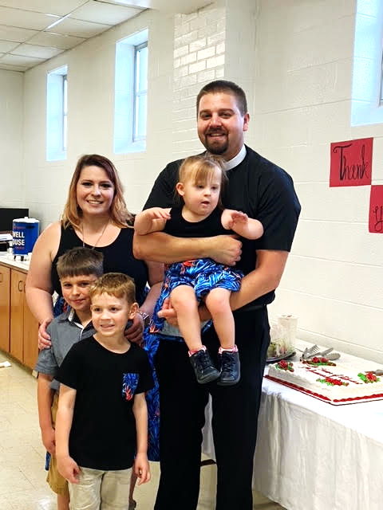
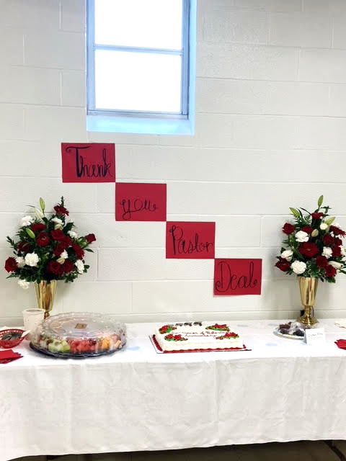
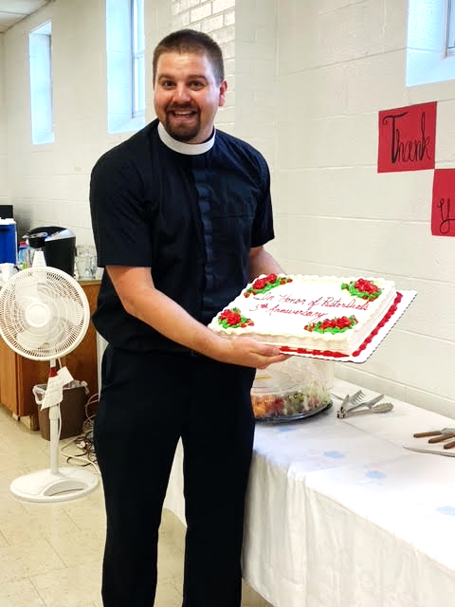
On Sunday, June 20th, we had the opportunity to celebrate the 5th Anniversary of Pastor Deal’s Ordination and Installation as our Pastor.
Sincere thanks are extended to all who planned or participated in this event.

