Sts. Peter & Paul
Evangelical Lutheran Church
Lutheran Church-Missouri Synod
Founded-1917

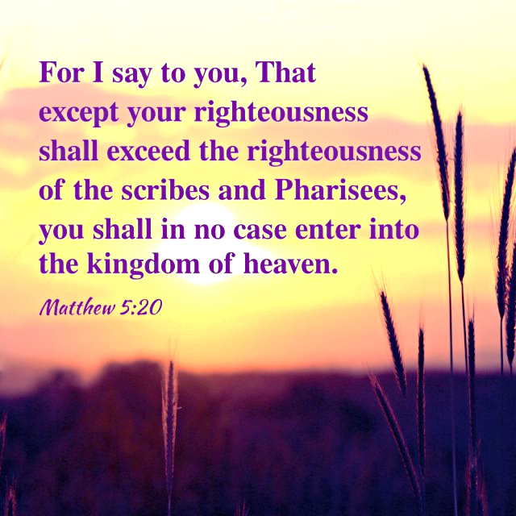

July 16, 2023

699 Stambaugh Ave.
Sharon, Pennsylvania 16146

“I was glad when they said to me,
Let us go to the house of the LORD!”
Psalm 122:1
Sts. Peter & Paul Evangelical Lutheran Church, LC-MS
THE SIXTH SUNDAY AFTER TRINITY
July 16, 2023
A special welcome to our guests this day! If you would like more information about The Lutheran Church - Missouri Synod, or this congregation, please speak with Pastor Deal or an Elder after the service.
Members & Guests: Don’t be embarrassed if your children make noise during the worship service, all children do. We encourage families to worship together but, if you feel the need, there are pews in the rear of the Church which are reserved for young families on both sides of the sanctuary. There is also a quiet room available to you, located next to the sanctuary (formerly the Pastor’s office), where you would be able to follow along with the service.

Today’s service includes the Sacrament of Holy Communion. If during this past year, you have not worshipped with us and been communed, we respectfully ask that you do not partake of this sacrament this day before first speaking with Pastor Deal.
If visiting from a sister congregation of the LC-MS and are in good standing, please inform Pastor Deal of your desire to commune prior to the service.
If wishing to receive a blessing during communion, please approach with your arms crossed.

CONTACT INFORMATION
Pastor Deal: pastordeal@saintspeterandpaul.net or 724-347-3620 (opt. 2)
Church Office: church@saintspeterandpaul.net or 724-347-3620 (opt. 3)
Secretary’s Office will be open Monday (8:30-5) and Thursday (8:30-10; 11-5) this week.

Silent prayer before worship: Dear Lord, through Your Word the Holy Spirit enables me to believe. By Your grace, lead me to trust You not only for eternal life, but to strengthen me and lead me through each day. In Jesus’ name. Amen.

Confession and Absolution

Opening Hymn: LSB #918 “Guide Me, O Thou Great Redeemer”

Stand

The sign of the cross may be made by all in remembrance of their Baptism.

Invocation
P In the name of the Father and of the T Son and of the Holy Spirit.
C Amen.

Exhortation Hebrews 10:22; Psalm 124:8; Psalm 32:5
P Beloved in the Lord! Let us draw near with a true heart and confess our sins unto God our Father, beseeching Him in the name of our Lord Jesus Christ to grant us forgiveness.

P Our help is in the name of the Lord,
C who made heaven and earth.
P I said, I will confess my transgressions unto the Lord,
C and You forgave the iniquity of my sin.

Silence for reflection on God’s Word and for self-examination.

Confession of Sins
P O almighty God, merciful Father,
C I, a poor, miserable sinner, confess unto You all my sins and iniquities with which I have ever offended You and justly deserved Your temporal and eternal punishment. But I am heartily sorry for them and sincerely repent of them, and I pray You of Your boundless mercy and for the sake of the holy, innocent, bitter sufferings and death of Your beloved Son, Jesus Christ, to be gracious and merciful to me, a poor, sinful being.

Absolution [John 20:19–23]
P Upon this your confession, I, by virtue of my office, as a called and ordained servant of the Word, announce the grace of God unto all of you, and in the stead and by the command of my Lord Jesus Christ I forgive you all your sins in the name of the Father and of the T Son and of the Holy Spirit.
C Amen.

Service of the Word

Introit Psalm 28:1–2, 7; antiphon: vv. 8–9
The Lord is the strength of his | people;*
he is the saving refuge of his a- | nointed.
Save your people and bless your | heritage!*
Be their shepherd and carry them for- | ever.
To you, O Lord, I call; my rock, be not | deaf to me,*
lest, if you be silent to me, I become like those who go down | to the pit.
Hear the voice of my pleas for mercy, when I cry to | you for help,*
when I lift up my hands toward your most holy sanctu- | ary.
The Lord is my strength and my shield; in him my heart trusts, and | I am helped;*
my heart exults, and with my song I give | thanks to him.
The Lord is the strength of his | people;*
he is the saving refuge of his a- | nointed.
Save your people and bless your | heritage!*
Be their shepherd and carry them for- | ever.

Gloria Patri
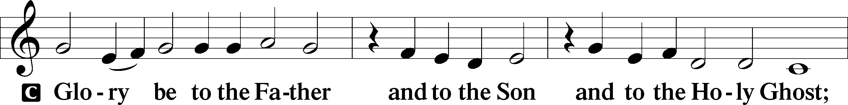
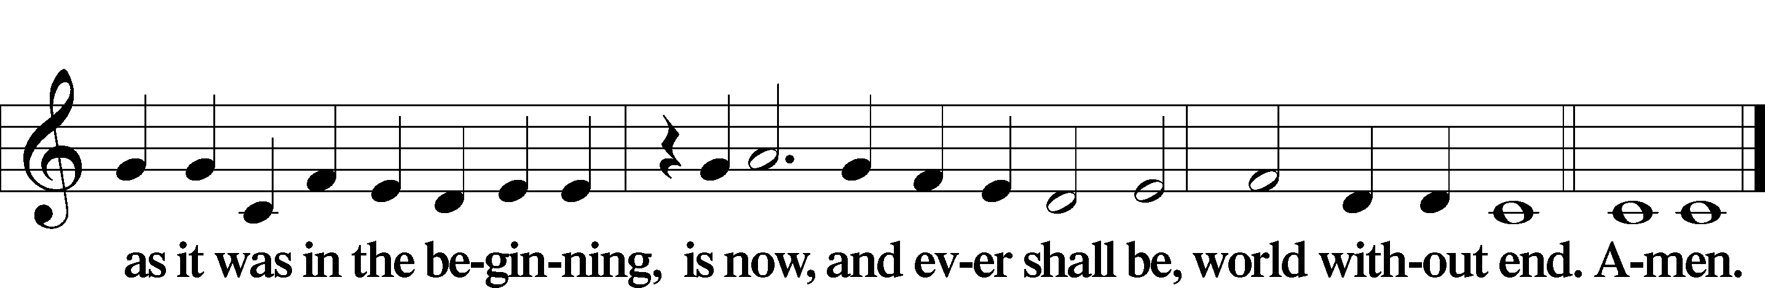

Kyrie Mark 10:47
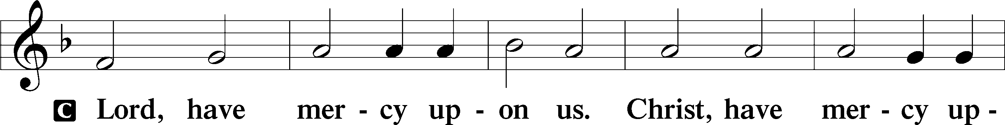
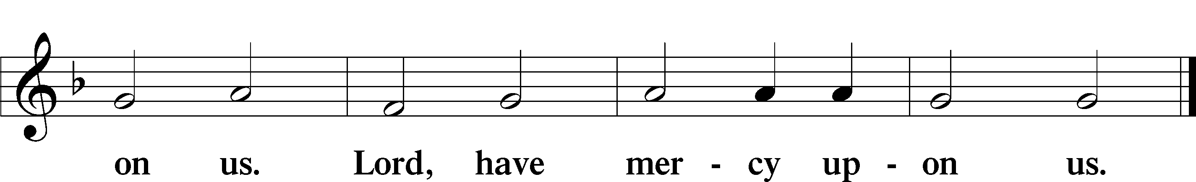

Gloria in Excelsis Luke 2:14; John 1:29
P Glory be to God on high:
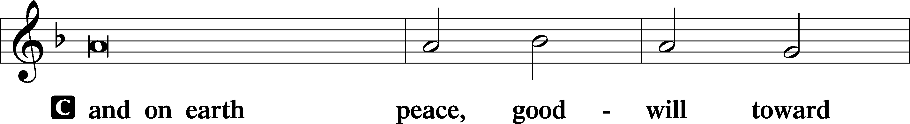
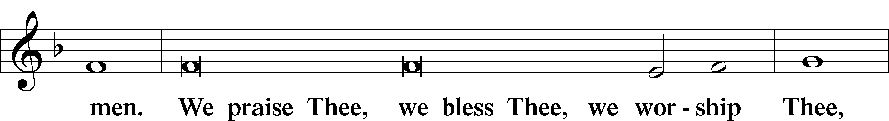
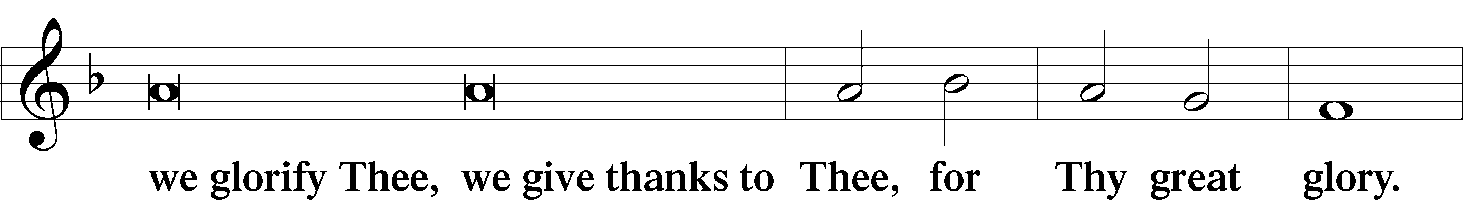
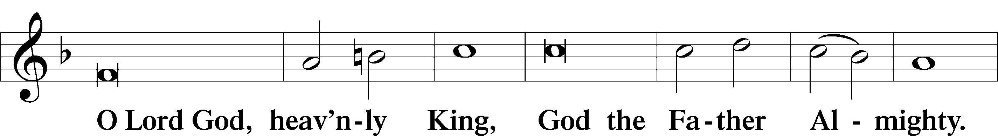
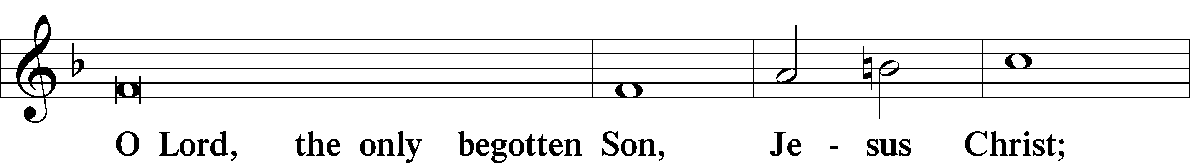
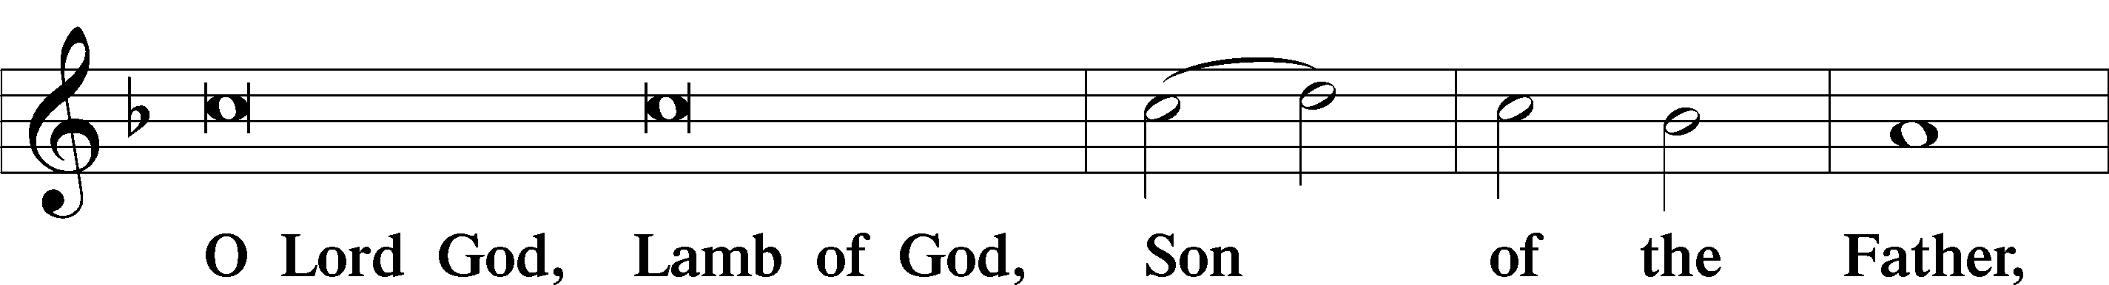
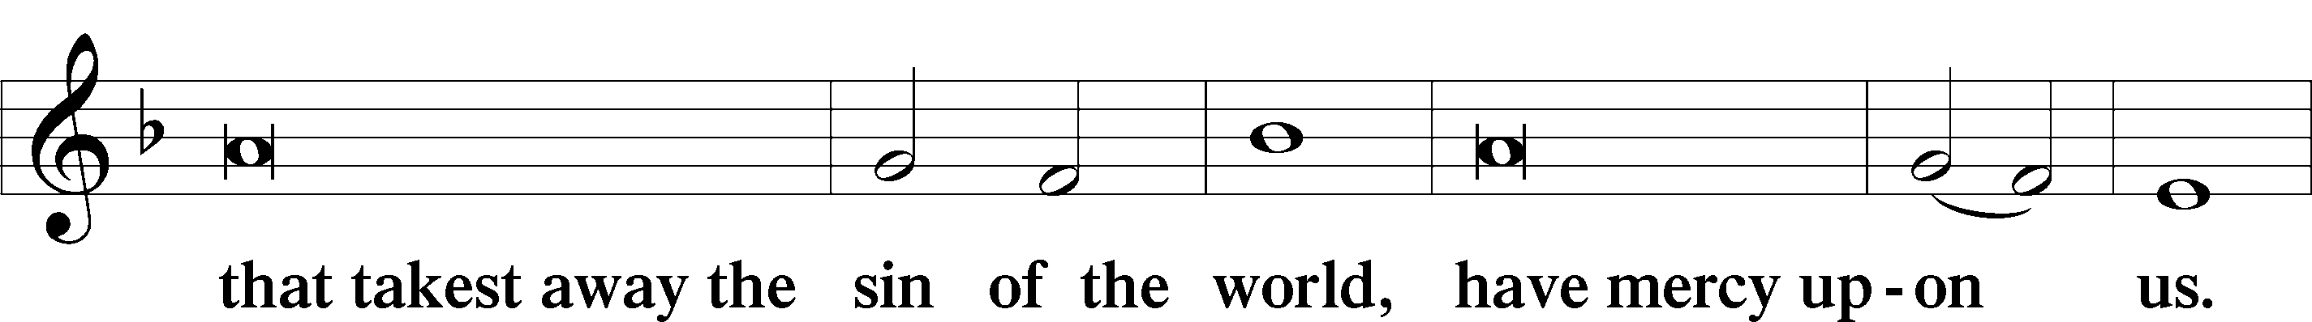
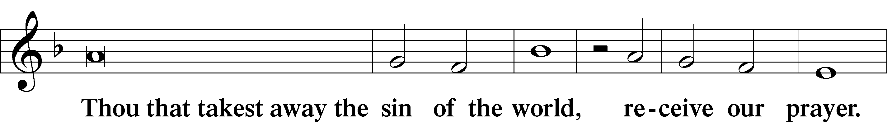
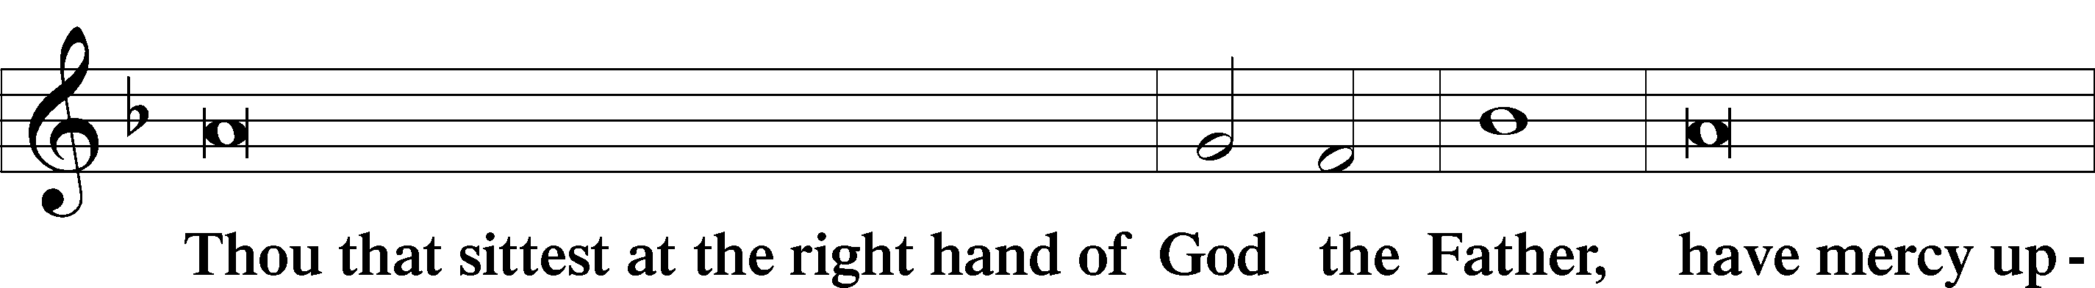
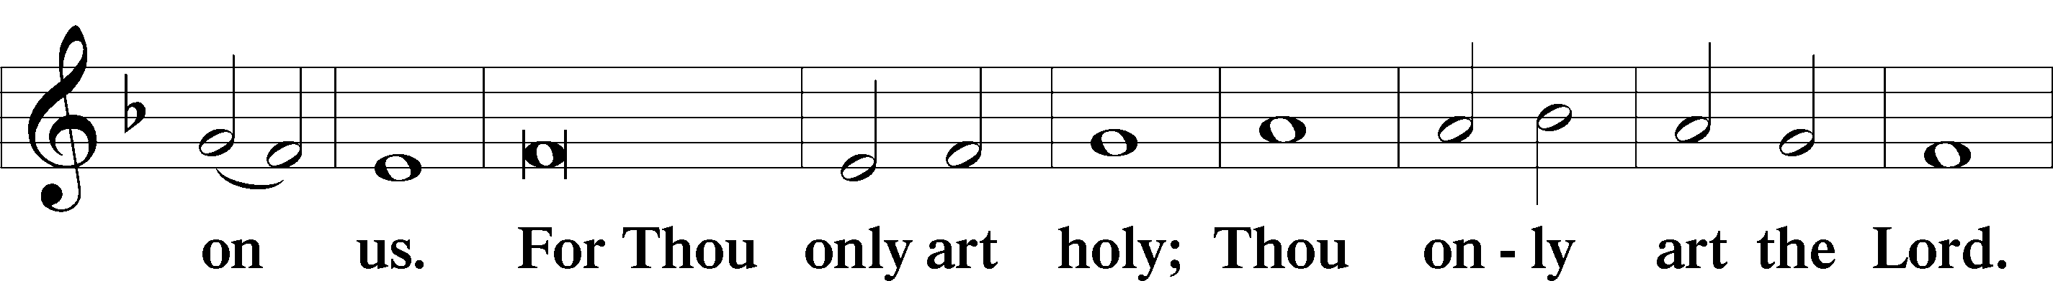
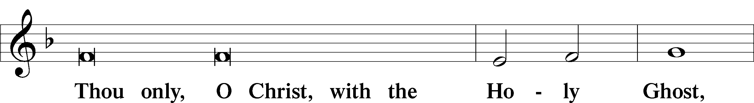
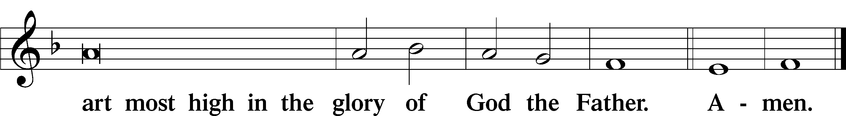

Salutation and Collect of the Day: Trinity 6
P The Lord be with you.
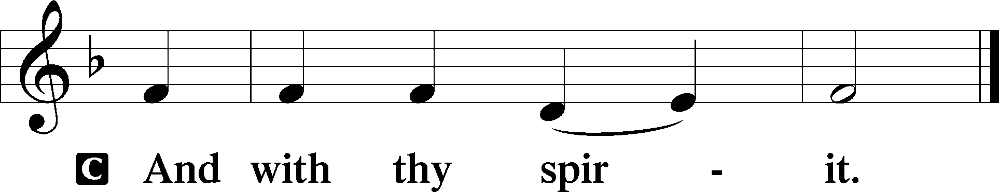

P Let us pray.
Lord of all power and might, author and giver of all good things, graft into our hearts the love of Your name, increase in us true religion, nourish us with all goodness, and of Your great mercy keep us in the same; through Jesus Christ, Your Son, our Lord, who lives and reigns with You and the Holy Spirit, one God, now and forever.
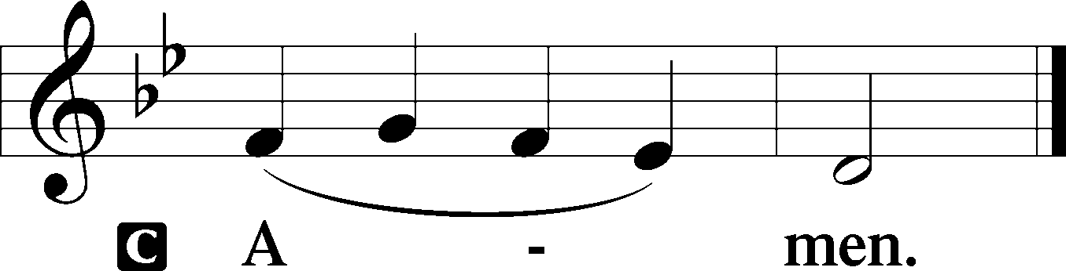
Sit
Prophecy: Exodus 20:1–17 (NKJV)
In those days: God spoke all these words, saying: “I am the Lord your God, who brought you out of the land of Egypt, out of the house of bondage. You shall have no other gods before Me. You shall not make for yourself a carved image—any likeness of anything that is in heaven above, or that is in the earth beneath, or that is in the water under the earth; you shall not bow down to them nor serve them. For I, the Lord your God, am a jealous God, visiting the iniquity of the fathers upon the children to the third and fourth generations of those who hate Me, but showing mercy to thousands, to those who love Me and keep My commandments. You shall not take the name of the Lord your God in vain, for the Lord will not hold him guiltless who takes His name in vain. Remember the Sabbath day, to keep it holy. Six days you shall labor and do all your work, but the seventh day is the Sabbath of the Lord your God. In it you shall do no work: you, nor your son, nor your daughter, nor your male servant, nor your female servant, nor your cattle, nor your stranger who is within your gates. For in six days the Lord made the heavens and the earth, the sea, and all that is in them, and rested the seventh day. Therefore the Lord blessed the Sabbath day and hallowed it. Honor your father and your mother, that your days may be long upon the land which the Lord your God is giving you. You shall not murder. You shall not commit adultery. You shall not steal. You shall not bear false witness against your neighbor. You shall not covet your neighbor’s house; you shall not covet your neighbor’s wife, nor his male servant, nor his female servant, nor his ox, nor his donkey, nor anything that is your neighbor’s.”

P This is the Word of the Lord.
C Thanks be to God.

Gradual Psalm 90:13, 1, 2b
Return, O Lord! | How long?*
Have pity on your | servants!
Lord, you have been our dwelling place in all gener- | ations.*
From everlasting to everlasting | you are God.

Epistle: Romans 6:3–11 (NKJV)
Brethren: As many of us as were baptized into Christ Jesus were baptized into His death. Therefore we were buried with Him through baptism into death, that just as Christ was raised from the dead by the glory of the Father, even so we also should walk in newness of life. For if we have been united together in the likeness of His death, certainly we also shall be in the likeness of His resurrection, knowing this, that our old man was crucified with Him, that the body of sin might be done away with, that we should no longer be slaves of sin. For he who has died has been freed from sin. Now if we died with Christ, we believe that we shall also live with Him, knowing that Christ, having been raised from the dead, dies no more. Death no longer has dominion over Him. For the death that He died, He died to sin once for all; but the life that He lives, He lives to God. Likewise you also, reckon yourselves to be dead indeed to sin, but alive to God in Christ Jesus our Lord.

P This is the Word of the Lord.
C Thanks be to God.

Stand

Verse Psalm 31:1
Alleluia. In you, O Lord, do I take refuge; let me never be put to shame; in your righteousness deliver me! Alleluia.

Alleluia
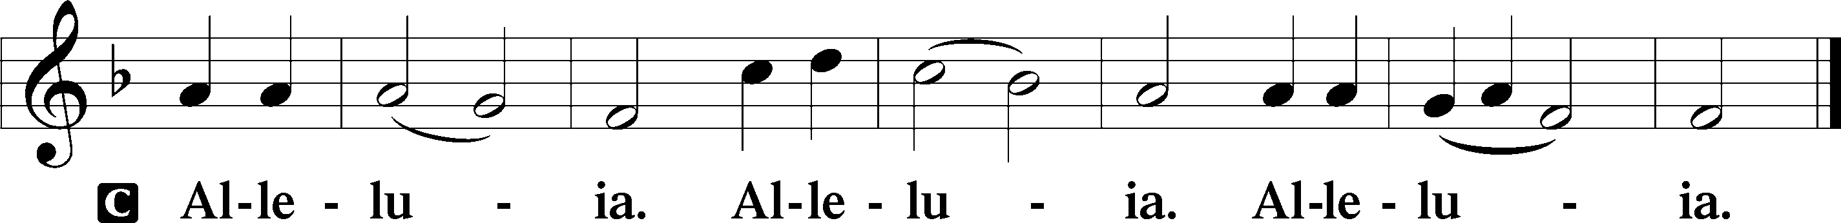

Holy Gospel: Matthew 5:20–26 (NKJV)
P The Holy Gospel according to St. Matthew, the fifth chapter.
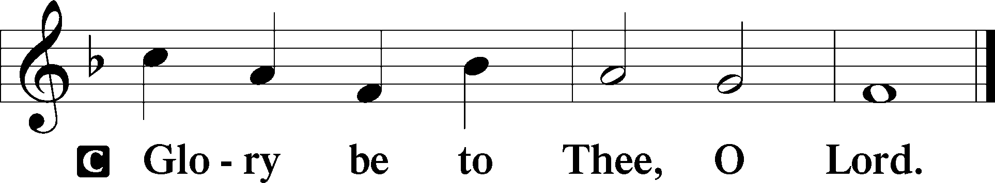

At that time Jesus said to His disciples: “Assuredly, I say to you, unless your righteousness exceeds the righteousness of the scribes and Pharisees, you will by no means enter the kingdom of heaven. You have heard that it was said to those of old, ‘You shall not murder, and whoever murders will be in danger of the judgment.’ But I say to you that whoever is angry with his brother without a cause shall be in danger of the judgment. And whoever says to his brother, ‘Raca!’ shall be in danger of the council. But whoever says, ‘You fool!’ shall be in danger of hell fire. Therefore if you bring your gift to the altar, and there remember that your brother has something against you, leave your gift there before the altar, and go your way. First be reconciled to your brother, and then come and offer your gift. Agree with your adversary quickly, while you are on the way with him, lest your adversary deliver you to the judge, the judge hand you over to the officer, and you be thrown into prison. Assuredly, I say to you, you will by no means get out of there till you have paid the last penny.”

P This is the Gospel of the Lord.
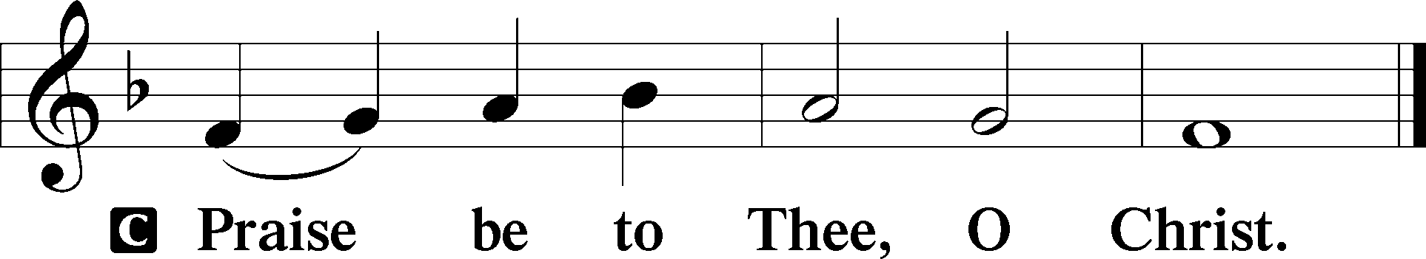

Nicene Creed
C I believe in one God,
the Father Almighty,
maker of heaven and earth
and of all things visible and invisible.

And in one Lord Jesus Christ,
the only-begotten Son of God,
begotten of His Father before all worlds,
God of God, Light of Light,
very God of very God,
begotten, not made,
being of one substance with the Father,
by whom all things were made;
who for us men and for our salvation came down from heaven
and was incarnate by the Holy Spirit of the virgin Mary
and was made man;
and was crucified also for us under Pontius Pilate.
He suffered and was buried.
And the third day He rose again according to the Scriptures
and ascended into heaven
and sits at the right hand of the Father.
And He will come again with glory to judge both the living and the dead,
whose kingdom will have no end.

And I believe in the Holy Spirit,
the Lord and giver of life,
who proceeds from the Father and the Son,
who with the Father and the Son together is worshiped and glorified,
who spoke by the prophets.
And I believe in one holy Christian and apostolic Church,
I acknowledge one Baptism for the remission of sins,
and I look for the resurrection of the dead
and the life T of the world to come. Amen.
Sit

Hymn of the Day: LSB #696 “O God, My Faithful God”

Sermon

Stand

Prayer of the Church

Offertory Psalm 51:10–12
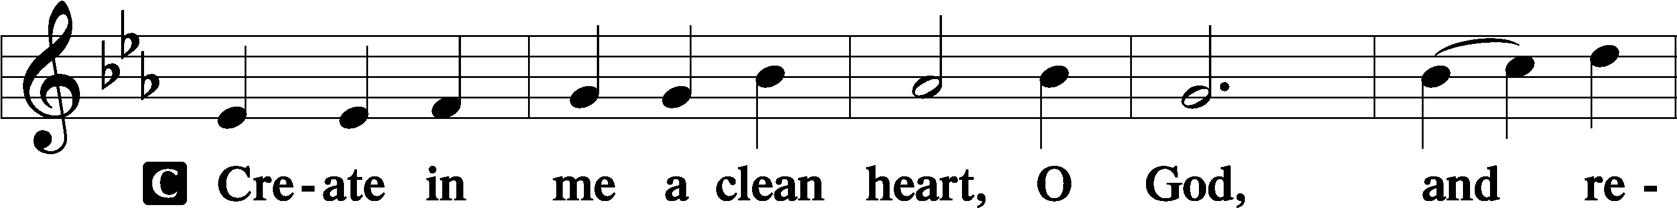
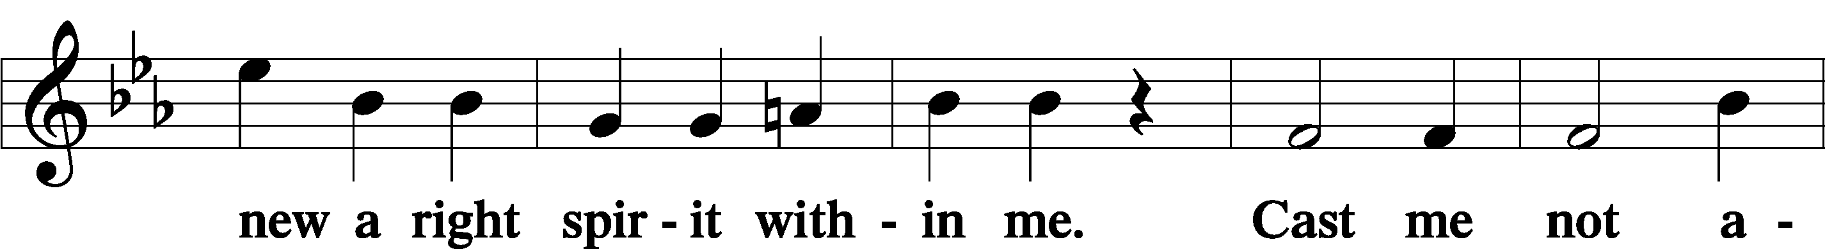
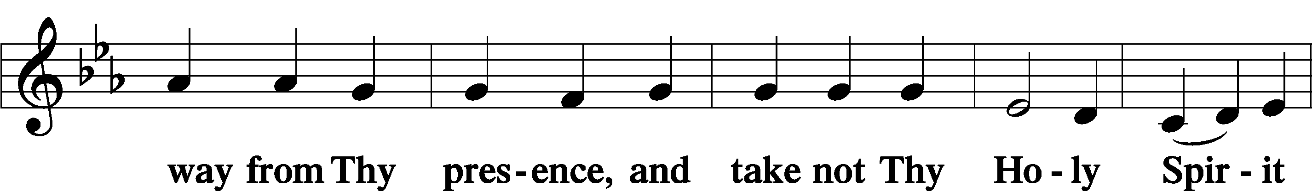
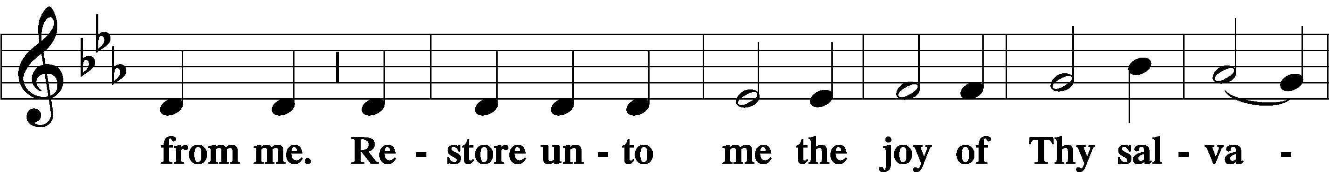
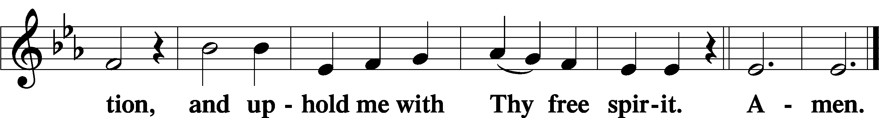
Sit

Preparatory Hymn: LSB #575 “My Hope Is Built on Nothing Less”

Stand

Service of the Sacrament

Preface 2 Timothy 4:22; Colossians 3:1 Psalm 136
P The Lord be with you.

P Lift up your hearts.
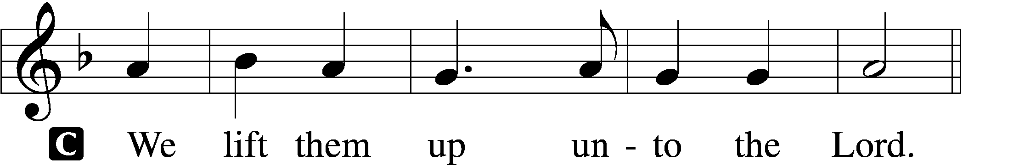

P Let us give thanks unto the Lord, our God.
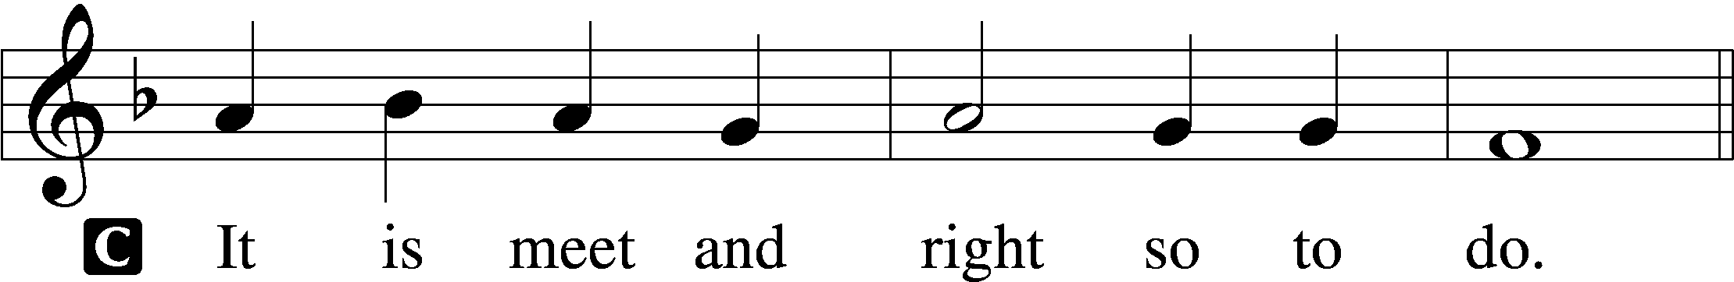

Proper Preface (Abbreviated) LSB 194
P It is truly meet, right, and salutary . . . evermore praising You and saying:

Sanctus Isaiah 6:3; Matthew 21:9
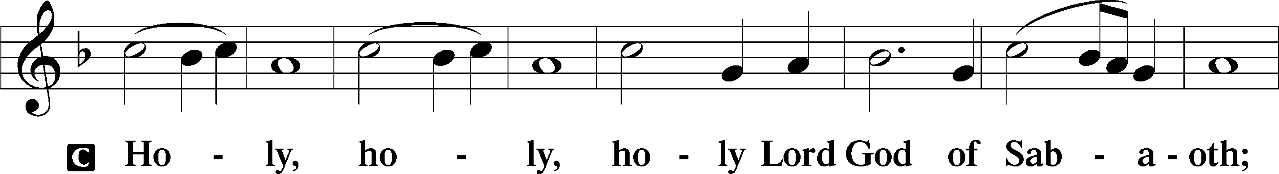
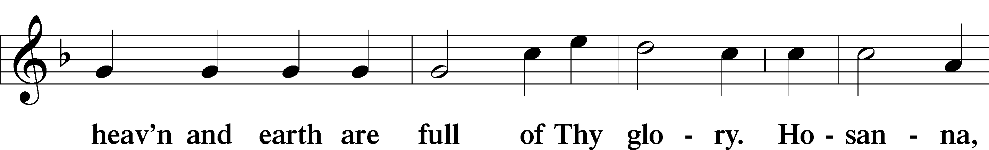
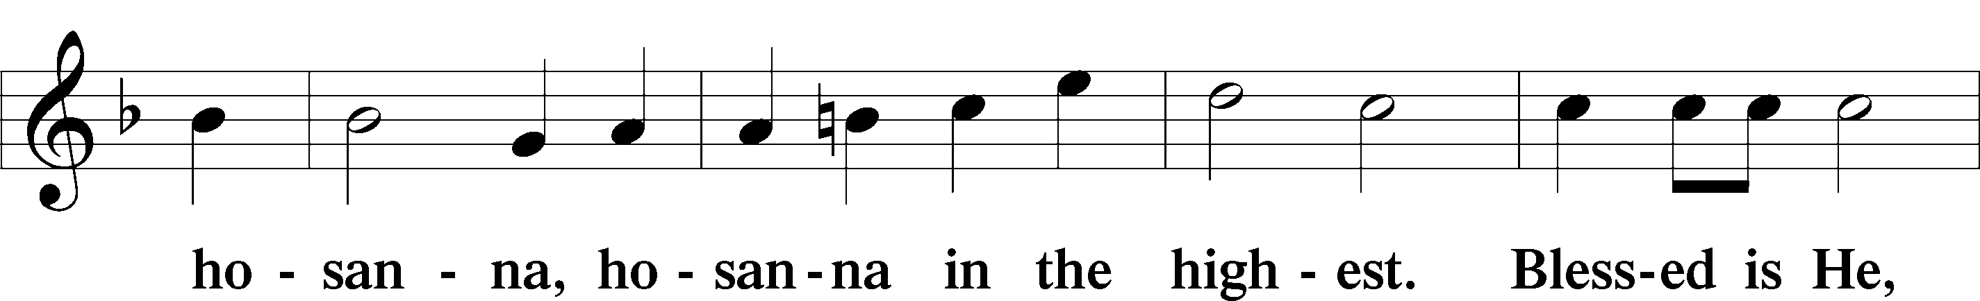
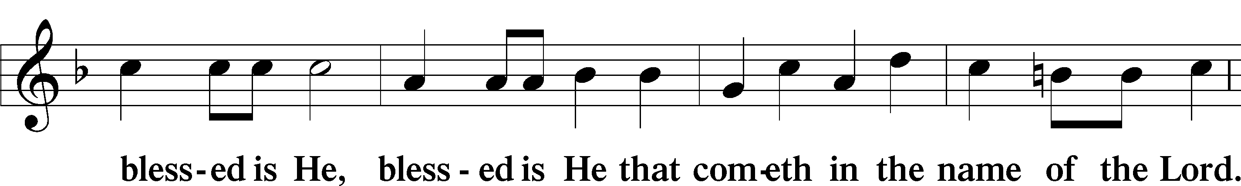
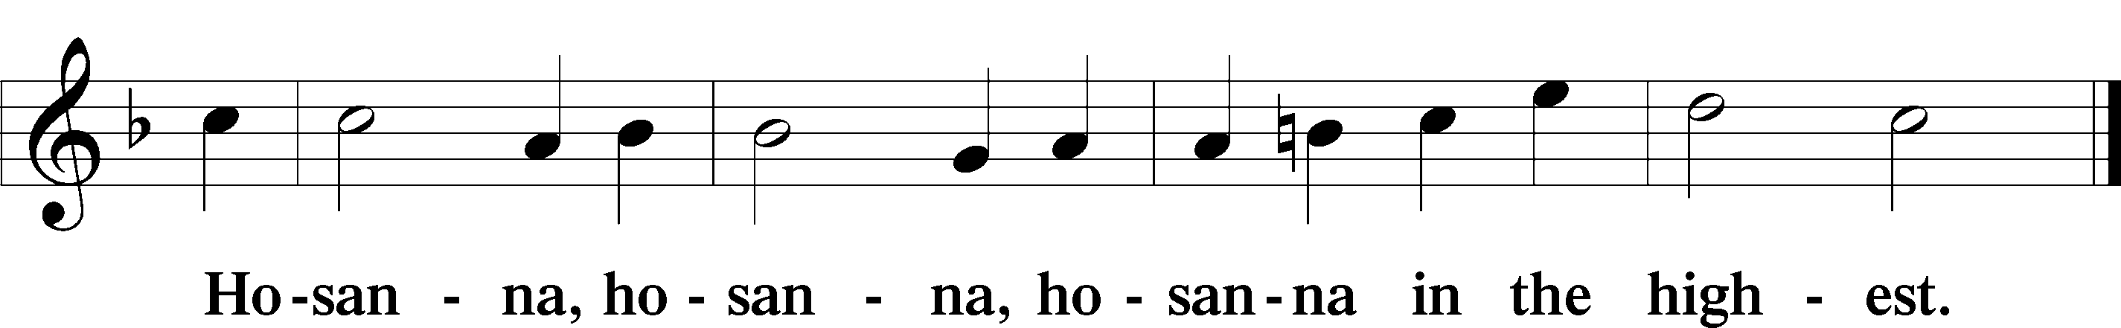

Lord’s Prayer Matthew 6:9–13
C Our Father who art in heaven,
hallowed be Thy name,
Thy kingdom come,
Thy will be done on earth as it is in heaven;
give us this day our daily bread;
and forgive us our trespasses as we forgive those who trespass against us;
and lead us not into temptation,
but deliver us from evil.
For Thine is the kingdom and the power and the glory forever and ever. Amen.

The Words of Our Lord Matthew 26:26–28; Mark 14:22–24; Luke 22:19–20; 1 Corinthians 11:23–25
P Our Lord Jesus Christ, on the night when He was betrayed, took bread, and when He had given thanks, He broke it and gave it to the disciples and said: “Take, eat; this is My T body, which is given for you. This do in remembrance of Me.”

In the same way also He took the cup after supper, and when He had given thanks, He gave it to them, saying: “Drink of it, all of you; this cup is the new testament in My T blood, which is shed for you for the forgiveness of sins. This do, as often as you drink it, in remembrance of Me.”

Pax Domini John 20:19
P The peace of the Lord be with you always.
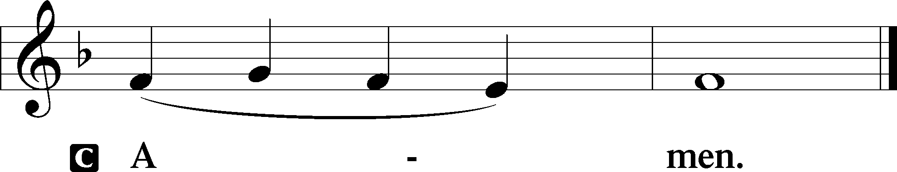

Agnus Dei John 1:29
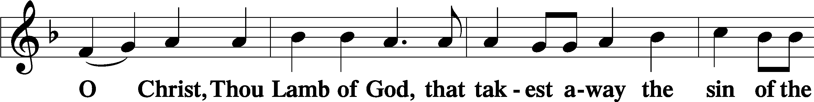
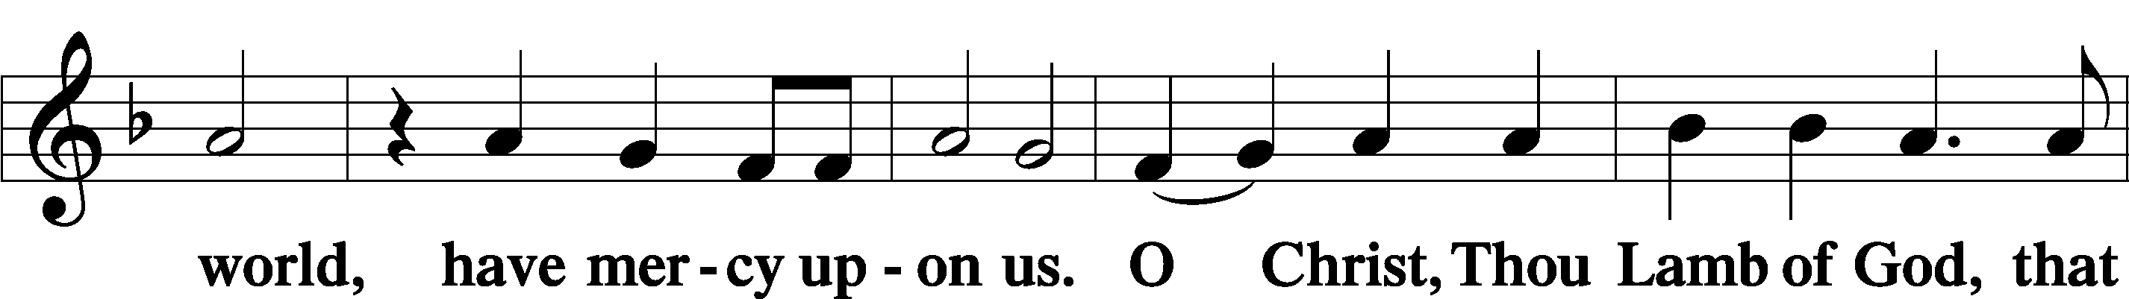
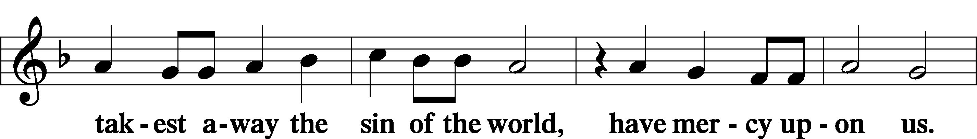
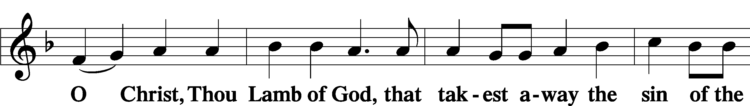
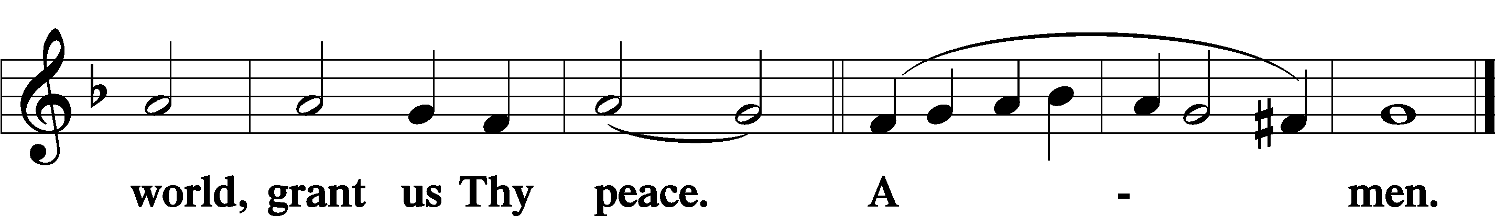
Sit

Distribution
The pastor and those who assist him receive the body and blood of Christ first and then distribute them to those who come to receive, saying:
Take, eat; this is the true body of our Lord and Savior Jesus Christ, given into death for your sins.
Amen.

Take, drink; this is the true blood of our Lord and Savior Jesus Christ, shed for the forgiveness of your sins.
Amen.

In dismissing the communicants, the following is said:
The Dismissal
P The body and blood of our Lord Jesus Christ strengthen and preserve you in body and soul to life everlasting. Depart T in peace.
C Amen.

Distribution Hymn: LSB #594 “God’s Own Child, I Gladly Say It”

Distribution Hymn: LSB #555 “Salvation unto Us Has Come”

Nunc Dimittis Luke 2:29–32
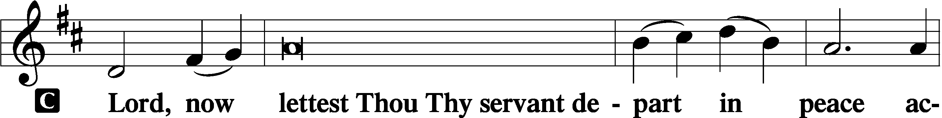
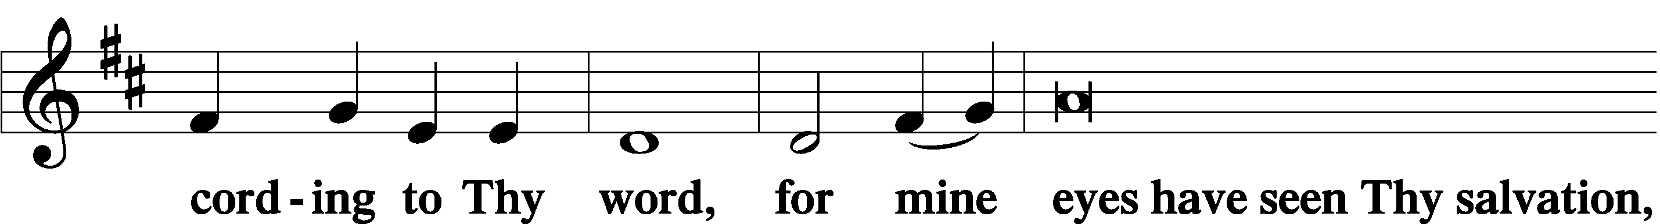
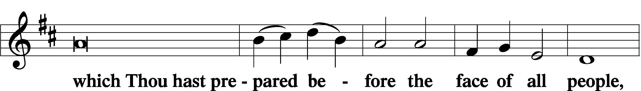
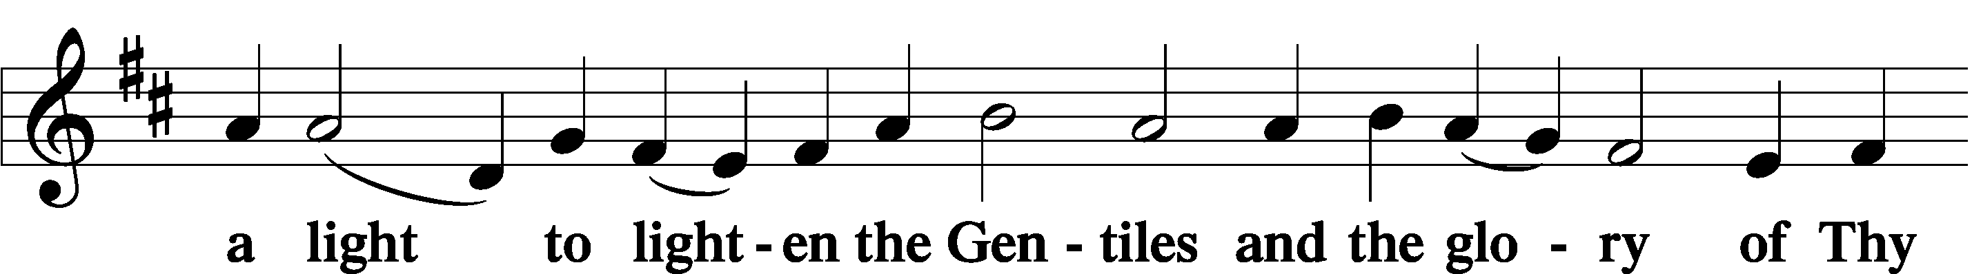
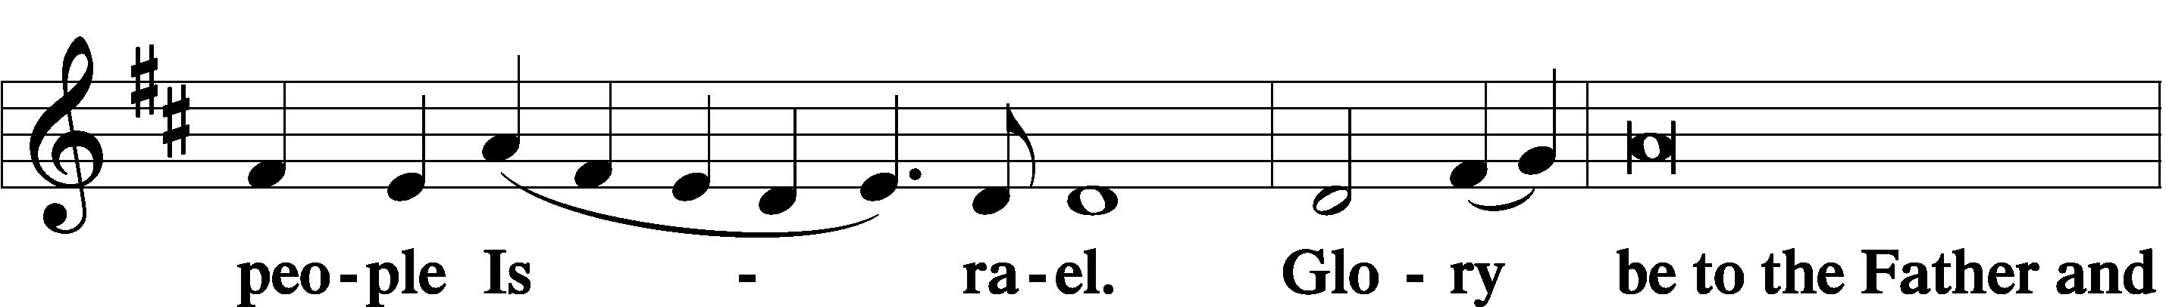
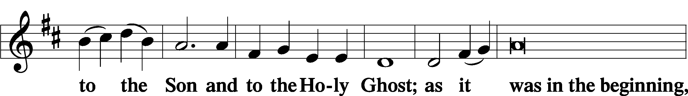
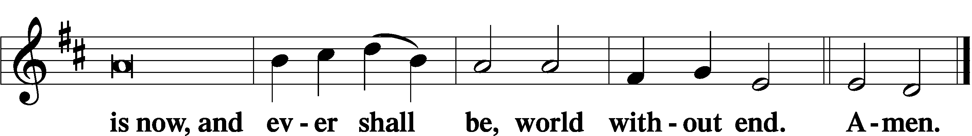

Thanksgiving Psalm 107:1
P O give thanks unto the Lord, for He is good,
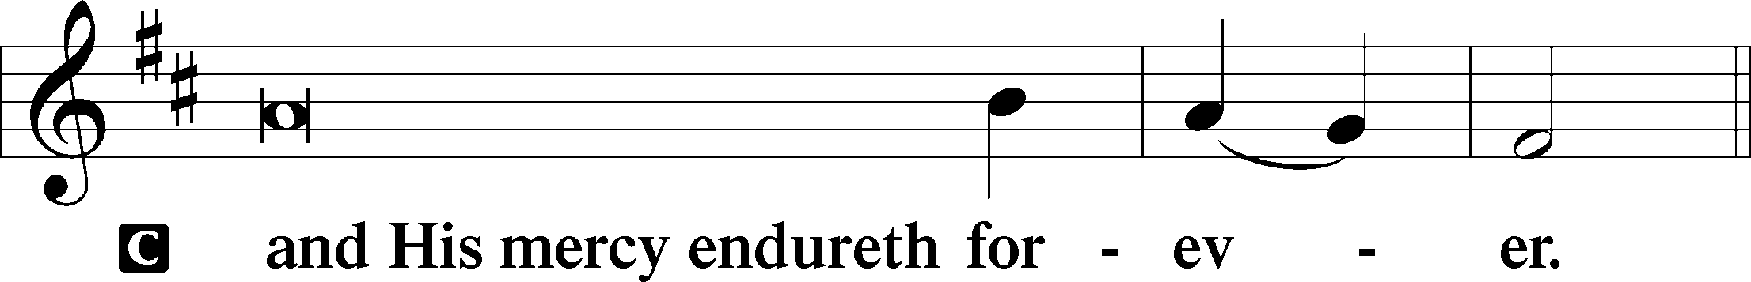

Post-Communion Collect
P Let us pray.
We give thanks to You, almighty God, that You have refreshed us through this salutary gift, and we implore You that of Your mercy You would strengthen us through the same in faith toward You and in fervent love toward one another; through Jesus Christ, Your Son, our Lord, who lives and reigns with You and the Holy Spirit, one God, now and forever.
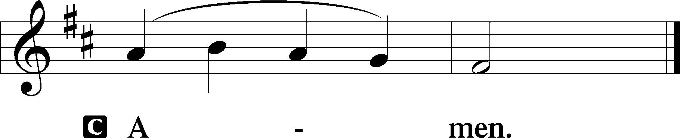

Salutation 2 Timothy 4:22
P The Lord be with you.
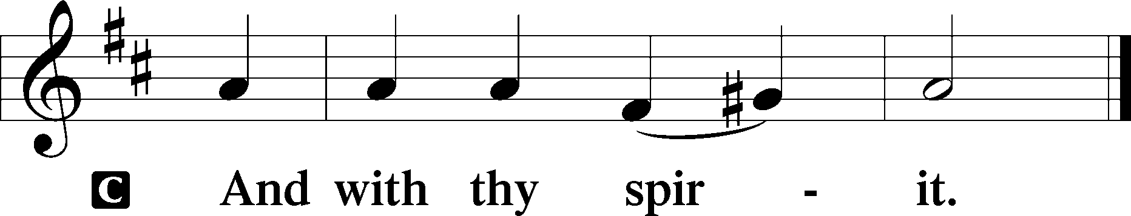

Benedicamus Psalm 103:1
P Bless we the Lord.
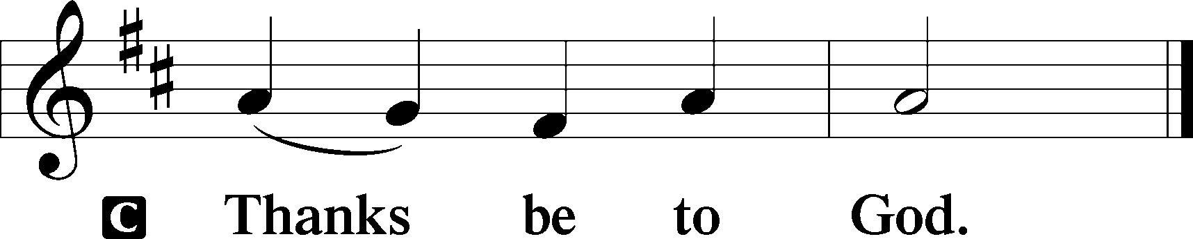

Benediction Numbers 6:24–26
P The Lord bless you and keep you.
The Lord make His face shine upon you and be gracious unto you.
The Lord lift up His countenance upon you and T give you peace.
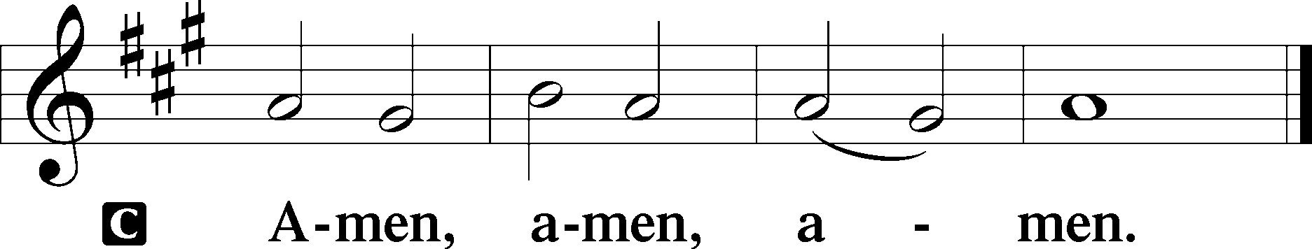

Closing Hymn: LSB #834 “O God, O Lord of Heaven and Earth”

Silent prayer after worship: Dear Jesus, lead me to daily pray and read Your Word so the Holy Spirit can draw me closer to You. As Your child and heir of Your kingdom, help me to live my life for You. Amen.
fffffffffffffffffffffffffffffffffff
Acknowledgments
Unless otherwise indicated, Scripture quotations are from the ESV® Bible (The Holy Bible, English Standard Version®), copyright © 2001 by Crossway, a publishing ministry of Good News Publishers. Used by permission. All rights reserved.
Created by Lutheran Service Builder © 2023 Concordia Publishing House.
fffffffffffffffffffffffffffffffffff

fffffffffffffffffffffffffffffffffff
In Loving Memory of Parents’ (Mr. & Mrs. Raymond Fee) Wedding Day, July 13, 1939: Dolores Fee (Capital Campaign).
fffffffffffffffffffffffffffffffffff
SCHEDULE THROUGH JULY 23, 2023:

:

Today, Following Worship, Library: Monthly/Quarterly Audit
7 pm, Fellowship Hall: AA Meeting
Tuesday, 7-9 pm, Fellowship Hall: Penn-Ohio Singers
Wednesday, 7:30 pm, Fellowship Hall: NA Meeting
Thursday, 10 am, Fellowship Hall: Women’s Bible Study
Saturday, 7 pm, Sanctuary: Festival of St. Mary Magdalene, Divine Service
Next Sunday, 9 am, Sanctuary: Divine Service
7 pm, Fellowship Hall: AA Meeting
fffffffffffffffffffffffffffffffffff
Attendance: Sunday, July 9, 2023: 43
fffffffffffffffffffffffffffffffffff
THANK YOU FOR SERVING IN JULY: Elder: Jonathan Baisch; Ushers: Matt Berent, Mark Gabriel, Michael Laird, & Jerome Thomas; Altarware: (prior) Diane Riefstahl & Marie Flaugher (07/09 & 07/30); (after) Elizabeth Haenftling (07/02 & 07/16) & Marie Flaugher (07/09, 07/23, & 07/30).
fffffffffffffffffffffffffffffffffff
Bible Memory Verses ~ Week of July 16th:
For Adults: Heaven and earth will pass away, but my words will not pass away.
Mark 13:31
For Children: Fear not, for I have redeemed you; I have called you by name, you are mine. Isaiah 43:1
fffffffffffffffffffffffffffffffffff
August calendar and newsletter items are due to the secretary’s office by noon July 24th. Church Council members are reminded that reports for that evening’s council meeting are due by noon that day as well.
fffffffffffffffffffffffffffffffffff
Our Stewardship of Treasures for the Lord:
In order to do the Lord’s work, we need $2,553.63 each week to meet our 2023 budget for general purposes and $76.92 for the SELC.
Online Figure (06.22.2023)
General Fund: $80.00
Figures for Sunday, July 9, 2023
General Fund: $1,375.00 Behind for the week: -$1,098.63
SELC: $5.00 Behind for the week: -$71.92
Food Pantry: $1,015.00
Capital Campaign: $235.00

For online giving, check out https://www.saintspeterandpaul.net/online-giving.
fffffffffffffffffffffffffffffffffff
Remember the following in Prayer…
~The Hurting and Healing: The family and friends of Martin Anderson (Rebecca Marquette’s father), who passed away July 8, 2023; also, Amy, Steve Antolovich, Ellen Baron^{CA}, Lois Bortner^{CA}, Joe & Bev Chlpka, Kathleen Coughenour, Susan Davies, Tim Dudash, Judith & Eddy Furey, Griffin, Austin Hamilton, Joan, Darla Krajci, Barbara Kreske, Jess Lavoie, Elizabeth Loughan, Paul Lucas^{CA}, Sandy Marshall, Gene Moore, Frank Niemeyer^{CA}, Juanita Rentschler, Richard Reuning^{CA}, Nancy Robertson^{CA}, Toni Shaw (Hank Holcroft’s daughter), Joel & Peggy Wasson, Angela Weser^{CA}, and Ruth Wolf.
~The Homebound: Anna Mae Daris, Millie Elavsky, Rudy & Jean Tomko, Betty Wolf, and Ed & Millie Zachar.
~Celebrating this Week: Birthdays: Clara Krivosh (07.16) & Casonddra Thomas (07.20); Anniversary: Mark & Janelle Gabriel (07.19).
~Serving in the Military: Alex (Sasha) Carr, Curtis Sinewe, and Joshua Solyan.
~Community & World Needs: Those suffering from or affected by the coronavirus; those suffering due to the conflict between Ukraine and Russia; those suffering from loss and dislocation because weather disasters; those suffering from addiction and their families; Local, State, and National Government Leaders; safety for all Police Officers, Firefighters, & First Responders; the unemployed; our Third Quarter Local Mission: Luther Classical College.
*CA represents cancer.
Heartfelt sympathy is extended to Rebecca & Gordon Marquette upon the passing of Rebecca’s father, Martin Anderson, Saturday, July 8th. Condolences may be sent to the Marquette’s and Rebecca’s mother, Mary Jane Anderson, c/o 4046 Ellwood Rd., New Castle, PA, 16101.
May those who mourn his passing take comfort that he is now resting in the arms of our Lord and Savior Jesus Christ.
fffffffffffffffffffffffffffffffffff
Alex (Sasha) Carr would welcome cards/letters (no packages) as he completes his basic training for the US Army. His address is (capitalization is intentional)…
PVT Alexander Carr RN 141
CO C 2nd BN 47th INFANTRY
197th INFANTRY BRIGADE
9375 CONWAY DRIVE 3425
FORT MOORE, GA 31905-4931
fffffffffffffffffffffffffffffffffff
Church Council members are reminded that there will be a meeting Monday, July 24th at 7 pm. The next Voters’ Assembly will take place following worship, Sunday, August 20th.
fffffffffffffffffffffffffffffffffff
Our prayer list has been updated. If you would like someone’s name added or deleted from our Prayer List, please put a note in the secretary’s mail slot. Thank you!
fffffffffffffffffffffffffffffffffff
Recently, our Food Pantry was blessed with a $1000.00 donation from the NLMK workers and their 50-50 raffle. This donation, through the Shenango Valley Charitable Foundation fund, will go a long way in assisting those families who depend on our Food Pantry to make ends meet.
fffffffffffffffffffffffffffffffffff
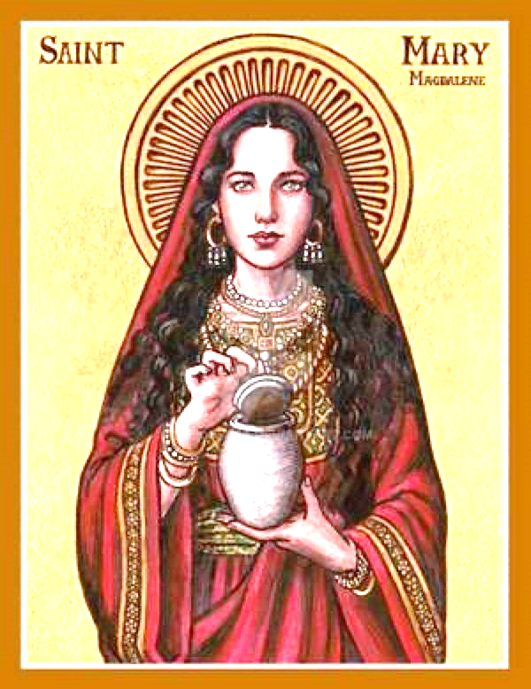
Join us this Saturday evening at 7 pm, for a special
Divine Service
celebrating St. Mary Magdalene.

Here to Serve
Pastor………………………………………………...……………Rev. Jacob Deal
E-mail …………………………….……pastordeal@saintspeterandpaul.net
Phone Number……………………..…………………724-347-3620 (Option 2)
Church Office………………………..…………………724-347-3620 (Option 3)
Website …………………………………………www.saintspeterandpaul.net
Secretary…………………………………………………………Diane Riefstahl
E-mail ………………………………………church@saintspeterandpaul.net
Website …………………………………………www.saintspeterandpaul.net
Food Pantry: Please leave message……………724-347-3620 (Option 3)
AA Contact: Steve………………………………………………..…724-813-2358
NA Contact: Larry………………………………………………..724-977-8733
Choir Director………………………………………………………Chris Nelson
Congregation President……………………………………Jonathan Baisch
Church Elder …………………………………………...…… Jonathan Baisch
fffffffffffffffffffffffffffffffffff
If needing to get into the church building during the week, please phone first to make certain someone is here to let you in.

