Sts. Peter & Paul
Evangelical Lutheran Church
Lutheran Church-Missouri Synod
Founded-1917

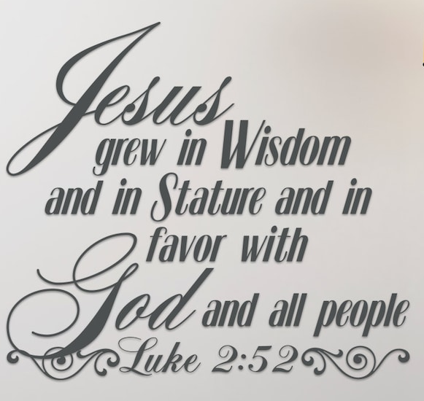

January 8, 2023

699 Stambaugh Avenue
Sharon, Pennsylvania 16146

“I was glad when they said to me,
Let us go to the house of the LORD!”
Psalm 122:1
Sts. Peter & Paul Evangelical Lutheran Church, LC-MS
THE FIRST SUNDAY AFTER EPIPHANY
January 8, 2023

A special welcome to our guests this day! If you would like more information about The Lutheran Church - Missouri Synod, or this congregation, please speak with Pastor Deal or an Elder after the service.
Members & Guests: Don’t be embarrassed if your children make noise during the worship service, all children do. We encourage families to worship together but, if you feel the need, there are pews in the rear of the Church which are reserved for young families on both sides of the sanctuary. There is also a quiet room available to you during our service which is located down the hallway past the offices on the right side of the church as well as a children’s area in the Fellowship Hall where you are able to follow along with the service.

Today’s service includes the Sacrament of Holy Communion. If during this past year, you have not worshipped with us and been communed, we respectfully ask that you do not partake of this sacrament this day before first speaking with Pastor Deal.
If visiting from a sister congregation of the LC-MS and are in good standing, please inform Pastor Deal of your desire to commune prior to the service.
If wishing to receive a blessing during communion, please approach with your arms crossed.

CONTACT INFORMATION
Pastor Deal: pastordeal@saintspeterandpaul.net or 724-347-3620 (opt. 2)
Church Office: church@saintspeterandpaul.net or 724-347-3620 (opt. 3)

Silent prayer before worship: Heavenly Father, make the light of Your Gospel shine in my heart that I may have the assurance of salvation in Christ, and be able to share that hope with others. In Jesus’ name. Amen.

Confession and Absolution

Opening Hymn: LSB #401 “From God the Father, Virgin-Born”

The sign of the cross may be made by all in remembrance of their Baptism.
Invocation
P In the name of the Father and of the T Son and of the Holy Spirit.
C Amen.

Exhortation Hebrews 10:22; Psalm 124:8; Psalm 32:5
P Beloved in the Lord! Let us draw near with a true heart and confess our sins unto God our Father, beseeching Him in the name of our Lord Jesus Christ to grant us forgiveness.

P Our help is in the name of the Lord,
C who made heaven and earth.
P I said, I will confess my transgressions unto the Lord,
C and You forgave the iniquity of my sin.

Silence for reflection on God’s Word and for self-examination.

Confession of Sins
P O almighty God, merciful Father,
C I, a poor, miserable sinner, confess unto You all my sins and iniquities with which I have ever offended You and justly deserved Your temporal and eternal punishment. But I am heartily sorry for them and sincerely repent of them, and I pray You of Your boundless mercy and for the sake of the holy, innocent, bitter sufferings and death of Your beloved Son, Jesus Christ, to be gracious and merciful to me, a poor, sinful being.

Absolution [John 20:19–23]
P Upon this your confession, I, by virtue of my office, as a called and ordained servant of the Word, announce the grace of God unto all of you, and in the stead and by the command of my Lord Jesus Christ I forgive you all your sins in the name of the Father and of the T Son and of the Holy Spirit.
C Amen.
Service of the Word

Introit Psalm 100; antiphon: Isaiah 6:1; Revelation 19:6
I saw the Lord sitting upon a throne, high and | lifted up;*
and the train of his robe filled the | temple.
Then I heard the voice of a great multitude, | crying out,*
“Hallelujah! For the Lord our God the Al- | mighty reigns.”
Make a joyful noise to the Lord, | all the earth!*
Serve the Lord with gladness! Come into his presence with | singing!
Know that the Lord, | he is God!*
It is he who made us, and we are his; we are his people, and the sheep of his | pasture.
Enter his gates with thanksgiving, and his | courts with praise!*
Give thanks to him; | bless his name!
For the Lord is good; his steadfast love endures for- | ever,*
and his faithfulness to all gener- | ations.
I saw the Lord sitting upon a throne, high and | lifted up;*
and the train of his robe filled the | temple.
Then I heard the voice of a great multitude, | crying out,*
“Hallelujah! For the Lord our God the Al- | mighty reigns.”

Gloria Patri
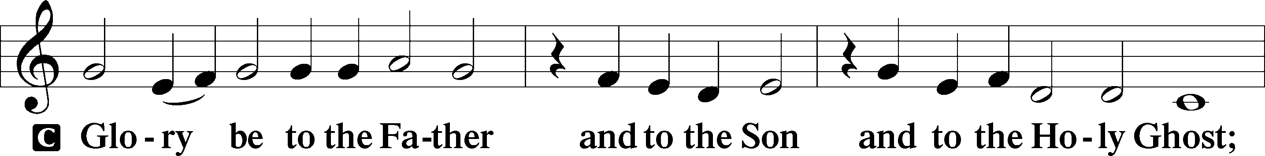
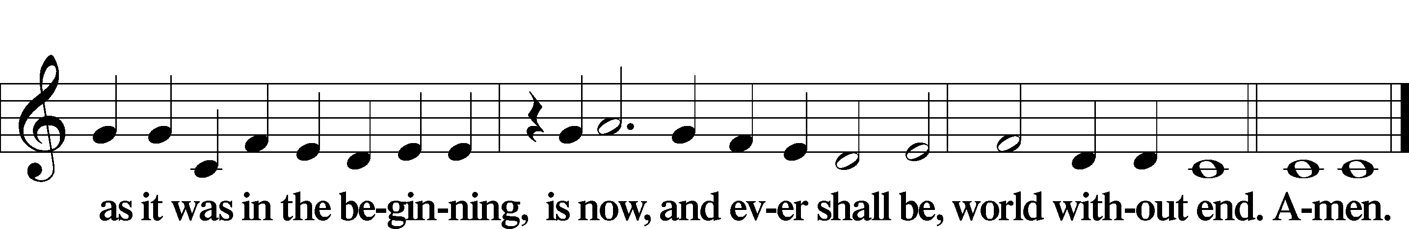

Kyrie Mark 10:47
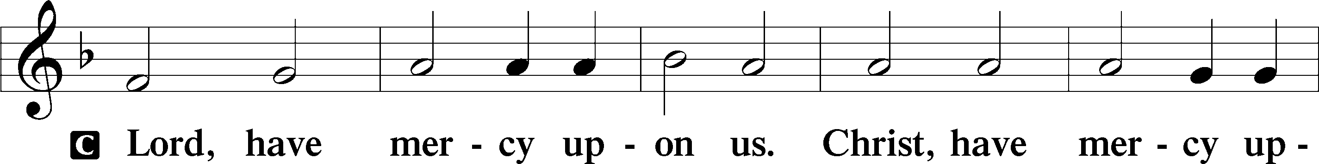
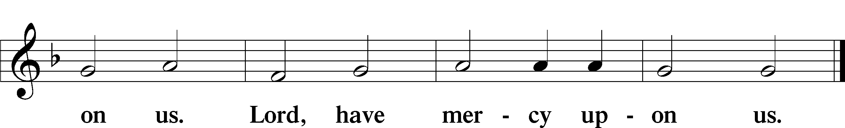

Gloria in Excelsis Luke 2:14; John 1:29
P Glory be to God on high:
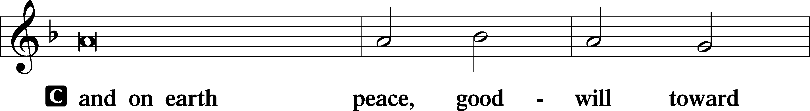
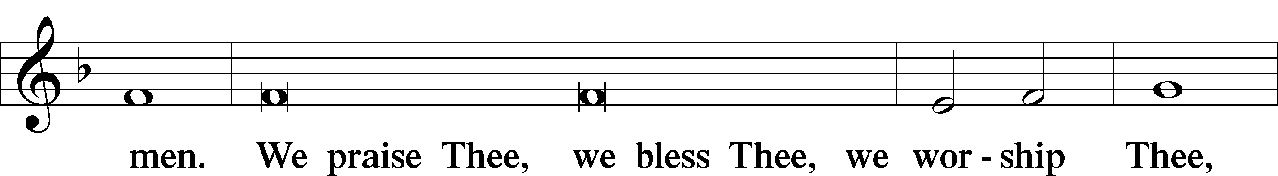
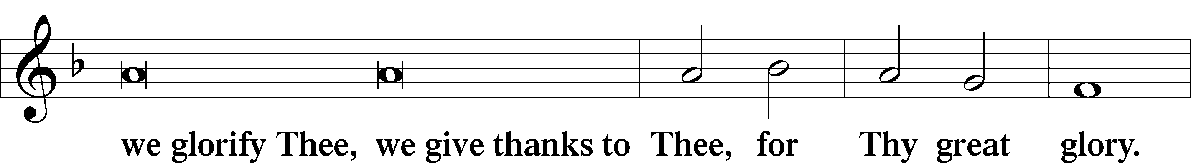
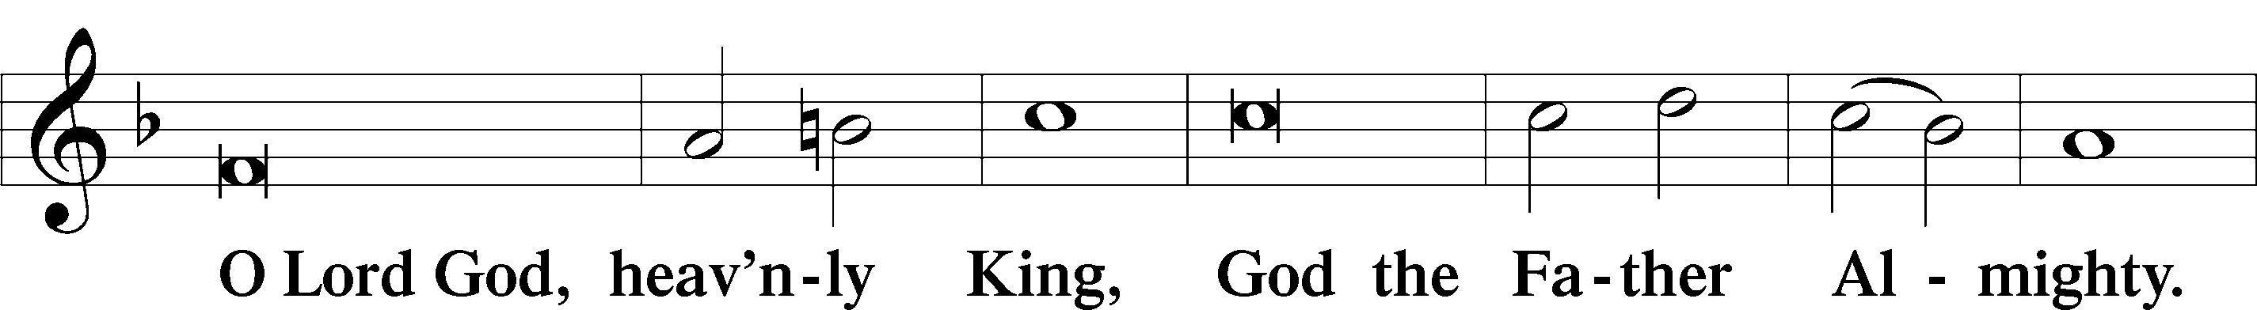
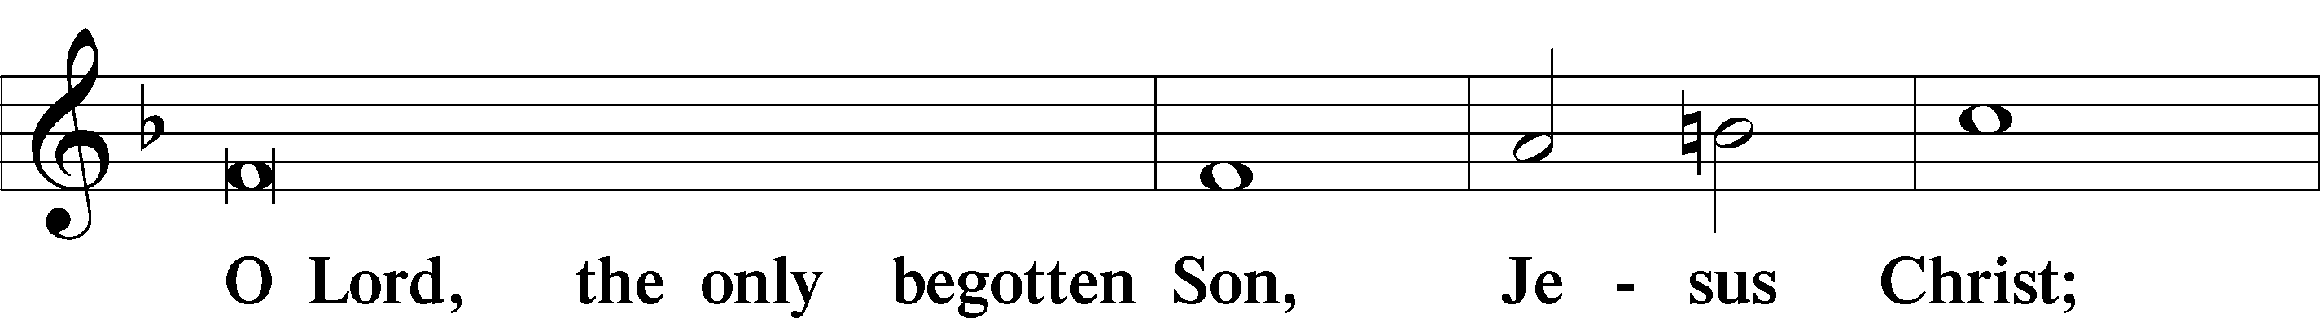
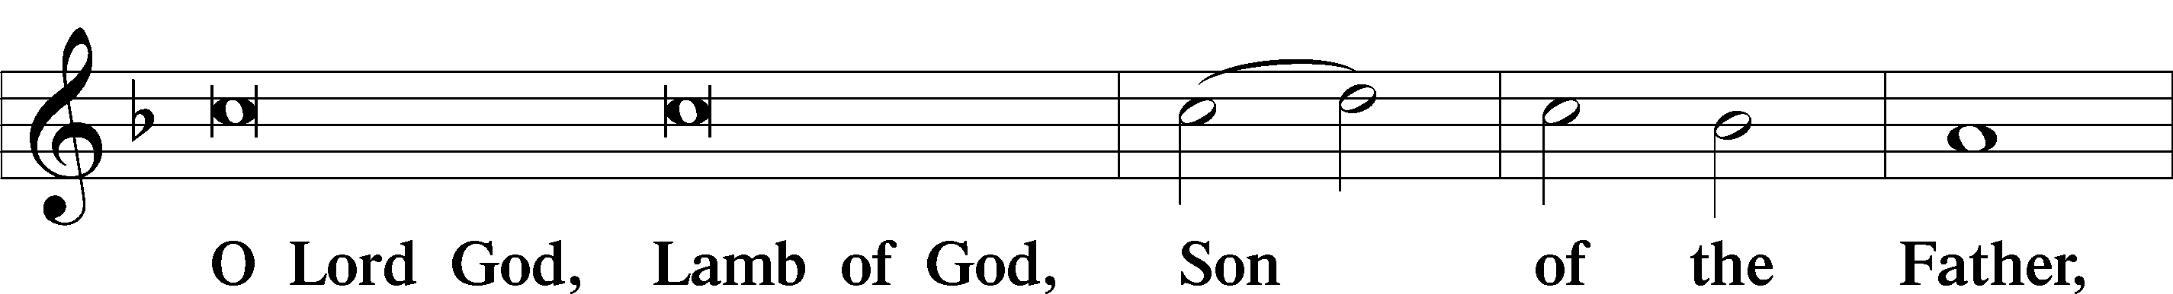
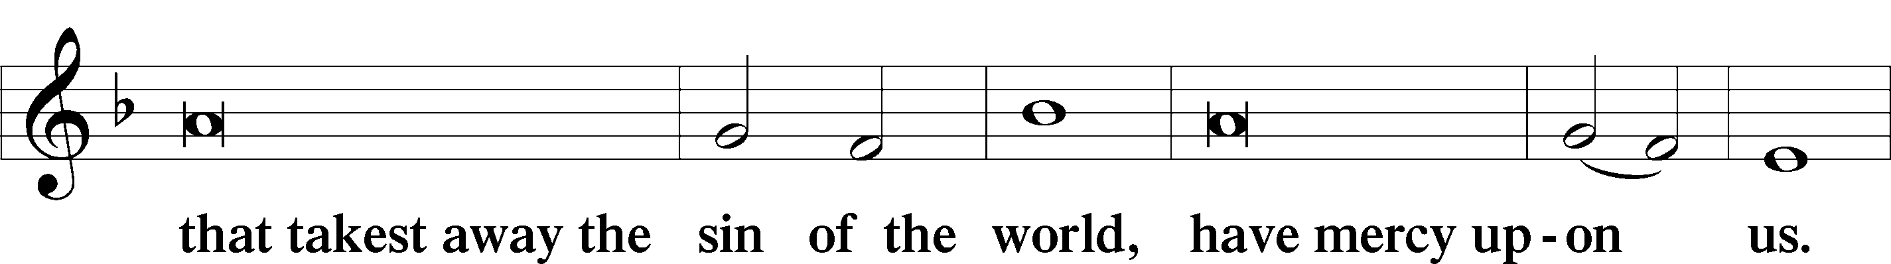
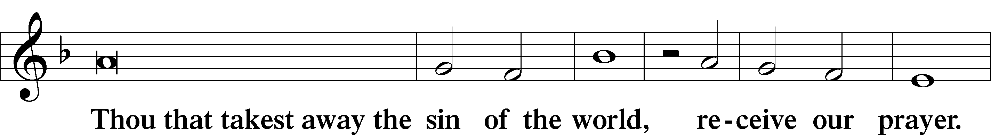
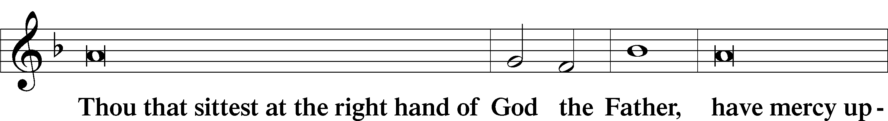
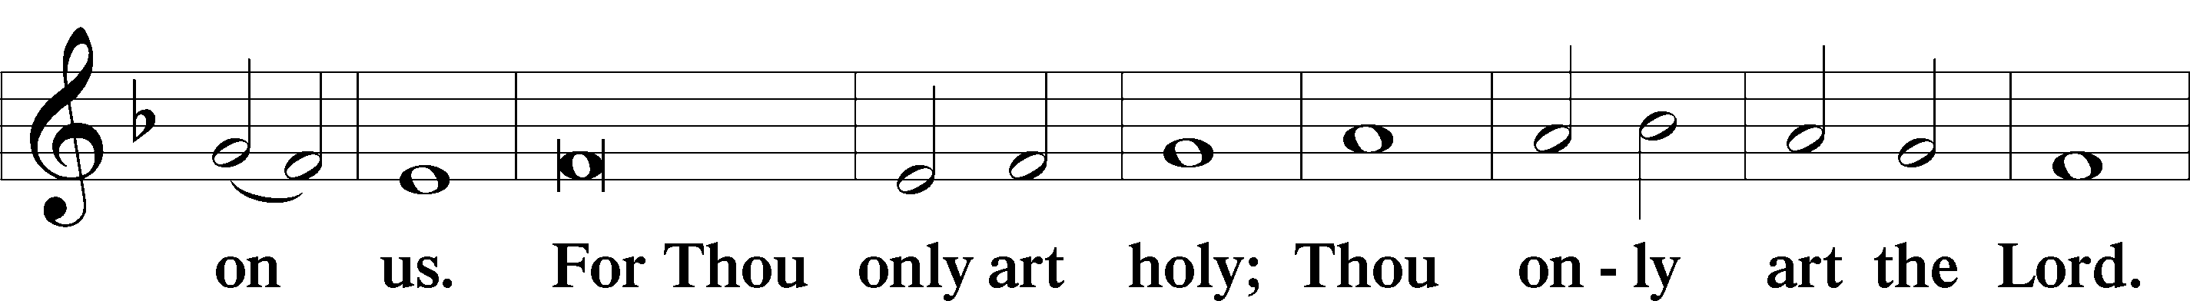
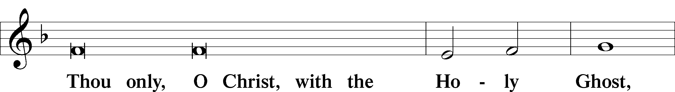
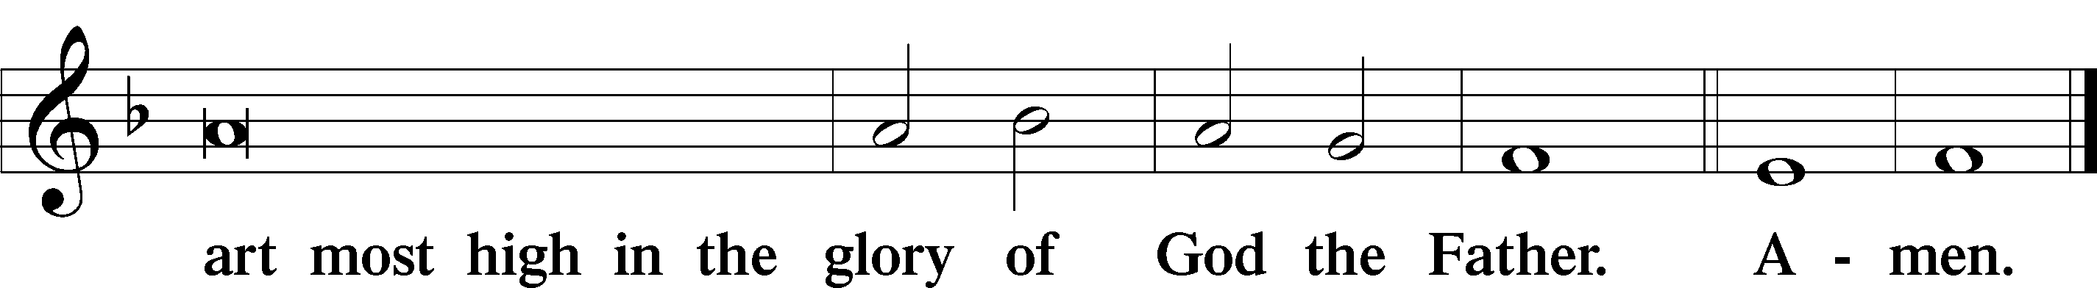

Salutation and Collect of the Day: Epiphany 1
P The Lord be with you.
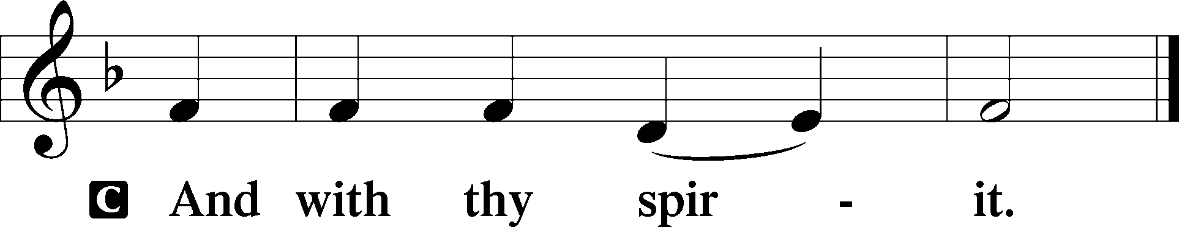

P Let us pray.
O Lord, mercifully receive the prayers of Your people who call upon You and grant that they both perceive and know what things they ought to do and also may have grace and power faithfully to fulfill the same; through Jesus Christ, Your Son, our Lord, who lives and reigns with You and the Holy Spirit, one God, now and forever.
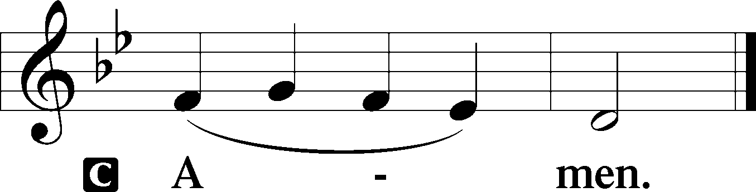
Sit
Prophecy: Isaiah 42:1-9 (NKJV)
Thus says the Lord God: “Behold! My Servant whom I uphold, my Elect One in whom My soul delights! I have put My Spirit upon Him; He will bring forth justice to the Gentiles. He will not cry out, nor raise His voice, nor cause His voice to be heard in the street. A bruised reed He will not break, and smoking flax He will not quench; He will bring forth justice for truth. He will not fail nor be discouraged, till He has established justice in the earth; and the coastlands shall wait for His law.” Thus says God the Lord, who created the heavens and stretched them out, who spread forth the earth and that which comes from it, who gives breath to the people on it, and spirit to those who walk on it: “I, the Lord, have called You in righteousness, and will hold Your hand; I will keep You and give You as a covenant to the people, as a light to the Gentiles, to open blind eyes, to bring out prisoners from the prison, those who sit in darkness from the prison house. I am the Lord, that is My name; and My glory I will not give to another, nor My praise to carved images. Behold, the former things have come to pass, and new things I declare; before they spring forth I tell you of them.”

P This is the Word of the Lord.
C Thanks be to God.

Gradual Psalm 72:18, 3
Blessèd be the Lord, the God of | Israel,*
who alone does | wondrous things.
Let the mountains bear prosperity for the | people,*
and the hills, in | righteousness!

Epistle: Romans 12:1-6a (NKJV)
Brethren: I beseech you by the mercies of God, that you present your bodies a living sacrifice, holy, acceptable to God, which is your reasonable service. And do not be conformed to this world, but be transformed by the renewing of your mind, that you may prove what is that good and acceptable and perfect will of God. For I say, through the grace given to me, to everyone who is among you, not to think of himself more highly than he ought to think, but to think soberly, as God has dealt to each one a measure of faith. For as we have many members in one body, but all the members do not have the same function, so we, being many, are one body in Christ, and individually members of one another. Having then gifts differing according to the grace that is given to us, let us use them, in Christ Jesus our Lord.

P This is the Word of the Lord.
C Thanks be to God.
Stand

Verse Psalm 100:1–2a
Alleluia. Make a joyful noise to the Lord, all the earth! Serve the Lord with gladness! Alleluia.

Alleluia
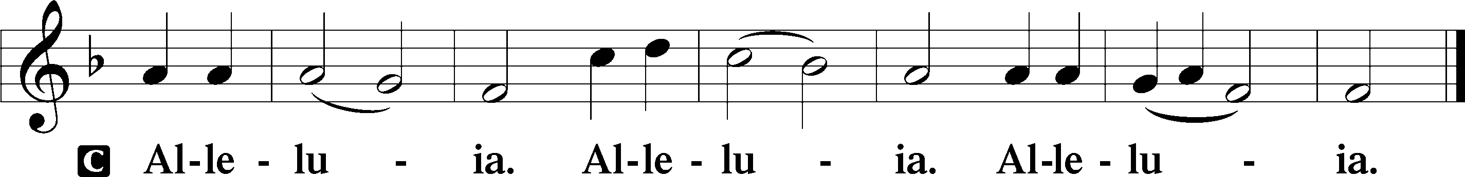

Holy Gospel: Luke 2:42-52 (NKJV)
P The Holy Gospel according to St. Luke, the second chapter.
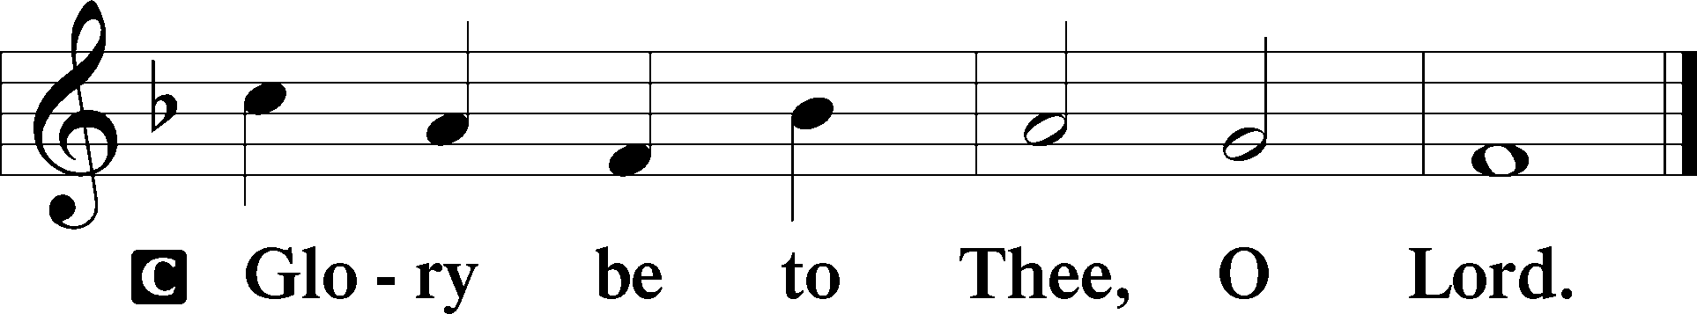

At that time: When Jesus was twelve years old, they went up to Jerusalem according to the custom of the feast. When they had finished the days, as they returned, the Boy Jesus lingered behind in Jerusalem. And Joseph and His mother did not know it; but supposing Him to have been in the company, they went a day’s journey, and sought Him among their relatives and acquaintances. So when they did not find Him, they returned to Jerusalem, seeking Him. Now so it was that after three days they found Him in the temple, sitting in the midst of the teachers, both listening to them and asking them questions. And all who heard Him were astonished at His understanding and answers. So when they saw Him, they were amazed; and His mother said to Him, “Son, why have You done this to us? Look, Your father and I have sought You anxiously.” And He said to them, “Why did you seek Me? Did you not know that I must be about My Father’s business?” But they did not understand the statement which He spoke to them. Then He went down with them and came to Nazareth, and was subject to them, but His mother kept all these things in her heart. And Jesus increased in wisdom and stature, and in favor with God and men.

P This is the Gospel of the Lord.
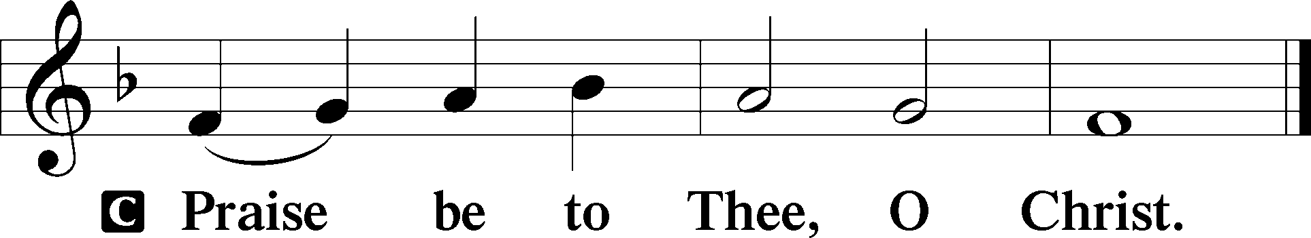

Nicene Creed
C I believe in one God,
the Father Almighty,
maker of heaven and earth
and of all things visible and invisible.

And in one Lord Jesus Christ,
the only-begotten Son of God,
begotten of His Father before all worlds,
God of God, Light of Light,
very God of very God,
begotten, not made,
being of one substance with the Father,
by whom all things were made;
who for us men and for our salvation came down from heaven
and was incarnate by the Holy Spirit of the virgin Mary
and was made man;
and was crucified also for us under Pontius Pilate.
He suffered and was buried.
And the third day He rose again according to the Scriptures
and ascended into heaven
and sits at the right hand of the Father.
And He will come again with glory to judge both the living and the dead,
whose kingdom will have no end.

And I believe in the Holy Spirit,
the Lord and giver of life,
who proceeds from the Father and the Son,
who with the Father and the Son together is worshiped and glorified,
who spoke by the prophets.
And I believe in one holy Christian and apostolic Church,
I acknowledge one Baptism for the remission of sins,
and I look for the resurrection of the dead
and the life T of the world to come. Amen.
Sit

Hymn of the Day: LSB #410 “Within the Father’s House”

Sermon

Stand

Installation of Congregational Officers

Those to be installed are presented before the altar. The pastor addresses the congregation:
P Beloved in the Lord, Holy Scripture admonishes us that “all things should be done decently and in order.”

To that end, the constitution and bylaws of this congregation establish various offices to which men and women are elected and appointed to serve. In so doing, the Church follows the example of the Early Christian Church as described in Acts, chapter six:

The twelve summoned the full number of the disciples and said, “It is not right that we should give up preaching the word of God to serve tables. Therefore, brothers, pick out from among you seven men of good repute, full of the Spirit and of wisdom, whom we will appoint to this duty. But we will devote ourselves to prayer and to the ministry of the word.”

The apostle Peter writes in his first epistle:

As each has received a gift, use it to serve one another, as good stewards of God’s varied grace: whoever speaks, as one who speaks oracles of God; whoever serves, as one who serves by the strength that God supplies—in order that in everything God may be glorified through Jesus Christ. To him belong glory and dominion forever and ever. Amen.

The pastor addresses the officers-elect:
P You have been chosen to fill specific offices and positions of responsibility at Sts. Peter & Paul Evangelical Lutheran Church. You are to work with the pastor, that our life together in Christ may be orderly and pleasing in His sight.

You are to see that the services of God’s house are held at the proper times, that the Word of God is purely preached and taught according to the Lutheran Confessions, that the Sacraments of Christ are administered according to His institution, that provision is made for the Christian instruction of young and old, that the erring are admonished, and that discipline is maintained.

You are to see that the temporal affairs of the congregation are properly administered and that proper support is provided for the workers of this congregation. You are to assist in caring for the poor and the sick, in cultivating harmony among the members, in promoting the general welfare of the congregation, and in furthering the kingdom of Christ here and throughout the world.

While holiness of life and obedience to Christ are expected of all members of the congregation, it is especially important that you, as office-bearers in His Church, show yourselves, by word and example, to be faithful to Him in service and Christian devotion.

In the presence of God and of this congregation, I therefore ask you: Do you accept the offices entrusted to you, and do you promise faithfully to carry out your duties, trusting in the Lord and conforming yourself to His Word in accordance with the faith of the Evangelical Lutheran Church? If so, then answer: I do.
R I do.

The pastor addresses the congregation:
P Beloved in the Lord, you have heard the promises of faithfulness spoken by these men and women whom you have selected to serve as officers of Sts. Peter & Paul Evangelical Lutheran Church. Do you promise to support them in their work, to remember them in your prayers, and to work with them to the best of the abilities that God has given you, so that He may be glorified and His work be done in our midst? If so, then answer: We do.
C We do.

The pastor addresses the officers-elect:
P Brothers and sisters in Christ, I install you as officers Sts. Peter & Paul Evangelical Lutheran Church in the name of the Father and of the T Son and of the Holy Spirit.
C Amen.

P The almighty and most merciful God enlighten and strengthen you in your offices that you may be good and faithful stewards to the glory of His name and the good of His people.
C Amen.

Stand
P Let us pray.
Lord God, heavenly Father, we give thanks that You have raised up these servants for work among Your people. We humbly implore You to grant them, by Your Holy Spirit, those gifts needed for the faithful carrying out of their tasks, most especially wisdom, strength, and willing hearts. Let Your blessing rest on this congregation. Strengthen the faith, quicken the love, and enkindle the zeal of its members, that Your name may be glorified and that here and in all places under heaven the kingdom of Your Son may be advanced. We remember with thanksgiving those who have faithfully served Your people and have now completed their time of service. We pray that in the end of days we, with all Your faithful people, may hear the voice of Christ saying: “Come, you who are blessed by My Father; inherit the kingdom prepared for you from the foundation of the world”; through Jesus Christ, Your Son, our Lord, who lives and reigns with You and the Holy Spirit, one God, now and forever.
C Amen.

P Go in the name of the Lord. Be steadfast, immovable, always abounding in the work of the Lord, knowing that in the Lord your labor is not in vain. The almighty and most merciful God, the Father, the T Son, and the Holy Spirit, bless and preserve you.
C Amen.
Sit

Recognition of Servants of the Congregation
Those to be honored are presented before the altar. The pastor may greet each one individually with a handshake.
P Dear brothers and sisters in Christ, the following have served our Lord faithfully for various periods of time: Joani Rice, financial staff; Anson Holcroft, trustee; Hank Holcroft, trustee; and Barry Nelson, elder . Hear what Holy Scripture has to say about those who serve in the Church.

I thank my God in all my remembrance of you, always in every prayer of mine for you all making my prayer with joy, because of your partnership in the gospel from the first day until now. And I am sure of this, that he who began a good work in you will bring it to completion at the day of Jesus Christ. It is right for me to feel this way about you all, because I hold you in my heart, for you are all partakers with me of grace, both in my imprisonment and in the defense and confirmation of the gospel. For God is my witness, how I yearn for you all with the affection of Christ Jesus.

And let the peace of Christ rule in your hearts, to which indeed you were called in one body. And be thankful. Let the word of Christ dwell in you richly, teaching and admonishing one another in all wisdom, singing psalms and hymns and spiritual songs, with thankfulness in your hearts to God. And whatever you do, in word or deed, do everything in the name of the Lord Jesus, giving thanks to God the Father through him.
Stand
P Let us pray.
Gracious Father, You direct Your people to use their gifts in service to others. Receive our thanks and praise for the faithful service of these individuals. Bless them with wisdom and patience, and with love and faithfulness to Your Word, that they may continue to serve with gladness; through Jesus Christ, Your Son, our Lord, who lives and reigns with You and the Holy Spirit, one God, now and forever.
C Amen.

P Go in the name of the Lord. Be steadfast, immovable, always abounding in the work of the Lord, knowing that in the Lord your labor is not in vain. The almighty and most merciful God, the Father, the T Son, and the Holy Spirit, bless and preserve you.
C Amen.

Prayer of the Church

Offertory Psalm 51:10–12
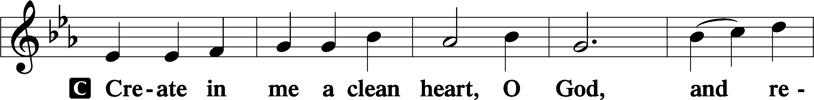
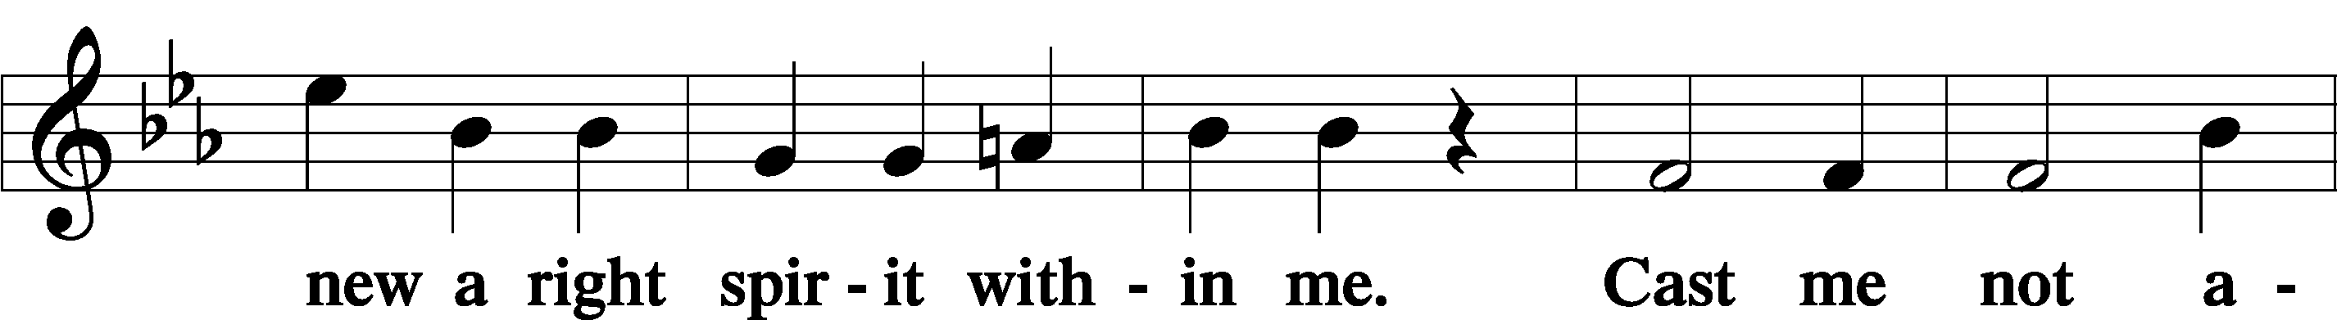
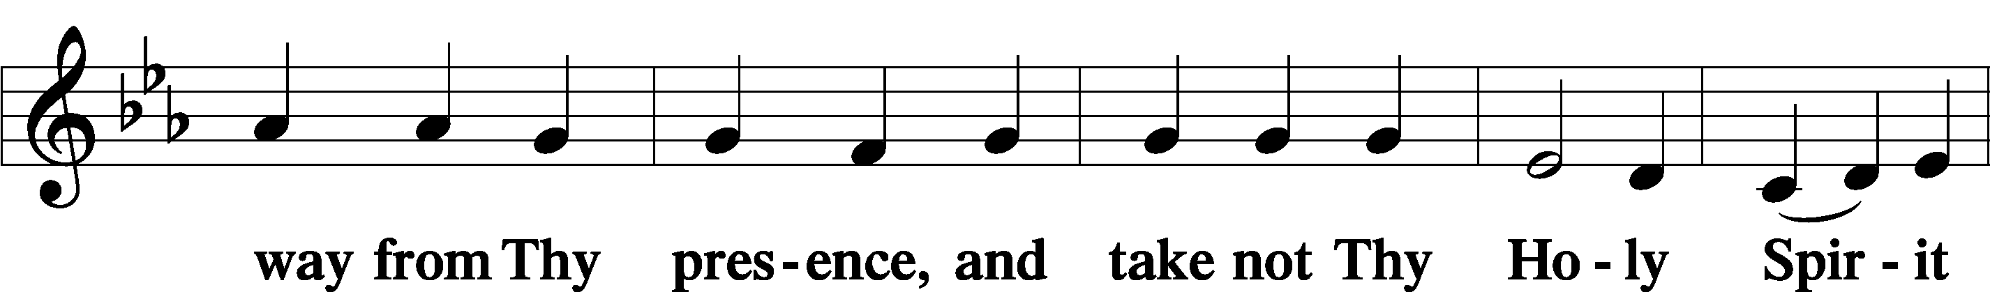
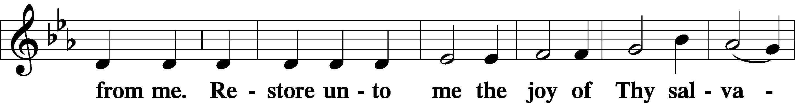
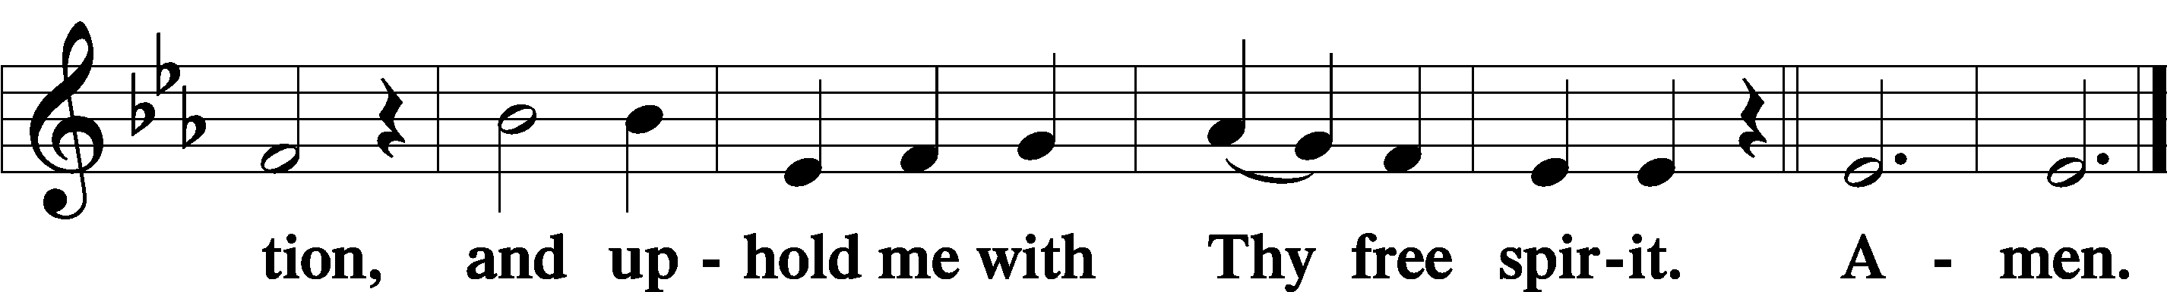
Sit

Preparatory Hymn: LSB #412 “The People That in Darkness Sat”

Service of the Sacrament

Preface 2 Timothy 4:22; Colossians 3:1 Psalm 136
P The Lord be with you.

P Lift up your hearts.
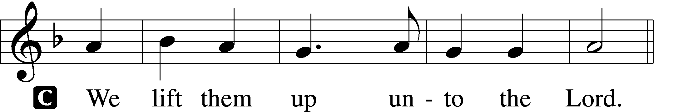

P Let us give thanks unto the Lord, our God.
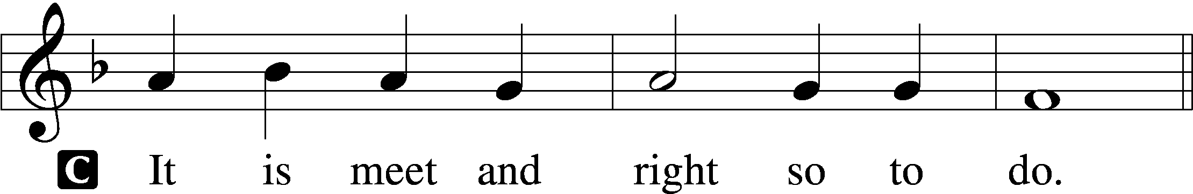

Proper Preface (Abbreviated) LSB 194
P It is truly meet, right, and salutary . . . evermore praising You and saying:

Sanctus Isaiah 6:3; Matthew 21:9
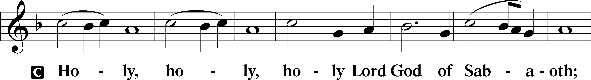
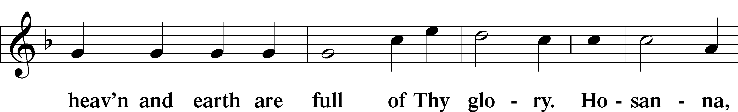
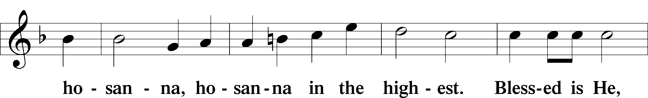
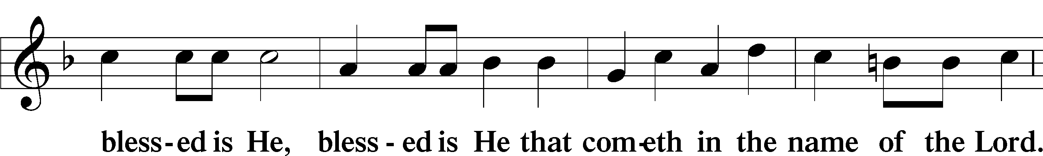
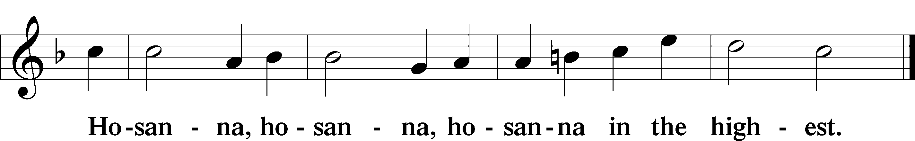

Lord’s Prayer Matthew 6:9–13
C Our Father who art in heaven,
hallowed be Thy name,
Thy kingdom come,
Thy will be done on earth as it is in heaven;
give us this day our daily bread;
and forgive us our trespasses as we forgive those who trespass against us;
and lead us not into temptation,
but deliver us from evil.
For Thine is the kingdom and the power and the glory forever and ever. Amen.

The Words of Our Lord Matthew 26:26–28; Mark 14:22–24; Luke 22:19–20; 1 Corinthians 11:23–25
P Our Lord Jesus Christ, on the night when He was betrayed, took bread, and when He had given thanks, He broke it and gave it to the disciples and said: “Take, eat; this is My T body, which is given for you. This do in remembrance of Me.”

In the same way also He took the cup after supper, and when He had given thanks, He gave it to them, saying: “Drink of it, all of you; this cup is the new testament in My T blood, which is shed for you for the forgiveness of sins. This do, as often as you drink it, in remembrance of Me.”

Pax Domini John 20:19
P The peace of the Lord be with you always.
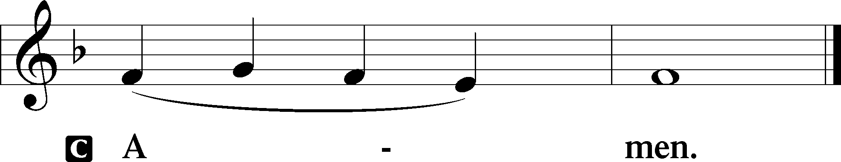

Agnus Dei John 1:29
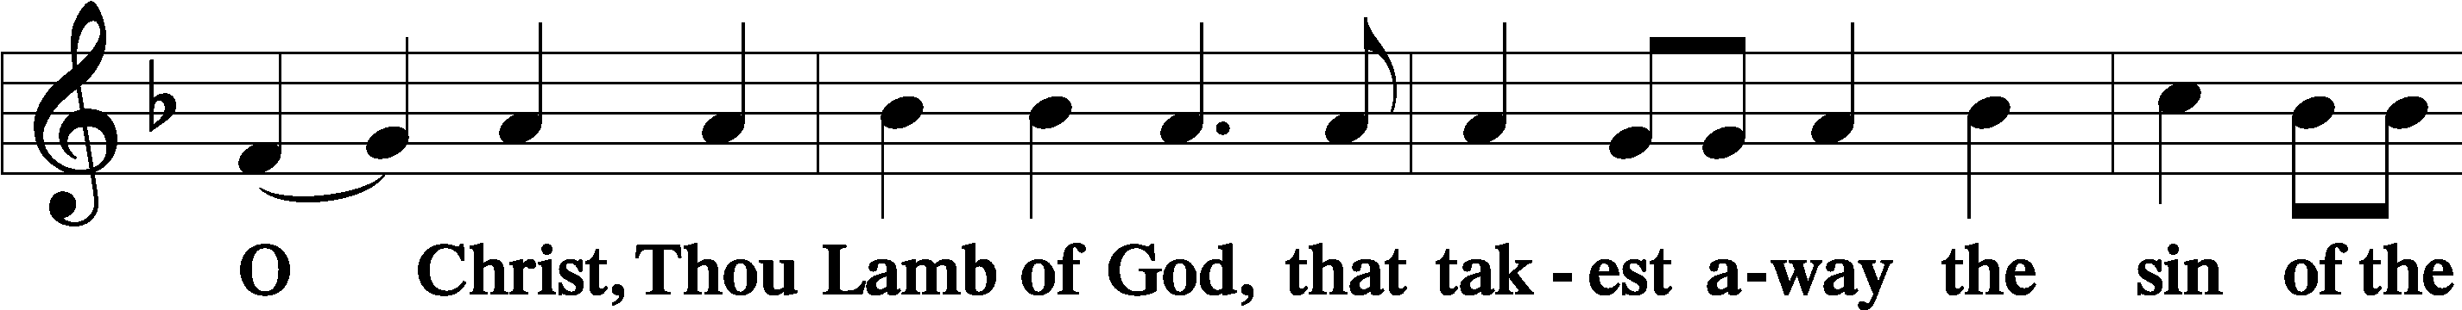
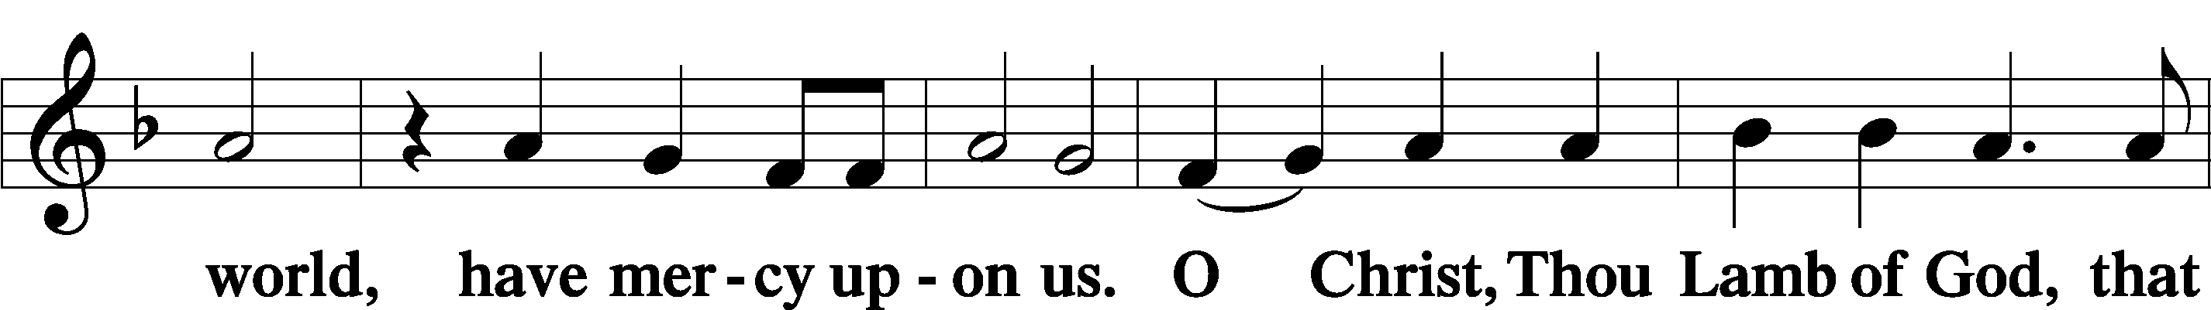
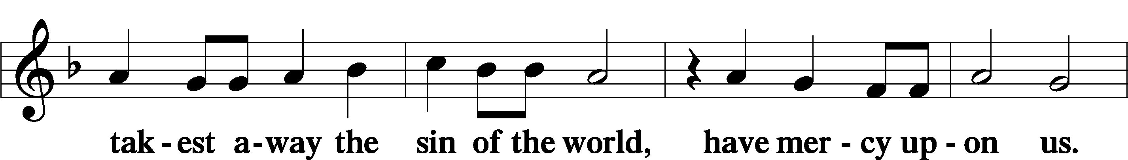
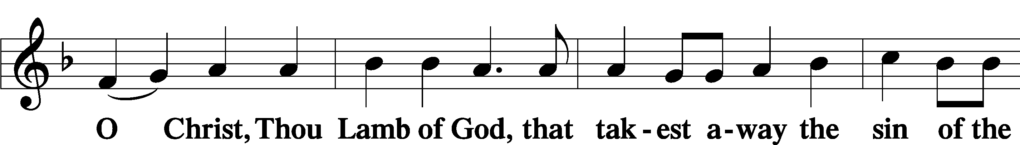
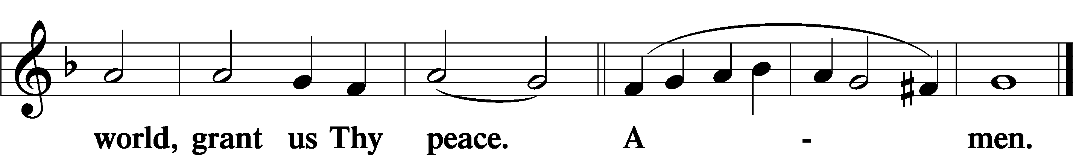
Sit

Distribution
The pastor and those who assist him receive the body and blood of Christ first and then distribute them to those who come to receive, saying:
Take, eat; this is the true body of our Lord and Savior Jesus Christ, given into death for your sins.
Amen.

Take, drink; this is the true blood of our Lord and Savior Jesus Christ, shed for the forgiveness of your sins.
Amen.

In dismissing the communicants, the following is said:
The Dismissal
P The body and blood of our Lord Jesus Christ strengthen and preserve you in body and soul to life everlasting. Depart T in peace.
C Amen.

Distribution Hymn: LSB #352 “Let the Earth Now Praise the Lord”

Distribution Hymn: LSB #936 “Sing Praise to the God of Israel”

Distribution Hymn: LSB #703 “How Can I Thank You, Lord”

Stand

Nunc Dimittis Luke 2:29–32
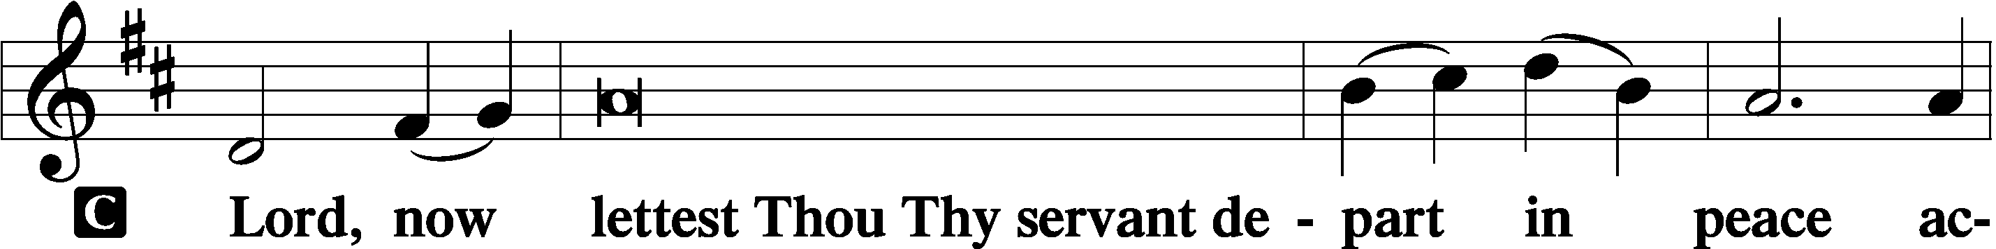
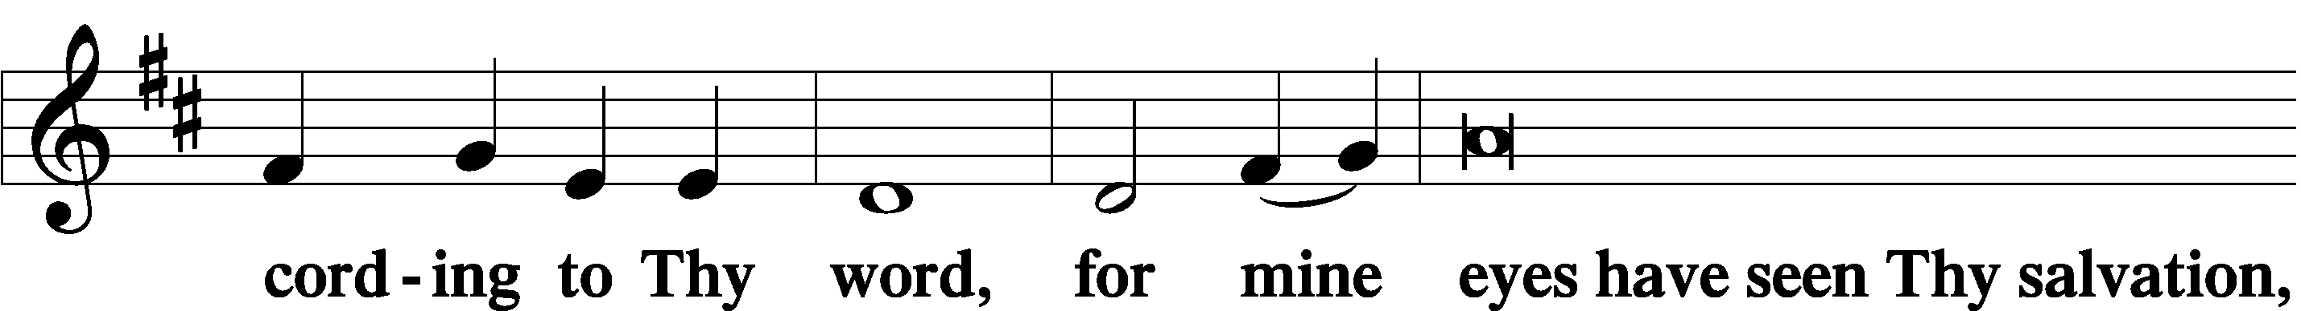
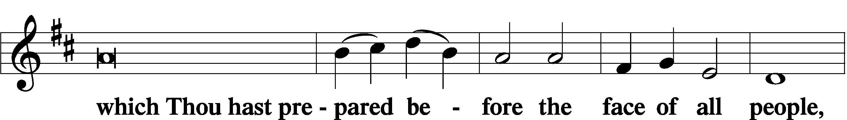
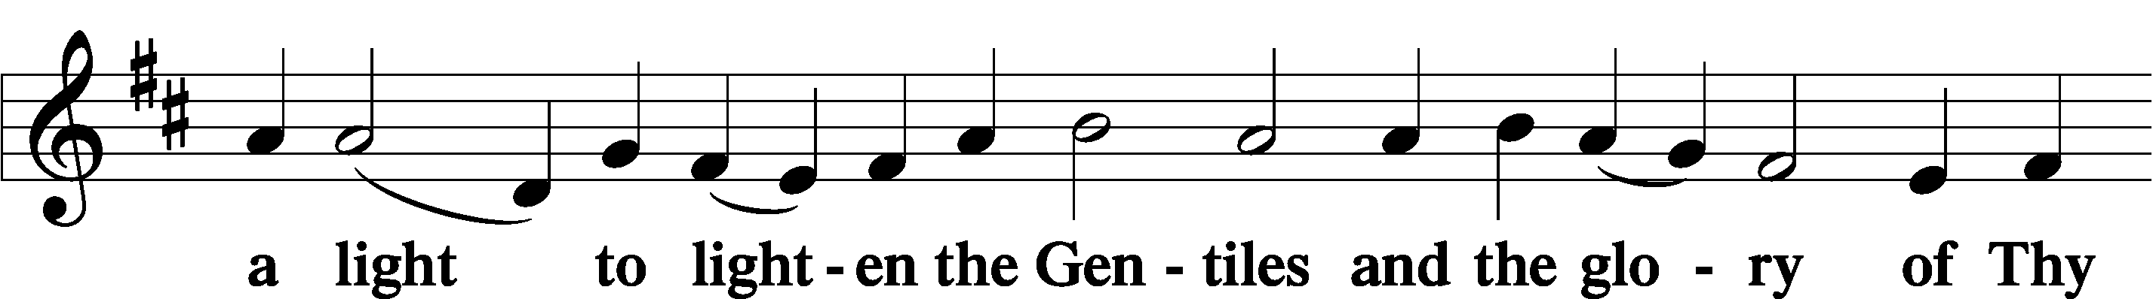
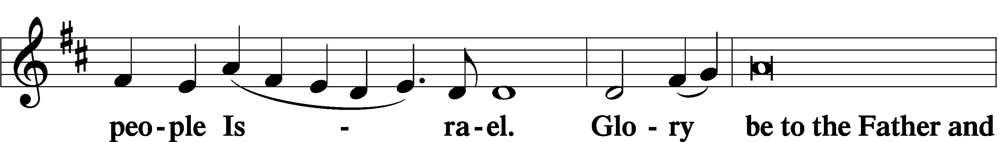
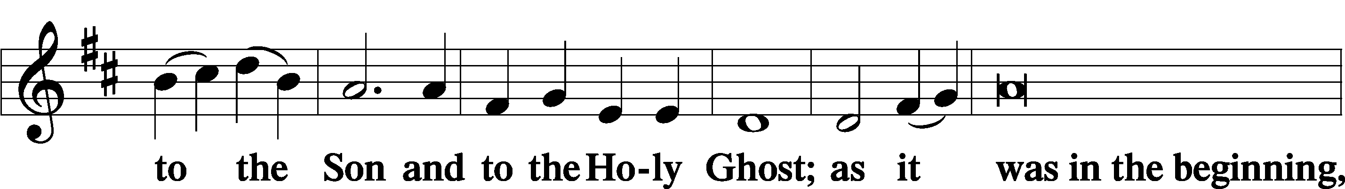
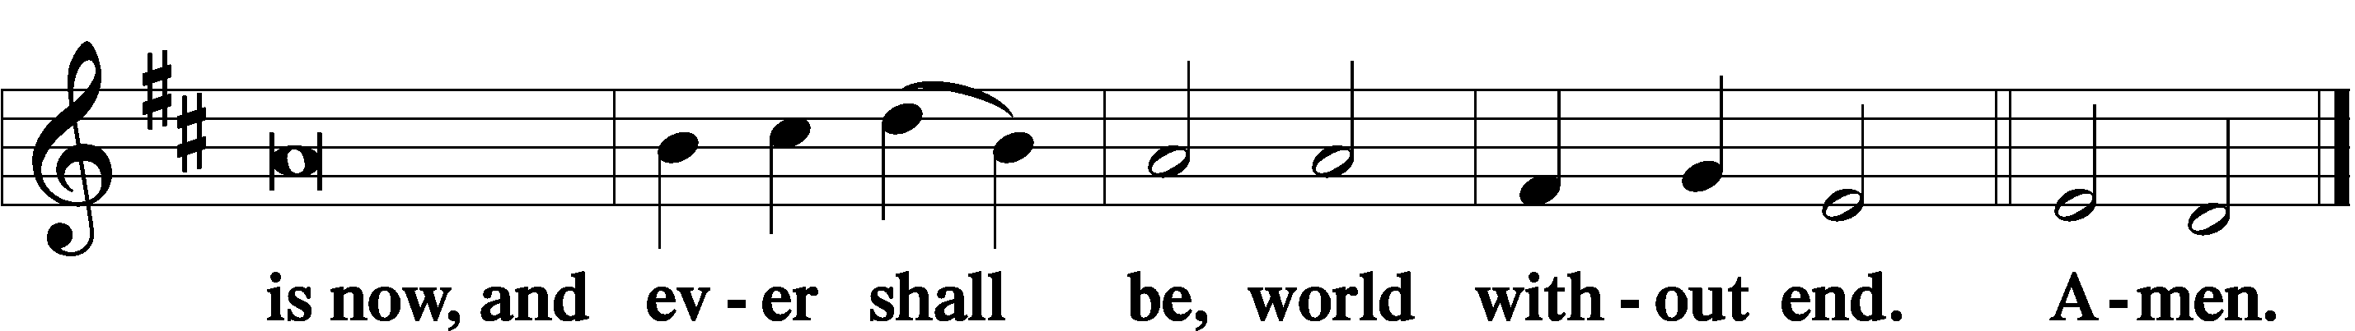

Thanksgiving Psalm 107:1
P O give thanks unto the Lord, for He is good,
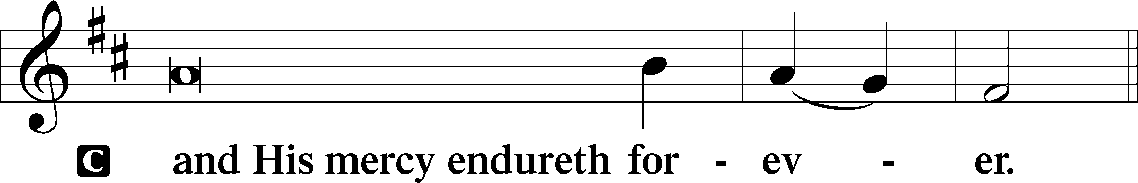

Post-Communion Collect
P Let us pray.
We give thanks to You, almighty God, that You have refreshed us through this salutary gift, and we implore You that of Your mercy You would strengthen us through the same in faith toward You and in fervent love toward one another; through Jesus Christ, Your Son, our Lord, who lives and reigns with You and the Holy Spirit, one God, now and forever.
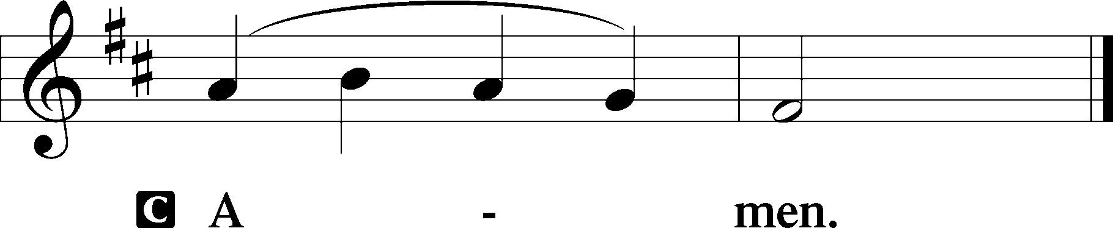

Salutation 2 Timothy 4:22
P The Lord be with you.
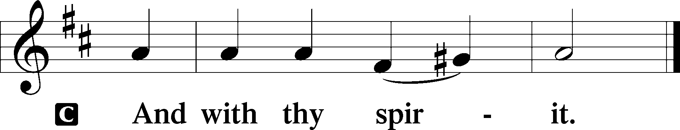

Benedicamus Psalm 103:1
P Bless we the Lord.
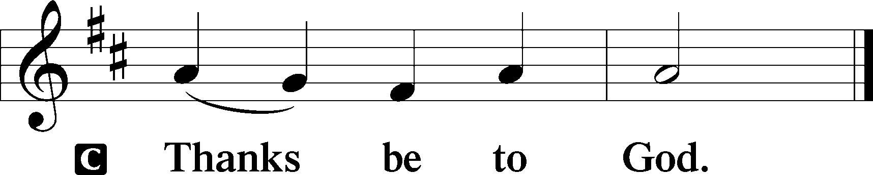

Benediction Numbers 6:24–26
P The Lord bless you and keep you.
The Lord make His face shine upon you and be gracious unto you.
The Lord lift up His countenance upon you and T give you peace.
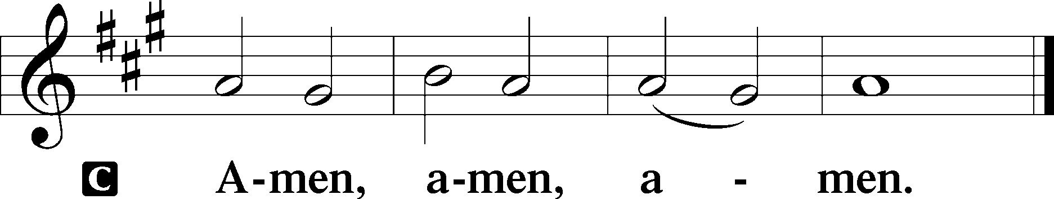

Closing Hymn: LSB #839 “O Christ, Our True and Only Light”

Silent prayer after worship: Lord Jesus, You have come as Savior not just to a few, but to the entire world. Cause the light of Your Word to shine forth in my life, that I may give glory to God and to proclaim to all that You are our Savior. Amen.
fffffffffffffffffffffffffffffffffff
Acknowledgments: Unless otherwise indicated, Scripture quotations are from the ESV® Bible (The Holy Bible, English Standard Version®), copyright © 2001 by Crossway, a publishing ministry of Good News Publishers. Used by permission. All rights reserved.
Created by Lutheran Service Builder © 2021 Concordia Publishing House.
fffffffffffffffffffffffffffffffffff
fffffffffffffffffffffffffffffffffff
In Loving Memory of Uncles Andy and Mike Petro: Michael A. Petro (Capital Campaign).
fffffffffffffffffffffffffffffffffff
Attendance: Saturday, December 31, 2022: 19
Sunday, January 1, 2023: 24
fffffffffffffffffffffffffffffffffff
Please join us downstairs following worship this morning for Coffee Fellowship. This month’s sponsors are the Deal Family. We are grateful for their sponsorship! If interested in sponsoring in 2023, please sign the sheet posted on the bulletin board in the narthex.
fffffffffffffffffffffffffffffffffff
Please take home poinsettias today! Unclaimed plants will be discarded.
SCHEDULE THROUGH JANUARY 15, 2023:

:

Today, following Worship, Fellowship Hall: Coffee Fellowship
7 pm, Fellowship Hall: AA Meeting
Tuesday, 7 pm, Library: Trustees’ Meeting
7-9 pm, Fellowship Hall: Penn-Ohio Singers
Wednesday, 7:30 pm, Downstairs: NA Meeting
Thursday, 9 am, Downstairs: Food Pantry
Saturday, 10 am, Sanctuary: Church Un-decorating
Next Sunday, 8 am, Fellowship Hall: Bible Study
9 am, Sanctuary: Divine Service
Following Worship, Fellowship Hall: Coffee Fellowship
7 pm, Fellowship Hall: AA Meeting
fffffffffffffffffffffffffffffffffff
THANK YOU FOR SERVING IN JANUARY: Elder: Jonathan Baisch; Altarware: Marie Flaugher and Altar Guild Volunteers
fffffffffffffffffffffffffffffffffff
Congratulations to our 2023 OFFICERS and BOARDS
President: Jonathan Baisch
Vice President: Matt Berent
Secretary: Diane Riefstahl
Treasurer: Rebekah Baisch
Financial Secretary: Dolores Fee
Trustees: Cheryl Fedele, Mike Flaugher, Michael Laird, Jesse Riffle, and Jeff Sutton

Auditors: Bev Chlpka, Marie Flaugher, Elizabeth Haenftling, Kati Laird, Jerome Thomas

Financial Staff: Rev. Art Baisch, Susan Bender, Nancy Robertson, and Linda Tomko
“Thank you” to our past Church servants
Elder: Barry Nelson
Trustees: Anson & Hank Holcroft
Financial Staff: Joani Rice
Our Stewardship of Treasures for the Lord:
In order to do the Lord’s work, we need $2,462.92 each week to meet our 2022 budget for general purposes and $80.00 for the SELC.
Figures for Saturday, December 24, 2022 (erroneously listed last Sunday as Dec. 21st)
General Fund: $965.00
SELC: $0.00
Capital Campaign: $35.00
Other: $500.00
Figures for Saturday, December 31, 2022
General Fund: $125.00
SELC: $20.00
Capital Campaign: $35.00
Figures for Sunday, January 1, 2023:
Unavailable at this time.

For online giving, check out https://www.saintspeterandpaul.net/online-giving.

fffffffffffffffffffffffffffffffffff
This morning is Food Pantry Sunday!
Financial donations may be put in a pew envelope and placed in the offering plate.
Thank you for participating in this outreach mission.
fffffffffffffffffffffffffffffffffff
Copies of the January issue of “The Rock and the Sword” newsletter are available on the sign-in table by Pastor Deal’s office and on the shelf in the narthex. Please be certain to note anticipated meeting dates (Church Council, Auditors, Trustees, and Voters Assembly) for 2023.
fffffffffffffffffffffffffffffffffff
A special “thanks” is extended to Joanne Lozier for filling in this morning as our organist. Joanne plays regularly for services at All Saints Lutheran Church in Slippery Rock.
fffffffffffffffffffffffffffffffffff
Sunday Bible Study resumes next Sunday at 8 am. We will be studying the 14 Minor Prophets. Please consider joining us!
Remember the following in Prayer…
~The Hurting and Healing: Amy, Gerald Arthur, Evelyn Baisch, Ellen Baron^{CA}, Lois Bortner^{CA}, John Burdette, Bev & Joe Chlpka, Kathleen Coughenour, Kim, Anna Mae Daris, Susan Davies, Tim Dudash, Millie Elavsky, Joseph Fleet, Eddy Furey, Tim Haenftling, Austin Hamilton, Anson Holcroft, Neil Huston, Darla Krajci, Barbara Kreske, Michelle Kelly^{CA}, Donna Kennedy, Gerald Krivosh, Jess Lavoie, Paul Lucas^{CA}, Sandy Marshall, Ernie Meszaros, David Nelson, Linda Parkany, Juanita Rentschler, Richard Reuning^{CA}, Nancy Robertson^{CA}, Viola Sakony, Marty Scott, Kara, Fred Tonty, Angela Weser^{CA}, and Ruth Wolf.
~The Homebound: Rudy & Jean Tomko, Betty Wolf, and Ed & Millie Zachar.
~Celebrating: Birthday: Gerald Arthur (01.12).
~Serving in the Military: Curtis Sinewe and Joshua Solyan.
~Community & World Needs: Those suffering from or affected by the coronavirus; those suffering due to the conflict between Ukraine and Russia; those suffering from loss and dislocation because weather disasters; those suffering from addiction and their families; Local, State, and National Government Leaders; safety for all Police Officers, Firefighters, & First Responders; the unemployed; our First Quarter Local Mission: Sts. Peter & Paul’s Community Day 2023.
*CA represents cancer.
fffffffffffffffffffffffffffffffffff
Bible Memory Verses ~ Week of January 8th:
For Adults: The Lord is my light and my salvation; whom shall I fear? The Lord is the stronghold of my life; of whom shall I be afraid? Psalm 27:1
For Children: We have seen his glory, glory as of the only Son from the Father. John 1:14
fffffffffffffffffffffffffffffffffff
It’s time to prepare for the 2022 Annual Report! If you are responsible for a report, a copy of your 2021 report should have been emailed to you. Please email 2022 information to church@saintspeterandpaul.net on or before TOMORROW, Monday, January 9th. Material will be formatted for you. See Diane with any questions.
fffffffffffffffffffffffffffffffffff
Here to Serve

Pastor………………………………………………...……………Rev. Jacob Deal
E-mail …………………………….……pastordeal@saintspeterandpaul.net
Phone Number……………………..…………………724-347-3620 (Option 2)
Church Office………………………..…………………724-347-3620 (Option 3)
Website …………………………………………www.saintspeterandpaul.net
Secretary…………………………………………………………Diane Riefstahl
E-mail ………………………………………church@saintspeterandpaul.net
Website …………………………………………www.saintspeterandpaul.net
Food Pantry: Please leave message……………724-347-3620 (Option 3)
AA Contact: Steve………………………………………………..…724-813-2358
NA Contact: Larry………………………………………………..724-977-8733
Choir Director………………………………………………………Chris Nelson
Congregation President……………………………………Jonathan Baisch
Church Elder …………………………………………...…… Jonathan Baisch
fffffffffffffffffffffffffffffffffff
If needing to get into the church building during the week, please phone first to make certain someone is here to let you in.

