Sts. Peter & Paul
Evangelical Lutheran Church
Lutheran Church-Missouri Synod
Founded-1917

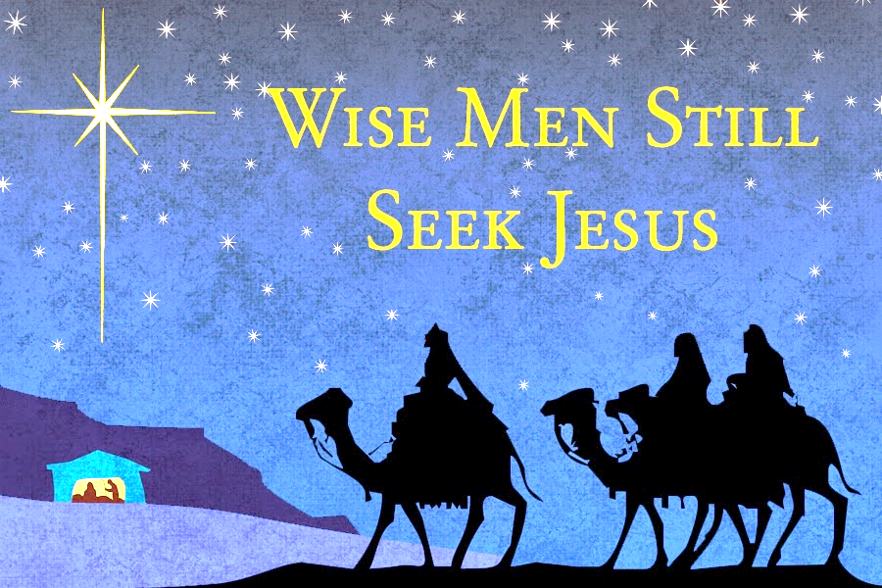

January 6, 2023

699 Stambaugh Avenue
Sharon, Pennsylvania 16146

“I was glad when they said to me,
Let us go to the house of the LORD!”
Psalm 122:1
Sts. Peter & Paul Evangelical Lutheran Church, LC-MS
THE EPIPHANY OF OUR LORD
January 6, 2023

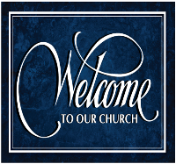
A special welcome to our guests this day! If you would like more information about The Lutheran Church - Missouri Synod, or this congregation, please speak with Pastor Deal or an Elder after the service.
Members & Guests: Don’t be embarrassed if your children make noise during the worship service, all children do. We encourage families to worship together but, if you feel the need, there are pews in the rear of the Church which are reserved for young families on both sides of the sanctuary. There is also a quiet room available to you during our service which is located down the hallway past the offices on the right side of the church as well as a children’s area in the Fellowship Hall where you are able to follow along with the service.

Today’s service includes the Sacrament of Holy Communion. If during this past year, you have not worshipped with us and been communed, we respectfully ask that you do not partake of this sacrament this day before first speaking with Pastor Deal.
If visiting from a sister congregation of the LC-MS and are in good standing, please inform Pastor Deal of your desire to commune prior to the service.
If wishing to receive a blessing during communion, please approach with your arms crossed.

CONTACT INFORMATION
Pastor Deal: pastordeal@saintspeterandpaul.net or 724-347-3620 (opt. 2)
Church Office: church@saintspeterandpaul.net or 724-347-3620 (opt. 3)

Silent prayer before worship: Heavenly Father, give me a humble and thankful heart so that I may worship You not just with my lips, but with my heart, soul and mind. In Jesus’ name. Amen.

Confession and Absolution

Opening Hymn: LSB #367 “Angels from the Realms of Glory”

Stand

The sign of the cross may be made by all in remembrance of their Baptism.

Invocation
P In the name of the Father and of the T Son and of the Holy Spirit.
C Amen.

Exhortation Hebrews 10:22; Psalm 124:8; Psalm 32:5
P Beloved in the Lord! Let us draw near with a true heart and confess our sins unto God our Father, beseeching Him in the name of our Lord Jesus Christ to grant us forgiveness.

P Our help is in the name of the Lord,
C who made heaven and earth.
P I said, I will confess my transgressions unto the Lord,
C and You forgave the iniquity of my sin.

Silence for reflection on God’s Word and for self-examination.

Confession of Sins
P O almighty God, merciful Father,
C I, a poor, miserable sinner, confess unto You all my sins and iniquities with which I have ever offended You and justly deserved Your temporal and eternal punishment. But I am heartily sorry for them and sincerely repent of them, and I pray You of Your boundless mercy and for the sake of the holy, innocent, bitter sufferings and death of Your beloved Son, Jesus Christ, to be gracious and merciful to me, a poor, sinful being.

Absolution [John 20:19–23]
P Upon this your confession, I, by virtue of my office, as a called and ordained servant of the Word, announce the grace of God unto all of you, and in the stead and by the command of my Lord Jesus Christ I forgive you all your sins in the name of the Father and of the T Son and of the Holy Spirit.
C Amen.

Service of the Word

Introit Psalm 72:1–2, 10–11; antiphon: Liturgical Text
Behold the Lord, the rul- | er, has come,*
and the kingdom and the power and the glory are | in his hand.
Give the king your justice, | O God,*
and your righteousness to the | royal son!
May he judge your people with | righteousness,*
and your poor with | justice!
May the kings of Tarshish and of the coastlands render him | tribute;*
may the kings of Sheba and Seba | bring gifts!
May all kings fall down be- | fore him,*
all nations | serve him!
Behold the Lord, the rul- | er, has come,*
and the kingdom and the power and the glory are | in his hand.

Gloria Patri
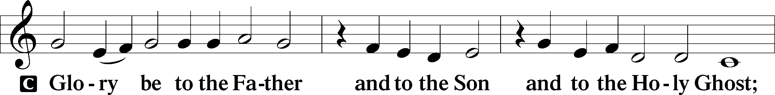
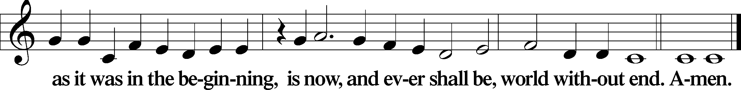
Kyrie Mark 10:47
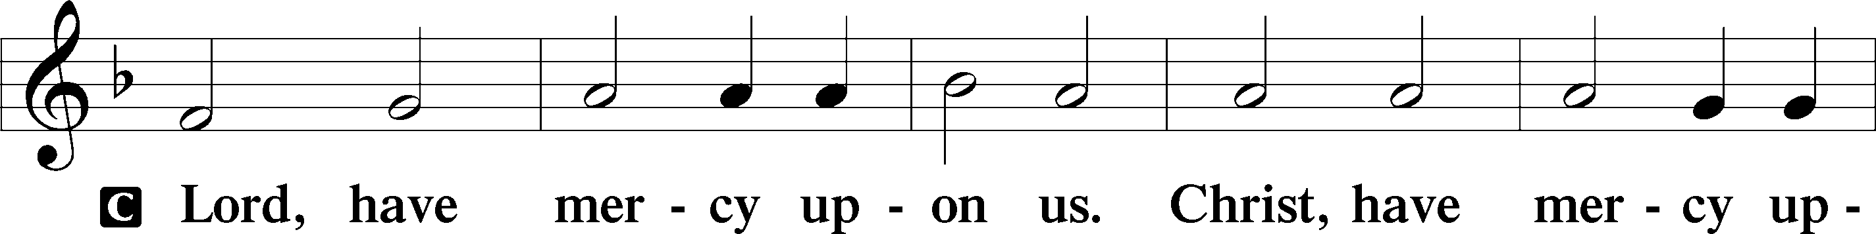
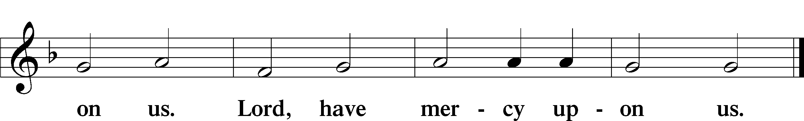

Gloria in Excelsis Luke 2:14; John 1:29
P Glory be to God on high:
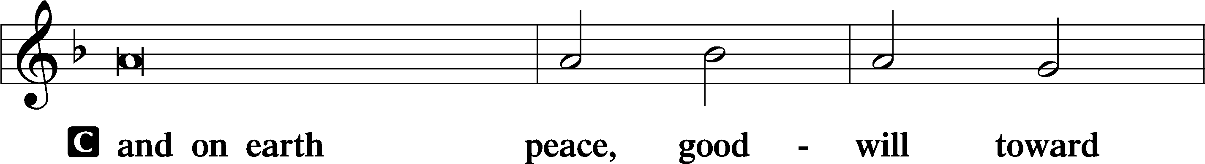
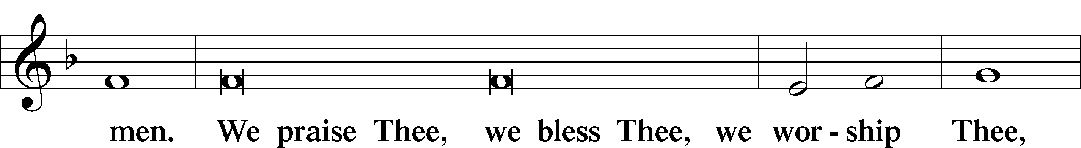
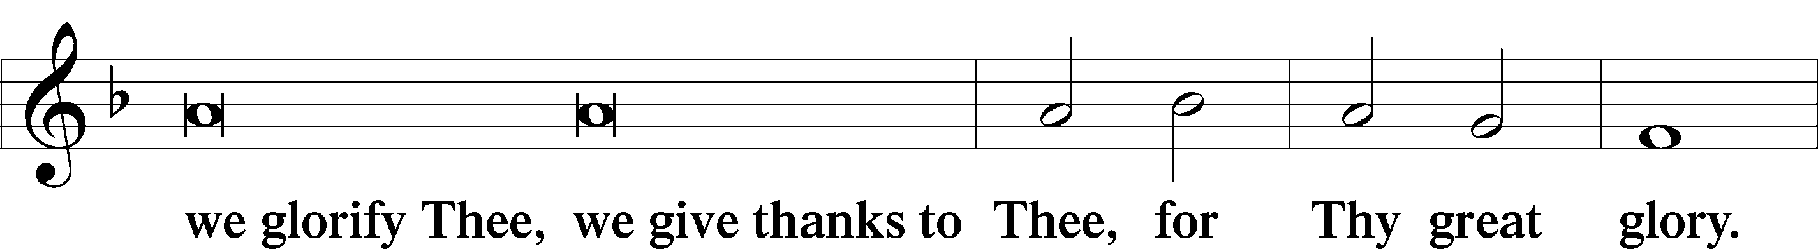
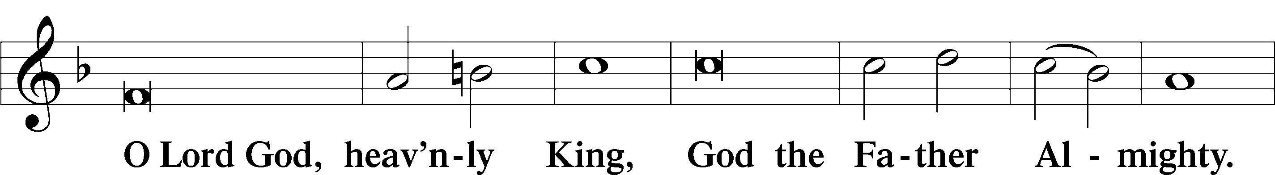
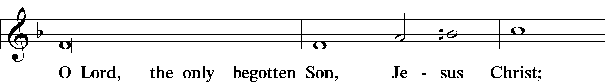
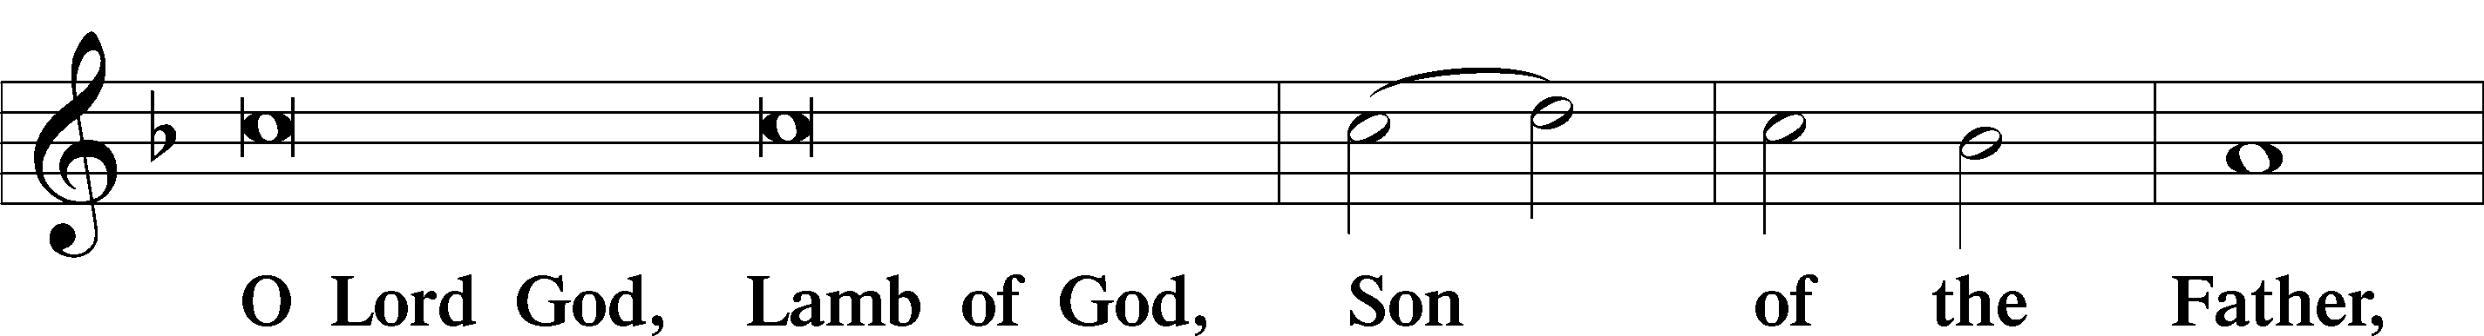
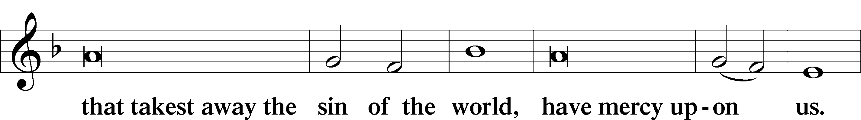
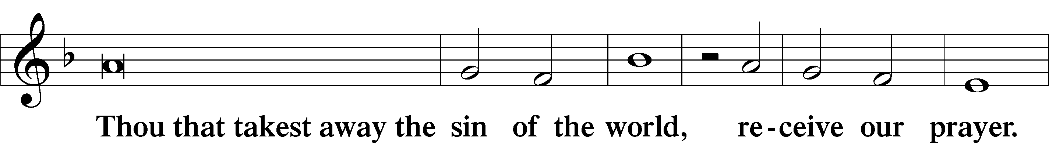
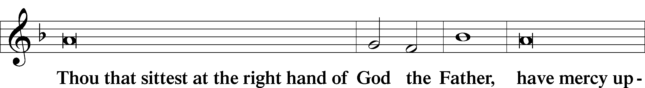
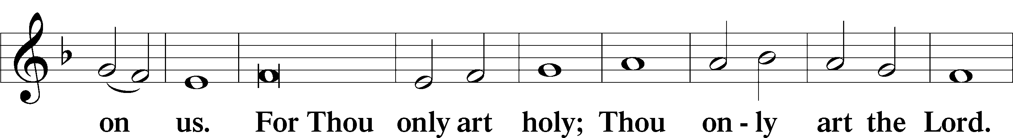
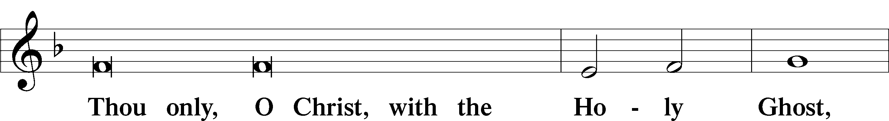
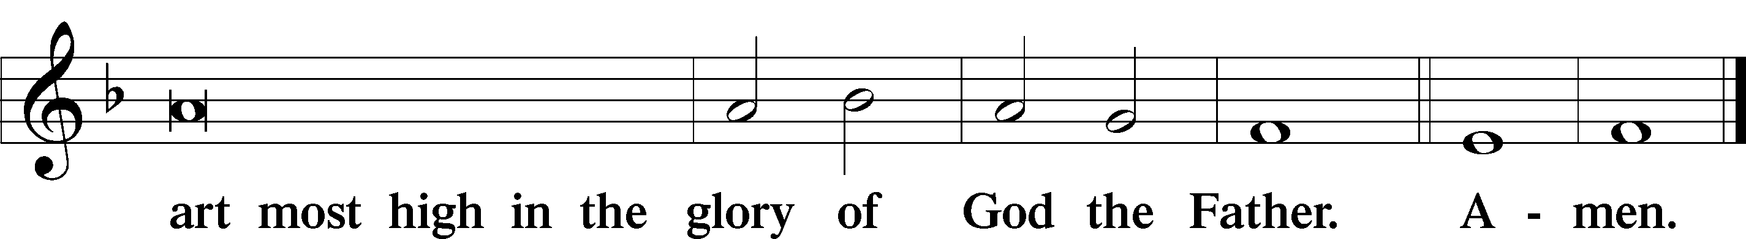

Salutation and Collect of the Day: Epiphany
P The Lord be with you.
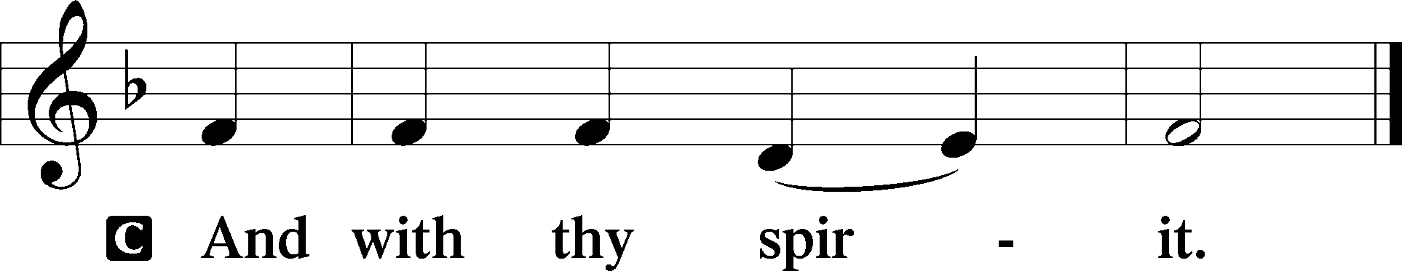

P Let us pray.
O God, by the leading of a star You made known Your only-begotten Son to the Gentiles. Lead us, who know You by faith, to enjoy in heaven the fullness of Your divine presence; through the same Jesus Christ, our Lord, who lives and reigns with You and the Holy Spirit, one God, now and forever.

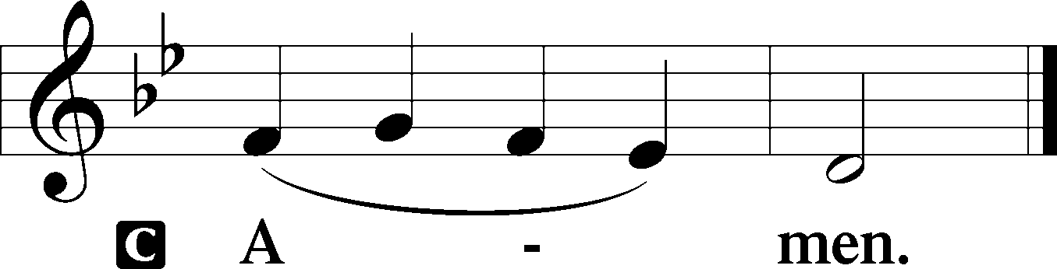
Sit

Prophecy: Isaiah 60:1–6 (NKJV)
Thus says the Lord God: Arise, shine; for your light has come!
And the glory of the Lord is risen upon you.
For behold, the darkness shall cover the earth,
And deep darkness the people;
But the Lord will arise over you,
And His glory will be seen upon you.
The Gentiles shall come to your light,
And kings to the brightness of your rising.

Lift up your eyes all around, and see:
They all gather together, they come to you;
Your sons shall come from afar,
And your daughters shall be nursed at your side.
Then you shall see and become radiant,
And your heart shall swell with joy;
Because the abundance of the sea shall be turned to you,
The wealth of the Gentiles shall come to you.
The multitude of camels shall cover your land,
The dromedaries of Midian and Ephah;
All those from Sheba shall come;
They shall bring gold and incense,
And they shall proclaim the praises of the Lord.

P This is the Word of the Lord.
C Thanks be to God.

Gradual Isaiah 60:6b, 1
Those from She- | ba shall come.*
They shall bring gold and frankincense, and shall bring good news, the praises | of the Lord.
Arise, shine, for your | light has come,*
and the glory of the Lord has risen up- | on you.
Epistle: Ephesians 3:2–12 (NKJV)
Brethren: You have heard of the dispensation of the grace of God which was given to me for you, how that by revelation He made known to me the mystery (as I have briefly written already, by which, when you read, you may understand my knowledge in the mystery of Christ), which in other ages was not made known to the sons of men, as it has now been revealed by the Spirit to His holy apostles and prophets: that the Gentiles should be fellow heirs, of the same body, and partakers of His promise in Christ through the gospel, of which I became a minister according to the gift of the grace of God given to me by the effective working of His power.
To me, who am less than the least of all the saints, this grace was given, that I should preach among the Gentiles the unsearchable riches of Christ, and to make all see what is the fellowship of the mystery, which from the beginning of the ages has been hidden in God who created all things through Jesus Christ; to the intent that now the manifold wisdom of God might be made known by the church to the principalities and powers in the heavenly places, according to the eternal purpose which He accomplished in Christ Jesus our Lord, in whom we have boldness and access with confidence through faith in Him.

P This is the Word of the Lord.
C Thanks be to God.

Stand

Verse Matthew 2:2b
Alleluia. We saw his star when it rose and have come to worship him. Alleluia.

Alleluia
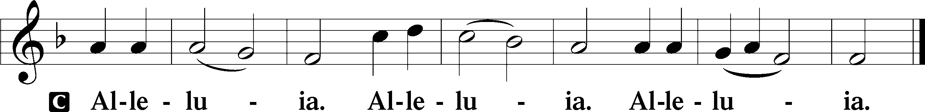

Holy Gospel: Matthew 2:1–12 (NKJV)
P The Holy Gospel according to St. Matthew, the second chapter.
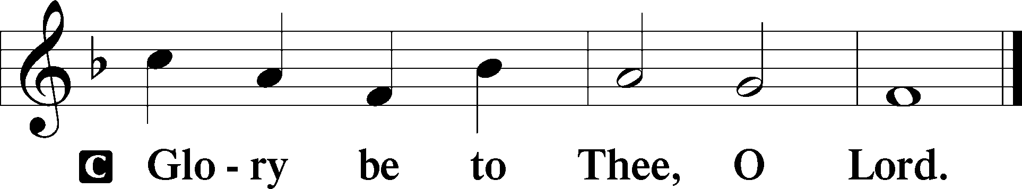
After Jesus was born in Bethlehem of Judea in the days of Herod the king, behold, wise men from the East came to Jerusalem, saying, “Where is He who has been born King of the Jews? For we have seen His star in the East and have come to worship Him.”
When Herod the king heard this, he was troubled, and all Jerusalem with him. And when he had gathered all the chief priests and scribes of the people together, he inquired of them where the Christ was to be born.
So they said to him, “In Bethlehem of Judea, for thus it is written by the prophet:
‘But you, Bethlehem, in the land of Judah,
Are not the least among the rulers of Judah;
For out of you shall come a Ruler
Who will shepherd My people Israel.’ ”
Then Herod, when he had secretly called the wise men, determined from them what time the star appeared. And he sent them to Bethlehem and said, “Go and search carefully for the young Child, and when you have found Him, bring back word to me, that I may come and worship Him also.”
When they heard the king, they departed; and behold, the star which they had seen in the East went before them, till it came and stood over where the young Child was. When they saw the star, they rejoiced with exceedingly great joy. And when they had come into the house, they saw the young Child with Mary His mother, and fell down and worshiped Him. And when they had opened their treasures, they presented gifts to Him: gold, frankincense, and myrrh.
Then, being divinely warned in a dream that they should not return to Herod, they departed for their own country another way.

P This is the Gospel of the Lord.
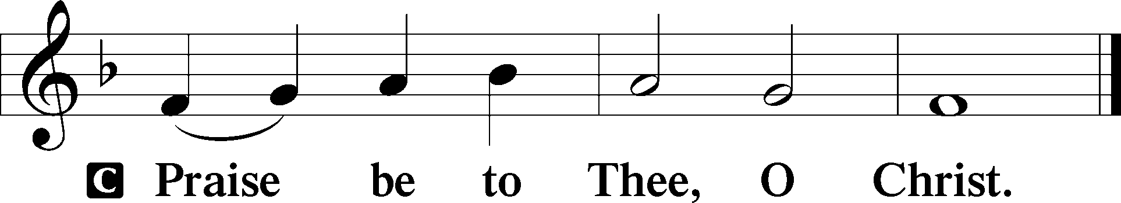

Nicene Creed
C I believe in one God,
the Father Almighty,
maker of heaven and earth
and of all things visible and invisible.

And in one Lord Jesus Christ,
the only-begotten Son of God,
begotten of His Father before all worlds,
God of God, Light of Light,
very God of very God,
begotten, not made,
being of one substance with the Father,
by whom all things were made;
who for us men and for our salvation came down from heaven
and was incarnate by the Holy Spirit of the virgin Mary
and was made man;
and was crucified also for us under Pontius Pilate.
He suffered and was buried.
And the third day He rose again according to the Scriptures
and ascended into heaven
and sits at the right hand of the Father.
And He will come again with glory to judge both the living and the dead,
whose kingdom will have no end.

And I believe in the Holy Spirit,
the Lord and giver of life,
who proceeds from the Father and the Son,
who with the Father and the Son together is worshiped and glorified,
who spoke by the prophets.
And I believe in one holy Christian and apostolic Church,
I acknowledge one Baptism for the remission of sins,
and I look for the resurrection of the dead
and the life T of the world to come. Amen.
Sit

Hymn of the Day: LSB #395 “O Morning Star, How Fair and Bright”

Sermon

Stand

Prayer of the Church

Offertory Psalm 51:10–12
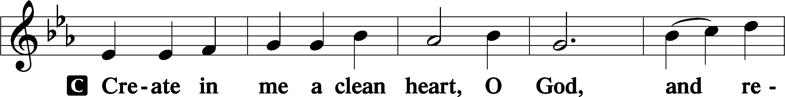
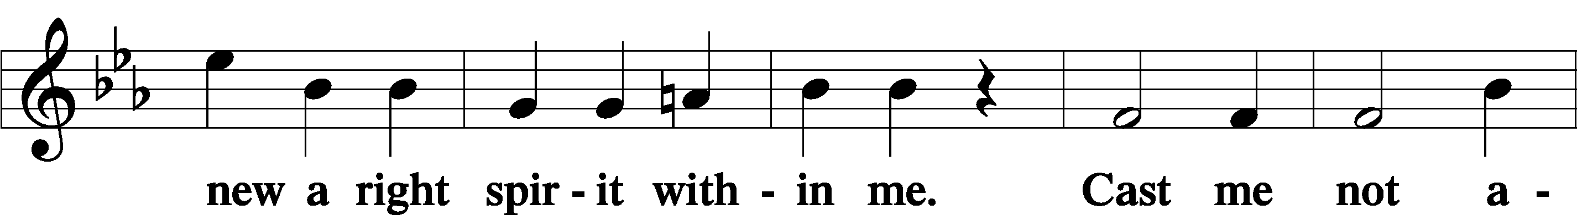
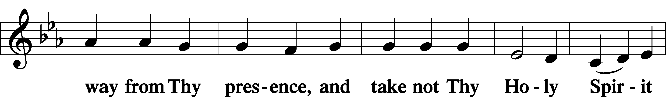
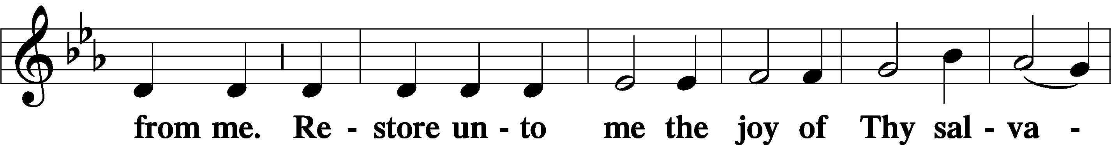
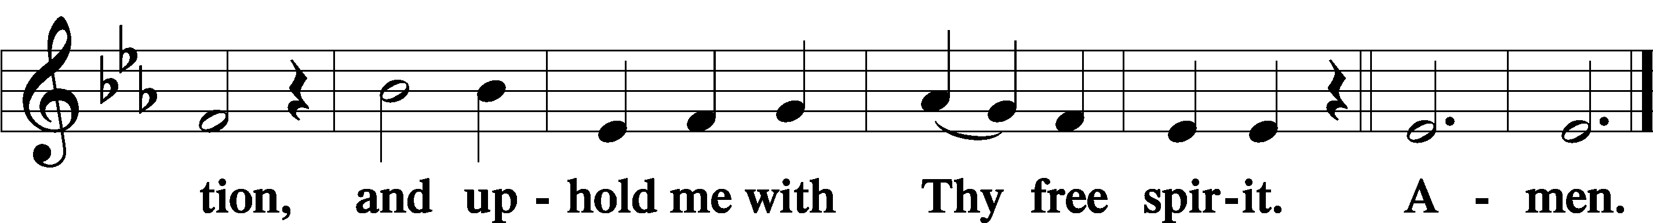
Sit
Preparatory Hymn: LSB #372 “O Jesus Christ, Thy Manger Is”

Stand
Service of the Sacrament

Preface 2 Timothy 4:22; Colossians 3:1 Psalm 136
P The Lord be with you.
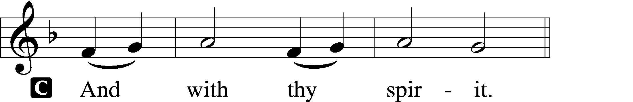

P Lift up your hearts.
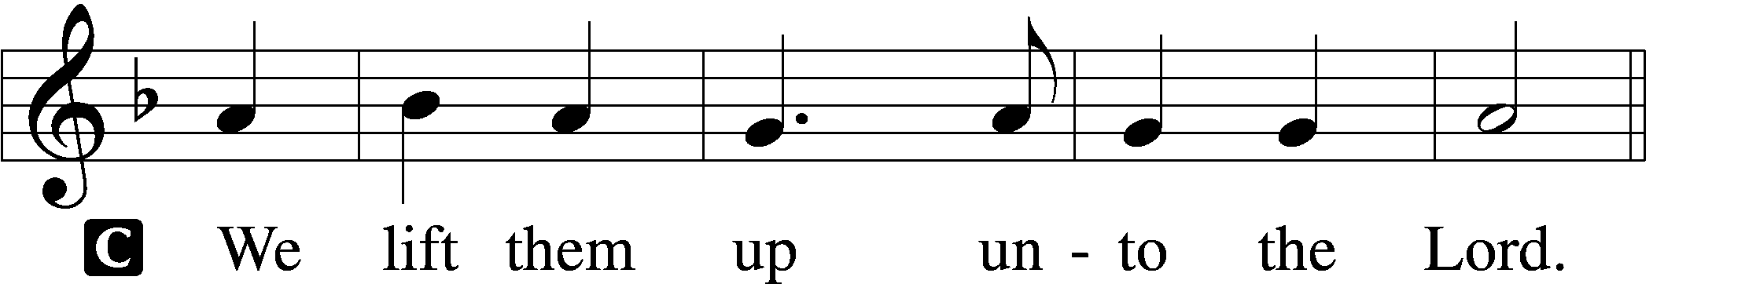

P Let us give thanks unto the Lord, our God.
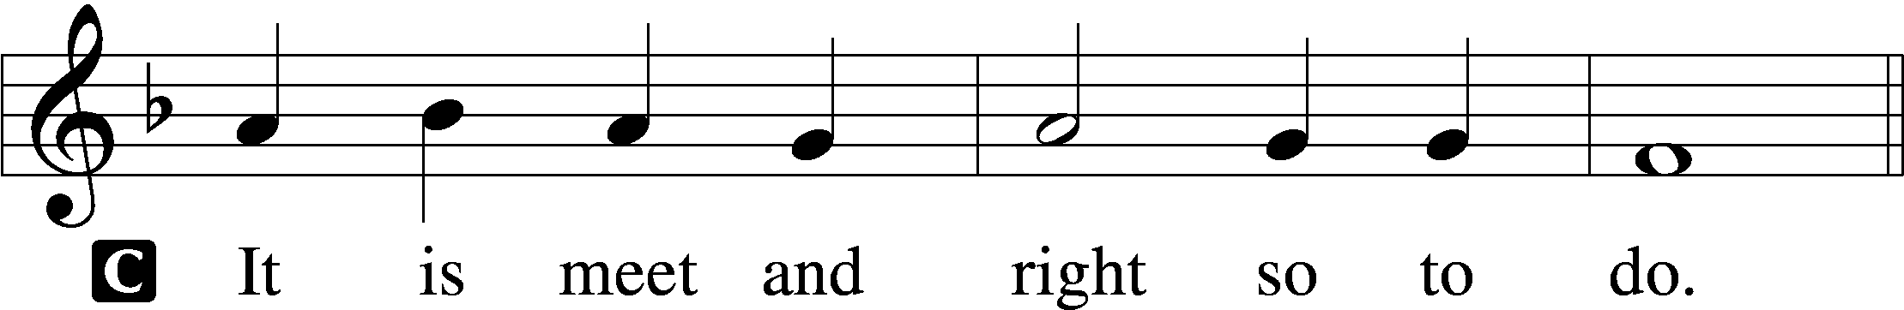

Proper Preface (Abbreviated) LSB 194
P It is truly meet, right, and salutary . . . evermore praising You and saying:

Sanctus Isaiah 6:3; Matthew 21:9
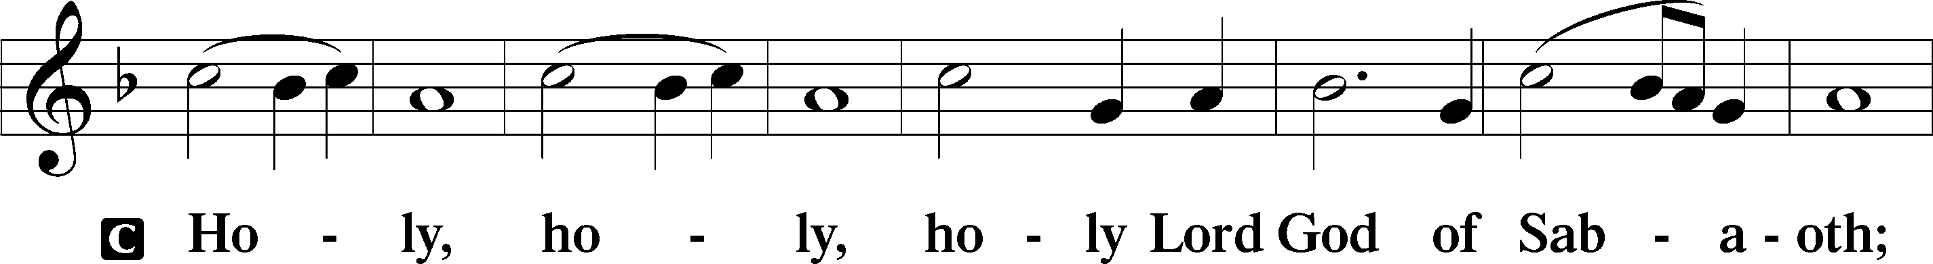
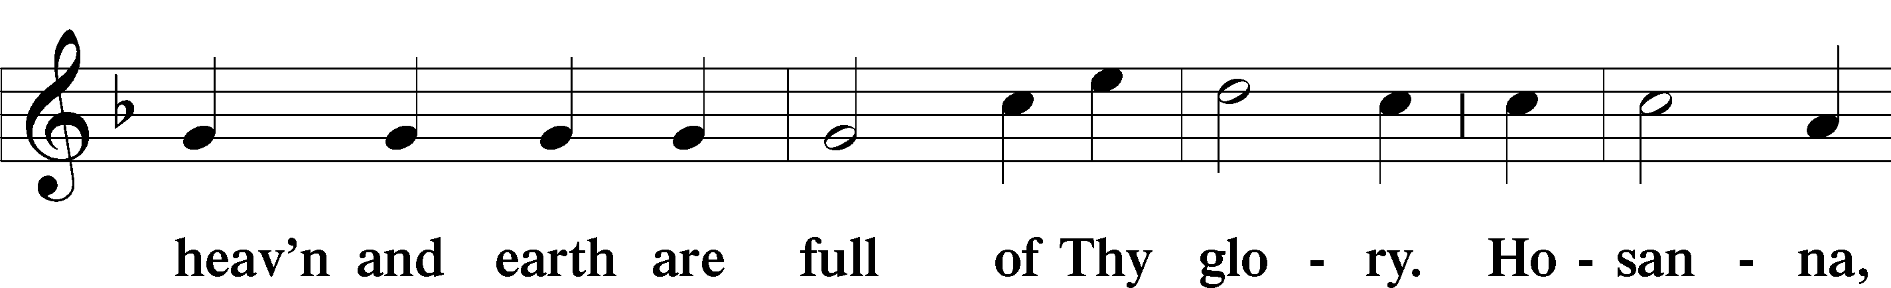
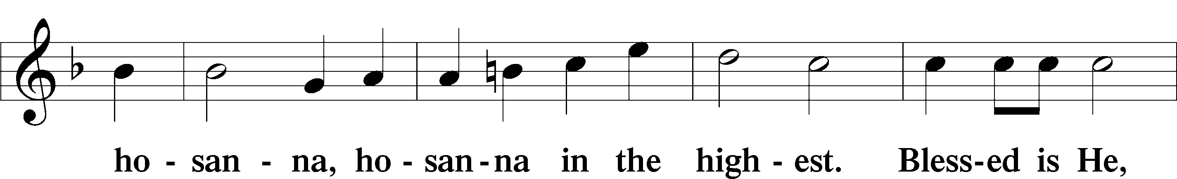
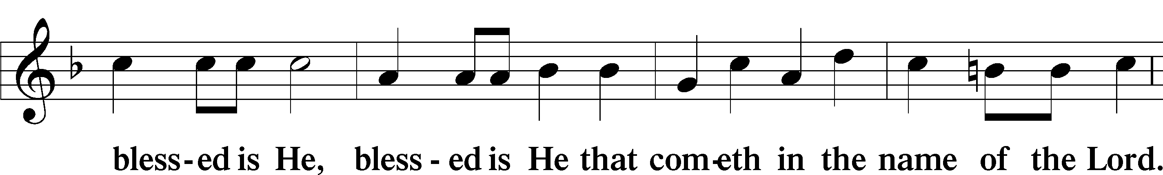
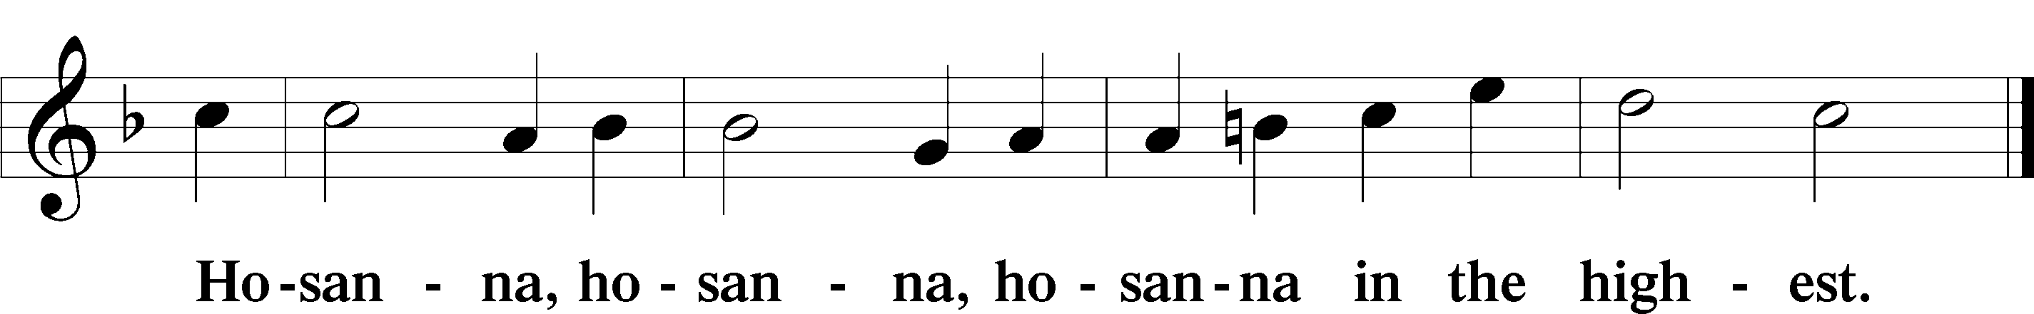

Lord’s Prayer Matthew 6:9–13
C Our Father who art in heaven,
hallowed be Thy name,
Thy kingdom come,
Thy will be done on earth as it is in heaven;
give us this day our daily bread;
and forgive us our trespasses as we forgive those who trespass against us;
and lead us not into temptation,
but deliver us from evil.
For Thine is the kingdom and the power and the glory forever and ever. Amen.

The Words of Our Lord Matthew 26:26–28; Mark 14:22–24; Luke 22:19–20; 1 Corinthians 11:23–25
P Our Lord Jesus Christ, on the night when He was betrayed, took bread, and when He had given thanks, He broke it and gave it to the disciples and said: “Take, eat; this is My T body, which is given for you. This do in remembrance of Me.”

In the same way also He took the cup after supper, and when He had given thanks, He gave it to them, saying: “Drink of it, all of you; this cup is the new testament in My T blood, which is shed for you for the forgiveness of sins. This do, as often as you drink it, in remembrance of Me.”

Pax Domini John 20:19
P The peace of the Lord be with you always.
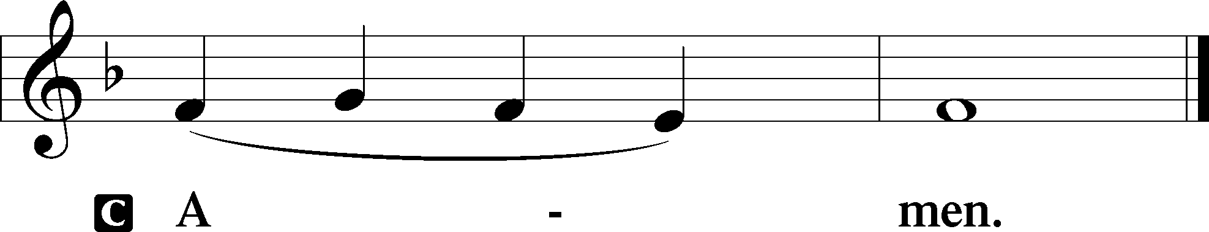

Agnus Dei John 1:29
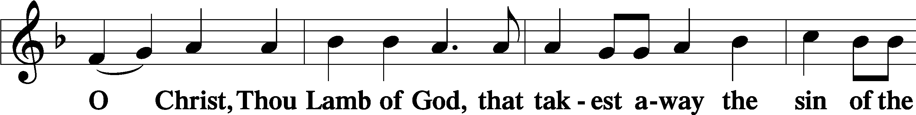
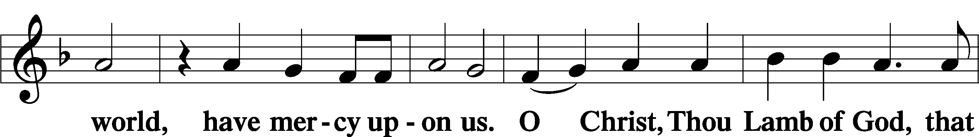
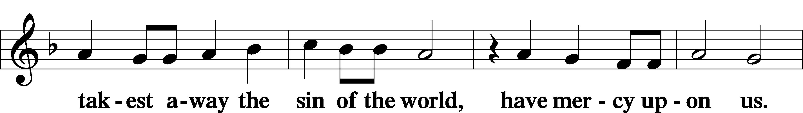
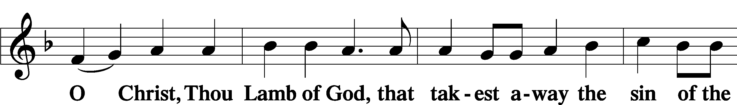
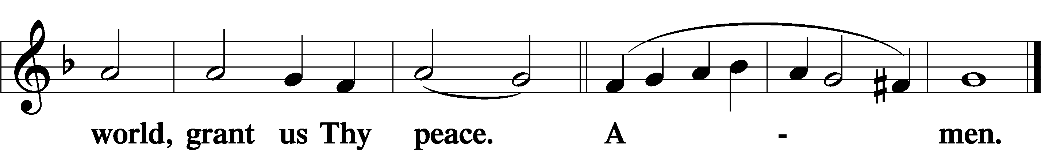
Sit

Distribution
The pastor and those who assist him receive the body and blood of Christ first and then distribute them to those who come to receive, saying:

Take, eat; this is the true body of our Lord and Savior Jesus Christ, given into death for your sins.
Amen.

Take, drink; this is the true blood of our Lord and Savior Jesus Christ, shed for the forgiveness of your sins.
Amen.

In dismissing the communicants, the following is said:
The Dismissal
P The body and blood of our Lord Jesus Christ strengthen and preserve you in body and soul to life everlasting. Depart T in peace.
C Amen.

Distribution Hymn: LSB #398 “Hail to the Lord’s Anointed”

Distribution Hymn: LSB #874 “O Splendor of God’s Glory Bright”

Distribution Hymn: LSB #703 “How Can I Thank You, Lord”

Nunc Dimittis Luke 2:29–32
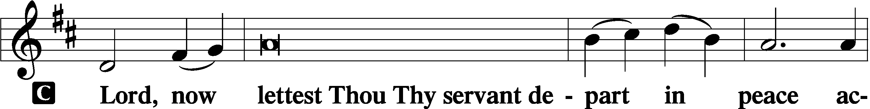
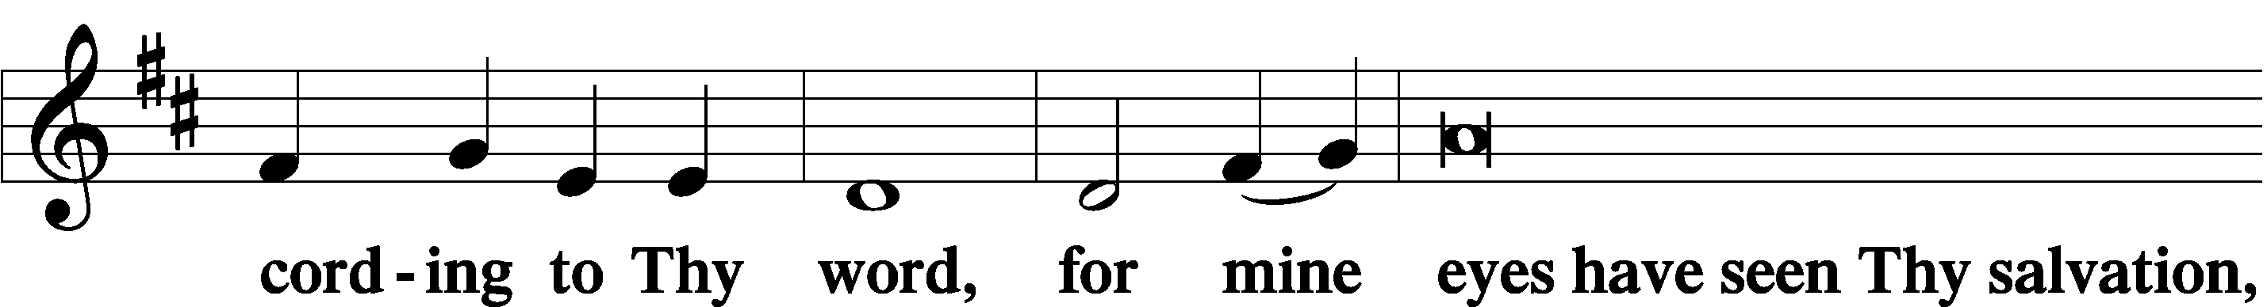
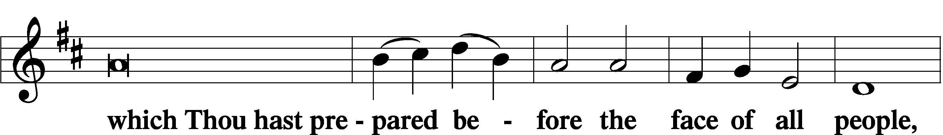
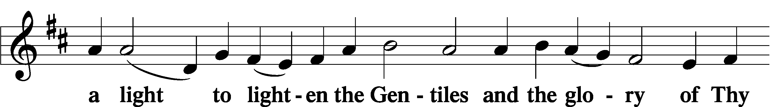
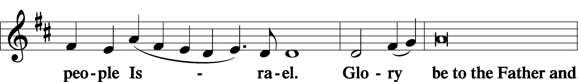
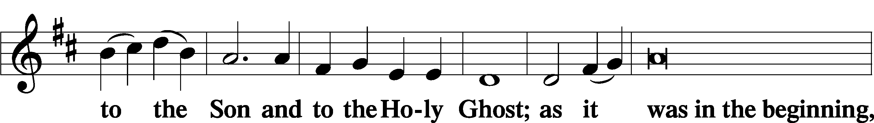
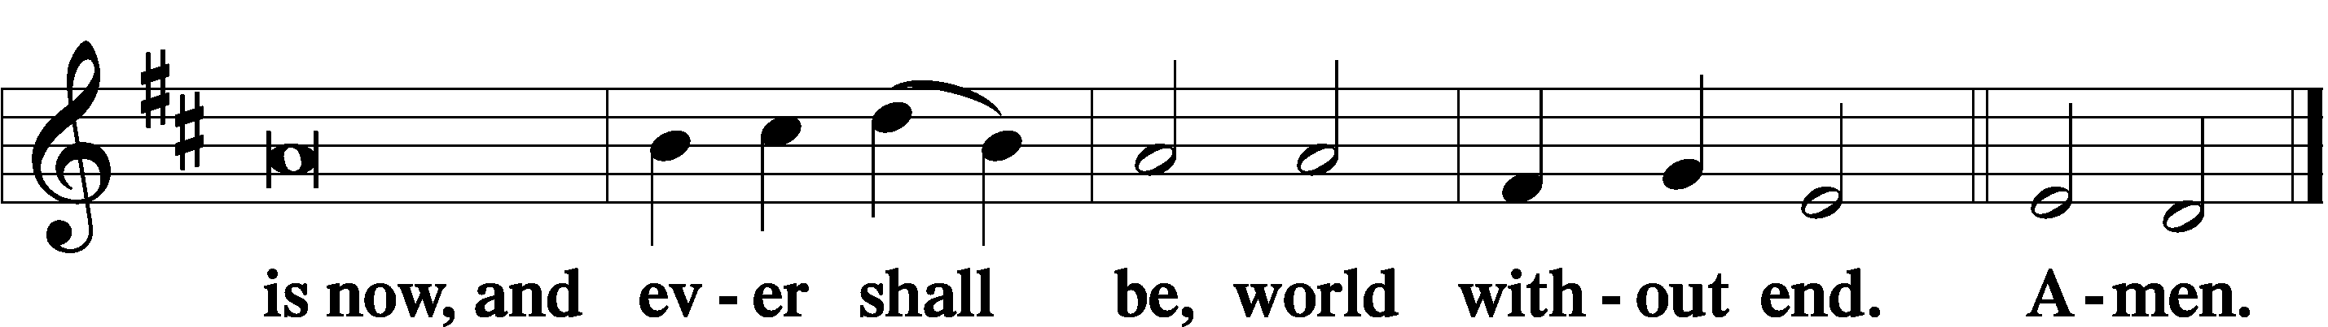

Thanksgiving Psalm 107:1
P O give thanks unto the Lord, for He is good,
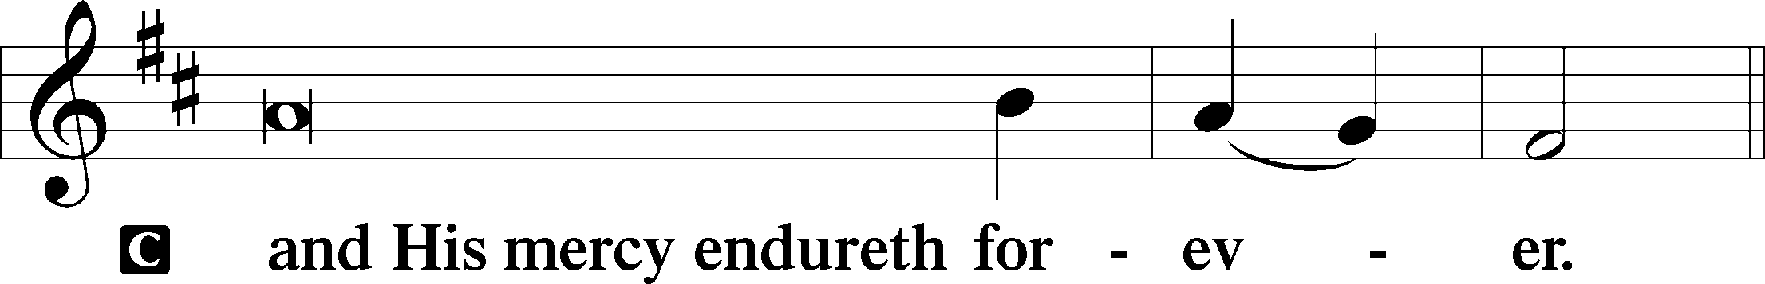

Post-Communion Collect
P Let us pray.
We give thanks to You, almighty God, that You have refreshed us through this salutary gift, and we implore You that of Your mercy You would strengthen us through the same in faith toward You and in fervent love toward one another; through Jesus Christ, Your Son, our Lord, who lives and reigns with You and the Holy Spirit, one God, now and forever.
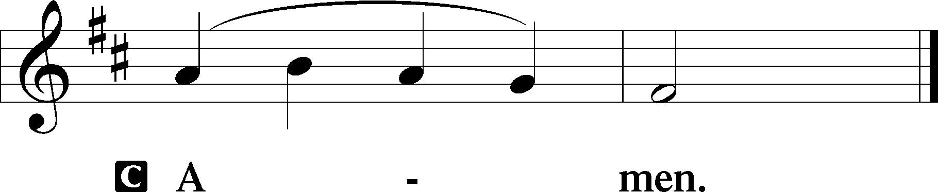

Salutation 2 Timothy 4:22
P The Lord be with you.
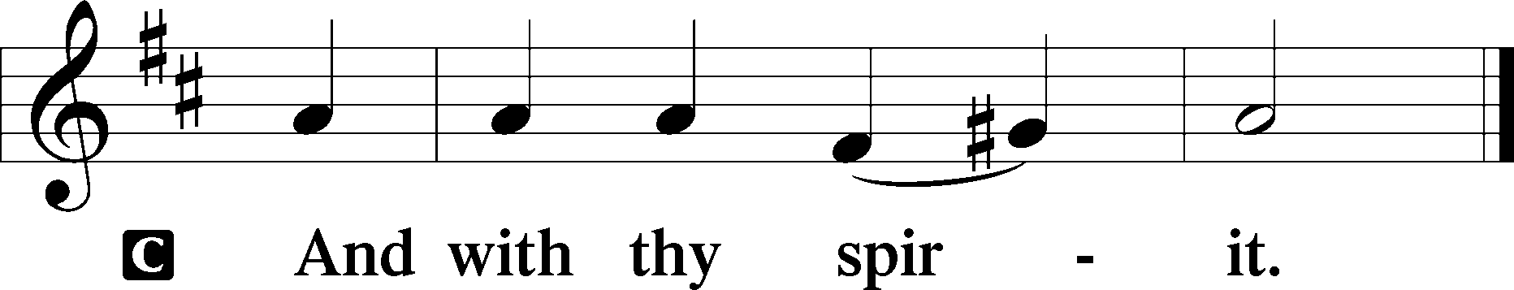

Benedicamus Psalm 103:1
P Bless we the Lord.
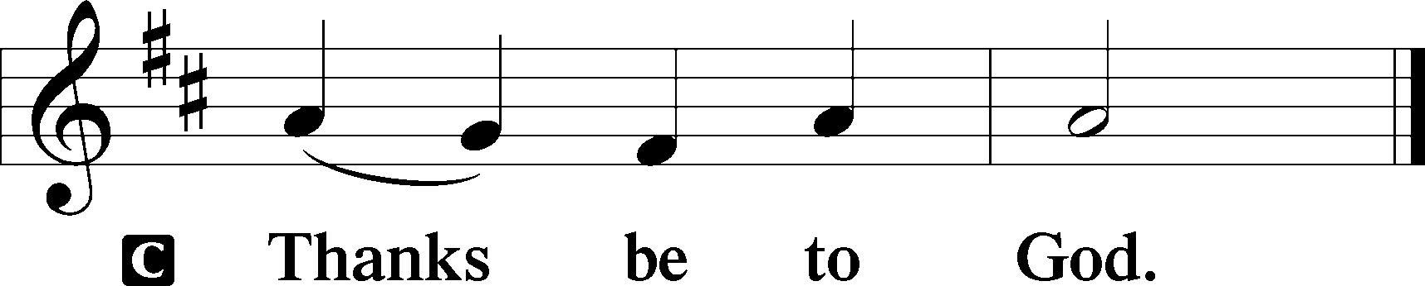

Benediction Numbers 6:24–26
P The Lord bless you and keep you.
The Lord make His face shine upon you and be gracious unto you.
The Lord lift up His countenance upon you and T give you peace.
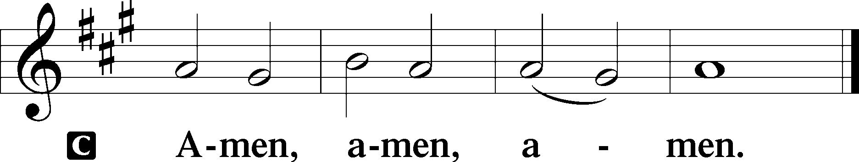

Closing Hymn: LSB #402 “The Only Son from Heaven”

Silent prayer after worship: Lord Jesus, You have been given the name above all names. Forgive me for my hesitance to call on Your name in prayer, and for the times I have dishonored Your name. Lead me to honor Your holy name through all that I do and say. Amen.
fffffffffffffffffffffffffffffffffff
Acknowledgments
Unless otherwise indicated, Scripture quotations are from the ESV® Bible (The Holy Bible, English Standard Version®), copyright © 2001 by Crossway, a publishing ministry of Good News Publishers. Used by permission. All rights reserved.
Created by Lutheran Service Builder © 2023 Concordia Publishing House.

