Sts. Peter & Paul
Evangelical Lutheran Church
Lutheran Church-Missouri Synod
Founded-1917
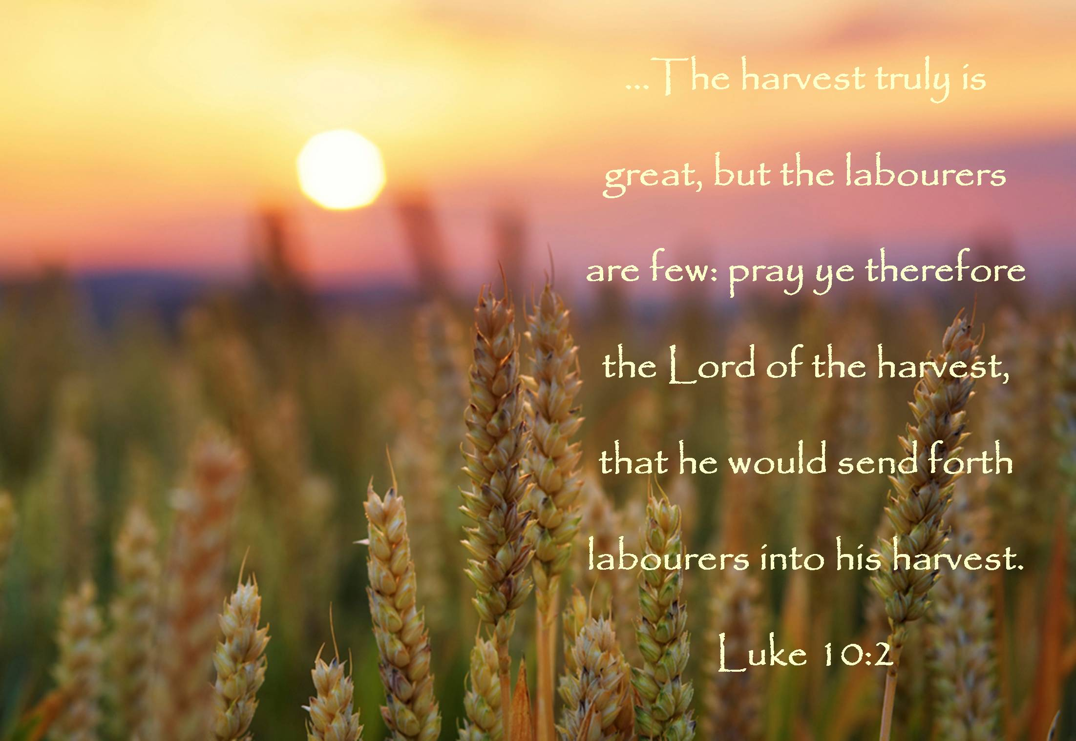

Feast of St. Titus, Pastor & Confessor

January 26, 2024

699 Stambaugh Avenue
Sharon, Pennsylvania 16146

“I was glad when they said to me,
Let us go to the house of the LORD!”
Psalm 122:1
VESPERS
Opening Hymn: LSB #589 “Speak, O Lord, Your Servant Listens”
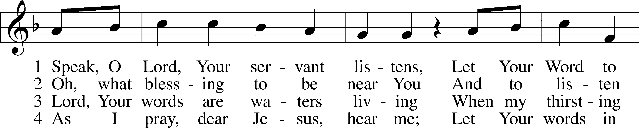
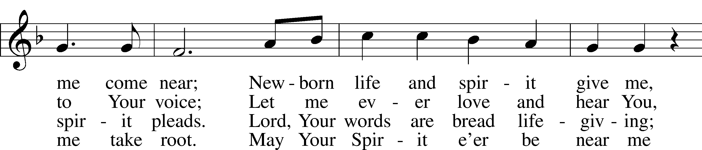
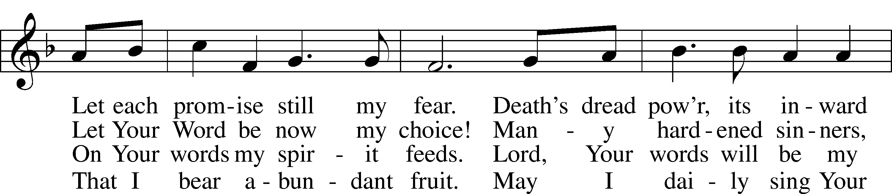
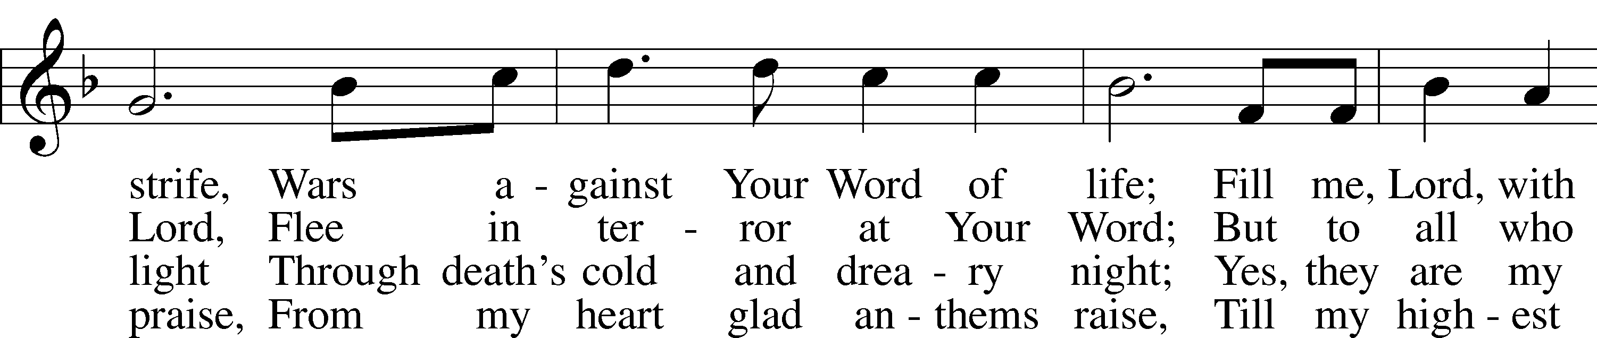
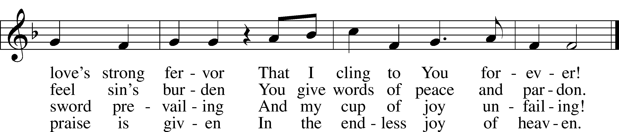

Text: Anna Sophia von Hessen-Darmstadt, 1638–83; (sts. 1–3): tr. George A. T. Rygh, 1860–1942, alt.; (st. 4): tr. Christian Worship, 1993 Tune: Johann Schop, c. 1590–1667 Text and tune: Public domain

Stand
Common Versicles LSB 229

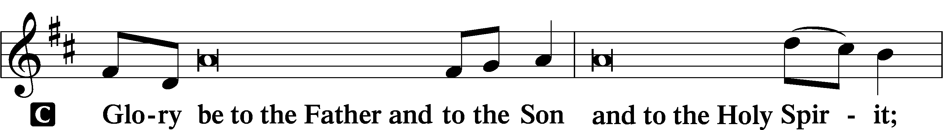
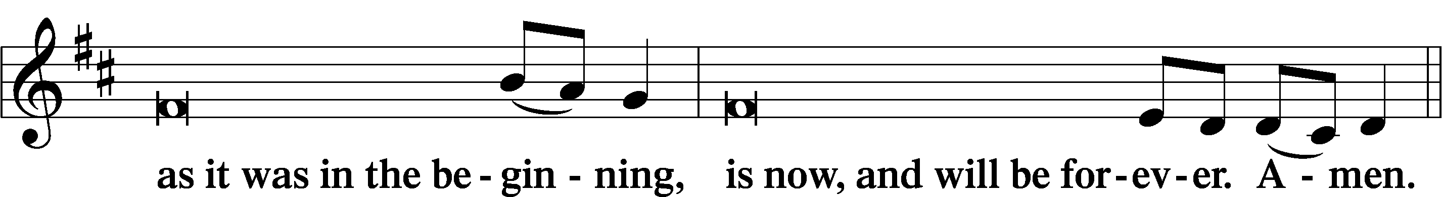
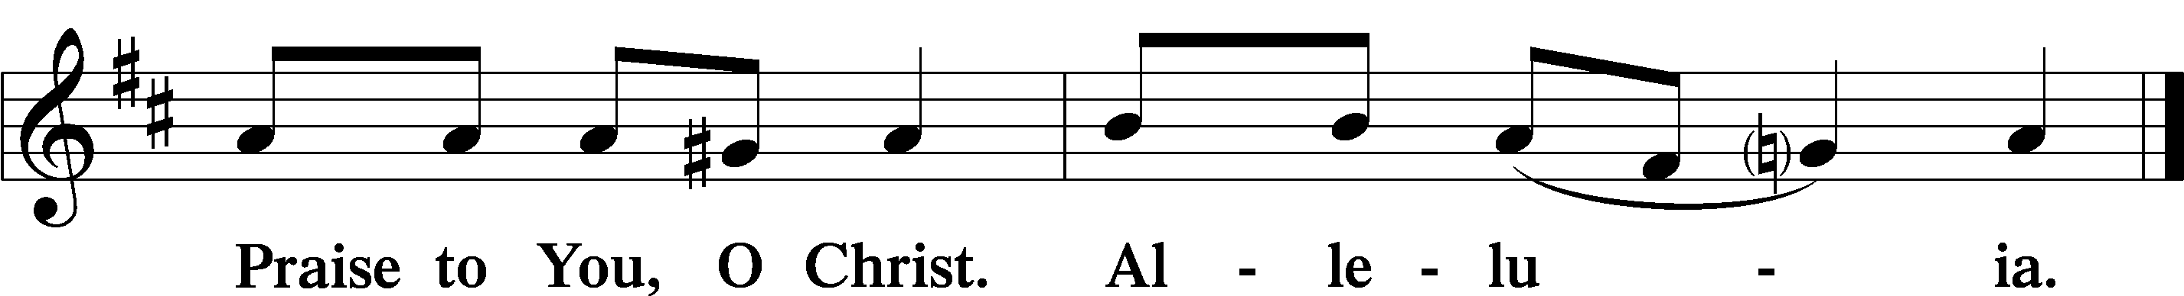

Psalmody

Psalm: Psalm 71:1–14 (NKJV)
In You, O Lord, I put my trust;
Let me never be put to shame.
Deliver me in Your righteousness, and cause me to escape;
Incline Your ear to me, and save me.
Be my strong refuge,
To which I may resort continually;
You have given the commandment to save me,
For You are my rock and my fortress.
Deliver me, O my God, out of the hand of the wicked,
Out of the hand of the unrighteous and cruel man.
For You are my hope, O Lord God;
You are my trust from my youth.
By You I have been upheld from birth;
You are He who took me out of my mother’s womb.
My praise shall be continually of You.

I have become as a wonder to many,
But You are my strong refuge.
Let my mouth be filled with Your praise
And with Your glory all the day.

Do not cast me off in the time of old age;
Do not forsake me when my strength fails.
For my enemies speak against me;
And those who lie in wait for my life take counsel together,
Saying, “God has forsaken him;
Pursue and take him, for there is none to deliver him.”

O God, do not be far from me;
O my God, make haste to help me!
Let them be confounded and consumed
Who are adversaries of my life;
Let them be covered with reproach and dishonor
Who seek my hurt.

But I will hope continually,
And will praise You yet more and more.

Sit

Hymn of the Day: LSB #586 “Preach You the Word”
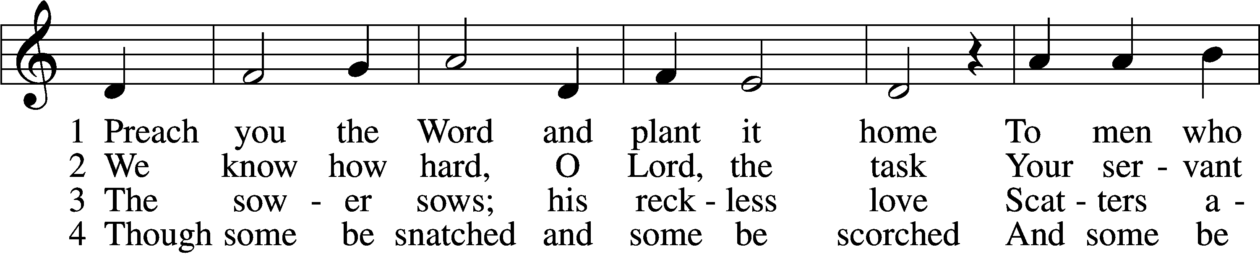
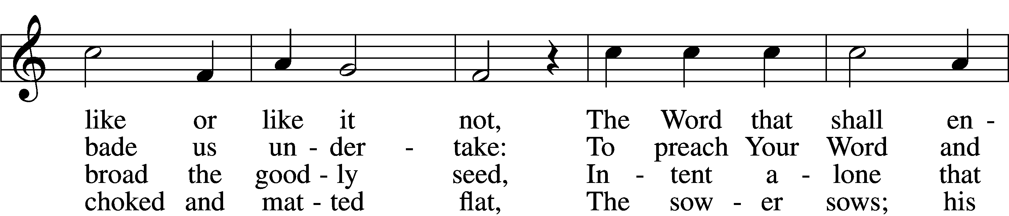
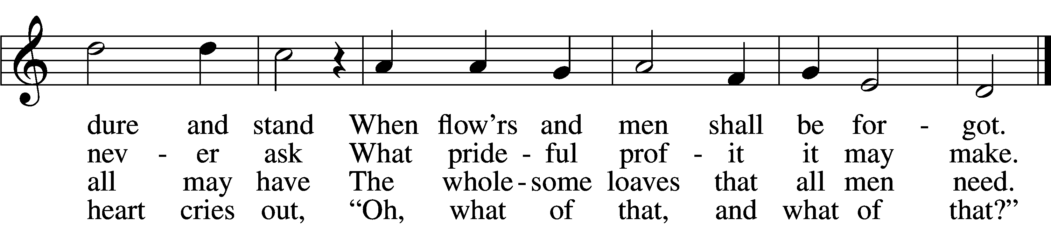

5 Of all his scattered plenteousness
One-fourth waves ripe on hill and flat,
And bears a harvest hundredfold:
“Ah, what of that, Lord, what of that!”

6 Preach you the Word and plant it home
And never faint; the Harvest Lord
Who gave the sower seed to sow
Will watch and tend His planted Word.

Text: Martin H. Franzmann, 1907–76, alt. Tune: Rheinfelssisch Deutsches Catholisches Gesangbuch, 1666, Augsburg Text: © 1971 The Franzmann Family. Used by permission: LSB Hymn License no. 110004782 Tune: Public domain

Readings

Prophecy: Acts 20:28–35 (NKJV)
Therefore take heed to yourselves and to all the flock, among which the Holy Spirit has made you overseers, to shepherd the church of God which He purchased with His own blood. For I know this, that after my departure savage wolves will come in among you, not sparing the flock. Also from among yourselves men will rise up, speaking perverse things, to draw away the disciples after themselves. Therefore watch, and remember that for three years I did not cease to warn everyone night and day with tears.

“So now, brethren, I commend you to God and to the word of His grace, which is able to build you up and give you an inheritance among all those who are sanctified. I have coveted no one’s silver or gold or apparel. Yes, you yourselves know that these hands have provided for my necessities, and for those who were with me. I have shown you in every way, by laboring like this, that you must support the weak. And remember the words of the Lord Jesus, that He said, ‘It is more blessed to give than to receive.’ ”

P This is the Word of the Lord.
C Thanks be to God.

Epistle: Titus 1:1–9 (NKJV)
Paul, a bondservant of God and an apostle of Jesus Christ, according to the faith of God’s elect and the acknowledgment of the truth which accords with godliness, in hope of eternal life which God, who cannot lie, promised before time began, but has in due time manifested His word through preaching, which was committed to me according to the commandment of God our Savior;

To Titus, a true son in our common faith:

Grace, mercy, and peace from God the Father and the Lord Jesus Christ our Savior.

For this reason I left you in Crete, that you should set in order the things that are lacking, and appoint elders in every city as I commanded you— if a man is blameless, the husband of one wife, having faithful children not accused of dissipation or insubordination. For a bishop must be blameless, as a steward of God, not self-willed, not quick-tempered, not given to wine, not violent, not greedy for money, but hospitable, a lover of what is good, sober-minded, just, holy, self-controlled, holding fast the faithful word as he has been taught, that he may be able, by sound doctrine, both to exhort and convict those who contradict.
P O Lord, have mercy on us.
C Thanks be to God.

Gospel: Luke 10:1–9 (NKJV)
After these things the Lord appointed seventy others also, and sent them two by two before His face into every city and place where He Himself was about to go. Then He said to them, “The harvest truly is great, but the laborers are few; therefore pray the Lord of the harvest to send out laborers into His harvest. Go your way; behold, I send you out as lambs among wolves. Carry neither money bag, knapsack, nor sandals; and greet no one along the road. But whatever house you enter, first say, ‘Peace to this house.’ And if a son of peace is there, your peace will rest on it; if not, it will return to you. And remain in the same house, eating and drinking such things as they give, for the laborer is worthy of his wages. Do not go from house to house. Whatever city you enter, and they receive you, eat such things as are set before you. And heal the sick there, and say to them, ‘The kingdom of God has come near to you.’

P This is the Word of the Lord.
C Thanks be to God.

Responsory LSB 230
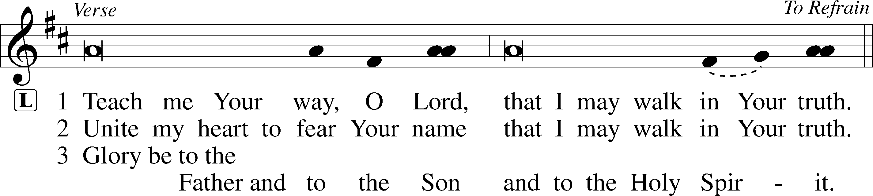
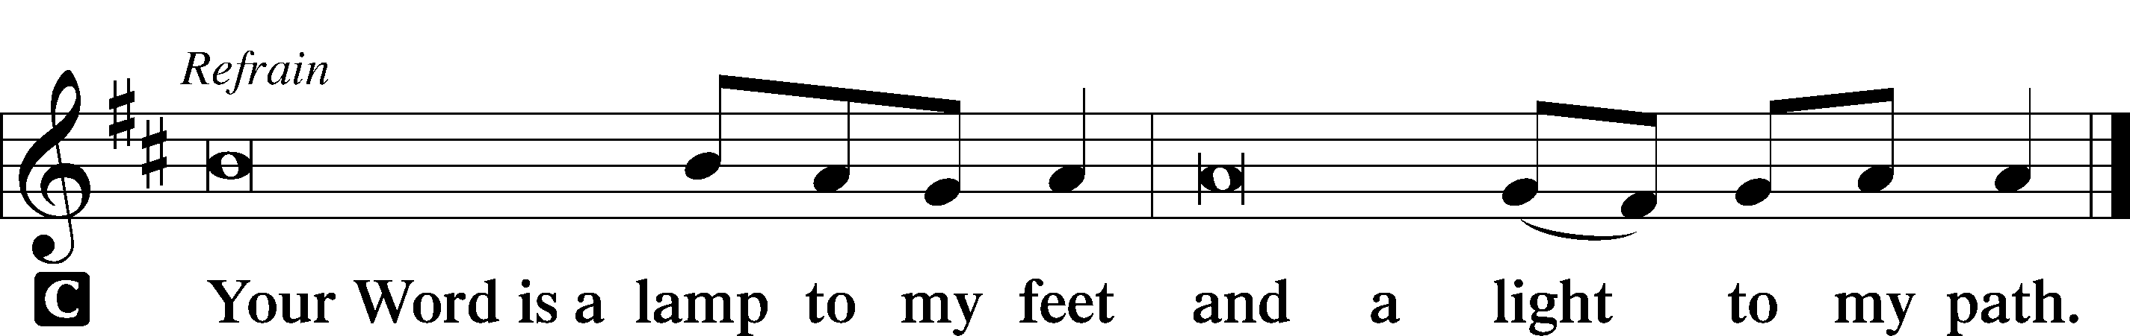

Sermon

Canticle

Stand

Antiphon (Common) 231
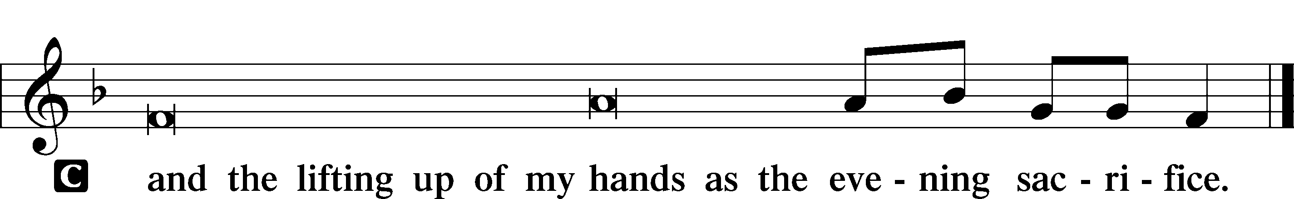

Magnificat 231
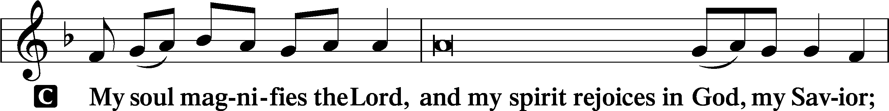
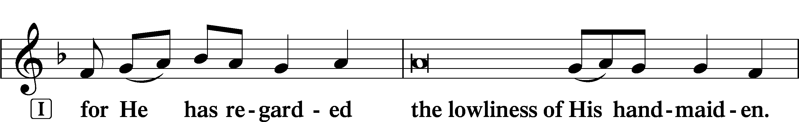
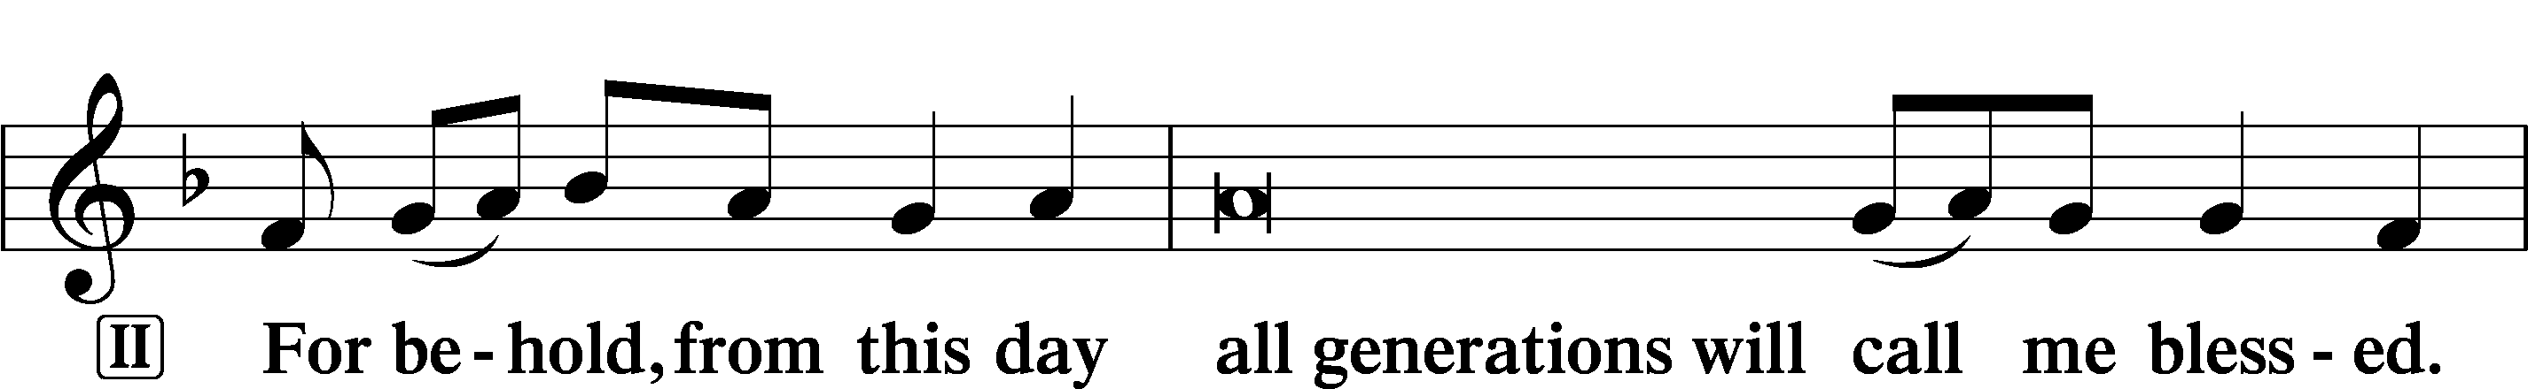
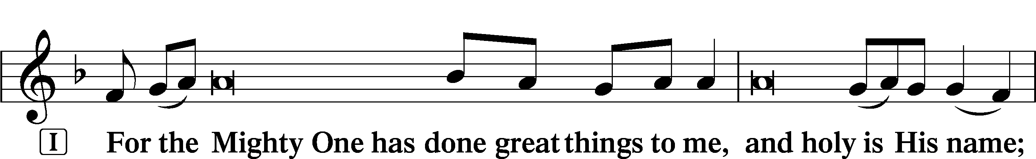
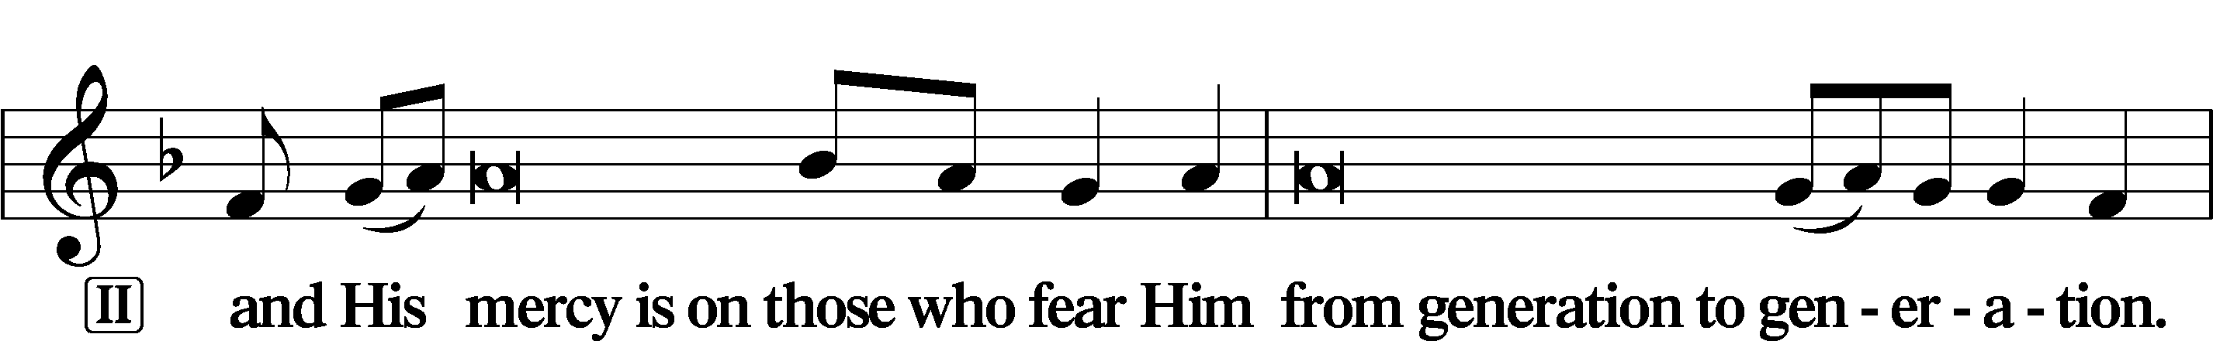
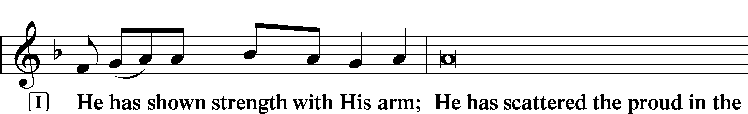
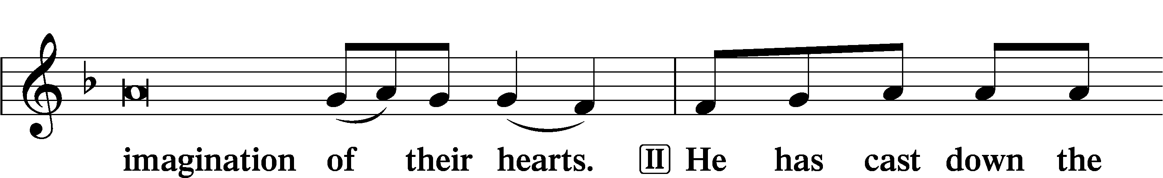
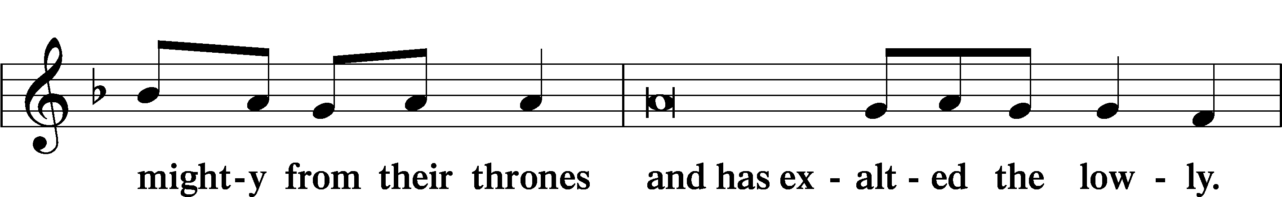
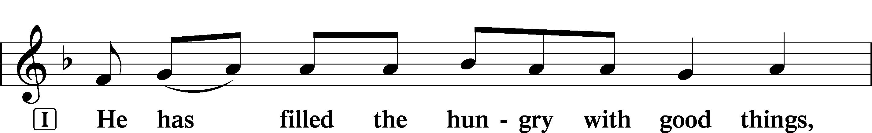
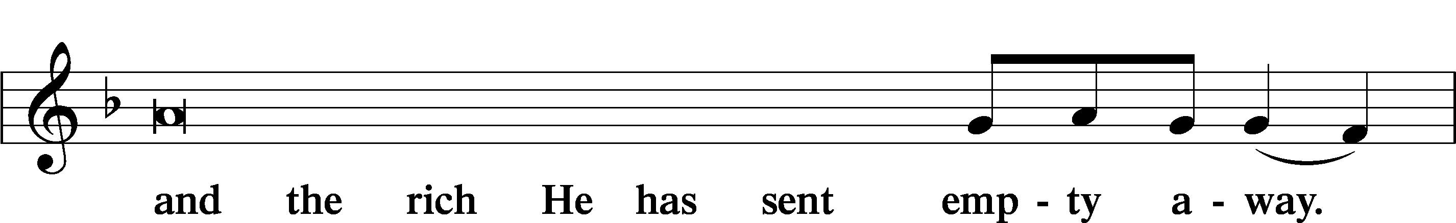
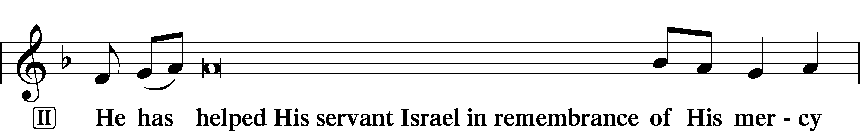
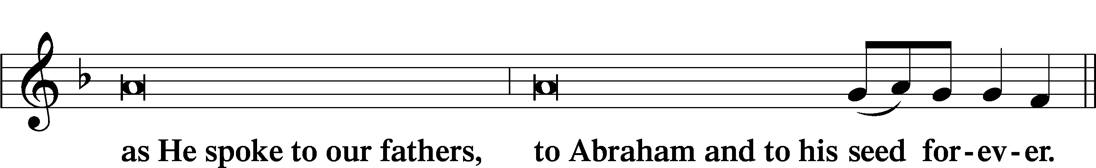
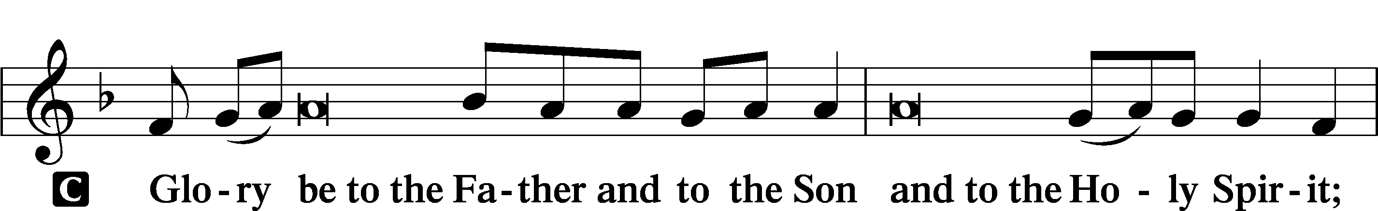
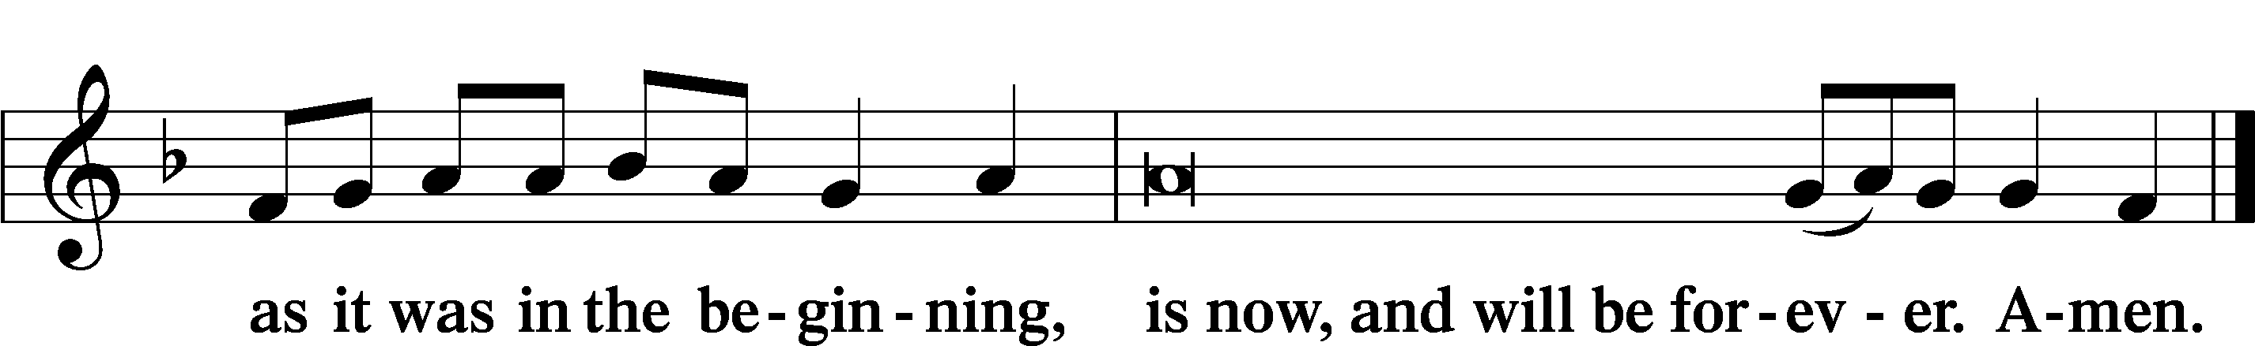
Prayer

Kyrie LSB 233
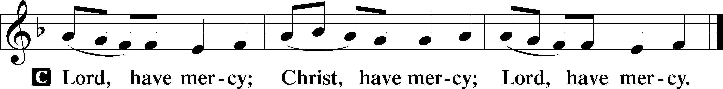

The Lord’s Prayer LSB 957
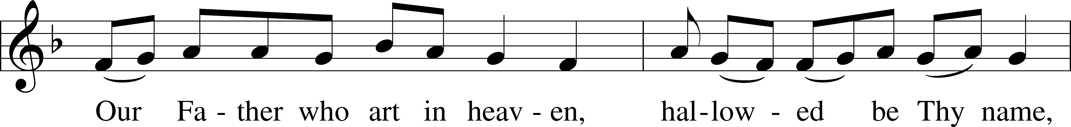
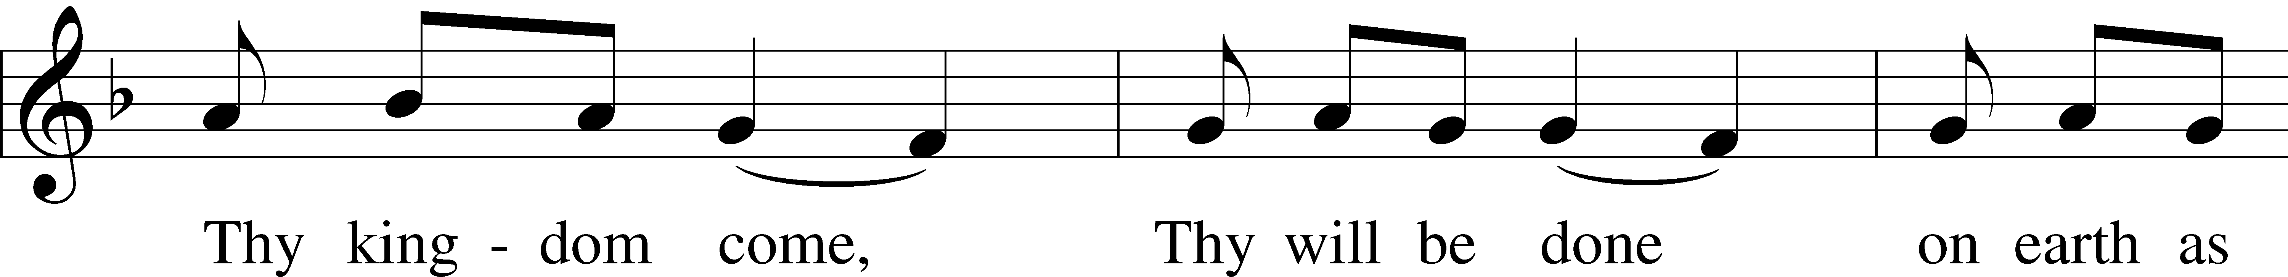
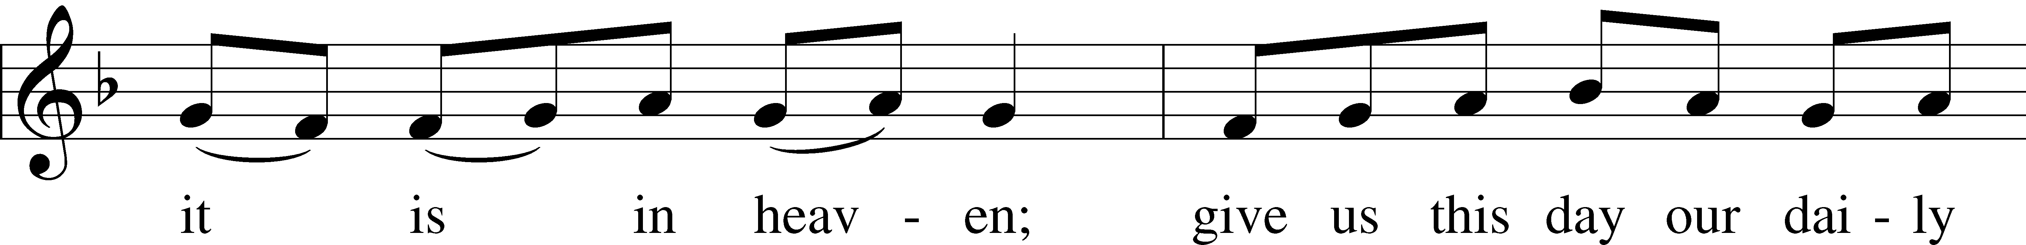
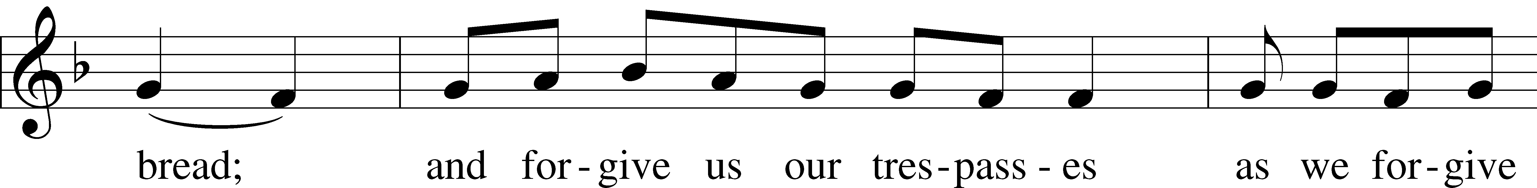
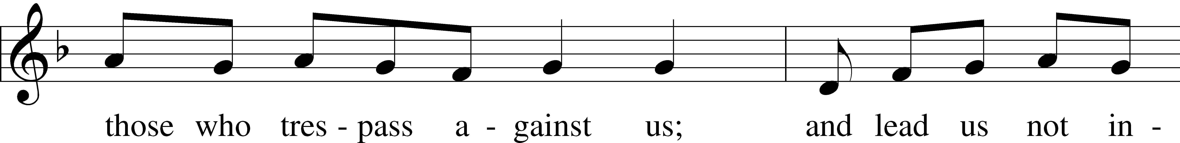
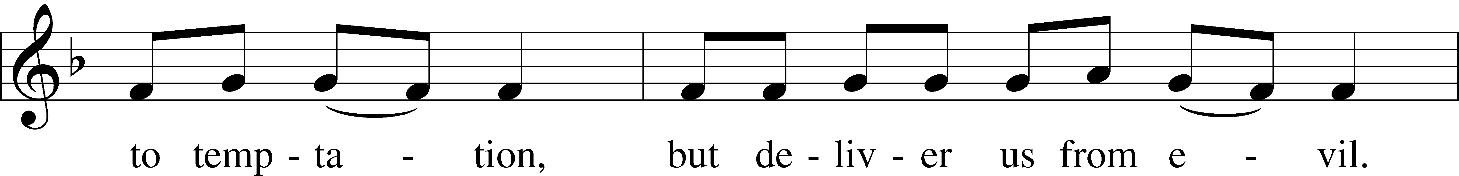
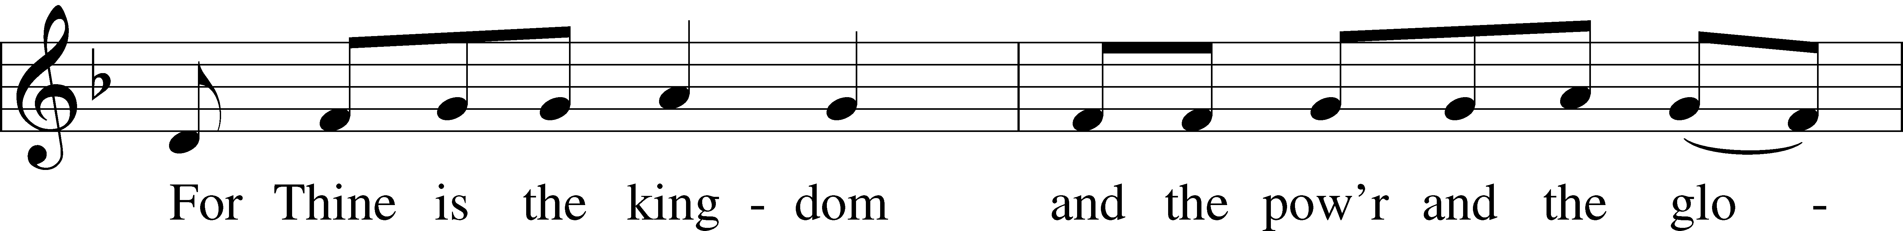
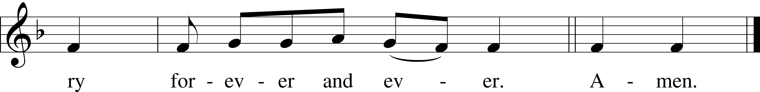

Collects
Introduction to Collects LSB 233
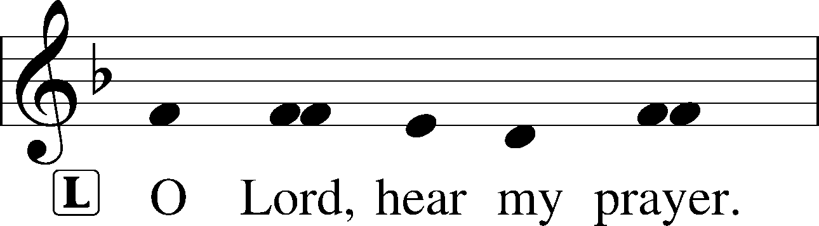
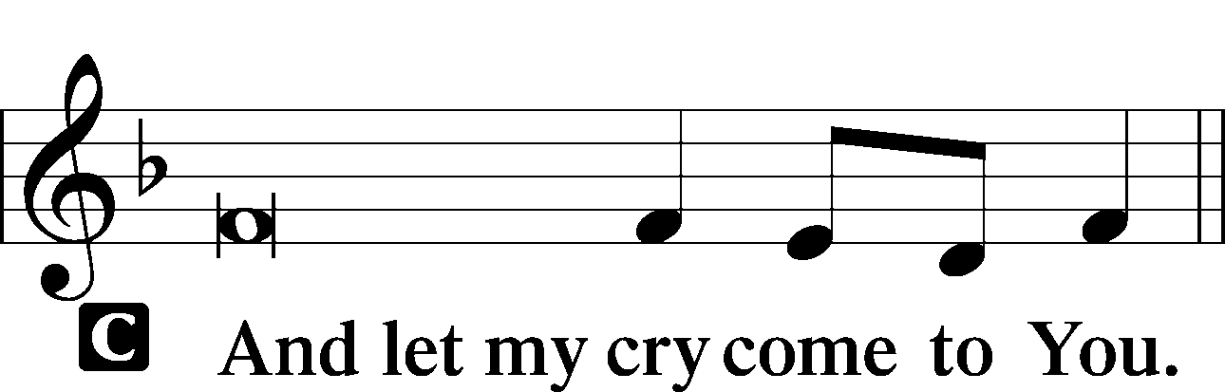

Collect of the Day: Titus
P Almighty God, You called Titus to the work of pastor and teacher. Make all shepherds of Your flock diligent in preaching Your holy Word so that the whole world may know the immeasurable riches of our Savior, Jesus Christ, who lives and reigns with You and the Holy Spirit, one God, now and forever.

Collect for Peace
P O God, from whom come all holy desires, all good counsels, and all just works, give to us, Your servants, that peace which the world cannot give, that our hearts may be set to obey Your commandments and also that we, being defended from the fear of our enemies, may live in peace and quietness; through Jesus Christ, Your Son, our Lord, who lives and reigns with You and the Holy Spirit, one God, now and forever.
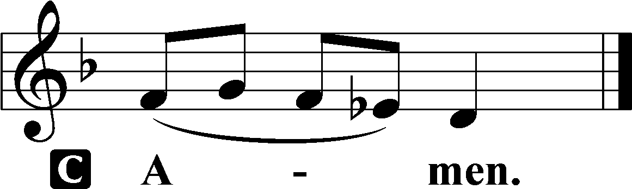

Benedicamus LSB 234
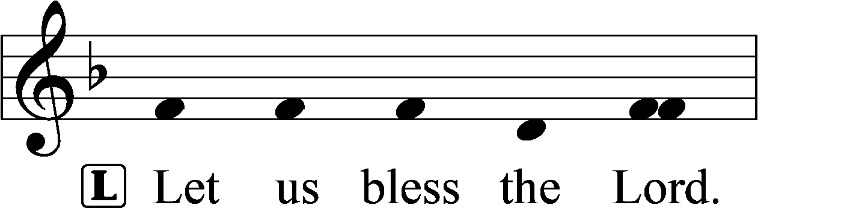
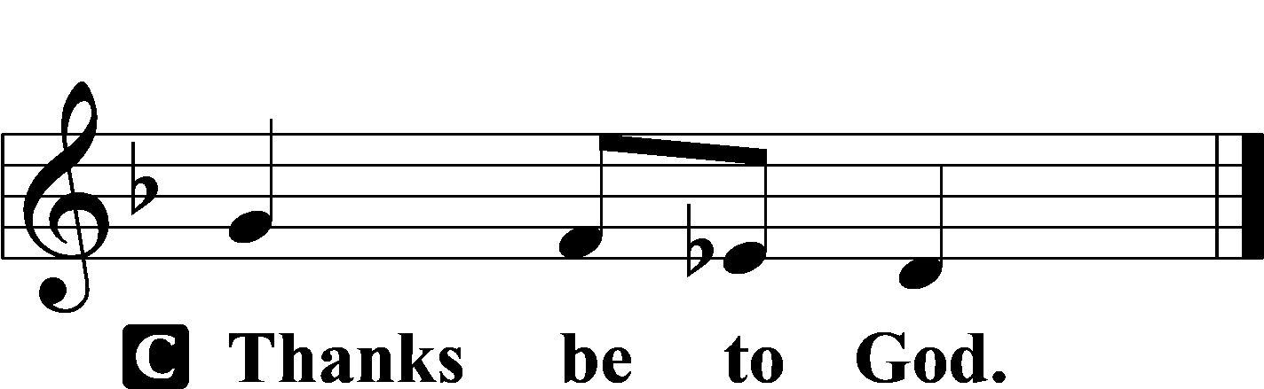

Benediction LSB 234
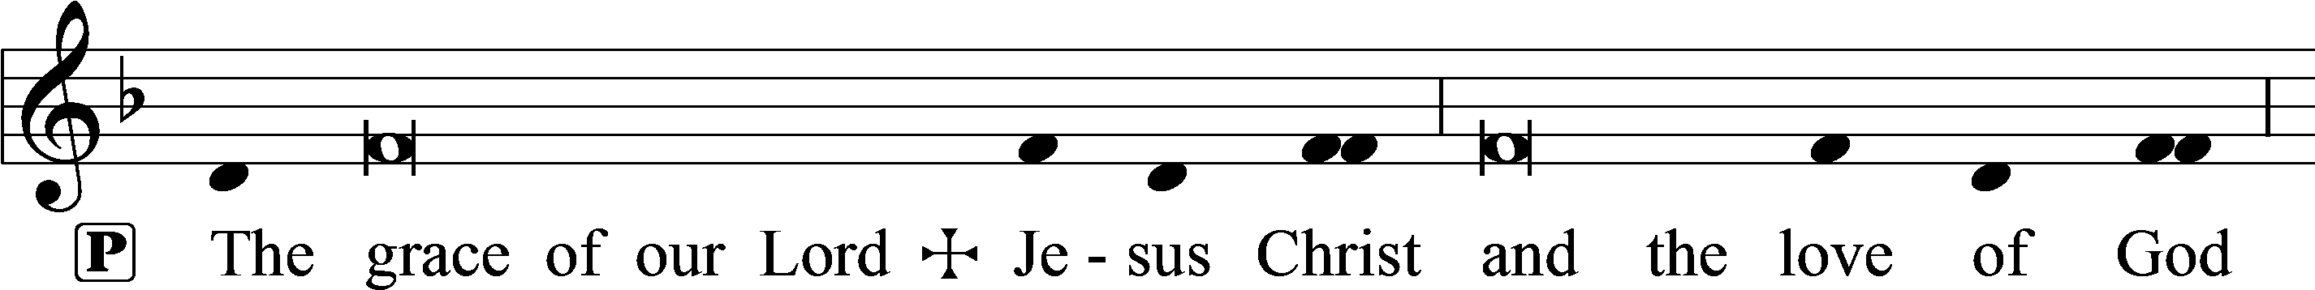
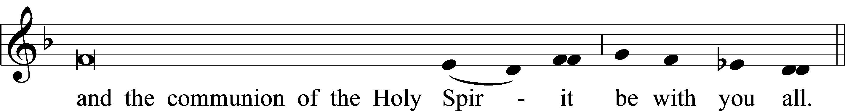

Closing Hymn: LSB #731 “O God, Forsake Me Not”
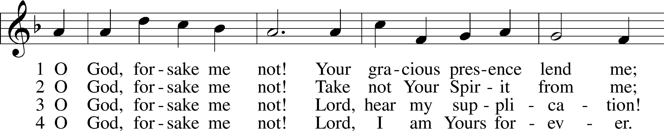
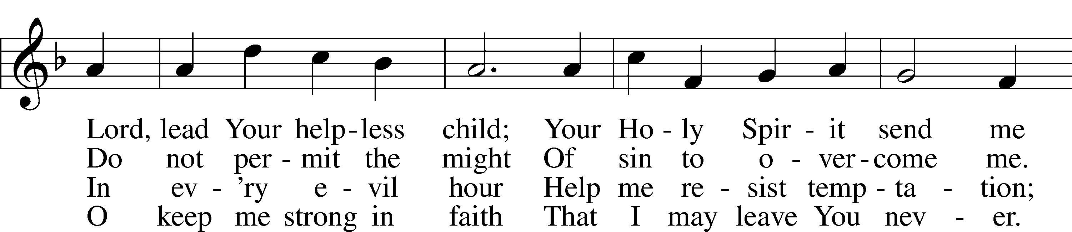
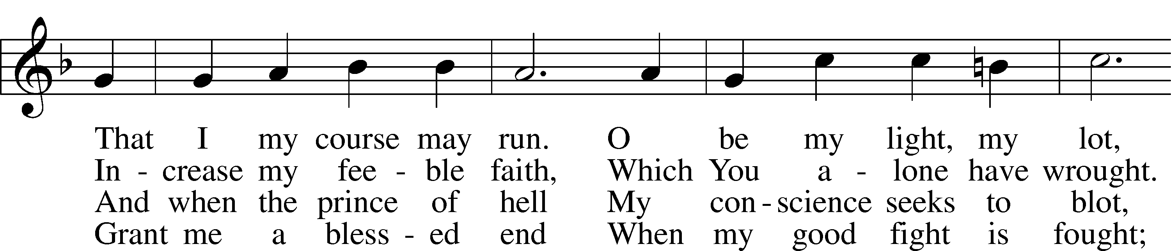
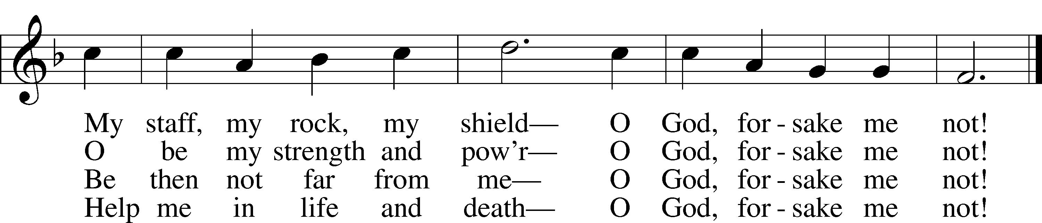

Text: Salomo Franck, 1659–1725; tr. August Crull, 1845–1923, alt. Tune: Neu-vermehrtes . . . Gesangbuch, 1693, 3rd ed., Meiningen Text and tune: Public domain

Acknowledgments
Unless otherwise indicated, Scripture quotations are from the ESV® Bible (The Holy Bible, English Standard Version®), copyright © 2001 by Crossway, a publishing ministry of Good News Publishers. Used by permission. All rights reserved.
Created by Lutheran Service Builder © 2024 Concordia Publishing House.

