Sts. Peter & Paul
Evangelical Lutheran Church
Lutheran Church-Missouri Synod
Founded-1917

January 21, 2024

699 Stambaugh Ave.
Sharon, Pennsylvania 16146

“I was glad when they said to me,
Let us go to the house of the LORD!”
Psalm 122:1
Sts. Peter & Paul Evangelical Lutheran Church, LC-MS
THE TRANSFIGURATION OF OUR LORD
January 21, 2024

A special welcome to our guests this day! If you would like more information about The Lutheran Church - Missouri Synod, or this congregation, please speak with Pastor Deal or an Elder after the service.
Members & Guests: Don’t be embarrassed if your children make noise during the worship service, all children do. We encourage families to worship together but, if you feel the need, there are pews in the rear of the Church which are reserved for young families on both sides of the sanctuary. There is also a quiet room available to you, located next to the sanctuary (formerly the Pastor’s office), where you would be able to follow along with the service.

Today’s service includes the Sacrament of Holy Communion. If during this past year, you have not worshipped with us and been communed, we respectfully ask that you do not partake of this sacrament this day before first speaking with Pastor Deal.
If visiting from a sister congregation of the LC-MS and are in good standing, please inform Pastor Deal of your desire to commune prior to the service.
If wishing to receive a blessing during communion, please approach with your arms crossed.

CONTACT INFORMATION
Pastor Deal: pastordeal@saintspeterandpaul.net or 724-347-3620 (opt. 2)
Church Office: church@saintspeterandpaul.net or 724-347-3620 (opt. 3)
Secretary’s Office: The office will be open Monday and Thursday (8:30 am – 4:30 pm).

Silent prayer before worship: Lord, lead me to worship You with my heart, soul, mind, and lips that I may give You glory and be a blessing to those who worship with me. Graciously accept my worship in Jesus’ name. Amen.

Confession and Absolution

Opening Hymn: LSB #403 “O Savior of Our Fallen Race”

The sign of the cross may be made by all in remembrance of their Baptism.

Invocation
P In the name of the Father and of the T Son and of the Holy Spirit.
C Amen.

Exhortation Hebrews 10:22; Psalm 124:8; Psalm 32:5
P Beloved in the Lord! Let us draw near with a true heart and confess our sins unto God our Father, beseeching Him in the name of our Lord Jesus Christ to grant us forgiveness.

P Our help is in the name of the Lord,
C who made heaven and earth.
P I said, I will confess my transgressions unto the Lord,
C and You forgave the iniquity of my sin.

Silence for reflection on God’s Word and for self-examination.

Confession of Sins
P O almighty God, merciful Father,
C I, a poor, miserable sinner, confess unto You all my sins and iniquities with which I have ever offended You and justly deserved Your temporal and eternal punishment. But I am heartily sorry for them and sincerely repent of them, and I pray You of Your boundless mercy and for the sake of the holy, innocent, bitter sufferings and death of Your beloved Son, Jesus Christ, to be gracious and merciful to me, a poor, sinful being.

Absolution [John 20:19–23]
P Upon this your confession, I, by virtue of my office, as a called and ordained servant of the Word, announce the grace of God unto all of you, and in the stead and by the command of my Lord Jesus Christ I forgive you all your sins in the name of the Father and of the T Son and of the Holy Spirit.
C Amen.
Service of the Word

Introit Psalm 84:1–2a, 4, 10–11; antiphon: Psalm 77:18b
Your lightnings lighted | up the world;*
the earth trem- | bled and shook.
How lovely is your dwelling place, O | Lord of hosts!*
My soul longs, yes, faints for the courts | of the Lord.
Blessèd are those who dwell | in your house,*
ever sing- | ing your praise!
For a day in your courts is better than a thousand | elsewhere.*
I would rather be a doorkeeper in the house of my God than dwell in the tents of | wickedness.
For the Lord God is a sun and shield; the Lord bestows favor and | honor.*
No good thing does he withhold from those who walk up- | rightly.
Your lightnings lighted | up the world;*
the earth trem- | bled and shook.

Gloria Patri
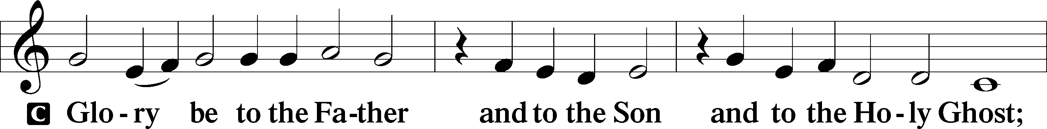
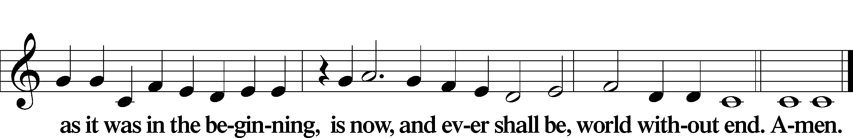

Kyrie Mark 10:47
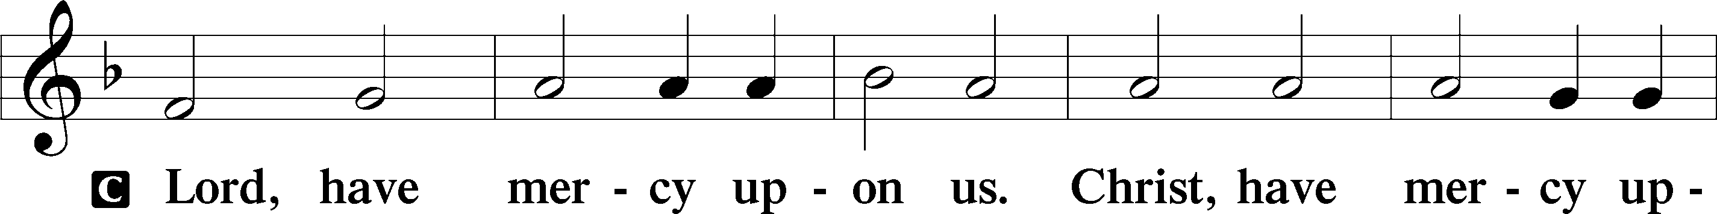
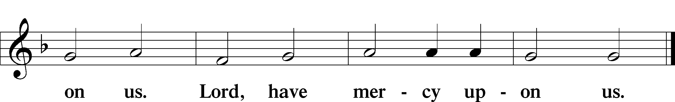

Gloria in Excelsis Luke 2:14; John 1:29
P Glory be to God on high:
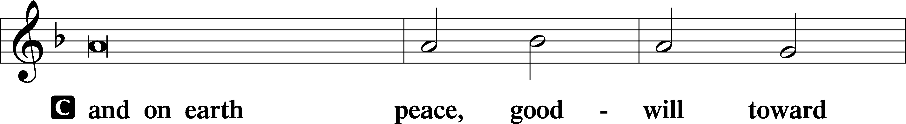
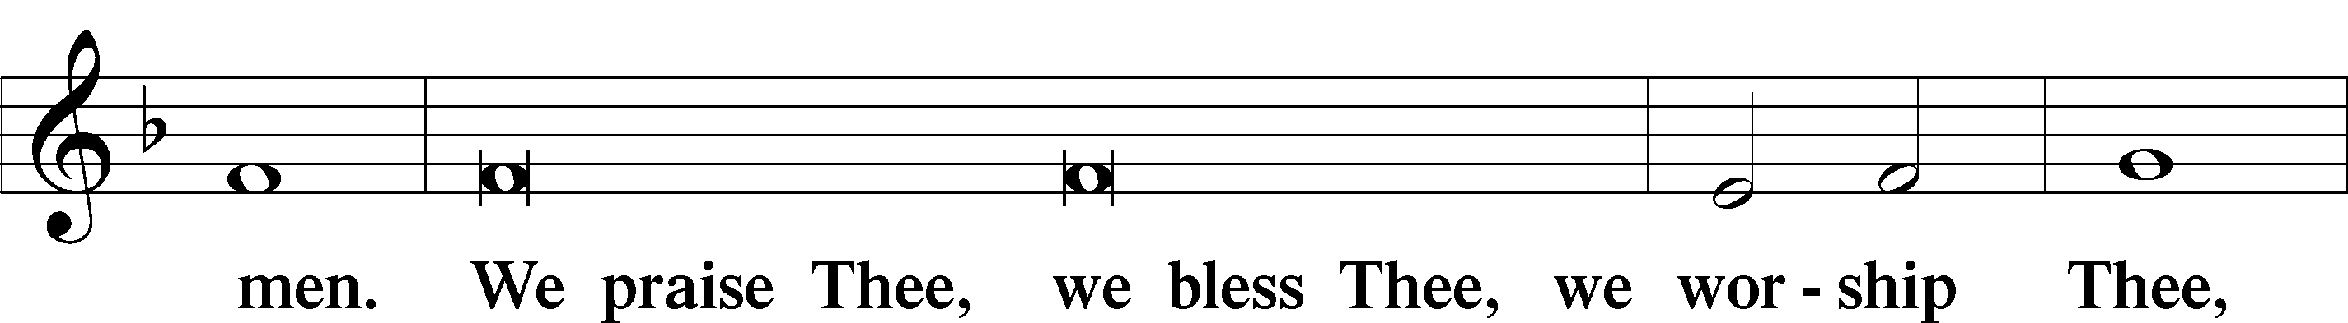
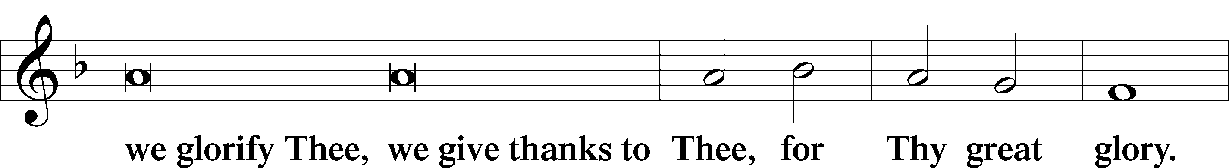
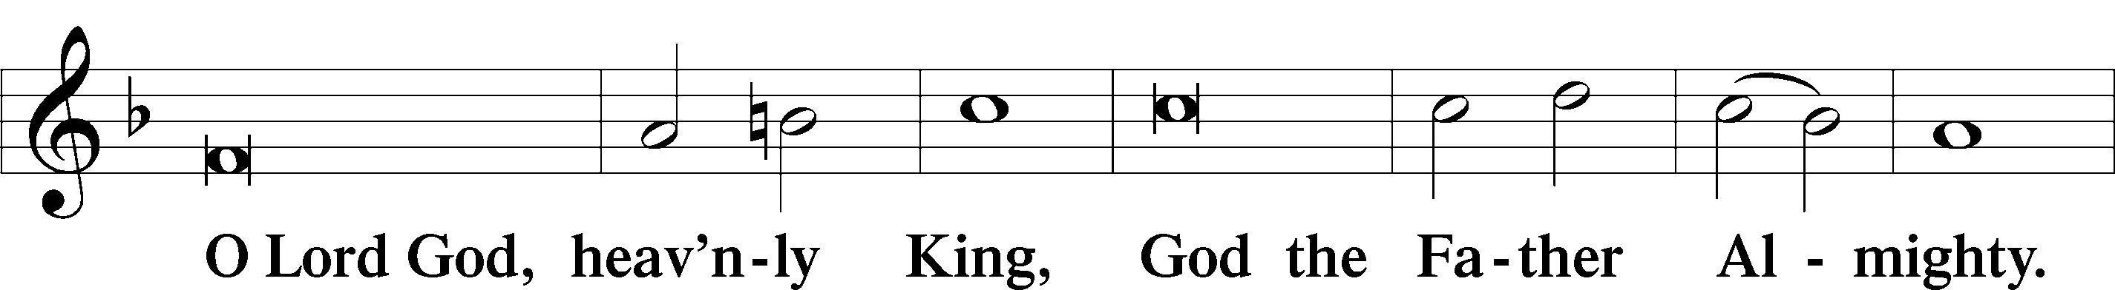
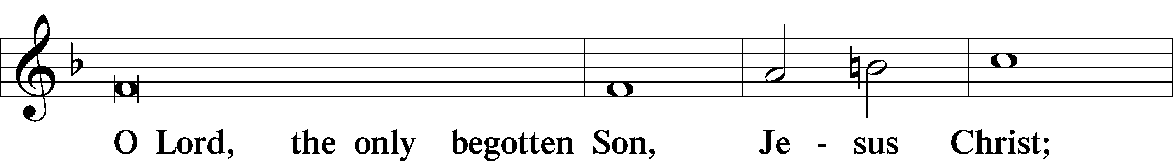
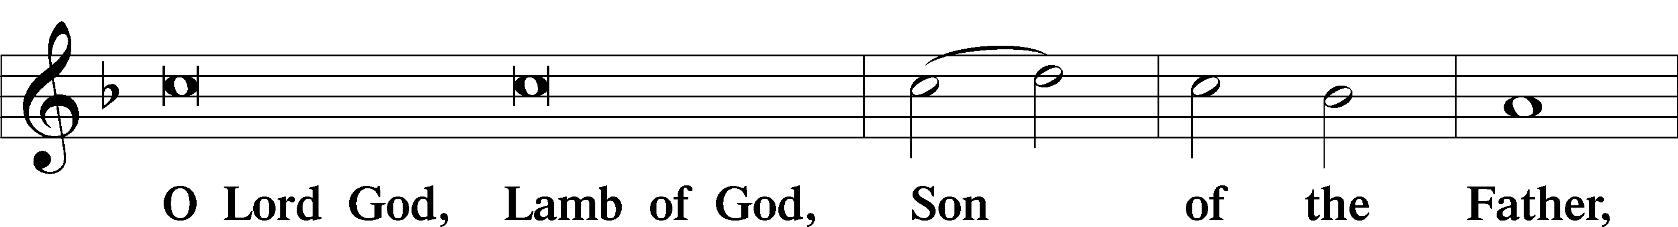
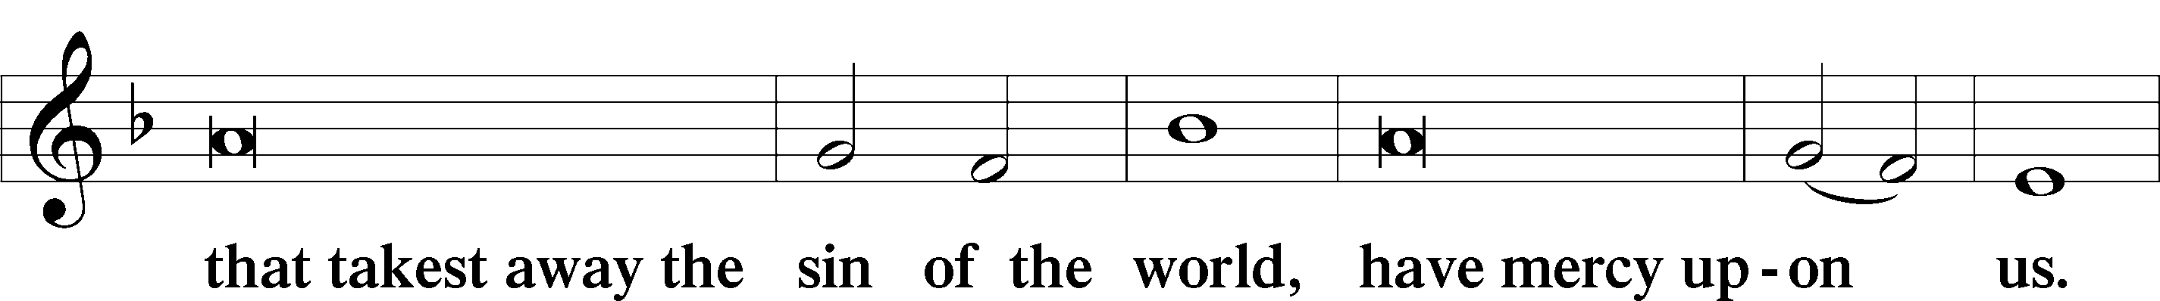
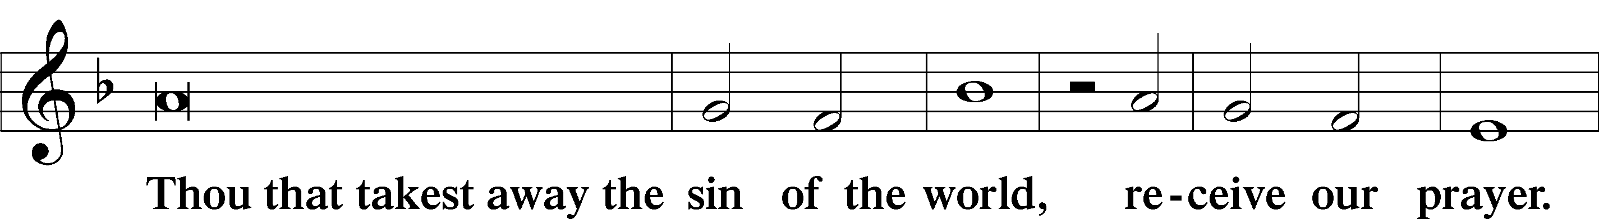
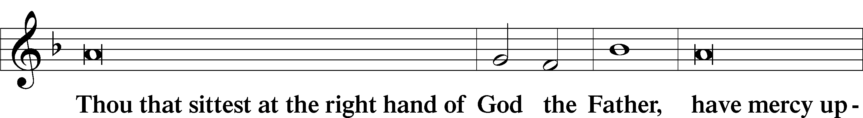
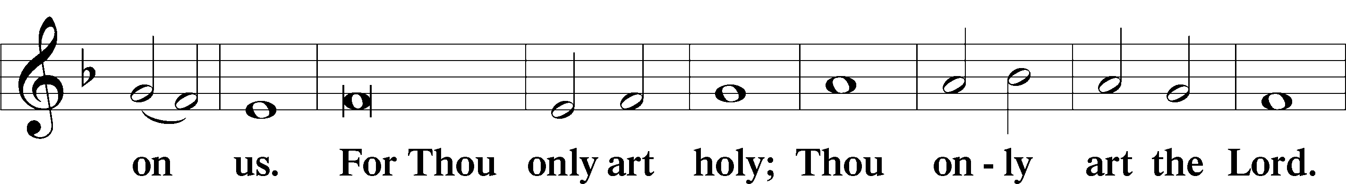
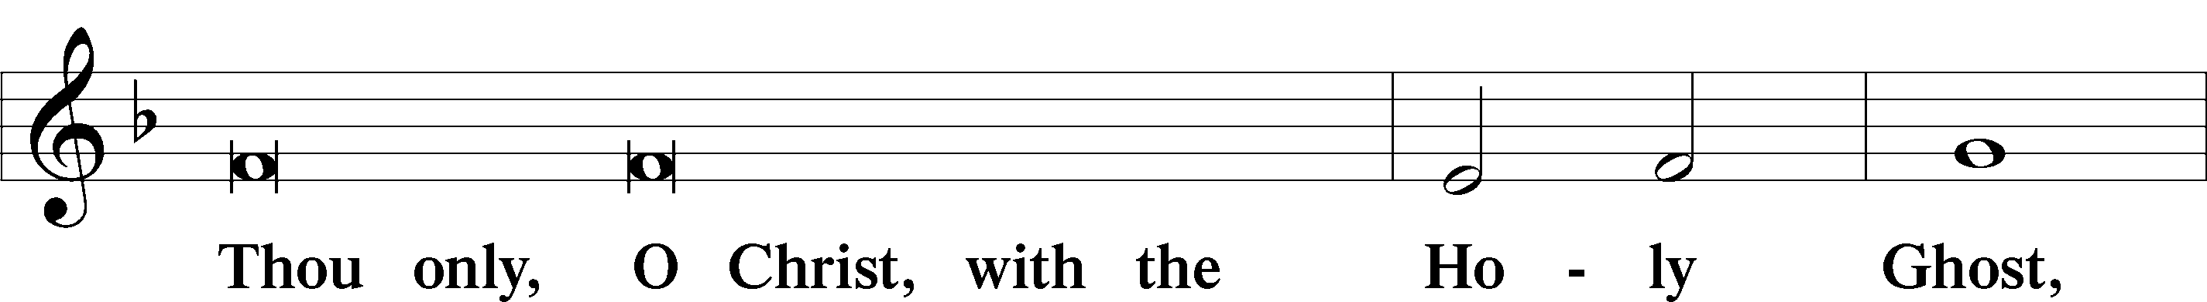
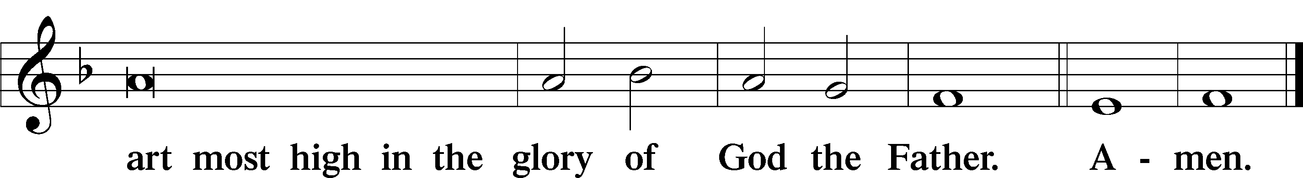

Salutation and Collect of the Day: Transfiguration
P The Lord be with you.
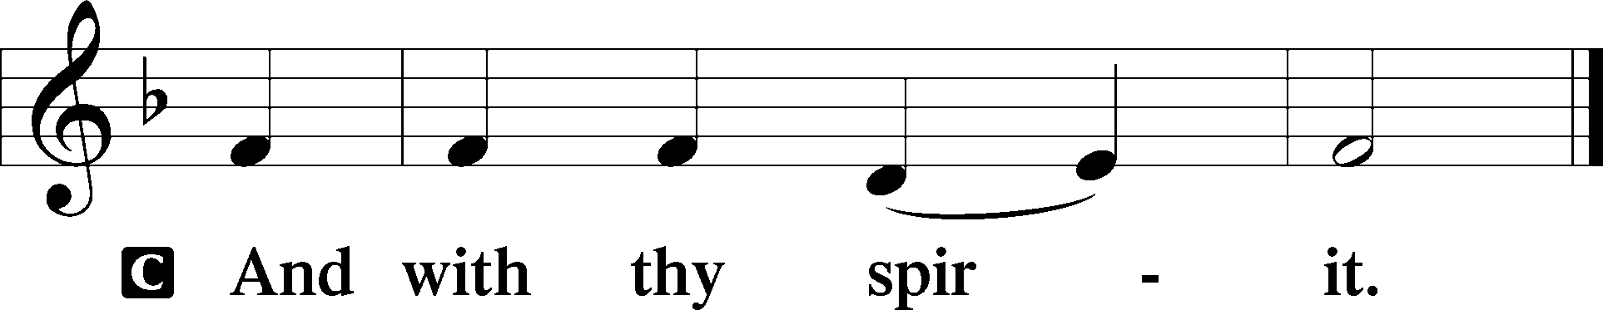

P Let us pray.
O God, in the glorious transfiguration of Your beloved Son You confirmed the mysteries of the faith by the testimony of Moses and Elijah. In the voice that came from the bright cloud You wonderfully foreshowed our adoption by grace. Mercifully make us co-heirs with the King in His glory and bring us to the fullness of our inheritance in heaven; through the same Jesus Christ, our Lord, who lives and reigns with You and the Holy Spirit, one God, now and forever.
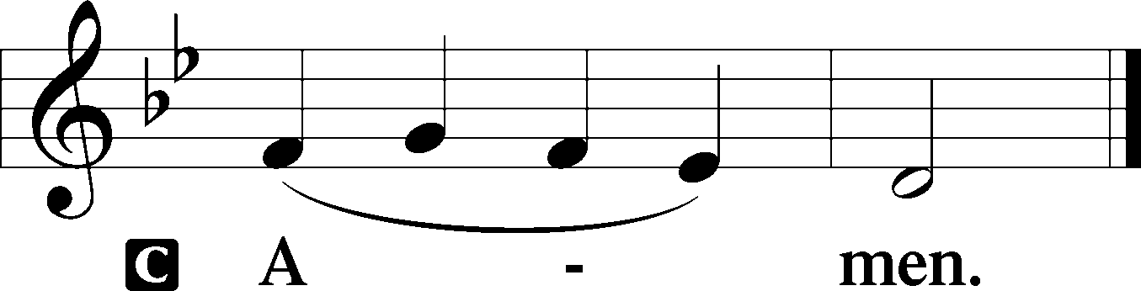
Sit

Prophecy: Exodus 34:29–35 (NKJV)
In those days: When Moses came down from Mount Sinai (and the two tablets of the Testimony were in Moses’ hand when he came down from the mountain), Moses did not know that the skin of his face shone while he talked with Him. So when Aaron and all the children of Israel saw Moses, behold, the skin of his face shone, and they were afraid to come near him. Then Moses called to them, and Aaron and all the rulers of the congregation returned to him; and Moses talked with them. Afterward all the children of Israel came near, and he gave them as commandments all that the Lord had spoken with him on Mount Sinai. And when Moses had finished speaking with them, he put a veil on his face. But whenever Moses went in before the Lord to speak with Him, he would take the veil off until he came out; and he would come out and speak to the children of Israel whatever he had been commanded. And whenever the children of Israel saw the face of Moses, that the skin of Moses’ face shone, then Moses would put the veil on his face again, until he went in to speak with Him.

P This is the Word of the Lord.
C Thanks be to God.

Gradual Psalm 45:2a; 110:1
You are the most handsome of the | sons of men;*
grace is poured up- | on your lips.
The Lord says to my Lord: “Sit at my | right hand,*
until I make your enemies your | footstool.”

Epistle: 2 Peter 1:16–21 (NKJV)
Dearly Beloved: We did not follow cunningly devised fables when we made known to you the power and coming of our Lord Jesus Christ, but were eyewitnesses of His majesty. For He received from God the Father honor and glory when such a voice came to Him from the Excellent Glory: “This is My beloved Son, in whom I am well pleased.” And we heard this voice which came from heaven when we were with Him on the holy mountain. And so we have the prophetic word confirmed, which you do well to heed as a light that shines in a dark place, until the day dawns and the morning star rises in your hearts; knowing this first, that no prophecy of Scripture is of any private interpretation, for prophecy never came by the will of man, but holy men of God spoke as they were moved by the Holy Spirit.

P This is the Word of the Lord.
C Thanks be to God.

Stand

Verse Psalm 96:2–3
Alleluia. Sing to the Lord; tell of his salvation from day to day. Declare his glory among the nations, his marvelous works among all the peoples! Alleluia.

Alleluia
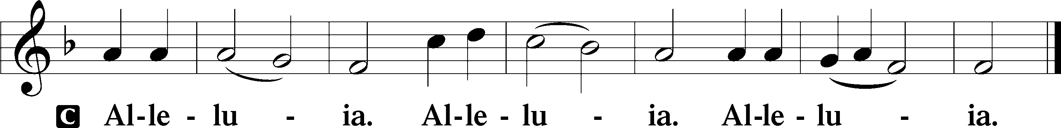

Holy Gospel: Matthew 17:1–9 (NKJV)
P The Holy Gospel according to St. Matthew, the seventeenth chapter.
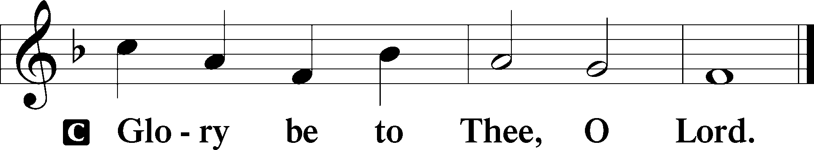

At that time: Jesus took Peter, James, and John his brother, led them up on a high mountain by themselves; and He was transfigured before them. His face shone like the sun, and His clothes became as white as the light. And behold, Moses and Elijah appeared to them, talking with Him. Then Peter answered and said to Jesus, “Lord, it is good for us to be here; if You wish, let us make here three tabernacles: one for You, one for Moses, and one for Elijah.” While he was still speaking, behold, a bright cloud overshadowed them; and suddenly a voice came out of the cloud, saying, “This is My beloved Son, in whom I am well pleased. Hear Him!” And when the disciples heard it, they fell on their faces and were greatly afraid. But Jesus came and touched them and said, “Arise, and do not be afraid.” When they had lifted up their eyes, they saw no one but Jesus only. Now as they came down from the mountain, Jesus commanded them, saying, “Tell the vision to no one until the Son of Man is risen from the dead.”

P This is the Gospel of the Lord.
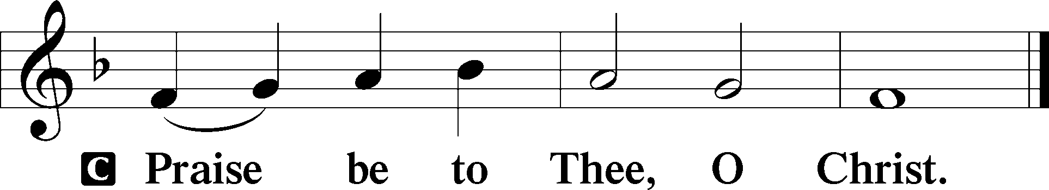

Nicene Creed
C I believe in one God,
the Father Almighty,
maker of heaven and earth
and of all things visible and invisible.

And in one Lord Jesus Christ,
the only-begotten Son of God,
begotten of His Father before all worlds,
God of God, Light of Light,
very God of very God,
begotten, not made,
being of one substance with the Father,
by whom all things were made;
who for us men and for our salvation came down from heaven
and was incarnate by the Holy Spirit of the virgin Mary
and was made man;
and was crucified also for us under Pontius Pilate.
He suffered and was buried.
And the third day He rose again according to the Scriptures
and ascended into heaven
and sits at the right hand of the Father.
And He will come again with glory to judge both the living and the dead,
whose kingdom will have no end.

And I believe in the Holy Spirit,
the Lord and giver of life,
who proceeds from the Father and the Son,
who with the Father and the Son together is worshiped and glorified,
who spoke by the prophets.
And I believe in one holy Christian and apostolic Church,
I acknowledge one Baptism for the remission of sins,
and I look for the resurrection of the dead
and the life T of the world to come. Amen.
Sit

Hymn of the Day: LSB #413 “O Wondrous Type! O Vision Fair”

Sermon

Stand

Offertory Psalm 51:10–12
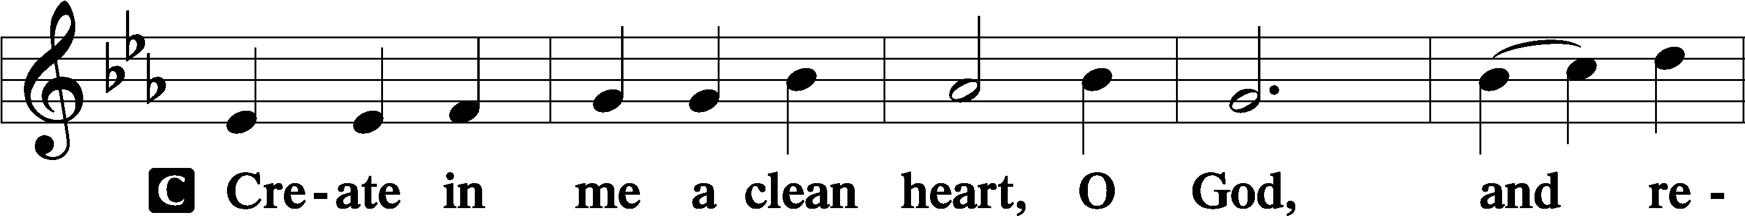
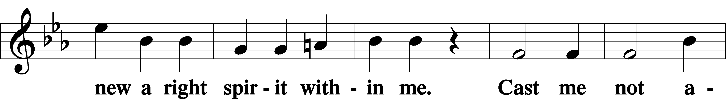
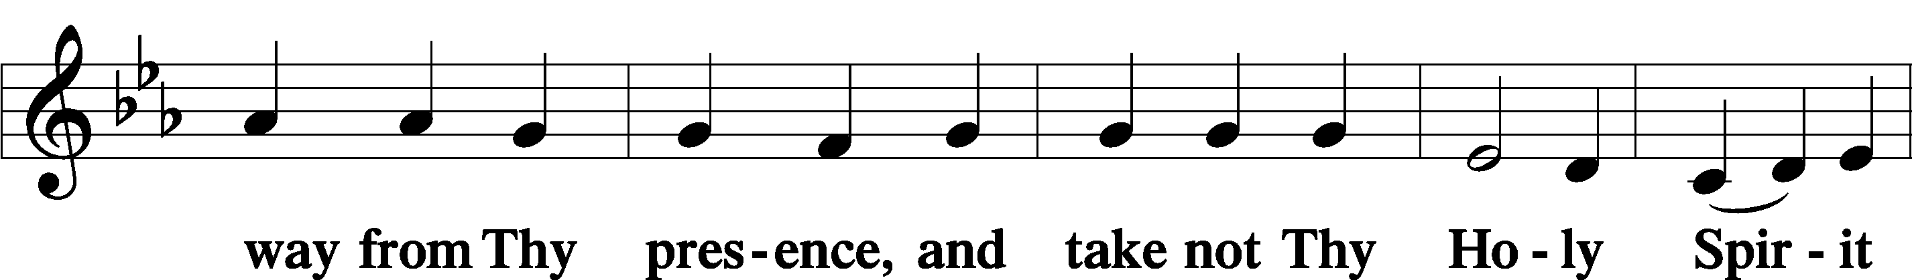
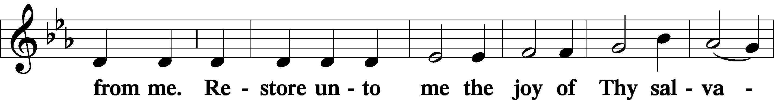
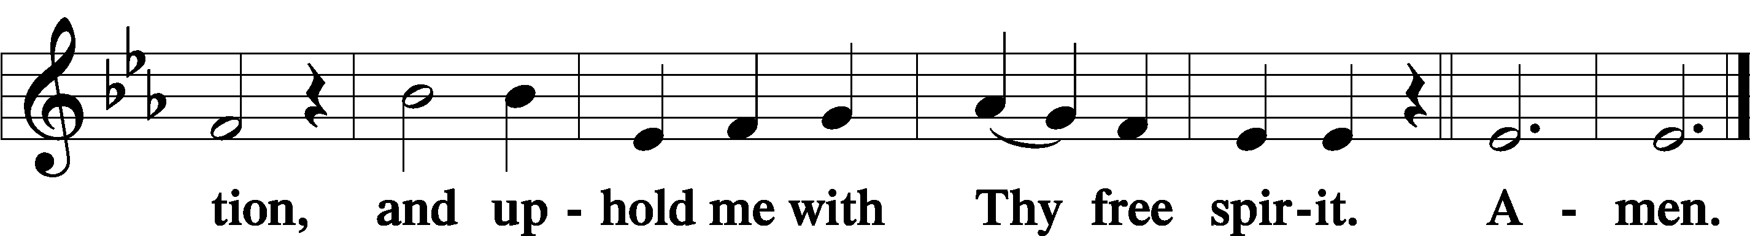

Prayer of the Church

Sit

Preparatory Hymn: LSB pp 223-225 “Te Deum”

Stand
Service of the Sacrament

Preface 2 Timothy 4:22; Colossians 3:1 Psalm 136
P The Lord be with you.
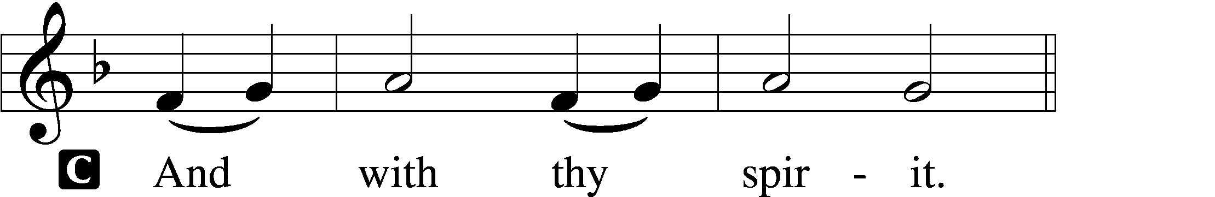

P Lift up your hearts.
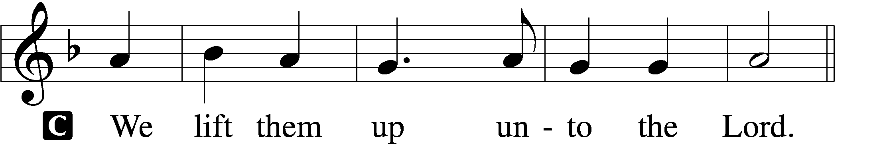

P Let us give thanks unto the Lord, our God.
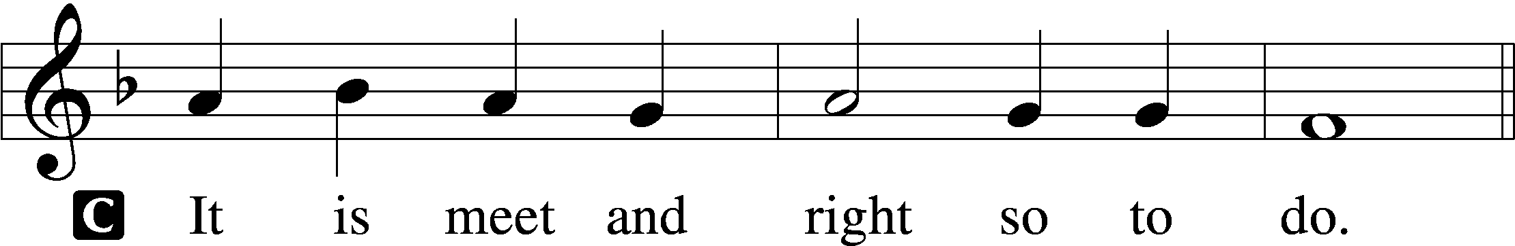

Proper Preface (Abbreviated) LSB 194
P It is truly meet, right, and salutary . . . evermore praising You and saying:

Sanctus Isaiah 6:3; Matthew 21:9
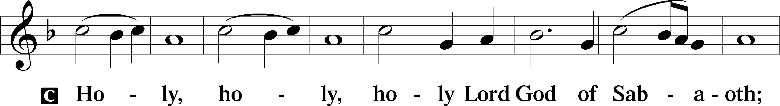
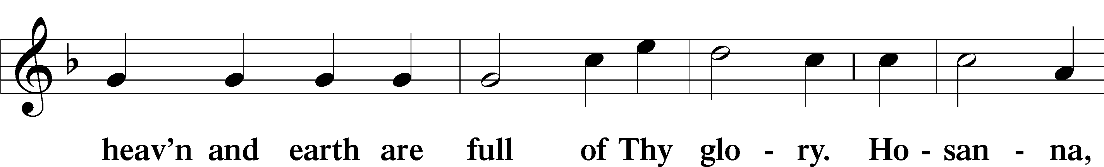
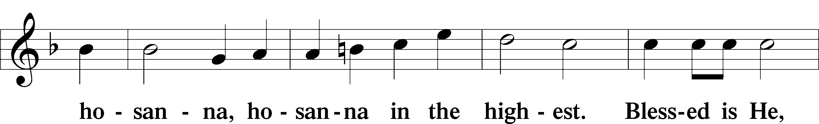
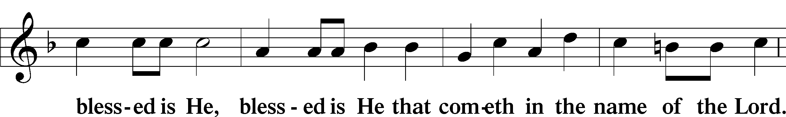
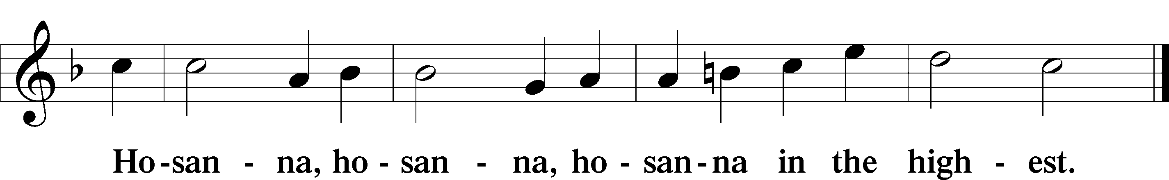

Lord’s Prayer The congregation is encouraged to silently pray the Lord’s Prayer as it is chanted. Matthew 6:9–13
P Our Father who art in heaven,
hallowed be Thy name,
Thy kingdom come,
Thy will be done on earth as it is in heaven;
give us this day our daily bread;
and forgive us our trespasses as we forgive those who trespass against us;
and lead us not into temptation,
but deliver us from evil.
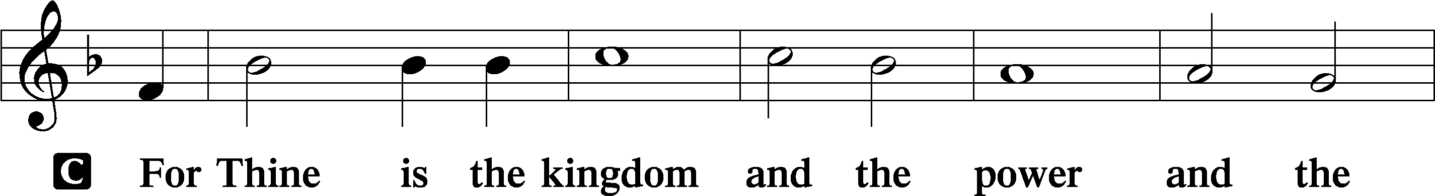
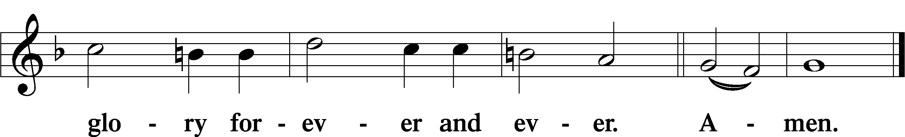

The Words of Our Lord Matthew 26:26–28; Mark 14:22–24; Luke 22:19–20; 1 Corinthians 11:23–25
P Our Lord Jesus Christ, on the night when He was betrayed, took bread, and when He had given thanks, He broke it and gave it to the disciples and said: “Take, eat; this is My T body, which is given for you. This do in remembrance of Me.”

In the same way also He took the cup after supper, and when He had given thanks, He gave it to them, saying: “Drink of it, all of you; this cup is the new testament in My T blood, which is shed for you for the forgiveness of sins. This do, as often as you drink it, in remembrance of Me.”

Pax Domini John 20:19
P The peace of the Lord be with you always.
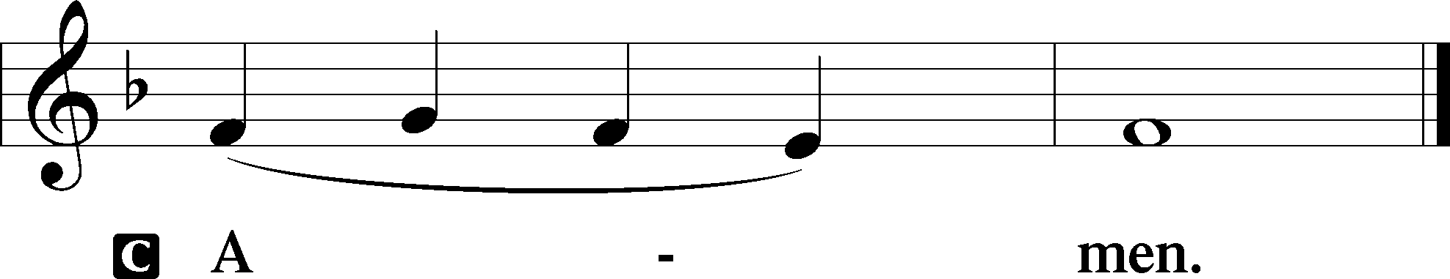

Agnus Dei John 1:29
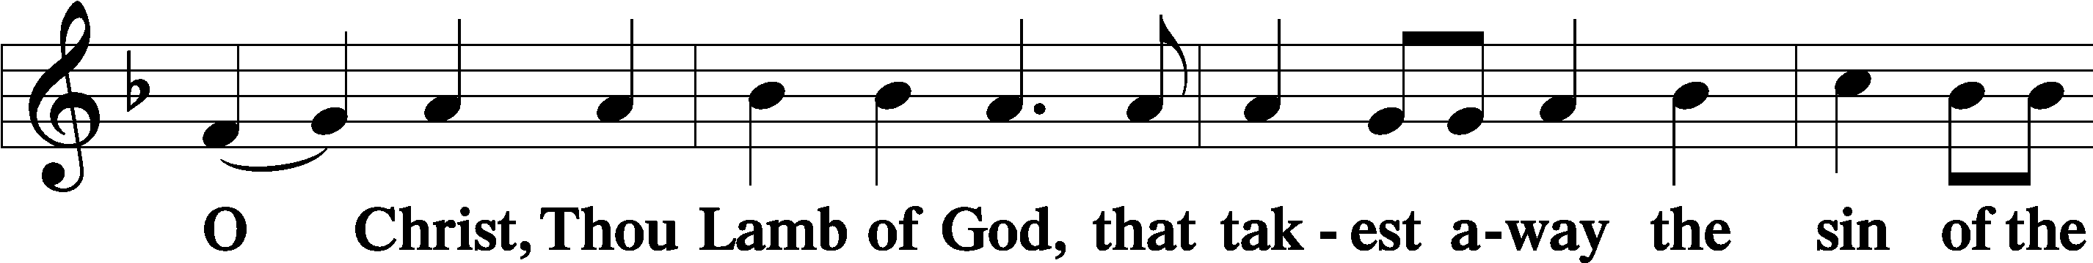
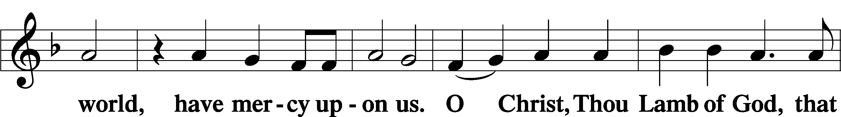
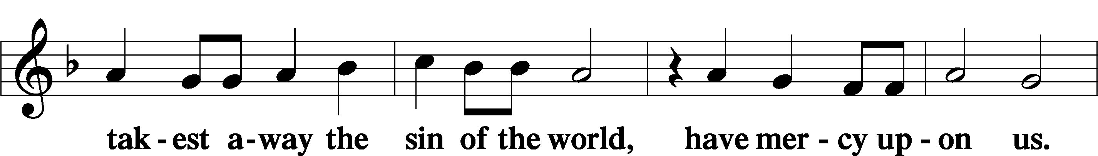
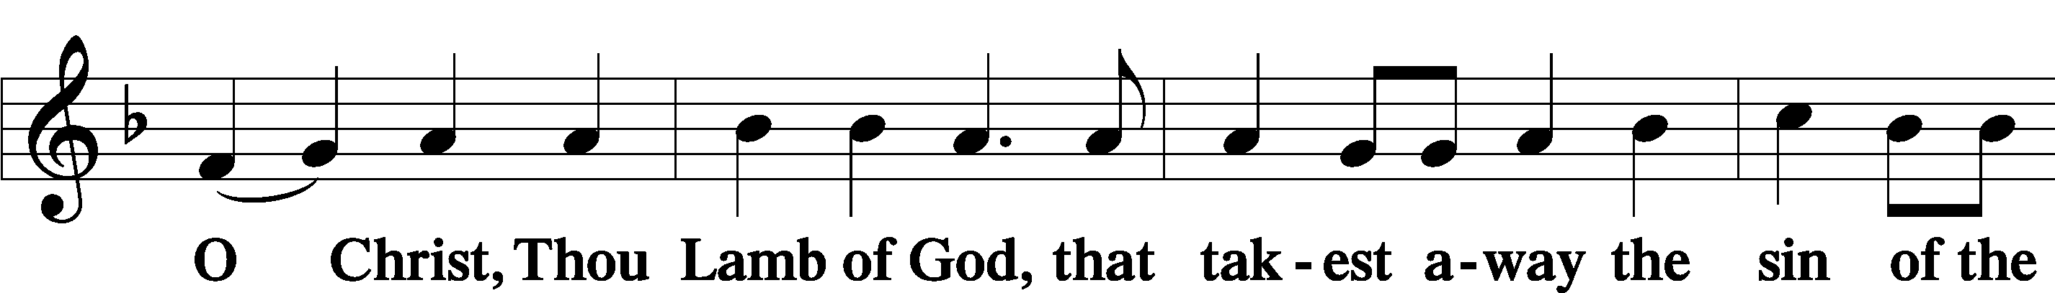
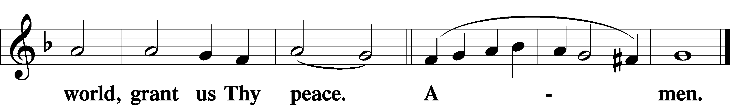
Sit
Distribution
The pastor and those who assist him receive the body and blood of Christ first and then distribute them to those who come to receive, saying:
Take, eat; this is the true body of our Lord and Savior Jesus Christ, given into death for your sins.
Amen.

Take, drink; this is the true blood of our Lord and Savior Jesus Christ, shed for the forgiveness of your sins.
Amen.

In dismissing the communicants, the following is said:
The Dismissal
P The body and blood of our Lord Jesus Christ strengthen and preserve you in body and soul to life everlasting. Depart T in peace.
C Amen.

Distribution Hymn: LSB #414 “’Tis Good, Lord, to Be Here”

Distribution Hymn: LSB #621 “Let All Mortal Flesh Keep Silence”

Distribution Hymn: LSB #874 “O Splendor of God’s Glory Bright”

Nunc Dimittis Luke 2:29–32
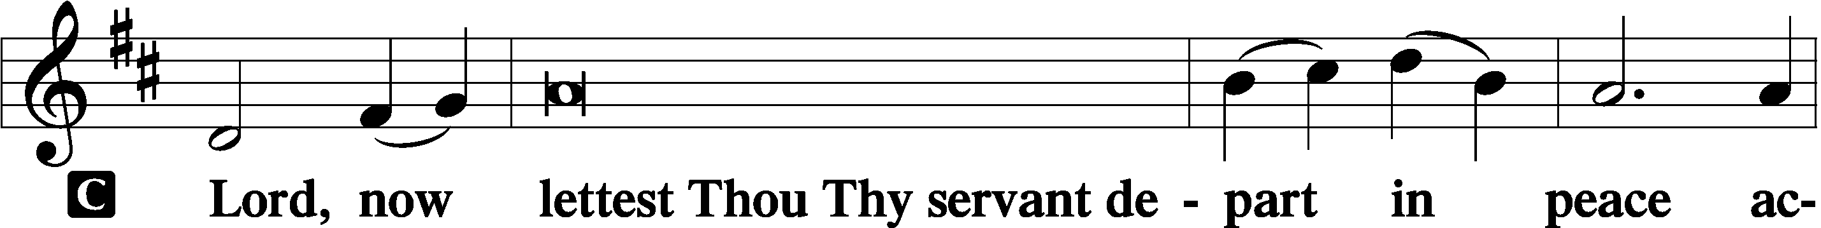
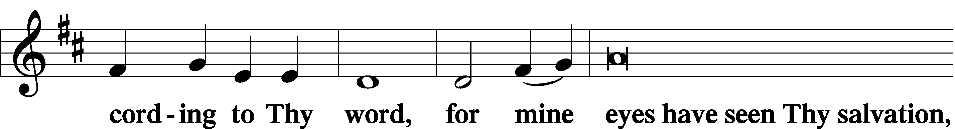
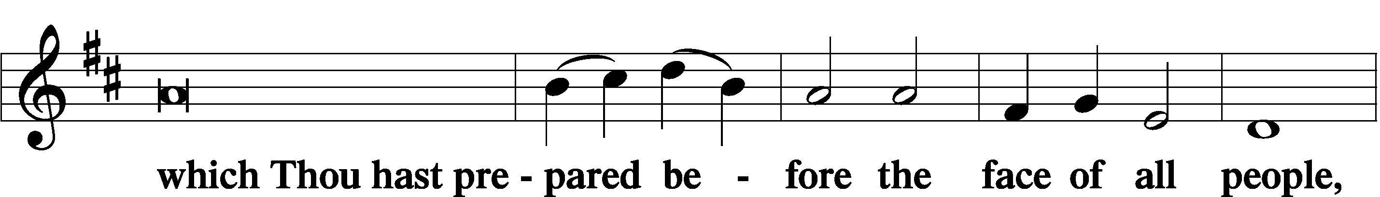
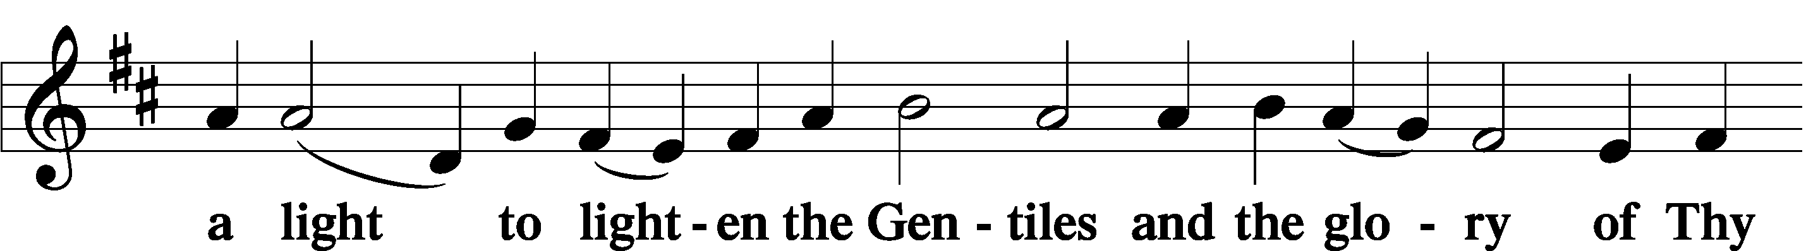
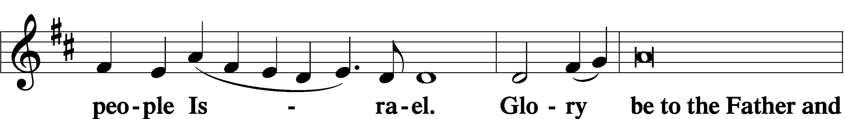
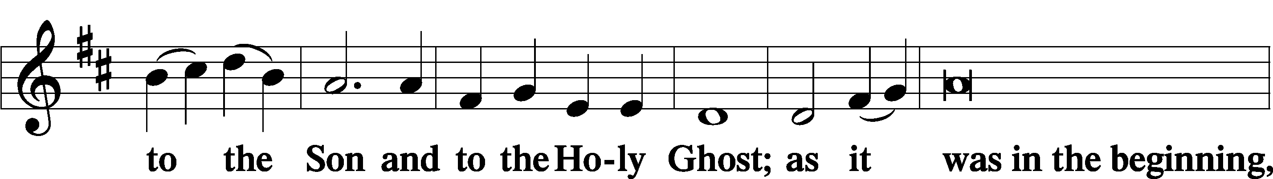
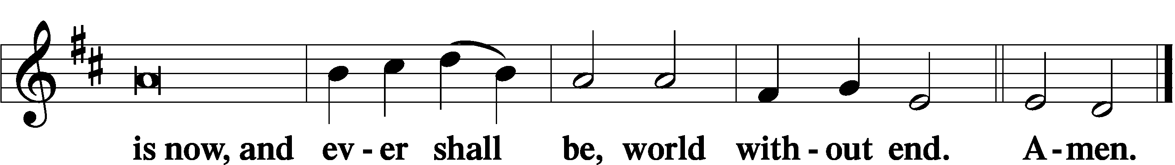

Thanksgiving Psalm 107:1
P O give thanks unto the Lord, for He is good,
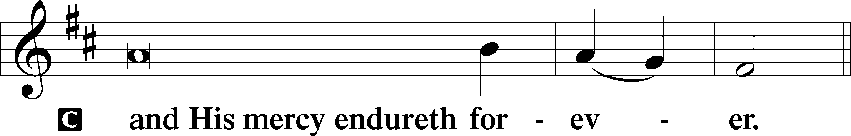

Post-Communion Collect
P Let us pray.
We give thanks to You, almighty God, that You have refreshed us through this salutary gift, and we implore You that of Your mercy You would strengthen us through the same in faith toward You and in fervent love toward one another; through Jesus Christ, Your Son, our Lord, who lives and reigns with You and the Holy Spirit, one God, now and forever.
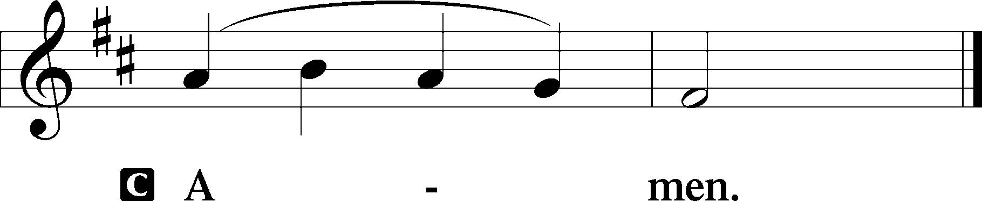

Salutation 2 Timothy 4:22
P The Lord be with you.
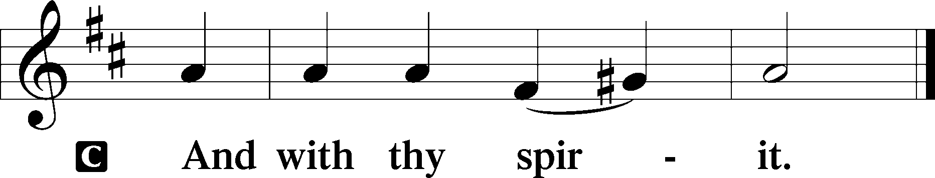

Benedicamus Psalm 103:1
P Bless we the Lord.
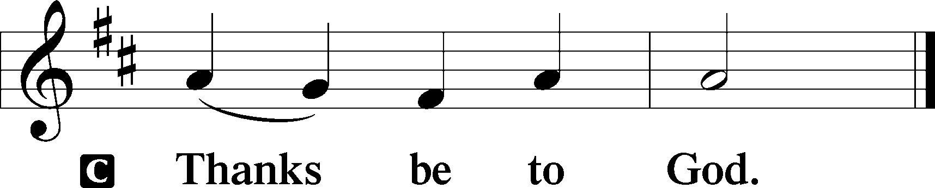

Benediction Numbers 6:24–26
P The Lord bless you and keep you.
The Lord make His face shine upon you and be gracious unto you.
The Lord lift up His countenance upon you and T give you peace.
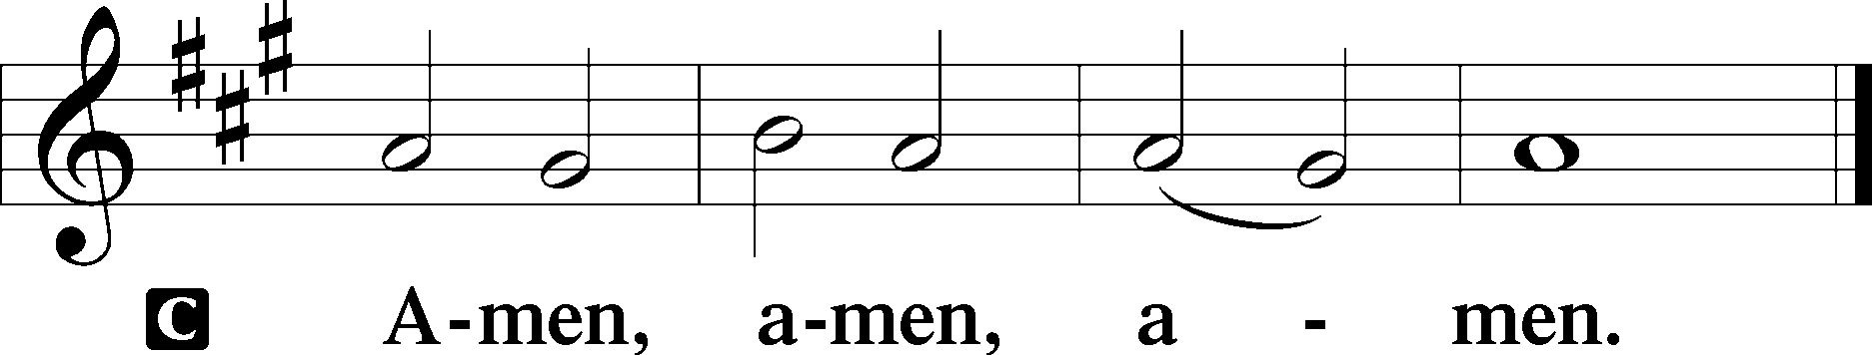

Closing Hymn: LSB #417 “Alleluia, Song of Gladness”

Silent prayer after worship: Almighty God, You sent Your Son to proclaim Your kingdom and to teach with power and authority. Empower me by Your Holy Spirit to live my life in Christ and to share His love with others. In Jesus’ name. Amen.

Acknowledgments
Unless otherwise indicated, Scripture quotations are from the ESV® Bible (The Holy Bible, English Standard Version®), copyright © 2001 by Crossway, a publishing ministry of Good News Publishers. Used by permission. All rights reserved.
Created by Lutheran Service Builder © 2024 Concordia Publishing House.
fffffffffffffffffffffffffffffffffff
fffffffffffffffffffffffffffffffffff
In Loving Memory of Erna Fleig: Catherine Carr (Capital Campaign).
fffffffffffffffffffffffffffffffffff
THANK YOU FOR SERVING IN JANUARY: Elder: Jonathan Baisch; Ushers: Cheryl Fedele, Mike Flaugher, & Jesse Riffle; Altarware ~ Sundays: (prior) Diane Riefstahl (01.21 & 01.28); (after) Cheryl Fedele & Clara Krivosh.
fffffffffffffffffffffffffffffffffff
Attendance: Sunday, January 14, 2024: 28
fffffffffffffffffffffffffffffffffff

SCHEDULE THROUGH JANUARY 28, 2024:

:

Today, following Worship, Library: Monthly/Quarterly Audits
7 pm, Fellowship Hall: AA Meeting
Tuesday, 7-9 pm, Fellowship Hall: Penn-Ohio Singers
Wednesday, 7 pm, Fellowship Hall: NA Meeting
7 pm, Sanctuary: Vespers Service (St. Timothy, Pastor and Confessor)
Thursday, 9 am, Downstairs: Food Pantry
Friday, 7 pm, Sanctuary: Vespers Service (St. Titus, Pastor and Confessor)
Next Sunday, 8 am, Downstairs: Bible Study
9 am, Sanctuary: Divine Service
7 pm, Fellowship Hall: AA Meeting
fffffffffffffffffffffffffffffffffff
Our Stewardship of Treasures for the Lord:

Figures for Sunday, January 14, 2024
General Fund: $1,210.00
SELC: $22.00
Food Pantry: $38.00
Quarterly Missions: $0.00
Capital Campaign: $315.00
Other: $675.00
Online Figures for Tuesday, January 16, 2024
General Fund: $150.00
Capital Campaign: $200.00

For online giving, check out https://www.saintspeterandpaul.net/online-giving.
fffffffffffffffffffffffffffffffffff
UP-COMING MEETING:
Monday, January 29th: Church Council meeting at 7 pm in the Fellowship Hall. (Reports are due to Diane by noon that day.)
fffffffffffffffffffffffffffffffffff
Items for the 2023 Annual Report and February Calendar and Newsletter are due to Diane by 9 am tomorrow, January 22nd. Thank you!
fffffffffffffffffffffffffffffffffff
Remember the following in Prayer…
~The Hurting and Healing: Amy, Steve, Mary Jane Anderson, Steve Antolovich, Ellen Baron^{CA}, Amy Blomenberg, Lois Bortner^{CA}, Sara Brubaker and her son, Canaan; Dee Bullock, Bev & Joe Chlpka, Susan Davies, Loretta Deal, Tim Dudash, Mike Flaugher, Judith & Eddy Furey, Griffin, Pastor Charles Henrickson, Joan, Keith Jozwiakowski, Rhyan Kirsch, Darla Krajci, Barbara Kreske, Jess Lavoie, Paul Lucas^{CA}, Sandy Marshall, Lynn Price, Juanita Rentschler, Richard Reuning^{CA}, Nancy Robertson^{CA}, Kriss Svidro^{CA}, Rudy Tomko, Bob Usnarski, Joel & Peggy Wasson, Angela Weser^{CA}, Ruth Wolf, and Michelle Young.
~The Homebound: Anna Mae Daris, Millie Elavsky, Jean Tomko, Betty Wolf, and Ed & Millie Zachar.
~Serving in the Military: Alex (Sasha) Carr, Duncan Vaupel, Curtis Sinewe, and Joshua Solyan.
~Community & World Needs: Those suffering due to the conflicts in the Middle East and between Ukraine and Russia; those suffering from loss and dislocation because weather disasters; those suffering from addiction and their families; Local, State, and National Government Leaders; safety for all Police Officers, Firefighters, & First Responders; the unemployed; our First Quarter Local Mission: Community Outreach. *CA represents cancer.
fffffffffffffffffffffffffffffffffff
Bible Memory Verses ~ Week of January 21st:
For Adults: I have been crucified with Christ. It is no longer I who live, but Christ who lives in me. And the life I now live in the flesh I live by faith in the Son of God, who loved me and gave himself for me. Galatians 2:20

For Children: God, who said, “Let light shine out of darkness,” has shone in our hearts to give the light of the knowledge of the glory of God in the face of Jesus Christ. 2 Corinthians 4:6
fffffffffffffffffffffffffffffffffff
Auditors are asked to meet in the library following worship this morning for monthly and quarterly audits.
fffffffffffffffffffffffffffffffffff
Altar Guild members are reminded that 2024 dues ($25) may be paid to Treasurer Evelyn Baisch. Checks should be made out to the church.

Join us this
Wednesday and Friday evenings,
January 24th and 26th
at 7 pm
as we celebrate
The Feast of St. Timothy,
Pastor and Confessor
and
The Feast of St. Titus,
Pastor and Confessor

Here to Serve
Pastor………………………………………………...……………Rev. Jacob Deal
E-mail …………………………….……pastordeal@saintspeterandpaul.net
Phone Number……………………..…………………724-347-3620 (Option 2)
Church Office………………………..…………………724-347-3620 (Option 3)
Website …………………………………………www.saintspeterandpaul.net
Secretary…………………………………………………………Diane Riefstahl
E-mail ………………………………………church@saintspeterandpaul.net
Website …………………………………………www.saintspeterandpaul.net
Food Pantry (email): ……………foodpantry@saintspeterandpaul.net
Congregation President………………………………….…Jonathan Baisch
Church Elder …………………………………………...……. Jonathan Baisch
Organist………………………………………………..….…Rebecca Marquette
AA Contact: Steve………………………………………………...…724-813-2358
NA Contact: Larry……………………………………..…………..724-977-8733
fffffffffffffffffffffffffffffffffff
If needing to get into the church building during the week, please phone first to make certain someone is here to let you in.

