Sts. Peter & Paul Evangelical Lutheran Church LC-MS
Monthly Newsletter --- January 2024
699 Stambaugh Avenue, Sharon, PA 16146
Phone: 724.347.3620 (Opt. 2, Pastor Deal; Opt. 3, Office)
E-mail: church@saintspeterandpaul.net www.saintspeterandpaul.net

“THE ROCK and THE SWORD”
“Built upon the Rock of Christ and wielding the
Sword of the Spirit, the Word of God.”

From the Pastor:
Daniel and the Wise Men
God makes a way and His word always prevails. Around 604 BC, Daniel found himself in exile in Babylon under King Nebuchadnezzar. God had allowed Nebuchadnezzar, a foreign and pagan king, to overthrow Jerusalem as a chastisement upon His own people. Reading Isaiah, Jeremiah, and Ezekiel, as well as the Minor Prophets, shows us through the eyes of the Lord just how wicked the nation of Israel had become; northern and southern kingdoms alike. As the righteous have nothing to fear from the Lord, He did not leave Daniel alone, but upheld him in wisdom and strength so that the opportunity to interpret King Nebuchadnezzar’s dream was presented to him. This was very important as after the Spirit and Wisdom of God had given the sure and certain interpretation to Daniel who then spoke it to the king, it is written:
Then King Nebuchadnezzar fell on his face, prostrate before Daniel, and commanded that they should present an offering and incense to him. The king

answered Daniel, and said, “Truly your God is the God of gods, the Lord of kings, and a revealer of secrets, since you could reveal this secret.” Then the king promoted Daniel and gave him many great gifts; and he made him ruler over the whole province of Babylon, and chief administrator over all the wise men of Babylon. Daniel 2:46-48

Now, what I have neglected to tell you is that by this, Daniel/GOD saved the lives of every Wise Man of Babylon. They had all failed to interpret Nebuchadnezzar’s dream and the king wanted them terminated. However, God spared them through Daniel who stopped the king’s guard. How do the Wise Men offer their thanks to God? Some of them remained in the Word which Daniel spoke to them, interpreting the signs and the seasons. Then we hear that after 604 years, Christ is born in Bethlehem in the city of David. And who is it that comes from the East, following the Star of David? None other than the Wise Men from all over the region Chaldea, once occupied by Babylon.
These Wise Men come bearing the gifts of gold, frankincense, and myrrh for the king of mercy who many, many years ago spared the lives of their ancestors so that they might become worshipers of the true God.
Today, we are sojourners in this world, though it may seem as if we are captives in a foreign country under a strange king. We cannot let ourselves give up hope in the God of mercy whose desire it is to save. He can and will continue to accomplish wonderful things through His almighty Word and Spirit.

In Christ,
Pastor Deal
llllllllllllllllllllllllllll
Thank You for Serving in January:
Elder: Jonathan Baisch; Ushers: Cheryl Fedele, Mike Flaugher, & Jesse Riffle; Altarware ~ Sundays: (prior) Elizabeth Haenftling (01.07), Marie Flaugher (01.14), & Diane Riefstahl (01.21 & 01.28); (after) Cheryl Fedele & Clara Krivosh; Special Divine Service: Diane Riefstahl (01.06).
llllllllllllllllllllllllllll
January Church Office Hours
The secretary’s office will be open as follows in January:
- Week of December 31: Tuesday (8:30 am – 4:30 pm), Wednesday (8:30 am – 1 pm), and Thursday, as needed.
- Weeks of January 7 & 21: Mondays & Thursdays (8:30 am – 4:30 pm).
- Week of January 14: Monday (8:30 am – 4:30 pm), Thursday (8:30 am – 1 pm), and Friday (9:30 am – 2 pm).
- Week of January 29: Monday (11:30 am – 7 pm) and Thursday (8:30 am – 10 am; 11 am – 5 pm).

If needing to enter the building during the week, please phone first to make certain someone is there to let you in.
CAPITAL CAMPAIGN AT A GLANCE

Blue: Pledged as of 12.24.2023 $184,320 (92.16%)
Orange: Remaining
$15,680 (7.84%)

Total Contributions
as of 12.24.2023:
$188,595 (94.3%)
Previous: $184,804 (92.4%)
New: $3,791 (1.9%)
Remaining: $11,405 (5.7%)

Amounts used are based on
weekly deposits reported.

It’s not too late to submit a Capital Campaign pledge card! Pledge cards are available on the table outside Pastor’s office. If circumstances have changed and you need to update your pledge card, please see Jonathan Baisch. Updated pledges help our Trustees plan more effectively and efficiently.
llllllllllllllllllllllllllll

NEWS FROM THE TRUSTEES
Thanks to all who helped with the decorating the church for the Christmas season. It looked great! The manger scene in the balcony was a great touch. It was nice addition to see when one walked into the church. Special “thanks” to Pastor Deal and Vicar Wessel for making that happen.
The trustees will be “un-decorating” the church Saturday, January 13, 2024, at 10 am. Anyone else wishing to help is more than welcome to join us!

The following projects were addressed in the month of December:
- Central Heating did the annual service of the heating system. We are “good to go” for another year.
- Cabinets were removed from the old stage to improve the area for the food pantry. Thanks, Cheryl, for painting the floor. It’s much improved.
- Batteries were replaced in all thermostats.
- The cold-water faucet in the upstairs women's restroom was repaired as it was dripping badly.
- Williams Window was in to start repair on the stained-glass window in Pastor’s office. They removed the window and are scheduled to return the first week in January to re-install the repaired window,
- Banner brackets were installed in room 4 for the church banners to be hung.

The organizational meeting for the Trustees will be Tuesday, January 16th at 7 pm. It is important for all to attend.
As always, please feel free to speak with a Trustee with any concerns or place a note in Mike Flaugher’s library mailbox.
ATTENTION AUDITORS! A Quarterly & Monthly Audit will take place following worship, Sunday, January 21st in the library. If unable to attend, please phone Bev Chlpka at 724-962-4806.
llllllllllllllllllllllllllll
SCRIP Program:
The next date for SCRIP orders and payments is Sunday, January 7th. Checks should be made out to Sts. Peter & Paul’s and are to be given to Matt Berent or placed in the offering plate. You should receive your gift cards the following week.
Forms for ordering gift cards are available on tables in the narthex and next to the nursery.
llllllllllllllllllllllllllll
Bible Study Classes
- The Sunday Morning Bible Study (8 am)
will resume January 14th.
- The Women’s Bible Study group is currently studying the book of Romans. We will next meet Thursday, January 3rd at 10 am when we will continue with our study of Romans 3.
- The Men’s Bible Study is temporarily suspended until a new meeting day/time is determined.
llllllllllllllllllllllllllll
CELEBRATING IN JANUARY!
Birthdays
Mike Flaugher 1 - 4
Gerald Arthur 1 - 12
Evelyn Baisch 1 - 15
Rachal Myers 1 - 22
Bess Kleindienst 1 - 23

*If birthdays or anniversaries have been omitted, please let the church office know. Thank You!
llllllllllllllllllllllllllll
Submissions for the February issue of “The Rock and the Sword” newsletter and calendar are due to the secretary’s office Monday, January 22nd at 9 am. This includes meeting dates and times for the church calendar.
llllllllllllllllllllllllllll
Collected pop tabs can be left for Marie Flaugher in the library.
llllllllllllllllllllllllllll
A note of appreciation!
Thanks to all for the many prayers, kind words, and generosity since I have taken the organist position. I am truly blessed to serve at Sts. Peter & Paul’s.
~Rebecca Marquette
llllllllllllllllllllllllllll
Sincere sympathy is extended to Jesse & Alyxis Riffle as well as their family and friends upon the passing of Jesse’s father, Timith Riffle, December 9, 2023. May those who mourn his passing take comfort in the fact that he now rests with his Lord and Savior Jesus Christ.
llllllllllllllllllllllllllll
Changes of Address:
Please update your church directories with the following changes of address:
- The Suttons: 268 Mitchell Rd., West Middlesex, PA 16159
- April Bosnjak: 821 Arlington Dr., Greenville, PA 16125

Plans are to publish a new church directory in March 2024. Please notify the secretary in writing if you do not want your information included or if there has been a change in information.
llllllllllllllllllllllllllll
Please keep the following
in your prayers
PVT Alexander Carr
(New address currently unknown.)
lll lll lll lll lll lll lll lll lll lll lll lll lll lll lll
Anna Mae Daris
1865 Hofius Lane
Hermitage, PA 16148
724-962-5079
lll lll lll lll lll lll lll lll lll lll lll lll lll lll lll
Millie Elavsky
1209 Maple Dr.
Hermitage, PA 16148
724-342-0345
lll lll lll lll lll lll lll lll lll lll lll lll lll lll lll
Rudy Tomko
Rm. 8
Nugent Convalescent Home
500 Clarksville Rd.
Hermitage, PA 16148
lll lll lll lll lll lll lll lll lll lll lll lll lll lll lll
Jean Tomko
2629 Romar Dr.
Hermitage, PA 16148
724-979-4360
lll lll lll lll lll lll lll lll lll lll lll lll lll lll lll
Betty Ann Wolf
7777 Arthur St.
Masury, OH 44438
330-448-1080
lll lll lll lll lll lll lll lll lll lll lll lll lll lll lll
Ed & Millie Zachar
1320 Old Forge Rd.
Niles, OH 44446
330-652-9316
lll lll lll lll lll lll lll lll lll lll lll lll lll lll lll
REMINDER: If you do not have an email account or do not receive emails from the church, but wish to be notified of significant information concerning your fellow church members, please put a note in the secretary’s mail slot asking to receive a phone call. Every attempt will be made to phone you within 24 hours of an email being sent out.
llllllllllllllllllllllllllll
LIKE & FOLLOW our Church’s Facebook page
(Saints Peter and Paul Evangelical Lutheran Church)!
Altar Guild News
The Altar Guild has been graced with a generous donation in memory of Barry Nelson from his family. Barry was a strong supporter of the Altar Guild and was always at the ready to lend a helping hand when needed. We are deeply touched by this act of kindness.
The 2024 Altar Ware Schedule has been finalized. Holy Communion set-up will be done by Elizabeth Haenftling (1st Sunday of month), Marie Flaugher (2nd and 5th Sundays), and Diane Riefstahl (3rd and 4th Sundays).
Those responsible for Sunday clean-up are as follows:
- January: Cheryl Fedele & Clara Krivosh
- February: Marie Flaugher
- March: Cheryl Fedele & Clara Krivosh
- April: Evelyn Baisch & Traudi Sulek
- May: Elizabeth Haenftling & Hank Holcroft
- June: Marie Flaugher
- July: Hank Holcroft & Arlene Sutton
- August: Evelyn Baisch & Elizabeth Haenftling
- September: Hank Holcroft & Arlene Sutton
- October: Evelyn Baisch & Kati Laird
- November: Marie Flaugher
- December: Kati Laird & Traudi Sulek

The next Altar Guild meeting will take place Saturday, January 20th at 1 pm.
llllllllllllllllllllllllllll
A sign-up sheet for 2024 Altar Flowers has been posted on the bulletin board in the narthex. Please speak with Diane if you should have any questions.
To listen to Pastor Deal’s sermons, phone 724-347-3620 (Opt. 6).

llllllllllllllllllllllllllll
Word of Hope: 1-888-217-8679
The only 24/7 CONFIDENTIAL Hotline that is distinctly Lutheran, bringing healing found in Christ, to those whose hearts have been broken by abortion.
llllllllllllllllllllllllllll
Coffee Fellowship
is January 14th!
Join us following worship, Sunday, January 14th for Coffee Fellowship courtesy of Jonathan & Bekah Baisch.
The 2024 Fellowship Sponsor sheet has been posted on the bulletin board in the narthex. If interested in being a sponsor, please sign your name on the sheet. Sponsors are asked to drop off 2-1/2—3 dozen “treats” and a quart of juice in the Fellowship Hall kitchen prior to church on their given Sunday. Coffee preparation, set-up, and clean-up will be done for you.
Please speak with Diane Riefstahl if you should have any questions.
llllllllllllllllllllllllllll
REMINDER: Please let the church office know of any changes to your address, phone, cell phone or your e-mail address!
llllllllllllllllllllllllllll
Congratulations to Alex (Sasha) Carr who recently completed his second phase of training with the US Army! Sasha is in the process of moving to Kentucky where he will be stationed for the next two years.
If wishing to send Sasha notes or cards during this time of transition, please send them to his mother’s address (2449 Romar Dr., Hermitage, PA 16148). She will make certain that he gets them!
llllllllllllllllllllllllllll
Remember the following in prayer…
~The Hurting and Healing: Amy, Mary Jane Anderson, Steve Antolovich, Ellen Baron^{CA}, Amy Blomenberg, Lois Bortner^{CA}, Sara Brubaker, Dee Bullock, Bev & Joe Chlpka, Susan Davies, Loretta Deal, Tim Dudash, Judith & Eddy Furey, Griffin, Austin Hamilton, Pastor Charles Henrickson, Joan, Keith Jozwiakowski, Rhyan Kirsch, Darla Krajci, Barbara Kreske, Jess Lavoie, Paul Lucas^{CA}, Sandy Marshall, Frank Niemeyer^{CA}, Juanita Rentschler, Richard Reuning^{CA}, Rosemary (Posey) Rice^{CA}, Nancy Robertson^{CA}, Kriss Svidro^{CA}, Rudy Tomko, Bob Usnarski, Joel & Peggy Wasson, Angela Weser^{CA}, and Ruth Wolf.
~The Homebound: Anna Mae Daris, Millie Elavsky, Jean Tomko, Betty Wolf, and Ed & Millie Zachar.
~Serving in the Military: Alex (Sasha) Carr, Duncan Vaupel, Curtis Sinewe, and Joshua Solyan.
~Community & World Needs: Those suffering from or affected by the coronavirus; those suffering due to the conflicts in the Middle East and between Ukraine and Russia; those suffering from loss and dislocation because weather disasters; those suffering from addiction and their families; Local, State, and National Government Leaders; safety for all Police Officers, Firefighters, & First Responders; the unemployed; our First Quarter Local Mission: Community Outreach.
*CA represents cancer.

Congratulations to the Recently-Elected 2024 Church Officers
and Boards!
President
Jonathan Baisch

Vice President
Matt Berent

Recording Secretary
Diane Riefstahl

Treasurer
Rebekah Baisch

Financial Secretary
Dolores Fee

Trustees
Pastor Baisch Bess Kleindienst
Cheryl Fedele Jerry Krivosh
Mike Flaugher Rebecca Marquette
Mark Gabriel Jerome Thomas
Auditors
Evelyn Baisch Elizabeth Haenftling
Bev Chlpka Kati Laird
Marie Flaugher Jerome Thomas

Financial Staff
Mark Gabriel Traudi Sulek
Gordon Marquette
Joan Rice June Thomas
Nancy Robertson Linda Tomko

The Installation of Church Officers and Boards will take place during the January 14th Divine Service. Also being recognized that day for their past service will be Sue Bender and Pastor Baisch (past Financial Staff members) along with Michael Laird and Jesse Riffle (past Trustees).
llllllllllllllllllllllllllll
FOOD PANTRY NEWS
The second Sunday of each month is designated as “Food Pantry Sunday”. Your financial support of this community outreach is greatly appreciated.
We are very grateful to all those who contributed to our special collection of papers products in December. These items were graciously appreciated by our food pantry clients.
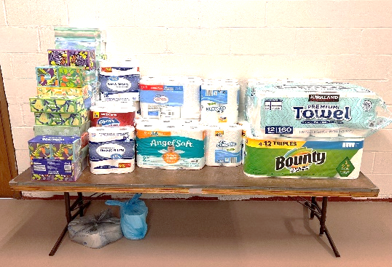
llllllllllllllllllllllllllll
ADF: Biological Reality in a Culture of Lies

You . . . helped make possible a major legal victory for women’s sports!!
Just about everywhere you look, you can see the encroaching threats from gender ideology. There are threats against fairness in sports and privacy in intimate spaces – and threats of irreversible harm from unproven interventions. In short, gender ideology has infiltrated and is infecting many areas of our society.
But with generous support from donors, Alliance Defending Freedom [ADF] has helped to shed light on the harmful ways gender ideology is threatening our nation’s women and girls.
In January [2023], ADF was instrumental in stopping a legal challenge at the district level to West Virginia women’s sports legislation, which effectively protects the safety and fairness of girls and women [in sports]. It was the first major victory of its kind to stop gender ideology from overtaking women’s sports. The case is now on appeal.
And ADF has helped draft and pass similar laws protecting women in sports in 23 states across the United States.
As a society we can’t give up on supporting and defending the truth about being created Male and Female. No society can flourish if it is built upon lies about sexuality. It’s a fundamental part of the family, the building block of society.
That’s why [our church’s] partnership with Alliance Defending Freedom (ADF) makes a difference – standing for the truth about biology!
YOUR support for ADF’s efforts is making a path to victory possible. Thank YOU for helping to build a future where biological reality is preserved and our women and girls are protected!
Together with ADF we will stand for the truth that:
- God created us male and female, a fact that matters in how we educate our children and protect the safety of women and girls in sports, restrooms, and college dorms;
- Religious freedom means that all people have the right to follow their conscience and peaceably to live out their faith; and
- The right to speak freely should be protected because it is the basis of a free nation.
From ADF’s Year-End Report, Dec. 2023.
Submitted by Pastor Emeritus Arthur H. Baisch
llllllllllllllllllllllllllll
Memory Verses for December
For Adults:
Dec. 3: I am the way, and the truth, and the life. No one comes to the Father except through me. John 14:6
Dec. 10: If you confess with your mouth that Jesus is Lord and believe in your heart that God raised him from the dead, you will be saved. Romans 10:9
Dec. 17: For by grace you have been saved through faith. And this is not your own doing; it is the gift of God, not a result of works, so that no one may boast. Ephesians 2:8-9
Dec. 24: Therefore, if anyone is in Christ, he is a new creation. The old has passed away; behold, the new has come.
2 Corinthians 5:17
Dec. 31: Come to me, all who labor and are heavy laden, and I will give you rest. Take my yoke upon you, and learn from me, for I am gentle and lowly in heart, and you will find rest for your souls. For my yoke is easy, and my burden is light. Matthew 11:28-30

For Children:
Dec. 3: Behold, your king is coming to you; righteous and having salvation is he. Zechariah 9:9
Dec. 10: Raise your heads, because your redemption is drawing near.
Luke 21:28
Dec. 17: Prepare the way of the Lord; behold, the Lord God comes with might. Isaiah 40:3, 10
Dec. 24: My soul magnifies the Lord, and my spirit rejoices in God my Savior.
Luke 1:46-47
Dec. 31: Lord, now you are letting your servant depart in peace, according to your word; for my eyes have seen your salvation.
Luke 2:29-30
llllllllllllllllllllllllllll

We were chosen! By directing designated Choice Dollars through Thrivent Choice, eligible Thrivent members choose where Thrivent Financial for Lutherans distributes some of its charitable outreach grant dollars among thousands of participating Lutheran nonprofit organizations and congregations.
Many thanks to Thrivent Financial members Evelyn Baisch and Laura Williams who recently directed Choice dollars to our church!
llllllllllllllllllllllllllll
OUR 1st QUARTER MISSION:
Community Outreach
At the December 2023 Voters’ Assembly, voters approved the re-naming and re-purposing of the former “Community Day” 1st Quarter Mission to “Community Outreach”. The purpose of this move is to expand our opportunities to serve our local community through a variety of different means.
Last year, rather than hosting our own Community Day activities, Sts. Peter & Paul’s joined with the City of Sharon in its annual Children’s Carnival which was held at nearby Wengler Field. Tentative plans are to participate in this activity once again in 2024.
If you should have any ideas of other community events to join in, please speak with Pastor Deal.
Your support of this Quarterly Mission will be greatly appreciated. Donations may be placed in a pew envelope and put in the offering plate.
REMINDER: If you do not have an email account or do not receive emails from the church, but wish to be notified of significant information concerning your fellow church members, please put a note in the secretary’s mail slot asking to receive a phone call. Every attempt will be made to phone you within 24 hours of an email being sent out.
llllllllllllllllllllllllllll
Shelves have been placed in front of the secretary’s office for recent copies of items generally found in the narthex (Council/Voters’ Assembly agendas & minutes, etc.). Items will now be available in both locations for your convenience.
llllllllllllllllllllllllllll
Please check in! It is important that you mark the attendance sheet each service which you attend! This information is valuable in helping us track attendance and plan for up-coming services (preparing bulletins, etc.).
Checking in not only is important for Divine Services (when the Sacrament of Holy Communion occurs), but should be done at all services. Check-in sheets are available both in the narthex and near the parking lot entrance. Please help and take a moment to let us know you’re here. It will be greatly appreciated!
llllllllllllllllllllllllllll
Christmas 2023
Poinsettia Donations
Anonymous: In Honor of Rev. & Mrs. Deal & Family and Past and Present Church Council Members (1 red and 1 white plant)

Catherine Carr: In Loving Memory of Rev. Timothy Carr, Rev. Otto & Millie Brillinger (1 red and 1 white plant)
Mike & Marie Flaugher: In Honor of Everyone Who Serves the Church (3 red plants)

Judith A. Furey: In Loving Memory of Judith E. Boal, Dorothy Shoenberger, and Viola Sakony (2 large red/white/pink plants)

Mark Gabriel: In Loving Memory of Parents, Peter & Anne Gabriel, and Brother, Denny A. Gabriel (1 large red/white/pink plant)

Henrietta Holcroft: In Loving Memory of Anson, Vi, and Barry (1 white plant)

Elizabeth Loughan: In Loving Memory of William Loughan and Iris & James Reigelman (2 large red/white/pink plants)

Ruth Meszaros: In Loving Memory of Ernie Meszaros, My Wonderful Husband of 62 years (1 white plant)

The Nelson Family: In Loving Memory of Barry Nelson, Bill & Margie Nelson, John & Mary Ann Krajci; John G. Krajci; Olivia Sovesky; David Nelson; and All Loved Ones (1 red plant and 1 large red/white/pink plant)

Diane Riefstahl: In Loving Memory of Parents, Donald L. & Lucile M. Riefstahl, and Brother, Donald C. Riefstahl (1 large red/white/pink plant)

Mrs. Robert Sulek: In Loving Memory of My Husband, Robert Sulek (1 red plant)

Linda Tomko: In Loving Memory of Lillian & Paul Tomko; Susan & Michael Tomko; and Lillian & George Stull (1 large red/white/pink plants)

Also, special “thanks” to Mark Gabriel for donating the plants which line the hallway windows!
Plants should be taken home
following worship January 7th.
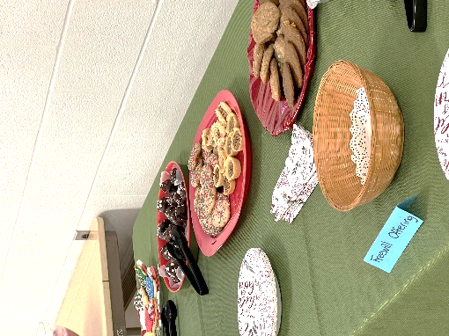
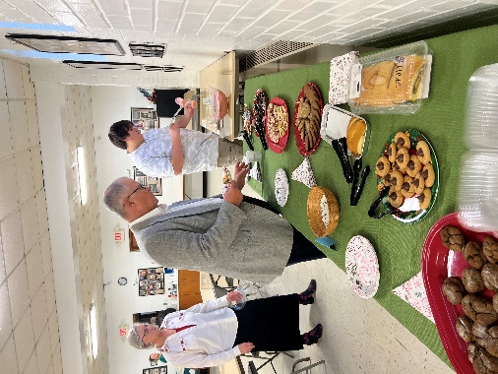

Additional Opportunities for Worship this January
In addition to regular Sunday morning Divine Services at 9 am, the following will be observed this month:
- Monday, January 1st at 7 pm
Vespers Service celebrating the Circumcision and Name of Jesus
- Saturday, January 6th at 7 pm
Divine Service celebrating the Epiphany of Our Lord
- Wednesday, January 24th at 7 pm Vespers Service celebrating the Feast of St. Timothy, Pastor & Confessor
- Friday, January 26th at 7 pm
Vespers Service celebrating the Feast of St. Titus, Pastor & Confessor
llllllllllllllllllllllllllll
Church Council will meet Monday, January 29th at 7 pm. Please email copies of reports to Diane by noon that day.
llllllllllllllllllllllllllll
2023 Annual Report
Work on the 2023 Annual Report will begin soon. If you are responsible for a section of the report, you will be receiving a copy of your 2022 report and guidelines for this year’s submission the first week of January. You are asked to submit your material to Diane no later than Monday, January 22nd.
llllllllllllllllllllllllllll
Sights of the Season…
From the Altar Guild’s third annual “Coffee & Cookies” to decorating the sanctuary for Christmas, there were plenty of opportunities for fellowship this past month.

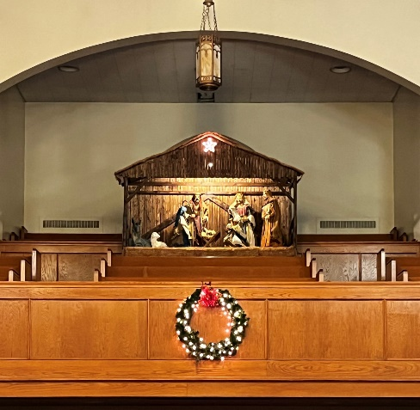

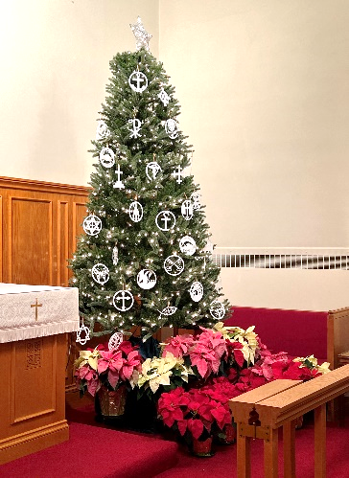
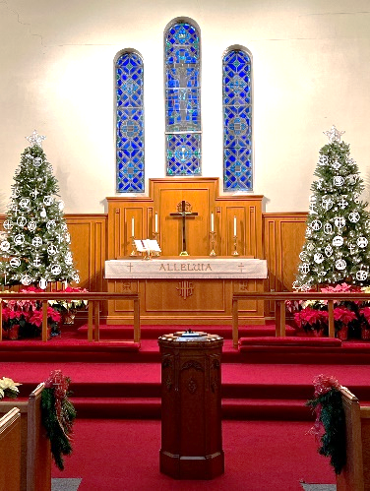

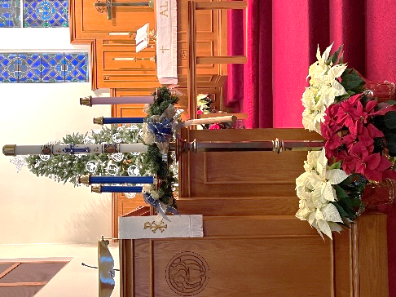
2024 Meetings and Events
(Subject to change. Does not include Worship Services.)

January
14 (Sun): Coffee Fellowship
16 (Tues): Trustees’ Mtg (7 pm)
20 (Sat): Altar Guild Mtg (1 pm)
21 (Sun): Quarterly/Monthly Audit
29 (Mon): Church Council (7 pm)

February
11 (Sun): Coffee Fellowship
13 (Tues): Trustees Mtg (7 pm)
18 (Sun): Monthly Audit

March (Easter is March 31)
3 (Sun): Voters’ Assembly
10 (Sun): Coffee Fellowship
16 (Sat) : Altar Guild Mtg (1 pm)
17 (Sun): Monthly Audit

April
7 (Sun): Finance Committee Mtg
14 (Sun): Coffee Fellowship
20 (Sat): Ladies Luncheon (11 am)
21 (Sun): Quarterly/Monthly Audit
22 (Mon): Church Council (7 pm)

May (Mother’s Day is May 12)
18 (Sat) : Altar Guild Mtg (1 pm)
19 (Sun): Coffee Fellowship
19 (Sun): Voters’ Assembly
26 (Sun): Monthly Audit

June (Father’s Day is June 16)
9 (Sun): Coffee Fellowship
23 (Sun): Monthly Audit

July
7 (Sun): Finance Committee Mtg
14 (Sun): Coffee Fellowship
21 (Sun): Quarterly/Monthly Audit
22 (Mon): Church Council (7 pm)

August
11 (Sun): Coffee Fellowship
11 (Sun): Voters’ Assembly
18 (Sun): Monthly Audit

September
8 (Sun): Coffee Fellowship
15 (Sun): Monthly Audit
21 (Sat) : Altar Guild Mtg (1 pm)

October
13 (Sun): Coffee Fellowship
13 (Sun): 2025 Budget forms distributed
20 (Sun): Quarterly/Monthly Audit
27 (Sun): 2025 Budget forms due

November
3 (Sun): Finance Committee Mtg
10 (Sun): Coffee Fellowship
10 (Sun): 2025 Budget DUE
16 (Sat) : Altar Guild Mtg (1 pm)
17 (Sun): Monthly Audit
18 (Mon): Church Council (7 pm)

December
8 (Sun): Coffee Fellowship
8 (Sun): Voters’ Assembly
15 (Sun): Monthly Audit
2024 Usher Schedule

January
Cheryl Fedele
Mike Flaugher
Jesse Riffle

February
Matt Berent
Mark Gabriel
Michael Laird
Jerome Thomas

March
Mark Kleindienst
Jerry Krivosh
Gordon Marquette

April
Cheryl Fedele
Mike Flaugher
Jesse Riffle

May
Matt Berent
Mark Gabriel
Michael Laird
Jerome Thomas

June
Mark Kleindienst
Jerry Krivosh
Gordon Marquette

July
Matt Berent
Mark Gabriel
Michael Laird
Jerome Thomas

August
Mark Kleindienst
Jerry Krivosh
Gordon Marquette

September
Cheryl Fedele
Mike Flaugher
Jesse Riffle

October
Matt Berent
Mark Gabriel
Michael Laird
Jerome Thomas

November
Mark Kleindienst
Jerry Krivosh
Gordon Marquette

December
Cheryl Fedele
Mike Flaugher
Jesse Riffle

