Sts. Peter & Paul Evangelical Lutheran Church LC-MS
Monthly Newsletter --- January 2022
699 Stambaugh Avenue, Sharon, PA 16146
Phone: 724.347.3620 (Opt. 2, Pastor Deal; Opt. 3, Office)
E-mail: church@saintspeterandpaul.net www.saintspeterandpaul.net

“THE ROCK and THE SWORD”
“Built upon the Rock of Christ and wielding the
Sword of the Spirit, the Word of God.”

BUILT ON THE ROCK UPDATE

Campaign Progress
Saints Peter and Paul is less than 6 months into our 3-year capital campaign and the progress has been wonderful! To date we have received 40% of our pledged donations ($46,306) and another $5,000 in unpledged donations. The first two projects, replacement of the roof, fascia, and gutters, have been completed and the trustees have been diligent in supervising the projects. In Q1 2022 council will discuss the timing of the first large payment toward repaying the loan while keeping the campaign on track. A highlight of the projects on the horizon and in progress follows.

Drainage Project
The Voters’ Assembly in December approved a contract with Greenawalt Excavating to resolve our drainage issues. The project includes replacing the segment of pipe blocked by a baseball on the northeast corner. New drain lines also will be run in the courtyard from the gutters to the street. The trustees have plans to remove the courtyard shrubs which are overgrown and putting additional strain on the foundations and replace them with new shrubs and smaller plants. Greenawalt will be removing the old shrubs while their equipment is onsite for our excavating work. No date has been provided by Greenwalt yet, but we expect to hear from them soon.

Mold Mitigation
The trustees are working to have the company that assessed the basement mold return to provide a quote to mitigate the mold in the old church attic and stairwell. This project was on-hold until the roofing was completed. Now that the leaks have been repaired, the mold can be mitigated. The trustees, with help from our members, will also be working to complete the basement mold mitigation efforts the church began in 2019.

Masonry Repair 75,000
Masonry repair work will begin when campaign donations reach $75,000. The trustees have already procured a pair of contractor estimates and discussed contractor recommendations regarding how much work is needed. These initial quotes varied greatly and the trustees will be working to determine how much work is actually required to maintain and repair the brickwork. Please look for more details in the future.
**********************************************
As our campaign progresses, please keep the campaign and church leadership in prayer for God’s favor and guidance. This is a task where all members can participate and rely on God’s promise to hear our prayers. The prayer below is from our campaign booklet.

T Heavenly Father, who knows all things & orders all things for our good, you have caused it to be written by the Psalmist that “unless the LORD builds the house, those who build it labor in vain.” We humbly ask that you may continue to build the house of Saints Peter and Paul Lutheran Church that our labors may not be in vain, but may be blessed by the gracious hand of the Father, through the work of the Son, who was vindicated by the Spirit, Amen. -- Based on Psalm 127:1, Romans 8:28, I Timothy 3:16

The Word of the Lord Endures Forever (VDMA),
~President Baisch
llllllllllllllllllllllllllll
It’s not too late to submit a Capital Campaign pledge card! Pledge cards are available on the table outside Pastor’s office.
llllllllllllllllllllllllllll
ATTENTION AUDITORS! The January monthly audit of deposits and the Food Pantry account will take place following worship, Sunday, January 16th in the library. If unable to attend, please phone Bev Chlpka at 724-962-4806.
llllllllllllllllllllllllllll
CAPITAL CAMPAIGN AT A GLANCE

Blue: Pledged as of 12.19.2021 (56.67%)
Orange: Remaining (43.33%)

Total Contributions
as of 12.19.21: $53,928.00

Previous: $49,193.00 (24.59%)
New: $4,735.00 (2.37%)
Remaining: $146,072.00 (73.04%)
llllllllllllllllllllllllllll
Pastor Deal continues to serve as Vacancy Pastor for All Saints Lutheran Church in Slippery Rock, PA until further notice. As he must leave shortly following our worship service in order to travel safely to Slippery Rock, Pastor will be available one hour prior to our service for those wishing to speak with him.
llllllllllllllllllllllllllll
To listen to Pastor Deal’s sermons, phone 724-347-3620 and press Opt. 6.

Homebound Members & Friends
Please keep the following in your prayers:
Marion Roberts
The Lakes at Jefferson
7271 W. Market St.
Mercer, PA 16137
724-946-2236
lll lll lll lll lll lll lll lll lll lll lll lll lll lll lll
Betty Ann Wolf
7777 Arthur St., SC
Masury, OH 44438
330-448-1080
lll lll lll lll lll lll lll lll lll lll lll lll lll lll lll
Ed & Millie Zachar
1320 Old Forge Rd.
Niles, OH 44446
330-652-9316
llllllllllllllllllllllllllll
SCRIP Program:
The next date for SCRIP orders and payments is Sunday, January 2nd. Checks should be made out to Sts. Peter & Paul’s and are to be given to Matt Berent or placed in the offering plate. You should receive your gift cards the following week.
Participation in the SCRIP program is a wonderful way to help out our church. Participants receive the full value of gift cards purchased with the church receiving a percentage of the amount spent from the gift card providers. The amount varies based upon the gift card purchased.
Forms for ordering gift cards are available in both the narthex and on the parking lot entrance sign-in table.
llllllllllllllllllllllllllll
CELEBRATING IN JANUARY!
Birthdays
Mike Flaugher 1 - 4
Gerald Arthur 1- 12
Evelyn Baisch 1 - 15
Rachal Myers 1- 22
*If birthdays or anniversaries have been omitted, please let the church office know. Thank You!
TRUSTEES’ UPDATE
By Mike Flaugher, Chairman
As stated in last month’s newsletter, the next big project before the Trustees is repairs to our drainage system around the church. This is scheduled to begin in March, weather permitting.
Trustees will be moving on to other projects, as Jonathan Baisch outlined in his article, as the year progresses and money allows.
A big “thank you” goes out to Mike Laird and Jonathan Baisch for helping me hang the reframed/restored historic photos in the Fellowship Hall. We also would like to thank Bob Sulek for gathering the tools and supplies needed to undertake this project.
Update: The flashing on the Stambaugh Steet side of the church was blown loose and the roofing company has been contacted to repair. Hopefully, it will have been fixed by the time this has been printed.
Snow Plowing: We were contacted late this fall that our previous snow plowing provider would not be able to continue with us this year due to a lack of man power. If anyone knows of possible plowing contractors, please supply their names/phone numbers to me ASAP. I can be contacted at 724-301-8277.
llllllllllllllllllllllllllll
LIKE & FOLLOW our Church’s Facebook page (Saints Peter and Paul Evangelical Lutheran Church)!
Remember to like, comment, and share to help us reach as many people as possible.
llllllllllllllllllllllllllll
REMINDER: Please let the church office know of any changes to your address, phone, cell phone or your e-mail address!
STS. PETER & PAUL’S
FOOD PANTRY UPDATE
At this time, our Food Pantry is not in need of additional donations. Please consider re-directing money which you might typically give to other funds in our church which have need.
We are in need, however, of manpower. If able and available to assist us packing/distributing goods Thursday mornings, please contact Barry Nelson at 724-866-7417.
llllllllllllllllllllllllllll
Thank You for Serving in January:
Head Elder: Jonathan Baisch
Assisting Elder: Bob Sulek
Ushers: To be determined.
Altarware: (Before service) Marie Flaugher (01.30) & Diane Riefstahl; (After service) Hank Holcroft & Kati Laird
Finance Committee: (All should report following each Sunday’s worship service.)
llllllllllllllllllllllllllll
If you do not have an email account or do not receive emails from the church but wish to be notified of significant information concerning your fellow church members (such as births or deaths), please put a note in the Secretary’s mail slot asking to receive a phone call. Every attempt will be made to phone you within 24 hours of an email being sent out.
llllllllllllllllllllllllllll
Special “THANK YOU’s!” are extended to Rev. Baisch for his assistance with our Christmas Eve Service of “Readings & Carols” this year and to Chris Nelson for filling in as organist for Catherine Carr periodically.
Historical Picture Project Update: The restoration and reframing of our historical pictures which hang in the Fellowship Hall is nearing completion! This project, which began over two years ago, has involved a great deal of time and effort by Marie Flaugher and others. We are deeply grateful to Marie for all her efforts to bring this project to fruition.
One additional frame of pictures of past Slovak conventions is yet to be completed. Once finished, this will hang on the southwest wall of the hall.
Members are asked to check out the newly-framed pictures for correctness. Please note any possible errors on a notecard, listing details of what you believe is wrong, and place the notecard in the secretary’s mail slot by January 15th. Be sure to note your name in case we have any questions. Once corrections have been verified, frames will be returned to Hobby Lobby for corrections to be made.
llllllllllllllllllllllllllll
The 2022 Coffee & Fellowship Sponsor sheet has been posted on the bulletin board in the narthex. Please consider becoming a sponsor! Sponsors need to bring 2-3 dozen donuts/muffins (or other treats!) and 1 qt. orange juice on the day they are scheduled and place them in the Fellowship Hall prior to the worship service. Set up and clean-up will be done for you. Freewill donations will help cover the cost of coffee, tea, creamers, sugar, and miscellaneous supplies.
llllllllllllllllllllllllllll
2022 Altar Flower Sign-up Sheet has been posted in the narthex. Speak with Diane Riefstahl if you should have any questions.
CONGRATULATIONS TO THE NEWLY-ELECTED CHURCH OFFICERS AND BOARDS
- President: Jonathan Baisch
- Vice President: Matt Berent
- Secretary: Diane Riefstahl
- Treasurer: Rebekah Baisch
- Financial Secretary: Dolores Fee
Trustees: Cheryl Fedele, Mike Flaugher, Anson Holcroft, Henrietta (Hank) Holcroft, Michael Laird, Jesse Riffle

Auditors: Bev Chlpka, Marie Flaugher, Elizabeth Haenftling, Kati Laird, Jerome Thomas

Financial Staff: Rev. Art Baisch, Susan Bender, Joani Rice, Nancy Robertson

There are two open positions: Youth Director and Sunday School Superintendent.

Installation of Officers and Boards will take place during worship, Sunday,
January 9, 2022.
llllllllllllllllllllllllllll
Quarterly Missions: At the 2021 4th Quarter Voters’ Assembly, voters agreed to support the following quarterly missions:
1st Quarter: Sts. Peter & Paul’s Annual Community Day
2nd Quarter: Support of a CTSFW seminarian
3rd Quarter: Support of a missionary
4th Quarter: Willow Women’s Center, Transfer, PA
Further information will be shared with voters at up-coming meetings concerning specific details regarding seminarian / missionary support.
llllllllllllllllllllllllllll
Remember the
following in Prayer…
~The Hurting and Healing: The families and friends of Anne Colt, who passed November 24th and Ron Carson, who passed December 20th; also, Kristine Altenor, Joseph Altenor, Ellen Baron^{CA}, Lois Bortner^{CA}, Richard Brandes, Jean Brillinger, John Burdette, Kathleen Coughenour, Kim, Susan Davies, Sophia Dean, Tim Dudash, Dolores Fee, Joseph Fleet, Eddy Furey, Judith Furey, Neale & Melissa Huston, Michelle Kelly^{CA}, Donna Kennedy, Gerald Krivosh, Jess Lavoie, Paul Lucas^{CA}, Sandy Marshall, Ernie Meszaros, David Nelson, Juanita Rentschler, Richard Reuning^{CA}, Viola Sakony, Marty Scott, Bob & Traudi Sulek, and Angela Weser^{CA}.
~The Homebound: Marion Roberts, Betty Wolf, and Ed & Millie Zachar.
~Serving in the Military: Curtis Sinewe and Joshua Solyan.
~Community & World Needs: Those suffering from or affected by the coronavirus; those suffering from loss and dislocation because weather disasters; those suffering from addiction and their families; Local, State, and National Government Leaders; safety for all Police Officers, Firefighters, & First Responders; the unemployed; our First Quarter Local Mission: Sts. Peter & Paul’s Community Day.
*CA represents cancer
llllllllllllllllllllllllllll
.REMINDER: If you would like someone’s name to be added to or deleted from our prayer list, please put a written note in the secretary’s mail slot by the office door.
llllllllllllllllllllllllllll
“Thank you” to all who assisted with decorating our church for Christmas. “Un-decorating” is scheduled for 10 am Jan. 8th.
FROM YOUR ALTAR GUILD:
By Marie Flaugher

It is never easy to say “good-bye”. Late in November, one of our sweetest and most-beloved members, Anne Colt, passed from this life to her heavenly reward. Her contributions to our Altar Guild and church, as a whole, were immense. Anne exuded a quiet strength and unwavering faith. In spite of many earthly trials, Anne’s love of her Lord and belief in His promises were evident to all who knew her. Her presence among us will be missed, yet we are comforted in knowing that she rests at the side of her Lord and Savior.

Some Altar Guild highlights from 2021 include:
*Added two new members! Welcome!
*Conducted our first, successful fundraiser! Did everyone enjoy the pies?
*Sponsored altar flowers in June in celebration of the fifth anniversary of Pastor Deal’s ordination and installation.
*Held our first annual Ladies’ Christmas Lunch which was open to all female church members and their guests.
*Sponsored the December “Coffee & Fellowship” and provided home-made Christmas cookies. Boxes were provided for anyone who wanted to take some home or to share with others.
*The parament committee created 2 new veils using the Jerusalem Cross on each. Additional fair linens and purificators have also been completed.
*Enacted a membership fee of $25/per year, to begin in 2022. A portion of this money will be used for a donation to the group's choice each year.
*Committed to a short bible study before each meeting beginning in 2022 to be led by Pastor Deal, when available.
*Purchased a memorial book in which to record donations of items to the church.
*Met in late summer to go through Fellowship Hall kitchen cabinets, removing items no longer of use and arranging things in an orderly fashion.
*Created an additional artificial flower arrangement to be used during the summer months.
* Petitioned Church Council for a seat, voice, and vote on Council in the future.
*Established meeting dates as the second Saturday of each month (except June-August) at 11 am.
I personally want to thank all Guild members for the work they have taken on and do in the name of the Lord! It is a true pleasure to serve with you and I look forward to what 2022 brings!
llllllllllllllllllllllllllll
REMINDER: 2022 Altar Guild dues of $25 are to be given directly to AG Treasurer Evelyn Baisch. Please make any checks out to Sts. Peter & Paul Ev. Lutheran Church.
llllllllllllllllllllllllllll

2022 Altar Ware Schedule
JANUARY
Set-up: Marie Flaugher (01/30)
Diane Riefstahl (remaining)
Clean-up: Hank Holcroft & Kati Laird

FEBRUARY
Set-up: Marie Flaugher (02/27) Diane Riefstahl (remaining)
Clean-up: Cheryl Fedele & Clara Krivosh

MARCH
Set-up: Marie Flaugher (03/27)
Diane Riefstahl (remaining)
Clean-up: Ruth Meszaros & Evelyn
Baisch

APRIL
Set-up: Marie Flaugher (04/24)
Diane Riefstahl (remaining)
Clean-up: Joan Rice & Elizabeth
Haenftling

MAY
Set-up: Diane Riefstahl
Clean-up: Marie Flaugher

JUNE
Set-up: Marie Flaugher (06/26)
Diane Riefstahl (remaining)
Clean-up: Traudi Sulek & Elizabeth
Haenftling

JULY
Set-up: Diane Riefstahl
Clean-up: Marie Flaugher

AUGUST
Set-up: Marie Flaugher (08/28)
Diane Riefstahl (remaining)
Clean-up: Kati Laird & Evelyn Baisch

SEPTEMBER
Set-up: Marie Flaugher (09/25)
Diane Riefstahl (remaining)
Clean-up: Hank Holcroft & Ruth
Meszaros

OCTOBER
Set-up: Marie Flaugher (10/30)
Diane Riefstahl (remaining)
Clean-up: Cheryl Fedele & Clara
Krivosh

NOVEMBER
Set-up: Marie Flaugher (11/27)
Diane Riefstahl (remaining)
Clean-up: Traudi Sulek & Kati Laird

DECEMBER
Set-up: Diane Riefstahl
Clean-up: Diane Riefstahl

If you know you will be unable to attend a service when you are scheduled, please try to arrange ahead of time for someone to cover for you.

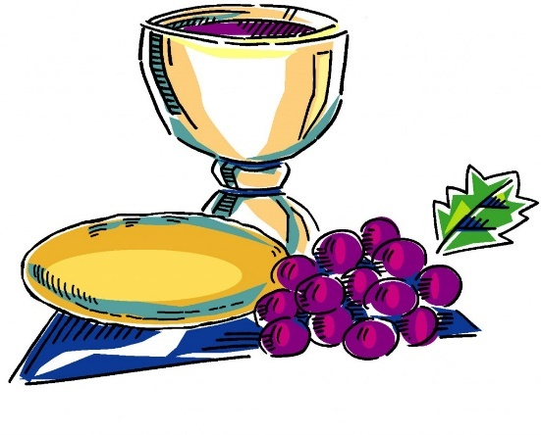
llllllllllllllllllllllllllll
Word of Hope: 1-888-217-8679
The only 24/7 CONFIDENTIAL Hotline that is distinctly Lutheran, bringing healing found in Christ, to those whose hearts have been broken by abortion.
llllllllllllllllllllllllllll
IMPORTANT 2022 DATES
The following meetings/events have been tentatively slated for 2022. Please be sure to mark them on your calendars if they apply to you. All take place on Sundays unless otherwise noted.

January
8~Altar Guild meeting (Sat.-11 am)
9~Installation of Officers of the Congregation; Reception of New Members; Recognition of Servants of the Congregation
16~Audit of deposits
23~Quarterly audit
31~Church Council (Mon.-7 pm)

February
12~Altar Guild meeting (Sat.-11 am)
20~Voters’ Assembly (10 min. after worship)
27~Audit of deposits

March
12~Altar Guild meeting (Sat.-11 am)
20~Audit of deposits

April
6~Altar Guild polishing (Wed. 1 pm)
9~Altar Guild meeting (Sat.-11 am)
24~Quarterly/monthly audit

May
1~Church Council meeting (following worship)
14~Altar Guild meeting (Sat.-11 am)
15~Audit of deposits
22~Voters’ Assembly (10 min. after worship)

June
19~Audit of deposits

July
16~Community Day (Sat.)
17~Audit of deposits
25~Church Council (Mon.-7 pm)

August
14~Voters’ Assembly (10 min. after worship)
21~Audit of deposits

September
10~Altar Guild meeting (Sat.-11 am)
18~Audit of deposits

October
8~Altar Guild meeting (Sat.-11 am)
16~Audit of deposits
23~Quarterly audit
24~Church Council (Mon.-7 pm)
29~Trunk or Treat (Sat.)

November
12~Altar Guild meeting (Sat.-11 am)
20~Voters’ Assembly (10 min. after worship)
27~Audit of deposits

December
3~Ladies’ Christmas Luncheon (Sat.-11 am)
18~Audit of deposits

Remember to check out our website’s calendar page for the latest information.
www.saintspeterandpaul.net

Our 1st Quarter Mission is
Sts. Peter & Paul’s Annual
Community Day
Scheduled for Saturday, July 16th, this will be Sts. Peter & Paul’s 5th Annual Community Day celebration (not including 2020)! Started in 2017, the purpose of Community Day is to give back to our neighborhood with a family-friendly, free gathering. Although attendance has varied from year to year and plans have had to be modified depending on circumstances (such as in 2020 when we shifted to an outdoor movie event due to the Pandemic), the event has been warmly received by our neighbors.
In recent years, Community Day expanded to include a “Trunk or Treat” opportunity for neighborhood children. This year’s is scheduled for October 29th.
If you would like to be involved with the planning of either of these events, please speak with Pastor Deal, Jesse Riffle, or Diane Riefstahl.
llllllllllllllllllllllllllll
Submissions for the February issue of “The Rock and the Sword” newsletter are due to the secretary’s office Monday, January 24th at noon. This includes meeting dates and times for the church calendar.
llllllllllllllllllllllllllll
Pastor Deal will be attending “Symposia” January 17-21. Please contact Elder Chairman Barry Nelson (724-866-7414) if in need of pastoral care at this time.
llllllllllllllllllllllllllll
“Thanks” are extended to those donated hats, scarves, mittens, and gloves to Concordia Lutheran’s (Youngstown, OH) give-away in December. Your generosity was greatly appreciated.
BIBLE MEMORY VERSES FROM DECEMBER
For Adults
Dec. 5: If you confess with your mouth that Jesus is Lord and believe in your heart that God raised him from the dead, you will be saved. Romans 10:9
Dec. 12: For by grace you have been saved through faith. And this is not your own doing; it is the gift of God, not a result of works, so that no one may boast.
Ephesians 2:8-9
Dec. 19: Therefore, if anyone is in Christ, he is a new creation. The old has passed away; behold, the new has come.
2 Corinthians 5:17
Dec. 26 And we know that for those who love God all things work together for good, for those who are called according to his purpose. Romans 8:28
1
For Children
Dec. 5: Raise your heads, because your redemption is drawing near.
Luke 21:28
Dec. 12: Prepare the way of the Lord; behold, the Lord God comes with might.
Isaiah 40:3, 10
Dec. 19: My soul magnifies the Lord, and my spirit rejoices in God my Savior.
Luke 1:46-47
Dec. 26: Lord, now you are letting your servant depart in peace, according to your word; for my eyes have seen your salvation. Luke 2:29-30
llllllllllllllllllllllllllll
The Sunday Morning Bible Study class has just completed its study of Baptism. We will not be meeting in January. Join us in February at 9 am as we begin our next topic.
We are grateful to the following individuals and families for their donations of poinsettias to adorn our sanctuary for the 2021 Christmas season.

Catherine Carr and Children & Grandchildren: In Loving Memory of Rev. Timothy Carr, Rev. Otto Brillinger, Millie Brillinger, & James Carr (2 white plants, 2 large red plants)
Mike & Marie Flaugher: In Honor of Our Church (2 red plants)
Judith A. Furey: In Loving Memory of Judith E. Boal, Beloved Daughter, and Dorothy Shoenberger, Beloved Friend (2 large white plants)
Mark Gabriel: In Loving Memory of Parents, Peter & Anne Gabriel and Brother, Denny A. Gabriel (1 large red plant)
Anson & Hank Holcroft: In Loving Memory of Sisters, Janice & Helen (1 red plant)
Kati and Michael Laird: In Loving Memory of Kati’s Parents, Raymond & Ruth Winters and Michael’s Sister, Sheri Amon (2 red plants and 1 white plant)
Elizabeth Loughan: In Loving Memory of Bill Loughan and Iris & James Reigelman (2 large red plants)
Ruth Meszaros: In Loving Memory of Many Friends and Relatives (1 white plant)
Barry & Chris Nelson, Bill Nelson, and Brittany & Ian Forbis: In Loving Memory of our Parents, Bill & Margie Nelson, John & Mary Ann Krajci; Brother, John G. Krajci; Niece, Olivia Lynn Sovesky; and All Loved Ones (1 red plant and 1 large red plant)
Joan Rice: In Loving Memory of Bob Rice (1 red plant)
Diane Riefstahl: In Loving Memory of Parents, Donald L. & Lucile M. Riefstahl and Church Members Who Departed this Life in 2021 (2 large red plants)
Viola Sakony: In Loving Memory of Husband, John Sakony (1 red plant)
Mr. & Mrs. Robert Sulek: In Loving Memory of Brother, Richard Dorfi and Grandparents, Michael & Anna Sulek (2 red plants)
Plants may be taken home following worship Sunday, January 2nd.
llllllllllllllllllllllllllll
Submissions for the 2021 Annual Report are due to the secretary’s office by Sunday, January 9, 2022. Copies from 2020 have been placed in mailboxes for reference. If possible, email your new report to Diane at church@saintspeterandpaul.net. You do not have to worry about formatting your report as this will be done for you. Speak with Diane if you should have any questions.
llllllllllllllllllllllllllll
Join us at 6 pm Thursday, January 6th for a special Epiphany
Divine Service.

Heartfelt sympathy is extended to the friends and family of Anne Colt who passed away November 24th.

Anne was laid to rest November 26th and a memorial service was held at the church December 18th.

The following is Anne’s obituary as printed in the Sharon Herald.

Anne Colt
Anne Tomko Colt, 89, of Hermitage, went to be with the Lord, on Wednesday, Nov. 24, 2021, in her home.
Mrs. Colt was born July 31, 1932, in Sharon, a daughter of the late Michael and Susan (Ocenus) Tomko.
She was a 1950 graduate of Sharon High School.
Anne was employed at the former Sharon Transformer Division of Westinghouse Electric Corp. She ultimately retired in 1994 from Alcoa Fujikura, Spartanburg, S.C., as a sales assistant.
Anne was a faithful member of Saints Peter and Paul Evangelical Lutheran Church, Sharon, where she served on the altar guild.
She had many interests, but ultimately loved being "Grammy."
She is survived by her husband, Anthony Edward "Ed" Colt, whom she married July 19, 1953; a daughter, Sandra L. Colt, Pittsburgh; a daughter-in-law, Julina Colt, Reno, Nev.; a son-in-law, Tod Davis, Hermitage; four grandchildren, Elizabeth and Hannah Davis, and Catherine and Jack Colt; a sister, Dorothy Dutka and her husband James, Cleveland; a brother, Rudy Tomko and his wife Jean, Hermitage; and numerous nieces and nephews.
In addition to her parents, Anne was preceded in death by a daughter, Lori Davis; a son, Edward H. Colt; a grandson, Christopher Edward Colt; two sisters, Susan Dyll and Mary Vanetti; and five brothers, Michael, John, Paul, Andrew, and Edward Tomko.
The family suggests memorial contributions be directed to Saints Peter and Paul Evangelical Lutheran Church, 699 Stambaugh Ave., Sharon, Pa., 16148; or to a charity of the donor's choice.
llllllllllllllllllllllllllll
Mission Outreach Project…
International Christian Literature Distributors, Inc. focuses on getting the Bible and study materials to learn the Bible into the hands of Christian leaders in the least-fortunate places of the world. They supply churches and schools of Bible learning throughout the English speaking world. Your old Portals of Prayer, seasonal devotions, and other materials are greatly appreciated. For more information about ICLD, check out their website: www.icld.org. Please recycle these items by dropping them in the basket in the hallway by the offices. Thank you!
llllllllllllllllllllllllllll
Thank you for your service this past year!
Jesse Riffle (Vice President)
Evelyn Baisch (Financial Staff)
Catherine Carr (Financial Staff)
Matt Berent (Auditor)
Bob Sulek (Trustee)
These individuals will be recognized during the January 9th Divine Service.
December was a busy month with many special events. Here are a few pictures of what took place.

Historical Pictures’ Pot-luck Dinner
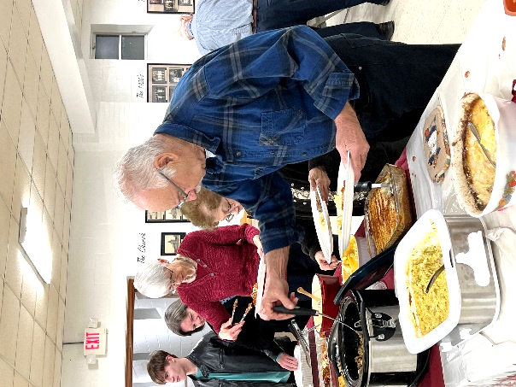
A variety of dishes were contributed.
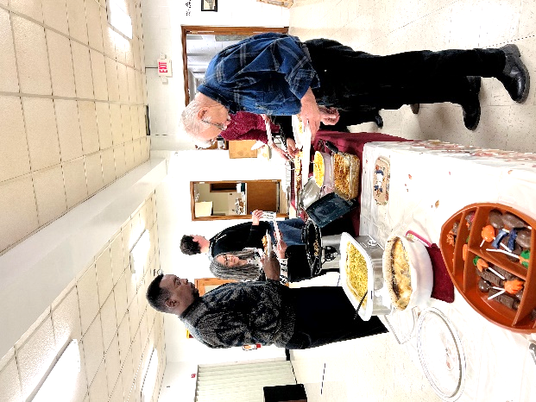

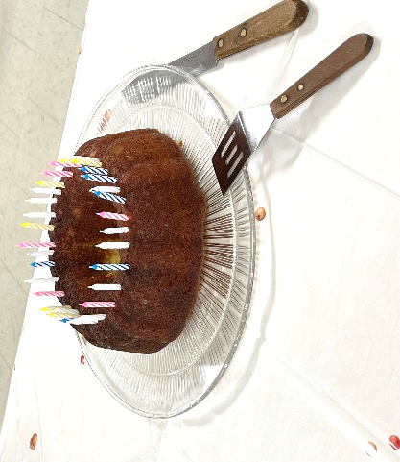
Dessert included a birthday cake for Pastor Deal’s 31st birthday.
Ladies’ Christmas Luncheon
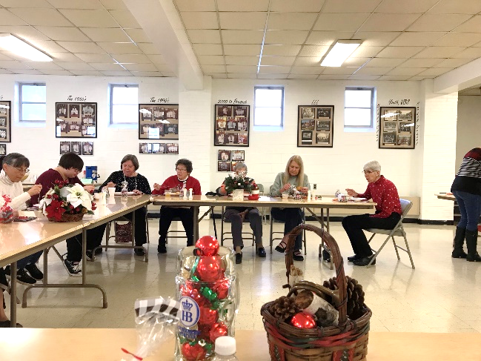

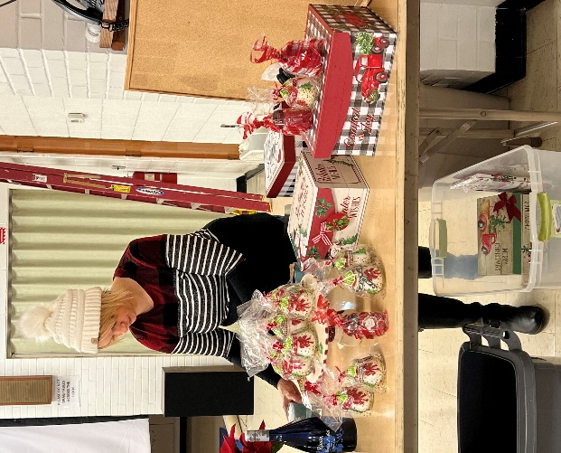
Christine Hamilton gifted guests with homemade candles.
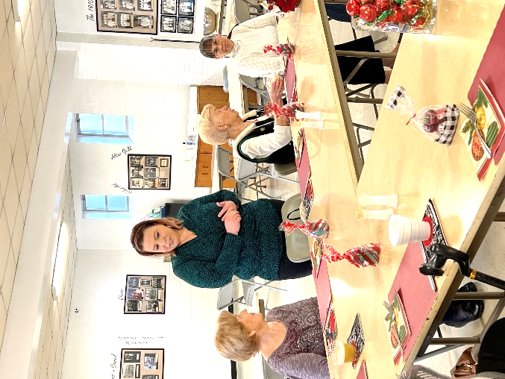
Guests shared memories of past Christmases.
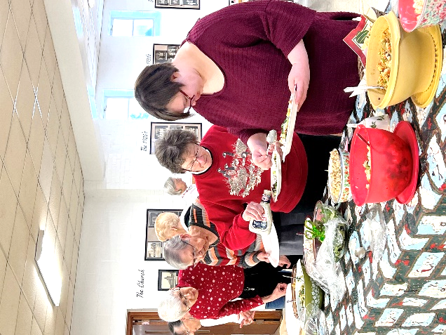
A variety of salads were offered.

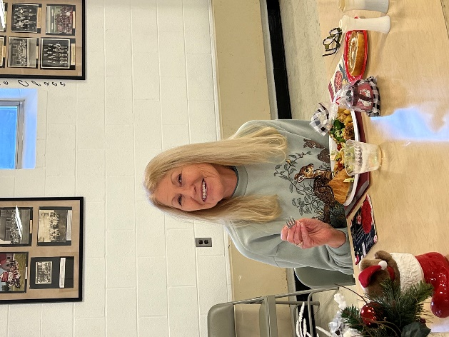
Cheryl appears to be enjoying herself.

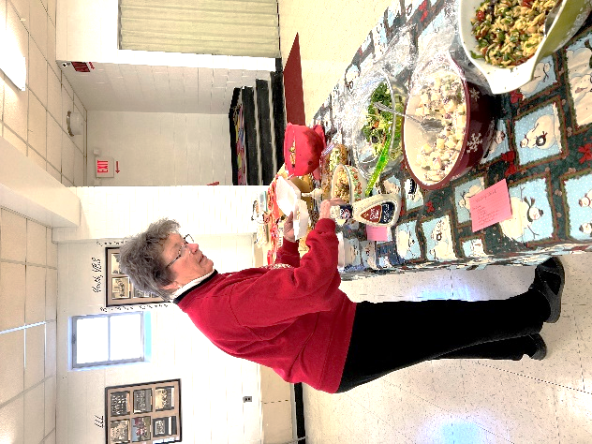
Elizabeth contemplates her choices.
“Coffee & Cookies” Sponsored by the Altar Guild
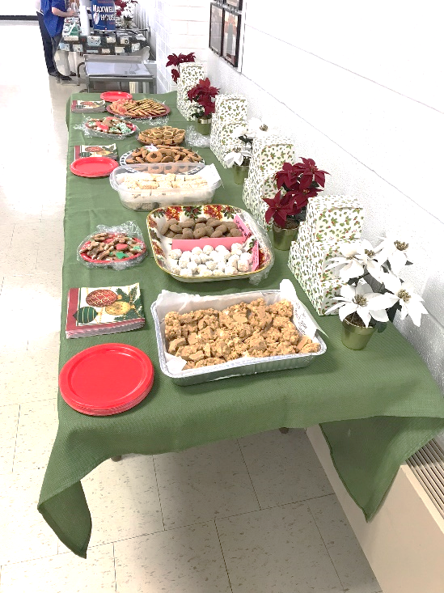
Altar Guild members brought plenty of cookies for members to take home.

Christmas Preparations
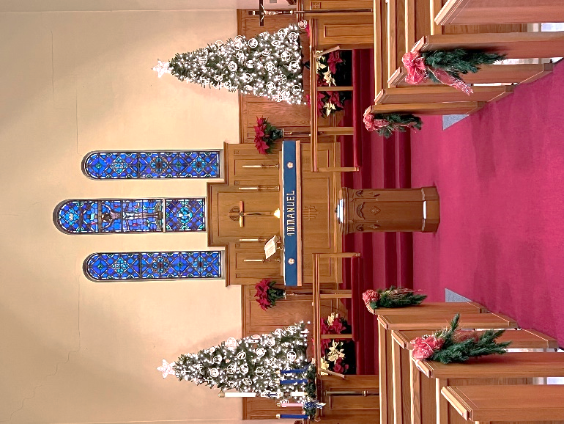
Once again, the sanctuary was beautifully decorated.

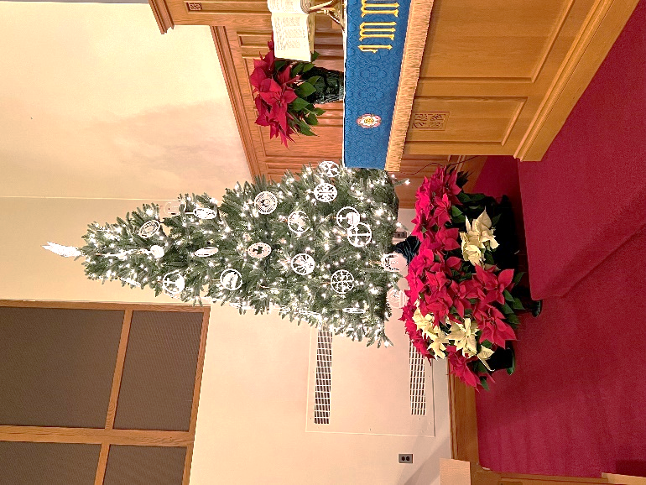
Members generously donated poinsettias to adorn the sanctuary.

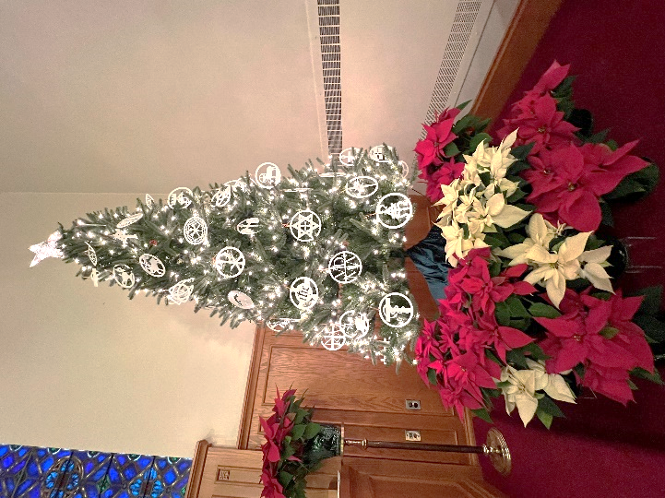
Christmons, symbols of Christianity, once again beautify our trees.

Slovak Phrases for the Christmas Season
(Courtesy of “The Lutheran Beacon”)

Veselé Vianoce! - Merry Christmas!

Narodil se Kristus Pán – Hymn The Lord Christ Was Born… the English version is Be joyful, Earth and Starry Sky

Cas radosti, veselosti - Hymn - Let our Gladness Banish Sadness

On behalf of Pastor Deal, the church leadership, and myself, we wish you and your family a very Merry Christmas and a healthy and safe New Year!
~Diane

