Sts. Peter & Paul Evangelical Lutheran Church LC-MS
Monthly Newsletter --- December 2020
699 Stambaugh Avenue, Sharon, PA 16146
Phone: 724.347.3620 (Opt. 2, Pastor Deal; Opt. 3, Office)
E-mail: church@saintspeterandpaul.net www.saintspeterandpaul.net

“THE ROCK and THE SWORD”
“Built upon the Rock of Christ and wielding the
Sword of the Spirit, the Word of God.”

From the Pastor:
Finding One’s Worth

Sometimes I go in search of “inspirational” quotations that I can use for newsletter articles. The December quotes were just super-disappointing, until I found this one. “You will never find your worth in another person- you find it in yourself, and then you will attract those who are worthy of your energy. Stop waiting for others to tell you how important you are. Tell yourself right now!” - Michael Nulty. Nulty is a “Transformational Life Coach” and people are using his worldview to shape their own lives. Whether you’ve heard of him or not, you have most likely heard this idea that we really don’t know our value until we find it deep inside of us. To my utter sadness, I’m sure many of the “new beginnings” (resolutions) starting January 1st are going to be based on this introspective approach to self-worth.
It would seem foolproof. If I’m the judge of my own self-worth and give a value to how important I am, then who can argue? What could possibly go wrong? For the Christian, everything will go wrong. As the Christian examines his own life, he comes to the same realization as Saint Paul: “For I do not understand my own actions. For I do not do what I want, but I do the very thing I hate” (Romans 7:15). As we search inside ourselves, we are confronted with our own sin and our own failings, whether it be what we did or said, or what we failed to do. How much we find really depends on our

honesty with ourselves. I find it is much easier to lie to myself. If I say something over and over again to myself, eventually I will believe it’s true. Perhaps that will give someone confidence for a short period of time, but sooner or later it won’t be enough to stay off the demons who torment us. Then it won’t just be a disparaging of the self, but a despair of the soul and the questions of matters of salvation. “You will never find your worth in yourself- you will find it in another person, namely Jesus Christ, God’s own Son incarnate (in the flesh), and then you will be attracted to the gifts God freely gives in Word and Sacrament so that you will be renewed in body and soul. Stop waiting to find out how important you are, read the Bible and see what God has done for you.”
Of course, it’s quite cheesy to try to redo silly, inspirational quotes. We are not to be conformed to the World. These quotes should, however, make us consider this question, “Why do Christians focus so heavily on the love of God being undeserved?” You’d think this concept would make a bunch of folks jump off the cliff of despair. But it doesn’t. Yet, we’re still left thinking, “How could someone who loves us more than anyone, tell us that we are not worthy of His love?” Look at this passage from 1 John 1:8-10 “If we say we have no sin, we deceive ourselves, and the truth is not in us. If we confess our sins, he is faithful and just to forgive us our sins and to cleanse us from all unrighteousness. If we say we have not sinned, we make him a liar, and his word is not in us.” God tells us the truth. His prophets and apostles spoke the truth. And His pastor, to this day, tells us the truth, that we are unworthy of His love because we are not faithful. However, God’s love isn’t dependent upon our faithfulness, but upon His.
This fact makes His love for us even better than what we could have expected even if we had deserved it. That’s why Christians don’t jump off the cliff of despair when coming to terms with their sins. We know we have One who overcame our sins in His body upon the cross, and defeated death and hell for us in the resurrection. That proves that we are worth more than our minds can truly comprehend. Christ is the source of our peace in heart, mind, body, and soul. Dear Michael Nulty, we will never find our worth by looking inward. That worth will only stay for as long as we can lie to ourselves. Honest people know that that’s where they find filthy thoughts, evil desires, and plenty of guilt. Now, you’re mostly right when you say that we will not find our worth in another person, but even that isn’t entirely true since our God took on flesh to save us. You see, we are sure of our worth because we were created in the image of God (and so were you). We also know and believe in this God who was born of the Virgin Mary. He is a person like us, but also not like us, because He came and lived without sin. He then took our sins and shed His blood for us on the cross. There is nothing more valuable to base my worth on than the precious blood of Christ and His innocent suffering and death. How important does that make me, to know that God left heaven, was born to humble beginnings, lived perfectly, shed His blood in a humiliating death, and rose again, all to save me from myself?
When someone bases his worth/importance/value on his own standards and views, it is ever-changing and may depend on the day. However, recognizing the worth of being created in God’s image, being His baptized child, and a sheep of the Good Shepherd's flock is a constant. This year I want you to begin with arrogance (boldness, confidence) in Christ!
- But now thus says the Lord, he who created you, O Jacob, he who formed you, O Israel: “Fear not, for I have redeemed you; I have called you by name, you are mine. Isaiah 43.1
- But when the goodness and loving kindness of God our Savior appeared, he saved us, not because of works done by us in righteousness, but according to his own mercy, by the washing of regeneration and renewal of the Holy Spirit, whom he poured out on us richly through Jesus Christ our Savior, so that being justified by his grace we might become heirs according to the hope of eternal life. The saying is trustworthy…. Titus 3:4-8a
- Baptism, which corresponds to this, now saves you, not as a removal of dirt from the body but as an appeal to God for a good conscience, through the resurrection of Jesus Christ…. 1 Peter 3: 21
- We were buried therefore with him by baptism into death, in order that, just as Christ was raised from the dead by the glory of the Father, we too might walk in newness of life. Romans 6:4
- My sheep hear my voice, and I know them, and they follow me. I give them eternal life, and they will never perish, and no one will snatch them out of my hand. My Father, who has given them to me, is greater than all, and no one is able to snatch them out of the Father's hand.I and the Father are one. John 10:27-30

With these words of Christ, you can stand even against the devil and the demons. As Luther said, “So when the devil throws your sins in your face and declares that you deserve death and hell, tell him this: "I admit that I deserve death and hell, what of it? For I know One who suffered and made satisfaction on my behalf. His name is Jesus Christ, Son of God, and, where He is, there I shall be also!” Now, what greater confidence could you have all the days of your life?
Your new beginning doesn’t have to be January 1st, it can be right now, and it can be every morning you wake up in the blessed baptism that God gave you. Furthermore, each week you can be
strengthened in this foundation of hope in the Divine Service of our God. He who raised you with Christ to walk in the newness of life will never fail you. He will surely carry you with the glorious hope and confidence that He who rescued you 2,000 years ago is still with you to this day and until the end of the age.
So, throw away those cheesy and narcissistic inspirational quotes and be raised to newness of life with faith in Christ!
Your Servant in Christ,
Pastor Jacob Deal


To listen to Pastor Deal’s sermons, phone 724-347-3620 and press Option 6.
Current sermons will be available by Sunday evening.

Services are currently being live-streamed on Sunday mornings. Check out our Facebook page (Saints Peter and Paul Evangelical Lutheran Church) for the youtu.be link.

Thank You for Serving in January:
Assisting Elder: Bob Sulek
Altarware: (Before service) Diane Riefstahl; (After service) Cheryl Fedele & Clara Krivosh.
Note: Our greeting and ushering programs are temporarily suspended at this time.

REMINDER: Please let the church office know of any changes to your address, phone, cell phone or your e-mail address!

Looking for a meaningful New Year’s Resolution? Why not resolve to gain a deeper understanding of your faith by studying God’s word weekly at the Sunday morning Bible Study? This class, held following the Divine Service, is led by Pastor Deal. Attendees are encouraged to participate in group discussions and ask questions. For more information, please speak with Pastor Deal.
2021 THRIVENT POP
TAB CHALLENGE!
Don’t forget to be collecting “pop tabs” for Thrivent’s 2021 challenge which will take place this spring!
Containers for tabs may be found on the pew outside Pastor Deal’s office. Collected tabs may be dropped off in the Secretary’s office or given to Marie Flaugher who is organizing our participation.
This project benefits the Ronald McDonald House.
If you have any questions, feel free to contact Marie Flaugher at 724-301-8278
sssssssssssssssssssssssssssssssssssssssssssss
Scrip/Gift Card Program The next date for turning in SCRIP/Gift Card orders and payments is Sunday, January 3rd. Please make all checks out to Sts. Peter & Paul’s.
Order forms for this program may be found on the table in the narthex as well in the main hallway. Both orders and payments may be placed in the offering plate prior to the service.
llllllllllllllllllllllllllll
Mission Outreach Project…
International Christian Literature Distributors, Inc. focuses on getting the Bible and study materials to learn the Bible into the hands of Christian leaders in the least-fortunate places of the world. They supply churches and schools of Bible learning throughout the English speaking world. Your old Portals of Prayer, seasonal devotions, and other materials are greatly appreciated. For more information about ICLD, check out their website: www.icld.org. Please recycle these items by dropping them in the basket in the hallway by the offices. Thank you!

LIKE & FOLLOW our Church’s Facebook page (Saints Peter and Paul Evangelical Lutheran Church)!

Remember to like, comment, and share to help us reach as many people as possible.

Preschool Up-date:
At the December 6th Voters’ Assembly Meeting, it was decided by the voters to permanently close our preschool at this time.
With the retirements of preschool teacher and aide, Paula and Mark Ostheimer, last spring and the issues of uncertainty of dealing with Covid-19, it was decided at that time to suspend our program. Further evaluation of the program led us to conclude that the existing program was not meeting the needs of those looking for preschools and that our program would have to undergo some significant changes to do so: offering a five-day program or full-day program and possible childcare or transportation to other facilities. Along with radically changing our program was the issue of dealing with “free, government-run” programs.
The 2019 preschool board has also been handled the authority to decide what to do with the preschool materials which remain. Not knowing exactly what the future may hold, valuable teaching tools are being kept and will be store for potential future use. Well-worn items have been disposed of and remaining items are going to be re-purposed or donated. It is a long, challenging process to go through all the items which remain and it will take time.
The closing of our preschool brings this chapter to an end. There are hopes, though, one day to again offer a Christ-based learning opportunity to our community.

“Thanks” extended to the Ostheimers:
Donations were accepted to be given to Paula and Mark Ostheimer in appreciation for their years of service to our preschool. A total of $650.00 was collected and given to them.
The following is their note of thanks in response:
Dear Congregation,
Thank you so much for your kind words of appreciation.
It was an honor to teach for nearly 13 years at Sts. Peter and Paul Preschool. You all welcomed me with open arms from day one and, over the years, I met many dear and special people that I miss very much!
Your loving token means so much to us. We know many worthy organizations that need help during this devastating time. We plan to use your gift to help as many of these groups as possible. Your generosity will be put to good use. We love and miss you!
~Paula and Mark

“Stock the Food Pantry Sunday” is January 10th!
Let us remember those in need!
Your financial contributions to this outreach mission will be greatly appreciated!
(At this time, we are unable to accept direct donations of food products.)

Sts. Peter & Paul’s Food Pantry is able to assist those in need of emergency food!
If you or someone you know is in need of emergency food during this time, please contact John Dyll (724-734-7016). Our food pantry operates through the Community Food Warehouse of Mercer County and distributes food the second and fourth Thursdays of each month beginning at 9 am.
Please consider “lending a hand up” to those in need.

‘Truly, I say to you, as you did it to one of the least of these my brothers, you did it to me.’ Matthew 25:40
Help will be appreciated as we “un-decorate” and store our church’s Christmas decorations Saturday, January 16th at 11 am.

Please consider lending a hand!
You can now find “The Lutheran Beacon” online! If you are a first-time visitor to the Beacon Online, we invite you to subscribe by emailing the District Office at selc.lcms@gmail.com. Please feel free to share the Beacon Online and encourage others to subscribe.
Homebound Members & Friends
Please keep the following people in your prayers:
Helen Bender
920 Pleasantview Dr.
New Castle, PA 16101

Mary Ann Krajci, John XXIII
2250 Shenango Valley Freeway
Hermitage, PA 16148
724-981-3200

Robert Murchek
394 Fisher Hill St.
Sharon, PA 16146-5801

Marion Roberts
287 East 2nd St. Apt. #103
Hummelstown, PA 17036
724-893-4570 (This is a corrected phone number!)

CELEBRATING IN JANUARY!
Birthdays
Mike Flaugher 1 - 4
Gerald Arthur 1- 12
Evelyn Baisch 1 - 15
Kenzie Critzer 1- 20
Rachal Myers 1- 22

*If birthdays or anniversaries have been omitted, please let the church office know. Thank You!

Word of Hope: 1-888-217-8679
The only 24/7 CONFIDENTIAL Hotline that is distinctly Lutheran, bringing healing found in Christ, to those whose hearts have been broken by abortion.

ATTENTION AUDITORS!
2021 auditors are reminded that there will be an audit of deposits following worship Sunday, January 10th and a general audit of accounts Sunday, January 17th. If unable to attend these meetings, please phone Bev Chlpka at 724-962-4806.


LIVE ALTAR FLOWERS AVAILABLE
For those wishing to sponsor live altar flowers and not be responsible for picking them up and delivering them to the church, arrangements have been made with Cottage Gardens in Hermitage.
Sponsors will be able to select the types of flowers they wish. Prices per vase vary accordingly. Options are…
- Lilies, roses, mix of flowers: $40 each vase
- Carnations, mums, gerbera daisies, mix of flowers: $35 each vase
- Carnations, mums, daisies, alstroemeria, mix of flowers: $30 each vase
- Colors can be a special request or seasonal arrangements can be designed to match the season’s prettiest colors and flowers.
There is a delivery charge of $7.00. Flowers will be delivered Saturdays prior to the Divine Service. Sponsors are encouraged to remove the flowers from the altar following Sunday’s service and take them home.
If you would like to sponsor flowers, sign the 2021 Flower Sponsor sheet posted in the narthex. Please pre-pay for your arrangements and delivery by placing the corresponding amount in a pew envelope and putting it in the offering plate. Any checks should be made out to the church. Please be sure to indicate desired wording for the service bulletin on your pew envelope.
You can still opt to provide your own flowers. Be sure to indicate this when signing up on the sponsor sheet.
qqqqqqqqqqqqqqqqqqqqq
WELCOME NA!
Church elders and trustees have approved the usage of our Fellowship Hall by Narcotics Anonymous. It is anticipated that meetings will be held Wednesday evenings beginning at 7 pm.
Submissions for the
2020 ANNUAL REPORT
are due to Diane
by Sunday, January 10th.

FROM YOUR ALTAR GUILD:
I’VE HAD AN EPIPHANY!

Most likely you have heard someone exclaim this in glee! Or, perhaps, it may have even been you! What does it mean to have “an epiphany”? Simply stated, an epiphany is a “realization or discovery”.
Each January 6th, we celebrate the greatest Epiphany of all: the manifestation of Christ to the Gentiles as represented by the Magi. Matthew 2:1-12 recounts this Epiphany.
Now after Jesus was born in Bethlehem of Judea in the days of Herod the king, behold, wise men from the east came to Jerusalem, saying, “Where is he who has been born king of the Jews? For we saw his star when it rose and have come to worship him.” When Herod the king heard this, he was troubled, and all Jerusalem with him; and assembling all the chief priests and scribes of the people, he inquired of them where the Christ was to be born. They told him, “In Bethlehem of Judea, for so it is written by the prophet:
“‘And you, O Bethlehem, in the land of Judah,
are by no means least among the rulers of Judah;
for from you shall come a ruler
who will shepherd my people Israel.’”
Then Herod summoned the wise men secretly and ascertained from them what time the star had appeared. And he sent them to Bethlehem, saying, “Go and search diligently for the child, and when you have found him, bring me word, that I too may come and worship him.” After listening to the king, they went on their way. And behold, the star that they had seen when it rose went before them until it came to rest over the place where the child was. When they saw the star, they rejoiced exceedingly with great joy. And going into the house, they saw the child with Mary his mother, and they fell down and worshiped him. Then, opening their treasures, they offered him gifts, gold and frankincense and myrrh. And being warned in a dream not to return to Herod, they departed to their own country by another way.
Each week in our Divine Service, we make reference to this Epiphany as we sing the words of the “Nunc Dimittis” or “Song of Simon”. We are reminded that Christ, “a light to lighten the Gentiles”, is truly the God of all.
The secular world tends to be in a hurry to “put away Christmas” soon after December 25th. In the church, though, Christmas decorations remain through the first Sunday after Epiphany. The candles in the Advent wreath are lit and the altar paraments remain white as a reminder of Christ’s purity.
Join us for our Epiphany Divine Service at 5 pm January 6th and celebrate that Christ came to save us all.
sssssssssssssssssssssssssssssssssssssssssssssBible Memory Verses from December:
For Adults:
Dec. 6: If you confess with your mouth that Jesus is Lord and believe in your heart that God raised him from the dead, you will be saved. Romans 10:9

Dec. 13: For by grace you have been saved through faith. And this is not your own doing; it is the gift of God, not a result of works, so that no one may boast. Ephesians 2:8-9

Dec. 20: : Therefore, if anyone is in Christ, he is a new creation. The old has passed away; behold, the new has come. 2 Corinthians 5:17

Dec. 27: And we know that for those who love God all things work together for good, for those who are called according to his purpose. Romans 8:28

For Children:
Dec. 6: Raise your heads, because your redemption is drawing near. Luke 21:28

Dec. 13: Prepare the way of the Lord; behold, the Lord God comes with might. Isaiah 40:3, 10

Dec. 20: My soul magnifies the Lord, and my spirit rejoices in God my Savior. Luke 1:46-47

Dec. 27: Lord, now you are letting your servant depart in peace, according to your word; for my eyes have seen your salvation. Luke 2:29-30

CONGRATULATIONS TO THE NEWLY ELECTED CHURCH OFFICERS AND BOARDS!
President: Jonathan Baisch
Vice President: Jesse Riffle
Secretary: Diane Riefstahl
Treasurer: Bekah Baisch
Financial Secretary: Dolores Fee
Trustees
Cheryl Fedele Henrietta (Hank) Holcroft
Mike Flaugher Anson Holcroft
Michael Laird Bob Sulek
Auditors
Matt Berent Elizabeth Haenftling
Bev Chlpka Kati Laird
Marie Flaugher Jerome Thomas
Financial Staff
Rev. Art Baisch Joan Rice
Evelyn Baisch Nancy Robertson
Catherine Carr
Youth Director
Elizabeth Haenftling
The INSTALLATION of 2021 Officers and Boards will take place during the Divine Service Sunday, January 3, 2021.

Please try to be in attendance.

qqqqqqqqqqqqqqqqqqqqq
Thank you for your service this past year!
Matt Berent (Secretary)
Ana Deal (Auditor)
Marie Flaugher (Preschool Board)
Ruth Meszaros (Financial Staff)
Diane Riefstahl (Financial Staff and Preschool Board)

2021 MEETING DATES:
Church Council: All meetings are held Monday evenings beginning at 7 pm.
January 18 July 19
April 26 November 15

Quarterly Audits: All meetings are held directly after the Divine Service.
January 17 July 18
April 25 October 24

Voters’ Assembly Meetings: All meetings begin 10 minutes following the conclusion of the Divine Service.
February 7 August 8
May 16 December 5
llllllllllllllllllllllllllll
If you do not have an email account or do not receive emails from the church but wish to be notified of significant information concerning your fellow church members (such as births or deaths), please put a note in the Secretary’s mail slot asking to receive a phone call. Every attempt will be made to phone you within 24 hours of an email being sent out.
llllllllllllllllllllllllllll
Our First Quarter Local Mission is
Willow Women’s Center
Willow Women’s Center is a non-profit organization which assists women facing unplanned pregnancies with quality medical services at no cost. The Center does not promote or provide abortions. The organization is funded by individuals and grants.
Please consider supporting this organization! For further information as to how you can make a difference, check out their website: willowwomenscenter.com.
Donations may be placed in a pew envelope and placed in the offering plate.
DECEMBER MEMORIAL
CONTRIBUTIONS
(Bulletins December 6-27, 2020)
In Loving Memory of Eleanor Besser: Anne Colt, Dolores Fee, Rev. & Mrs. Ed Kucera (Missions). Kathy & Kevin McCormack, James & Augustine Smith, Viola Sakony, Mr. & Mrs. Robert Sulek (Major Repair), and Wessex Capital Investment.s
In Loving Memory of Aunt Eleanor Besser: Gregg & Sarah Rearick.
In Loving Memory of Mary Chmielewski: Rev. & Mrs. Ed Kucera (Food Pantry).
In Loving Memory of Dan Davis: Mr. & Mrs. Robert Sulek (Major Repair).
In Loving Memory of Betty and Regis Knauff: Joan Rice (Missions).
In Loving Memory of Father, Paul Petro: Michael A. Petro.
In Loving Memory of John Sakony: Mr. & Mrs. Edward Zachar.
In Loving Memory of John Zachar: Sue Bender, Gary & Eileen Burns, Jeffrey & Erin Burns, and Kevin Burns & Family (Major Repair); Shirley Cerbus, Anne Colt, Anna Mae Daris, Dolores Fee, Ruth Fitzgerald, Mark Gabriel, Anson & Hank Holcroft, Lisa and Max Jelinek, Clara Krivosh, Rev. Ed & Irene Kucera (Food Pantry), Patty Parker, Michael A. Petro, Joan Rice (Major Repair), Diane Riefstahl, Viola Sakony, Mr. & Mrs. Robert Sulek (Major Repair), Mr. & Mrs. Rudy Tomko, Pat Voytik, and Tom, Trudy & Ed Zipay (Sunday School).
In Loving Memory of John Zachar, “Thank you for always making us smile!” The Brandes Family (Missions).
In Loving Memory of Uncle John Zachar: Joseph & Andrea Zachar and Mr. & Mrs. Steve Zachar and Family
With Prayers for Good Health for Our Families and Others: Mr. & Mrs. Joseph Chlpka.
In Thankfulness for Another Year of Blessings: Joan Rice.

Our Stewardship of Treasures
for the Lord:
In order to do the Lord’s work, we need $2,487.81 each week to meet our 2020 budget for general purposes and $39.62 for missions.

Wed., Nov. 25, 2020:
General Offering: $145.00
SELC Missions: $25.00
Other: $50.00
Sun., Nov. 29, 2020:
General Offering: $2,309.00
SELC Missions: $50.00
Quarterly Missions: $100.00
Online Giving (11/25/20): $55.00
Other: $5,259.00
Wed., Dec. 2, Sat., Dec. 5 and Sun., Dec. , 2020:
General Offering: $3,135.00
SELC Missions: $125.00
Online Giving (12/02/20): $55.00
Other: $42.00
Wed, Dec. 9, Sat., Dec. 12 and Sun., Dec. 13, 2020:
General Offering: $1,153.00
SELC Missions: $25.00 62
Other: $170.00
Wed., Dec. 16, Sat., Dec. 19 and Sun., Dec.20, 2020:
General Offering: $2,440.00
SELC Missions: $160.00
Other: $300.00
Remember, you now have the option of on-line giving! Check out https://www.saintspeterandpaul.net/online-giving.


A note from Pastor Deal: Please let me know if you or a loved one are in the hospital or have a special need. Also, please ask the hospital to call me or the church office. I wish to visit those who may be hurting.
TRUSTEES’ UP-DATE
Tight Seal, of Niles, OH, has been hired to replace ten glass block windows in the basement of the old section of the church.
This work is scheduled to begin January 20th and is a two-day process involving the complete removal and replacement of the old windows.

Remember the following in Prayer…
~The Mourning: The friends and families of Judy Usnarski, Cheryl Fedele’s neighbor, who passed Dec. 21st.
~The Hurting and Healing: Darlene Berent, Lois Bortner^{CA}, Richard Brandes, Kim, Darlene Cesta, Susan Davies, Tim Dudash, Joseph Fleet, Marie Haenftling, Neale & Melissa Huston, Donna Kennedy, Jess Lavoie, Paul Lucas^{CA}, Sandy Marshall, Ernie Meszaros, Rhonda Moats, David Nelson, Juanita Rentschler, Richard Reuning^{CA}, Marty Scott, Dan Spanos, Traudi Sulek, Bob Usnarski, Martin Weisenborn, Angela Weser^{CA}, and Millie Zachar.
~The Homebound: Helen Bender, Mary Ann Krajci, Robert Murchek, and Marion Roberts.
~Serving in the Military: Curtis Sinewe and Joshua Solyan.
~Community & World Needs: Those suffering from or affected by the coronavirus; those suffering from loss and dislocation because weather disasters; those suffering from addiction and their families; Local, State, and National Government Leaders; safety for all Police Officers, Firefighters, & First Responders; the unemployed; our First Quarter Local Mission: Willow Women’s Center of Transfer, PA.
*CA represents cancer.
sssssssssssssssssssssssssssssssssssssssssssss
Thank you to those who helped with the decorating of our church for the Christmas season. We are also grateful to those who purchased poinsettias to adorn the altar.
Some pictures from Christmas 2020!

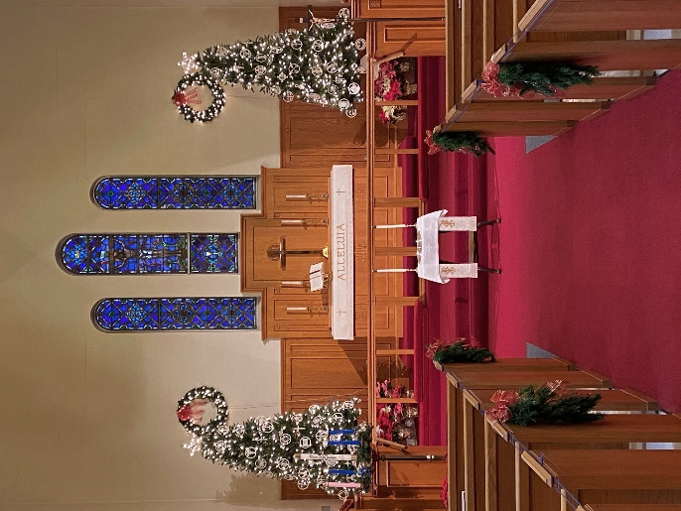

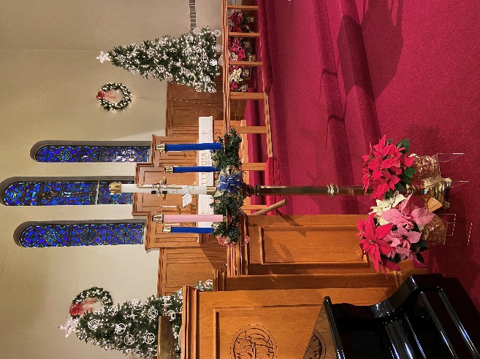

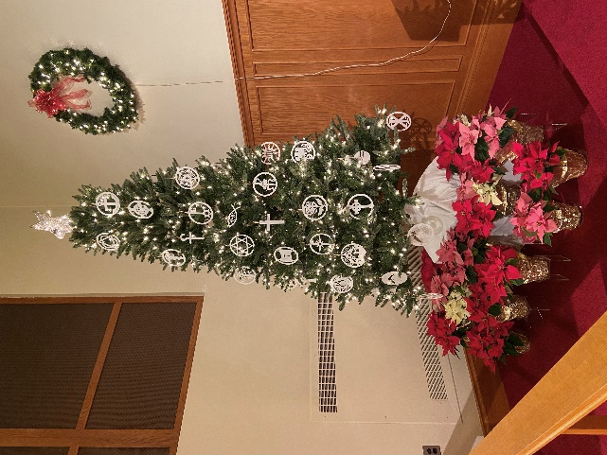

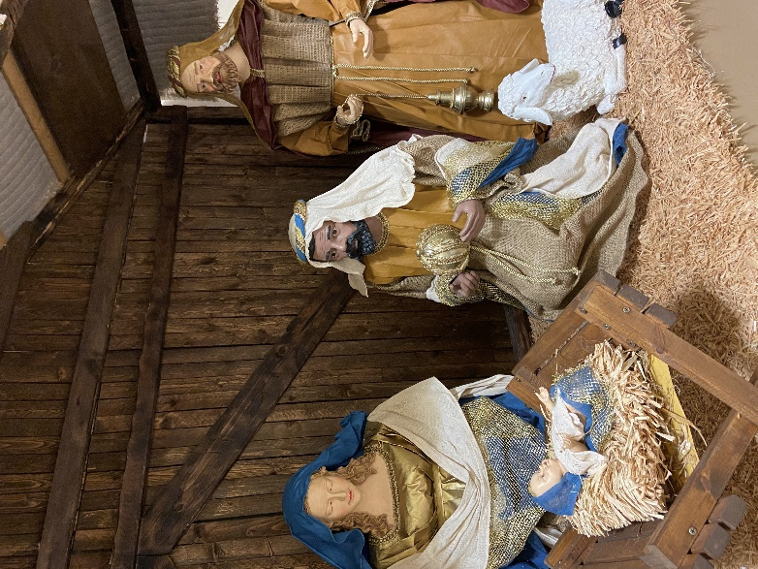

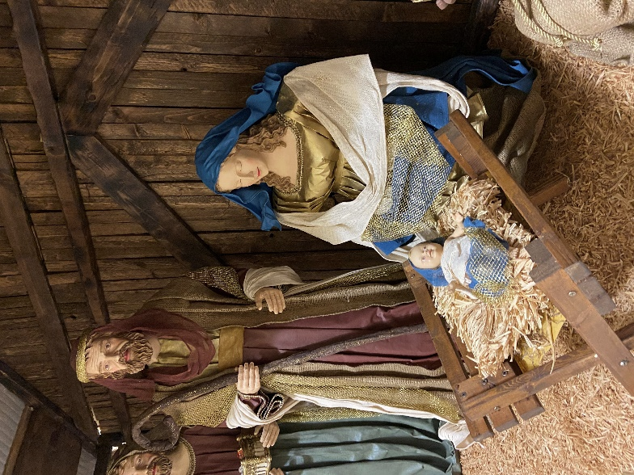

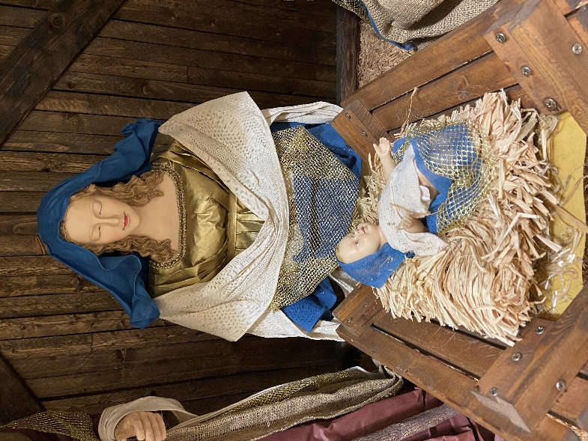

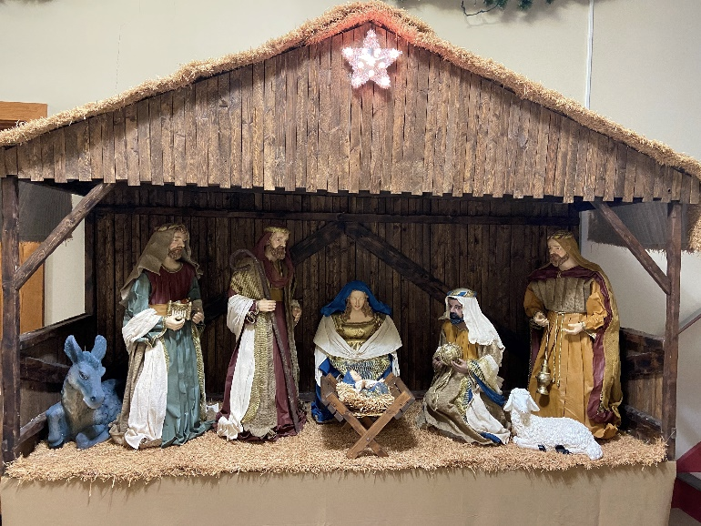

Best wishes for a safe and healthy New Year!

