Sts. Peter & Paul
Evangelical Lutheran Church
Lutheran Church-Missouri Synod
Founded-1917

January 1, 2024
699 Stambaugh Avenue
Sharon, Pennsylvania 16146

“I was glad when they said to me,
Let us go to the house of the LORD!”
Psalm 122:1

VESPERS
Opening Hymn: TLH #104 “Now Praise We Christ, the Holy One”
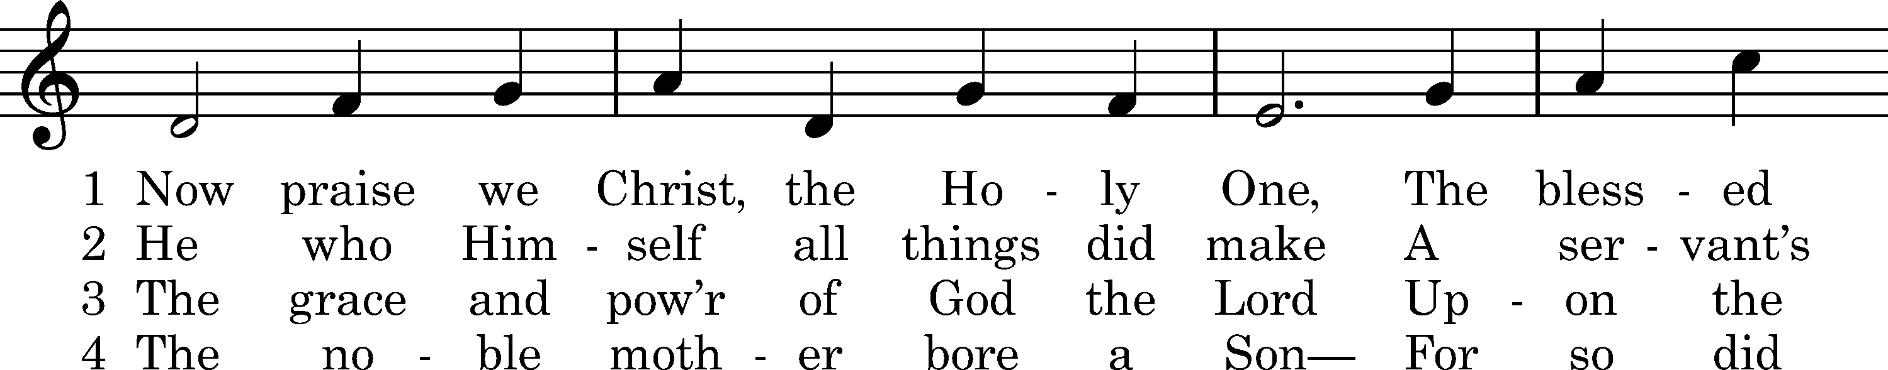
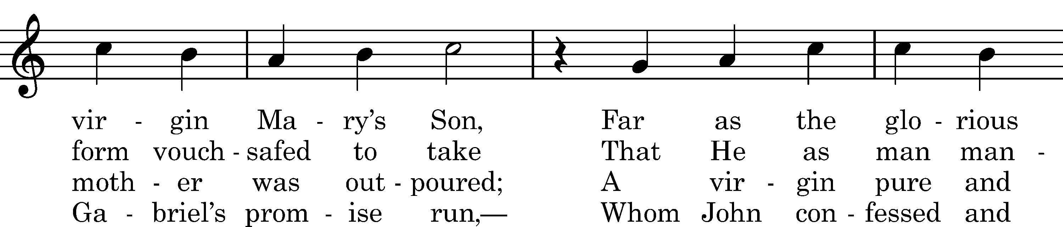
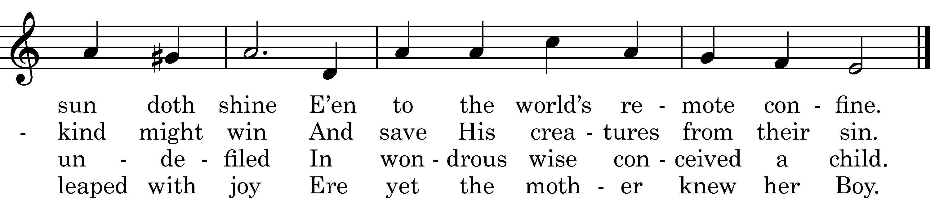

5 Upon a manger filled with hay
In poverty content He lay;
With milk was fed the Lord of all,
Who feeds the ravens when they call.

6 The heav'nly choirs rejoice and raise
Their voice to God in songs of praise.
To humble shepherds is proclaimed
The Shepherd who the world hath framed.

D 7 All honor unto Christ be paid,
Pure Offspring of the favored maid,
With Father and with Holy Ghost,
Till time in endless time be lost.

Text: tr. Richard Massie, 1854, alt.; Martin Luther, 1524, alt.; Coelius Sedulius, c. 450, alt. Tune: Enchiridion, Erfurt, 1524 Text and tune: Public domain

Common Versicles LSB 229

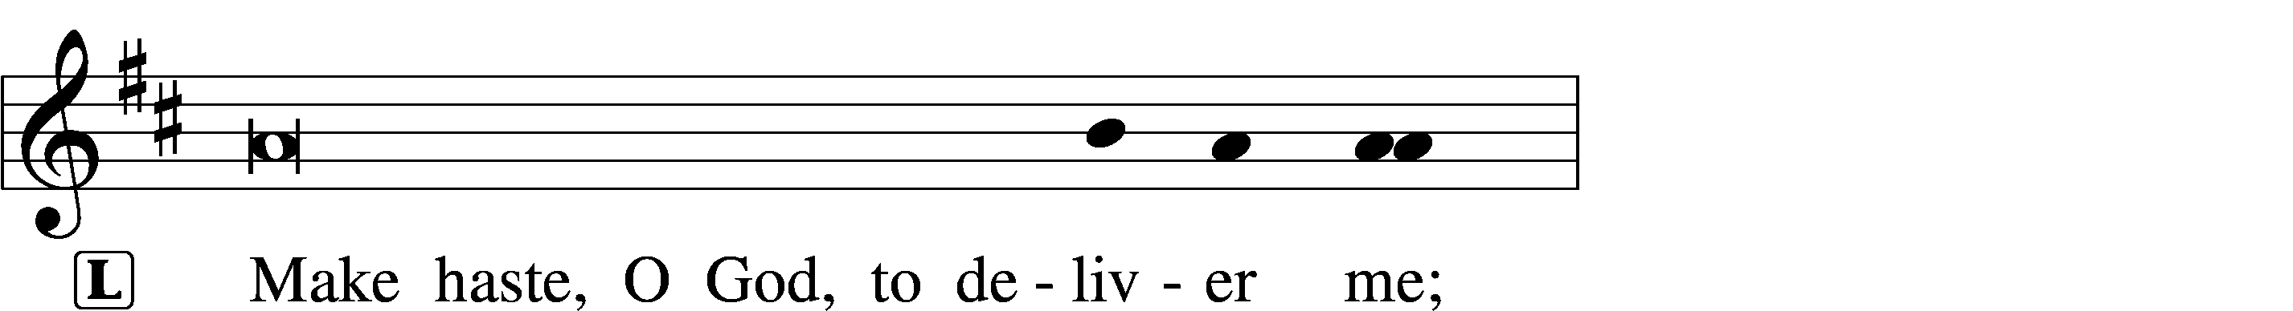

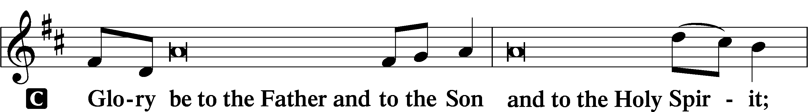
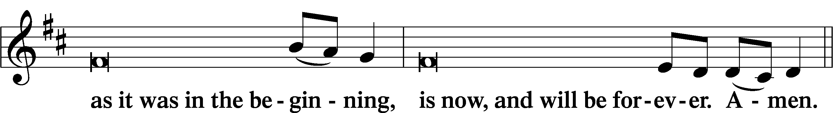
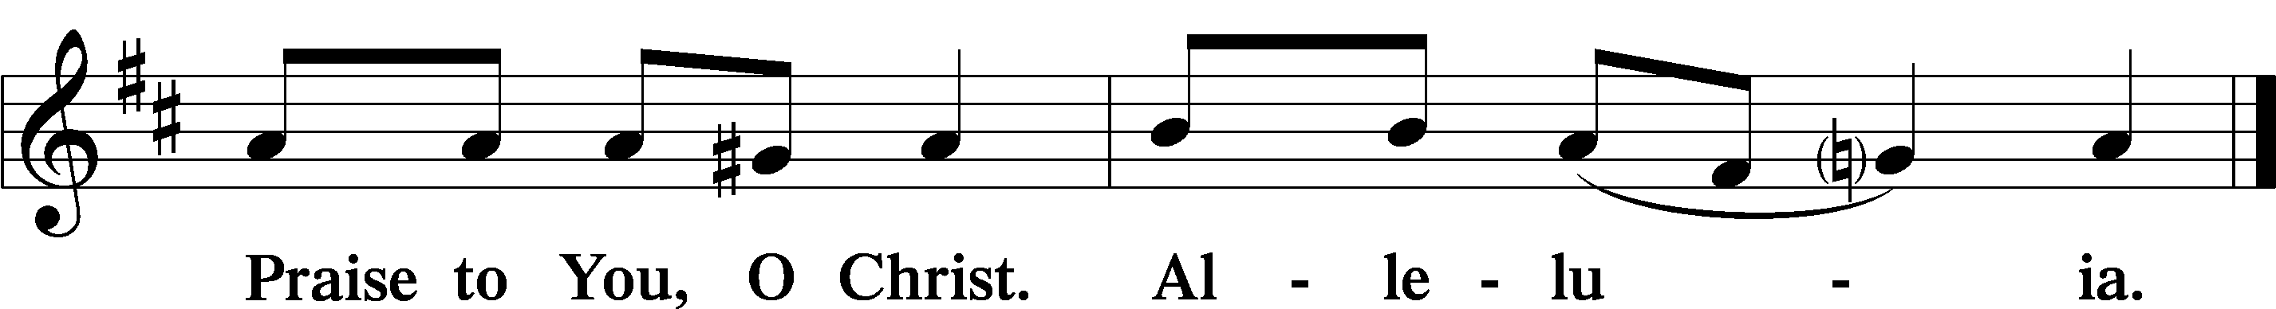

Psalmody

Psalm: Psalm 8 (NKJV)
O Lord, our Lord,
How excellent is Your name in all the earth,
Who have set Your glory above the heavens!

Out of the mouth of babes and nursing infants
You have ordained strength,
Because of Your enemies,
That You may silence the enemy and the avenger.

When I consider Your heavens, the work of Your fingers,
The moon and the stars, which You have ordained,
What is man that You are mindful of him,
And the son of man that You visit him?
For You have made him a little lower than the angels,
And You have crowned him with glory and honor.

You have made him to have dominion over the works of Your hands;
You have put all things under his feet,
All sheep and oxen—
Even the beasts of the field,
The birds of the air,
And the fish of the sea
That pass through the paths of the seas.

O Lord, our Lord,
How excellent is Your name in all the earth!
Sit

Hymn of the Day: TLH #115 “O Blessed Day When First Was Poured”
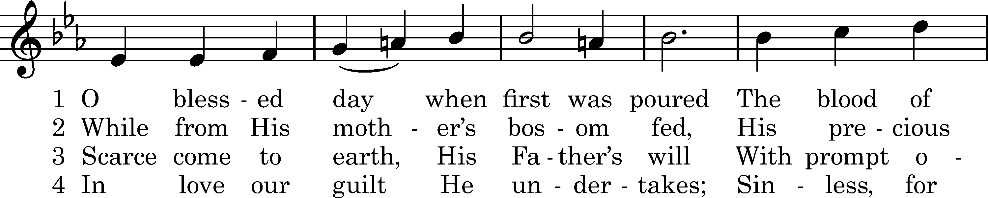
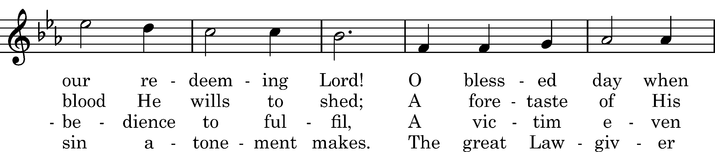
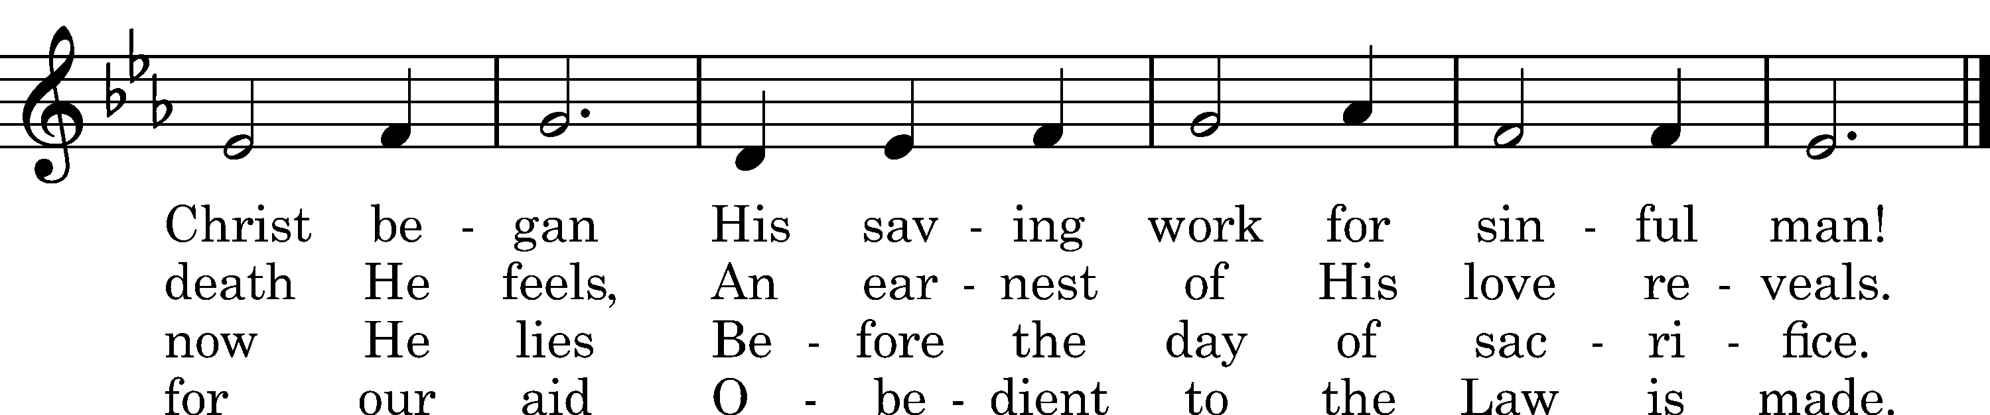

5 Lord, circumcise our heart, we pray,
And take what is not Thine away.
Write Thine own name upon our hearts,
Thy Law within our inward parts.

D 6 O Lord, the Virgin-born, to Thee
Eternal praise and glory be,
Whom with the Father we adore
And Holy Ghost forevermore.

Text: tr. John Chandler, 1837, alt.; Sebastian Besnault, †1724 Tune: Heilige Seelenlust, Breslau, 1657 Text and tune: Public domain

Readings

Prophecy: Genesis 17:3b-14 (NKJV)
In those days the Lord spoke to Abram, saying: “Behold, My covenant is with you, and you shall be a father of many nations. No longer shall your name be called Abram, but your name shall be Abraham; for I have made you a father of many nations. I will make you exceedingly fruitful; and I will make nations of you, and kings shall come from you. And I will establish My covenant between Me and you and your descendants after you in their generations, for an everlasting covenant, to be God to you and your descendants after you. Also I give to you and your descendants after you the land in which you are a stranger, all the land of Canaan, as an everlasting possession; and I will be their God.” And God said to Abraham: “As for you, you shall keep My covenant, you and your descendants after you throughout their generations. This is My covenant which you shall keep, between Me and you and your descendants after you: Every male child among you shall be circumcised; and you shall be circumcised in the flesh of your foreskins, and it shall be a sign of the covenant between Me and you. He who is eight days old among you shall be circumcised, every male child in your generations, he who is born in your house or bought with money from any foreigner who is not your descendant. He who is born in your house and he who is bought with your money must be circumcised, and My covenant shall be in your flesh for an everlasting covenant. And the uncircumcised male child, who is not circumcised in the flesh of his foreskin, that person shall be cut off from his people; he has broken My covenant.”

P This is the Word of the Lord.
C Thanks be to God.

Epistle: Galatians 3:23–29 (NKJV)
Brethren: Before faith came, we were kept under guard by the law, kept for the faith which would afterward be revealed. Therefore the law was our tutor to bring us to Christ, that we might be justified by faith. But after faith has come, we are no longer under a tutor. For you are all sons of God through faith in Christ Jesus. For as many of you as were baptized into Christ have put on Christ. There is neither Jew nor Greek, there is neither slave nor free, there is neither male nor female; for you are all one in Christ Jesus. And if you are Christ’s, then you are Abraham’s seed, and heirs according to the promise.

P O Lord, have mercy on us.
C Thanks be to God.

Stand
Gospel: Luke 2:21 (NKJV)
At that time: When eight days were completed for the circumcision of the Child, His name was called Jesus, the name given by the angel before He was conceived in the womb.

L O Lord, have mercy on us.
C Thanks be to God.
Sit

Sermon

Canticle

Stand

Antiphon (Common) 231
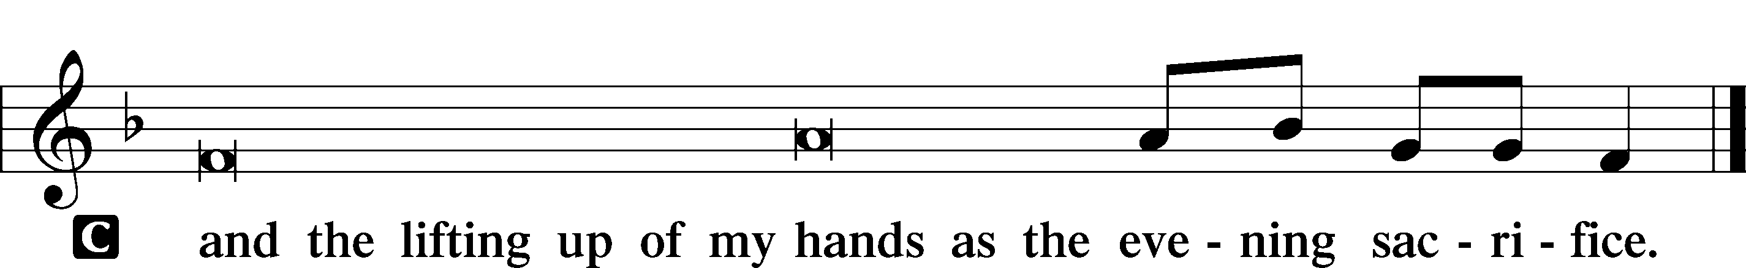

Magnificat 231
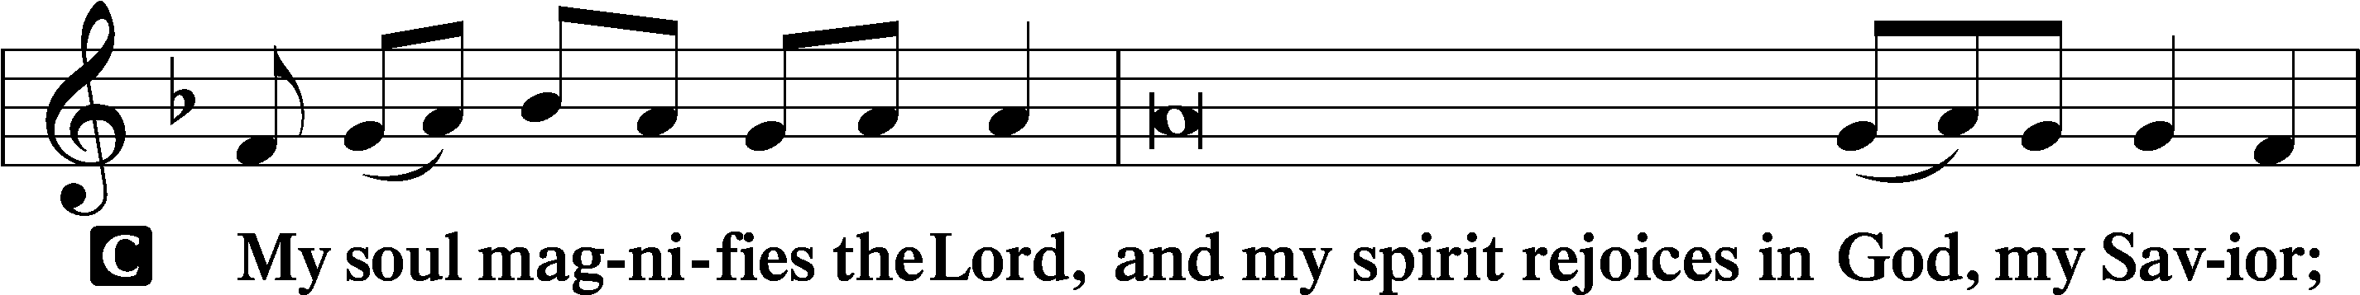
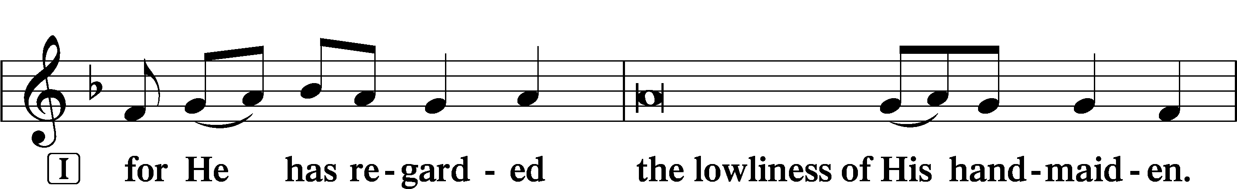
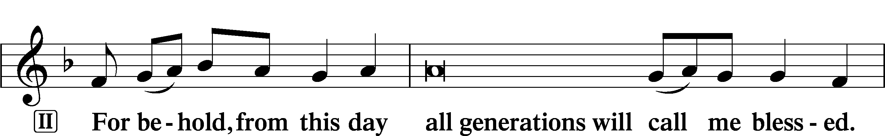
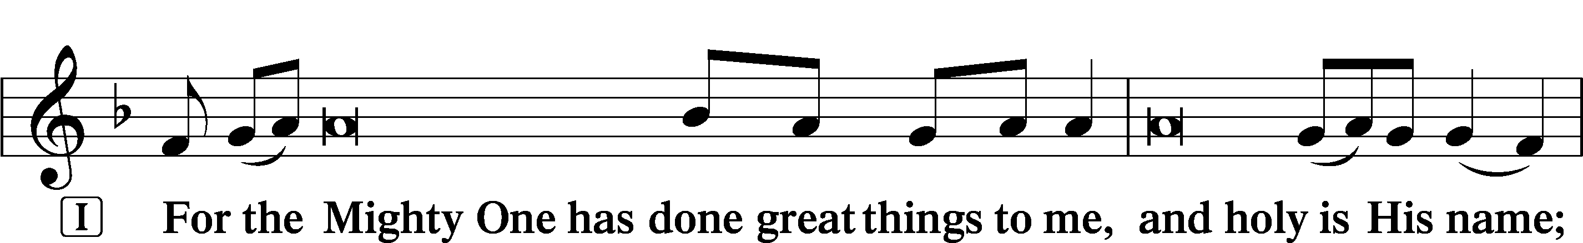
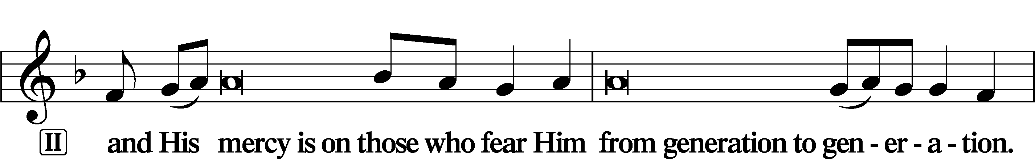
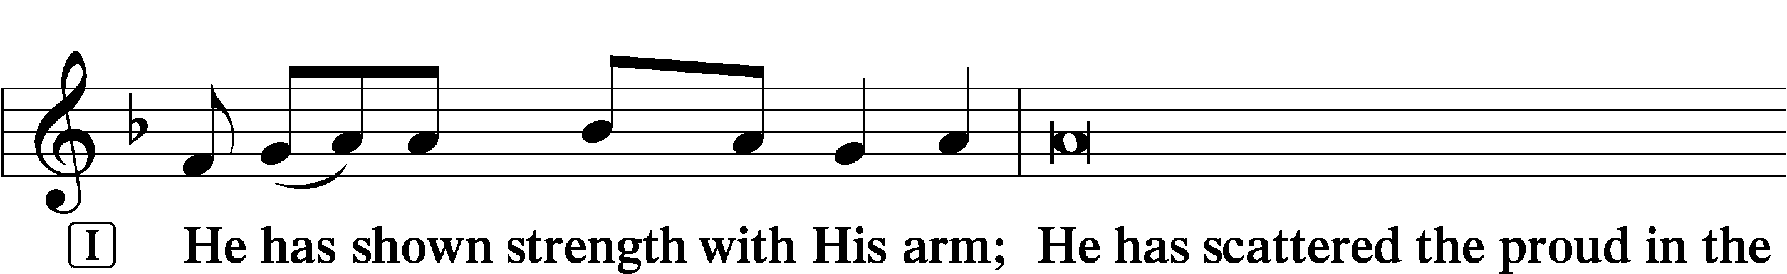
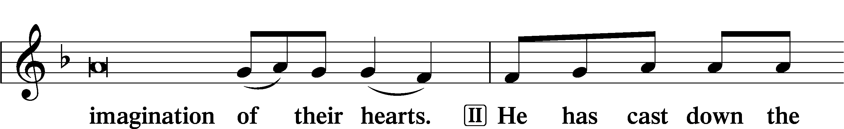
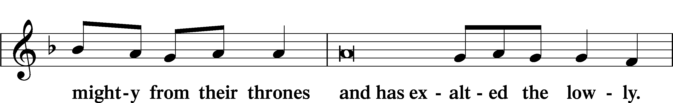
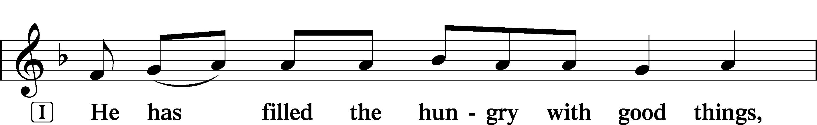
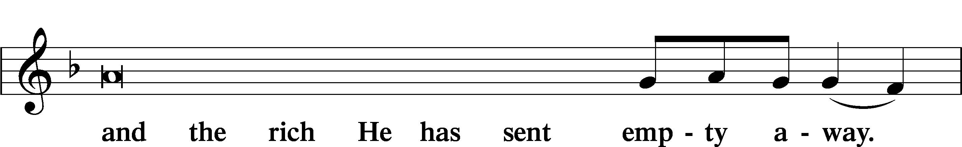
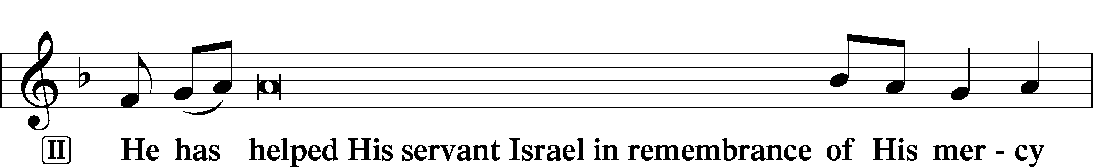
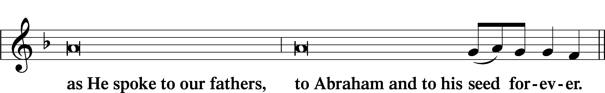
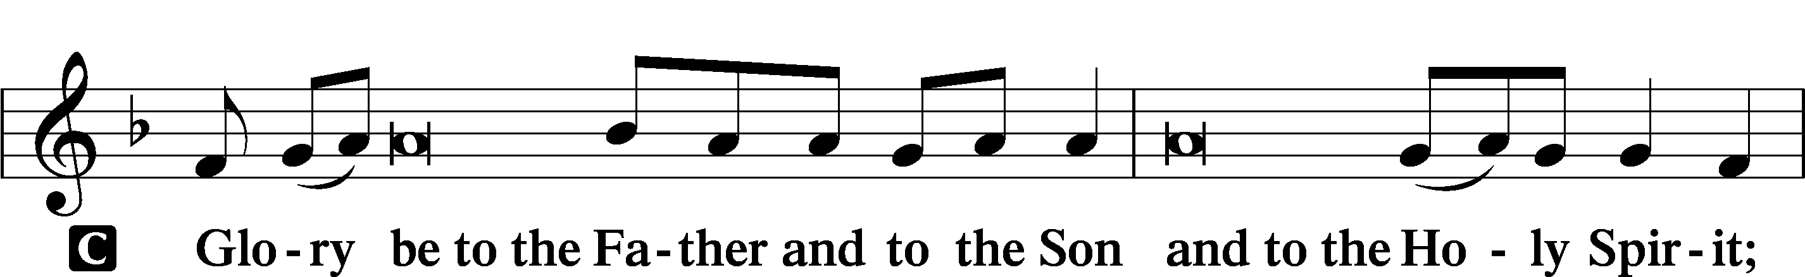
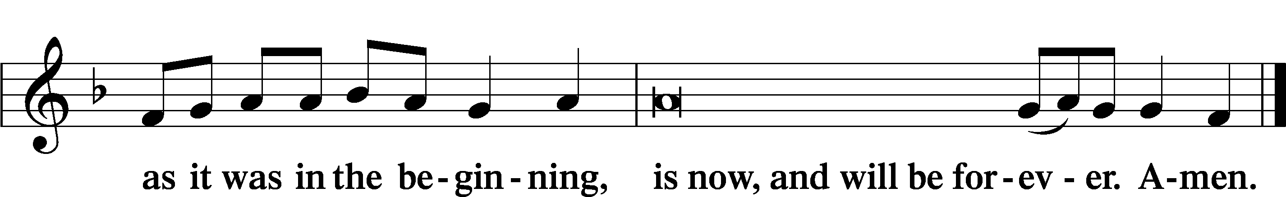

Prayer

Kyrie LSB 233
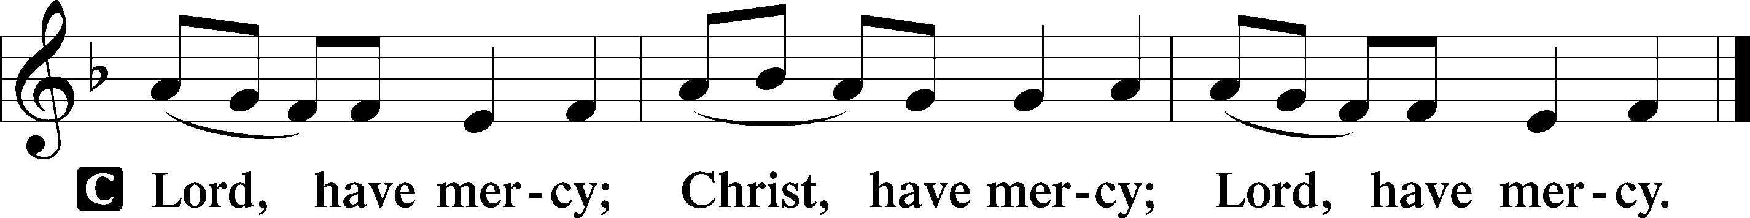

The Lord’s Prayer LSB 957
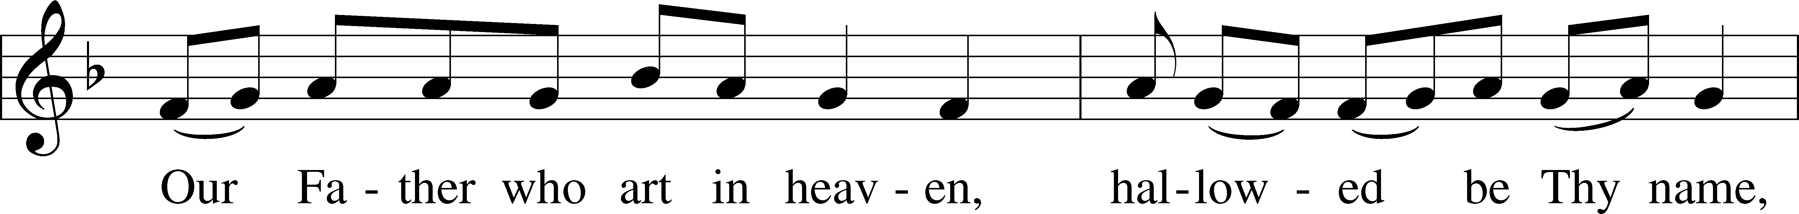
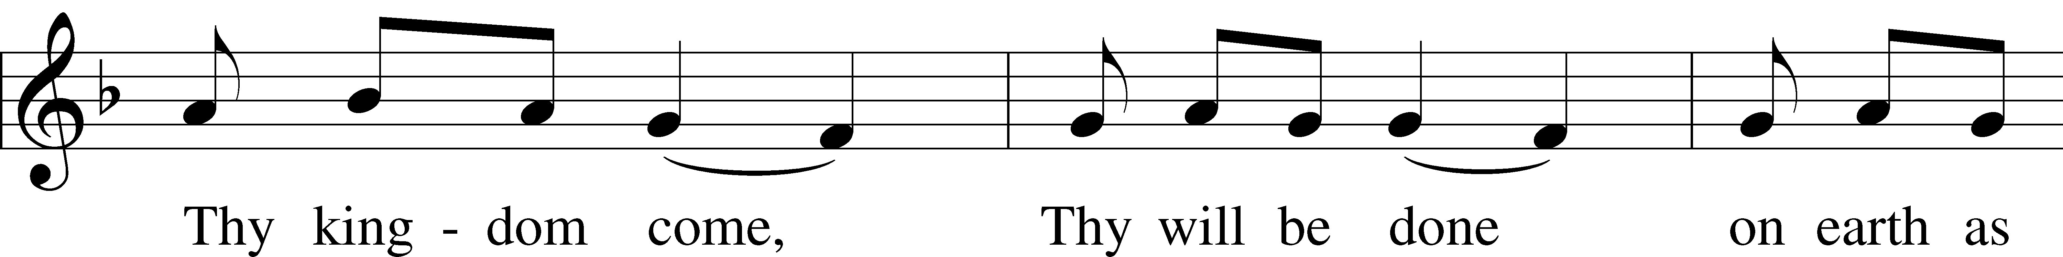
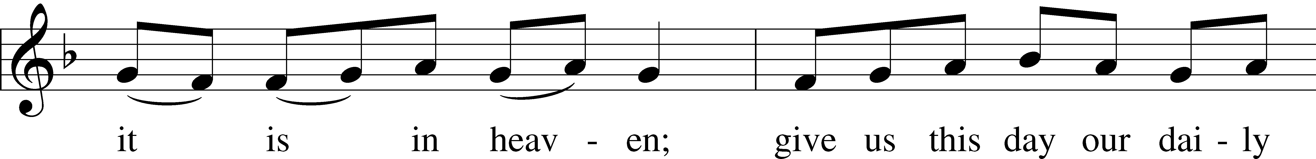
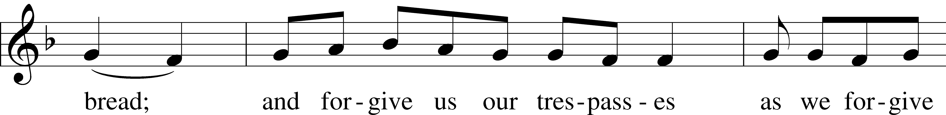
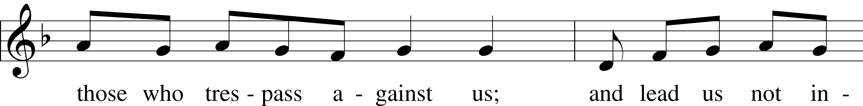
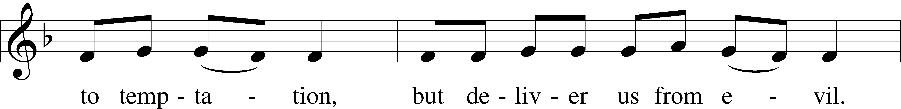
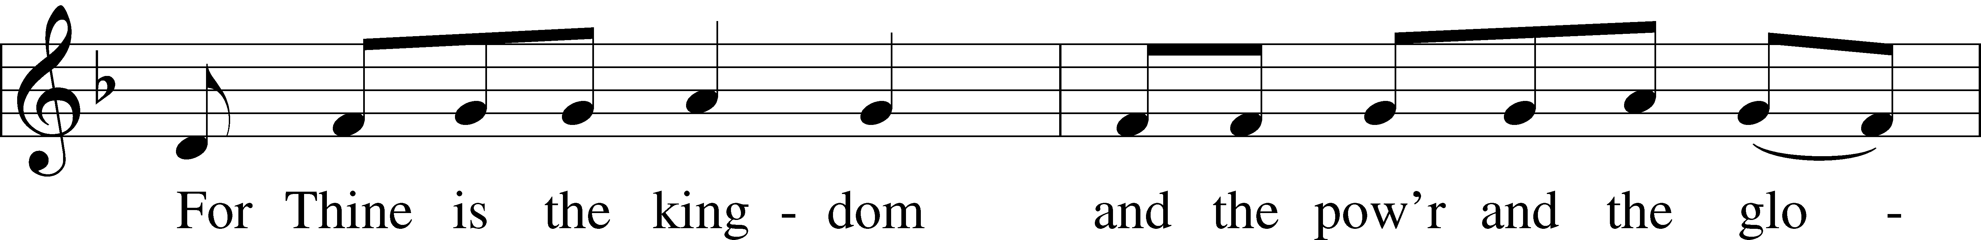
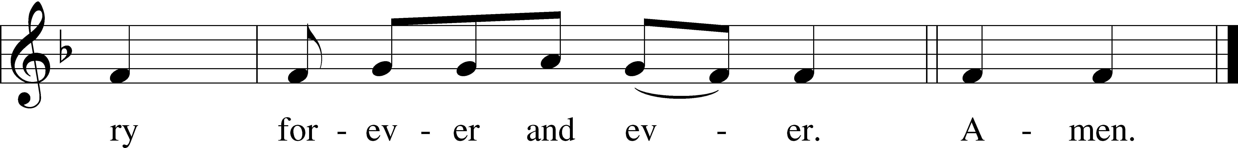

Collects
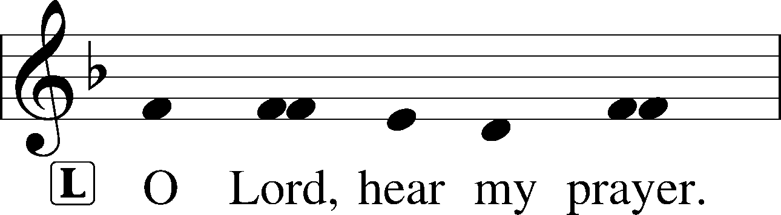
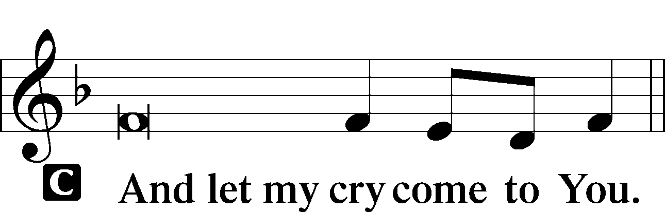

Collect of the Day: Circumcision of Jesus
P Lord God, You made Your beloved Son, our Savior, subject to the Law and caused Him to shed His blood on our behalf. Grant us the true circumcision of the Spirit that our hearts may be made pure from all sins; through Jesus Christ, our Lord, who lives and reigns with You and the Holy Spirit, one God, now and forever.

Collect for Peace
L O God, from whom come all holy desires, all good counsels, and all just works, give to us, Your servants, that peace which the world cannot give, that our hearts may be set to obey Your commandments and also that we, being defended from the fear of our enemies, may live in peace and quietness; through Jesus Christ, Your Son, our Lord, who lives and reigns with You and the Holy Spirit, one God, now and forever.
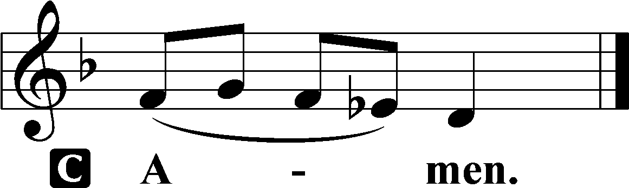

Benedicamus LSB 234
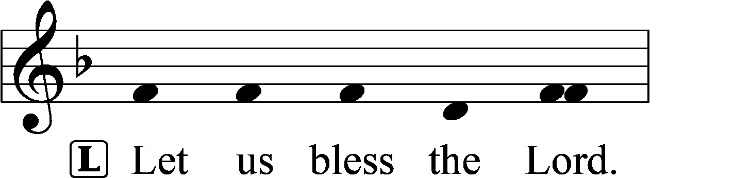
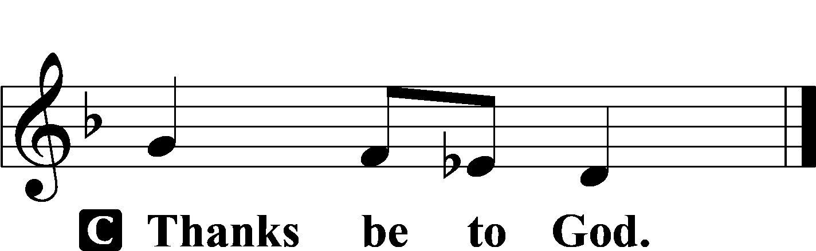
Benediction LSB 234
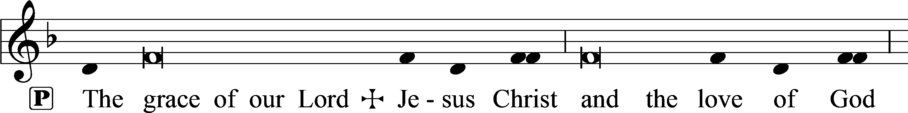
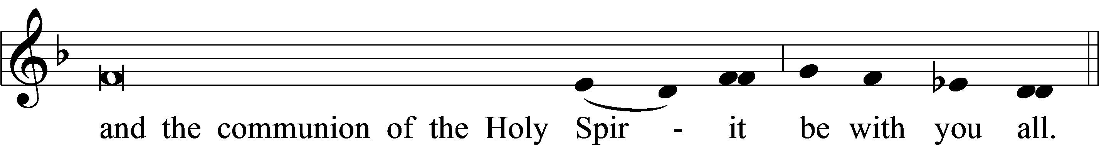

Closing Hymn: TLH #112 “To God the Anthem Raising”
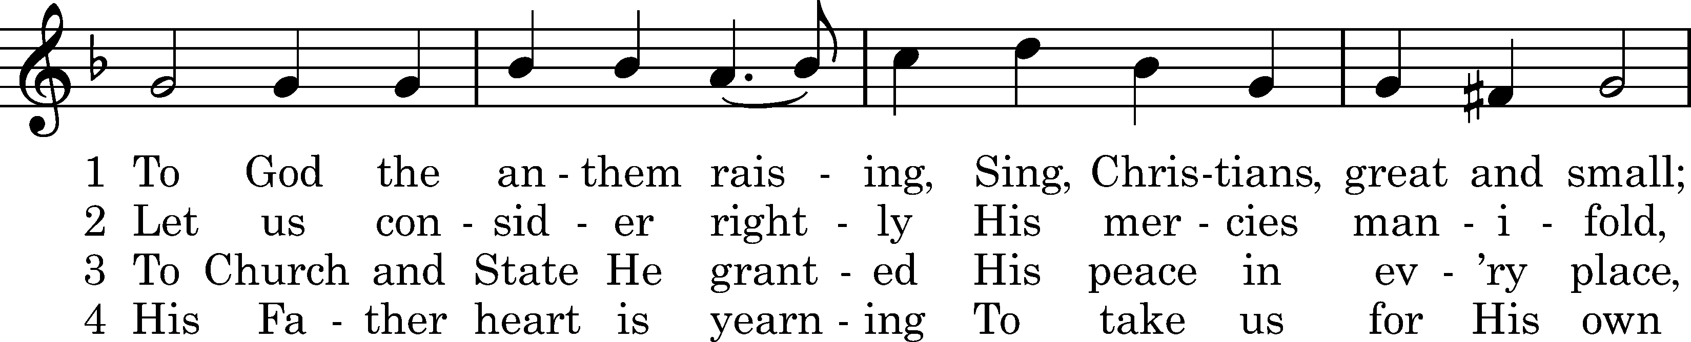
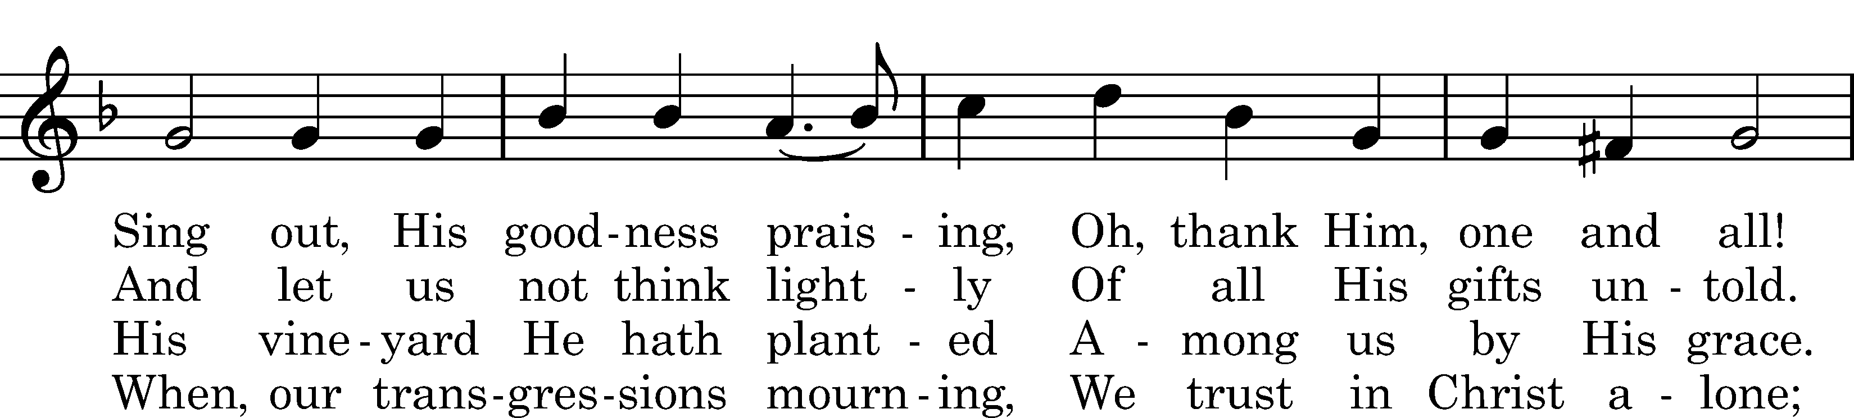
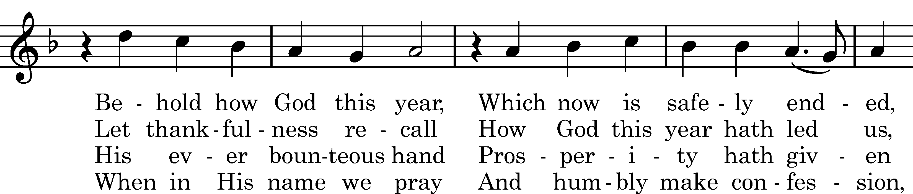
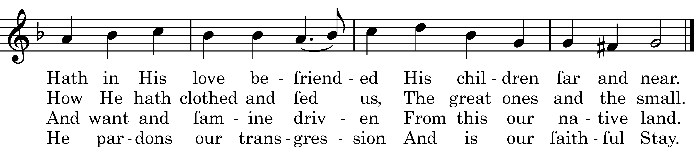
5 Our God hath well defended,
Hath kept us through His grace;
But if He had contended
With us our sins to trace
And given us our meed,
We all would then be lying
In sin and sorrow, dying,
Each one for his misdeed.

6 O Father dear in heaven,
For all Thy gifts of love
Which Thou to us hast given
We lift our thanks above.
In Jesus' name we here,
To Thee our prayers addressing,
Still ask Thee for Thy blessing:
Grant us a joyful year.

Text: tr. Carl Doving, 1907; Paul Eber, 1571 Tune: Wolfgang Figulus, 1575 Text and tune: Public domain

Acknowledgments
Unless otherwise indicated, Scripture quotations are from the ESV® Bible (The Holy Bible, English Standard Version®), copyright © 2001 by Crossway, a publishing ministry of Good News Publishers. Used by permission. All rights reserved.
Created by Lutheran Service Builder © 2023 Concordia Publishing House.

