Sts. Peter & Paul
Evangelical Lutheran Church
Lutheran Church-Missouri Synod
Founded-1917

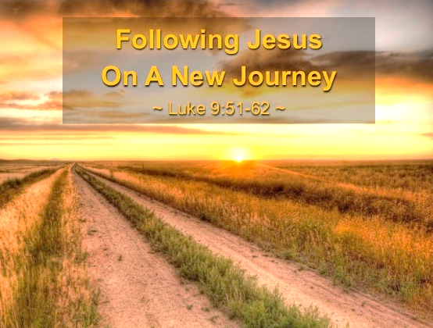

February 7, 2023

699 Stambaugh Avenue
Sharon, Pennsylvania 16146

“I was glad when they said to me,
Let us go to the house of the LORD!”
Psalm 122:1
Sts. Peter & Paul Evangelical Lutheran Church, LC-MS
DIVINE SERVICE
February 7, 2023

A special welcome to our guests this day! If you would like more information about The Lutheran Church - Missouri Synod, or this congregation, please speak with Pastor Deal or an Elder after the service.
Members & Guests: Don’t be embarrassed if your children make noise during the worship service, all children do. We encourage families to worship together but, if you feel the need, there are pews in the rear of the Church which are reserved for young families on both sides of the sanctuary. There is also a quiet room available to you during our service which is located down the hallway past the offices on the right side of the church as well as a children’s area in the Fellowship Hall where you are able to follow along with the service.

Today’s service includes the Sacrament of Holy Communion. If during this past year, you have not worshipped with us and been communed, we respectfully ask that you do not partake of this sacrament this day before first speaking with Pastor Deal.
If visiting from a sister congregation of the LC-MS and are in good standing, please inform Pastor Deal of your desire to commune prior to the service.
If wishing to receive a blessing during communion, please approach with your arms crossed.

CONTACT INFORMATION
Pastor Deal: pastordeal@saintspeterandpaul.net or 724-347-3620 (opt. 2)
Church Office: church@saintspeterandpaul.net or 724-347-3620 (opt. 3)

Silent prayer before worship: Almighty God, through Your Word, make me aware of Your awesome power and of Your boundless love in Jesus Christ, and lead me to worship You with my heart as well as my lips. In Jesus’ name. Amen.

Confession and Absolution

Opening Hymn: LSB #608 “Lord, to You I Make Confession”

Stand

The sign of the cross may be made by all in remembrance of their Baptism.

Invocation
P In the name of the Father and of the T Son and of the Holy Spirit.
C Amen.

Exhortation Hebrews 10:22; Psalm 124:8; Psalm 32:5
P Beloved in the Lord! Let us draw near with a true heart and confess our sins unto God our Father, beseeching Him in the name of our Lord Jesus Christ to grant us forgiveness.

P Our help is in the name of the Lord,
C who made heaven and earth.
P I said, I will confess my transgressions unto the Lord,
C and You forgave the iniquity of my sin.

Silence for reflection on God’s Word and for self-examination.

Confession of Sins
P O almighty God, merciful Father,
C I, a poor, miserable sinner, confess unto You all my sins and iniquities with which I have ever offended You and justly deserved Your temporal and eternal punishment. But I am heartily sorry for them and sincerely repent of them, and I pray You of Your boundless mercy and for the sake of the holy, innocent, bitter sufferings and death of Your beloved Son, Jesus Christ, to be gracious and merciful to me, a poor, sinful being.

Absolution [John 20:19–23]
P Upon this your confession, I, by virtue of my office, as a called and ordained servant of the Word, announce the grace of God unto all of you, and in the stead and by the command of my Lord Jesus Christ I forgive you all your sins in the name of the Father and of the T Son and of the Holy Spirit.
C Amen.
Service of the Word

Introit: Psalm 139:1–10, 23–24
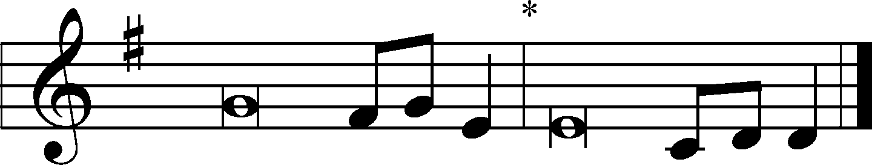
O Lord, you have searched me and | known me!*
You know when I sit down and when I rise up;
you discern my thoughts | from afar.
You search out my path and my | lying down*
and are acquainted with | all my ways.
Even before a word is | on my tongue,*
behold, O Lord, you know it alto- | gether.
You hem me in, behind | and before,*
and lay your hand up- | on me.
Such knowledge is too wonder- | ful for me;*
it is high; I cannot | attain it.
Where shall I go from your | Spirit?*
Or where shall I flee from your | presence?
If I ascend to heaven, | you are there!*
If I make my bed in Sheol, | you are there!
If I take the wings of the | morning*
and dwell in the uttermost parts | of the sea,
even there your hand shall | lead me,*
and your right hand shall | hold me.
Search me, O God, and | know my heart!*
Try me and | know my thoughts!
And see if there be any grievous | way in me,*
and lead me in the way ever- | lasting!
Glory be to the Father and | to the Son*
and to the Holy | Spirit;
as it was in the be- | ginning,*
is now, and will be forever. | Amen.

Kyrie Mark 10:47
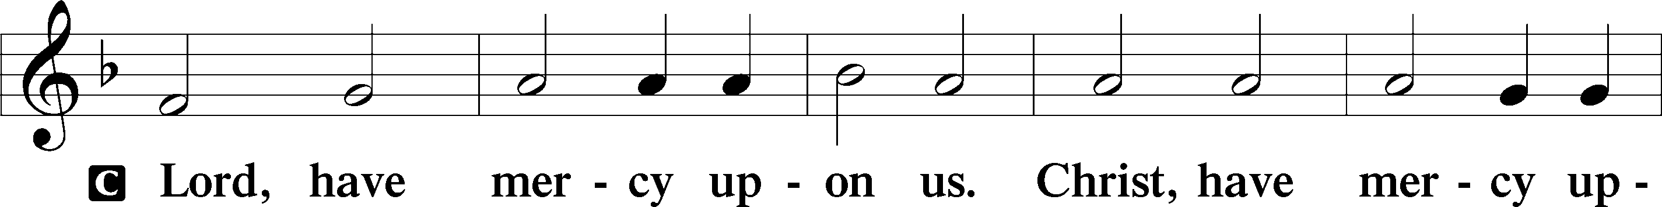
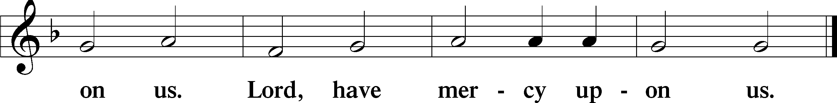

Salutation and Collect of the Day
P The Lord be with you.
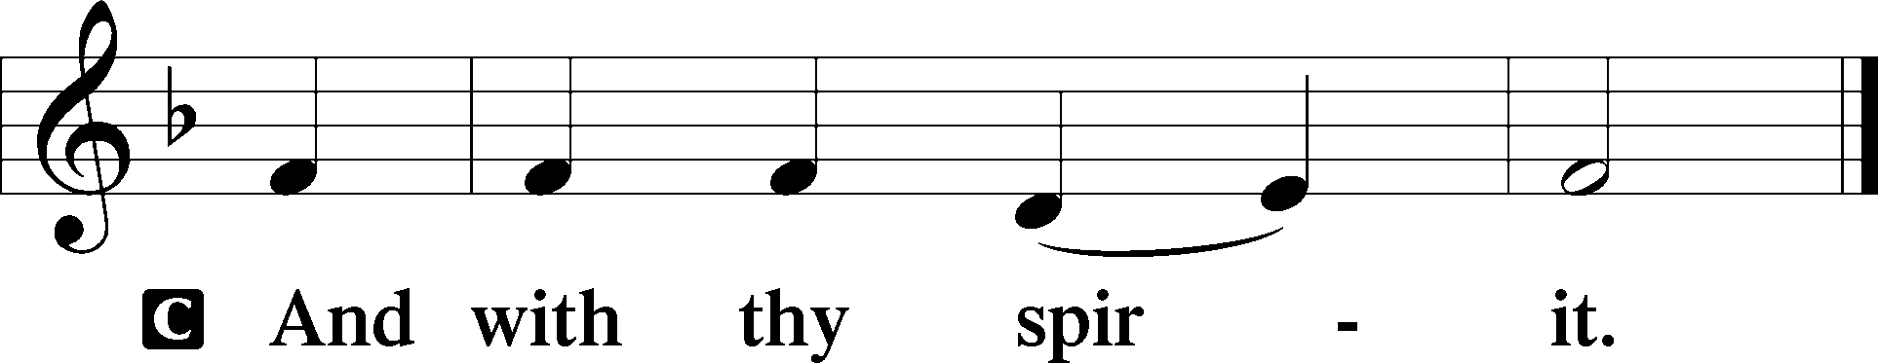

P Let us pray.
O Lord, graciously hear the prayers of Your people that we who justly suffer the consequence of our sin may be mercifully delivered by Your goodness to the glory of Your name; through Jesus Christ, Your Son, our Lord, who lives and reigns with You and the Holy Spirit, one God, now and forever.
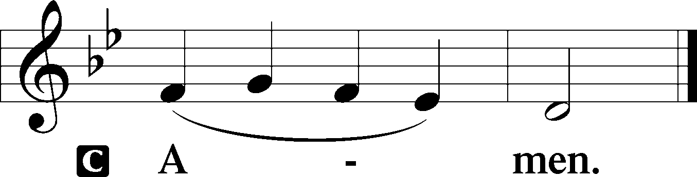
Sit
Epistle: Romans 5:18–21
Brethren: As through one man’s offense judgment came to all men, resulting in condemnation, even so through one Man’s righteous act the free gift came to all men, resulting in justification of life. For as by one man’s disobedience many were made sinners, so also by one Man’s obedience many will be made righteous. Moreover the law entered that the offense might abound. But where sin abounded, grace abounded much more, so that as sin reigned in death, even so grace might reign through righteousness to eternal life through Jesus Christ our Lord.

P This is the Word of the Lord.
C Thanks be to God.

Stand
Holy Gospel: Luke 9:57–62
P The Holy Gospel according to St. Luke, the ninth chapter.
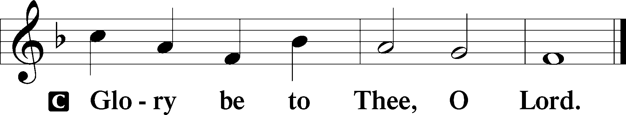

At that time: As Jesus journeyed on the road, someone said to Him, “Lord, I will follow You wherever You go.” And Jesus said to him, “Foxes have holes and birds of the air have nests, but the Son of Man has nowhere to lay His head.” Then He said to another, “Follow Me.” But he said, “Lord, let me first go and bury my father.” Jesus said to him, “Let the dead bury their own dead, but you go and preach the kingdom of God.” And another also said, “Lord, I will follow You, but let me first go and bid them farewell who are at my house.” But Jesus said to him, “No one, having put his hand to the plow, and looking back, is fit for the kingdom of God.”

P This is the Gospel of the Lord.
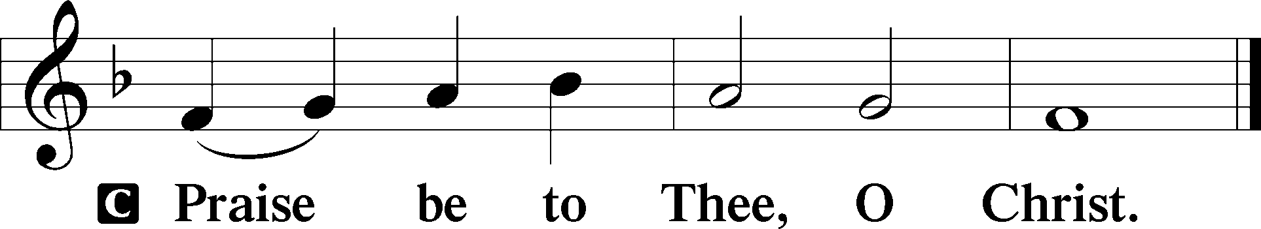
Nicene Creed
C I believe in one God,
the Father Almighty,
maker of heaven and earth
and of all things visible and invisible.

And in one Lord Jesus Christ,
the only-begotten Son of God,
begotten of His Father before all worlds,
God of God, Light of Light,
very God of very God,
begotten, not made,
being of one substance with the Father,
by whom all things were made;
who for us men and for our salvation came down from heaven
and was incarnate by the Holy Spirit of the virgin Mary
and was made man;
and was crucified also for us under Pontius Pilate.
He suffered and was buried.
And the third day He rose again according to the Scriptures
and ascended into heaven
and sits at the right hand of the Father.
And He will come again with glory to judge both the living and the dead,
whose kingdom will have no end.

And I believe in the Holy Spirit,
the Lord and giver of life,
who proceeds from the Father and the Son,
who with the Father and the Son together is worshiped and glorified,
who spoke by the prophets.
And I believe in one holy Christian and apostolic Church,
I acknowledge one Baptism for the remission of sins,
and I look for the resurrection of the dead
and the life T of the world to come. Amen.
Sit

Hymn of the Day: LSB #688 “’Come, Follow Me,’ the Savior Spake”

Sermon

Stand

Prayer of the Church

Offertory Psalm 51:10–12
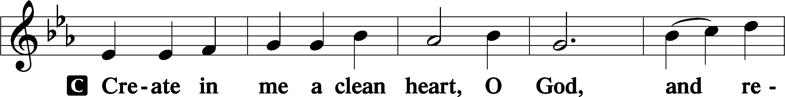
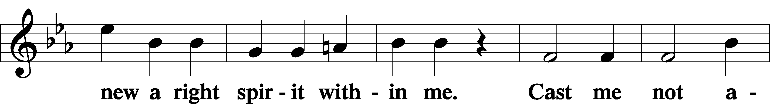
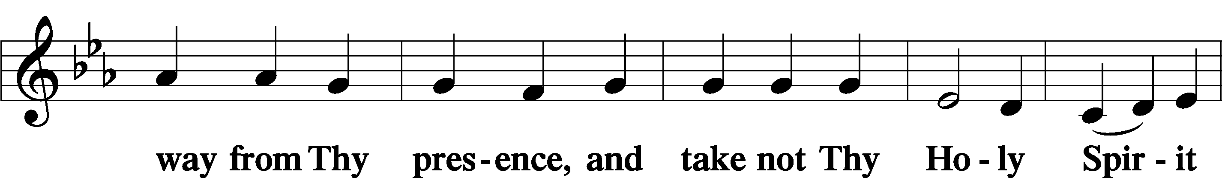
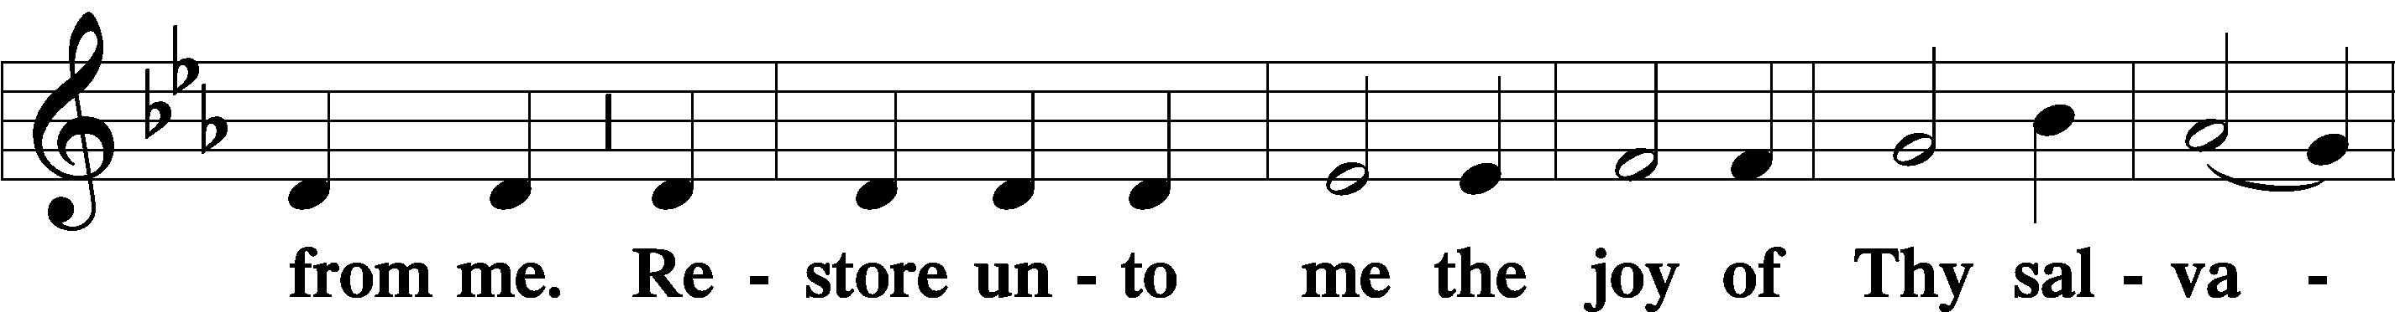
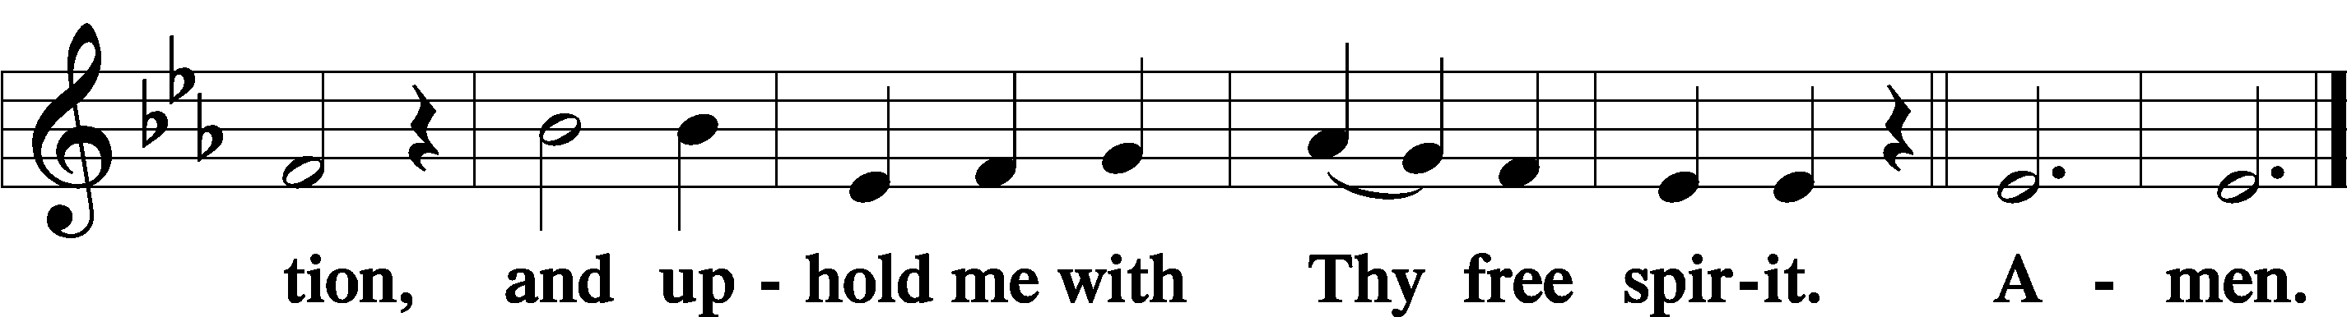
Sit

Preparatory Hymn: LSB #760 “What God Ordains Is Always Good”

Stand

Service of the Sacrament

Preface 2 Timothy 4:22; Colossians 3:1 Psalm 136
P The Lord be with you.
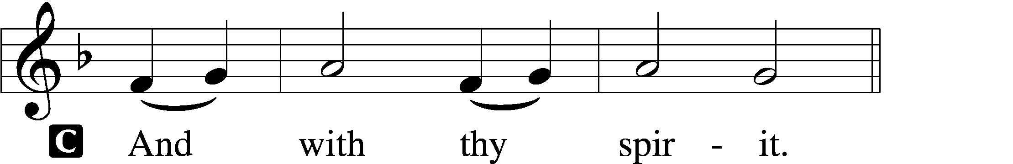

P Lift up your hearts.
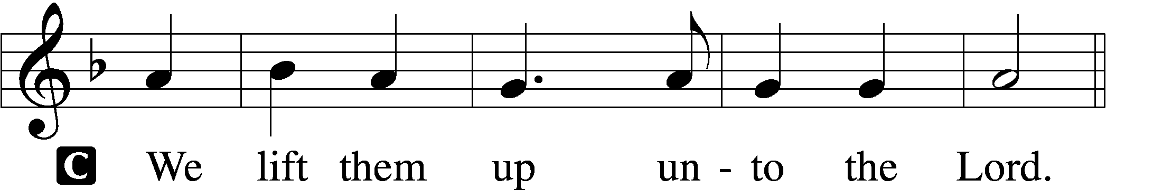

P Let us give thanks unto the Lord, our God.
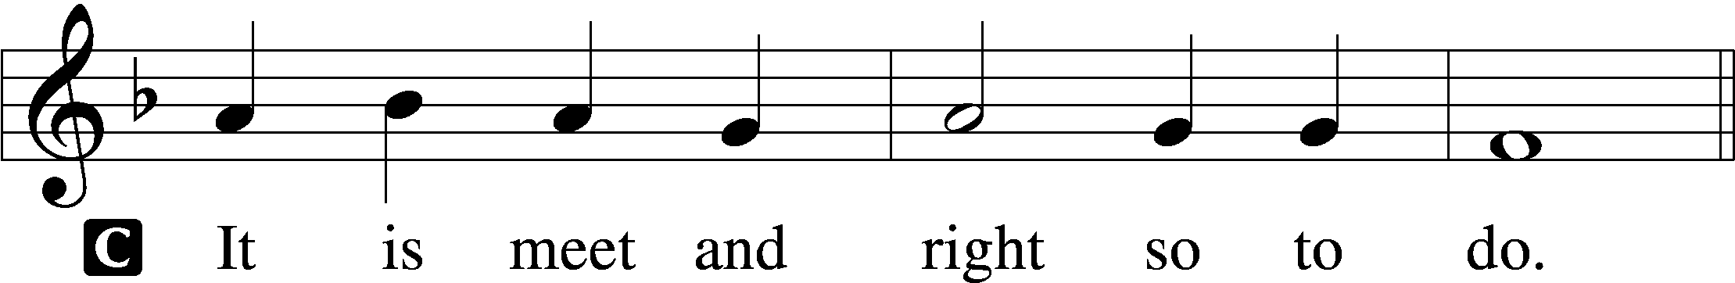

Proper Preface (Abbreviated) LSB 194
P It is truly meet, right, and salutary . . . evermore praising You and saying:

Sanctus Isaiah 6:3; Matthew 21:9
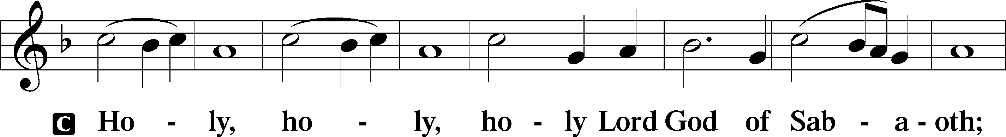
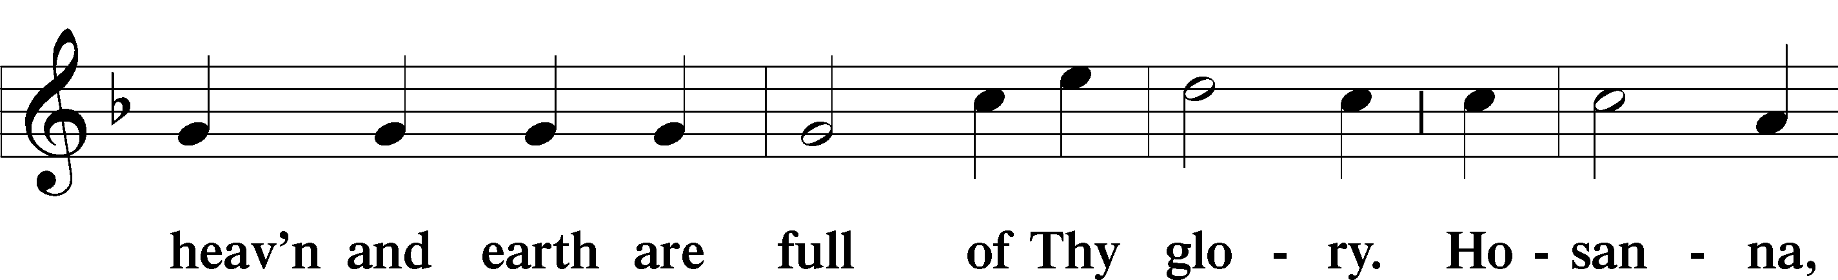
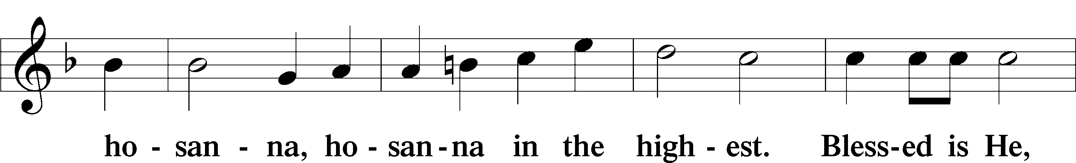
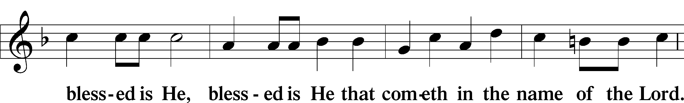
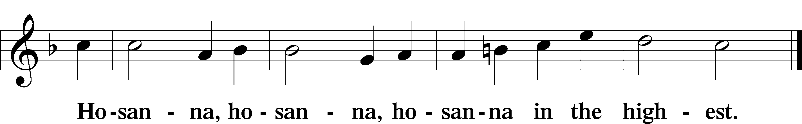

Lord’s Prayer Matthew 6:9–13
C Our Father who art in heaven,
hallowed be Thy name,
Thy kingdom come,
Thy will be done on earth as it is in heaven;
give us this day our daily bread;
and forgive us our trespasses as we forgive those who trespass against us;
and lead us not into temptation,
but deliver us from evil.
For Thine is the kingdom and the power and the glory forever and ever. Amen.

The Words of Our Lord Matthew 26:26–28; Mark 14:22–24; Luke 22:19–20; 1 Corinthians 11:23–25
P Our Lord Jesus Christ, on the night when He was betrayed, took bread, and when He had given thanks, He broke it and gave it to the disciples and said: “Take, eat; this is My T body, which is given for you. This do in remembrance of Me.”

In the same way also He took the cup after supper, and when He had given thanks, He gave it to them, saying: “Drink of it, all of you; this cup is the new testament in My T blood, which is shed for you for the forgiveness of sins. This do, as often as you drink it, in remembrance of Me.”

Pax Domini John 20:19
P The peace of the Lord be with you always.
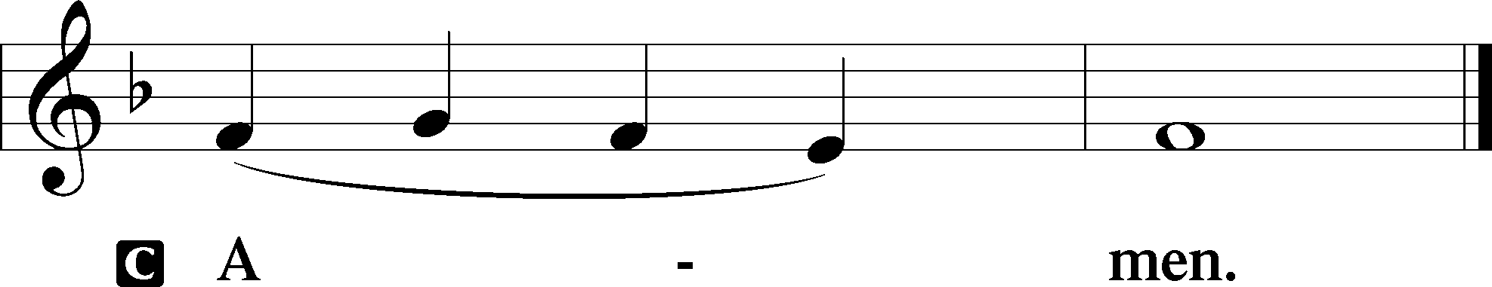

Agnus Dei John 1:29
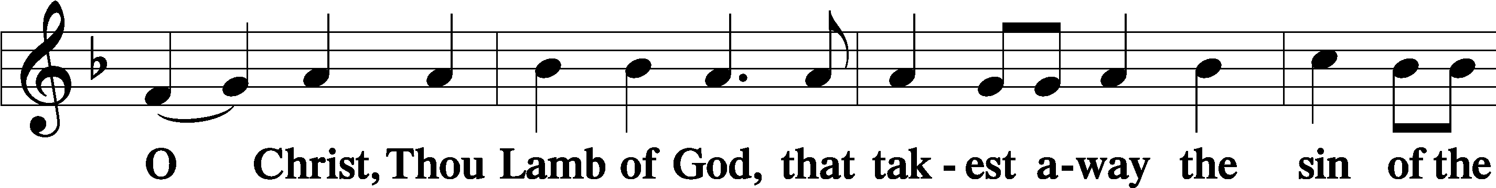
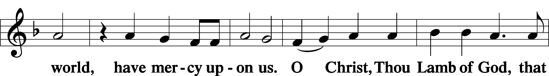
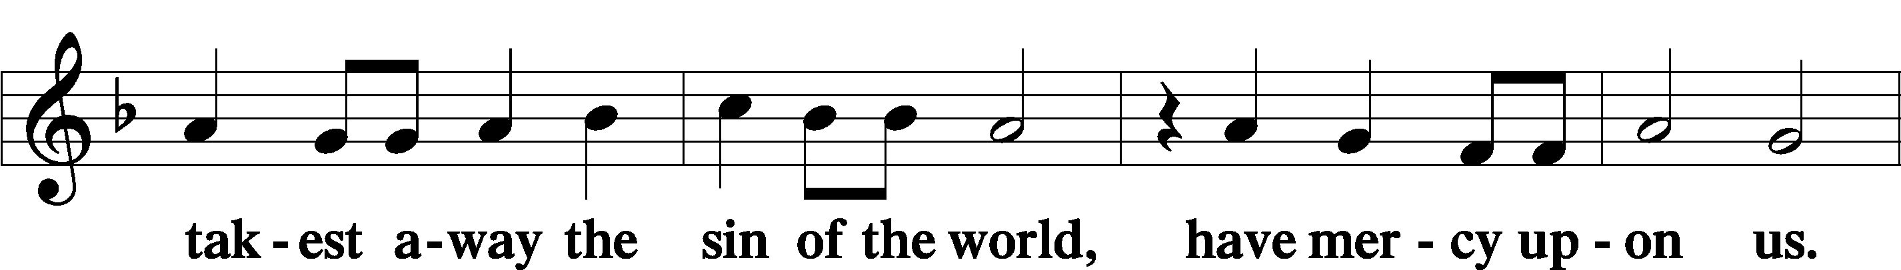
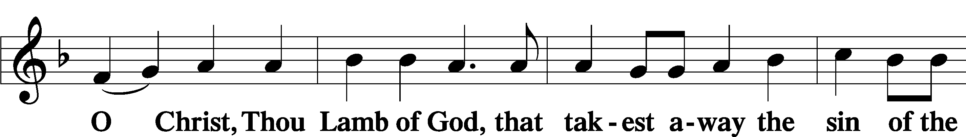
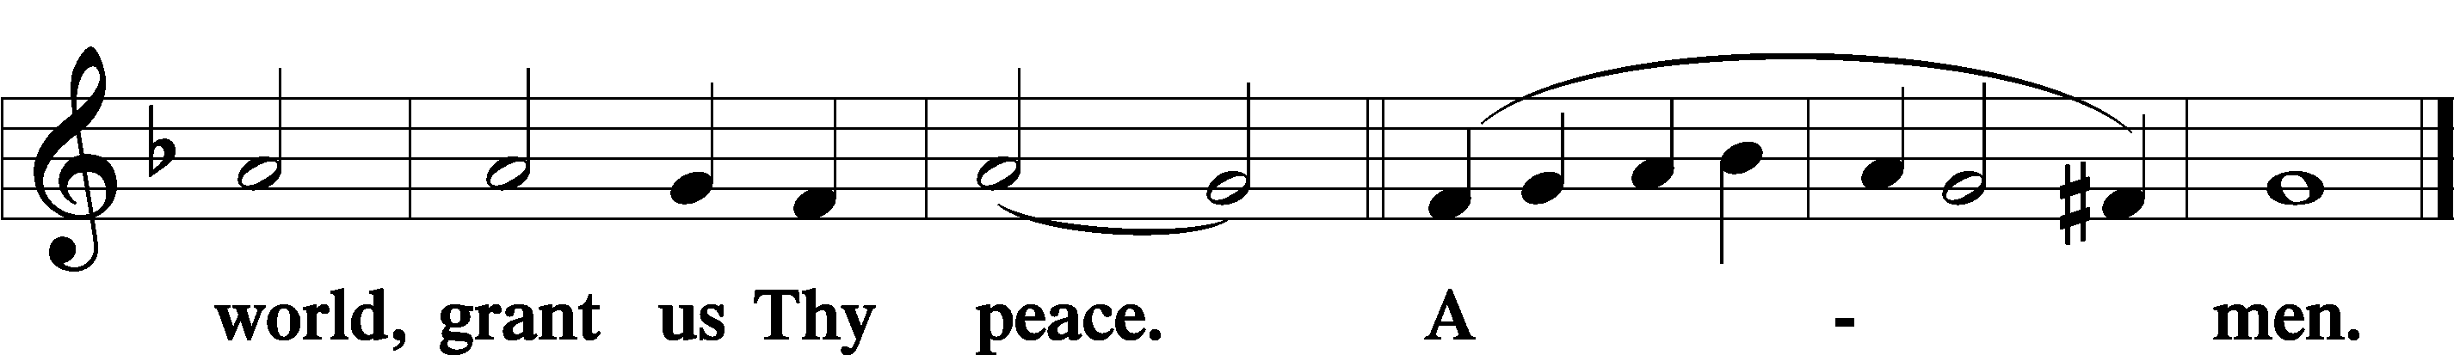
Sit

Distribution
The pastor and those who assist him receive the body and blood of Christ first and then distribute them to those who come to receive, saying:
Take, eat; this is the true body of our Lord and Savior Jesus Christ, given into death for your sins.
Amen.

Take, drink; this is the true blood of our Lord and Savior Jesus Christ, shed for the forgiveness of your sins.
Amen.

In dismissing the communicants, the following is said:
The Dismissal
P The body and blood of our Lord Jesus Christ strengthen and preserve you in body and soul to life everlasting. Depart T in peace.
C Amen.

Stand
Nunc Dimittis Luke 2:29–32
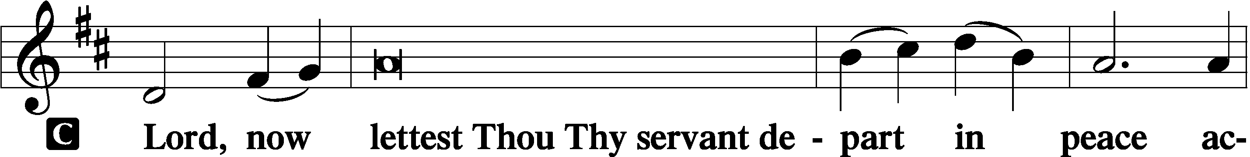
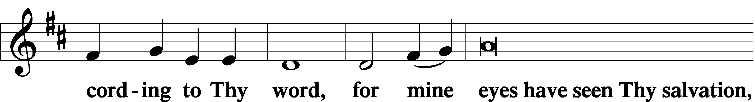
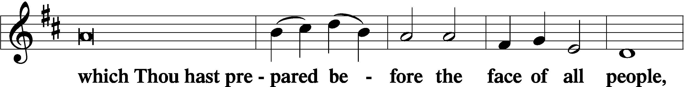
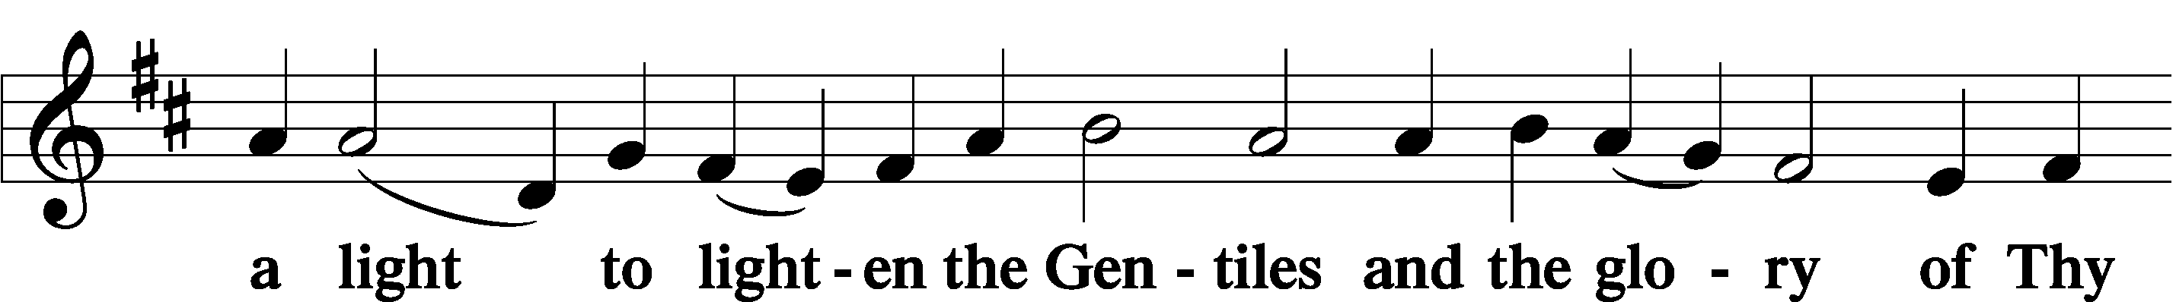
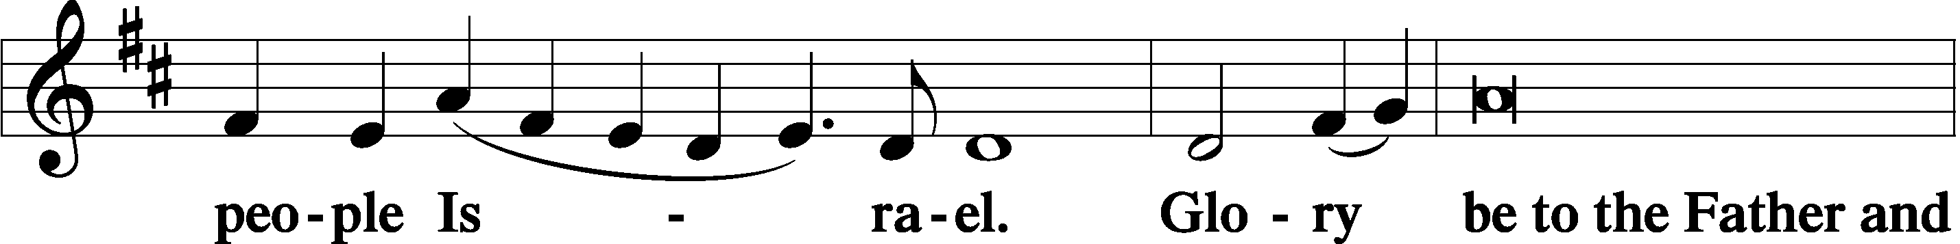
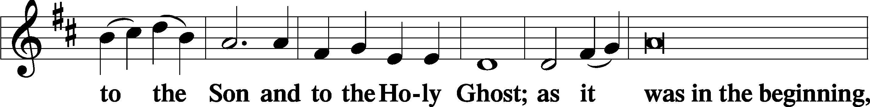
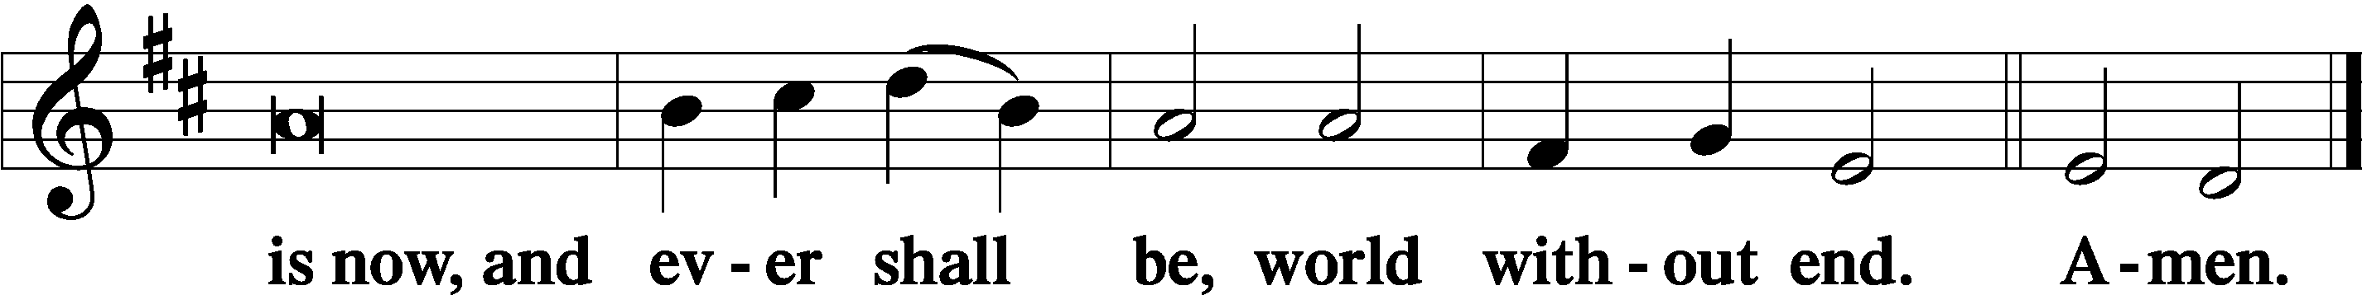

Thanksgiving Psalm 107:1
P O give thanks unto the Lord, for He is good,
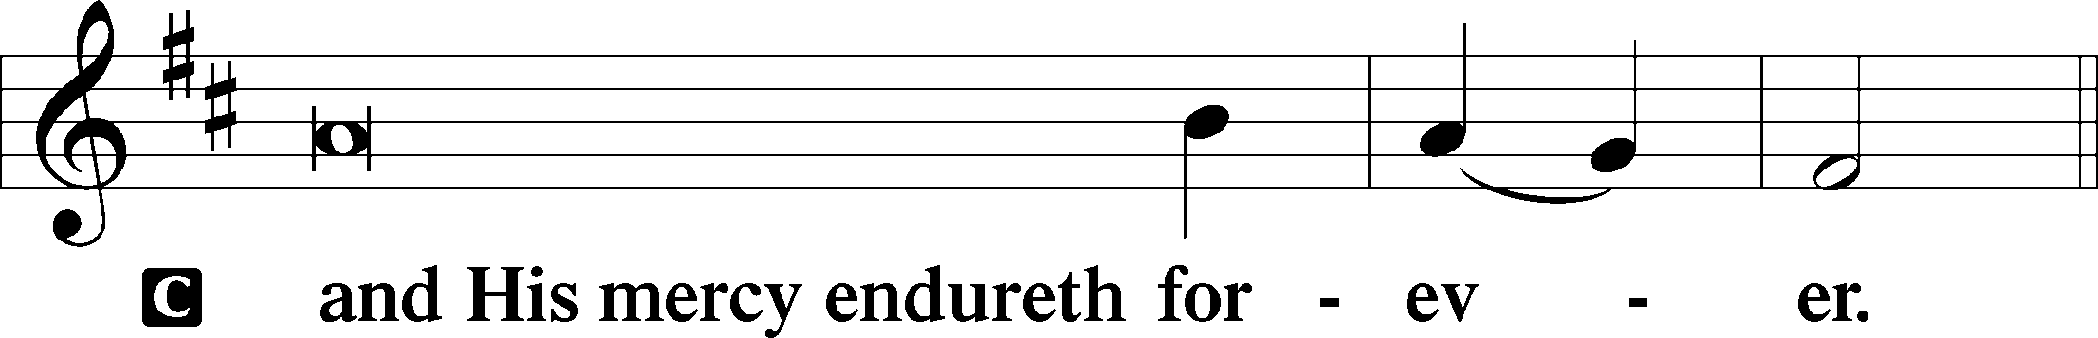

Post-Communion Collect
P Let us pray.
We give thanks to You, almighty God, that You have refreshed us through this salutary gift, and we implore You that of Your mercy You would strengthen us through the same in faith toward You and in fervent love toward one another; through Jesus Christ, Your Son, our Lord, who lives and reigns with You and the Holy Spirit, one God, now and forever.
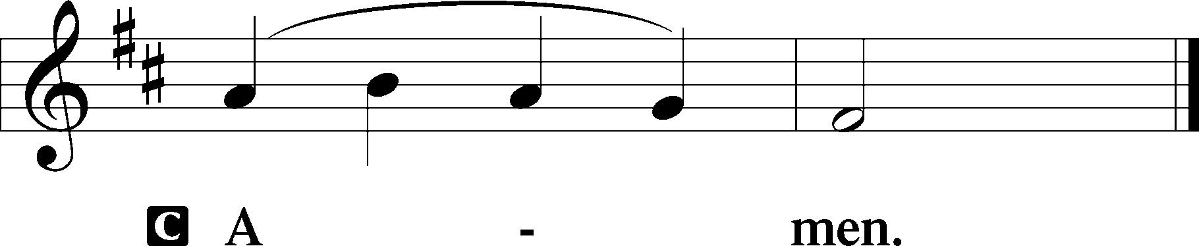

Salutation 2 Timothy 4:22
P The Lord be with you.
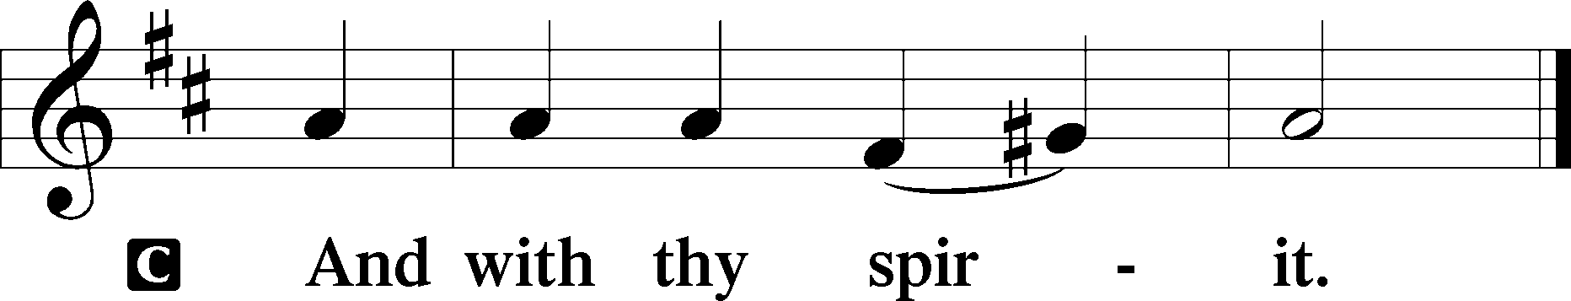

Benedicamus Psalm 103:1
P Bless we the Lord.
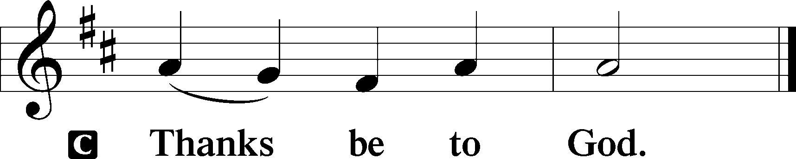

Benediction Numbers 6:24–26
P The Lord bless you and keep you.
The Lord make His face shine upon you and be gracious unto you.
The Lord lift up His countenance upon you and T give you peace.
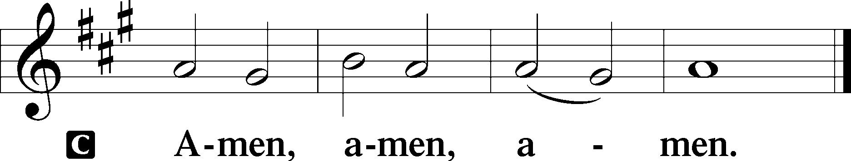

Closing Hymn: TLH #407 “Farewell I Gladly Bid Thee”
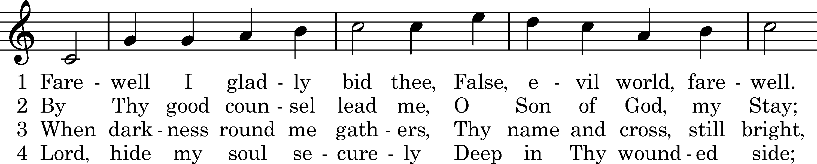
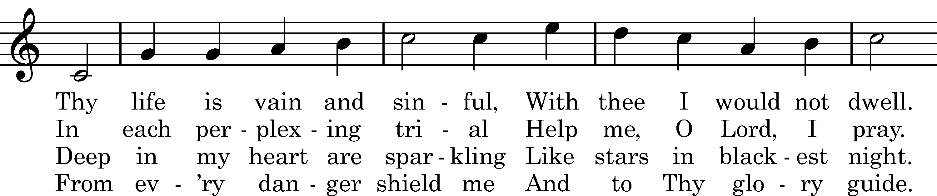
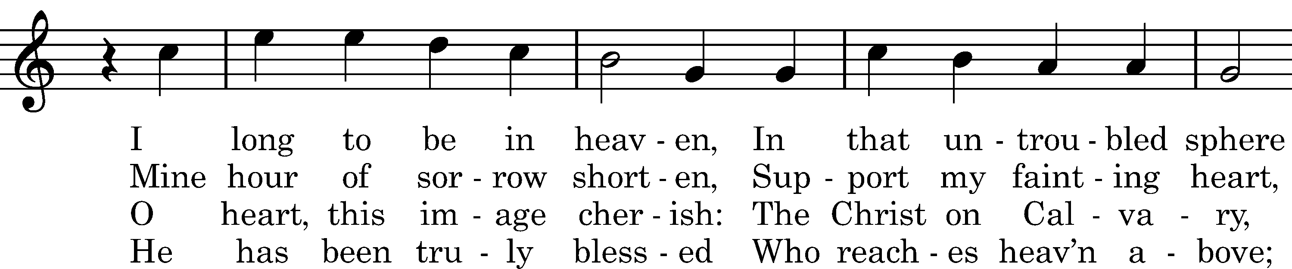
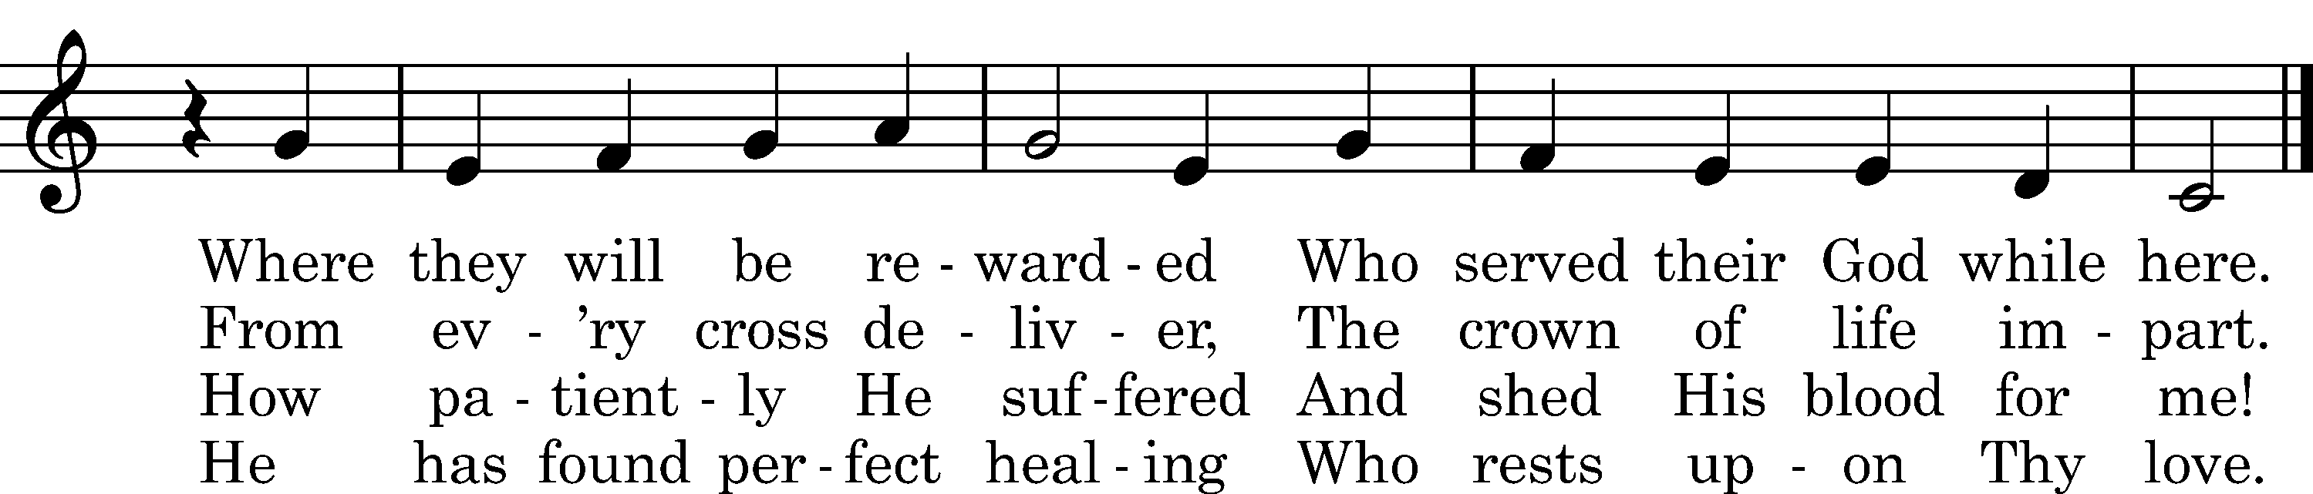

5 Lord, write my name, I pray Thee,
Now in the Book of Life
And with all true believers
Take me where joys are rife.
There let me bloom and flourish,
Thy perfect freedom prove,
And tell, as I adore Thee,
How faithful was Thy love.
Text: tr. Catherine Winkworth, 1863, alt.; Valerius Herberger, 1613
Tune: Melchior Teschner, 1613
Text and tune: Public domain

Silent prayer after worship: O Lord, lead me to daily read Your word and pray that I may receive Your blessings and grow in my faith, so that my life may be a light that gives You glory and directs others to You. In Jesus’ name. Amen.
fffffffffffffffffffffffffffffffffff
Acknowledgments: Unless otherwise indicated, Scripture quotations are from the ESV® Bible (The Holy Bible, English Standard Version®), copyright © 2001 by Crossway, a publishing ministry of Good News Publishers. Used by permission. All rights reserved.
Created by Lutheran Service Builder © 2021 Concordia Publishing House.
fffffffffffffffffffffffffffffffffff

Here to Serve

Pastor………………………………………………...……………Rev. Jacob Deal
E-mail …………………………….……pastordeal@saintspeterandpaul.net
Phone Number……………………..…………………724-347-3620 (Option 2)
Church Office………………………..…………………724-347-3620 (Option 3)
Website …………………………………………www.saintspeterandpaul.net
Secretary…………………………………………………………Diane Riefstahl
E-mail ………………………………………church@saintspeterandpaul.net
Website …………………………………………www.saintspeterandpaul.net
Food Pantry: Please leave message……………724-347-3620 (Option 3)
AA Contact: Steve………………………………………………..…724-813-2358
NA Contact: Larry………………………………………………..724-977-8733
Choir Director………………………………………………………Chris Nelson
Congregation President……………………………………Jonathan Baisch
Church Elder …………………………………………...…… Jonathan Baisch
fffffffffffffffffffffffffffffffffff
If needing to get into the church building during the week, please phone first to make certain someone is here to let you in.

