Sts. Peter & Paul
Evangelical Lutheran Church
Lutheran Church-Missouri Synod
Founded-1917

February 5, 2023

699 Stambaugh Avenue
Sharon, Pennsylvania 16146

“I was glad when they said to me,
Let us go to the house of the LORD!”
Psalm 122:1
Sts. Peter & Paul Evangelical Lutheran Church, LC-MS
SEPTUAGESIMA
February 5, 2023

A special welcome to our guests this day! If you would like more information about The Lutheran Church - Missouri Synod, or this congregation, please speak with Pastor Deal or an Elder after the service.
Members & Guests: Don’t be embarrassed if your children make noise during the worship service, all children do. We encourage families to worship together but, if you feel the need, there are pews in the rear of the Church which are reserved for young families on both sides of the sanctuary. There is also a quiet room available to you during our service which is located down the hallway past the offices on the right side of the church as well as a children’s area in the Fellowship Hall where you are able to follow along with the service.

Today’s service includes the Sacrament of Holy Communion. If during this past year, you have not worshipped with us and been communed, we respectfully ask that you do not partake of this sacrament this day before first speaking with Pastor Deal.
If visiting from a sister congregation of the LC-MS and are in good standing, please inform Pastor Deal of your desire to commune prior to the service.
If wishing to receive a blessing during communion, please approach with your arms crossed.

CONTACT INFORMATION
Pastor Deal: pastordeal@saintspeterandpaul.net or 724-347-3620 (opt. 2)
Church Office: church@saintspeterandpaul.net or 724-347-3620 (opt. 3)

Silent prayer before worship: Almighty God, through Your Word, make me aware of Your awesome power and of Your boundless love in Jesus Christ, and lead me to worship You with my heart as well as my lips. In Jesus’ name. Amen.

Confession and Absolution

Opening Hymn: TLH #260 “O Lord, Look Down from Heaven, Behold”

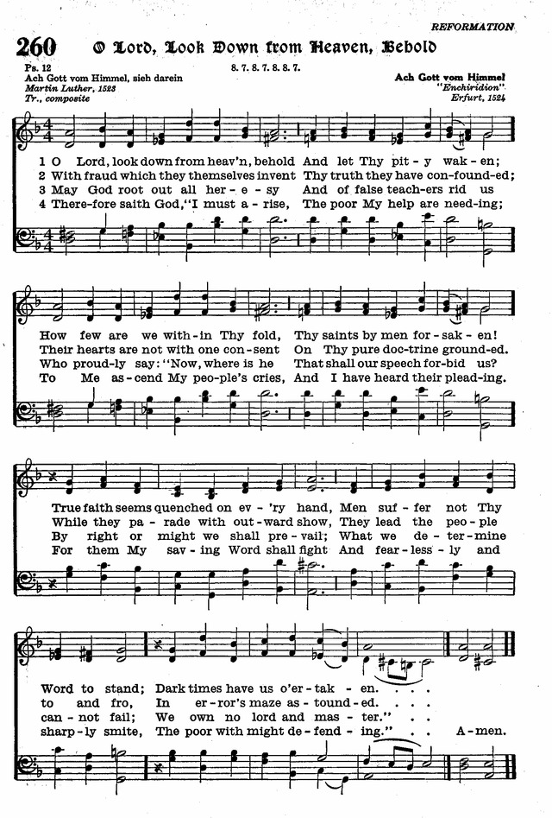
5 As silver tried by fire is pure
From all adulteration,
So thro' God's Word shall men endure
Each trial and temptation.
Its light beams brighter thro' the cross,
And, purified from human dross,
It shines through every nation.
6 Defend Thy truth, O God, and stay
This evil generation;
And from the error of its way
Keep Thine own congregation.
The wicked everywhere abound
And would Thy little flock confound;
But Thou art our Salvation. Amen.
Stand

The sign of the cross may be made by all in remembrance of their Baptism.

Invocation
P In the name of the Father and of the T Son and of the Holy Spirit.
C Amen.

Exhortation Hebrews 10:22; Psalm 124:8; Psalm 32:5
P Beloved in the Lord! Let us draw near with a true heart and confess our sins unto God our Father, beseeching Him in the name of our Lord Jesus Christ to grant us forgiveness.

P Our help is in the name of the Lord,
C who made heaven and earth.
P I said, I will confess my transgressions unto the Lord,
C and You forgave the iniquity of my sin.

Silence for reflection on God’s Word and for self-examination.

Confession of Sins
P O almighty God, merciful Father,
C I, a poor, miserable sinner, confess unto You all my sins and iniquities with which I have ever offended You and justly deserved Your temporal and eternal punishment. But I am heartily sorry for them and sincerely repent of them, and I pray You of Your boundless mercy and for the sake of the holy, innocent, bitter sufferings and death of Your beloved Son, Jesus Christ, to be gracious and merciful to me, a poor, sinful being.

Absolution [John 20:19–23]
P Upon this your confession, I, by virtue of my office, as a called and ordained servant of the Word, announce the grace of God unto all of you, and in the stead and by the command of my Lord Jesus Christ I forgive you all your sins in the name of the Father and of the T Son and of the Holy Spirit.
C Amen.
Service of the Word

Introit Psalm 18:1–2a, 27, 32, 49; antiphon: vv. 5–6a
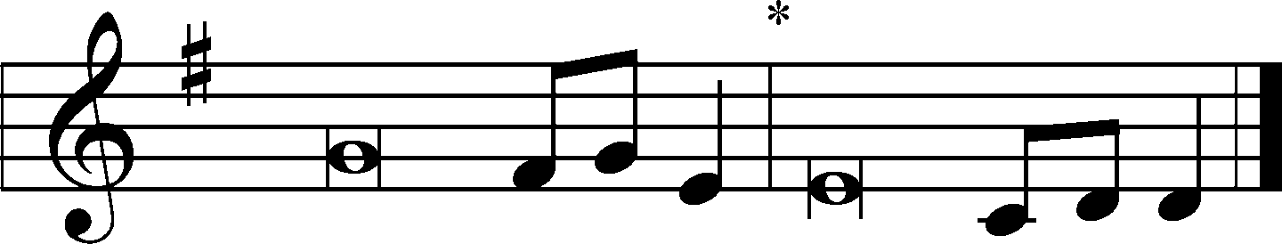
The cords of Sheol en- | tangled me;*
the snares of death con- | fronted me.
In my distress I called up- | on the Lord.*
From his temple he | heard my voice.
I love you, O | Lord, my strength.*
The Lord is my rock and my fortress and my de- | liverer.
For you save a humble | people,*
but the haughty eyes | you bring down.
[You have] equipped | me with strength*
and made my way | blameless.
For this I will praise you, O Lord, among the | nations,*
and sing | to your name.
Glory be to the Father and | to the Son*
and to the Holy | Spirit;
as it was in the be- | ginning,*
is now, and will be forever. | Amen.
Kyrie Mark 10:47
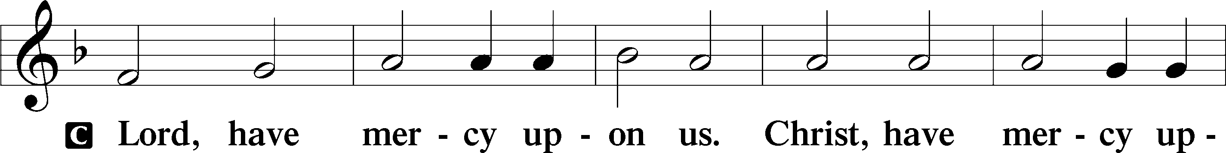
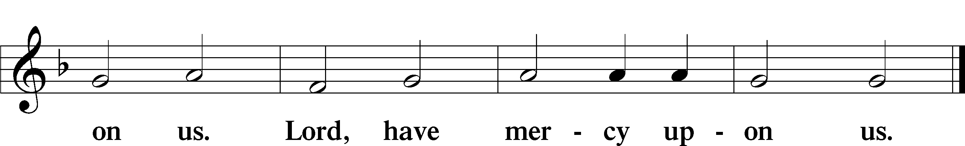

Salutation and Collect of the Day: Epiphany 6 / Septuagesima
P The Lord be with you.
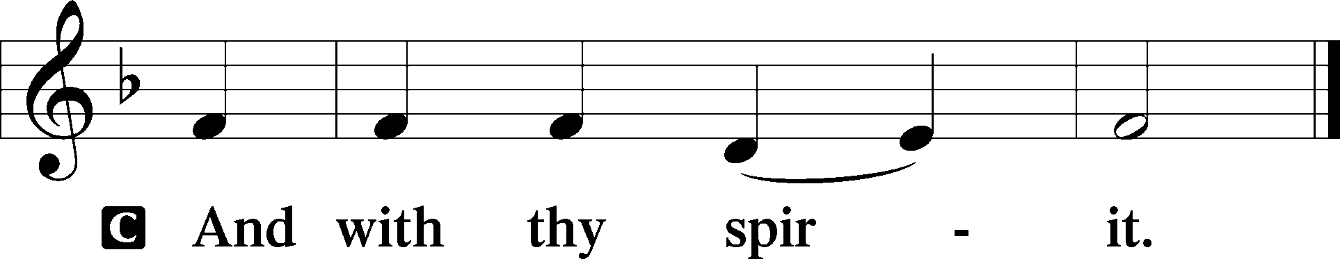

P Let us pray.
O Lord, graciously hear the prayers of Your people that we who justly suffer the consequence of our sin may be mercifully delivered by Your goodness to the glory of Your name; through Jesus Christ, Your Son, our Lord, who lives and reigns with You and the Holy Spirit, one God, now and forever.
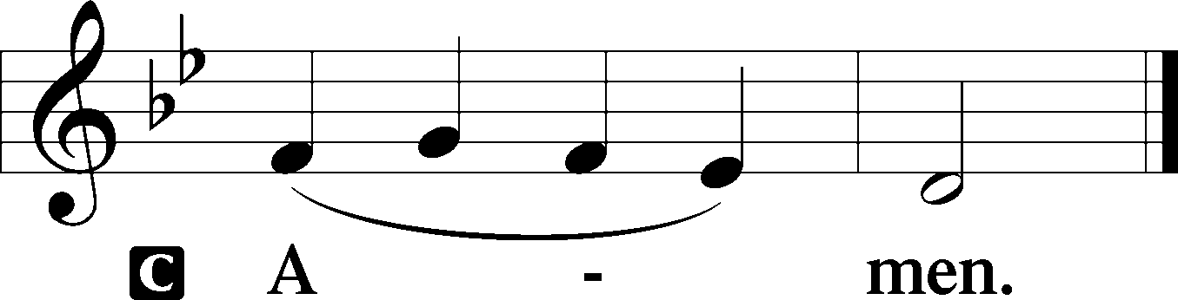
Sit

Prophecy: Daniel 9:2-10
In those days: I, Daniel, understood by the books the number of the years specified by the word of the Lord through Jeremiah the prophet, that He would accomplish seventy years in the desolations of Jerusalem. Then I set my face toward the Lord God to make request by prayer and supplications, with fasting, sackcloth, and ashes. And I prayed to the Lord my God, and made confession, and said, “O Lord, great and awesome God, who keeps His covenant and mercy with those who love Him, and with those who keep His commandments, we have sinned and committed iniquity, we have done wickedly and rebelled, even by departing from Your precepts and Your judgments. Neither have we heeded Your servants the prophets, who spoke in Your name to our kings and our princes, to our fathers and all the people of the land. O Lord, righteousness belongs to You, but to us shame of face, as it is this day—to the men of Judah, to the inhabitants of Jerusalem and all Israel, those near and those far off in all the countries to which You have driven them, because of the unfaithfulness which they have committed against You. O Lord, to us belongs shame of face, to our kings, our princes, and our fathers, because we have sinned against You. To the Lord our God belong mercy and forgiveness, though we have rebelled against Him. We have not obeyed the voice of the Lord our God, to walk in His laws, which He set before us by His servants the prophets.”

P This is the Word of the Lord.
C Thanks be to God.

Gradual Psalm 9:9–10, 18–19a
The Lord is a stronghold for | the oppressed,*
a stronghold in times of | trouble.
And those who know your name put their | trust in you,*
for you, O Lord, have not forsaken those who | seek you.
For the needy shall not always be for- | gotten,*
and the hope of the poor shall not perish for- | ever.
A- | rise, O Lord!*
Let not | man prevail.

Epistle: 1 Corinthians 9:24—10:4
Brethren: Do you not know that those who run in a race all run, but one receives the prize? Run in such a way that you may obtain it. And everyone who competes for the prize is temperate in all things. Now they do it to obtain a perishable crown, but we for an imperishable crown. Therefore I run thus: not with uncertainty. Thus I fight: not as one who beats the air. But I discipline my body and bring it into subjection, lest, when I have preached to others, I myself should become disqualified. Moreover, brethren, I do not want you to be unaware that all our fathers were under the cloud, all passed through the sea, all were baptized into Moses in the cloud and in the sea, all ate the same spiritual food, and all drank the same spiritual drink. For they drank of that spiritual Rock that followed them, and that Rock was Christ.

P This is the Word of the Lord.
C Thanks be to God.

Stand

Holy Gospel: Matthew 20:1–16
P The Holy Gospel according to St. Matthew, the twentieth chapter.
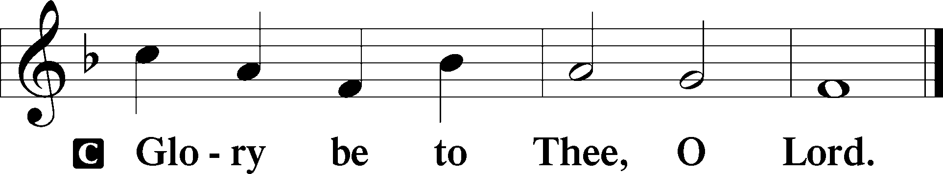

At that time Jesus spoke this parable to His disciples: “The kingdom of heaven is like a landowner who went out early in the morning to hire laborers for his vineyard. Now when he had agreed with the laborers for a denarius a day, he sent them into his vineyard. And he went out about the third hour and saw others standing idle in the marketplace, and said to them, ‘You also go into the vineyard, and whatever is right I will give you.’ So they went. Again he went out about the sixth and the ninth hour, and did likewise. And about the eleventh hour he went out and found others standing idle, and said to them, ‘Why have you been standing here idle all day?’ They said to him, ‘Because no one hired us.’ He said to them, ‘You also go into the vineyard, and whatever is right you will receive.’ So when evening had come, the owner of the vineyard said to his steward, ‘Call the laborers and give them their wages, beginning with the last to the first.’ And when those came who were hired about the eleventh hour, they each received a denarius. But when the first came, they supposed that they would receive more; and they likewise received each a denarius. And when they had received it, they complained against the landowner, saying, ‘These last men have worked only one hour, and you made them equal to us who have borne the burden and the heat of the day.’ But he answered one of them and said, ‘Friend, I am doing you no wrong. Did you not agree with me for a denarius? Take what is yours and go your way. I wish to give to this last man the same as to you. Is it not lawful for me to do what I wish with my own things? Or is your eye evil because I am good?’ So the last will be first, and the first last. For many are called, but few chosen.”

P This is the Gospel of the Lord.
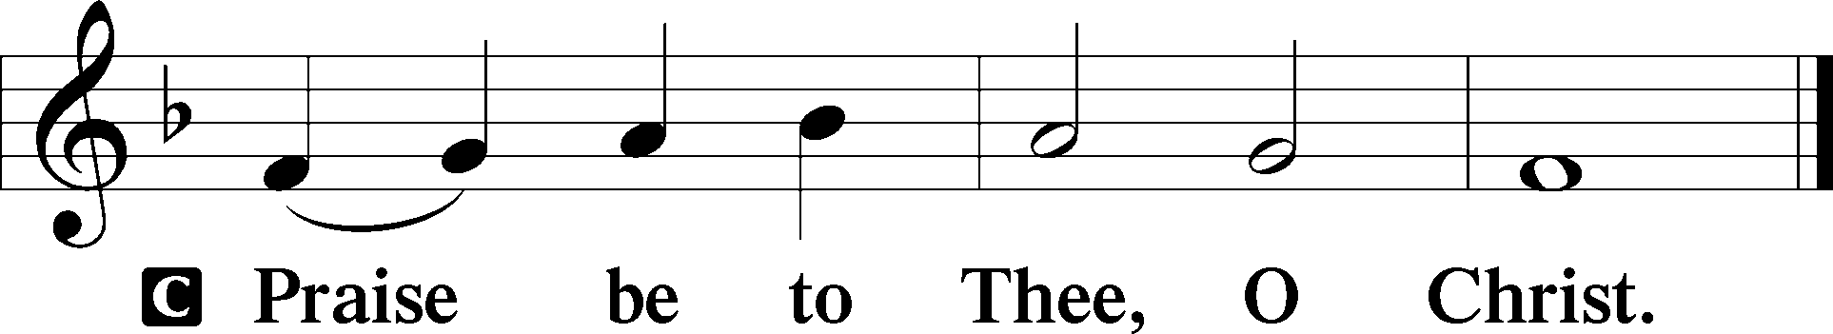

Nicene Creed
C I believe in one God,
the Father Almighty,
maker of heaven and earth
and of all things visible and invisible.

And in one Lord Jesus Christ,
the only-begotten Son of God,
begotten of His Father before all worlds,
God of God, Light of Light,
very God of very God,
begotten, not made,
being of one substance with the Father,
by whom all things were made;
who for us men and for our salvation came down from heaven
and was incarnate by the Holy Spirit of the virgin Mary
and was made man;
and was crucified also for us under Pontius Pilate.
He suffered and was buried.
And the third day He rose again according to the Scriptures
and ascended into heaven
and sits at the right hand of the Father.
And He will come again with glory to judge both the living and the dead,
whose kingdom will have no end.

And I believe in the Holy Spirit,
the Lord and giver of life,
who proceeds from the Father and the Son,
who with the Father and the Son together is worshiped and glorified,
who spoke by the prophets.
And I believe in one holy Christian and apostolic Church,
I acknowledge one Baptism for the remission of sins,
and I look for the resurrection of the dead
and the life T of the world to come. Amen.
Sit

Hymn of the Day: LSB #555 “Salvation unto Us Has Come”

Sermon

Stand

Prayer of the Church

Offertory Psalm 51:10–12
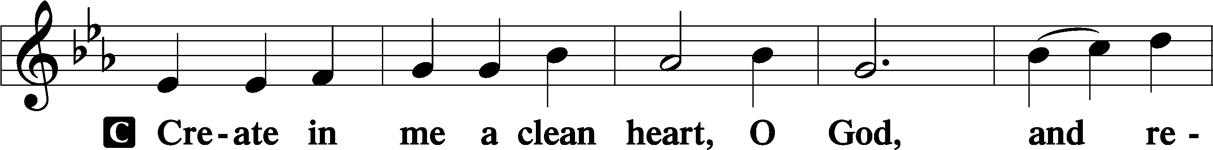
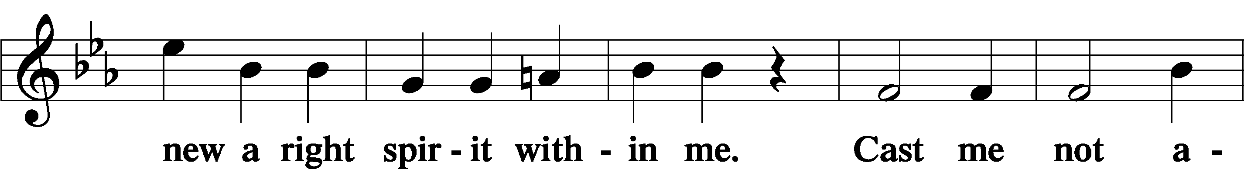
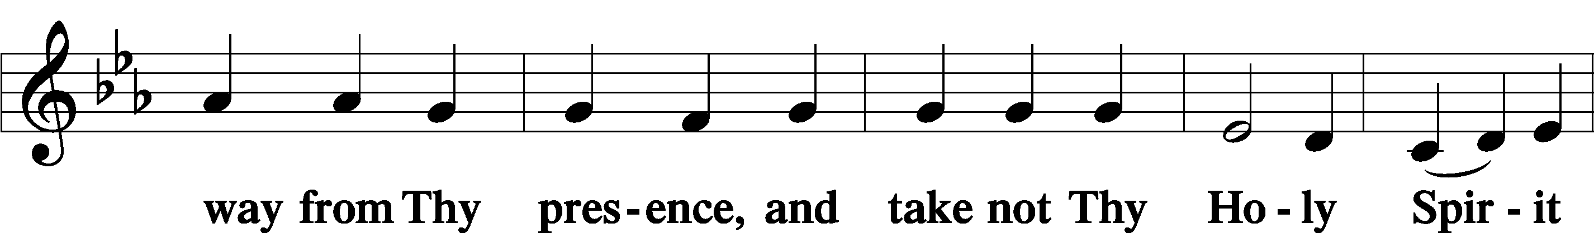
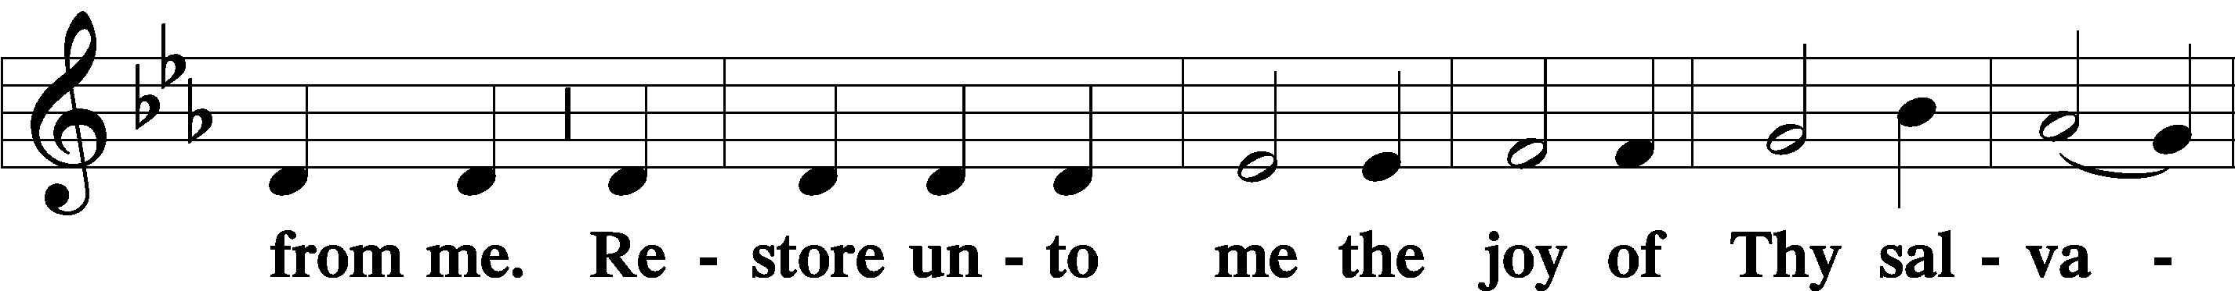
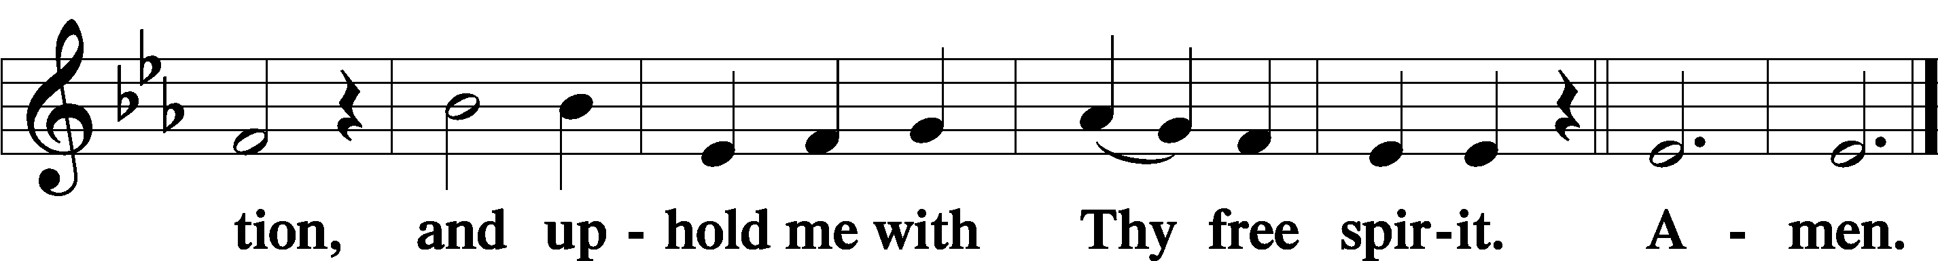
Sit

Preparatory Hymn: LSB #823 “May God Bestow on Us His Grace”

Service of the Sacrament

Preface 2 Timothy 4:22; Colossians 3:1 Psalm 136
P The Lord be with you.
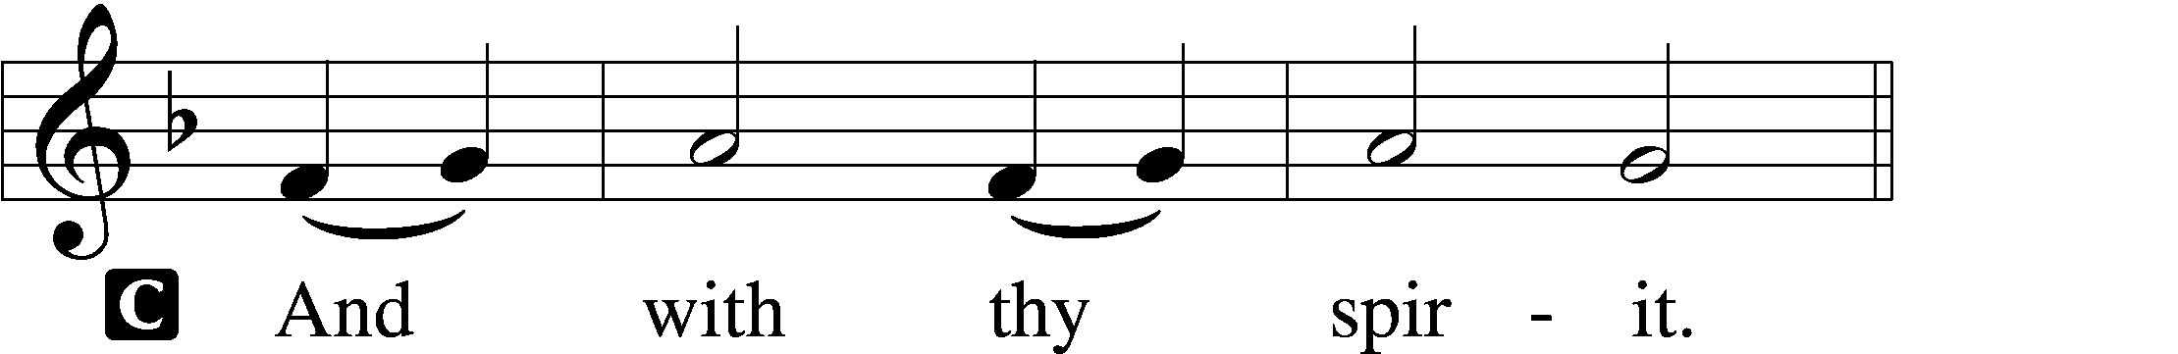

P Lift up your hearts.
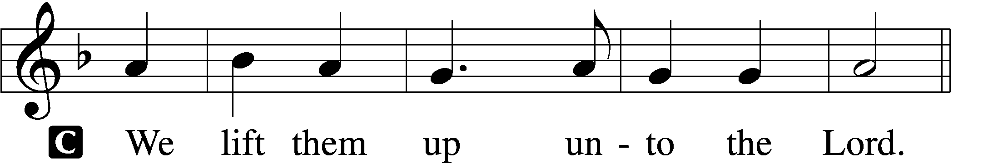

P Let us give thanks unto the Lord, our God.
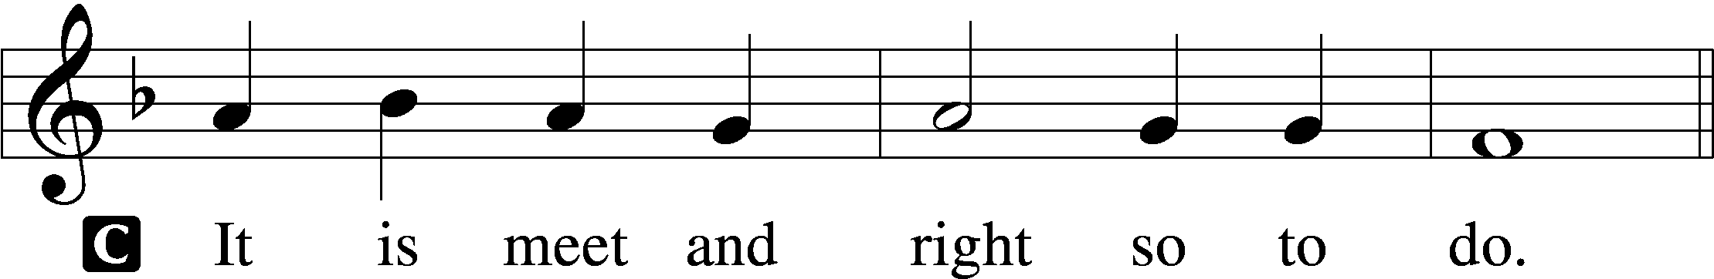

Proper Preface (Abbreviated) LSB 194
P It is truly meet, right, and salutary . . . evermore praising You and saying:

Sanctus Isaiah 6:3; Matthew 21:9
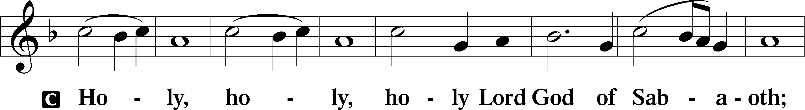
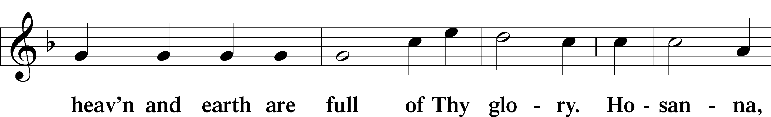
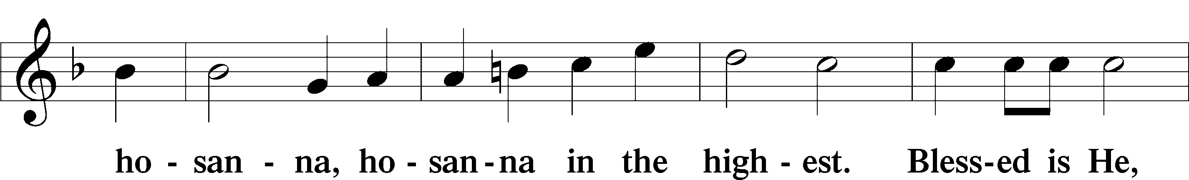
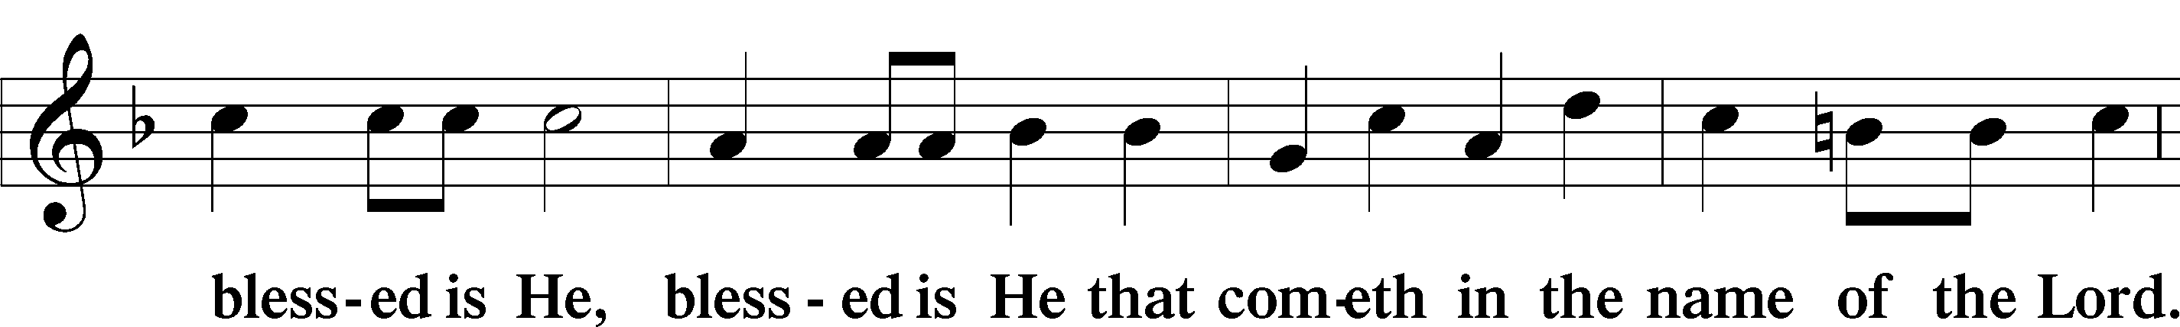
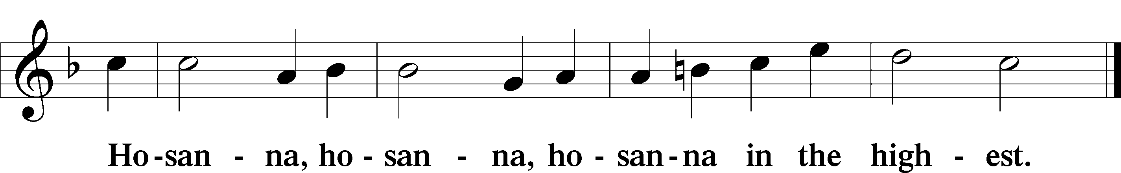

Lord’s Prayer Matthew 6:9–13
C Our Father who art in heaven,
hallowed be Thy name,
Thy kingdom come,
Thy will be done on earth as it is in heaven;
give us this day our daily bread;
and forgive us our trespasses as we forgive those who trespass against us;
and lead us not into temptation,
but deliver us from evil.
For Thine is the kingdom and the power and the glory forever and ever. Amen.
The Words of Our Lord Matthew 26:26–28; Mark 14:22–24; Luke 22:19–20; 1 Corinthians 11:23–25
P Our Lord Jesus Christ, on the night when He was betrayed, took bread, and when He had given thanks, He broke it and gave it to the disciples and said: “Take, eat; this is My T body, which is given for you. This do in remembrance of Me.”

In the same way also He took the cup after supper, and when He had given thanks, He gave it to them, saying: “Drink of it, all of you; this cup is the new testament in My T blood, which is shed for you for the forgiveness of sins. This do, as often as you drink it, in remembrance of Me.”

Pax Domini John 20:19
P The peace of the Lord be with you always.
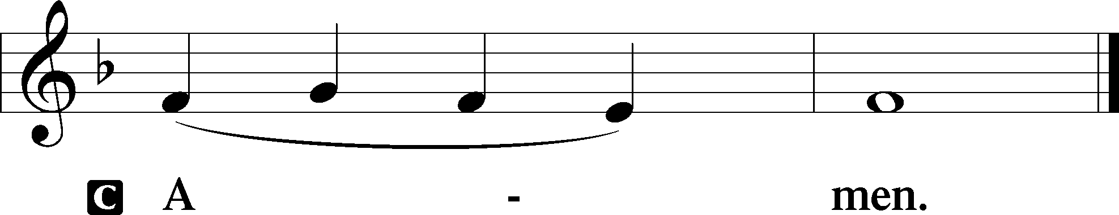

Agnus Dei John 1:29
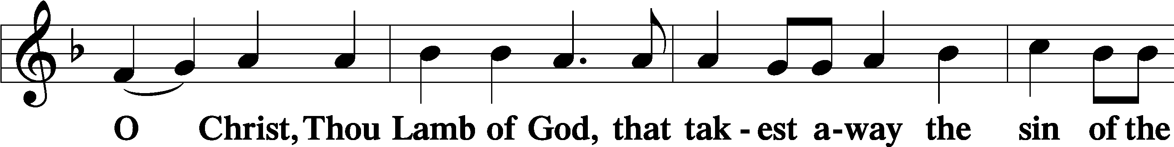
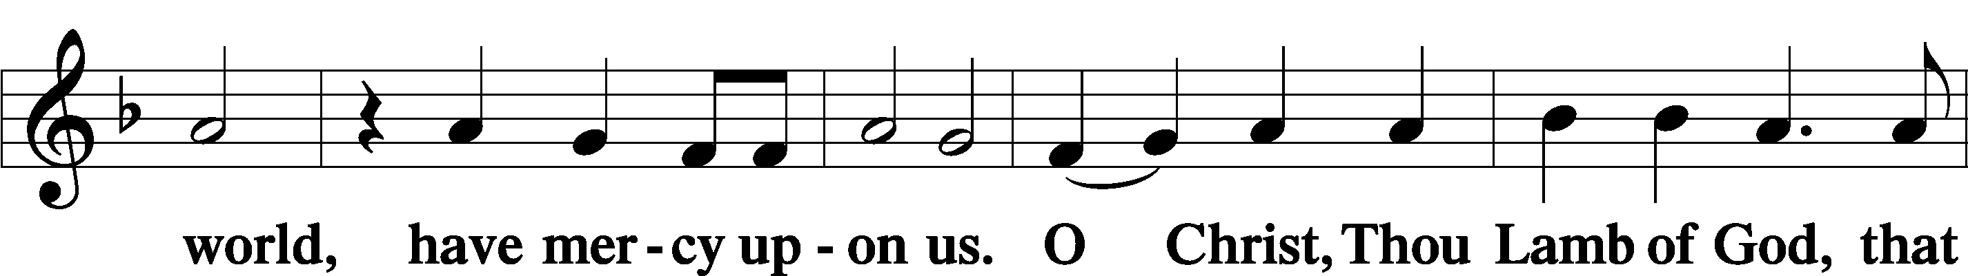
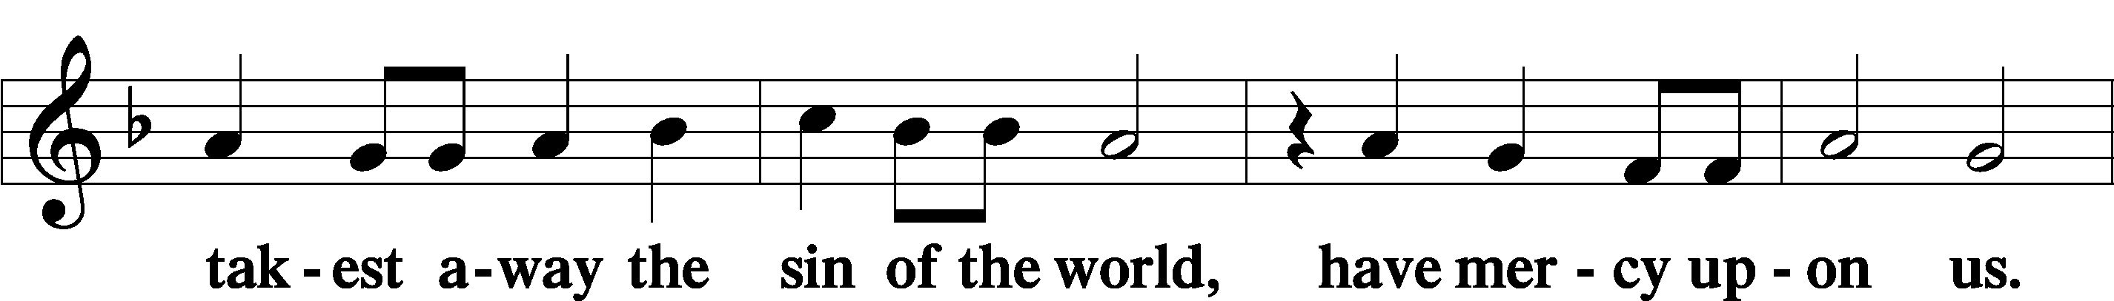
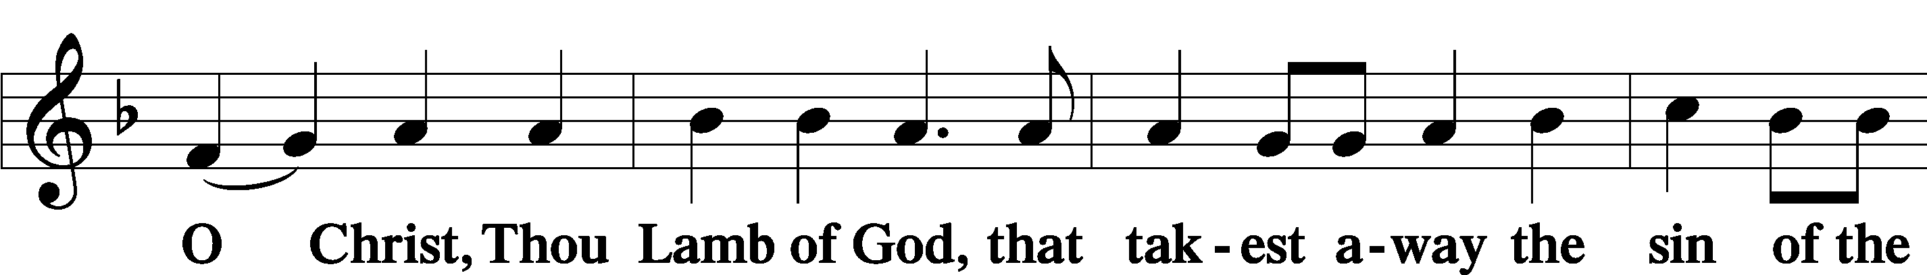
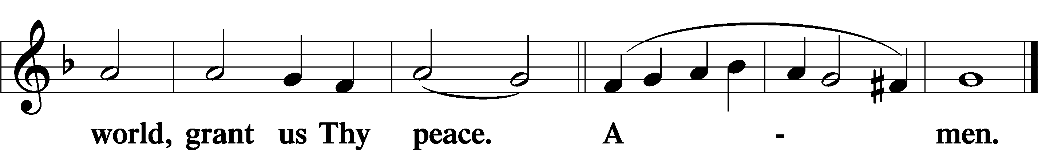
Sit
Distribution
The pastor and those who assist him receive the body and blood of Christ first and then distribute them to those who come to receive, saying:
Take, eat; this is the true body of our Lord and Savior Jesus Christ, given into death for your sins.
Amen.

Take, drink; this is the true blood of our Lord and Savior Jesus Christ, shed for the forgiveness of your sins.
Amen.

In dismissing the communicants, the following is said:
The Dismissal
P The body and blood of our Lord Jesus Christ strengthen and preserve you in body and soul to life everlasting. Depart T in peace.
C Amen.

Distribution Hymn: LSB #919 “Abide, O Dearest Jesus”

Distribution Hymn: LSB #724 “If God Himself Be for Me”

Distribution Hymn: LSB #577 “Almighty God, Your Word Is Cast”

Stand

Nunc Dimittis Luke 2:29–32
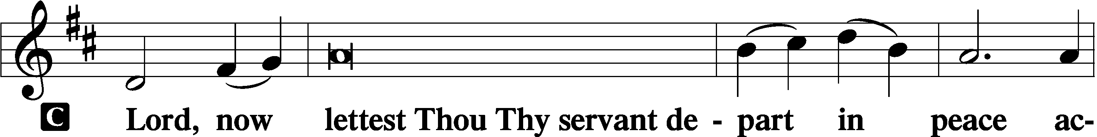
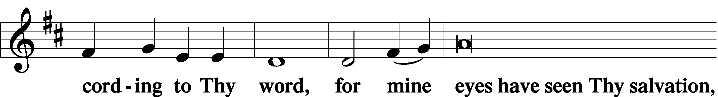
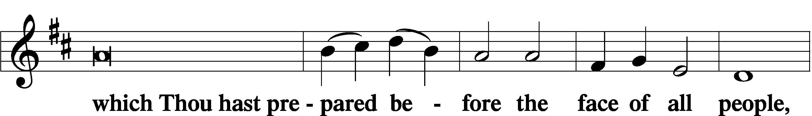
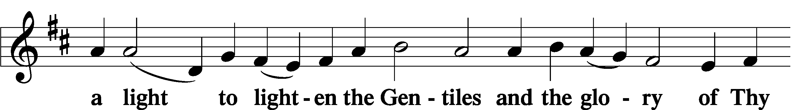
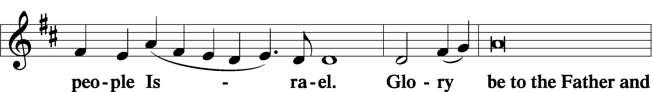
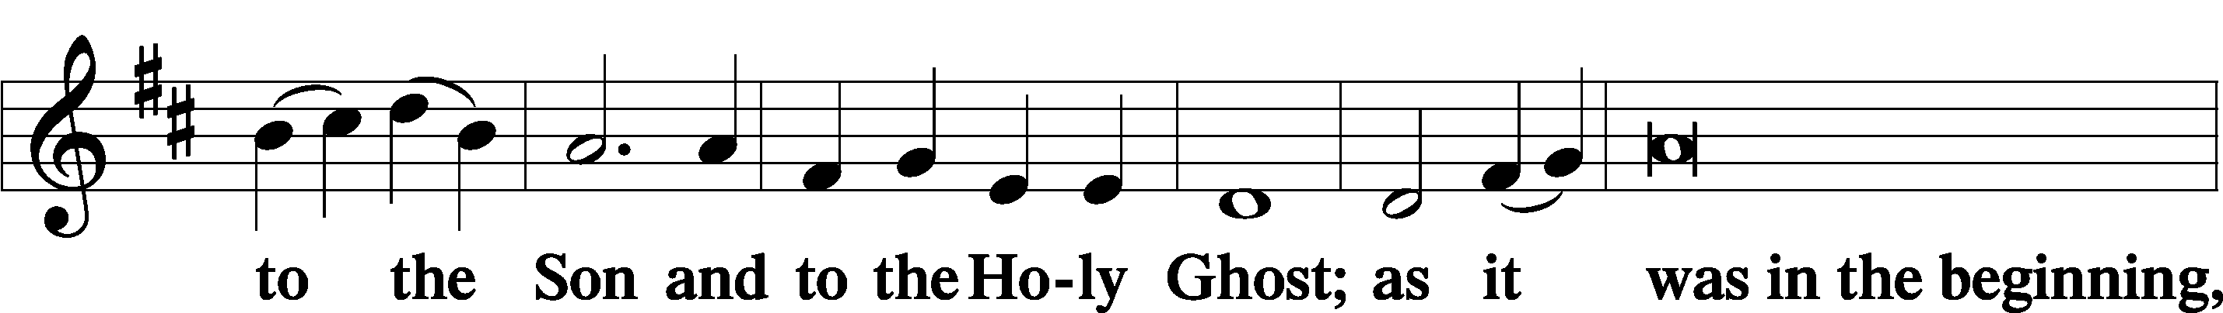
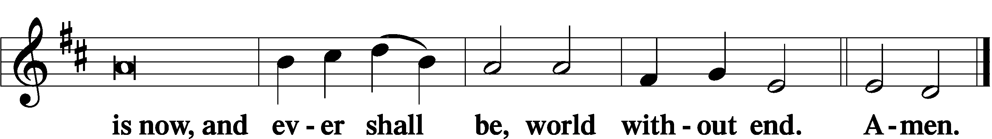

Thanksgiving Psalm 107:1
P O give thanks unto the Lord, for He is good,
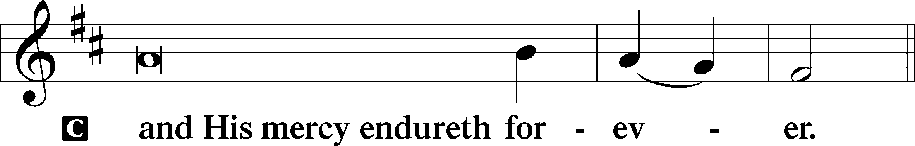

Post-Communion Collect
P Let us pray.
We give thanks to You, almighty God, that You have refreshed us through this salutary gift, and we implore You that of Your mercy You would strengthen us through the same in faith toward You and in fervent love toward one another; through Jesus Christ, Your Son, our Lord, who lives and reigns with You and the Holy Spirit, one God, now and forever.
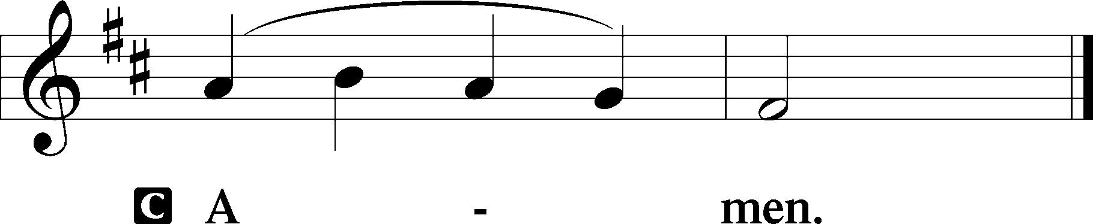

Salutation 2 Timothy 4:22
P The Lord be with you.
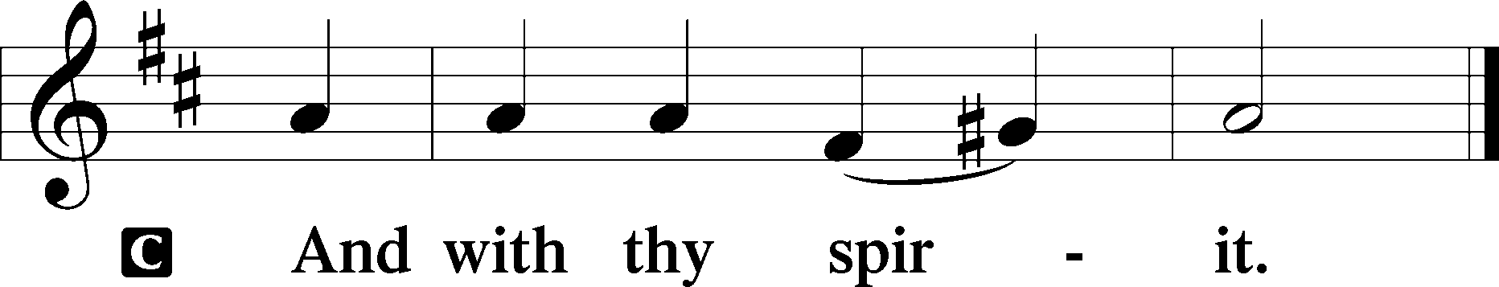

Benedicamus Psalm 103:1
P Bless we the Lord.
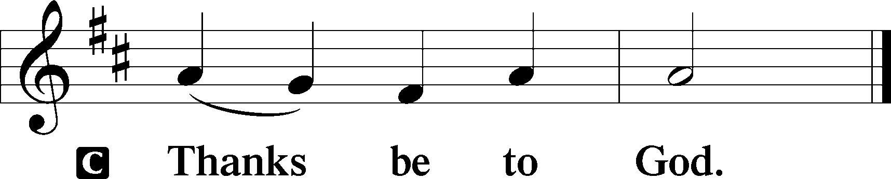

Benediction Numbers 6:24–26
P The Lord bless you and keep you.
The Lord make His face shine upon you and be gracious unto you.
The Lord lift up His countenance upon you and T give you peace.
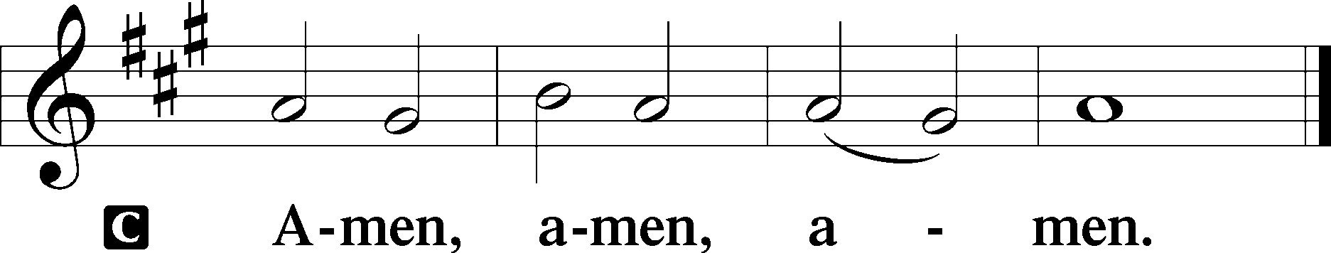

Closing Hymn: TLH #308 “Invited, Lord, by Boundless Grace”
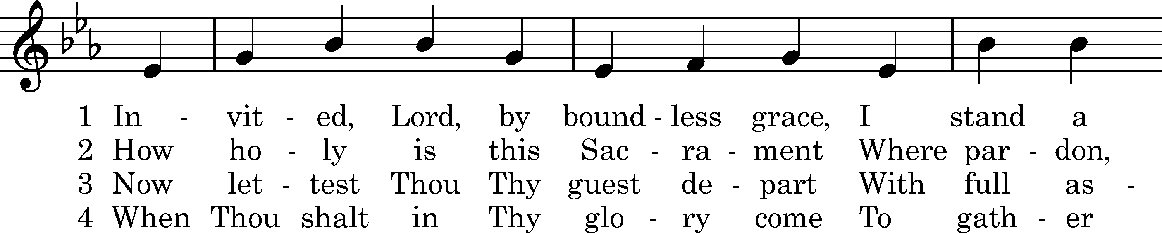
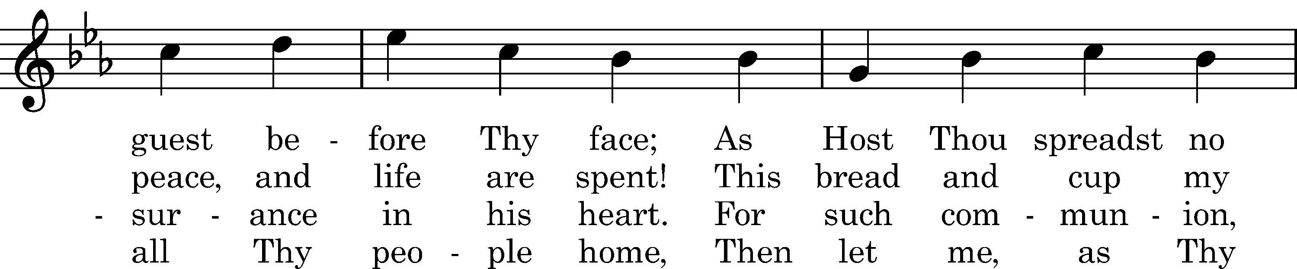
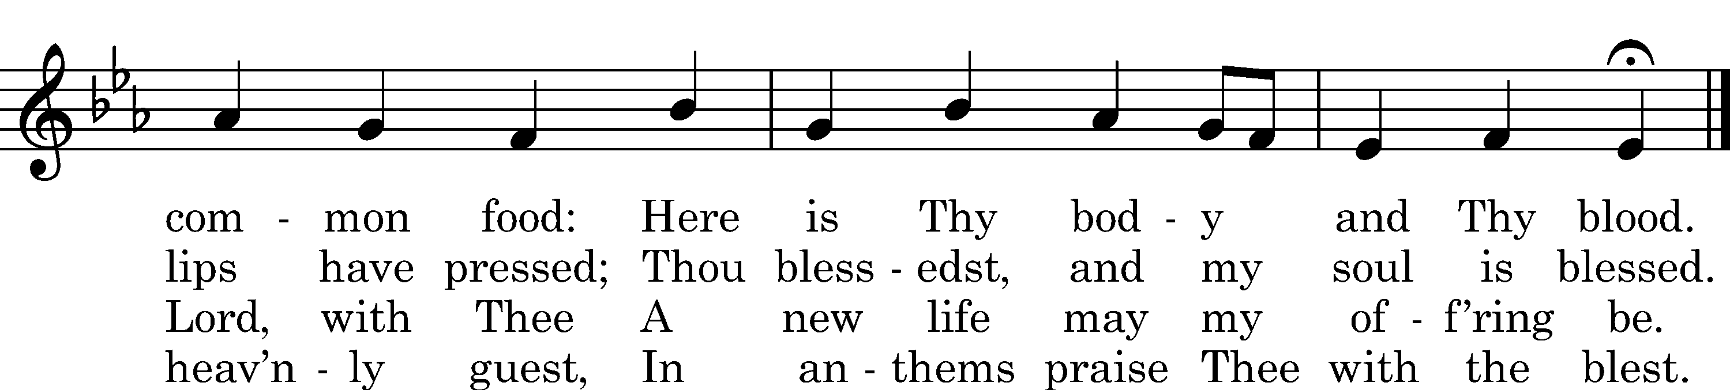
Text: Emanuel Cronenwett, 1880
Tune: Daniel Vetter, 1713
Text and tune: Public domain
Silent prayer after worship: O Lord, lead me to daily read Your word and pray that I may receive Your blessings and grow in my faith, so that my life may be a light that gives You glory and directs others to You. In Jesus’ name. Amen.
fffffffffffffffffffffffffffffffffff
Acknowledgments: Unless otherwise indicated, Scripture quotations are from the ESV® Bible (The Holy Bible, English Standard Version®), copyright © 2001 by Crossway, a publishing ministry of Good News Publishers. Used by permission. All rights reserved.
Created by Lutheran Service Builder © 2021 Concordia Publishing House.
fffffffffffffffffffffffffffffffffff
fffffffffffffffffffffffffffffffffff
In Loving Memory of Betty Hardell: Paul & Joyce Petro, Kara Montgomery, and Erika Roeder (Major Repair).
In Loving Memory of Cousins: Bob Sulek, Jean Murchek Bobby, Marion Roberts, and Robert Murchek: Joani Rice (Major Repair).
fffffffffffffffffffffffffffffffffff
Attendance: Sunday, January 29, 2023: 33
fffffffffffffffffffffffffffffffffff
Sunday Bible Study has resumed! We are studying the Minor Prophets. Please consider joining us each Sunday morning at 8 am!
fffffffffffffffffffffffffffffffffff
THANK YOU FOR SERVING IN FEBRUARY: Elder: Jonathan Baisch; Altarware: Marie Flaugher (prior) and Cheryl Fedele & Clara Krivosh (after).
fffffffffffffffffffffffffffffffffff
SCHEDULE THROUGH FEBRUARY 12, 2023:

:

Today, 7 pm, Fellowship Hall: AA Meeting
Tuesday-Wednesday, Fellowship Hall: Circuit Conference
Tuesday, 6 pm, Sanctuary: Divine Service
Tuesday, 7-9 pm, Fellowship Hall: Penn-Ohio Singers
Wednesday, 7:30 pm, Fellowship Hall: NA Meeting
Thursday, 9 am, Downstairs: Food Pantry
Next Sunday, 8 am, Fellowship Hall: Bible Study
9 am, Sanctuary: Divine Service
Following, Fellowship Hall: Coffee Fellowship
7 pm, Fellowship Hall: AA Meeting
Our Stewardship of Treasures for the Lord:
In order to do the Lord’s work, we need $2,553.63 each week to meet our 2023 budget for general purposes and $76.92 for the SELC.
Figures for Sunday, January 29, 2023
General Fund: $631.00 Behind for the week: -$1,922.63
SELC: $0.00 Behind for the week: -$76.92
Capital Campaign: $510.00
Other: $300.00

For online giving, check out https://www.saintspeterandpaul.net/online-giving.
fffffffffffffffffffffffffffffffffff
SCRIP ORDERS AND PAYMENTS for February are due this morning and should be given to Diane Riefstahl or placed in the offering plate. Forms are available both in the narthex and on the sign-in table next to Pastor Deal’s office.
fffffffffffffffffffffffffffffffffff
Minutes from the January 30th Church Council meeting are available in the narthex.
fffffffffffffffffffffffffffffffffff
Join us next Sunday following worship for Coffee Fellowship sponsored by Joe & Bev Chlpka in celebration of their 50th Wedding Anniversary!
fffffffffffffffffffffffffffffffffff
Bible Memory Verses ~ Week of February 5th:
For Adults: Beloved, let us love one another, for love is from God, and whoever loves has been born of God and knows God. 1 John 4:7

For Children: We do not present our pleas before you because of our righteousness, but because of your great mercy. Daniel 9:8
fffffffffffffffffffffffffffffffffff
Sincere sympathy is extended to Ruth Meszaros, her family, and friends at the passing of Ruth’s husband, Ernie, Tuesday, January 31, 2023. May all find comfort in the promises of our Lord and Savior, Jesus Christ.
fffffffffffffffffffffffffffffffffff
MARK YOUR CALENDAR! There will be a special Divine Service this Tuesday evening at 6 pm as part of the Circuit Conference. All are welcome to attend!
Remember the following in Prayer…
~The Hurting and Healing: The family and friends of Ernest Meszaros, who passed away Tuesday, January 31, 2023; also Amy, Gerald Arthur, Evelyn Baisch, Ellen Baron^{CA}, Lois Bortner^{CA}, John Burdette, Bev & Joe Chlpka, Kathleen Coughenour, Kim, Anna Mae Daris, Susan Davies, Tim Dudash, Millie Elavsky, Joseph Fleet, Judith & Eddy Furey, Tim Haenftling, Austin Hamilton, Anson Holcroft, Neil Huston, Darla Krajci, Barbara Kreske, Michelle Kelly^{CA}, Donna Kennedy, Gerald Krivosh, Jess Lavoie, Paul Lucas^{CA}, Sandy Marshall, David Nelson, Linda Parkany, Juanita Rentschler, Richard Reuning^{CA}, Diane Riefstahl, Nancy Robertson^{CA}, Viola Sakony, Marty Scott, Kara, Fred Tonty, Angela Weser^{CA}, and Ruth Wolf.
~The Homebound: Rudy & Jean Tomko, Betty Wolf, and Ed & Millie Zachar.
~Celebrating: Anniversary: Joseph & Beverly Chlpka (02.10).
~Serving in the Military: Curtis Sinewe and Joshua Solyan.
~Community & World Needs: Those suffering from or affected by the coronavirus; those suffering due to the conflict between Ukraine and Russia; those suffering from loss and dislocation because weather disasters; those suffering from addiction and their families; Local, State, and National Government Leaders; safety for all Police Officers, Firefighters, & First Responders; the unemployed; our First Quarter Local Mission: Sts. Peter & Paul’s Community Day 2023.
*CA represents cancer.
fffffffffffffffffffffffffffffffffff

Copies of the minutes from the recent Altar Guild meeting along with corrected Altar Ware Set-up and Cleaning Schedules are available in the narthex.
fffffffffffffffffffffffffffffffffff

Next Sunday is “Stock the Food Pantry Sunday”! Your financial donations will be greatly appreciated.

fffffffffffffffffffffffffffffffffff

Here to Serve

Pastor………………………………………………...……………Rev. Jacob Deal
E-mail …………………………….……pastordeal@saintspeterandpaul.net
Phone Number……………………..…………………724-347-3620 (Option 2)
Church Office………………………..…………………724-347-3620 (Option 3)
Website …………………………………………www.saintspeterandpaul.net
Secretary…………………………………………………………Diane Riefstahl
E-mail ………………………………………church@saintspeterandpaul.net
Website …………………………………………www.saintspeterandpaul.net
Food Pantry: Please leave message……………724-347-3620 (Option 3)
AA Contact: Steve………………………………………………..…724-813-2358
NA Contact: Larry………………………………………………..724-977-8733
Choir Director………………………………………………………Chris Nelson
Congregation President……………………………………Jonathan Baisch
Church Elder …………………………………………...…… Jonathan Baisch
fffffffffffffffffffffffffffffffffff
If needing to get into the church building during the week, please phone first to make certain someone is here to let you in.

