Sts. Peter & Paul
Evangelical Lutheran Church
Lutheran Church-Missouri Synod
Founded-1917

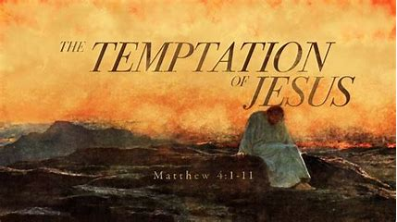

February 26, 2023

699 Stambaugh Avenue
Sharon, Pennsylvania 16146

“I was glad when they said to me,
Let us go to the house of the LORD!”
Psalm 122:1
Sts. Peter & Paul Evangelical Lutheran Church, LC-MS
INVOCAVIT
February 26, 2023

A special welcome to our guests this day! If you would like more information about The Lutheran Church - Missouri Synod, or this congregation, please speak with Pastor Deal or an Elder after the service.
Members & Guests: Don’t be embarrassed if your children make noise during the worship service, all children do. We encourage families to worship together but, if you feel the need, there are pews in the rear of the Church which are reserved for young families on both sides of the sanctuary. There is also a quiet room available to you during our service which is located down the hallway past the offices on the right side of the church as well as a children’s area in the Fellowship Hall where you are able to follow along with the service.

Today’s service includes the Sacrament of Holy Communion. If during this past year, you have not worshipped with us and been communed, we respectfully ask that you do not partake of this sacrament this day before first speaking with Pastor Deal.
If visiting from a sister congregation of the LC-MS and are in good standing, please inform Pastor Deal of your desire to commune prior to the service.
If wishing to receive a blessing during communion, please approach with your arms crossed.

CONTACT INFORMATION
Pastor Deal: pastordeal@saintspeterandpaul.net or 724-347-3620 (opt. 2)
Church Office: church@saintspeterandpaul.net or 724-347-3620 (opt. 3)

Silent prayer before worship: Almighty God, You sent Your Son to die and rise again that all who believe in him may live. Grant that I may faithfully walk the way of the cross and show forth true love for You and for my neighbors. In Jesus’ name. Amen.
Confession and Absolution

Opening Hymn: LSB #433 “Glory Be to Jesus”

Stand

The sign of the cross may be made by all in remembrance of their Baptism.

Invocation
P In the name of the Father and of the T Son and of the Holy Spirit.
C Amen.

Exhortation Hebrews 10:22; Psalm 124:8; Psalm 32:5
P Beloved in the Lord! Let us draw near with a true heart and confess our sins unto God our Father, beseeching Him in the name of our Lord Jesus Christ to grant us forgiveness.

P Our help is in the name of the Lord,
C who made heaven and earth.
P I said, I will confess my transgressions unto the Lord,
C and You forgave the iniquity of my sin.

Silence for reflection on God’s Word and for self-examination.

Confession of Sins
P O almighty God, merciful Father,
C I, a poor, miserable sinner, confess unto You all my sins and iniquities with which I have ever offended You and justly deserved Your temporal and eternal punishment. But I am heartily sorry for them and sincerely repent of them, and I pray You of Your boundless mercy and for the sake of the holy, innocent, bitter sufferings and death of Your beloved Son, Jesus Christ, to be gracious and merciful to me, a poor, sinful being.

Absolution [John 20:19–23]
P Upon this your confession, I, by virtue of my office, as a called and ordained servant of the Word, announce the grace of God unto all of you, and in the stead and by the command of my Lord Jesus Christ I forgive you all your sins in the name of the Father and of the T Son and of the Holy Spirit.
C Amen.
Service of the Word

Introit Psalm 91:1–2, 9–10, 13; antiphon: vv. 15a, c, 16
When he calls to me, I will | answer him;*
I will rescue him and | honor him.
With long life I will sat- | isfy him*
and show him my sal- | vation.
He who dwells in the shelter of the | Most High*
will abide in the shadow of the Al- | mighty.
I will say to the Lord, “My refuge and my | fortress,*
my God, in | whom I trust.”
Because you have made the Lord your | dwelling place—*
the Most High, who is my | refuge—
no evil shall be allowed to be- | fall you,*
no plague come | near your tent.
You will tread on the lion and the | adder;*
the young lion and the serpent you will trample | underfoot.
Glory be to the Father and | to the Son*
and to the Holy | Spirit;
as it was in the be- | ginning,*
is now, and will be forever. | Amen.
Kyrie Mark 10:47
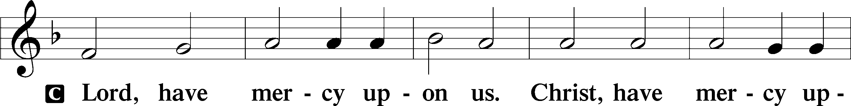
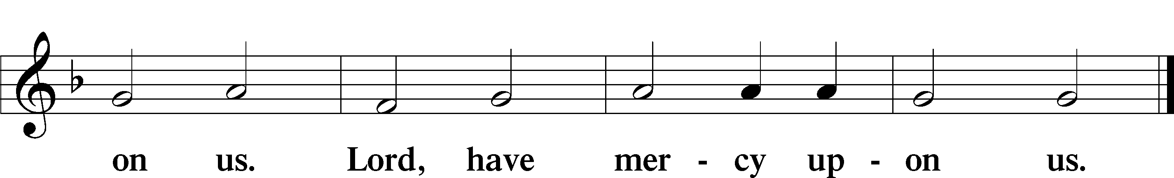

Salutation and Collect of the Day: Invocavit
P The Lord be with you.
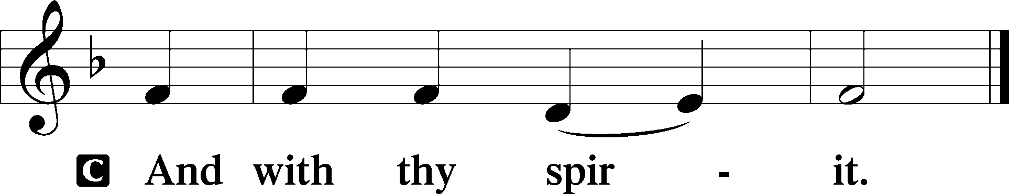

P Let us pray.
O Lord God, You led Your ancient people through the wilderness and brought them to the promised land. Guide the people of Your Church that following our Savior we may walk through the wilderness of this world toward the glory of the world to come; through Jesus Christ, Your Son, our Lord, who lives and reigns with You and the Holy Spirit, one God, now and forever.
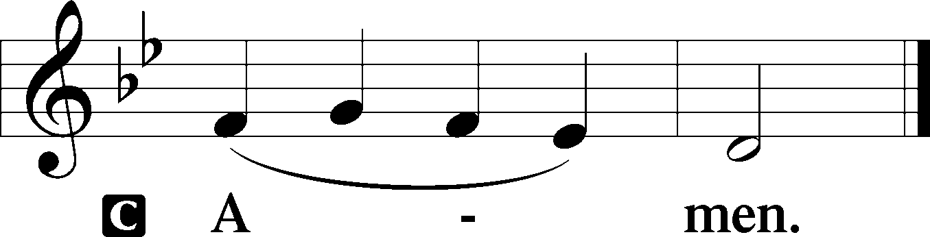
Sit

Prophecy: Genesis 3:1–21 (NKJV)
In those days: The serpent was more cunning than any beast of the field which the Lord God had made. And he said to the woman, “Has God indeed said, ‘You shall not eat of every tree of the garden’?” And the woman said to the serpent, “We may eat the fruit of the trees of the garden; but of the fruit of the tree which is in the midst of the garden, God has said, ‘You shall not eat it, nor shall you touch it, lest you die.’ ” Then the serpent said to the woman, “You will not surely die. For God knows that in the day you eat of it your eyes will be opened, and you will be like God, knowing good and evil.” So when the woman saw that the tree was good for food, that it was pleasant to the eyes, and a tree desirable to make one wise, she took of its fruit and ate. She also gave to her husband with her, and he ate. Then the eyes of both of them were opened, and they knew that they were naked; and they sewed fig leaves together and made themselves coverings. And they heard the sound of the Lord God walking in the garden in the cool of the day, and Adam and his wife hid themselves from the presence of the Lord God among the trees of the garden. Then the Lord God called to Adam and said to him, “Where are you?” So he said, “I heard Your voice in the garden, and I was afraid because I was naked; and I hid myself.” And He said, “Who told you that you were naked? Have you eaten from the tree of which I commanded you that you should not eat?” Then the man said, “The woman whom You gave to be with me, she gave me of the tree, and I ate.” And the Lord God said to the woman, “What is this you have done?” The woman said, “The serpent deceived me, and I ate.” So the Lord God said to the serpent: “Because you have done this, you are cursed more than all cattle, and more than every beast of the field; on your belly you shall go, and you shall eat dust all the days of your life. And I will put enmity between you and the woman, and between your seed and her Seed; He shall bruise your head, and you shall bruise His heel.” To the woman He said: “I will greatly multiply your sorrow and your conception; in pain you shall bring forth children; your desire shall be for your husband, and he shall rule over you.” Then to Adam He said, “Because you have heeded the voice of your wife, and have eaten from the tree of which I commanded you, saying, ‘You shall not eat of it’: Cursed is the ground for your sake; in toil you shall eat of it all the days of your life. Both thorns and thistles it shall bring forth for you, and you shall eat the herb of the field. In the sweat of your face you shall eat bread till you return to the ground, for out of it you were taken; for dust you are, and to dust you shall return.” And Adam called his wife’s name Eve, because she was the mother of all living. Also for Adam and his wife the Lord God made tunics of skin, and clothed them.

P This is the Word of the Lord.
C Thanks be to God.

Gradual Psalm 91:11–12
He will command his angels con- | cerning you*
to guard you in | all your ways.
On their hands they will | bear you up,*
lest you strike your foot a- | gainst a stone.

Epistle: 2 Corinthians 6:1-10 (NKJV)
Brethren: We plead with you not to receive the grace of God in vain. For He says: “In an acceptable time I have heard you, and in the day of salvation I have helped you.” Behold, now is the accepted time; behold, now is the day of salvation. We give no offense in anything, that our ministry may not be blamed. But in all things we commend ourselves as ministers of God: in much patience, in tribulations, in needs, in distresses, in stripes, in imprisonments, in tumults, in labors, in sleeplessness, in fastings; by purity, by knowledge, by longsuffering, by kindness, by the Holy Spirit, by sincere love, by the word of truth, by the power of God, by the armor of righteousness on the right hand and on the left, by honor and dishonor, by evil report and good report; as deceivers, and yet true; as unknown, and yet well known; as dying, and behold we live; as chastened, and yet not killed; as sorrowful, yet always rejoicing; as poor, yet making many rich; as having nothing, and yet possessing all things.

P This is the Word of the Lord.
C Thanks be to God.

Stand

Holy Gospel: Matthew 4:1–11 (NKJV)
P The Holy Gospel according to St. Matthew, the fourth chapter.
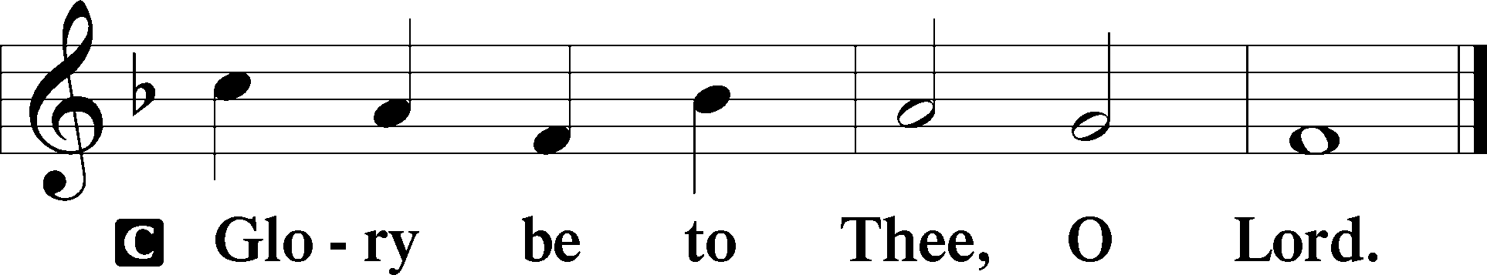

At that time: Jesus was led up by the Spirit into the wilderness to be tempted by the devil. And when He had fasted forty days and forty nights, afterward He was hungry. Now when the tempter came to Him, he said, “If You are the Son of God, command that these stones become bread.” But He answered and said, “It is written, ‘Man shall not live by bread alone, but by every word that proceeds from the mouth of God.’ ” Then the devil took Him up into the holy city, set Him on the pinnacle of the temple, and said to Him, “If You are the Son of God, throw Yourself down. For it is written: ‘He shall give His angels charge over you,’ and, ‘In their hands they shall bear you up, lest you dash your foot against a stone.’ ” Jesus said to him, “It is written again, ‘You shall not tempt the Lord your God.’ ” Again, the devil took Him up on an exceedingly high mountain, and showed Him all the kingdoms of the world and their glory. And he said to Him, “All these things I will give You if You will fall down and worship me.” Then Jesus said to him, “Away with you, Satan! For it is written, ‘You shall worship the Lord your God, and Him only you shall serve.’ ” Then the devil left Him, and behold, angels came and ministered to Him.

P This is the Gospel of the Lord.
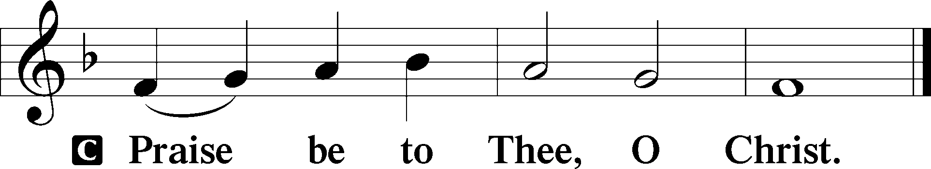

Nicene Creed
C I believe in one God,
the Father Almighty,
maker of heaven and earth
and of all things visible and invisible.

And in one Lord Jesus Christ,
the only-begotten Son of God,
begotten of His Father before all worlds,
God of God, Light of Light,
very God of very God,
begotten, not made,
being of one substance with the Father,
by whom all things were made;
who for us men and for our salvation came down from heaven
and was incarnate by the Holy Spirit of the virgin Mary
and was made man;
and was crucified also for us under Pontius Pilate.
He suffered and was buried.
And the third day He rose again according to the Scriptures
and ascended into heaven
and sits at the right hand of the Father.
And He will come again with glory to judge both the living and the dead,
whose kingdom will have no end.

And I believe in the Holy Spirit,
the Lord and giver of life,
who proceeds from the Father and the Son,
who with the Father and the Son together is worshiped and glorified,
who spoke by the prophets.
And I believe in one holy Christian and apostolic Church,
I acknowledge one Baptism for the remission of sins,
and I look for the resurrection of the dead
and the life T of the world to come. Amen.
Sit

Hymn of the Day: LSB #656 “A Mighty Fortress Is Our God” (Please, stand.)

Sermon

Stand

Prayer of the Church

Offertory Psalm 51:10–12
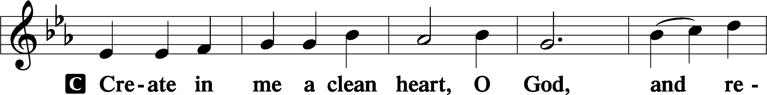
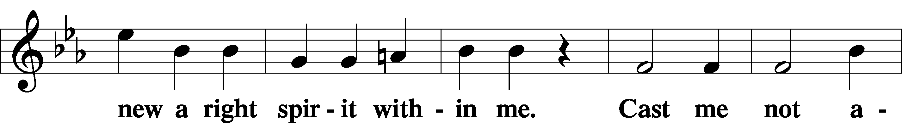
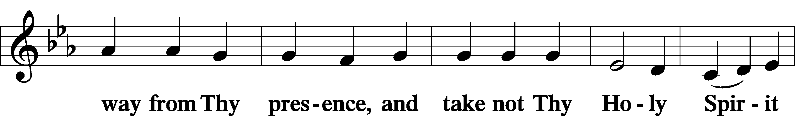
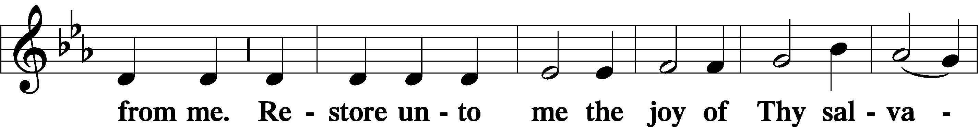
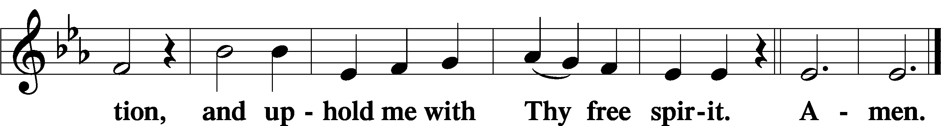
Sit

Preparatory Hymn: LSB #620 “Jesus Comes Today with Healing”

Stand
Service of the Sacrament

Preface 2 Timothy 4:22; Colossians 3:1 Psalm 136
P The Lord be with you.

P Lift up your hearts.
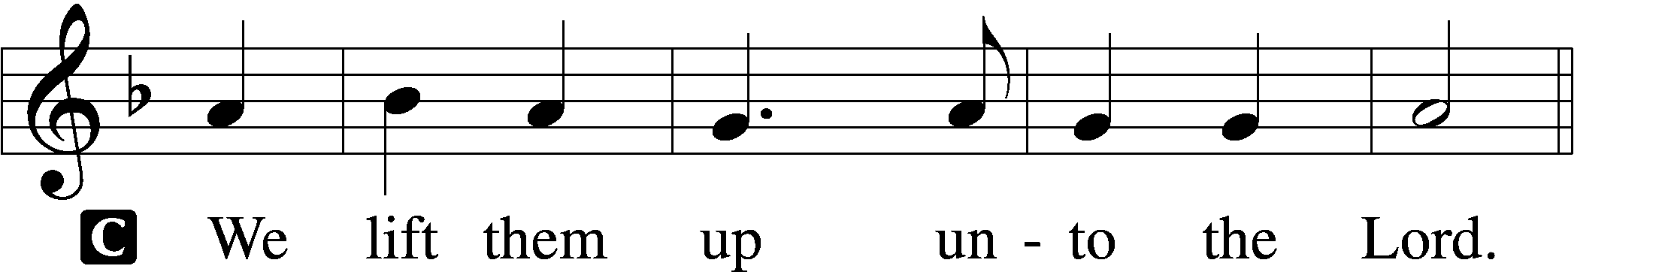

P Let us give thanks unto the Lord, our God.
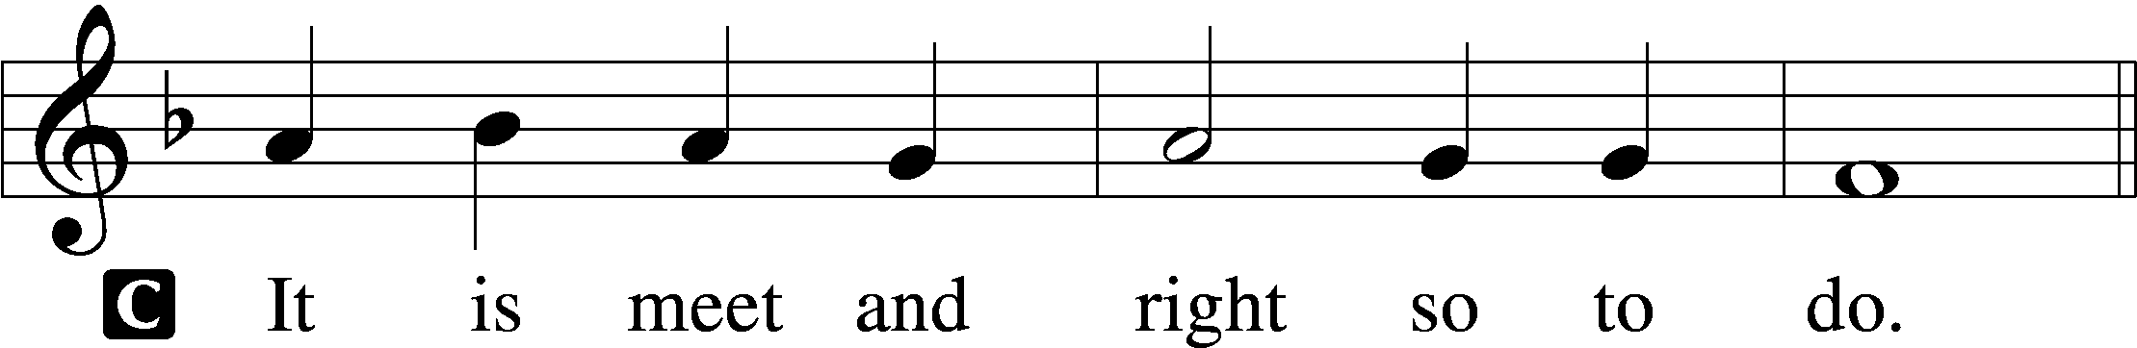

Proper Preface (Abbreviated) LSB 194
P It is truly meet, right, and salutary . . . evermore praising You and saying:

Sanctus Isaiah 6:3; Matthew 21:9
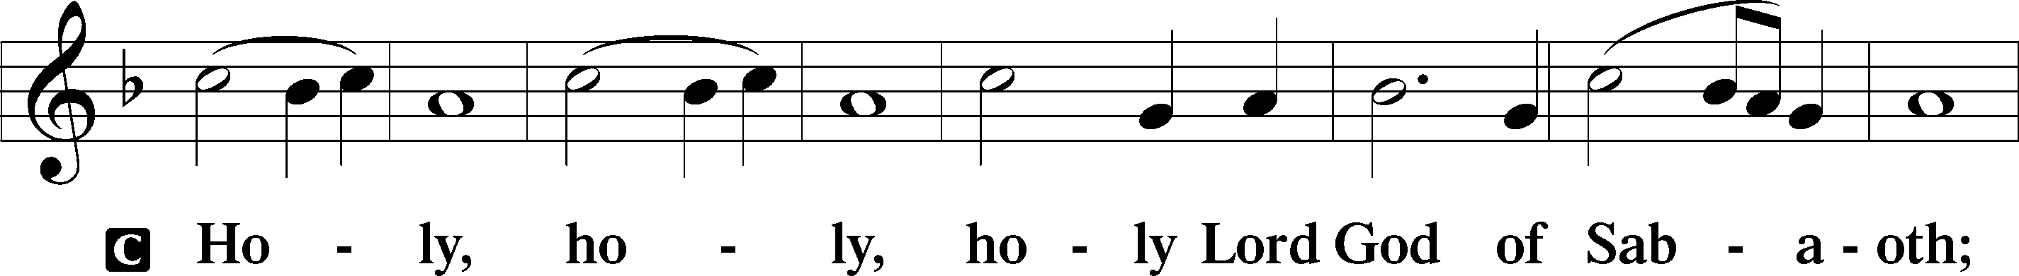
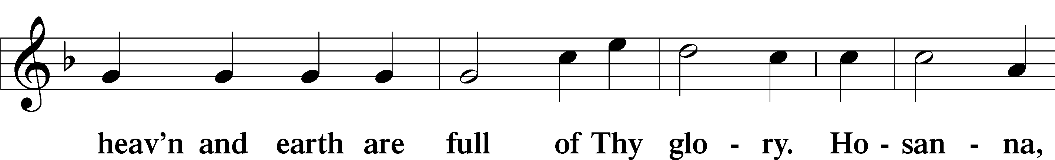
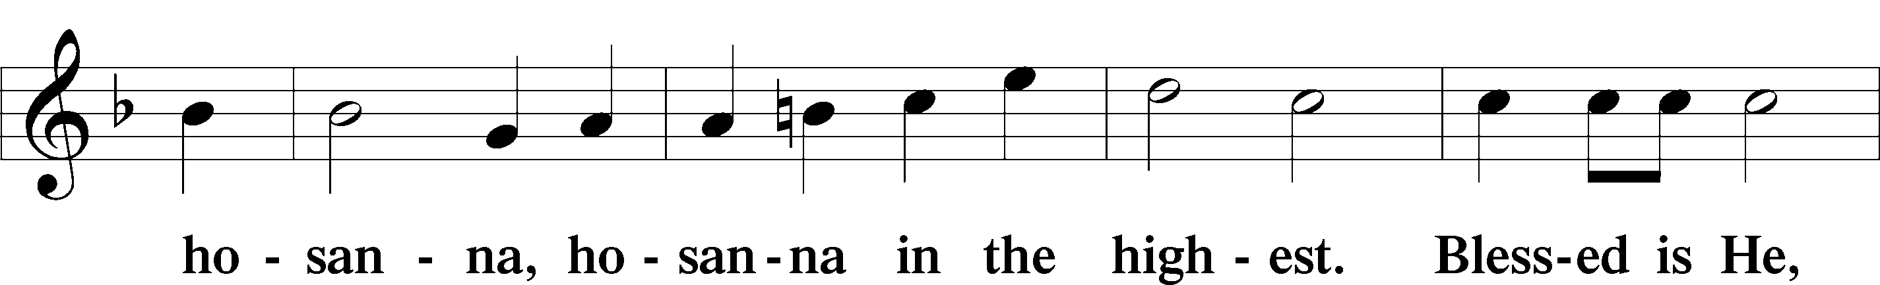
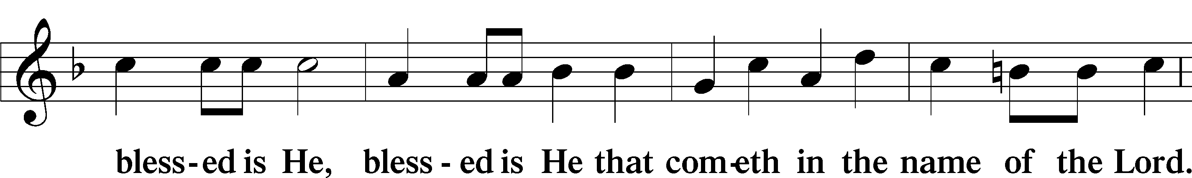
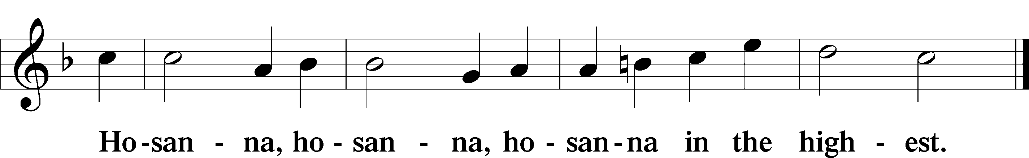

Lord’s Prayer Matthew 6:9–13
C Our Father who art in heaven,
hallowed be Thy name,
Thy kingdom come,
Thy will be done on earth as it is in heaven;
give us this day our daily bread;
and forgive us our trespasses as we forgive those who trespass against us;
and lead us not into temptation,
but deliver us from evil.
For Thine is the kingdom and the power and the glory forever and ever. Amen.

The Words of Our Lord Matthew 26:26–28; Mark 14:22–24; Luke 22:19–20; 1 Corinthians 11:23–25
P Our Lord Jesus Christ, on the night when He was betrayed, took bread, and when He had given thanks, He broke it and gave it to the disciples and said: “Take, eat; this is My T body, which is given for you. This do in remembrance of Me.”

In the same way also He took the cup after supper, and when He had given thanks, He gave it to them, saying: “Drink of it, all of you; this cup is the new testament in My T blood, which is shed for you for the forgiveness of sins. This do, as often as you drink it, in remembrance of Me.”

Pax Domini John 20:19
P The peace of the Lord be with you always.
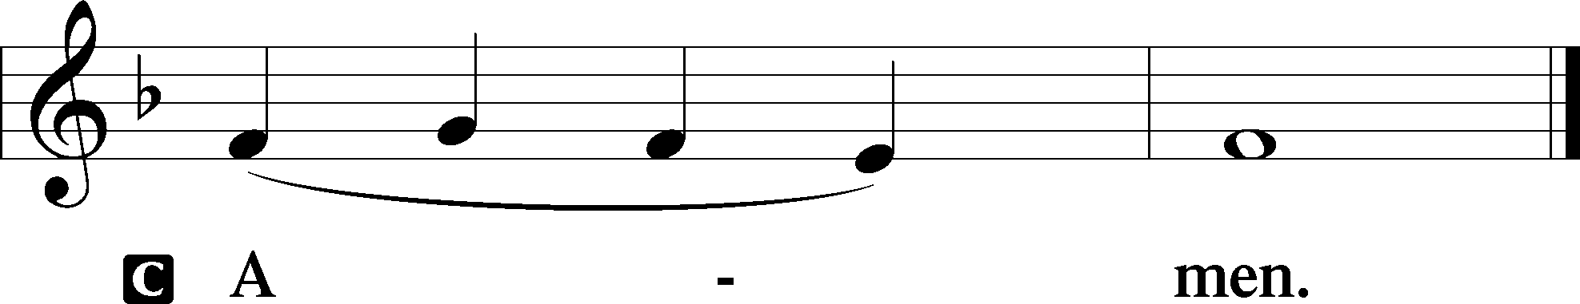

Agnus Dei John 1:29
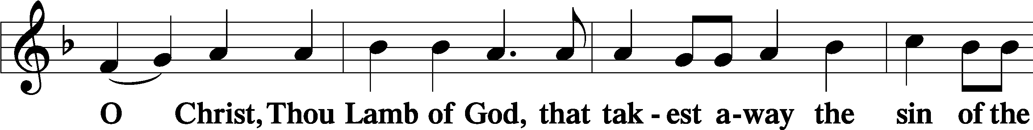
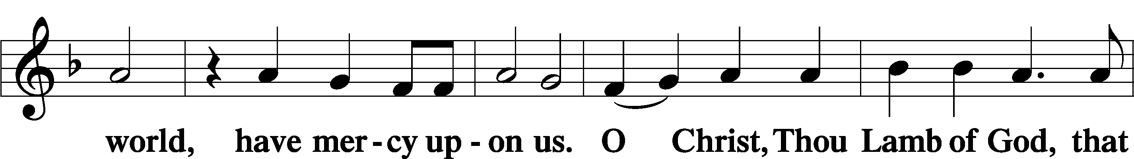
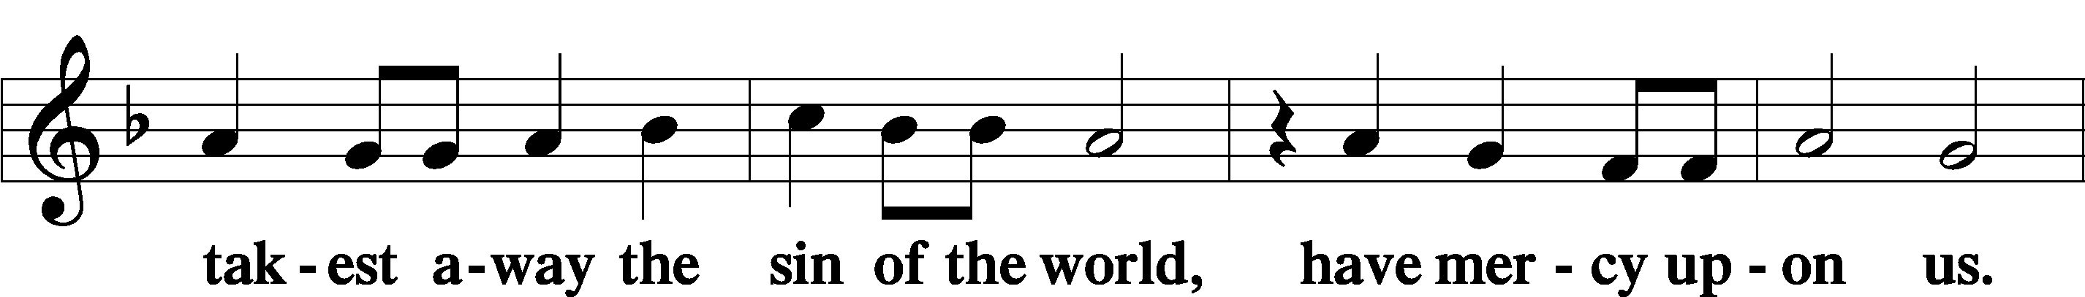
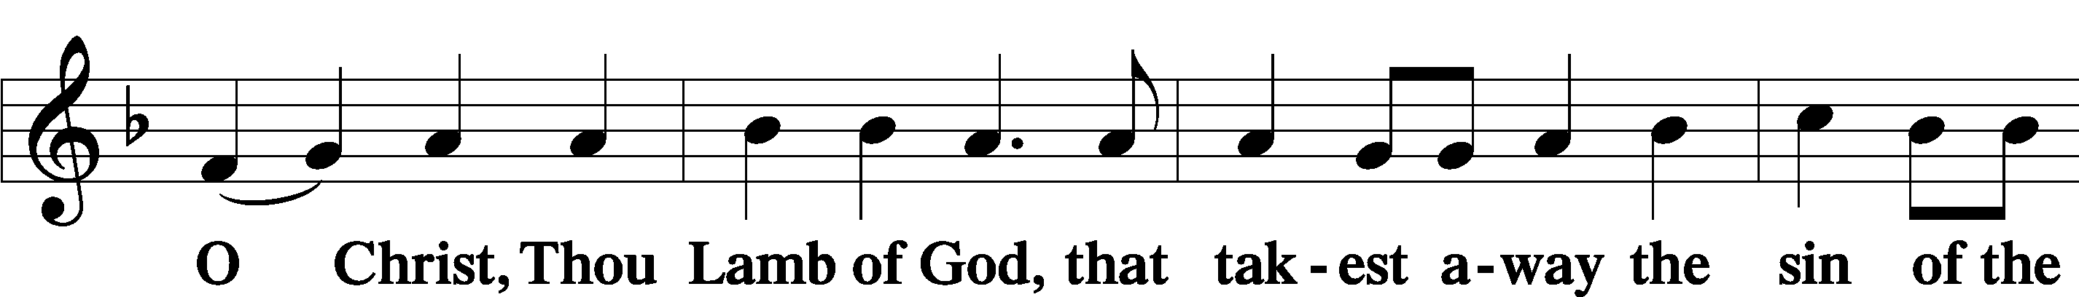
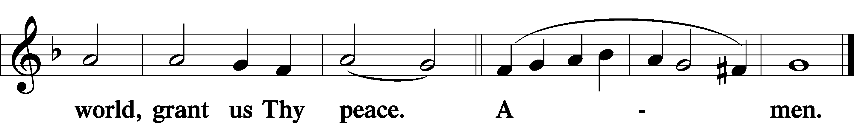
Sit
Distribution
The pastor and those who assist him receive the body and blood of Christ first and then distribute them to those who come to receive, saying:
Take, eat; this is the true body of our Lord and Savior Jesus Christ, given into death for your sins.
Amen.

Take, drink; this is the true blood of our Lord and Savior Jesus Christ, shed for the forgiveness of your sins.
Amen.

In dismissing the communicants, the following is said:
The Dismissal
P The body and blood of our Lord Jesus Christ strengthen and preserve you in body and soul to life everlasting. Depart T in peace.
C Amen.

Distribution Hymn: LSB #755 “In the Very Midst of Life”

Distribution Hymn: LSB #659 “Lord of Our Life”

Distribution Hymn: LSB #630 “Now, My Tongue, the Mystery Telling”

Stand

Nunc Dimittis Luke 2:29–32
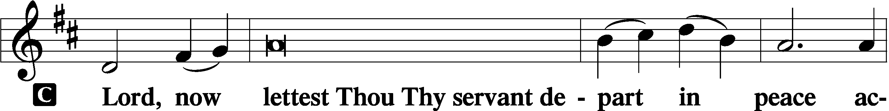
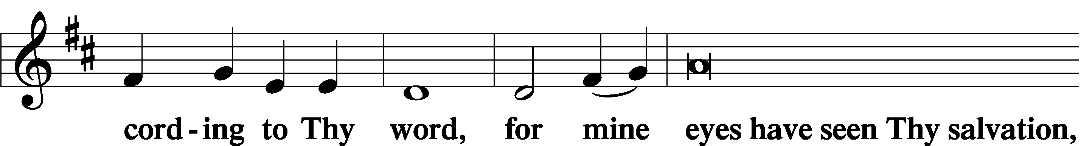
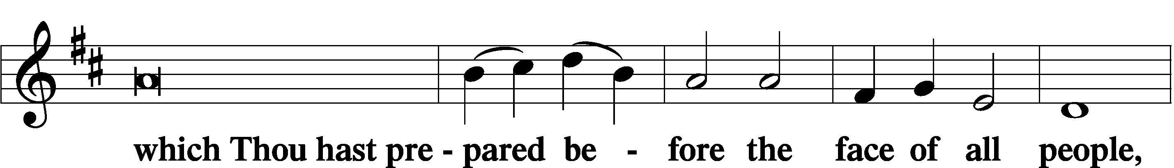
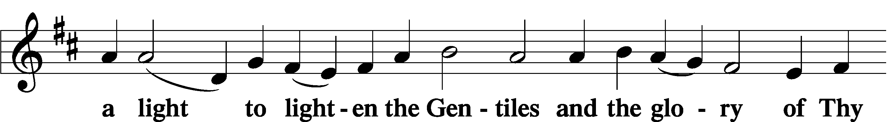
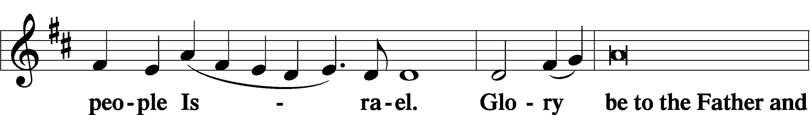
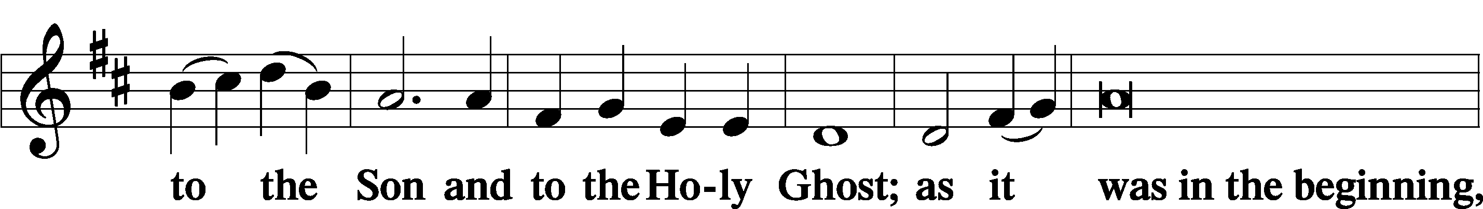
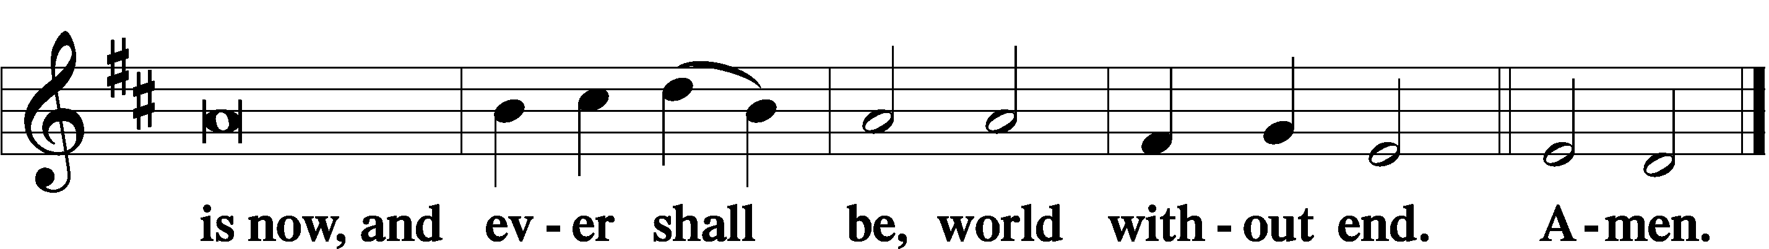

Thanksgiving Psalm 107:1
P O give thanks unto the Lord, for He is good,
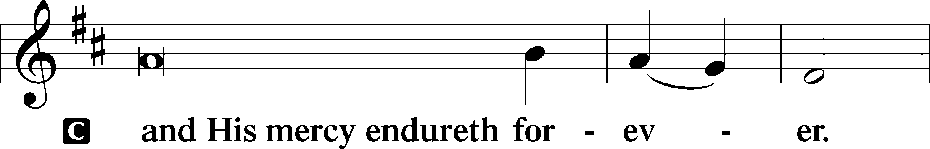

Post-Communion Collect
P Let us pray.
We give thanks to You, almighty God, that You have refreshed us through this salutary gift, and we implore You that of Your mercy You would strengthen us through the same in faith toward You and in fervent love toward one another; through Jesus Christ, Your Son, our Lord, who lives and reigns with You and the Holy Spirit, one God, now and forever.
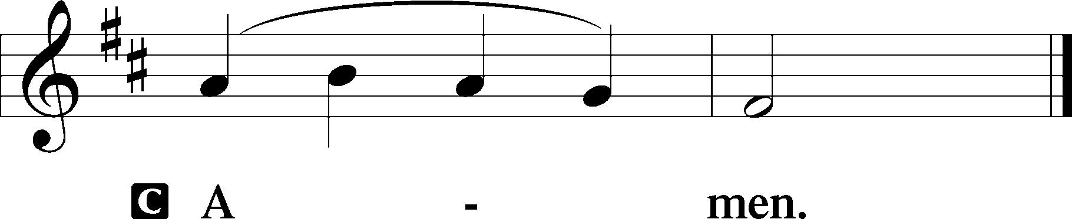

Salutation 2 Timothy 4:22
P The Lord be with you.
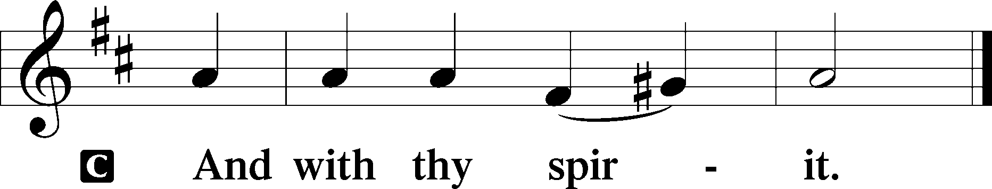

Benedicamus Psalm 103:1
P Bless we the Lord.
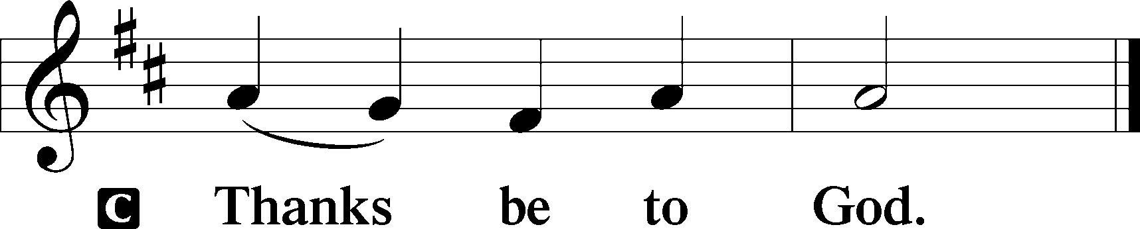

Benediction Numbers 6:24–26
P The Lord bless you and keep you.
The Lord make His face shine upon you and be gracious unto you.
The Lord lift up His countenance upon you and T give you peace.
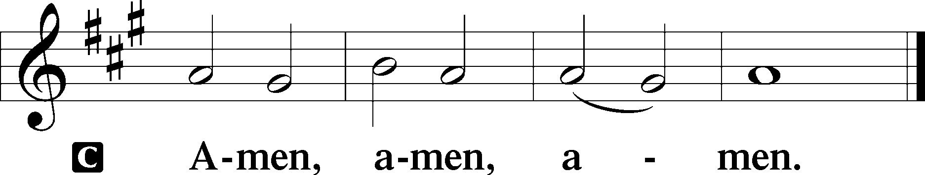

Closing Hymn: LSB #730 “What Is the World to Me”

Silent prayer after worship: Lord Jesus, You overcame Satan by the power of the Word. Lead me to be in Your Word daily, that I also may overcome the devil’s temptations, die to sin, and live in Your righteousness. Amen.
fffffffffffffffffffffffffffffffffff
Acknowledgments: Unless otherwise indicated, Scripture quotations are from the ESV® Bible (The Holy Bible, English Standard Version®), copyright © 2001 by Crossway, a publishing ministry of Good News Publishers. Used by permission. All rights reserved.
Created by Lutheran Service Builder © 2021 Concordia Publishing House.
fffffffffffffffffffffffffffffffffff

SCHEDULE THROUGH MARCH 5, 2023:

:

Today, 7 pm, Fellowship Hall: AA Meeting
Tuesday, 7-9 pm, Fellowship Hall: Penn-Ohio Singers
Wednesday, Noon, Sanctuary: Lenten Midweek Matins Service
5:30 pm, Sanctuary: Choir Practice
7 pm, Sanctuary: Lenten Midweek Vespers Service
7:30 pm, Fellowship Hall: NA Meeting
Saturday, 9 am, All Saints~Slippery Rock: Catechism Class
Next Sunday, 8 am, Fellowship Hall: Bible Study
9 am, Sanctuary: Divine Service
Following, Fellowship Hall: Voters’ Assembly
7 pm, Fellowship Hall: AA Meeting
fffffffffffffffffffffffffffffffffff
Attendance: Sunday, February 19, 2023: 38
fffffffffffffffffffffffffffffffffff
THANK YOU FOR SERVING IN FEBRUARY: Elder: Jonathan Baisch; Ushers: Matt Berent, Mark Gabriel, Michael Laird, and Jerome Thomas; Altarware: Marie Flaugher (prior) and Cheryl Fedele & Clara Krivosh (after).
fffffffffffffffffffffffffffffffffff
THANK YOU FOR SERVING IN MARCH: Elder: Jonathan Baisch; Ushers: Cheryl Fedele, Mike Flaugher, and Jesse Riffle; Altarware: (prior) Diane Riefstahl & Marie Flaugher (03/12); (after) Elizabeth Haenftling & Traudi Sulek.
fffffffffffffffffffffffffffffffffff
Bible Memory Verses ~ Week of February 26th:
For Adults: Above all, keep loving one another earnestly, since love covers a multitude of sins. 1 Peter 4:8
For Children: The reason the Son of God appeared was to destroy the works of the devil. 1 John 3:8
fffffffffffffffffffffffffffffffffff
Altar Guild members are reminded that 2023 dues should be paid to Treasurer, Evelyn Baisch. If paying by check, please make it out to Sts. Peter & Paul’s.
fffffffffffffffffffffffffffffffffff

Our Stewardship of Treasures for the Lord:
In order to do the Lord’s work, we need $2,553.63 each week to meet our 2023 budget for general purposes and $76.92 for the SELC.
Figures for Sunday, February 19, 2023
General Fund: $1,168.00 Behind for the week: -$1,385.63
SELC: $52.00 Behind for the week: -$24.92
Food Pantry: $0.00
Capital Campaign: $435.00
Other: $125.00

For online giving, check out https://www.saintspeterandpaul.net/online-giving.
fffffffffffffffffffffffffffffffffff
Copies of the 2023 Lenten Devotions, “Given and Shed for You”, are available in the narthex and on the table next to Pastor Deal’s office. These devotions correspond to the lessons of the mid-week Lenten services which we will be observing.
fffffffffffffffffffffffffffffffffff
Be certain to pick up your copy of the brochure “Almsgiving, Praying, Fasting” which Pastor Deal prepared for the Lenten season. Copies are available both in the narthex and on the table next to Pastor Deal’s office.
fffffffffffffffffffffffffffffffffff
Choir practice continues this Wednesday evening at 5:30 pm. If interested in singing, but unable to attend, please contact Chris Nelson.
fffffffffffffffffffffffffffffffffff
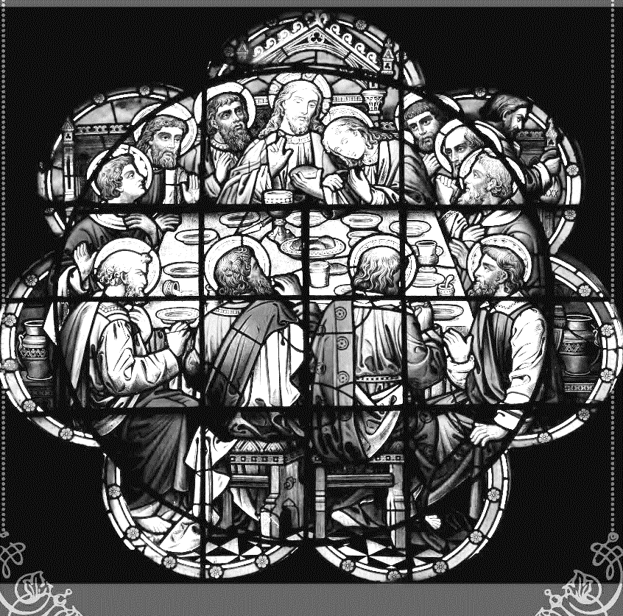
Join us this Lenten season as we focus on the Lord’s Supper with the following Wednesday midweek services:
March 1-29
Matins Service at Noon
Vespers Service at 7 pm

fffffffffffffffffffffffffffffffffff
The March issue of “The Rock and the Sword” newsletter is available on the tables in the narthex and the sign-in table next to Pastor Deal’s office. Also available in the narthex is the 2022 Annual Report.
fffffffffffffffffffffffffffffffffff
Remember the following in Prayer…
~The Hurting and Healing: The family and friends of Anson Holcroft, who passed away Wednesday, February 22, 2023; Amy, Gerald Arthur, Evelyn Baisch, Ellen Baron^{CA}, Lois Bortner^{CA}, John Burdette, Bev & Joe Chlpka, Kathleen Coughenour, Kim, Anna Mae Daris, Susan Davies, Tim Dudash, Millie Elavsky, Joseph Fleet, Judith & Eddy Furey, Tim Haenftling, Austin Hamilton, Neil Huston, Joan, Darla Krajci, Barbara Kreske, Donna Kennedy, Jess Lavoie, Paul Lucas^{CA}, Sandy Marshall, David Nelson, Linda Parkany, Juanita Rentschler, Richard Reuning^{CA}, Diane Riefstahl, Nancy Robertson^{CA}, Viola Sakony, Marty Scott, Kara, Fred Tonty, Angela Weser^{CA}, and Ruth Wolf.
~The Homebound: Rudy & Jean Tomko, Betty Wolf, and Ed & Millie Zachar.
~Celebrating: Birthday: Traudi Sulek (02.28); Anniversary: Eddy & Judith Furey (03.01).
~Serving in the Military: Curtis Sinewe and Joshua Solyan.
~Community & World Needs: Those suffering from or affected by the coronavirus; those suffering due to the conflict between Ukraine and Russia; those suffering from loss and dislocation because weather disasters; those suffering from addiction and their families; Local, State, and National Government Leaders; safety for all Police Officers, Firefighters, & First Responders; the unemployed; our First Quarter Local Mission: Sts. Peter & Paul’s Community Day 2023.
*CA represents cancer.
fffffffffffffffffffffffffffffffffff
There will be a VOTERS’ ASSEMBLY in the Fellowship Hall next Sunday (March 5), ten minutes following the end of worship. Your attendance will be greatly appreciated. Copies of the revised agenda are available on the table in the narthex.
fffffffffffffffffffffffffffffffffff
Heartfelt sympathy is extended to the family and friends of Anson Holcroft who was called home to his Lord, Wednesday, February 22, 2023. Anson was a faithful servant to this church and, although he will be greatly missed, we are comforted in the knowledge that he is with our Lord, and Savior.
Calling hours will be held at the church Tuesday, February 28th beginning at 10 am with a funeral service to follow at 11 am. There will be a luncheon at the church following the service.

Here to Serve
Pastor………………………………………………...……………Rev. Jacob Deal
E-mail …………………………….……pastordeal@saintspeterandpaul.net
Phone Number……………………..…………………724-347-3620 (Option 2)
Church Office………………………..…………………724-347-3620 (Option 3)
Website …………………………………………www.saintspeterandpaul.net
Secretary…………………………………………………………Diane Riefstahl
E-mail ………………………………………church@saintspeterandpaul.net
Website …………………………………………www.saintspeterandpaul.net
Food Pantry: Please leave message……………724-347-3620 (Option 3)
AA Contact: Steve………………………………………………..…724-813-2358
NA Contact: Larry………………………………………………..724-977-8733
Choir Director………………………………………………………Chris Nelson
Congregation President……………………………………Jonathan Baisch
Church Elder …………………………………………...…… Jonathan Baisch
fffffffffffffffffffffffffffffffffff
If needing to get into the church building during the week, please phone first to make certain someone is here to let you in.

