Sts. Peter & Paul
Evangelical Lutheran Church
Lutheran Church-Missouri Synod
Founded-1917
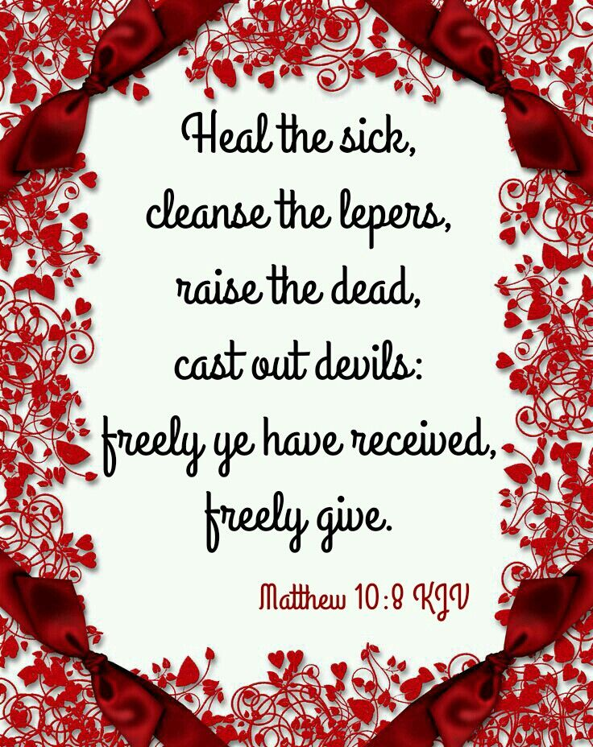

February 24, 2024

699 Stambaugh Avenue
Sharon, Pennsylvania 16146

“I was glad when they said to me,
Let us go to the house of the LORD!”
Psalm 122:1

VESPERS
The Vigil of Saint Matthias, Apostle

Silent prayer before worship: Almighty God, You sent Your Son to die and rise again that all who believe in him may live. Grant that I may faithfully walk the way of the cross and show forth true love for You and for my neighbors. In Jesus’ name. Amen.


Opening Hymn: LSB #828 “We Are Called to Stand Together”

Stand
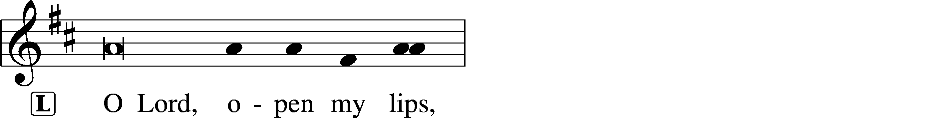
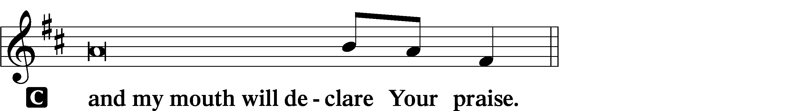

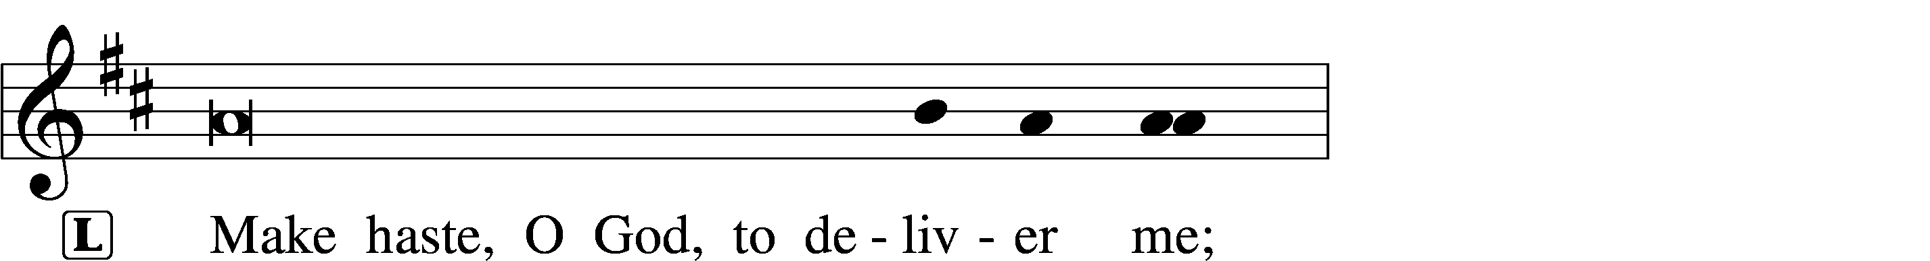
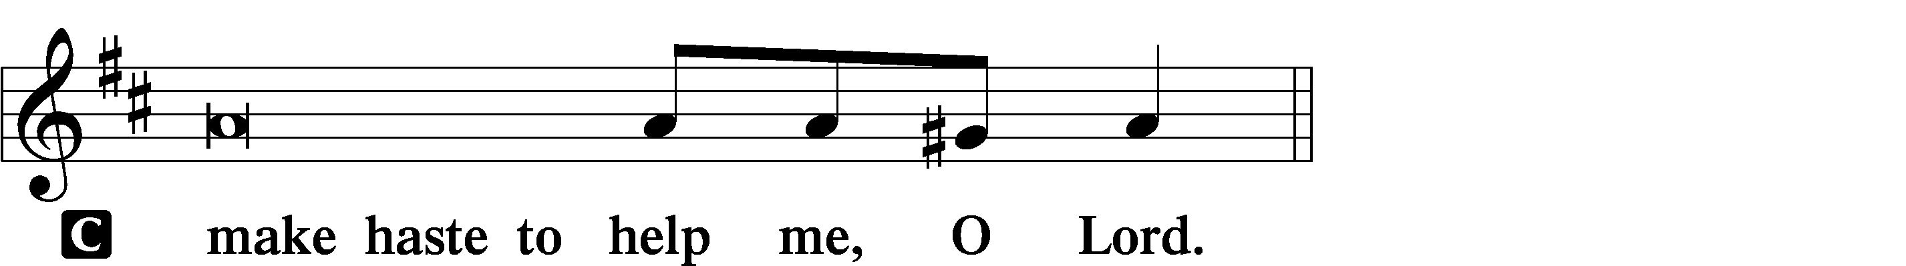

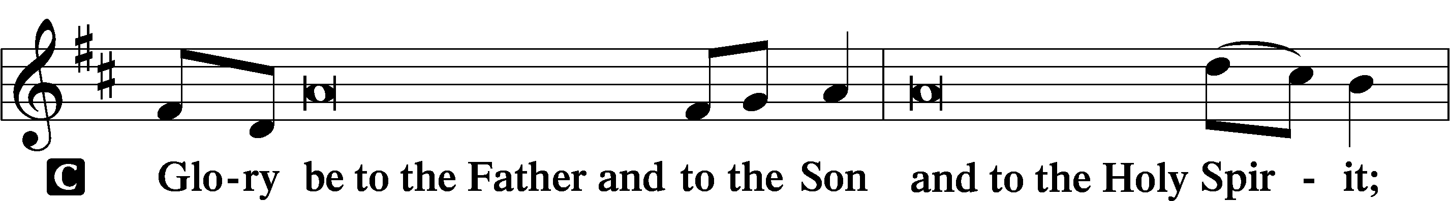
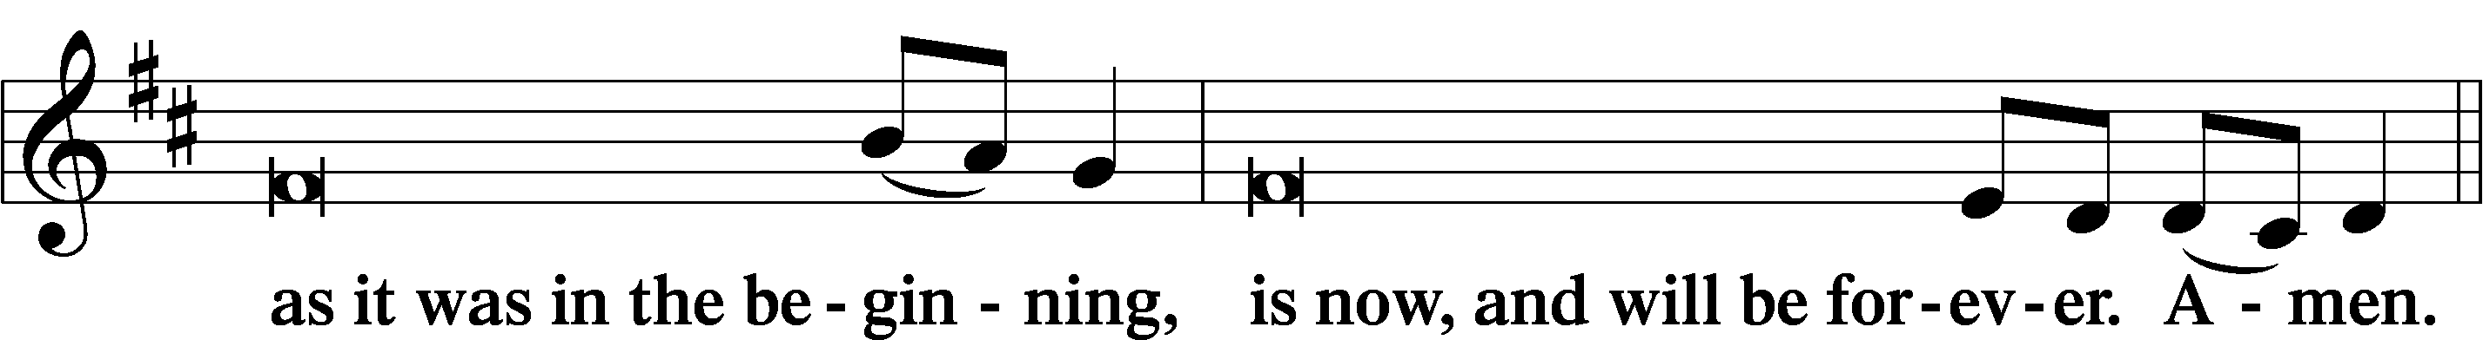
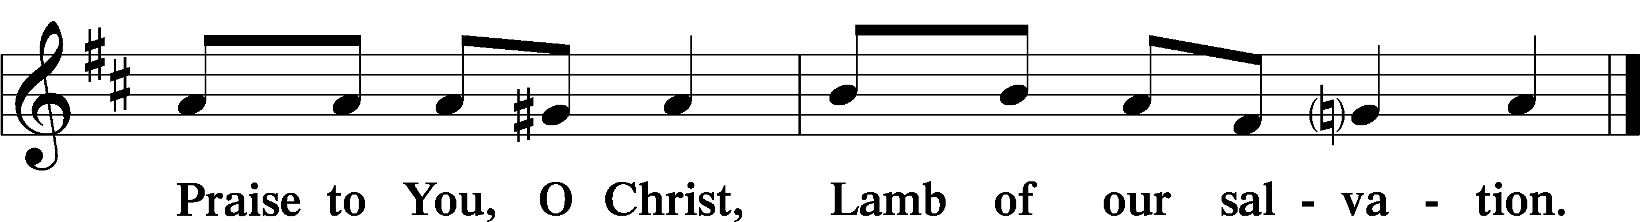
Psalmody

Psalm: Psalm 52:8a, 9b
I am like a green olive tree in the house of God:
I trust in the mercy of my God,
and I will wait on Thy name;
for it is good before Thy saints.
Sit

Hymn of the Day: LSB #831 “’How Shall They Hear,’ Who Have Not Heard”

Readings

First Reading: Sirach 31:8-11 (NKJV)
Blessed is the rich man who is found blameless, and who does not go after gold. Who is he? And we will call him blessed, for he has done wonderful things among his people. Who has been tested by it and been found perfect? Let it be for him a ground for boasting. Who has had the power to transgress and did not transgress, and to do evil and did not do it? His prosperity will be established, and the assembly will relate his acts of charity.

P O Lord, have mercy on us.
C Thanks be to God.

Stand
Gospel: Matthew 10:5-8 (NKJV)
At that time: Jesus sent out the twelve and commanded them, saying: “Do not go into the way of the Gentiles, and do not enter a city of the Samaritans. But go rather to the lost sheep of the house of Israel. And as you go, preach, saying, ‘The kingdom of heaven is at hand.’ Heal the sick, cleanse the lepers, raise the dead, cast out demons. Freely you have received, freely give.”

P O Lord, have mercy on us.
C Thanks be to God.
Responsory (Lent) LSB 231
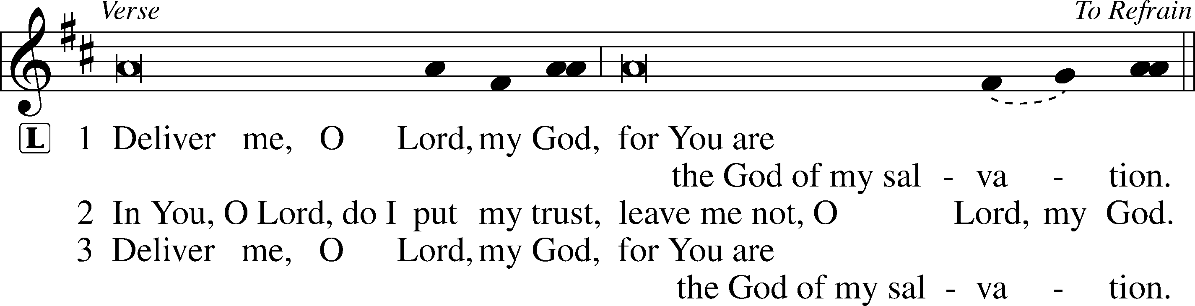
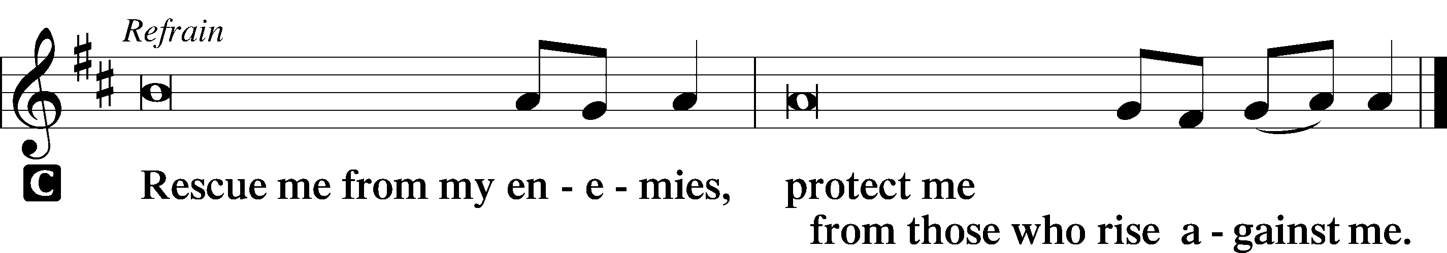

Sit
Sermon
Canticle
Stand
Antiphon (Common) 231
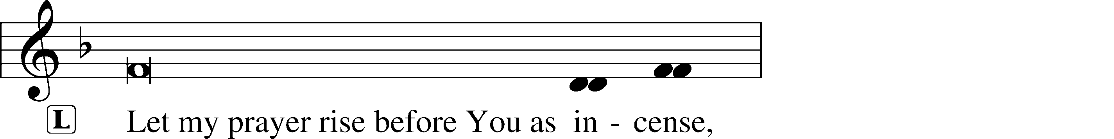
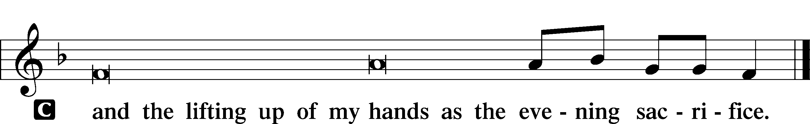

Magnificat 231
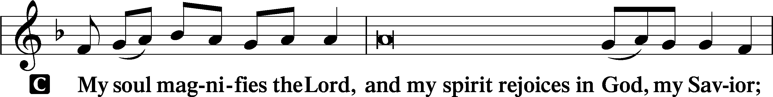
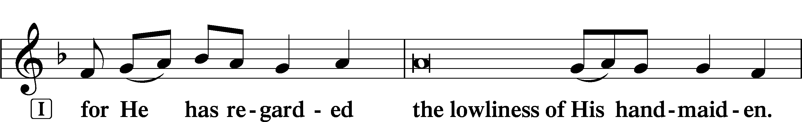
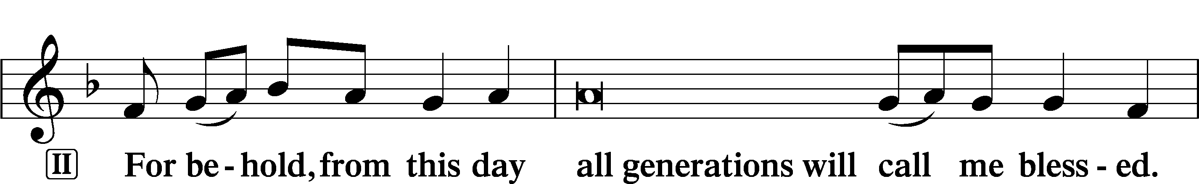
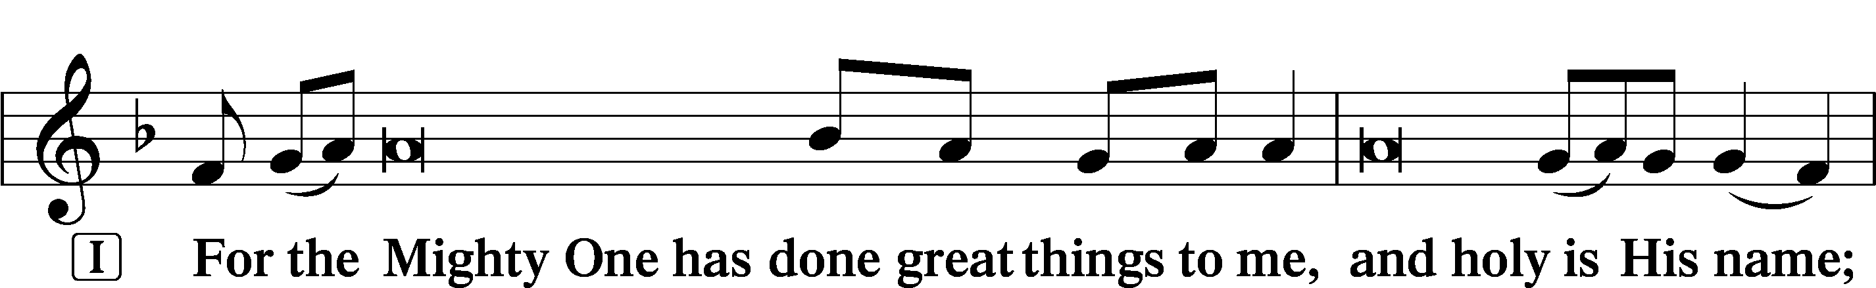
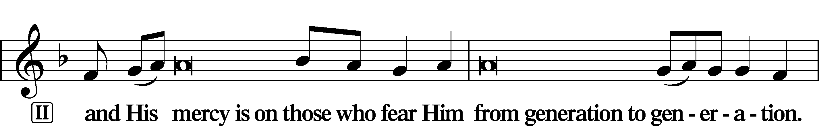
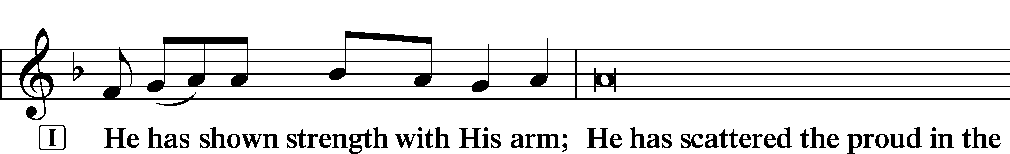
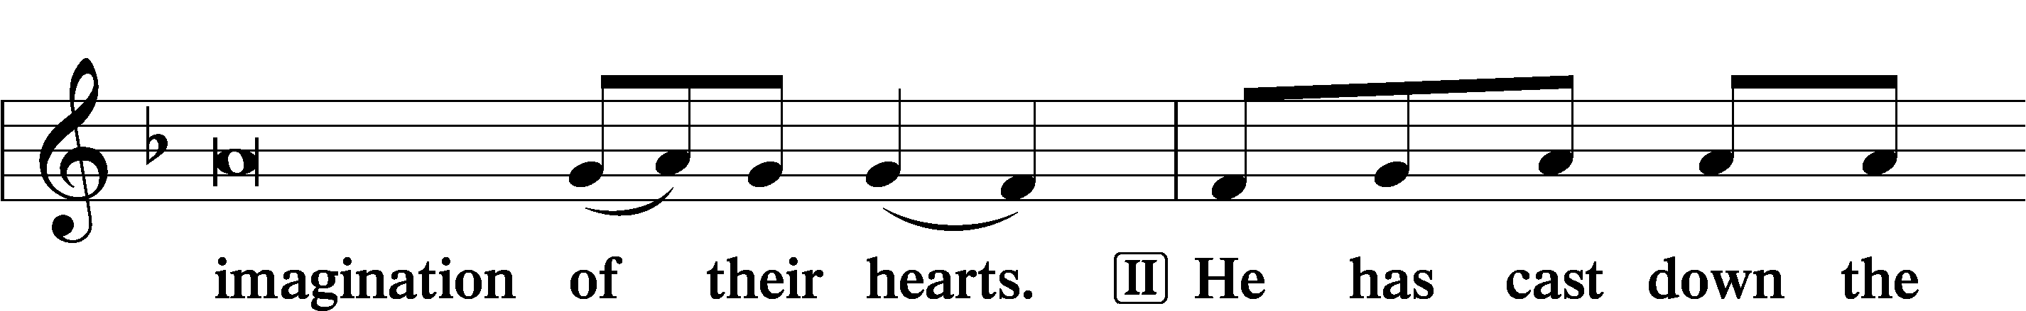
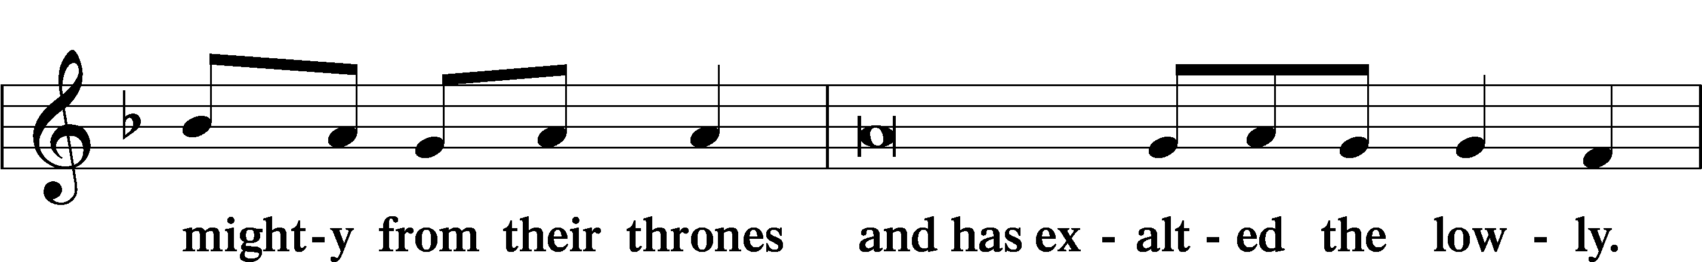
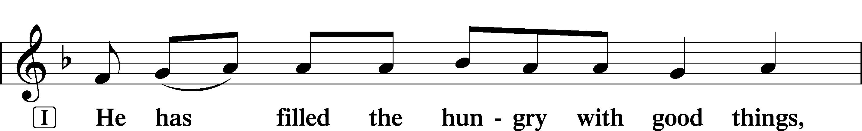
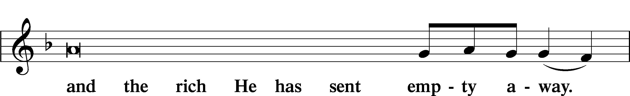
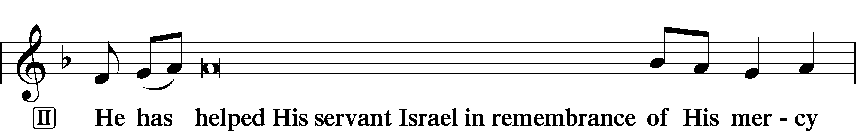
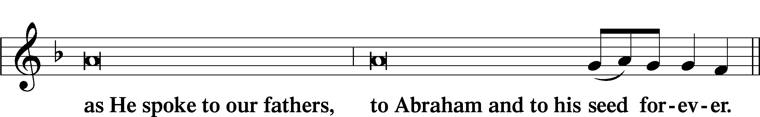
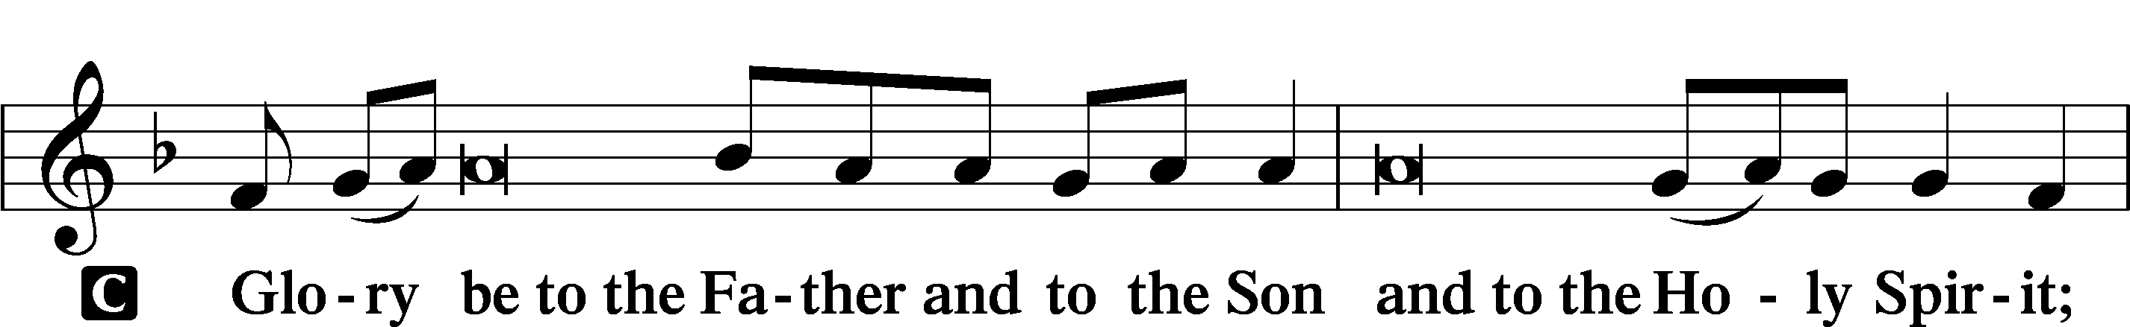
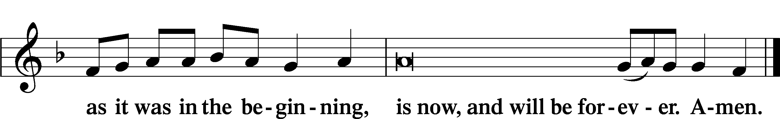

Prayer

Kyrie LSB 233
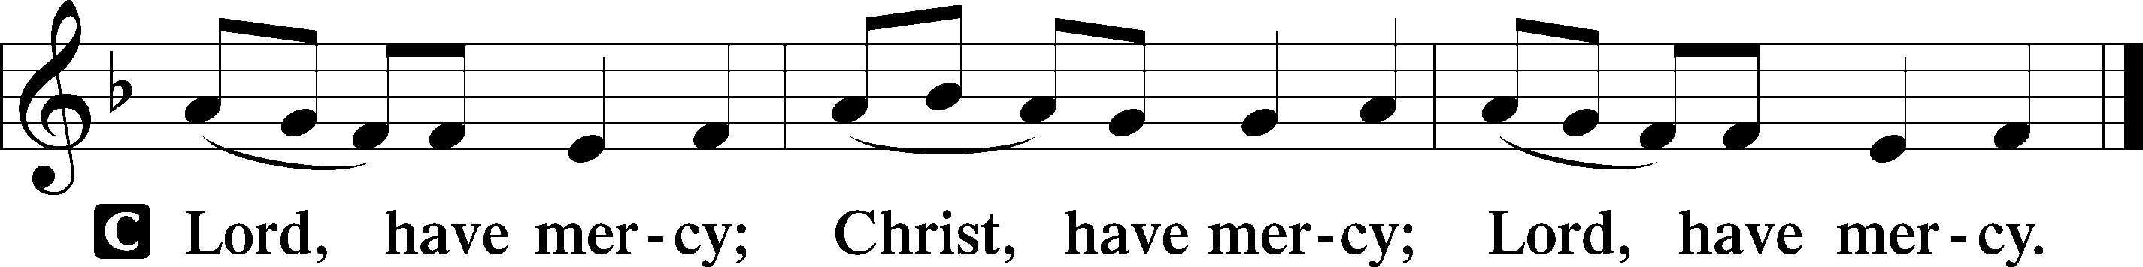

The Lord’s Prayer LSB 957
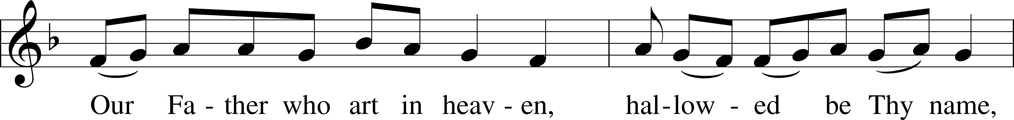
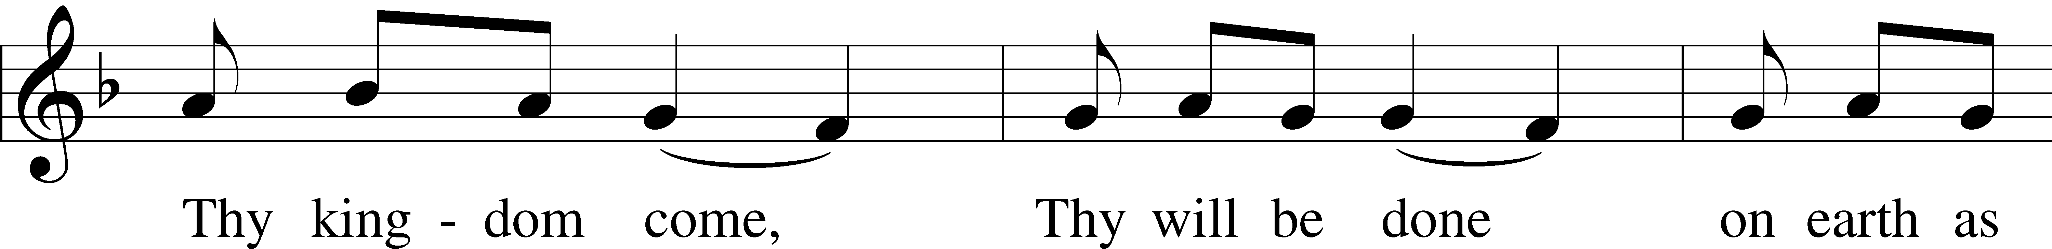
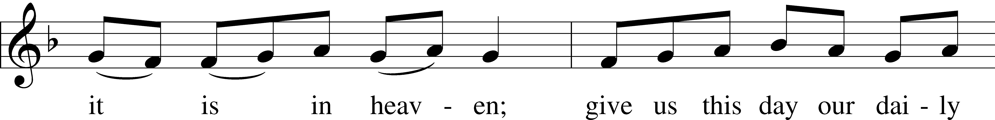
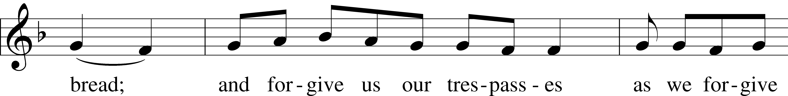
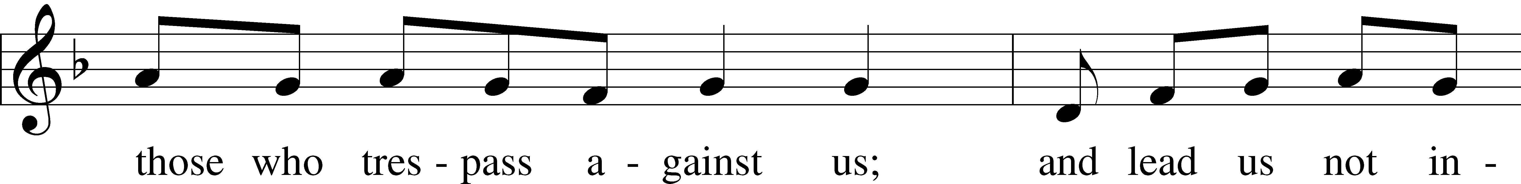
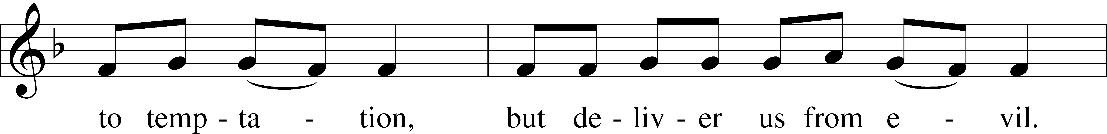
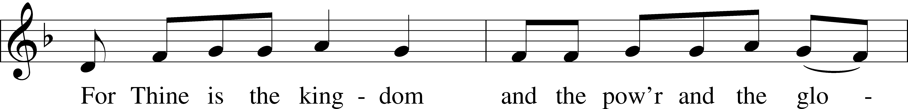
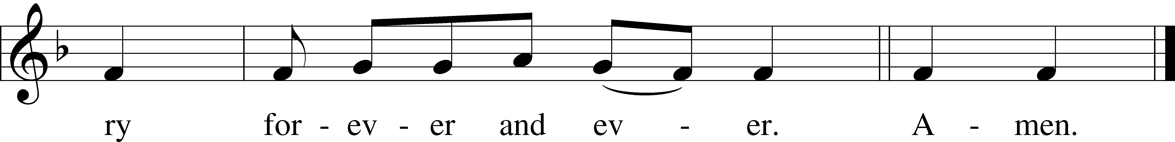

Collects
Introduction to Collects LSB 233
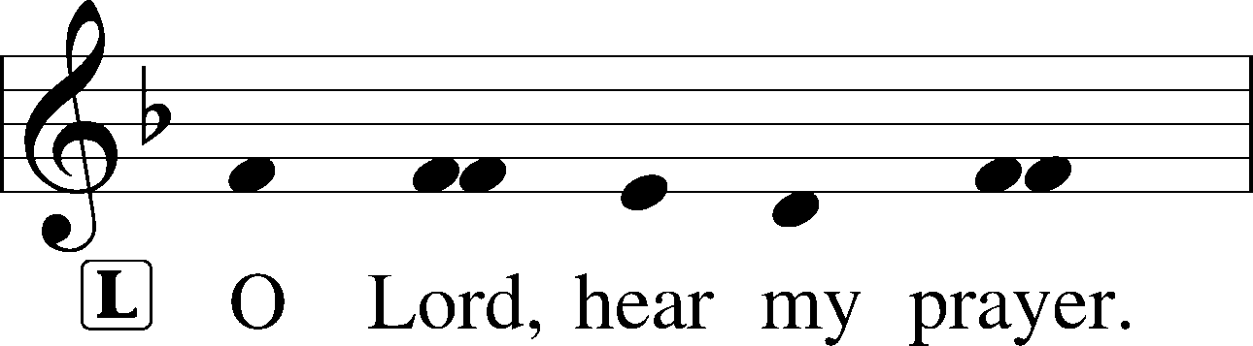
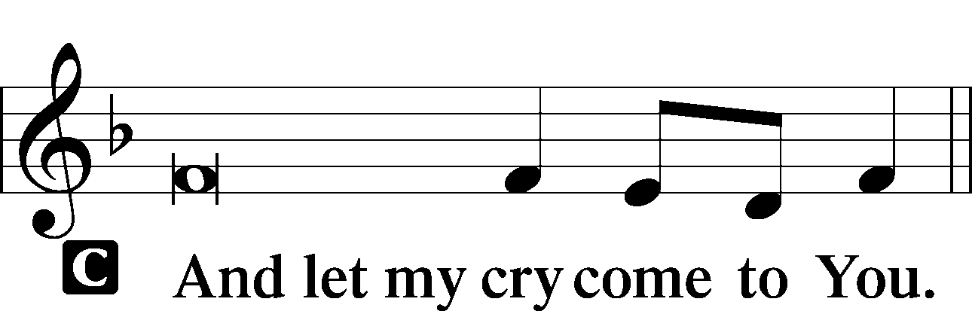

Collect of the Day: St. Matthias
P Almighty God, You chose Your servant Matthias to be numbered among the Twelve. Grant that Your Church, ever preserved from false teachers, may be taught and guided by faithful and true pastors; through Jesus Christ, our Lord, who lives and reigns with You and the Holy Spirit, one God, now and forever.

Collect for Peace
P O God, from whom come all holy desires, all good counsels, and all just works, give to us, Your servants, that peace which the world cannot give, that our hearts may be set to obey Your commandments and also that we, being defended from the fear of our enemies, may live in peace and quietness; through Jesus Christ, Your Son, our Lord, who lives and reigns with You and the Holy Spirit, one God, now and forever.
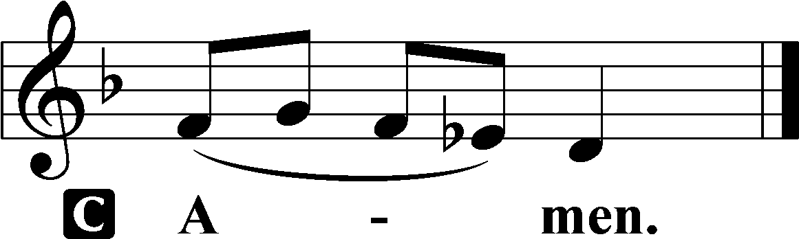

Benedicamus LSB 234
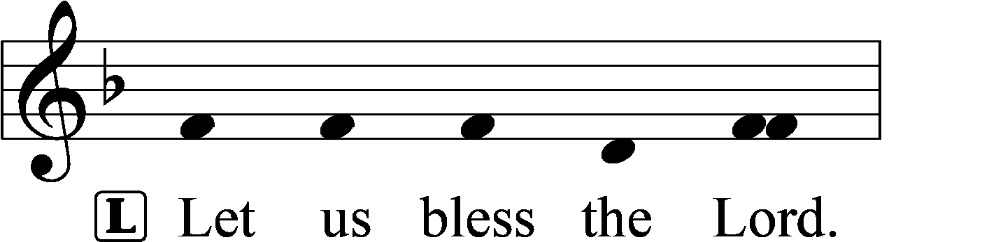
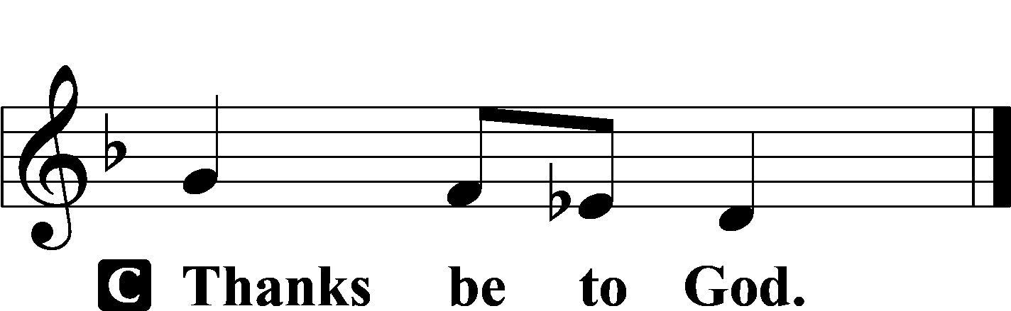

Benediction LSB 234
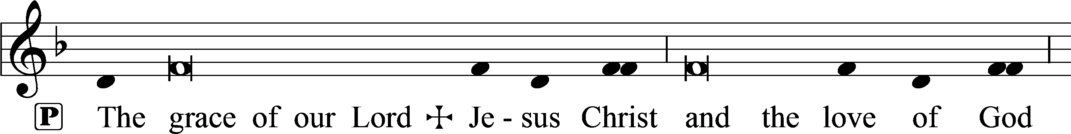
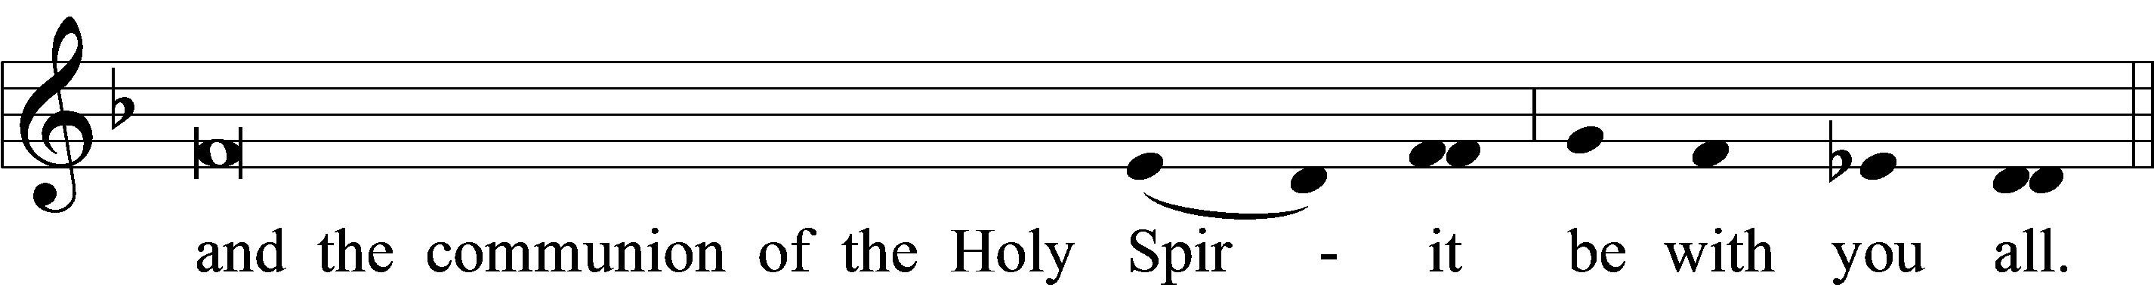

Closing Hymn: LSB #901 “Open Now Thy Gates of Beauty”

Text: Benjamin Schmolck, 1672–1737; tr. Catherine Winkworth, 1827–78, alt. Tune: Joachim Neander, 1650–80 Text and tune: Public domain

Silent prayer after worship: Lord Jesus, as I go forth from this worship service, cause me to remember Your great love for me and all people. Give me boldness and faith to share Your love with others through my words and deeds. Amen.

Acknowledgments: Unless otherwise indicated, Scripture quotations are from the ESV® Bible (The Holy Bible, English Standard Version®), copyright © 2001 by Crossway, a publishing ministry of Good News Publishers. Used by permission. All rights reserved. Created by Lutheran Service Builder © 2024 Concordia Publishing House

