Sts. Peter & Paul Evangelical Lutheran Church LC-MS
Monthly Newsletter --- February 2022
699 Stambaugh Avenue, Sharon, PA 16146
Phone: 724.347.3620 (Opt. 2, Pastor Deal; Opt. 3, Office)
E-mail: church@saintspeterandpaul.net www.saintspeterandpaul.net

“THE ROCK and THE SWORD”
“Built upon the Rock of Christ and wielding the
Sword of the Spirit, the Word of God.”

The following devotion was printed in the February 2022 issue of “The Pittsburgh Lutheran” (Volume 92, Number 1)

“Endings and Beginnings”
by The Reverend Dr. Douglas H. Spittel, President, Pittsburgh Area Lutheran Ministries
And behold, there was a man in Jerusalem whose name was Simeon, and this man was just and devout, waiting for the Consolation of Israel, and the Holy Spirit was upon him. And it had been revealed to him by the Holy Spirit that he would not see death before he had seen the Lord’s Christ. St. Luke 2:25-26
February is known for being short, dark, and cold. It is the depths of Winter and a month best simply endured in the environs of Pittsburgh. Just the mention of the month’s name evokes images of slush, freezing rain, and dinner after an early sunset. The world turns its attention to a large rodent from Punxsutawney with light-hearted fun and the superstitious hope that Winter will end early.
But the Church celebrates February differently. The second day of the month, having nothing to do with a creature named Phil, is rather, the Feast of the Presentation of our Lord and the Purification of Mary. This commemorates the Holy Family bringing the Blessed Virgin and her Son to the Temple in Jerusalem
both for her ritual purification after childbirth and His presentation as a son of Israel. For the Church, this marks the end of the forty-day cycle of Christmas. Any decorations that have remained since Christmas (our mission church in Hazelwood remains fully decked until this day) are removed after this Feast
Day. The church is stripped of its festive Christmas decorations in preparation for the more penitential season to come. It was on this day that the elderly Saint Simeon, who had waited his entire life to see
the Christ, not only saw Him, but took Him in his arms and gave thanks, knowing that his time in this world was ending with the joy and privilege of holding Him who had and would continue to hold Simeon in His bosom.

The Feast of the Presentation is also called Candlemas because on this day, the Church blesses the candles that will be used to light the church and the homes of Christian families for the rest of the year. In the cold darkness of February, the Church confesses with Simeon that Jesus is “a light to bring revelation to the Gentiles, and the glory of Your people Israel.” If a single candle can dispel the
darkness, then the Church knows and proclaims that the light of Christ will cast away the darkness of sin and death.

Christmas is behind us, its cycle has ended. Before us lies the Lenten road to Jerusalem, an analog of our lives lived under the cross. But the eyes of faith are focused on the new light of Christ that shines forth from Easter and enlightens the world. Let us pause in February with old Simeon and behold the
new life that Christ brings to us for eternity.
llllllllllllllllllllllllllll
CAPITAL CAMPAIGN AT A GLANCE

Blue: Pledged as of 01.16.2022 (56.67%)
Orange: Remaining (43.33%)

Total Contributions
as of 01.23.2022: $92,058.00

Previous: $53,928.00 (26.96%)
New: $38,130.00 (19.07%)
Remaining: $107,942.00 (53.97%)
llllllllllllllllllllllllllll
It’s not too late to submit a Capital Campaign pledge card! Pledge cards are available on the table outside Pastor’s office.
llllllllllllllllllllllllllll
ATTENTION AUDITORS! The February monthly audit of deposits and the Food Pantry account will take place following worship, Sunday, February 27th in the library. If unable to attend, please phone Bev Chlpka at 724-962-4806.
llllllllllllllllllllllllllll
Pastor Deal continues to serve as Vacancy Pastor for All Saints Lutheran Church in Slippery Rock, PA until further notice. As he must leave shortly following our worship service in order to travel safely to Slippery Rock, Pastor will be available one hour prior to our service for those wishing to speak with him.
llllllllllllllllllllllllllll
To listen to Pastor Deal’s sermons, phone 724-347-3620 and press Opt. 6.

Homebound Members & Friends
Please keep the following in your prayers:
Marion Roberts
The Lakes at Jefferson
7271 W. Market St.
Mercer, PA 16137
724-946-2236
lll lll lll lll lll lll lll lll lll lll lll lll lll lll lll
Betty Ann Wolf
7777 Arthur St., SC
Masury, OH 44438
330-448-1080
lll lll lll lll lll lll lll lll lll lll lll lll lll lll lll
Ed & Millie Zachar
1320 Old Forge Rd.
Niles, OH 44446
330-652-9316
llllllllllllllllllllllllllll
REMINDER: Please let the church office know of any changes to your address, phone, cell phone or your e-mail address!
SCRIP Program:
The next date for SCRIP orders and payments is Sunday, February 6th. Checks should be made out to Sts. Peter & Paul’s and are to be given to Matt Berent or placed in the offering plate. You should receive your gift cards the following week.
Participation in the SCRIP program is a wonderful way to help out our church. Participants receive the full value of gift cards purchased with the church receiving a percentage of the amount spent from the gift card providers. The amount varies based upon the gift card purchased.
Forms for ordering gift cards are available in both the narthex and on the parking lot entrance sign-in table.
llllllllllllllllllllllllllll
CELEBRATING IN FEBRUARY!
Birthdays
Beverly Chlpka 2 — 4
Jennifer Russell 2 — 20
Bradley Dirgo 2 — 21
Traudi Sulek 2 — 28
Anniversary
Joseph & Beverly Chlpka 2—10
*If birthdays or anniversaries have been omitted, please let the church office know. Thank You!
llllllllllllllllllllllllllll
TRUSTEES’ UPDATE
By Mike Flaugher, Chairman
Trustees addressed the following items in January:
- 1/07/2022 The pump motor that circulates the water in our boiler systems was replaced.
- 1/13/2022 Installed motion sensor light switches in the men's and women's restrooms nearest the fellowship Hall.
- 1/13/2022 Dr Auto Lock was on site to repair the door lock on the side entry door off the Stambaugh Avenue entrance.
- 1/15/2022 Installed new toilet in restroom next the sacristy. This should help with our water consumption.
- 1/15/2022 Installed handrail in the men's restrooms nearest the fellowship Hall.
We have lined up the snow removal for both the parking lot and the sidewalks and so far, so good.

Onto other topics:
- The light on the north cross on Stambaugh Avenue is not working. If anyone knows an electrician, please let a trustee know. The repair will more than likely require the electrician to climb upon the roof to troubleshoot the problem.
- Trustees will be looking into addressing the water pressure issues throughout the church as we go forward into the year.
- The kitchen dishwasher system needs removed. If anyone knows of a person, group, or restaurant who could use this let the trustees know.
llllllllllllllllllllllllllll
LIKE & FOLLOW our Church’s Facebook page (Saints Peter and Paul Evangelical Lutheran Church)!
Remember to like, comment, and share to help us reach as many people as possible.
llllllllllllllllllllllllllll
Submissions for the March issue of “The Rock and the Sword” newsletter are due to the secretary’s office Monday, February 21st at noon. This includes meeting dates and times for the church calendar.
STS. PETER & PAUL’S
FOOD PANTRY UPDATE
At this time, our Food Pantry is not in need of additional donations. Please consider re-directing money which you might typically give to other funds in our church which have need.
We are in need, however, of manpower. If able and available to assist us packing/distributing goods Thursday mornings, please contact Barry Nelson at 724-866-7417.
We have been very blessed to have someone volunteer to knit children’s sweaters for our Food Pantry families. If you should have any yarn at home which you would be willing to donate towards this effort, please give it to Barry Nelson. He will then forward it to our crafty knitter.
llllllllllllllllllllllllllll
Thank You for Serving in February:
Head Elder: Barry Nelson
Assisting Elder: Jonathan Baisch
Ushers: To be determined.
Altarware: (Before service) Diane Riefstahl; (After service) Cheryl Fedele & Clara Krivosh
Finance Committee: (All should report following each Sunday’s worship service.)
llllllllllllllllllllllllllll
If you do not have an email account or do not receive emails from the church but wish to be notified of significant information concerning your fellow church members (such as births or deaths), please put a note in the Secretary’s mail slot asking to receive a phone call. Every attempt will be made to phone you within 24 hours of an email being sent out.
llllllllllllllllllllllllllll

The 2022 Coffee & Fellowship Sponsor sheet has been posted on the bulletin board in the narthex. Please consider becoming a sponsor! Sponsors need to bring 2-3 dozen donuts/muffins (or other treats!) and 1 qt. orange juice on the day they are scheduled and place them in the Fellowship Hall prior to the worship service. Set up and clean-up will be done for you. Freewill donations will help cover the cost of coffee, tea, creamers, sugar, and miscellaneous supplies.
Results of the recent Coffee & Fellowship survey will be published in the March newsletter.
Our next Coffee & Fellowship will take place following worship Sunday, February 13th. This month’s sponsor is Diane Riefstahl.
llllllllllllllllllllllllllll
2022 Altar Flower Sign-up Sheet has been posted in the narthex. Speak with Diane Riefstahl if you should have any questions.
llllllllllllllllllllllllllll
Mark Your Calendars!
The next VOTERS’ ASSEMBLY will take place 10 minutes following worship Sunday, February 20th.
If you have any items for the agenda, please discuss them with Jonathan Baisch by Friday, February 6th so they may be included on the agenda.

llllllllllllllllllllllllllll
Word of Hope: 1-888-217-8679
The only 24/7 CONFIDENTIAL Hotline that is distinctly Lutheran, bringing healing found in Christ, to those whose hearts have been broken by abortion.
It is with heavy hearts that we give our deepest sympathy to the family and friends of Robert (Bob) A. Sulek who passed away suddenly January 23rd and was laid to rest January 28th. Although we rejoice in the fact that he now resides with our Lord and Savior, he will be deeply missed. Whoever said no man is irreplaceable, must have never met Bob. Let us honor his memory by lifting up his family in prayer.

The following is Bob’s obituary as printed in the Sharon Herald.

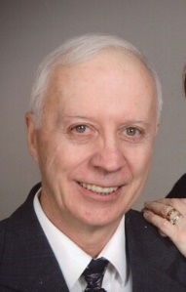
Robert Andrew "Bob" Sulek, 75, of Hermitage, passed away unexpectedly on Sunday evening, Jan. 23, 2022, in the emergency room of Sharon Regional Medical Center.
He was born on July 16, 1946, in Sharon, the son of Betty (Hutchison) Sulek and Andrew Sulek.
Bob graduated from Reynolds High School in 1964.
He worked at Westinghouse Electric Corps for 18 years and also was owner and operator of Sulek's Auto Repair. He retired from Delphi Packard.
He was a member of Saints Peter and Paul Evangelical Lutheran Church where he was an elder, trustee, and handyman.
Bob was a veteran of the U.S. Air Force.
He enjoyed racing go-carts, working on lawnmowers and cars, but most of all, he enjoyed spending time with his family and grandsons.
Surviving are his wife, Edeltraud “Traudi " (Dorfi ) Sulek, whom he married May 15, 1971, and she survives at home; daughters, Cynthia Sulek of Hillsville, Pa., and Christine Hamilton of Hermitage; a sister, Sandy Sulek (Earl) Firestone of North Carolina; a brother, Andy Sulek and his wife, Cate, of Atlanta, Ga.; and grandchildren, Dillon, Charlie, Austin, Joey, and Nicole.
He was preceded in death by his parents and an infant sister, Linda Sulek.
Memorial contributions may be sent to Saints Peter and Paul Evangelical Lutheran Church, 699 Stambaugh Ave., Sharon, Pa., 16146.
llllllllllllllllllllllllllll
Mission Outreach Project…
International Christian Literature Distributors, Inc. focuses on getting the Bible and study materials to learn the Bible into the hands of Christian leaders in the least-fortunate places of the world. They supply churches and schools of Bible learning throughout the English speaking world. Your old Portals of Prayer, seasonal devotions, and other materials are greatly appreciated. For more information about ICLD, check out their website: www.icld.org. Please recycle these items by dropping them in the basket in the hallway by the offices. Thank you!
llllllllllllllllllllllllllll
Our 1st Quarter Mission is
Sts. Peter & Paul’s Annual
Community Day
Donations may be placed in a pew envelope and put in the offering plate.
Welcome New Members!
During the Divine Service January 9th, we were pleased to welcome as new members of Sts. Peter & Paul’s Arlene & Jeff Sutton and Alyxis Riffle. Welcome to our church family!

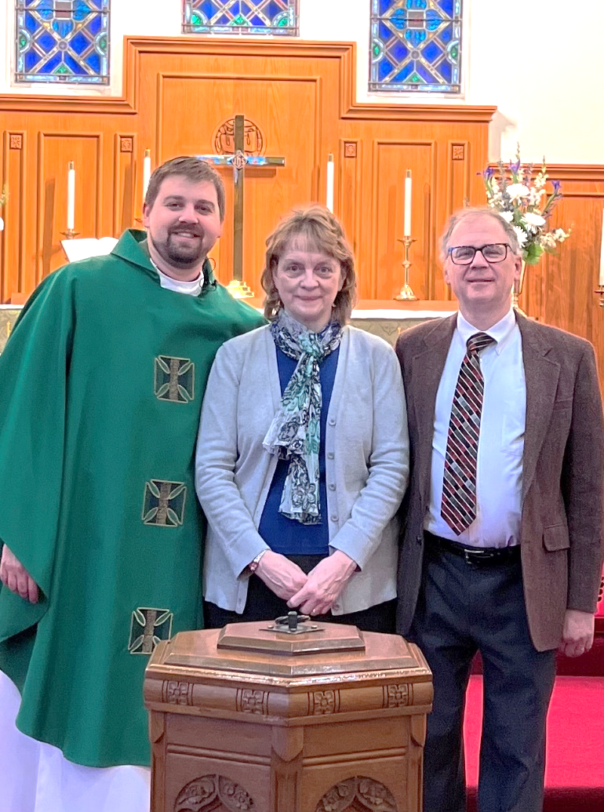
Pictured with Pastor Deal are Arlene and Jeff Sutton.

llllllllllllllllllllllllllll
Pastor Deal will be attending the Central Circuit Conference in Parma, OH Tuesday and Wednesday, February 1 & 2. Please contact Elder Chairman Barry Nelson (724-866-7417) if in need of pastoral care.
llllllllllllllllllllllllllll
REMINDER: If you would like someone’s name to be added to or deleted from our prayer list, please put a written note in the secretary’s mail slot by the office door.
llllllllllllllllllllllllllll

Remember the
following in Prayer…
~The Hurting and Healing: The family and friends of Robert (Bob) Sulek who passed away January 23rd and was laid to rest January 28th; also Kristine Altenor, Joseph Altenor, Ellen Baron^{CA}, Lois Bortner^{CA}, Richard Brandes, John Burdette, Kathleen Coughenour, Kim, Susan Davies, Sophia Dean, Tim Dudash, Joseph Fleet, Eddy Furey, & Melissa Huston, Michelle Kelly^{CA}, Donna Kennedy, Jess Lavoie, Paul Lucas^{CA}, Sandy Marshall, Ernie Meszaros, David Nelson, Juanita Rentschler, Richard Reuning^{CA}, Viola Sakony, Marty Scott, and Angela Weser^{CA}.
~The Homebound: Marion Roberts, Betty Wolf, and Ed & Millie Zachar.
~Serving in the Military: Curtis Sinewe and Joshua Solyan.
~Community & World Needs: Those suffering from or affected by the coronavirus; those suffering from loss and dislocation because weather disasters; those suffering from addiction and their families; Local, State, and National Government Leaders; safety for all Police Officers, Firefighters, & First Responders; the unemployed; our First Quarter Local Mission: Sts.Peter & Paul’s Annual Community Day.
*CA represents cancer
llllllllllllllllllllllllllll
We were chosen! By directing designated Choice Dollars through Thrivent Choice, eligible Thrivent members choose where Thrivent Financial for Lutherans distributes some of its charitable outreach grant dollars among thousands of participating Lutheran nonprofit organizations and congregations.
Many thanks to Thrivent Financial members Lisa Jelinek, Max Jelinek, and Robert Sulek who recently directed Choice dollars to our church!
llllllllllllllllllllllllllll
ALTAR GUILD NEWS
The next meeting for the Altar Guild will take place Saturday, February 12th at 11 am. We will have a bit of a different format for this month’s meeting. Following a 30-minute Bible Study with Pastor Deal, all those who set up or clean up from Holy Communion will have an orientation with Pastor concerning the proper care of items used. It is asked that anyone who participates in this (Altar Guild member or not) attend this orientation. We will meet in the sanctuary at 11:45 am. Please enter the building via the Clover St. entrance.
There will be no business meeting this month.
A note from Altar Guild Vice President Marie Flaugher:
Please keep Traudi and her family in your prayers as she works through the loss of Bob. Our Church loss is great. His presence is everywhere. There is not a repair or fixture in the church that Bob could not handle. Nothing will ever be the same at Sts Peter & Paul’s now that he is gone, but we will carry on.
Do not plan your tomorrows, God has it covered.
lllllllllllllllllllllllllll.
BIBLE MEMORY VERSES FROM JANUARY
For Adults
Jan. 2: Come to me, all who labor and are heavy laden, and I will give you rest. Take my yoke upon you, and learn from me, for I am gentle and lowly in heart, and you will find rest for your souls. For my yoke is easy, and my burden is light. Matthew 11:28-30

Jan. 9: The Lord is my light and my salvation; whom shall I fear? The Lord is the stronghold of my life; of whom shall I be afraid? Psalm 27:1

Jan. 16: But he said to me, “My grace is sufficient for you, for my power is made perfect in weakness.” Therefore I will boast all the more gladly of my weaknesses, so that the power of Christ may rest upon me. 2 Corinthians 12:9

Jan. 23: The fear of the LORD is the beginning of wisdom.
Psalm 111:110

Jan. 30: Trust in the Lord with all your heart, and do not lean on your own understanding. Proverbs 3:5

For Children
Jan. 2: For he will command his angels concerning you to guard you in all your ways. Psalm 91:11
Jan. 9: We have seen his glory, glory as of the only Son from the Father.
John 1:14
Jan. 16: The law was given through Moses; grace and truth came through Jesus Christ.
John 1:17
Jan. 23: People will come from east and west, and from north and south, and recline at table in the kingdom of God.
Luke 13:29
Jan. 30: The creation waits with eager longing for the revealing of the sons of God.
Romans 8:19
lllllllllllllllllllllllllll.

During the month of February, we will begin our celebration of the “Gesimas” which prepare us for Ash Wednesday and the season of Lent which will occur in March. The following is an explanation of these important days leading us into Lent.
The “Gesima” Season
The Liturgical preparation for Easter takes place through three periods or steps: The first is the “-gesimas”. These three Sundays before Lent constitute catechesis in the Grace of God in which that grace is examined from three perspectives:
Septuagesima (meaning “about 70 days”): Grace is undeserved.
The Collect for this Sunday implores God to graciously hear us, who are justly punished for our sin, so that we may be delivered by God’s goodness. The goodness of God is emphasized in the parable (Matt 20: 1-16), where all the laborers receive the reward because of the goodness of the landowner. So we, too, receive the reward of eternal life, because God is good, and Another has borne the heat and burden of the day for us that we might have it.
Sexagesima (meaning “about 60 days”): Grace is passively received.
In the Collect, we pray to the God who sees that we put not our trust in anything we do, but mercifully defends us by His power. In the parable of the sower, the seed of God’s Word is passively received in good and noble hearts.
Quinquagesima (meaning “about 50 days”): Grace is not easily understood
In the Gospel, Jesus predicts His passion and the disciples “understood none of these things: and this saying was hid from them, neither knew they the things which were spoken.” (Luke 18: 34).
The three “Gesima” Sundays begin the Lenten Preparation for Easter. They take on the character of Lent, but mildly. The parament color remains green before turning to violet in Lent. The “Alleluias” are dropped. Pictures and Crosses remain unveiled. Flowers may adorn the chancel. In the Gesimas, this provides a gradual progression of liturgical removals as we approach Passiontide.
The second step or stage of Lent begins Ash Wednesday (This year, March 2nd). The explanation of this second stage will continue in the March newsletter.

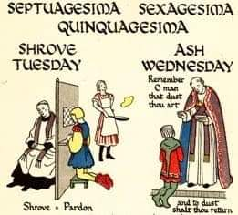
lllllllllllllllllllllllllll.
Dear Church Family,
We would like to sincerely thank you for the cards and gifts given to us this past Christmas season. We were very touched by your generosity and kindness.
We are truly blessed to be part of this congregation.
In Christian love,
Pastor & Ana Deal, Isaiah, Titus, and Loretta

