Sts. Peter & Paul
Evangelical Lutheran Church
Lutheran Church-Missouri Synod
Founded-1917

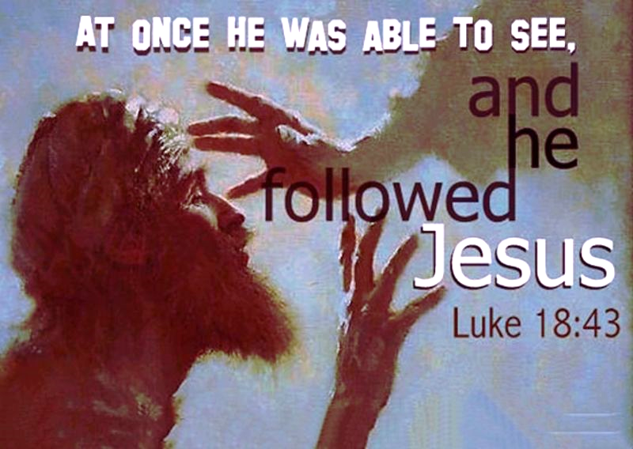

February 19, 2023

699 Stambaugh Avenue
Sharon, Pennsylvania 16146

“I was glad when they said to me,
Let us go to the house of the LORD!”
Psalm 122:1
Sts. Peter & Paul Evangelical Lutheran Church, LC-MS
QUINQUAGESIMA
February 19, 2023

A special welcome to our guests this day! If you would like more information about The Lutheran Church - Missouri Synod, or this congregation, please speak with Pastor Deal or an Elder after the service.
Members & Guests: Don’t be embarrassed if your children make noise during the worship service, all children do. We encourage families to worship together but, if you feel the need, there are pews in the rear of the Church which are reserved for young families on both sides of the sanctuary. There is also a quiet room available to you during our service which is located down the hallway past the offices on the right side of the church as well as a children’s area in the Fellowship Hall where you are able to follow along with the service.

Today’s service includes the Sacrament of Holy Communion. If during this past year, you have not worshipped with us and been communed, we respectfully ask that you do not partake of this sacrament this day before first speaking with Pastor Deal.
If visiting from a sister congregation of the LC-MS and are in good standing, please inform Pastor Deal of your desire to commune prior to the service.
If wishing to receive a blessing during communion, please approach with your arms crossed.

CONTACT INFORMATION
Pastor Deal: pastordeal@saintspeterandpaul.net or 724-347-3620 (opt. 2)
Church Office: church@saintspeterandpaul.net or 724-347-3620 (opt. 3)

Silent prayer before worship: Heavenly Father, You sent Your only Son Jesus to wash away my sins and to give me eternal life. Open my heart this day, so that I can receive Your Word and Sacrament and be assured of Your gracious love. In Jesus’ name. Amen.

Confession and Absolution

Opening Hymn: LSB #504 “Father Most Holy”

The sign of the cross may be made by all in remembrance of their Baptism.

Invocation
P In the name of the Father and of the T Son and of the Holy Spirit.
C Amen.

Exhortation Hebrews 10:22; Psalm 124:8; Psalm 32:5
P Beloved in the Lord! Let us draw near with a true heart and confess our sins unto God our Father, beseeching Him in the name of our Lord Jesus Christ to grant us forgiveness.

P Our help is in the name of the Lord,
C who made heaven and earth.
P I said, I will confess my transgressions unto the Lord,
C and You forgave the iniquity of my sin.

Silence for reflection on God’s Word and for self-examination.

Confession of Sins
P O almighty God, merciful Father,
C I, a poor, miserable sinner, confess unto You all my sins and iniquities with which I have ever offended You and justly deserved Your temporal and eternal punishment. But I am heartily sorry for them and sincerely repent of them, and I pray You of Your boundless mercy and for the sake of the holy, innocent, bitter sufferings and death of Your beloved Son, Jesus Christ, to be gracious and merciful to me, a poor, sinful being.

Absolution [John 20:19–23]
P Upon this your confession, I, by virtue of my office, as a called and ordained servant of the Word, announce the grace of God unto all of you, and in the stead and by the command of my Lord Jesus Christ I forgive you all your sins in the name of the Father and of the T Son and of the Holy Spirit.
C Amen.
Service of the Word

Introit Psalm 31:1, 5, 9, 16; antiphon: vv. 2b–3
Be a rock of ref- | uge for me,*
a strong fortress to | save me!
For you are my rock and my | fortress;*
and for your name’s sake you lead me and | guide me.
In you, O Lord, do I take refuge; let me never be | put to shame;*
in your righteousness de- | liver me!
Into your hand I commit my | spirit;*
you have redeemed me, O Lord, | faithful God.
Be gracious to me, O Lord, for I am | in distress;*
my eye is wasted from grief; my soul and my body | also.
Make your face shine on your | servant;*
save me in your | steadfast love!
Glory be to the Father and | to the Son*
and to the Holy | Spirit;
as it was in the be- | ginning,*
is now, and will be forever. | Amen.

Kyrie Mark 10:47
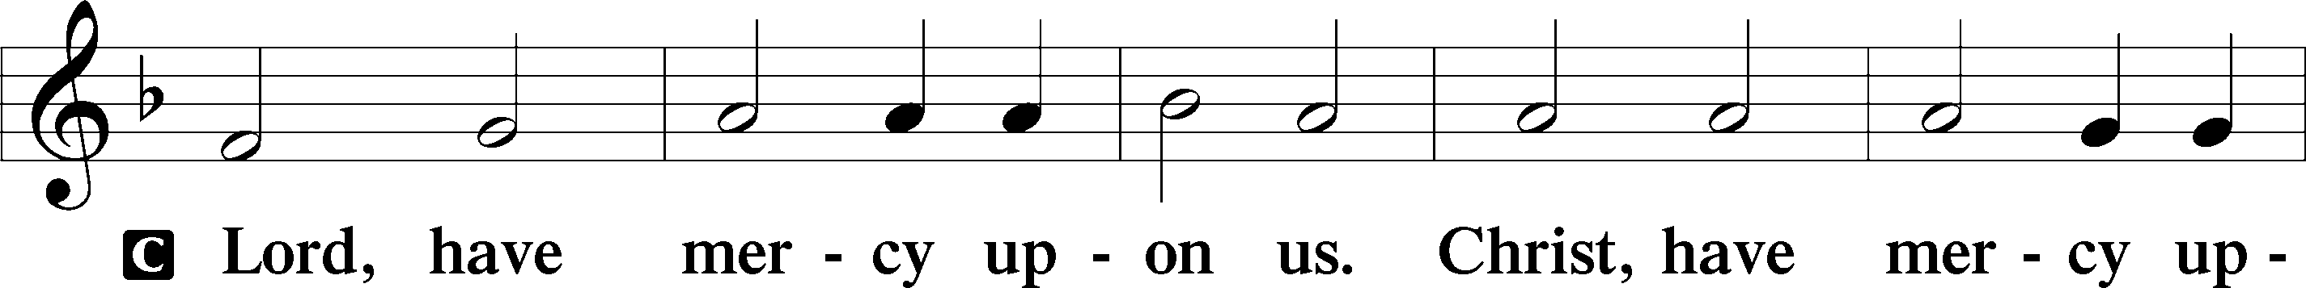
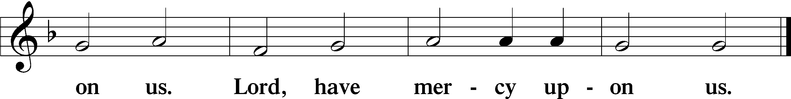
Salutation and Collect of the Day: Quinquagesima
P The Lord be with you.
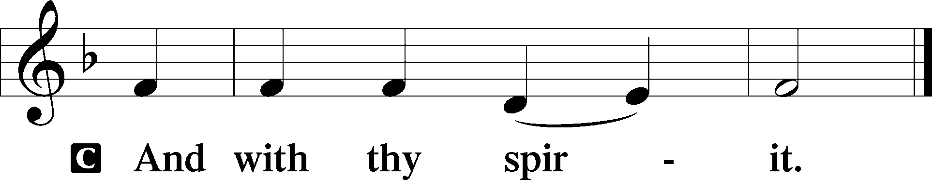

P Let us pray.
O Lord, mercifully hear our prayers and having set us free from the bonds of our sins deliver us from every evil; through Jesus Christ, Your Son, our Lord, who lives and reigns with You and the Holy Spirit, one God, now and forever.
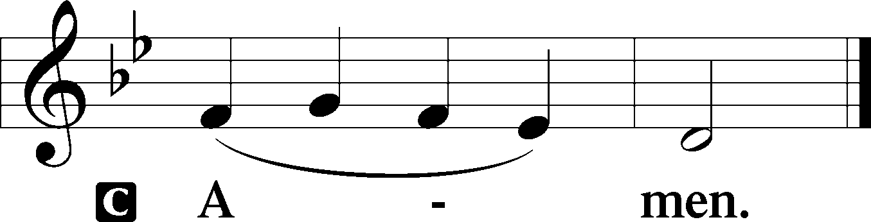
Sit

Prophecy: 1 Samuel 16:1–13
In those days: The Lord said to Samuel, “How long will you mourn for Saul, seeing I have rejected him from reigning over Israel? Fill your horn with oil, and go; I am sending you to Jesse the Bethlehemite. For I have provided Myself a king among his sons.” And Samuel said, “How can I go? If Saul hears it, he will kill me.” But the Lord said, “Take a heifer with you, and say, ‘I have come to sacrifice to the Lord.’ Then invite Jesse to the sacrifice, and I will show you what you shall do; you shall anoint for Me the one I name to you.” So Samuel did what the Lord said, and went to Bethlehem. And the elders of the town trembled at his coming, and said, “Do you come peaceably?” And he said, “Peaceably; I have come to sacrifice to the Lord. Sanctify yourselves, and come with me to the sacrifice.” Then he consecrated Jesse and his sons, and invited them to the sacrifice. So it was, when they came, that he looked at Eliab and said, “Surely the Lord’s anointed is before Him!” But the Lord said to Samuel, “Do not look at his appearance or at his physical stature, because I have refused him. For the Lord does not see as man sees; for man looks at the outward appearance, but the Lord looks at the heart.” So Jesse called Abinadab, and made him pass before Samuel. And he said, “Neither has the Lord chosen this one.” Then Jesse made Shammah pass by. And he said, “Neither has the Lord chosen this one.” Thus Jesse made seven of his sons pass before Samuel. And Samuel said to Jesse, “The Lord has not chosen these.” And Samuel said to Jesse, “Are all the young men here?” Then he said, “There remains yet the youngest, and there he is, keeping the sheep.” And Samuel said to Jesse, “Send and bring him. For we will not sit down till he comes here.” So he sent and brought him in. Now he was ruddy, with bright eyes, and good-looking. And the Lord said, “Arise, anoint him; for this is the one!” Then Samuel took the horn of oil and anointed him in the midst of his brothers; and the Spirit of the Lord came upon David from that day forward. So Samuel arose and went to Ramah.

P This is the Word of the Lord.
C Thanks be to God.

Gradual Psalm 77:14–15
You are the God who works | wonders;*
you have made known your might among the | peoples.
You with your arm redeemed your | people,*
the children of Jacob and | Joseph.

Epistle: 1 Corinthians 13:1–13
Brethren: Though I speak with the tongues of men and of angels, but have not love, I have become sounding brass or a clanging cymbal. And though I have the gift of prophecy, and understand all mysteries and all knowledge, and though I have all faith, so that I could remove mountains, but have not love, I am nothing. And though I bestow all my goods to feed the poor, and though I give my body to be burned, but have not love, it profits me nothing. Love suffers long and is kind; love does not envy; love does not parade itself, is not puffed up; does not behave rudely, does not seek its own, is not provoked, thinks no evil; does not rejoice in iniquity, but rejoices in the truth; bears all things, believes all things, hopes all things, endures all things. Love never fails. But whether there are prophecies, they will fail; whether there are tongues, they will cease; whether there is knowledge, it will vanish away. For we know in part and we prophesy in part. But when that which is perfect has come, then that which is in part will be done away. When I was a child, I spoke as a child, I understood as a child, I thought as a child; but when I became a man, I put away childish things. For now we see in a mirror, dimly, but then face to face. Now I know in part, but then I shall know just as I also am known. And now abide faith, hope, love, these three; but the greatest of these is love.

P This is the Word of the Lord.
C Thanks be to God.

Stand

Holy Gospel: Luke 18:31–43
P The Holy Gospel according to St. Luke, the eighteenth chapter.
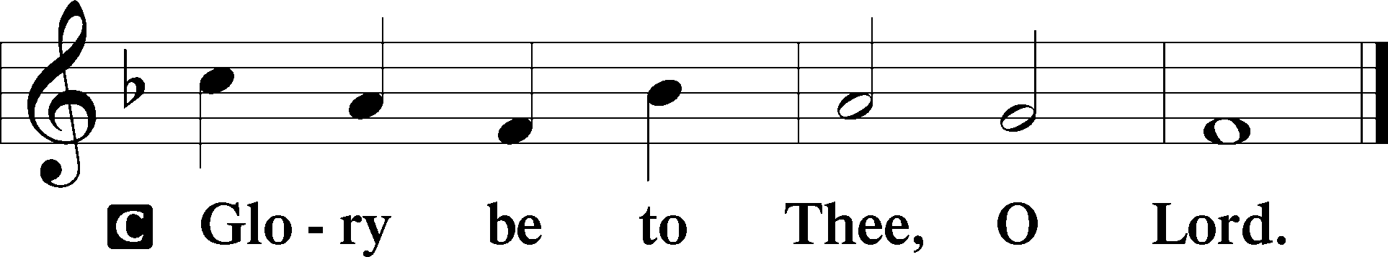

At that time: Jesus took the twelve aside and said to them, “Behold, we are going up to Jerusalem, and all things that are written by the prophets concerning the Son of Man will be accomplished. For He will be delivered to the Gentiles and will be mocked and insulted and spit upon. They will scourge Him and kill Him. And the third day He will rise again.” But they understood none of these things; this saying was hidden from them, and they did not know the things which were spoken. Then it happened, as He was coming near Jericho, that a certain blind man sat by the road begging. And hearing a multitude passing by, he asked what it meant. So they told him that Jesus of Nazareth was passing by. And he cried out, saying, “Jesus, Son of David, have mercy on me!” Then those who went before warned him that he should be quiet; but he cried out all the more, “Son of David, have mercy on me!” So Jesus stood still and commanded him to be brought to Him. And when he had come near, He asked him, saying, “What do you want Me to do for you?” He said, “Lord, that I may receive my sight.” Then Jesus said to him, “Receive your sight; your faith has saved you.” And immediately he received his sight, and followed Him, glorifying God. And all the people, when they saw it, gave praise to God.

P This is the Gospel of the Lord.
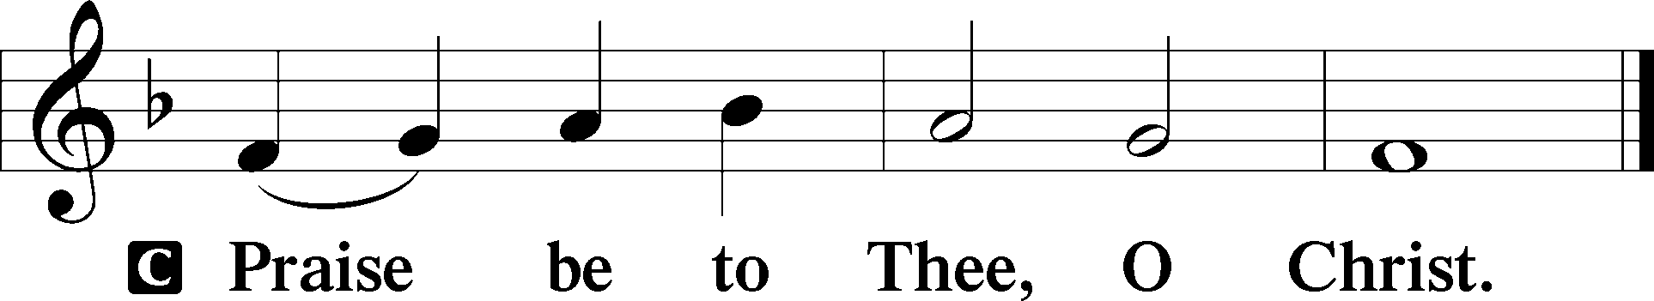

Nicene Creed
C I believe in one God,
the Father Almighty,
maker of heaven and earth
and of all things visible and invisible.
And in one Lord Jesus Christ,
the only-begotten Son of God,
begotten of His Father before all worlds,
God of God, Light of Light,
very God of very God,
begotten, not made,
being of one substance with the Father,
by whom all things were made;
who for us men and for our salvation came down from heaven
and was incarnate by the Holy Spirit of the virgin Mary
and was made man;
and was crucified also for us under Pontius Pilate.
He suffered and was buried.
And the third day He rose again according to the Scriptures
and ascended into heaven
and sits at the right hand of the Father.
And He will come again with glory to judge both the living and the dead,
whose kingdom will have no end.

And I believe in the Holy Spirit,
the Lord and giver of life,
who proceeds from the Father and the Son,
who with the Father and the Son together is worshiped and glorified,
who spoke by the prophets.
And I believe in one holy Christian and apostolic Church,
I acknowledge one Baptism for the remission of sins,
and I look for the resurrection of the dead
and the life T of the world to come. Amen.
Sit

Hymn of the Day: TLH #353 “Lord Jesus Christ, My Savior Blest”
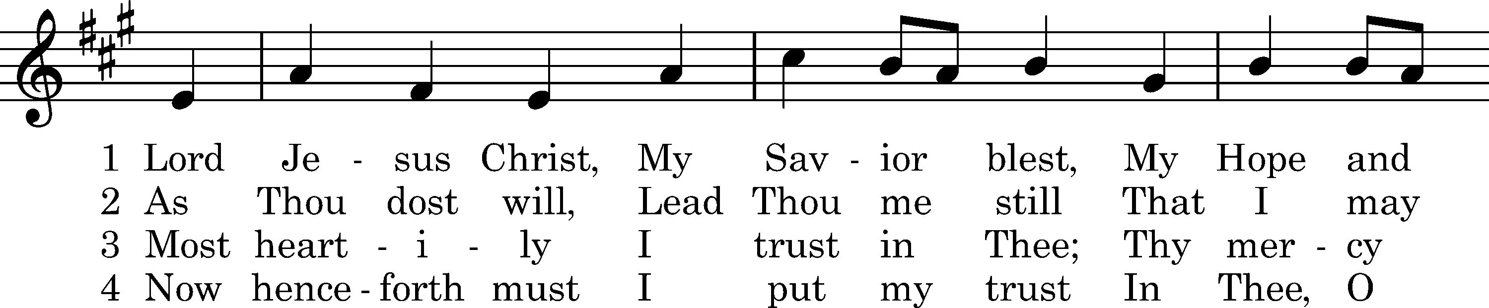
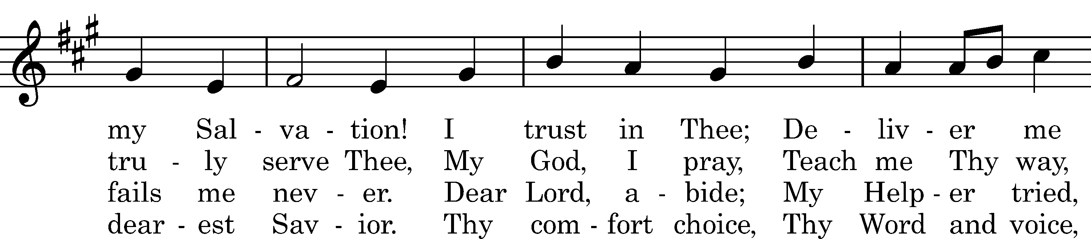
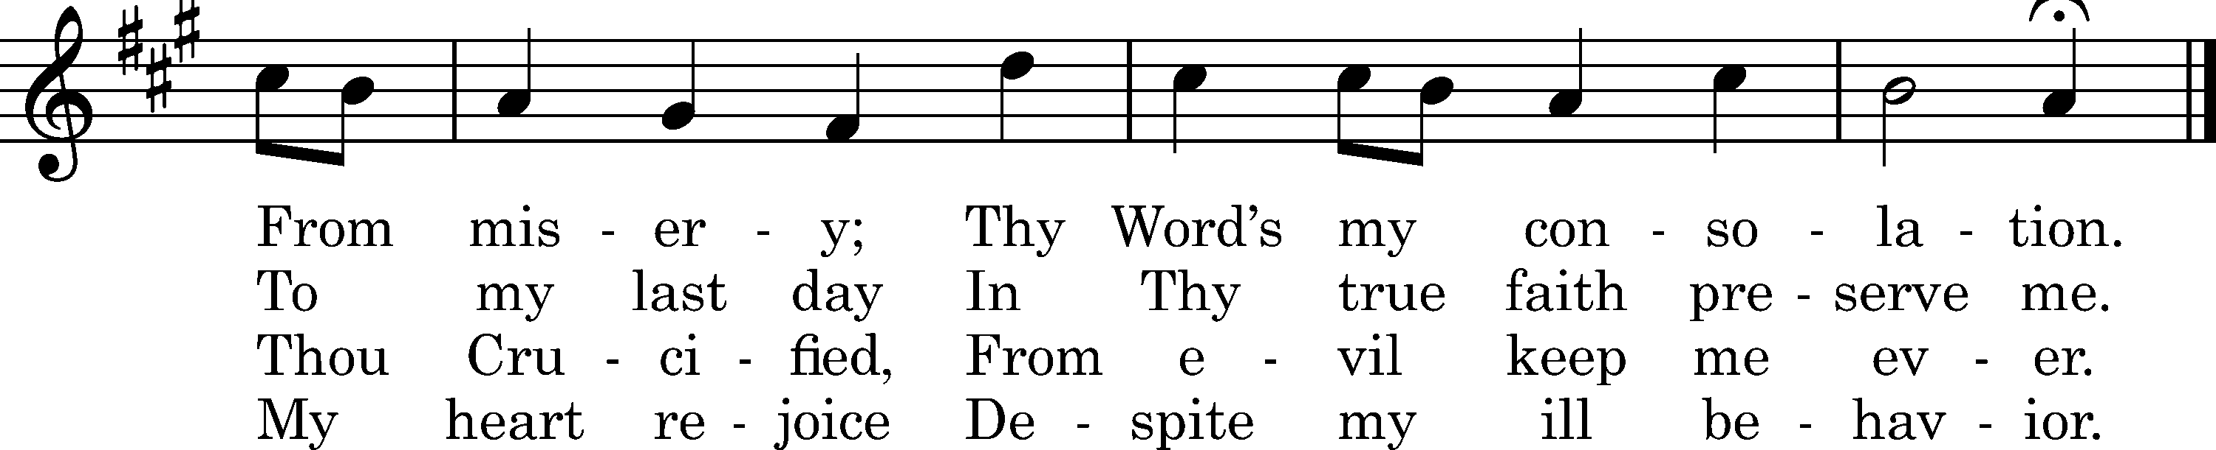

5 When sorrows rise,
My refuge lies
In Thy compassion tender.
Within Thine arm
Can naught alarm;
Keep me from harm,
Be Thou my strong Defender.

6 I have Thy Word,
Christ Jesus, Lord;
Thou never wilt forsake me.
This will I plead
In time of need.
Oh, help me speed
When troubles overtake me!

7 Grant, Lord, I pray,
Thy grace each day
That I, Thy Law revering,
May live with Thee
And happy be
Eternally,
Before Thy throne appearing.
Text: tr. Harriet R. Spaeth, 1898; Hans C. Sthen, c. 1500
Tune: Ludvig M. Lindeman, 1971
Text and tune: Public domain

Sermon

Stand

Prayer of the Church

Offertory Psalm 51:10–12
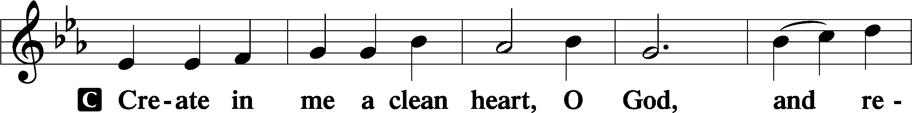
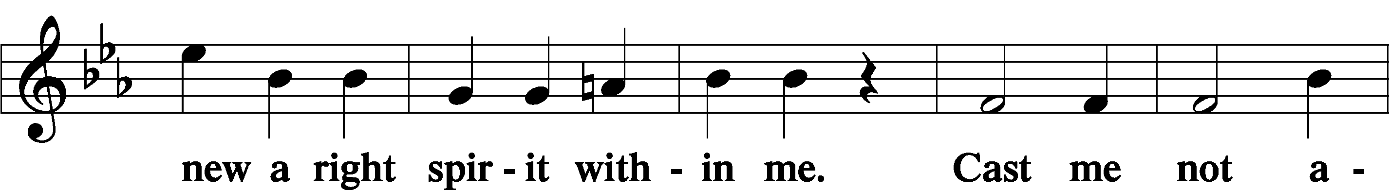
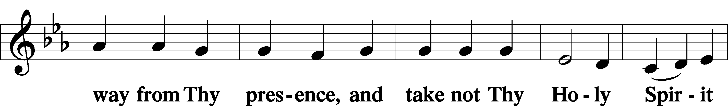
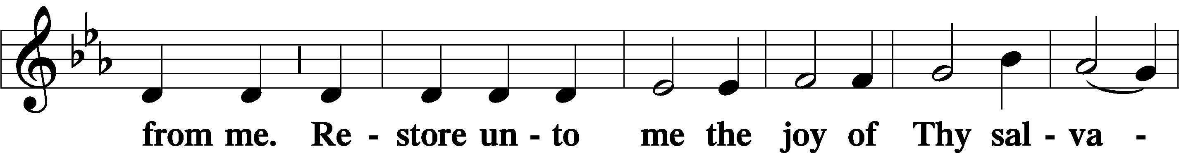
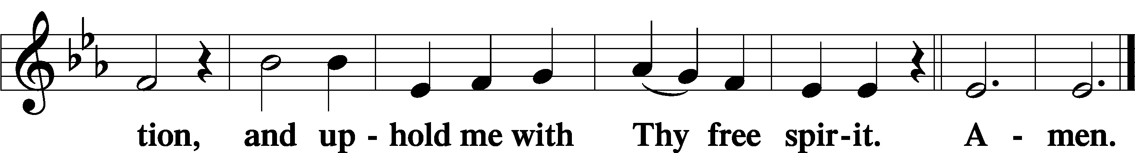
Sit

Preparatory Hymn: LSB #688 “’Come, Follow Me,’ the Savior Spake”

Stand

Service of the Sacrament

Preface 2 Timothy 4:22; Colossians 3:1 Psalm 136
P The Lord be with you.
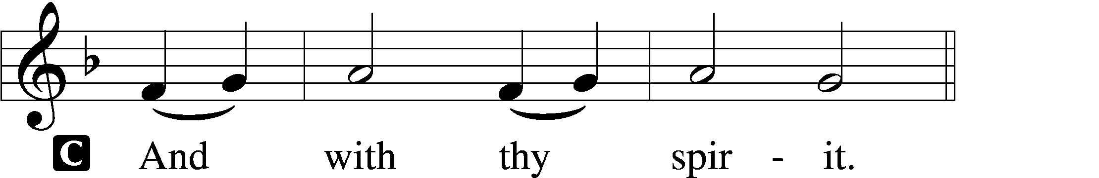

P Lift up your hearts.
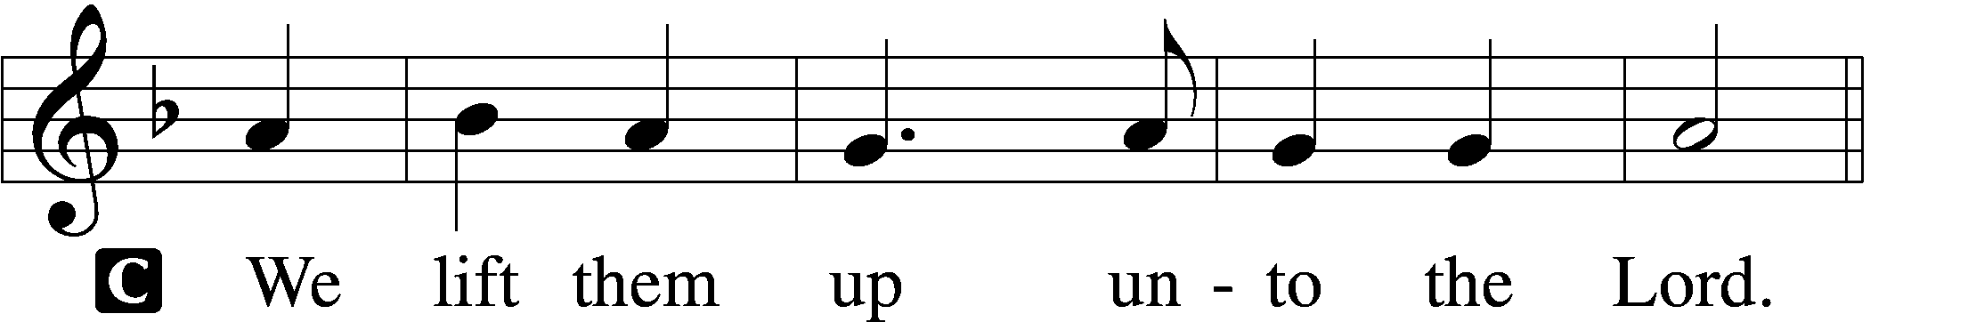

P Let us give thanks unto the Lord, our God.
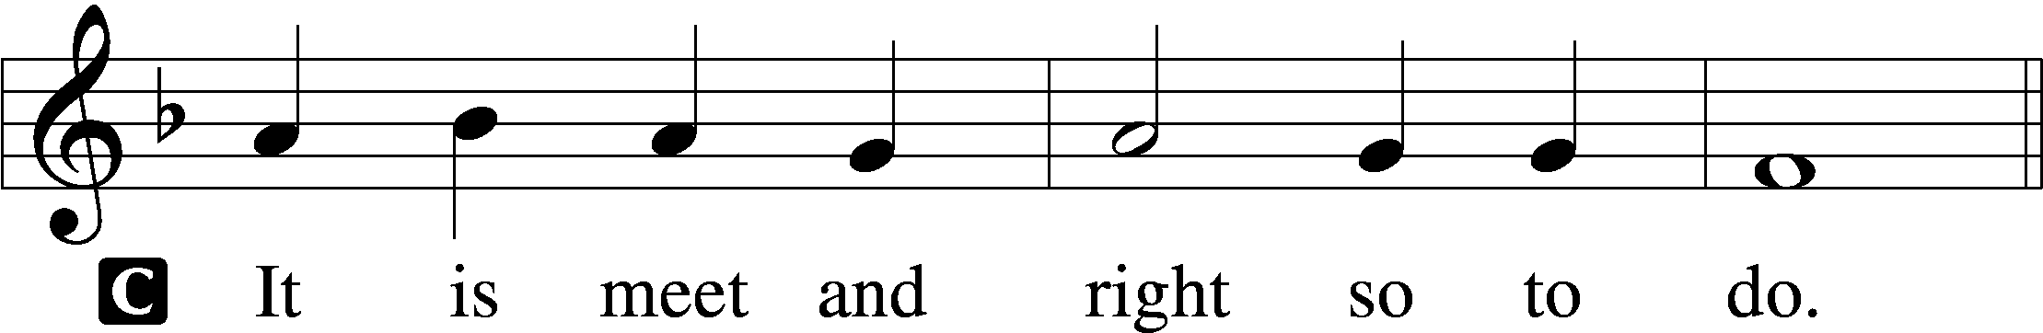

Proper Preface (Abbreviated) LSB 194
P It is truly meet, right, and salutary . . . evermore praising You and saying:

Sanctus Isaiah 6:3; Matthew 21:9
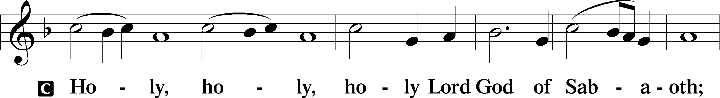
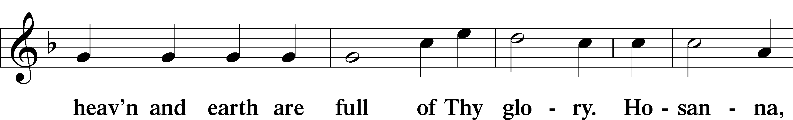
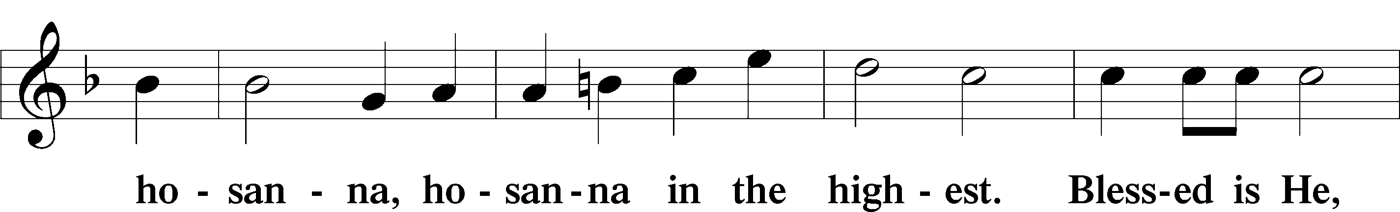
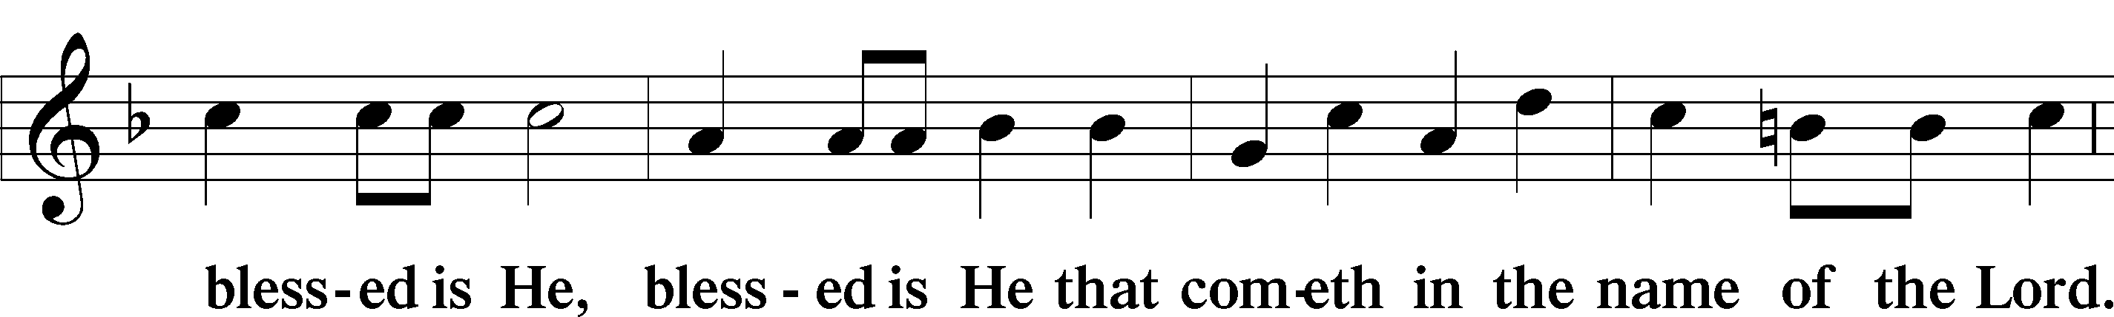
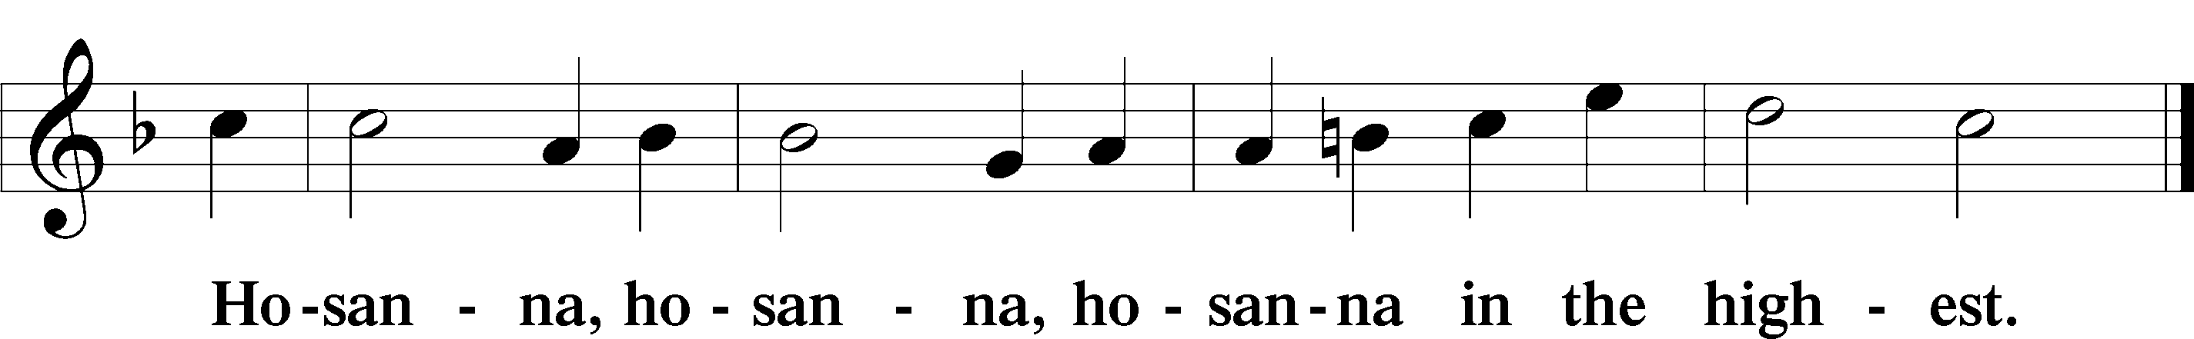

Lord’s Prayer Matthew 6:9–13
C Our Father who art in heaven,
hallowed be Thy name,
Thy kingdom come,
Thy will be done on earth as it is in heaven;
give us this day our daily bread;
and forgive us our trespasses as we forgive those who trespass against us;
and lead us not into temptation,
but deliver us from evil.
For Thine is the kingdom and the power and the glory forever and ever. Amen.

The Words of Our Lord Matthew 26:26–28; Mark 14:22–24; Luke 22:19–20; 1 Corinthians 11:23–25
P Our Lord Jesus Christ, on the night when He was betrayed, took bread, and when He had given thanks, He broke it and gave it to the disciples and said: “Take, eat; this is My T body, which is given for you. This do in remembrance of Me.”

In the same way also He took the cup after supper, and when He had given thanks, He gave it to them, saying: “Drink of it, all of you; this cup is the new testament in My T blood, which is shed for you for the forgiveness of sins. This do, as often as you drink it, in remembrance of Me.”

Pax Domini John 20:19
P The peace of the Lord be with you always.
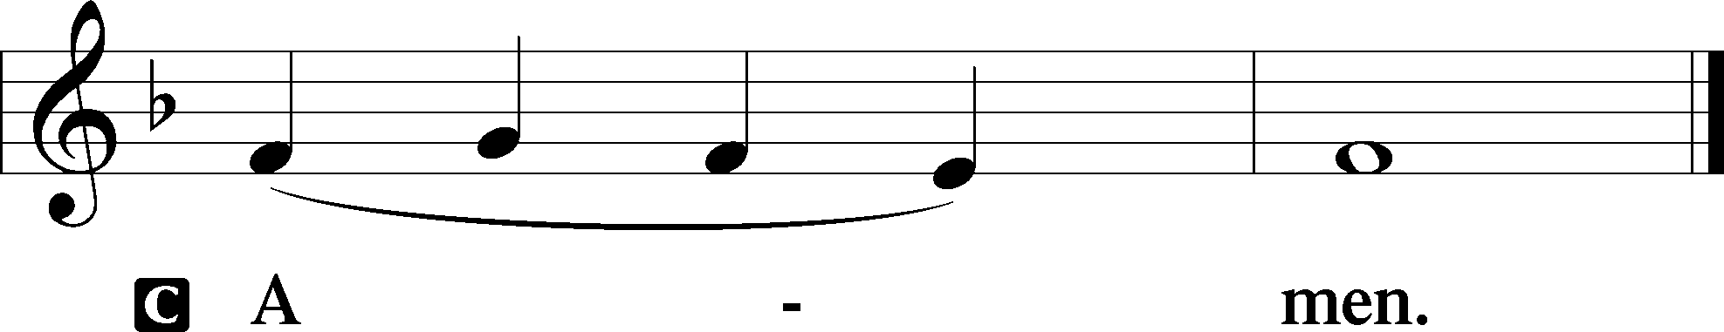

Agnus Dei John 1:29
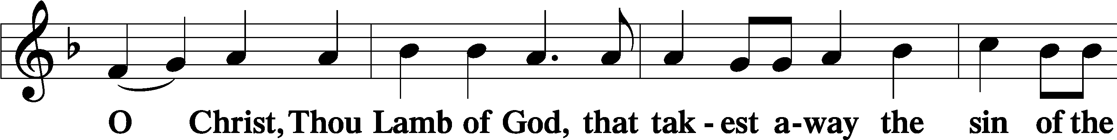
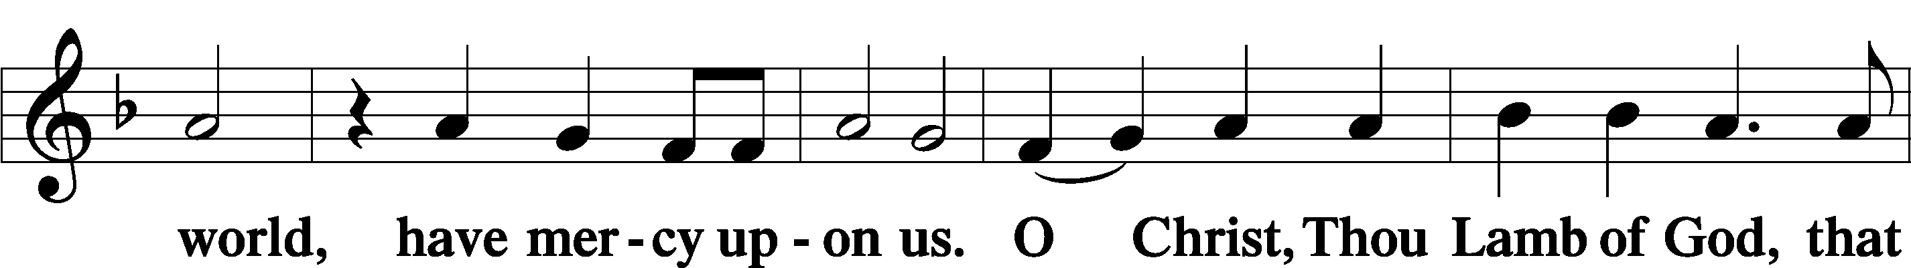
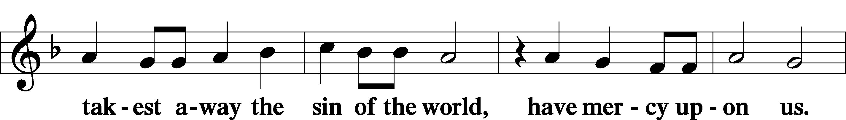
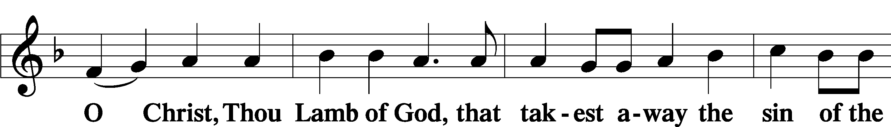
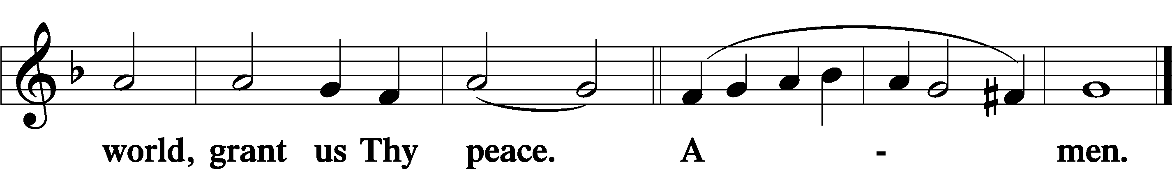
Sit
Distribution
The pastor and those who assist him receive the body and blood of Christ first and then distribute them to those who come to receive, saying:
Take, eat; this is the true body of our Lord and Savior Jesus Christ, given into death for your sins.
Amen.

Take, drink; this is the true blood of our Lord and Savior Jesus Christ, shed for the forgiveness of your sins.
Amen.

In dismissing the communicants, the following is said:
The Dismissal
P The body and blood of our Lord Jesus Christ strengthen and preserve you in body and soul to life everlasting. Depart T in peace.
C Amen.

Distribution Hymn: TLH #165 “Behold the Lamb of God!”
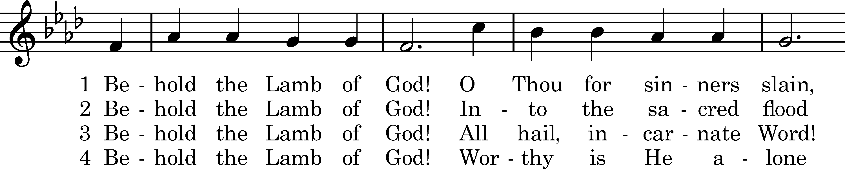
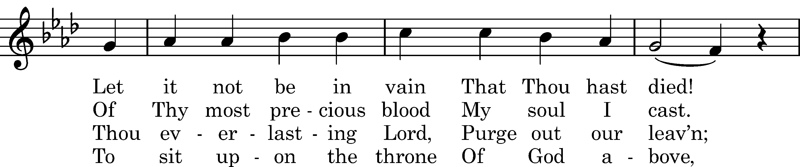
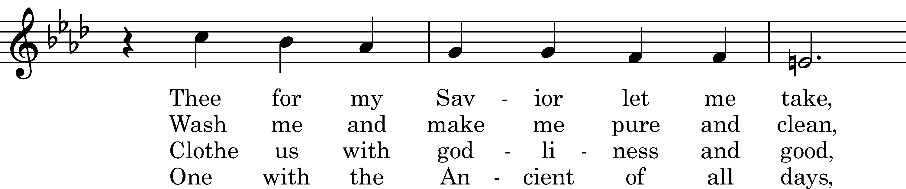
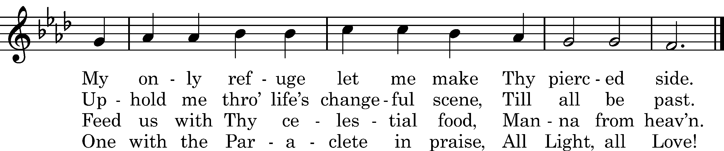
Text: Matthew Bridges, 1848, alt.
Tune: Neues Gesangbuch, Dresden, 1593
Text and tune: Public domain

Distribution Hymn: LSB #706 “Love in Christ Is Strong and Living”

Distribution Hymn: LSB #685 “Let Us Ever Walk with Jesus”

Stand

Nunc Dimittis Luke 2:29–32
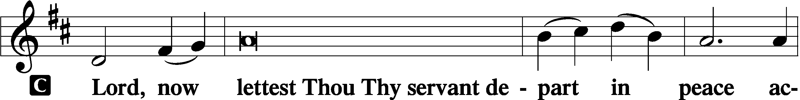
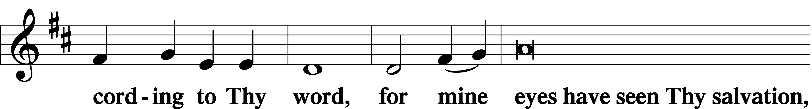
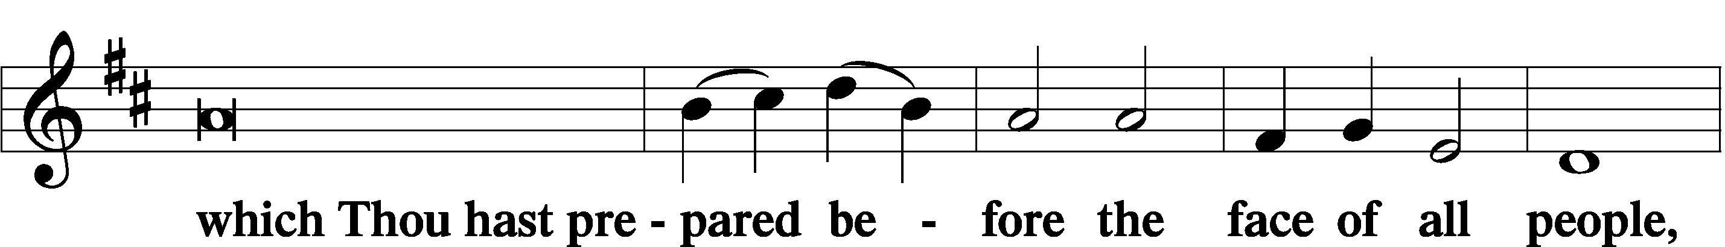
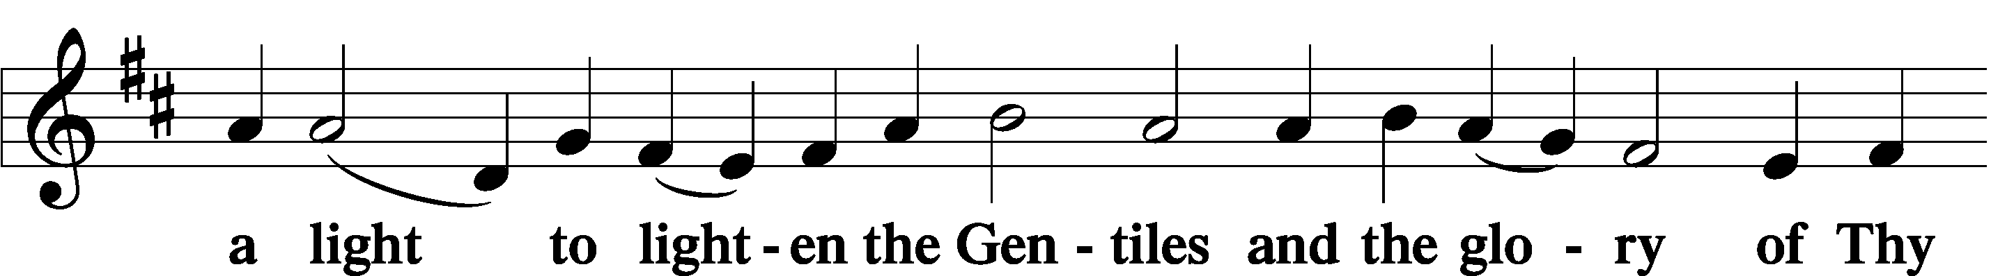
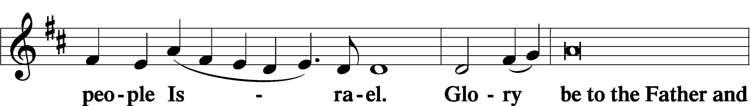
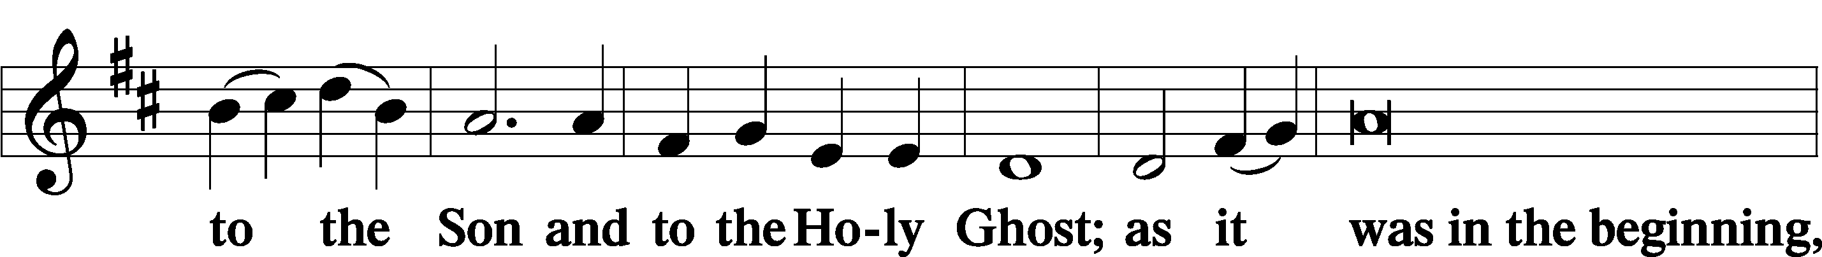
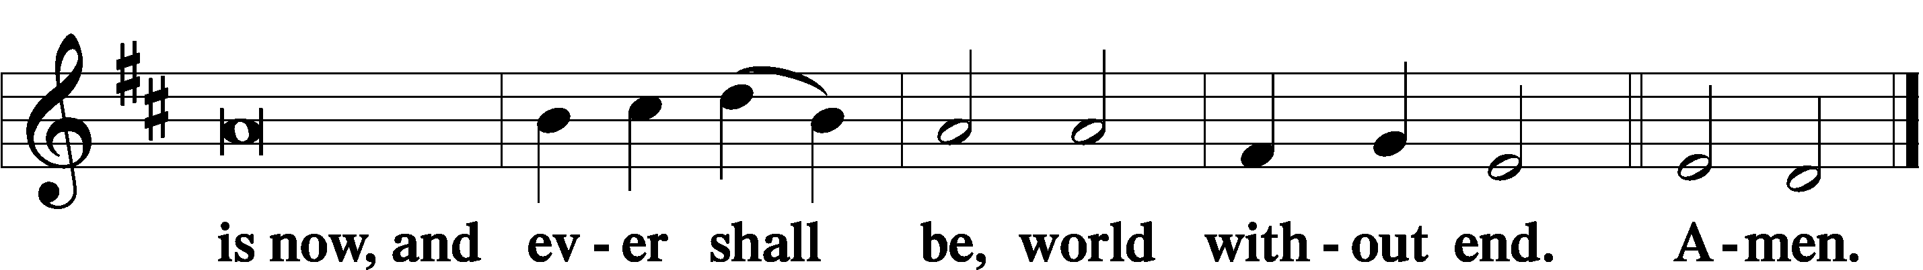

Thanksgiving Psalm 107:1
P O give thanks unto the Lord, for He is good,
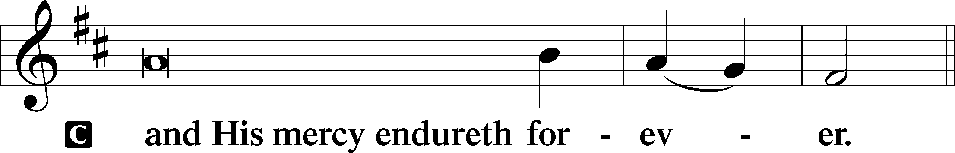

Post-Communion Collect
P Let us pray.
We give thanks to You, almighty God, that You have refreshed us through this salutary gift, and we implore You that of Your mercy You would strengthen us through the same in faith toward You and in fervent love toward one another; through Jesus Christ, Your Son, our Lord, who lives and reigns with You and the Holy Spirit, one God, now and forever.
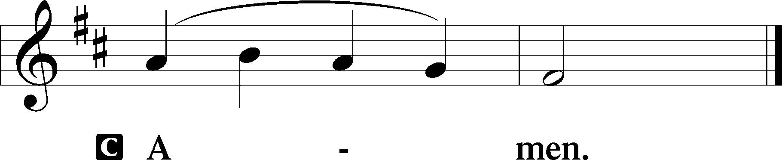

Salutation 2 Timothy 4:22
P The Lord be with you.
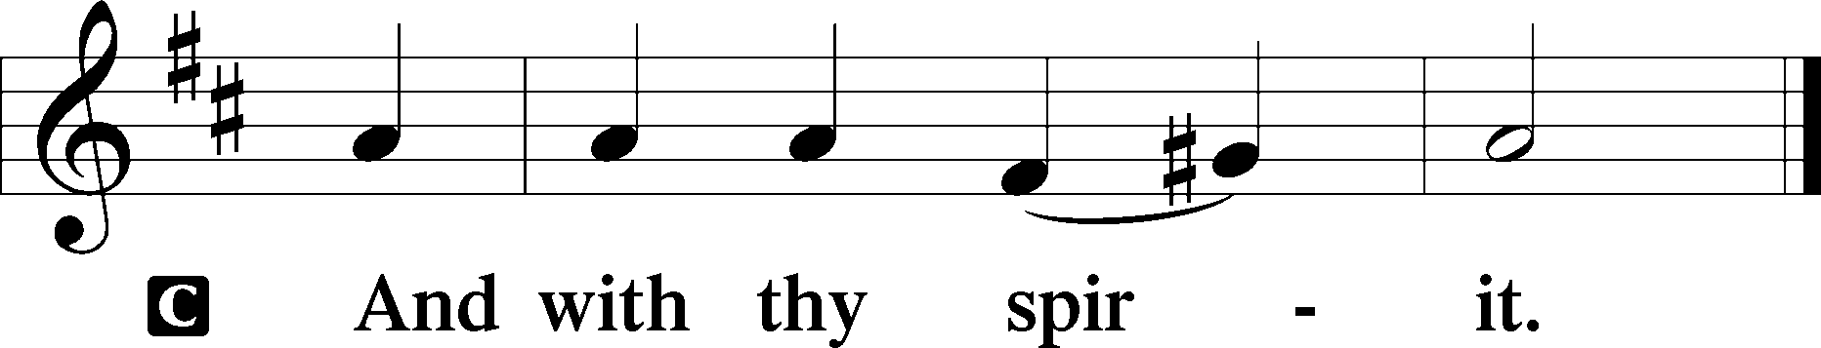

Benedicamus Psalm 103:1
P Bless we the Lord.
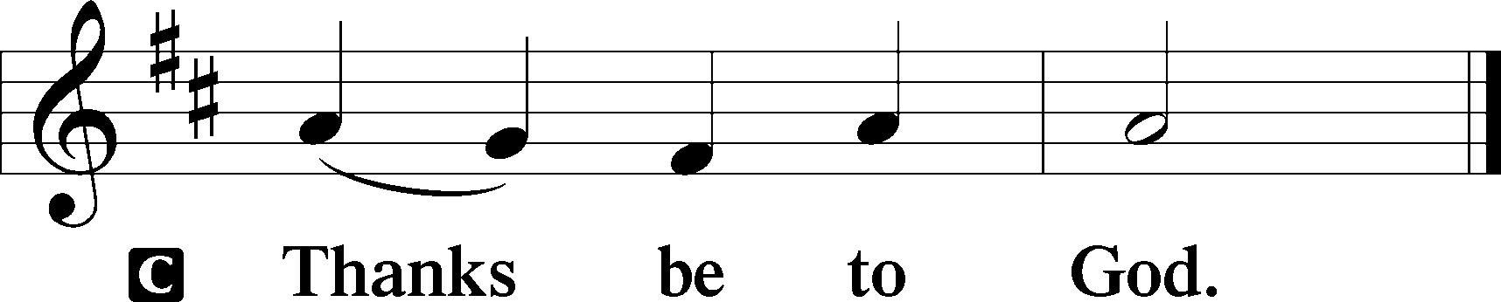

Benediction Numbers 6:24–26
P The Lord bless you and keep you.
The Lord make His face shine upon you and be gracious unto you.
The Lord lift up His countenance upon you and T give you peace.
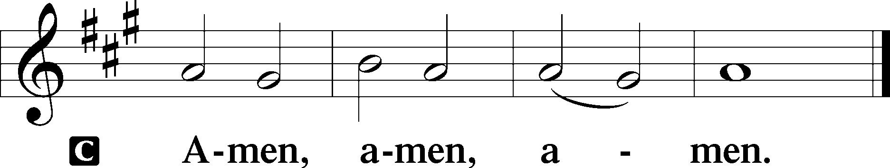

Closing Hymn: LSB #661 “The Son of God Goes Forth to War”

Silent prayer after worship: Lord Jesus, as I go forth from this worship service, cause me to remember Your great love for me and all people. Give me boldness and faith to share Your love with others through my words and deeds. Amen.
fffffffffffffffffffffffffffffffffff
Acknowledgments: Unless otherwise indicated, Scripture quotations are from the ESV® Bible (The Holy Bible, English Standard Version®), copyright © 2001 by Crossway, a publishing ministry of Good News Publishers. Used by permission. All rights reserved.
Created by Lutheran Service Builder © 2021 Concordia Publishing House.
fffffffffffffffffffffffffffffffffff

fffffffffffffffffffffffffffffffffff
In Loving Memory of Ernie Meszaros: Rev. Ed & Irene Kucera (Food Pantry).
In Loving Memory of Parents, Michael & Eva Dorfi: Edeltraud Sulek (Capital Campaign).
fffffffffffffffffffffffffffffffffff
SCHEDULE THROUGH FEBRUARY 26, 2023:

:

Today, following Worship, Library: Audit of Deposits
7 pm, Fellowship Hall: AA Meeting
Tuesday, 7-9 pm, Fellowship Hall: Penn-Ohio Singers
Wednesday, 5:30 pm, Sanctuary: Choir Practice
7 pm, Sanctuary: Ash Wednesday Divine Service
7:30 pm, Fellowship Hall: NA Meeting
Thursday, 9 am, Downstairs: Food Pantry
Next Sunday, 8 am, Fellowship Hall: Bible Study
9 am, Sanctuary: Divine Service
7 pm, Fellowship Hall: AA Meeting
fffffffffffffffffffffffffffffffffff
Attendance: Sunday, February 12, 2023: 46
fffffffffffffffffffffffffffffffffff
THANK YOU FOR SERVING IN FEBRUARY: Elder: Jonathan Baisch; Ushers: Matt Berent, Mark Gabriel, Michael Laird, and Jerome Thomas; Altarware: Marie Flaugher (prior) and Cheryl Fedele & Clara Krivosh (after).
fffffffffffffffffffffffffffffffffff
Bible Memory Verses ~ Week of February 19th:
For Adults: You shall love your neighbor as yourself. Mark 12:31

For Children: See, we are going up to Jerusalem, and everything that is written about the Son of Man by the prophets will be accomplished. Luke 18:31
fffffffffffffffffffffffffffffffffff
Altar Guild members are reminded that 2023 dues should be paid to Treasurer, Evelyn Baisch. If paying by check, please make it out to Sts. Peter & Paul’s.
fffffffffffffffffffffffffffffffffff
Our Stewardship of Treasures for the Lord:
In order to do the Lord’s work, we need $2,553.63 each week to meet our 2023 budget for general purposes and $76.92 for the SELC.
Figures for Sunday, February 12, 2023
General Fund: $1,136.00 Behind for the week: -$1,417.63
SELC: $50.00 Behind for the week: -$26.92
Food Pantry: $80.00
Capital Campaign: $395.00
Other: $825.00

For online giving, check out https://www.saintspeterandpaul.net/online-giving.
fffffffffffffffffffffffffffffffffff
Copies of the 2023 Lenten Devotions, “Given and Shed for You”, are available in the narthex and on the table next to Pastor Deal’s office. These devotions correspond to the lessons of the mid-week Lenten services which we will be observing beginning with our Ash Wednesday service, February 22nd at 7 pm. Feel free to take a copy for a friend and invite them to join you in worship this Lenten season.
fffffffffffffffffffffffffffffffffff
Be certain to pick up your copy of the brochure “Almsgiving, Praying, Fasting” which Pastor Deal prepared for the Lenten season. Copies are available both in the narthex and on the table next to Pastor Deal’s office.
fffffffffffffffffffffffffffffffffff
Items for the March issue of the newsletter and calendar are due to Diane no later than noon, tomorrow, February 20th.
fffffffffffffffffffffffffffffffffff

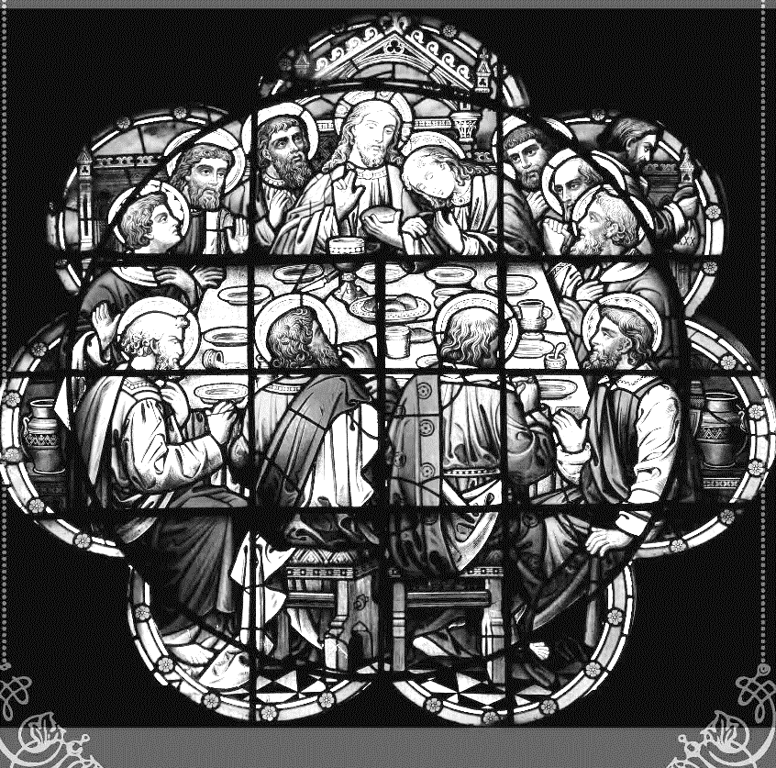
Join us this Lenten season as we focus on the Lord’s Supper with the following services: Ash Wednesday Divine Service (February 22nd at 7 pm) and Wednesday Mid-week Lenten Services (Matins Service at noon and Vesper’s Service at 7 pm) March 1st – 29th.

fffffffffffffffffffffffffffffffffff

Remember the following in Prayer…
~The Hurting and Healing: The family and friends of Ernest Meszaros, who passed away Tuesday, January 31, 2023; also Amy, Gerald Arthur, Evelyn Baisch, Ellen Baron^{CA}, Lois Bortner^{CA}, John Burdette, Bev & Joe Chlpka, Kathleen Coughenour, Kim, Anna Mae Daris, Susan Davies, Tim Dudash, Millie Elavsky, Joseph Fleet, Judith & Eddy Furey, Tim Haenftling, Austin Hamilton, Anson Holcroft, Neil Huston, Darla Krajci, Barbara Kreske, Donna Kennedy, Jess Lavoie, Paul Lucas^{CA}, Sandy Marshall, David Nelson, Linda Parkany, Juanita Rentschler, Richard Reuning^{CA}, Diane Riefstahl, Nancy Robertson^{CA}, Viola Sakony, Marty Scott, Kara, Fred Tonty, Angela Weser^{CA}, and Ruth Wolf.
~The Homebound: Rudy & Jean Tomko, Betty Wolf, and Ed & Millie Zachar.
~Celebrating: Birthdays: Jennifer Russell (02.20) and Bradley Dirgo (02.21).
~Serving in the Military: Curtis Sinewe and Joshua Solyan.
~Community & World Needs: Those suffering from or affected by the coronavirus; those suffering due to the conflict between Ukraine and Russia; those suffering from loss and dislocation because weather disasters; those suffering from addiction and their families; Local, State, and National Government Leaders; safety for all Police Officers, Firefighters, & First Responders; the unemployed; our First Quarter Local Mission: Sts. Peter & Paul’s Community Day 2023.
*CA represents cancer.
fffffffffffffffffffffffffffffffffff
Thanks to so many of you for your prayers for my hip replacement surgery and recovery! God’s miracle of healing through the medical community is amazing as are His peace and presence through your prayers for me! I am doing well and hope to return to church soon. My husband has been doing worship services and Bible classes at Gethsemane Lutheran near our home while they are in the process of calling another pastor. I have been attending with him since I’m not driving yet.
Thanks again and God’s blessings –
Evelyn Baisch
fffffffffffffffffffffffffffffffffff
Choir practice resumes this Wednesday evening at 5:30 pm. If interested in singing, but unable to attend, please contact Chris Nelson.
Here to Serve

Pastor………………………………………………...……………Rev. Jacob Deal
E-mail …………………………….……pastordeal@saintspeterandpaul.net
Phone Number……………………..…………………724-347-3620 (Option 2)
Church Office………………………..…………………724-347-3620 (Option 3)
Website …………………………………………www.saintspeterandpaul.net
Secretary…………………………………………………………Diane Riefstahl
E-mail ………………………………………church@saintspeterandpaul.net
Website …………………………………………www.saintspeterandpaul.net
Food Pantry: Please leave message……………724-347-3620 (Option 3)
AA Contact: Steve………………………………………………..…724-813-2358
NA Contact: Larry………………………………………………..724-977-8733
Choir Director………………………………………………………Chris Nelson
Congregation President……………………………………Jonathan Baisch
Church Elder …………………………………………...…… Jonathan Baisch
fffffffffffffffffffffffffffffffffff
If needing to get into the church building during the week, please phone first to make certain someone is here to let you in.

