Sts. Peter & Paul
Evangelical Lutheran Church
Lutheran Church-Missouri Synod
Founded-1917

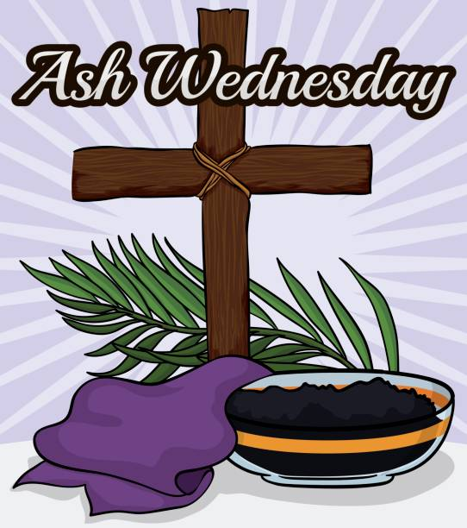

February 14, 2024

699 Stambaugh Avenue
Sharon, Pennsylvania 16146

“I was glad when they said to me,
Let us go to the house of the LORD!”
Psalm 122:1
Sts. Peter & Paul Evangelical Lutheran Church, LC-MS
Ash Wednesday
February 14, 2024

A special welcome to our guests this day! If you would like more information about The Lutheran Church - Missouri Synod, or this congregation, please speak with Pastor Deal or an Elder after the service.
Members & Guests: Don’t be embarrassed if your children make noise during the worship service, all children do. We encourage families to worship together but, if you feel the need, there are pews in the rear of the Church which are reserved for young families on both sides of the sanctuary. There is also a quiet room available to you during our service which is located down the hallway past the offices on the right side of the church as well as a children’s area in the Fellowship Hall where you are able to follow along with the service.

Today’s service includes the Sacrament of Holy Communion. If during this past year, you have not worshipped with us and been communed, we respectfully ask that you do not partake of this sacrament this day before first speaking with Pastor Deal.
If visiting from a sister congregation of the LC-MS and are in good standing, please inform Pastor Deal of your desire to commune prior to the service.
If wishing to receive a blessing during communion, please approach with your arms crossed.

CONTACT INFORMATION
Pastor Deal: pastordeal@saintspeterandpaul.net or 724-347-3620 (opt. 2)
Church Office: church@saintspeterandpaul.net or 724-347-3620 (opt. 3)
Secretary’s Office: The office will be open Tuesday and Thursday (8:30 am – 4:30 pm).

Silent prayer before worship: Heavenly Father, You sent Your only Son Jesus to wash away my sins and to give me eternal life. Open my heart this day, so that I can receive Your Word and Sacrament and be assured of Your gracious love. In Jesus’ name. Amen.
ASH WEDNESDAY ADDRESS
Stand

P Dear brothers and sisters of our Lord Jesus Christ, on this day the Church begins a holy season of prayerful and penitential reflection. Our attention is especially directed to the holy sufferings and death of our Lord Jesus Christ.

From ancient times the season of Lent has been kept as a time of special devotion, self-denial, and humble repentance born of a faithful heart that dwells confidently on His Word and draws from it life and hope.

Let us pray that our dear Father in heaven, for the sake of His beloved Son and in the power of His Holy Spirit, might richly bless this Lententide for us so that we may come to Easter with glad hearts and keep the feast in sincerity and truth.

Silence for reflection.

P O Lord,
C have mercy.
P O Christ,
C have mercy.
P O Lord,
C have mercy.
P O Christ,
C hear us.
P God the Father in heaven,
C have mercy.
P God the Son, Redeemer of the world,
C have mercy.
P God the Holy Spirit,
C have mercy.
P Be gracious to us.
C Spare us, good Lord.
P Be gracious to us.
C Help us, good Lord.
P By the mystery of Your holy incarnation;
by Your holy nativity;
by Your baptism, fasting, and temptation;
by Your agony and bloody sweat;
by Your cross and passion;
by Your precious death and burial;
by Your glorious resurrection and ascension;
and by the coming of the Holy Spirit, the Comforter:
C Help us, good Lord.
P In all time of our tribulation;
in all time of our prosperity;
in the hour of death;
and in the day of judgment:
C Help us, good Lord.
P We poor sinners implore You
C to hear us, O Lord.
P To prosper the preaching of Your Word;
to bless our prayer and meditation;
to strengthen and preserve us in the true faith;
and to give heart to our sorrow and strength to our repentance:
C We implore You to hear us, good Lord.
P To draw all to Yourself;
to bless those who are instructed in the faith;
to watch over and console the poor, the sick, the distressed, the lonely, the forsaken, the abandoned, and all who stand in need of our prayers;
to give abundant blessing to all works of mercy;
and to have mercy on us all:
C We implore You to hear us, good Lord.
P To turn our hearts to You;
to turn the hearts of our enemies, persecutors, and slanderers;
and graciously to hear our prayers:
C We implore You to hear us, good Lord.
P Lord Jesus Christ, Son of God,
C we implore You to hear us.
P Christ, the Lamb of God, who takes away the sin of the world,
C have mercy.
P Christ, the Lamb of God, who takes away the sin of the world,
C have mercy.
P Christ, the Lamb of God, who takes away the sin of the world,
C grant us Your peace.
P O Christ,
C hear us.
P O Lord,
C have mercy.
P O Christ,
C have mercy.
P O Lord,
C have mercy. Amen.

P O God, You desire not the death of sinners, but rather that they turn from their wickedness and live. We implore You to have compassion on the frailty of our mortal nature, for we acknowledge that we are dust and to dust we shall return. Mercifully pardon our sins that we may obtain the promises You have laid up for those who are repentant; through Jesus Christ, Your Son, our Lord, who lives and reigns with You and the Holy Spirit, one God, now and forever.
C Amen.
Sit

The pastor and assistants receive ashes first, followed by the congregation. Using the right thumb, the pastor places the ashes on the forehead of each person in the sign of the cross, saying:

Remember that you are dust, and to dust you shall return.

After receiving the ashes, each person returns to his place in silence. There is no statement of dismissal.

Hymn for Imposition of Ashes: LSB #419 “Savior, When in Dust to Thee”

After all have received the ashes, the service continues with the Service of Confession and Absolution in the Divine Service.

Confession and Absolution

Hymn: LSB #418 “O Lord, throughout These Forty Days”

Stand
The sign of the cross may be made by all in remembrance of their Baptism.

Invocation
P In the name of the Father and of the T Son and of the Holy Spirit.
C Amen.

Exhortation Hebrews 10:22; Psalm 124:8; Psalm 32:5
P Beloved in the Lord! Let us draw near with a true heart and confess our sins unto God our Father, beseeching Him in the name of our Lord Jesus Christ to grant us forgiveness.

P Our help is in the name of the Lord,
C who made heaven and earth.
P I said, I will confess my transgressions unto the Lord,
C and You forgave the iniquity of my sin.

Silence for reflection on God’s Word and for self-examination.

Confession of Sins
P O almighty God, merciful Father,
C I, a poor, miserable sinner, confess unto You all my sins and iniquities with which I have ever offended You and justly deserved Your temporal and eternal punishment. But I am heartily sorry for them and sincerely repent of them, and I pray You of Your boundless mercy and for the sake of the holy, innocent, bitter sufferings and death of Your beloved Son, Jesus Christ, to be gracious and merciful to me, a poor, sinful being.
Absolution [John 20:19–23]
P Upon this your confession, I, by virtue of my office, as a called and ordained servant of the Word, announce the grace of God unto all of you, and in the stead and by the command of my Lord Jesus Christ I forgive you all your sins in the name of the Father and of the T Son and of the Holy Spirit.
C Amen.
Service of the Word

Introit Psalm 57:1–3a, c; antiphon: Liturgical Text
You have mercy on | all, O Lord,*
and abhor nothing | you have made.
You look past the sins of men that they | may repent.*
You spare them all because you are our | Lord, our God.
Be merciful to me, O God, be merci- | ful to me,*
for in you my soul takes | refuge;
in the shadow of your wings I will take | refuge,*
till the storms of destruction | pass by.
I cry out to | God Most High,*
to God who fulfills his pur- | pose for me.
He will send from heaven and | save me.*
God will send out his steadfast love and his | faithfulness!
Glory be to the Father and | to the Son*
and to the Holy | Spirit;
as it was in the be- | ginning,*
is now, and will be forever. | Amen.
Kyrie Mark 10:47
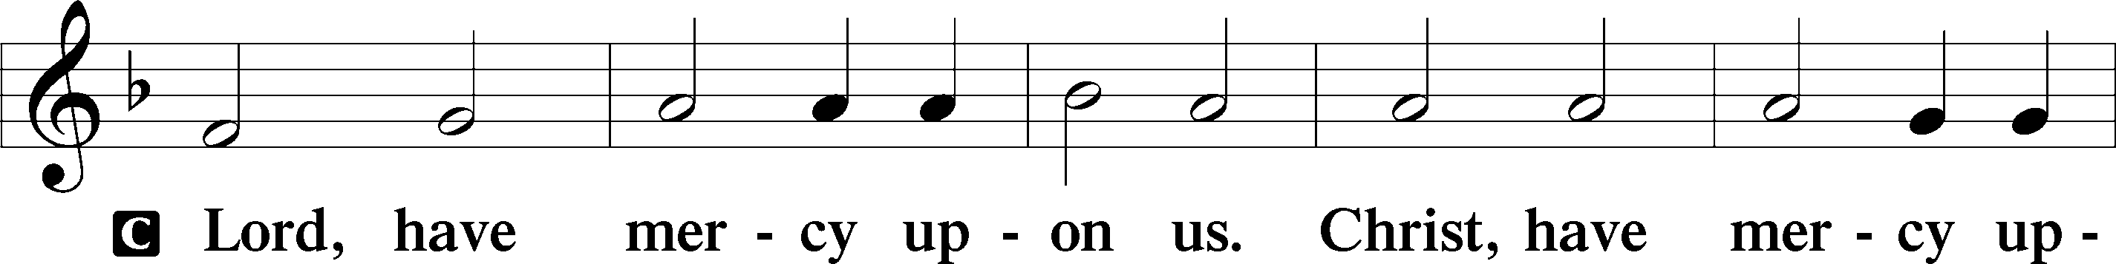
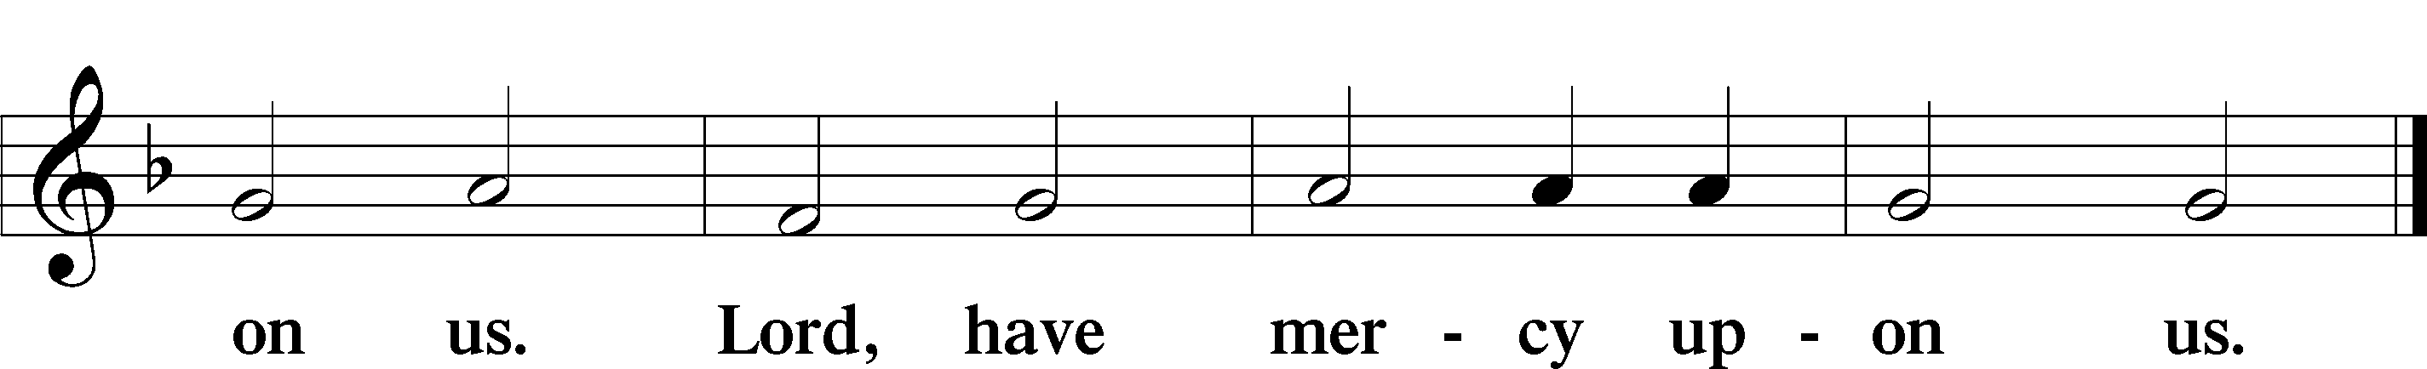

Salutation and Collect of the Day: Ash Wednesday
P The Lord be with you.
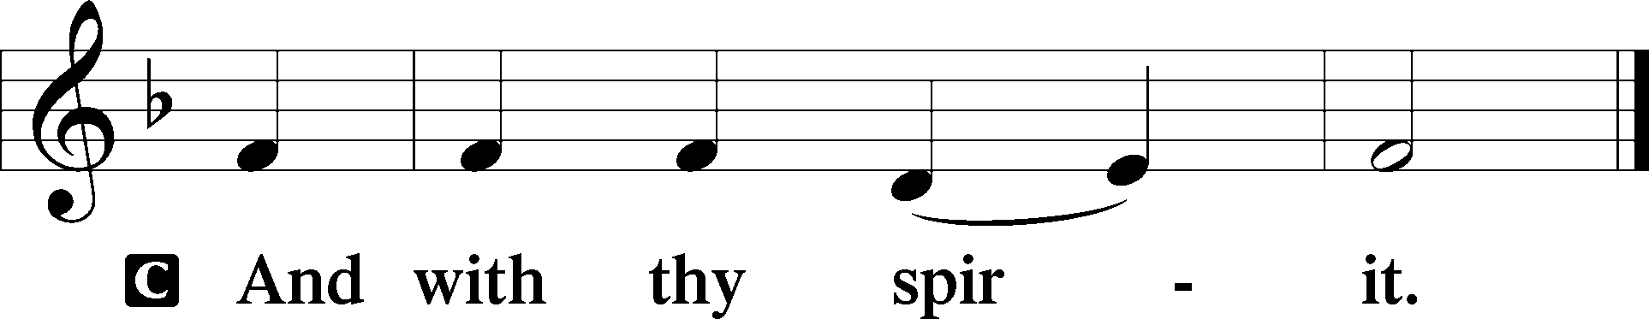

P Let us pray.
Almighty and everlasting God, You despise nothing You have made and forgive the sins of all who are penitent. Create in us new and contrite hearts that lamenting our sins and acknowledging our wretchedness we may receive from You full pardon and forgiveness; through Jesus Christ, Your Son, our Lord, who lives and reigns with You and the Holy Spirit, one God, now and forever.
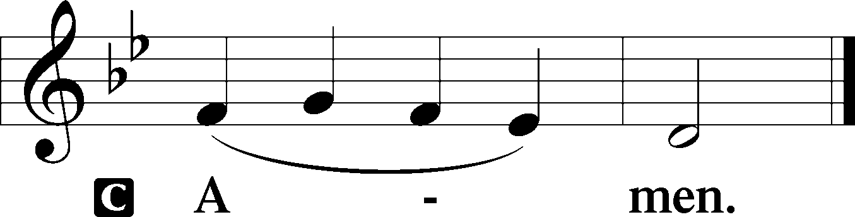
Sit

Prophecy: Joel 2:12-19 (NKJV)
Thus says the Lord God: “Turn to Me with all your heart, with fasting, with weeping, and with mourning.” So rend your heart, and not your garments; return to the Lord your God, for He is gracious and merciful, slow to anger, and of great kindness; and He relents from doing harm. Who knows if He will turn and relent, and leave a blessing behind Him—a grain offering and a drink offering for the Lord your God? Blow the trumpet in Zion, consecrate a fast, call a sacred assembly; gather the people, sanctify the congregation, assemble the elders, gather the children and nursing babes; let the bridegroom go out from his chamber, and the bride from her dressing room. Let the priests, who minister to the Lord, weep between the porch and the altar; let them say, “Spare Your people, O Lord, and do not give Your heritage to reproach, that the nations should rule over them. Why should they say among the peoples, ‘Where is their God?’ ” Then the Lord will be zealous for His land, and pity His people. The Lord will answer and say to His people, “Behold, I will send you grain and new wine and oil, and you will be satisfied by them; I will no longer make you a reproach among the nations,” says the Lord Almighty.

P This is the Word of the Lord.
C Thanks be to God.

Gradual Psalm 57:1a, 3a
Be merciful to me, O God, be merci- | ful to me,*
for in you my soul takes | refuge.
He will send from heaven and | save me;*
he will put to shame him who tramples | on me.

Epistle: 2 Peter 1:2–11 (NKJV)
Dearly Beloved: Grace and peace be multiplied to you in the knowledge of God and of Jesus our Lord, as His divine power has given to us all things that pertain to life and godliness, through the knowledge of Him who called us by glory and virtue, by which have been given to us exceedingly great and precious promises, that through these you may be partakers of the divine nature, having escaped the corruption that is in the world through lust. But also for this very reason, giving all diligence, add to your faith virtue, to virtue knowledge, to knowledge self-control, to self-control perseverance, to perseverance godliness, to godliness brotherly kindness, and to brotherly kindness love. For if these things are yours and abound, you will be neither barren nor unfruitful in the knowledge of our Lord Jesus Christ. For he who lacks these things is shortsighted, even to blindness, and has forgotten that he was cleansed from his old sins. Therefore, brethren, be even more diligent to make your call and election sure, for if you do these things you will never stumble; for so an entrance will be supplied to you abundantly into the everlasting kingdom of our Lord and Savior Jesus Christ.

P This is the Word of the Lord.
C Thanks be to God.

Stand

Tract Psalm 103:10; 79:8a, 9a
He does not deal with us according | to our sins,*
nor repay us according to our in- | iquities.
Do not remember against us our former in- | iquities;*
let your compassion come speedily to | meet us.
Help us, O God of our sal- | vation,*
for the glory | of your name.

Holy Gospel: Matthew 6:16–21 (NKJV)
P The Holy Gospel according to St. Matthew, the sixth chapter.
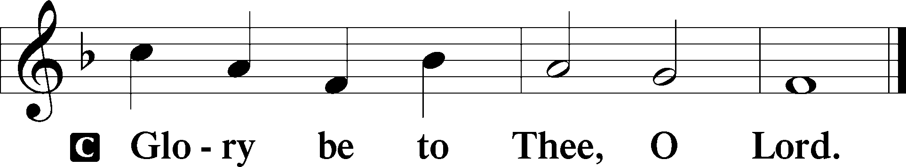

At that time Jesus said to His disciples: “When you fast, do not be like the hypocrites, with a sad countenance. For they disfigure their faces that they may appear to men to be fasting. Assuredly, I say to you, they have their reward. But you, when you fast, anoint your head and wash your face, so that you do not appear to men to be fasting, but to your Father who is in the secret place; and your Father who sees in secret will reward you openly. Do not lay up for yourselves treasures on earth, where moth and rust destroy and where thieves break in and steal; but lay up for yourselves treasures in heaven, where neither moth nor rust destroys and where thieves do not break in and steal. For where your treasure is, there your heart will be also.”

P This is the Gospel of the Lord.
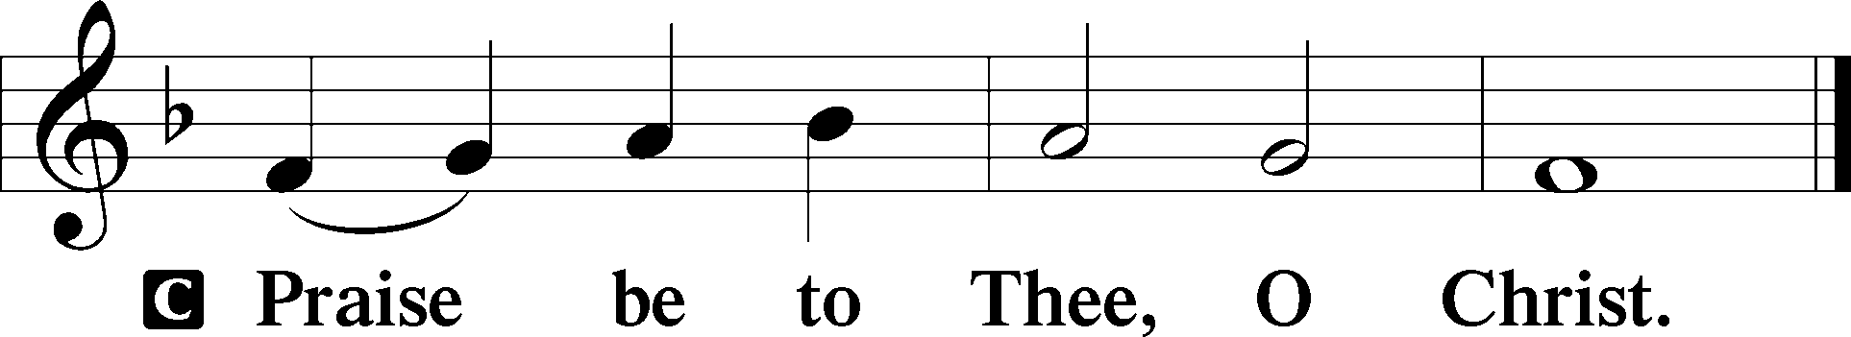

Nicene Creed
C I believe in one God,
the Father Almighty,
maker of heaven and earth
and of all things visible and invisible.

And in one Lord Jesus Christ,
the only-begotten Son of God,
begotten of His Father before all worlds,
God of God, Light of Light,
very God of very God,
begotten, not made,
being of one substance with the Father,
by whom all things were made;
who for us men and for our salvation came down from heaven
and was incarnate by the Holy Spirit of the virgin Mary
and was made man;
and was crucified also for us under Pontius Pilate.
He suffered and was buried.
And the third day He rose again according to the Scriptures
and ascended into heaven
and sits at the right hand of the Father.
And He will come again with glory to judge both the living and the dead,
whose kingdom will have no end.

And I believe in the Holy Spirit,
the Lord and giver of life,
who proceeds from the Father and the Son,
who with the Father and the Son together is worshiped and glorified,
who spoke by the prophets.
And I believe in one holy Christian and apostolic Church,
I acknowledge one Baptism for the remission of sins,
and I look for the resurrection of the dead
and the life T of the world to come. Amen.
Sit

Hymn of the Day: LSB #607 “From Depths of Woe I Cry to Thee”

Sermon

Stand
Offertory Psalm 51:10–12
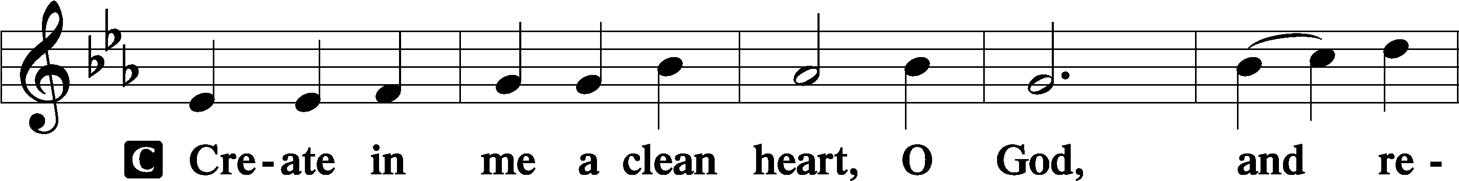
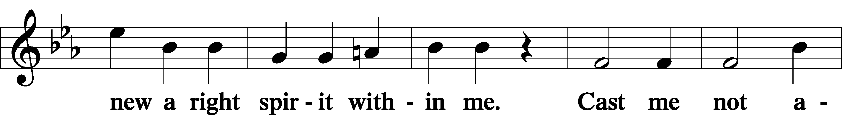
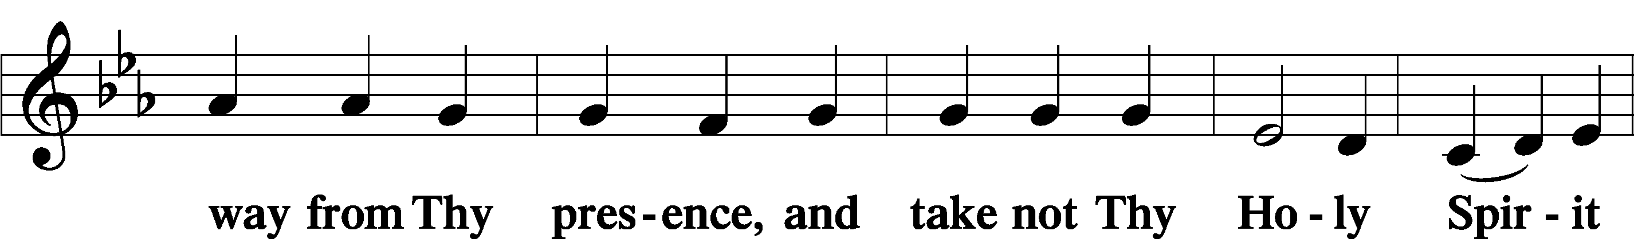
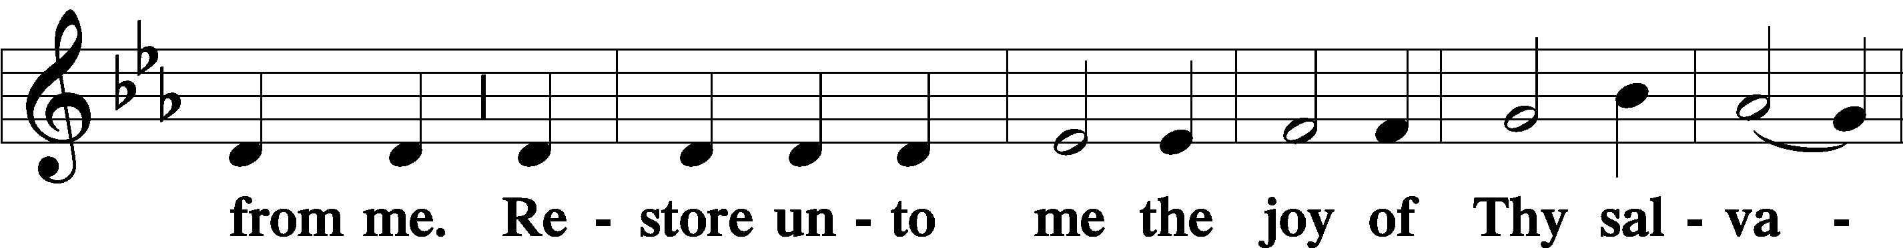
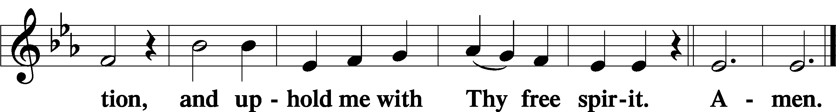

Prayer of the Church

Sit

Preparatory Hymn: LSB #440 “Jesus, I Will Ponder Now”

Stand
Service of the Sacrament

Preface 2 Timothy 4:22; Colossians 3:1 Psalm 136
P The Lord be with you.
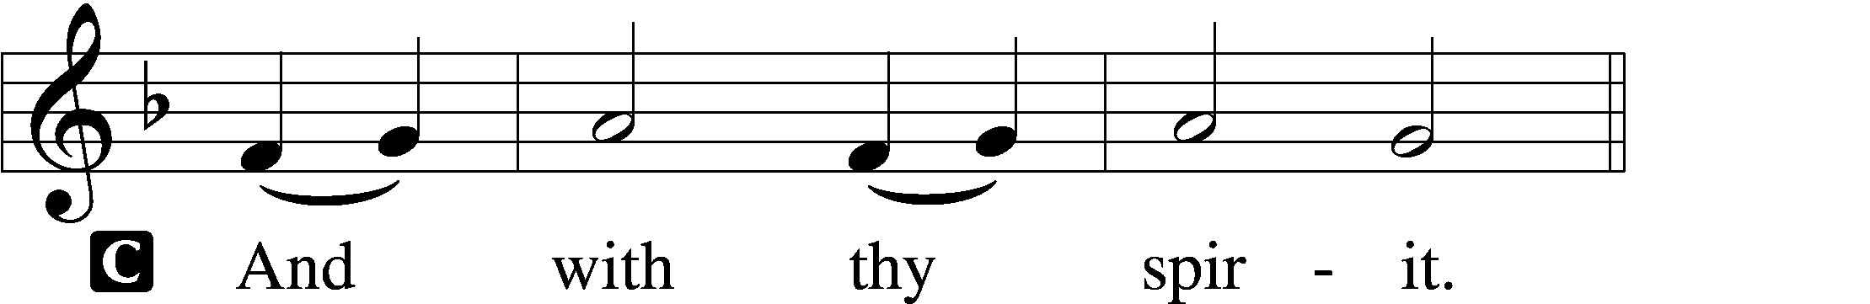

P Lift up your hearts.
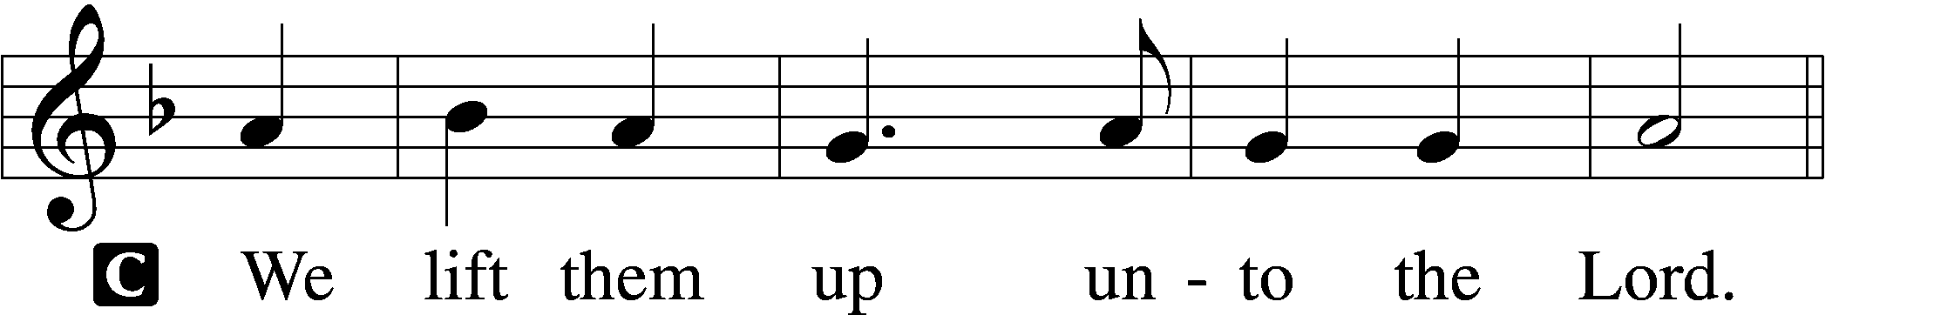

P Let us give thanks unto the Lord, our God.
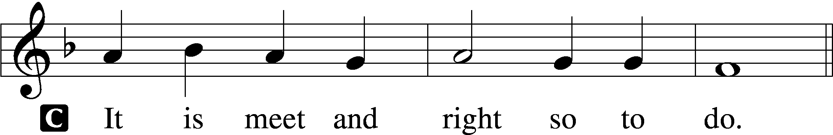

Proper Preface (Abbreviated) LSB 194
P It is truly meet, right, and salutary . . . evermore praising You and saying:

Sanctus Isaiah 6:3; Matthew 21:9
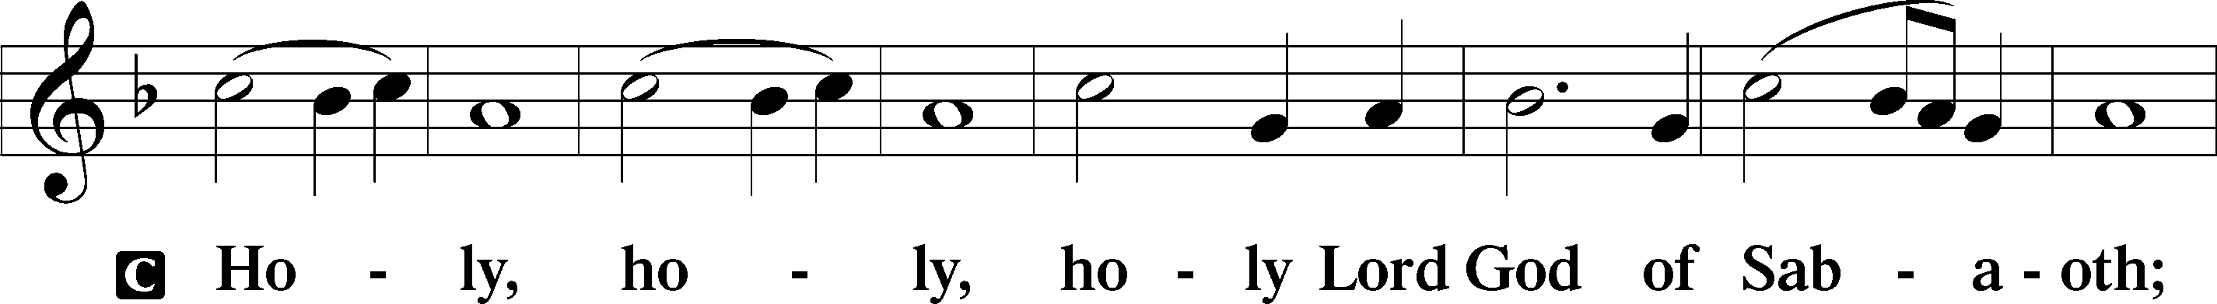
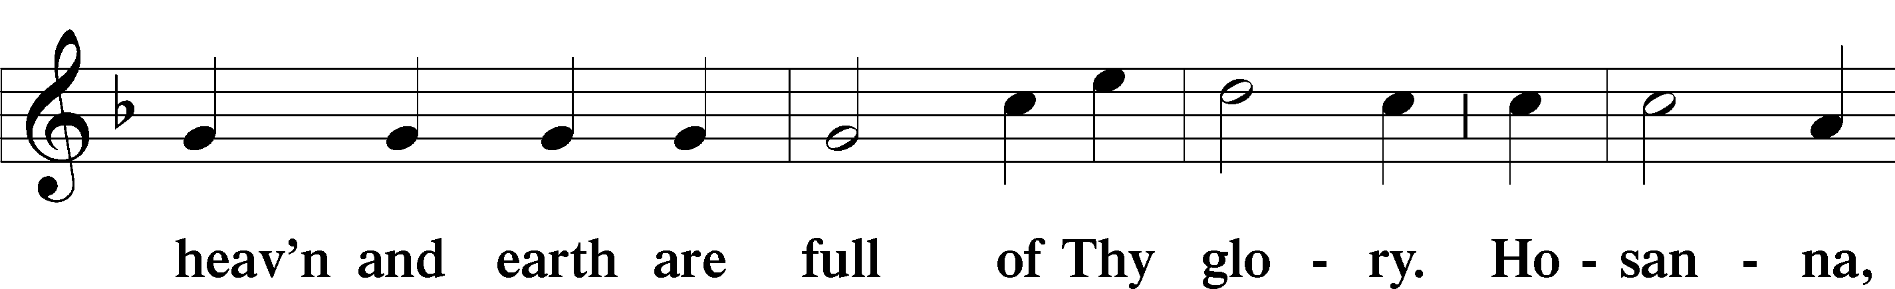
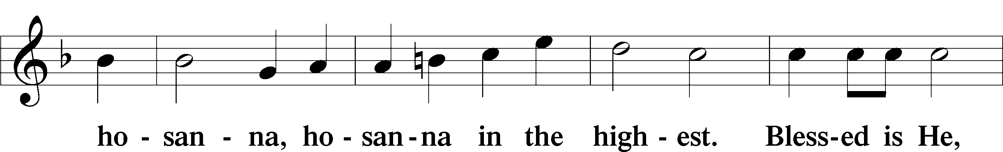
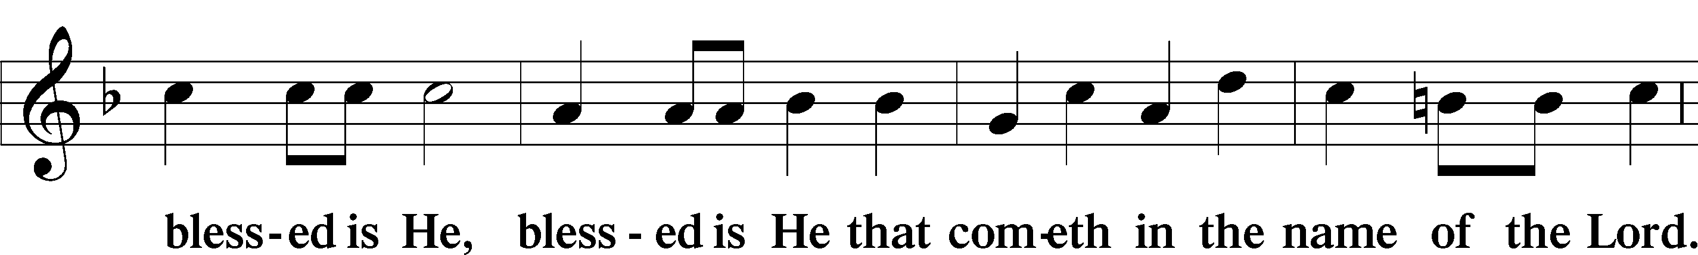
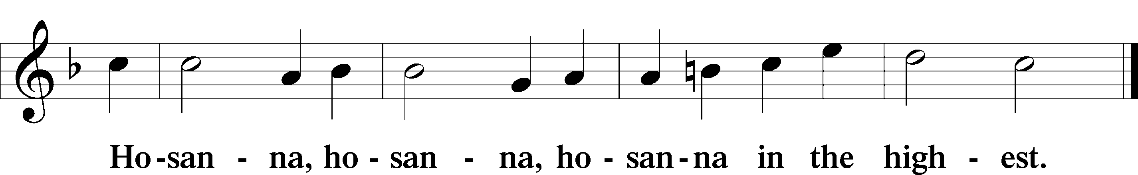

Lord’s Prayer The congregation is encouraged to silently pray the Lord’s Prayer as it is chanted. Matthew 6:9–13
P Our Father who art in heaven,
hallowed be Thy name,
Thy kingdom come,
Thy will be done on earth as it is in heaven;
give us this day our daily bread;
and forgive us our trespasses as we forgive those who trespass against us;
and lead us not into temptation,
but deliver us from evil.
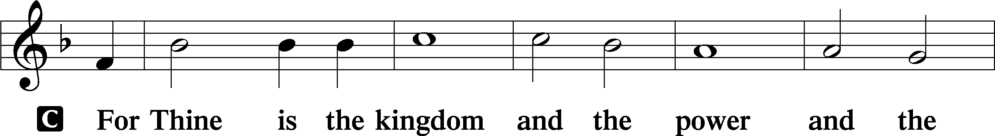
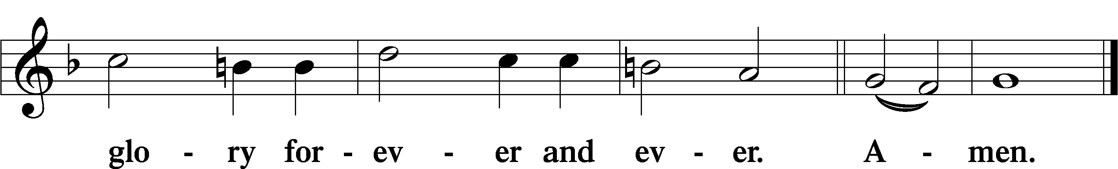

The Words of Our Lord Matthew 26:26–28; Mark 14:22–24; Luke 22:19–20; 1 Corinthians 11:23–25
P Our Lord Jesus Christ, on the night when He was betrayed, took bread, and when He had given thanks, He broke it and gave it to the disciples and said: “Take, eat; this is My T body, which is given for you. This do in remembrance of Me.”

In the same way also He took the cup after supper, and when He had given thanks, He gave it to them, saying: “Drink of it, all of you; this cup is the new testament in My T blood, which is shed for you for the forgiveness of sins. This do, as often as you drink it, in remembrance of Me.”

Pax Domini John 20:19
P The peace of the Lord be with you always.
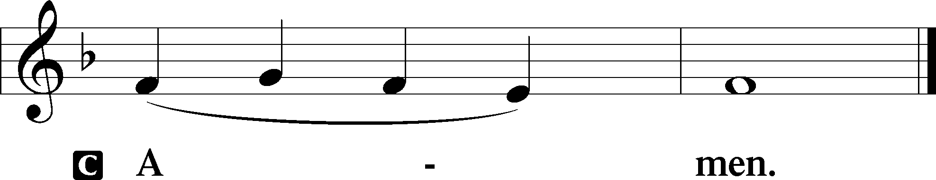

Agnus Dei John 1:29
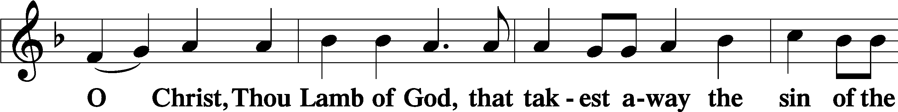
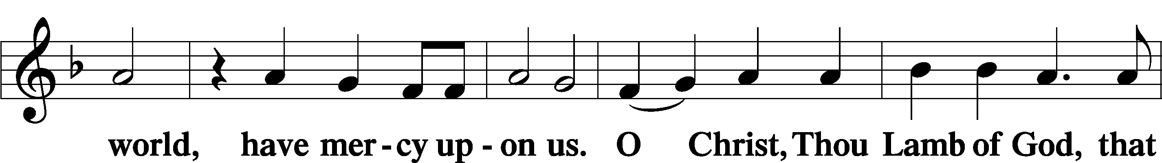
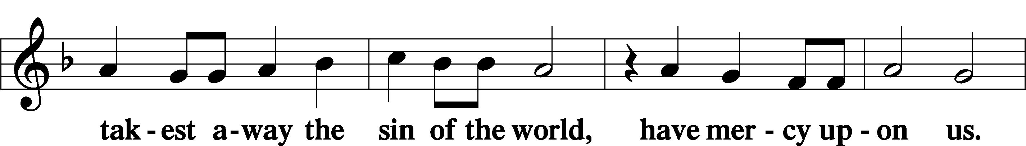
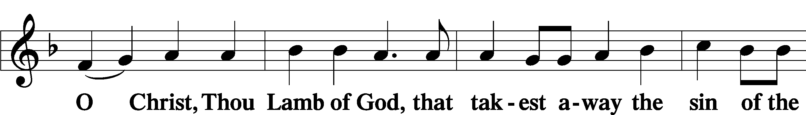
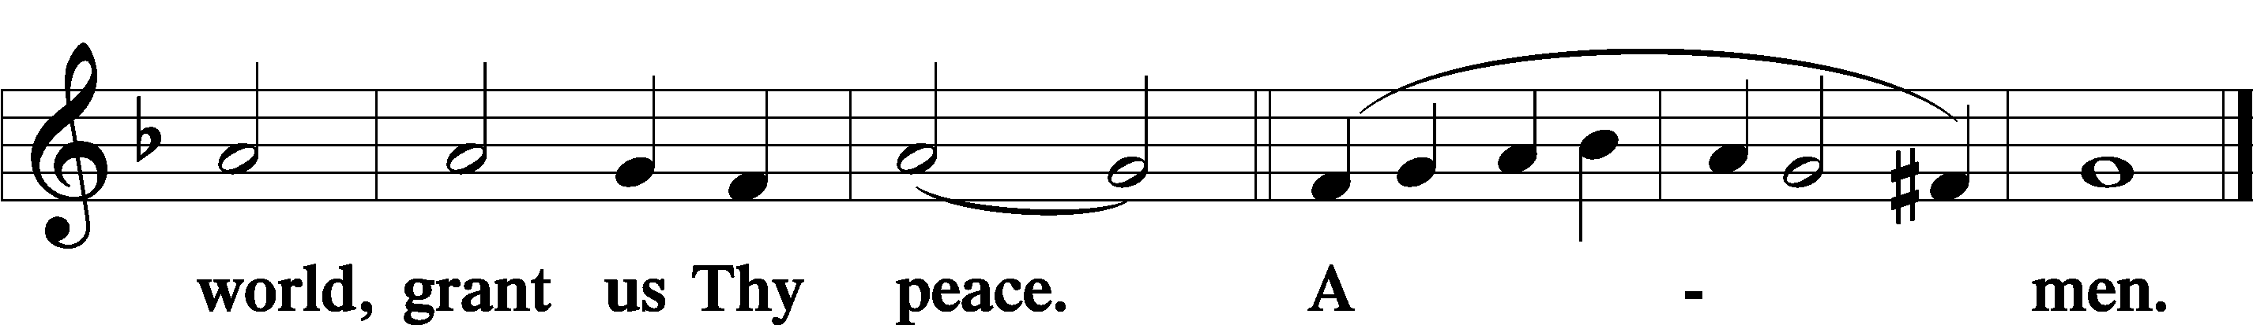
Sit

Distribution
The pastor and those who assist him receive the body and blood of Christ first and then distribute them to those who come to receive, saying:
Take, eat; this is the true body of our Lord and Savior Jesus Christ, given into death for your sins.
Amen.

Take, drink; this is the true blood of our Lord and Savior Jesus Christ, shed for the forgiveness of your sins.
Amen.

In dismissing the communicants, the following is said:
The Dismissal
P The body and blood of our Lord Jesus Christ strengthen and preserve you in body and soul to life everlasting. Depart T in peace.
C Amen.

Distribution Hymn: LSB #421 “Jesus, Grant That Balm and Healing”

Distribution Hymn: LSB #610 “Lord Jesus, Think on Me”

Stand

Nunc Dimittis Luke 2:29–32
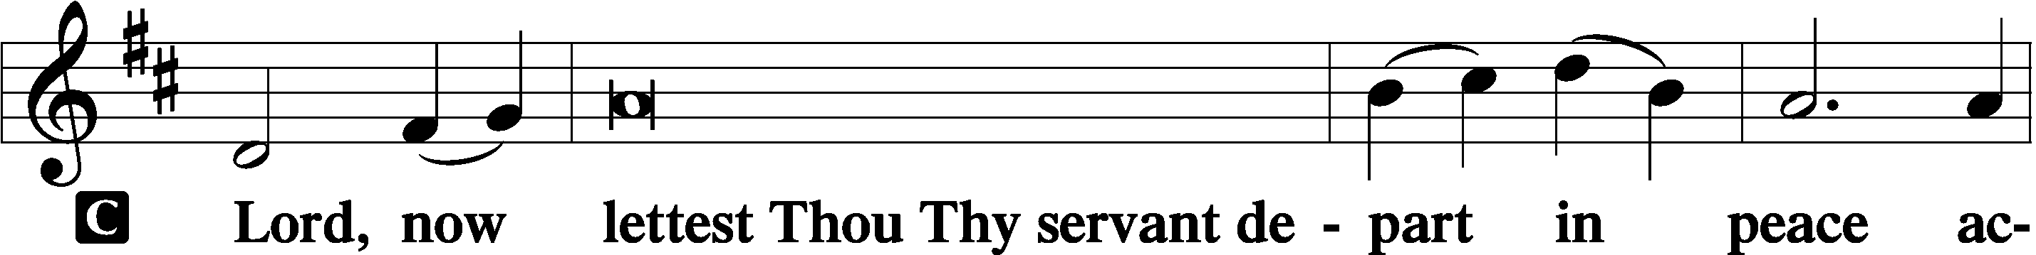
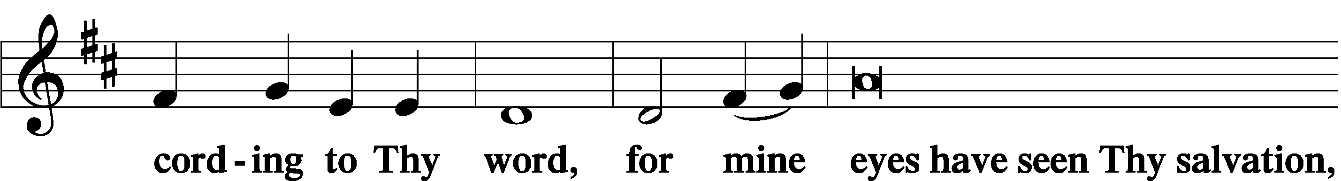
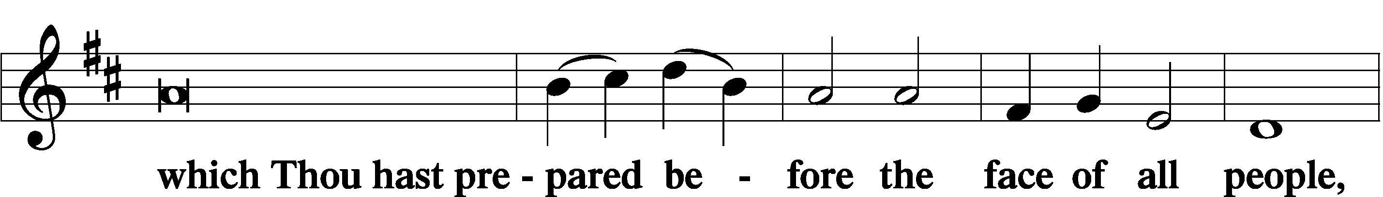
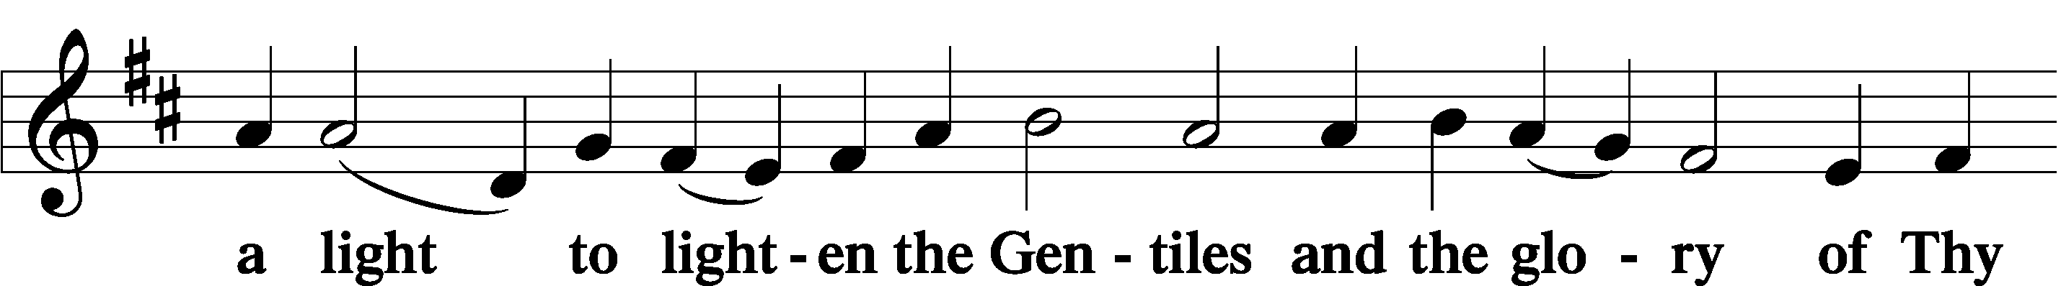
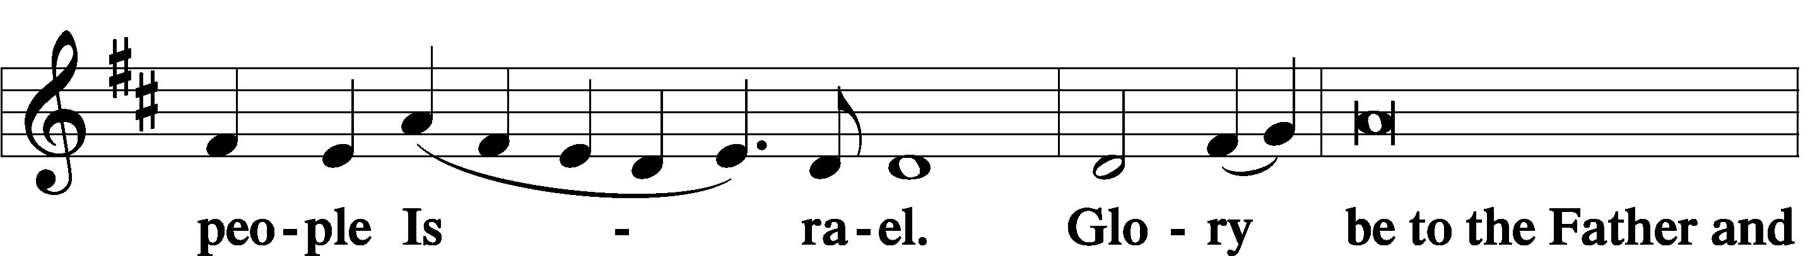
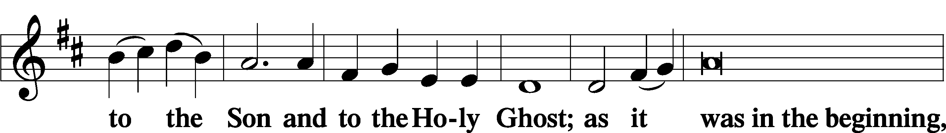
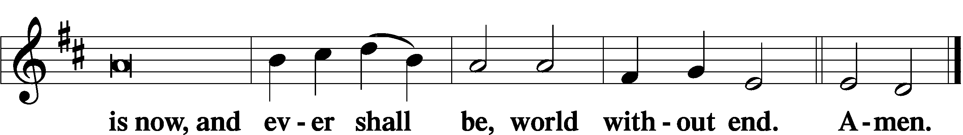

Thanksgiving Psalm 107:1
P O give thanks unto the Lord, for He is good,
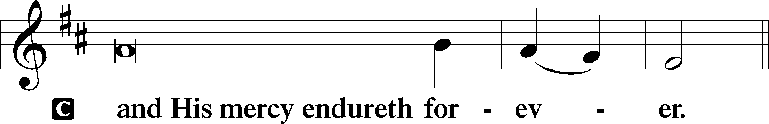

Post-Communion Collect
P Let us pray.
We give thanks to You, almighty God, that You have refreshed us through this salutary gift, and we implore You that of Your mercy You would strengthen us through the same in faith toward You and in fervent love toward one another; through Jesus Christ, Your Son, our Lord, who lives and reigns with You and the Holy Spirit, one God, now and forever.
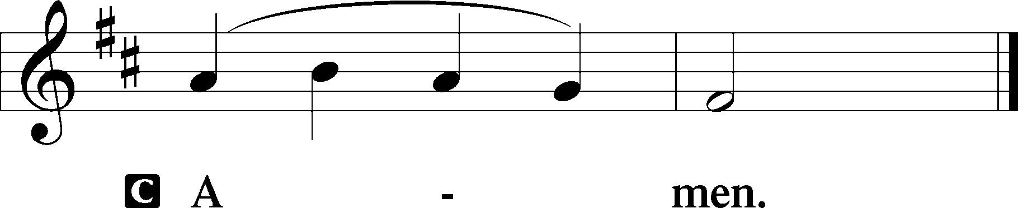

Salutation 2 Timothy 4:22
P The Lord be with you.
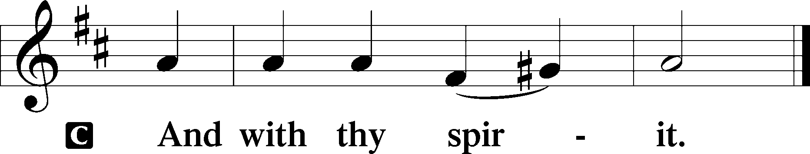

Benedicamus Psalm 103:1
P Bless we the Lord.
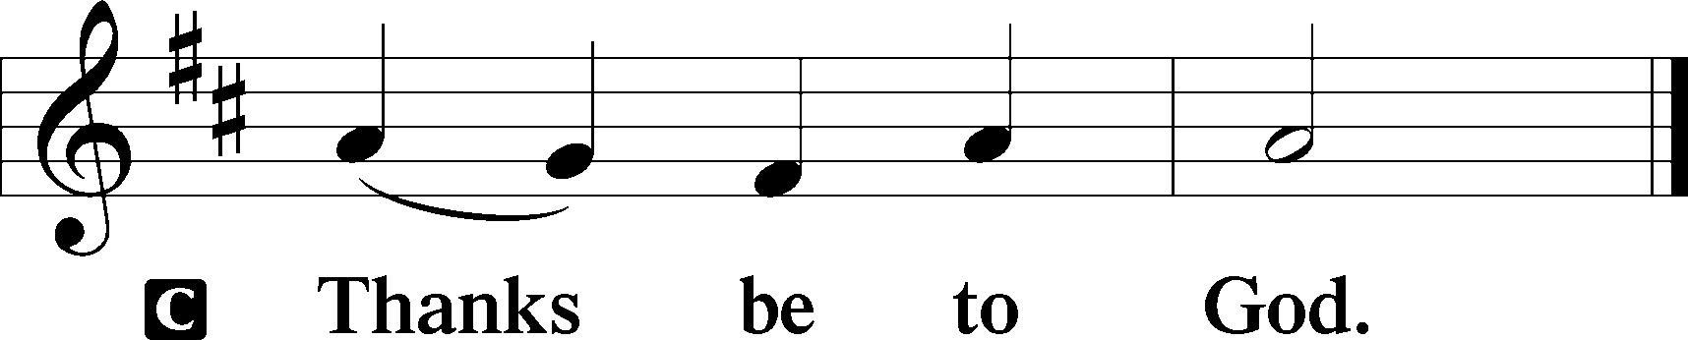

Benediction Numbers 6:24–26
P The Lord bless you and keep you.
The Lord make His face shine upon you and be gracious unto you.
The Lord lift up His countenance upon you and T give you peace.
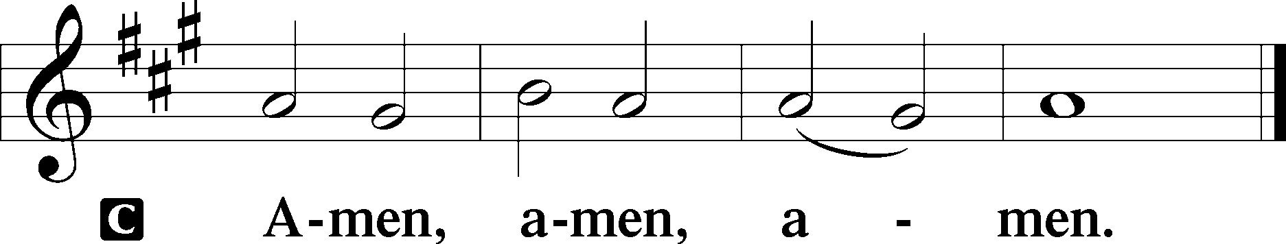

Closing Hymn: TLH #152 “When o'er My Sins I Sorrow”
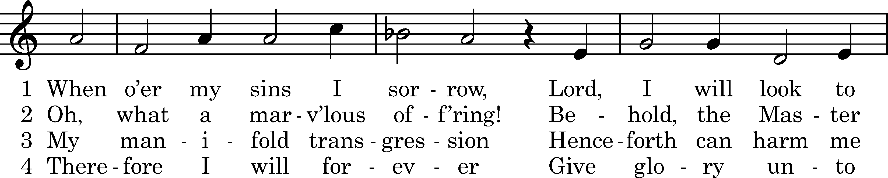
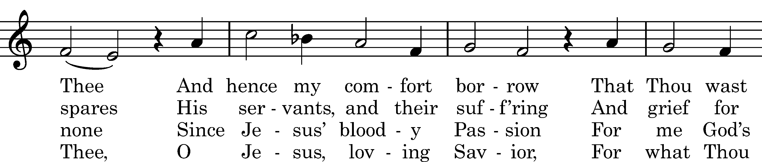
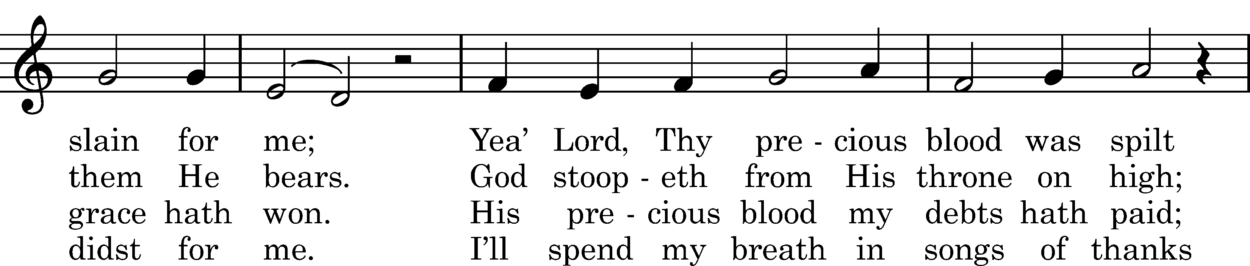
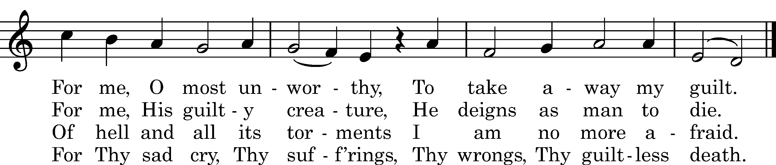

Text: Justus Gesenius, 1646, cento; (st. 1): tr. Catherine Winkworth, 1863, alt.; (sts. 2–4): tr. Composite Tune: Michael Praetorius, 1609 Text and tune: Public domain
Silent prayer after worship: Lord Jesus, as I go forth from this worship service, cause me to remember Your great love for me and all people. Give me boldness and faith to share Your love with others through my words and deeds. Amen.

Acknowledgments
Unless otherwise indicated, Scripture quotations are from the ESV® Bible (The Holy Bible, English Standard Version®), copyright © 2001 by Crossway, a publishing ministry of Good News Publishers. Used by permission. All rights reserved.
Created by Lutheran Service Builder © 2024 Concordia Publishing House.

Lenten Soup Fellowship
Join us during the penitential season of Lent and share a weekly meal of soup and bread combined with fellowship.
From February 21st through March 20th, meals will be offered following the 10 am Matins Service and at 6 pm, prior to the 7 pm Vespers Service.
A sign-up sheet is on the table in the narthex for those willing to provide the soup and bread. Please plan on enough for about 12-14 people at each meal. Soup bowls are available in the Fellowship Hall kitchen along with napkins and cutlery.
The morning meal will be combined with a Bible Study on the book of Romans.
Hope to see you there!

Here to Serve

Pastor………………………………………………...……………Rev. Jacob Deal
E-mail …………………………….……pastordeal@saintspeterandpaul.net
Phone Number……………………..…………………724-347-3620 (Option 2)
Church Office………………………..…………………724-347-3620 (Option 3)
Website …………………………………………www.saintspeterandpaul.net
Secretary…………………………………………………………Diane Riefstahl
E-mail ………………………………………church@saintspeterandpaul.net
Food Pantry (email): ……………foodpantry@saintspeterandpaul.net
Congregation President………………………………….…Jonathan Baisch
Church Elder …………………………………………...……. Jonathan Baisch
Organist………………………………………………..….…Rebecca Marquette
AA Contact: Steve………………………………………………...…724-813-2358
NA Contact: Larry……………………………………..…………..724-977-8733
fffffffffffffffffffffffffffffffffff
If needing to get into the church building during the week, please phone first to make certain someone is here to let you in.

