Sts. Peter & Paul
Evangelical Lutheran Church
Lutheran Church-Missouri Synod
Founded-1917

February 12, 2023

699 Stambaugh Avenue
Sharon, Pennsylvania 16146

“I was glad when they said to me,
Let us go to the house of the LORD!”
Psalm 122:1
Sts. Peter & Paul Evangelical Lutheran Church, LC-MS
SEXAGESIMA
February 12, 2023

A special welcome to our guests this day! If you would like more information about The Lutheran Church - Missouri Synod, or this congregation, please speak with Pastor Deal or an Elder after the service.
Members & Guests: Don’t be embarrassed if your children make noise during the worship service, all children do. We encourage families to worship together but, if you feel the need, there are pews in the rear of the Church which are reserved for young families on both sides of the sanctuary. There is also a quiet room available to you during our service which is located down the hallway past the offices on the right side of the church as well as a children’s area in the Fellowship Hall where you are able to follow along with the service.

Today’s service includes the Sacrament of Holy Communion. If during this past year, you have not worshipped with us and been communed, we respectfully ask that you do not partake of this sacrament this day before first speaking with Pastor Deal.
If visiting from a sister congregation of the LC-MS and are in good standing, please inform Pastor Deal of your desire to commune prior to the service.
If wishing to receive a blessing during communion, please approach with your arms crossed.

CONTACT INFORMATION
Pastor Deal: pastordeal@saintspeterandpaul.net or 724-347-3620 (opt. 2)
Church Office: church@saintspeterandpaul.net or 724-347-3620 (opt. 3)

Silent prayer before worship: Almighty God, cleanse me of my sins. Cause Your Holy Spirit to work through Your Word so that my heart and soul may receive the new life that You have promised in Christ. In His name I pray. Amen.

Confession and Absolution

Opening Hymn: LSB #923 “Almighty Father, Bless the Word”

The sign of the cross may be made by all in remembrance of their Baptism.

Invocation
P In the name of the Father and of the T Son and of the Holy Spirit.
C Amen.

Exhortation Hebrews 10:22; Psalm 124:8; Psalm 32:5
P Beloved in the Lord! Let us draw near with a true heart and confess our sins unto God our Father, beseeching Him in the name of our Lord Jesus Christ to grant us forgiveness.

P Our help is in the name of the Lord,
C who made heaven and earth.
P I said, I will confess my transgressions unto the Lord,
C and You forgave the iniquity of my sin.

Silence for reflection on God’s Word and for self-examination.

Confession of Sins
P O almighty God, merciful Father,
C I, a poor, miserable sinner, confess unto You all my sins and iniquities with which I have ever offended You and justly deserved Your temporal and eternal punishment. But I am heartily sorry for them and sincerely repent of them, and I pray You of Your boundless mercy and for the sake of the holy, innocent, bitter sufferings and death of Your beloved Son, Jesus Christ, to be gracious and merciful to me, a poor, sinful being.

Absolution [John 20:19–23]
P Upon this your confession, I, by virtue of my office, as a called and ordained servant of the Word, announce the grace of God unto all of you, and in the stead and by the command of my Lord Jesus Christ I forgive you all your sins in the name of the Father and of the T Son and of the Holy Spirit.
C Amen.

Anniversary of Holy Matrimony
Service of the Word

Introit Psalm 44:1–2, 7–8; antiphon: vv. 23, 25a, 26a
Awake! Why are you sleeping, | O Lord?*
Rouse yourself! Do not reject us for- | ever!
For our soul is bowed down | to the dust.*
Rise up; come | to our help!
O God, we have heard with our ears, our fathers have | told us,*
what deeds you performed in their days, in the | days of old:
you with your own hand drove out the nations, but them you | planted;*
you afflicted the peoples, but them you | set free.
But you have saved us | from our foes*
and have put to shame those who | hate us.
In God we have boasted con- | tinually,*
and we will give thanks to your name for- | ever.
Glory be to the Father and | to the Son*
and to the Holy | Spirit;
as it was in the be- | ginning,*
is now, and will be forever. | Amen.

Kyrie Mark 10:47
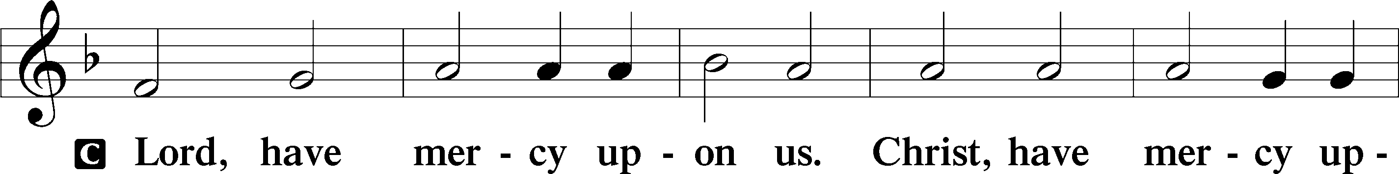
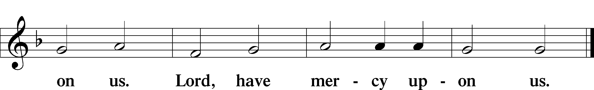

Salutation and Collect of the Day: Sexagesima
P The Lord be with you.
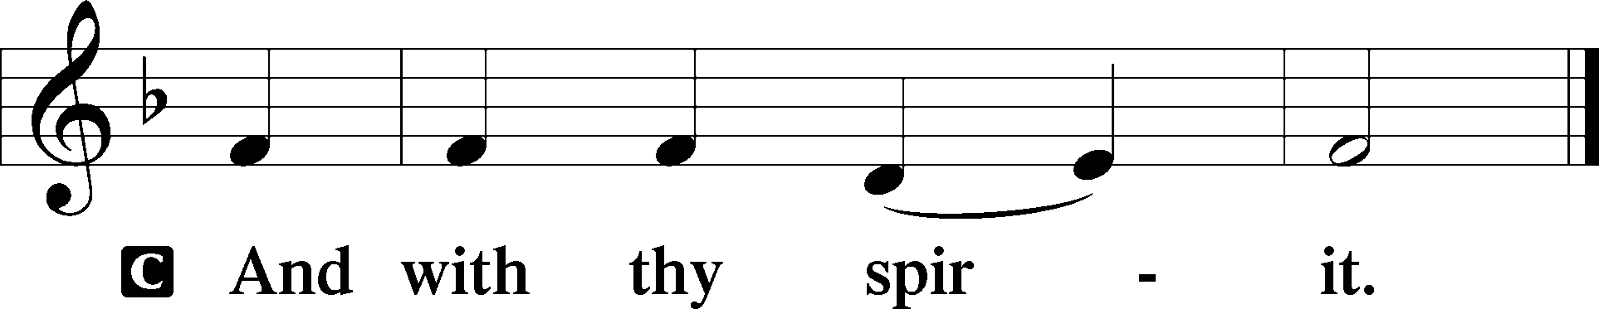

P Let us pray.
O God, the strength of all who put their trust in You, mercifully grant that by Your power we may be defended against all adversity; through Jesus Christ, Your Son, our Lord, who lives and reigns with You and the Holy Spirit, one God, now and forever.
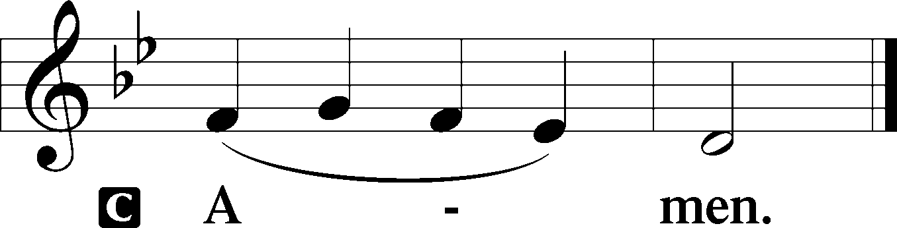

Sit

Prophecy: Isaiah 55:10–13
Thus says the Lord God: “As the rain comes down, and the snow from heaven, and do not return there, but water the earth, and make it bring forth and bud, that it may give seed to the sower and bread to the eater, so shall My word be that goes forth from My mouth; it shall not return to Me void, but it shall accomplish what I please, and it shall prosper in the thing for which I sent it. For you shall go out with joy, and be led out with peace; the mountains and the hills shall break forth into singing before you, and all the trees of the field shall clap their hands. Instead of the thorn shall come up the cypress tree, and instead of the brier shall come up the myrtle tree; and it shall be to the Lord for a name, for an everlasting sign that shall not be cut off,” says the Lord Almighty.

P This is the Word of the Lord.
C Thanks be to God.
Gradual Psalm 83:18, 13
[Let your enemies] know that you alone, whose name | is the Lord,*
are the Most High over | all the earth.
O my God, make them like | whirling dust,*
like chaff be- | fore the wind.

Epistle: 2 Corinthians 11:19—12:9
Brethren: You put up with fools gladly, since you yourselves are wise! For you put up with it if one brings you into bondage, if one devours you, if one takes from you, if one exalts himself, if one strikes you on the face. To our shame I say that we were too weak for that! But in whatever anyone is bold—I speak foolishly—I am bold also. Are they Hebrews? So am I. Are they Israelites? So am I. Are they the seed of Abraham? So am I. Are they ministers of Christ?—I speak as a fool—I am more: in labors more abundant, in stripes above measure, in prisons more frequently, in deaths often. From the Jews five times I received forty stripes minus one. Three times I was beaten with rods; once I was stoned; three times I was shipwrecked; a night and a day I have been in the deep; in journeys often, in perils of waters, in perils of robbers, in perils of my own countrymen, in perils of the Gentiles, in perils in the city, in perils in the wilderness, in perils in the sea, in perils among false brethren; in weariness and toil, in sleeplessness often, in hunger and thirst, in fastings often, in cold and nakedness—besides the other things, what comes upon me daily: my deep concern for all the churches. Who is weak, and I am not weak? Who is made to stumble, and I do not burn with indignation? If I must boast, I will boast in the things which concern my infirmity. The God and Father of our Lord Jesus Christ, who is blessed forever, knows that I am not lying. In Damascus the governor, under Aretas the king, was guarding the city of the Damascenes with a garrison, desiring to arrest me; but I was let down in a basket through a window in the wall, and escaped from his hands. It is doubtless not profitable for me to boast. I will come to visions and revelations of the Lord: I know a man in Christ who fourteen years ago—whether in the body I do not know, or whether out of the body I do not know, God knows—such a one was caught up to the third heaven. And I know such a man—whether in the body or out of the body I do not know, God knows—how he was caught up into Paradise and heard inexpressible words, which it is not lawful for a man to utter. Of such a one I will boast; yet of myself I will not boast, except in my infirmities. For though I might desire to boast, I will not be a fool; for I will speak the truth. But I refrain, lest anyone should think of me above what he sees me to be or hears from me. And lest I should be exalted above measure by the abundance of the revelations, a thorn in the flesh was given to me, a messenger of Satan to buffet me, lest I be exalted above measure. Concerning this thing I pleaded with the Lord three times that it might depart from me. And He said to me, “My grace is sufficient for you, for My strength is made perfect in weakness.” Therefore most gladly I will rather boast in my infirmities, that the power of Christ may rest upon me.

P This is the Word of the Lord.
C Thanks be to God.

Stand

Holy Gospel: Luke 8:4–15
P The Holy Gospel according to St. Luke, the eighth chapter.
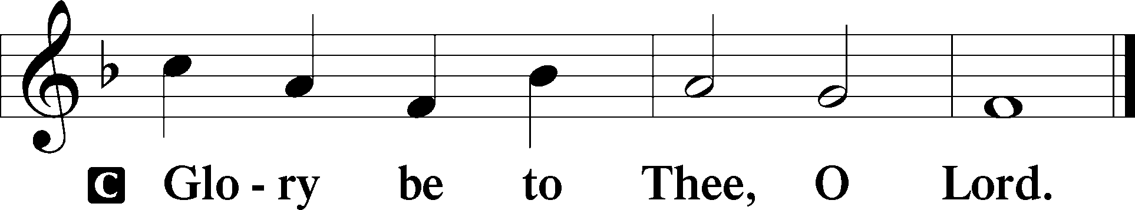

At that time: When a great multitude had gathered, and they had come to Him from every city, Jesus spoke by a parable: “A sower went out to sow his seed. And as he sowed, some fell by the wayside; and it was trampled down, and the birds of the air devoured it. Some fell on rock; and as soon as it sprang up, it withered away because it lacked moisture. And some fell among thorns, and the thorns sprang up with it and choked it. But others fell on good ground, sprang up, and yielded a crop a hundredfold.” When He had said these things He cried, “He who has ears to hear, let him hear!” Then His disciples asked Him, saying, “What does this parable mean?” And He said, “To you it has been given to know the mysteries of the kingdom of God, but to the rest it is given in parables, that ‘Seeing they may not see, and hearing they may not understand.’ Now the parable is this: The seed is the word of God. Those by the wayside are the ones who hear; then the devil comes and takes away the word out of their hearts, lest they should believe and be saved. But the ones on the rock are those who, when they hear, receive the word with joy; and these have no root, who believe for a while and in time of temptation fall away. Now the ones that fell among thorns are those who, when they have heard, go out and are choked with cares, riches, and pleasures of life, and bring no fruit to maturity. But the ones that fell on the good ground are those who, having heard the word with a noble and good heart, keep it and bear fruit with patience.”

P This is the Gospel of the Lord.
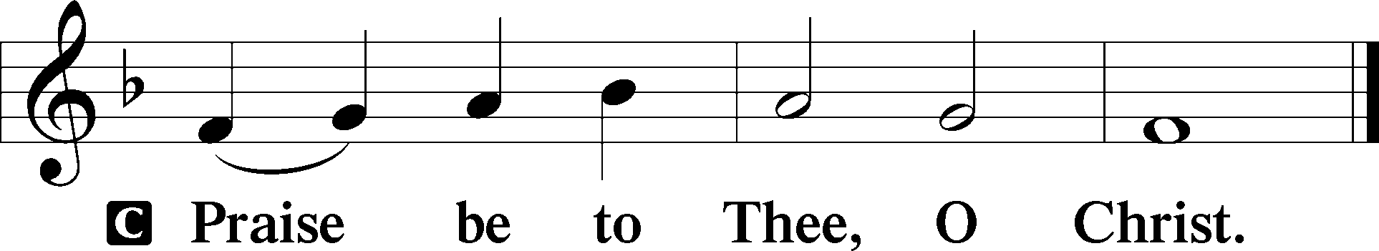

Nicene Creed
C I believe in one God,
the Father Almighty,
maker of heaven and earth
and of all things visible and invisible.

And in one Lord Jesus Christ,
the only-begotten Son of God,
begotten of His Father before all worlds,
God of God, Light of Light,
very God of very God,
begotten, not made,
being of one substance with the Father,
by whom all things were made;
who for us men and for our salvation came down from heaven
and was incarnate by the Holy Spirit of the virgin Mary
and was made man;
and was crucified also for us under Pontius Pilate.
He suffered and was buried.
And the third day He rose again according to the Scriptures
and ascended into heaven
and sits at the right hand of the Father.
And He will come again with glory to judge both the living and the dead,
whose kingdom will have no end.

And I believe in the Holy Spirit,
the Lord and giver of life,
who proceeds from the Father and the Son,
who with the Father and the Son together is worshiped and glorified,
who spoke by the prophets.
And I believe in one holy Christian and apostolic Church,
I acknowledge one Baptism for the remission of sins,
and I look for the resurrection of the dead
and the life T of the world to come. Amen.
Sit

Hymn of the Day: LSB #823 “May God Bestow on Us His Grace”

Sermon

Stand

Prayer of the Church

Offertory Psalm 51:10–12
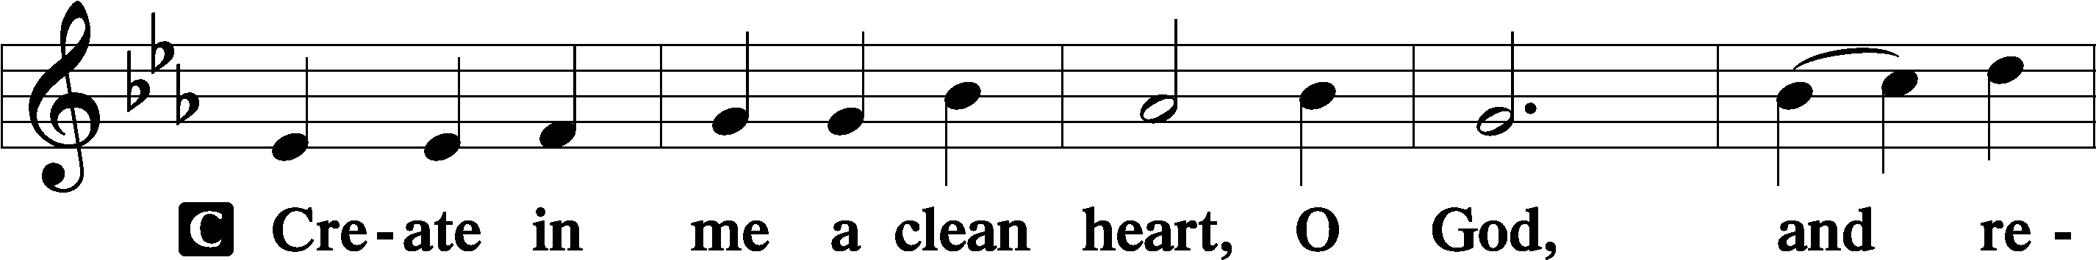
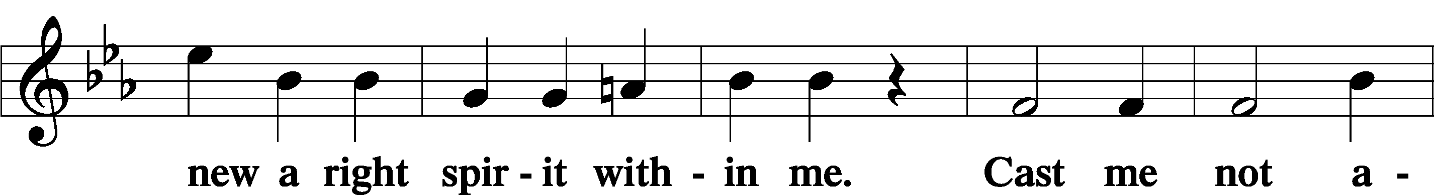
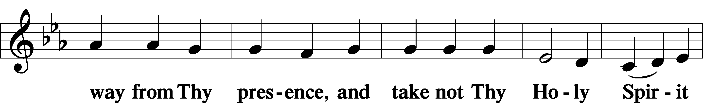
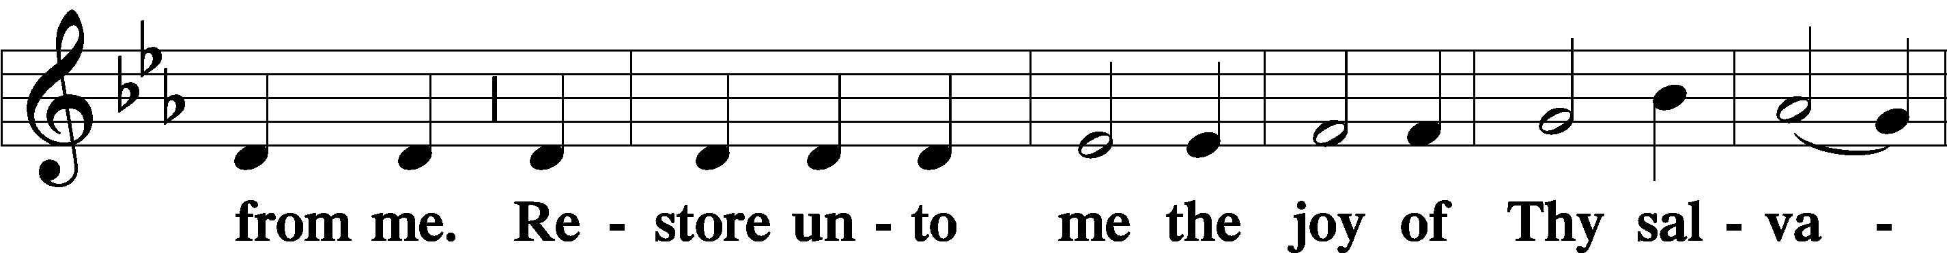
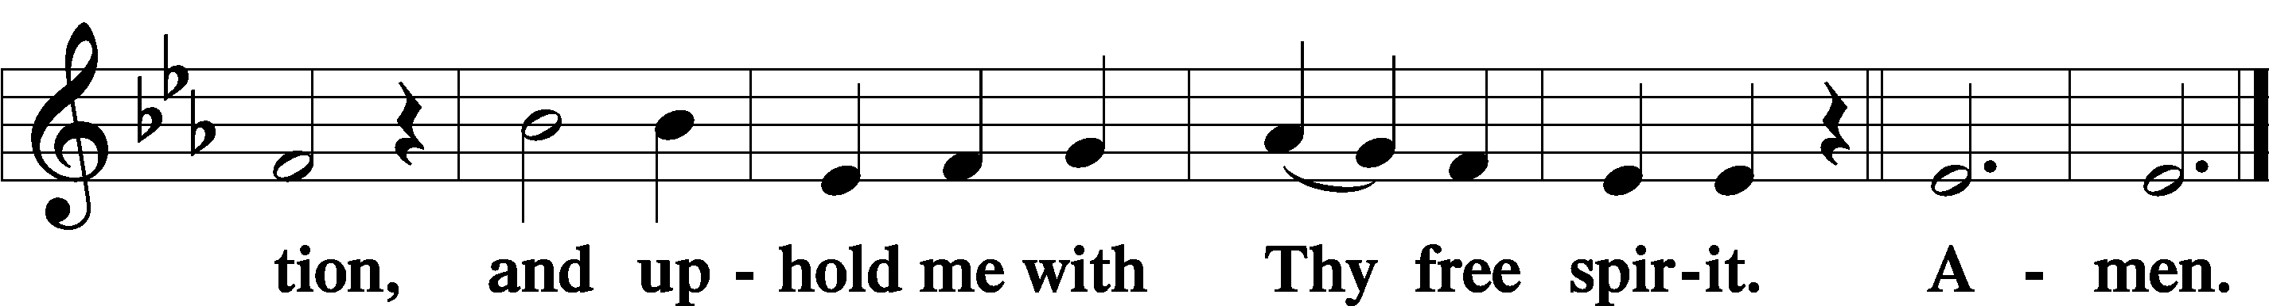
Sit

Preparatory Hymn: LSB #639 “Wide Open Stand the Gates”

Stand
Service of the Sacrament

Preface 2 Timothy 4:22; Colossians 3:1 Psalm 136
P The Lord be with you.
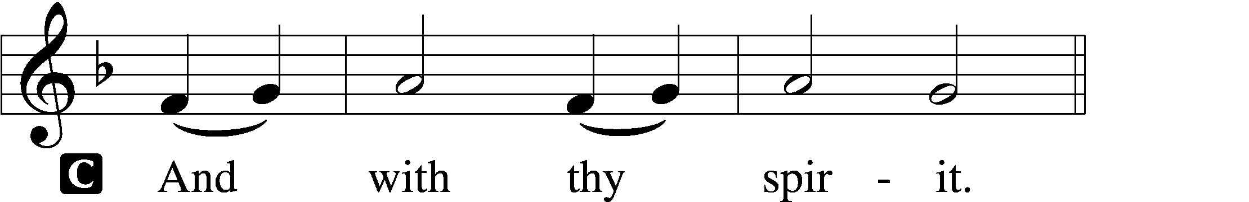

P Lift up your hearts.
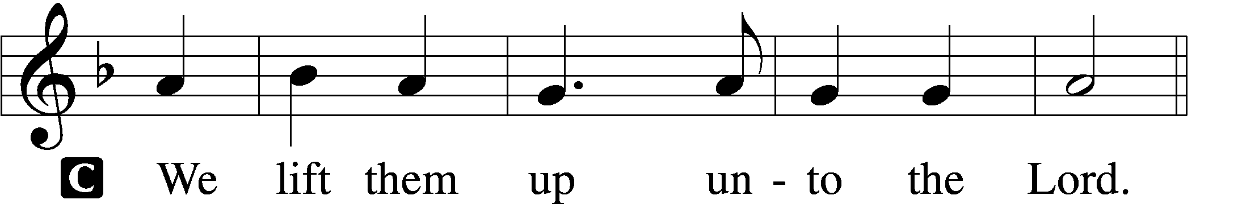

P Let us give thanks unto the Lord, our God.
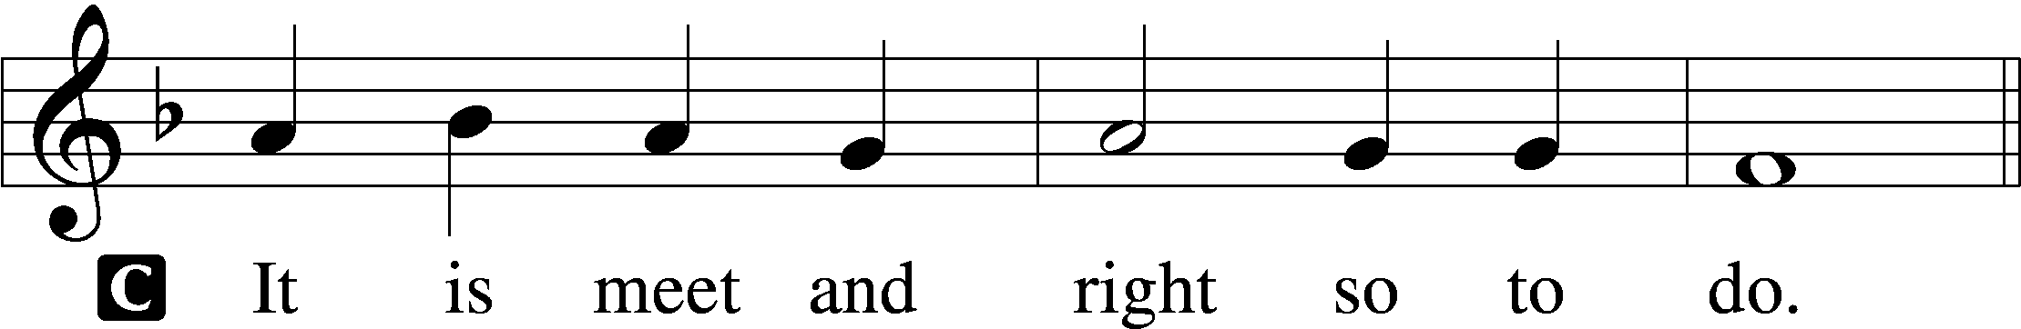

Proper Preface (Abbreviated) LSB 194
P It is truly meet, right, and salutary . . . evermore praising You and saying:

Sanctus Isaiah 6:3; Matthew 21:9
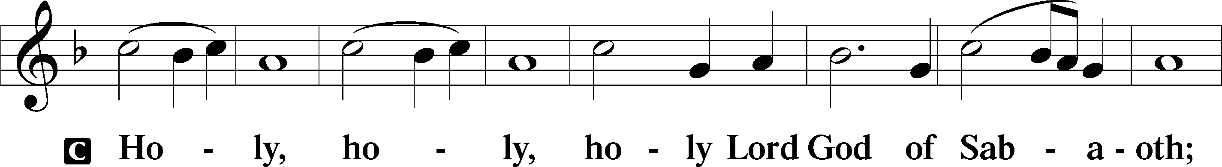
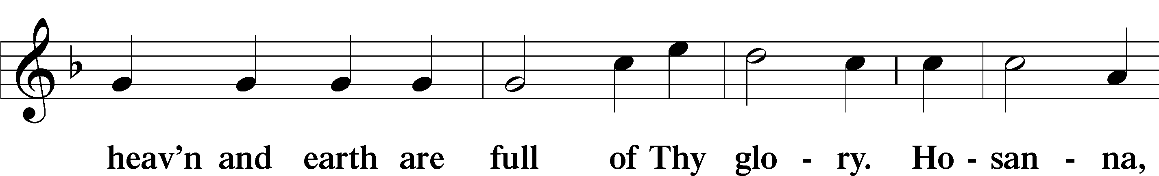
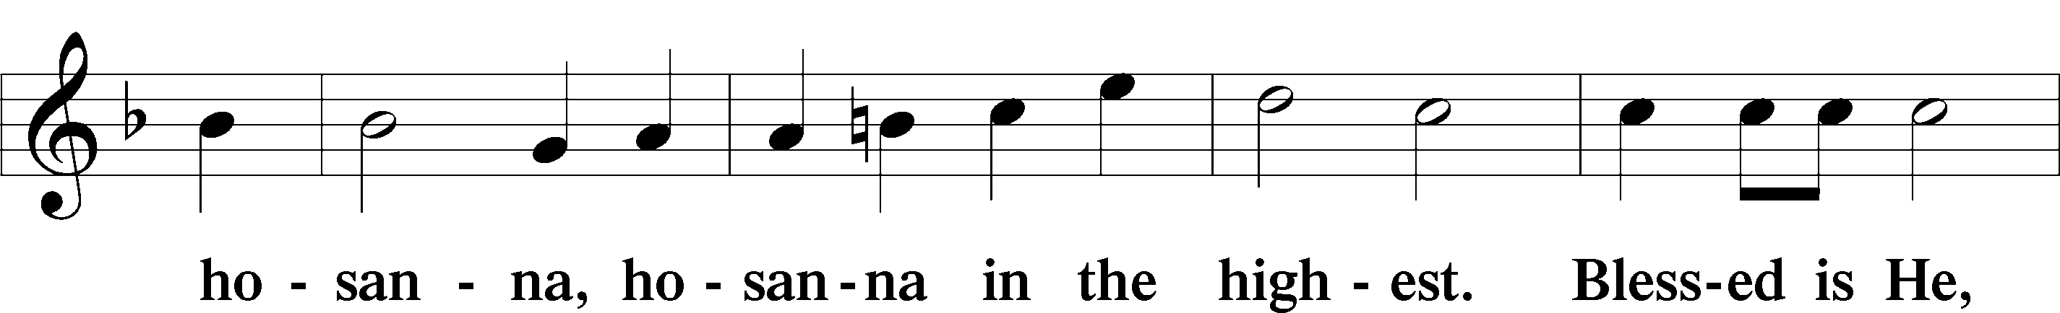
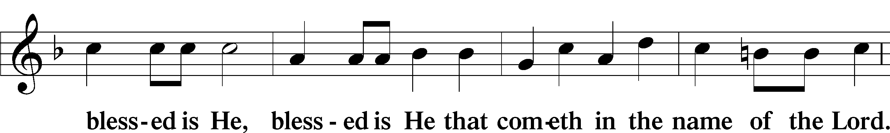
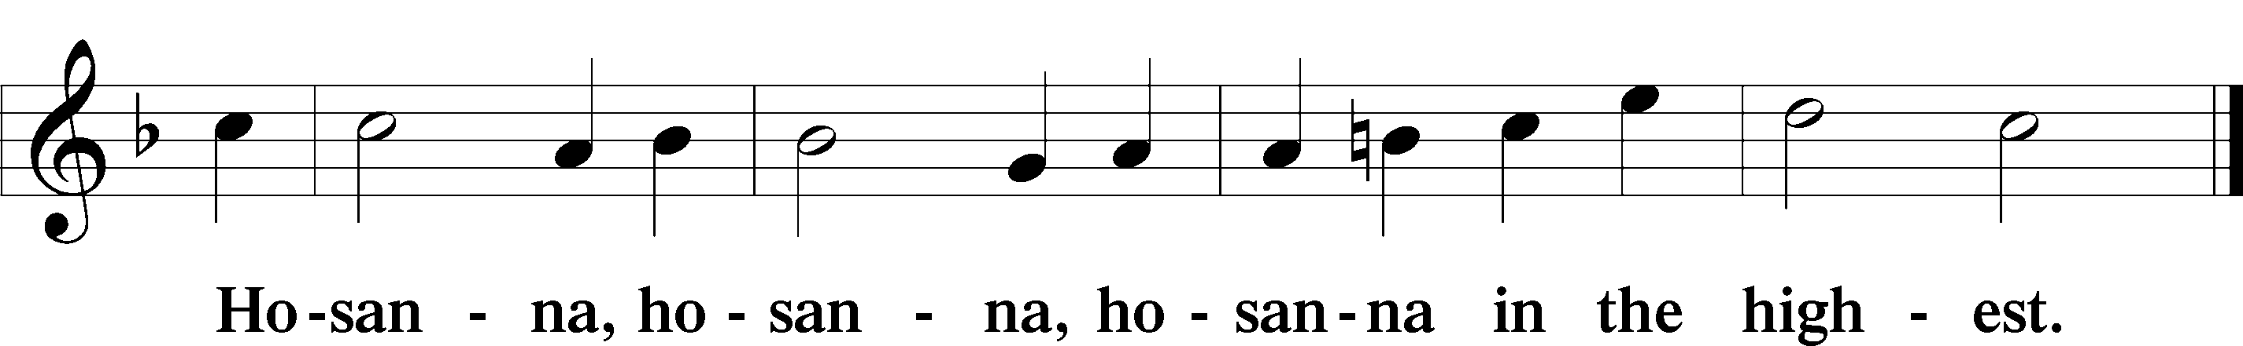

Lord’s Prayer Matthew 6:9–13
C Our Father who art in heaven,
hallowed be Thy name,
Thy kingdom come,
Thy will be done on earth as it is in heaven;
give us this day our daily bread;
and forgive us our trespasses as we forgive those who trespass against us;
and lead us not into temptation,
but deliver us from evil.
For Thine is the kingdom and the power and the glory forever and ever. Amen.

The Words of Our Lord Matthew 26:26–28; Mark 14:22–24; Luke 22:19–20; 1 Corinthians 11:23–25
P Our Lord Jesus Christ, on the night when He was betrayed, took bread, and when He had given thanks, He broke it and gave it to the disciples and said: “Take, eat; this is My T body, which is given for you. This do in remembrance of Me.”

In the same way also He took the cup after supper, and when He had given thanks, He gave it to them, saying: “Drink of it, all of you; this cup is the new testament in My T blood, which is shed for you for the forgiveness of sins. This do, as often as you drink it, in remembrance of Me.”

Pax Domini John 20:19
P The peace of the Lord be with you always.
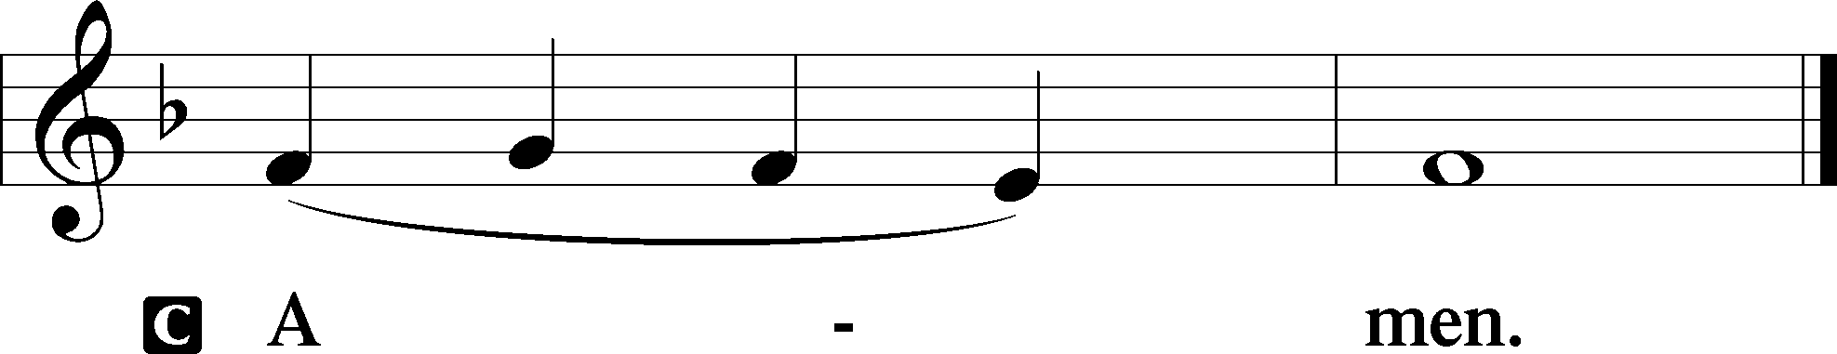

Agnus Dei John 1:29
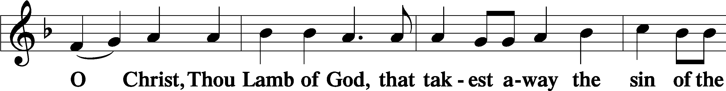
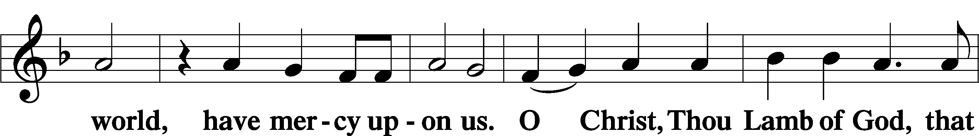
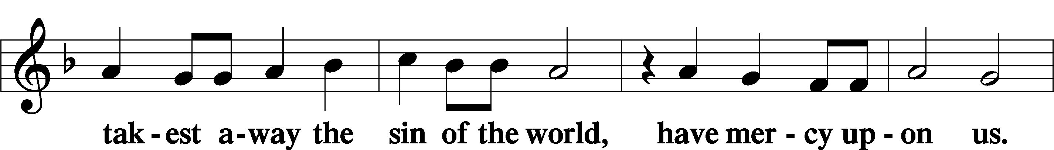
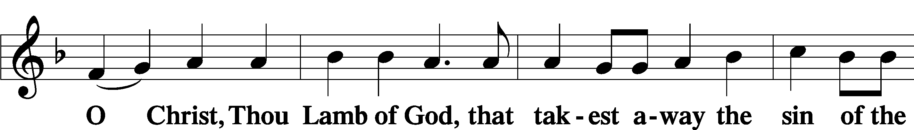
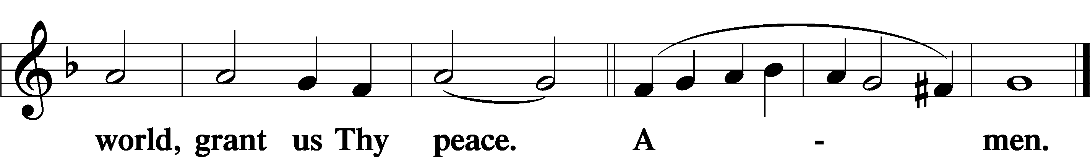
Sit
Distribution
The pastor and those who assist him receive the body and blood of Christ first and then distribute them to those who come to receive, saying:
Take, eat; this is the true body of our Lord and Savior Jesus Christ, given into death for your sins.
Amen.

Take, drink; this is the true blood of our Lord and Savior Jesus Christ, shed for the forgiveness of your sins.
Amen.

In dismissing the communicants, the following is said:
The Dismissal
P The body and blood of our Lord Jesus Christ strengthen and preserve you in body and soul to life everlasting. Depart T in peace.
C Amen.

Distribution Hymn: LSB #636 “Soul, Adorn Yourself with Gladness”

Distribution Hymn: LSB #642 “O Living Bread from Heaven”

Stand

Nunc Dimittis Luke 2:29–32
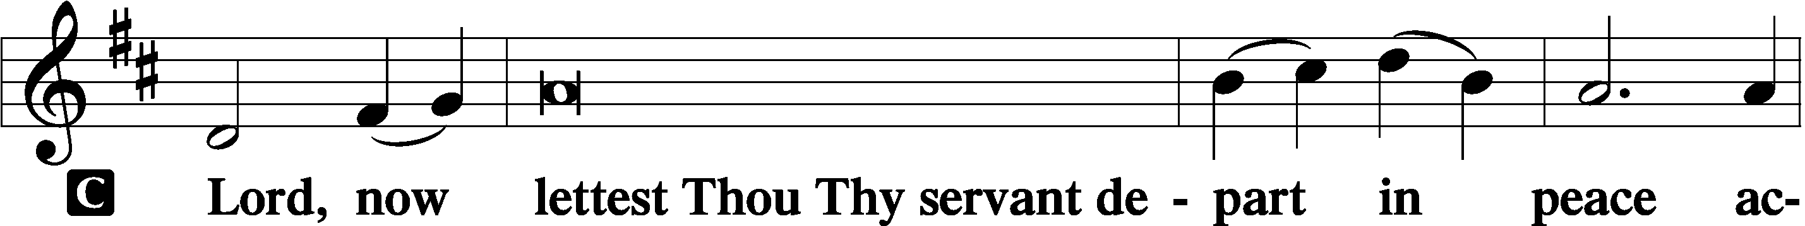
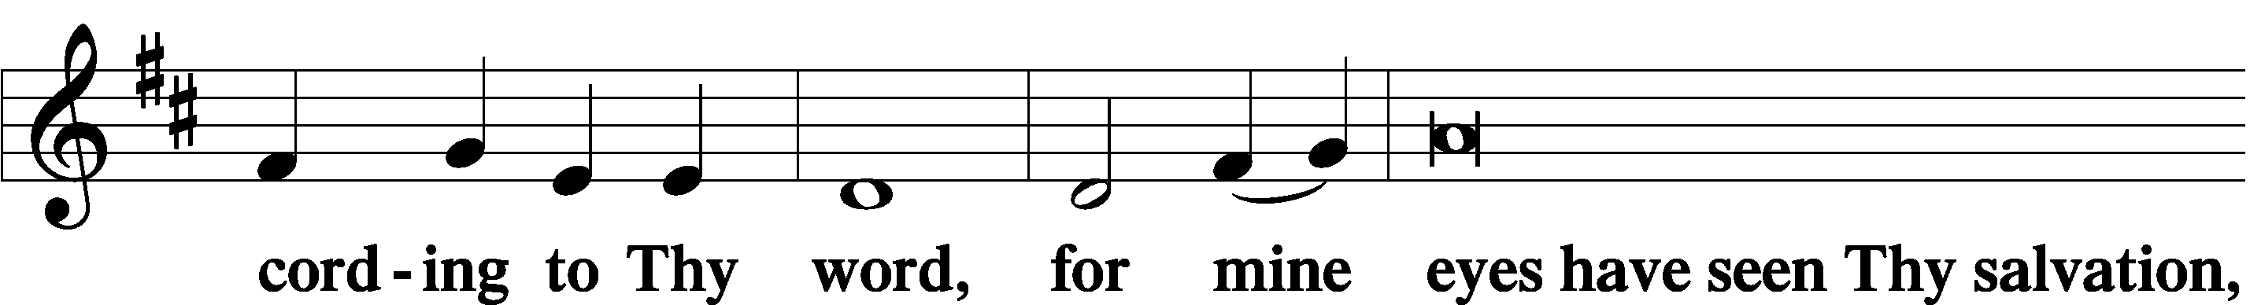
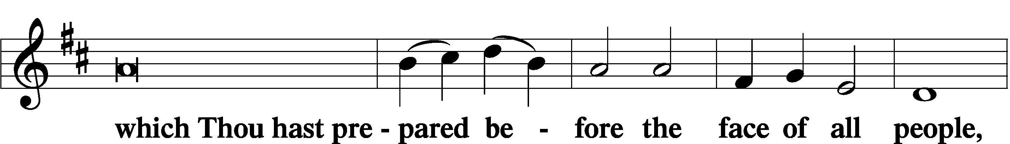
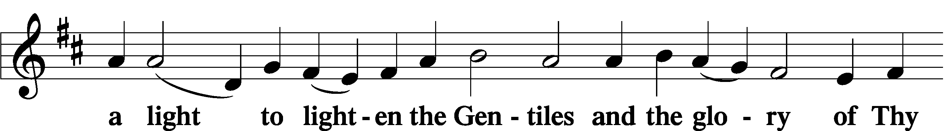
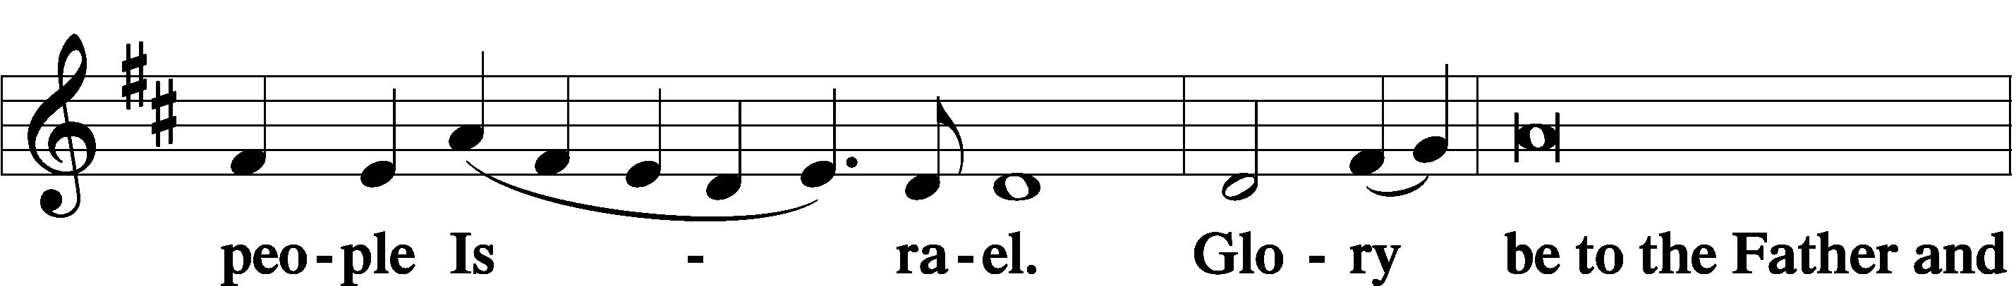
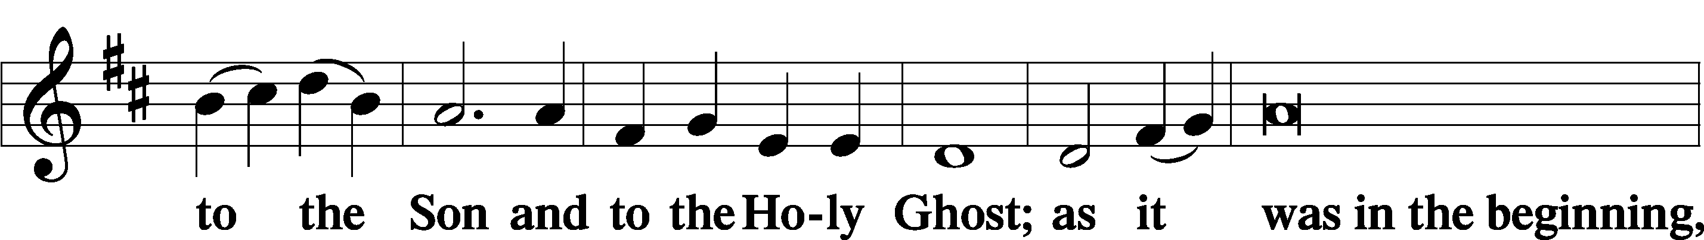
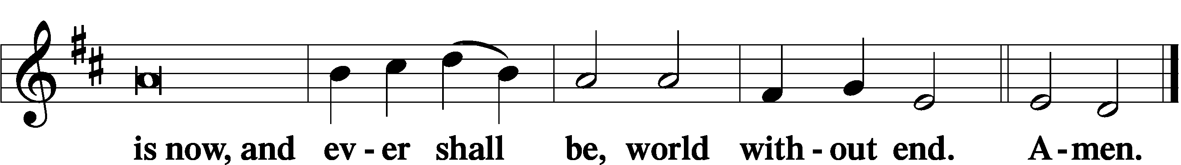

Thanksgiving Psalm 107:1
P O give thanks unto the Lord, for He is good,
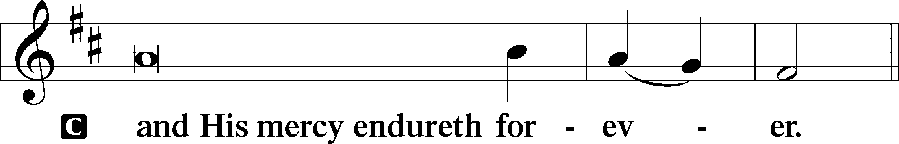

Post-Communion Collect
P Let us pray.
We give thanks to You, almighty God, that You have refreshed us through this salutary gift, and we implore You that of Your mercy You would strengthen us through the same in faith toward You and in fervent love toward one another; through Jesus Christ, Your Son, our Lord, who lives and reigns with You and the Holy Spirit, one God, now and forever.
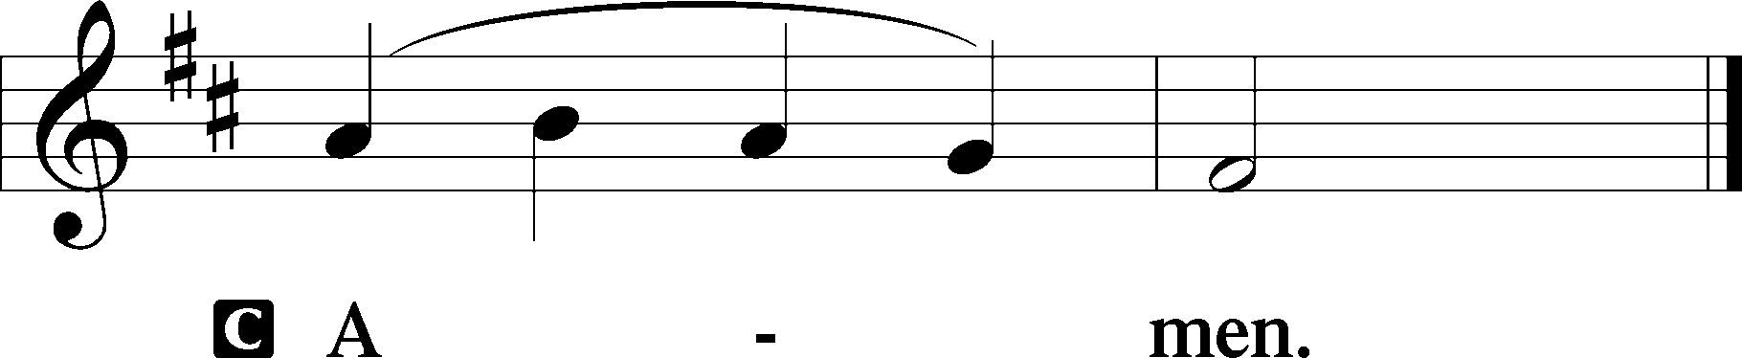

Salutation 2 Timothy 4:22
P The Lord be with you.
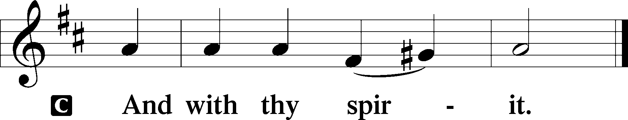

Benedicamus Psalm 103:1
P Bless we the Lord.
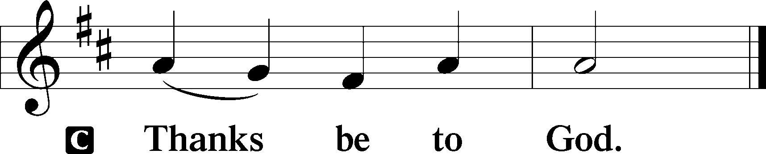

Benediction Numbers 6:24–26
P The Lord bless you and keep you.
The Lord make His face shine upon you and be gracious unto you.
The Lord lift up His countenance upon you and T give you peace.
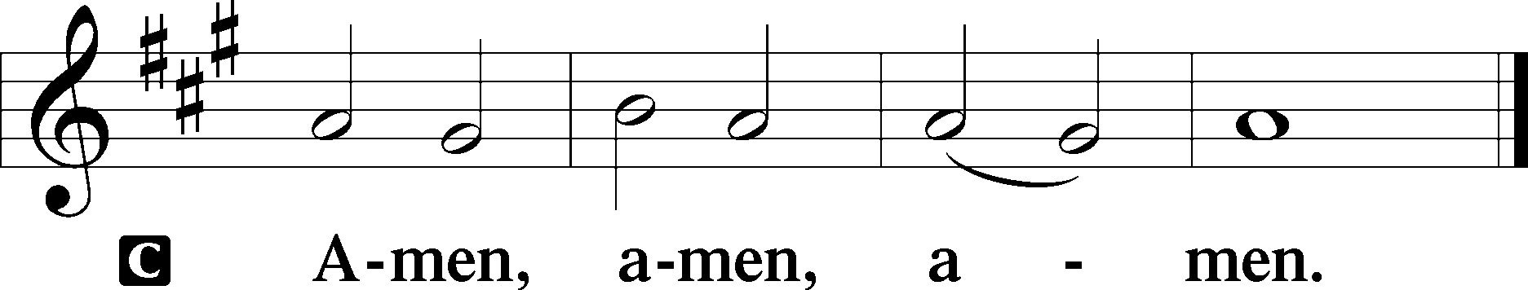

Closing Hymn: LSB #778 “Grant Peace, We Pray, in Mercy, Lord”

Silent prayer after worship: O Lord, enable me to live each day by Your grace, trusting in Your mercy alone for my salvation. Put to death my sinful flesh, so that I might humbly serve You in thanksgiving for the life You give me. In Jesus’ name. Amen.
fffffffffffffffffffffffffffffffffff
Acknowledgments: Unless otherwise indicated, Scripture quotations are from the ESV® Bible (The Holy Bible, English Standard Version®), copyright © 2001 by Crossway, a publishing ministry of Good News Publishers. Used by permission. All rights reserved.
Created by Lutheran Service Builder © 2021 Concordia Publishing House.
fffffffffffffffffffffffffffffffffff
fffffffffffffffffffffffffffffffffff
In Celebration of Our 50th Wedding Anniversary February 10, 2023: Joseph & Beverly Chlpka
For the 50th Anniversary of Parents, Beverly & Joseph Chlpka, February 10, 2023: Tina & Keith Jozwiakowski
In Loving Memory of Ernie Meszaros: Diane Riefstahl (Food Pantry)
In Loving Memory of Sophia Mihm: Lisa Jelinek (Food Pantry, Altar Guild, and General Fund)
fffffffffffffffffffffffffffffffffff
SCHEDULE THROUGH FEBRUARY 19, 2023:

:

Today, following Worship: Coffee Fellowship in Celebration of Joe & Bev Chlpka
7 pm, Fellowship Hall: AA Meeting
Tuesday, 7-9 pm, Fellowship Hall: Penn-Ohio Singers
Wednesday, 7:30 pm, Fellowship Hall: NA Meeting
Saturday, 1 pm, Fellowship Hall: Women’s Bible Study
4 pm, Fellowship Hall: Men’s Bible Study
Next Sunday, 8 am, Fellowship Hall: Bible Study
9 am, Sanctuary: Divine Service
Following, Library: Audit of Deposits
7 pm, Fellowship Hall: AA Meeting
fffffffffffffffffffffffffffffffffff
Attendance: Sunday, February 5, 2023: 27
Tuesday, February 7, 2023: 14
fffffffffffffffffffffffffffffffffff
Sunday Bible Study has resumed! We are studying the Minor Prophets. Please consider joining us each Sunday morning at 8 am!
fffffffffffffffffffffffffffffffffff
THANK YOU FOR SERVING IN FEBRUARY: Elder: Jonathan Baisch; Ushers: Matt Berent, Mark Gabriel, Michael Laird, and Jerome Thomas; Altarware: Marie Flaugher (prior) and Cheryl Fedele & Clara Krivosh (after).
fffffffffffffffffffffffffffffffffff
Joe and Bev Chlpka will be affirming their wedding vows during this morning’s Divine Service and invite all to join them for Coffee Fellowship following the service. Congratulations, Bev & Joe, on 50 years of marriage!
fffffffffffffffffffffffffffffffffff
Bible Memory Verses ~ Week of February 12th:
For Adults: You shall love the Lord your God with all your heart and with all your soul and with all your mind and with all your strength. Mark 12:30

For Children: Today, if you hear his voice, do not harden your hearts. Psalms 95:7-8
Our Stewardship of Treasures for the Lord:
In order to do the Lord’s work, we need $2,553.63 each week to meet our 2023 budget for general purposes and $76.92 for the SELC.
Figures for Thursday, February 2, 2023
General Fund: $510.00
SELC: $15.00
Food Pantry: $500.00
Other: $200.00
Figures for Sunday, February 5, 2023
General Fund: $1,081.00 Behind for the week: -$962.63
SELC: $30.00 Behind for the week: -$31.92
Food Pantry: $20.00
Capital Campaign: $200.00

For online giving, check out https://www.saintspeterandpaul.net/online-giving.
fffffffffffffffffffffffffffffffffff
Altar Guild members are reminded that 2023 dues should be paid to Treasurer, Evelyn Baisch. If paying by check, please make it out to Sts. Peter & Paul’s.
fffffffffffffffffffffffffffffffffff
Minutes from the January 30th Church Council meeting are available in the narthex. Also available are up-dated Communion Ware cleaning schedules and minutes from the January 21st Altar Guild meeting.
fffffffffffffffffffffffffffffffffff
Sincere sympathy is extended to Ruth Meszaros, her family, and friends at the passing of Ruth’s husband, Ernie, Tuesday, January 31, 2023. May all find comfort in the promises of our Lord and Savior, Jesus Christ.
fffffffffffffffffffffffffffffffffff
Copies of the 2023 Lenten Devotions, “Given and Shed for You”, are available in the narthex and on the table next to Pastor Deal’s office. These devotions correspond to the lessons of the mid-week Lenten services which we will be observing beginning with our Ash Wednesday service, February 22nd at 7 pm. Feel free to take a copy for a friend and invite them to join you in worship this Lenten season.
fffffffffffffffffffffffffffffffffff
Remember the following in Prayer…
~The Hurting and Healing: The family and friends of Ernest Meszaros, who passed away Tuesday, January 31, 2023; also Amy, Gerald Arthur, Evelyn Baisch, Ellen Baron^{CA}, Lois Bortner^{CA}, John Burdette, Bev & Joe Chlpka, Kathleen Coughenour, Kim, Anna Mae Daris, Susan Davies, Tim Dudash, Millie Elavsky, Joseph Fleet, Judith & Eddy Furey, Tim Haenftling, Austin Hamilton, Anson Holcroft, Neil Huston, Darla Krajci, Barbara Kreske, Michelle Kelly^{CA}, Donna Kennedy, Gerald Krivosh, Jess Lavoie, Paul Lucas^{CA}, Sandy Marshall, David Nelson, Linda Parkany, Juanita Rentschler, Richard Reuning^{CA}, Diane Riefstahl, Nancy Robertson^{CA}, Viola Sakony, Marty Scott, Kara, Fred Tonty, Angela Weser^{CA}, and Ruth Wolf.
~The Homebound: Rudy & Jean Tomko, Betty Wolf, and Ed & Millie Zachar.
~Serving in the Military: Curtis Sinewe and Joshua Solyan.
~Community & World Needs: Those suffering from or affected by the coronavirus; those suffering due to the conflict between Ukraine and Russia; those suffering from loss and dislocation because weather disasters; those suffering from addiction and their families; Local, State, and National Government Leaders; safety for all Police Officers, Firefighters, & First Responders; the unemployed; our First Quarter Local Mission: Sts. Peter & Paul’s Community Day 2023.
*CA represents cancer.
fffffffffffffffffffffffffffffffffff

This morning is “Stock the Food Pantry Sunday”! Your financial donations will be greatly appreciated.

fffffffffffffffffffffffffffffffffff
Pastor & Ana will be out of town Wednesday through Saturday morning this week. Please contact Pastor Baisch, 501-253-8292, if in need of pastoral counseling.
fffffffffffffffffffffffffffffffffff
Be certain to pick up your copy of the brochure “Almsgiving, Praying, Fasting” which Pastor Deal prepared for the Lenten season. Copies are available both in the narthex and on the table next to Pastor Deal’s office.
fffffffffffffffffffffffffffffffffff
Items for the March issue of the newsletter and calendar are due to Diane no later than noon, February 20th.
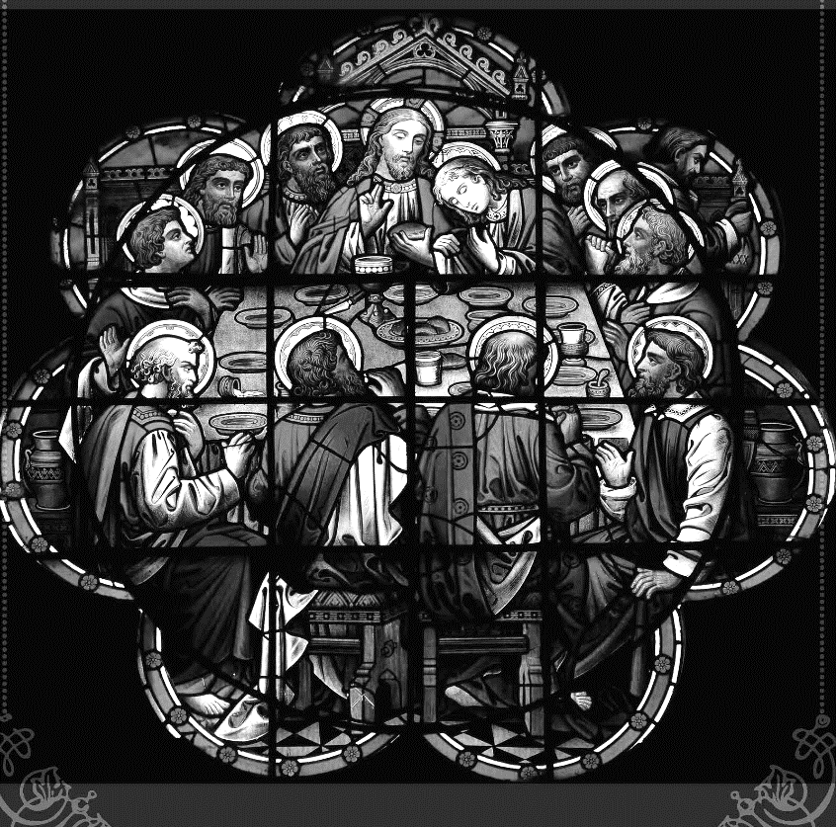

Join us this Lenten season
as we focus on the
Lord’s Supper
with the following services:

Ash Wednesday Divine Service
February 22nd at 7 pm

Wednesday Mid-week Lenten Services
Service of Morning Prayer at noon
Vesper’s Service at 7 pm
Beginning March 1st – 29th

Here to Serve

Pastor………………………………………………...……………Rev. Jacob Deal
E-mail …………………………….……pastordeal@saintspeterandpaul.net
Phone Number……………………..…………………724-347-3620 (Option 2)
Church Office………………………..…………………724-347-3620 (Option 3)
Website …………………………………………www.saintspeterandpaul.net
Secretary…………………………………………………………Diane Riefstahl
E-mail ………………………………………church@saintspeterandpaul.net
Website …………………………………………www.saintspeterandpaul.net
Food Pantry: Please leave message……………724-347-3620 (Option 3)
AA Contact: Steve………………………………………………..…724-813-2358
NA Contact: Larry………………………………………………..724-977-8733
Choir Director………………………………………………………Chris Nelson
Congregation President……………………………………Jonathan Baisch
Church Elder …………………………………………...…… Jonathan Baisch
fffffffffffffffffffffffffffffffffff
If needing to get into the church building during the week, please phone first to make certain someone is here to let you in.

